Lab # 01

Introduction to Pointers and Arrays



Spring 2026
Data Structures And Algorithms Lab

Submitted by: M Mohsin Khan
Registration No.: 24PWCSE2382
Class Section: C

Submitted to:
Engr. Abdullah Hamid
June 3rd , 2026

Department of Computer Systems Engineering
University of Engineering and Technology, Peshawar

Task 01:
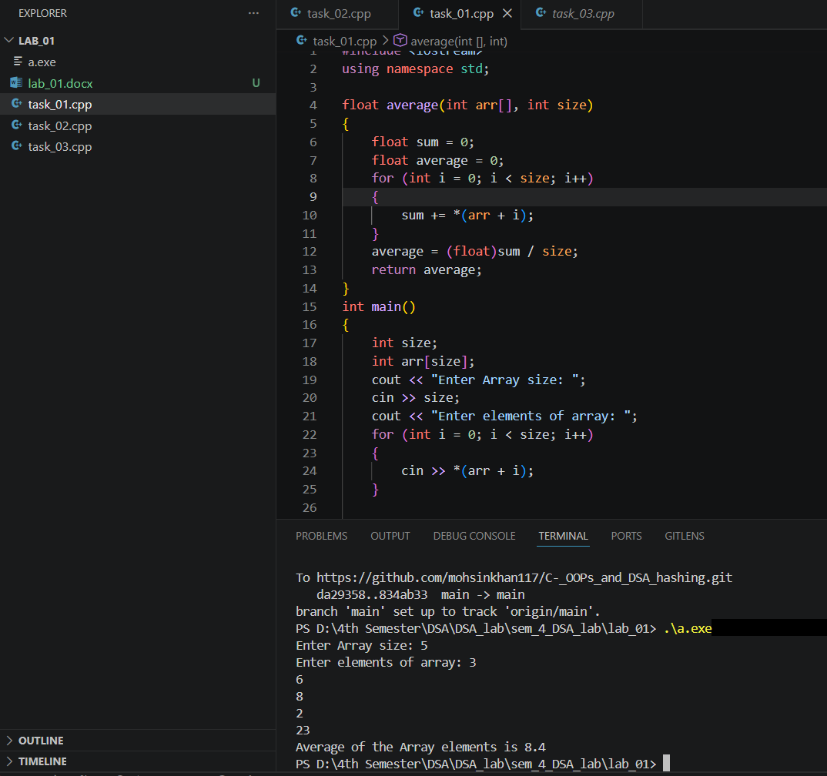
Write a program that reads numbers from the user in to an array of type “float”, average

Task 02:
Write a function that takes an int array and array’s size as argument and return maximum
value of array elements.

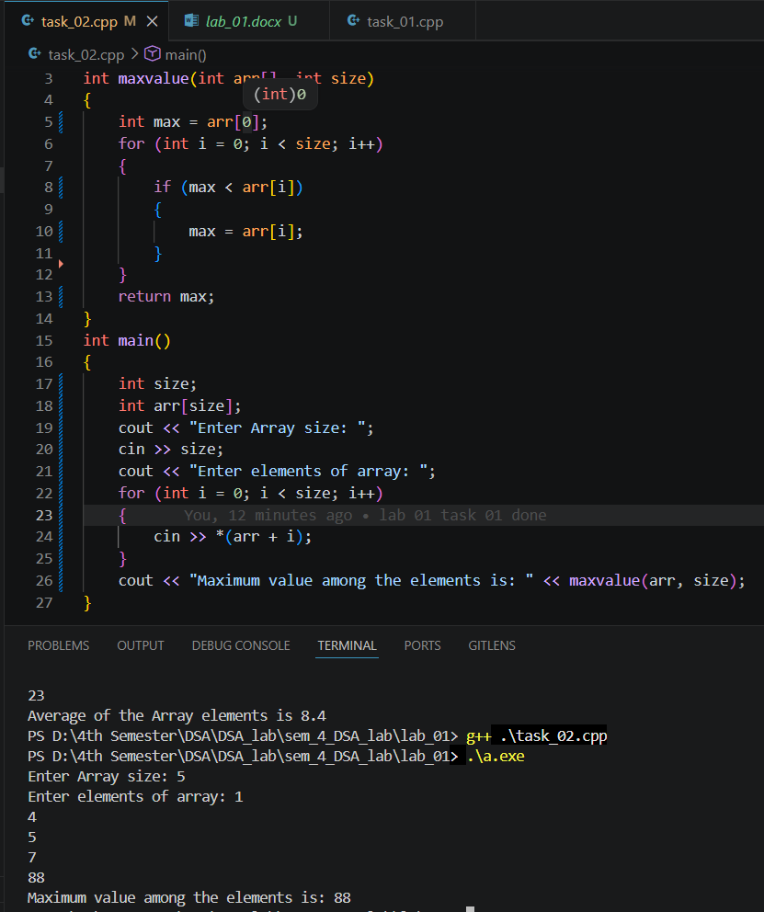

Task 03:
Write a function that takes an int array and the array's size as arguments. It should create a new array that is twice the size of the argument array. The function should copy the contents of the argument array to the new array, and initialize the unused elements of new array with -1. The function should return a pointer to the new array.
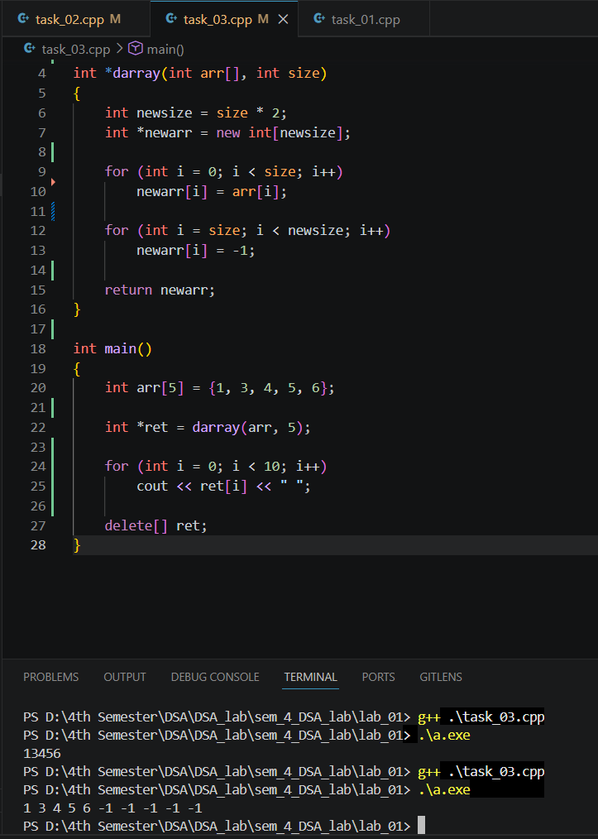

Task 4: Write a function that takes two int arrays and the arrays' sizes as arguments. It should create a new array big enough to store both arrays. Then it should copy the contents of the first array to the new array, and then copy the contents of the second array to the new array in the remaining elements, and return a pointer to the new array.

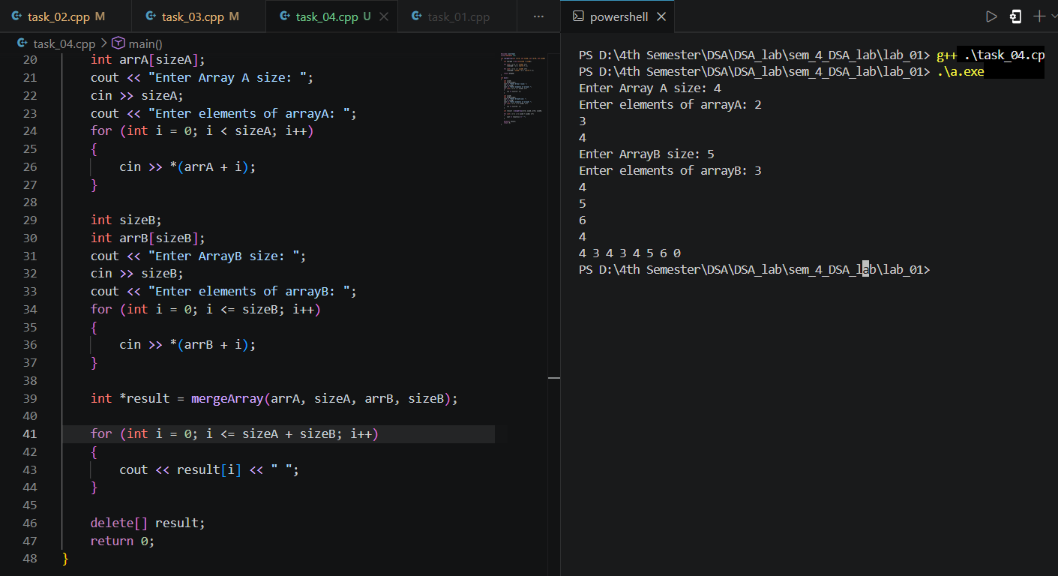

RUBRICS (LABS/ PROJECTS):
Criteria & Point  Assigned | Outstanding  4 | Acceptable  3 | Considerable  2 | Below  Expectations  1 | Score
Valuing related to work,  including  responsibility, and  professionalism. | Demonstrates  excellent  responsibility and professionalism in task managment. Shows strong  commitment to  quality work,  meeting the  deadline, and  comprehensive, well-organized  effective  documentation  following all  guidelines with  exemplary  attention to detail. | Demonstrates  some  responsibility and professionalism. Displays  moderate  commitment to quality work,  meets the  deadline and  shows sufficient thoroughness in documentation, adhering to  guidelines, with some room for  enhancement. | Demonstrates limited effort in responsibility  and  professionalism. Misses the  deadline with  notable  inconsistency in quality work and shows  insufficient  thoroughness or clarity in  documentation, necessitating  improvements. | Demonstrates a lack of  responsibility  and  professionalism. Misses the  deadline and  lacks quality  work.  Documentation is incomplete,  disorganized, or unclear.
Ability to apply techniques,  methods, and  procedures  effectively. | Executes lab tasks with exceptional skill to  design/develop  solution and  shows proficiency in lab techniques and procedures. | Executes lab tasks with adequate skill to  design/develop solution and  shows  proficiency in lab techniques and procedures. | Executes lab  tasks with  minimal skill to design/develop solution and  shows modeate proficiency in  lab techniques and procedures. | Executes lab  tasks with  limited skill to design/develop solution and  lacks  proficiency in  lab techniques and procedures.
Demonstrate  understanding and relevant  Knowledge. | Demonstrates  exceptional  understanding of concepts with  clear explanation of investigation  and analysis of the objectives and  outcomes. | Demonstrates a good  understanding of concepts with  some  explanations of investigation and analysis that align with the lab's  objectives and  outcomes. | Demonstrates a basic  understanding of key concepts but lacks clarity or depth in  explaining the investigation  and analysis,  with some  inconsistencies. | Demonstrates limited  understanding  of concepts with unclear  explanations of investigation  and analysis  that do not align with the lab’s  objectives and outcomes.

