Lab # 02

Linear Search and Binary Search



Spring 2026
Data Structures and Algorithms Lab

Submitted by: M Mohsin Khan
Registration No.: 24PWCSE2382
Class Section: C

Submitted to:
Engr. Abdullah Hamid
June 3rd , 2026

Department of Computer Systems Engineering
University of Engineering and Technology, Peshawar

Task 01: Implementation of Linear Search in Arrays:
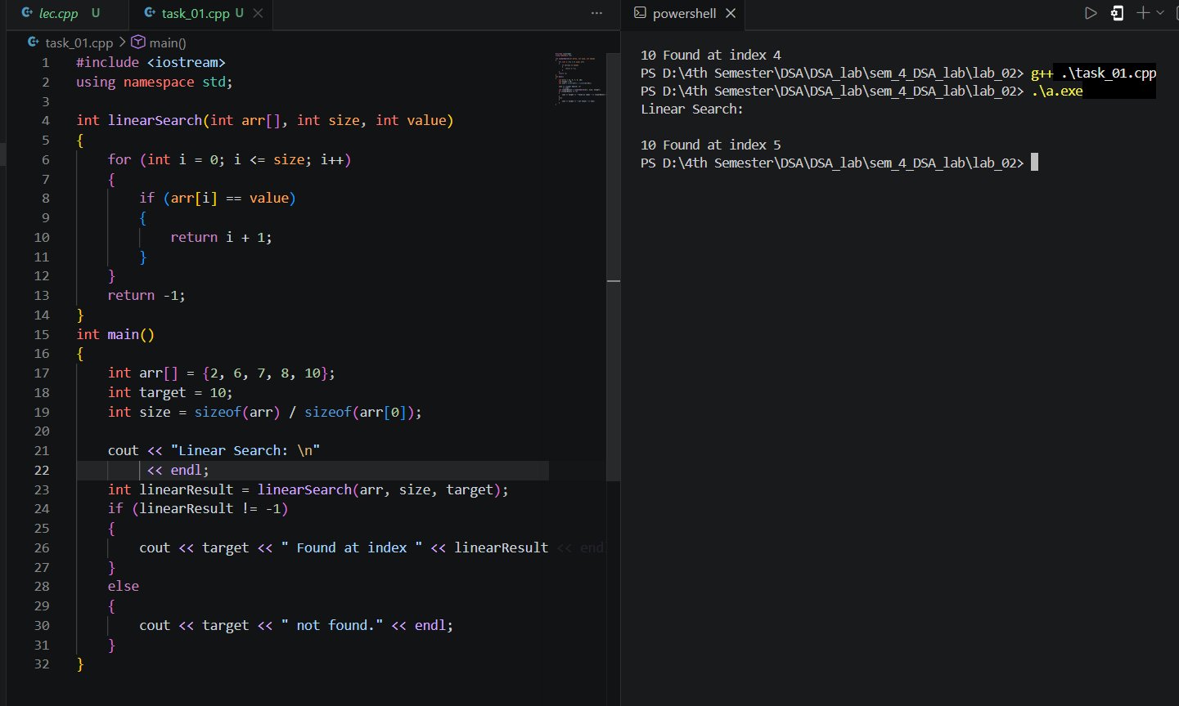
Task 02: Binary Search implementation:
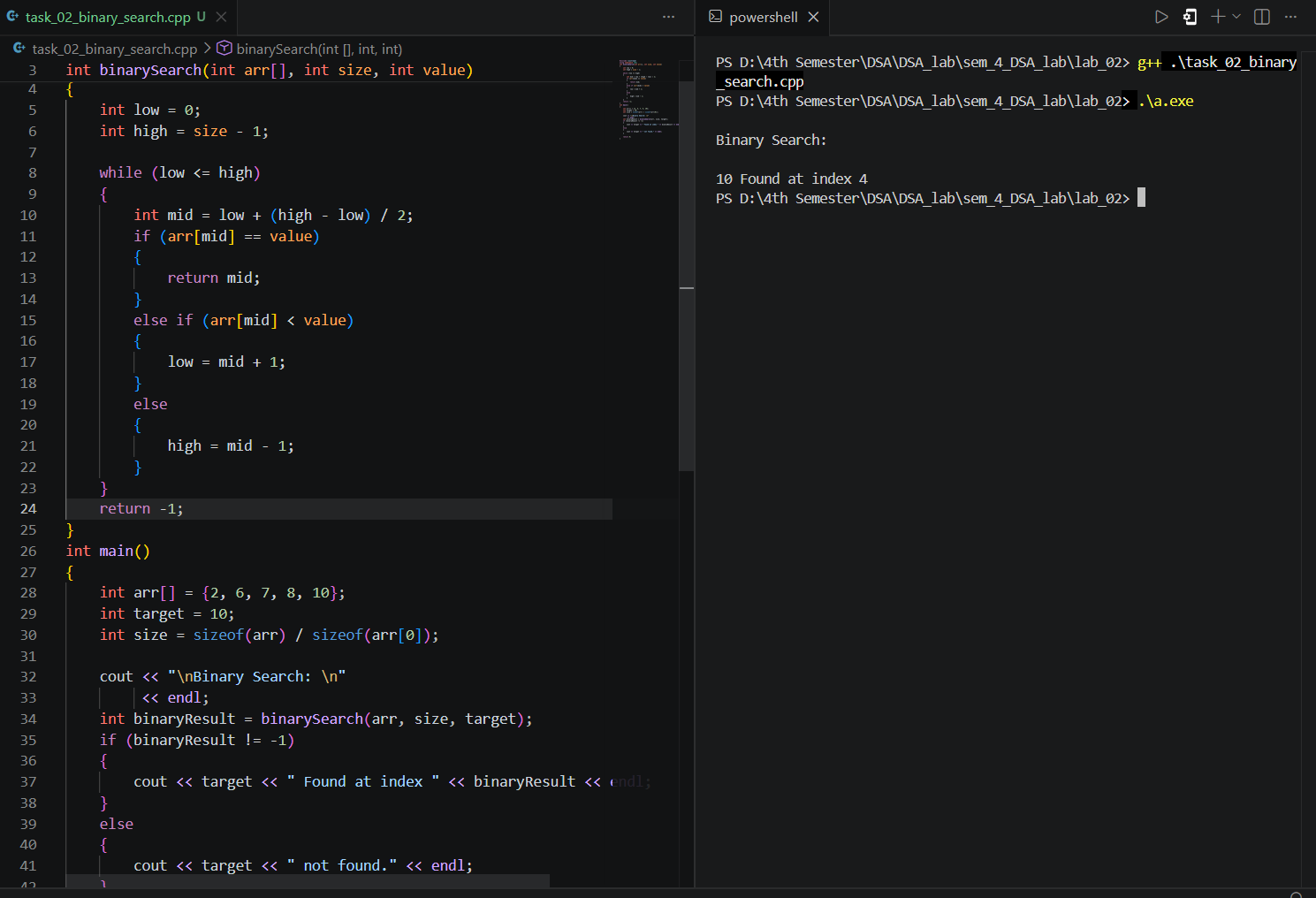
Comparison :
Case | Linear Search | Binary Search
Best Case | O(1) | O(1)
Average Case | O(n) | O(log n)
Worst Case | O(n) | O(log n)
Requires Sorted Array | No | Yes
Space Complexity | O(1) | O(1)

RUBRICS (LABS/ PROJECTS):
Criteria & Point  Assigned | Outstanding  4 | Acceptable  3 | Considerable  2 | Below  Expectations  1 | Score
Valuing related to work,  including  responsibility, and  professionalism. | Demonstrates  excellent  responsibility and professionalism in task managment. Shows strong  commitment to  quality work,  meeting the  deadline, and  comprehensive, well-organized  effective  documentation  following all  guidelines with  exemplary  attention to detail. | Demonstrates  some  responsibility and professionalism. Displays  moderate  commitment to quality work,  meets the  deadline and  shows sufficient thoroughness in documentation, adhering to  guidelines, with some room for  enhancement. | Demonstrates limited effort in responsibility  and  professionalism. Misses the  deadline with  notable  inconsistency in quality work and shows  insufficient  thoroughness or clarity in  documentation, necessitating  improvements. | Demonstrates a lack of  responsibility  and  professionalism. Misses the  deadline and  lacks quality  work.  Documentation is incomplete,  disorganized, or unclear.
Ability to apply techniques,  methods, and  procedures  effectively. | Executes lab tasks with exceptional skill to  design/develop  solution and  shows proficiency in lab techniques and procedures. | Executes lab tasks with adequate skill to  design/develop solution and  shows  proficiency in lab techniques and procedures. | Executes lab  tasks with  minimal skill to design/develop solution and  shows modeate proficiency in  lab techniques and procedures. | Executes lab  tasks with  limited skill to design/develop solution and  lacks  proficiency in  lab techniques and procedures.
Demonstrate  understanding and relevant  Knowledge. | Demonstrates  exceptional  understanding of concepts with  clear explanation of investigation  and analysis of the objectives and  outcomes. | Demonstrates a good  understanding of concepts with  some  explanations of investigation and analysis that align with the lab's  objectives and  outcomes. | Demonstrates a basic  understanding of key concepts but lacks clarity or depth in  explaining the investigation  and analysis,  with some  inconsistencies. | Demonstrates limited  understanding  of concepts with unclear  explanations of investigation  and analysis  that do not align with the lab’s  objectives and outcomes.

