Lab # 01

Introduction to Pointers and Arrays



Spring 2026
CSE-204L Operating Systems Lab

Submitted by: M Mohsin Khan
Registration No.: 24PWCSE2382
Class Section: C

Submitted to:
Engr. Abdullah Hamid
June 2nd, 2026

Department of Computer Systems Engineering
University of Engineering and Technology, Peshawar

Task 01:
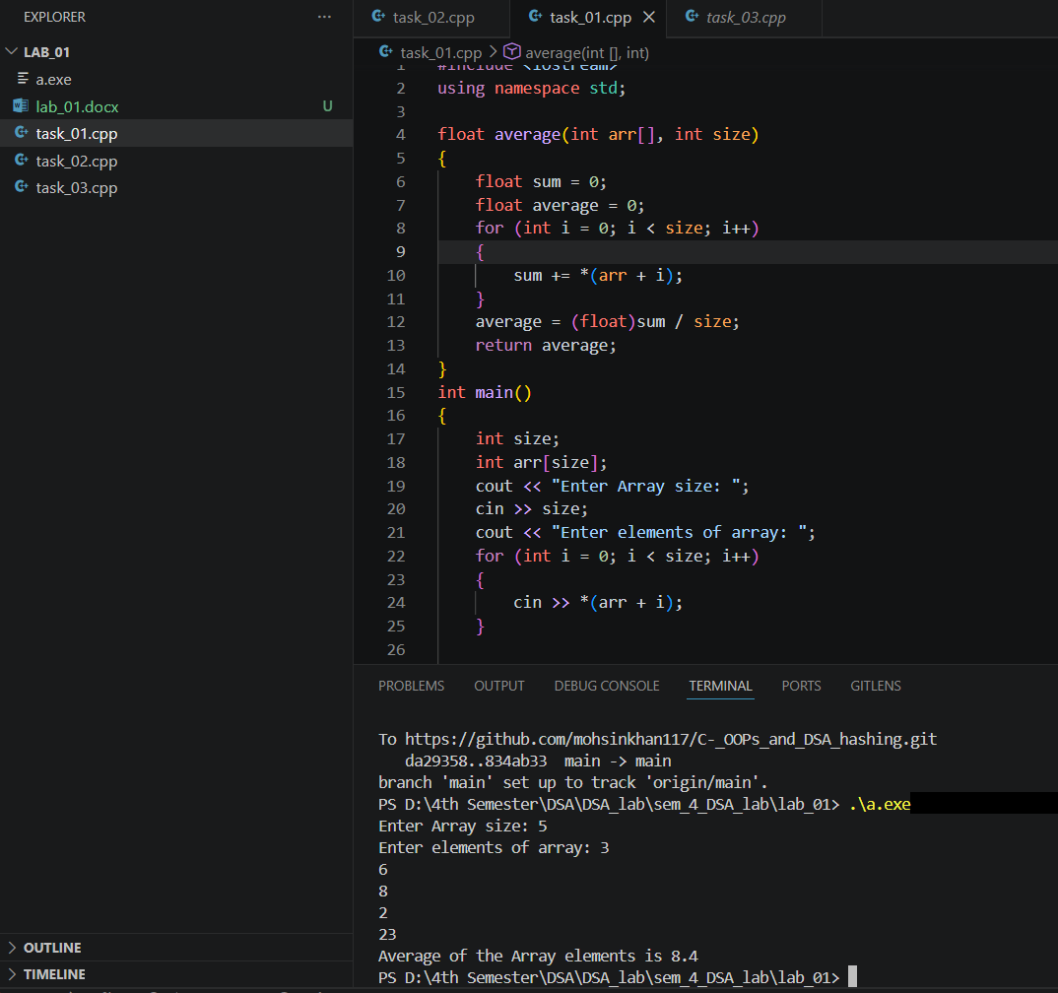
Write a program that reads numbers from the user in to an array of type “float”, average

Task 02:
Write a function that takes an int array and array’s size as argument and return maximum
value of array elements.

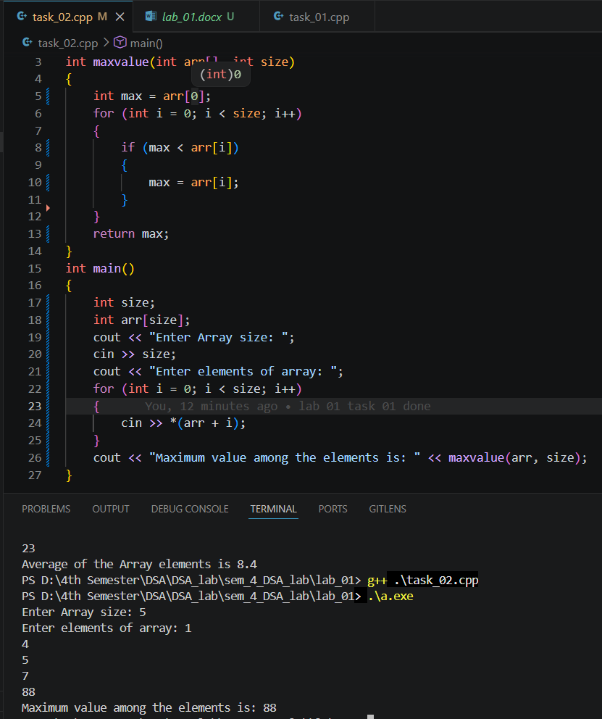

Task 03:
Write a function that takes an int array and the array's size as arguments. It should create a new array that is twice the size of the argument array. The function should copy the contents of the argument array to the new array, and initialize the unused elements of new array with -1. The function should return a pointer to the new array.
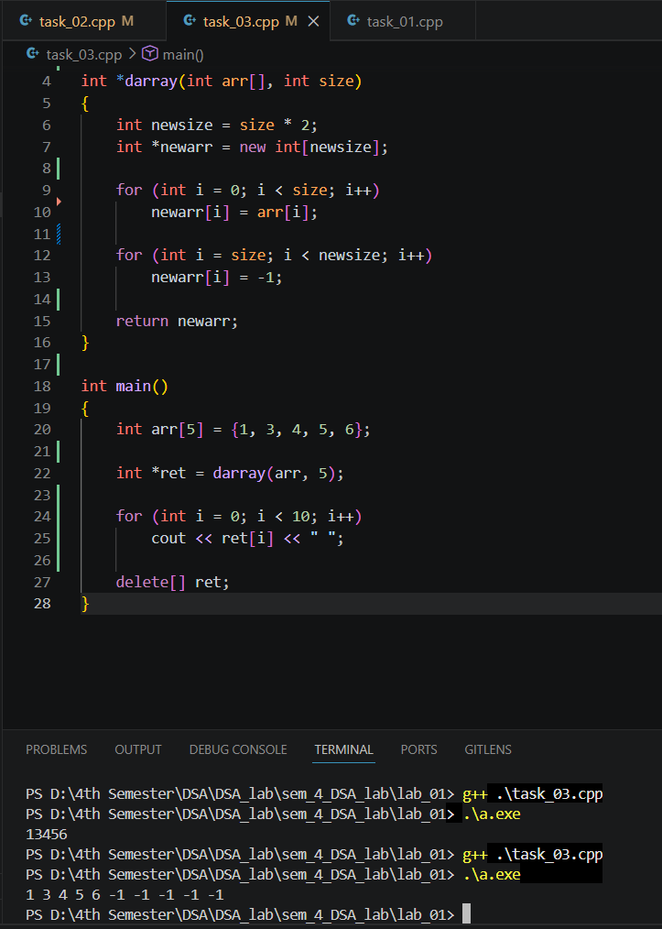

Task 4: Write a function that takes two int arrays and the arrays' sizes as arguments. It should create a new array big enough to store both arrays. Then it should copy the contents of the first array to the new array, and then copy the contents of the second array to the new array in the remaining elements, and return a pointer to the new array.

