Lab# 02: Passing and Returning Objects from Member Functions



Fall 2025

Submitted by

M Mohsin Khan (24pwcse2382)

Class Section: C

“On my honor, as student of University of Engineering and Technology, I have neither given nor received unauthorized assistance on this academic work.”

Submitted to: Engr. Sumayyah Salahuddin

Oct 23th, 2025

Department of Computer Systems Engineering

University of Engineering and Technology, Peshawar

2.1 Introduction
This lab aims to provide a comprehensive understanding of class objects in C++ and their use as function arguments and return values in member functions.
It also focuses on developing the ability to test member functions effectively using well-defined test cases.

2.2 Objectives of the Lab
By the end of this lab, students will be able to:
- Understand how class objects can be passed to and returned from member functions.
- Write a class that includes member functions accepting objects as parameters.
- Implement member functions that return objects.
- Test these member functions effectively using provided or custom test cases.

2.3 Pre-Lab Preparation

2.3.1 Objects as Function Arguments
- A member function has direct access to all members (both public and private) of its own class.
- A function can also have indirect access to members of another object of the same class when that object is passed as an argument.
Indirect Access:
This is achieved using the object name, followed by a dot (.), and then the member name.

2.4.1 Activity
Reuse Complex class written in Activity 2.4.1 to modify the addCom(), subCom(), and
mulCom() class functions. Instead of passing two objects in each, now pass only one object.
Change the return type of each function to complex. Adjust the function code to match the changes.

2.5.1 ML Diagram:
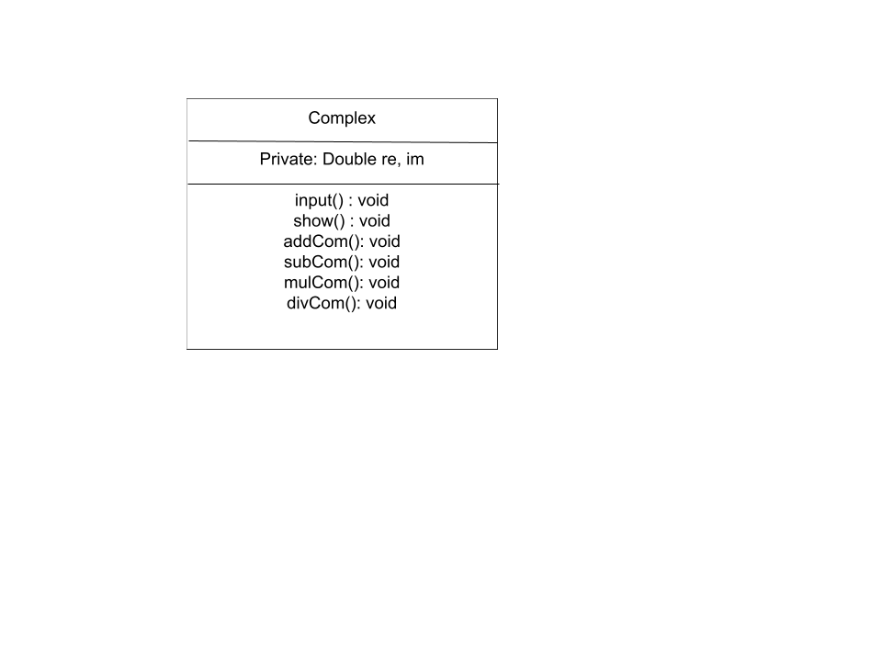

2.5.2 Flow Chart
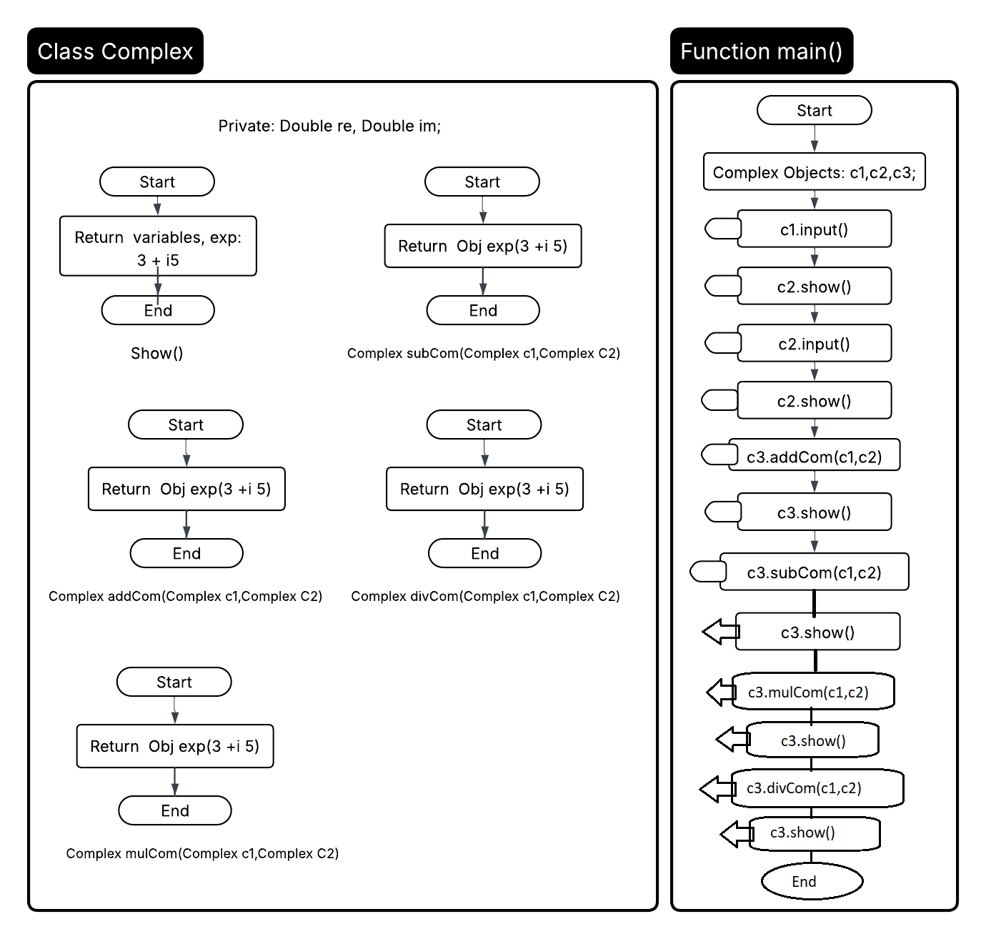

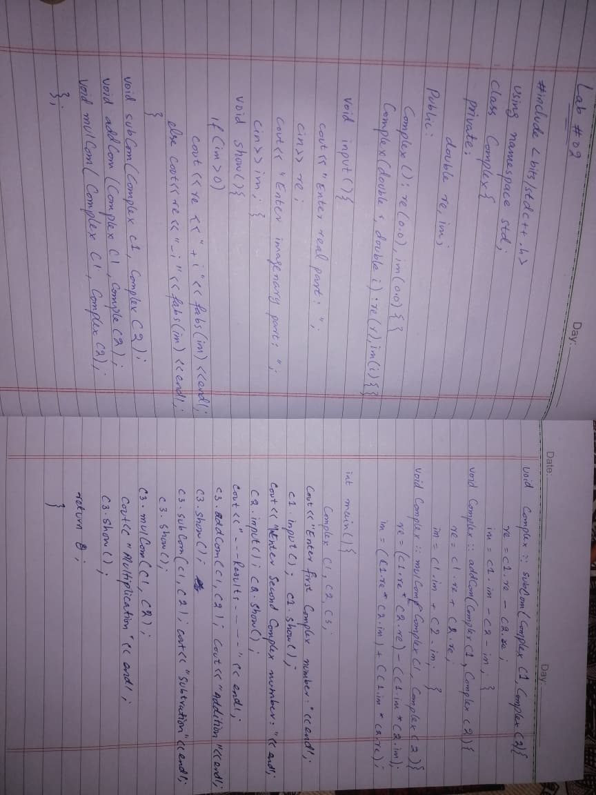
HandWritten Code:

2.5.1 Source Code:
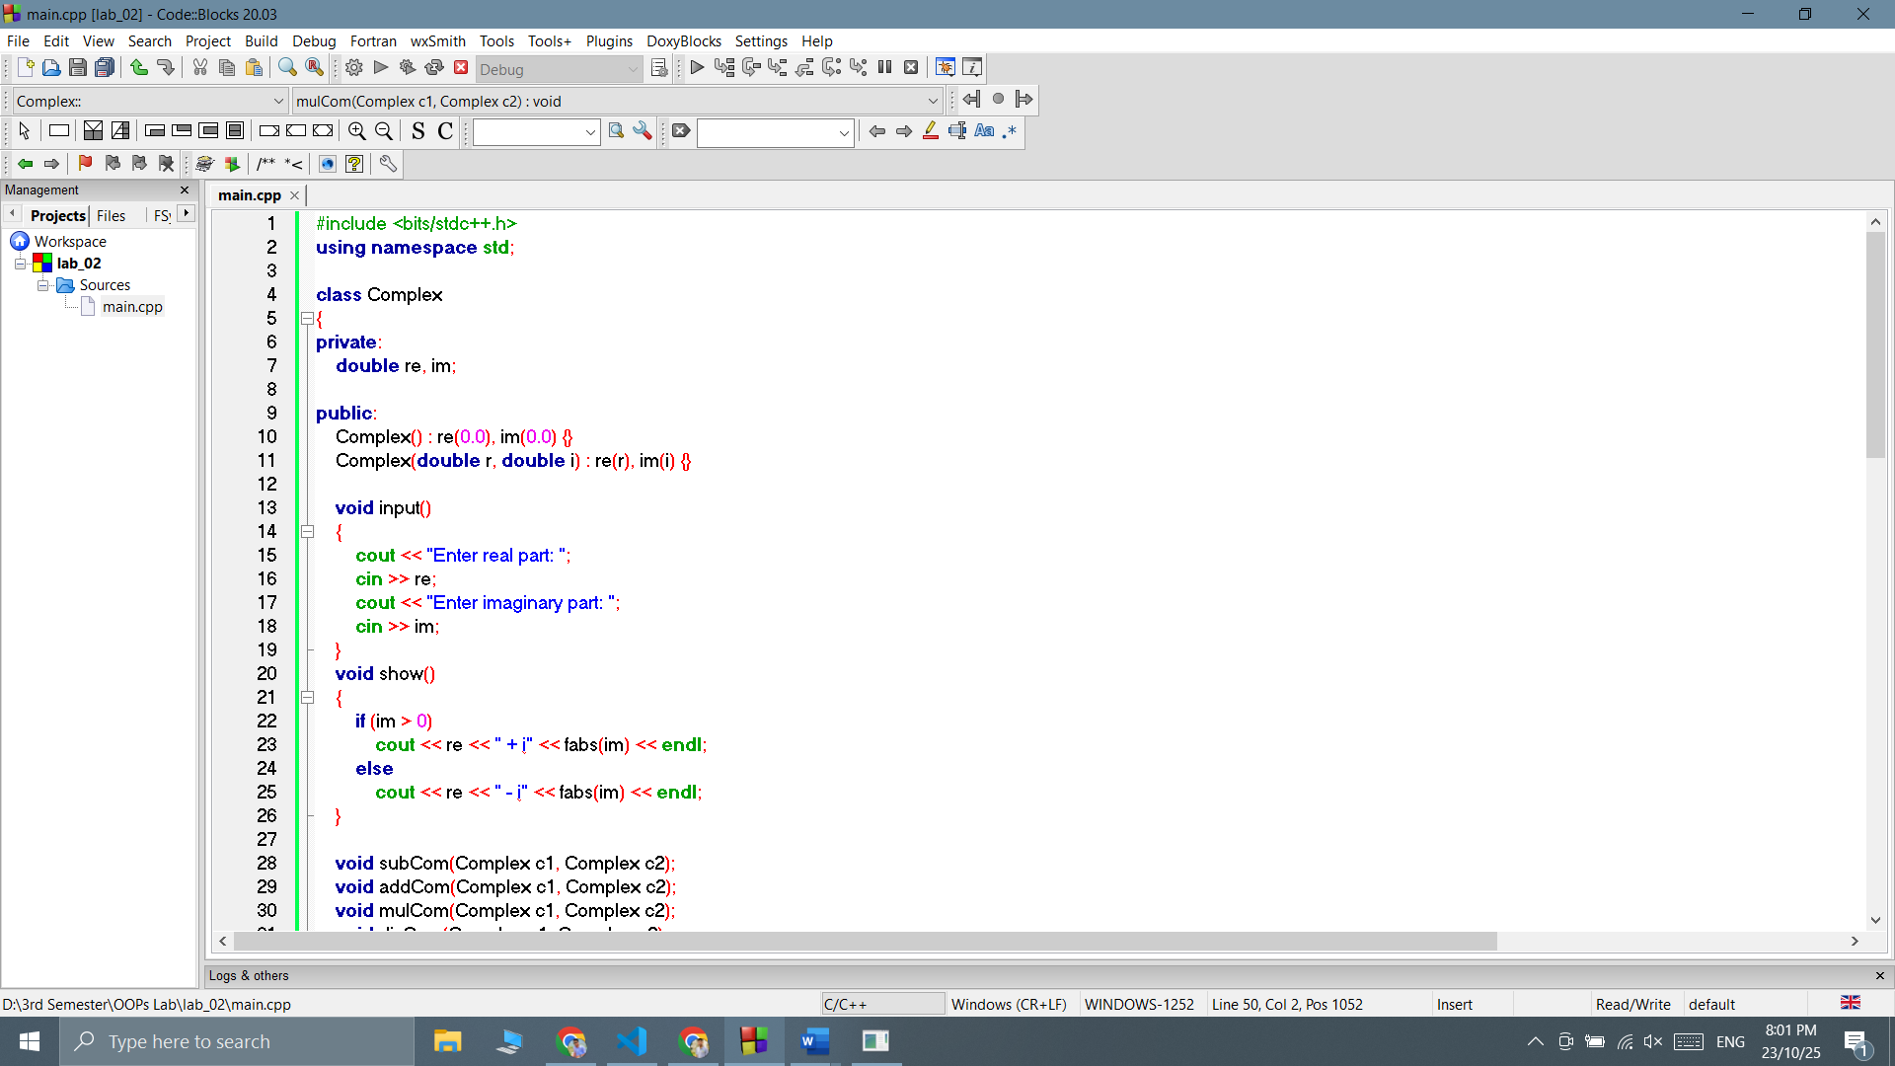

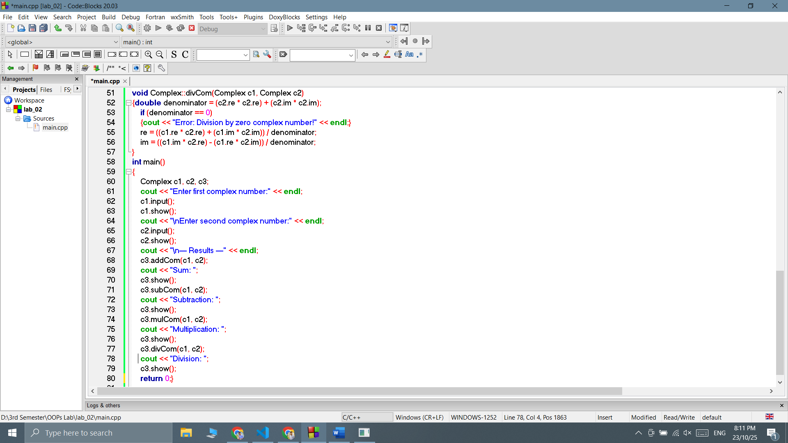
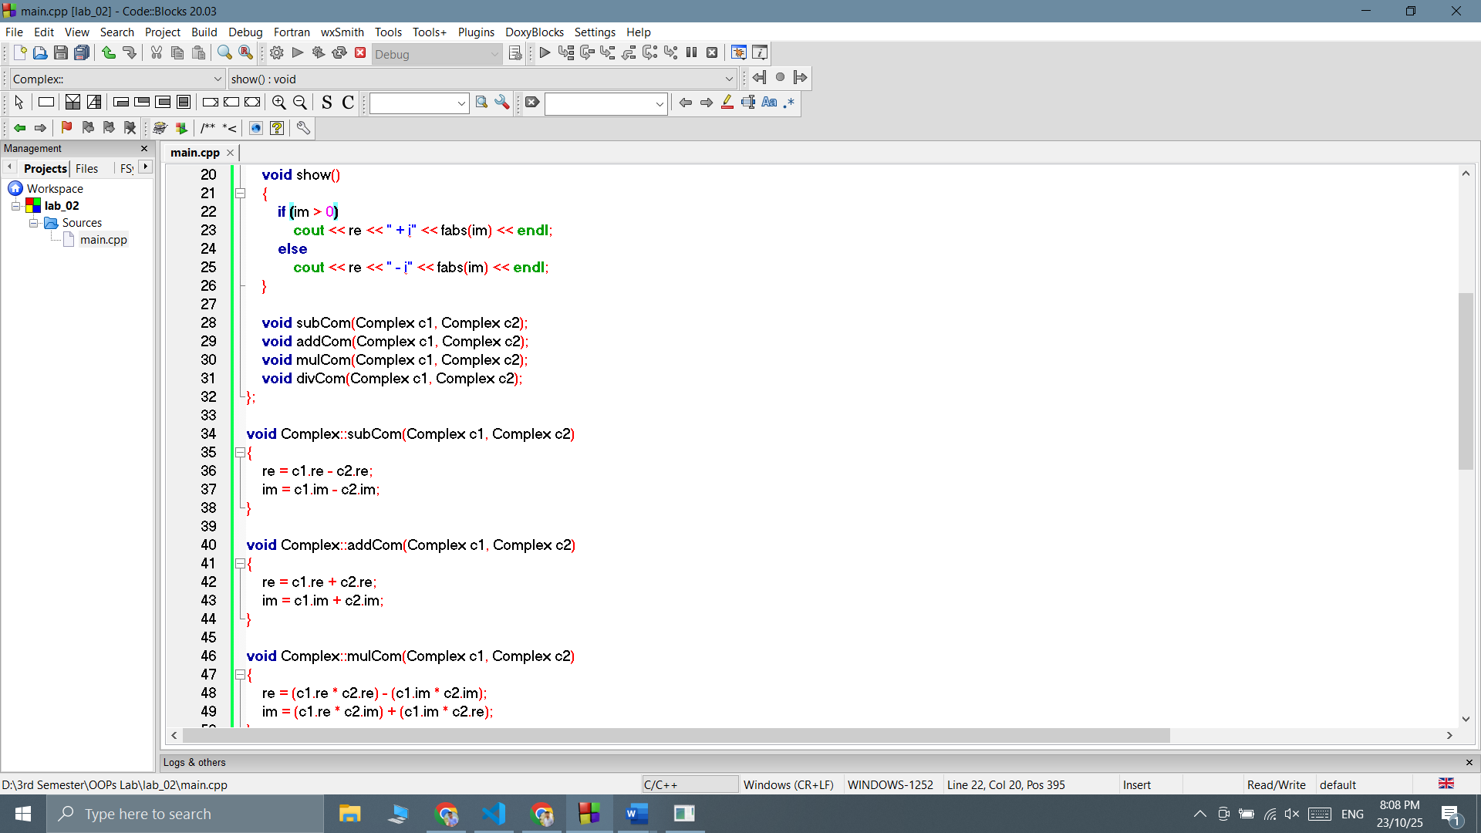

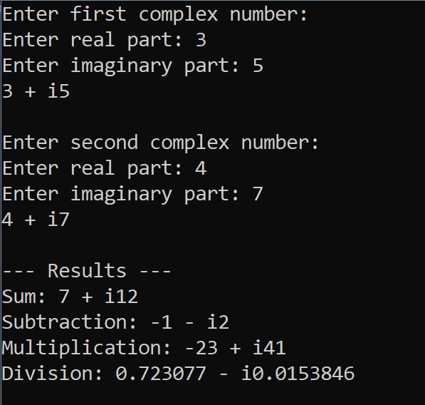
Output:

