Lab# 05: Implementing the Concept of Inheritance


Fall 2025

Submitted by

M Mohsin Khan (24pwcse2382)

Class Section: C

“On my honor, as student of University of Engineering and Technology, I have neither given nor received unauthorized assistance on this academic work.”

Submitted to: Engr. Sumayyah Salahuddin

Dec 26th, 2025

Department of Computer Systems Engineering

University of Engineering and Technology, Peshawar

5.1 Introduction
Reusability is a key characteristic of object-oriented programming (OOP). Features of a class—including both attributes (data members) and behaviors (member functions)—can be reused through inheritance between classes.
Typically, a class with certain data members and/or member functions is defined, and other classes are identified that can share these members. The original class is known as the parent, base, or super class, while the classes that inherit from it are called child, derived, or sub classes.
The base class is more general, while the derived class is a specialized version, allowing inheritance to maintain both generalization and specialization. Using inheritance helps programmers save time and reduce effort by avoiding duplicate code.
This lab covers inheritance in detail.

5.2 Lab Objectives
- Understand the concept of inheritance and its different forms.
- Write derived classes from a base class using inheritance.
- Understand constructor and destructor chaining in an inheritance hierarchy.
- Learn how to use base class constructors within derived classes.

5.3 Pre-Lab
5.3.1 Inheritance
- New classes are created from existing classes.
- Derived classes absorb attributes and behaviors from the base class.
- Classes are often closely related:
  - Common attributes and behaviors are “factored out” and placed in a base class.
  - Inheritance is used to form derived classes.
- Derived Class:
  - Inherits data members and member functions from a previously defined base class.
  - Extends or specializes the behavior of the base class.
- The class from which another class is derived is called the base class (also parent or superclass).
- The class that is derived from another is called the derived class (also child or subclass).
- The derived class is a superset of the base class.
As discussed earlier, there are three types of access specifiers:
- public
- protected
- private

Based on these, C++ supports three types of inheritance:
- Public inheritance
- Protected inheritance
- Private inheritance
5.3.3 Protected Access Specifier
- Provides an intermediate level of protection between public and private.
- A protected member cannot be accessed from outside the base and derived classes.
- Derived class members can refer to public and protected members of the base class directly by name.

5.4 Activities:

5.4.1 Activity:
Create a class called Employee with two protected data members: employeeID (integer) and name
(string). Provide a 2-argument constructor: one argument to initialize the employeeID and the other
argument to initialize the name. Provide a displayDetails() function for displaying the details of the
employee, including their name and employee ID.
Derive a class called Manager publicly from the Employee class. Add a new data member, department
(string), to represent the department the manager oversees. Implement a 3-argument constructor
that takes employee id, name, and department and initialized them. Include setter and getter
functions for the department. Provide function manageTeam() to manage the team that shows the
message "Managing the team in the ___ department" where ___ shows the department. Provide
function assignTasks() to assign tasks that shows the message "Assigning tasks to the team in the ___
department" where ___ shows the department.
Derive another class called Intern publicly from the Employee class. Add new members, supervisor
(string) and duration (integer), to represent the intern's supervisor and the duration of their
internship, respectively. Implement appropriate constructor to initialize the intern's details, including
the supervisor and duration of the internship. Provide a function to track the progress of the intern
trackProgress() that shows the message "Tracking progress of the intern under ___ for ___ months”
where first ___ shows the supervisor and the second ___ shows the duration. Provide a function
reportActivities() to report on their activities to the supervisor. It shows the message "Reporting
activities to ___ regularly" where ___ shows the supervisor.
Write a main function to test the functionality of these classes, creating instances of employees,
managers, and interns, and invoking various member functions to demonstrate their behavior within
the company environment.

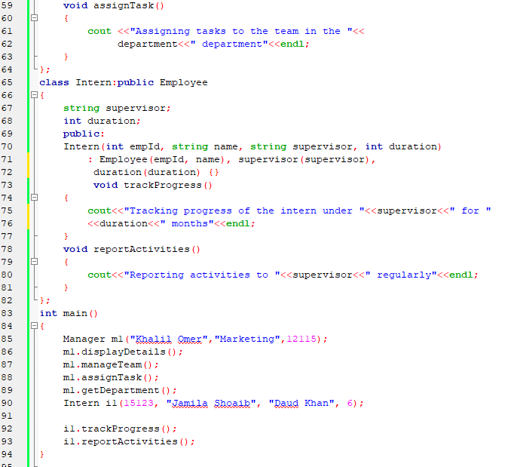
Code snippets:
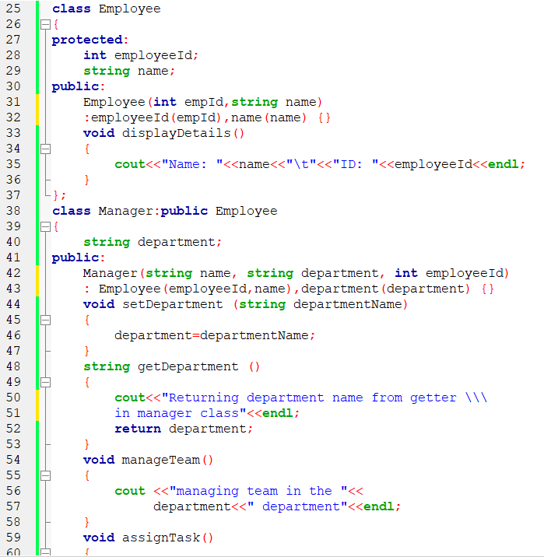

Output:
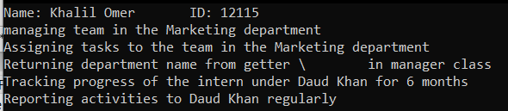

Flow Chart:
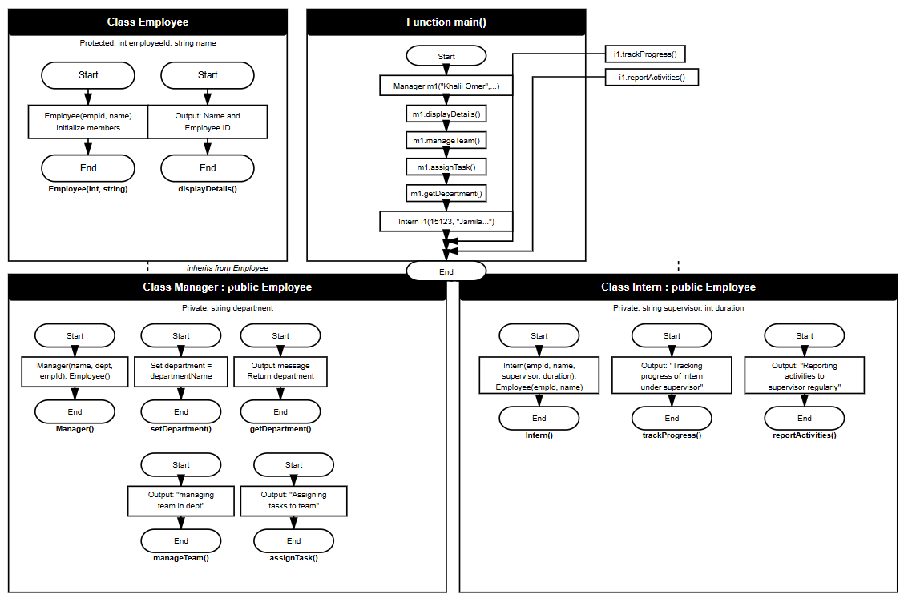

Hand Written:
