Lab# 08: Polymorphism and Virtual Functions



Fall 2025

Submitted by

M Mohsin Khan (24pwcse2382)

Class Section: C

“On my honor, as student of University of Engineering and Technology, I have neither given nor received unauthorized assistance on this academic work.”

Submitted to: Engr. Sumayyah Salahuddin

Dec 28th, 2025

Department of Computer Systems Engineering

University of Engineering and Technology, Peshawar

8.1 Introduction
In object-oriented programming, the ability of a derived class pointer to be compatible with a base class pointer is a fundamental concept. This feature enables polymorphism, allowing objects to take multiple forms when they are referenced through base class pointers within an inheritance hierarchy. Polymorphism is achieved through the use of virtual functions combined with base class pointers. This lab focuses on understanding polymorphism and virtual functions in detail, along with the concepts of abstract and concrete classes.

8.2 Objectives of the Lab
The objectives of this lab are as follows:
- Understand the distinction between static binding and dynamic binding.
- Demonstrate polymorphism using virtual functions and base class pointers.
- Design and implement abstract classes using pure virtual functions.

8.3 Pre-Lab

8.3.1 Polymorphism
Polymorphism is a general term that means “many forms.” In C++, one of the simplest forms of polymorphism is function overloading. It allows objects belonging to different classes to respond differently to the same function call. When a base class pointer or reference invokes a virtual function, C++ dynamically selects the correct overridden function based on the type of object being referenced. Polymorphism is achieved by declaring functions as virtual in the base class. The keyword virtual is used in the function declaration of the base class, while its use in derived classes is optional since overridden functions are treated as virtual automatically.

8.3.4 How to Make a Class Abstract
A class is made abstract by declaring one or more virtual functions as pure virtual. This is done by assigning zero to the virtual function declaration, for example:
virtual double earnings() const = 0;
A class that contains at least one pure virtual function is an abstract class, whereas a class without any pure virtual functions is known as a concrete class.

8.4.1 Activity
Define an abstract base class shape that includes protected data members for area and volume of a
shape, public methods for computing area and volume of a shape (make these functions virtual), and a
display function to display the information about an object. Make this class abstract by making display
function pure virtual.
Derive a concrete class point from the shape class. This point class contains two protected data
members that hold the position of point. Provide no-argument and 2-argument constructors. Override
the appropriate functions of base class.
Derive a class Circle publicly from the point class. This class has a protected data member of radius.
Provide a no-argument constructor to initialize the fields to some fixed values. Provide a 3-argument
constructor to initialize the data members of Circle class to the values sent from outside. Override the
methods of base class as required.
Derive another class Cylinder from the Circle class. Provide a protected data member for height of
cylinder. Provide a no-argument constructor for initializing the data members to default values. Provide
a 4-argument constructor to initialize x- and y-coordinates, radius, and height of cylinder. Override the
methods of base class.
Write a driver program to check the polymorphic behavior of this class.

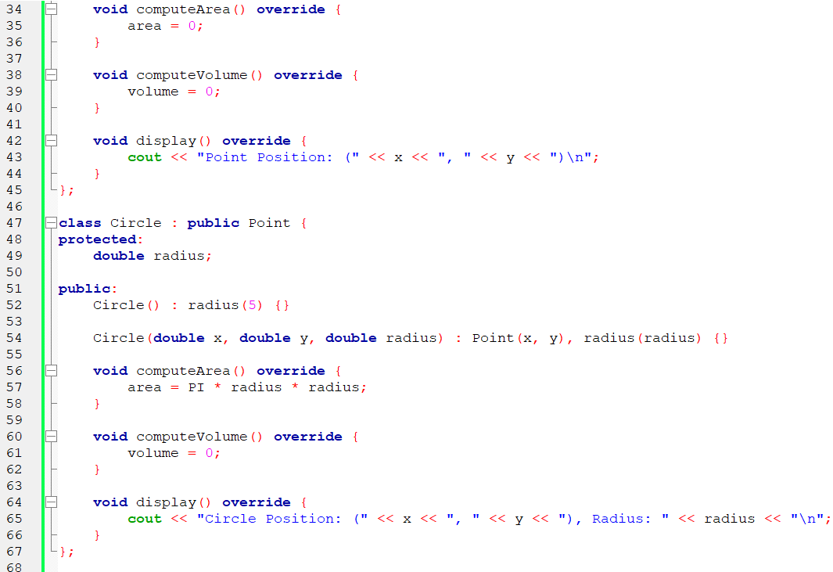
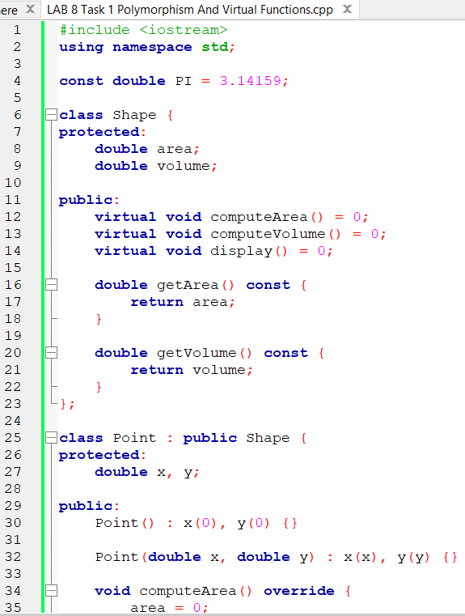
Code Snippets:
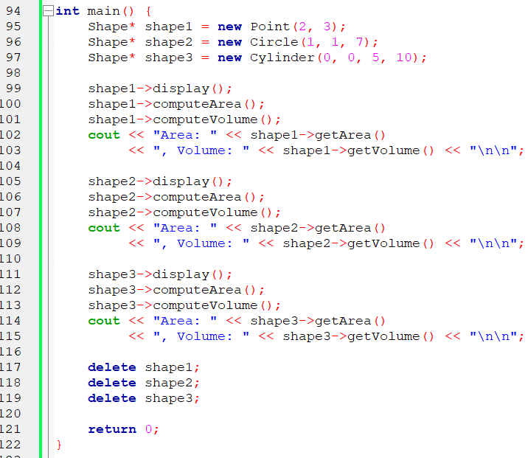
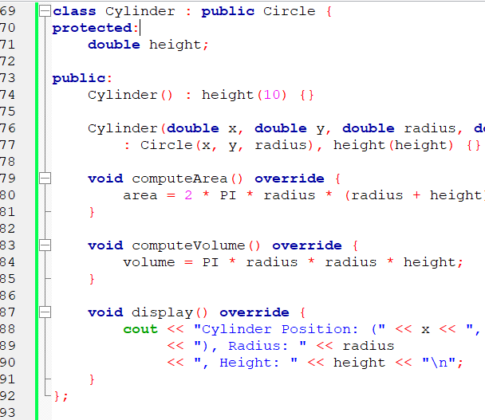

Output:
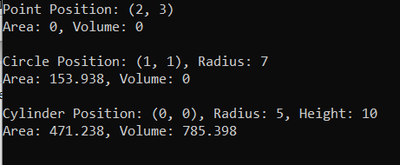

Flow Chart:

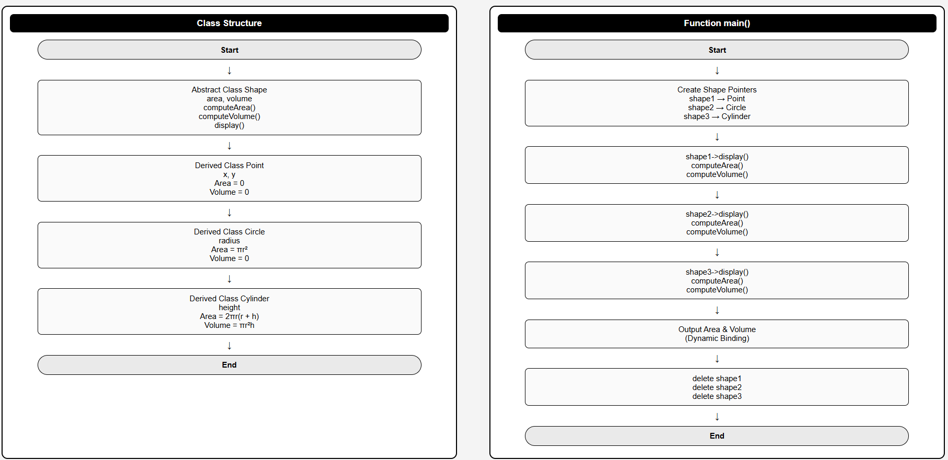

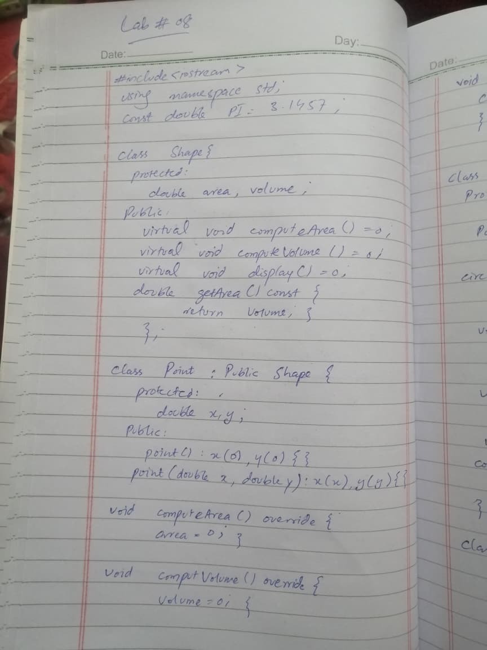
Hand Written Code:
