OWASP Top 10 Assessment Toolkit
for a Restaurant Chain
Individual Contributor Report — Member 3
(Urooba Mohsin)
Focus Area: Dynamic Application Security Testing (DAST) with OWASP ZAP
Tool Used | OWASP ZAP 2.17.0
Test Target (Authorized Lab) | OWASP Juice Shop — http://127.0.0.1:3000
Scan Types | Automated Scan (Traditional + AJAX Spider), Active Scan
Findings Logged | 6 (1 High, 3 Medium, 2 Low)
Difficulty Level | Professional
Semester | 6th

1. Mini-Plan
As Member 3, my piece of the OWASP Top 10 Assessment Toolkit is the dynamic (black-box) vulnerability scan using OWASP ZAP. I set up ZAP 2.17.0 against a locally hosted, authorized lab instance of OWASP Juice Shop (http://127.0.0.1:3000) — never a live or production system. I ran ZAP's Automated Scan (spider + AJAX spider) followed by an Active Scan to surface both passive header/configuration issues and active injection-class vulnerabilities. Each alert was triaged, screenshotted as evidence, and written up below with a severity rating, business impact for the restaurant chain, and a concrete remediation, ready to merge into the group's consolidated toolkit report.

2. Tool, Scope & Authorization
- Tool: OWASP ZAP (Zed Attack Proxy) v2.17.0, run in Standard Mode.
- Target: OWASP Juice Shop, an intentionally vulnerable e-commerce web app, running locally at http://127.0.0.1:3000 inside an isolated lab VM. This stands in for the restaurant chain's online ordering web app for practice purposes.
- Authorization: Juice Shop is a purpose-built, open-source training target designed to be attacked. No real, live, or third-party system was scanned at any point.
- Scan flow: Quick Start > Automated Scan (traditional spider + AJAX spider with Firefox) > Active Scan against discovered endpoints > review of Alerts tab.
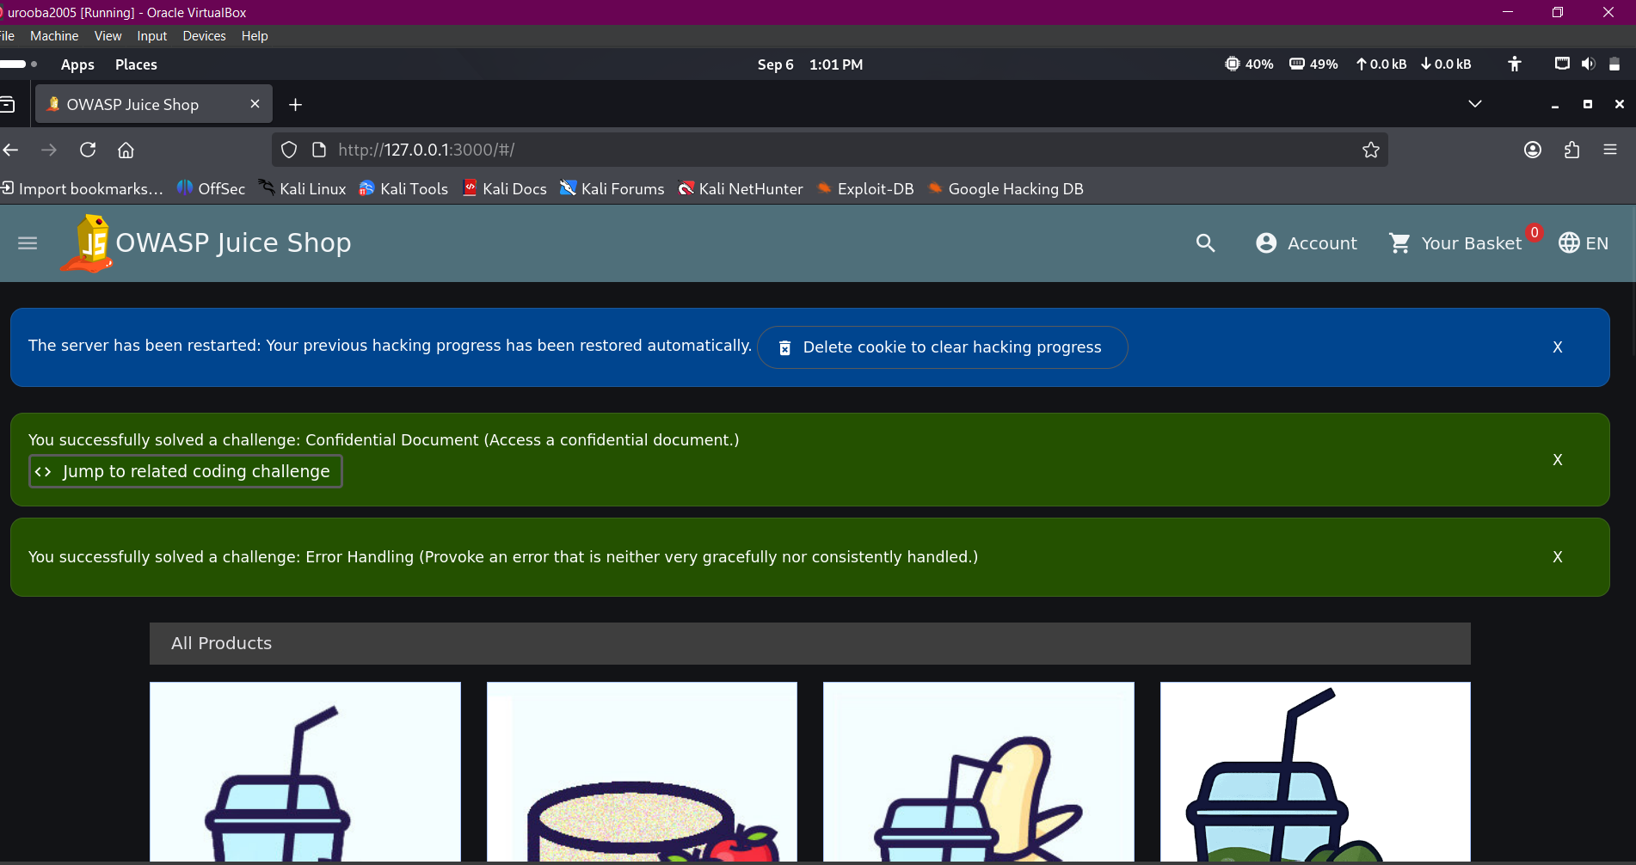
Figure 1: Authorized lab target — OWASP Juice Shop running locally in an isolated VM.
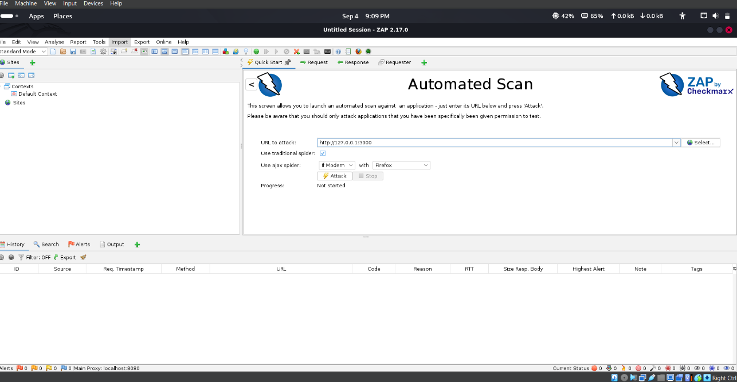
Figure 2: Launching ZAP's Automated Scan against the lab target only (127.0.0.1:3000).
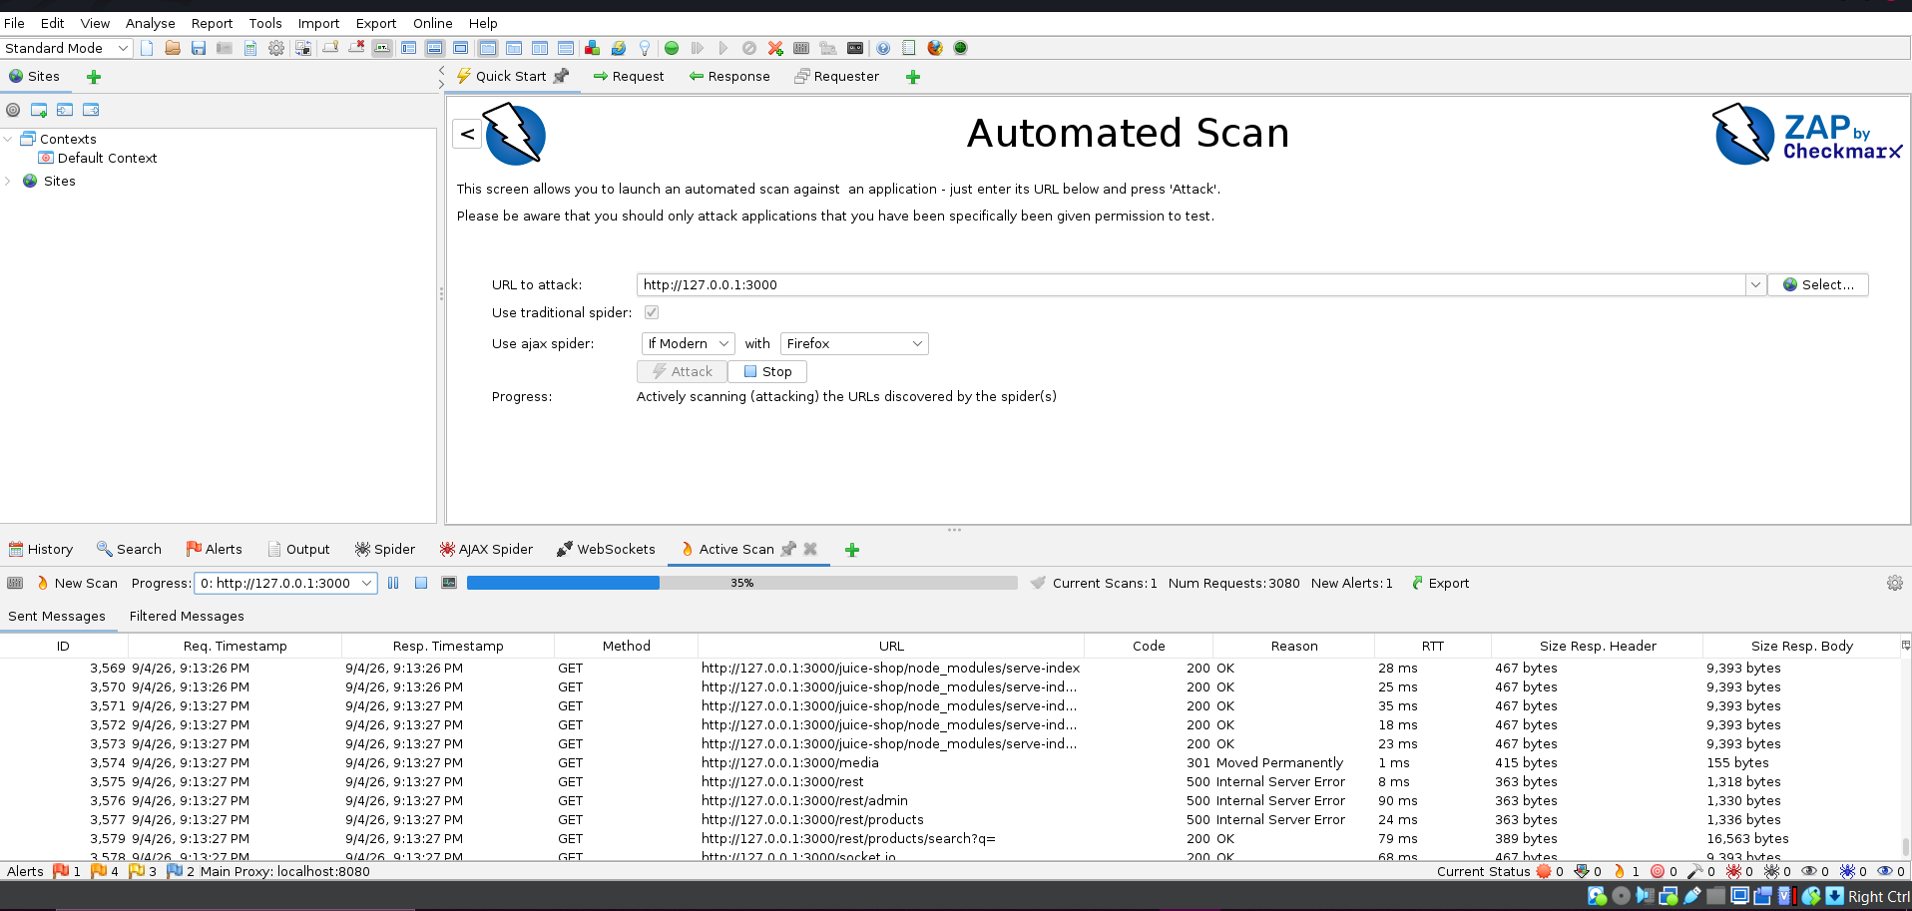
Figure 3: Active Scan in progress — ZAP fuzzing discovered endpoints and logging alerts in real time.

3. Findings Summary
# | Finding | OWASP Category | Risk | CWE
1 | SQL Injection | A03:2021 – Injection | High | CWE-89
2 | CSP: Failure to Define Directive with No Fallback | A05:2021 – Security Misconfiguration | Medium | CWE-693
3 | Missing Anti-Clickjacking Header | A05:2021 – Security Misconfiguration | Medium | CWE-1021
4 | Cross-Domain Misconfiguration (CORS) | A05:2021 – Security Misconfiguration | Medium | CWE-264
5 | Private IP Disclosure | A01:2021 – Broken Access Control | Low | CWE-497
6 | Application Error Disclosure | A09:2021 – Security Logging & Monitoring Failures | Low | CWE-550

4. Detailed Findings
Finding 1 — SQL Injection
Risk Rating | High
OWASP Top 10 (2021) Category | A03:2021 – Injection
Affected URL / Endpoint | http://127.0.0.1:3000/rest/products/search?q=%27%28
CWE ID | CWE-89
WASC ID | 19
Evidence | HTTP/1.1 500 Internal Server Error returned after injecting a single quote into the 'q' search parameter

Description
ZAP's active scanner injected SQL meta-characters (e.g. a lone apostrophe) into the product search query parameter and the server responded with a 500 Internal Server Error instead of gracefully handling the malformed input. This is a strong indicator that the search query is built by concatenating user input directly into a SQL statement rather than using parameterized queries.
Impact on the Restaurant Chain
If this existed in the restaurant chain's real ordering platform, an attacker could potentially read, modify, or delete data in the backend database — including customer records, saved payment/loyalty details, order history, or admin credentials — through the public-facing menu/search feature. This is the single most severe finding in this assessment and should be treated as a blocker for go-live.
Remediation Recommendation
- Never build SQL queries by concatenating raw user input; use parameterized queries / prepared statements (or an ORM) everywhere the search and filter features touch the database.
- Apply strict server-side input validation and type-checking on the 'q' parameter (and all other query parameters) in addition to any client-side checks.
- Ensure the database account used by the web app has least-privilege access (no DROP/ALTER rights) so a successful injection has limited blast radius.
- Add a Web Application Firewall (WAF) rule set tuned for SQLi as a defense-in-depth measure, not a substitute for fixing the code.
Reference(s)
https://cheatsheetseries.owasp.org/cheatsheets/SQL_Injection_Prevention_Cheat_Sheet.html
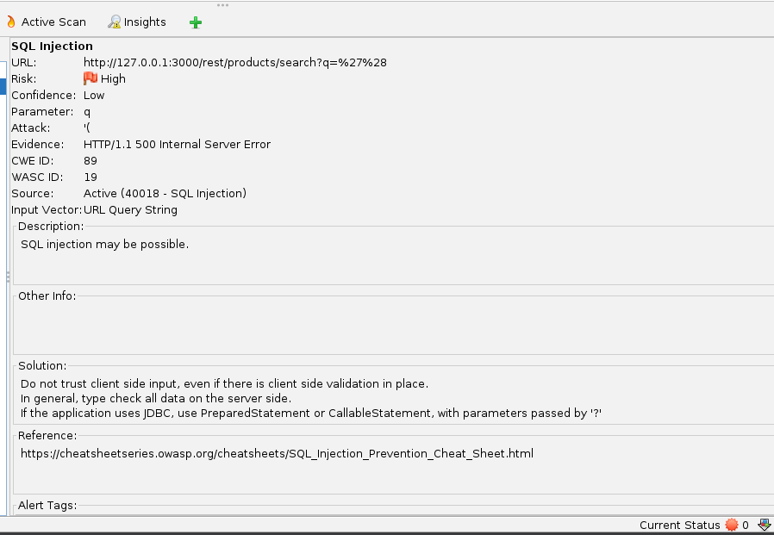
Figure: ZAP alert detail — Finding 1 — SQL Injection (authorized lab target: OWASP Juice Shop, http://127.0.0.1:3000)
Finding 2 — CSP: Failure to Define Directive with No Fallback
Risk Rating | Medium
OWASP Top 10 (2021) Category | A05:2021 – Security Misconfiguration
Affected URL / Endpoint | http://127.0.0.1:3000/assets
CWE ID | CWE-693
WASC ID | 15
Evidence | Content-Security-Policy header present with default-src 'none' but missing frame-ancestors and form-action directives, which do not fall back to default-src

Description
The app sets a Content-Security-Policy header, which is good practice, but omits directives such as frame-ancestors and form-action. Because browsers do not fall back to default-src for these specific directives, omitting them effectively leaves those attack surfaces unrestricted even though default-src looks strict.
Impact on the Restaurant Chain
For an online ordering or reservations page, an incomplete CSP weakens protection against clickjacking and malicious form-hijacking/data-exfiltration scripts, which could be used to trick customers into submitting payment or personal data to an attacker-controlled endpoint.
Remediation Recommendation
- Explicitly define every relevant CSP directive rather than relying on default-src to cover gaps — at minimum set frame-ancestors and form-action.
- Test the policy with the CSP Evaluator (or ZAP's passive rules) after every deployment to catch regressions.
- Roll the policy out in Content-Security-Policy-Report-Only mode first to catch breakage before enforcing it.
Reference(s)
https://content-security-policy.com/
https://web.dev/articles/csp#resource-options
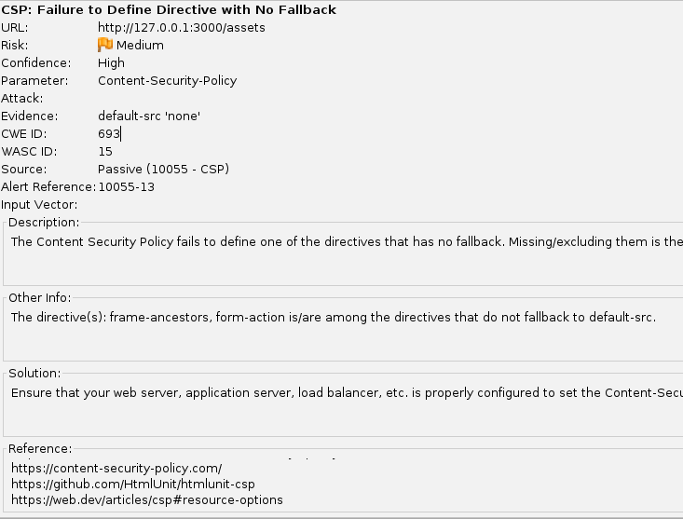
Figure: ZAP alert detail — Finding 2 — CSP: Failure to Define Directive with No Fallback (authorized lab target: OWASP Juice Shop, http://127.0.0.1:3000)
Finding 3 — Missing Anti-Clickjacking Header
Risk Rating | Medium
OWASP Top 10 (2021) Category | A05:2021 – Security Misconfiguration
Affected URL / Endpoint | http://127.0.0.1:3000/socket.io/?EIO=4&transport=polling...
CWE ID | CWE-1021
WASC ID | 15
Evidence | Response lacks both X-Frame-Options and a CSP frame-ancestors directive

Description
The response for this endpoint does not include either the X-Frame-Options header or a CSP frame-ancestors directive, meaning the page/response can be loaded inside an <iframe> on an attacker-controlled site.
Impact on the Restaurant Chain
An attacker could frame a page from the restaurant chain's ordering site (e.g. the checkout or account page) inside a lookalike site and trick logged-in customers into clicking invisible buttons — placing orders, changing account details, or authorizing payments without their knowledge (a classic clickjacking attack).
Remediation Recommendation
- Set X-Frame-Options: DENY (or SAMEORIGIN if legitimate framing is needed) on all responses.
- Alternatively/additionally, add a CSP frame-ancestors 'none' (or 'self') directive, which is the modern replacement for X-Frame-Options.
- Apply the header at the web server / load balancer / API gateway level so it is enforced consistently across every route, including WebSocket upgrade endpoints like this one.
Reference(s)
https://developer.mozilla.org/en-US/docs/Web/HTTP/Reference/Headers/X-Frame-Options
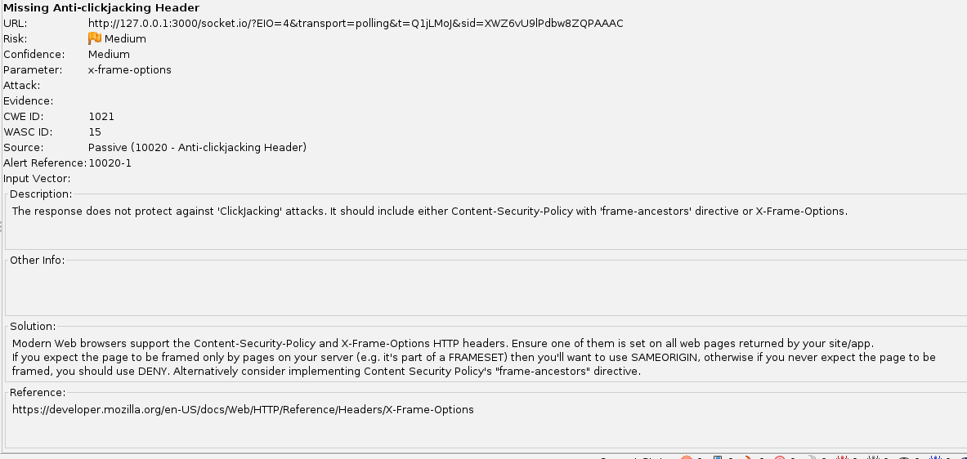
Figure: ZAP alert detail — Finding 3 — Missing Anti-Clickjacking Header (authorized lab target: OWASP Juice Shop, http://127.0.0.1:3000)
Finding 4 — Cross-Domain Misconfiguration (CORS)
Risk Rating | Medium
OWASP Top 10 (2021) Category | A05:2021 – Security Misconfiguration
Affected URL / Endpoint | http://127.0.0.1:3000
CWE ID | CWE-264
WASC ID | 14
Evidence | Access-Control-Allow-Origin: *

Description
The server returns a wildcard Access-Control-Allow-Origin header, permitting any website on the internet to make cross-origin reads of unauthenticated API responses from this domain.
Impact on the Restaurant Chain
While unauthenticated endpoints carry lower direct risk, a wildcard CORS policy is frequently left in place accidentally on endpoints that later become authenticated (e.g. loyalty points, saved addresses), which would let any malicious website silently read that data from a logged-in customer's browser.
Remediation Recommendation
- Replace the wildcard with an explicit allow-list of trusted origins (e.g. the chain's own web and mobile app domains).
- Never combine Access-Control-Allow-Origin: * with Access-Control-Allow-Credentials: true.
- Periodically re-audit CORS configuration whenever new authenticated endpoints are added, since misconfiguration tends to be inherited from earlier, less sensitive routes.
Reference(s)
https://vulncat.fortify.com/en/detail?category=HTML5&subcategory=Overly%20Permissive%20CORS%20Policy
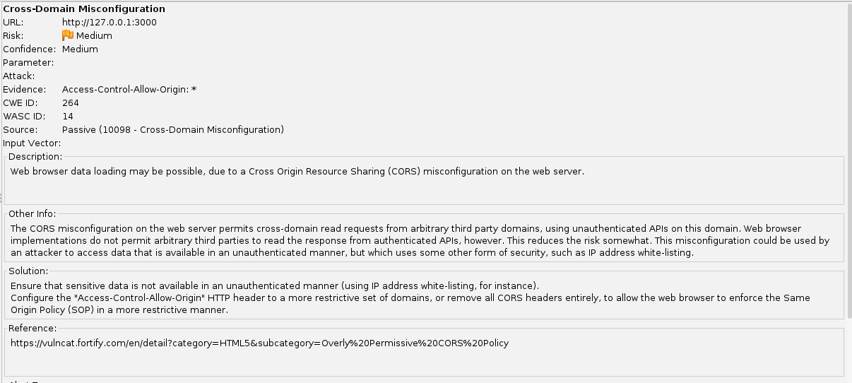
Figure: ZAP alert detail — Finding 4 — Cross-Domain Misconfiguration (CORS) (authorized lab target: OWASP Juice Shop, http://127.0.0.1:3000)
Finding 5 — Private IP Disclosure
Risk Rating | Low
OWASP Top 10 (2021) Category | A01:2021 – Broken Access Control
Affected URL / Endpoint | http://127.0.0.1:3000/rest/admin/application-configuration
CWE ID | CWE-497
WASC ID | 13
Evidence | 192.168.99.100:3000 and 192.168.99.100:4200 found in the HTTP response body

Description
An internal/private IP address is disclosed in the response body of an administrative configuration endpoint, revealing details of the internal network topology.
Impact on the Restaurant Chain
By itself this is low severity, but it gives an attacker reconnaissance information — internal hostnames/IP ranges — that can be chained with other findings (like the exposed admin config endpoint itself) to plan further attacks against the restaurant chain's internal infrastructure.
Remediation Recommendation
- Strip internal IP addresses, hostnames, and infrastructure details from any response body reachable by unauthenticated or low-privileged users.
- Ensure the /rest/admin/* configuration endpoints require proper authentication and role-based authorization — an admin-configuration endpoint should not be reachable at all without an authenticated admin session.
- Use environment-specific config that never echoes internal network details back to the client.
Reference(s)
https://datatracker.ietf.org/doc/html/rfc1918
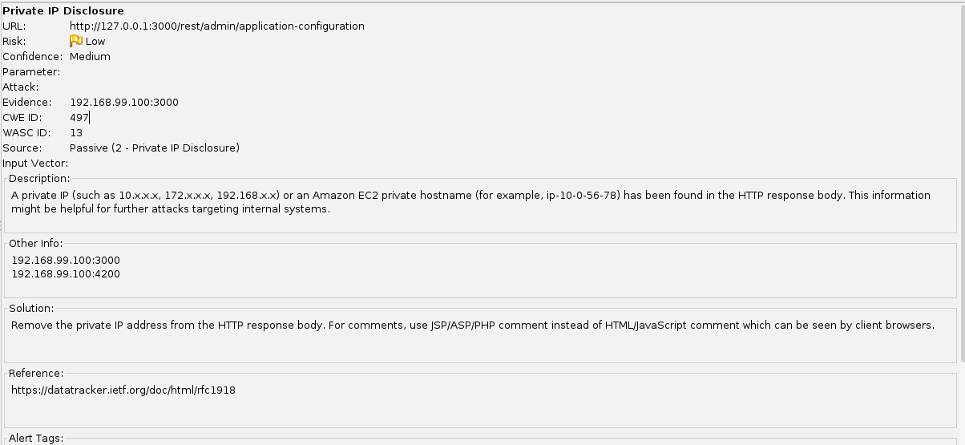
Figure: ZAP alert detail — Finding 5 — Private IP Disclosure (authorized lab target: OWASP Juice Shop, http://127.0.0.1:3000)
Finding 6 — Application Error Disclosure
Risk Rating | Low
OWASP Top 10 (2021) Category | A09:2021 – Security Logging and Monitoring Failures
Affected URL / Endpoint | http://127.0.0.1:3000/api
CWE ID | CWE-550
WASC ID | 13
Evidence | HTTP/1.1 500 Internal Server Error returned with a raw, unhandled exception in the response

Description
This endpoint returns a raw error/warning message on failure, which can leak implementation details such as file paths, stack traces, or framework version information.
Impact on the Restaurant Chain
Verbose error messages make it easier for an attacker to fingerprint the restaurant chain's backend stack and craft more targeted exploits (including chaining with Finding 1's SQL Injection). It also risks exposing internal file structure to customers by accident.
Remediation Recommendation
- Implement custom, generic error pages for all 4xx/5xx responses shown to end users.
- Log full exception details server-side only, and return a unique, non-sensitive error/reference ID to the client for support purposes.
- Disable framework debug/verbose-error modes in production configuration.
Reference(s)
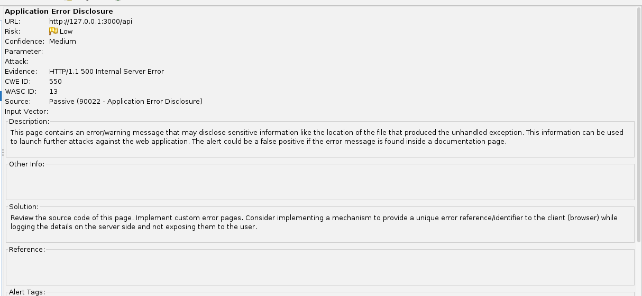
Figure: ZAP alert detail — Finding 6 — Application Error Disclosure (authorized lab target: OWASP Juice Shop, http://127.0.0.1:3000)

5. Overall Risk Summary & Priority
Across this scan of the lab target, 1 High, 3 Medium, and 2 Low severity issues were identified. If mapped onto the restaurant chain's real ordering platform, the priority order for remediation would be:
- Priority 1 (fix before launch): SQL Injection (Finding 1) — direct risk to customer and payment data.
- Priority 2 (fix in current sprint): Missing/incomplete security headers — CSP gaps, missing anti-clickjacking header, and permissive CORS (Findings 2–4).
- Priority 3 (fix and monitor): Information disclosure issues — private IP and verbose error messages (Findings 5–6).
This individual scan and finding set is intended to feed into the group's consolidated OWASP Top 10 Assessment Toolkit deliverable alongside the other members' contributions (e.g. static/manual testing, authentication testing, business-logic testing).

