**CURRICULUM VITAE**

**Sacharum Noor Zhafiroh**

**October 2nd 1998**

Motto: *Man Shabara Zhafirah*

Bachelor of Pharmacy

Sriwijaya University

GPA:3.60

TOELF: 513

ACADEMIC ACTIVITIES



- Selected in Peningkatan Prestasi Akademik Scholarship since 2016-2018

- Laboratory assistent for Basic Pharmaceutics I in 2017,

2019, 2020

- Laboratory assistent for Organic Chemistry in 2018

- Laboratory assistent for Pharmacognition in 2018

- Laboratory assistent for Anatomy of Plant Physiology in

2018

- Laboratory assistent for Technology of Pharmacy (solid) in

2018 and 2020

- Laboratory assistent for Phytochemicals in 2019

- Laboratory assistent for Technology of Pharmacy (Sterile)

in 2019

- Laboratory assistent for Microbiology in 2019

ORGANIZATION EXPERIENCE



HKMF (Himpunan Keluarga Mahasiswa Farmasi

CONTACT DETAILS

2016-2018

2019-2020

- Member of Internal Division

- Head of Internal Division

[sacharumnz@gmail.com](mailto:sacharumnz@gmail.com)

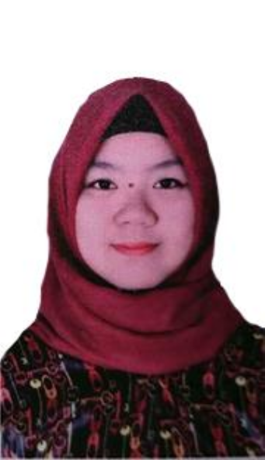

+6281366278198

Palembang, Indonesia

SKILL AND INTEREST

• Experienced as English Speaker of

Presentation

• Good Analytical Skill, Good Basic Computer Skill, Good Organizing Skill

• Good at Make Schedule, Great

Teamwork

• Ability to Work Under Pressure

LANGUAGES

• Indonesian – Native

• English – Fluent

2017-2018 COIN (Community of Science)

- Organization of research for college student of Faculty of Mathematics and Natural Science

- Secretary of HRD

2018-2019 KOSMIC (Komunitas Generasi Muslim Scientist)

- Organization of moeslim in Faculty of

Mathematics and Natural Science

- Member of Kemuslimahan

- General Treasurer

2016-2020 U-Read (Unsri Riset dan Edukasi)

- Organization of Science in University of

Sriwijaya

- Member of “Badan Otonom”

Department (2016-2018)

- Member of “Hubungan Kelembagaan”

Department (2018-2020)

EDUCATION



2002 – 2004 TK Cinta Manis

2004 – 2010 SD Negeri 11 Indralaya

2010 – 2013 SMP Negeri 1 Indralaya

2013 – 2016 SMA Negeri 1 Indralaya

2016 – 2020 Universitas Sriwijaya

ACHIEVEMENTS



2017 **3rd Winner** of Lomba Karya Tulis Ilmiah in Sriwijaya University held by COIN

2018 **Top 10 Finalist** for Lomba Karya Tulis Ilmiah in University of North Sumatera

2018 **1st Winner** of Lomba Kreativitas Mahasiswa in Faculty of Mathematics and Natural Science Sriwijaya University

2019 **Bronze Medal** in Asian Youth Innovation Award in Kuala Lumpur, Malaysia held by Malaysian Technology Expo

2019 **1st Winner** of Mahasiswa Berprestasi in Faculty of Mathematics and Natural Science

2019 **Best Profile** Video in selection of Mahasiswa Berpestasi of Sriwijaya University

2019 **Delegates** for International Scholarship Workshop in Kuala Lumpur, Malaysia held by Lingkar Insipirasi Bangsa

2019 **Bronze Medal** in Seoul International Invention Fair in Seoul, South Korea held by Korea Invention Promotion Association

2020 **Best Pharmacy Student** held by ISMAFARSI (Ikatan Senat Mahasiswa Farmasi Seluruh Indonesia) AWARD in Jakarta

2020 **Gold Medal** **and Special Award** in International Invention and Innovation Competition “ Sahasak Nimavum 2020” in Sri Lanka organized by Sri Lanka Inventor Commision

2020 **1st Winner Innovator**

As category “Mahasiswa Inovator” held by Gubernur Sumatera Selatan