`

**HEALTH CARE E-PROJECT DOCUMENTATION**

|  |  |
| --- | --- |
| STUDENT NAME | STUDENT ID |
| MUHAMMAD MOHTASHAM | STUDENT1431527 |
| MUHAMMAD FAHAD | STUDENT1436660 |
| MUHAMMAD FAHAD | STUDENT1436660 |

**PROJECT GROUP MEMBER**

FACULTY:MISS BAKHTAWAR SIRAJ

CO-ORDINATOR:MISS MUNAZZAH

CURRICULUM:7062

BATCH:2211B2

SCREEN SHOOTS

**DEVELOPER GUIDE ADMIN DASHBOARD**

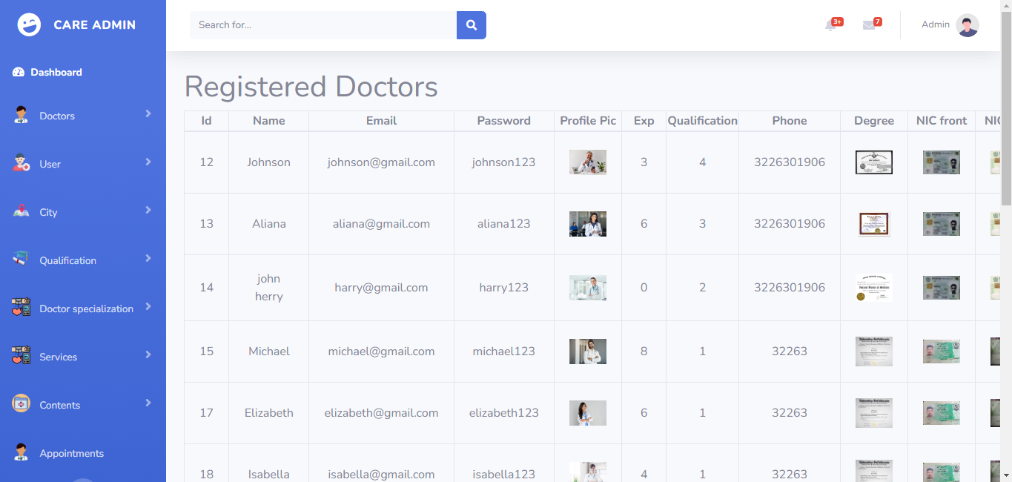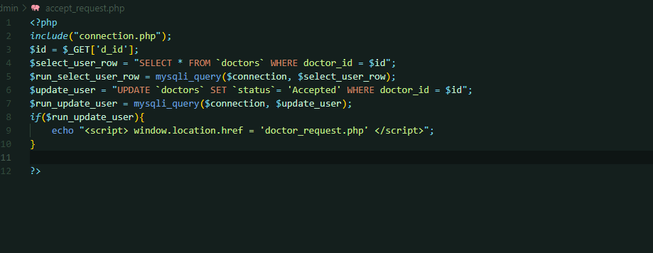

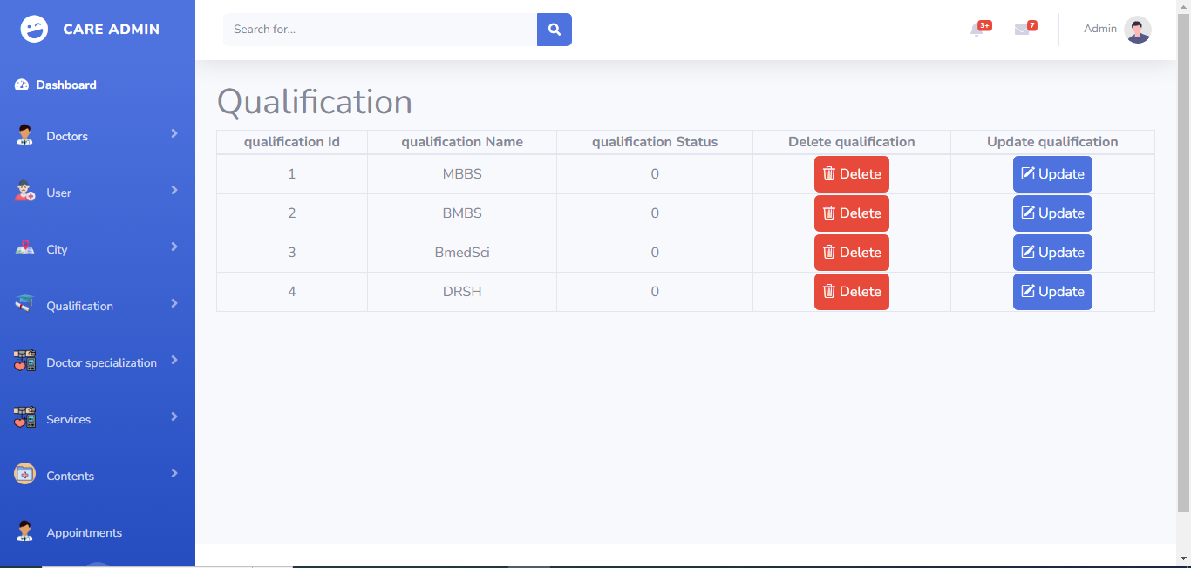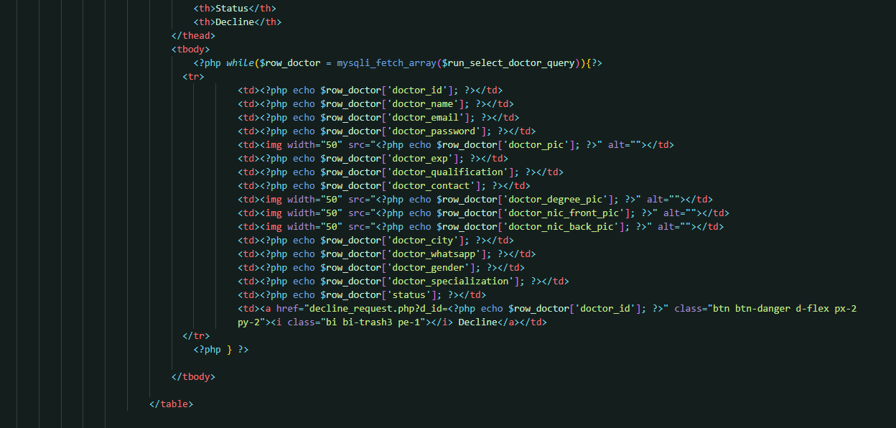

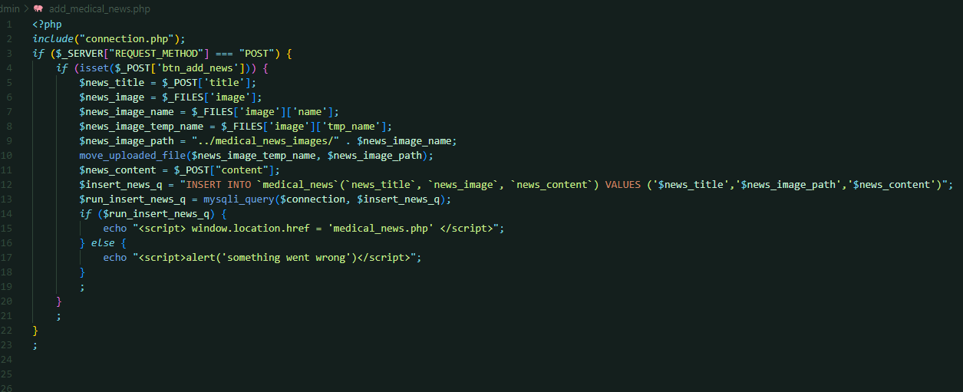

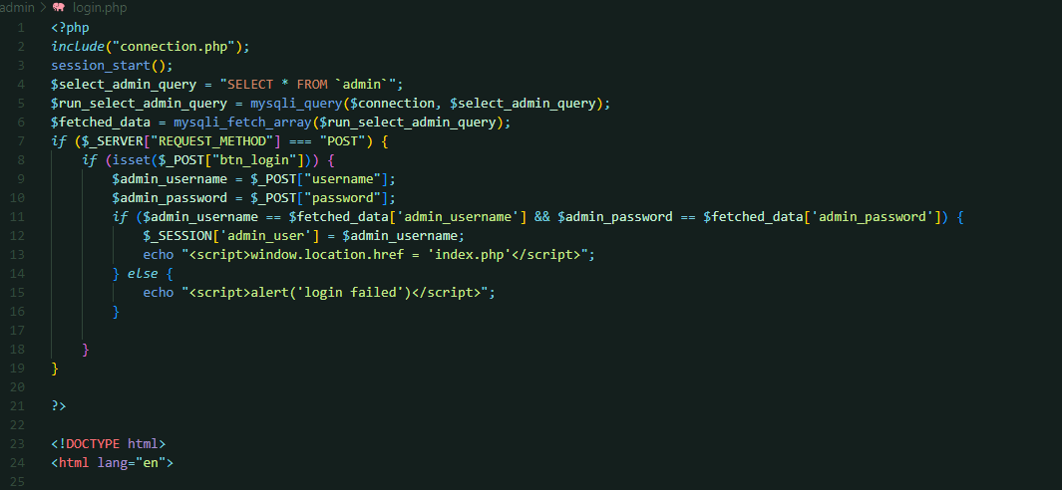

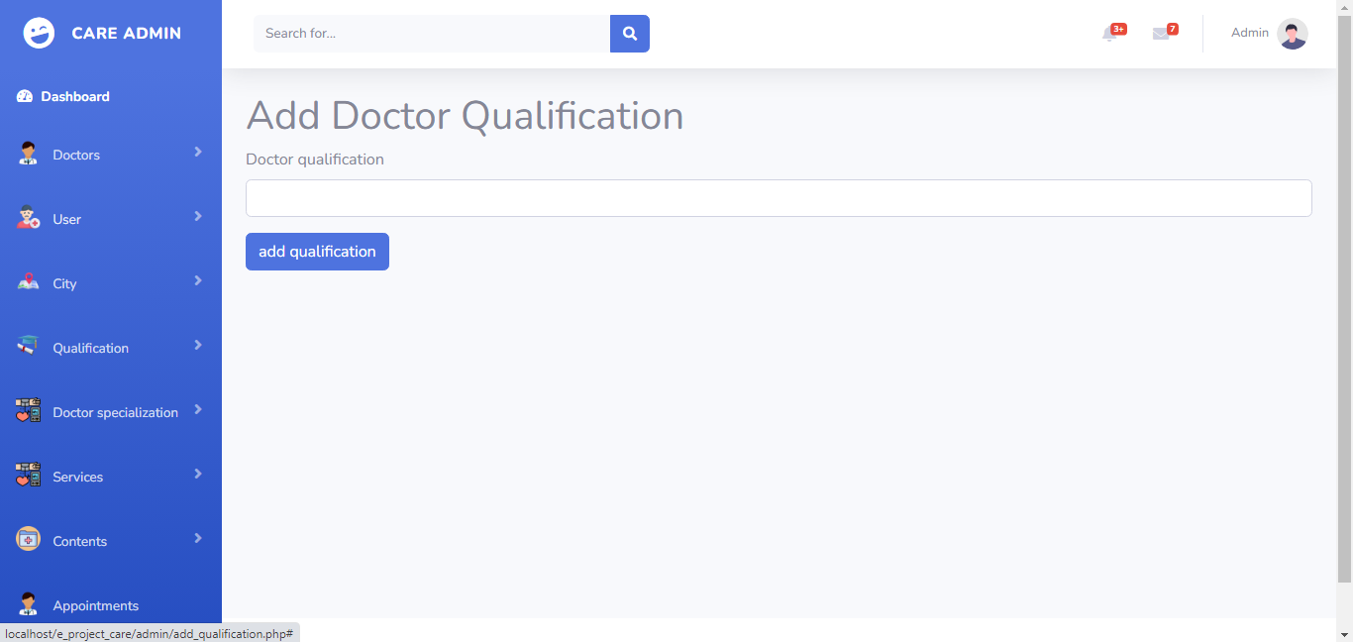

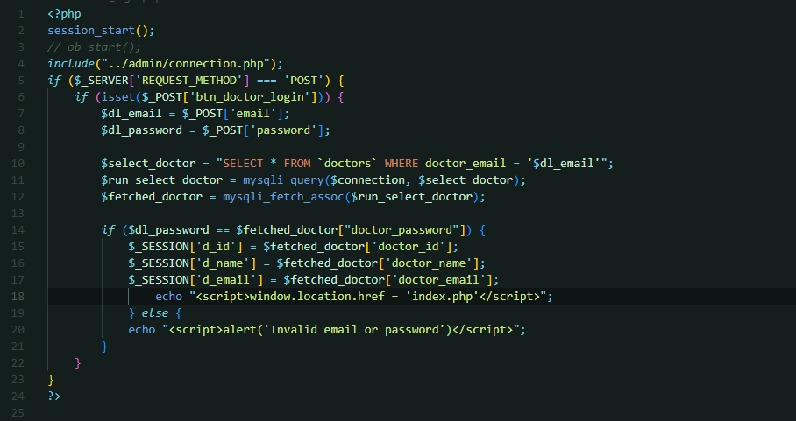



**DOCTOR SIGN UP PAGE**

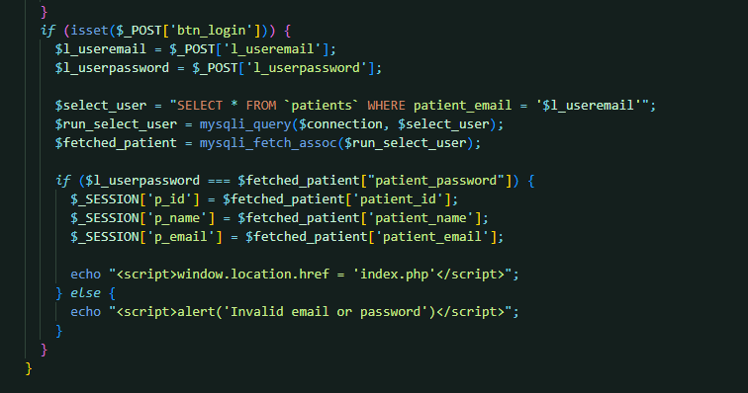

**PATIENT SIGN UP PAGE**



**SEARCH A DOCTOR**

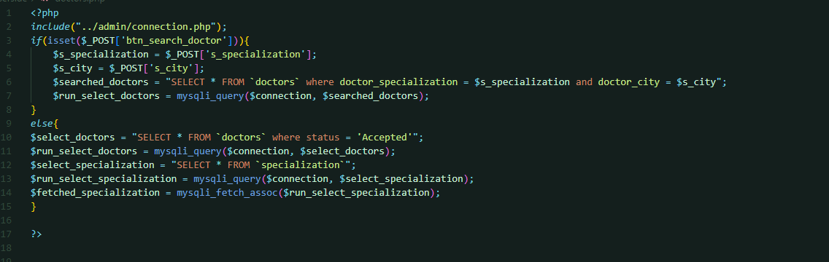

**OUR DOCTORS**

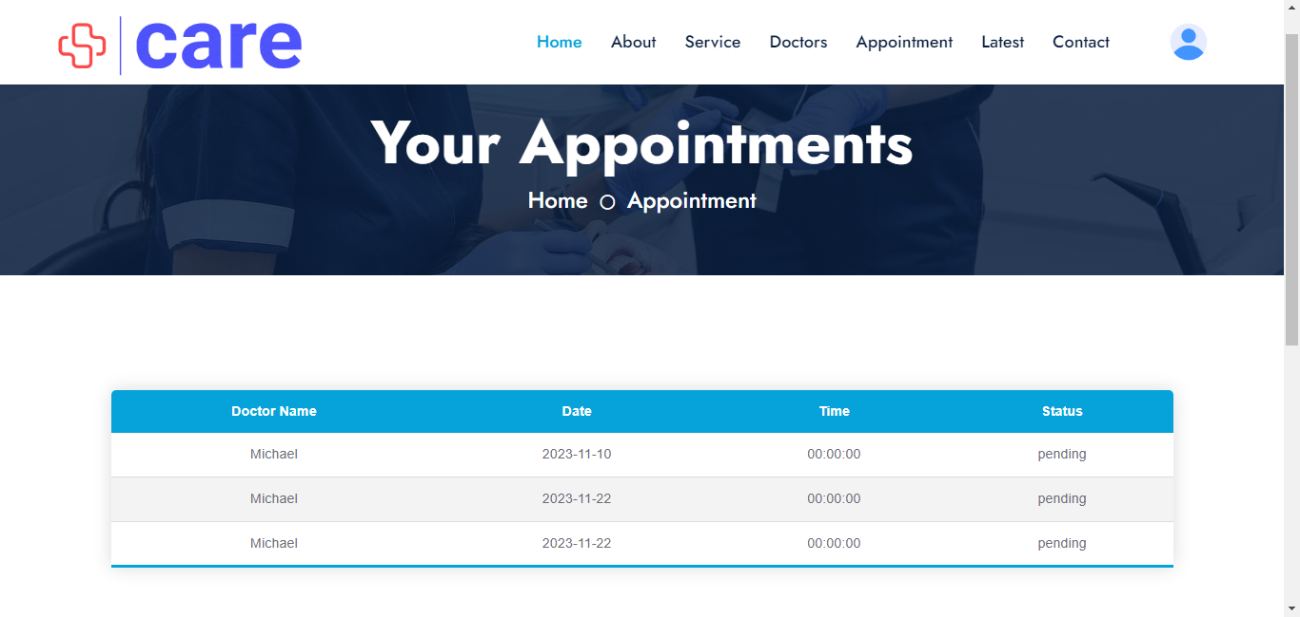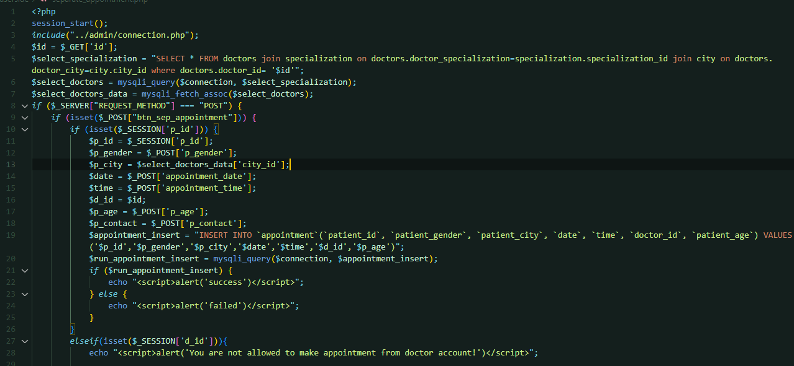

**APPOINTMENTS**



**SERVICES**

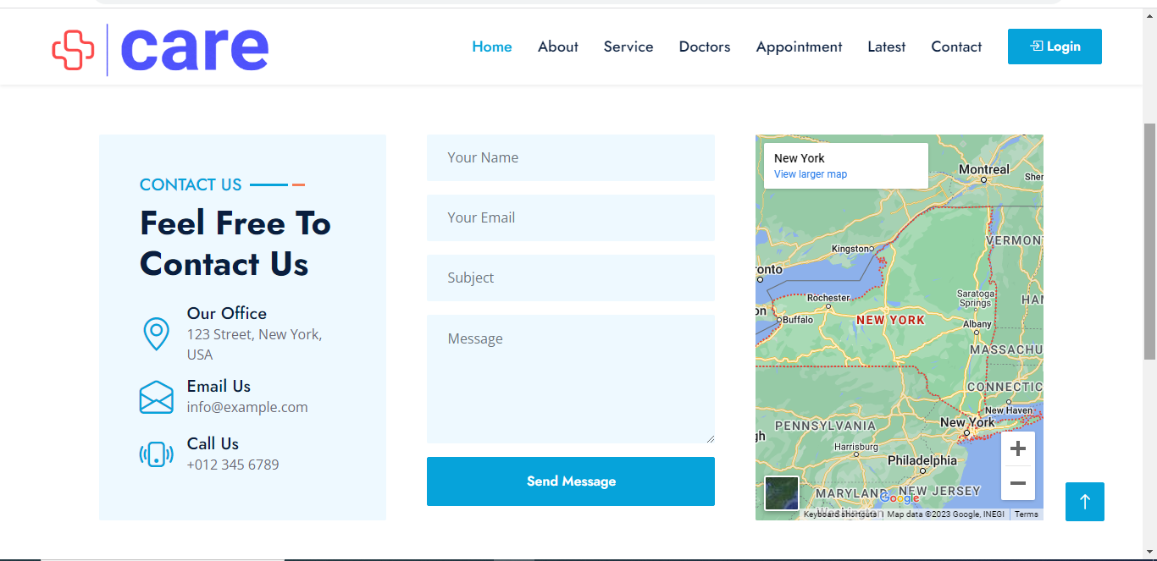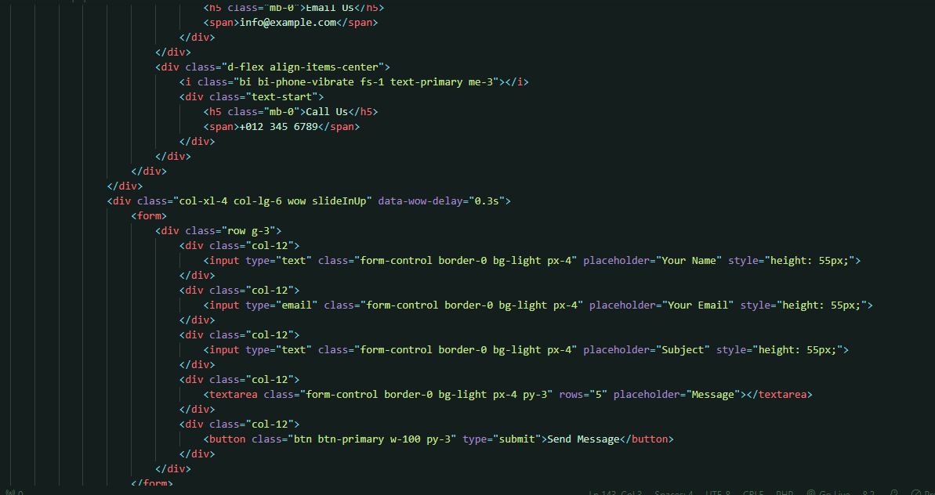

**CONTACT PAGE**

**ABOUT US**

