Genesis Ideathon: Final Presentation
Team ID: GEN26-A0H-I133
Team Name: TECH FORGE 6
Domain: Food Security, Agriculture & Rural Transformation
11th October 2026
Presentation Outline
0.48
0.48

1 Problem Statement
Problem Statement
3cm(-,0.12cm) 
block body PROBLEM STATEMENT: Smallholder farmers in India often make sowing decisions independently, without knowing what crops other farmers in their taluk are planting. When many farmers cultivate the same crop simultaneously, their harvests overlap, causing market oversupply, falling prices, and financial losses.

2 Problem Understanding
Problem Understanding
3cm(-,0.12cm)
- Who experiences this problem?
- Small and marginal farmers cultivating crops such as tomatoes, onions, and bananas.
- Farmers depending on local markets for selling their produce.
- Agricultural traders and consumers affected by supply fluctuations.
- What causes the problem?
- Farmers make sowing decisions independently without coordination.
- Many farmers choose the same crop based on previous market prices.
- Simultaneous harvesting creates excess supply in local markets.
- Lack of advance information about neighboring farmer’s cultivation plans.
- How does it affect users or stakeholders?
- Farmers: Face price crashes, reduced profits, and financial losses.
- Traders: Experience unpredictable supply and market fluctuations.
- Consumers: Face price instability due to oversupply and shortages.
- Agricultural sector: Increased food wastage and inefficient resource utilization.

3 Existing Gaps & Challenges
Existing Gaps & Challenges
3cm(-,0.12cm)
- Existing gap or limitation 1: Limited Market Prediction
- - Existing tools mainly show current prices rather than future harvest oversupply.
- Existing gap or limitation 2: Lack of Farmer Coordination
- No shared visibility into neighboring farmer’s sowing plans.
- Limited accessibility for farmers without smartphones.
- Main challenge that remains unsolved:
- - Predicting taluk-level crop oversupply before sowing and providing coordinated crop recommendations.

4 Our Proposed Solution
Our Proposed Solution
3cm(-,0.12cm)
- Core idea or product: CropClash
- - An AI-powered crop planning and early-warning system to prevent market oversupply.
- How the solution works at a high level:
- Collects farmer’s sowing plans through Tamil IVR calls.
- AI predicts harvest timing and potential crop oversupply.
- Recommends suitable crops and staggered sowing dates.
- Main value delivered to users:
- Prevents avoidable market oversupply.
- Reduces price-crash risks and crop wastage.
- Helps farmers make informed sowing decisions.

5 Technical Approach
Technical Approach
3cm(-,0.12cm)
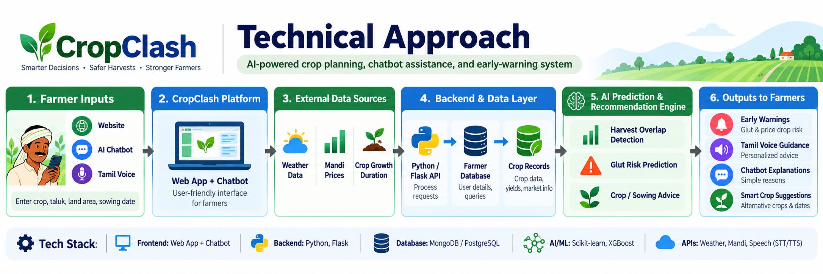
Proposed System Architecture of CropClash
How Components Work Together: - Farmers enter crop details through the website or voice interface. - AI analyzes sowing patterns to identify potential market oversupply. - The AI chatbot helps farmers understand risks and crop recommendations in simple Tamil.
block body
Tech Stack
Frontend: CropClash Web Application, AI Chatbot UI | Database: MongoDB / PostgreSQL (proposed)
Backend: Web APIs, Python (proposed) | AI/ML, APIs, or Hardware: Machine Learning, APIs Weather, Speech-to-Text, Text-to-Speech

6 Innovation & Uniqueness
Innovation & Uniqueness
3cm(-,0.12cm)
- [What is new or different?] AI predicts crop oversupply before sowing, not just market prices.
- Tamil AI chatbot and voice assistance support farmers with limited literacy.
- [Why is this approach suited to the problem?] Uses taluk-level sowing data to predict harvest overlaps.
- Suggests alternative crops and staggered sowing dates to reduce oversupply risks
- [What is the key differentiator?] - Combines AI forecasting, farmer coordination, and voice-based guidance in one platform.
- - Makes crop recommendations based on collective sowing patterns, not just individual preferences. Key Innovation: CropClash helps farmers coordinate what and when to plant, before market oversupply occurs.

7 Feasibility & Scalability
Feasibility & Scalability
3cm(-,0.12cm)
- Feasibility: Resources & Steps
- Use existing CropClash website and AI chatbot.
- Integrate farmer data, weather APIs, and mandi prices.
- Develop AI models and test with local farmers.
- Scalability: Future Expansion
- Start with one taluk and expand across districts.
- Support more crops and regional languages.
- Scale using cloud infrastructure and automated IVR.
- Risks: Challenges & Mitigations
- Inaccurate Data: Validate using market records and farmer inputs.
- Low Farmer Adoption: Provide Tamil voice guidance and simple interfaces.
- Multiple Simultaneous Calls: Use cloud-based IVR with automated call handling.

8 Cost for Product
Cost for Product (Optional)
3cm(-,0.12cm)
- Development or hardware cost:
- Website and AI chatbot development: ₹3,000
- AI model development and testing: ₹2,000
- Hardware: No dedicated hardware required
- Hosting or maintenance cost:
- Cloud hosting and database: ₹3,000
- IVR and voice API services: ₹5,000
- Testing and maintenance: ₹2,000
- Estimated total:
- Estimated 3-Month Pilot Budget : ₹15,000(For approximately 100 farmers)

9 Use Cases
Use Cases (compulsorily 3 use cases must be there)
3cm(-,0.12cm)
- Use case 1: Crop Oversupply Prediction
- User: Tomato Farmer
- - Farmer enters crop and sowing details on CropClash. - AI predicts potential harvest overlaps and market oversupply. - Farmer receives early warnings before sowin
- Use case 2: Smart Crop Recommendation
- User: Smallholder Farmer
- - Farmer checks which crop to cultivate. - AI analyzes market demand, weather, and existing sowing plans. - Suggests suitable alternative crops or sowing dates.
- Use case 3:AI Chatbot & Voice Assistance
- User: Farmer with Limited Literacy
- - Farmer interacts with the AI chatbot using Tamil voice assistance. - Asks questions about crops, prices, and cultivation risks. - Receives simple, understandable guidance.

10 Impacts and Benefits
Impacts and Benefits
3cm(-,0.12cm)
- [Benefit to the target users] Helps farmers make informed sowing decisions.
- Reduces crop oversupply and price-crash risks.
- Provides accessible AI guidance through Tamil chatbot assistance
- [Social, economic, or environmental impact] Social: Empowers smallholder farmers through accessible technology.
- Economic: Supports income stability and reduces financial losses.
- Environmental: Minimizes potential crop wastage and resource misuse.
- [Expected measurable outcome] - Forecast Accuracy: Target 80 percent accuracy in identifying harvest overlaps.
- - Farmer Adoption: Target 100 farmers during the pilot phase.
- - Crop Wastage: Target 10-15 percent reduction in participating farms. Key Impact: Smarter crop planning, reduced market risks, and improved farmer livelihoods.

11 Sustainable Development Goals
Sustainable Development Goals (SDGs)
3cm(-,0.12cm)
C2.1cm|C2.25cm|L2.45cm|L2.95cm SDG Number & Target Number & Goal Name & Connection
SDG 2 & Target 2.3& Zero Hunger &Supports smallholder farmer’s income through smarter crop planning.
SDG 12 & Target 12.3& Responsible Consumption and Production & Aims to reduce crop wastage by predicting market oversupply.

12 Individual Member Contribution
Individual Member Contribution
3cm(-,0.12cm)
C2.6cm|L7.0cm Member & Contribution or responsibility
Siva Prasantham K & Project leadership, research paper analysis, problem identification, solution development, website and AI chatbot design, technical planning, documentation, and presentation preparation.
Mohul M & Supporting research, AI methodology discussions, and technical inputs.
Sri Varshan M & Website review, testing support, and solution feedback.
Gowtham Krishna J & Feasibility discussions, presentation review, and documentation support.
Yukti ID
3cm(-,0.12cm)

