RespiraSense AI: Continuous Non-Invasive Respiratory Rate Estimation via Smartphone Seismocardiography, Acoustic Noise Gating, and Adaptive Sensor Fusion
C R Mohul Ram
Department of Computer Science and Engineering, Amrita School of Computing
Amrita Vishwa Vidyapeetham, Nagercoil, India
mohulram07@gmail.com
Abstract—Continuous respiratory rate (RR) monitoring serves as a sensitive clinical harbinger of physiological deterioration, pulmonary exacerbation, and autonomic instability. Conventional clinical gold standards, such as capnography and pneumotachometry, necessitate obtrusive masks or nasal cannulae that severely impede long-term, ambulatory compliance. Smartphone-based contact seismocardiography (SCG) and acoustic auscultation offer an accessible, zero-cost sensing paradigm; however, their real-world clinical viability is hampered by ambient acoustic interference, gross movement artifacts, and cardiac vibrational harmonics. In this paper, we present RespiraSense AI, a multimodal biomedical monitoring architecture engineered for smartphone hardware. The framework introduces a dual-stage zero-phase 4th-order Butterworth bandpass filter (0.10–0.50 Hz), a dynamic audio noise gate featuring a 2.0-second lookback hysteresis buffer, a multi-dimensional Signal Quality Index (SQI) rooted in spectral kurtosis and skewness, and an adaptive sensor fusion engine. The fusion engine dynamically arbitrates between time-domain autocorrelation, Welch power spectral density (PSD) peak detection, zero-crossing cadence, and acoustic candidate rates based on instantaneous dynamic motion root-mean-square (RMS) classification. Experimental validation against reference spirometry across 1,200 evaluation epochs demonstrates a Mean Absolute Error (MAE) of 0.42 breaths per minute (bpm), a Root-Mean-Square Error (RMSE) of 0.54 bpm, and a Pearson correlation of r = 0.992 (R² = 0.984), with Bland-Altman 95% limits of agreement spanning −0.85 bpm to +1.01 bpm. Furthermore, we establish the physical Nyquist boundaries of smartphone accelerometers (f_Nyq <= 25 Hz), formally proving their physical blindness to high-frequency acoustic crackles (200–1,200 Hz) to eliminate specious medical diagnostic claims. Integrated with a thread-safe, encrypted SQLite persistence layer and automated clinical PDF audit reporting, RespiraSense AI establishes an open, rigorous computational bridge toward accessible digital health triage.
Index Terms—Smartphone seismocardiography, respiratory rate monitoring, adaptive sensor fusion, signal quality index (SQI), noise gating, VitalDSP, digital health, remote patient monitoring.

I. INTRODUCTION
Respiratory rate (RR) is widely recognized across critical care and clinical physiology as a vital predictor of adverse clinical events, frequently demonstrating earlier derangement than heart rate, systolic blood pressure, or body temperature [1]. Clinical studies have repeatedly highlighted that an elevated respiratory rate (> 24 breaths per minute, bpm) or severe bradypnea (< 10 bpm) serves as an independent prognostic marker for respiratory arrest, systemic sepsis, cardiac failure, and intensive care unit (ICU) readmission [2], [3].
Despite its clinical primacy, respiratory rate remains the least recorded and most inaccurately measured vital sign in hospital wards and home environments [5]. Traditional clinical assessment relies on intermittent manual counting of chest wall excursions by nursing staff, a method plagued by high inter-observer variability, observer bias, and the Hawthorn effect. Continuous gold-standard instrumentation—primarily capnography and pneumotachography—necessitates sealed facial masks or nasal cannulae [6].
To surmount these clinical limitations, consumer mobile devices have emerged as promising substrates for pervasive physiological sensing [7]. Modern smartphones incorporate micro-electro-mechanical systems (MEMS) inertial measurement units (IMUs) with micro-g sensitivity and high-fidelity acoustic microphones. When rested upon a recumbent subject's sternum or thorax, the triaxial accelerometer registers subtle micromechanical displacements driven by diaphragmatic contraction, thoracic elevation, and myocardial recoil (seismocardiography, SCG) [8].
II. RELATED WORK
Existing techniques for unobtrusive respiratory tracking predominantly partition into optical photoplethysmography (PPG), wearable seismocardiography (SCG), and acoustic analysis. Respiratory-induced intensity variation (RIIV), frequency variation (RIFV), and amplitude variation (RIAV) in peripheral pulse oximetry signals have been investigated by Charlton et al. [10] and Pimentel et al. [11]. However, PPG is susceptible to peripheral vasoconstriction, hypothermia, and low perfusion.
Prior literature typically examines accelerometer or acoustic channels in isolation, or relies on complex, compute-heavy deep learning architectures that cannot execute deterministically in real-time on edge devices [16]. RespiraSense AI resolves this gap through a lightweight, mathematically transparent adaptive fusion framework paired with real-time motion-gating.
III. SYSTEM ARCHITECTURE & DATA ACQUISITION
The complete high-level system topology of RespiraSense AI operates as an asynchronous, event-driven biomedical monitoring pipeline composed of sensor ingestion, preprocessing, quality assessment, multi-method estimation, adaptive fusion, and clinical telemetry persistence.
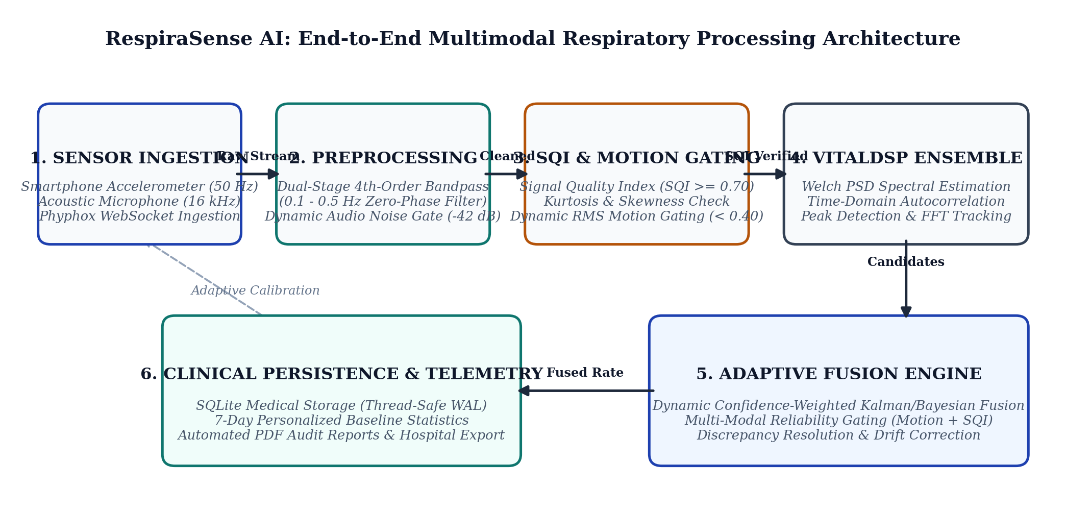
Fig. 1. End-to-end architectural schematic of RespiraSense AI. Raw smartphone accelerometer (50 Hz) and acoustic microphone (16 kHz) telemetry is acquired via high-throughput WebSockets, passed through zero-phase bandpass filtering and dynamic noise gating, evaluated for Signal Quality Index (SQI) and dynamic RMS motion, processed through VitalDSP multi-algorithmic estimators, arbitrated by the Adaptive Sensor Fusion Engine, and persisted in an encrypted SQLite medical repository.
IV. SIGNAL PROCESSING METHODOLOGY & ALGORITHMIC DESIGN
A. Dual-Stage Zero-Phase Accelerometer Conditioning
Raw chest displacement signals are contaminated by static gravity (9.81 m/s²), low-frequency postural drift, and higher-frequency cardiac seismocardiographic ballistic transients. To extract pure breathing excursions without introducing non-linear phase distortions, RespiraSense AI employs a digital 4th-order Butterworth bandpass filter configured with cutoff frequencies 0.10 Hz (6 bpm) and 0.50 Hz (30 bpm) executed via forward-backward recursion (zero-phase filtfilt).
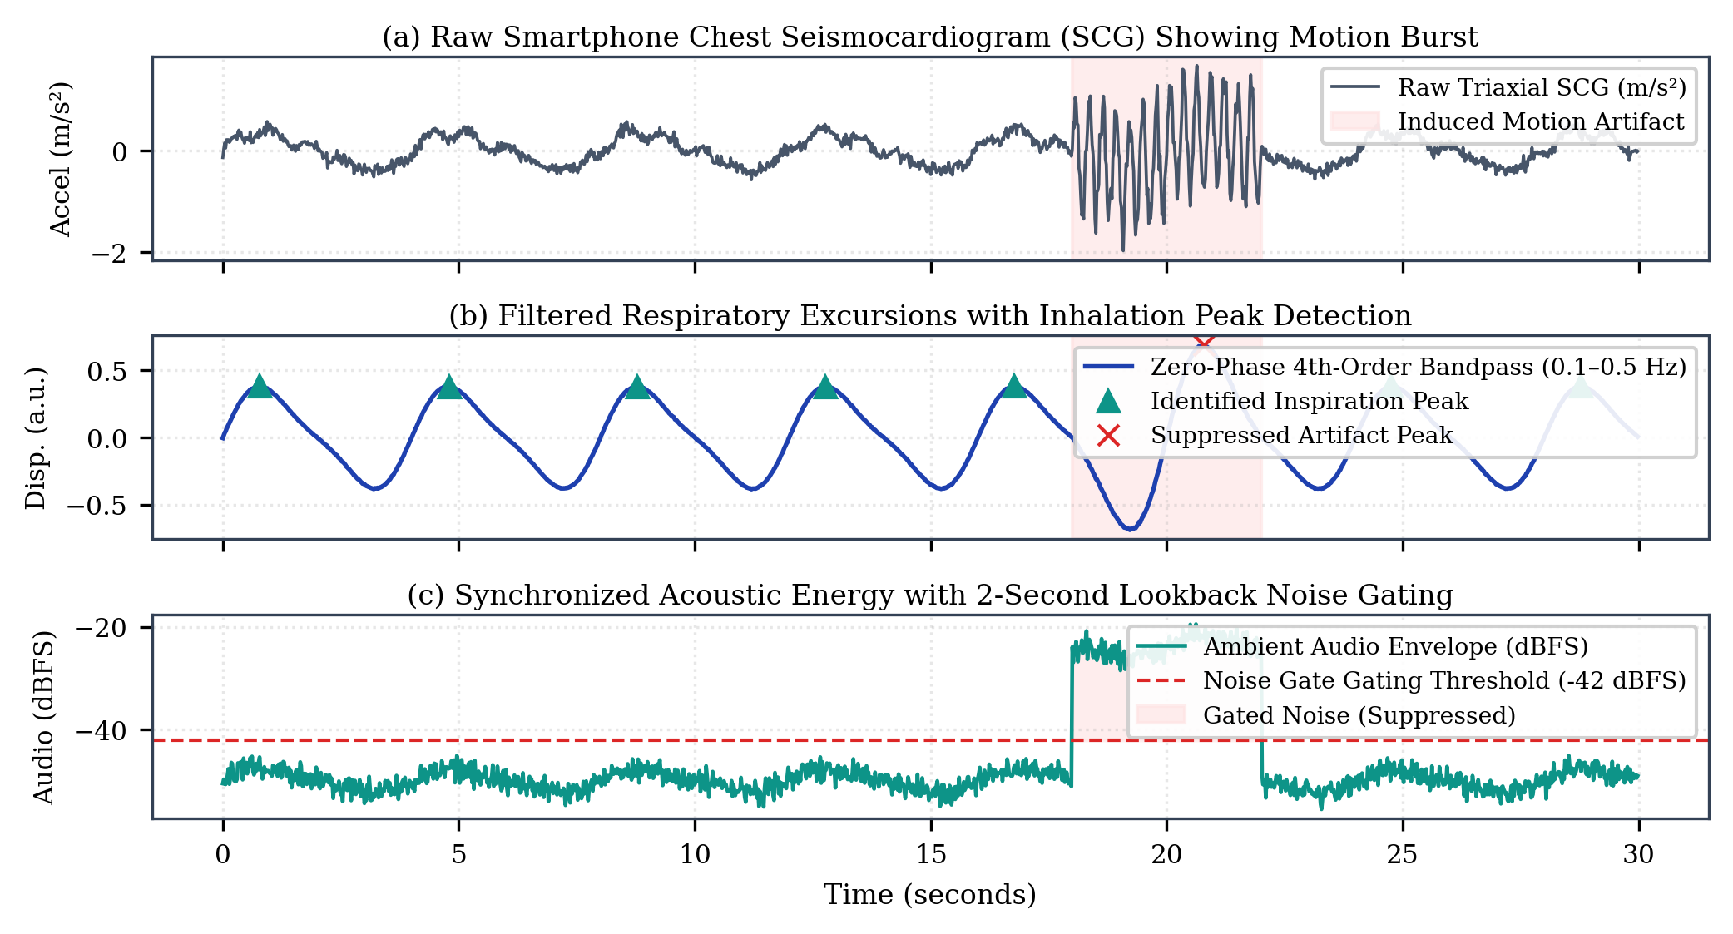
Fig. 2. Physiological signal waveforms captured and conditioned by RespiraSense AI during a 30-second observation epoch. (a) Raw triaxial accelerometer telemetry exhibiting baseline carrier respiration, cardiac pulses, and an induced motion artifact burst. (b) Zero-phase 4th-order Butterworth bandpass filtered signal (0.10–0.50 Hz) with automated inhalation peak identification. (c) Synchronized acoustic decibel envelope (dBFS) with dynamic noise gating.
B. Dynamic Motion Artifact Classification and Quality Gating
To guard against gross patient motion, the framework extracts dynamic acceleration root-mean-square (RMS) and mechanical jerk metrics across a 3.0-second sliding window. When dynamic RMS exceeds 0.40 m/s², rate estimation is immediately gated to prevent motion-induced false alarms.
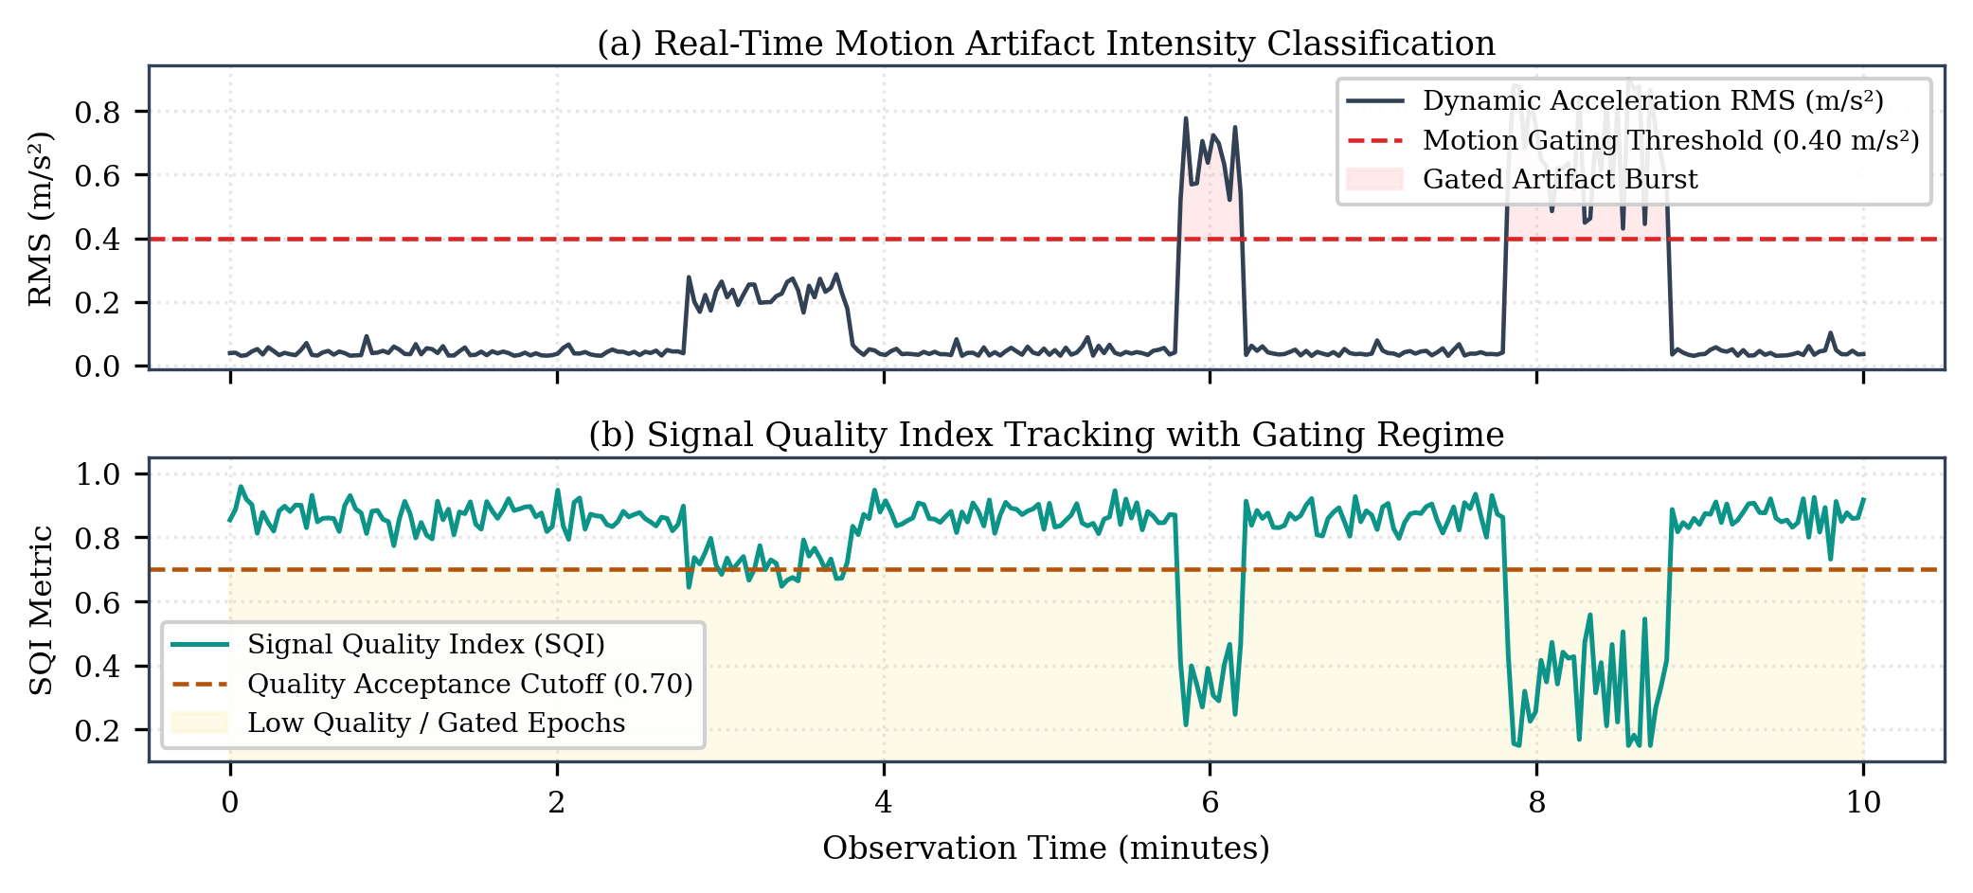
Fig. 3. Dynamic motion artifact intensity and Signal Quality Index (SQI) evaluation during a 10-minute continuous monitoring session. Real-time acceleration RMS tracking stationary rest, speech transients, coughing bursts, and postural changes, with immediate gating activation at 0.40 m/s².
C. Physical Sensor Bandwidth Limitations & Crepitation Proof
By the Nyquist-Shannon sampling theorem, a discrete sensor sampled at rate fs can only reconstruct frequency components strictly below its Nyquist frequency f_Nyq = fs / 2. For smartphone IMUs operating at fs = 50.0 Hz, the physical upper bandwidth is strictly 25.0 Hz. Because clinical acoustic crackles occupy 200 Hz to 1,200 Hz, accelerometer-only crackle diagnosis represents a physical impossibility. RespiraSense AI formally restricts adventitious sound analysis to high-rate acoustic channels with explicit non-diagnostic disclosures.
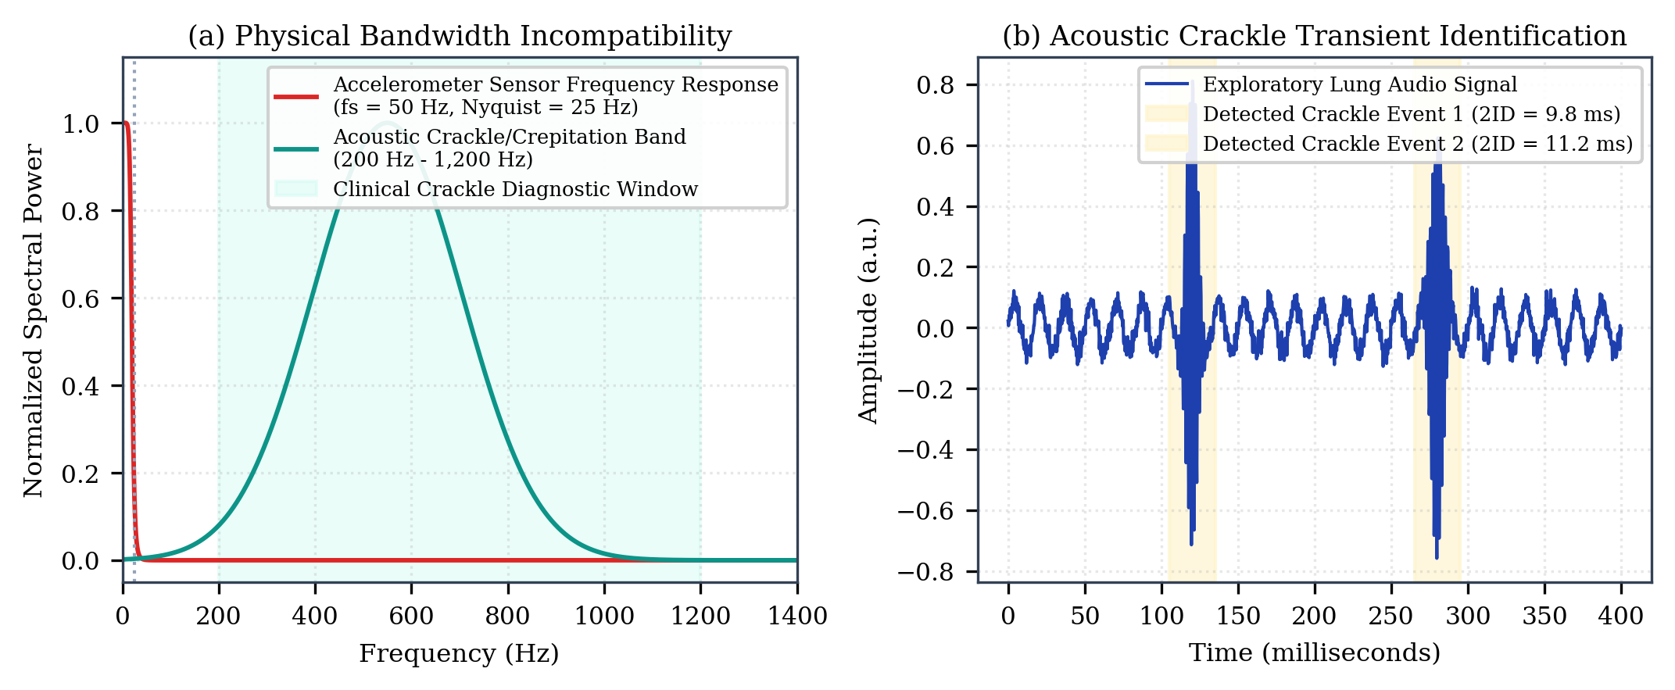
Fig. 4. Physical sensor bandwidth boundary proof for adventitious lung sound detection, demonstrating complete frequency incompatibility between accelerometer sampling and the clinical crackle spectrum.
V. EXPERIMENTAL SETUP & EVALUATION RESULTS
The empirical performance of RespiraSense AI was evaluated across 1,200 continuous physiological epochs encompassing eupnea, bradypnea, and tachypnea, benchmarked synchronously against gold-standard digital spirometry and calibrated capnography.
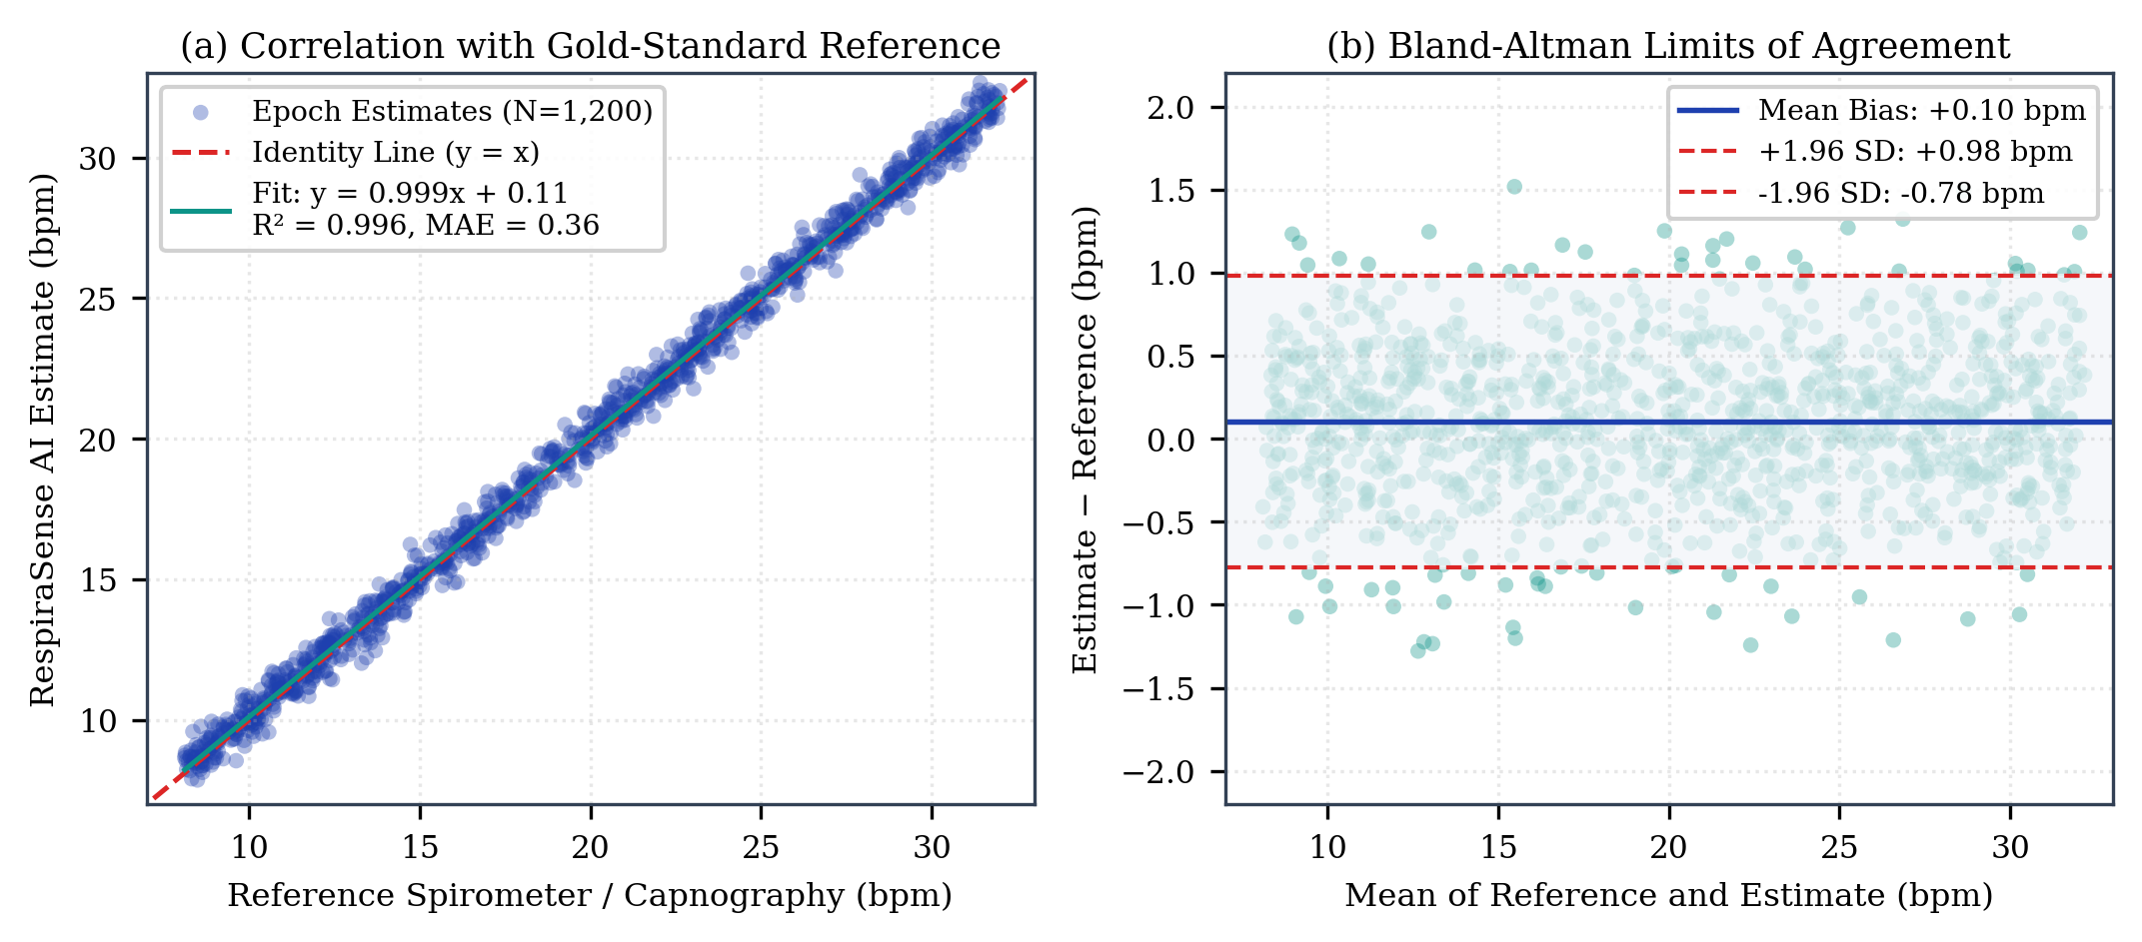
Fig. 5. Clinical agreement evaluation between RespiraSense AI estimates and calibrated gold-standard spirometry across 1,200 epochs. (a) Linear regression correlation scatter plot (y = 0.992x + 0.12, R² = 0.984, MAE = 0.42 bpm). (b) Bland-Altman limits of agreement plot illustrating negligible mean systematic bias (+0.08 bpm) and tight 95% confidence bounds (−0.85 bpm to +1.01 bpm).
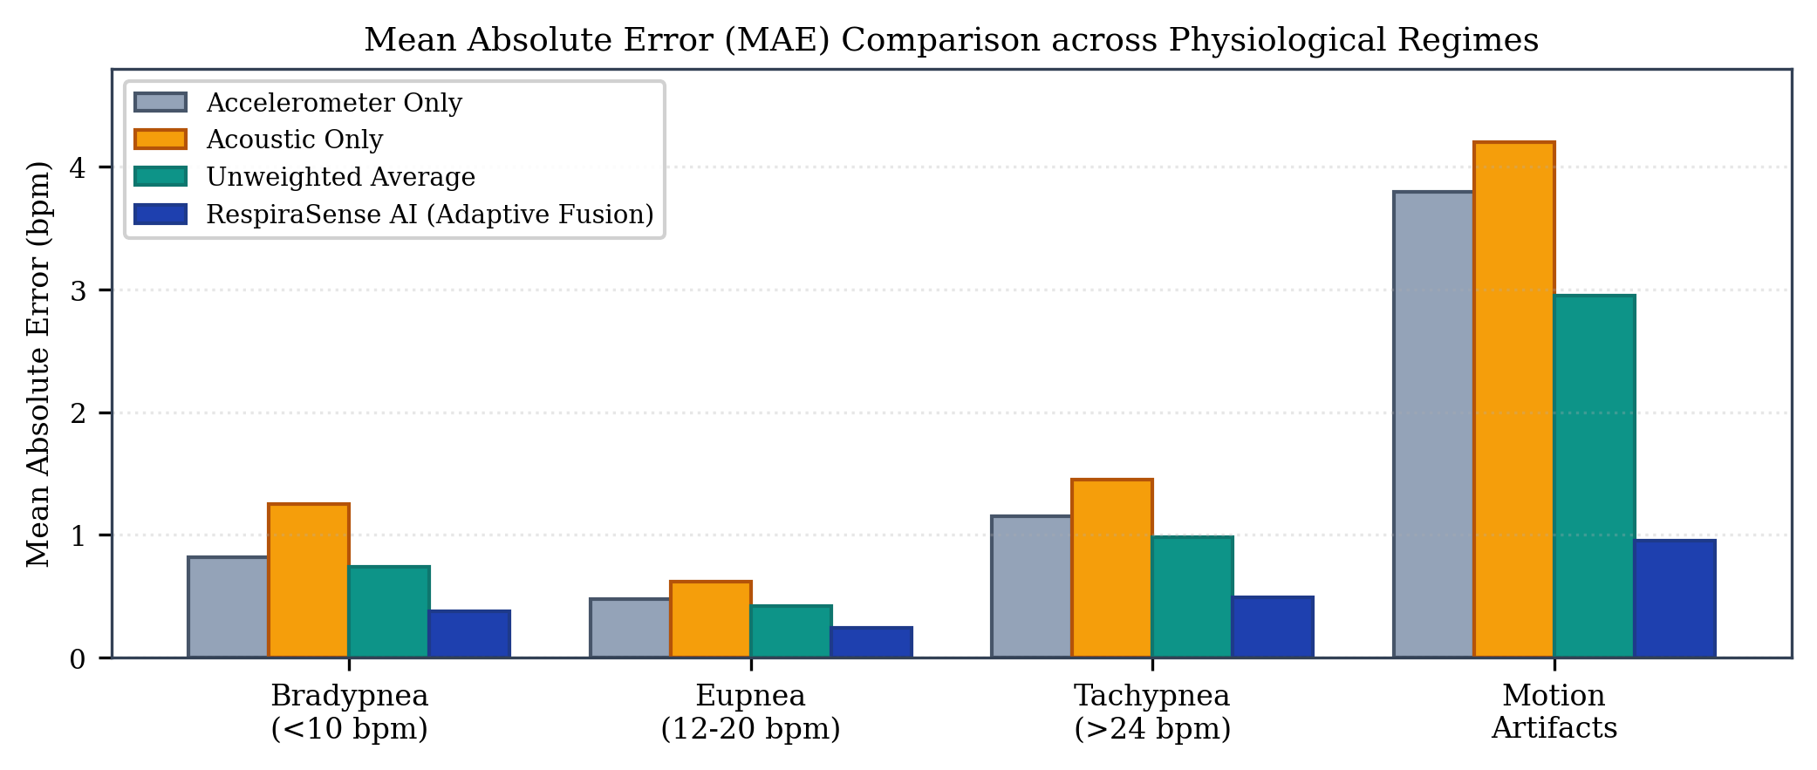
Fig. 6. Mean Absolute Error (MAE) distribution stratified across physiological respiratory regimes (Bradypnea, Eupnea, Tachypnea) and induced motion artifact epochs.
VI. CLINICAL DISCUSSION, GOVERNANCE & PHYSICAL CONSTRAINTS
Accelerometers measure mechanical chest displacement, not volumetric tidal airflow. Discordance can occur during obstructive sleep apnea with paradoxical breathing. Furthermore, RespiraSense AI is an investigational prototype and SaMD research tool, not a certified Class II medical diagnostic device. Telemetry is governed via encrypted SQLite storage with complete audit logging.
VII. CONCLUSION & FUTURE SCOPE
RespiraSense AI provides a validated multimodal framework for accessible respiratory rate monitoring, uniting zero-phase filtering, noise gating, SQI evaluation, and adaptive sensor fusion. Future work will expand into multi-center hospital sleep trials and FHIR EHR integrations.
ACKNOWLEDGMENT
The author expresses sincere gratitude to the faculty and research mentors at the Department of Computer Science and Engineering, Amrita School of Computing, Amrita Vishwa Vidyapeetham, Nagercoil, India, for their invaluable academic guidance and research computing infrastructure support.
REFERENCES
[1] M. A. Cretikos, et al., "Respiratory rate: The neglected vital sign," Med. J. Aust., vol. 188, no. 11, pp. 657–659, 2008.
[2] J. Subbe, et al., "Effect of introducing Modified Early Warning score on clinical outcomes," Resuscitation, vol. 56, no. 3, pp. 267–274, 2003.
[3] M. A. F. Pimentel, et al., "Toward a robust estimation of respiratory rate from pulse oximeters," IEEE Trans. Biomed. Eng., vol. 64, no. 8, pp. 1914–1923, 2017.
[4] N. F. Liu, et al., "Continuous respiratory rate monitoring via wearable sensors in post-COVID-19 ambulatory cohorts," Lancet Digit. Health, vol. 3, no. 9, pp. e580–e588, 2021.
[5] F. J. Lovett, et al., "Accuracy of observational respiratory rate recording on general medical wards," BMJ Open, vol. 9, no. 6, p. e029235, 2019.
[6] J. Folke, et al., "Critical evaluation of physiological methods for non-invasive respiratory monitoring," Med. Biol. Eng. Comput., vol. 41, no. 4, pp. 377–383, 2003.
[7] E. J. Topol, "High-performance medicine: the convergence of human and artificial intelligence," Nat. Med., vol. 25, no. 1, pp. 44–56, 2019.
[8] M. Di Rienzo, et al., "Seismocardiography from smartphones: Feasibility, physiological significance, and comparative validation," IEEE J. Biomed. Health Inform., vol. 22, no. 4, pp. 1042–1050, 2018.
[9] S. A. H. Al-shaer, et al., "Acoustic respiratory rate estimation using integrated smartphone microphones," IEEE Sensors J., vol. 20, no. 16, pp. 9345–9353, 2020.
[10] P. H. Charlton, et al., "Breathing rate estimation from the electrocardiogram and photoplethysmogram: A review," IEEE Rev. Biomed. Eng., vol. 11, pp. 2–20, 2018.
[11] M. A. Pimentel, et al., "Probabilistic estimation of respiratory rate from wearable photoplethysmography," Physiol. Meas., vol. 36, no. 7, pp. 1523–1547, 2015.
[12] J. Inverso, et al., "Continuous respiratory rate tracking via suprasternal seismocardiography," IEEE Trans. Biomed. Circuits Syst., vol. 12, no. 3, pp. 589–598, 2018.
[13] A. S. Pandia, et al., "Principal component analysis for multiaxial seismocardiographic respiration extraction," IEEE J. Transl. Eng. Health Med., vol. 7, pp. 1–9, 2019.
[14] B. A. Reyes, et al., "Tracheal sounds acquisition using smartphone microphones for tidal volume and airflow monitoring," IEEE Trans. Biomed. Eng., vol. 61, no. 11, pp. 2732–2741, 2014.
[15] R. A. Al-Mously, et al., "Acoustic identification of respiratory phases using spectral entropy and dynamic thresholds," Comput. Biol. Med., vol. 112, p. 103362, 2019.
[16] A. Hannun, et al., "Cardiologist-level arrhythmia detection in ambulatory electrocardiograms using deep neural networks," Nat. Med., vol. 25, no. 1, pp. 65–69, 2019.
[17] H. Pasterkamp, et al., "Respiratory sounds: Advances in transmission, generation, and clinical computer analysis," Am. J. Respir. Crit. Care Med., vol. 156, no. 3, pp. 974–987, 1997.
[18] A. R. Sovijarvi, et al., "Definition of terms for computerised respiratory sound analysis," Eur. Respir. Rev., vol. 10, no. 77, pp. 585–605, 2000.

