- Output from schema script
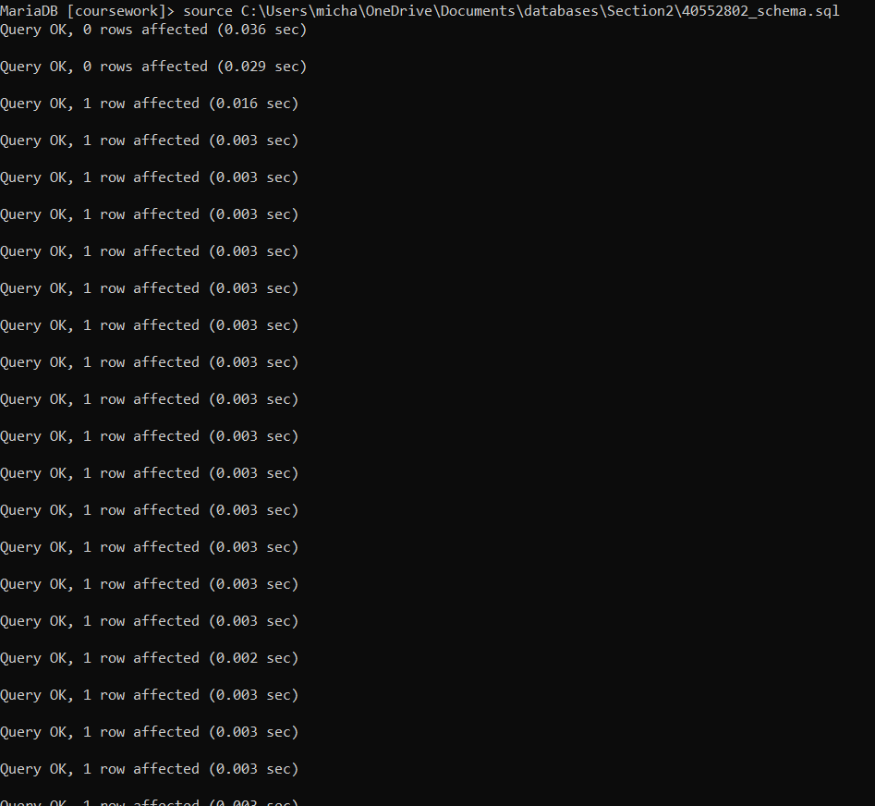
Output from query A
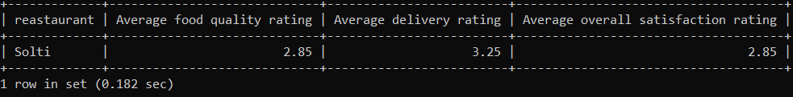
Output from query B
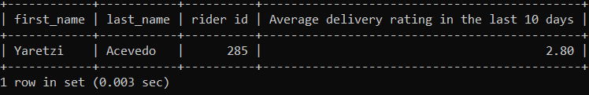
ii)

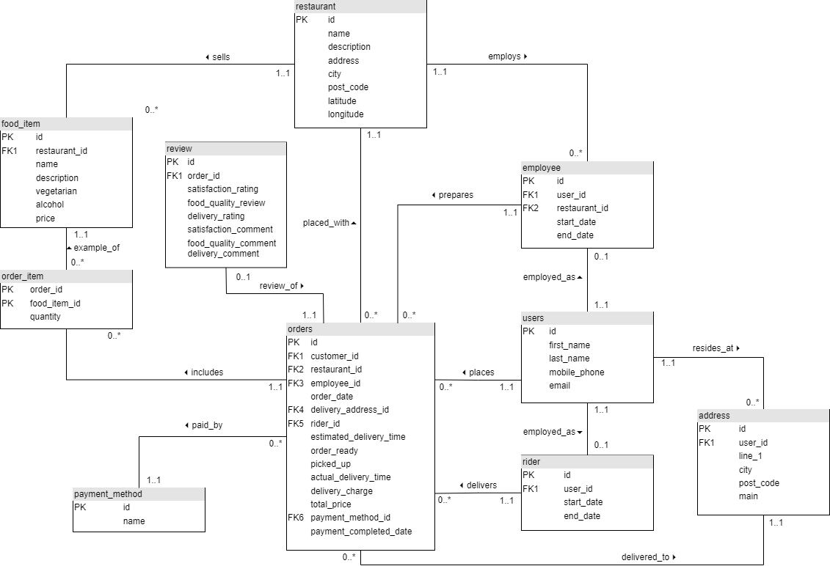
iii)
iv) I’ve assumed that the queries in section 2 are to be from the last date recorded in the database so that there are some results returned, so I have hardcoded that date in instead of using the current date. I’ve assumed that an entry into the review table if a user leaves any type of rating.

