CAIE 9618 AS 计算机科学 · Unit 2 Communication
2.1 Networks including the internet — MS 原文背诵笔记
考纲 | 2027–2029 syllabus（version 2，2025 年 12 月）。2.1 的学习目标与 2024–2026 版相同，本笔记按其顺序排列。
检索范围（9618） | Paper 1，2021 May/June – 2026 May/June 的全部 May/June 与 Oct/Nov 场次（variant 11/12/13，共 33 份 MS）。2026 Oct/Nov 尚未公布。
检索范围（9608） | 旧考纲 Paper 1，2015–2021 全部 May/June 与 Oct/Nov 场次（共 42 份 MS），只在 9618 MS 没有或太少的知识点使用。
未纳入 | Feb/March 场次（9618 Paper 12 / 9608 Paper 12）在公开渠道（PapaCambridge、PMT 等）都下载不到，未能检索。

标记说明
MS 最全的一张原 MS 截图（含 Question / Answer / Marks 原表格）。
同类 MS 其他场次出现过的同类评分点，内容已包含在上图中，只列出处、不重复截图。
＋ 额外得分点 其他场次 MS 中有、而上图没有的独立得分点，直接截取原 MS 的对应行。
题目情景 QP 只在 MS 依赖题目情景（才能看懂）时附上题干截图。
9608 旧考纲 来自旧考纲 9608 的 MS，用于补充 9618 没有或太少的知识点。
⚠ 未找到 MS 9618 与 9608 都没有 MS。若旧笔记有内容则保留并注明“非 MS”，下方留空白供补笔记。
注：2026 May/June 的 MS 来自 PapaCambridge，原 PDF 自带淡色网站水印；部分 9608 旧卷的右上角有网站角标。截图保持原样，未做修改。
目录
1 Purpose and benefits of networking devices 网络设备的目的与好处
1.1 Purpose and benefits of networking devices
2 Characteristics of a LAN and a WAN LAN 与 WAN 的特征
2.1 Characteristics of a LAN
2.2 Characteristics of a WAN
2.3 Differences between a LAN and a WAN
2.4 Identifying a LAN in a scenario
3 Client-server and peer-to-peer models 客户端-服务器模型与对等网络模型
3.1 Client-server: what it is / roles of the computers
3.2 Client-server: benefits （9608 补充）
3.3 Client-server: drawbacks ⚠ 未找到 MS
3.4 Peer-to-peer: key features
3.5 Peer-to-peer: benefits ⚠ 未找到 MS
3.6 Peer-to-peer: drawbacks
3.7 Justify the use of a model for a given situation ⚠ 未找到 MS
4 Thin-client and thick-client 瘦客户端与胖客户端
4.1 Thin-client
4.2 Thick-client
4.3 Differences between thin-client and thick-client ⚠ 未找到 MS
5 Bus, star, mesh and hybrid topologies 总线、星型、网状与混合拓扑
5.1 Comparing bus, star and mesh
5.2 Bus: how packets are transmitted between two hosts
5.3 Bus: drawbacks
5.4 Bus: benefits ⚠ 未找到 MS
5.5 Star: structure (drawing a star topology)
5.6 Star: how packets are transmitted between two hosts
5.7 Star: benefits (justify star instead of bus)
5.8 Mesh: what it is / how packets are transmitted
5.9 Mesh: benefits (instead of bus)
5.10 Hybrid topology ⚠ 未找到 MS
6 Cloud computing 云计算
6.1 What is cloud computing
6.2 Public cloud and private cloud
6.3 Why use a public cloud (scenario)
6.4 Benefits of a private cloud instead of a public cloud
6.5 Benefits of cloud computing / cloud storage
6.6 Drawbacks of cloud computing / cloud storage
6.7 Disadvantages of a public cloud compared with a server on a LAN
7 Wired and wireless networks 有线与无线网络
7.1 Characteristics of the media (fibre-optic, radio waves / microwaves)
7.2 Characteristics of the media (copper cable, satellite, radio waves) （9608 补充）
7.3 Differences between fibre-optic and copper cable
7.4 Benefits of fibre-optic vs copper cable (including benefits of copper) （9608 补充）
7.5 Drawbacks of fibre-optic cable （9608 补充）
7.6 Satellites instead of copper cables
7.7 Wired vs wireless: benefits of each
7.8 Wireless: drawbacks
7.9 Why provide both wired and wireless connections (scenario)
8 Hardware used to support a LAN 支持 LAN 的硬件
8.1 Router / WNIC / Repeater / WAP (descriptions)
8.2 Switch / WAP / Bridge (purpose)
8.3 Switch: functions
8.4 Server （9608 补充）
8.5 NIC (Network Interface Card) ⚠ 未找到 MS
8.6 WNIC: functions
8.7 WAP, cables, bridge, repeater
8.8 Designing a LAN (diagram)
9 Role and function of a router 路由器的作用与功能
9.1 Functions of a router
10 Ethernet and CSMA/CD 以太网与 CSMA/CD
10.1 Ethernet
10.2 How CSMA/CD detects and avoids collisions
10.3 Drawbacks of CSMA/CD
11 Bit streaming 比特流
11.1 What is bit streaming
11.2 Real-time vs on-demand: definitions （9608 补充）
11.3 Real-time vs on-demand: differences
11.4 How real-time bit streaming works
11.5 How on-demand bit streaming works (and real-time) （9608 补充）
11.6 Benefits and problems of bit streaming （9608 补充）
11.7 Importance of bit rate / broadband speed
12 The World Wide Web (WWW) and the internet WWW 与互联网的区别
12.1 Using the internet and/or the WWW (scenario)
12.2 Differences between the WWW and the internet （9608 补充）
13 Hardware used to support the internet 支持互联网的硬件
13.1 Modems and dedicated lines
13.2 PSTN
13.3 Dedicated lines: benefit and drawback （9608 补充）
13.4 Cell phone network
13.5 Ways to connect to the internet (dedicated line / cell phone network / satellite) （9608 补充）
14 IP addresses IP 地址
14.1 Format of IPv4 and IPv6
14.2 Valid or invalid IP address (application)
14.3 How an IP address is associated with a device
14.4 Public / private / static / dynamic IP addresses: definitions
14.5 Public vs private IP: differences and implications for security （9608 补充）
14.6 Static vs dynamic IP: why a server uses a static IP （9608 补充）
14.7 Subnetting: purpose
14.8 Subnetting: benefits / why it is used
14.9 Subnetting: network ID and host ID
15 URL and DNS URL 与 DNS
15.1 How a web browser uses a URL to access a web page
15.2 What a URL is and the role of DNS （9608 补充）
15.3 Domain name and IP address （9608 补充）

1 Purpose and benefits of networking devices｜网络设备的目的与好处

1.1 Purpose and benefits of networking devices
MS 9618 · 2023 May/June · Paper 12 · Q1(a)
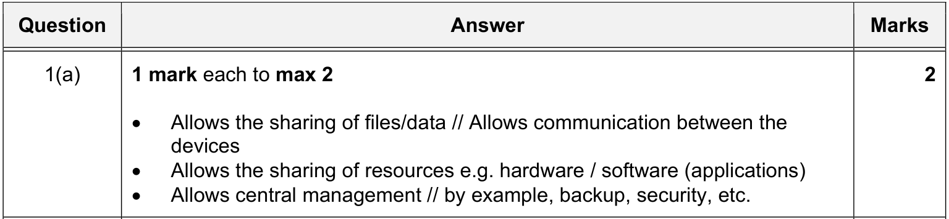

2 Characteristics of a LAN and a WAN｜LAN 与 WAN 的特征

2.1 Characteristics of a LAN
MS 9618 · 2025 Oct/Nov · Paper 12 · Q5(a)
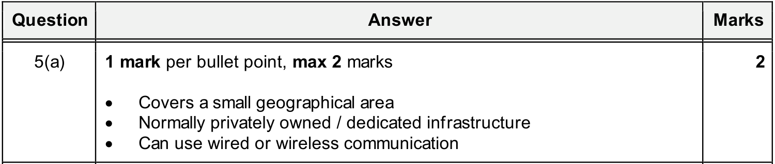
同类 MS（已包含在上图中）：9618 · 2023 May/June · Paper 12 · Q1(b)

2.2 Characteristics of a WAN
MS 9618 · 2024 Oct/Nov · Paper 13 · Q9(a)
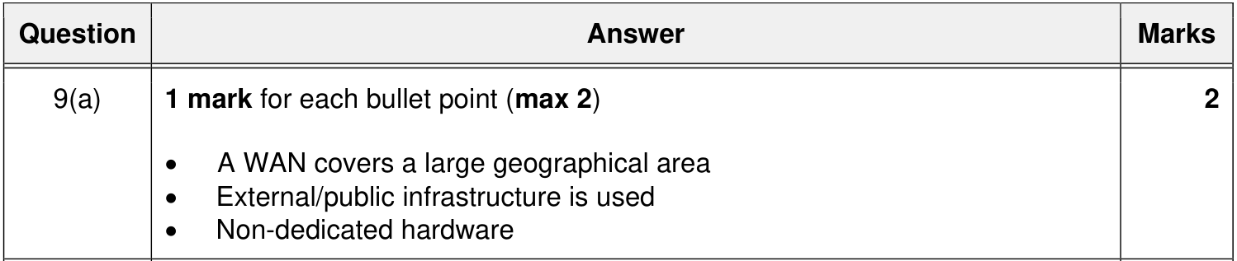

2.3 Differences between a LAN and a WAN
MS 9618 · 2023 May/June · Paper 13 · Q2(a)
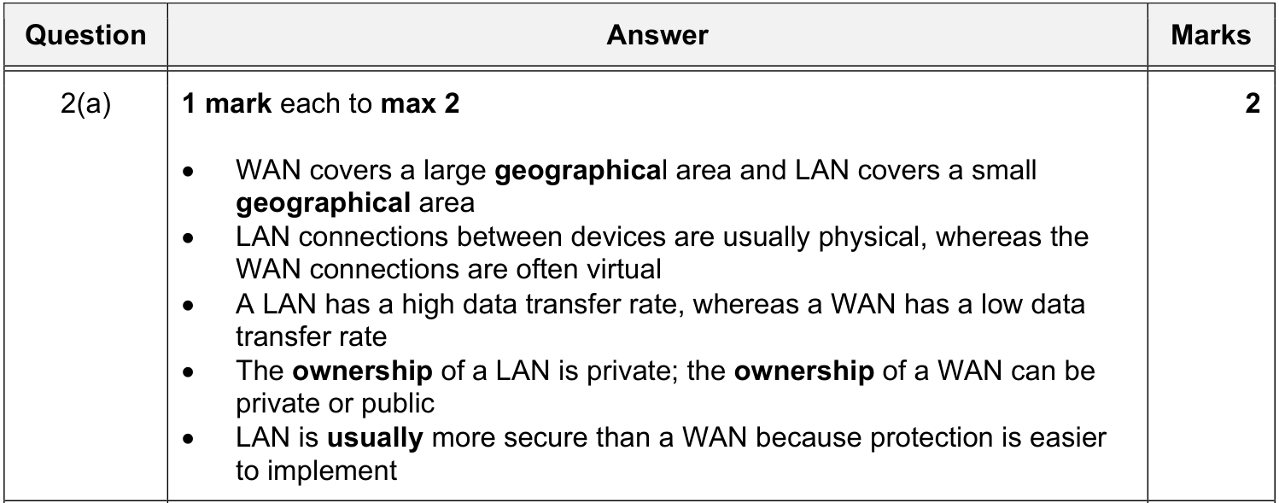
＋ 额外得分点 9618 · 2025 May/June · Paper 12 · Q6(a)
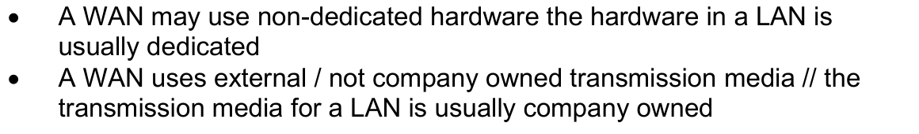

2.4 Identifying a LAN in a scenario
MS 9618 · 2021 Oct/Nov · Paper 11 · Q8(a)
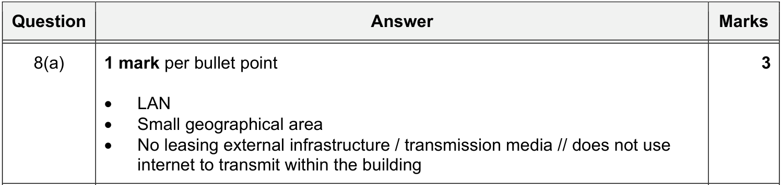
同类 MS（已包含在上图中）：9618 · 2021 Oct/Nov · Paper 13 · Q8(a)

3 Client-server and peer-to-peer models｜客户端-服务器模型与对等网络模型

3.1 Client-server: what it is / roles of the computers
题目情景 QP 9618 · 2025 May/June · Paper 13 · Q3(c)
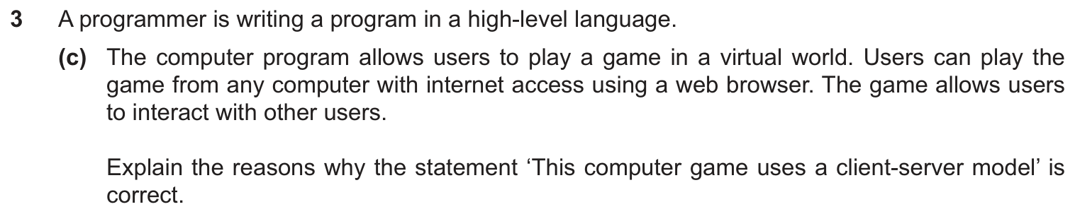
MS 9618 · 2025 May/June · Paper 13 · Q3(c)
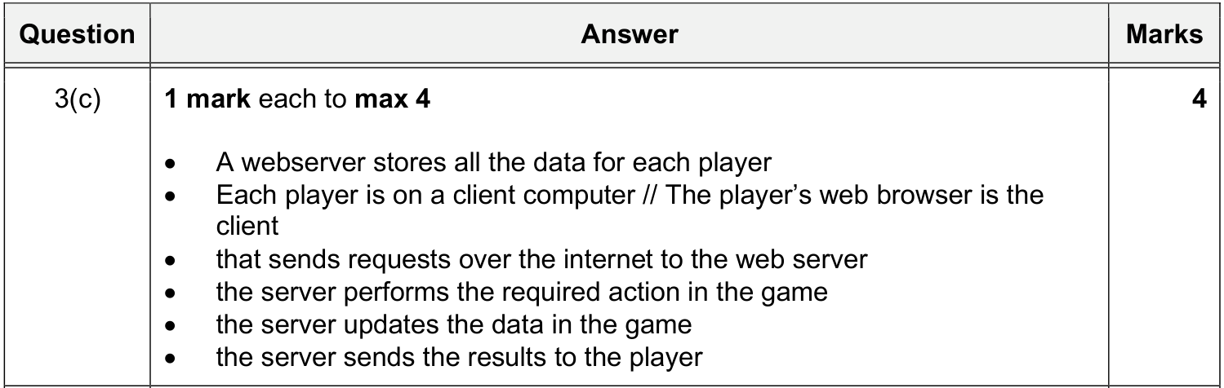
＋ 额外得分点 9618 · 2024 May/June · Paper 11 · Q5(a)
＋ 额外得分点 9618 · 2024 May/June · Paper 11 · Q5(a)
MS 9608 旧考纲 9608 · 2015 Oct/Nov · Paper 11 · Q7(a)(i)
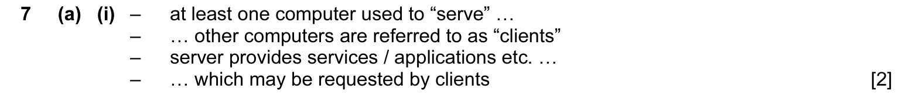
同类 MS（已包含在上图中）：9608 · 2019 Oct/Nov · Paper 11 · Q4(a)(i)；9608 · 2020 May/June · Paper 13 · Q1(b)；9608 · 2021 Oct/Nov · Paper 11 · Q11(a)

3.2 Client-server: benefits
MS 9608 旧考纲 9608 · 2015 Oct/Nov · Paper 11 · Q7(a)(ii)
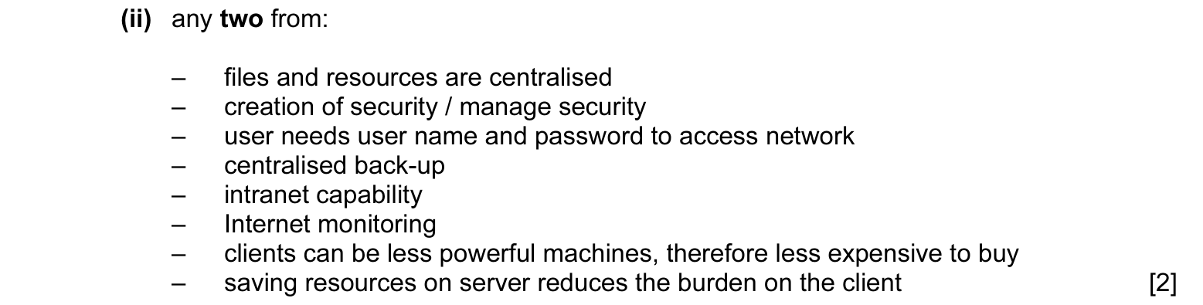
同类 MS（已包含在上图中）：9608 · 2015 Oct/Nov · Paper 13 · Q7(a)(ii)

3.3 Client-server: drawbacks
⚠ 未找到 MS 9618（2021–2026，33 份）和 9608（2015–2021，42 份）Paper 1 的 MS 里，都没有针对这一点的评分点。
原笔记内容（不是 MS 原文，来源可能是课本或自己总结，仅供参考）：
• Initial set-up costs for the server and the client workstations will be high
• A server-based network requires the use of a specialist network operating system
• If the server fails then the work of all users is affected

我的笔记：

3.4 Peer-to-peer: key features
MS 9618 · 2021 May/June · Paper 11 · Q4(a)
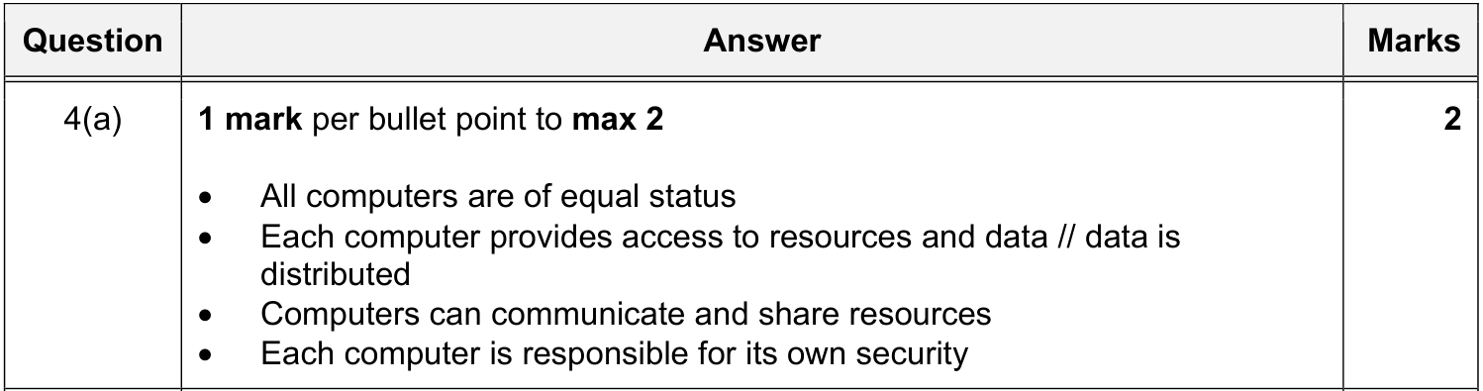
同类 MS（已包含在上图中）：9618 · 2021 May/June · Paper 13 · Q4(a)

3.5 Peer-to-peer: benefits
⚠ 未找到 MS 9618（2021–2026，33 份）和 9608（2015–2021，42 份）Paper 1 的 MS 里，都没有针对这一点的评分点。
原笔记内容（不是 MS 原文，来源可能是课本或自己总结，仅供参考）：
• No dedicate additional computers
• additional computer can join the P2P network easily
• server is not required
• can act as both a provider and receiver of resources

我的笔记：

3.6 Peer-to-peer: drawbacks
MS 9618 · 2021 May/June · Paper 11 · Q4(b)
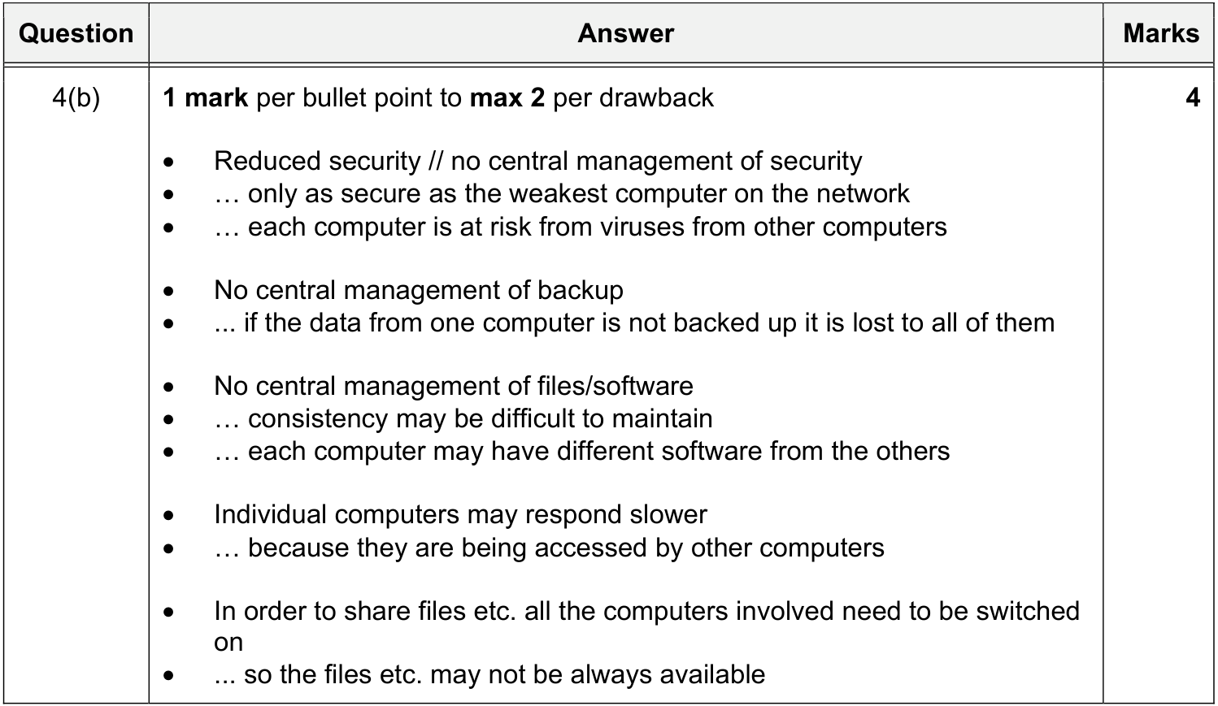
同类 MS（已包含在上图中）：9618 · 2021 May/June · Paper 13 · Q4(b)

3.7 Justify the use of a model for a given situation
⚠ 未找到 MS 9618（2021–2026，33 份）和 9608（2015–2021，42 份）Paper 1 的 MS 里，都没有针对这一点的评分点。
我的笔记：

4 Thin-client and thick-client｜瘦客户端与胖客户端

4.1 Thin-client
MS 9618 · 2026 May/June · Paper 11 · Q7(a)
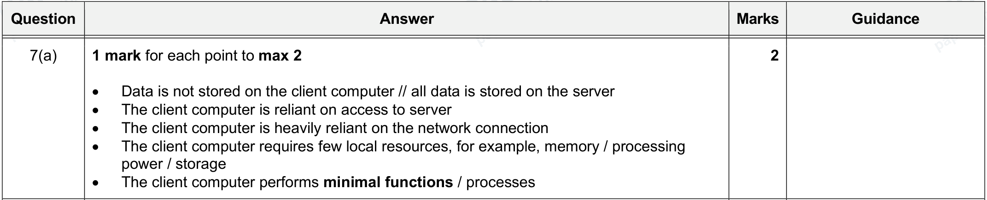
同类 MS（已包含在上图中）：9618 · 2024 May/June · Paper 12 · Q3(b)
＋ 额外得分点 9618 · 2023 May/June · Paper 13 · Q2(c)
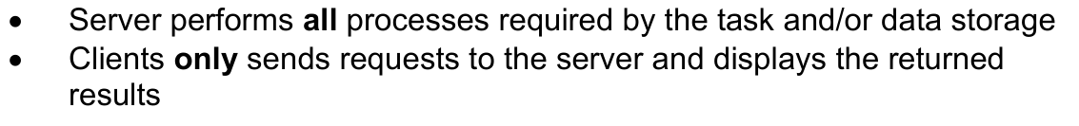

4.2 Thick-client
MS 9618 · 2023 May/June · Paper 12 · Q1(e)
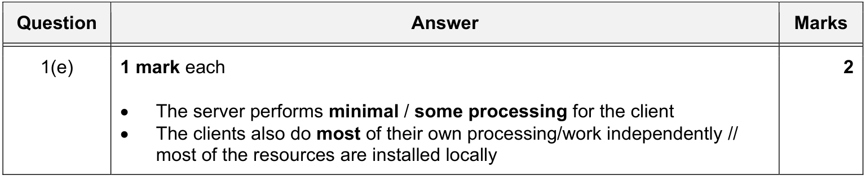

4.3 Differences between thin-client and thick-client
没有一道 MS 直接问“两者区别”。可以对照 4.1 和 4.2 的 MS 自己总结。
⚠ 未找到 MS 9618（2021–2026，33 份）和 9608（2015–2021，42 份）Paper 1 的 MS 里，都没有针对这一点的评分点。
我的笔记：

5 Bus, star, mesh and hybrid topologies｜总线、星型、网状与混合拓扑

5.1 Comparing bus, star and mesh
MS 9618 · 2024 May/June · Paper 11 · Q8(a)
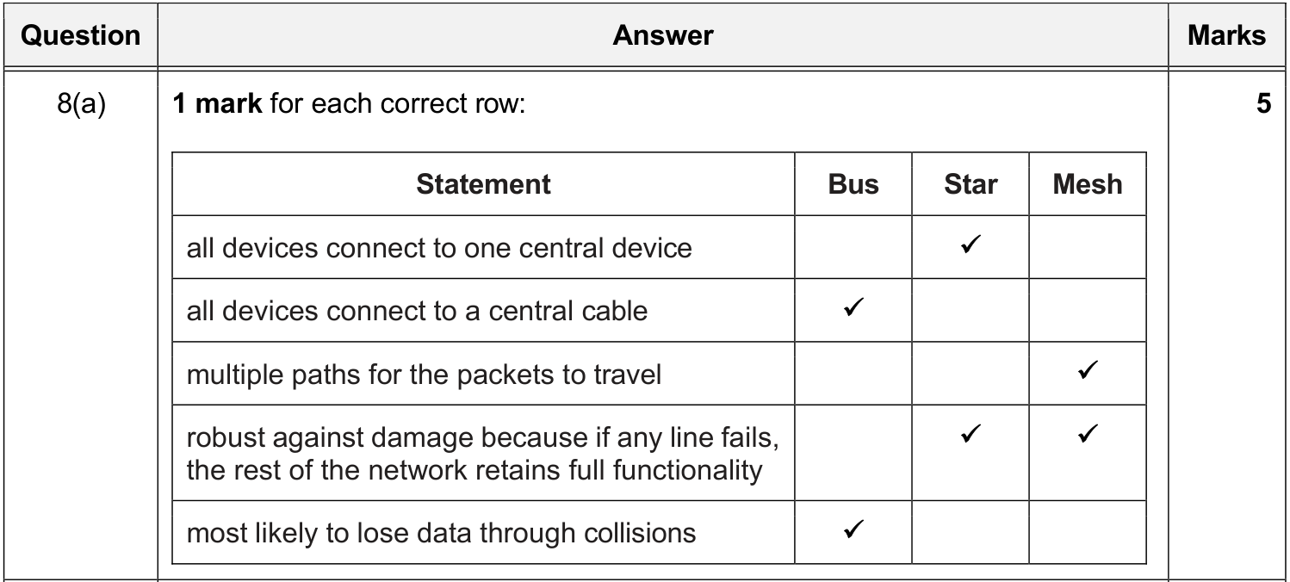

5.2 Bus: how packets are transmitted between two hosts
MS 9618 · 2026 May/June · Paper 11 · Q7(b)(i)
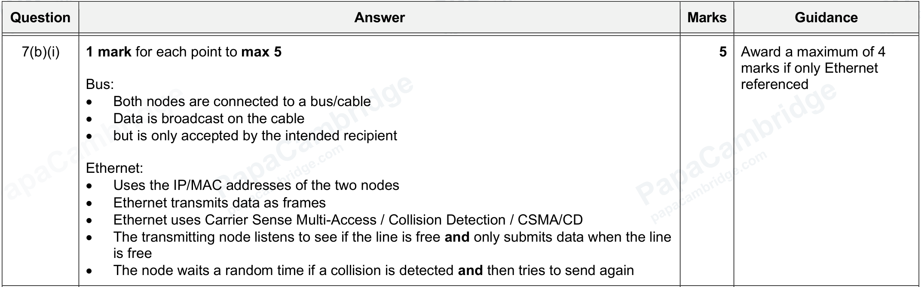
说明：这道题同时考了 Bus 与 Ethernet，第 10.1 节也会用到。

5.3 Bus: drawbacks
MS 9618 · 2026 May/June · Paper 11 · Q7(b)(ii)
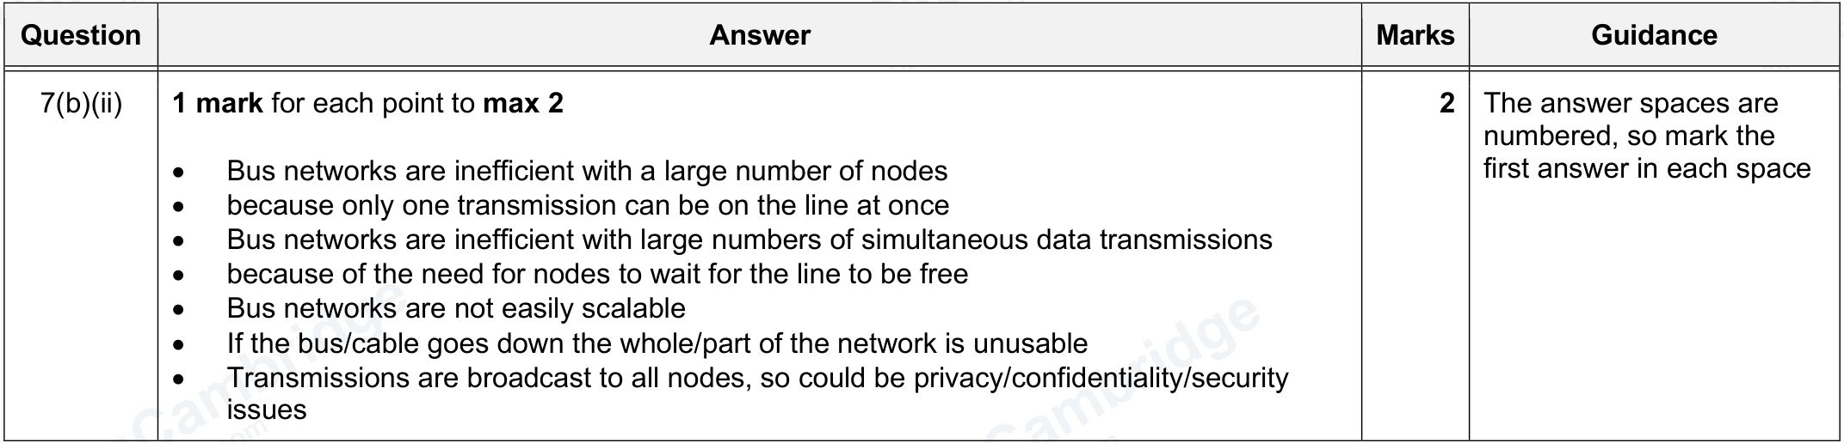

5.4 Bus: benefits
⚠ 未找到 MS 9618（2021–2026，33 份）和 9608（2015–2021，42 份）Paper 1 的 MS 里，都没有针对这一点的评分点。
原笔记内容（不是 MS 原文，来源可能是课本或自己总结，仅供参考）：
• Easier to set-up/extend
• Less cable required

我的笔记：

5.5 Star: structure (drawing a star topology)
MS 9618 · 2023 May/June · Paper 12 · Q1(c)
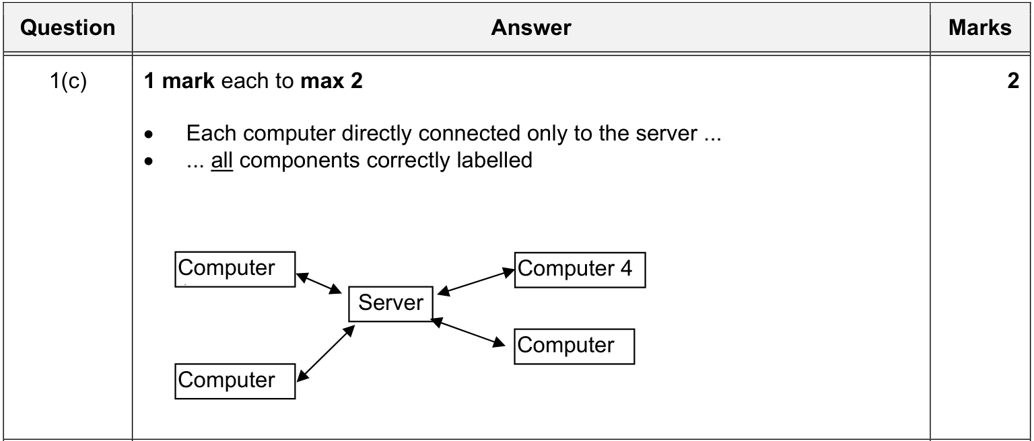
同类 MS（已包含在上图中）：9618 · 2022 Oct/Nov · Paper 12 · Q10(a)；9618 · 2023 Oct/Nov · Paper 12 · Q7(b)(i)；9618 · 2025 Oct/Nov · Paper 12 · Q5(b)
MS 9618 · 2021 Oct/Nov · Paper 12 · Q3(b)(i)
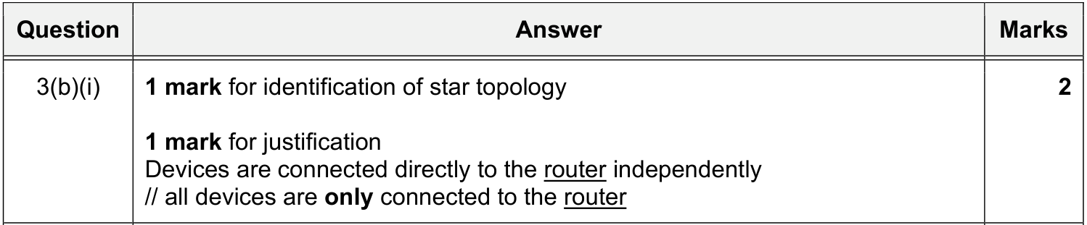

5.6 Star: how packets are transmitted between two hosts
MS 9618 · 2023 Oct/Nov · Paper 12 · Q7(b)(ii)
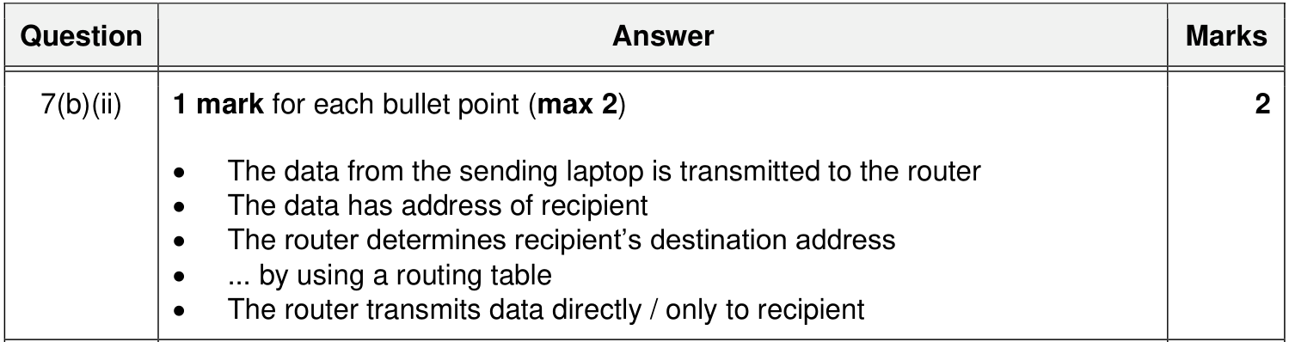
同类 MS（已包含在上图中）：9618 · 2024 May/June · Paper 13 · Q5(b)；9618 · 2025 Oct/Nov · Paper 12 · Q5(c)

5.7 Star: benefits (justify star instead of bus)
MS 9618 · 2023 Oct/Nov · Paper 11 · Q2(d)
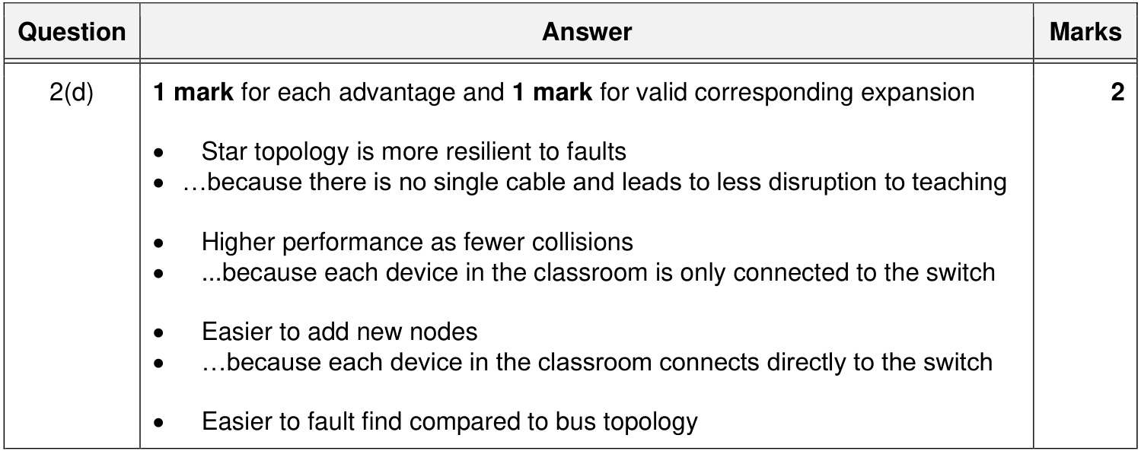

5.8 Mesh: what it is / how packets are transmitted
MS 9618 · 2023 May/June · Paper 13 · Q2(b)(i)
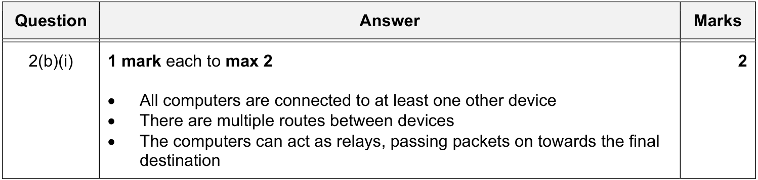

5.9 Mesh: benefits (instead of bus)
MS 9618 · 2023 May/June · Paper 13 · Q2(b)(ii)
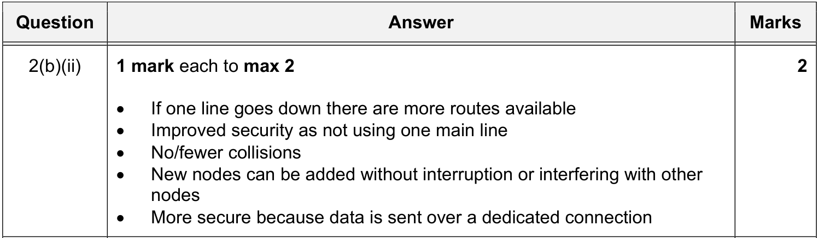

5.10 Hybrid topology
⚠ 未找到 MS 9618（2021–2026，33 份）和 9608（2015–2021，42 份）Paper 1 的 MS 里，都没有针对这一点的评分点。
原笔记内容（不是 MS 原文，来源可能是课本或自己总结，仅供参考）：
• Definition: a collection of connected LANs where some of them have different topologies or supporting technologies
• Benefits: It is of an advantage to be able to connect a new topology LAN to existing LANs where it is not sensible or not possible to use the existing topology for the new LAN. An example is when a wired LAN is already installed but a new wireless LAN is to be connected to it.

我的笔记：

6 Cloud computing｜云计算

6.1 What is cloud computing
MS 9618 · 2022 May/June · Paper 13 · Q8(a)
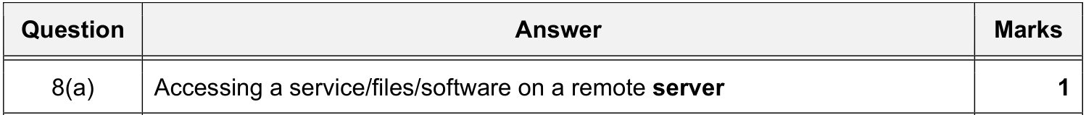

6.2 Public cloud and private cloud
MS 9618 · 2022 May/June · Paper 13 · Q8(b)
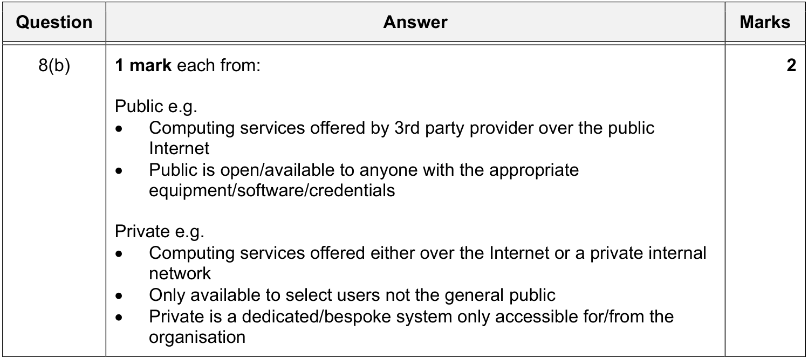
同类 MS（已包含在上图中）：9618 · 2024 May/June · Paper 13 · Q5(a)(i)；9618 · 2026 May/June · Paper 13 · Q3(c)(ii)；9618 · 2022 Oct/Nov · Paper 13 · Q7(a)

6.3 Why use a public cloud (scenario)
题目情景 QP 9618 · 2023 Oct/Nov · Paper 13 · Q3(a)
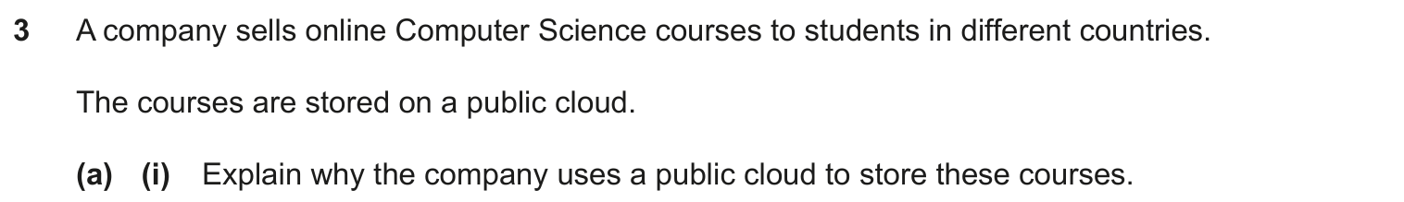
MS 9618 · 2023 Oct/Nov · Paper 13 · Q3(a)(i)
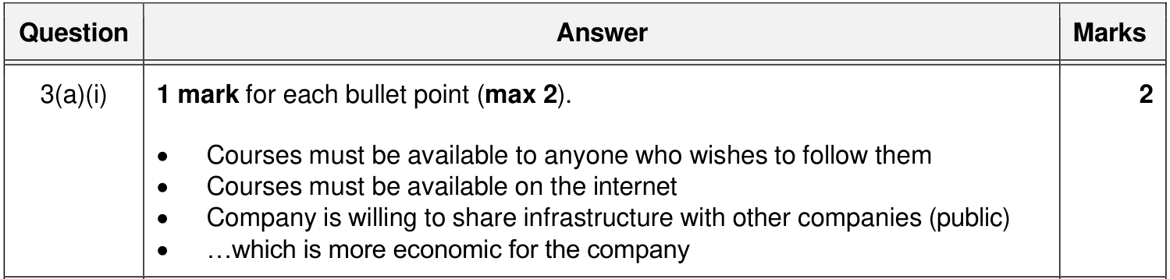

6.4 Benefits of a private cloud instead of a public cloud
MS 9618 · 2024 May/June · Paper 13 · Q5(a)(ii)
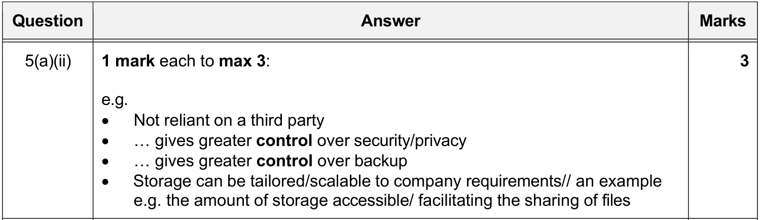

6.5 Benefits of cloud computing / cloud storage
MS 9618 · 2021 May/June · Paper 12 · Q5(c)(i)
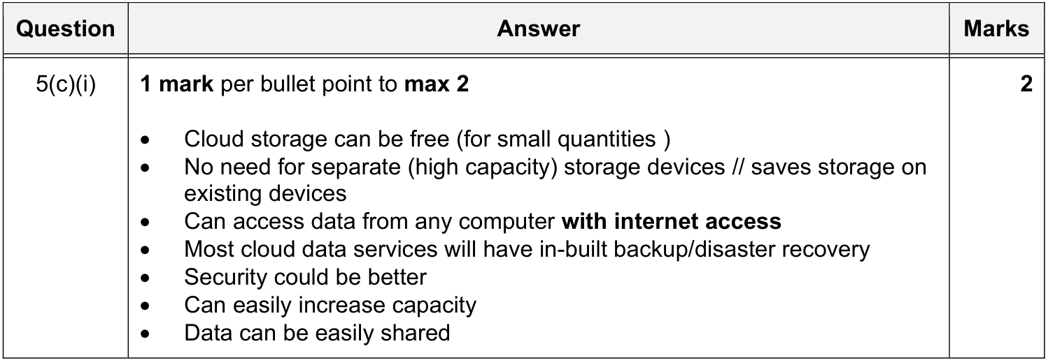
同类 MS（已包含在上图中）：9618 · 2025 Oct/Nov · Paper 12 · Q8(a)(i)；9618 · 2022 May/June · Paper 13 · Q8(c)；9618 · 2026 May/June · Paper 13 · Q3(c)(iii)
＋ 额外得分点 9618 · 2022 May/June · Paper 13 · Q8(c)
＋ 额外得分点 9618 · 2022 May/June · Paper 13 · Q8(c)
＋ 额外得分点 9618 · 2026 May/June · Paper 12 · Q6(d)

6.6 Drawbacks of cloud computing / cloud storage
MS 9618 · 2025 Oct/Nov · Paper 12 · Q8(a)(ii)
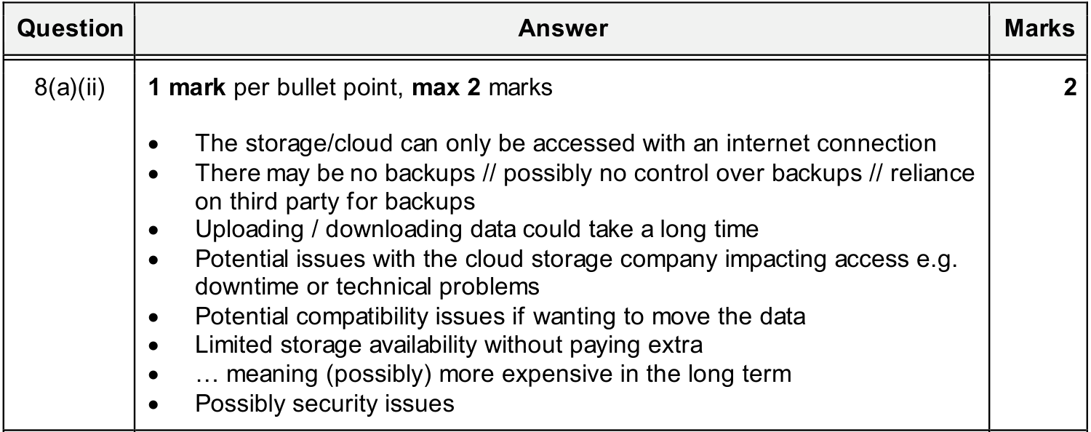
同类 MS（已包含在上图中）：9618 · 2021 May/June · Paper 12 · Q5(c)(ii)；9618 · 2022 May/June · Paper 13 · Q8(c)；9618 · 2023 Oct/Nov · Paper 11 · Q2(c)
＋ 额外得分点 9618 · 2026 May/June · Paper 12 · Q6(d)

6.7 Disadvantages of a public cloud compared with a server on a LAN
题目情景 QP 9618 · 2023 Oct/Nov · Paper 13 · Q3(a)(ii)
MS 9618 · 2023 Oct/Nov · Paper 13 · Q3(a)(ii)
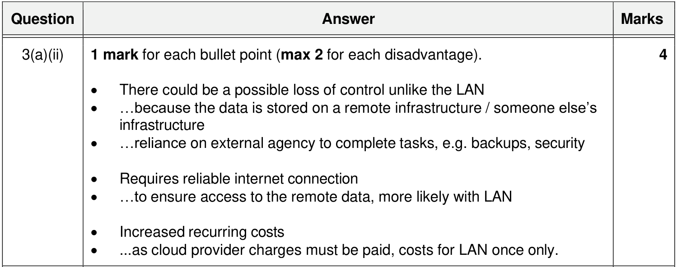

7 Wired and wireless networks｜有线与无线网络

7.1 Characteristics of the media (fibre-optic, radio waves / microwaves)
MS 9618 · 2024 Oct/Nov · Paper 13 · Q9(b)
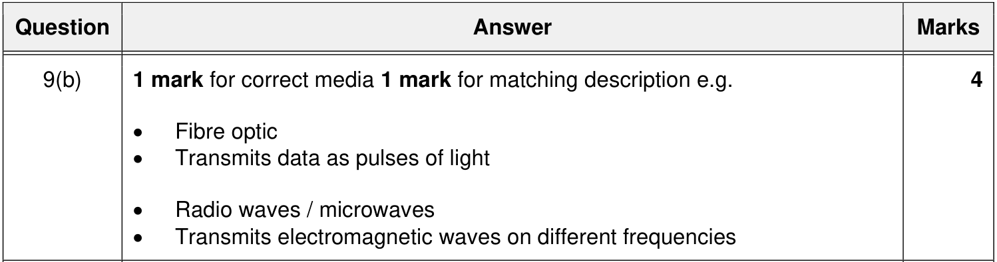

7.2 Characteristics of the media (copper cable, satellite, radio waves)
9618 MS 里没有描述 copper cable 和 satellite 的题，下面用 9608 旧考纲补充。
MS 9608 旧考纲 9608 · 2020 May/June · Paper 13 · Q1(a)
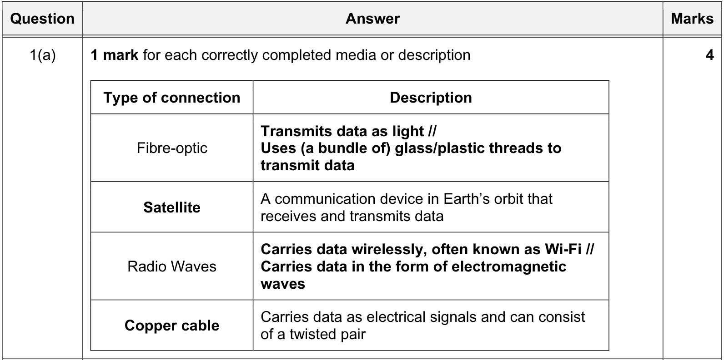

7.3 Differences between fibre-optic and copper cable
MS 9618 · 2022 May/June · Paper 12 · Q9(b)
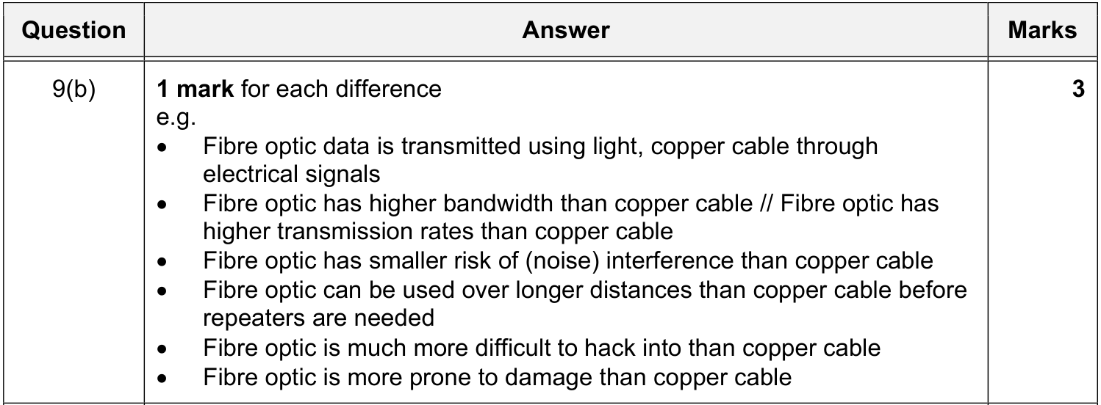

7.4 Benefits of fibre-optic vs copper cable (including benefits of copper)
MS 9608 旧考纲 9608 · 2015 Oct/Nov · Paper 11 · Q6
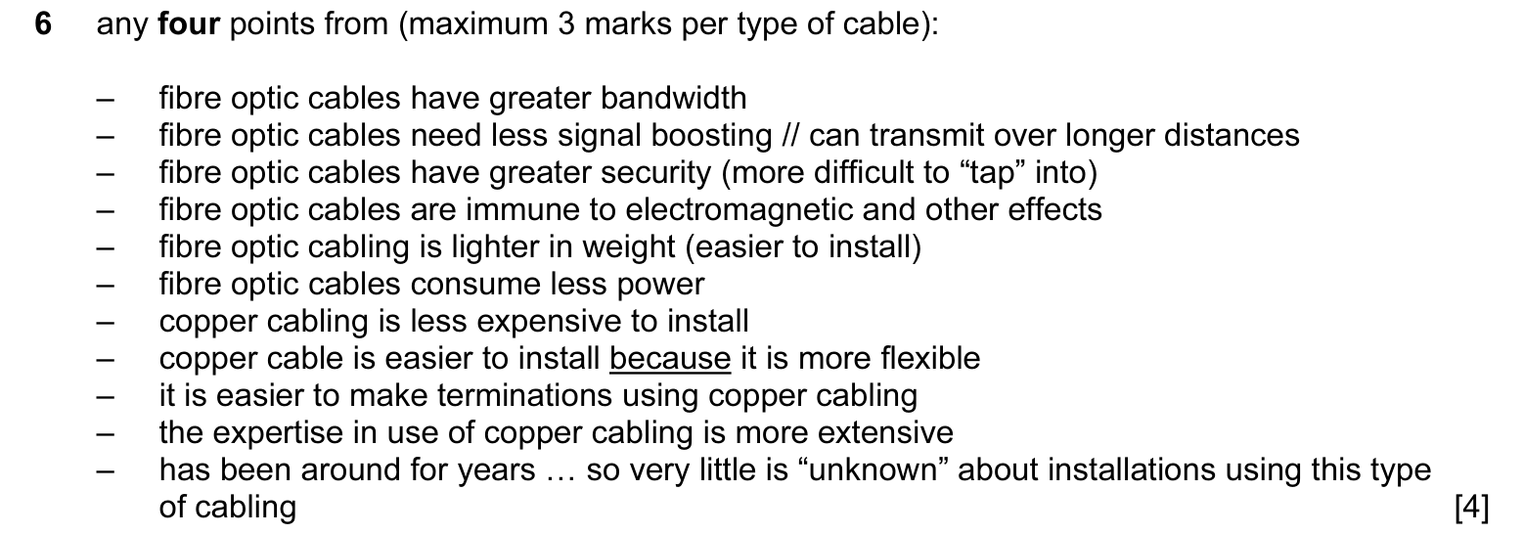
同类 MS（已包含在上图中）：9608 · 2015 Oct/Nov · Paper 13 · Q6；9608 · 2018 Oct/Nov · Paper 12 · Q2(c)(i)；9608 · 2019 Oct/Nov · Paper 11 · Q4(c)(i)

7.5 Drawbacks of fibre-optic cable
MS 9608 旧考纲 9608 · 2018 Oct/Nov · Paper 12 · Q2(c)(ii)
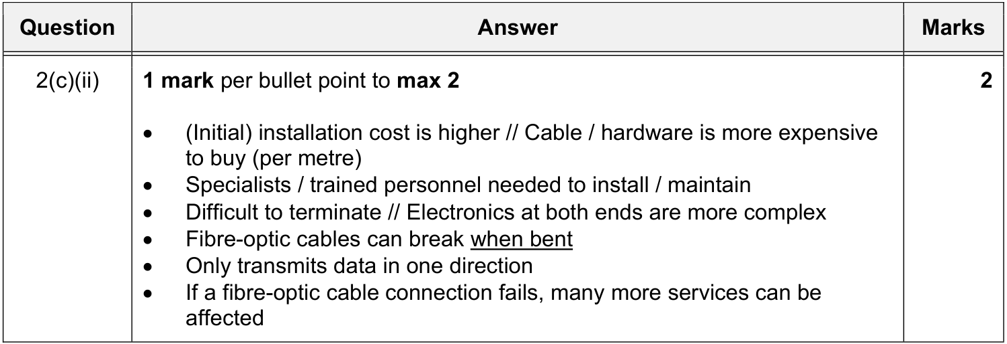
＋ 额外得分点 9608 旧考纲 9608 · 2019 Oct/Nov · Paper 11 · Q4(c)(ii)

7.6 Satellites instead of copper cables
MS 9618 · 2022 Oct/Nov · Paper 13 · Q7(b)
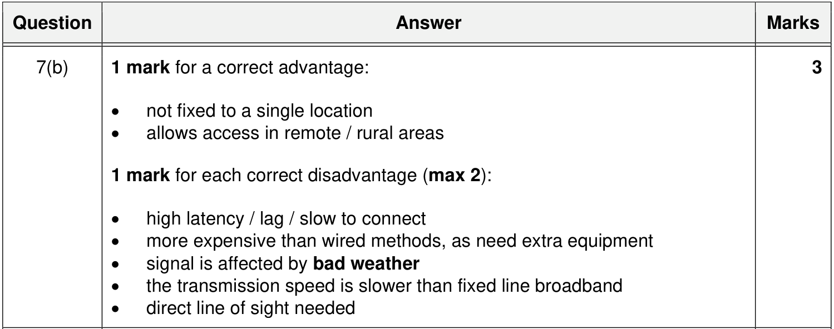

7.7 Wired vs wireless: benefits of each
题目情景 QP 9618 · 2021 May/June · Paper 11 · Q4(c)(ii)
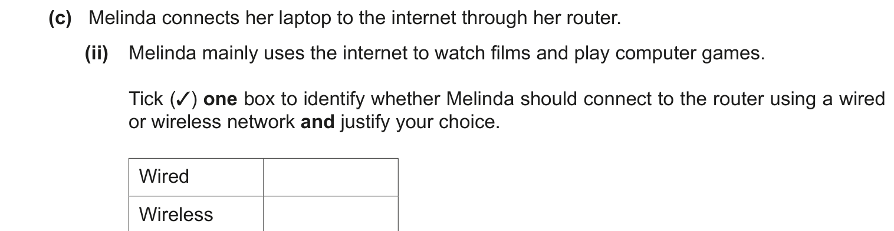
MS 9618 · 2021 May/June · Paper 11 · Q4(c)(ii)
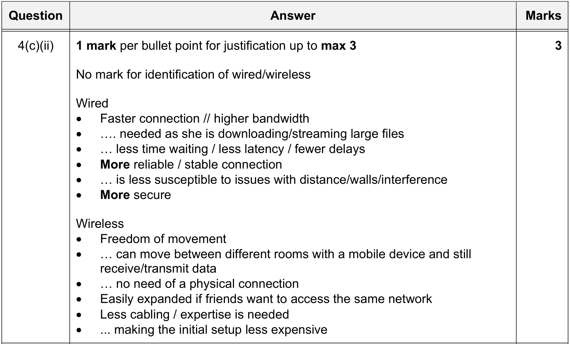
同类 MS（已包含在上图中）：9618 · 2021 May/June · Paper 13 · Q4(c)(ii)；9618 · 2025 Oct/Nov · Paper 13 · Q4(a)；9608 · 2018 Oct/Nov · Paper 13 · Q7(a)
＋ 额外得分点 9618 · 2025 Oct/Nov · Paper 13 · Q4(a)

7.8 Wireless: drawbacks
MS 9618 · 2025 Oct/Nov · Paper 13 · Q4(b)
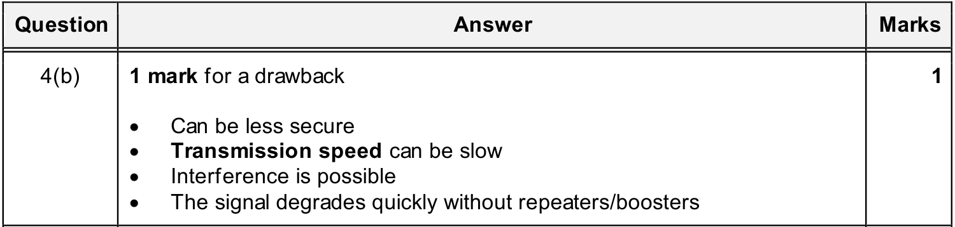
同类 MS（已包含在上图中）：9608 · 2018 Oct/Nov · Paper 13 · Q7(b)

7.9 Why provide both wired and wireless connections (scenario)
题目情景 QP 9618 · 2023 May/June · Paper 13 · Q2(d)
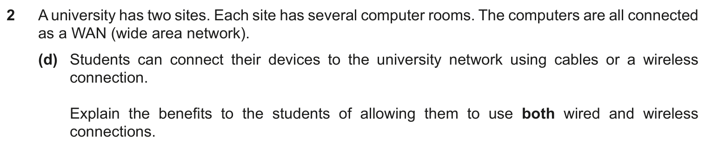
MS 9618 · 2023 May/June · Paper 13 · Q2(d)
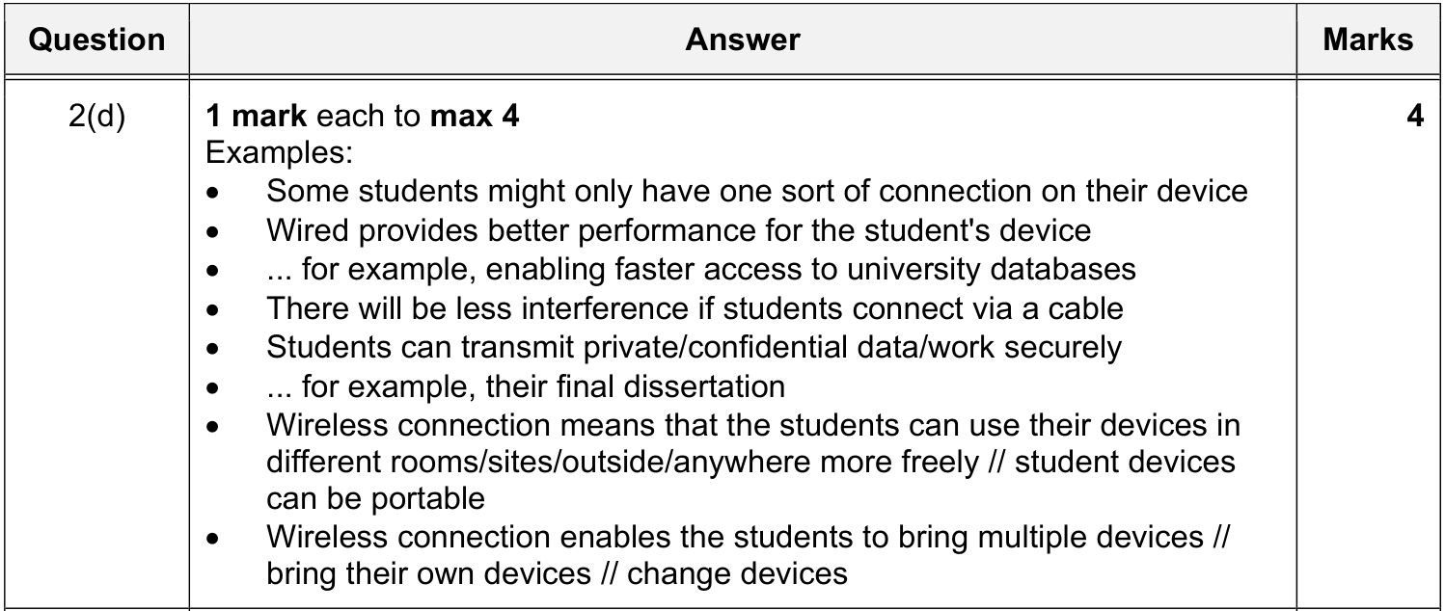

8 Hardware used to support a LAN｜支持 LAN 的硬件

8.1 Router / WNIC / Repeater / WAP (descriptions)
MS 9618 · 2022 May/June · Paper 12 · Q9(a)
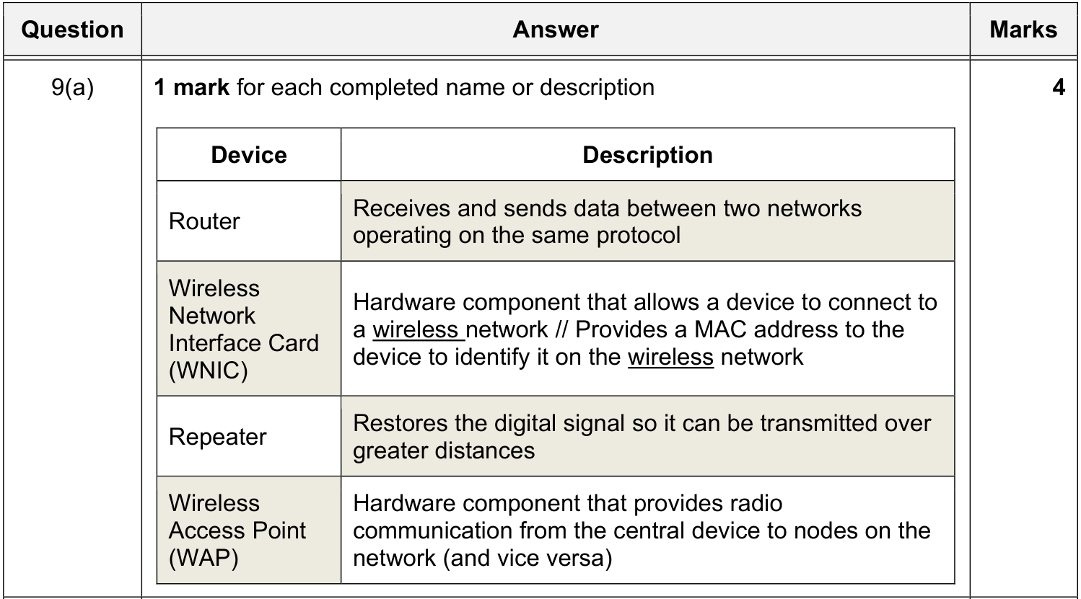

8.2 Switch / WAP / Bridge (purpose)
MS 9618 · 2023 Oct/Nov · Paper 11 · Q2(b)
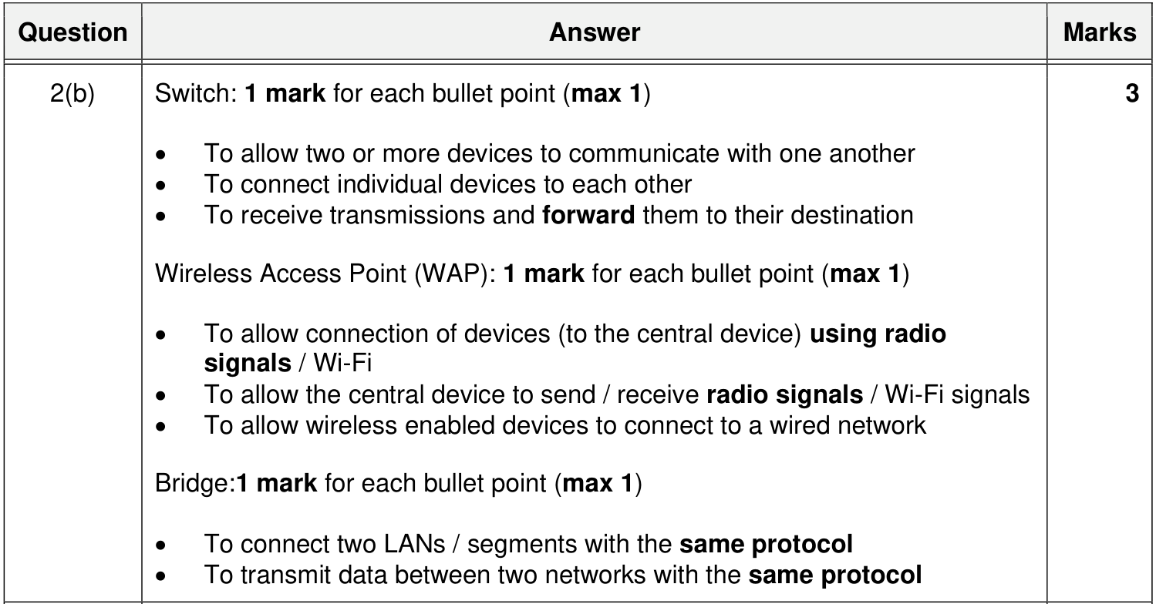

8.3 Switch: functions
MS 9618 · 2025 May/June · Paper 12 · Q6(e)
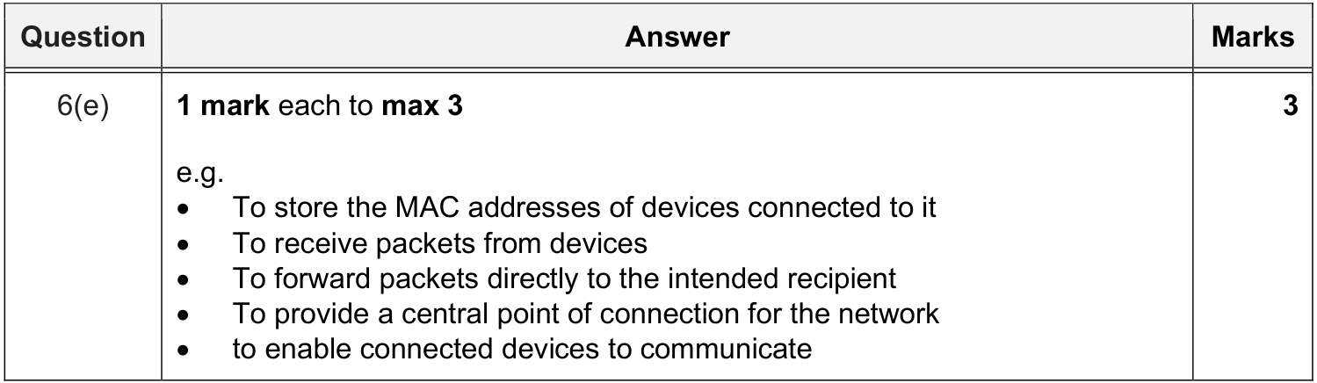

8.4 Server
9618 MS 里没有专门定义 server 的题，下面用 9608 旧考纲补充。
MS 9608 旧考纲 9608 · 2021 May/June · Paper 11 · Q9(b)
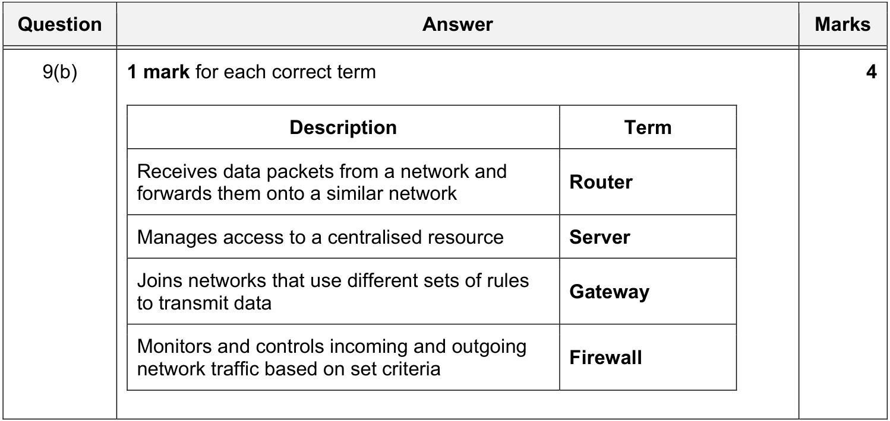
MS 9608 旧考纲 9608 · 2019 May/June · Paper 12 · Q1(d)
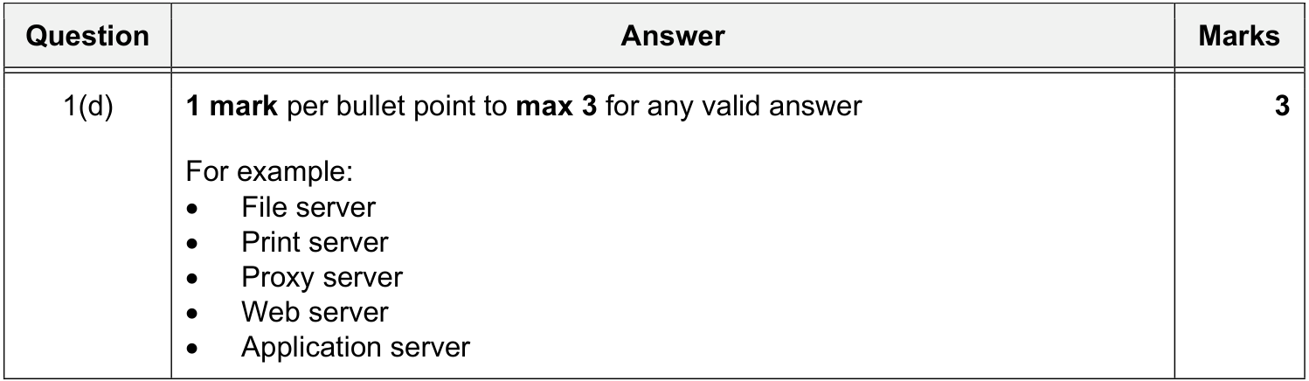
同类 MS（已包含在上图中）：9608 · 2018 May/June · Paper 11 · Q5(a)

8.5 NIC (Network Interface Card)
⚠ 未找到 MS 9618（2021–2026，33 份）和 9608（2015–2021，42 份）Paper 1 的 MS 里，都没有针对这一点的评分点。
原笔记内容（不是 MS 原文，来源可能是课本或自己总结，仅供参考）：
• NIC: Hardware component that allows a device to connect to a wired network

我的笔记：

8.6 WNIC: functions
MS 9618 · 2021 Oct/Nov · Paper 11 · Q8(c)
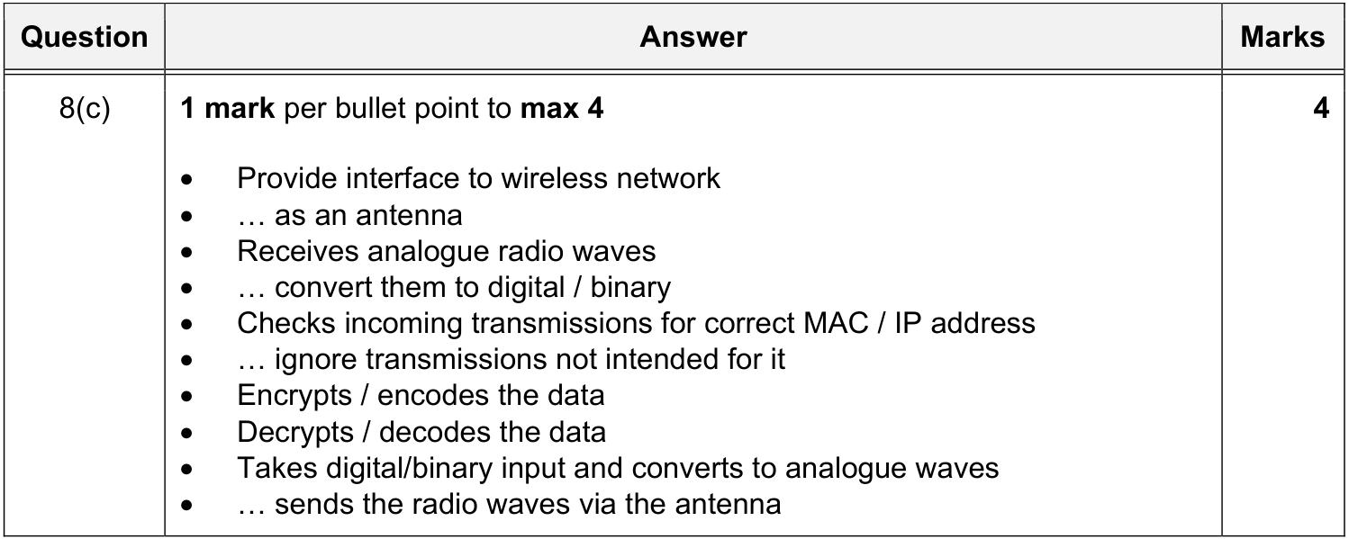
同类 MS（已包含在上图中）：9618 · 2021 Oct/Nov · Paper 13 · Q8(c)

8.7 WAP, cables, bridge, repeater
WAP 见 8.1 与 8.2；bridge 见 8.2；repeater 见 8.1；cables（copper / fibre-optic）见第 7 节。

8.8 Designing a LAN (diagram)
MS 9618 · 2025 May/June · Paper 12 · Q6(d)
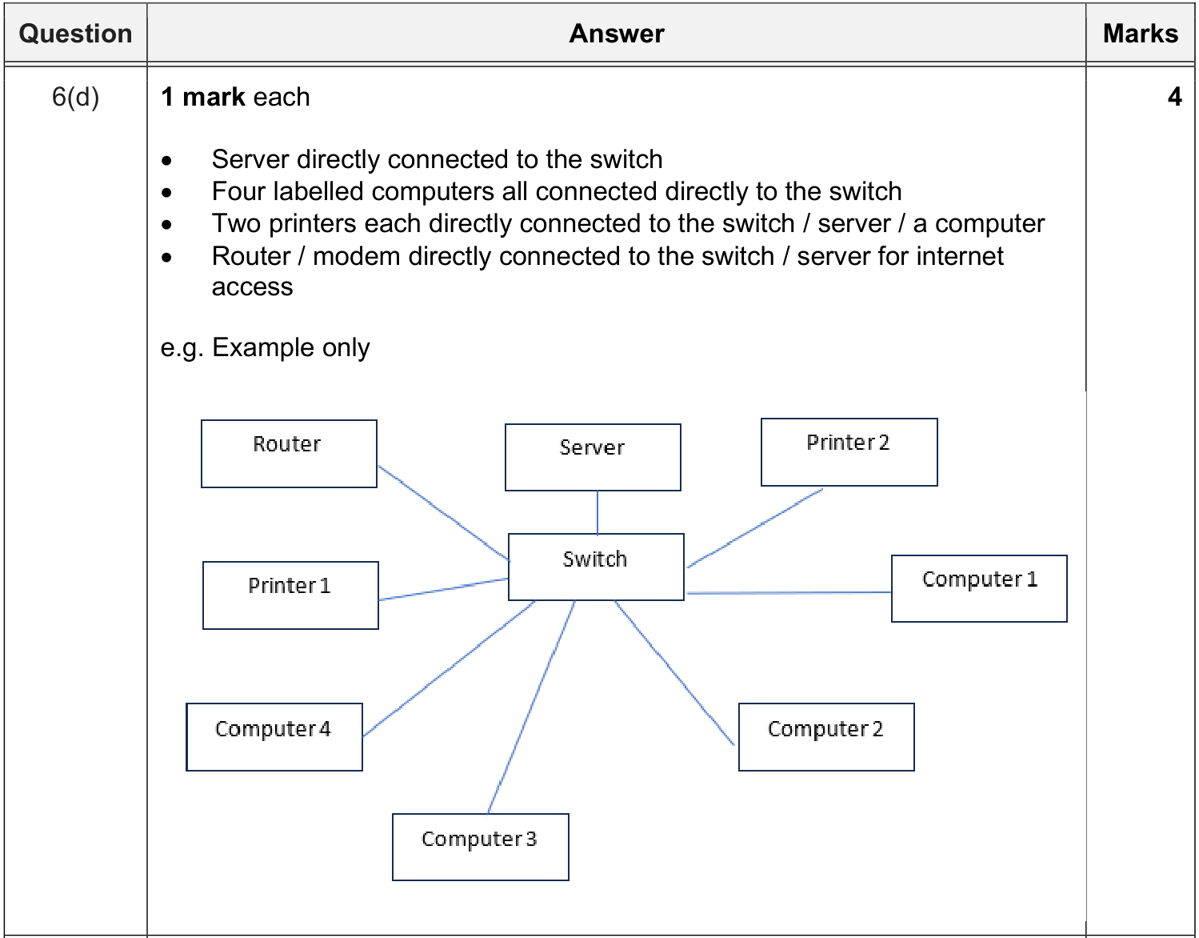

9 Role and function of a router｜路由器的作用与功能

9.1 Functions of a router
MS 9618 · 2022 Oct/Nov · Paper 12 · Q10(b)(ii)
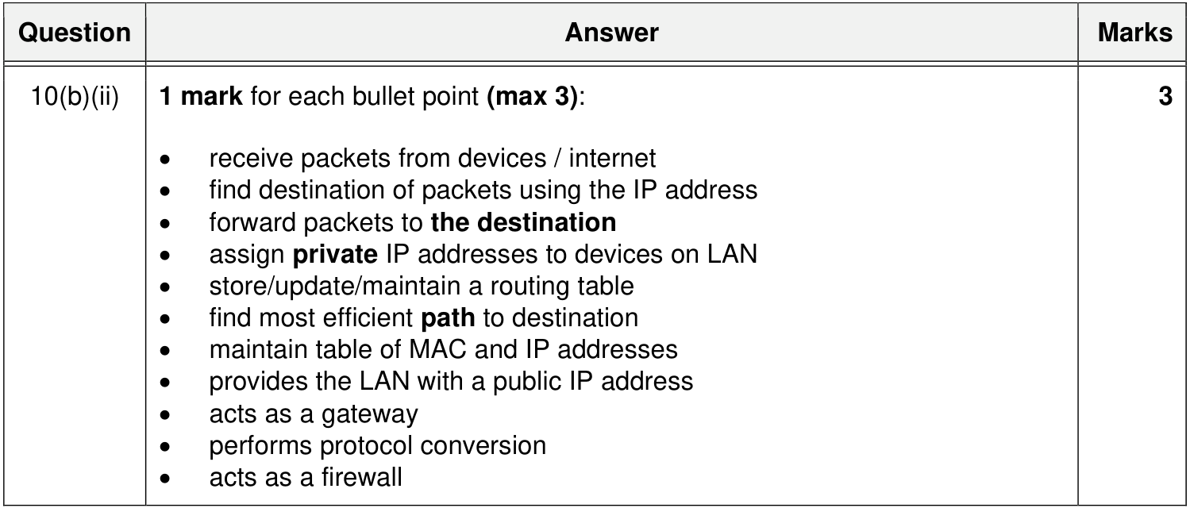
同类 MS（已包含在上图中）：9618 · 2021 Oct/Nov · Paper 12 · Q3(b)(ii)；9618 · 2023 Oct/Nov · Paper 11 · Q2(a)；9618 · 2024 May/June · Paper 12 · Q3(c)(i)；9618 · 2021 May/June · Paper 11 · Q4(c)(i)
＋ 额外得分点 9618 · 2023 Oct/Nov · Paper 11 · Q2(a)
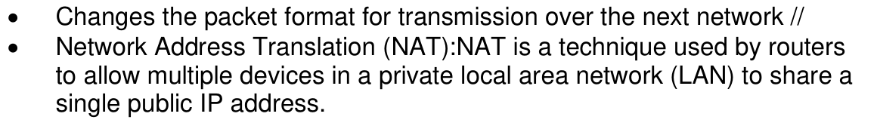

10 Ethernet and CSMA/CD｜以太网与 CSMA/CD

10.1 Ethernet
MS 9618 · 2023 May/June · Paper 12 · Q1(d)
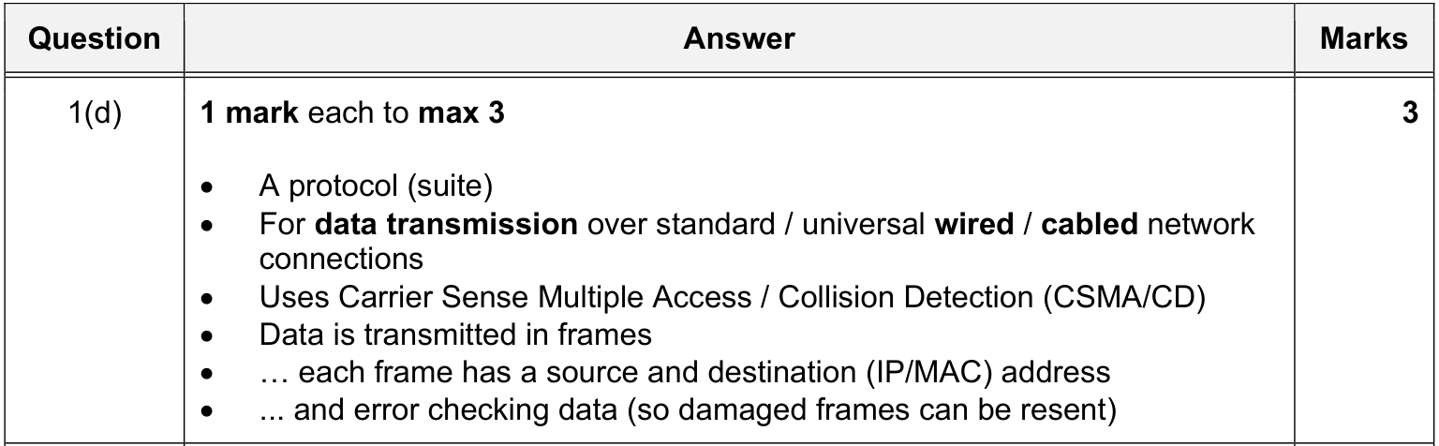
同类 MS（已包含在上图中）：9618 · 2026 May/June · Paper 11 · Q7(b)(i)（见 5.2）

10.2 How CSMA/CD detects and avoids collisions
MS 9618 · 2022 Oct/Nov · Paper 11 · Q8
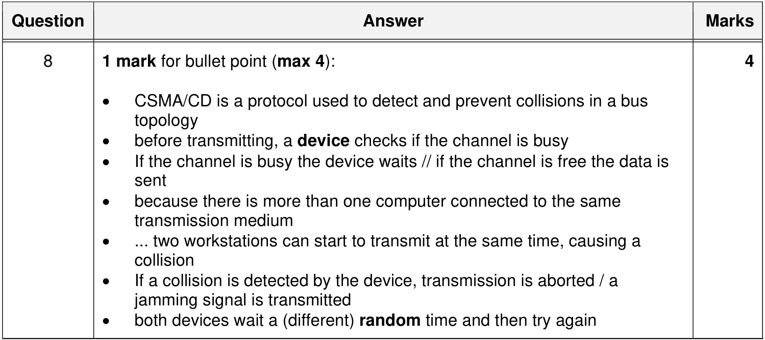
同类 MS（已包含在上图中）：9618 · 2022 May/June · Paper 12 · Q9(c)；9618 · 2023 Oct/Nov · Paper 12 · Q7(c)；9618 · 2024 May/June · Paper 13 · Q5(c)(i)；9618 · 2025 Oct/Nov · Paper 12 · Q5(d)
＋ 额外得分点 9618 · 2025 Oct/Nov · Paper 12 · Q5(d)

10.3 Drawbacks of CSMA/CD
MS 9618 · 2024 May/June · Paper 13 · Q5(c)(ii)
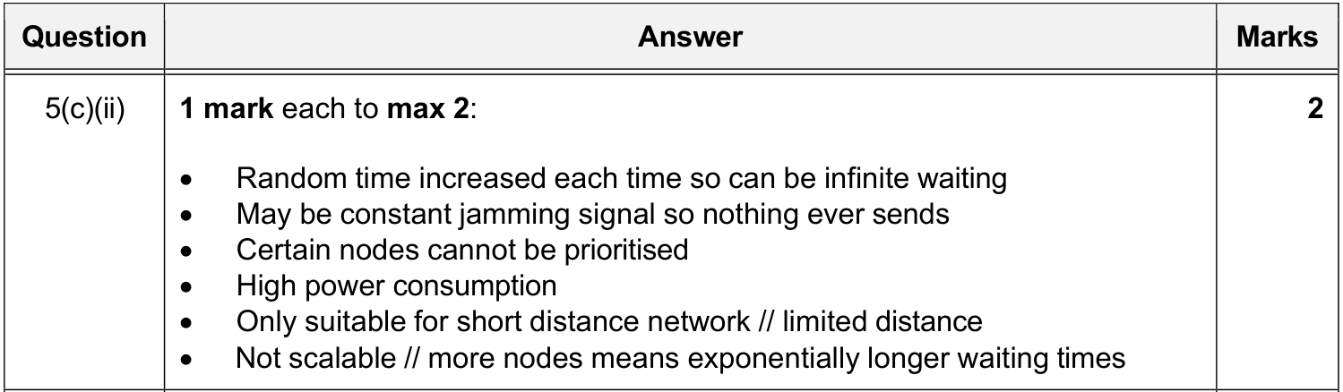

11 Bit streaming｜比特流

11.1 What is bit streaming
MS 9618 · 2024 May/June · Paper 11 · Q2(e)(i)
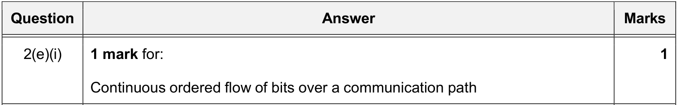
MS 9608 旧考纲 9608 · 2015 Oct/Nov · Paper 11 · Q1(a)
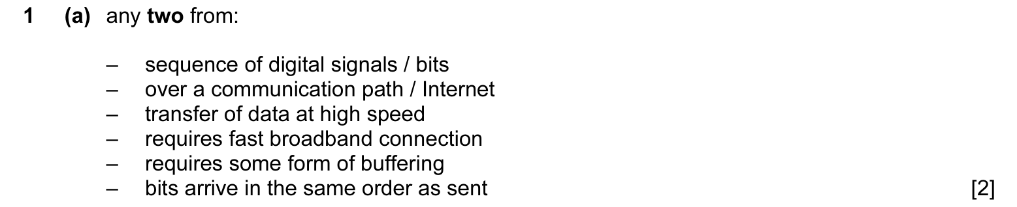
同类 MS（已包含在上图中）：9608 · 2015 Oct/Nov · Paper 13 · Q1(a)

11.2 Real-time vs on-demand: definitions
MS 9608 旧考纲 9608 · 2016 May/June · Paper 13 · Q6(c)
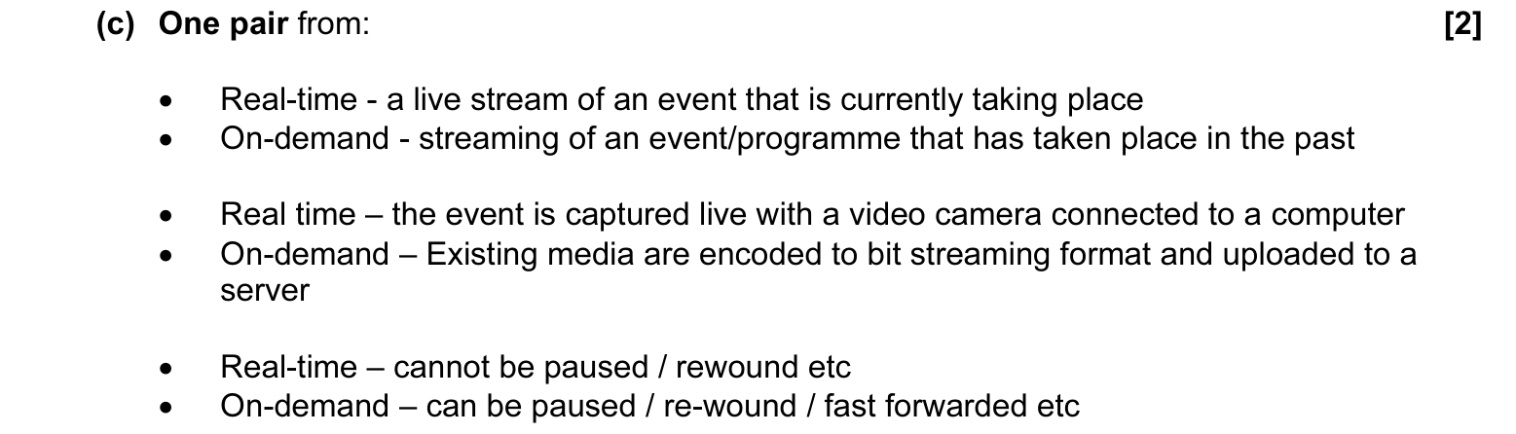

11.3 Real-time vs on-demand: differences
MS 9618 · 2024 May/June · Paper 11 · Q2(e)(ii)
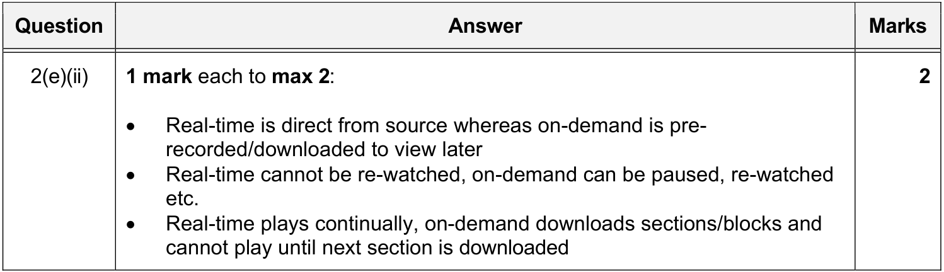

11.4 How real-time bit streaming works
MS 9618 · 2025 May/June · Paper 11 · Q2(a)
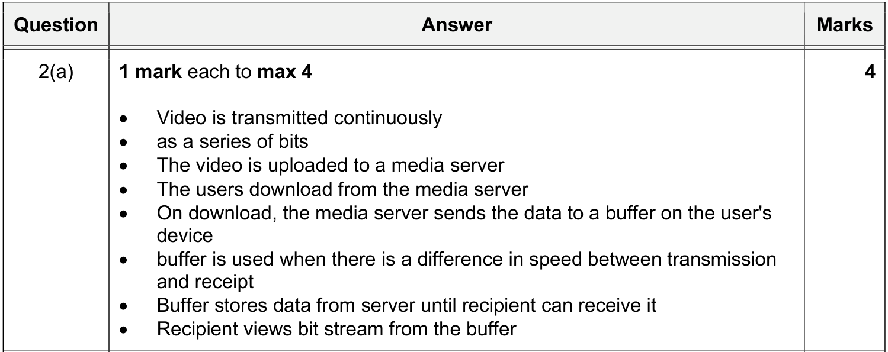
同类 MS（已包含在上图中）：9618 · 2024 Oct/Nov · Paper 13 · Q9(c)；9608 · 2019 Oct/Nov · Paper 12 · Q6(e)(i)
＋ 额外得分点 9618 · 2024 Oct/Nov · Paper 13 · Q9(c)

11.5 How on-demand bit streaming works (and real-time)
9618 MS 里没有讲 on-demand 流程的题，下面用 9608 旧考纲补充。
MS 9608 旧考纲 9608 · 2015 Oct/Nov · Paper 11 · Q1(c)
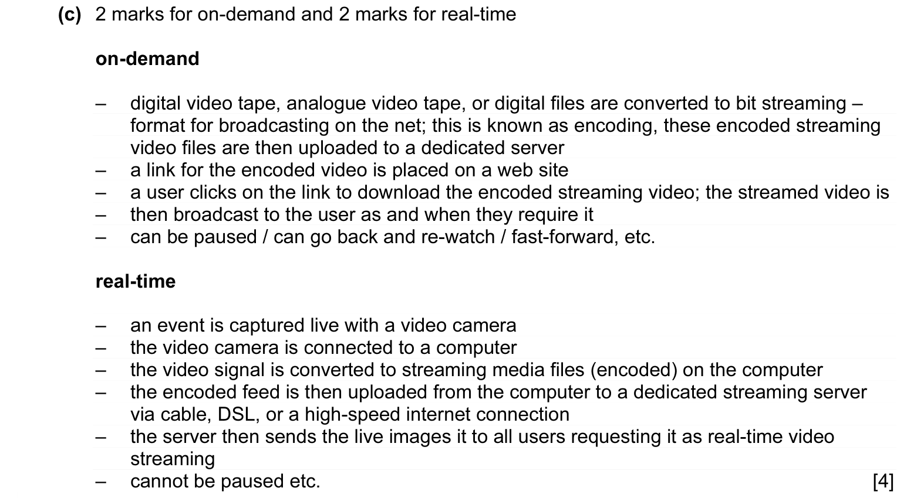
同类 MS（已包含在上图中）：9608 · 2015 Oct/Nov · Paper 13 · Q1(c)

11.6 Benefits and problems of bit streaming
MS 9608 旧考纲 9608 · 2015 Oct/Nov · Paper 11 · Q1(b)(i)
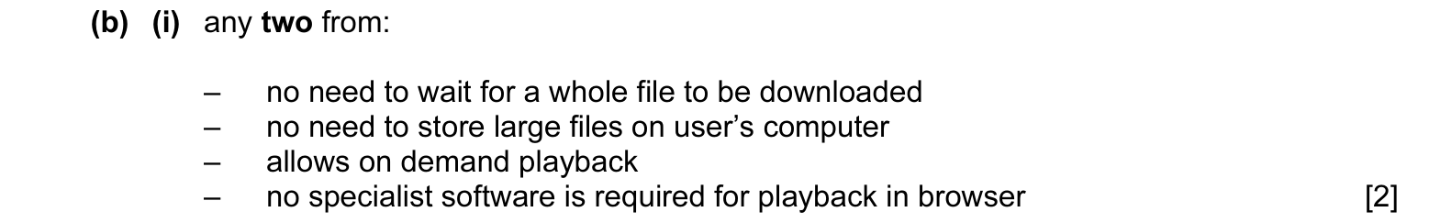
MS 9608 旧考纲 9608 · 2015 Oct/Nov · Paper 11 · Q1(b)(ii)
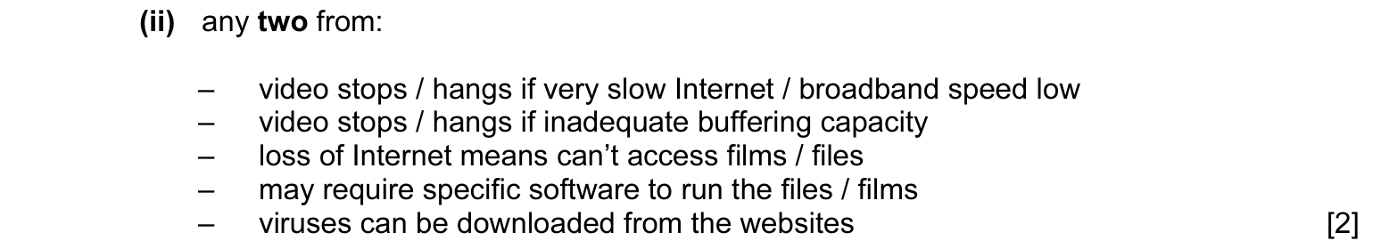

11.7 Importance of bit rate / broadband speed
题目情景 QP 9618 · 2025 May/June · Paper 11 · Q2(b)(i)
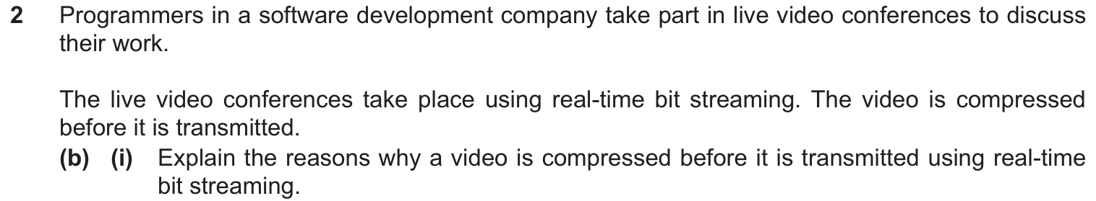
MS 9618 · 2025 May/June · Paper 11 · Q2(b)(i)
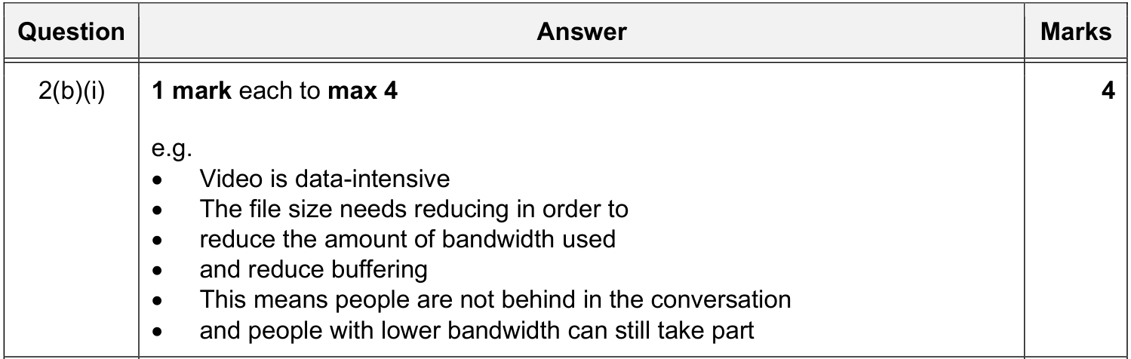
MS 9608 旧考纲 9608 · 2016 Oct/Nov · Paper 11 · Q6
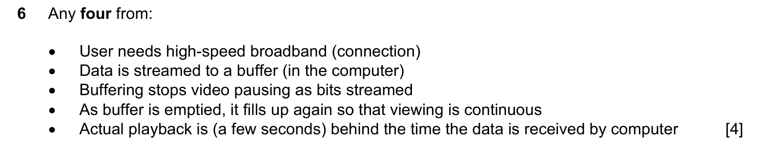
同类 MS（已包含在上图中）：9608 · 2016 Oct/Nov · Paper 13 · Q6
MS 9608 旧考纲 9608 · 2020 Oct/Nov · Paper 11 · Q5(a)(ii)
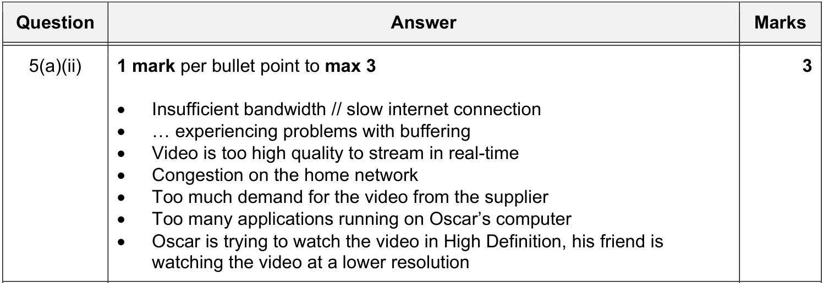

12 The World Wide Web (WWW) and the internet｜WWW 与互联网的区别

12.1 Using the internet and/or the WWW (scenario)
题目情景 QP 9618 · 2021 May/June · Paper 11 · Q4(d)
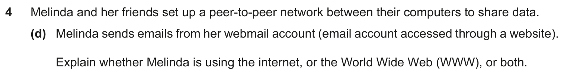
MS 9618 · 2021 May/June · Paper 11 · Q4(d)
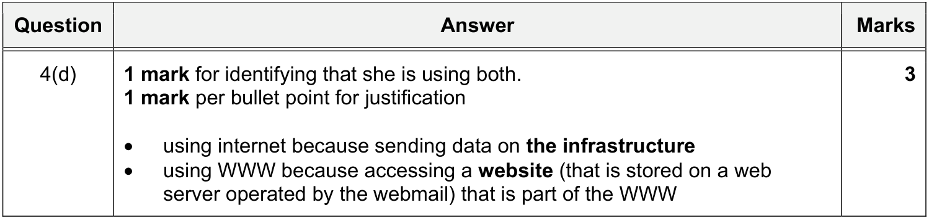
同类 MS（已包含在上图中）：9618 · 2021 May/June · Paper 13 · Q4(d)

12.2 Differences between the WWW and the internet
9618 MS 里没有直接问两者区别的题，下面用 9608 旧考纲补充。
MS 9608 旧考纲 9608 · 2015 May/June · Paper 11 · Q5(b)
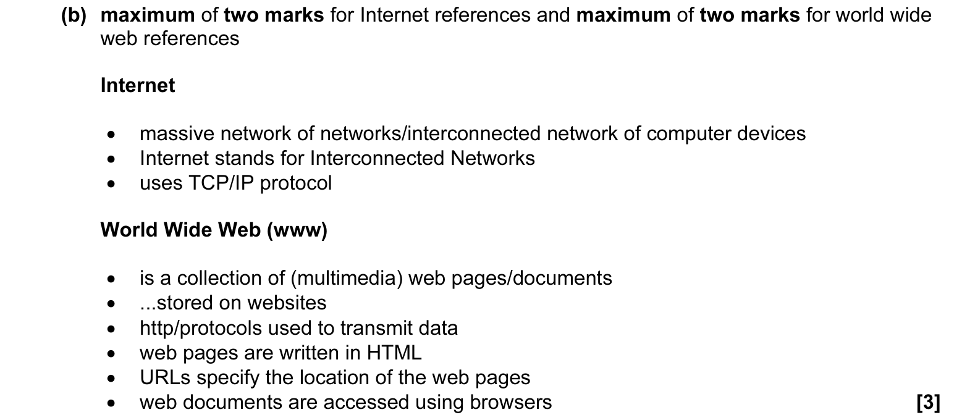
同类 MS（已包含在上图中）：9608 · 2015 May/June · Paper 12 · Q5(b)；9608 · 2016 May/June · Paper 13 · Q6(a)；9608 · 2018 May/June · Paper 11 · Q5(b)
＋ 额外得分点 9608 旧考纲 9608 · 2018 May/June · Paper 11 · Q5(b)

13 Hardware used to support the internet｜支持互联网的硬件

13.1 Modems and dedicated lines
MS 9618 · 2025 May/June · Paper 11 · Q2(c)
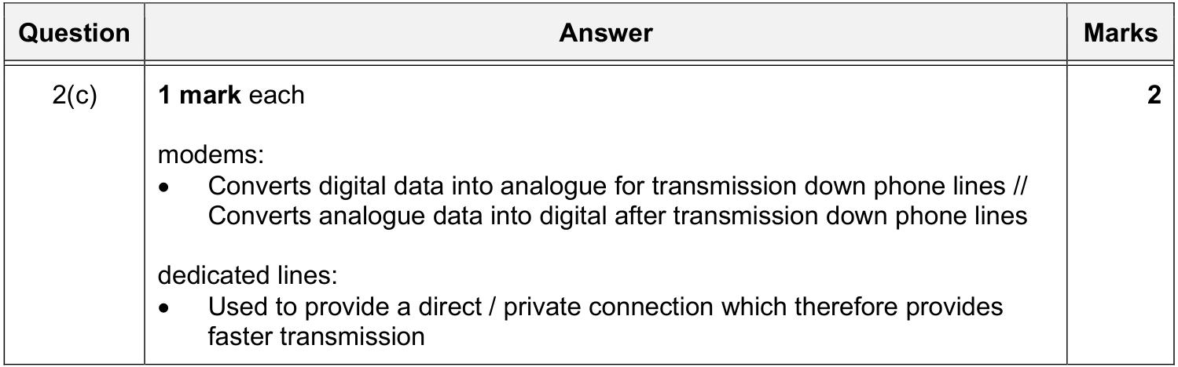

13.2 PSTN
MS 9618 · 2024 May/June · Paper 12 · Q3(c)(ii)
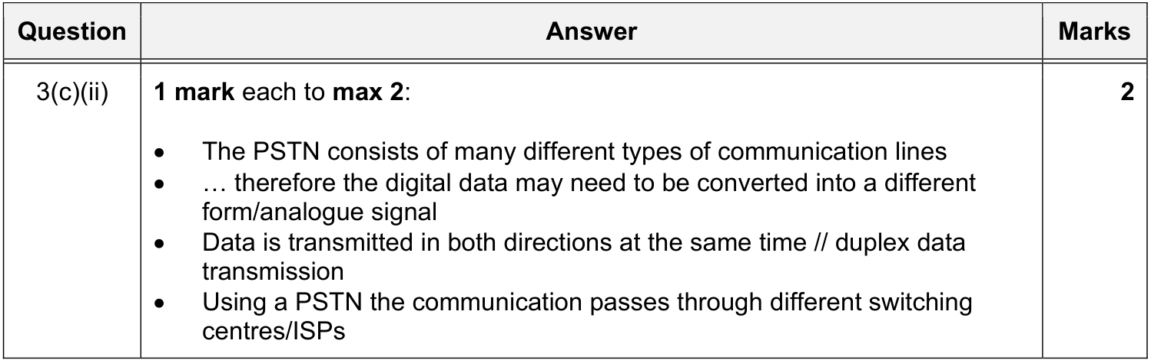
同类 MS（已包含在上图中）：9608 · 2019 May/June · Paper 12 · Q1(b)(i)
MS 9608 旧考纲 9608 · 2015 May/June · Paper 11 · Q5(a)
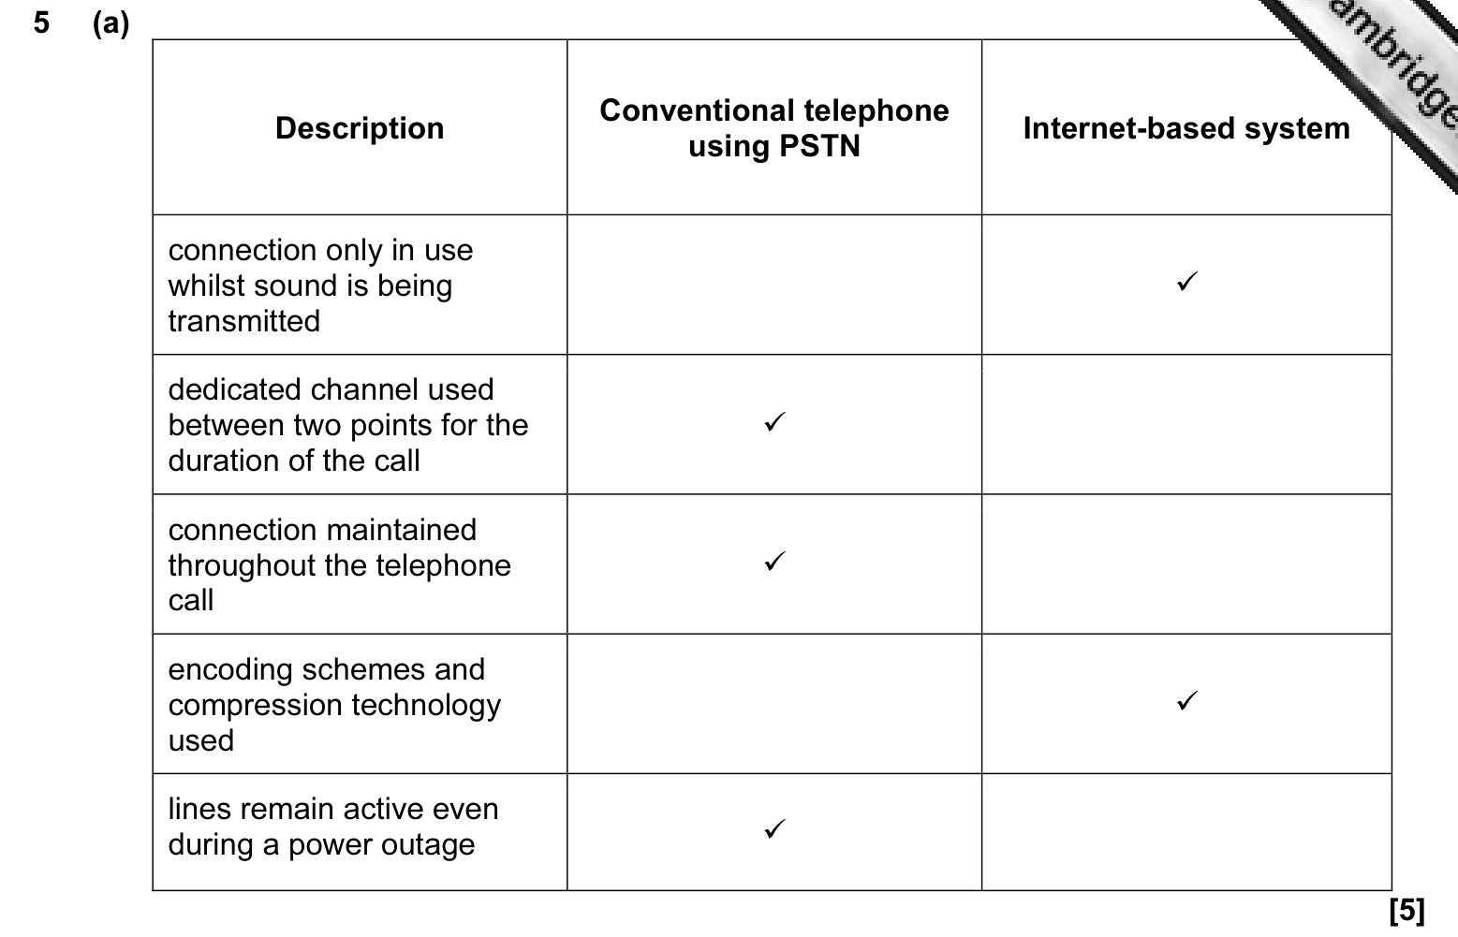
同类 MS（已包含在上图中）：9608 · 2015 May/June · Paper 12 · Q5(a)

13.3 Dedicated lines: benefit and drawback
MS 9608 旧考纲 9608 · 2019 May/June · Paper 12 · Q1(b)(ii)
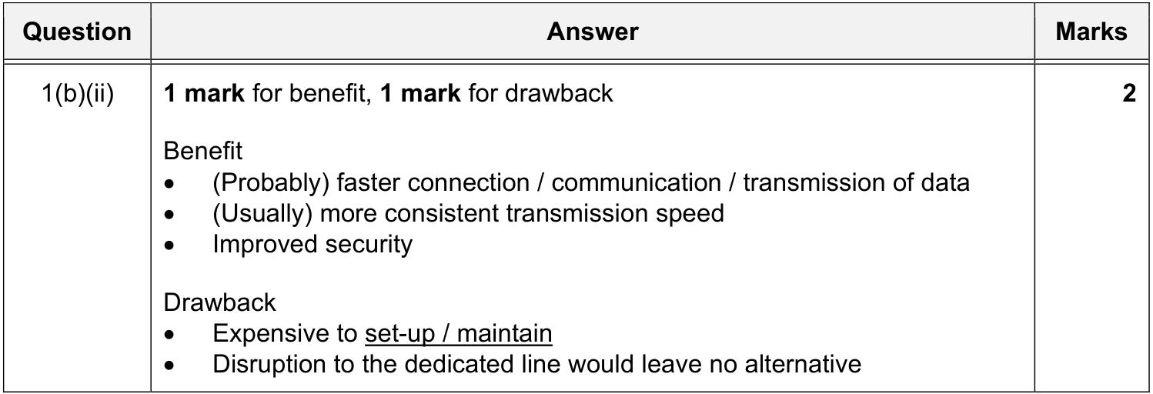

13.4 Cell phone network
MS 9618 · 2025 May/June · Paper 12 · Q6(b)
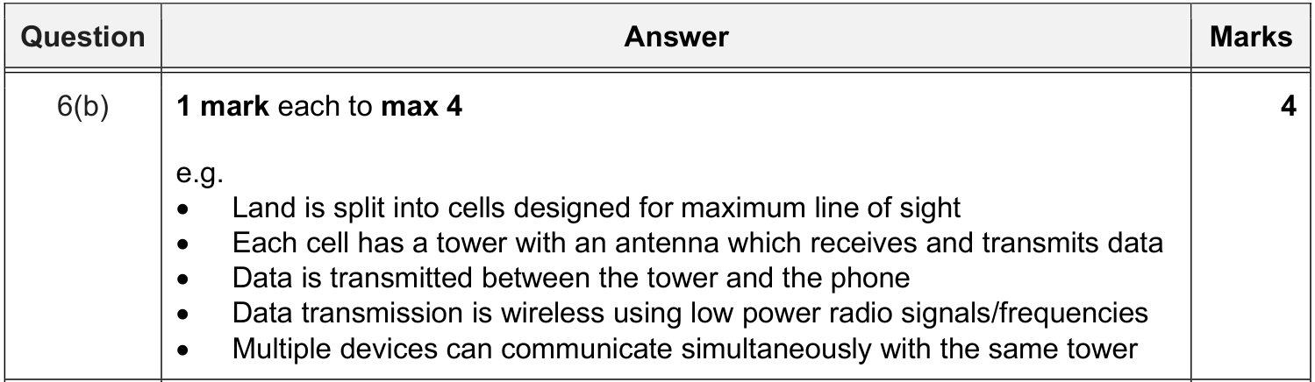

13.5 Ways to connect to the internet (dedicated line / cell phone network / satellite)
MS 9608 旧考纲 9608 · 2020 Oct/Nov · Paper 13 · Q4(b)
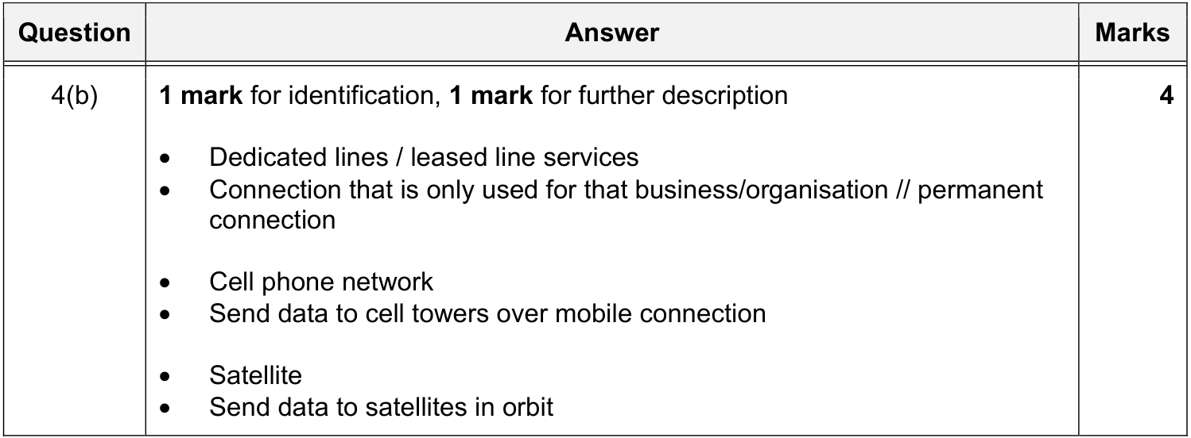
同类 MS（已包含在上图中）：9608 · 2021 Oct/Nov · Paper 12 · Q3(a)

14 IP addresses｜IP 地址

14.1 Format of IPv4 and IPv6
MS 9618 · 2025 May/June · Paper 12 · Q6(c)
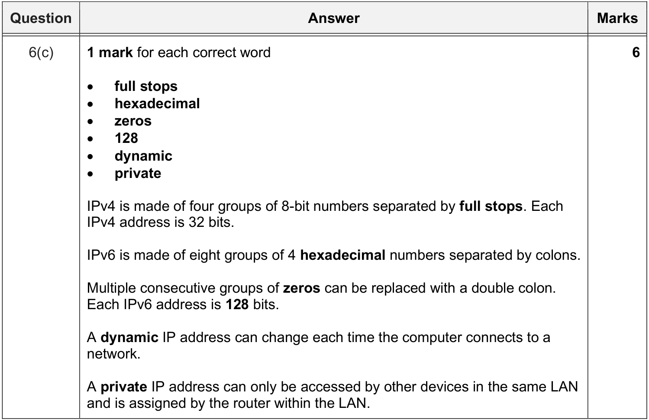
同类 MS（已包含在上图中）：9618 · 2024 May/June · Paper 11 · Q8(b)(ii)；9618 · 2023 May/June · Paper 11 · Q4(d)(i)；9618 · 2023 Oct/Nov · Paper 12 · Q7(a)
＋ 额外得分点 9618 · 2024 May/June · Paper 11 · Q8(b)(ii)
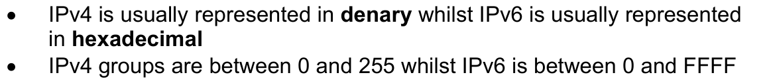
＋ 额外得分点 9618 · 2023 May/June · Paper 11 · Q4(d)(i)
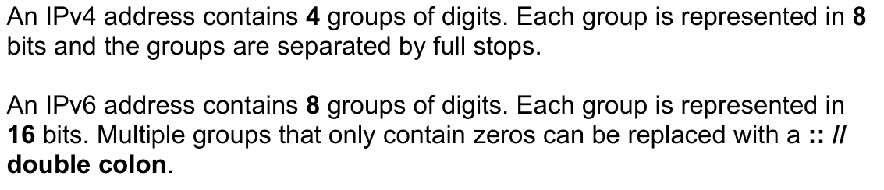

14.2 Valid or invalid IP address (application)
题目情景 QP 9618 · 2025 Oct/Nov · Paper 11 · Q7(b)
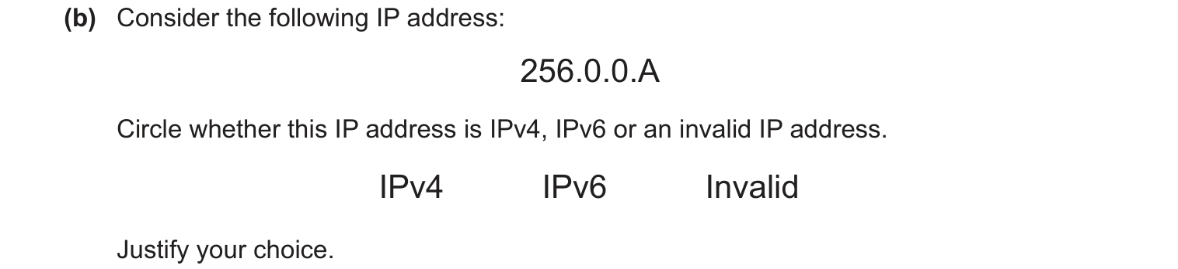
MS 9618 · 2025 Oct/Nov · Paper 11 · Q7(b)
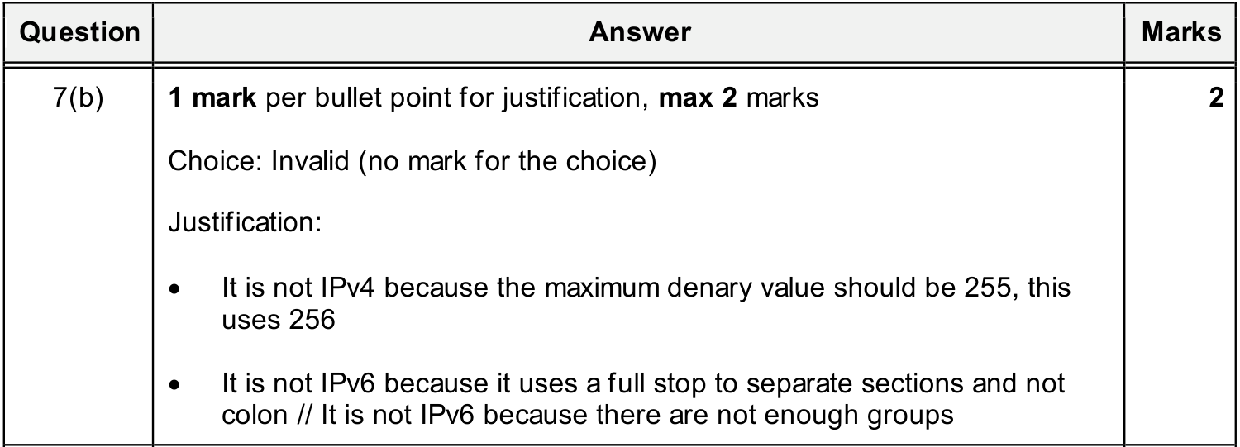

14.3 How an IP address is associated with a device
MS 9618 · 2024 May/June · Paper 11 · Q8(b)(i)
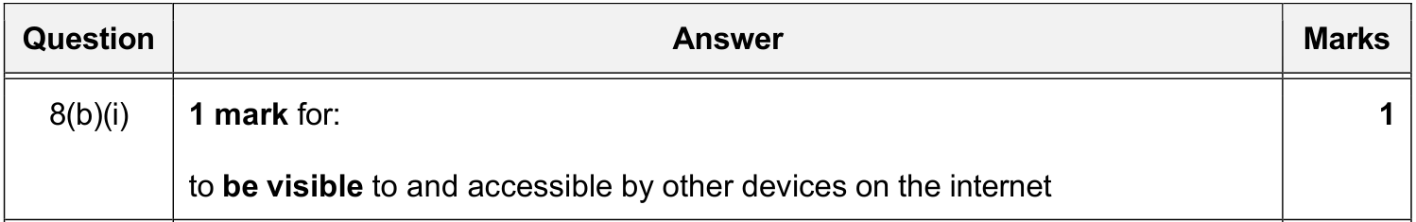
MS 9618 · 2024 Oct/Nov · Paper 13 · Q9(d)(i)
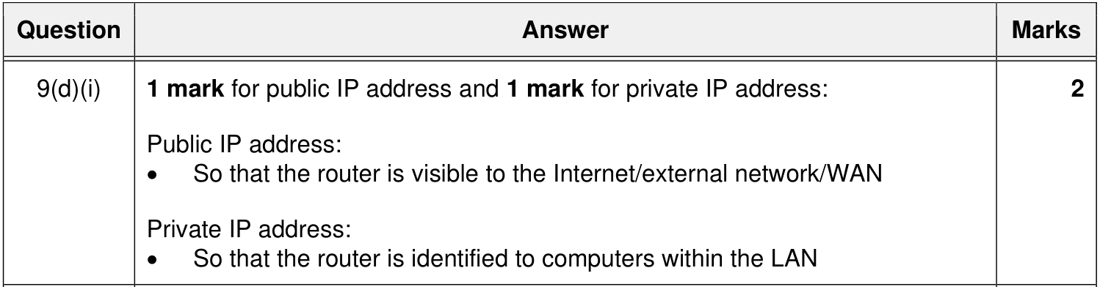
9618 MS 只考过 public IP 的用途，下面用 9608 旧考纲补充 IP 地址本身的作用。
MS 9608 旧考纲 9608 · 2018 Oct/Nov · Paper 12 · Q2(b)
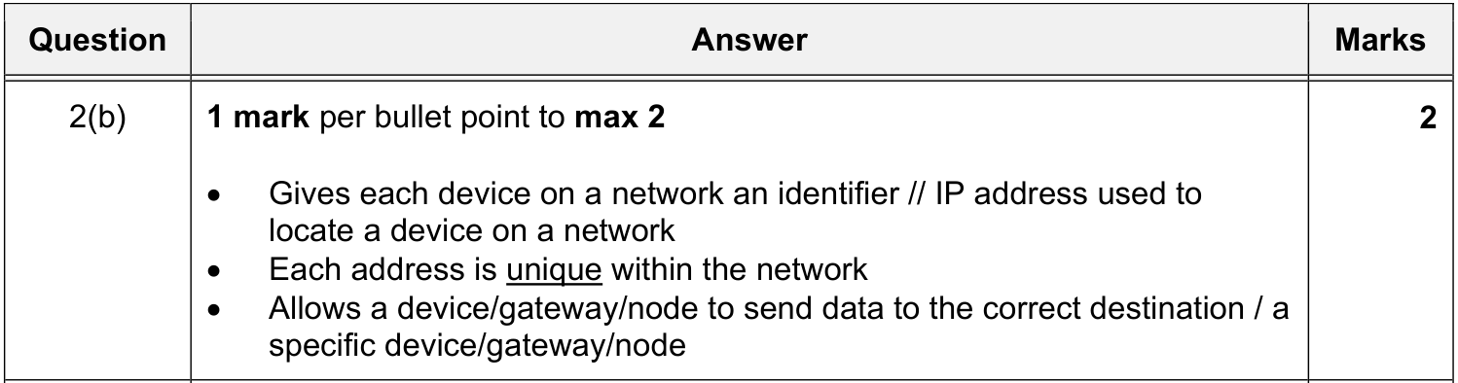
MS 9608 旧考纲 9608 · 2020 Oct/Nov · Paper 11 · Q8(a)
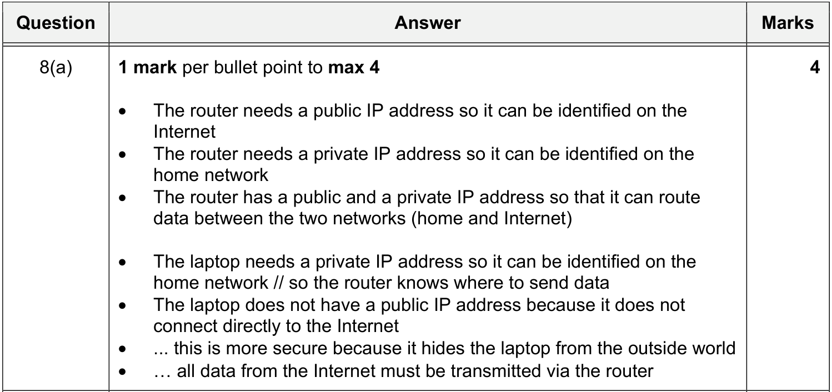
同类 MS（已包含在上图中）：9608 · 2020 Oct/Nov · Paper 13 · Q4(a)(i)；9608 · 2020 Oct/Nov · Paper 13 · Q4(a)(ii)

14.4 Public / private / static / dynamic IP addresses: definitions
MS 9618 · 2023 Oct/Nov · Paper 12 · Q7(d)
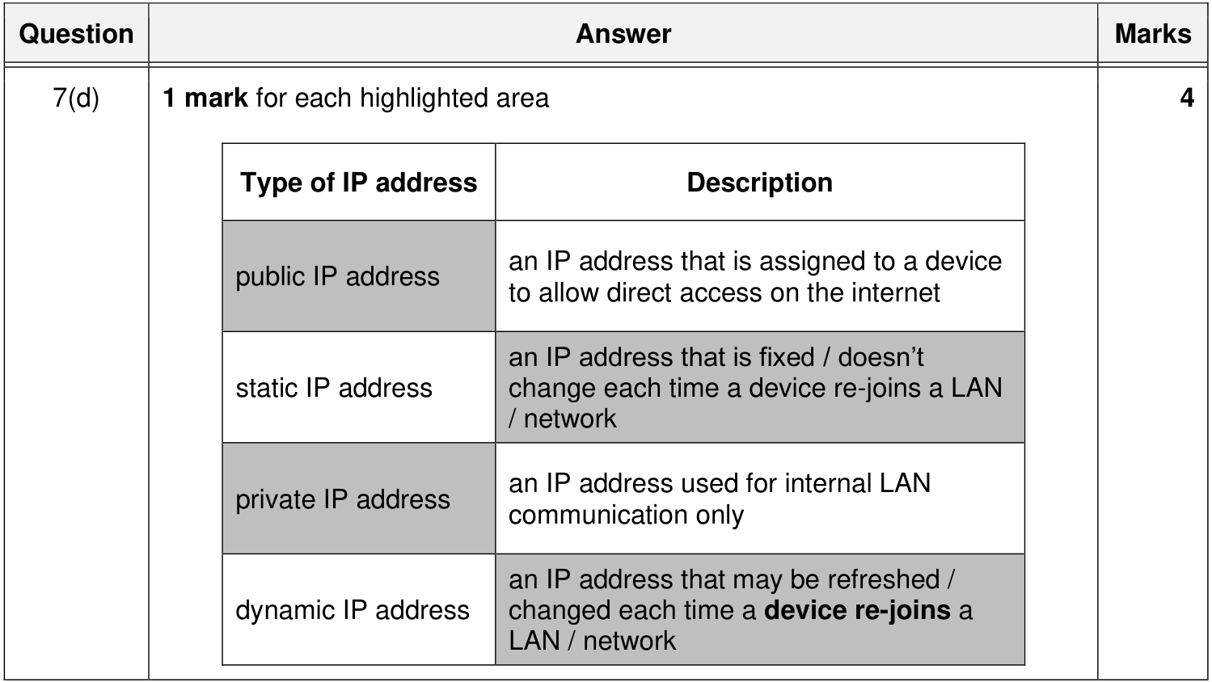
同类 MS（已包含在上图中）：9618 · 2025 Oct/Nov · Paper 11 · Q7(a)；9618 · 2024 May/June · Paper 13 · Q5(d)；9618 · 2026 May/June · Paper 11 · Q7(c)(i)

14.5 Public vs private IP: differences and implications for security
9618 MS 里没有专门比较 public 与 private IP 的题，下面用 9608 旧考纲补充。
MS 9608 旧考纲 9608 · 2016 May/June · Paper 11 · Q7(c)
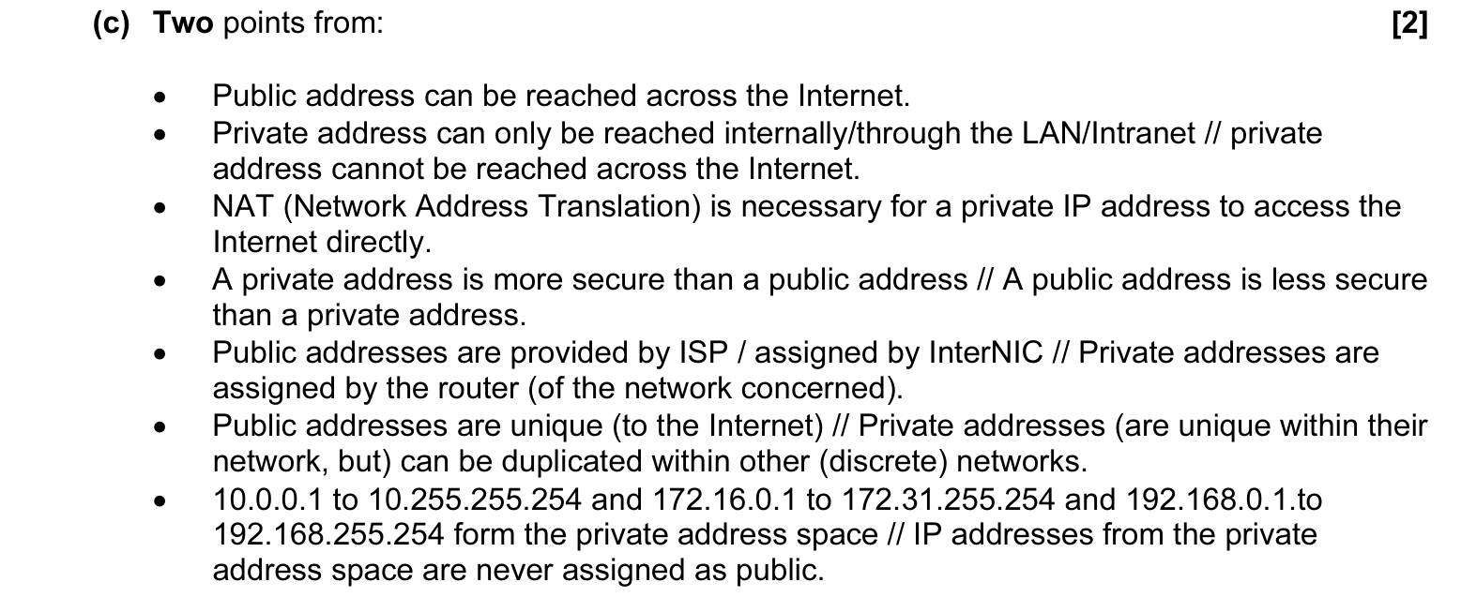
同类 MS（已包含在上图中）：9608 · 2016 May/June · Paper 12 · Q7(c)；9608 · 2021 May/June · Paper 11 · Q9(a)；9608 · 2021 Oct/Nov · Paper 13 · Q3(a)；9608 · 2018 Oct/Nov · Paper 13 · Q4(c)；9608 · 2018 Oct/Nov · Paper 11 · Q2(b)(ii)
＋ 额外得分点 9608 旧考纲 9608 · 2021 Oct/Nov · Paper 13 · Q3(a)
＋ 额外得分点 9608 旧考纲 9608 · 2021 Oct/Nov · Paper 13 · Q3(a)
MS 9608 旧考纲 9608 · 2020 May/June · Paper 13 · Q1(c)
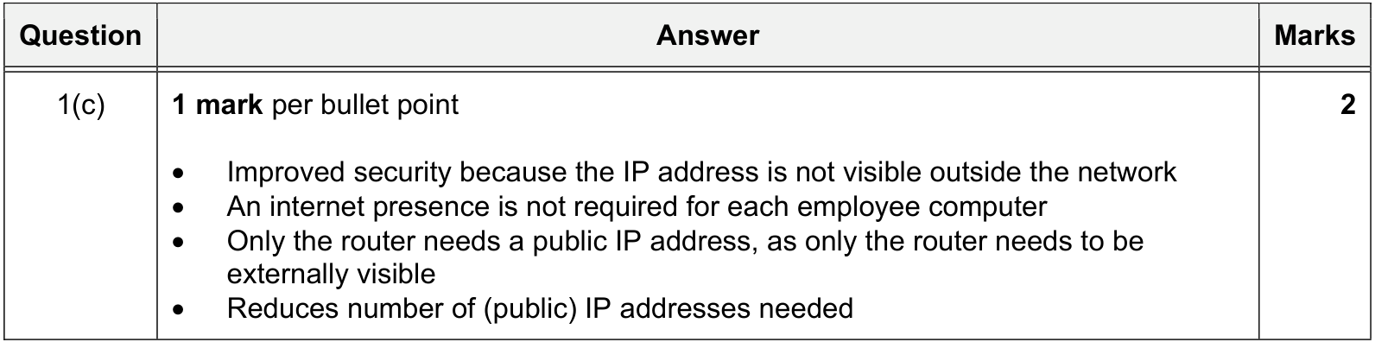

14.6 Static vs dynamic IP: why a server uses a static IP
MS 9608 旧考纲 9608 · 2020 Oct/Nov · Paper 12 · Q7(b)
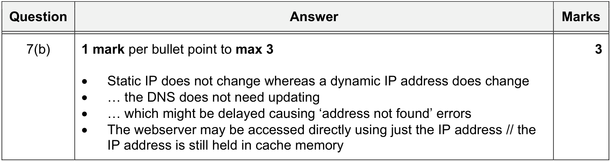

14.7 Subnetting: purpose
MS 9618 · 2024 Oct/Nov · Paper 13 · Q9(d)(ii)
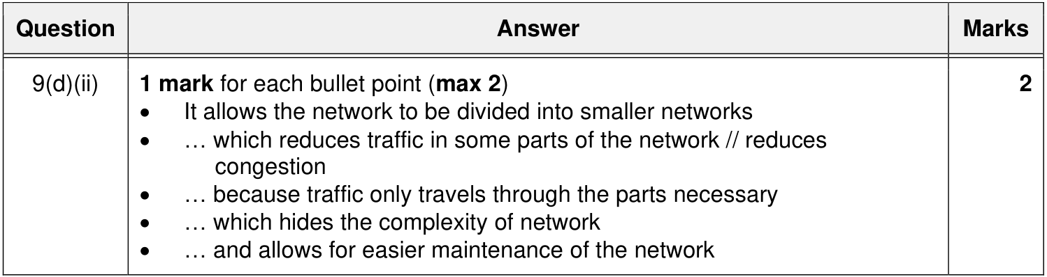

14.8 Subnetting: benefits / why it is used
MS 9618 · 2023 Oct/Nov · Paper 12 · Q7(b)(iii)
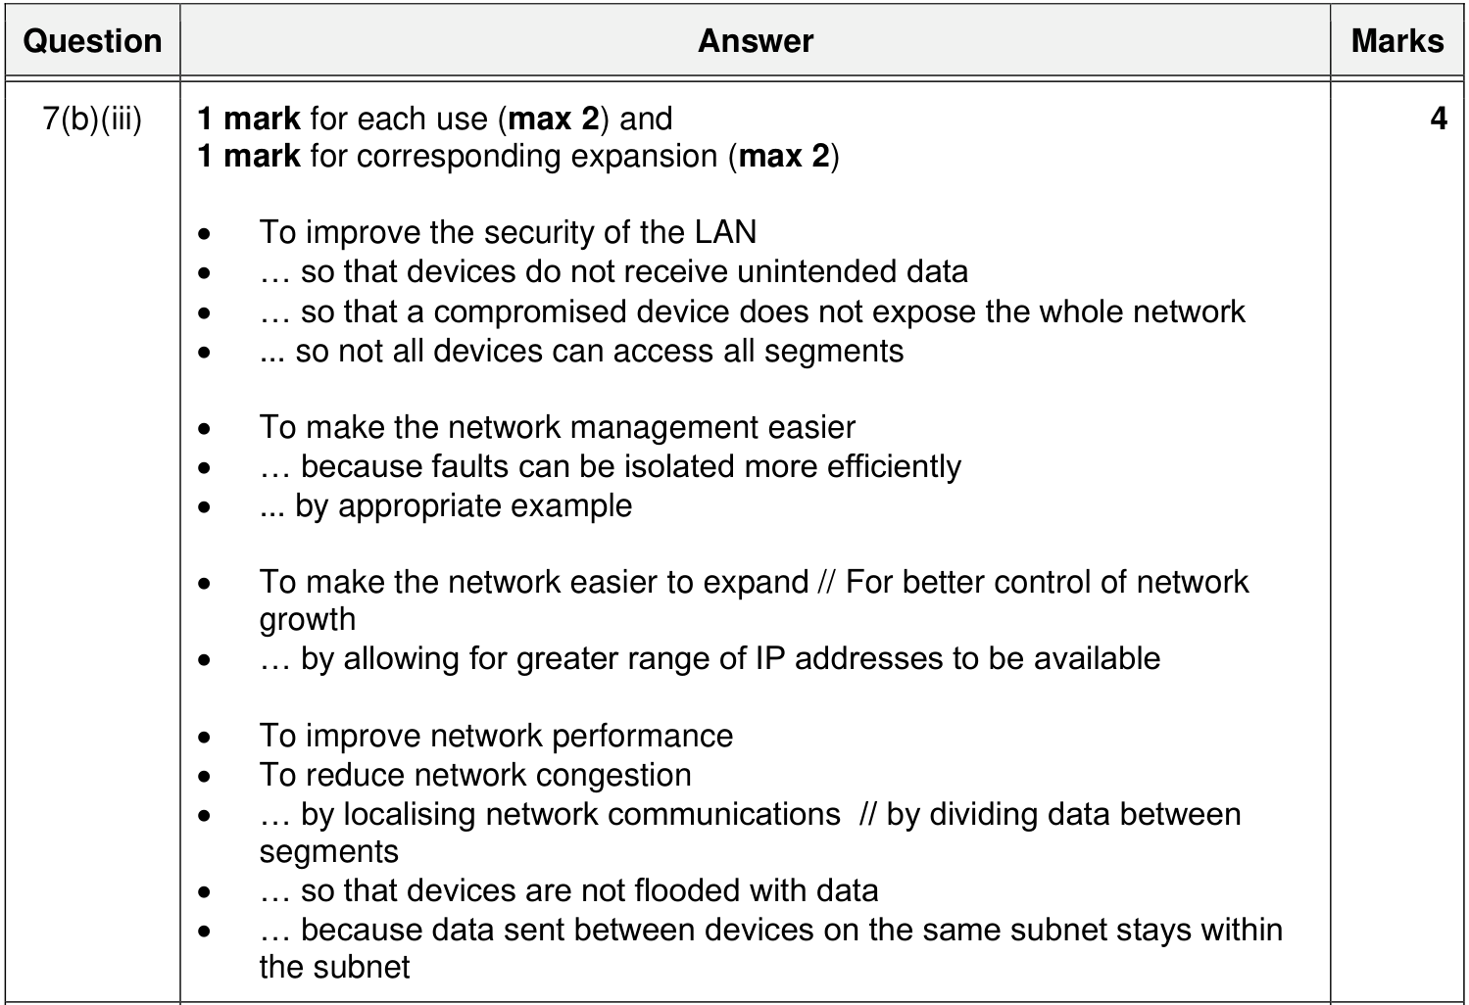
同类 MS（已包含在上图中）：9618 · 2023 May/June · Paper 11 · Q4(d)(ii)；9618 · 2026 May/June · Paper 11 · Q7(c)(ii)；9618 · 2022 Oct/Nov · Paper 13 · Q7(c)(i)
＋ 额外得分点 9618 · 2026 May/June · Paper 11 · Q7(c)(ii)
＋ 额外得分点 9618 · 2023 May/June · Paper 11 · Q4(d)(ii)
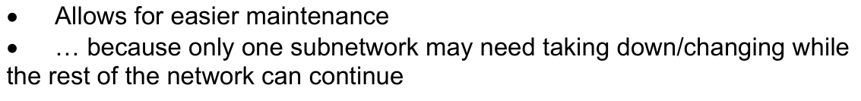

14.9 Subnetting: network ID and host ID
MS 9618 · 2023 May/June · Paper 13 · Q2(e)
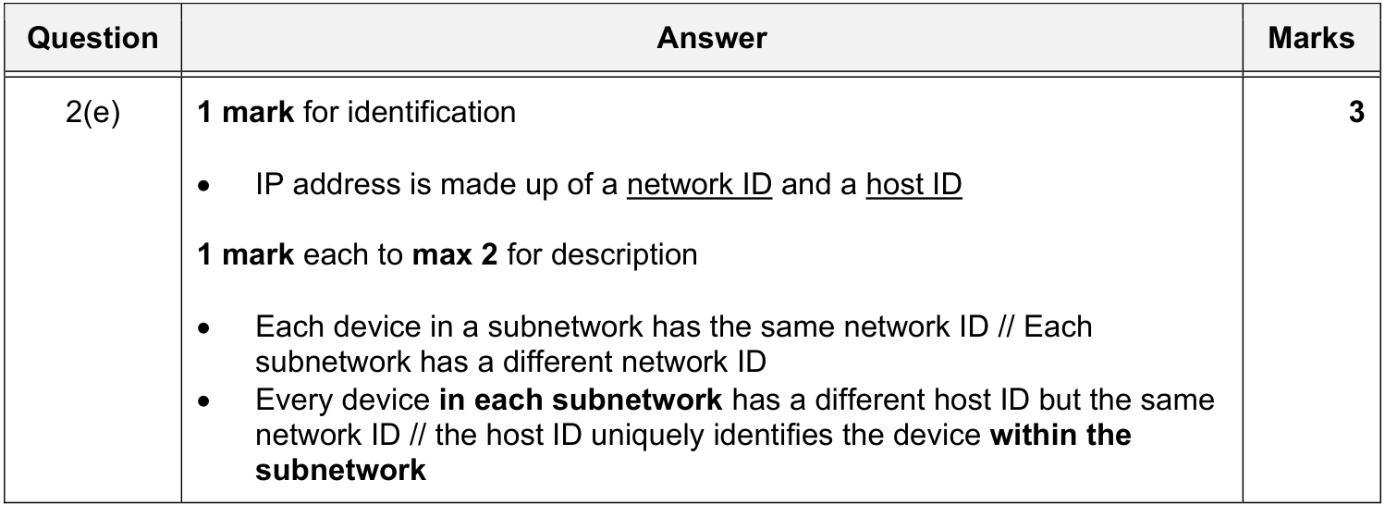
题目情景 QP 9618 · 2022 Oct/Nov · Paper 13 · Q7(c)(ii)
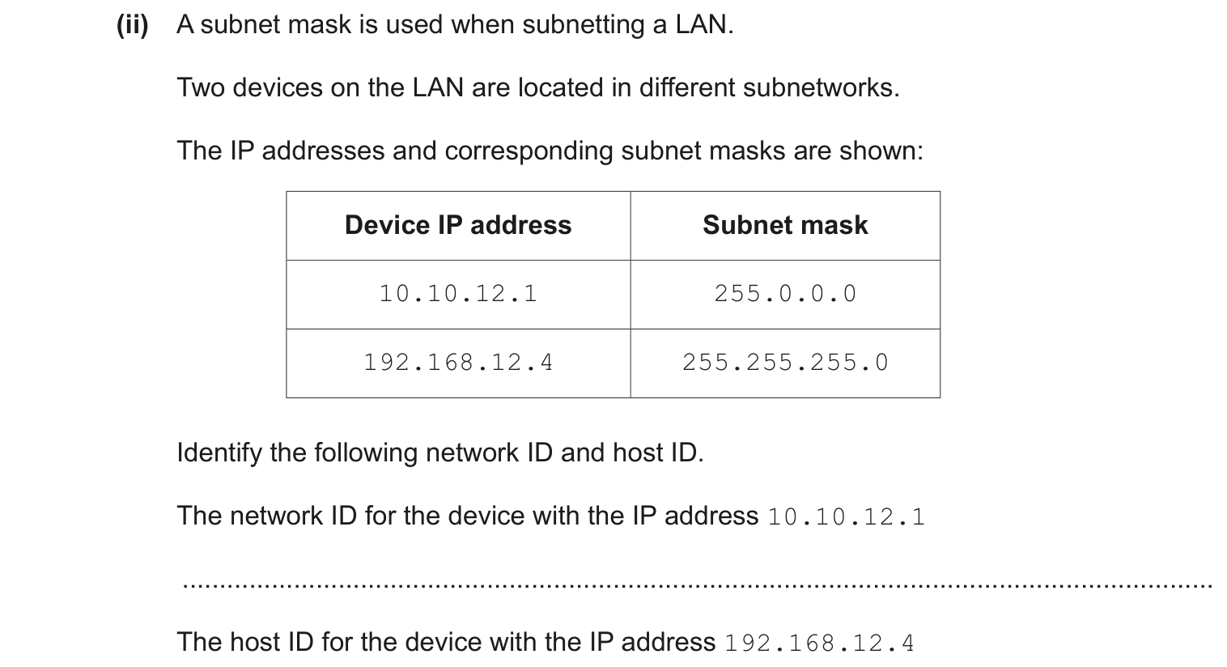
MS 9618 · 2022 Oct/Nov · Paper 13 · Q7(c)(ii)
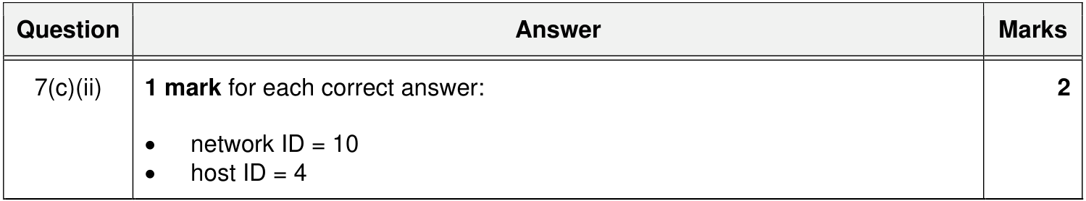

15 URL and DNS｜URL 与 DNS

15.1 How a web browser uses a URL to access a web page
MS 9618 · 2025 Oct/Nov · Paper 11 · Q7(c)
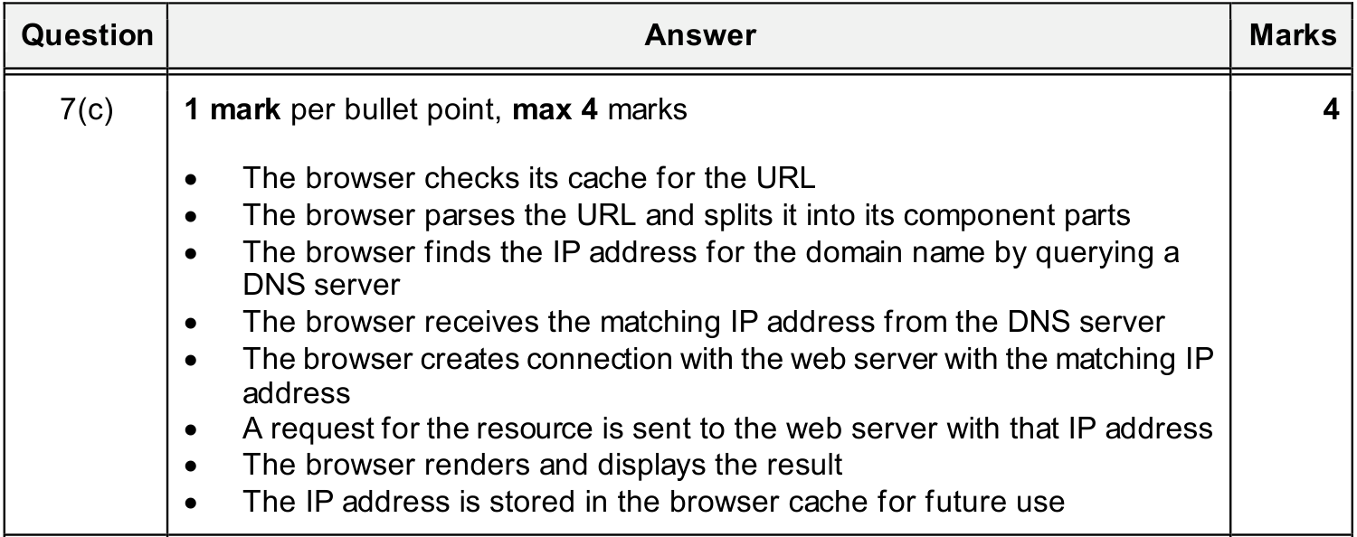

15.2 What a URL is and the role of DNS
9618 MS 里没有专门定义 URL、讲 DNS 解析过程的题，下面用 9608 旧考纲补充。
MS 9608 旧考纲 9608 · 2015 Oct/Nov · Paper 12 · Q9(b)
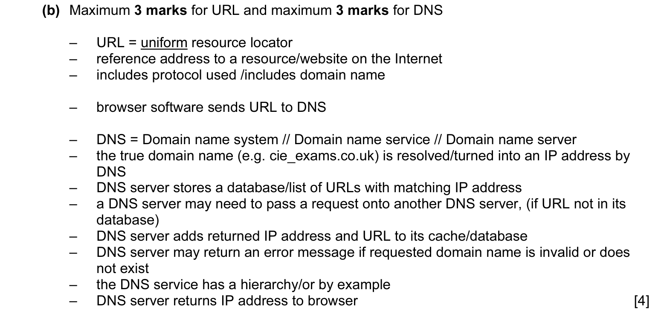
同类 MS（已包含在上图中）：9608 · 2016 May/June · Paper 13 · Q6(e)；9608 · 2017 May/June · Paper 11 · Q7(b)；9608 · 2019 May/June · Paper 11 · Q1(b)；9608 · 2020 Oct/Nov · Paper 11 · Q8(b)；9608 · 2021 Oct/Nov · Paper 13 · Q3(b)

15.3 Domain name and IP address
MS 节选 9608 旧考纲 9608 · 2021 May/June · Paper 13 · Q6(b)
MS 节选 9608 旧考纲 9608 · 2021 May/June · Paper 13 · Q6(b)

附录 MS 来源索引（按场次）
列出本笔记用到的每份 MS 及对应知识点编号，方便回查原卷。
场次 · 卷号 | 题号 → 知识点（用途）
9618 · 2021 May/June · Paper 11 | Q4(a) → 3.4（主图）；Q4(b) → 3.6（主图）；Q4(c)(ii) → 7.7（主图）；Q4(c)(i) → 9.1（同类）；Q4(d) → 12.1（主图）
9618 · 2021 May/June · Paper 12 | Q5(c)(i) → 6.5（主图）；Q5(c)(ii) → 6.6（同类）
9618 · 2021 May/June · Paper 13 | Q4(a) → 3.4（同类）；Q4(b) → 3.6（同类）；Q4(c)(ii) → 7.7（同类）；Q4(d) → 12.1（同类）
9618 · 2021 Oct/Nov · Paper 11 | Q8(a) → 2.4（主图）；Q8(c) → 8.6（主图）
9618 · 2021 Oct/Nov · Paper 12 | Q3(b)(i) → 5.5（主图）；Q3(b)(ii) → 9.1（同类）
9618 · 2021 Oct/Nov · Paper 13 | Q8(a) → 2.4（同类）；Q8(c) → 8.6（同类）
9618 · 2022 May/June · Paper 12 | Q9(b) → 7.3（主图）；Q9(a) → 8.1（主图）；Q9(c) → 10.2（同类）
9618 · 2022 May/June · Paper 13 | Q8(a) → 6.1（主图）；Q8(b) → 6.2（主图）；Q8(c) → 6.5（同类）；Q8(c) → 6.5（额外得分点）；Q8(c) → 6.6（同类）
9618 · 2022 Oct/Nov · Paper 11 | Q8 → 10.2（主图）
9618 · 2022 Oct/Nov · Paper 12 | Q10(a) → 5.5（同类）；Q10(b)(ii) → 9.1（主图）
9618 · 2022 Oct/Nov · Paper 13 | Q7(a) → 6.2（同类）；Q7(b) → 7.6（主图）；Q7(c)(i) → 14.8（同类）；Q7(c)(ii) → 14.9（主图）
9618 · 2023 May/June · Paper 11 | Q4(d)(i) → 14.1（同类）；Q4(d)(i) → 14.1（额外得分点）；Q4(d)(ii) → 14.8（同类）；Q4(d)(ii) → 14.8（额外得分点）
9618 · 2023 May/June · Paper 12 | Q1(a) → 1.1（主图）；Q1(b) → 2.1（同类）；Q1(e) → 4.2（主图）；Q1(c) → 5.5（主图）；Q1(d) → 10.1（主图）
9618 · 2023 May/June · Paper 13 | Q2(a) → 2.3（主图）；Q2(c) → 4.1（额外得分点）；Q2(b)(i) → 5.8（主图）；Q2(b)(ii) → 5.9（主图）；Q2(d) → 7.9（主图）；Q2(e) → 14.9（主图）
9618 · 2023 Oct/Nov · Paper 11 | Q2(d) → 5.7（主图）；Q2(c) → 6.6（同类）；Q2(b) → 8.2（主图）；Q2(a) → 9.1（同类）；Q2(a) → 9.1（额外得分点）
9618 · 2023 Oct/Nov · Paper 12 | Q7(b)(i) → 5.5（同类）；Q7(b)(ii) → 5.6（主图）；Q7(c) → 10.2（同类）；Q7(a) → 14.1（同类）；Q7(d) → 14.4（主图）；Q7(b)(iii) → 14.8（主图）
9618 · 2023 Oct/Nov · Paper 13 | Q3(a)(i) → 6.3（主图）；Q3(a)(ii) → 6.7（主图）
9618 · 2024 May/June · Paper 11 | Q5(a) → 3.1（额外得分点）；Q8(a) → 5.1（主图）；Q2(e)(i) → 11.1（主图）；Q2(e)(ii) → 11.3（主图）；Q8(b)(ii) → 14.1（同类）；Q8(b)(ii) → 14.1（额外得分点）；Q8(b)(i) → 14.3（主图）
9618 · 2024 May/June · Paper 12 | Q3(b) → 4.1（同类）；Q3(c)(i) → 9.1（同类）；Q3(c)(ii) → 13.2（主图）
9618 · 2024 May/June · Paper 13 | Q5(b) → 5.6（同类）；Q5(a)(i) → 6.2（同类）；Q5(a)(ii) → 6.4（主图）；Q5(c)(i) → 10.2（同类）；Q5(c)(ii) → 10.3（主图）；Q5(d) → 14.4（同类）
9618 · 2024 Oct/Nov · Paper 13 | Q9(a) → 2.2（主图）；Q9(b) → 7.1（主图）；Q9(c) → 11.4（同类）；Q9(c) → 11.4（额外得分点）；Q9(d)(i) → 14.3（主图）；Q9(d)(ii) → 14.7（主图）
9618 · 2025 May/June · Paper 11 | Q2(a) → 11.4（主图）；Q2(b)(i) → 11.7（主图）；Q2(c) → 13.1（主图）
9618 · 2025 May/June · Paper 12 | Q6(a) → 2.3（额外得分点）；Q6(e) → 8.3（主图）；Q6(d) → 8.8（主图）；Q6(b) → 13.4（主图）；Q6(c) → 14.1（主图）
9618 · 2025 May/June · Paper 13 | Q3(c) → 3.1（主图）
9618 · 2025 Oct/Nov · Paper 11 | Q7(b) → 14.2（主图）；Q7(a) → 14.4（同类）；Q7(c) → 15.1（主图）
9618 · 2025 Oct/Nov · Paper 12 | Q5(a) → 2.1（主图）；Q5(b) → 5.5（同类）；Q5(c) → 5.6（同类）；Q8(a)(i) → 6.5（同类）；Q8(a)(ii) → 6.6（主图）；Q5(d) → 10.2（同类）；Q5(d) → 10.2（额外得分点）
9618 · 2025 Oct/Nov · Paper 13 | Q4(a) → 7.7（同类）；Q4(a) → 7.7（额外得分点）；Q4(b) → 7.8（主图）
9618 · 2026 May/June · Paper 11 | Q7(a) → 4.1（主图）；Q7(b)(i) → 5.2（主图）；Q7(b)(ii) → 5.3（主图）；Q7(b)(i)（见 → 10.1（同类）；Q7(c)(i) → 14.4（同类）；Q7(c)(ii) → 14.8（同类）；Q7(c)(ii) → 14.8（额外得分点）
9618 · 2026 May/June · Paper 12 | Q6(d) → 6.5（额外得分点）；Q6(d) → 6.6（额外得分点）
9618 · 2026 May/June · Paper 13 | Q3(c)(ii) → 6.2（同类）；Q3(c)(iii) → 6.5（同类）
9608 · 2015 May/June · Paper 11 | Q5(b) → 12.2（主图）；Q5(a) → 13.2（主图）
9608 · 2015 May/June · Paper 12 | Q5(b) → 12.2（同类）；Q5(a) → 13.2（同类）
9608 · 2015 Oct/Nov · Paper 11 | Q7(a)(i) → 3.1（主图）；Q7(a)(ii) → 3.2（主图）；Q6 → 7.4（主图）；Q1(a) → 11.1（主图）；Q1(c) → 11.5（主图）；Q1(b)(i) → 11.6（主图）；Q1(b)(ii) → 11.6（主图）
9608 · 2015 Oct/Nov · Paper 12 | Q9(b) → 15.2（主图）
9608 · 2015 Oct/Nov · Paper 13 | Q7(a)(ii) → 3.2（同类）；Q6 → 7.4（同类）；Q1(a) → 11.1（同类）；Q1(c) → 11.5（同类）
9608 · 2016 May/June · Paper 11 | Q7(c) → 14.5（主图）
9608 · 2016 May/June · Paper 12 | Q7(c) → 14.5（同类）
9608 · 2016 May/June · Paper 13 | Q6(c) → 11.2（主图）；Q6(a) → 12.2（同类）；Q6(e) → 15.2（同类）
9608 · 2016 Oct/Nov · Paper 11 | Q6 → 11.7（主图）
9608 · 2016 Oct/Nov · Paper 13 | Q6 → 11.7（同类）
9608 · 2017 May/June · Paper 11 | Q7(b) → 15.2（同类）
9608 · 2018 May/June · Paper 11 | Q5(a) → 8.4（同类）；Q5(b) → 12.2（同类）；Q5(b) → 12.2（额外得分点）
9608 · 2018 Oct/Nov · Paper 11 | Q2(b)(ii) → 14.5（同类）
9608 · 2018 Oct/Nov · Paper 12 | Q2(c)(i) → 7.4（同类）；Q2(c)(ii) → 7.5（主图）；Q2(b) → 14.3（主图）
9608 · 2018 Oct/Nov · Paper 13 | Q7(a) → 7.7（同类）；Q7(b) → 7.8（同类）；Q4(c) → 14.5（同类）
9608 · 2019 May/June · Paper 11 | Q1(b) → 15.2（同类）
9608 · 2019 May/June · Paper 12 | Q1(d) → 8.4（主图）；Q1(b)(i) → 13.2（同类）；Q1(b)(ii) → 13.3（主图）
9608 · 2019 Oct/Nov · Paper 11 | Q4(a)(i) → 3.1（同类）；Q4(c)(i) → 7.4（同类）；Q4(c)(ii) → 7.5（额外得分点）
9608 · 2019 Oct/Nov · Paper 12 | Q6(e)(i) → 11.4（同类）
9608 · 2020 May/June · Paper 13 | Q1(b) → 3.1（同类）；Q1(a) → 7.2（主图）；Q1(c) → 14.5（主图）
9608 · 2020 Oct/Nov · Paper 11 | Q5(a)(ii) → 11.7（主图）；Q8(a) → 14.3（主图）；Q8(b) → 15.2（同类）
9608 · 2020 Oct/Nov · Paper 12 | Q7(b) → 14.6（主图）
9608 · 2020 Oct/Nov · Paper 13 | Q4(b) → 13.5（主图）；Q4(a)(i) → 14.3（同类）；Q4(a)(ii) → 14.3（同类）
9608 · 2021 May/June · Paper 11 | Q9(b) → 8.4（主图）；Q9(a) → 14.5（同类）
9608 · 2021 May/June · Paper 13 | Q6(b) → 15.3（节选）
9608 · 2021 Oct/Nov · Paper 11 | Q11(a) → 3.1（同类）
9608 · 2021 Oct/Nov · Paper 12 | Q3(a) → 13.5（同类）
9608 · 2021 Oct/Nov · Paper 13 | Q3(a) → 14.5（同类）；Q3(a) → 14.5（额外得分点）；Q3(b) → 15.2（同类）

