Please find the details regarding Jenkins build integration. Request you to trigger a test build and verify yourself.

**Note:** 1:Once integrated with Development_Working_Copy,  We’ll create a new jenkins build url e.g. <http://10.30.211.197:8080/job/BUILD_KSAR_DEVELOPEMENT_WORKING_COPY>  for main-line exe.

          2: Before committing code be sure that we have to change the version of the  code("*.product,plugin.xml,*.htm,*.html,  license plugin).

**Trigger a build:**

1)      Go to <http://10.30.211.197:8080/job/BUILD_KSAR_CBA_WORKING_COPY/> : Click Build_Now

Or

2)      Copy \\D-5331\ARTOP_Share\BUILD_CBA_WORKING_COPY folder to local and doubleclick **trigger_build.bat** file. (Just incase your browser not working or you don’t have browser yet)

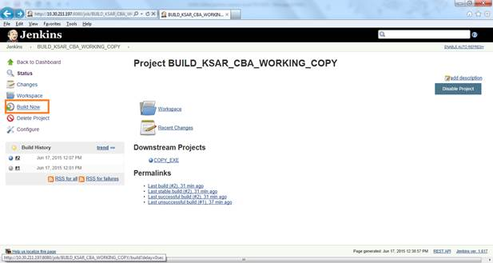

**Check if build succeds :**

Go to <http://10.30.211.197:8080/job/BUILD_KSAR_CBA_WORKING_COPY/>

Select the build # you have triggered :

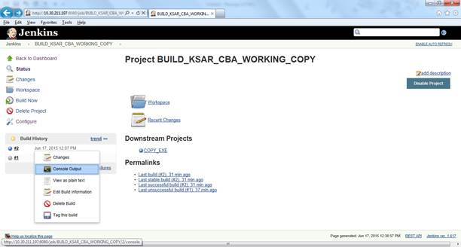

Check the consoleoutput :

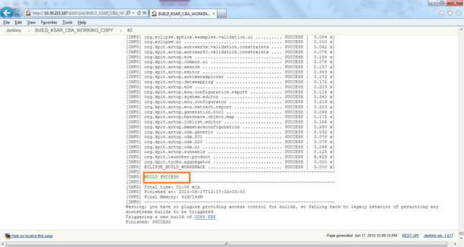

The binaries copied to \\D-5331\ARTOP_Share\BUILD_OUTPUT

Additional notes for Jenkins admin:

**Builds discard Strategy** : Keep old builds upto 5 days and Maximum 20 builds . Can be configured through : Jenkins---> < Build ID> ---> Configure :

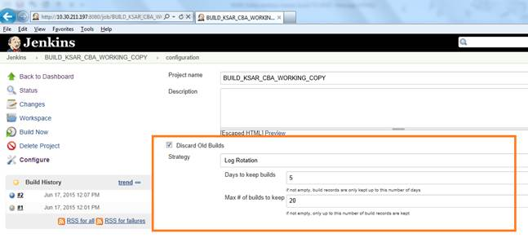

**Manually Delete a build:** This will just delete the particular build and has no collateral impact.

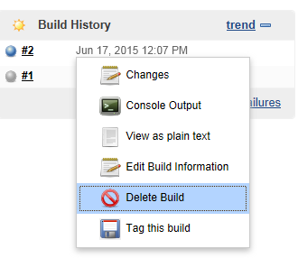

**Cancel a running build:** Click the cancel button :

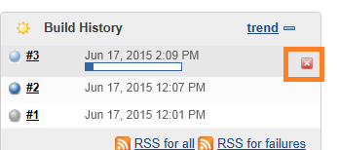

P.S: The detailed [READ-ME](http://10.30.12.251/kpit_autosar_ext_repos/R4.0.3/branches/Tools/K-SAR_Editor/Miscellaneous/maven_build_README.txt) checked in the SVN. So that we can set the maven-jenkins build automation from scratch.

Current Limitations:

1)      We could not provide Commit-hook script for TortoiesSVN  because of tightly coupled local checked-in folder and inability of SVN client to check proper java version in remote machine.

2)      Could not provide build status mailer service due to non-availability SMTP server details.

Thanks,

Jagan