Lab 5 Report: Adversarial Search
Minimax and Alpha-Beta Pruning | CAI601400 - Artificial Intelligence
Field | Detail
Name | Moiez Ali Khan
Roll Number | SU92-BSAIM-F25-250
Section | 03-D
GitHub Repository | https://github.com/moiezkhan707-cmyk/AI-lab-tasks
Lab Folder | Lab05/

1. Problem Statement
A game-playing agent must choose a move while assuming the opponent also plays optimally. Searching every leaf of the game tree is expensive, so the agent needs a way to skip branches that cannot change the final decision. This lab applies Minimax to small fixed-depth game trees, adds Alpha-Beta pruning, counts the leaves evaluated by each, and checks that reordering branches changes the amount of pruning but not the Minimax value.

2. Assumptions and Conventions
- The game tree is a complete binary tree stored as a list of leaf utilities. The root (depth 0) is a MAX node and layers alternate MAX, MIN, MAX, and so on.
- The utilities are synthetic lab values from the manual. The game is two-player and zero-sum, so MAX wants a high value and MIN wants a low one.
- A leaf evaluation is counted each time a terminal node's utility is read.
- Alpha-Beta prunes with the condition alpha >= beta, as in the manual's code. The tie case (alpha = beta) is also pruned.
- As in the manual, the 6-leaf tree is padded with zeros to 8 leaves so that it becomes complete. The padded zeros are artificial leaves (see the edge case in Section 9).

3. Task 1: Hand Trace of the Supplied Tree (Minimax)
Supplied leaves from Section 5.1: [3, 5, 2, 9, 0, 7], padded to [3, 5, 2, 9, 0, 7, 0, 0]. The tree has depth 3 (8 leaves). Values are computed from the leaves up to the root.
Layer | Player | Calculation | Values
Depth 3 | Leaves | Given utilities | 3, 5, 2, 9, 0, 7, 0, 0
Depth 2 | MAX | max(3,5)=5; max(2,9)=9; max(0,7)=7; max(0,0)=0 | 5, 9, 7, 0
Depth 1 | MIN | min(5,9)=5; min(7,0)=0 | 5, 0
Depth 0 | MAX (root) | max(5, 0)=5 | 5

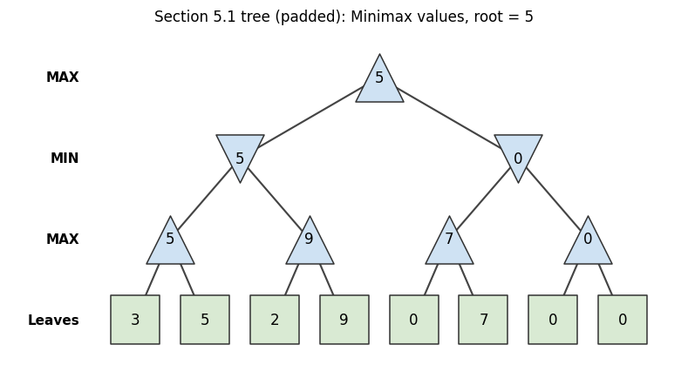
Figure 1: Minimax values for the supplied tree. Triangles pointing up are MAX nodes and triangles pointing down are MIN nodes.
The root value is 5, and the best move for MAX is the left branch (value 5) because the right branch only guarantees 0. This matches the program output, and the manual's Minimax code also returns 5 for this tree.

4. Task 2: Leaf-Evaluation Counters
A counter was added to the terminal-node case of both functions. Both algorithms were run on the Section 5.1 tree and on the Section 5.2 tree [3, 5, 2, 9, 3, 5, 2, 9].
Tree | Root value | Minimax leaves | Alpha-beta leaves | Same value?
Section 5.1 (padded) | 5 | 8 | 8 | Yes
Section 5.2 | 5 | 8 | 6 | Yes

4.1 Hand trace of alpha-beta on the Section 5.2 tree
At the root, alpha = -infinity and beta = +infinity. The left MIN node evaluates its first MAX child (leaves 3 and 5, value 5) and its second MAX child (leaves 2 and 9, value 9), so it returns min(5, 9) = 5 and the root alpha becomes 5. The right MIN node starts with alpha = 5. Its first MAX child (leaves 3 and 5) returns 5, so beta becomes 5. Now alpha (5) >= beta (5), so the right child (leaves 2 and 9) is pruned and 2 leaves are skipped. The root value is max(5, 5) = 5, with 6 leaves evaluated.
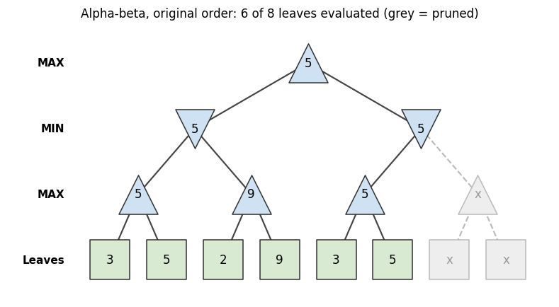
Figure 2: Alpha-beta on the Section 5.2 tree in the original order. Grey nodes and dashed edges were pruned.
On the Section 5.1 tree there is no pruning. In the right MIN node (alpha = 5), the first MAX child (leaves 0 and 7) returns 7, so beta = 7 and 5 >= 7 is false. The second child then returns 0, which would allow pruning, but it is already the last child, so nothing is skipped. Alpha-beta therefore evaluates the same 8 leaves as Minimax here.

5. Task 3: Reordering Branches
The children of each internal node of the Section 5.2 tree can be swapped independently. With 7 internal nodes this gives 128 orderings. All 128 were run through both algorithms.
Ordering | Leaves | Minimax leaves | Alpha-beta leaves | Root value
Original | 3, 5, 2, 9, 3, 5, 2, 9 | 8 | 6 | 5
All children swapped | 9, 2, 5, 3, 9, 2, 5, 3 | 8 | 8 | 5
Best found | 3, 5, 9, 2, 3, 5, 2, 9 | 8 | 5 | 5
Worst found | 3, 5, 2, 9, 2, 9, 3, 5 | 8 | 8 | 5

All 128 orderings: the root value was 5 for both algorithms in every case. Alpha-beta evaluated between 5 and 8 leaves, never more than Minimax (8). The distribution was 5 leaves for 16 orderings, 6 leaves for 48, 7 leaves for 16 and 8 leaves for 48.
Why the best ordering prunes more: in the best ordering, the second MAX node has leaves 9 then 2. After reading 9, alpha becomes 9, which is already >= beta (5), so the leaf 2 is skipped. The MIN node on the right is pruned as before. Two prunings skip 3 leaves in total, leaving 5 evaluated.
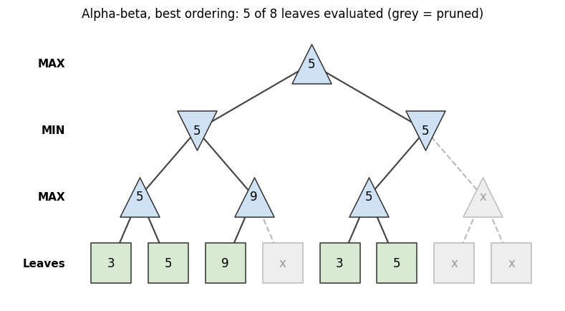
Figure 3: Alpha-beta on the best ordering found. Only 5 of 8 leaves are evaluated.
Reordering changes how much work alpha-beta does, but it never changes the Minimax value. This is because pruning only removes branches that cannot influence the decision at the root.

6. Minimax vs Alpha-Beta
Aspect | Minimax | Alpha-beta
Root value | Optimal Minimax value | Same value in every test
Leaves evaluated | All 8 leaves in every ordering | 5 to 8 leaves, depending on ordering
Depends on move ordering? | No | Yes. Strong moves first give more pruning
Extra bookkeeping | None | Two bounds, alpha and beta
Worst case | Same | Can degrade to Minimax (8 leaves in 48 orderings)

7. Code and Captured Output

7.1 Code: lab5.py
"""Lab 5: Adversarial Search - Minimax and Alpha-Beta Pruning (single-file version).
Complete binary game tree stored as a leaf list. Depth 0 is the root (MAX), layers
alternate MAX/MIN. Both algorithms count evaluated leaves (terminal-node reads).
Pruning condition: break when alpha >= beta. Utilities are synthetic lab values.
Run: python lab5.py
"""
import math
from itertools import product

# ---------- Minimax with a leaf counter ----------
def minimax(depth, index, max_turn, scores, target, counter):
if depth == target:
counter[0] += 1 # leaf evaluated
return scores[index]
values = [minimax(depth + 1, index * 2 + i, not max_turn, scores, target, counter)
for i in range(2)]
return max(values) if max_turn else min(values)

# ---------- Alpha-beta with a leaf counter and a pruning log ----------
def alphabeta(depth, index, max_turn, scores, target, alpha, beta, counter, log=None):
if depth == target:
counter[0] += 1 # leaf evaluated
return scores[index]
value = float("-inf") if max_turn else float("inf")
for i in range(2):
child = alphabeta(depth + 1, index * 2 + i, not max_turn, scores, target,
alpha, beta, counter, log)
if max_turn:
value = max(value, child)
alpha = max(alpha, value)
else:
value = min(value, child)
beta = min(beta, value)
if alpha >= beta:
if i == 0 and log is not None: # a sibling subtree is skipped
skipped = 2 ** (target - depth - 1)
log.append(f"depth {depth}, node {index} ({'MAX' if max_turn else 'MIN'}): "
f"alpha={alpha}, beta={beta} -> prune right child ({skipped} leaf/leaves skipped)")
break
return value

def tree_depth(scores):
return int(math.log2(len(scores)))

def run_both(scores, log=None):
"""Return (value, minimax_leaves, alphabeta_value, alphabeta_leaves)."""
d = tree_depth(scores)
c1, c2 = [0], [0]
v1 = minimax(0, 0, True, scores, d, c1)
v2 = alphabeta(0, 0, True, scores, d, float("-inf"), float("inf"), c2, log)
return v1, c1[0], v2, c2[0]

def reorder(scores, flags):
"""Swap the two child subtrees at internal node k when flags[k] is True (heap numbering)."""
def build(lo, hi, k):
if hi - lo == 1:
return [scores[lo]]
mid = (lo + hi) // 2
left, right = build(lo, mid, 2 * k + 1), build(mid, hi, 2 * k + 2)
return right + left if flags[k] else left + right
return build(0, len(scores), 0)

if __name__ == "__main__":
# ===== Task 1: supplied tree (Section 5.1), padded to a complete binary tree =====
raw = [3, 5, 2, 9, 0, 7]
padded = raw + [0] * (2 ** math.ceil(math.log2(len(raw))) - len(raw))
print("=== Task 1: supplied tree (Section 5.1) ===")
print("Leaves after padding with 0:", padded, "| depth:", tree_depth(padded))
layer2 = [max(padded[i], padded[i + 1]) for i in range(0, 8, 2)]
layer1 = [min(layer2[i], layer2[i + 1]) for i in range(0, 4, 2)]
root = max(layer1)
print("Depth 2 (MAX) values:", layer2)
print("Depth 1 (MIN) values:", layer1)
print("Root (MAX) value :", root, "-> best move: left" if layer1[0] >= layer1[1] else "-> best move: right")

# ===== Task 2: leaf counters on both algorithms =====
print("\n=== Task 2: leaf counters ===")
for name, sc in [("Section 5.1 tree (padded)", padded),
("Section 5.2 tree", [3, 5, 2, 9, 3, 5, 2, 9])]:
v1, n1, v2, n2 = run_both(sc)
print(f"{name}: leaves={sc}")
print(f" Minimax : value={v1}, leaves evaluated={n1}")
print(f" Alpha-beta : value={v2}, leaves evaluated={n2}, same value={v1 == v2}")
log = []
run_both([3, 5, 2, 9, 3, 5, 2, 9], log)
print("Pruning log (Section 5.2 tree):", log if log else "no pruning")
log = []
run_both(padded, log)
print("Pruning log (Section 5.1 tree):", log if log else "no pruning")

# ===== Task 3: reorder branches =====
print("\n=== Task 3: reordering the Section 5.2 tree [3, 5, 2, 9, 3, 5, 2, 9] ===")
base = [3, 5, 2, 9, 3, 5, 2, 9]
results = []
for flags in product([False, True], repeat=7): # all 128 child-swap orderings
sc = reorder(base, flags)
v1, n1, v2, n2 = run_both(sc)
results.append((n2, sc, v1, v2))
values_equal = all(v1 == v2 == 5 for _, _, v1, v2 in results)
counts = [r[0] for r in results]
best = min(results, key=lambda r: r[0])
worst = max(results, key=lambda r: r[0])
print("Orderings tested:", len(results), "| all root values equal 5:", values_equal)
print("Alpha-beta leaves: min =", min(counts), ", max =", max(counts), "(Minimax always 8)")
print("Best ordering :", best[1], "->", best[0], "leaves")
print("Worst ordering:", worst[1], "->", worst[0], "leaves")
print("Distribution (leaves: how many orderings):", {k: counts.count(k) for k in sorted(set(counts))})
for label, sc in [("original", base), ("all children swapped", reorder(base, [True] * 7)),
("best", best[1]), ("worst", worst[1])]:
v1, n1, v2, n2 = run_both(sc)
print(f" {label:20s} {sc} | minimax {v1}/{n1} | alpha-beta {v2}/{n2}")
log = []
run_both(best[1], log)
print("Pruning log (best ordering):")
for line in log:
print(" ", line)

# ===== Edge cases =====
print("\n=== Edge cases ===")
print("Single leaf [7] :", run_both([7]))
print("All equal [4,4,4,4] :", run_both([4, 4, 4, 4]))
print("Negative utilities :", run_both([-3, -5, -2, -9]))
print("Padding changes the answer : pad with 0 ->", run_both(raw + [0, 0])[0],
"| pad with 100 ->", run_both(raw + [100, 100])[0])

7.2 Captured output
=== Task 1: supplied tree (Section 5.1) ===
Leaves after padding with 0: [3, 5, 2, 9, 0, 7, 0, 0] | depth: 3
Depth 2 (MAX) values: [5, 9, 7, 0]
Depth 1 (MIN) values: [5, 0]
Root (MAX) value : 5 -> best move: left

=== Task 2: leaf counters ===
Section 5.1 tree (padded): leaves=[3, 5, 2, 9, 0, 7, 0, 0]
Minimax : value=5, leaves evaluated=8
Alpha-beta : value=5, leaves evaluated=8, same value=True
Section 5.2 tree: leaves=[3, 5, 2, 9, 3, 5, 2, 9]
Minimax : value=5, leaves evaluated=8
Alpha-beta : value=5, leaves evaluated=6, same value=True
Pruning log (Section 5.2 tree): ['depth 1, node 1 (MIN): alpha=5, beta=5 -> prune right child (2 leaf/leaves skipped)']
Pruning log (Section 5.1 tree): no pruning

=== Task 3: reordering the Section 5.2 tree [3, 5, 2, 9, 3, 5, 2, 9] ===
Orderings tested: 128 | all root values equal 5: True
Alpha-beta leaves: min = 5 , max = 8 (Minimax always 8)
Best ordering : [3, 5, 9, 2, 3, 5, 2, 9] -> 5 leaves
Worst ordering: [3, 5, 2, 9, 2, 9, 3, 5] -> 8 leaves
Distribution (leaves: how many orderings): {5: 16, 6: 48, 7: 16, 8: 48}
original [3, 5, 2, 9, 3, 5, 2, 9] | minimax 5/8 | alpha-beta 5/6
all children swapped [9, 2, 5, 3, 9, 2, 5, 3] | minimax 5/8 | alpha-beta 5/8
best [3, 5, 9, 2, 3, 5, 2, 9] | minimax 5/8 | alpha-beta 5/5
worst [3, 5, 2, 9, 2, 9, 3, 5] | minimax 5/8 | alpha-beta 5/8
Pruning log (best ordering):
depth 2, node 1 (MAX): alpha=9, beta=5 -> prune right child (1 leaf/leaves skipped)
depth 1, node 1 (MIN): alpha=5, beta=5 -> prune right child (2 leaf/leaves skipped)

=== Edge cases ===
Single leaf [7] : (7, 1, 7, 1)
All equal [4,4,4,4] : (4, 4, 4, 3)
Negative utilities : (-5, 4, -5, 4)
Padding changes the answer : pad with 0 -> 5 | pad with 100 -> 7

7.3 Screenshots of the terminal run
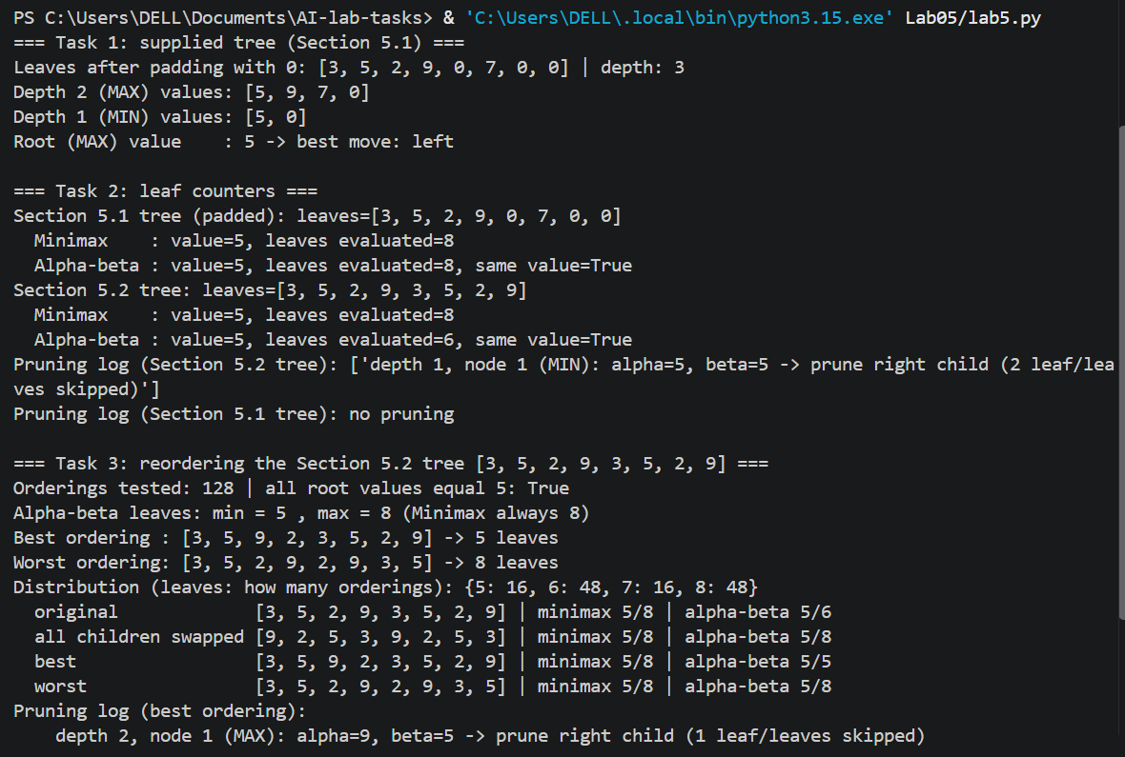
Figure 4: Terminal output of lab5.py (start): Task 1 hand-trace values, Task 2 leaf counters, pruning logs and the start of Task 3.
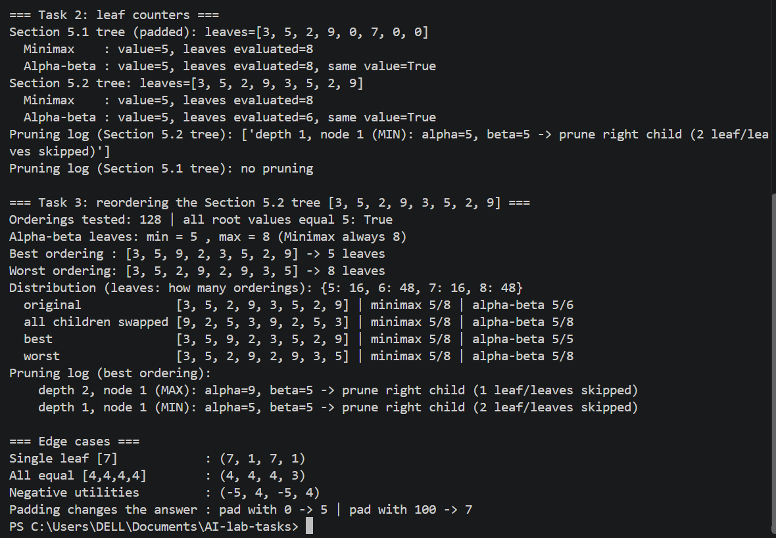
Figure 5: Terminal output of lab5.py (continued): Task 2 counters, the 128-ordering experiment, best-ordering pruning log and the edge cases.

8. Edge-Case Tests
Test | Input | Result (value, minimax leaves, alpha-beta value, alpha-beta leaves)
Single leaf | [7] | (7, 1, 7, 1)
All leaves equal | [4, 4, 4, 4] | (4, 4, 4, 3). The tie (alpha = beta) prunes one leaf
Negative utilities | [-3, -5, -2, -9] | (-5, 4, -5, 4). Same value, no pruning
Padding value | [3, 5, 2, 9, 0, 7] padded with 0 or 100 | Root 5 with zeros, root 7 with 100

9. Failure / Edge-Case Analysis
Item | Detail
Input | The supplied leaves [3, 5, 2, 9, 0, 7], padded to 8 leaves with 0, compared with padding by 100
Observed behaviour | The root value is 5 with zero padding but 7 with padding value 100, so the answer depends on the padding.
Likely cause | Padding turns missing positions into artificial terminal nodes that MIN or MAX can choose. The padded zeros are not real game outcomes.
Proposed improvement | Build the tree from real game positions, or treat a missing child as unavailable (skip it) instead of giving it a utility value. For a complete tree the number of leaves should be a power of two.

This shows that the Minimax value is only meaningful for a correctly defined tree. Alpha-beta does not protect against a badly constructed tree, because it preserves whatever value Minimax would give on that tree.

10. Limitations
- The trees are small complete binary trees with synthetic utilities, so the savings (up to 3 of 8 leaves) are small. Real games have larger branching factors.
- Counts depend on ordering and tie handling (alpha >= beta). Using a strict > would prune less.
- The experiment reorders only subtrees of this one tree. The measured distribution cannot be generalised to other trees.
- No heuristic evaluation function or depth cut-off is used, because all leaves are terminal.

11. Reflection
1. Kya naya samajh aaya? Mujhe samajh aaya ke Minimax mein MAX bada value chunta hai aur MIN chhota, is liye values leaves se upar root ki taraf nikalte hain. Alpha-beta wahi jawab deta hai lekin kuch branches skip kar deta hai. Is lab mein Minimax ne 8 leaves dekhe aur alpha-beta ne 6.
2. Kahan atke ya kya ajeeb laga? Ajeeb ye laga ke branches ka order badalne se leaves ki ginti 5 se 8 tak badli, lekin root value har baar 5 hi rahi. Aur tree ko 0 se pad karne par jawab 5 aaya, jabke 100 se pad karne par 7 ho gaya.
3. Isay kahan use kar sakte ho? Chess ya tic-tac-toe jaise game agent mein, jahan opponent bhi sahi chaal chalta hai. Wahan alpha-beta ke saath achhi chaalen pehle check karna aur depth limit lagana zaroori hai.
4. Agle lab mein kya alag karoge? Pruning pehle hath se trace karunga aur phir code se match karunga. Aur tree ko banawati values se pad karne se bachunga, kyunke is se jawab badal jata hai.

12. Responsible-Practice Response
Following the transparency goal of the lab, the tree, the utilities and the pruning decisions are shown so another student can reproduce the chosen move. The leaf counts are the real output of the code. The utilities are synthetic and do not represent a real game. If a game agent were used in a real setting, its assumption that the opponent plays optimally should be stated, since a weaker or unpredictable opponent may make other moves better. The code uses no credentials or private data and follows the guided examples in the lab manual [1].

References
[1] CAI601400 Artificial Intelligence Lab Manual, Lab 5: Adversarial Search: Minimax & Alpha-Beta Pruning.
[2] S. Russell and P. Norvig, Artificial Intelligence: A Modern Approach, 4th ed., Pearson, 2020 (Chapter 5: Adversarial Search and Games).
[3] D. E. Knuth and R. W. Moore, "An Analysis of Alpha-Beta Pruning," Artificial Intelligence, vol. 6, no. 4, pp. 293-326, 1975.

