CLJD

Updated Report

<2019-11-22>

Updated Description

The Arithmetic Logic Unit, or ALU as descripted in the draft description, still fulfils the requirements of taking a set of data and instruction inputs to perform different arithmetic operations. The ALU calculates these inputs, as if it were a calculator. The ALU functions fulfilled are add, subtract, multiply, and divide. The size of the numbers being calculated are 16 bit integers, thus we have carry-over and overflow errors that the ALU handles. The ALU reflected from this report can perform the following basic logic functions: ANDing, ORing, XORing, NOTing, NANDing, NORing, and XNORing.

**The obvious but unforeseen carry-over error that was added is handling carry-over in the multiply module.** Another unforeseen error handle which was not explicitly stated in the first progress report is **handling a divide-by-zero error**. The divide module currently reflects this error handle. **We have also defined a decoder, multiplexer, and a state machine** which was not originally defined in the draft description.

Our development workspaces differ but we are still using Verilog version 10.1 as the central language.

The overall purpose of the ALU is to perform simple calculations via a combinational digital logic circuit, and to follow the requirements specifications listed in Dr. Becker’s project description.

Updated Member Task List

Draft Member Tasks

|  |  |  |  |  |
| --- | --- | --- | --- | --- |
|  | **Charles** | **Liora** | **Jacob** | **Dylan** |
| Updated Report | | | | |
| Title Page |  |  |  |  |
| Updated Report |  |  |  |  |
| Updated Description |  |  |  |  |
| Updated Member Task List |  |  |  |  |
| Updated Software Discovery |  |  |  |  |
| Updated Participation  Census |  |  |  |  |
| System Design | | | | |
| Title Page |  |  |  |  |
| Parts List |  |  |  |  |
| Input List |  |  |  |  |
| Output List |  |  |  |  |
| Interface List |  |  |  |  |
| Module List |  |  |  |  |
| Mode List |  |  |  |  |
| Circuit Diagram |  |  |  |  |
| State Machine Diagram |  |  |  |  |
| Code and Output | | | | |
| Add |  |  |  |  |
| Subtract |  |  |  |  |
| Multiply |  |  |  |  |
| Divide |  |  |  |  |
| Bit Shift |  |  |  |  |

Updated Software Discovery

**In addition to using Logisim, we have decided to also use draw.io**. Draw.io is also an open source software used by millions of people, but what ultimately makes draw.io a valuable choice is its ability to enable team members to work on projects collectively at the same time from different machines. We found it difficult to find time in our schedules to meet face to face outside of class, so a feature like this held extreme value. Our draw.io circuit diagram is linked to our Google drives, which serves as a safe backup, and is also how we share and work on the circuit diagram.

Furthermore, unlike Logisim which was last updated on October 11, 2014 and is running on version 2.7.0, draw.io is continuously being updated. The current version of draw.io is 12.2.8 which was updated on November 21, 2019. Draw.io is a very current form of open source software that is being used by many, that with its continuous updates and versatility in diagrams, serves as a valuable asset in creating diagrams.

In terms of Verilog, we are still using iVerilog version 10.1 for our project.

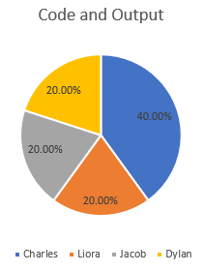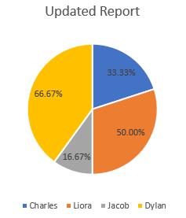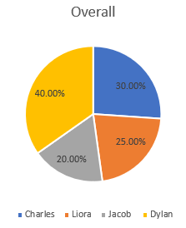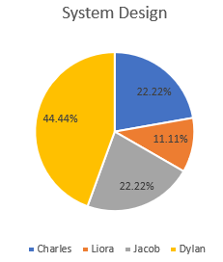 Updated Participation Census