USER MANUAL - CODOC

- CODOC DESCRIPTION:
This is a graphical interface designed to automate the process of multi-target virtual screening, managing the application of other open-source software available exclusively for command-line execution (AutoDockVina and Vina-GPU). CODOC enables research groups with limited computational resources, lacking high-performance computing clusters, to prepare ligand libraries, protein targets, and perform screenings using molecular docking methods. It allows users to choose between CPU usage, suitable for libraries of hundreds or thousands of ligands, and GPU for larger datasets that may reach millions of ligands. During the process, dataframes in .csv format are generated, containing physicochemical and structural information of the ligands as well as pose results, organized into folders by target and subfolders by ligand database. This tool was developed in Shell/Bash and uses YAD to generate the graphical user interface (GUI).

- SOFTWARE INSTALLATION:
During the initialization process, the software itself verifies the necessary directories and creates them if they are missing. The organization of directories and subdirectories is described in the following figure, with some illustrative examples:

2.1 Download the compressed file from:
https://github.com/moimaian/CODOC/archive/refs/heads/main.zip

2.2 Extract the file to a working directory, for example, "$HOME/CODOC":
This can be done graphically using a file manager such as Nemo:
- Create the folder $HOME/CODOC
- Extract the contents of the CODOC-main.zip file into the $HOME/CODOC folder
Or use the following command in the terminal:
sudo apt-get install
unzip CODOC-main.zip -d $HOME/Downloads && mkdir $HOME/CODOC
mv $HOME/Downloads/CODOC-main/* $HOME/CODOC

2.3 Navigate to the working directory and grant execution permissions to the CODOC.sh file:
This can be done graphically in a file manager such as Nemo:
- Right-click on the program (CODOC.sh bash script)
- Select Properties in the menu
- In the opened window, select Permissions
- Check the box to allow execution as a program
Or use the following command in the terminal:
chmod +x $HOME/CODOC/CODOC.sh

2.4 In a file manager, double-click on the CODOC.sh icon and click on Run in Terminal.
Or execute it in the terminal:
cd $HOME/CODOC && ./CODOC.sh

- PREREQUISITES: (Installations performed within the software)
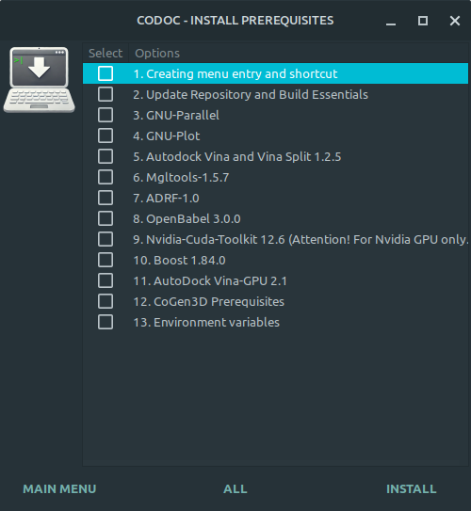
In the software’s main menu, there is an INSTALL option that, when clicked, opens an installation window (Figure 1) listing the prerequisites for running CODOC. It displays a checklist allowing the user to select the programs they wish to install, with an additional button for complete installation (ALL).

- YAD;
- GNU-Parallel;
- GNU-plot;
- AutoDock Vina 1.2.5 e AutoDock Split 1.2.5;
- AutoDockTools-MGLTools 1.5.7;
- ADRF-1.0;
- OpenBabel 3.0.0;
- Cuda Toolkit 11.6;
- Boost 1.84;
- Vina-GPU 2.1;
- CoGen3D prerequisites: Python3 and and associated packages (pip, pandas, rdkit, dimorphite-dl, tqdm, meeko, xlsxwriter).

Figure 1. Installation window.

- ORGANIZATION OF DIRECTORIES:
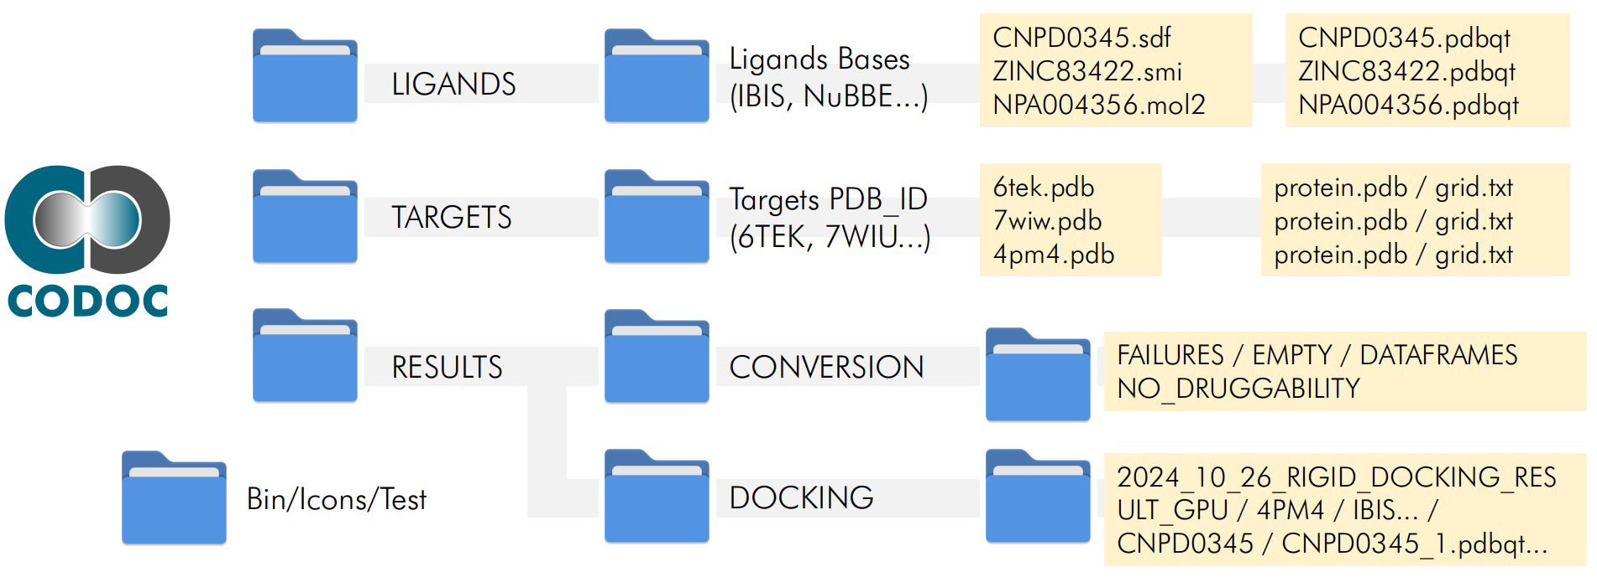
During the CODOC initialization process, the necessary directories are checked. If these directories are missing, they will be created in the folder where the CODOC.sh executable is located. The organization of the directories and subdirectories is described in Figure 2 below, with some illustrative examples.

Figure 2. Organization of directories.

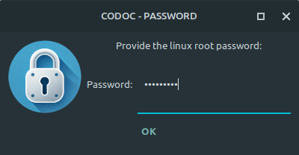
- GENERAL GUIDELINES FOR USE:
When running CODOC for the first time, you will be prompted for the Linux root password. This password is required to install the YAD window manager and later for the prerequisites when clicking INSTALL in the main menu (See topic 3). Password window in Figure 3 on the side:
The CODOC startup screen (Figure 4) will then be displayed, containing the logo and illustrative image, while the initial check of the directories required to run the program is performed (See topic 4).
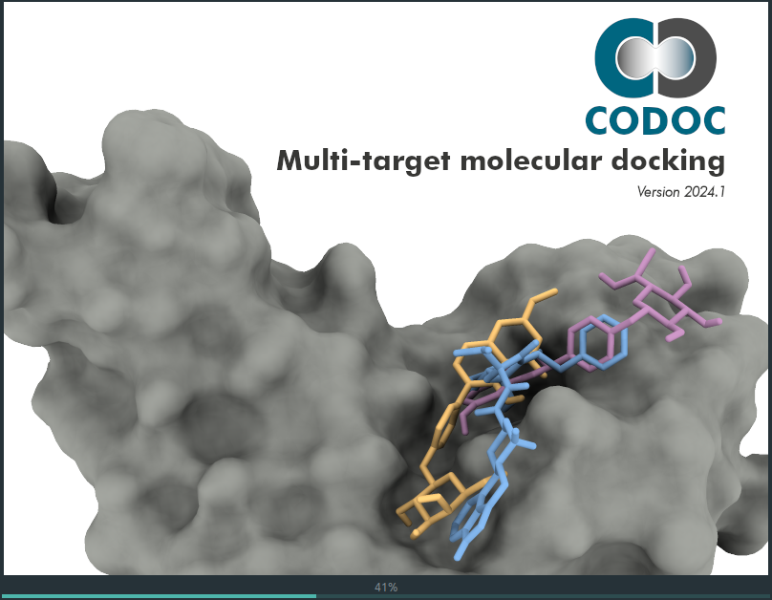
Figure 3. Password window.
Figura 5. Menu Principal.

Figura 4. Janela de inicialização do CODOC.

Na sequência é apresentado o menu principal do CODOC, conforme Figura 5.
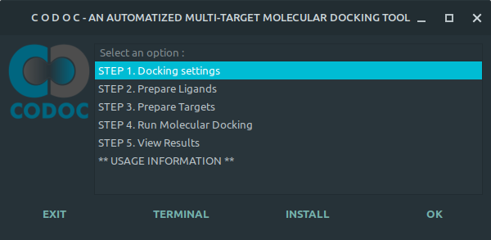

To perform Molecular Docking with CODOC, 5 steps must be followed as described in the main menu.
STEP 1: Docking Configuration - In this step, several molecular docking parameters must be configured (Figure 6).
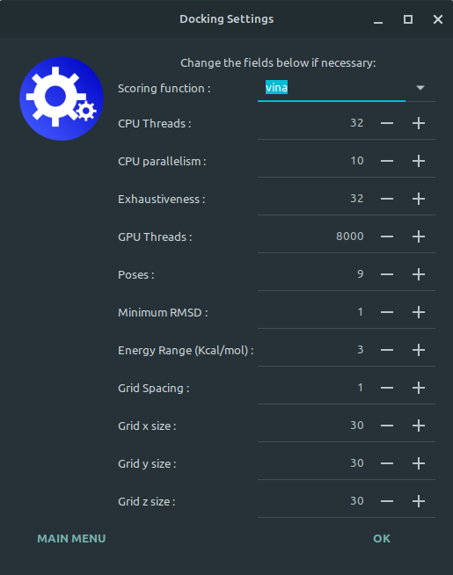

Figure 6. Docking configuration window.

STAGE 2: Ligand preparation - In this stage, the ligand databases will be prepared for docking through several processes. There are two preparation options: the first using Openbabel and the second using RDKit (Cogen3D) (Figure 7).

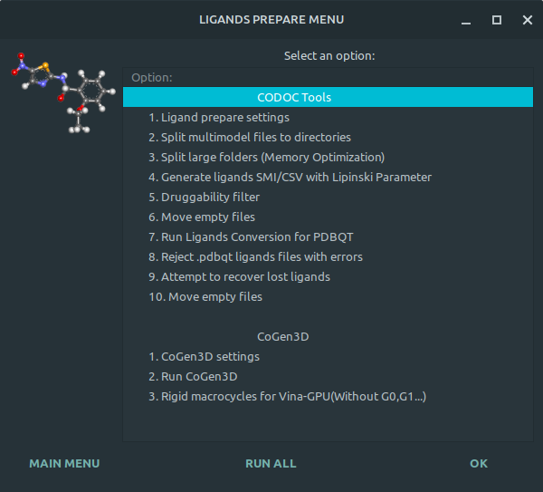

Figure 7. Binder preparation window.
STEP 3: Target Preparation - In this step, the protein targets will be prepared for docking through several processes. (Figure 8).

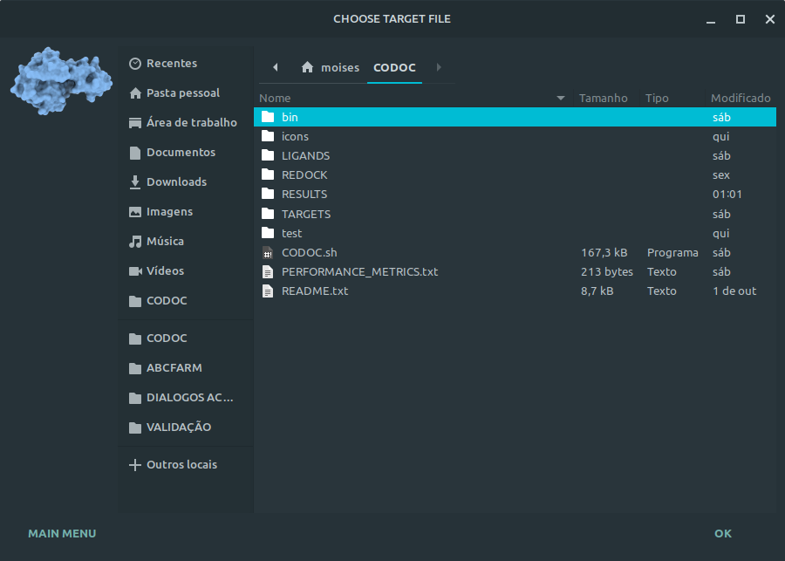

Figure 8. Target preparation window.

STEP 4: Executing Molecular Docking - In this step, molecular docking will be executed, and it will be necessary to choose between rigid and flexible docking, between using the CPU or GPU in the calculation and also whether it will be a new calculation or whether it will be resumed from a previous calculation that has stopped. (Figure 9). Then, when the execution starts, a new window will be displayed containing monitoring metrics and a progress bar (Figure 10).

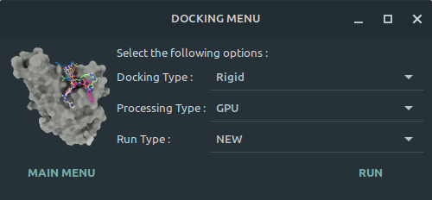

Figure 10. Docking monitoring window.
Figure 9. Docking selection window.

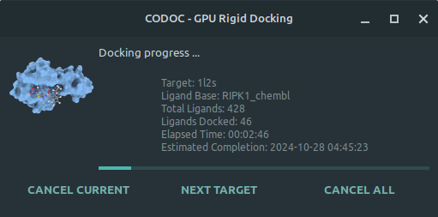

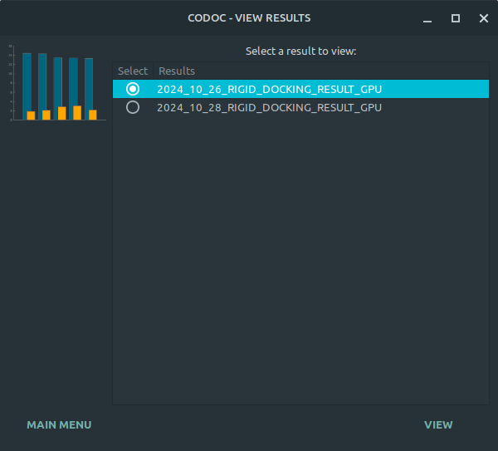
STEP 5: Viewing the results - In this step, the user must choose which result and which target they want to view, the number of ligands and the RMSD cutoff value (Figure 11). Next, they will be asked to choose between viewing the results in a Table (Figure 12) or in a bar graph (Figure 13).

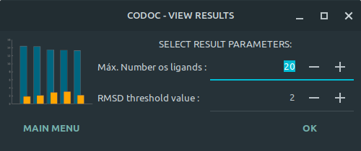

Figure 11. Result selection windows.
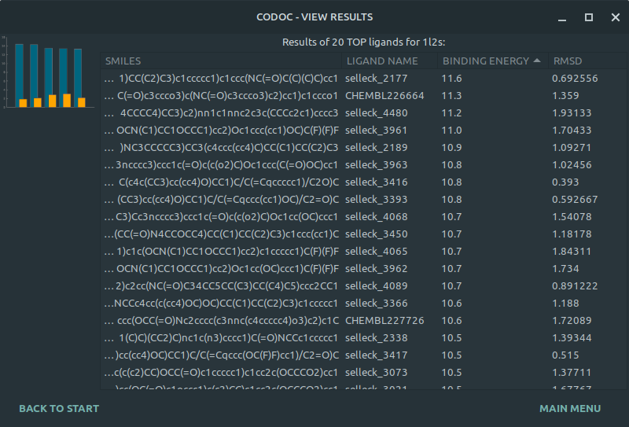

Figure 12. Result window by Table.
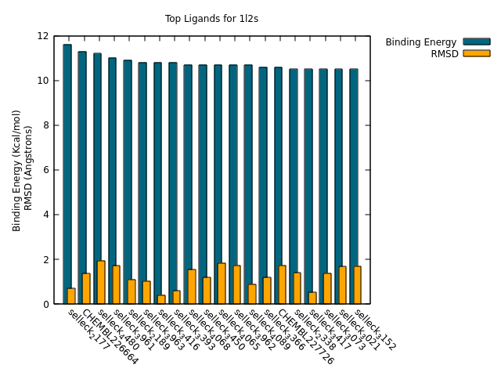

Figure 13. Result window by Bar Chart.

