EXPLORATION STRATEGIES
IN TABULAR Q-LEARNING
Project Report
Academic Year 2023
Author: Moin Tariq
Bachelor of Science in Mathematics
Department of Mathematics & Statistics | International Islamic University, Islamabad
Supervisor: Dr. Nayyar Mehmood

Abstract
Reinforcement learning studies sequential decisions learned through interaction. This project compares constant epsilon-greedy, decaying epsilon-greedy, softmax, and upper-confidence-bound exploration for tabular Q-learning in a finite stochastic grid-world. Exact value iteration supplies the optimal action-value benchmark. Ten independent random seeds are assessed using greedy-policy return, success rate, and maximum action-value error. UCB obtains the highest final mean return and success rate, whereas constant epsilon-greedy gives the smallest maximum Q-error. The findings demonstrate that policy performance and numerical value accuracy are related but distinct.
Keywords: reinforcement learning, Markov decision process, Q-learning, exploration, value iteration

1. Introduction
In reinforcement learning (RL), an agent observes a state, chooses an action, receives a reward, and moves to another state. It is not supplied with the correct action and must discover useful behaviour from rewards generated by its decisions.
Exploitation selects an action that currently appears best. Exploration selects a less-certain action to gain information. Too little exploration can produce a poor policy; continual undirected exploration can waste samples and rewards.
Research question: How does the exploration strategy affect the convergence, stability, and performance of tabular Q-learning in a finite stochastic Markov decision process?
The objectives are to formulate a finite MDP, compute an exact value-iteration benchmark, implement Q-learning and four exploration rules without an RL library, and compare them over repeated random trials.

2. Mathematical background

2.1 Markov decision processes
A finite discounted Markov decision process consists of finite state and action spaces, transition probabilities, rewards, and a discount factor 0 <= gamma < 1.
M = (S, A, P, R, gamma)
G_t = sum_(k=0)^infinity gamma^k R_(t+k+1)
V_pi(s) = E_pi[G_t | S_t=s], Q_pi(s,a) = E_pi[G_t | S_t=s, A_t=a]

2.2 Bellman optimality and contraction
Q*(s,a) = sum_(s') P(s'|s,a)[R(s,a,s') + gamma max_b Q*(s',b)]
||TQ - TU||_infinity <= gamma ||Q - U||_infinity
The Bellman operator is therefore a contraction. By the Banach fixed-point theorem, it has a unique fixed point Q*. Repeated exact Bellman updates converge to this benchmark.

2.3 Q-learning
Q_(t+1)(S_t,A_t) = Q_t(S_t,A_t) + alpha_t[R_(t+1) + gamma max_a Q_t(S_(t+1),a) - Q_t(S_t,A_t)]
Classical convergence requires all state-action pairs to be visited repeatedly and learning rates with sum alpha_t infinite and sum alpha_t squared finite. This finite study uses constant alpha = 0.15 for practical comparison, so exact asymptotic convergence is not claimed.

3. Exploration strategies

3.1 Constant epsilon-greedy
Choose a uniformly random action with probability epsilon = 0.10 and a greedy action otherwise.

3.2 Decaying epsilon-greedy
epsilon_k = max(0.02, 1.0(0.995)^k)
The agent explores heavily at first and becomes increasingly greedy.

3.3 Softmax
Pr(A_t=a | S_t=s) = exp(Q(s,a)/tau) / sum_b exp(Q(s,b)/tau)
Temperature decays from 1.0 to 0.05. Large temperatures make choices more uniform; small temperatures emphasize high estimates.

3.4 Upper confidence bound
A_t = arg max_a [Q(S_t,a) + c sqrt(log(N(S_t)+1) / N(S_t,a))]
The implementation uses c = 1 and prioritizes untried actions. The rule adapts a classical bandit confidence bonus to state-dependent selection.

4. Methodology

4.1 Environment
The environment is a stochastic 6-by-6 grid with 36 states and four actions. The agent begins at the lower-left and seeks the upper-right goal. Five hazards terminate an episode. The goal reward is +10, a hazard gives -10, and an ordinary step gives -0.1.
The requested direction occurs with probability 0.90 and each other direction with probability 0.10/3. Boundary movements leave the state unchanged. Episodes terminate at the goal or a hazard and are otherwise truncated after 100 steps.

4.2 Parameters
Parameter | Value
Training episodes | 1,500
Independent seeds | 10
Discount factor | 0.95
Learning rate | 0.15
Evaluation interval | 25 episodes
Evaluation episodes | 40
Maximum length | 100 steps

4.3 Evaluation measures
- Mean undiscounted greedy-policy return.
- Probability that the greedy policy reaches the goal.
- Maximum absolute Q-error over nonterminal state-action pairs.
- Across-seed mean with an approximate 95% confidence interval.
E_Q = max_(s not in T,a) |Q(s,a) - Q*(s,a)|
confidence interval = x-bar +/- 1.96 s / sqrt(n)

5. Results
Strategy | Return | Std. dev. | Success | Max Q error
Constant epsilon-greedy | 5.02 | 3.50 | 82.5% | 8.64
Decaying epsilon-greedy | 4.08 | 6.05 | 75.5% | 9.07
Softmax | 6.41 | 1.12 | 87.0% | 9.30
UCB | 7.17 | 1.51 | 91.0% | 9.41

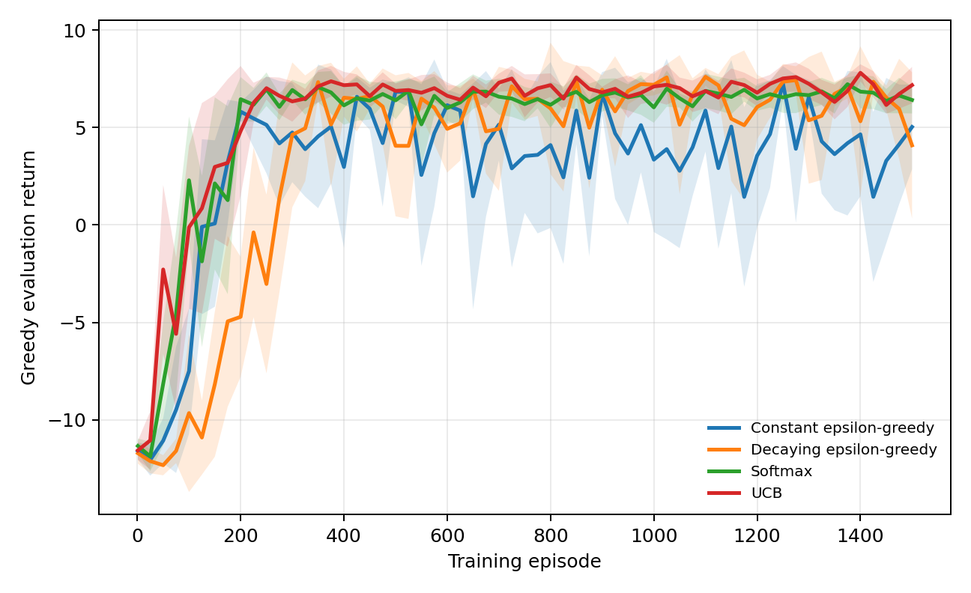
Figure 1. Mean greedy-policy evaluation return with approximate 95% confidence intervals.
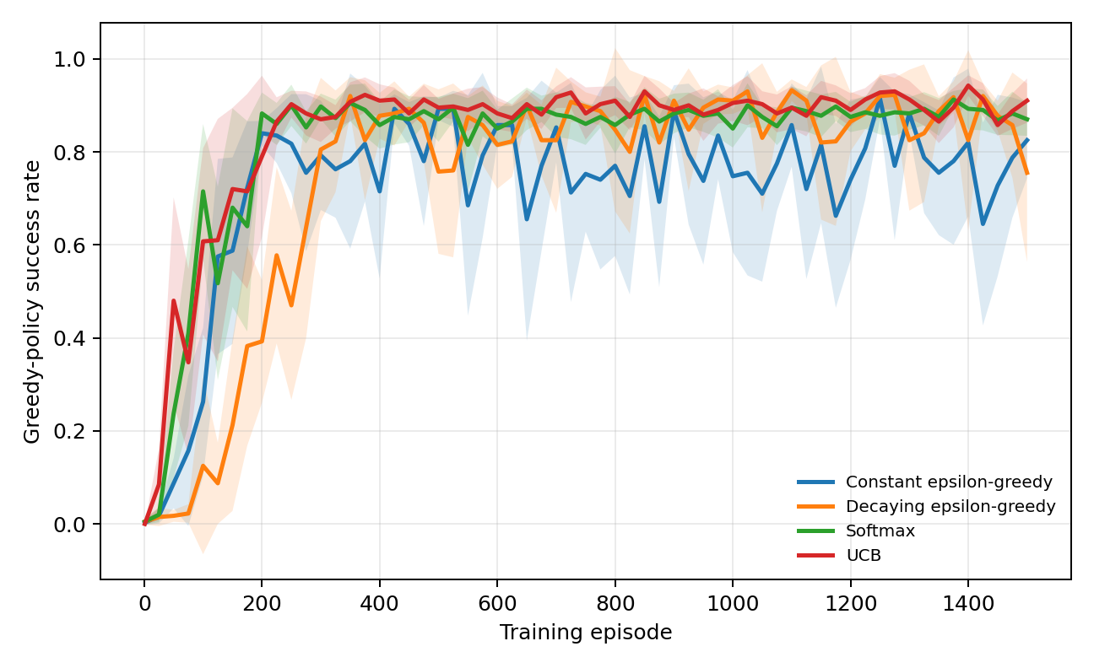
Figure 2. Mean probability of reaching the goal.
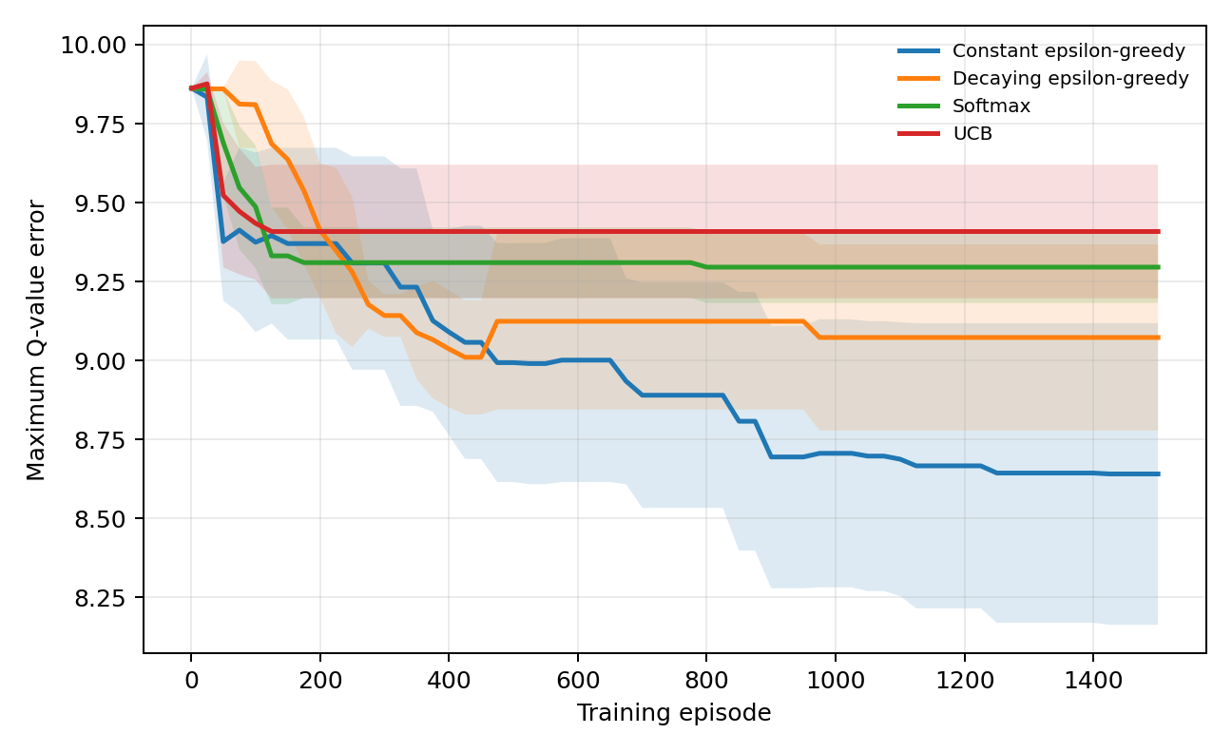
Figure 3. Maximum absolute action-value error.

6. Discussion
UCB has the highest final mean return and success rate. Its bonus directs choices toward less-tried actions and quickly establishes a successful policy. Softmax also performs strongly and has the smallest final return variability. Constant epsilon-greedy is less stable in evaluation but attains the lowest maximum Q-error, consistent with continuing random exploration.
These rankings are specific to one environment and parameter configuration. The UCB bonus uses counts but does not fully describe uncertainty propagated through future transitions. A successful greedy policy may coexist with inaccurate values because the best action can remain correctly ranked. Policy quality and Q-value accuracy therefore answer different questions.

7. Conclusion
The project connects exact finite-MDP mathematics with sample-based learning. Bellman contraction supplies a unique optimal benchmark; Q-learning estimates it from stochastic transitions. Exploration materially affects learning speed, stability, policy success, and value accuracy. The best-performing policy need not produce the most accurate complete Q-table.

References
- Auer, P., Cesa-Bianchi, N., & Fischer, P. (2002). Finite-time analysis of the multiarmed bandit problem. Machine Learning, 47, 235-256.
- Bellman, R. (1957). Dynamic Programming. Princeton University Press.
- Farama Foundation. (2022). Announcing the Farama Foundation.
- Sutton, R. S., & Barto, A. G. (2018). Reinforcement Learning: An Introduction (2nd ed.). MIT Press.
- Watkins, C. J. C. H., & Dayan, P. (1992). Q-learning. Machine Learning, 8, 279-292.

