**Contents**

ABSTRACT 3

INTRODUCTION 4

1.1 Objective 4

LITERATURE SURVEY 5

2.1 Agriculture and Raw Materials from Campden BRI 5

2.2 How The Fertilizer Industry Works (Business Maps of India) 5

2.3 *20 Minutes to Understanding a Database* 6

2.4 Promotion of Standardization and Grading of Agricultural and Allied Produce 7

System Analysis 12

3.1 Purpose 12

3.2 Scope 12

3.3 Existing System 12

3.4 Proposed System 12

3.5 Summary 13

SOFTWARE REQUIREMENTS SPECIFICATION 14

4.1 Operating Environment 14

4.1.2 Microsoft Visual Studio 2015 IDE 14

4.1.3 C# Language 15

4.1.4 Asp.Net Technology 15

4.1.5 Microsoft SQL Server 2008 15

4.2 Functional Requirements 15

4.3 Non Functional requirements 16

4.4 User Characteristics 17

4.5 Application of System 17

4.6 Advantages of system 17

4.7 Summary 18

SYSTEM DESIGN 19

5.1 Introduction 19

5.2 Development Strategy 19

5.2.1 System Analysis 20

5.2.2 System Design 20

5.2.3 Coding 20

5.2.4 Testing 20

5.2.6 Maintenance 20

5.3 System Architecture 20

5.4 Summary 21

DETAILED DESIGN 22

6.1 Activity Diagram 22

6.2 Use Case Diagram 23

6.3 Sequence Diagram 24

6.4 Summary 25

DATABASES 26

7.1 ER Diagram 26

7.2 Tables structure 27

Fig 7.1.1 Display of database for Farmer Registration 27

Fig 7.1.2 Display of database for Field Agent 27

Fig 7.1.3 Display of database for Crop Details 28

Fig 7.1.4 Display of database for farmer authentication 28

Fig 7.1.5 Display of database for marketeer registration 29

Fig 7.1.6 Display of database for manufacturer product details 29

7.3 NORMALIZATION 30

# ABSTRACT

3 Sector Help System provides an efficient search of various raw materials and finished products required by farmers, manufacturers and marketers. The project 3SH system is known to be a pilot project that is designed to gather the raw materials sold by the farmer to manufacturer and finished products sold by the manufacturer to marketer from a vast area and to help them undertake their working activities easily so as to connect them under one roof. It maintains a library of the data given and required by the 3 individual sectors i.e., farmers, manufacturers and the marketers. Sometimes the 3 sectors face difficulty in finding the required resource for the respective processes to be undertaken in a given point of time. This project has attempted to provide the answer to the same by taking upon itself the task of collecting volunteering individuals as well as organizations for the cause and care of all the interconnected people in need.

# INTRODUCTION

The 3 sector management system is a user friendly application software in getting faster and more efficient access to the required stock of the respective working sectors. This webpage also provides a platform for individuals or companies volunteering to sell their produce and also to register themselves as their sector accordingly. The 3SH Management System is designed such that it represents the view of a distributed architecture having the database as its centralized storage. The aim is to maintain and provide information regarding individuals ready to sell their produce accordingly.

## 1.1 Objective

The 3SH management system is intended to provide information about the availability of raw materials and manufactured products in various weather conditions and maintaining the status of availability based on the requirement and ensuring secure provision and process. The purpose is to meet the challenging requirement of modern day working of the 3 main sectors efficiently under a single roof.

# LITERATURE SURVEY

## 2.1 Agriculture and Raw Materials from Campden BRI

Good quality products require good quality ingredients. Increasingly, crop raw materials are grown with a specific final product in mind: particular fruit and vegetable varieties are directed to the fresh produce market, whereas others are suitable for canning or freezing.

The way that they are produced is also important - segregation of organically and conventionally grown raw materials has been a major issue for several years, and this has highlighted the need for good [traceability](https://www.campdenbri.co.uk/publications/pubDetails.php?pubsID=2489) systems.

Campden BRI has been closely involved with these food chain issues for over half a century and we are the people to contact with questions on [raw material production systems](https://www.campdenbri.co.uk/services/raw-material-production-systems.php) and [post-harvest operations,](https://www.campdenbri.co.uk/services/post-harvestoperations.php) including [pesticide](https://www.campdenbri.co.uk/sectors/pest.php) issues such as [pesticide taint testing,](https://www.campdenbri.co.uk/sectors/pesticide-taint-testing.php) and how the agricultural production and distribution chain should be [managed and monitored.](https://www.campdenbri.co.uk/services/haccp-guidelines.php)

Two Lists of Accepted Agrochemicals for the brewing industry have been developed; one for [cereals](https://www.campdenbri.co.uk/services/downloads/BARLEYOctober2015.pdf) and one for [hops.](https://www.campdenbri.co.uk/services/downloads/HopAnnexesOct2015.pdf) Additional guidance for using the hop list can be found in the respective official site.

The Accepted List for cereals details the agrochemicals that are accepted for use on malting barley or wheat and, for each active ingredient, lists the EU and Codex Maximum Residue Limits (MRL), EU and UK expiry dates and any limitations of use. The Accepted List for Hops details similar information for hops grown in the UK, hops grown in the EU but outside of the UK and hops imported into the UK from outside the EU.

## 2.2 How The Fertilizer Industry Works (Business Maps of India)

Fertilizers are substances that supply one or more of the chemicals required for plant growth. Fertilizers can be both organic and inorganic. As per industry experts it is said that there are sixteen elements that are absolutely necessary for plant growth. Out of these sixteen 9 elements are required in large quantities while the other seven are needed in smaller amounts.

Since agriculture is a very important sector it goes without saying that the fertilizer industry is one which the Indian economy cannot do without. The fertilizer industry in India is extremely vital as it manufactures some of the most important raw materials required for crop production. The primary objective of this industry is to ensure the inflow of both primary and secondary elements required for crop production in the desirable quantities.

The success of the agricultural sector in India is largely dependent on the fertilizer industry. The benchmark that the food industry in India has set is mainly due to the many technically competent fertilizer producing companies in the country.

India is home to numerous top class private and government fertilizer companies. Ranging from fertilizers to seeds to fungicides the many fertilizer companies in India are the major reason behind the success story of the sector in India.

In the present scenario, there are more than 57 large and 64 medium and small fertilizer production units under the India fertilizer industry. The main products manufactured by the fertilizer industry in India are phosphate based fertilizers, nitrogenous fertilizers, and complex fertilizers. The fertilizer industry in India with its rapid growth is all set to make a long lasting global impression.

## 2.3 *20 Minutes to Understanding a Database*

Spatial RDBMS is an RDBMS that can process spatial data. Popular RDBMSs, such as Oracle, offer their own Spatial RDBMS features or add-ons so that spatial data can be processed. Since each DBMS has a different architecture, it is difficult to show how it operates through a simple diagram. But we can explain at least the concept of a spatial DBMS through the following diagram.

Spatial RDBMS allows to use SQL data types, such as *int* and *varchar*, as well as spatial data types, such as *Point*, *Linestring* and *Polygon* for geometric calculations like distance or relationships between shapes.

RDBMS uses the **B-Tree** series or **Hash Function** to process indexes (see [CUBRID Query Tuning](http://www.cubrid.org/cubrid_query_tuning)

[Techniques](http://www.cubrid.org/cubrid_query_tuning) for more explanation), basically to determine the size or redundancies of column values. In other words, only one-dimensional data can be processed. Since spatial data types are two or three dimensional:

1. **R-Tree** series or **Quad Trees** can be used in Spatial RDBMS to process such data;
2. Or it is necessary to transform two or three dimensional data to one dimensional data, then **B-Tree** can be used.

Many benefits follow if the existing RDBMS is extended to process spatial data. First, even when conducting geo-spatial tasks, there will be many occasions when basic data types, such as numbers or characters, are used. Another benefit is that there will not be a burden of additional training, since SQL is already a verified solution which can successfully store the data.

RDBMS is not the only database management system available. Likewise, spatial RDBMS is not the only spatial database management system available. Many databases, such as MongoDB, the document-oriented database, search engines such as Lucerne or Solar, provide spatial data processing features. However, these solutions offer less features and do not provide high precision calculations. To understand what high precision calculations mean, we will take a closer look at the features a spatial DBMS provides.

## 2.4 Promotion of Standardization and Grading of Agricultural and Allied Produce

Quality Grading and Certification for:

* Export
* Domestic Trade

Farm Level Grading:

* Grading at Producer's Level.

Quality Certification Mark: AGMARK

Acts as: Third Party Guarantee to Quality Certified.

Legal Backup: Agricultural Produce (Grading and Marking) Act, 1937 as amended in 1986.

|  |  |
| --- | --- |
|  | * Agricultural Produce Grading and Marking Act, 1937 |
|  | * [Schedule Appended to AP (G&M) Act,1937](http://agmarknet.nic.in/schedule1937.htm) |
|  | * [General Grading and Marking Rules, 1988](http://agmarknet.nic.in/gmr1988.pdf) |
|  | * [Commodity Grading and Marking Rules](http://agmarknet.nic.in/listgradinglatest.pdf) |
|  | * [List of commodities for which mark Grade Standards have been formulated and notified under the Agricultural Produce (G&M) Act,1937](http://agmarknet.nic.in/listcommodity1937.pdf) |
|  | * [Organic Certification](http://agmarknet.nic.in/organic.htm) |
|  | * [Manual on Standards of Paddy](http://agmarknet.nic.in/Paddy_manual.htm) |
|  | * [Manual on Standards of Wheat](http://agmarknet.nic.in/Wheat_manual.htm) |
|  | * [Manual on Standards of Maize](http://agmarknet.nic.in/Maize_manual.htm) |
|  | * [Manual on Standards of Mustard and Rapeseed](http://agmarknet.nic.in/MustardRapeseed_manual.htm) |
|  | * [Delegation of powers to ROs and SOs of DMI](http://agmarknet.nic.in/rosodmi.pdf) |

|  |
| --- |
| AGMARK STANDARDS |
| * Pulses [English](http://agmarknet.nic.in/pgrad.htm)  [Hindi](http://agmarknet.nic.in/pgradH.pdf) |
| * [Cereals, 1966](http://agmarknet.nic.in/cergr.htm) |
| * Cereals, 2000 [English](http://agmarknet.nic.in/Cereals_2001.htm)  [Hindi](http://agmarknet.nic.in/Cereals2000H.pdf) |
| * [Essential Oils](http://agmarknet.nic.in/Essential_Oils.pdf) |
| * Makhana [English](http://agmarknet.nic.in/Makhana_Grading.htm)  [Hindi](http://agmarknet.nic.in/Makhana_GradingH.pdf) |
| * Vegetable Oils [English](http://agmarknet.nic.in/vogmrule.htm) [Hindi](http://agmarknet.nic.in/hindiveg.pdf) |
| * [Fruits and Vegetables Grading and Marking Rules,2004](http://agmarknet.nic.in/fveggmrules04.htm) |
| * [Fruits and Vegetables Grading and Marking (Amendment) Rules, 2007](http://agmarknet.nic.in/FruitVegGmRules.pdf) |
| * Fruits and Vegetables Grading and Marking (Amendment) Rules,201[0 English](http://agmarknet.nic.in/fv2010.pdf) [Hindi](http://agmarknet.nic.in/HindiFV.pdf) |
| * [Fruits and Vegetables Grading and Marking Rules, 2012](http://agmarknet.nic.in/FruitVegGmRules2012.pdf) |
| * [Roasted Bengal Gram](http://agmarknet.nic.in/rbggrad%202001.htm) |
| * [Vermicelli, Macroni & Spaghetti English](http://agmarknet.nic.in/vmsgrad2003.htm)  [Hindi](http://agmarknet.nic.in/vmsgrad2003H.pdf) |
| * [Oil Seeds](http://agmarknet.nic.in/oilseeds1.htm) |
| * [Vegetable Oil Cakes Grading and Marking Rules](http://agmarknet.nic.in/oil%20cakes.pdf) |
| * [Fat spread Grading and Marking Rules](http://agmarknet.nic.in/fatspreadgmr.pdf) |
| * [Vanaspati Grading and Marking Rules](http://agmarknet.nic.in/vanaspati.pdf) |
| * [Blended Edible Vegetable Oils Grading and Marking Rules](http://agmarknet.nic.in/Blended%20edible%20vegetable%20oil.pdf) |
| * [Notification of Vegetable Oils Grading and Marking(Amendment) Rules, 2009](http://agmarknet.nic.in/VegOilAmen.pdf) |
| * [Sattu Grading and Marking Rules, 2007](http://agmarknet.nic.in/sattu-final.pdf) |
|  |

|  |  |  |  |  |
| --- | --- | --- | --- | --- |
| Fibre Crops Grading and Marking Rules | |  |  | |
| * [Sann Hemp](http://agmarknet.nic.in/sannhempgmr.pdf) | |  |  | |
| * [Palmyra Fibre](http://agmarknet.nic.in/palmyrafibregmr.pdf) | |  |  | |
| * [Cotton](http://agmarknet.nic.in/cottongmr.pdf) | |  |  | |
| * [Aloe Fibre](http://agmarknet.nic.in/aloefibregmr.pdf) | |  |  | |
| * [Jute](http://agmarknet.nic.in/jutegmr.pdf) | |  |  | |
|  | |  |  | |
| Edible Nuts Grading and Marking Rules | |  |  | |
| * [Areca nuts](http://agmarknet.nic.in/arecanutsgmr.pdf) | |  |  | |
| * [Cashew Kernels](http://agmarknet.nic.in/cashewkernelsgmr.pdf) | |  |  | |
| * [Water Chestnuts](http://agmarknet.nic.in/waterchestnutsgmr.pdf) | |  |  | |
| * [Walnuts](http://agmarknet.nic.in/walnutsgmr.pdf) | |  |  | |
| * [Raw Cashew nuts](http://agmarknet.nic.in/rawcashewnutgmr.pdf) | |  |  | |
| * [Groundnuts](http://agmarknet.nic.in/groundnutsgmr.pdf) | |  |  | |
| * [Coconut](http://agmarknet.nic.in/coconutgmr.pdf) | |  |  | |
|  | |  |  | |
| Live Stock Grading and Marking Rules | |  |  | |
| * [Animal Casings](http://agmarknet.nic.in/animalcasingsgmr.pdf) | |  | [Hides](http://agmarknet.nic.in/hidesgmr.pdf) | |
| * [Bristles](http://agmarknet.nic.in/bristlesgmr.pdf) | |  | [Raw Meat (Chilled or Frozen)](http://agmarknet.nic.in/rawmeatgmr.pdf) | |
| * [Creamery Butter](http://agmarknet.nic.in/creamerygmr.pdf) | |  | [Skins](http://agmarknet.nic.in/skinsgmr.pdf) | |
| * [Ghee](http://agmarknet.nic.in/gheegmr.pdf) | |  | [Table Eggs](http://agmarknet.nic.in/tableeggsgmr.pdf) | |
| * [Goat Hair](http://agmarknet.nic.in/goathairgmr.pdf) | | * [Wool](http://agmarknet.nic.in/woolgmr.pdf) | | |
|  | | | | |
| Agricultural & allied Products (Miscellaneous) Grading and Marking Rules | | | | |
| * [Tobacco](http://agmarknet.nic.in/tobaccogmr.pdf) | * [Senna Leaves & Pods](http://agmarknet.nic.in/sennaleavesgmr.pdf) | * [Papain](http://agmarknet.nic.in/papaingmr.pdf) | | * Henna Pods |
| * Gur | * [Tapioca Products](http://agmarknet.nic.in/tapiocagmr.pdf) | * [Tapioca](http://agmarknet.nic.in/tapiocasagogmr.pdf) | | * [Tamarind Seeds](http://agmarknet.nic.in/tamarindseedsgmr.pdf) |
| * [Brown Sugar](http://agmarknet.nic.in/burasugargmr.pdf) | * Honey [English](http://agmarknet.nic.in/honeygmr.pdf)  [Hindi](http://agmarknet.nic.in/hindihoney.pdf) | * [Isabgol](http://agmarknet.nic.in/isubgoalhusk.pdf) | | * Mahua [English](http://agmarknet.nic.in/mahuagmr.pdf)  [Hindi](http://agmarknet.nic.in/hindimahua.pdf) |
| * [Lac](http://agmarknet.nic.in/lacgmr.pdf) | * [Shukokai](http://agmarknet.nic.in/sheekakaigmr.pdf) | * [Guar Gum](http://agmarknet.nic.in/guargumgmr.pdf) | | * [Cocoa Powder](http://agmarknet.nic.in/cocoapowdergmr.pdf) |
| * [Myrobalan](http://agmarknet.nic.in/myrobalangmr.pdf) | * [Kangra Tea](http://agmarknet.nic.in/kangrateagmr.pdf) | * Gum Karaya | | * [Cocoa Beans](http://agmarknet.nic.in/cocoabeansgmr.pdf) |
| * [Tendu](http://agmarknet.nic.in/tenduleafgmr.pdf) | * [Agar Agar](http://agmarknet.nic.in/agaragargmr.pdf) | * [Catechu](http://agmarknet.nic.in/catechugmr.pdf) | | * [Tamarind Powder](http://agmarknet.nic.in/driedtamarindgmr.pdf) |
| * [Karanj Seeds](http://agmarknet.nic.in/Karanjseeds.pdf) | * [Jatropha Seeds](http://agmarknet.nic.in/jatrophagm.doc) | * [Guar](http://agmarknet.nic.in/guargm.doc) | | * Bajri Seeds |
| Spices Grading and Marking Rules | | | | |
| Spices [English](http://agmarknet.nic.in/SpicesGMRules2012.pdf)  [Hindi](http://agmarknet.nic.in/SpicesGMRules2012-H.pdf) | | [Sun Dried Raw Mango Slices And Powder](http://agmarknet.nic.in/Sundried.pdf) | | |
| * [Ajowan Seeds (Whole And Powdered)](http://agmarknet.nic.in/ajowan.pdf) | | * [Compounded Asafoetida](http://agmarknet.nic.in/CompoundedAsafotied.pdf) | | |
| * Caraway And Black Caraway [English](http://agmarknet.nic.in/Caraway.pdf)  [Hindi](http://agmarknet.nic.in/CarawayH.pdf) | | * [Nutmeg](http://agmarknet.nic.in/Nutmeggrading.pdf) | | |
| * [Mace](http://agmarknet.nic.in/mace.pdf) | | * [Curry Powder](http://agmarknet.nic.in/currypowder.pdf) | | |
| * [Seedless Tamarind](http://agmarknet.nic.in/SeedlessTamarind.pdf) | | * Saffron [English](http://agmarknet.nic.in/saffron.pdf)  [Hindi](http://agmarknet.nic.in/saffronhindi.pdf) | | |
| * [Cloves](http://agmarknet.nic.in/Cloves.pdf) | | * [Tejpat](http://agmarknet.nic.in/tejpat.pdf) | | |
| * [Mixed Masala Powders](http://agmarknet.nic.in/MixedMasala.pdf) | | * [Poppy Seeds](http://agmarknet.nic.in/poppyseeds.pdf) | | |

# System Analysis

## 3.1 Purpose

The 3SH management system is intended to provide information about the availability of raw materials and manufactured products in various weather conditions and maintaining the status of availability based on the requirement and ensuring secure provision and process. The purpose is to meet the challenging requirement of modern day working of the 3 main sectors efficiently under a single roof.

## 3.2 Scope

▪ To create a platform for all the three sectors to connect and join hands under a single roof.

▪ To provide maximum number of trusted farmers an easier and better way to sell their produce

▪ To help the manufacturers buy raw materials and connect to the marketers to sell their finished products.

▪ To help the farmers, manufacturers, marketers and dealers to post their details and get involved in their respective activities through buying and selling with the help of a dealer.

## 3.3 Existing System

▪ The Existing system involves one-to-one connection with any of the 2 sectors.

▪ It is sometimes limited to a particular boundary or state and does not cover vast areas.

▪ The facts and various additional details are seldom known in other software.

## 3.4 Proposed System

▪ It ensures better quality and service assurance.

▪ It involves the connection of all the three sectors for better interaction and easier implementation.

▪ It provides additional details and facts to help them know better about their counterpart.

▪ It gives better communication medium and avoids confusion as it is mostly undertaken by the administrator.

## 3.5 Summary

This chapter gives the details about the existing problem and the purpose of our project. It also contains details about the system and the proposed system. It makes us aware about the different terminologies, definition and abbreviation used in the project.

# SOFTWARE REQUIREMENTS SPECIFICATION

The software requirement specification is the official statement of what the system developers should implement. It should include both the user requirements for a system and a detailed specification of the system requirements. In some cases, the user and the system requirements may be integrated into single description.

In other cases, the user requirements are defined in introduction to the system requirement specification.

## 4.1 Operating Environment

This project is implemented in C# with the back-end being Ms SQL Server database. This is executed in Windows environment.

**4.1.1 Software Requirement**

* **Operating System:** Windows
* **Front End:** ASP.NET using C#
* **Back end:** Microsoft SQLserver 2008

### 4.1.2 Microsoft Visual Studio 2015 IDE

Microsoft Visual Studio is an integrated development environment (IDE) from Microsoft. It is used to develop computer programs, as well as websites, web apps, web services and mobile apps. Visual Studio uses Microsoft software development platforms such as Windows API, Windows Forms, Windows Presentation Foundation, Windows Store and Microsoft Silverlight. It can produce both native code and managed code.

Visual Studio includes a code editor supporting IntelliSense (the code completion component) as well as code refactoring. The integrated debugger works both as a source-level debugger and a machine-level debugger. Other built-in tools include a code profiler, designer for building GUI applications, web designer, class designer, and database schema designer. It accepts plug-ins that enhance the functionality at almost every level—including adding support for source control systems (like Subversion and Git) and adding new toolsets like editors and visual designers for domain-specific languages or toolsets for other aspects of the software development lifecycle (like the Azure DevOps client: Team Explorer).

Visual Studio supports 36 different programming languages and allows the code editor and debugger to support (to varying degrees) nearly any programming language, provided a language-specific service exists. Built-in languages include C, C++, Visual Basic .NET, C#, JavaScript, TypeScript, XML, XSLT, HTML, and CSS. Support for other languages such as Python, Ruby, Node.js, and M among others is available via plug-ins. Java (and J#) were supported in the past.

The most basic edition of Visual Studio, the Community edition, is available free of charge. The slogan for Visual Studio Community edition is "Free, fully-featured IDE for students, open-source and individual developers".

### 4.1.3 C# Language

C# (pronounced see sharp, like the musical note C♯, but written with the number sign) is a general-purpose, multi-paradigm programming language encompassing strong typing, lexically scoped, imperative, declarative, functional, generic, object-oriented (class-based), and component-oriented programming disciplines. It was developed around 2000 by Microsoft as part of its .NET initiative, and later approved as an international standard by Ecma (ECMA-334) and ISO (ISO/IEC 23270:2018). Mono is the name of the free and open-source project to develop a compiler and runtime for the language. C# is one of the programming languages designed for the Common Language Infrastructure (CLI).

### 4.1.4 Asp.Net Technology

ASP.NET Web Forms is a web application framework and one of several programming models supported by the Microsoft ASP.NET technology. Web Forms applications can be written in any programming language which supports the Common Language Runtime, such as C# or Visual Basic. Main building blocks of Web Forms pages are server controls, which are reusable components responsible for rendering HTML markup and responding to events. A technique called view state is used to persist the state of server controls between normally stateless HTTP requests.

### 4.1.5 Microsoft SQL Server 2008

Microsoft SQL Server is a relational database management system developed by Microsoft. As a database server, it is a software product with the primary function of storing and retrieving data as requested by other software applications—which may run either on the same computer or on another computer across a network (including the Internet).

Microsoft markets at least a dozen different editions of Microsoft SQL Server, aimed at different audiences and for workloads ranging from small single-machine applications to large Internet-facing applications with many concurrent users.

## 4.2 Functional Requirements

Functional requirements are associated with specific functions; tasks or behaviours the system must support. The functional requirements address the quality characteristics of functionality while the other quality characteristics are concerned with various kinds of non-functional requirements. Non-functional requirements tend to be tested in terms of constraints on the results of tasks which are given as functional requirements.

This is the approach taken in this work.

**Farmer:**

* Farmer registers himself and logs in to sell his crops and display various details about his work.
* Farmer does direct contact with dealer and manufacturer.
* Farmer gets access to farming knowledge base.
* Dealers suggest the farmer which crop is mainly needed in the market.
* Farmer knows what is the demand in market and how much he can full fill the needs of the manufacturer.
* Farmer uploads and updates details about the crops grown by him.

**Manufacturer:**

* Manufacturer registers himself and logs in; in order to buy or sell his produce.
* He uploads and updates the details about his products, the quantity available, quality, etc.
* The manufacturer sells his products to various marketers depending on the market and demand and also buys the raw materials from the farmers.
* To contact the respective representatives and undertake buying and selling of the products.

**Marketer:**

* The similar process of registering ad logging in is followed by the marketer.
* It can upload and update his details to the web-page in order to gain exposure from different manufacturers.
* It can place orders as per the demand of products by the consumers.

## 4.3 Non Functional requirements

* **Availability:** The system will be available at any point in time with all the functionality as the data is loaded in the database and it can be viewed or updated by authorized personnel at any time and any place.
* **Robust:** The system ensures robustness by reducing the time of searching for the various requirements as the details are already uploaded and available easily.
* **Correctness:** Ensures the correctness in the system by updating the data as and when needed.
* **Accurate and Non-Tedious:** The data is relevant and trustworthy and is non-tedious as everything is connected under one roof so the work Is not hectic.
* **Security**:User authentication i.e., user name and password is provided and the data cannot be used by everyone without authentication.

## 4.4 User Characteristics

The four main users of the system are:

* Farmer
* Manufacturer
* Marketer
* Field Agent

**Farmer:** The role of the farmer is to register to the system and he does so by filling the complete and correct details and sells his produce as raw materials to different manufacturers.

**Manufacturer:** The role of the manufacturer is to register to the system and also complete the process by filling the correct details. Once registered, it has to keep updating the manufactured products availability and also the demand of various raw materials needed from the farmer accordingly.

**Marketer:** The role of the marketer will be to search any finished product according to his requirement and convenience and also inform the manufacturer about various demands made by the consumers.

**Field Agent:** The role of field agent is help the inexperienced farmer with the production of crops and understanding of various farming prospects.

## 4.5 Application of System

* The system can be applied for various business activities to help get a better exposure.
* It is also helpful for various farmers, factories and service sector related people.

## 4.6 Advantages of system

* It provides an opportunistic approach for various sectors to expand their work to a macro-view concept.
* It is user friendly providing different facts and information for better results.
* The system makes the overall 3SH system more advanced, easier and flexible.

## 4.7 Summary

This chapter gives the detail about the various hardware and software requirements i.e., details about the various hardware and software equipment used in this project. It also gives the details about the functional and non-functional requirements of our project. It provides information about the various characteristics of the user too.

# SYSTEM DESIGN

## 5.1 Introduction

The purpose of this system design chapter is to add the necessary details to the current project description to represent a suitable, model for coding. The system design documentation presents the structure of the system such as the architecture and data flow diagram.

## 5.2 Development Strategy

The system is designed using ‘The Waterfall Model’. The waterfall model was the first structured approach to systems development. The waterfall model is just a time ordered list of activities to be performed to obtain a system.

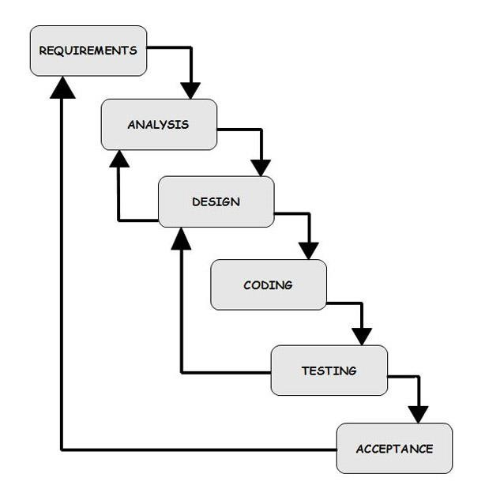

**Fig 5.1 Waterfall Model Activities**

The activities in waterfall model are:

### 5.2.1 System Analysis

This step refers to the gathering of system requirements with the goal of determining how these requirements will be integrated in the system. Extensive communication between the customer and the development team is essential. During system analysis feasibility studies are also carried out.

### 5.2.2 System Design

Once the requirements have been collected and analysed, it is necessary to identify in detail how the system will be constructed to perform the necessary tasks.

### 5.2.3 Coding

Also known a programming, this step involves the creation of the system software. Requirements and system specification are translated into computer code.

### 5.2.4 Testing

As the software is created and added to the developing system, testing is performed to ensure that it is working correctly and efficiently.

**5.2.5 Implementation**

After the code is tested, if it meets all the system requirements, it is handed over to the customers.

### 5.2.6 Maintenance

Inevitably the system will need maintenance. Software will definitely undergo change once it is delivered to the customer. Change could happen because of some unexpected input values to the system.

## 5.3 System Architecture

An architecture description is a format description and implementation of a system, organized in a way that supports reasoning about the structure of the system which comprises system components, the externally visible properties of those components, the relationship between them, and provides a plan from with products can be produced, and systems can be developed, that will work together to implement the overall system.

## 5.4 Summary

This chapter provides details about the various functionality of our system. The system architecture and the dataflow diagram at different levels is also mentioned here., it provides a brief description about the architecture of the system and about the goals and constraints of the system. The assumptions and dependencies are also mentioned.

# DETAILED DESIGN

The system design documentation provides the structure of the system such as the activity diagram, use case diagram, ER diagram and sequence diagram.

## 6.1 Activity Diagram

Activity diagrams are graphical representations of the step wise activities and actions with support for choice and iteration.

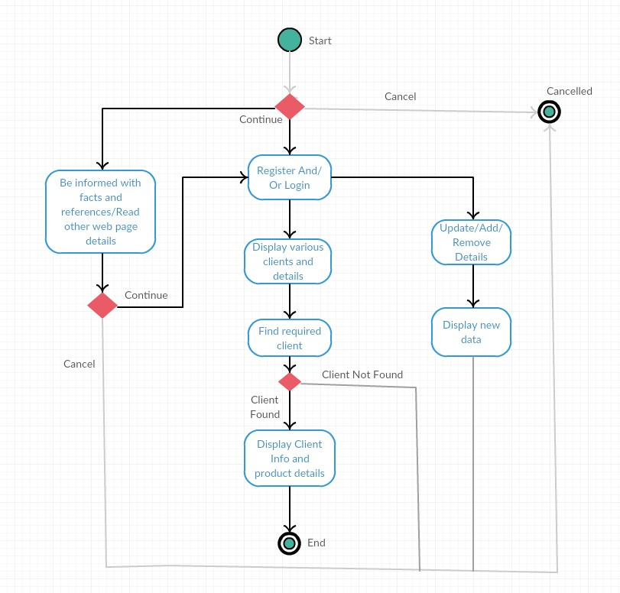

**Fig 6.1 Activity Diagram**

## 6.2 Use Case Diagram

Use case diagram is a diagram defined by and created from a Use-Case analysis. Its purpose is to present a graphical overview of the functionality provided by a system.

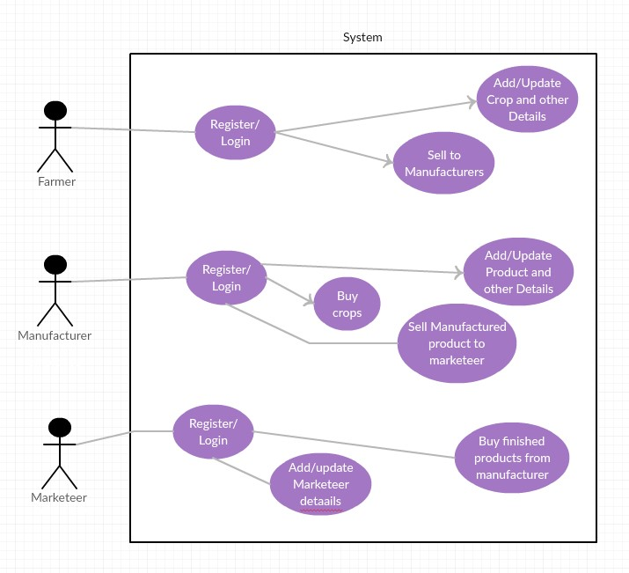

**Fig 6.2 Use case Diagram**

## 6.3 Sequence Diagram

A sequence diagram is an interaction diagram that shows how processes operate with one another and what is their order. A sequence diagram shows object interactions arranged in time sequence.

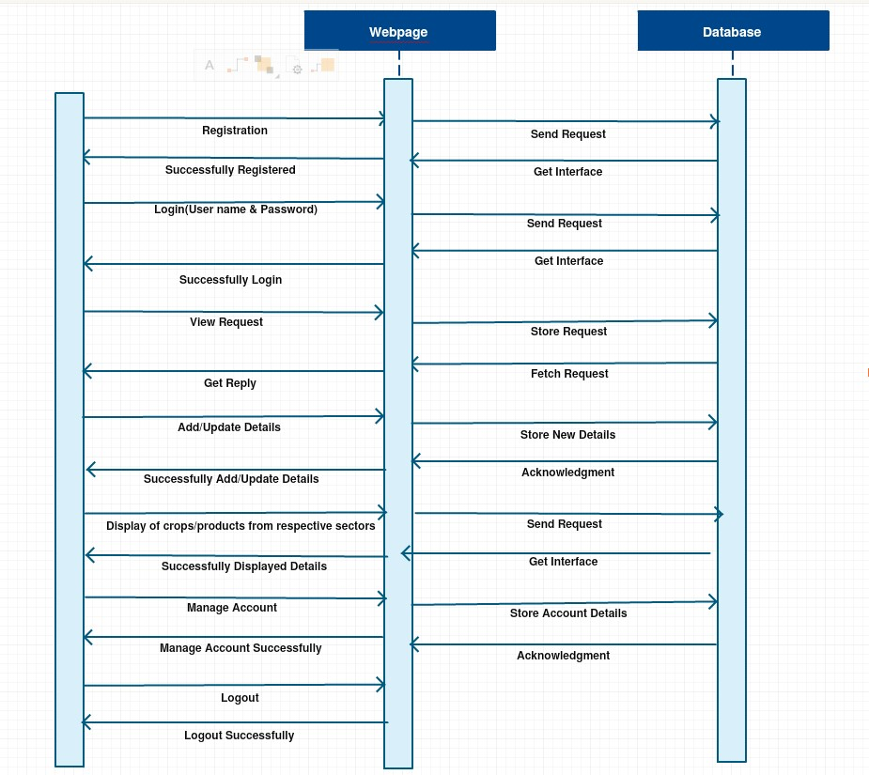

**Fig 6.3 Sequence Diagram**

## 6.4 Summary

This chapter summarizes the activity diagram, the use-case diagram, the ER diagram and the sequence diagram of the system.

# DATABASES

## 7.1 ER Diagram

ER Diagram stands for Entity Relationship Diagram. it is a visual representation of data that describes how data are related to each other.

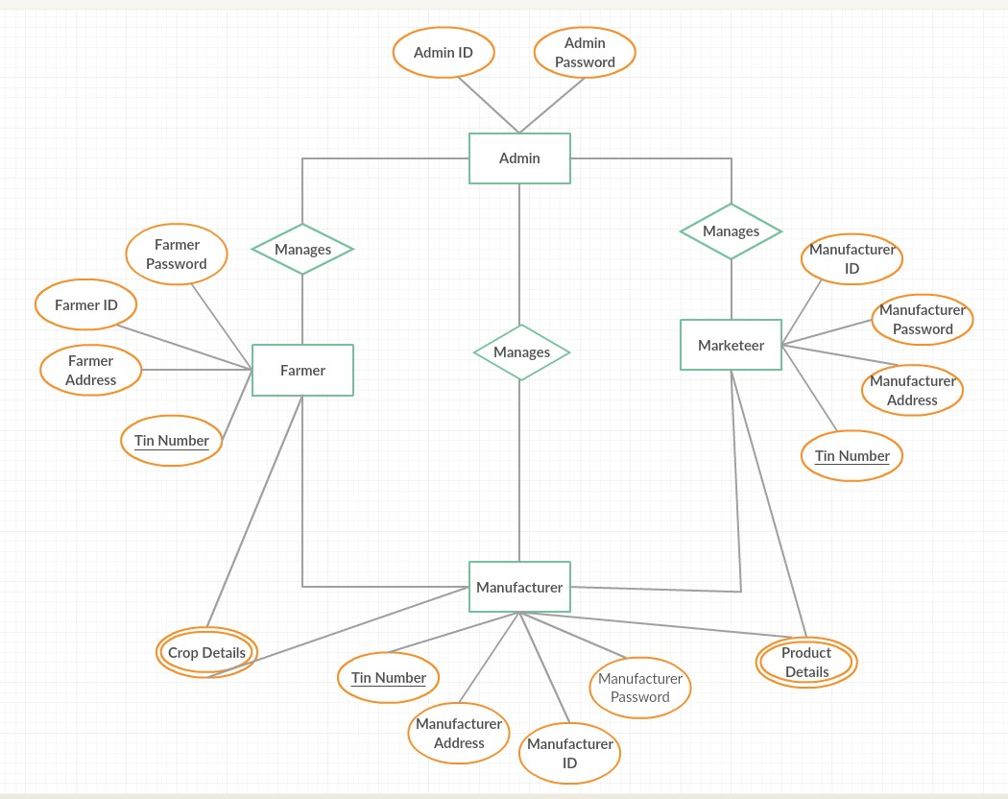

**Fig 7.1 ER Diagram**

## 7.2 Tables structure

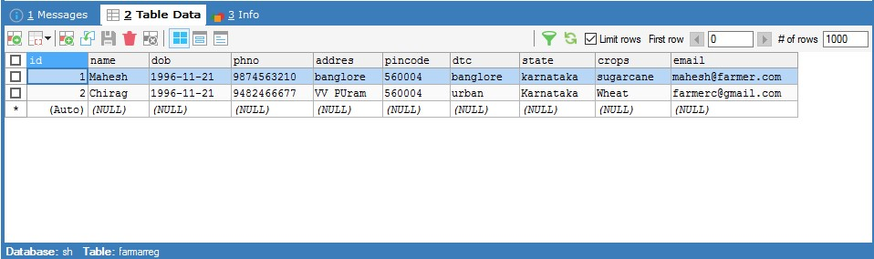

### Fig 7.1.1 Display of database for Farmer Registration

The Database table that consists of the details of the farmer at the time of registration to the 3SH system is shown in fig 7.1.1.

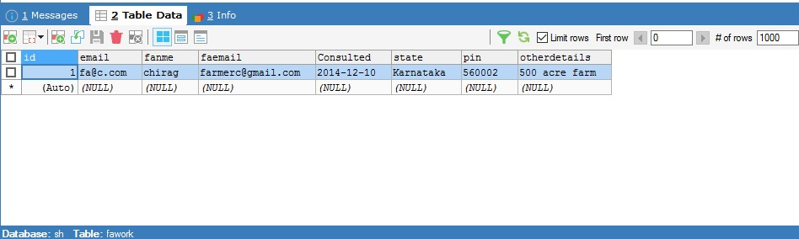

### Fig 7.1.2 Display of database for Field Agent

The Database table that consists of the details of the field agent as well as the details of the farmer that he is consulted with the consultation details is shown in fig 7.1.2.

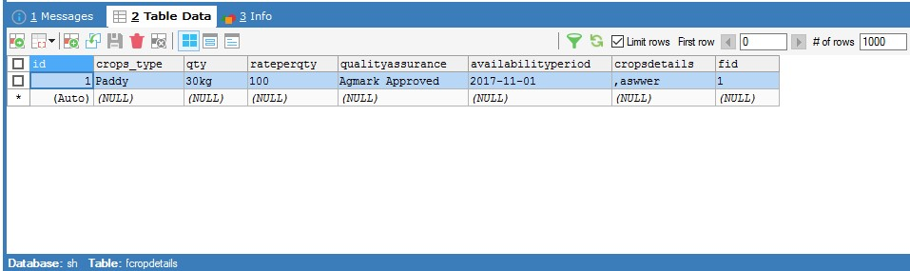

### Fig 7.1.3 Display of database for Crop Details

The Database table that consists of the details of the crops entered by the farmer after user authentication and logging in to the 3SH system is shown in fig 7.1.3.

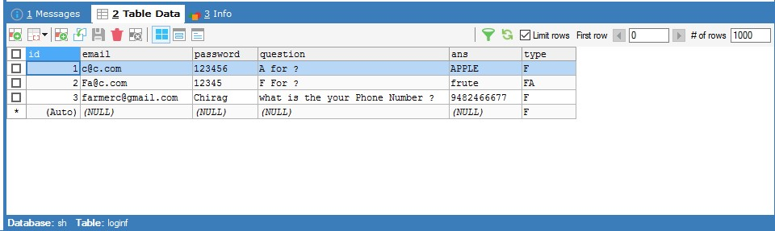

### Fig 7.1.4 Display of database for farmer authentication

The Database table that consists of the details of the farmer authentication i.e., the username and password that the farmer uses to login to the 3SH system is shown in fig 7.1.4.

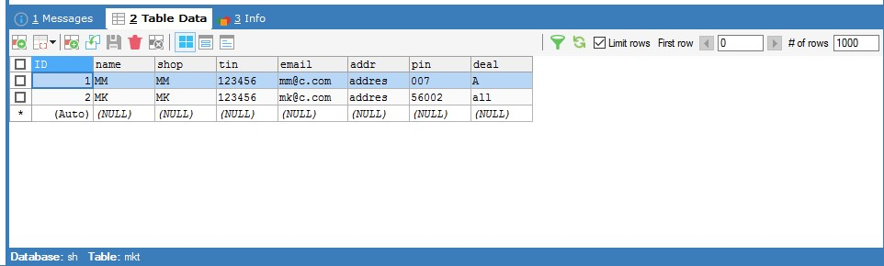

### Fig 7.1.5 Display of database for marketeer registration

The Database table that consists of the details of the marketeer at the time of registration to the 3SH system is shown in fig 7.1.5.

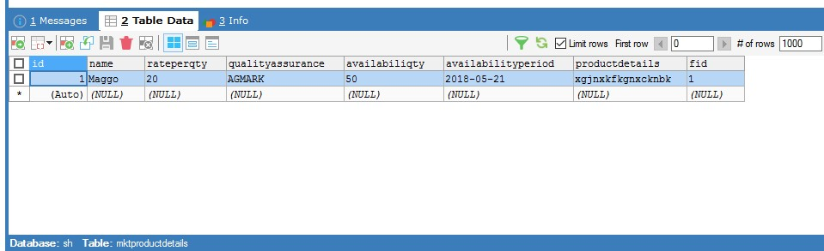

### Fig 7.1.6 Display of database for manufacturer product details

The Database table that consists of the details of the product that is produced by the manufacturer to be sold in the market and is displayed in the marketeer timeline after logging in and registering the product in the 3SH system is shown in fig 7.1.6.

## 7.3 NORMALIZATION

Normalization entails organizing the columns and tables of a database to ensure that their dependencies are properly enforced by database integrity constraints. Normalization is a systematic approach of decomposing tables to eliminate data redundancy (repetition) and undesirable characteristics like Insertion, Update and Deletion Anomalies. It is a multi-step process that puts data into tabular form, removing duplicated data from the relation tables.

* Normalization is the process of organizing the data in the database.
* Normalization is used to minimize the redundancy from a relation or set of relations. It is also used to eliminate the undesirable characteristics like Insertion, Update and Deletion Anomalies.
* Normalization divides the larger table into the smaller table and links them using relationship.
* Eliminating redundant (useless) data.

The various types of normalization are: -

* 1NF- First Normal Form
* 2NF- Second Normal Form
* 3NF- Third Normal Form

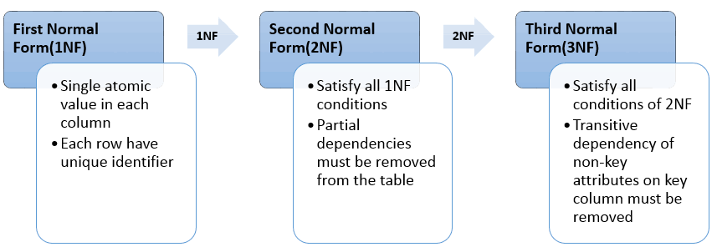

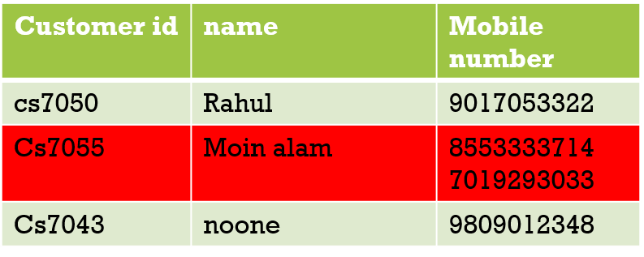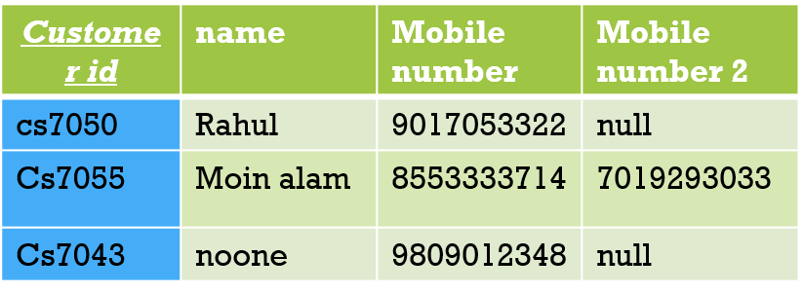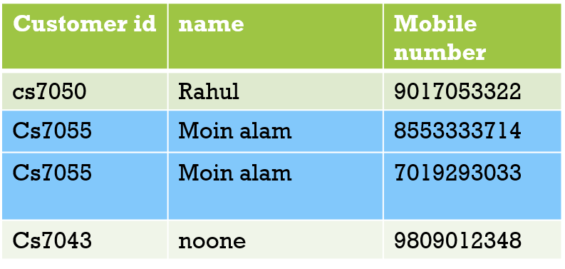

**Second NORMAL FORM (1NF):**

**FIRST NORMAL FORM (1NF):**

