    Joint Collaborative Team on Video Coding (JCT-VC)  of ITU-T SG16 WP3 and ISO/IEC JTC1/SC29/WG11  17th Meeting: Valencia, ES, 27 Mar. – 4 Apr. 2014 | Document: JCTVC-Q1002

Title: | High Efficiency Video Coding (HEVC) Test Model 15 (HM15) Encoder Description
Status: | Output Document of JCT-VC
Purpose: | Report
Author(s) or  Contact(s): | Il-Koo Kim (Samsung)  Ken McCann (Samsung/ZetaCast)  Kazuo Sugimoto (Mitsubishi)  Benjamin Bross (HHI)  Woo-Jin Han (Gachon University)  Gary Sullivan (Microsoft Corp.) | Email: | ilkoo.kim@samsung.com  ken@zetacast.com  sugimoto@merl.com  benjamin.bross@hhi.fraunhofer.de  hurumi@gmail.com  garysull@microsoft.com
Source: | Editors
_____________________________

Abstract
The JCT-VC established an 15th HEVC test model (HM15) at its 17th meeting in Valencia from 27 March to 4 April 2014. This document serves as a source of general tutorial information on HEVC and also provides an encoder-side description of HM15.
CONTENTS
Page
Abstract 1
List of figures 4
List of tables 5
1 Introduction 6
2 Scope 7
3 Description of HEVC Test Model 7
3.1 General overview of coding structure 7
3.2 Picture partitioning 8
3.2.1 CTU partitioning 8
3.2.2 Slice and tile structures 9
3.2.3 Coding unit (CU) and coding tree structure 10
3.2.4 Prediction unit (PU) structure 10
3.2.5 Transform unit (TU) and transform tree structure 11
3.3 Intra Prediction 12
3.3.1 Prediction modes 12
3.3.2 Filtering of neighbouring samples 13
3.4 Inter Prediction 13
3.4.1 Prediction modes 13
3.4.1.1 Derivation of merge candidates 14
3.4.1.2 Spatial merge candidates 14
3.4.1.3 Temporal merge candidates 15
3.4.1.4 Generated merge candidates 16
3.4.2 Motion vector prediction 16
3.4.2.1 Derivation of motion vector prediction candidates 16
3.4.2.2 Spatial motion vector candidates 17
3.4.2.3 Temporal motion vector candidates 17
3.4.3 Interpolation filter 17
3.4.4 Weighted Prediction 18
3.5 Transform and quantization (scaling) 18
3.5.1 Transform matrices 19
3.5.2 2D inverse transform 20
3.5.3 Discrete sine transform (DST) 20
3.5.4 Transform skip 20
3.5.5 Scaling and quantization 20
3.6 Entropy Coding 20
3.7 Loop Filtering 21
3.7.1 Overview of Loop filtering 21
3.7.2 Deblocking filter 21
3.7.2.1 Boundary decision 21
3.7.2.2 Boundary strength calculation 21
3.7.2.3 Threshold variables 22
3.7.2.4 Filter on/off decision for 4 lines 23
3.7.2.5 Strong/weak filter selection for 4 lines 23
3.7.2.6 Strong filtering 23
3.7.2.7 Weak filtering 24
3.7.2.8 Chroma filtering 24
3.7.3 Sample Adaptive Offset (SAO) 24
3.7.3.1 Operation of each SAO type 24
3.8 Wavefront parallel processing 25
4 Description of encoding methods 26
4.1 Cost Functions 26
4.1.1 Sum of Square Error (SSE) 26
4.1.2 Sum of Absolute Difference (SAD) 26
4.1.3 Hadamard transformed SAD (SATD) 26
4.1.4 RD cost functions 26
4.1.4.1 Lagrangian constant values 26
4.1.4.2 Weighting factor for chroma component 27
4.1.4.3 SAD based cost function for prediction parameter decision 27
4.1.4.4 SATD based cost function for prediction parameter decision 27
4.1.4.5 Cost function for mode decision 27
4.2 Encoder configurations 27
4.2.1 Overview of encoder configurations 27
4.2.2 Intra-only configuration 28
4.2.3 Low-delay configurations 28
4.2.4 Random-access configuration 28
4.3 Input bit depth modification 29
4.4 Slice partitioning operation 29
4.5 Derivation process for slice-level coding parameters 29
4.5.1 Sample Adaptive Offset (SAO) parameters 29
4.5.1.1 Search the SAO type with minimum rate-distortion cost 29
4.5.1.2 Slice level on/off Control 30
4.6 Derivation process for CU-level and PU-level coding parameters 30
4.6.1 Intra prediction mode and parameters 30
4.6.2 Inter prediction mode and parameters 30
4.6.2.1 Derivation of motion parameters 30
4.6.2.2 Motion estimation 31
4.6.2.3 Decision process on AMP mode evaluation procedure 33
4.6.3 Intra/Inter/PCM mode decision 33
4.7 Derivation process for TU-level coding parameters 35
4.7.1 Residual Quad-tree partitioning 35
4.7.2 Rate-Distortion Optimized Quantization 36
5 References 36

List of figures
Figure 3-1 – Simplified block diagram of HM encoder 7
Figure 3-2 – Example of a picture divided into CTUs 8
Figure 3-3 – Example of slices and slice segments 9
Figure 3-4 – Examples of tiles and slices 10
Figure 3-5 – Example of coding tree structure 10
Figure 3-6 – 8 partition modes for inter PU 11
Figure 3-7 – Example of transform tree structure within CU 11
Figure 3-8 – The 33 intra prediction directions 12
Figure 3-9 – Mapping between intra prediction direction and intra prediction mode 12
Figure 3-10 – Derivation process for merge candidate 14
Figure 3-11 – Positions of spatial merge candidate 14
Figure 3-12 – Positions for the second PU of Nx2N and 2NxN partitions 15
Figure 3-13 – Illustration of motion vector scaling for temporal merge candidate 15
Figure 3-14 – Candidate positions for temporal merge candidate, C3 and H 15
Figure 3-15 – Example of combined bi-predictive merge candidate 16
Figure 3-16 – Derivation process for motion vector prediction candidates 16
Figure 3-17 – Illustration of motion vector scaling for spatial motion vector candidate 17
Figure 3-18 – Overall processing flow of deblocking filter process 21
Figure 3-19 – Flow diagram for Bs calculation 22
Figure 3-20 – Referred information for Bs calculation at CTU boundary 22
Figure 3-21 – Pixels involved in filter on/off decision and strong/weak filter selection 23
Figure 3-22 – Four 1-D 3-pixel patterns for the pixel classification in EO 25
Figure 3-23 – Four bands are grouped together and represented by its starting band position 25
Figure 4-1 – Graphical presentation of intra-only configuration 28
Figure 4-2 – Graphical presentation of low-delay configuration 28
Figure 4-3 – Graphical presentation of random-access configuration 29
Figure 4-4 – Three step motion search strategy for integer-pel accuracy 31
Figure 4-5 – Start position selection 32
Figure 4-6 – Search patterns for the first search 32
Figure 4-7 – The schematic of Intra/Inter/PCM mode decision 35

List of tables
Table 1-1 – Structure of Tools in HM Configurations 6
Table 3-1 – Maximum quadtree depth according to test scenario and prediction modes 11
Table 3-2 – Mapping between intra prediction direction and intra prediction mode for chroma 13
Table 3-3 – Specification of predefined threshold for various transform block sizes 13
Table 3-4 – 8-tap DCT-IF coefficients for 1/4th luma interpolation 17
Table 3-5 – 4-tap DCT-IF coefficients for 1/8th chroma interpolation 18
Table 3-6 – Derivation of threshold variables from input Q 22
Table 3-7 – Specification of SAO type 24
Table 3-8 – Pixel classification rule for EO 25
Table 4-1 – Derivation of 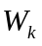 27
Table 4-2 – Conditions and actions for fast AMP mode evaluation 33

Introduction
The 15th HEVC test model (HM15) was specified by decisions taken at the 17th meeting of JCT-VC from 27 March to 4 April 2014.
Two configurations of tools have been defined in the HM software [17]: Main and Main10. These configurations of tools correspond to the Main profile and the Main 10 profile in the HEVC specification [16] respectively, with the bit depth for both luma and chroma set to 10 bit in the latter case.
A summary list of the tools that are included in Main and Main10 is provided in Table 1-1 below.
Table 1-1 – Structure of Tools in HM Configurations
Main |  | Main10
High-level Structure:
High-level support for frame rate temporal nesting and random access
Clean random access (CRA) support
Rectangular tile-structured scanning
Wavefront-structured processing dependencies for parallelism
Slices with spatial granularity equal to coding tree unit
Slices with independent and dependent slice segments
Coding units, Prediction units, and Transform units:
Coding unit quadtree structure
square coding unit block sizes 2Nx2N, for N=4, 8, 16, 32 (i.e. up to 64x64 luma samples in size)
Prediction units
(for coding unit size 2Nx2N: for Inter, 2Nx2N, 2NxN, Nx2N, and,
for N>4, also 2Nx(N/2+3N/2) & (N/2+3N/2)x2N; for Intra, only 2Nx2N and, for N=4, also NxN)
Transform unit tree structure within coding unit (maximum of 3 levels)
Transform block size of 4x4 to 32x32 samples (always square)
Spatial Signal Transformation and PCM Representation:
DCT-like integer block transform;
for Intra also a DST-based integer block transform (only for Luma 4x4)
Transforms can cross prediction unit boundaries for Inter; not for Intra
Skipping transform is allowed for 4x4 transform unit
PCM coding with worst-case bit usage limit
Intra-picture Prediction:
Angular intra prediction (35 modes including DC and Planar )
Planar intra prediction
Inter-picture Prediction:
Luma motion compensation interpolation: 1/4 sample precision,
8x8 separable with 6 bit tap values for 1/2 precision, 7x7 separable with 6 bit tap values for 1/4 precision
Chroma motion compensation interpolation: 1/8 sample precision,
4x4 separable with 6 bit tap values
Advanced motion vector prediction with motion vector “competition” and “merging”
Entropy Coding:
Context adaptive binary arithmetic entropy coding (CABAC)
Rate-distortion optimized quantization (RDOQ)
Picture Storage and Output Precision:
8 bit-per-sample storage and output | 10 bit-per-sample storage and output
In-Loop Filtering:
Deblocking filter
Sample-adaptive offset filter (SAO)
At its 1st meeting, in April 2010, the JCT-VC defined a "Test Model under Consideration" (TMuC), which was documented in JCTVC-B204 [1]. At its 3rd meeting, in October 2010, the JCT-VC defined a 1st HEVC Test Model (HM1) [2]. Further optimizations of the HEVC Test Model in HM2 [3], HM3 [4], HM4 [5], HM5 [6], HM6 [7], HM7[8], HM8[9], HM9[10], HM10[11], HM11[12], HM12[16], HM13[14] and HM14[15] were specified at subsequent meetings, with each successive model achieving better performance than the previous in terms of the trade-off between coding efficiency and complexity.

Scope
This document provides an encoder-side description of the HEVC Test Model (HM), which serves as a tutorial on the encoding model implemented in the HM software. The purpose of this text is to share a common understanding on reference encoding methods supported in the HM software, in order to facilitate the assessment of the technical impact of proposed new technologies during the HEVC standardization process. Although brief descriptions of the HEVC design are provided to help understanding of the HM, the corresponding sections of the HEVC draft specification [16] should be referred to for any descriptions regarding normative processes. A further document [17] defines the common test conditions and software reference configurations that should be used for experimental work.

Description of HEVC Test Model

General overview of coding structure
The HEVC standard is based on the well-known block-based hybrid coding architecture, combining motion-compensated prediction and transform coding with high-efficiency entropy coding. However, in contrast to previous video coding standards, it employs a flexible quad-tree coding block partitioning structure that enables the use of large and multiple sizes of coding, prediction, and transform blocks. It also employs improved intra prediction and coding, adaptive motion parameter prediction and coding, a new loop filter and an enhanced version of context-adaptive binary arithmetic coding (CABAC) entropy coding. New high level structures for parallel processing are also employed.
A general block-diagram of the HM encoder is depicted in Figure 3-1 below.
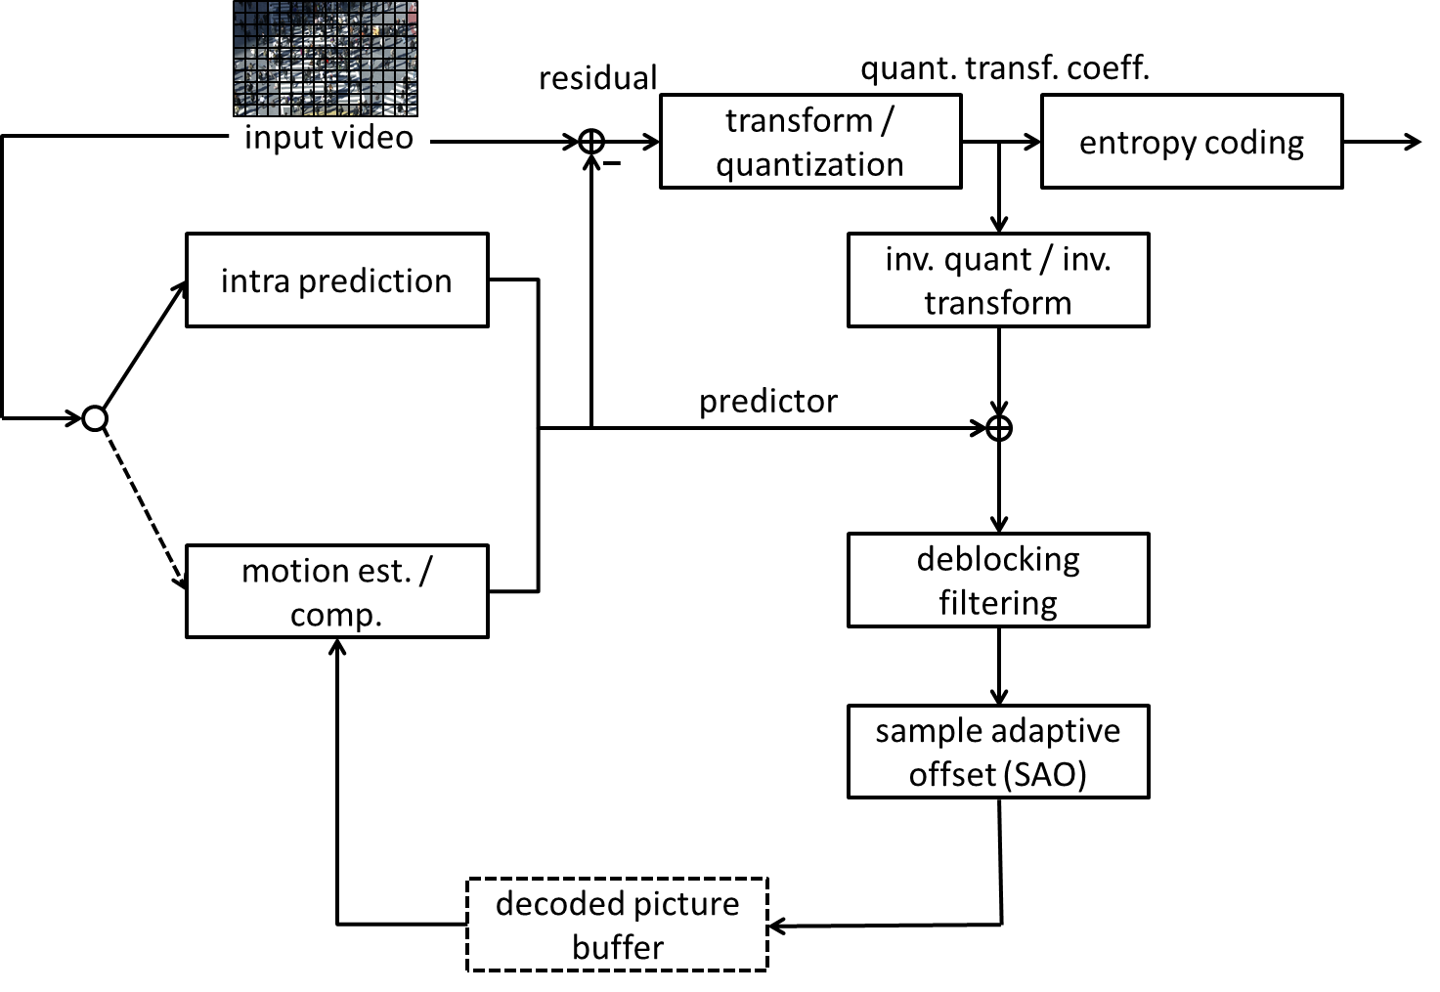
Figure 3-1 – Simplified block diagram of HM encoder
The picture partitioning structure is described in Section 3.2. The input video is first divided into blocks called coding tree units (CTUs), which perform a role that is broadly analogous to that of macroblocks in previous standards. The coding unit (CU) defines a region sharing the same prediction mode (intra, inter or skip) and it is represented by the leaf node of a quadtree structure. The prediction unit (PU) defines a region sharing the same prediction information. The transform unit (TU), specified by another quadtree, defines a region sharing the same transformation and quantization.
The intra-picture coding prediction processes are described in Section 3.3. The best intra mode among a total of 35 modes (Planar, DC and 33 angular directions) is selected and coded. Mode dependent context sample smoothing is applied to increase prediction efficiency and the three most probable modes (MPM) are used to increase symbol coding efficiency.
The inter-picture prediction processes are described in Section 3.4. The best motion parameters are selected and coded by merge mode and adaptive motion vector prediction (AMVP) mode, in which motion predictors are selected and explicitly coded among several candidates. To increase the efficiency of motion-compensated prediction, a non-cascaded interpolation structure with 1D FIR filters is used. An 8-tap or 7-tap filter is directly applied to generate the values of half-pel and quarter-pel luma samples, respectively. A 4-tap filter is utilized for chroma interpolation.
Transforms and quantization are described in Section 3.5. Residuals generated by subtracting the prediction from the input are spatially transformed and quantized. In the transform process, matrices which are approximations to DCT are used. A partial butterfly structure is implemented for the transformation, to reduce computational cost. In the case of 4x4 intra predicted residuals, an approximation to DST is used for the luma. 52-level quantization steps and rate-distortion optimized quantization (RDOQ) are used in the quantization process. Reconstructed samples are created by inverse quantization and inverse transform.
Entropy coding is described in Section 3.6. It is applied to the generated symbols and quantized transform coefficients in the encoding process using a Context-based Adaptive Binary Arithmetic Coding (CABAC) process.
Loop filtering is described in Section 3.7. After reconstruction, two in-loop filtering processes are applied to achieve better coding efficiency and visual quality: deblocking filtering and sample adaptive offset (SAO). Reconstructed CTUs are assembled to construct a picture that is stored in the decoded picture buffer to be used to encode the next picture of input video.

Picture partitioning

CTU partitioning
Pictures are divided into a sequence of coding tree units (CTUs). The CTU concept is broadly analogous to that of the macroblock in previous standards such as AVC[19]. For a picture that has three sample arrays, a CTU consists of an NxN block of luma samples together with two corresponding blocks of chroma samples.
The maximum allowed size of the luma block in a CTU is specified to be 64x64 in Main profile.
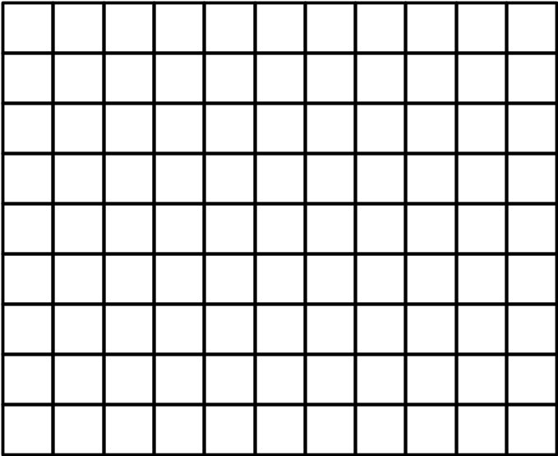
Figure 3-2 – Example of a picture divided into CTUs

Slice and tile structures
A slice is a data structure that can be decoded independently from other slices of the same picture, in terms of entropy coding, signal prediction, and residual signal reconstruction. A slice can either be the entire picture or a region of a picture, which is not necessarily rectangular. It consists of a sequence of one or more slice segments starting with an independent slice segment and containing all subsequent dependent slice segments (if any) that precede the next independent slice segment (if any) within the same access unit.
A slice segment consists of a sequence of CTUs. An independent slice segment is a slice segment for which the values of the syntax elements of the slice segment header are not inferred from the values for a preceding slice segment. A dependent slice segment is a slice segment for which the values of some syntax elements of the slice segment header are inferred from the values for the preceding independent slice segment in decoding order. For dependent slice segments, prediction can be performed across dependent slice segment boundaries, and entropy coding is not initialized at the starting of the dependent slice segment parsing process.
An example of picture with 11 by 9 coding tree units that is partitioned into two slices is shown in Figure 3-3, below. In this example, the first slice is composed of an independent slice segment containing 4 coding tree units, a dependent slice segment containing 32 coding tree units, and another dependent slice segment containing 24 coding tree units. The second slice consists of a single independent slice segment containing the remaining 39 coding tree units of the picture.
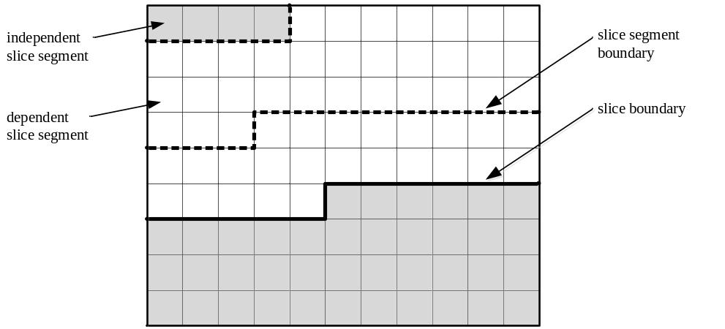
Figure 3-3 – Example of slices and slice segments
A tile is a rectangular region containing an integer number of coding tree units in coding tree block raster scan. The tile scan order is a specific sequential ordering of coding tree blocks partitioning a picture in which the coding tree blocks are ordered consecutively in coding tree block raster scan in a tile, whereas tiles in a picture are ordered consecutively in a raster scan of the tiles of the picture.
A tile may consist of coding tree units contained in more than one slice. Similarly, a slice may consist of coding tree units contained in more than one tile. Note that within the same picture, there may be both slices that contain multiple tiles and tiles that contain multiple slices.
One or both of the following conditions are fulfilled for each slice and tile:
– All coding tree units in a slice belong to the same tile.
– All coding tree units in a tile belong to the same slice.
One or both of the following conditions are fulfilled for each slice segment and tile:
– All coding tree units in a slice segment belong to the same tile.
– All coding tree units in a tile belong to the same slice segment.
Two examples of possible slice and tile structures for a picture with 11 by 9 coding tree units are shown in Figure 3-4, below. In both examples, the picture is partitioned into two tiles, separated by a vertical tile boundary. The left-hand example shows a case in which the picture only contains one slice, starting with an independent slice segment and followed by four dependent slice segments. The right-hand example illustrates an alternative case in which the picture contains two slices in the first tile and one slice in the second tile.
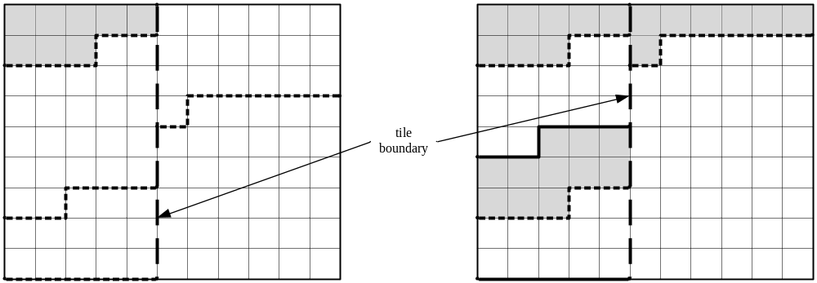
Figure 3-4 – Examples of tiles and slices

Coding unit (CU) and coding tree structure
The coding unit (CU) is a square region, represented as the leaf node of a quadtree partitioning of the CTU, which shares the same prediction mode: intra, inter or skipped. The quadtree partitioning structure allows recursive splitting into four equally sized nodes, starting from the CTU as illustrated in Figure 3-5.
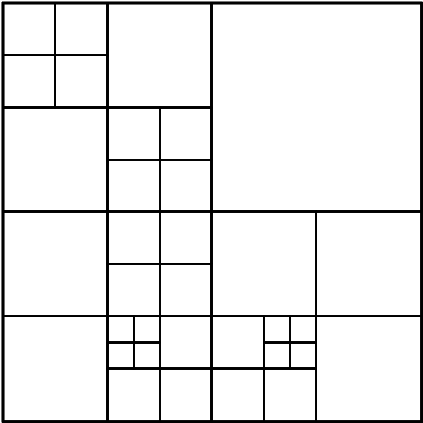
Figure 3-5 – Example of coding tree structure
This process gives a content-adaptive coding tree structure comprised of CUs, each of which may be as large as the CTU or as small as 8x8.
Each non-skipped CU is assigned to one of two prediction modes: intra prediction or inter prediction. A skipped CU is considered to be an inter prediction mode without coding of motion vector differences and residual information.

Prediction unit (PU) structure
The prediction unit (PU) is a region, defined by partitioning the CU, on which the same prediction is applied. In general, the PU is not restricted to being square in shape, in order to facilitate partitioning which matches the boundaries of real objects in the picture.
Each CU contains one, two or four PUs depending on the partition mode. Figure 3-6 illustrates the eight partition modes that may be used to define the PUs for an inter-coded CU. The PART_2Nx2N and PART_NxN partition modes are used for an intra-coded CU. The partition mode PART_NxN is allowed only when the corresponding CU size is equal to the minimum CU size.
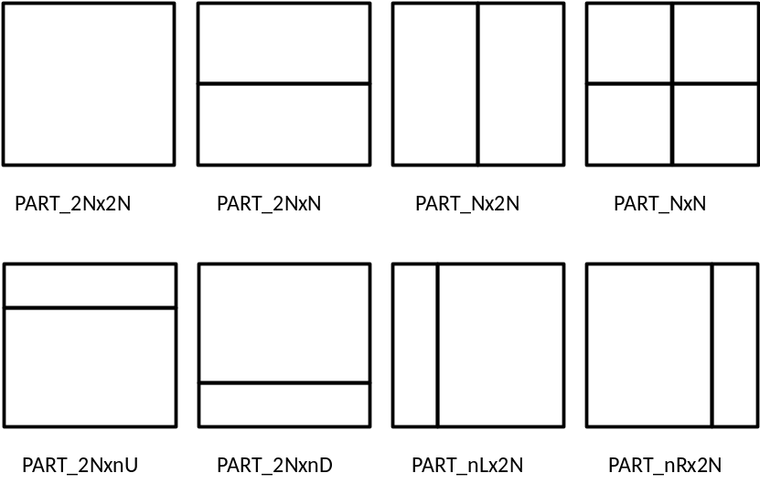
Figure 3-6 – 8 partition modes for inter PU
In general, the HM supports PU sizes from 64x64 down to 4x4 samples. However, in order to reduce the memory bandwidth of motion compensation, the 4x4 block size is not allowed for an inter-coded PU.

Transform unit (TU) and transform tree structure
The transform unit (TU) is a square region, defined by quadtree partitioning of the CU, which shares the same transform and quantization processes. The quadtree structure of multiple TUs within a CU is illustrated in Figure 3-7.
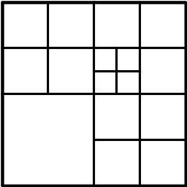
Figure 3-7 – Example of transform tree structure within CU
The TU shape is always square and it may take a size from 32x32 down to 4x4 samples. The maximum quadtree depth is adjustable and is specified in the slice header syntax. The values in the HM are set according to the test scenario, as shown in Table 3-2 below.
Table 3-2 – Maximum quadtree depth according to test scenario and prediction modes
Test scenario | Maximum quadtree depth  (for inter block) | Maximum quadtree depth  (for intra block)
Intra Only Main | - | 3
Random Access Main | 3 | 3
Low Delay Main | 3 | 3
Intra Only Main10 | - | 3
Random Access Main10 | 3 | 3
Low Delay Main10 | 3 | 3
For an inter CU, the TU can be larger than PU, i.e. the TU may contain PU boundaries. However, the TU cannot cross PU boundaries for an intra CU.

Intra Prediction

Prediction modes
The decoded boundary samples of adjacent blocks are used as reference data for spatial prediction in regions where inter picture prediction is not performed. All TUs within a PU use the same associated intra prediction mode for the luma component and the chroma components. The encoder selects the best luma intra prediction mode of each PU from 35 options: 33 directional prediction modes, a DC mode and a Planar mode. The 33 possible intra prediction directions are illustrated in Figure 3-8 below.
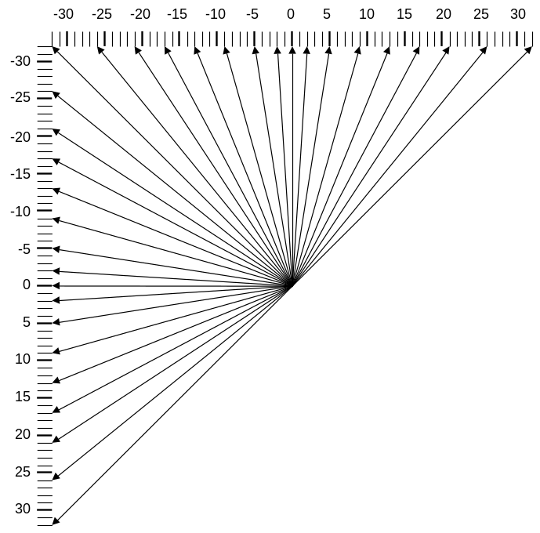
Figure 3-8 – The 33 intra prediction directions
The mapping between the intra prediction direction and the intra prediction mode number is specified in Figure 3-9, below.
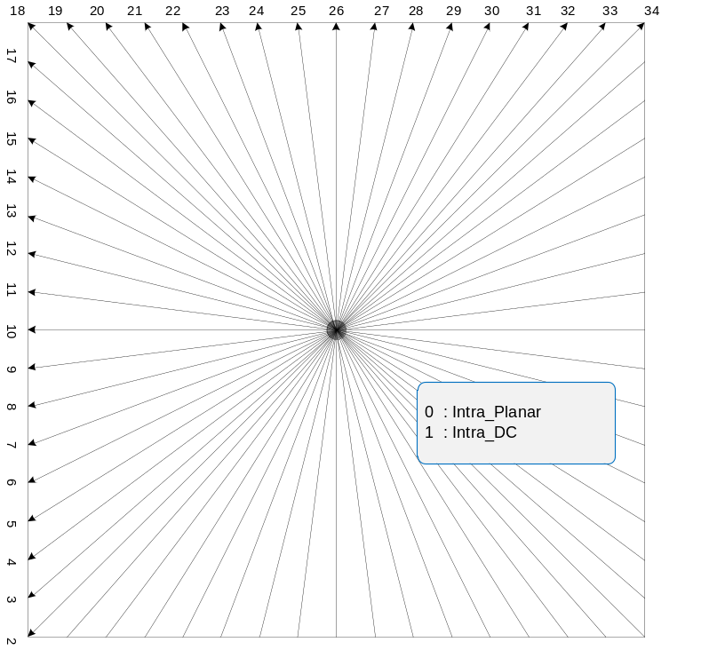
Figure 3-9 – Mapping between intra prediction direction and intra prediction mode
For the chroma component of an intra PU, the encoder selects the best chroma prediction modes among five modes including Planar, DC, Horizontal, Vertical and a direct copy of the intra prediction mode for the luma component. The mapping between intra prediction direction and intra prediction mode number for chroma is shown in Table 3-3.
Table 3-3 – Mapping between intra prediction direction and intra prediction mode for chroma
intra_chroma_pred_mode | Intra prediction direction
intra_chroma_pred_mode | 0 | 26 | 10 | 1 | X ( 0 <= X <= 34 )
0 | 34 | 0 | 0 | 0 | 0
1 | 26 | 34 | 26 | 26 | 26
2 | 10 | 10 | 34 | 10 | 10
3 | 1 | 1 | 1 | 34 | 1
4 | 0 | 26 | 10 | 1 | X
When the intra prediction mode number for the chroma component is 4, the intra prediction direction for the luma component is used for the intra prediction sample generation for the chroma component. When the intra prediction mode number for the chroma component is not 4 and it is identical to the intra prediction mode number for the luma component, the intra prediction direction of 34 is used for the intra prediction sample generation for the chroma component.

Filtering of neighbouring samples
For the luma component, the neighbouring samples used for intra prediction sample generations are filtered before the generation process. The filtering is controlled by the given intra prediction mode and transform block size. If the intra prediction mode is DC or the transform block size is equal to 4x4, neighbouring samples are not filtered. If the distance between the given intra prediction mode and vertical mode (or horizontal mode) is larger than predefined threshold, the filtering process is enabled. The predefined threshold is specified in Table 3-4, where nT represents the transform block size.
Table 3-4 – Specification of predefined threshold for various transform block sizes
 | nT = 8 | nT = 16 | nT = 32
Threshold | 7 | 1 | 0
For neighbouring sample filtering, [1, 2, 1] filter and bi-linear filter are used. The bi-linear filtering is conditionally used if all of the following conditions are true.
– strong_intra_smoothing_enable_flag is equal to 1
– transform block size is equal to 32
– Abs( p[ −1 ][ −1 ] + p[ nT*2−1 ][ −1 ] – 2*p[ nT−1 ][ −1 ] ) < (1 << ( BitDepthY − 5 ))
– Abs( p[ −1 ][ −1 ] + p[ −1 ][ nT*2−1 ] – 2*p[ −1 ][ nT−1 ] ) < (1 << ( BitDepthY − 5 ))

Inter Prediction

Prediction modes
Each inter coded PU has a set of motion parameters consisting of motion vector, reference picture index, reference picture list usage flag to be used for inter prediction sample generation, signalled in an explicit or implicit manner. When a CU is coded with skip mode, the CU is represented as one PU that has no significant transform coefficients and motion vectors, reference picture index and reference picture list usage flag obtained by merge mode. The merge mode is to find the neighbouring inter coded PU such that its motion parameters (motion vector, reference picture index, and reference picture list usage flag) can be inferred as the ones for the current PU. The encoder can select the best inferred motion parameters from multiple candidates formed by spatially neighbouring PUs and temporally neighbouring PUs, and transmit the corresponding index indicating the chosen candidate. The merge mode can be applied to any inter coded PU, not only for skip mode. In any inter coded PUs, the encoder can use merge mode or explicit transmission of motion parameters, where motion vector, corresponding reference picture index for each reference picture list and reference picture list usage flag are signalled explicitly per each PU. For inter coded PU, significant transform coefficients are sent to decoder. The details are presented in the following sections.

Derivation of merge candidates
Figure 3-10 summarizes the derivation process for merge candidates.
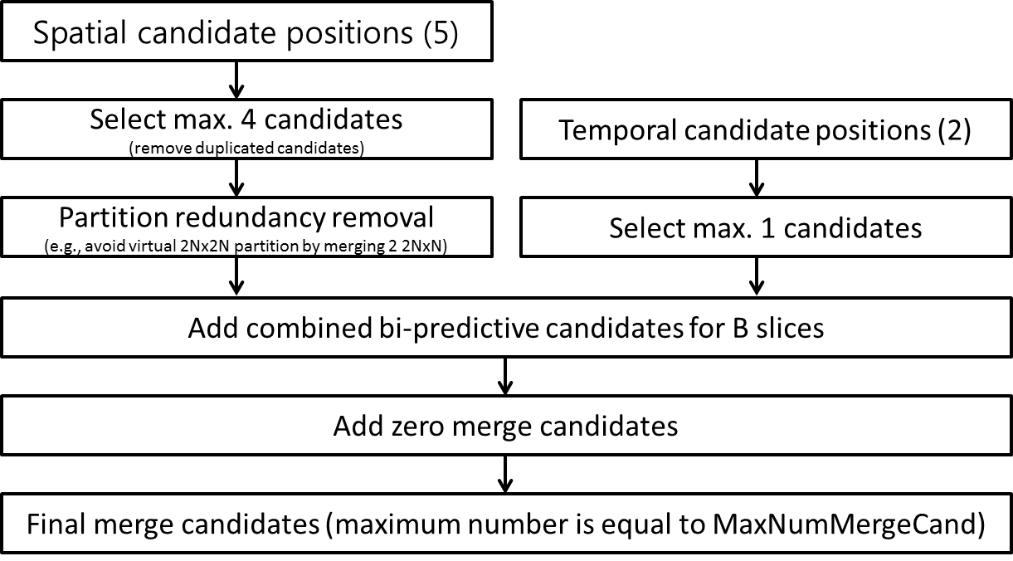
Figure 3-10 – Derivation process for merge candidate
Two types of merge candidates are considered in merge mode: spatial merge candidate and temporal merge candidate. For spatial merge candidate derivation, a maximum of four merge candidates are selected among candidates that are located in five different positions. In the process of candidate selection, duplicated candidates having the same motion parameters as the previous candidate in the processing order are removed from the candidate list. Also, candidates inside the same merge estimation region (MER) are not considered, in order to help parallel merge processing. Redundant partition shape is avoided in order to not emulate a virtual 2Nx2N partition.
For temporal merge candidate derivation, a maximum of one merge candidate is selected among two candidates. Since constant number of candidates for each PU is assumed at decoder, additional candidates are generated when the number of candidates does not reach to maximum number of merge candidate (MaxNumMergeCand) which is signalled in slice header. For B slices, combined bi-predictive candidates are generated utilizing the candidates from the list of spatio-temporal candidates. For both P- and B-slices, zero merge candidates are added at the end of the list. Between each generation step, the derivation process is stopped if the number of candidates reaches to MaxNumMergeCand. In the current common test condition, MaxNumMergeCand is set equal to five. Since the number of candidates is constant, index of best merge candidate is encoded using truncated unary binarization (TU). If the size of CU is equal to 8, all the PUs of the current CU share a single merge candidate list, which is identical to the merge candidate list of the 2Nx2N prediction unit.

Spatial merge candidates
In the derivation of spatial merge candidates, a maximum of four merge candidates are selected among candidates that are located in positions as depicted in Figure 3-11. The order of derivation is A₁ à B₁ à B₀ à A₀ à (B₂). Position B₂ is considered only when any PU of position A₁, B₁, B₀, A₀ is not available or is intra coded.

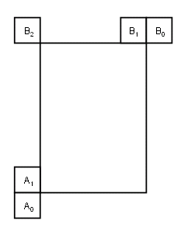
Figure 3-11 – Positions of spatial merge candidate
For the second PU of Nx2N, nLx2N and nRx2N partitions, position A₁ is not considered as a candidate to prevent 2Nx2N partition emulation. In these cases, the order of derivation is B₁ à B₀ à A₀ à B₂. Similarly, for the second PU of 2NxN, 2NxnU and 2NxnD partitions, position B₁ is not used: A₁ à B₀ à A₀ à B₂. Figure 3-12 depicts an example of candidate positions for the second PU of Nx2N and 2NxN, respectively.
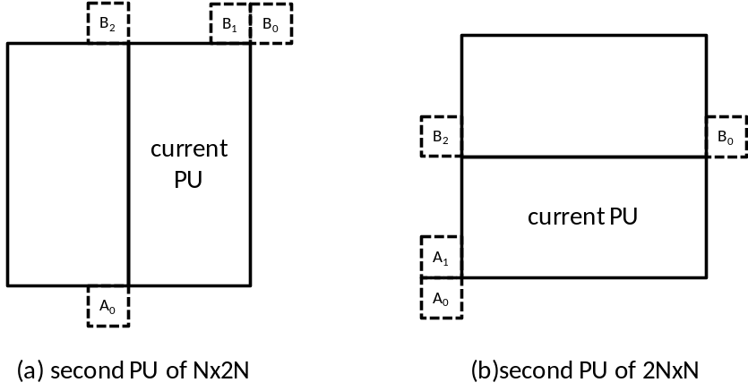
Figure 3-12 – Positions for the second PU of Nx2N and 2NxN partitions

Temporal merge candidates
In the derivation of temporal merge candidate, a scaled motion vector is derived based on co-located PU belonging to the picture which has the smallest POC difference with current picture within the given reference picture list. The reference picture list to be used for derivation of the co-located PU is explicitly signalled in the slice header. The scaled motion vector for temporal merge candidate is obtained as illustrated by the dotted line in Figure 3-13, which is scaled from the motion vector of the co-located PU using the POC distances, tb and td, where tb is defined to be the POC difference between the reference picture of the current picture and the current picture and td is defined to be the POC difference between the reference picture of the co-located picture and the co-located picture. The reference picture index of temporal merge candidate is set equal to zero. A practical realization of the scaling process is described in the HEVC specification [16]. For a B-slice, two motion vectors, one is for reference picture list 0 and the other is for reference picture list 1, are obtained and combined to make the bi-predictive merge candidate.
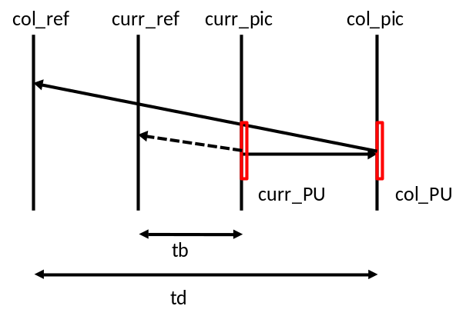
Figure 3-13 – Illustration of motion vector scaling for temporal merge candidate
The position of co-located PU is selected between two candidate positions, C3 and H, as depicted in Figure 3-14. If PU at position H is not available, is intra coded, or is outside of the current CTU, position C3 is used. Otherwise, position H is used for the derivation of the temporal merge candidate.
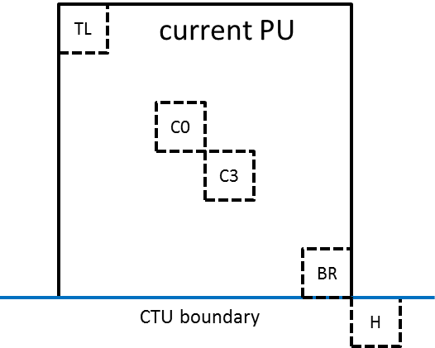
Figure 3-14 – Candidate positions for temporal merge candidate, C3 and H

Generated merge candidates
Besides spatio-temporal merge candidates, there are two additional types of merge candidates: combined bi-predictive merge candidate and zero merge candidate. Combined bi-predictive merge candidates are generated by utilizing spatio-temporal merge candidates. Combined bi-predictive merge candidate is used for B-Slice only. For example, two candidates in the original merge candidate list, which have mvL0 and refIdxL0 or mvL1 and refIdxL1, are used to create a combined bi-predictive merge candidate as illustrated in Figure 3-15.
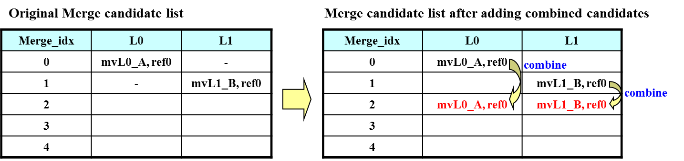
Figure 3-15 – Example of combined bi-predictive merge candidate

Motion vector prediction
Motion vector prediction exploits spatio-temporal correlation of motion vector with neighbouring PUs, which is used for explicit transmission of motion parameters. It constructs a motion vector candidate list by firstly checking availability of left, above temporally neighbouring PU positions, removing redundant candidates and adding zero vector to make the candidate list to be constant length. Then, the encoder can select the best predictor from the candidate list and transmit the corresponding index indicating the chosen candidate. Similarly with merge index signalling, the index of the best motion vector candidate is encoded using truncated unary, as maximum number is equal to 2. In the following sections, details about derivation process of motion vector prediction candidate are provided.

Derivation of motion vector prediction candidates
Figure 3-16 summarizes derivation process for motion vector prediction candidate.

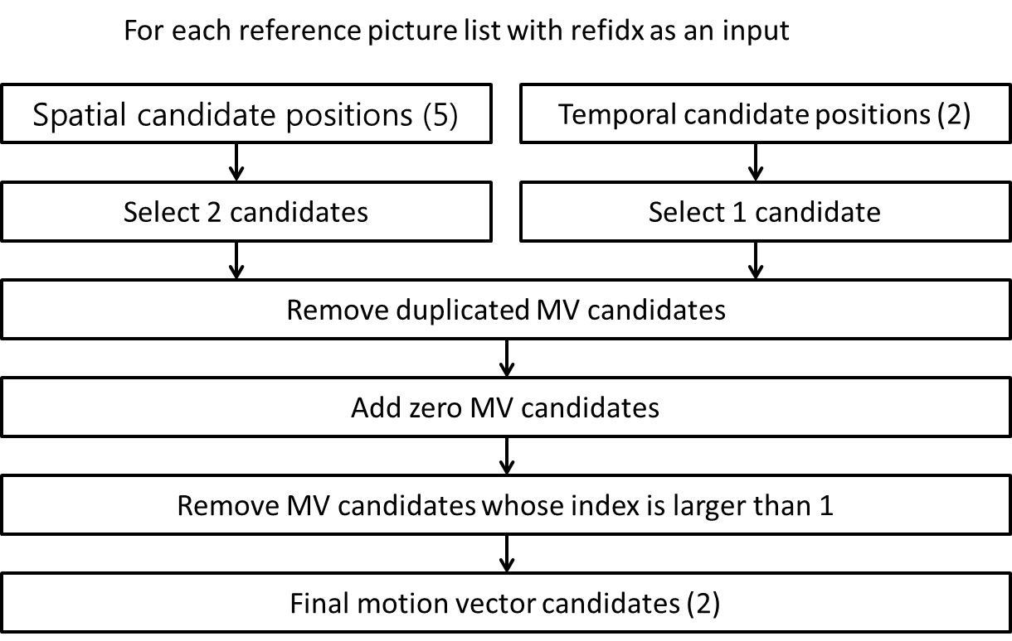
Figure 3-16 – Derivation process for motion vector prediction candidates
In motion vector prediction, two types of motion vector candidates are considered: spatial motion vector candidate and temporal motion vector candidate. For spatial motion vector candidate derivation, two motion vector candidates are derived based on motion vectors of each PU located in five different positions as depicted in Figure 3-12. Unless PUs in the left side of current PU are not available, one motion vector candidate is selected utilizing PUs in the left side of the current PU and one motion vector candidate is derived utilizing PUs in the above side of the current PU. Otherwise, two motion vector candidates are derived only from PUs in the above side.
For temporal motion vector candidate derivation, one motion vector candidate is selected from two candidates, which are derived based on two different co-located positions. After the first list of spatio-temporal candidates is made, duplicated motion vector candidates in the list are removed. If the number of potential candidates is larger than two, motion vector candidates whose index is larger than 1 are removed from the list. If the number of spatio-temporal motion vector candidates is smaller than two, additional zero motion vector candidates is added to the list.

Spatial motion vector candidates
In the derivation of spatial motion vector candidates, a maximum of two candidates are considered among five potential candidates, which are derived from PUs located in positions as depicted in Figure 3-11. The candidate positions of motion vector prediction are the same as those of motion merge. The order of derivation for left side of the current PU is set as A₀ à A₁ à scaled A₀ à scaled A₁. The order of derivation for above side of the current PU is set as B₀ à B₁ à B₂ à scaled B₀ à scaled B₁ à scaled B₂. For each side, there are four cases which can be used as motion vector candidate. Although two cases are not required to do spatial scaling, the other two cases are. The four different cases are summarized as follows.
- No spatial scaling
  - (1) Same reference picture list, and same reference picture index (same POC)
  - (2) Different reference picture list, but same reference picture (same POC)
- Spatial scaling
  - (3) Same reference picture list, but different reference picture (different POC)
  - (4) Different reference picture list, and different reference picture (different POC)
No spatial scaling cases are checked first and spatial scaling cases are checked sequentially. Spatial scaling is considered when POC is different between the reference picture of the neighbouring PU and that of the current PU regardless of reference picture list. If all PUs of left candidates are not available or are intra coded, scaling for the above motion vector is allowed to help parallel derivation of left and above MV candidates. Otherwise, spatial scaling is not allowed for the above motion vector.
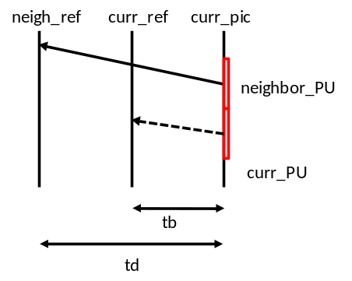
Figure 3-17 – Illustration of motion vector scaling for spatial motion vector candidate
In a spatial scaling process, the motion vector of the neighbouring PU is scaled in a similar manner as for temporal scaling, as depicted as Figure 3-17. The main difference is that the reference picture list and index of current PU is given as input; the actual scaling process is the same as that of temporal scaling.

Temporal motion vector candidates
Apart for the reference picture index derivation, all processes for the derivation of temporal merge candidates are the same as for the derivation of spatial motion vector candidates. The reference picture index is signalled to the decoder.

Interpolation filter
For the luma interpolation filtering, an 8-tap separable DCT-based interpolation filter is used for 2/4 precision samples and a 7-tap separable DCT-based interpolation filter is used for 1/4 precisions samples, as shown in Table 3-5.
Table 3-5 – 8-tap DCT-IF coefficients for 1/4th luma interpolation
Position | Filter coefficients
1/4 | { -1, 4, -10, 58, 17, -5, 1 }
2/4 | { -1, 4, -11, 40, 40, -11, 4, -1 }
3/4 | { 1, -5, 17, 58, -10, 4, -1 }
Similarly, a 4-tap separable DCT-based interpolation filter is used for the chroma interpolation filter, as shown in Table 3-6.
Table 3-6 – 4-tap DCT-IF coefficients for 1/8th chroma interpolation
Position | Filter coefficients
1/8 | { -2, 58, 10, -2 }
2/8 | { -4, 54, 16, -2 }
3/8 | { -6, 46, 28, -4 }
4/8 | { -4, 36, 36, -4 }
5/8 | { -4, 28, 46, -6 }
6/8 | { -2, 16, 54, -4 }
7/8 | { -2, 10, 58, -2 }
For the bi-directional prediction, the bit-depth of the output of the interpolation filter is maintained to 14-bit accuracy, regardless of the source bit-depth, before the averaging of the two prediction signals. The actual averaging process is done implicitly with the bit-depth reduction process as:
predSamples[ x, y ] = ( predSamplesL0[ x, y ] + predSamplesL1[ x, y ] + offset ) >> shift
where
shift = ( 15 – BitDepth ) and offset = 1 << ( shift – 1 )

Weighted Prediction
A weighted prediction (WP) tool is included in the HM encoding software. This WP tool corresponds to the equivalent tool for AVC and it is intended to improve the performance of inter prediction when the source material is subject to illumination variations, e.g. when using fading or cross-fading. It should be noted that WP is not enabled in the HM common test conditions.
The principle of WP is to replace the inter prediction signal P by a linear weighted prediction signal P’ (with weight w and offset o):
Uniprediction: P’ = w × P + o
Biprediction: P’ = (w0 × P0 + o0 + w1 × P1 + o1) / 2
The applicable weights and offsets are calculated by the encoder, using some mechanism that is not defined by the HEVC specification, and are conveyed within the bitstream. L0 and L1 suffixes define List0 and List1 of the reference pictures list, respectively. Bit depth is maintained to 14 bit accuracy before averaging the prediction signals, as for interpolation filters.
In the case of biprediction with at least one reference picture available in each list L0 and L1, the following formula applies to the explicit signalling of weighted prediction parameters relating to the luma channel:
predSamples[ x ][ y ] =
Clip3( 0, ( 1 << bitDepth ) − 1, ( predSamplesL0 [ x ][ y ] * w0 + predSamplesL1[ x ][ y ] * w1 + ( (o0 + o1 + 1) << log2WD) ) >> (log2WD + 1) )
where
log2WD = luma_log2_weight_denom + 14 - bitDepth
w0 = LumaWeightL0[ refIdxL0 ], w1 = LumaWeightL1[ refIdxL1 ]
o0 = luma_offset_l0[ refIdxL0 ] * ( 1 << ( bitDepth − 8 ) )
o1 = luma_offset_l1[ refIdxL1 ] * ( 1 << ( bitDepth − 8 ) )
A corresponding formula applies to the chroma channel and to the case of uniprediction.

Transform and quantization (scaling)
In HM, transforms of sizes 4x4 to 32x32 are supported.
If lossless mode and transform skip mode are not used, scaling and transformation process at the decoder side are as follows.
If transform skip is used, scaling and transformation process at the decoder side are as follows.
If lossless mode is used, scaling and transformation process at the decoder side are as follows.
r[ x ][ y ] = TransCoeffLevel[ x ][ y ]

Transform matrices
The transform matrices are an approximation of mathematical DCT matrices, which are rounded to 8 bit integer accuracy including sign. The matrices are optimized for maximizing orthogonality. Smaller size transform matrices are embedded in larger size transform matrices. This simplifies implementation, since a 32x32 matrix, can do 4x4, 8x8, 16x16, and 32x32 transform. In HM implementation, the transform is performed by partial butterfly structure for low computational complexity. Transform matrices for each size transform are as follows.
nS = 4
{64, 64, 64, 64}
{83, 36,-36,-83}
{64,-64,-64, 64}
{36,-83, 83,-36}
nS = 8
{64, 64, 64, 64, 64, 64, 64, 64}
{89, 75, 50, 18,-18,-50,-75,-89}
{83, 36,-36,-83,-83,-36, 36, 83}
{75,-18,-89,-50, 50, 89, 18,-75}
{64,-64,-64, 64, 64,-64,-64, 64}
{50,-89, 18, 75,-75,-18, 89,-50}
{36,-83, 83,-36,-36, 83,-83, 36}
{18,-50, 75,-89, 89,-75, 50,-18}
nS = 16
{64 64 64 64 64 64 64 64 64 64 64 64 64 64 64 64}
{90 87 80 70 57 43 25 9 -9-25-43-57-70-80-87-90}
{89 75 50 18-18-50-75-89-89-75-50-18 18 50 75 89}
{87 57 9-43-80-90-70-25 25 70 90 80 43 -9-57-87}
{83 36-36-83-83-36 36 83 83 36-36-83-83-36 36 83}
{80 9-70-87-25 57 90 43-43-90-57 25 87 70 -9-80}
{75-18-89-50 50 89 18-75-75 18 89 50-50-89-18 75}
{70-43-87 9 90 25-80-57 57 80-25-90 -9 87 43-70}
{64-64-64 64 64-64-64 64 64-64-64 64 64-64-64 64}
{57-80-25 90 -9-87 43 70-70-43 87 9-90 25 80-57}
{50-89 18 75-75-18 89-50-50 89-18-75 75 18-89 50}
{43-90 57 25-87 70 9-80 80 -9-70 87-25-57 90-43}
{36-83 83-36-36 83-83 36 36-83 83-36-36 83-83 36}
{25-70 90-80 43 9-57 87-87 57 -9-43 80-90 70-25}
{18-50 75-89 89-75 50-18-18 50-75 89-89 75-50 18}
{ 9-25 43-57 70-80 87-90 90-87 80-70 57-43 25 -9}
nS = 32
{64 64 64 64 64 64 64 64 64 64 64 64 64 64 64 64 64 64 64 64 64 64 64 64 64 64 64 64 64 64 64 64}
{90 90 88 85 82 78 73 67 61 54 46 38 31 22 13 4 -4-13-22-31-38-46-54-61-67-73-78-82-85-88-90-90}
{90 87 80 70 57 43 25 9 -9-25-43-57-70-80-87-90-90-87-80-70-57-43-25 -9 9 25 43 57 70 80 87 90}
{90 82 67 46 22 -4-31-54-73-85-90-88-78-61-38-13 13 38 61 78 88 90 85 73 54 31 4-22-46-67-82-90}
{89 75 50 18-18-50-75-89-89-75-50-18 18 50 75 89 89 75 50 18-18-50-75-89-89-75-50-18 18 50 75 89}
{88 67 31-13-54-82-90-78-46 -4 38 73 90 85 61 22-22-61-85-90-73-38 4 46 78 90 82 54 13-31-67-88}
{87 57 9-43-80-90-70-25 25 70 90 80 43 -9-57-87-87-57 -9 43 80 90 70 25-25-70-90-80-43 9 57 87}
{85 46-13-67-90-73-22 38 82 88 54 -4-61-90-78-31 31 78 90 61 4-54-88-82-38 22 73 90 67 13-46-85}
{83 36-36-83-83-36 36 83 83 36-36-83-83-36 36 83 83 36-36-83-83-36 36 83 83 36-36-83-83-36 36 83}
{82 22-54-90-61 13 78 85 31-46-90-67 4 73 88 38-38-88-73 -4 67 90 46-31-85-78-13 61 90 54-22-82}
{80 9-70-87-25 57 90 43-43-90-57 25 87 70 -9-80-80 -9 70 87 25-57-90-43 43 90 57-25-87-70 9 80}
{78 -4-82-73 13 85 67-22-88-61 31 90 54-38-90-46 46 90 38-54-90-31 61 88 22-67-85-13 73 82 4-78}
{75-18-89-50 50 89 18-75-75 18 89 50-50-89-18 75 75-18-89-50 50 89 18-75-75 18 89 50-50-89-18 75}
{73-31-90-22 78 67-38-90-13 82 61-46-88 -4 85 54-54-85 4 88 46-61-82 13 90 38-67-78 22 90 31-73}
{70-43-87 9 90 25-80-57 57 80-25-90 -9 87 43-70-70 43 87 -9-90-25 80 57-57-80 25 90 9-87-43 70}
{67-54-78 38 85-22-90 4 90 13-88-31 82 46-73-61 61 73-46-82 31 88-13-90 -4 90 22-85-38 78 54-67}
{64-64-64 64 64-64-64 64 64-64-64 64 64-64-64 64 64-64-64 64 64-64-64 64 64-64-64 64 64-64-64 64}
{61-73-46 82 31-88-13 90 -4-90 22 85-38-78 54 67-67-54 78 38-85-22 90 4-90 13 88-31-82 46 73-61}
{57-80-25 90 -9-87 43 70-70-43 87 9-90 25 80-57-57 80 25-90 9 87-43-70 70 43-87 -9 90-25-80 57}
{54-85 -4 88-46-61 82 13-90 38 67-78-22 90-31-73 73 31-90 22 78-67-38 90-13-82 61 46-88 4 85-54}
{50-89 18 75-75-18 89-50-50 89-18-75 75 18-89 50 50-89 18 75-75-18 89-50-50 89-18-75 75 18-89 50}
{46-90 38 54-90 31 61-88 22 67-85 13 73-82 4 78-78 -4 82-73-13 85-67-22 88-61-31 90-54-38 90-46}
{43-90 57 25-87 70 9-80 80 -9-70 87-25-57 90-43-43 90-57-25 87-70 -9 80-80 9 70-87 25 57-90 43}
{38-88 73 -4-67 90-46-31 85-78 13 61-90 54 22-82 82-22-54 90-61-13 78-85 31 46-90 67 4-73 88-38}
{36-83 83-36-36 83-83 36 36-83 83-36-36 83-83 36 36-83 83-36-36 83-83 36 36-83 83-36-36 83-83 36}
{31-78 90-61 4 54-88 82-38-22 73-90 67-13-46 85-85 46 13-67 90-73 22 38-82 88-54 -4 61-90 78-31}
{25-70 90-80 43 9-57 87-87 57 -9-43 80-90 70-25-25 70-90 80-43 -9 57-87 87-57 9 43-80 90-70 25}
{22-61 85-90 73-38 -4 46-78 90-82 54-13-31 67-88 88-67 31 13-54 82-90 78-46 4 38-73 90-85 61-22}
{18-50 75-89 89-75 50-18-18 50-75 89-89 75-50 18 18-50 75-89 89-75 50-18-18 50-75 89-89 75-50 18}
{13-38 61-78 88-90 85-73 54-31 4 22-46 67-82 90-90 82-67 46-22 -4 31-54 73-85 90-88 78-61 38-13}
{ 9-25 43-57 70-80 87-90 90-87 80-70 57-43 25 -9 -9 25-43 57-70 80-87 90-90 87-80 70-57 43-25 9}
{ 4-13 22-31 38-46 54-61 67-73 78-82 85-88 90-90 90-90 88-85 82-78 73-67 61-54 46-38 31-22 13 -4}

2D inverse transform
The clipping of intermediate sample values g[ x ][ y ] ensures that can be represented with 16 bits as depicted below.
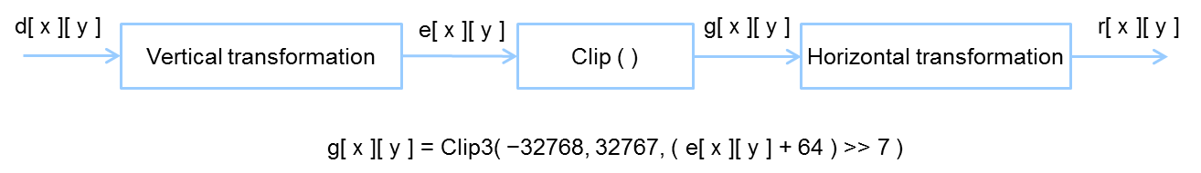

Discrete sine transform (DST)
For intra TU of luma component having 4x4 size, an approximation to the discrete sine transform (DST) is applied. The transform matrix is as follows.
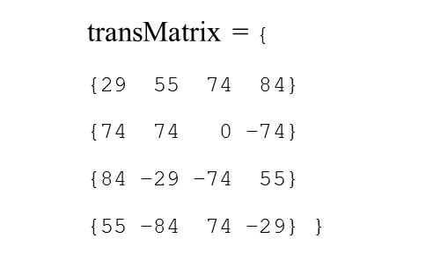

Transform skip
Transform skip (TS), replacing the transform by bit shift, may be applied to a 4x4 transform unit (TU). The TS process at the decoder side is as follows.

Scaling and quantization
The quantized transform coefficients q_{ij} (i, j=0..nS-1) are derived from the transform coeficients d_{ij} (i, j=0..nS-1) as
q_{ij} = ( d_{ij} * f[QP%6] + offset ) >> ( 29 + QP/6 – nS – BitDepth), with i,j = 0,...,nS-1
where
f[x] = {26214,23302,20560,18396,16384,14564}, x=0,…,5
2^{28+QP/6–nS-BitDepth} < offset < 2^{29+QP/6–nS-BitDepth}

Entropy Coding
A single entropy coding scheme is used in all configurations of HEVC: Context Adaptive Binary Arithmetic Coding (CABAC). There is no equivalent to the alternative second entropy coding scheme that was included in the earlier AVC [19] standard.
The core of the CABAC algorithm for HEVC is essentially the same as the CABAC algorithm for used AVC, but with some changes in the details. As a result, substantially fewer contexts are used in HEVC compared to the AVC standard, despite slightly improving the compression performance and throughput speed.

Loop Filtering

Overview of Loop filtering
HEVC includes two processing stages in the in-loop filter: a deblocking filter and then a Sample Adaptive Offset (SAO) filter. The deblocking filter aims to reduce the visibility of blocking artefacts and is applied only to samples located at block boundaries. The SAO filter aims to improve the accuracy of the reconstruction of the original signal amplitudes and is applied adaptively to all samples, by conditionally adding an offset value to each sample based on values in look-up tables defined by the encoder.

Deblocking filter
A deblocking filter process is performed for each CU in the same order as the decoding process. First vertical edges are filtered (horizontal filtering) then horizontal edges are filtered (vertical filtering). Filtering is applied to 8x8 block boundaries which are determined to be filtered, both for luma and chroma components. 4x4 block boundaries are not processed in order to reduce the complexity (unlike the earlier AVC standard [19]).
Figure 3-18 illustrates the overall flow of deblocking filter processes. A boundary can have three filtering status values: no filtering, weak filtering and strong filtering. Each filtering decision is based on boundary strength, Bs, and threshold values, β and t_{C}.

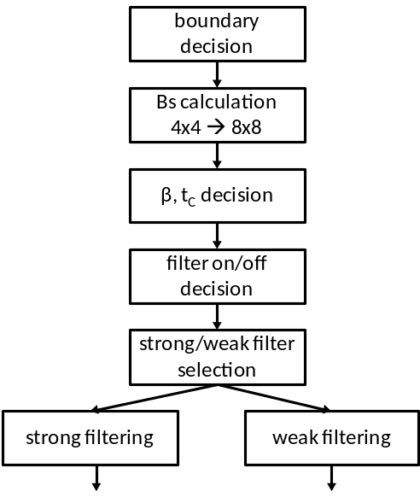
Figure 3-18 – Overall processing flow of deblocking filter process

Boundary decision
Two kinds of boundaries are involved in the deblocking filter process: TU boundaries and PU boundaries. CU boundaries are also considered, since CU boundaries are necessarily also TU and PU boundaries. When PU shape is 2NxN (N > 4) and RQT depth is equal to 1, TU boundaries at 8x8 block grid and PU boundaries between each PU inside the CU are also involved in the filtering.

Boundary strength calculation
The boundary strength (Bs) reflects how strong a filtering process may be needed for the boundary. A value of 2 for Bs indicates strong filtering, 1 indicates weak filtering and 0 indicates no deblocking filtering.,
Let P and Q be defined as blocks which are involved in the filtering, where P represents the block located to the left (vertical edge case) or above (horizontal edge case) the boundary and Q represents the block located to the right (vertical edge case) or above (horizontal edge case) the boundary. Figure 3-19 illustrates how the Bs value is calculated based on the intra coding mode, the existence of non-zero transform coefficients, reference picture, number of motion vectors and motion vector difference.
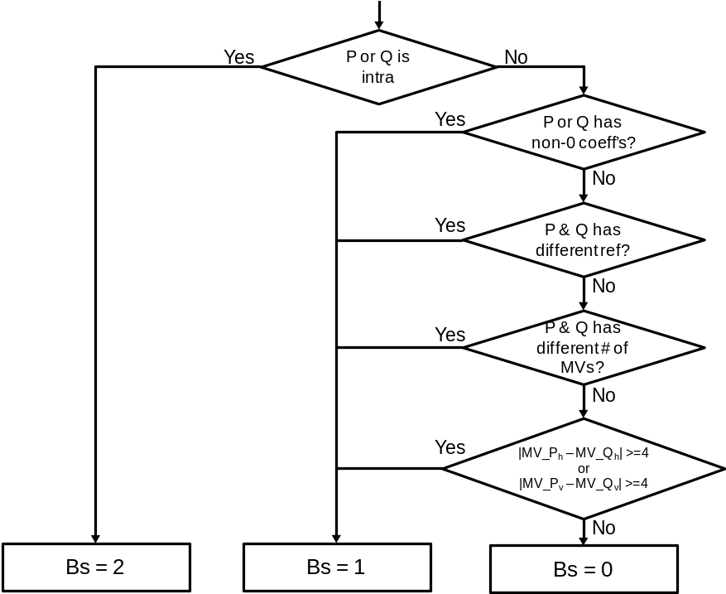
Figure 3-19 – Flow diagram for Bs calculation
Bs is calculated on a 4x4 block basis, but it is re-mapped to an 8x8 grid. The maximum of the two values of Bs which correspond to 8 pixels consisting of a line in the 4x4 grid is selected as the Bs for boundaries in the 8x8 grid.
At the CTU boundary, information on every second block (on a 4x4 grid) to the left or above is re-used as depicted in Figure 3-20, in order to reduce line buffer memory requirement.
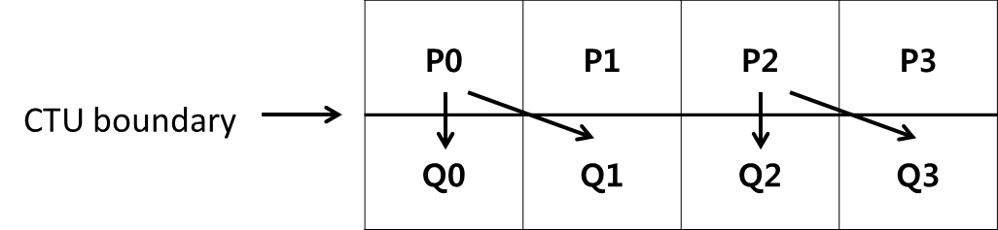
Figure 3-20 – Referred information for Bs calculation at CTU boundary

Threshold variables
Threshold values β′ and t_{C}′ are involved in the filter on/off decision, strong and weak filter selection and weak filtering process. These are derived from the value of the luma quantization parameter Q as shown in Table 3-7 .
Table 3-7 – Derivation of threshold variables from input Q
Q | 0 | 1 | 2 | 3 | 4 | 5 | 6 | 7 | 8 | 9 | 10 | 11 | 12 | 13 | 14 | 15 | 16 | 17 | 18
β′ | 0 | 0 | 0 | 0 | 0 | 0 | 0 | 0 | 0 | 0 | 0 | 0 | 0 | 0 | 0 | 0 | 6 | 7 | 8
t_{C}′ | 0 | 0 | 0 | 0 | 0 | 0 | 0 | 0 | 0 | 0 | 0 | 0 | 0 | 0 | 0 | 0 | 0 | 0 | 1
Q | 19 | 20 | 21 | 22 | 23 | 24 | 25 | 26 | 27 | 28 | 29 | 30 | 31 | 32 | 33 | 34 | 35 | 36 | 37
β′ | 9 | 10 | 11 | 12 | 13 | 14 | 15 | 16 | 17 | 18 | 20 | 22 | 24 | 26 | 28 | 30 | 32 | 34 | 36
t_{C}′ | 1 | 1 | 1 | 1 | 1 | 1 | 1 | 1 | 2 | 2 | 2 | 2 | 3 | 3 | 3 | 3 | 4 | 4 | 4
Q | 38 | 39 | 40 | 41 | 42 | 43 | 44 | 45 | 46 | 47 | 48 | 49 | 50 | 51 | 52 | 53
β′ | 38 | 40 | 42 | 44 | 46 | 48 | 50 | 52 | 54 | 56 | 58 | 60 | 62 | 64 | - | -
t_{C}′ | 5 | 5 | 6 | 6 | 7 | 8 | 9 | 10 | 11 | 13 | 14 | 16 | 18 | 20 | 22 | 24
The variable β is derived from β′ as follows:
β = β′ * ( 1 << ( BitDepth_{Y} − 8 ) )
The variable t_{C} is derived from t_{C}′ as follows:
t_{C} = t_{C}′ * ( 1 << ( BitDepth_{Y} − 8 ) )

Filter on/off decision for 4 lines
The filter on/off decision is made using 4 lines grouped as a unit, to reduce computational complexity. Figure 3-21 illustrates the pixels involving in the decision. The 6 pixels in the two red boxes in the first 4 lines are used to determine whether the filter is on or off for those 4 lines. The 6 pixels in the two red boxes in the second group of 4 lines are used to determine whether the filter is on or off for the second group of 4 lines.
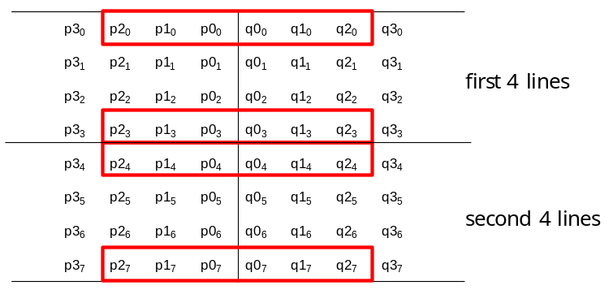
Figure 3-21 – Pixels involved in filter on/off decision and strong/weak filter selection
The following variables are defined:
dp0 = | p_{2,0} – 2*p_{1,0} + p_{0,0} |
dp3 = | p_{2,3} – 2*p_{1,3} + p_{0,3} |
dq0 = | q_{2,0} – 2*q_{1,0} + q_{0,0} |
dq3 = | q_{2,3} – 2*q_{1,3} + q_{0,3} |
If dp0+dq0+dp3+dq3 < β, filtering for the first four lines is turned on and the strong/weak filter selection process is applied. If this condition is not met, no filtering is done for the first 4 lines.
Additionally, if the condition is met, the variables dE, dEp1 and dEp2 are set as follows:
dE is set equal to 1
If dp0 + dp3 < (β + ( β >> 1 )) >> 3, the variable dEp1 is set equal to 1
If dq0 + dq3 < (β + ( β >> 1 )) >> 3, the variable dEq1 is set equal to 1
A filter on/off decision is made in a similar manner as described above for the second group of 4 lines.

Strong/weak filter selection for 4 lines
If filtering is turned on, a decision is made between strong and weak filtering. The pixels involved are the same as those used for the filter on/off decision, as depicted in Figure 3-21. If the following two sets of conditions are met, a strong filter is used for filtering of the first 4 lines. Otherwise, a weak filter is used.
1) 2*(dp0+dq0) < ( β >> 2 ), | p3₀ – p0₀ | + | q0₀ – q3₀ | < ( β >> 3 ) and | p0₀ – q0₀ | < ( 5* t_{C} + 1 ) >> 1
2) 2*(dp3+dq3) < ( β >> 2 ), | p3₃ – p0₃ | + | q0₃ – q3₃ | < ( β >> 3 ) and | p0₃ – q0₃ | < ( 5* t_{C} + 1 ) >> 1
The decision on whether to select strong or weak filtering for the second group of 4 lines is made in a similar manner.

Strong filtering
For strong filtering, the filtered pixel values are obtained by the following equations. Note that three pixels are modified using four pixels as an input for each P and Q block, respectively.
p₀’ = ( p₂ + 2*p₁ + 2*p₀ + 2*q₀ + q₁ + 4 ) >> 3
q₀’ = ( p₁ + 2*p₀ + 2*q₀ + 2*q₁ + q₂ + 4 ) >> 3
p₁’ = ( p₂ + p₁ + p₀ + q₀ + 2 ) >> 2
q₁’ = ( p₀ + q₀ + q₁ + q₂ + 2 ) >> 2
p₂’ = ( 2*p₃ + 3*p₂ + p₁ + p₀ + q₀ + 4 ) >> 3
q₂’ = ( p₀ + q₀ + q₁ + 3*q₂ + 2*q₃ + 4 ) >> 3

Weak filtering
Δ is defined as follows.
Δ = ( 9 * ( q₀ – p₀ ) – 3 * ( q₁ – p₁ ) + 8 ) >> 4
When abs(Δ) is less than t_{C} *10,
Δ = Clip3( - t_{C} , t_{C} , Δ )
p₀’ = Clip1_{Y}( p₀ + Δ )
q₀’ = Clip1_{Y}( q₀ - Δ )
If dEp1 is equal to 1,
Δp = Clip3( -( t_{C} >> 1), t_{C} >> 1, ( ( ( p₂ + p₀ + 1 ) >> 1 ) – p₁ + Δ ) >>1 )
p₁’ = Clip1_{Y}( p₁ + Δp )
If dEq1 is equal to 1,
Δq = Clip3( -( t_{C} >> 1), t_{C} >> 1, ( ( ( q₂ + q₀ + 1 ) >> 1 ) – q₁ – Δ ) >>1 )
q₁’ = Clip1_{Y}( q₁ + Δq )
Note that a maximum of two pixels are modified using three pixels as an input for each P and Q block, respectively.

Chroma filtering
The boundary strength Bs for chroma filtering is inherited from luma. If Bs > 1, chroma filtering is performed. No filter selection process is performed for chroma, since only one filter can be applied. The filtered sample values p₀’ and q₀’ are derived as follows.
Δ = Clip3( -t_{C}, t_{C}, ( ( ( ( q₀ – p₀ ) << 2 ) + p₁ – q₁ + 4 ) >> 3 ) )
p₀’ = Clip1_{C}( p₀ + Δ )
q₀’ = Clip1_{C}( q₀ - Δ )

Sample Adaptive Offset (SAO)
Sample adaptive offset (SAO) is applied to the reconstructed signal after the deblocking filter by using offsets specified for each CTB by the encoder. The HM encoder first makes the decision on whether or not the SAO process is to be applied for current slice. If SAO is applied for the slice, each CTB is classified as one of five SAO types as shown in Table 3-8. The concept of SAO is to classify pixels into categories and reduces the distortion by adding an offset to pixels of each category. SAO operation includes Edge Offset (EO) which uses edge properties for pixel classification in SAO type 1-4 and Band Offset (BO) which uses pixel intensity for pixel classification in SAO type 5. Each applicable CTB has SAO parameters including sao_merge_left_flag, sao_merge_up_flag, SAO type and four offsets. If sao_merge_left_flag is equal to 1, the current CTB will reuse the SAO type and offsets of the CTB to the left. If sao_merge_up_flag is equal to 1, the current CTB will reuse SAO type and offsets of the CTB above.
Table 3-8 – Specification of SAO type
SAO type | sample adaptive offset type to be used | Number of categories
0 | None | 0
1 | 1-D 0-degree pattern edge offset | 4
2 | 1-D 90-degree pattern edge offset | 4
3 | 1-D 135-degree pattern edge offset | 4
4 | 1-D 45-degree pattern edge offset | 4
5 | band offset | 4

Operation of each SAO type
Edge offset uses four 1-D 3-pixel patterns for classification of the current pixel p by consideration of edge directional information, as shown in Figure 3-22. From left to right these are: 0-degree, 90-degree, 135-degree and 45-degree.

 | p |  |  |  | p |  |  |  | p |  |  |  | p
Figure 3-22 – Four 1-D 3-pixel patterns for the pixel classification in EO

Each CTB is classified into one of five categories according to Table 3-9.
Table 3-9 – Pixel classification rule for EO
Category | Condition | Meaning
0 | None of the below | Largely monotonic
1 | p < 2 neighbours | Local minimum
2 | p < 1 neighbour && p == 1 neighbour | Edge
3 | p > 1 neighbour && p == 1 neighbour | Edge
4 | p > 2 neighbours | Local maximum

Band offset (BO) classifies all pixels in one CTB region into 32 uniform bands by using the five most significant bits of the pixel value as the band index. In other words, the pixel intensity range is divided into 32 equal segments from zero to the maximum intensity value (e.g. 255 for 8-bit pixels). Four adjacent bands are grouped together and each group is indicated by its most left-hand position as shown in Figure 3-23. The encoder searches all position to get the group with the maximum distortion reduction by compensating offset of each band.
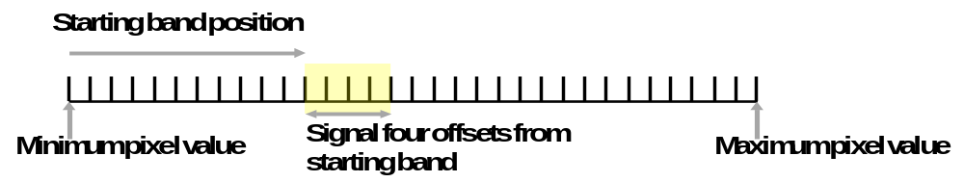
Figure 3-23 – Four bands are grouped together and represented by its starting band position

Wavefront parallel processing
Wavefront Parallel Processing (WPP) produces a bitstream that can be processed using one or more cores running in parallel. When WPP is used, a slice is divided into rows of CTUs. The first row is processed in an ordinary way, the second row can begin to be processed after only two CTUs have been processed in the first row, the third row can begin to be processed after only two CTUs have been processed in the second row, and so on. The context models of the entropy coder in each row are inferred from those in the preceding row with a two-CTU processing lag. WPP provides a form of processing parallelism within a slice, without the loss of compression performance that might be expected by using tiles within a slice.
The following operations are performed by the HM encoder.
- When starting the encoding of the first CTU in a CTU row, the following process is applied:
- if the last CU of the second CTU of the row above is available, the CABAC probabilities are set to the values stored in the buffer.
- if not, the CABAC probabilities are reset to the default values
- When the encoding of the second CTU in a CTU row is finished, the CABAC probabilities are stored in a buffer
- If the encoding of the last CTU in a CTU row is finished and the end of a slice has not been reached, CABAC is flushed and a byte alignment is performed.
Entry point offsets are written in the slice header. Each CTU row in the slice has an entry point offset, in byte units, that indicates where the corresponding data starts in the slice data. When WPP is used, a slice that does not start at the beginning of a CTU row does not finish after the last CTU in the same row. When a slice starts at the beginning of a CTB row, there is no constraint on where it finishes.

Description of encoding methods

Cost Functions
Various cost functions are used in the HM software encoder to perform non-normative mode/parameter decisions. In this section, the cost functions actually used in the encoding process of the HM software are specified for reference in the remaining sections of this document.

Sum of Square Error (SSE)
The difference between two blocks with the same block size is produced using
Diff(i,j) = BlockA(i,j) - BlockB(i,j) (4-)
SEE is computed using the following equation:
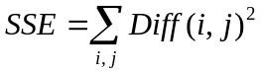 (4-)

Sum of Absolute Difference (SAD)
SAD is computed using the following equation:
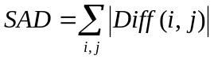 (4-)

Hadamard transformed SAD (SATD)
Since the transformed coefficients are coded, an improved estimation of the cost of each mode can be obtained by estimating DCT with the Hadamard transform.
SATD is computed using:
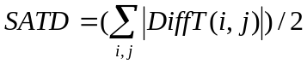 (4-)
The Hadamard transform flag can be turned on or off. SA(T)D refers to either SAD or SATD depending on the status of the Hadamard transform flag.
SAD is used when computing full-pel motion estimation while SA(T)D is used for sub-pel motion estimation.

RD cost functions

Lagrangian constant values
In the HM encoder, lambda values that are used for cost computation are defined as
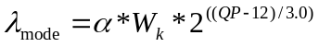 (4-)
_{pred} 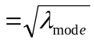 (4-)
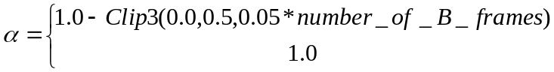 (4-)
, for referenced pictures
, for non-referenced pictures
represents weighting factor dependent to encoding configuration and QP offset hierarchy level of current picture within a GOP, as specified in Table 4-10. Note that the value of derived from Table 4-10 is further modified by multiplying 0.95 when SATD based motion estimation is used.
Table 4-10 – Derivation of
k | QP offset hierarchy level | Slice type | Referenced
0 | 0 | I | - | 0.57
1 | 0 | GPB | 1 | RA: 0.442  LD: 0.578
2 | 1, 2 | B or GPB | 1 | RA: 0.3536 * Clip3( 2.0, 4.0, (QP-12)/6.0 )  LD: 0.4624 * Clip3( 2.0, 4.0, (QP-12)/6.0 )
4 | 3 | B | 0 | RA: 0.68 * Clip3( 2.0, 4.0, (QP-12)/6.0 )

Weighting factor for chroma component
The following weighting parameter w_{chroma} is used to derive lambda value 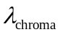to be used for chroma-specific decisions in RDOQ and SAO processes.
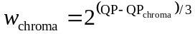 (4-)
With this parameter, 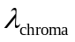is obtained by
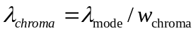 (4-)
Note that the parameter w_{chroma} is also used to define the cost function used for mode decisions in order to weight the chroma part of SSE.

SAD based cost function for prediction parameter decision
The cost for prediction parameter decision J_{pred,SAD} is specified by the following formula.
J_{pred,SAD} =SAD + λ_{pred} * B_{pred}, (4-)
where B_{pred} specifies bit cost to be considered for making decision, which depends on each decision case. λ_{pred} and SAD are defined in the section 4.1.4.1 and 4.1.2, respectively.

SATD based cost function for prediction parameter decision
The cost for motion parameter decision J_{pred,SATD} is specified by the following formula.
J_{pred,SATD} =SATD + λ_{pred} * B_{pred}, (4-)
where B_{pred} specifies bit cost to be considered for making decision, which depends on each decision case. λ_{pred} and SATD are defined in the section 4.1.4.1 and 4.1.3, respectively.

Cost function for mode decision
The cost for mode decision J_{mode} is specified by the following formula.
J_{mode} =(SSE_{luma}+ w_{chroma} *SSE_{chroma})+ λ_{mode} * B_{mode,} (4-)
where B_{mode} specifies bit cost to be considered for mode decision, which depends on each decision case. λ_{mode} and SSE are defined in the section 4.1.4.1 and 4.1.1, respectively.

Encoder configurations

Overview of encoder configurations
The HM encoder provides two configurations of encoder tools, designated Main and Main10 in the HM test conditions and software reference configuration document [17]. The coding tools for the Main configuration correspond to those supported in the Main profile of the HEVC specification [16]. The coding tools for the Main10 configuration correspond to the Main 10 profile in the HEVC specification with the bit depth for luma and chroma both set to 10 bit.
The HM encoder works with three kinds of temporal prediction structures depending on experimental conditions: intra-only, low-delay and random access. The reference picture list management depends on the temporal configuration.

Intra-only configuration
In the test case for intra-only coding, each picture in a video sequence is encoded as an IDR picture. No temporal reference pictures are used. QP does not change during a sequence within a picture. Figure 4-24 gives graphical presentation of an intra-only configuration, where the number associated with each picture represents the encoding order.
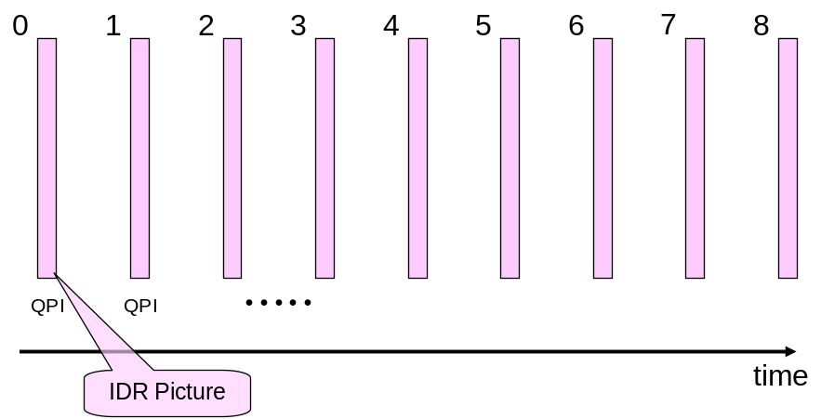
Figure 4-24 – Graphical presentation of intra-only configuration

Low-delay configurations
Two coding configurations have been defined for testing low-delay coding performance. For both these low-delay coding conditions, only the first picture in a video sequence is encoded as an IDR picture. In one low-delay test condition, the other pictures are encoded as generalized P and B-pictures (GPBs). The GPB is able to use only reference pictures whose POC is smaller than the current picture (i.e., all reference pictures in RefPicList0 and RefPicList1 are temporally previous in display order relative to the current picture). The contents of RefPicList0 and RefPicList1 are identical. The reference picture list combination is used for management and entropy coding of the reference picture index. Figure 4-25 shows a graphical presentation of this low-delay configuration (which has been used as a mandatory configuration for performance evaluation in many CEs). The number associated with each picture represents the encoding order. The QP of each inter coded picture is derived by adding an offset to the QP of the intra coded picture depending on the temporal layer. In the alternative low-delay condition (which has not been mandatory in most CEs), all inter pictures are coded as P-pictures, where only the content of RefPicList0 is used for inter prediction.
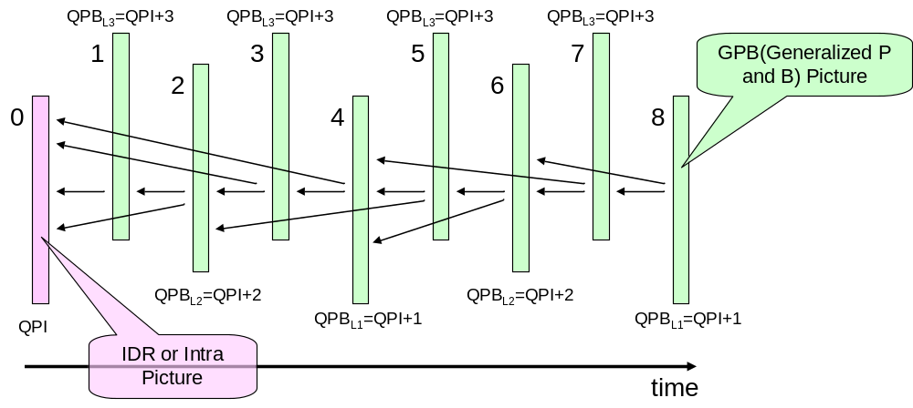
Figure 4-25 – Graphical presentation of low-delay configuration

Random-access configuration
For the random-access test condition, a hierarchical B structure is used for encoding. Figure 4-26 shows a graphical representation of a random-access configuration, where the number associated with each picture represents the encoding order. An intra picture is encoded at approximately one second intervals. The first intra picture of a video sequence is encoded as an IDR picture and the other intra pictures are encoded as non-IDR intra pictures (“Open GOP”). The pictures located between successive intra pictures in display order are encoded as B-pictures. The GPB picture is used as the lowest temporal layer that can refer to I or GPB pictures for inter prediction. The second and third temporal layers consist of referenced B pictures, while the highest temporal layer contains non-referenced B picture only. The QP of each inter-coded picture is derived by adding an offset to the QP of the intra-coded picture depending on the temporal layer. The reference picture list combination is used for management and entropy coding of the reference picture index.
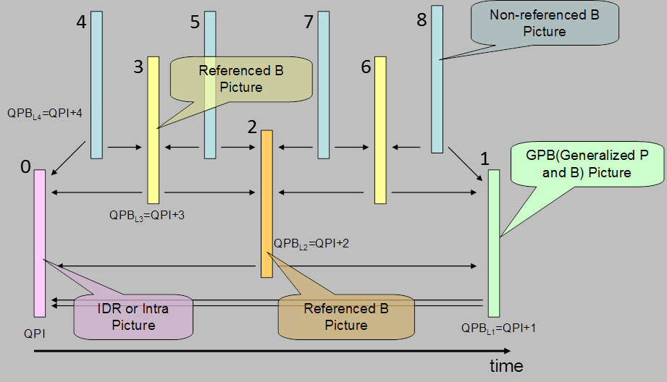
Figure 4-26 – Graphical presentation of random-access configuration

Input bit depth modification
When the Main configuration is used with a 10-bit source, each 10-bit source sample of value x is scaled to an 8-bit value prior to encoding, using the function (x+2)/4 clipped to the [0,255] range. Similarly when the Main10 configuration is used with an 8-bit source, each 8-bit source sample value x is scaled to a 10-bit value prior to encoding, using the function 4*x.
The former process is known as Internal Bit Depth Increase (IBDI) and it allows greater precision in the video codec operations (resulting in a coding efficiency improvement) at the cost of an increase in memory requirements, mainly to store reference pictures of the Decoded Pictures Buffer (DPB). This behaviour is built into the reference encoder and no external conversion program is required [17].

Slice partitioning operation
The HM encoder can partition a picture into several slices. Slices have spatial granularity equal to CTU. The HM encoder has three ways of determining slice size: by specifying the maximum number of CTUs in a slice, by specifying the number of bytes in a slice, and by specifying the number of tiles.

Derivation process for slice-level coding parameters

Sample Adaptive Offset (SAO) parameters

Search the SAO type with minimum rate-distortion cost
In the HM encoder, the following process is performed to determine the SAO parameters:
- Loop three colour components in a CTB as following
- Collect the statistical information for all SAO type as following
  - Set sao_type_idx = 0
  - Classified pixels into categories according to sao_type_idx.
    - Calculate sum of difference between original signal and reconstructed signal in each category.
    - Calculate number of pixels in each category.
    - Calculate offsets using step 2.2.1 and step 2.2.2.
    - Calculate RD-cost according to section 3.7.2.2
  - Set sao_type_idx = sao_type_idx+1; if sao_type_idx <= 5, run step 2.2; otherwise, end.
- Determine the SAO parameters with lowest rate-distortion (RD) cost among the following three items.
  - If left CTB is available, calculate the RD cost by reusing the SAO parameters of left CTB.
  - If upper CTB is available, calculate the RD cost by reusing SAO parameters of upper CTB.
  - Five SAO types with minimum RD-cost in step 2.
- Update pixels in DPB according to selected SAO type by adding offset.
- Run step1, 2, 3, and 4 for next CTB until all CTB is processed.

Slice level on/off Control
A hierarchical coding of pictures is used for both low delay and random access configurations which allows the encoder turns off (or on) SAO for picture with higher QP according to the percentage of SAO processed CTB of the previous picture with lower QP. If previous picture with lower QP with more than 25% of CTBs choosing SAO type from 1-5, SAO will be enabled for the current picture, otherwise SAO will be disabled for the current picture.

Derivation process for CU-level and PU-level coding parameters

Intra prediction mode and parameters
The unified intra coding tool provides up to 34 angular and planar prediction modes for luma component of different PUs. The best intra prediction mode for luma component of each PU is derived as follows. Firstly, a rough mode decision process is performed. Prediction cost J_{pred,SATD} specified in the section 4.1.4.4 is computed for all possible prediction modes and pre-determined number of intermediate candidates are found per each PU size (8 for 4x4-8x8 PU, 3 for other PU sizes) resulting in least prediction costs. In this rough decision process, number of coded bits for intra prediction mode is set to B_{pred}. Then, RD optimization using the coding cost J_{mode} specified in the section 4.1.4.5, is applied to the candidate modes selected by the rough mode decision and MostProbableMode. During this RD decision, prediction parameters and coefficients for luma component of the PU are accumulated into B_{mode}. Concerning chroma mode decision, all possible intra chroma prediction modes are evaluated through RD decision process, where coded bits for intra chroma prediction mode and chroma coefficient are used as B_{mode}.

Inter prediction mode and parameters

Derivation of motion parameters
In the HM encoder, an inter-coded CU can be segmented into multiple inter PUs, each of which has a set of motion parameters consisting of more than one motion vector (per RefPicListX), corresponding reference picture indices (ref_idx_lX) and prediction direction index (inter_pred_flag). Note that the current common test conditions those includes inter prediction coding are adopting reference picture list combination process, which is the case “X=c”. An inter-coded CU can be encoded with one of the following coding modes (“PredMode”): MODE_SKIP, MODE_INTER. For MODE_SKIP case, any sub-partitioning to smaller PUs is not allowed and its motion parameters are assigned to the CU itself, where the PU size is PART_2Nx2N. On the contrary, up to eight types of further partitioning to smaller PUs can be allowed for a CU coded with MODE_INTER. The PredMode and the CU partitioning shape (“PartMode”) are signaled by a CU level syntax element “part_type” as specified in Table 7-10 of the WD. For a MODE_INTER CU other than those having maximum depth, seven PU partitioning patterns (PART_2Nx2N, PART_2NxN, PART_Nx2N, PART_2NxnU, PART_2NxnD, PART_nLx2N and PART_nRx2N) can be selected. PART_NxN can only be chosen at maximum CU depth level but permission to set N to 4 is controlled by a specific flag in SPS (“inter_4x4_enabled_flag”). For each PU, PU-based Motion Merging (merge mode) or normal inter prediction with actually estimated motion parameters (inter mode) can be used. This section describes how luma motion parameters are obtained for each PU. It is noted that chroma motion vector are derived from luma motion vector of corresponding PU according to the normative process specified in section 8.4.2.1.10 of the WD, and the same reference picture index and prediction direction index as luma’s one are used in chroma components.

Motion Vector Prediction
For each PU, the best motion vector predictor is computed with the process specified as follows. Firstly, a set of motion vector predictor candidates for RefPicListX are derived with normative process specified in section 8.4.2.1.7 of the WD, by referring to motion parameters of neighbouring PUs. Then, the best one from the candidate set is determined by a criterion that selects a motion vector predictor candidate that minimizes the cost J_{pred,SAD} specified in the section 4.1.4.3, with setting the bits for an index specifying each motion vector predictor candidate to B_{pred}. The index corresponding to the selected best candidate is assigned to the mvp_idx_lX.

CU coding with MODE_SKIP
In the case of skip mode (i.e., PredMode == “MODE_SKIP”), motion parameters for the current CU(i.e., PART_2Nx2N PU) are derived by using merge mode. In this case, the motion parameters are determined by checking all possible merge candidates derived by the normative process specified in section 8.4.2.1.1 to 8.4.2.1.5 of the WD, and selecting the best set of motion parameters that minimizes the cost J_{mode} specified in the section 4.1.4.5. In this case, B_{mode} includes coded bits for skip_flag and merge_idx that signals position of the PU having the best motion parameters to be used for the current PU. Since prediction residual is not transmitted for skip mode, SSE is obtained by inter prediction samples.

CU coding with MODE_INTER
When a CU is coded with MODE_INTER, motion parameter decision for each PU is performed first based on the ME cost J_{pred,SATD} specified in the section 4.1.4.4.
For merge mode case, the motion parameter decision starts with checking availabilities of all neighbouring PUs to form merge candidates according to the normative process specified in the section 8.4.2.1.1 to 8.4.2.1.5 of the WD. If there is no available merge candidate, the HM encoder simply skips cost computation for merge mode and does not choose merge mode for the current PU. Otherwise(i.e., if there is at least one merge candidate), the ME cost J_{pred,SATD} specified in the section 4.1.4.4 is computed for all possible PUs as merge candidate and the best one is selected as the best motion parameters for the PU predicted with merge mode. SATD between source and prediction samples is used as distortion factor, and bits for merge_idx is set to B_{pred}.
For inter mode case, the best motion parameters are derived by invoking motion estimation process specified in the section 6.9.2.2. During the motion estimation process, the best motion parameters are obtained based on the cost function J_{pred,SATD} specified in the section 4.1.4.4, which is comparable with the cost of motion parameter derivation for merge mode. SATD between source and prediction samples is used as distortion factor, and bits for inter_pred_flag, ref_idx_lX, mvd_lX and mvp_idx_lX are set to B_{pred}.
After both of the best motion parameters are obtained, the best motion parameters are determined by comparing them and taking the better one that results in lower cost.

Motion estimation
In order to get motion vector for each PU, block matching algorithm (BMA) is performed at encoder. Motion vector accuracy supported in HEVC is quarter-pel. To generate half-pel and quarter-pel accuracy samples, interpolation filtering is performed for reference picture samples. Instead of searching all the positions for quarter-pel accuracy motion, integer-pel accuracy motion vector is obtained at first. For half-pel search, only 8 sample points around the motion vector which has the minimum cost are searched. Similarly, for quarter-pel search, 8 sample points around the motion which has the minimum cost so far are searched. The motion vector which has the minimum cost is selected as the motion vector of the PU. To get the cost, SAD is used for integer-pel motion search and SA(T)D is used for half-pel and quarter-pel motion search. The rate for motion vector is obtained by utilizing pre-calculated rate table. In the following sub-sections, algorithms for integer-pel motion search is provided in detail.

Integer-pel accuracy motion search
To reduce search points for integer-pel motion, 3 step motion search strategy is used. Figure 4-27 illustrates the 3 step approach for integer-pel accuracy motion search.
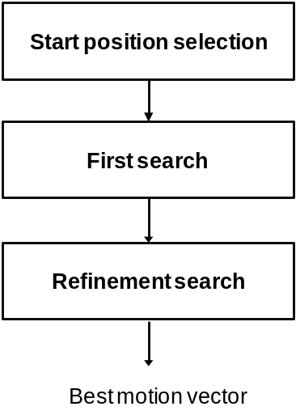
Figure 4-27 – Three step motion search strategy for integer-pel accuracy
At first, start position of the search is selected. As a default, motion vector predictor (PMV) obtained by motion vector predictor derivation process is used. Optionally, motion vectors of neighbouring positions (A, B, and C), and zero motion can be checked. In the common test condition, only PMV is used as the start position of integer-pel search.
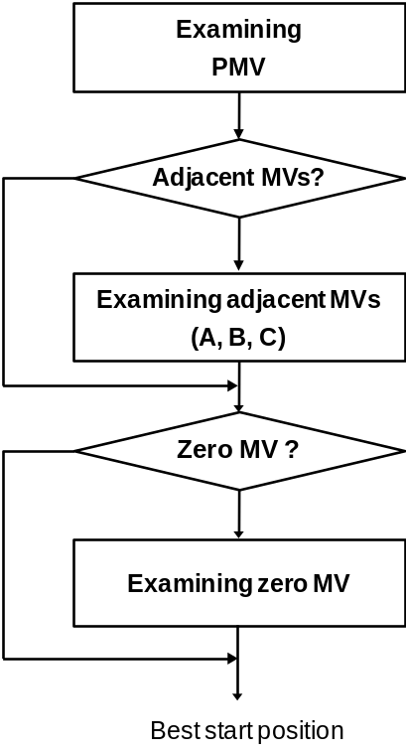
Figure 4-28 – Start position selection
As a second step, the first search is done using diamond search pattern or square search pattern. Currently, diamond search pattern is default, and square search pattern is used by changing input configuration. Additional raster search is performed when the difference between obtained motion vector and start position is too big. Currently, search range is set by 64 in integer-pel accuracy. Figure 4-29 illustrates the 3 search patterns used for the first search. Red circles represent current position and coloured squares represent candidate search positions for each pattern. Same colour means positions having same distance from the start position.
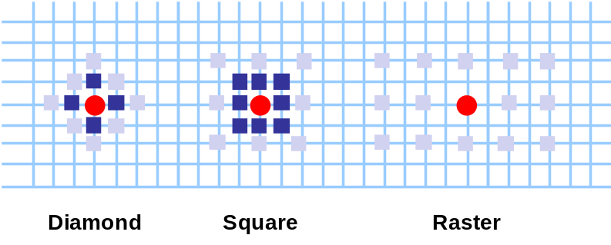
Figure 4-29 – Search patterns for the first search
Last step is refinement search. In this step, refinement search is performed by changing the start position to the best position from the second step. Also, diamond or square search is utilized, and refinement is stopped when 2 rounds are passed after best match.

Bi-predictive search strategy
In principle, bi-predictive motion search means to search two motion vectors which produce minimum error between original block (O) and predicted block with two prediction (P=P0+P1). In HM, practical strategy is implemented by utilizing iterative uni-predictive search. Bi-predictive search steps are as follows.
- Search P1 which produces minimum error with (2O - P0), where O represents original block and P0 means predictor produced by the first motion vector. P0 is fixed in this step. To get motion vector for P1, uni-predictive motion search is utilized after setting (2O - P0) as reference samples.
- Search P0 which produces minimum error with (2O – P1), where O represents original block and P1 means predictor produced by the second motion vector. P1 is the predictor obtained in step 1) and fixed in this step. To get P0, uni-predictive search is utilized after setting (2O – P1) as reference samples.
- Iterate 1) and 2) until maximum number of iterations is reached. The maximum number of iteration is set by 4 unless the fast search option is enabled.

Fast search options
There are two options to accelerate motion estimation. The first one is using sub-sampled SAD for integer motion search. This option is only used for blocks which have larger number of rows than 8. In this method, only samples in odd-number rows are involved for SAD calculations. The second option is reducing number of iterations for bi-predictive motion search. The number of iteration is set by 4 unless the fast search option is enabled.

Decision process on AMP mode evaluation procedure
For encoder speed up, additional conditions are checked before doing motion estimation for AMP. If certain conditions are met, additional motion estimation for AMP can be skipped. Conditions of mode skipping are based on two values: the best partition mode (PartMode) before AMP modes are evaluated and the PartMode and prediction mode (PredMode) at the lower level in the CU quad-tree, the so called parent CU, which contains the current PU. The conditions and actions are specified in Table 4-11..
Table 4-11 – Conditions and actions for fast AMP mode evaluation
Conditions | Actions
The best PartMode is SIZE_2NxN | Try SIZE_2NxnU and SIZE_2NxnD
The best PartMode is SIZE_Nx2N | Try SIZE_nLx2N and SIZE_nRx2N
The best PartMode is 2Nx2N &&  !merge mode && ! skip mode | Try all AMP modes
PartMode of parent CU is AMP mode | Try merge mode only for all AMP modes
PartMode of parent CU is PART_2Nx2N && parent CU is not skipped | Try merge mode only for all AMP modes
PredMode of parent CU is intra && the best PartMode is SIZE_2NxN | Try merge mode only for SIZE_2NxnU and SIZE_2NxnD
PredMode of parent CU is intra && the best PartMode is SIZE_Nx2N | Try merge mode only for SIZE_nLx2N and SIZE_nRx2N
Size of current CU is 64x64 | No AMP modes are evaluated

Intra/Inter/PCM mode decision
For inter coded CUs, the following mode decision process is conducted in the HM encoder. Its schematic is also shown in Figure 4-30. Please refer to contributions about early termination for Early_CU condition, CBF_Fast condition, and Early_SKIP condition.
- Coding costs (J_{mode}) for MODE_INTER with PART_2Nx2N is computed and J_{mode} is set to minimum CU coding cost J.
- Check if motion vector difference of MODE_INTER with PART_2Nx2N is equal to (0, 0) and MODE_INTER with PART_2Nx2N contains no non-zero transform coefficients (Early_SKIP condition). If both are true, proceed to 17 with setting the best interim coding mode as MODE_SKIP. Otherwise, proceed to 3.
- Check if MODE_INTER with PART_2Nx2N contains no non-zero transform coefficients (CBF_Fast condition). If the condition is true, proceed to 17 with setting the best interim coding mode as MODE_INTER with PART_2Nx2N. Otherwise, proceed to 4.
- J_{mode} for MODE_SKIP is evaluated and J is set equal to J_{mode} if J_{mode} < J.
- Check if the current CU depth is maximum and the current CU size is not 8x8 when inter_4x4_enabled_flag is zero. If the conditions are true, proceed to 6. Otherwise, proceed to 7.
- J_{mode} for MODE_INTER with PART_NxN is evaluated and J is set equal to J_{mode} if J_{mode} < J. After that, check if MODE_INTER with PART_NxN contains no non-zero transform coefficients (CBF_Fast condition). If the condition is true, proceed to 17 with setting the best interim coding mode as MODE_INTER with PART_NxN. Otherwise, proceed to 7.
- J_{mode} for MODE_INTER with PART_Nx2N is evaluated and J is set equal to J_{mode} if J_{mode} < J. After that, check if MODE_INTER with PART_Nx2N contains no non-zero transform coefficients (CBF_Fast condition). If the condition is true, proceed to 17 with setting the best interim coding mode as MODE_INTER with PART_Nx2N. Otherwise, proceed to 8.
- J_{mode} for MODE_INTER with PART_2NxN is evaluated and J is set equal to J_{mode} if J_{mode} < J. After that, check if MODE_INTER with PART_2NxN contains no non-zero transform coefficients (CBF_Fast condition). If the condition is true, proceed to 17 with setting the best interim coding mode as MODE_INTER with PART_2NxN. Otherwise, proceed to 9.
- Invoke a process to determine AMP mode evaluation procedure specified in 4.6.2.3. Output of this process is assigned to TestAMP_Hor and TestAMP_Ver. TestAMP_Hor specifies whether horizontal AMP modes are tested with specific ME or tested with merge mode or not tested. TestAMP_Ver specifies whether vertical AMP modes are tested with specific ME or tested with merge mode or not tested.
- If TestAMP_Hor indicates that horizontal AMP modes are tested, MODE_INTER with PART_2NxnU is evaluated with procedure suggested by TestAMP_Hor and J is set equal to the resulting coding cost J_{mode} if J_{mode} < J. After that, check if MODE_INTER with PART_2NxnU contains no non-zero transform coefficients (CBF_Fast condition). If the condition is true, proceed to 17 with setting the best interim coding mode as MODE_INTER with PART_2NxnU. Otherwise, MODE_INTER with PART_2NxnD is evaluated with procedure suggested by TestAMP_Hor and J is set equal to the resulting coding cost J_{mode} if J_{mode} < J. After that, check if MODE_INTER with PART_2NxnD contains no non-zero transform coefficients (CBF_Fast condition). If the condition is true, proceed to 17 with setting the best interim coding mode as MODE_INTER with PART_2NxnD. Otherwise, proceed to 11.
- If TestAMP_Ver indicates that vertical AMP modes are tested, MODE_INTER with PART_nLx2N is evaluated with procedure suggested by TestAMP_Ver and J is set equal to the resulting coding cost J_{mode} if J_{mode} < J. After that, check if MODE_INTER with PART_nLx2N contains no non-zero transform coefficients (CBF_Fast condition). If the condition is true, proceed to 17 with setting the best interim coding mode as MODE_INTER with PART_nLx2N. Otherwise, MODE_INTER with PART_nRx2N is evaluated with procedure suggested by TestAMP_Ver and J is set equal to the resulting coding cost J_{mode} if J_{mode} < J. After that, check if MODE_INTER with PART_nRx2N contains no non-zero transform coefficients (CBF_Fast condition). If the condition is true, proceed to 17 with setting the best interim coding mode as MODE_INTER with PART_nRx2N. Otherwise, proceed to 12.
- MODE_INTRA with PART_2Nx2N is evaluated by invoking the process specified in 4.6.1, only when at least one or more non-zero transform coefficients can be found by using the best interim coding mode. J is set equal to the resulting coding cost J_{mode} if J_{mode} < J.
- Check if the current CU depth is maximum, If the condition is true, proceed to 14. Otherwise, proceed to 15.
- MODE_INTRA with PART_NxN is evaluated by invoking the process specified in 4.6.1, only when the current CU size is larger than minimum TU size. The resulting coding cost J_{mode} is set to J if J_{mode} < J.
- Check if the current CU size is greater than or equal to the minimum PCM mode size specified by the log2_min_pcm_coding_block_size_minus3 value of SPS parameter. If the condition is true, proceed to 16. Otherwise, proceed to 17.
- Check if any of the following conditions are true. If the condition is true, PCM mode is evaluated and J is set equal to the resulting coding cost J_{mode} if J_{mode} < J.
- Bit cost of J is greater than that of the PCM sample data of the input image block.
- J is greater than bit cost of the PCM sample data of the input image block multiplied by λ_{mode}.
- Update bit cost B_{mode} by adding bits for CU split flag and re-compute minimum coding cost J.
- Check if the best interim coding mode is MODE_SKIP (Early_CU condition). If the condition is true, do not proceed to the recursive mode decision at next CU level. Otherwise, go to next CU level of recursive mode decision if the current CU depth is not maximum.
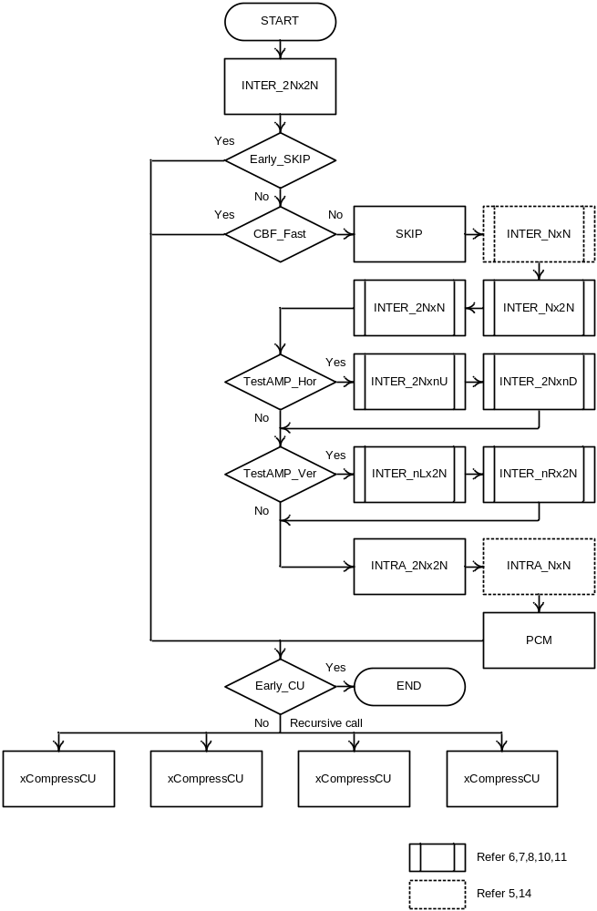
Figure 4-30 – The schematic of Intra/Inter/PCM mode decision
For the computation of J_{mode} except for PCM mode, residual signal is obtained by subtracting intra or inter prediction samples from source samples and is coded with transform and quantization with quad-tree TU partitioning as specified in the section 4.7. Bits for side information (skip_flag, merge_flag, merge_idx, pred_type, pcm_flag, inter_pred_flag, reference picture indices, motion vector(s), mvp_idx, intra prediction mode signaling) and residual coded data are considered as B_{mode}. SSE_{luma} and SSE_{chroma} are obtained by using local decoded samples, except for MODE_SKIP case where prediction sample is used as local decoded samples.
For the computation of J_{mode} for PCM mode, bits for side information (skip_flag, pred_type, pcm_flag, pcm_alignment_zero_bit) and PCM sample data are considered as B_{mode}. SSE_{luma} and SSE_{chroma} are set to 0. (Note that in current test conditions, the PCM mode decision processes in (15) and (16) are skipped since the minimum PCM mode size is 128.)
This CU level mode decision is recursively performed for each CU depth and final distribution of CU coding modes is determined at CTU level.

Derivation process for TU-level coding parameters

Residual Quad-tree partitioning
The residual quadtree is a recursive representation of the partitioning of a coding unit into transform units.
The encoding process for intra-coded coding units can be summarized as follows.
– The luma intra prediction mode (or modes for intra_split_flag equal to 1) is determined using the residual coding with the largest applicable transform size.
– Given the determined luma intra prediction mode (or modes for intra_split_flag equal to 1), the transform tree and the corresponding luma transform coefficient levels are determined using an exhaustive subdivision process, taking into account the maximum allowed transform hierarchy depth and considering only the luma component.
– The chroma intra prediction mode and the corresponding chroma transform coefficient levels are determined given the determined transform tree.
The encoding process for inter-coded coding units can be summarized as follows.
– The transform tree and the corresponding luma and chroma transform coefficient levels are determined using an exhaustive subdivision process, taking into account the maximum allowed transform hierarchy depth and considering both the luma component and the chroma components.

Rate-Distortion Optimized Quantization
The basic idea behind rate distortion optimized quantization (RDOQ) is to perform a soft decision quantization for a given coefficient given both its impact on the bitrate and quality. In the HM, RDOQ is applied in a similar manner as it was applied to CABAC in H264/AVC.
To estimate the number of bits required to code coefficients, tabularized values of entropy of the probabilities corresponding to states in CABAC coding engine are used. Residual coding in CABAC includes two parts, i.e., coding a so-called significance map and coding non-zero coefficients. Given a scan ordered sequence of transform coefficients, its significance map is a binary sequence which indicates the occurrence and location of the non-zero coefficients.

References
- JCT-VC, “Encoder-side description of Test Model under Consideration”, JCTVC-B204, JCT-VC Meeting, Geneva, July 2010
- JCT-VC, “High Efficiency Video Coding (HEVC) Test Model 1 (HM 1) Encoder Description”, JCTVC-C402, October 2010
- JCT-VC, “High Efficiency Video Coding (HEVC) Test Model 2 (HM 2) Encoder Description”, JCTVC-D502, January 2011
- JCT-VC, “High Efficiency Video Coding (HEVC) Test Model 3 (HM 3) Encoder Description”, JCTVC-E602, March 2011
- JCT-VC, “High Efficiency Video Coding (HEVC) Test Model 4 (HM 4) Encoder Description”, JCTVC-F802, July 2011
- JCT-VC, “High Efficiency Video Coding (HEVC) Test Model 5 (HM 5) Encoder Description”, JCTVC-G1102, November 2011
- JCT-VC, “High Efficiency Video Coding (HEVC) Test Model 6 (HM 6) Encoder Description”, JCTVC-H1002, February 2012
- JCT-VC, “High Efficiency Video Coding (HEVC) Test Model 7 (HM 7) Encoder Description”, JCTVC-I1002, May 2012
- JCT-VC, “High Efficiency Video Coding (HEVC) Test Model 8 (HM 8) Encoder Description”, JCTVC-J1002, July 2012
- JCT-VC, “High Efficiency Video Coding (HEVC) Test Model 9 (HM 9) Encoder Description”, JCTVC-K1002, October 2012
- JCT-VC, “High Efficiency Video Coding (HEVC) Test Model 10 (HM 10) Encoder Description”, JCTVC-L1002, January 2013
- JCT-VC, “High Efficiency Video Coding (HEVC) Test Model 11 (HM 11) Encoder Description”, JCTVC-M1002, April 2013
- JCT-VC, “High Efficiency Video Coding (HEVC) Test Model 12 (HM 12) Encoder Description”, JCTVC-N1002, August 2013
- JCT-VC, “High Efficiency Video Coding (HEVC) Test Model 13 (HM 13) Encoder Description”, JCTVC-O1002, November 2013
- JCT-VC, “High Efficiency Video Coding (HEVC) Test Model 14 (HM 14) Encoder Description”, JCTVC-P1002, January 2014

- JCT-VC, “High Efficiency Video Coding (HEVC) specification draft 10 (for FDIS & Consent)”, JCTVC-L1003, January 2013
- JCT-VC, “Common HM test conditions and software reference configurations”, JCTVC-L1100, January 2013
- JCT-VC, “High Efficiency Video Coding Test Model 12 (HM12) Reference Software”, JCTVC-N1010, August 2013
- ITU-T Recommendation H.264 / ISO/IEC 14496-10: "Information technology - Coding of audio-visual objects- Part 10: Advanced Video Coding"

