OpenNoiseNet Pro
Product Architecture, PRD, Data Model, Episode Guide, ML Strategy, API Surface, and Delivery Plan
Version 1.0 • 16 April 2026
Single-source planning document for commercializing OpenNoiseNet into a privacy-first acoustic evidence and detection platform.
Product thesis  Turn noisy, ambiguous acoustic activity into defensible episodes, reports, heatmaps, and case evidence — without making cloud audio surveillance the default. | Recommended ML posture  Use a hybrid edge pipeline: signal gate + LiteRT audio classifier as the primary detector; optional local summarizer only after aggregation.
Current repo baseline  Ground vNext on the actual supported surfaces in the repo today: auth, devices, events, map. Treat admin, snippets, AI workflows, and notifications as future work. | Commercial wedge  Start with property, housing, municipality, and consultant use cases where evidence, repeatability, exports, and site-level governance matter more than consumer novelty.

Grounding note
This document defines the commercial vNext target, not the current production reality. It is anchored to the current OpenNoiseNet repo state before extending it into episodes, cases, alerts, exports, calibration, and policy-driven evidence workflows.

Contents
• 1. Document intent and repo grounding
• 2. Executive summary
• 3. Product architecture
• 4. Product requirements document
• 5. Commercial packaging and target segments
• 6. Data model
• 7. Episode guide
• 8. ML and device strategy
• 9. API and integration surface
• 10. Privacy, legal, security, and non-functional requirements
• 11. Delivery roadmap, acceptance criteria, and KPIs
• 12. Open decisions and source grounding

1. Document intent and repo grounding
OpenNoiseNet is currently in a software stabilization phase. The repository already contains meaningful backend, dashboard, landing, infrastructure, and mobile code, but the current supported surface is intentionally narrow. The purpose of this document is to define the next commercial product layer — OpenNoiseNet Pro — without pretending that unreleased capabilities already exist.
The core design principle is strict separation between current repo truth and future product ambition. The platform should extend the repo’s existing device, event, and map primitives into a stronger commercial model centered on episodes, evidence quality, case workflows, and governance.

Current repo reality vs. OpenNoiseNet Pro vNext
Area | Current repo baseline | vNext defined here
Backend surface | Auth, device registration / heartbeat, events, map, health. | Add organizations, sites, zones, episodes, cases, exports, alerts, calibration, model-bundle lifecycle.
AI processing | Explicitly unreleased in the stabilization milestone. | Edge-first classifier pipeline, episode engine, nuisance scoring, optional local summarization.
Evidence | No supported snippet or case-evidence workflow. | Derived-only default, policy-controlled evidence modes, case export, audit trail, retention controls.
Notifications | Unreleased. | Rule-driven alerting and routing at site / zone / org scope.
Mobile | Substantial infrastructure exists but remains a stabilization target. | Android-first production node, iOS best-effort node, sensor-agnostic architecture for future hardware.

Architectural implication
Do not rebuild the platform from scratch. Preserve the existing auth, devices, events, and map foundations; introduce a new commercial domain layer above them.

2. Executive summary
OpenNoiseNet Pro is a privacy-first acoustic evidence platform. Its purpose is to convert acoustic disturbance into structured, reviewable episodes that can be acted on by operators, housing providers, municipalities, consultants, insurers, and enterprise site managers.
The product is not a general-purpose cloud surveillance system. By default, raw audio remains on the device. The primary unit of value is the episode: a time-bounded, classified, scored representation of a nuisance, disturbance, or safety-relevant event, backed by loudness metrics, confidence, review state, and exportability.
Commercial value comes from four layers working together: reliable edge detection, stable episode construction, policy-governed evidence handling, and defensible reporting. That combination is much more commercially useful than a public map alone.

OpenNoiseNet Pro in one view
Dimension | Definition
Core promise | Turn acoustic activity into defensible episodes, reports, heatmaps, and case evidence with a privacy-first default.
Primary buyers | Housing providers, property managers, municipalities, consultants, insurers, campus / industrial site operators.
Primary operator | An organization admin or reviewer who manages devices, sites, rules, review queues, and report access.
Primary technical posture | Edge-first detection; derived-event uploads; centralized storage and analytics for episodes and cases.
Primary metric of success | How reliably the platform converts noisy real-world signals into low-friction evidence and action.

3. Product architecture
The architecture should stay sensor-agnostic while treating the smartphone node as the fastest path to field value. Fixed sensor nodes, appliance-like nodes, and future dedicated hardware should all produce the same logical output: windows, candidates, episodes, and governance-aware evidence objects.
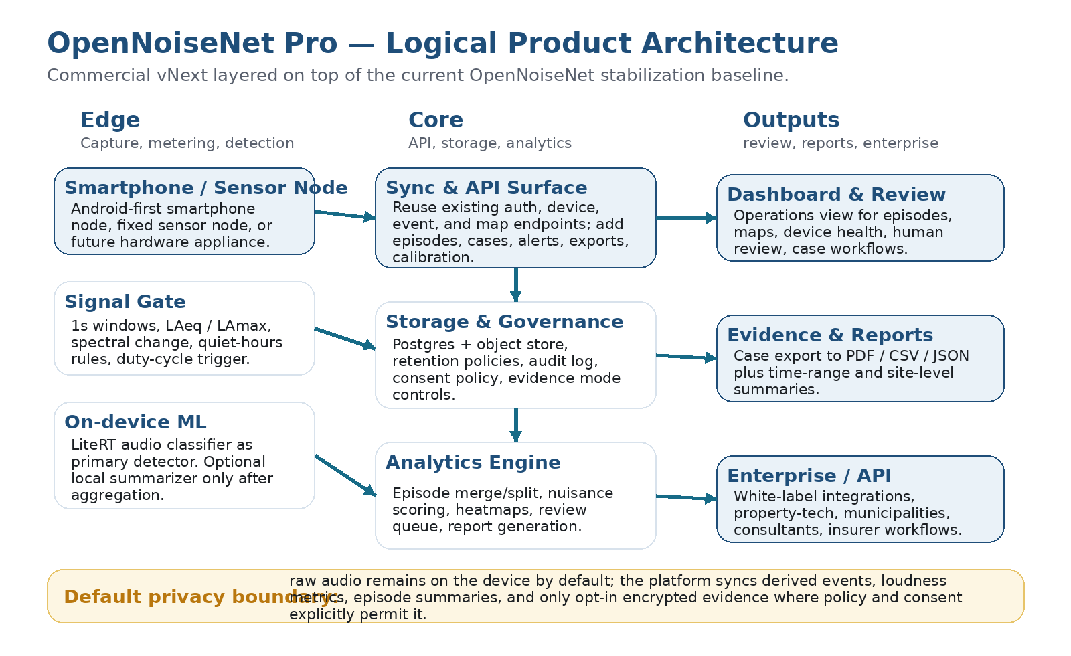
Figure 1. Logical architecture for OpenNoiseNet Pro.

Architecture principles
Principle | Interpretation
Derived-first | The system syncs derived events and episode objects by default. Raw audio stays local unless a stricter legal and consent mode explicitly permits otherwise.
Episode-centric | Events are intermediate; episodes are the commercial object that powers review, alerts, maps, cases, exports, and billing.
Policy-aware | Quiet hours, retention windows, allowed evidence modes, and alert thresholds are configurable per org, site, or zone.
Offline-tolerant | Edge nodes must continue detecting and queuing derived output even when network connectivity or background workers are unavailable.
Human-reviewable | Every automated classification and score must remain inspectable, overrideable, and auditable.

Core runtime components
Component | Responsibility | Must run on | Notes
Signal Gate | Cheap 1s feature extraction and trigger heuristics. | Device | Keeps the expensive model mostly asleep.
Audio Classifier | Primary class prediction over candidate windows. | Device | LiteRT model, replaceable by bundle.
Episode Builder | Merge / split / score / close logic. | Device + backend | Lightweight version runs on device; backend can re-score or refine.
Sync Agent | Batch upload, retry, offline queue. | Device | Uploads derived payloads only by default.
Core API | Auth, devices, episodes, cases, exports, alerts. | Backend | Preserve existing endpoints and add a commercial layer.
Analytics Engine | Trends, hot spots, site summaries, cross-device rollups. | Backend | Consumes episodes rather than raw audio streams.
Review & Export UI | Human review, case handling, PDF/CSV/JSON export. | Dashboard | This is the operator face of the product.

4. Product requirements document

4.1 Problem statement
Noise complaints, nuisance disputes, safety-related acoustic incidents, and environment-driven disturbances are typically under-instrumented. Existing evidence is often anecdotal, fragmented, or legally fragile. Buyers need a system that can observe acoustic conditions continuously, summarize them into defensible units, and produce useful exports without defaulting into invasive always-uploaded recordings.

4.2 Product definition
OpenNoiseNet Pro is a multi-tenant acoustic evidence and detection platform. It combines edge monitoring, on-device classification, episode construction, review workflows, case exports, and site-level governance. The product targets controlled environments — residential portfolios, sites, campuses, facilities, streets, or neighborhoods — where disturbances must be observed over time and turned into action.
The first commercial release should focus on nuisance and site-monitoring workflows, not consumer home surveillance. Safety classes such as smoke alarm, CO alarm, forced-entry impact, or glass break are valid future extensions of the same engine, but they are secondary to the evidence-grade nuisance workflow.

4.3 Goals
• Make acoustic disturbance observable as structured, reviewable episodes instead of unbounded recordings.
• Support site-level governance: quiet hours, rules, policies, retention, reviewer roles, and exports.
• Enable buyers to operate mixed fleets of smartphone nodes and fixed nodes under one platform model.
• Produce human-usable evidence packages: timeline, severity, repetition, confidence, labels, map position, and case attachments.
• Create a technical base that can later extend into safety monitoring, white-label APIs, and enterprise integrations.

4.4 Non-goals
• General-purpose cloud audio surveillance.
• Always-on speech transcription.
• A claim of laboratory-grade metrology on uncontrolled consumer hardware.
• A broad consumer home-security product in Release 1.
• Requiring unreleased repo surfaces to exist before starting the commercial design.

4.5 Primary user roles
Role | Need | Success condition
Organization Admin | Manage sites, devices, policies, roles, and report access. | Can onboard and govern a portfolio without engineering intervention.
Reviewer / Analyst | Review episodes, override labels, open cases, and export evidence. | Can resolve incidents quickly and defend why an episode matters.
Site Manager | Understand what is happening at a building, site, or zone. | Can spot recurring disturbances and act operationally.
Resident / Reporter | Submit complaints or attach context to an episode or case. | Feels the system captures reality without requiring manual logging all day.
Integrator / Partner | Pull episodes, status, and exports into another system. | Gets stable APIs and predictable object semantics.

4.6 Jobs to be done
• When a disturbance recurs over days or weeks, I want the system to convert it into comparable episodes so I can prove a pattern.
• When a serious incident happens at night, I want the system to flag it immediately and preserve the right evidence envelope.
• When devices operate in the field for long periods, I want detection to keep working through poor connectivity and low power states.
• When an operator exports a case, I want the output to read like a coherent incident timeline rather than a pile of raw metrics.

4.7 Release scope
Priority | Capability | Description
P0 | Android monitoring node | Locked-screen capable, derived-only uploads, model bundle support, calibration profile, offline queue.
P0 | Episode engine | Windowing, candidate creation, label confidence, merge / split, nuisance score, close rules.
P0 | Operator dashboard | Episode list, site / zone filters, maps, device health, review queue, manual relabel / severity override.
P0 | Case workflow | Open case from episode(s), attach notes, export PDF / CSV / JSON, retention policy enforcement.
P0 | Tenant governance | Organizations, sites, zones, roles, quiet hours, alert rules, consent / evidence mode policy.
P1 | iOS best-effort node | Useful but constrained by platform background behavior; documented trade-offs.
P1 | Safety-class alerts | Smoke alarm, CO alarm, glass break, forced-entry impact, panic classes.
P1 | Enterprise API / webhooks | Programmatic access for partners and white-label deployments.
P2 | Consumer / Home product | Only after nuisance and B2B workflows prove robust and legally well-bounded.

5. Commercial packaging and target segments

Recommended commercial packaging
Package | Buyer | Core scope | Commercial logic
Pro Site | Single property / site operator | Devices, episodes, review queue, basic exports. | Per site + per active device.
Portfolio | Housing provider / municipality / consultant | Multi-site governance, quiet-hour policies, case workflow, advanced reports. | Per site + portfolio analytics tier.
Enterprise API | Integrator / insurer / property-tech | Episodes, alerts, exports, white-label embedding. | Platform fee + usage-based API / export volume.

Segment prioritization
Segment | Why it fits first | Risk
Housing / property | Chronic nuisance patterns, repeated complaints, clear site model, high export value. | Legal and tenant communication must be handled carefully.
Municipal / public sector | Maps, pattern detection, zone governance, public-interest use cases. | Longer sales cycles and procurement friction.
Consultants / acoustic specialists | High need for structured exports and reviewable timelines. | May demand better calibration evidence earlier.
Industrial / campus sites | Controlled geography, safety classes, incident routing, alerting. | Needs stronger reliability and SLA posture.

6. Data model
The data model should separate raw capture mechanics from commercial objects. Sessions, windows, and candidates exist to support episode construction; organizations, sites, cases, exports, and consent policies exist to make the platform operable and sellable.
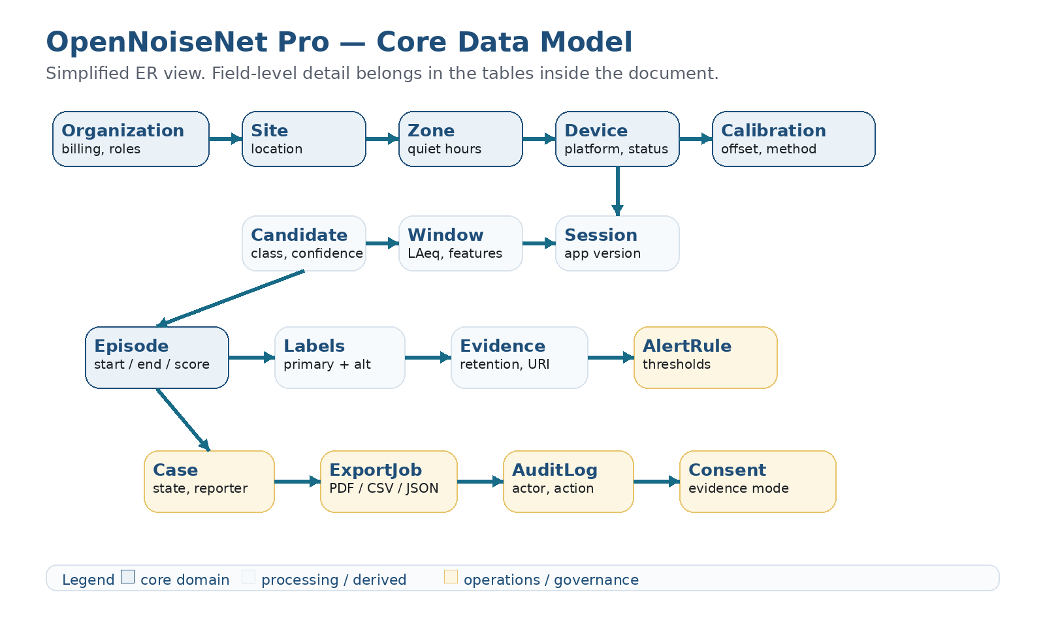
Figure 2. Simplified ER view for the OpenNoiseNet Pro domain.

Core and processing entities
Entity | Purpose | Minimum fields | Notes
Organization | Commercial owner and tenant boundary. | id, name, plan, billing_state, status | Root of roles, policies, sites, and usage accounting.
Site | Physical location under management. | id, organization_id, name, site_type, timezone, geofence | A building, campus, street, property, district, or facility.
Zone | Sub-area within a site. | id, site_id, name, quiet_hours_policy_id, geofence | Used for quieter hours, thresholds, and alert routing.
Device | Logical monitoring node. | id, site_id, platform, hardware_model, device_status, calibration_profile_id | Smartphone node first; architecture stays sensor-agnostic.
CalibrationProfile | Device-specific measurement correction. | id, device_id or device_model, offset_db, method, confidence | Necessary because consumer microphones vary.
SensorSession | Continuous operating period for a device. | id, device_id, started_at, ended_at, app_version, model_bundle_id | Useful for diagnostics and model-traceability.
SignalWindow | Short feature window. | id, session_id, ts_start, ts_end, LAeq_dBA, LAmax_dBA, feature_blob_ref | Default retention can be short-lived.
CandidateEvent | Intermediate candidate before episode merge. | id, session_id, ts_start, ts_end, class_label, confidence, family | May never be shown directly to buyers.
Episode | Primary commercial incident object. | id, site_id, zone_id, device_id, primary_class, severity, nuisance_score, started_at, ended_at, review_state | Everything downstream should anchor to this object.
EpisodeLabel | Alternative or human-corrected labels. | id, episode_id, label, confidence, source | Supports model + human disagreement without data loss.
EvidenceAsset | Reference to retained evidence envelope. | id, episode_id, evidence_mode, storage_uri, retention_until, encryption_state | Optional and policy-controlled.

Operations and governance entities
Entity | Purpose | Minimum fields | Notes
Case | Operator-managed incident container. | id, site_id, opened_by, status, title, summary, opened_at | Can group one or many episodes.
AlertRule | Policy for alert generation. | id, scope_type, scope_id, class_filter, severity_threshold, quiet_hours_only | Evaluated when episodes close or escalate.
ExportJob | Generated PDF / CSV / JSON package. | id, case_id or filter_scope, format, status, created_by, output_uri | Needed for evidence handoff and customer deliverables.
AuditLog | Immutable action history. | id, actor_id, action, target_type, target_id, created_at | Mandatory for trust, reviewability, and enterprise posture.
ConsentPolicy | Evidence handling policy. | id, scope_type, scope_id, evidence_mode, retention_days, notes | Defines what is allowed to leave the device.

Canonical object hierarchy
Organization -> Site -> Zone -> Device -> Session -> Window / Candidate -> Episode -> Case / Export. Episodes, not raw windows, are the main object exposed to operators and customers.

7. Episode guide
The episode is the decisive product object. A bad episode engine creates distrust even if the classifier is technically good. The engine therefore needs explicit rules for creation, extension, split, closure, confidence, and severity.
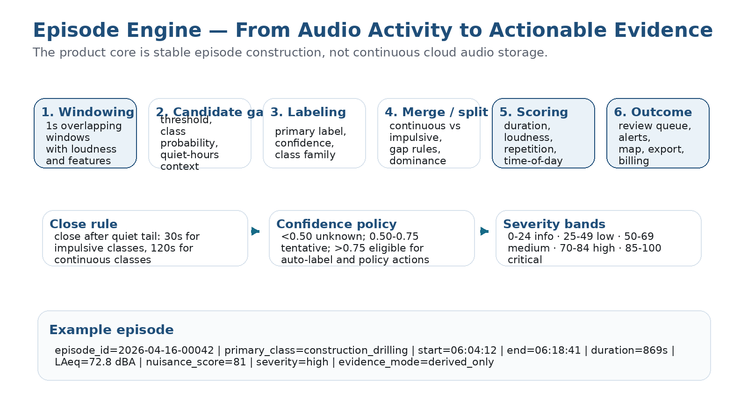
Figure 3. Episode engine overview.

Glossary
Term | Definition
Window | A short analysis slice, typically 1 second with overlap.
Candidate | A class-bearing window or short cluster that passed the gate.
Episode | A time-bounded incident formed by merging related candidates.
Primary class | The dominant class chosen for operator-facing representation.
Nuisance score | 0–100 score estimating disturbance impact in context.
Severity | Human-readable band derived from the nuisance score and policy.
Evidence mode | How much supporting material may be retained or exported.

7.1 Recommended episode state model
• open_candidate -> open_episode when a candidate passes class and policy thresholds.
• open_episode -> extended when same-class or family-compatible candidates continue within the allowed gap.
• open_episode -> split when silence exceeds the family gap or a different class dominates for multiple windows.
• open_episode -> closed when the quiet tail rule is satisfied.
• closed_episode -> reviewed when a human validates or overrides label / severity.
• closed_episode -> exported when attached to a case or direct report output.

7.2 Merge and split rules
Class family | Typical examples | Merge gap | Close tail | Notes
Continuous | traffic_constant, music_bass, drilling, machinery | Up to 120s | 120s quiet tail | Use to prevent over-fragmentation.
Intermittent | dog_bark, shouting, bin impact | Up to 20–40s | 30s quiet tail | Episodes may remain bursty but coherent.
Impulsive / safety | glass_break, forced_entry_impact, smoke_alarm | Usually none or <=10s | 10–30s quiet tail | Prefer fast closure and alerting.
Unknown | unknown_noise | Conservative | Short | Avoid aggressive auto-grouping until reviewed.

7.3 Confidence and scoring
Recommended confidence policy:
• confidence < 0.50 -> do not auto-label beyond unknown_noise or weak family hint
• 0.50 <= confidence < 0.75 -> tentative label, visible to operators but not trusted for strong policy action
• confidence >= 0.75 -> eligible for auto-label, scoring, alert evaluation, and case inclusion
Recommended nuisance score formula:
nuisance_score =
0.30 * loudness_score +
0.25 * duration_score +
0.20 * quiet_hours_score +
0.15 * repetition_score +
0.10 * class_impact_score

Severity bands should map from the normalized nuisance score as follows: 0–24 informational, 25–49 low, 50–69 medium, 70–84 high, 85–100 critical.

Evidence modes
Mode | Meaning | Default use
derived_only | Only episode metadata, labels, loudness metrics, timestamps, and review notes are retained. | Default everywhere.
encrypted_buffer | Short encrypted local buffer exists for policy-authorized extraction. | Restricted customers and jurisdictions only.
redacted_snippet | Strictly limited and reviewed evidence artifact detached from ambient speech where possible. | Exceptional workflow; legal review required.

Suggested class taxonomy v1
Family | Labels | Commercial value
Environmental | traffic_constant, aircraft_overflight, rail_passby, rain_wind | Context and baseline condition tracking.
Nuisance | loud_conversation, shouting, music_bass, dog_bark, construction_drilling, hammering, bin_impact | Primary Release 1 value.
Safety | smoke_alarm, CO_alarm, glass_break, forced_entry_impact | High urgency; likely P1.
Unknown | unknown_noise, unclassified_mechanical | Safety valve for low confidence or novel patterns.

8. ML and device strategy
The most important strategic choice is to avoid using a local LLM as the primary acoustic detector. Small audio classifiers are better suited to the first-pass task. A local or server-side language model may still add value later by summarizing already-constructed episodes, but it should not sit in the hot path.

Recommended ML stack
Layer | Recommended choice | Why
Metering / gate | Cheap signal features and heuristics | Preserves battery and CPU by waking the classifier only when needed.
Primary classifier | LiteRT-compatible audio classifier (YAMNet baseline or custom transfer-learned model) | Mobile-ready, understandable, replaceable by bundle, far better fit than an LLM for first-pass detection.
Production specialization | Custom model trained on OpenNoiseNet class taxonomy | Improves local relevance: nuisance, construction, bass, barking, alarms, site-specific classes.
Low-power fallback | Tiny CNN with MFCC / MFE features | Useful for weaker or older smartphones and appliance-grade nodes.
Optional summarizer | Local or backend text generator after episode aggregation | Turns structured episodes into readable report language without owning the core classification burden.

Device tier strategy
Tier | Target | Recommended posture
Tier A | Recent Android phones | Full P0 node: gate + classifier + local episode builder + sync.
Tier B | Older Android phones | Gate + smaller classifier + reduced cadence; avoid expensive local summarization.
Tier C | iPhone / iPad | Best-effort node where platform policy allows useful background behavior; document limits clearly.
Tier D | Fixed sensors / Pi-class | Same logical output schema; easiest path for calibrated or semi-permanent deployments.

Model-bundle design
Treat models as versioned bundles. Every session and episode should know which model bundle produced it so reviewers can trace behavior and regressions.

9. API and integration surface
The API should preserve the existing repo surfaces and add a commercial domain layer instead of replacing current primitives. Episodes become the main externally useful object; cases, exports, alerts, and governance endpoints complete the operator workflow.

Recommended API groups
Group | Representative endpoints | Purpose
Existing baseline | /api/v1/auth/*, /api/v1/devices/*, /api/v1/events/*, /api/v1/map/* | Keep compatibility with current repo truth.
Organizations & sites | /api/v1/organizations, /api/v1/sites, /api/v1/sites/{id}/zones | Multi-tenant governance and physical hierarchy.
Episodes | /api/v1/episodes, /api/v1/episodes/{id}, /api/v1/episodes/{id}/review | Primary incident object, filters, review actions.
Cases & exports | /api/v1/cases, /api/v1/cases/{id}, /api/v1/exports | Operator workflow and evidence handoff.
Alerts | /api/v1/alerts/rules, /api/v1/alerts/events | Policy-driven notifications.
Calibration & models | /api/v1/calibration/*, /api/v1/model-bundles/* | Measurement confidence and model lifecycle.

Canonical episode payload example:
{
"episode_id": "ep_2026_04_16_00042",
"organization_id": "org_01",
"site_id": "site_12",
"zone_id": "zone_north_courtyard",
"device_id": "dev_android_7f3a",
"primary_class": "construction_drilling",
"labels": [
{"label": "construction_drilling", "confidence": 0.91, "source": "model"},
{"label": "construction", "confidence": 0.97, "source": "family"}
],
"started_at": "2026-04-16T06:04:12Z",
"ended_at": "2026-04-16T06:18:41Z",
"duration_seconds": 869,
"metrics": {
"laeq_dba": 72.8,
"lamax_dba": 84.1
},
"nuisance_score": 81,
"severity": "high",
"evidence_mode": "derived_only",
"review_state": "pending_review",
"model_bundle_id": "model_audio_v1_3"
}

Compatibility rule: the existing event object may remain as a lower-level ingestion primitive, but the dashboard and customer-facing exports should privilege episodes whenever possible.

10. Privacy, legal, security, and non-functional requirements
OpenNoiseNet Pro should be designed so that the privacy-preserving operating mode is also the easiest mode to deploy. The system’s commercial credibility depends on this.
• Default to derived_only evidence mode.
• Do not require ambient speech transcription to deliver core value.
• Make all evidence retention rules explicit, reviewable, and tenant-scoped.
• Expose device status and active monitoring state clearly to users and operators.
• Require human review before any unusual evidence-mode escalation leaves the default posture.

Key non-functional requirements
Area | Target requirement
Battery / thermal | A reference Android node should support long-running monitoring without unacceptable heat or battery drain; provide low-power profiles.
Offline resilience | Derived episodes queue safely offline and sync later without duplication.
Traceability | Every episode stores enough lineage to explain the model bundle, device, calibration, policy, and reviewer actions behind it.
Retention | Short-lived low-level data; longer-lived episodes and audit logs; policy-driven evidence retention.
Security | Encrypt data in transit; protect sensitive evidence material at rest; separate tenant data; maintain audit logs.
Reviewability | Operators can relabel, re-severity, mute, suppress, or reopen an episode without destroying original model output.
Calibration | Allow per-device or per-model correction profiles and mark confidence of calibration quality.

Legal posture
The product should be positioned as a privacy-first acoustic evidence and site-monitoring platform, not a covert conversation-recording tool. Formal legal review remains necessary for any workflow that attempts to retain or export audio beyond derived metadata.

11. Delivery roadmap, acceptance criteria, and KPIs

Delivery roadmap
Phase | Outcome | Definition of done
0. Stabilize | Finish repo truth-alignment and green local baseline. | Existing auth / devices / events / map surfaces run and test cleanly.
1. Pro Beta | Android node, episode engine, review dashboard, cases, exports. | Operators can monitor a site, review episodes, and export a coherent case.
2. Governance & scale | Multi-site policies, alerts, calibration, enterprise API. | Portfolio buyers can manage rules and consume data programmatically.
3. Expansion | Safety classes, iOS best-effort, selected vertical extensions. | The same core engine supports new classes without breaking evidence semantics.

Acceptance criteria for Release 1
Area | Acceptance criterion
Edge node | Android node runs for extended locked-screen operation and uploads only derived payloads by default.
Episode engine | System consistently constructs episodes with usable boundaries, confidence, severity, and review state.
Dashboard | Operator can filter by org, site, zone, class, severity, device, and date; can review and override episodes.
Case export | Operator can generate coherent PDF / CSV / JSON outputs from one or many episodes.
Governance | Quiet hours, alert rules, retention policies, and evidence modes are configurable per scope.
Auditability | All human overrides and policy-driven actions are traceable in an audit log.

Suggested KPIs
KPI | Why it matters
Episode precision for top 6 nuisance classes | Measures whether the core engine is useful in the field.
False-positive rate during quiet hours | Directly impacts trust and alert fatigue.
Time from episode closure to export-ready case | Measures operational usefulness, not just model quality.
Median daily battery impact per active node | Determines whether smartphone deployment remains viable.
Reviewer override rate by class | Identifies weak labels, taxonomy problems, and model drift.
Site-level repeat-disturbance detection | Measures whether the platform surfaces patterns, not just isolated incidents.

12. Open decisions and source grounding

Open decisions
Decision | Why it matters
How far may evidence mode go beyond derived_only? | This is the main legal and trust boundary.
Exact nuisance taxonomy v1 | Too broad creates noise; too narrow blocks product-market fit.
Reference benchmark fleet | Needed for meaningful battery, latency, and calibration claims.
Scoring split: on-device vs backend vs hybrid | Affects traceability, consistency, and offline behavior.
When to add safety-class alerts | Can raise buyer value but also reliability expectations.

Source grounding
Source | Used for
OpenNoiseNet README (develop branch) | Current repo framing, supported MVP surface, repository layout.
docs/current-status.md (2026-04-16) | Canonical current repo state and supported endpoints.
ImplementationPlan.md | Stabilization intent and explicit unreleased surfaces.
Feature-Old-Smartphone.md | Existing smartphone-node direction and privacy-first upload concept.
TensorFlow / YAMNet documentation | Baseline recommendation for mobile audio-event classification.
Google AI Edge / LiteRT AudioClassifier docs | Recommended mobile deployment posture for custom or pretrained audio classifiers.
Edge Impulse audio documentation | Low-power MFCC / MFE fallback strategy and edge-audio workflow grounding.
German Criminal Code Section 201 | Legal caution against drifting into covert spoken-word recording workflows.

