**DATABASE MANAGEMENT SYSTEM**

**Mini Project on**

**BLOOD BANK MANGEMENT SYSTEM**

**Course Code :**  **CSE – 3102**

**Under the guidance of**

**Hasan Hafizur Rahman**

**Assistant Professor , Department of CSE , Comilla University**

**Group No : 01**

**Submitted By:**

1. **Nahidul Hasan ID : 11808001**
2. **Jannatul Ferduse ID : 11808002**
3. **Torikul Islam Sifat ID : 11808003**
4. **Nurnabi Nayem ID : 11808004**
5. **Abdullah Al Mamun ID : 11808005**
6. **Mazharul Hasan ID : 11808006**
7. **Sohel Rana ID : 11808007**
8. **Shahriar Soumik ID : 11808008**
9. **Md. Moin Uddin ID : 11808011**

**10. Asma Ul Mowa ID : 11808012**

**Submission Date : 22/08/2021**

**BLOOD BANK MANAGEMENT SYSTEM**

**Introduction :**

**Blood Bank Management System (BBMS) is a web based system that can assists the information of blood bag during its handling in the blood bank. With this system, the user of this system can key in the result of blood test that has been conducted to each of the blood bag received by the blood bank**

**Problem Description :**

**Web-based Blood Donation Management System is a management system website that enables individuals who want to donate blood to help the needy. It also enables hospitals to record and store the data for people who want to communicate with them, and it also provides a centralized blood bank database**

**Purpose of Database :**

**The purpose of the blood bank management system is to simplify and automate the process of searching for blood in case of emergency and maintain the records of blood donors, recipients, blood donation programs and blood stocks in the bank.**

**How This Database will help the Patient :**

**In short we can say that blood donation management system is an online web application which helps the blood bank and hospitals to look for the blood donor information and to provide direct link between the donor and recipient/patient.**

**How to develop a BLOOD BANK MANAGEMENT SYSTEM ?**

**Below is a guide on how to start our own blood bank.**

1. **Licensing Policy and Legal framework. A blood bank centre must ensure that it has complied to the legal framework that has been provided in Drugs and Cosmetics Act/Rules published in The Gazette of India.**
2. **Location.**
3. **Equipments.**
4. **Training.**
5. **Learning query (SQL) and Java/PhP et cetera .**
6. **Storage & Transportation.**

**Identifying the Entities :**

**We use many entities on this databases . These are**

1. **Doctor**
2. **Donor**
3. **Blood**
4. **Blood Bank**
5. **Patient**
6. **Blood Delivery**

**Attributes of the entities :**

**We use many attributes under the guidance of an entity .**

**In Doctor entity , we use …**

1. **Doctor_id**
2. **Doctor_add**
3. **Doctor_phn**
4. **Doctor_name**

**In Blood entity , we also use the attributes**

1. **Blood_type**
2. **Donor_id**
3. **Blood_bank**

**In Donor entity , we also use the attributes like**

1. **Donor_id**
2. **Donor_name**
3. **Donor_add**
4. **Iron_content**
5. **Gender**
6. **Date of Birth (DOB)**
7. **Weight**
8. **Donar_phn**

**In Blood Bank entity , we also use these attributes are**

1. **Blood_bank_id**
2. **Blood_bank_name**
3. **Blood_bank_add**

**In Patient entity , we also use these attributes ar**

1. **Patient_name**
2. **Patient_add**
3. **Pateint_phone**
4. **Hospita_add**

**The Entity-Relationship-Model ( E-R Diagram )**

**Blood dalivery**

donate

**Stored in**

**Patient**

**Blood Bank**

**Donor**

**blood**

**Doctor**

examines

Fig: Blood Donation System

**Schema Diagram :**

**Doctor :**

|  |  |  |  |
| --- | --- | --- | --- |
| **Doctor_id** | **Doctor_name** | **Doctor_add** | **Doctor_phn** |

**Donor :**

|  |  |  |  |  |  |  |  |  |  |
| --- | --- | --- | --- | --- | --- | --- | --- | --- | --- |
| **Donor_id** | **Donar_naeme** | **Do_phn** | **DOB** | **gender** | **Do_add** | **weight** | **Bp** | **ic** | **Doctor_id** |

**Blood Bank :**

|  |  |  |
| --- | --- | --- |
| **Blood_bank_id** | **Blood_bank_name** | **Blood_bank_add** |

**Blood :**

|  |  |  |
| --- | --- | --- |
| **Blood_type** | **Donor_id** | **Blood_bank_id** |

**Patient :**

|  |  |  |  |  |
| --- | --- | --- | --- | --- |
| **Patient_id** | **Patient_name** | **Patient_add** | **Patient_phn** | **Hospital_add** |

**Blood Delivery :**

|  |  |
| --- | --- |
| **Blood_bank_id** | **Patient_id** |

**Table Structure Query :**

**CREATE TABLE doctor**

**(**

**doctor_id int ,**

**doctor_name varchar(20) ,**

**doc_add varchar(25) ,**

**doc_phn bigint ,**

**constraint pk1 primary key (doctor_id)**

**) ;**

**CREATE TABLE donor**

**(**

**donor_id int ,**

**donor_name varchar(20) ,**

**donor_phn bigint ,**

**DOB date ,**

**address varchar(40) ,**

**weight int ,**

**blood_pressure int ,**

**iron_content int ,**

**doctor_id int ,**

**constraint pk2 primary key (donor_id) ,**

**constraint fk1 foreign key(doctor_id) references doctor(doctor_id)**

**);**

**CREATE TABLE blood_bank**

**(**

**blood_bank_id int not null ,**

**blood_bank_name varchar(30),**

**bank_add varchar(50),**

**constraint pk3 primary key (blood_bank_id)**

**);**

**CREATE TABLE blood**

**(**

**blood_type varchar(20),**

**donor_id int ,**

**blood_bank_id int ,**

**Constraint pk5 primary key (donor_id ) ,**

**Constraint pk5 foreign key (donor_id) references donor(donor_id) ,**

**constraint pk7 foreign key (blood_bank_id) references blood_bank (blood_bank_id)**

**);**

**CREATE TABLE patient**

**(**

**patient_id int ,**

**patient_name varchar(20),**

**p_phn bigint ,**

**hospital_add varchar(50) ,**

**p_add varchar(50) ,**

**constraint pk4 primary key(patient_id)**

**);**

**CREATE TABLE blood_delivery**

**(**

**blood_bank_id int ,**

**patient_id int ,**

**constraint pk6 primary key (blood_bank_id , patient_id) ,**

**constraint fk3 foreign key (blood_bank_id) references blood_bank (blood_bank_id) ,**

**constraint fk4 foreign key (patient_id) references patient (patient_id)**

**);**

**Stored Procedure :**

**Create procedure main @no int , @value varchar(20)**

**as**

**begin**

**select blood_type , count (blood_type) as count1**

**from blood b1**

**where blood_type = @value**

**and exist ( select blood_bank_id**

**From blood _bank b2**

**Where blood_bank_id = @no**

**And b1.blood_bank_id = b2.blood_bank_id )**

**end**

**Picture 1 :**

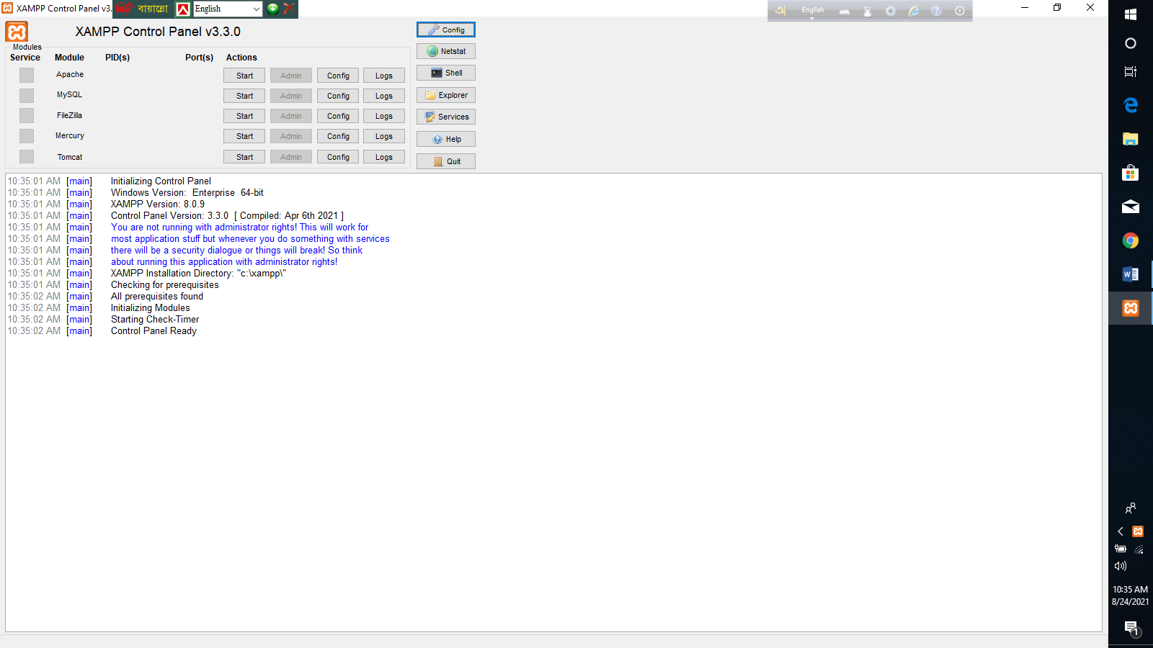

**Picture 2 :**

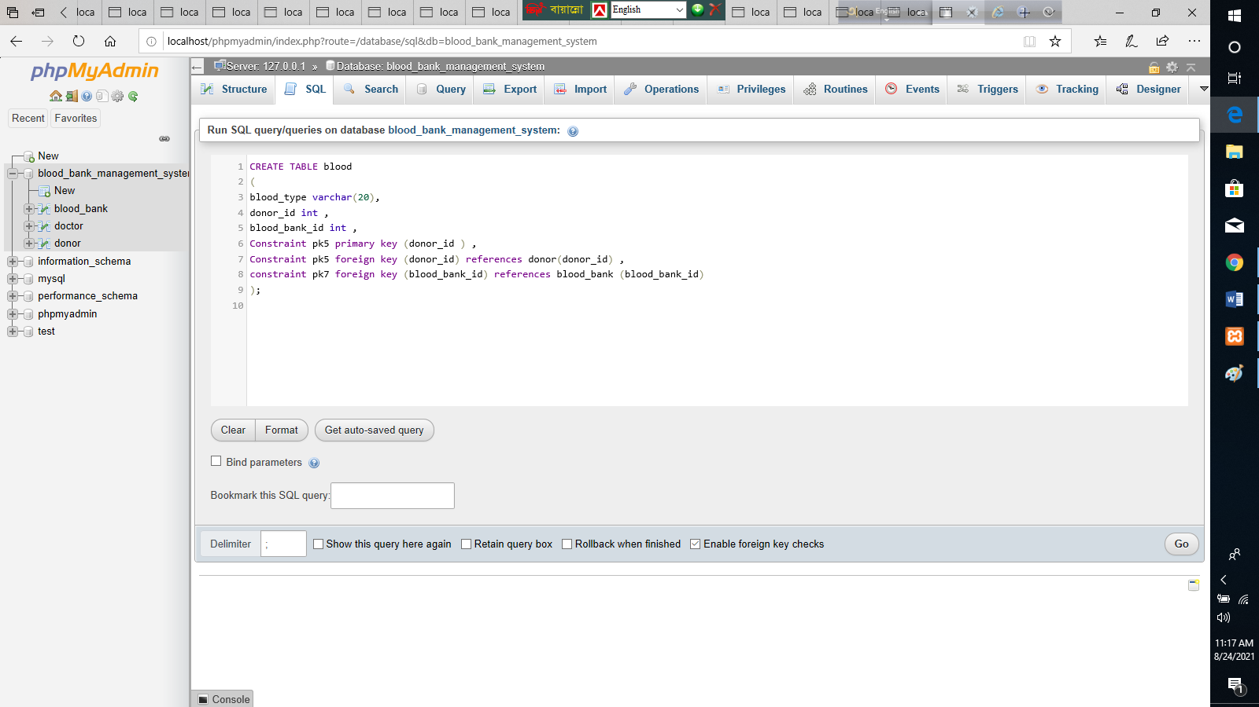

**Picture 3 :**

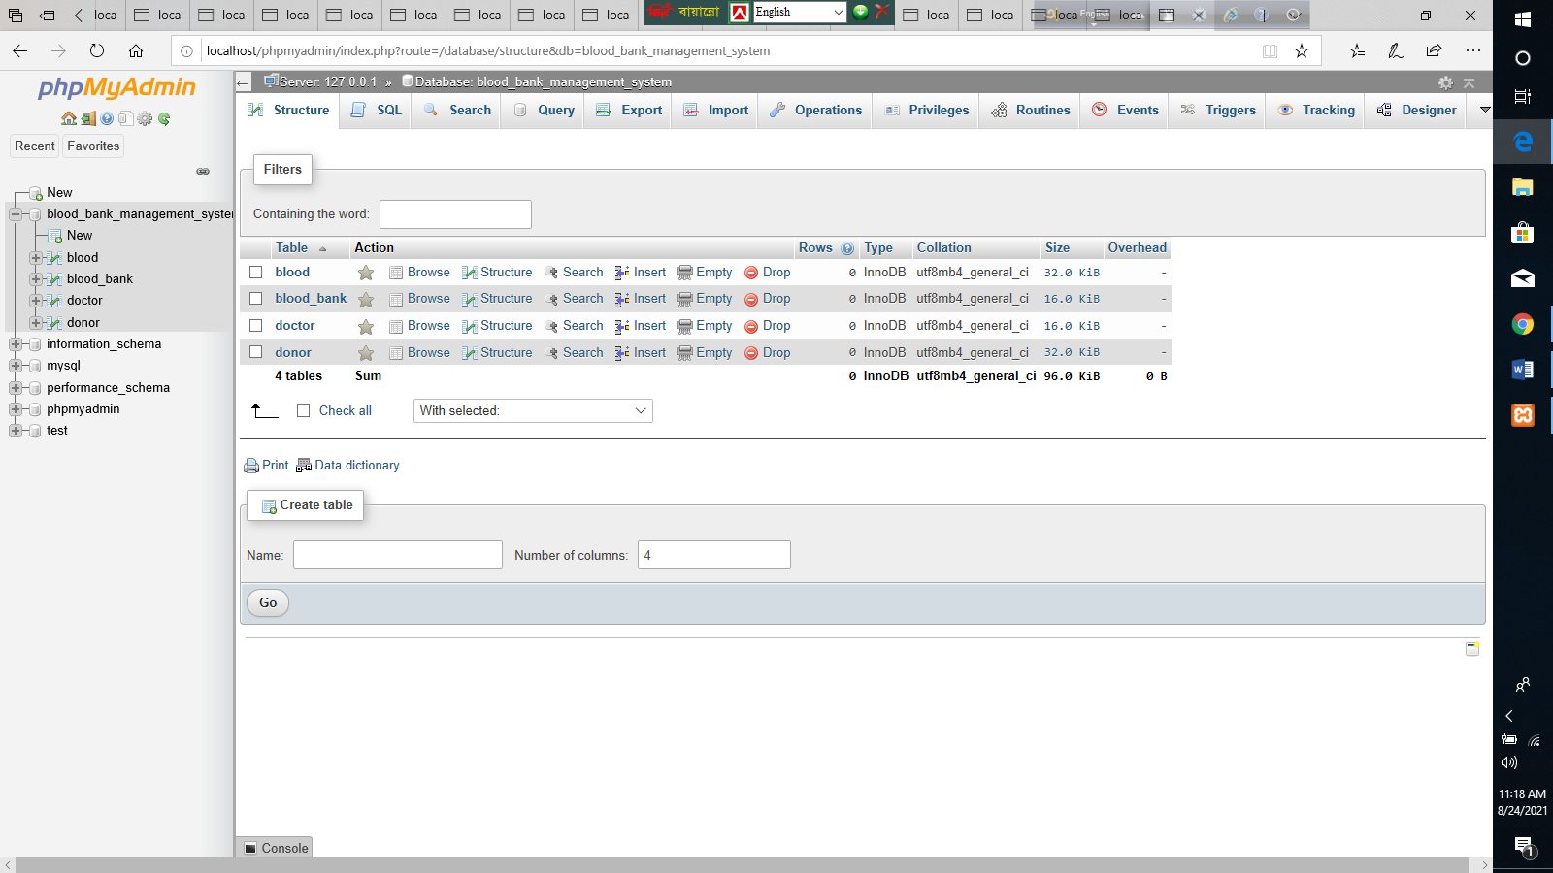

**Picture 4 :**

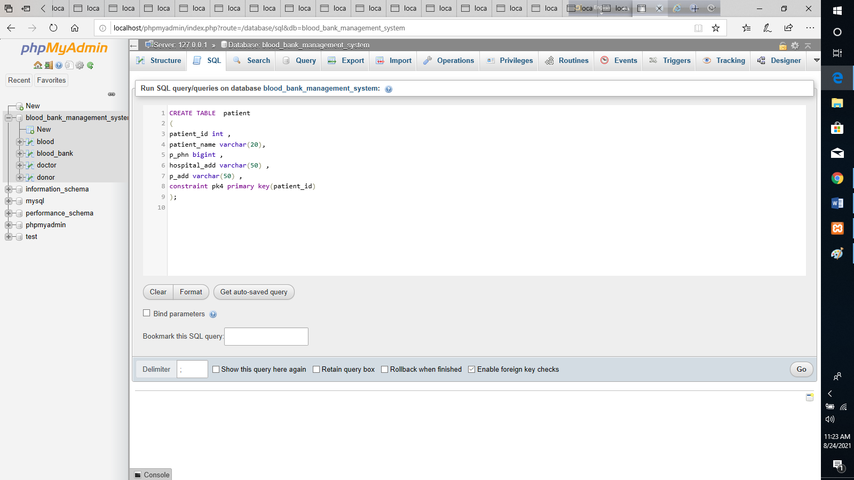

**Picture 5 :**

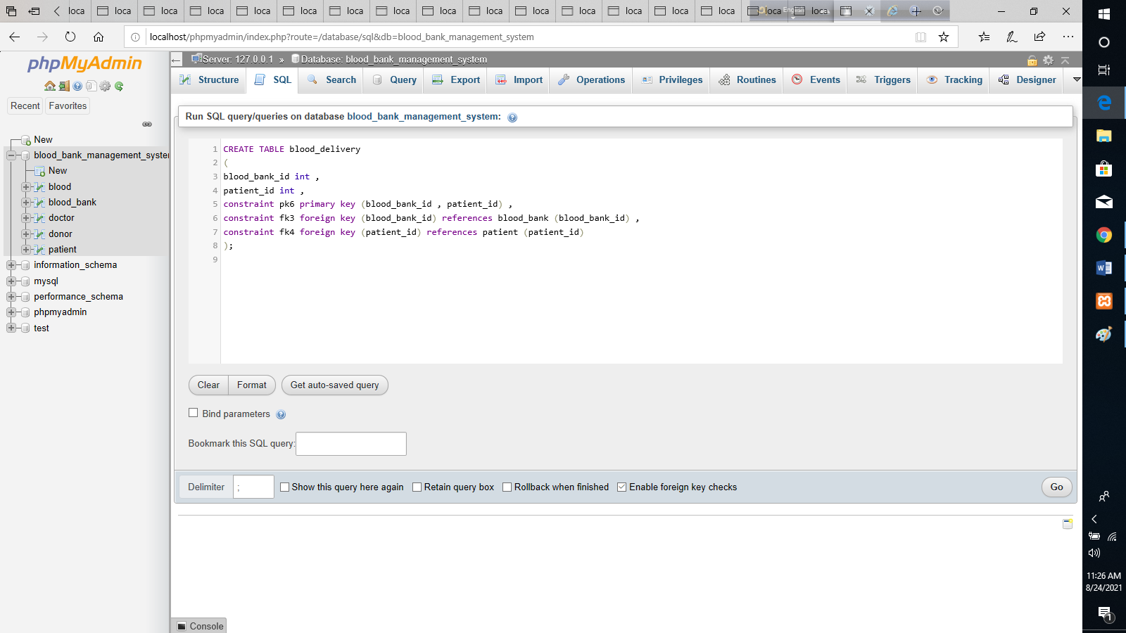

**Picture 6 :**

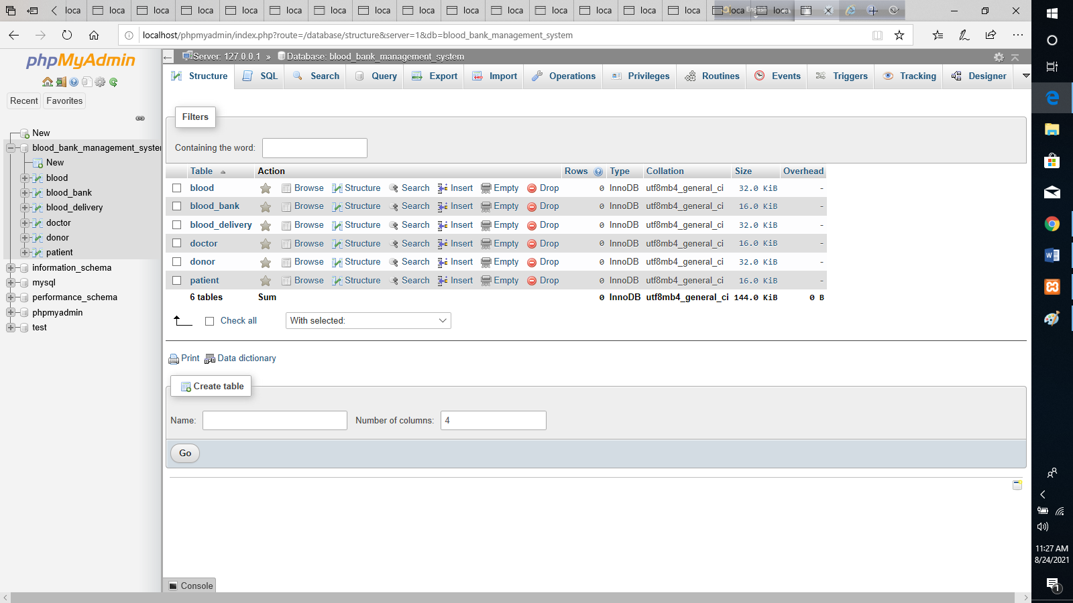

**Picture 7 :**

