**Problem Name :** **Write a code to perform frequency modulation and de-modulation using MATLAB function.**

**Sourse Code:**

**clc;**

**clear all;**

**close all;**

**fs = input('Enter Sample Frequency:');**

**fc = input('Enter Carrier Frequency:') ;**

**t = (0:1/fs:0.2);**

**x = sin(2*pi*30*t);**

**fdev = input('Deviation Frequency:') ;**

**y = fmmod(x, fc, fs, fdev);**

**z = fmdemod(y, fc, fs, fdev);**

**subplot(3, 1, 1);**

**plot(t, x);**

**title('Message Signal');**

**subplot(3, 1, 2);**

**plot(t, y);**

**title('Modulated Signal');**

**subplot(3, 1, 3);**

**plot(t, z);**

**title('Demodulated Signal');**

**Input:**

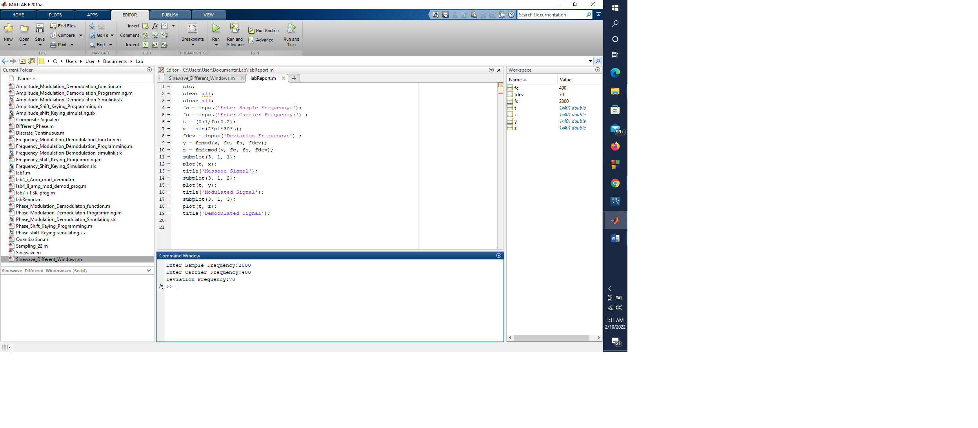

**Output:**

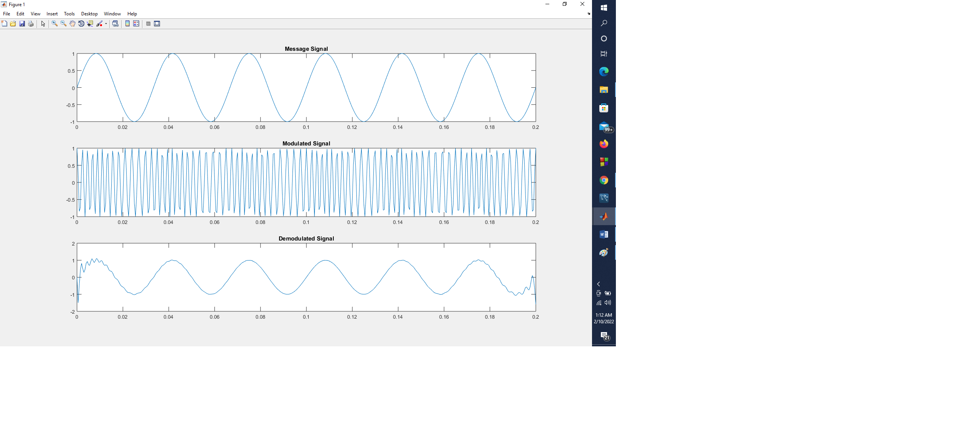

**Problem Name :** **Write a code to perform Phase modulation and de-modulation using MATLAB function.**

**Sourse Code:**

**clc;**

**clear all;**

**close all;**

**fs = input('Enter Sample Frequency:');**

**t = 0:1/fs:3;**

**fc =input('Enter Carrier Frequency:') ;**

**fm =input('Enter Message Frequency:') ;**

**pdev = pi/2 ;**

**ct = 1*sin(4*pi*fm*t);**

**mt = 1*sin(2*pi*fm*t)+ct;**

**x = pmmod(mt, fc, fs, pdev);**

**y = pmdemod(x, fc, fs, pdev);**

**subplot(4, 1, 1);**

**plot(t, mt, 'b');**

**title('Message Signal');**

**subplot(4, 1, 2);**

**plot(t, ct, 'r');**

**title('Carrier Signal');**

**subplot(4, 1, 3);**

**plot(t, x, 'r');**

**title('Phase Modulation Signal');**

**subplot(4, 1, 4);**

**plot(t, y, 'm');**

**title('Phase Demodulation Signal');**

**Input:**

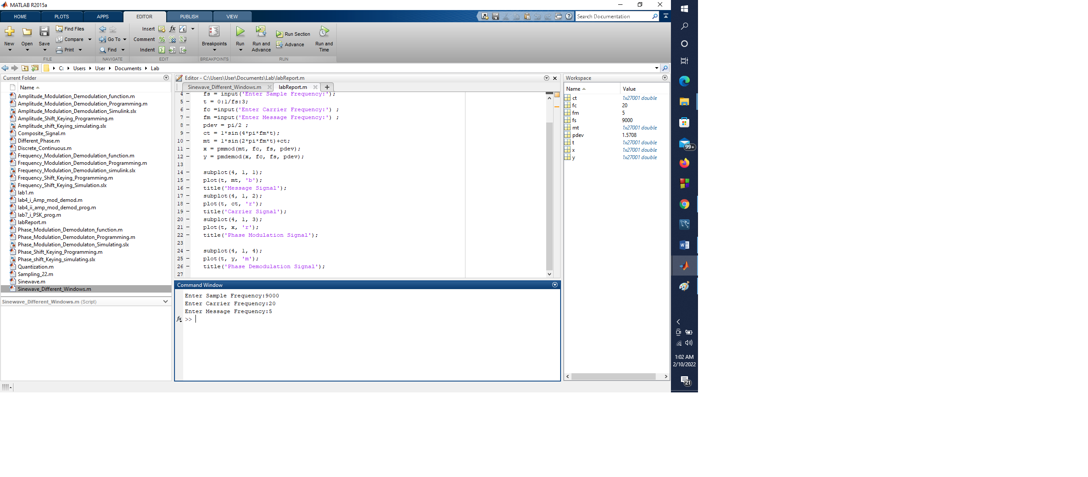

**Output:**

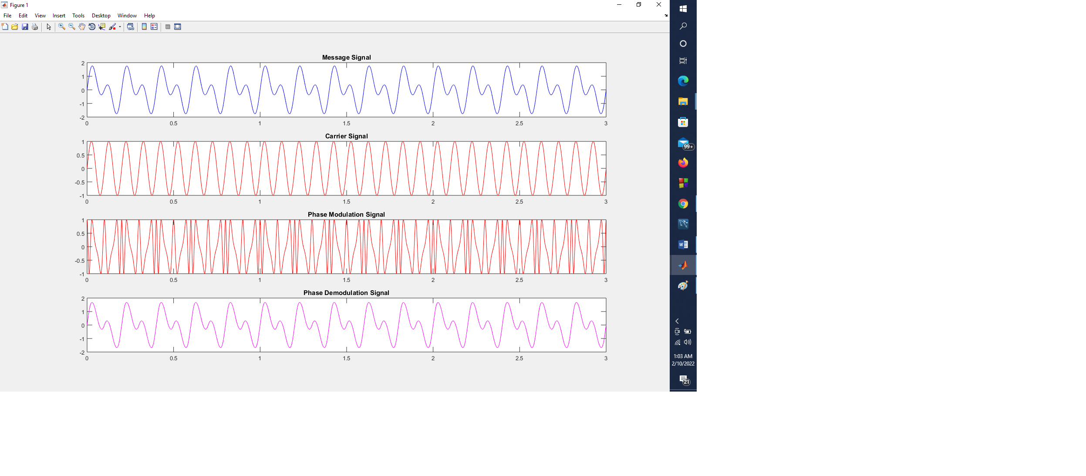

**Name :** **Write a code to perform frequency modulation and de-modulation using MATLAB Programming.**

**Sourse Code:**

**clc;**

**clear all;**

**close all;**

**t = [0:0.001:1];**

**f1 = input('Enter Frequency1:');**

**m = cos(2*pi*f1*t);**

**subplot(4, 1, 1);**

**plot(t, m);**

**title('Message Signal');**

**f2 =input('Enter Frequency2:') ;**

**c = sin(2*pi*f2*t);**

**subplot(4, 1, 2);**

**plot(t, c);**

**title('Carrier Signal');**

**mf = input('Message Frequency:');**

**s = sin((2*pi*f2*t)+(mf*sin(2*pi*f1*t)));**

**subplot(4, 1, 3);**

**plot(t, s);**

**title('FM signal');**

**x = diff(s);**

**y = abs(x);**

**[b, a] = butter(10, 0.056);**

**s1 = filter(b, a, y);**

**subplot(4, 1, 4);**

**plot(s1);**

**title('Demodulation');**

**Input:**

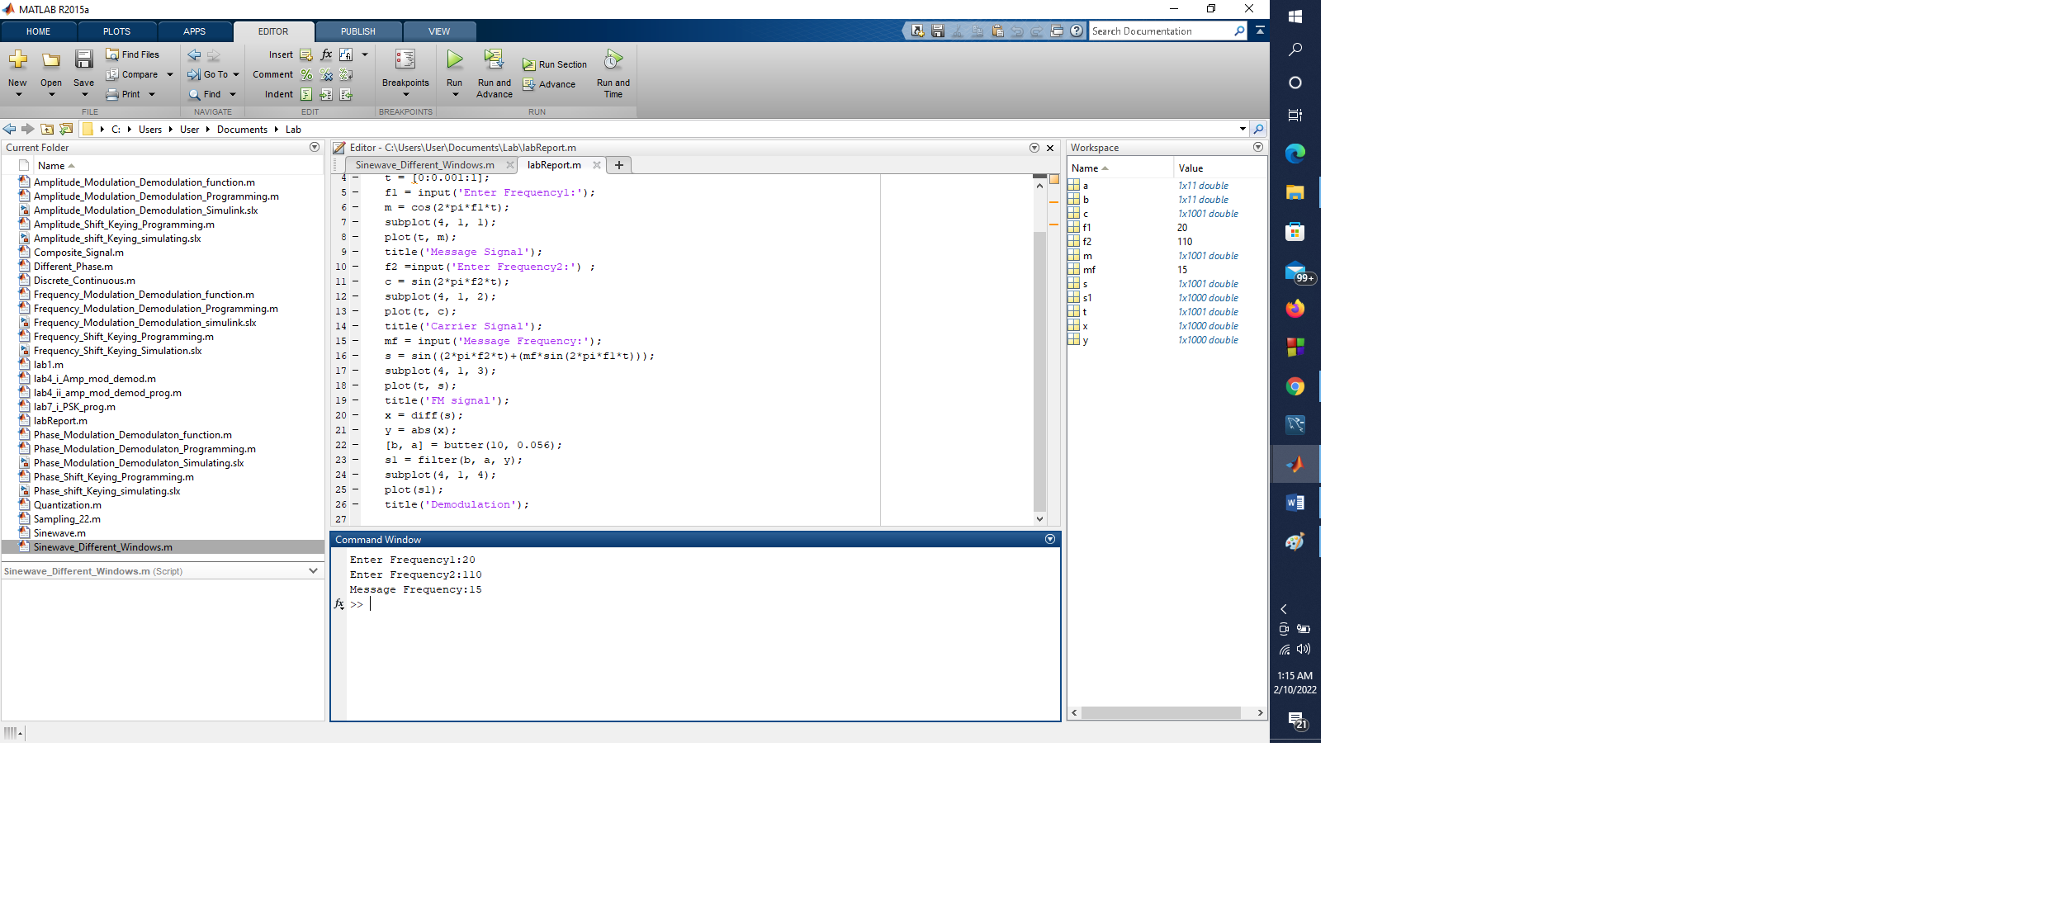

**Output:**

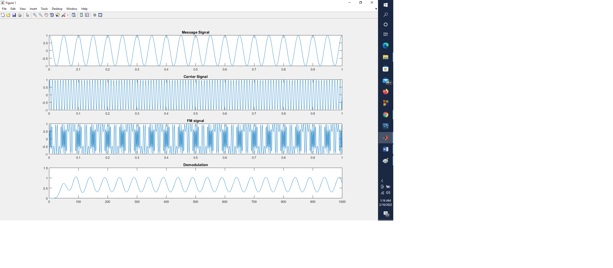

**Problem Name :** **Write a code to perform phase**

**modulation and de-modulation using MATLAB Programming.**

**Sourse Code:**

**clc;**

**clear all;**

**close all;**

**clearvars;**

**fc = input('Enter Carrier Frequency:');**

**fm =input('Enter Message Frequency:') ;**

**alpha = 1;**

**theta = pi/4;**

**beta = pi/5;**

**receiverKnowsCarrier= 'False';**

**fs = 8*fc;**

**duration = 0.5;**

**t = 0:1/fs:1-1/fs;**

**m_t = alpha*sin(2*pi*fm*t + theta);**

**c_t = alpha*sin(2*pi*fc*t + beta);**

**x = cos(2*pi*fc*t + beta + m_t );**

**figure(); subplot(4,1,1)**

**plot(t,m_t)**

**title('Modulating signal'); xlabel('t'); ylabel('m(t)')**

**subplot(4, 1, 2)**

**plot(t, c_t)**

**title('Carrier signal'); xlabel('t'); ylabel('c(t)');**

**subplot(4,1,3)**

**plot(t,x)**

**title('Modulated signal'); xlabel('t');ylabel('x(t)')**

**nMean = 0;**

**nSigma = 0.1;**

**n = nMean + nSigma*randn(size(t));**

**r = x + n;**

**z= hilbert(r);**

**inst_phase = unwrap(angle(z));**

**if strcmpi(receiverKnowsCarrier,'True')**

**offsetTerm = 2*pi*fc*t+beta;**

**else**

**p = polyfit(t,inst_phase,1);**

**estimated = polyval(p,t);**

**offsetTerm = estimated;**

**end**

**demodulated = inst_phase - offsetTerm;**

**subplot(4,1,4);**

**plot(t,demodulated);**

**title('Demodulated signal'); xlabel('n'); ylabel('\hat{m(t)}');**

**Input:**

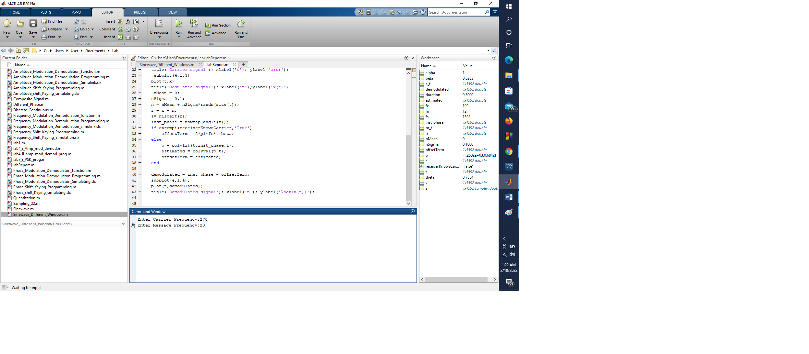

**Output:**

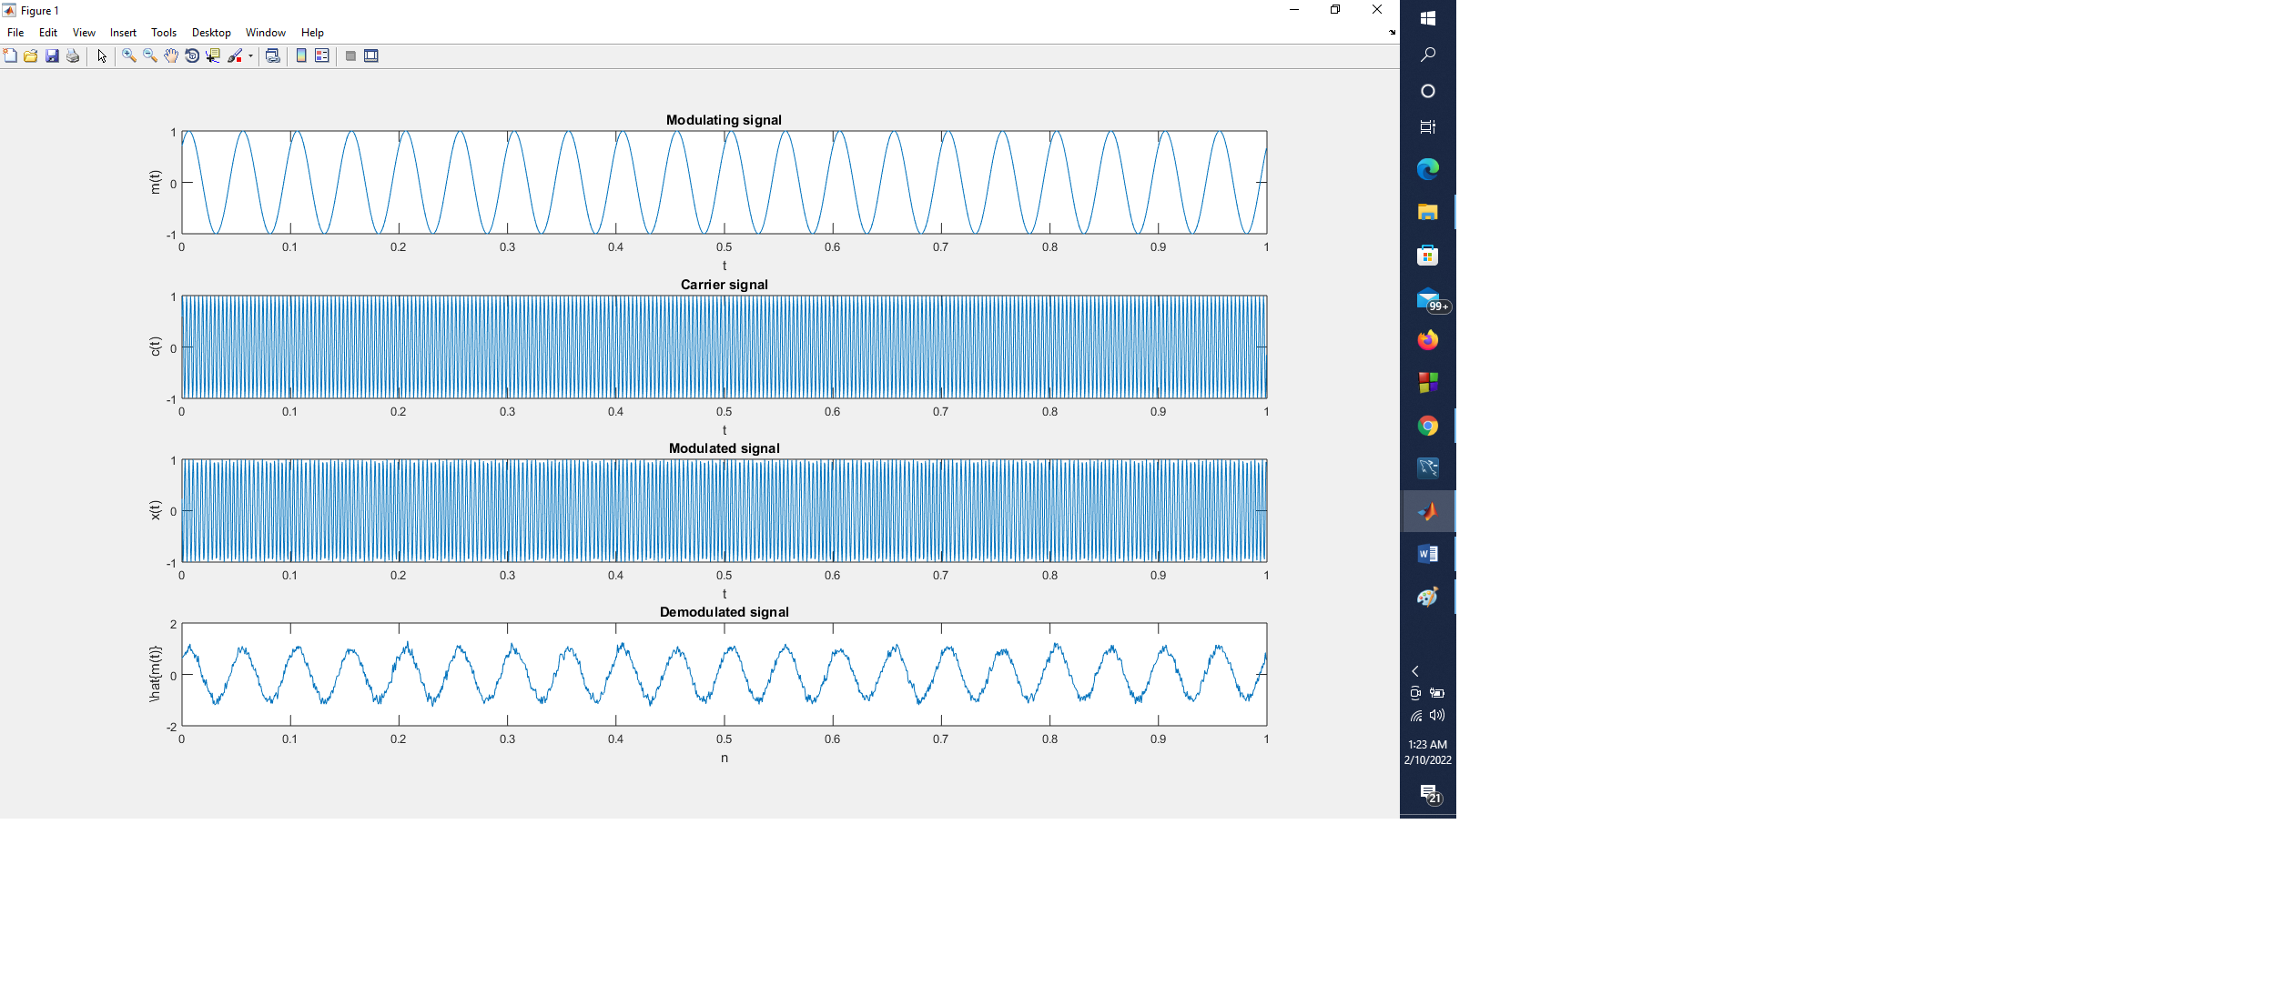

**Problem Name :** **Write a code to perform Frequency Shift Keying using Matlab Programming.**

**Sourse Code:**

**clc;**

**close all;**

**clear all;**

**ac = input('Enter Carrier Amplitude:');**

**fc = input('Enter Carrier Frequency:') ;**

**b = input('Enter the number of bits: ');**

**bs = randi([0 1], 1, b);**

**t = 0.01:0.01:b;**

**for i=1:b**

**mt((i-1)*100+1:i*100) = bs(i);**

**end**

**ct = ac*cos(2*pi*fc.*t);**

**st = ac*cos(2*pi*fc*(mt+1).*t);**

**subplot(3, 1, 1);**

**plot(t, mt);**

**title('Modulating Signal');**

**grid on;**

**subplot(3, 1, 2);**

**plot(t, ct);**

**title('Carrier Signal');**

**grid on;**

**subplot(3, 1, 3);**

**plot(t, st);**

**title('FSK signal');**

**grid on;**

**Input:**

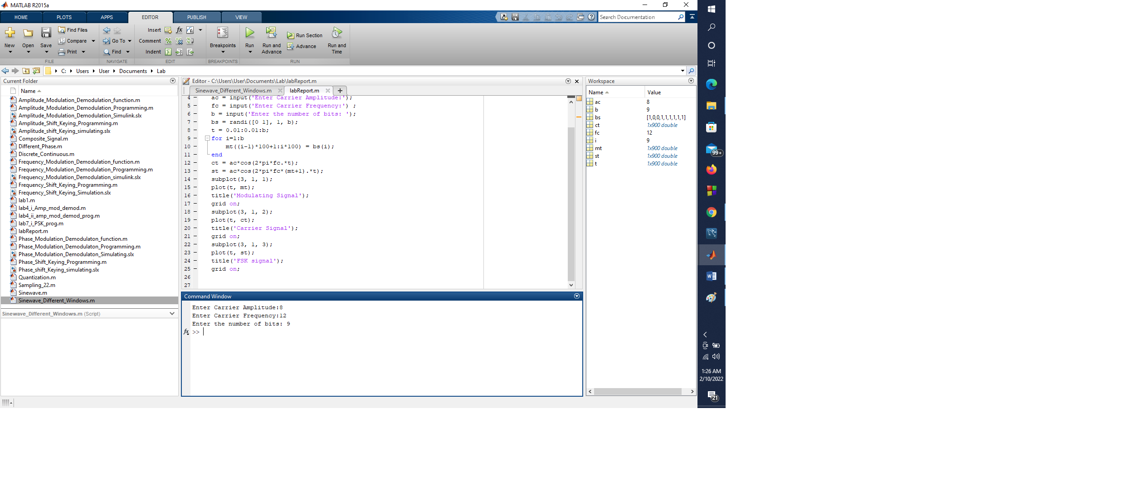

**Output:**

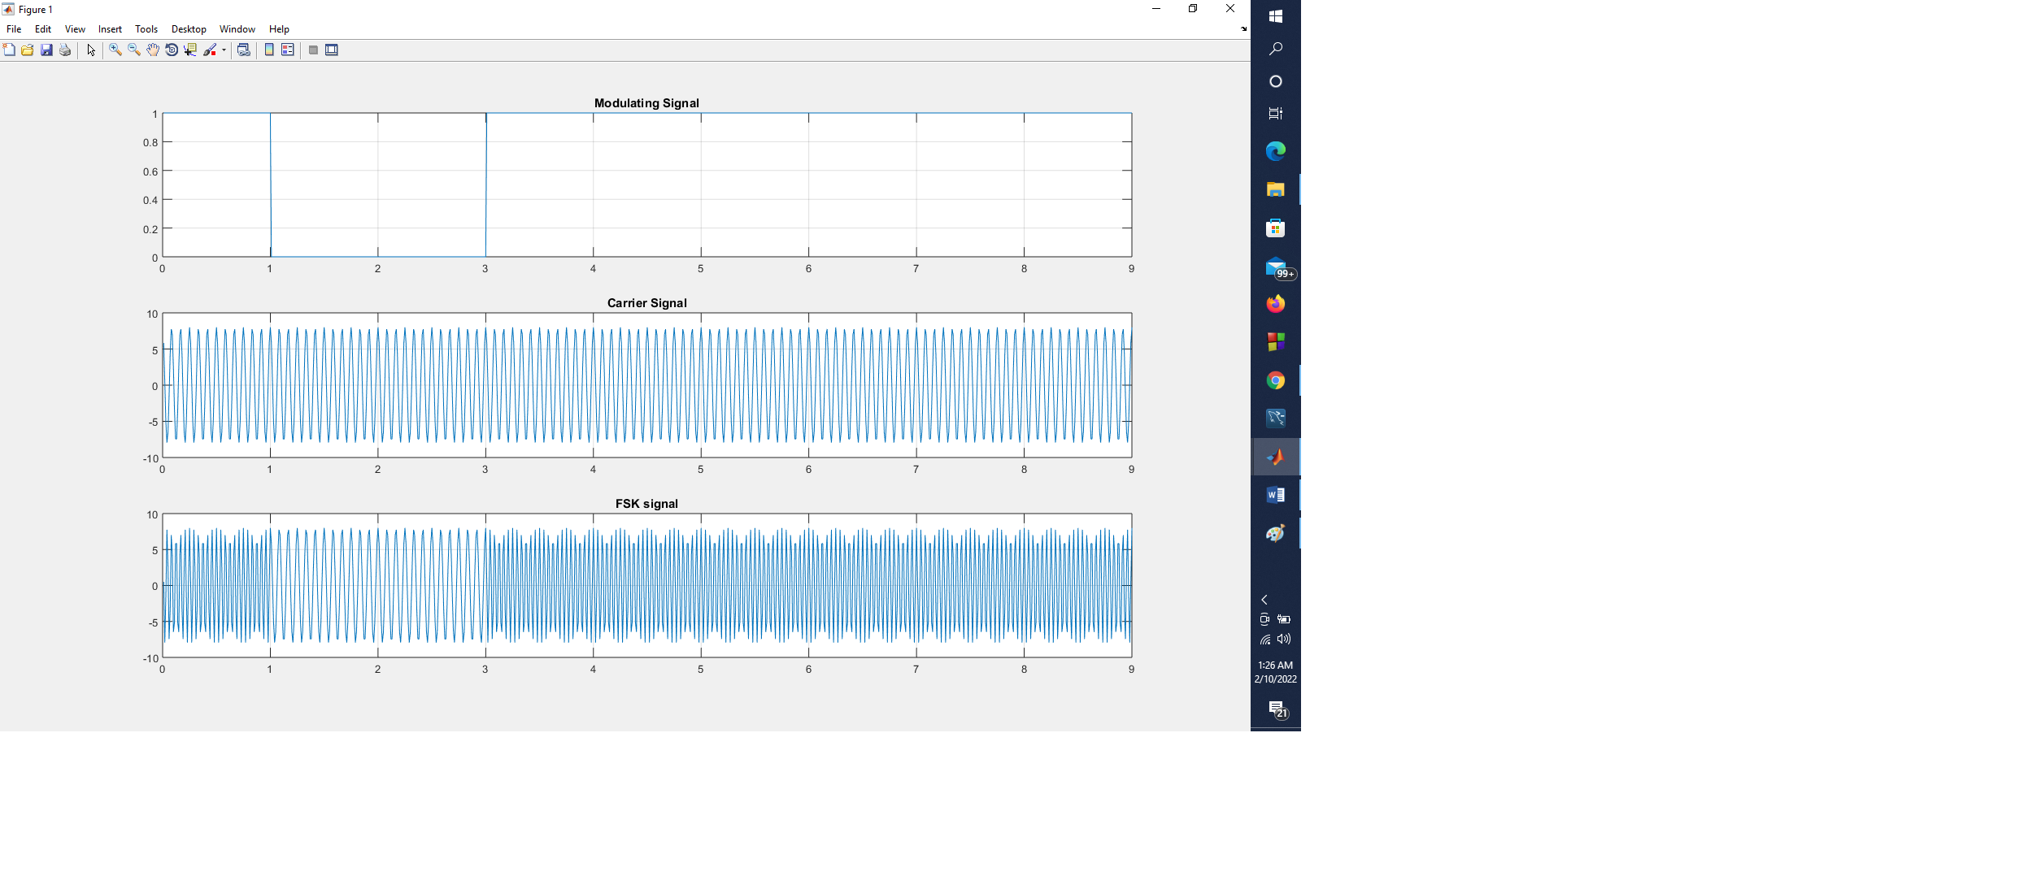

**Problem Name :** **Write a code to perform Frequency Shift Keying using Matlab Simulink Model.**

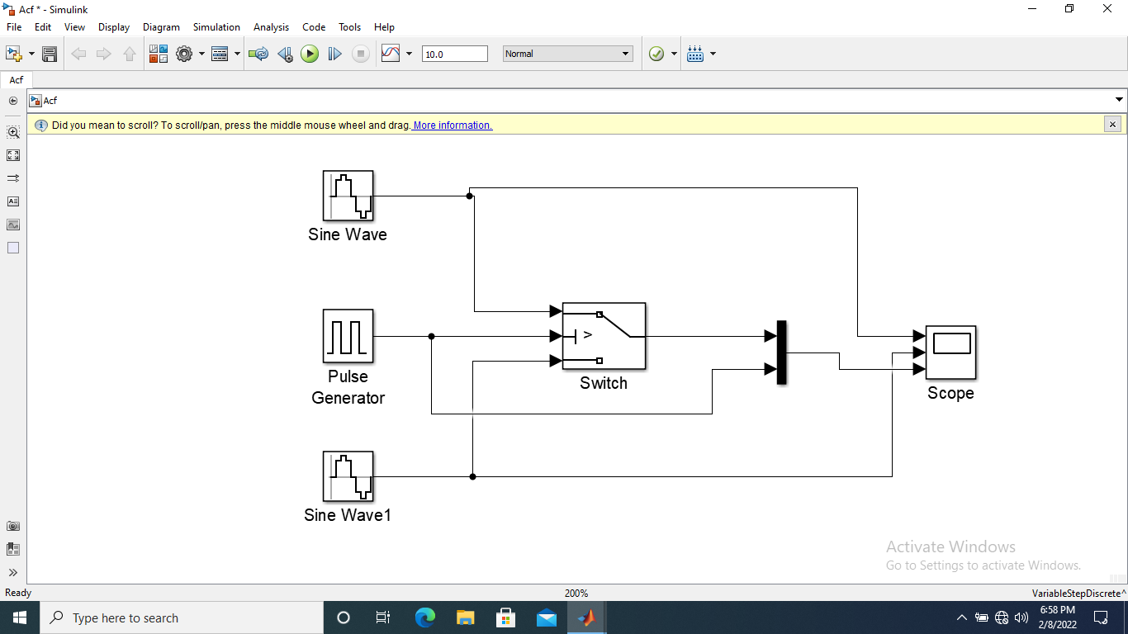**Output:**

**Problem Name :** **Write a code to perform Phase Shift Keying using Matlab Programming.**

**Sourse Code:**

**clc;**

**close all;**

**clear all;**

**ac = input('Enter Carrier Amplitude:');**

**fc =input('Enter Carrier Frequency:') ;**

**b = input('Enter the number of bits: ');**

**bs = randi([-1 1], 1, b);**

**t = 0.01:0.01:b;**

**for i=1:b**

**mt((i-1)*100+1:i*100) = bs(i);**

**end**

**ct = ac*cos(2*pi*fc.*t);**

**st = mt.*ct;**

**subplot(3, 1, 1);**

**plot(t, mt);**

**title('Modulating Signal');**

**grid on;**

**subplot(3, 1, 2);**

**plot(t, ct);**

**title('Carrier Signal');**

**grid on;**

**subplot(3, 1, 3);**

**plot(t, st);**

**title('PSK signal');**

**grid on;**

**Input:**

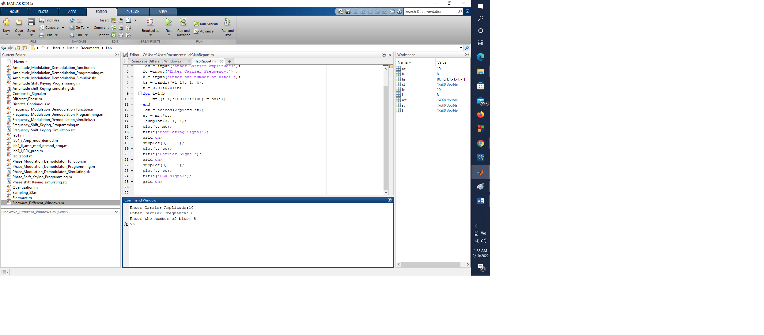

**Output:**



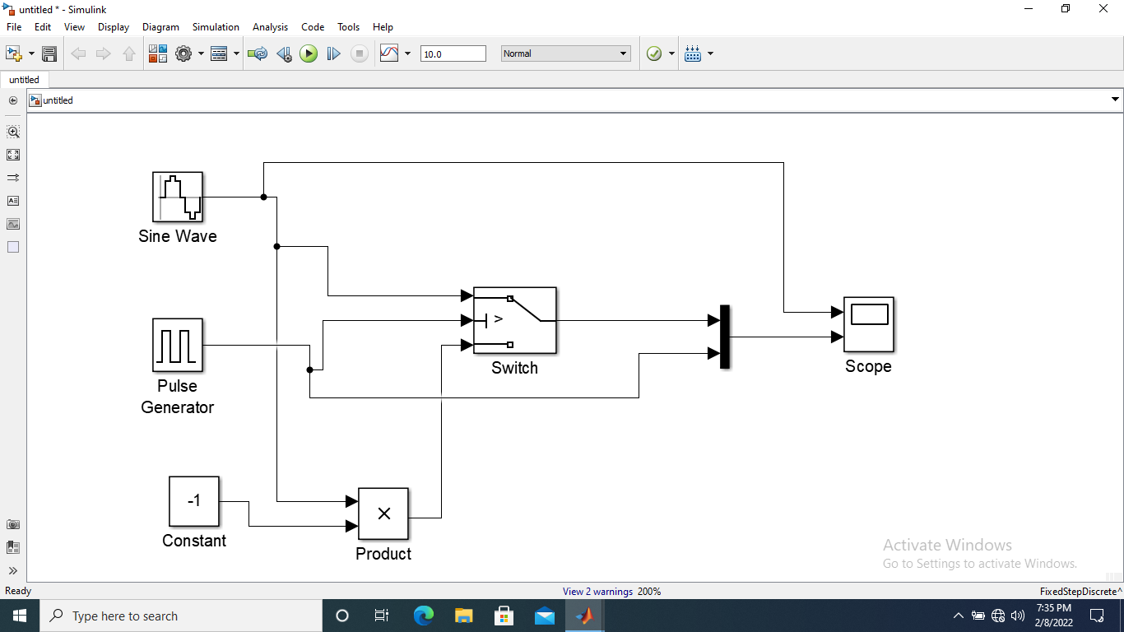**Problem Name: write a code to perform phase shift keying using Matlab simulink Model.**

**Output:**

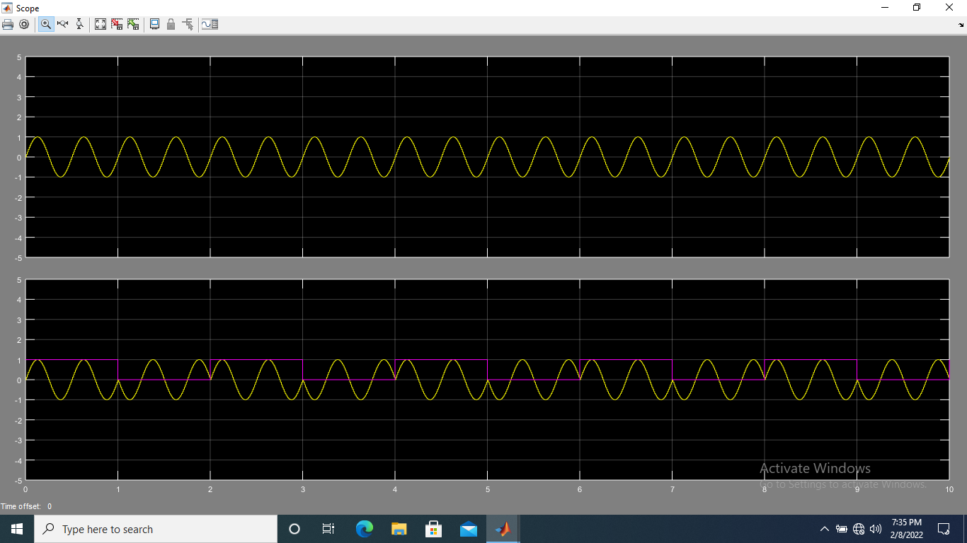

**Problem Name :** **Write a code to perform quantization of an analog signal using MATLAB.**

**Sourse Code:**

**clc;**

**clear all;**

**close all;**

**Ts=0.0001;**

**t=0:.00001:20*Ts;**

**sig=sin(2000*pi*t)+cos(2000*pi*t);**

**maxsig=max(sig);**

**interv=2*maxsig/(2^3-1);**

**u=maxsig+interv;**

**partition = [-maxsig:interv:maxsig];**

**codebook = [-maxsig:interv:u];**

**[index,quants] = quantiz(sig,partition,codebook);**

**subplot(2, 1, 1);**

**plot(t,sig,'-');**

**title('Original Signal');**

**subplot(2, 1, 2);**

**plot(t, quants, '-');**

**title('Quantized Signal');**

**Output:**

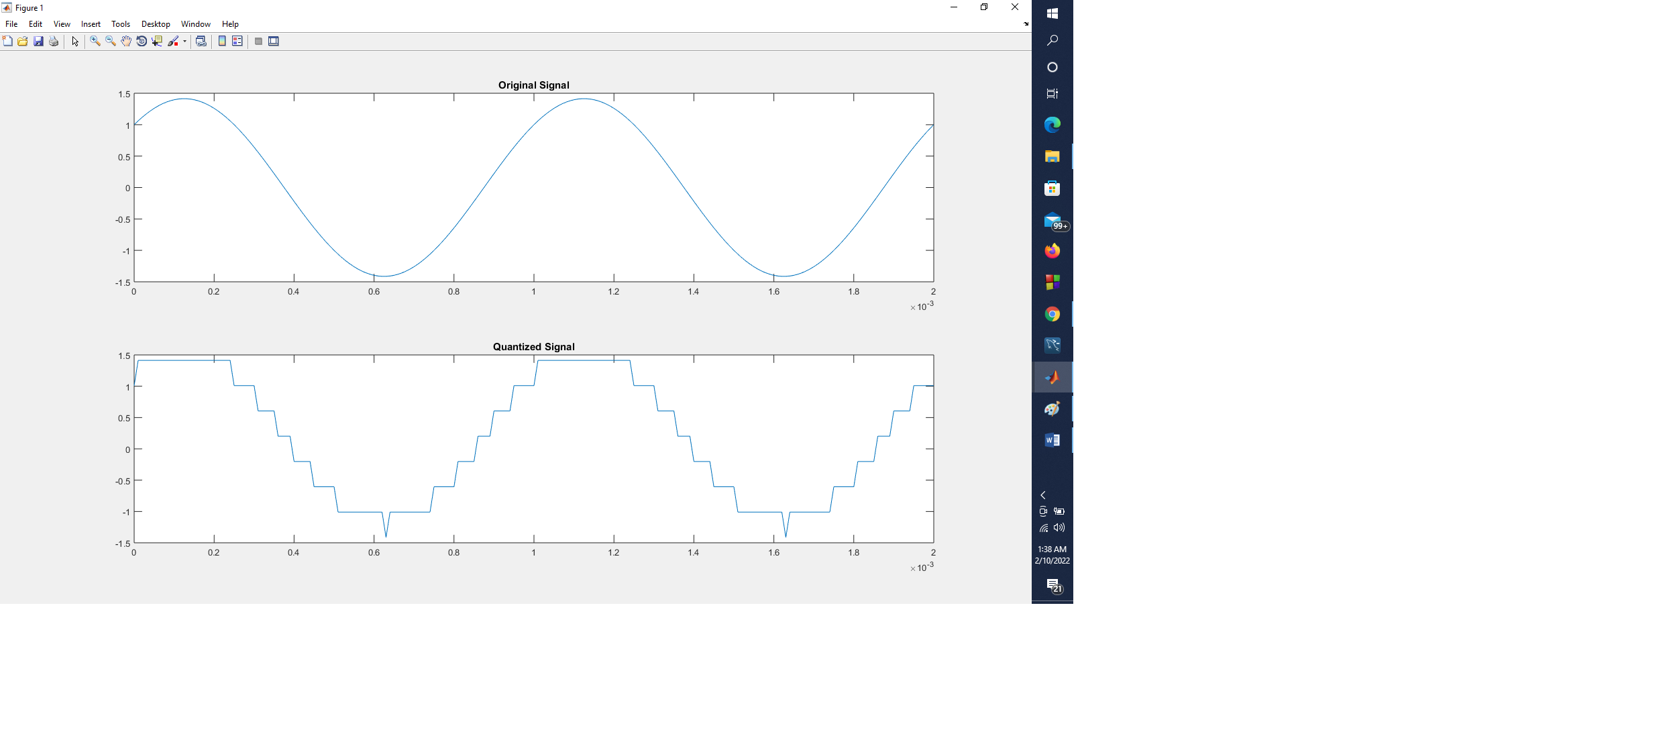

**Problem Name: Write a code to perform amplitude modulation using MATLAB Simulink Model.**

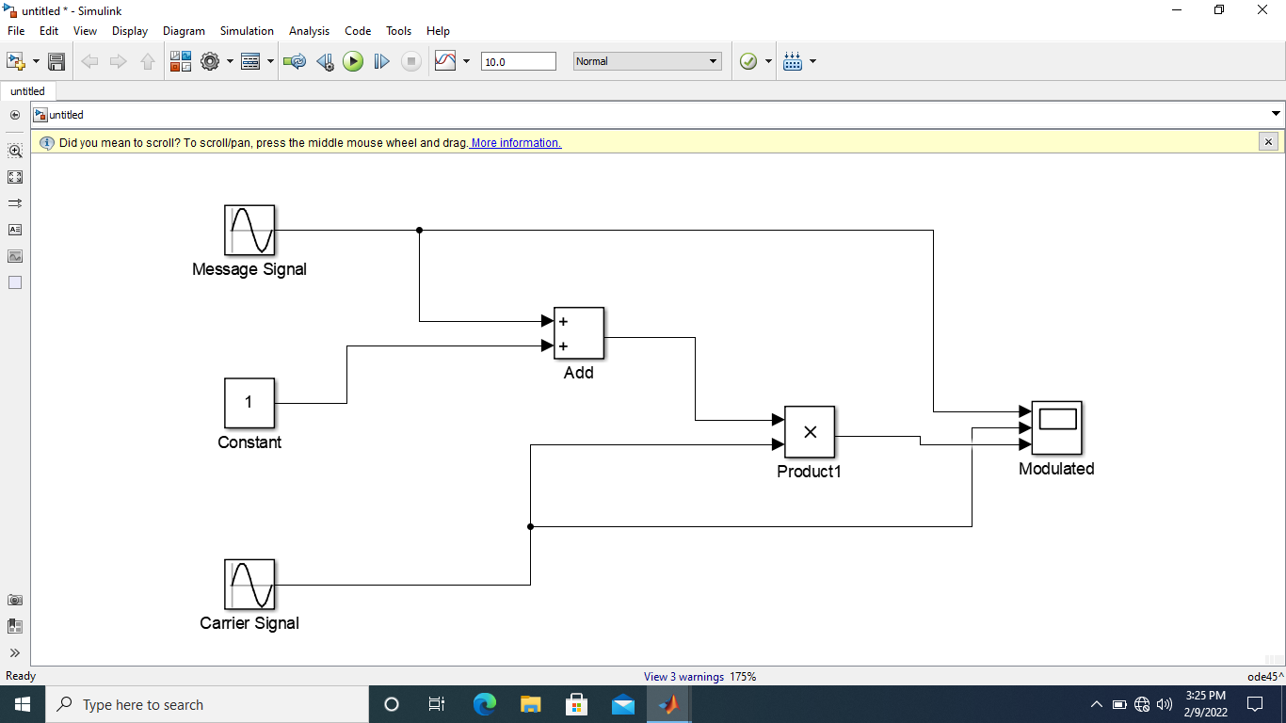

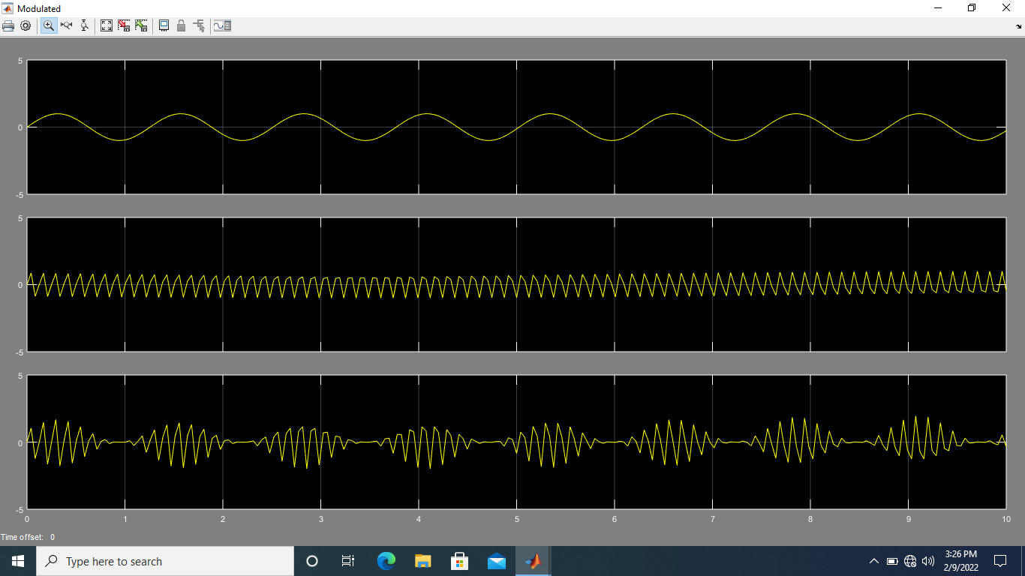**Output:**

**Problem Name: Write a code to perform amplitude de-modulation using MATLAB Simulink Model.**

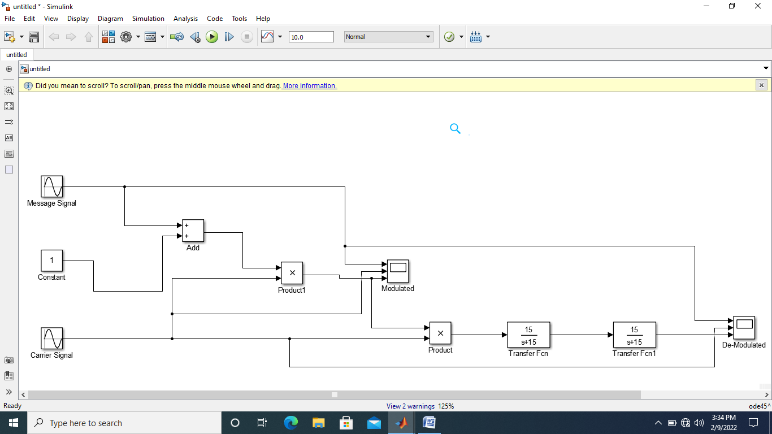

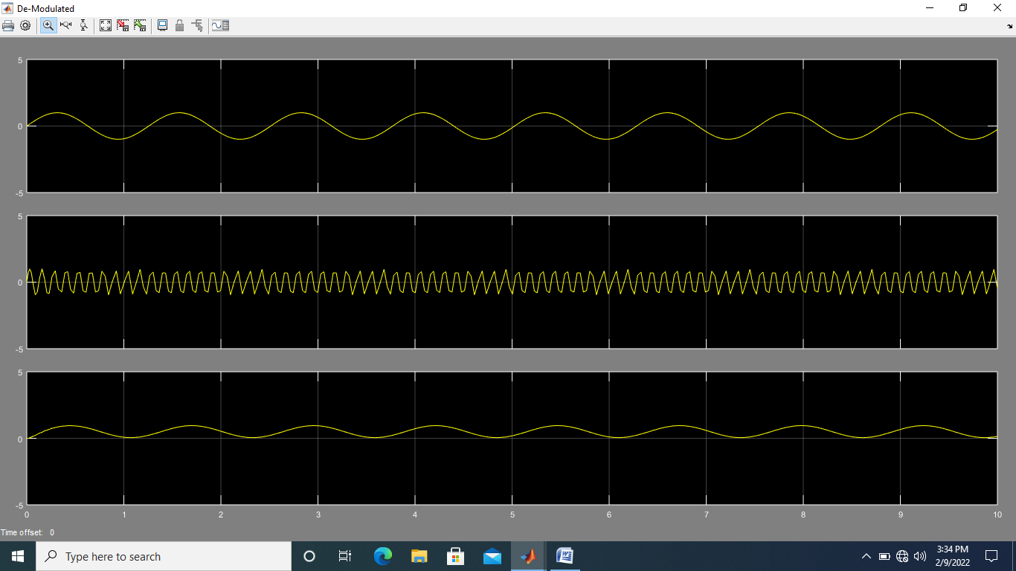**Output:**

**Problem Name: Write a code to perform frequency**

**modulation using MATLAB Simulink Model.**

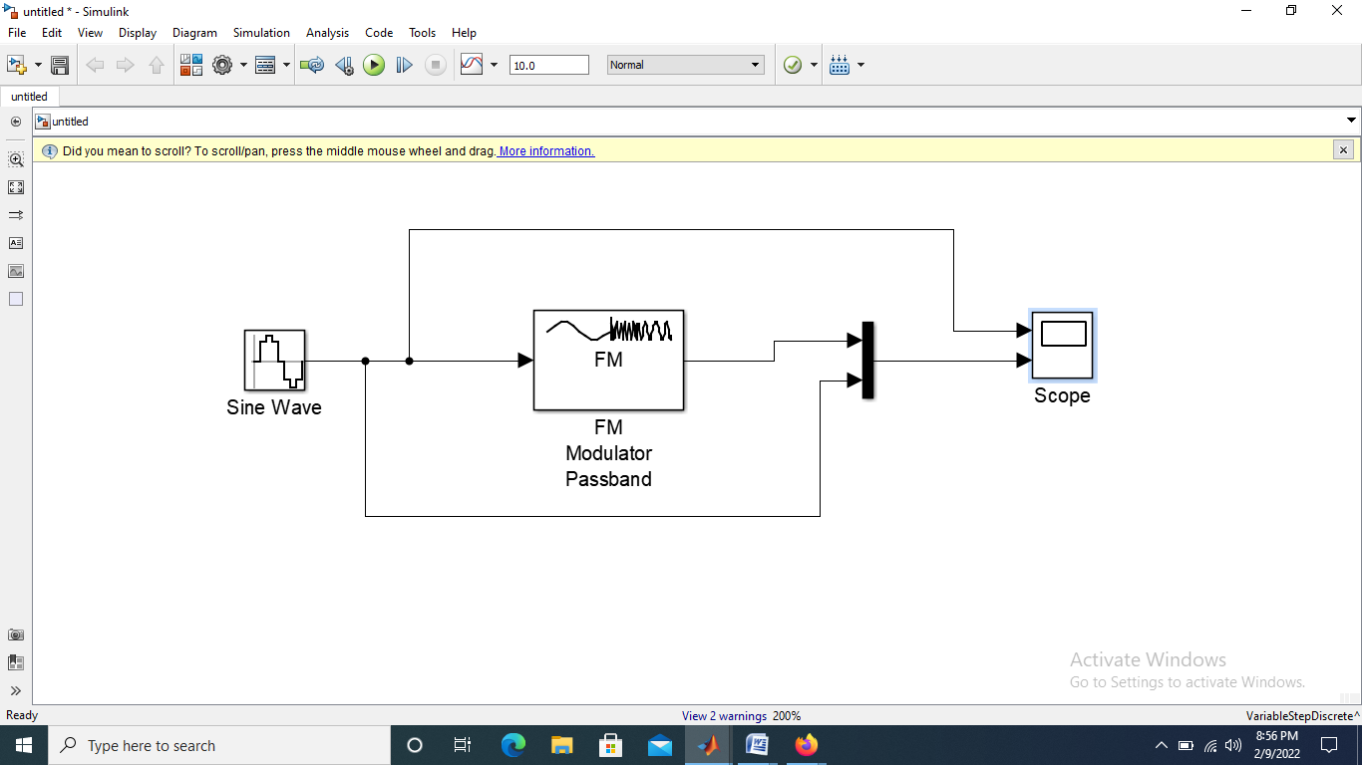

**Output:**

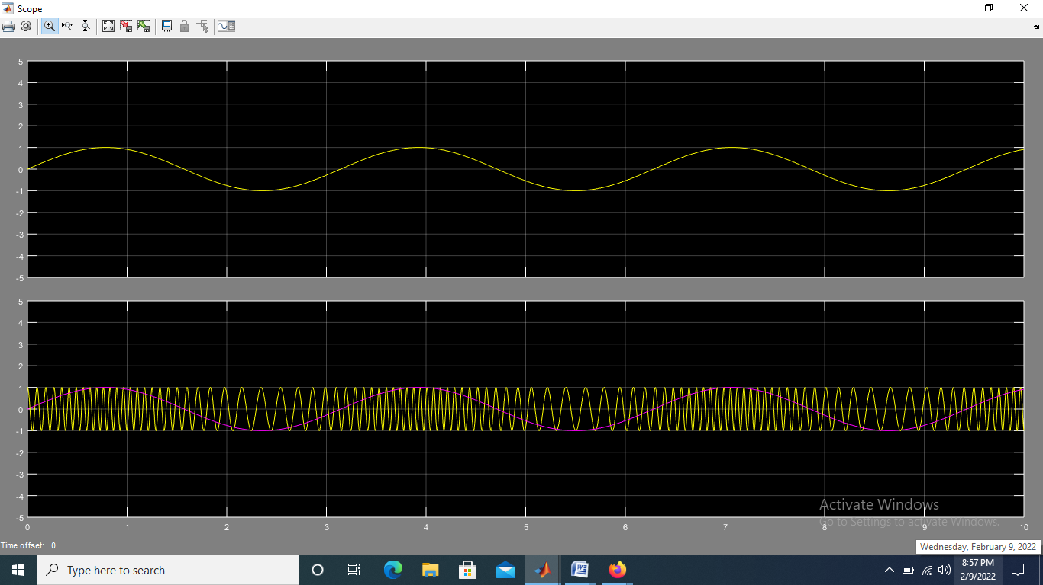

**Problem Name: Write a code to perform frequency de-modulation using MATLAB Simulink Model.**

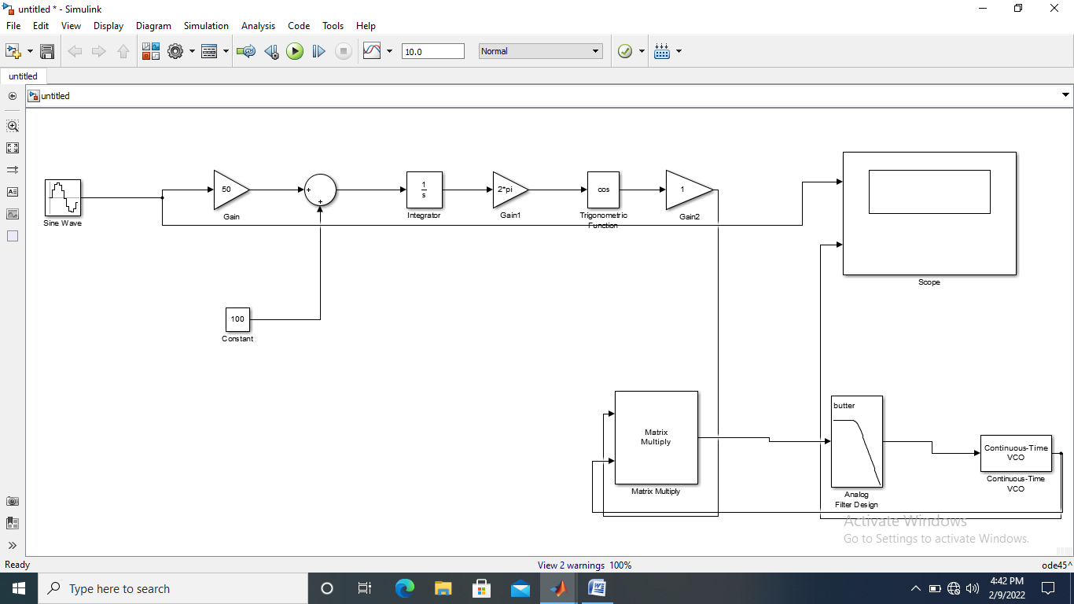

**Output:**

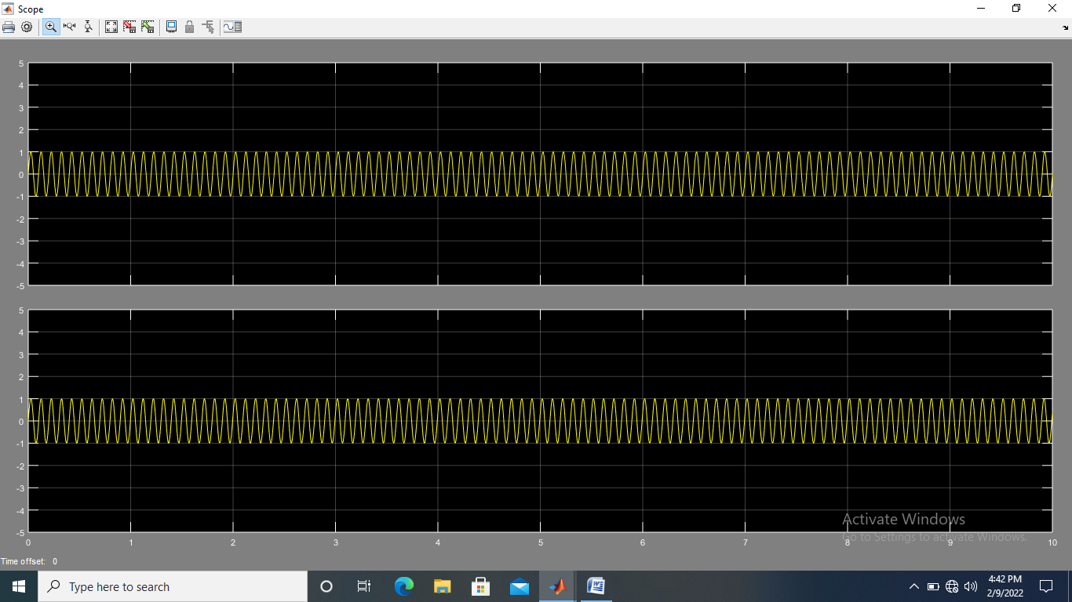

**Problem Name: Write a code to perform phase modulation using MATLAB Simulink Model.**

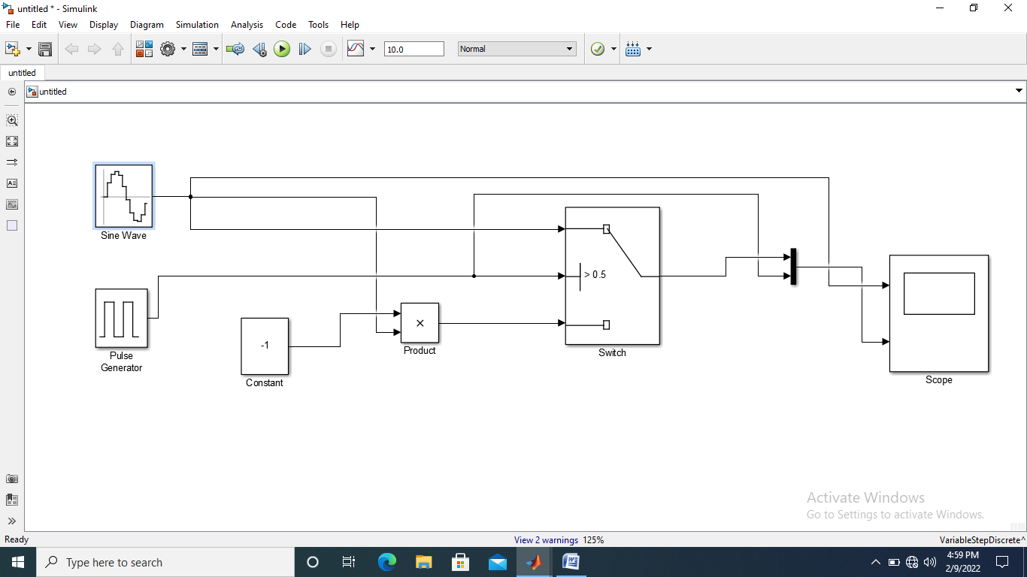

**Outout:**

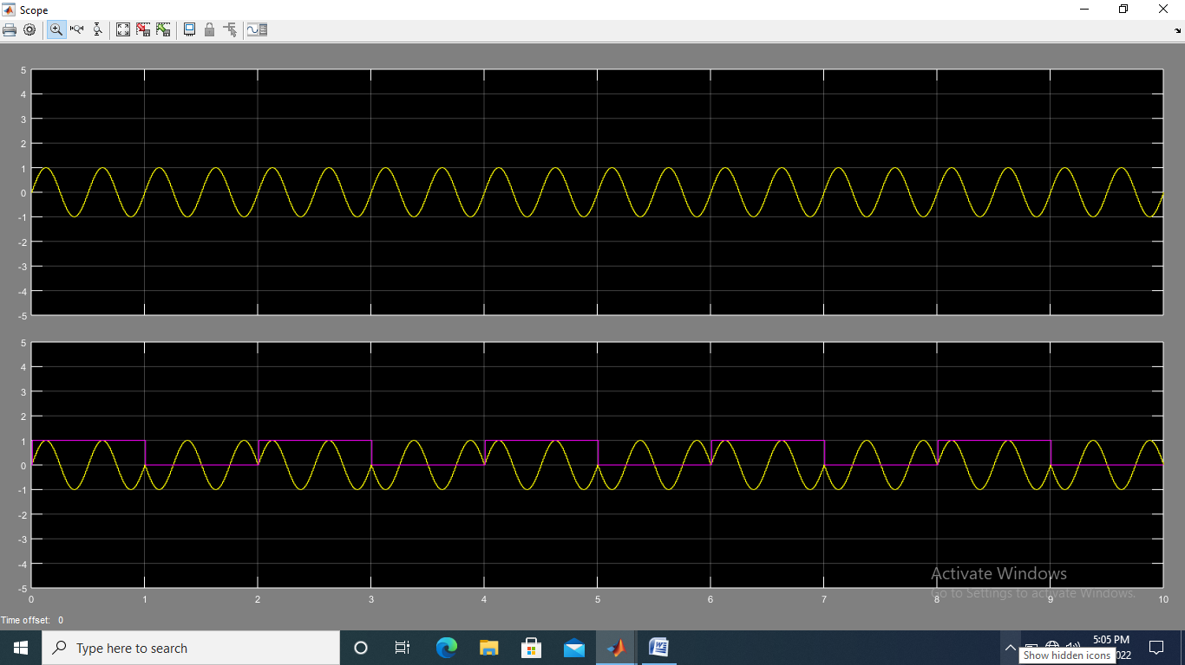

**Problem Name: Write a code to perform Phase de-modulation using MATLAB Simulink Model.**

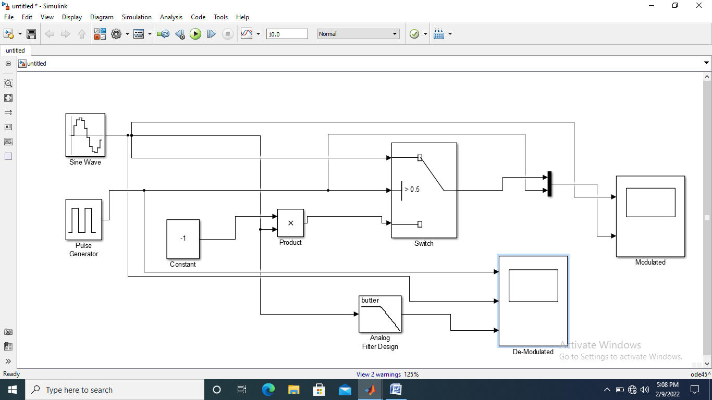

**Output:**

