(Designed for Anna University)



RAJALAKSHMI ENGINEERING

COLLEGE

THANDALAM, CHENNAI-602105

DEPARTMENT OF

ELECTRONICS & COMMUNICATION

ENGINEERING

Table of Contents

S.NO | DATE | NAME OF THE EXPERIMENT | PAGE NUMBER | SIGNATURE
1 |  | STUDY OF STOP AND WAIT PROTOCOL
 |  | STUDY OF GO BACK N PROTOCOL
3 |  | STUDY OF SELECTIVE REPEAT PROTOCOL
4 |  | IMPLEMENTATION AND STUDY OF CSMA-CA PROTOCOL
5 |  | IMPLEMENTATION AND STUDY OF CSMA-CD PROTOCOL
6 |  | STUDY OF TOKEN BUS AND TOKEN RING
7 |  | PROTOCOLSTUDY OF DATA ENCRYPTION AND DECRYPTION
8 |  | IMPLEMENTATION OF DISTANCE VECTOR ROUTING ALGORITHM
9 |  | IMPLEMENTATION OF LINK STATE ROUTING ALGORITHM
10 |  | SOCKET PROCESSING

STUDY OF STOP & WAIT PROTOCOL

Stop-and-wait ARQ is a method used in telecommunications to send information between two connected devices. It ensures that information is not lost due to dropped packets and that packets are received in the correct order. It is the simplest kind of automatic repeat-request (ARQ) method. A stop-and-wait ARQ sender sends one frame at a time; it is a special case of the general sliding window protocol with both transmit and receive window sizes equal to 1. After sending each frame, the sender doesn't send any further frames until it receives an acknowledgement (ACK) signal. After receiving a good frame, the receiver sends an ACK. If the ACK does not reach the sender before a certain time, known as the timeout, the sender sends the same frame again

EXPERIMENT 1

EXPERIMENT 1:

OBJECTIVE:
To study Stop & Wait protocol using LAN port interface.

EQUIPMENTS:
• LTS-01 trainer kit.
• 2 Computers with win-2K / XP and Ethernet port available on them
• RJ-45 to RJ-45 LAN connecting cables.
• L-SIM LAN protocol analyzer and simulator software

PROCEDURE:

1. Connect 2 computer LAN ports using RJ-45 to RJ-45 LAN connecting
cables provided with the system to LTS-01 star topology ports.
2. Switch on the LTS-01 & Computers.
3. Run L-SIM software on all the computers, one should be server and others
should be clients.
4. On the server computer select type of network as LAN.
5. On the server computer select the topology as STAR, select protocol as
Stop & Wait click on create network button.
6. Remote computer details will appear on the computers connected in
network, server will be able to see all clients and all clients will be able to
see only server.
7. Select the computer to whom data file is to be transferred, from the load
button, previously stored/selected file information can be loaded or you can
select any file, which is to be transmitted.
8. File size will appear in the software window, select the packet size, inter
packet delay and click OK.

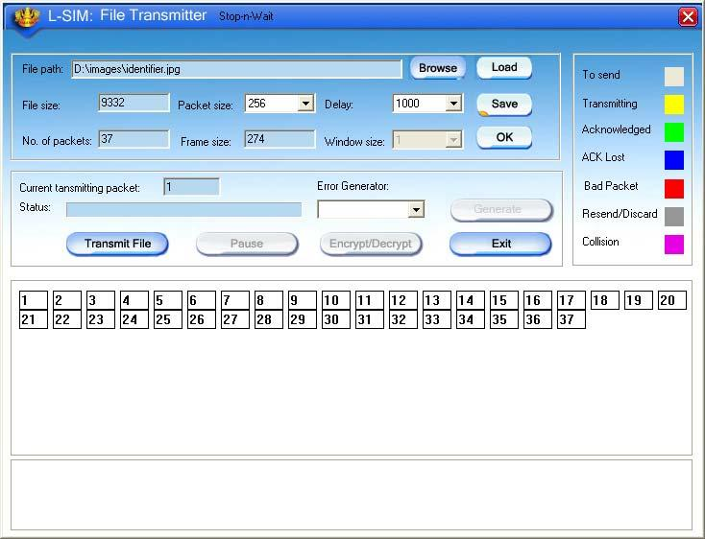

9.

Total packets formed for that file will be indicated on computers.

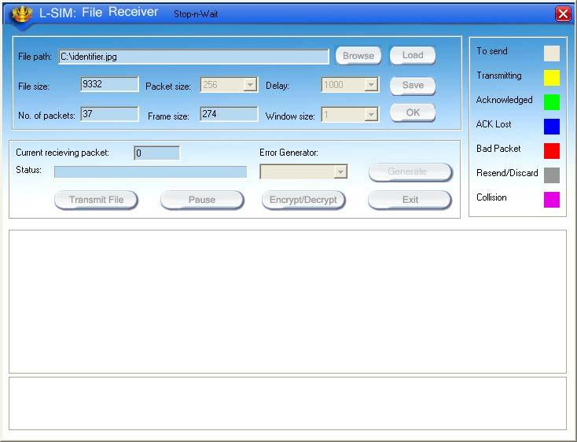

10. Same details of file will appear on remote computer to which file is to be
transmitted.

11. Click on file transfer button to transfer file.

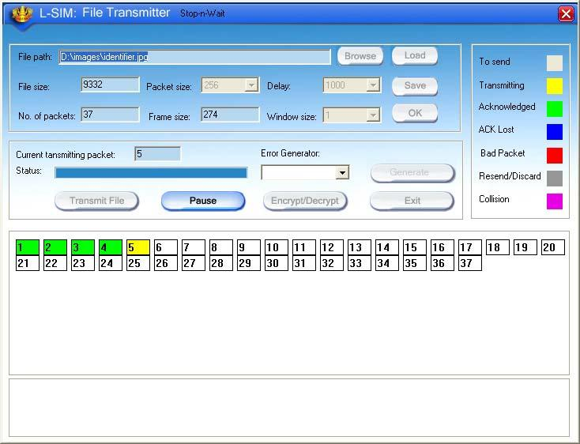

Transmission started screen in transmitter

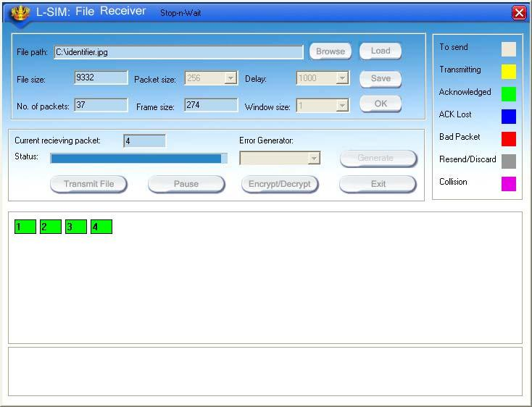

Transmission started screen in receiver

12. During file transfer process you can insert errors into data packets being
transmitted through software window.

13. See the effect of Bad packet error, Packet negative acknowledgment error
or auto errors on file transfer.

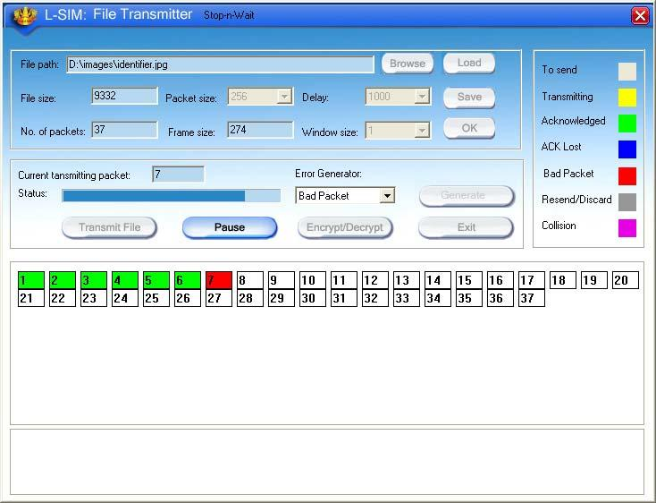

14. Select BAD PACKET error and click on Generate button in the transmitter
window when say 7th packet is in the transmission state.

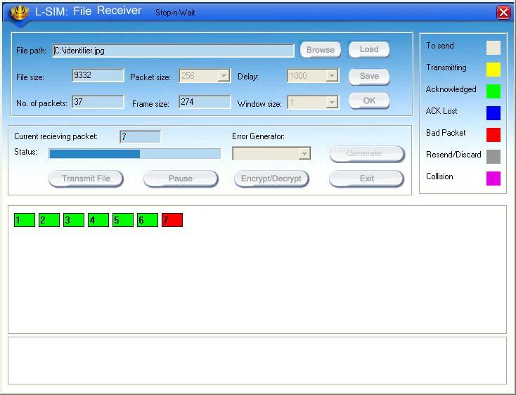

15. You will see that 7th packet in the receiver window will be marked as bad
packet.

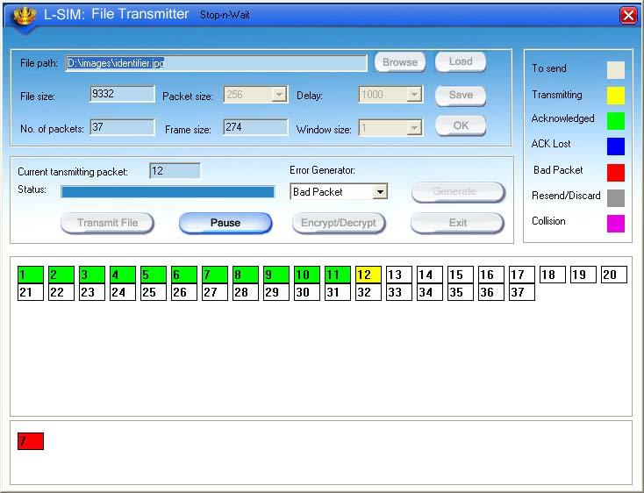

-

16. 7th packet will be retransmitted from transmitter.

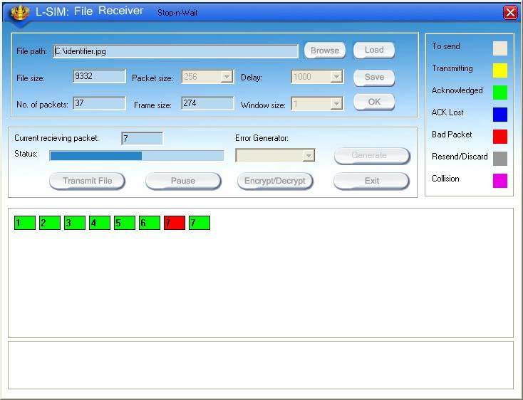

17. Retransmitted 7th packet will be received correctly this time.

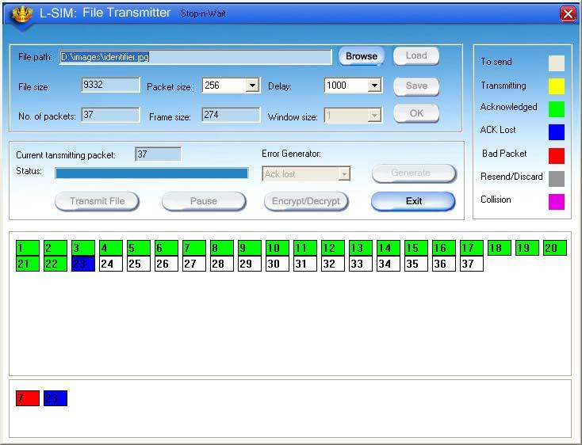

18. Select ACK LOST error and click on Generate button in the transmitter
window when say 23rd packet is in the transmission state.

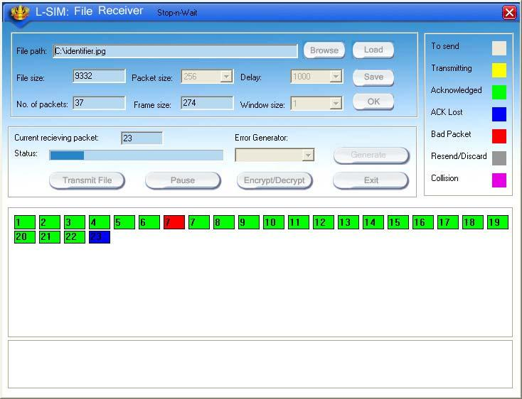

19. You will see that 23rd packet in the receiver window will be marked as
unacknowledged.

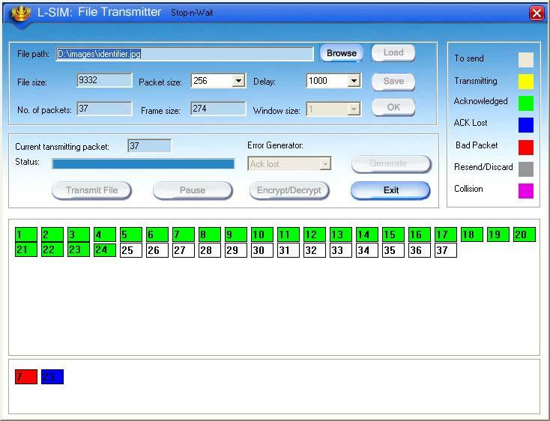

20. 23rd packet will be retransmitted from transmitter.

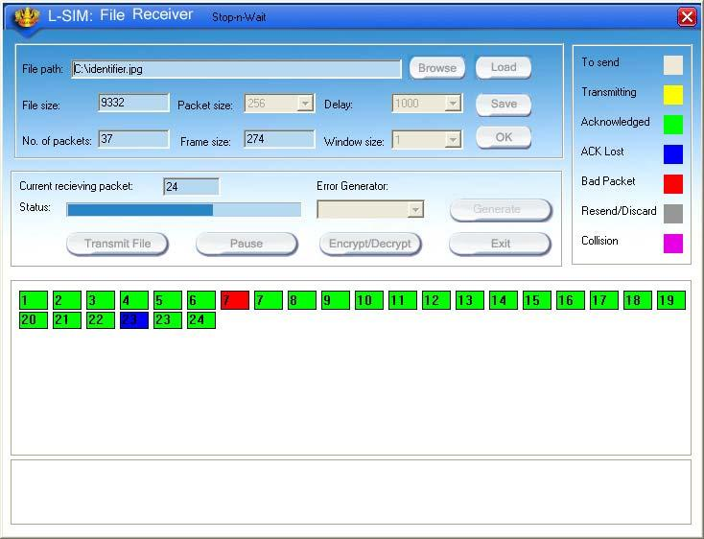

21. Retransmitted
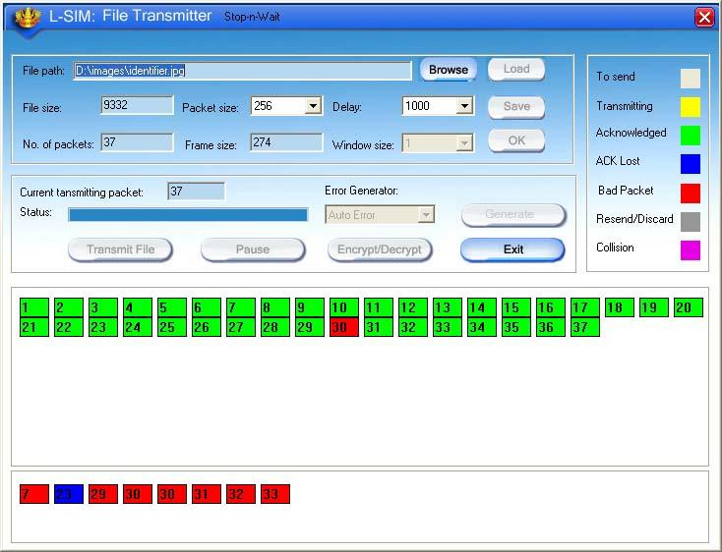

23rd packet will be received correctly this time.

22. Select AUTO ERROR and click on Generate button in the transmitter
window at any packet is in the transmission state, errors are generated at
random intervals and no other error insertion facility will be available to
user.

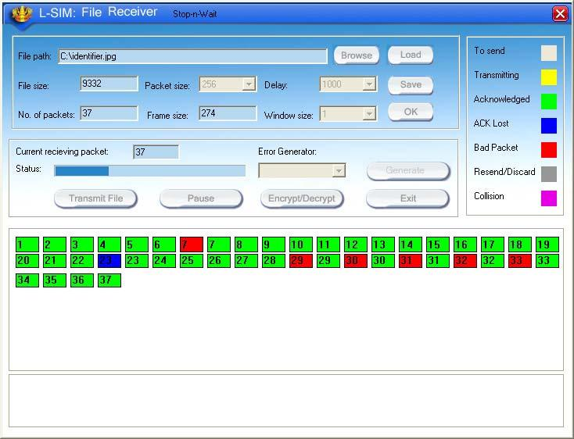

23. Status of packets received when auto error is selected.

24. File transfer from one computer to another will take place.

25. Multiple file transfer between various server-client combinations should be
performed to observe throughput v/s packet size graph on transmitter
computer.

26. Close file transfer window and click on protocol analyzer and Network
analyzer buttons on transmitter computer to view details of the log created.

27. Under Network analyzer window click on Graph analyzer button.

28. Calculate throughput and click on Plot graph button.

29. Detailed graph of throughput v/s packet size for the total file transfer activity
will appear on graph window.

30. This plot can be printed by clicking on print button.

Graph for Stop & Wait protocol without any packet errors

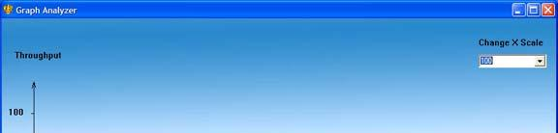

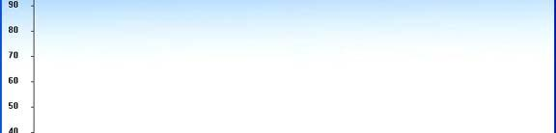

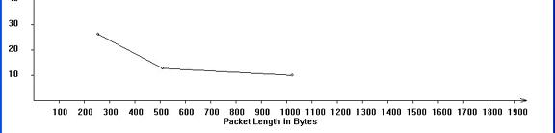

Graph for Stop & Wait protocol with one ACK lost packet error

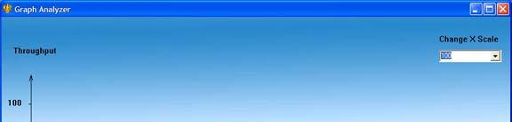
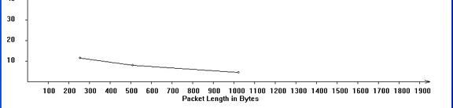

STUDY OF GO BACK N PROTOCOL

Go-Back-N ARQ is a specific instance of the automatic repeat request (ARQ) protocol, in which the sending process continues to send a number of frames specified by a window size even without receiving an acknowledgement (ACK) packet from the receiver. It is a special case of the general sliding window protocol with the transmit window size of N and receive window size of 1.The receiver process keeps track of the sequence number of the next frame it expects to receive, and sends that number with every ACK it sends. The receiver will ignore any frame that does not have the exact sequence number it expects – whether that frame is a "past" duplicate of a frame it has already ACK'ed ^{[1]} or whether that frame is a "future" frame past the last packet it is waiting for. Once the sender has sent all of the frames in its window, it will detect that all of the frames since the first lost frame are outstanding, and will go back to sequence number of the last ACK it received from the receiver process and fill its window starting with that frame and continue the process over again.Go-Back-N ARQ is a more efficient use of a connection than Stop-and-wait ARQ, since unlike waiting for an acknowledgement for each packet, the connection is still being utilized as packets are being sent. In other words, during the time that would otherwise be spent waiting, more packets are being sent. However, this method also results in sending frames multiple times – if any frame was lost or damaged, or the ACK acknowledging them was lost or damaged, then that frame and all following frames in the window (even if they were received without error) will be re-sent. To avoid this, Selective Repeat ARQ can be used.

EXPERIMENT 2:

OBJECTIVE:
To study Go Back N protocol using LAN port interface.

EQUIPMENTS:
• LTS-01 trainer kit.
• 2 Computers with win-2K / XP and Ethernet port available on them.
• RJ-45 to RJ-45 LAN connecting cables.
• L-SIM LAN protocol analyzer and simulator software

PROCEDURE:

1.

2.
3.

4.
5.

6.

7.

8.

Connect 3 or more computer LAN ports using RJ-45 to RJ-45 LAN
connecting cables provided with the system to LTS-01 star topology ports.
Switch on the LTS-01 & Computers.
Run L-SIM software on all the computers, one should be server and others
should be clients.
On the server computer select type of network as LAN.
On the server computer select the topology as STAR, select protocol as Go
Back N click on create network button.
Remote computer details will appear on the computers connected in
network, server will be able to see all clients and all clients will be able to
see only server.
Select the computer to whom data file is to be transferred, from the load
button, previously stored/selected file information can be loaded or you can
select any file, which is to be transmitted.
File size will appear in the software window, select the packet size, inter
packet delay, window size and click OK.

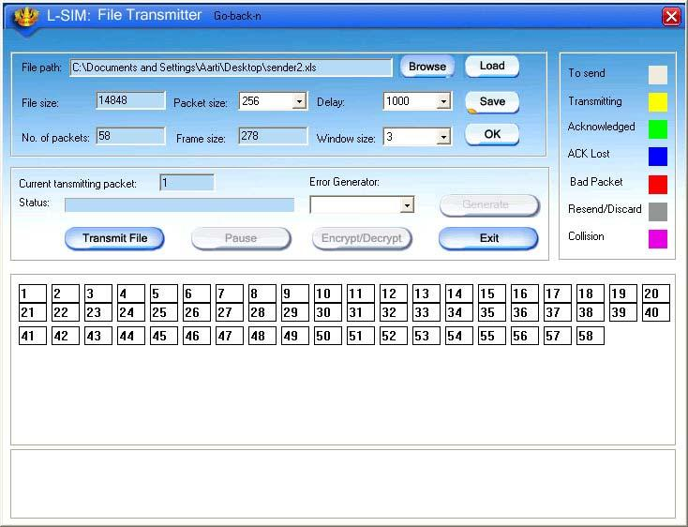

9. Total packets formed for that file will be indicated on computers.

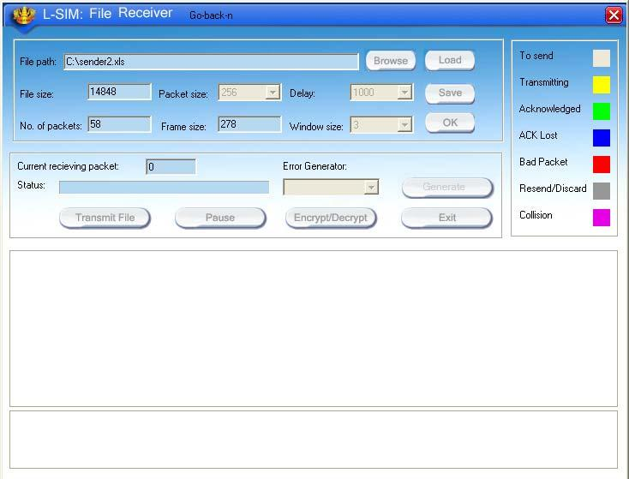

10. Same details of file will appear on remote computer to which file is to be
transmitted.

11. Click on file transfer button to transfer file.

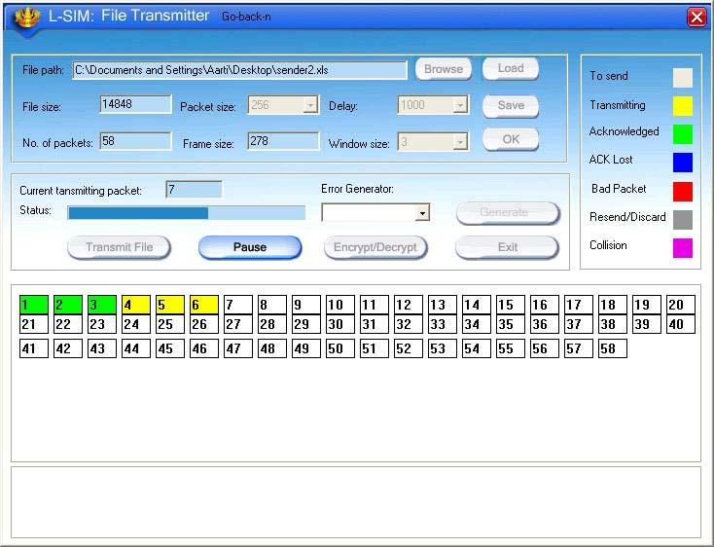

Transmission started screen in transmitter clearly show window size of 3 with 3
packets are transmitted at a time

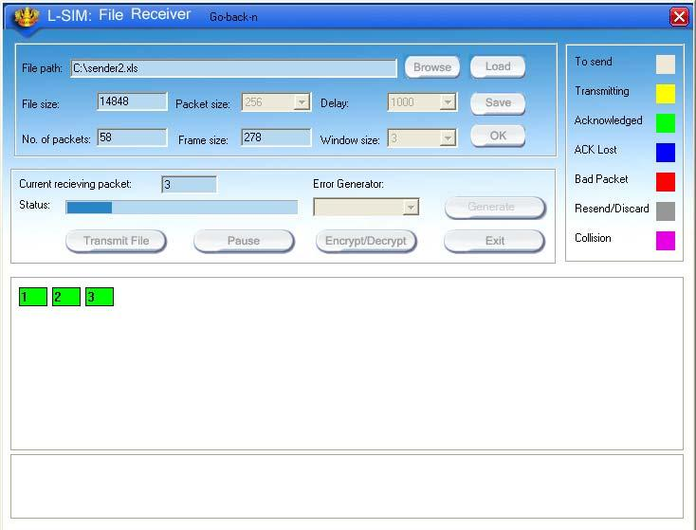

Transmission started screen in receiver

12. During file transfer process you can insert errors into data packets being
transmitted through software window.

13. See the effect of Bad packet error, Packet negative acknowledgment error
or auto errors on file transfer; observe carefully which packet/packets are
transmitted.

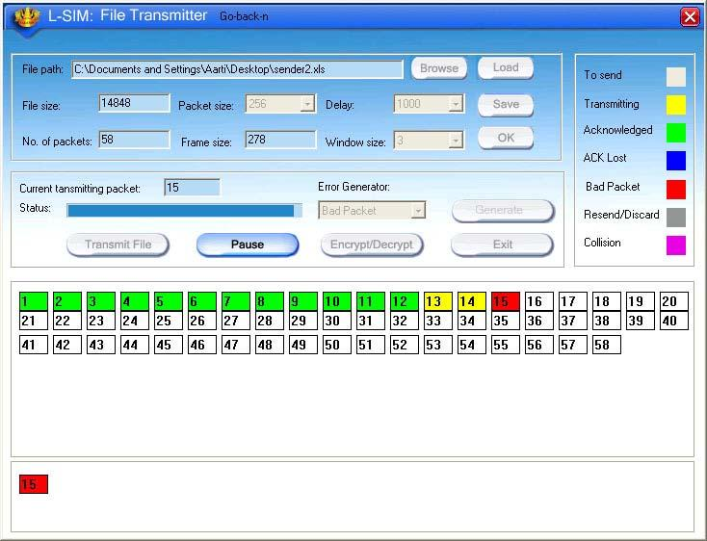

14. Select BAD PACKET error and click on Generate button in the transmitter
window when say 15th packet is in the transmission state.

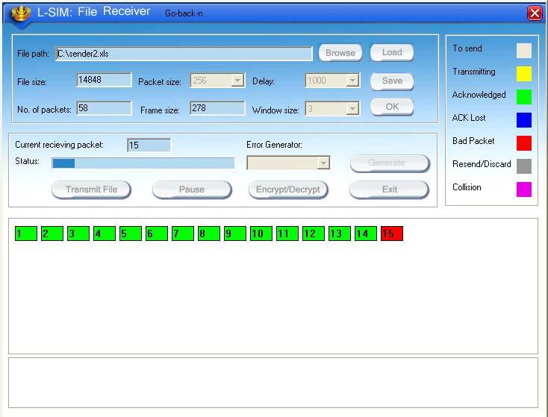

15. You will see that 15th packet in the receiver window will be marked as bad
packet.
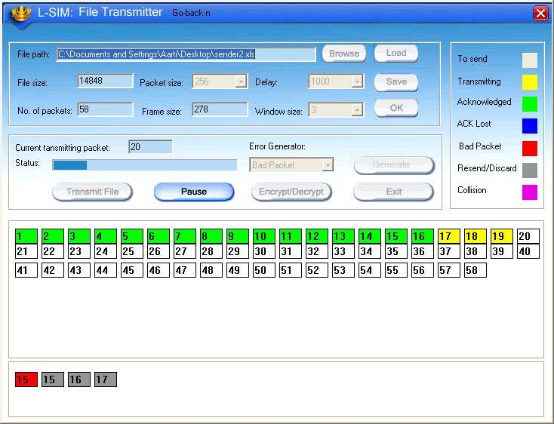

16. 15th, 16th & 17th packets will be retransmitted from transmitter.

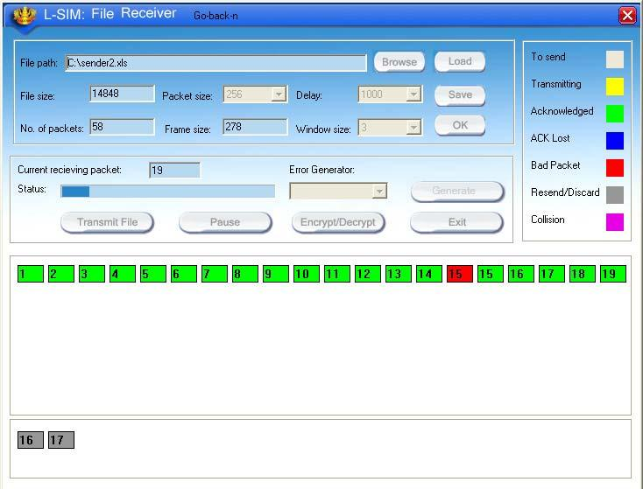

17. Retransmit Retransmitted 15th,16th and 17th packets will be received correctly

this time, receiver will discard 16th & 17th packets and only 15th packet is accepted.

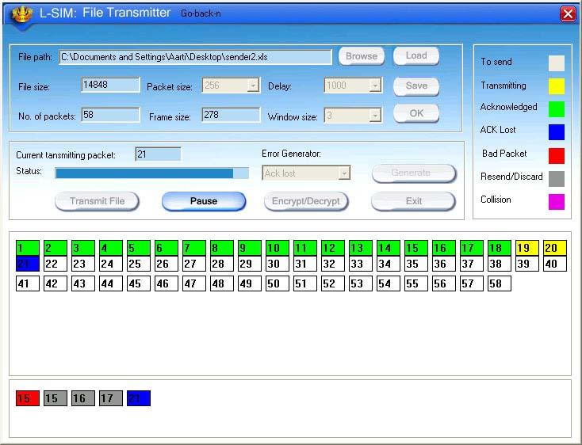

18. Select ACK LOST error and click on Generate button in the transmitter
window when say 21st packet is in the transmission state.

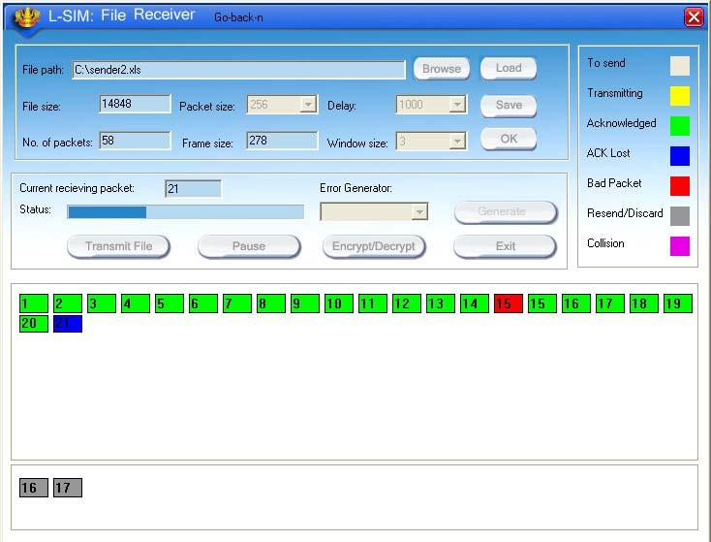

19. You will see that 21st packet in the receiver window will be marked as
unacknowledged.

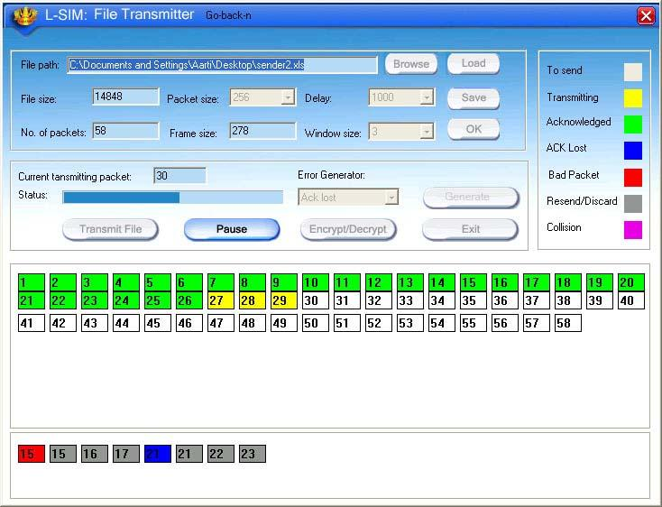

20. 21st, 22nd & 23rd packets will be retransmitted from transmitter.

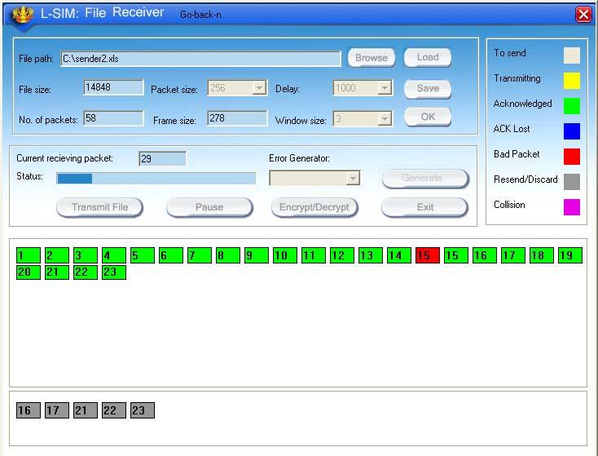

21. Retransmitted 21st, 22nd & 23rd packets will be received and discarded by
receiver as they were received correctly earlier.

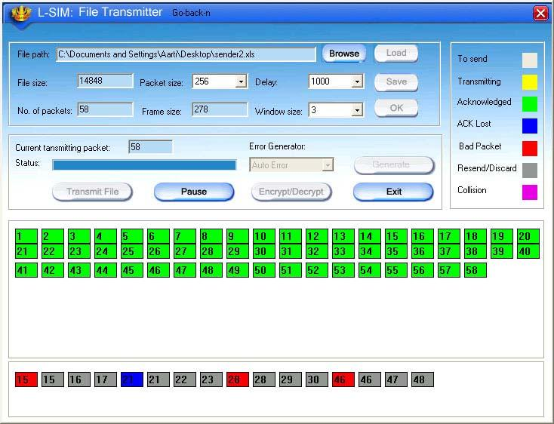

22. Select AUTO ERROR and click on Generate button in the transmitter
window at any packet is in the transmission state, errors are generated at
random intervals and no other error insertion facility will be available to
user.
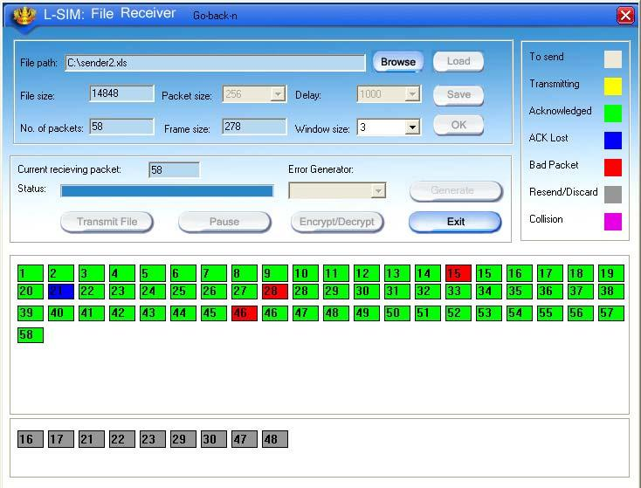

23. Status of packets received when auto error is selected.
24. File transfer from one computer to another will take place.
25. Multiple file transfer between various server-client combinations should be
performed to observe throughput v/s packet size graph on transmitter
computer.
26. Close file transfer window and click on protocol analyzer and Network
analyzer buttons on transmitter computer to view details of the log created.
27. Under Network analyzer window click on Graph analyzer button.
28. Calculate throughput and click on Plot graph button.

29. Detailed graph of throughput v/s packet size for the total file transfer activity
will appear on graph window.

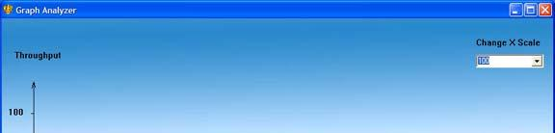

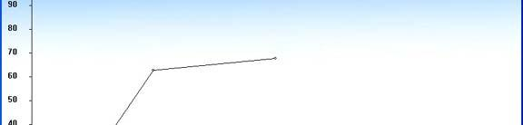

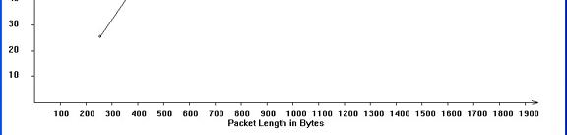

Graph for Go Back N protocol without any packet errors

30. This plot can be printed by clicking on print button.

STUDY OF SELECTIVE REPEAT PROTOCOL
Selective Repeat ARQ / Selective Reject ARQ is a specific instance of the Automatic Repeat-Request (ARQ)protocol used for communications.Selective Repeat is one of the automatic repeat-request (ARQ) techniques. With selective repeat, the sender sends a number of frames specified by a window size even without the need to wait for individual ACK from the receiver as in stop-and-wait. However, the receiver sends ACK for each frame individually, which is not like cumulative ACK as used with go-back-n. The receiver accepts out-of-order frames and buffers them. The sender individually retransmits frames that have timed out.

EXPERIMENT 3:

OBJECTIVE:
To study Selective Repeat protocol using LAN port interface.

EQUIPMENTS:
• LTS-01 trainer kit.
• 2 Computers with win-2K / XP and Ethernet port available on them.
• RJ-45 to RJ-45 LAN connecting cables.
• L-SIM LAN protocol analyzer and simulator software

PROCEDURE:

1. Connect 3 or more computer LAN ports using RJ-45 to RJ-45 LAN
connecting cables provided with the system to LTS-01 star topology ports.
2. Switch on the LTS-01 & Computers.
3. Run L-SIM software on all the computers, one should be server and others
should be clients.
4. On the server computer select type of network as LAN.
5. On the server computer select the topology as STAR, select protocol as
Selective Repeat click on create network button.
6. Remote computer details will appear on the computers connected in
network, server will be able to see all clients and all clients will be able to
see only server.
7. Select the computer to whom data file is to be transferred, from the load
button, previously stored/selected file information can be loaded or you can
select any file, which is to be transmitted.
8. File size will appear in the software window, select the packet size, inter
packet delay, window size and click OK.

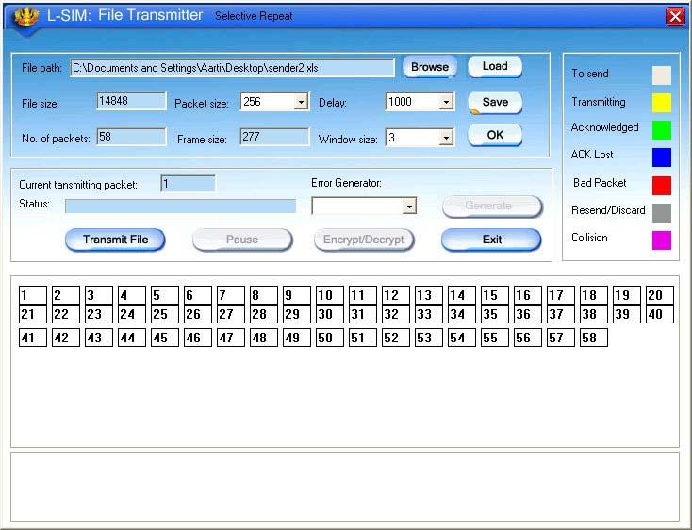

9. Total packets formed for that file will be indicated on computers.

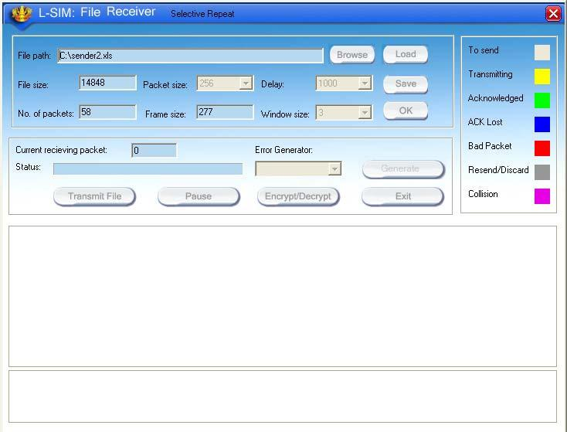

10. Same details of file will appear on remote computer to which file is to be
transmitted.

11. Click on file transfer button to transfer file.

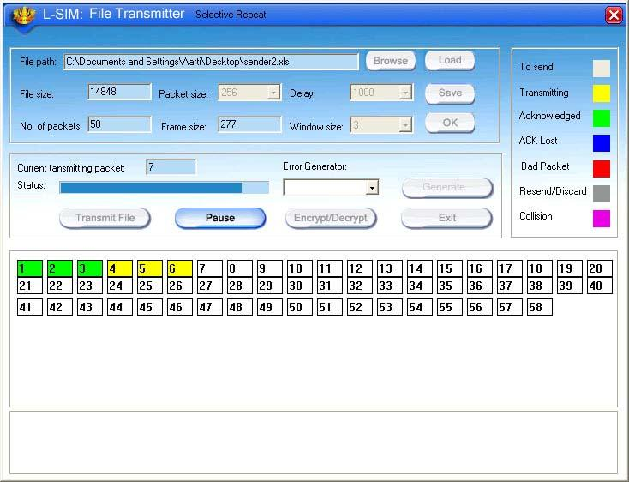

Transmission started screen in transmitter clearly show window size of 3 with 3
packets are transmitted at a time

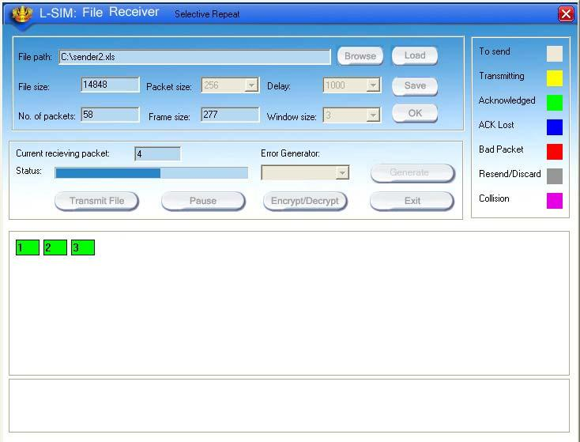

Transmission started screen in receiver

12. During file transfer process you can insert errors into data packets being
Transmitted through software window.

13. See the effect of Bad packet error, Packet negative acknowledgment error
or auto errors on file transfer; observe carefully which packet/packets are
transmitted.

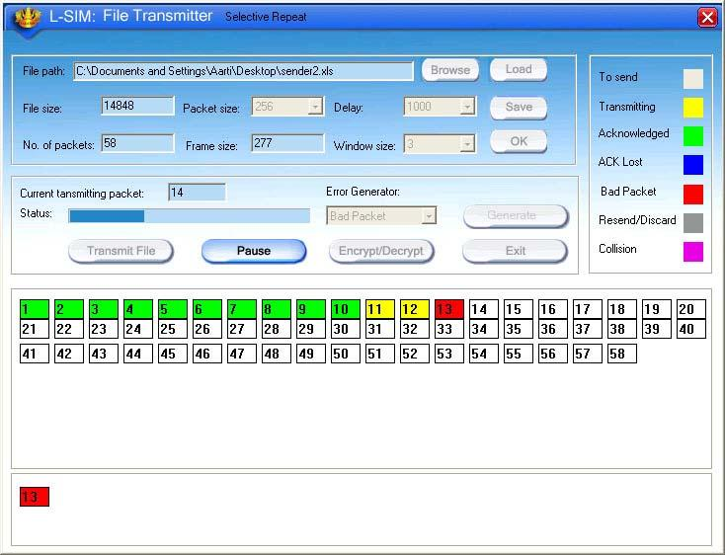

14. Select BAD PACKET error and click on Generate button in the transmitter
window when say 13th packet is in the transmission state.

15. You will see that 13th packet in the receiver window will be marked as bad
packet.

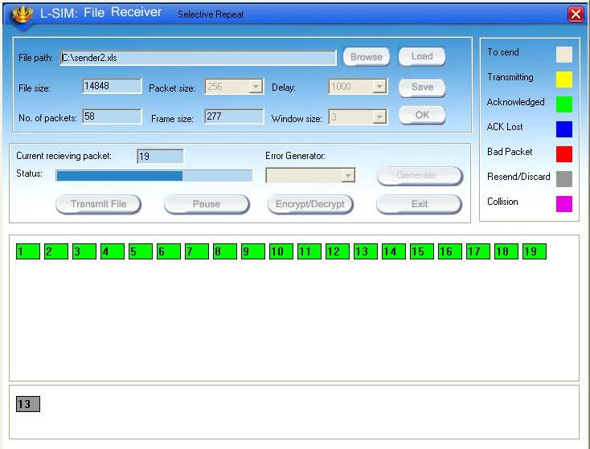

16. 13th packet will be retransmitted from transmitter.

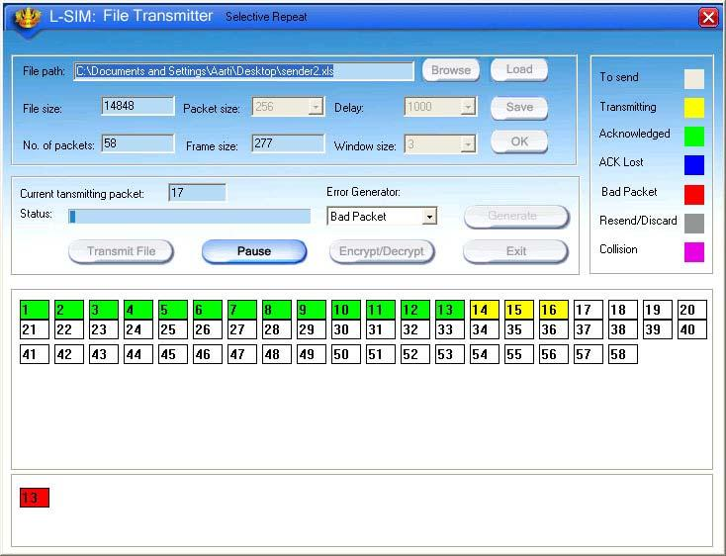

17. Retransmitted 13th packet will be received correctly this time

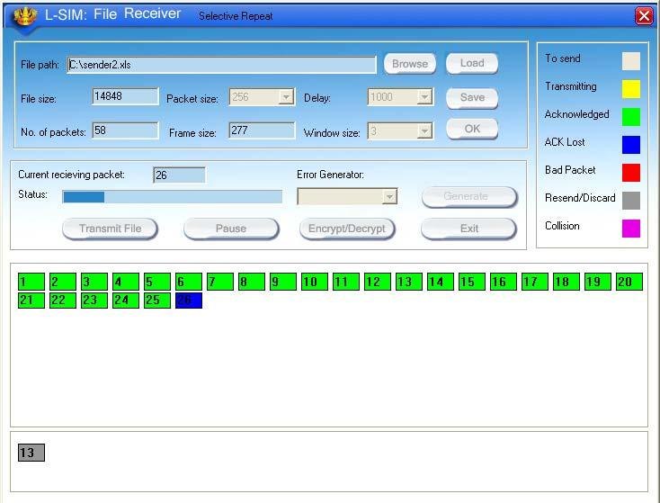

18. Select ACK LOST error and click on Generate button in the transmitter
window when say 26th packet is in the transmission state.

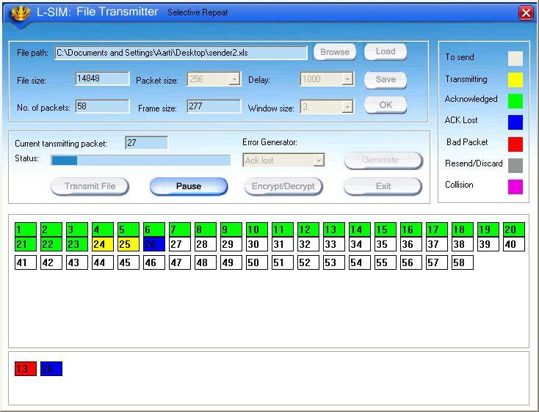

EXPERIMENT 3

19. You will see that 26th packet in the receiver window will be marked as
unacknowledged.

20. 26th packet will be retransmitted from transmitter.

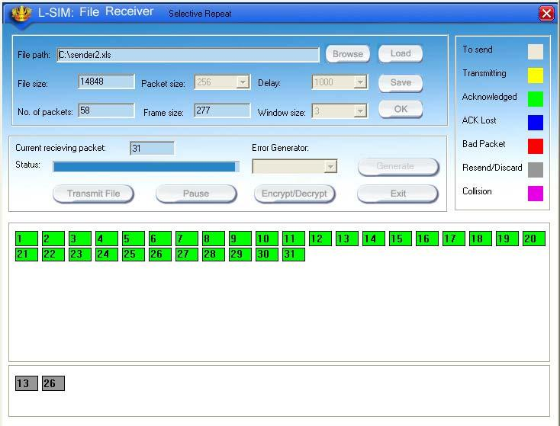

21. Retransmitted 26th packet will be received and discarded by receiver as it
was received correctly earlier.

22. Select AUTO ERROR and click on Generate button in the transmitter
window at any packet is in the transmission state, errors are generated at
random intervals and no other error insertion facility will be available to
user.
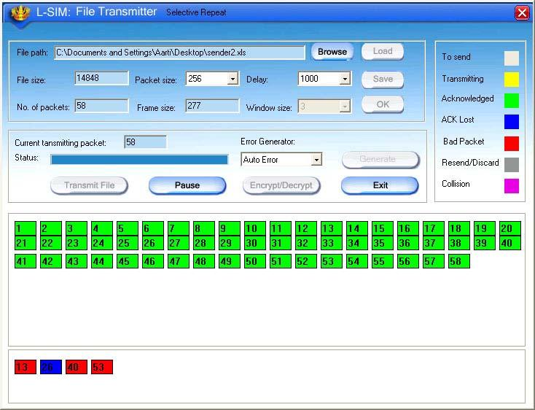

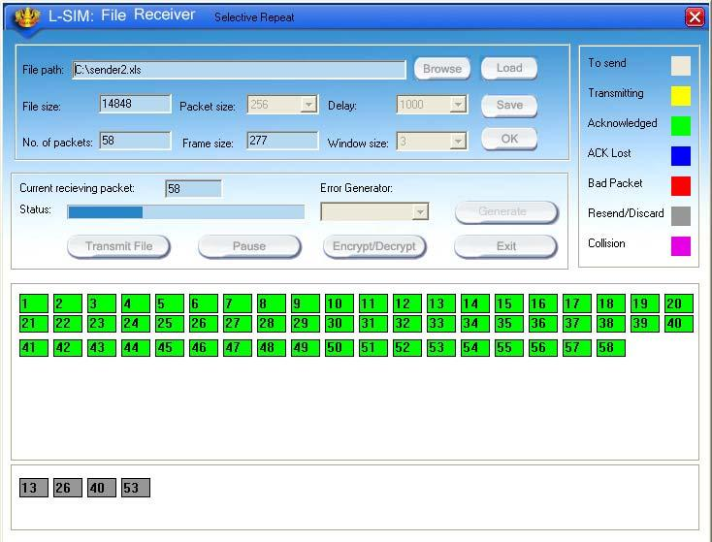

23. Status of packets received when auto error is selected.
24. File transfer from one computer to another will take place.
25. Multiple file transfer between various server-client combinations should be
performed to observe throughput v/s packet size graph on transmitter
computer.
26. Close file transfer window and click on protocol analyzer and Network
analyzer buttons on transmitter computer to view details of the log created.
27. Under Network analyzer window click on Graph analyzer button.
28. Calculate throughput and click on Plot graph button.
29. Detailed graph of throughput v/s packet size for the total file transfer activity
will appear on graph window.

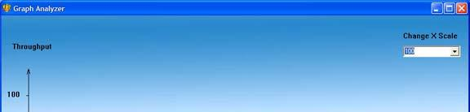

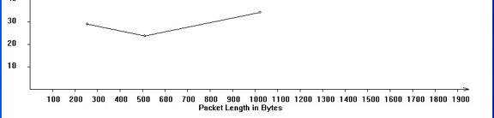

Graph for Selective Repeat protocol without any packet errors
30. This plot can be printed by clicking on print button.

ENT 4EX

IMPLEMENTATION AND STUDY OF CSMA-CA PROTOCOL

Collision avoidance is used to improve the performance of the CSMA method by attempting to divide the channel somewhat equally among all transmitting nodes within the collision domain.Although CSMA/CA has been used in a variety of wired communication systems, it is particularly beneficial in a wireless LAN due to a common problem of multiple stations being able to see the Access Point, but not each other. This is due to differences in transmit power, and receive sensitivity, as well as distance, and location with respect to the AP. This will cause a station to not be able to 'hear' another station's broadcast. This is the so called 'hidden node', or 'hidden station' problem. Devices utilizing 802.11based standards can enjoy the benefits of collision avoidance (RTS / CTS handshake, also Point coordination function), although they do not do so by default. By default they use a Carrier sensing mechanism called 'exponential backoff', or (Distributed coordination function) that relies upon a station attempting to 'listen' for another station's broadcast before sending. CA, or PCF relies upon the AP (or the 'receiver' for Ad hoc networks) granting a station the exclusive right to transmit for a given period of time after requesting it (Request to Send / Clear to Send).

EXPERIMENT 4:

OBJECTIVE:

Implementation and study of CSMA-CA protocol.

EQUIPMENTS:
• LTS-01 trainer kit
• 3 Computers with win-2K / XP and Ethernet port available on them
• RJ-45 to RJ-45 LAN connecting cables
• L-SIM LAN protocol analyzer and simulator software

PROCEDURE:

1.

2.
3.

4.
5.

6.

7.
8.

9.

10.

11.

12.

Connect 3 or more computer LAN ports using RJ-45 to RJ-45 LAN
connecting cables provided with the system to LTS-01 star topology ports.
Switch on the LTS-01 & Computers.
Run L-SIM software on all the computers, one should be server and others
should be clients.
On the server computer select type of network as LAN.
On the server computer select the topology as STAR, select protocol as
CSMA-CA click on create network button.
Remote computer details will appear on the computers connected in
network, server will be able to see all clients and all clients will be able to
see only server.
Click on the Send RTS button to get your computer into transmitter mode.
Select the computer to whom data file is to be transferred, from the load
button, previously stored/selected file information can be loaded or you can
select any file, which is to be transmitted.
File size will appear in the software window, select the packet size, inter
packet delay and click OK.
1 Total packets formed for that file will be indicated on computers, same
details of file will appear on remote computer to which file is to be transmitted.
Click on file transfer button to transfer file.

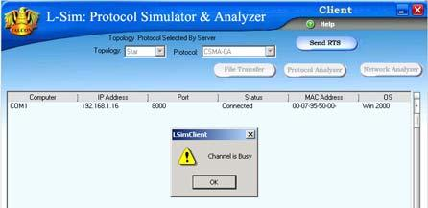

During file transfer process try to get access to transmit file by clicking on
Send RTS button on other computers, you will be prompted with channel is
busy message.

13. Thus collision of two packets transmitted simultaneously from two senders
is avoided.
14. File transfer from one computer to another will take place.
15. Multiple file transfer between various server-client combinations should be
performed to observe throughput v/s packet size graph on transmitter
computer.
16. Close file transfer window and click on protocol analyzer and Network
analyzer buttons on transmitter computer to view details of the log created.
17. Under Network analyzer window click on Graph analyzer button.
18. Calculate throughput and click on Plot graph button.

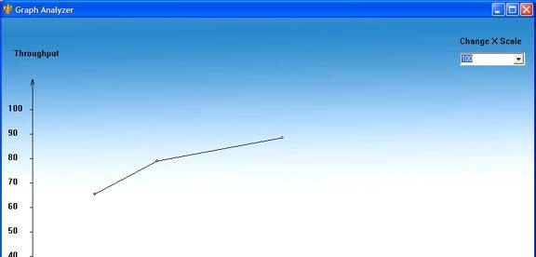

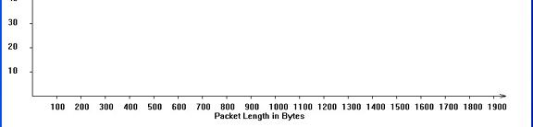

Graph for CSMA-CA protocol

19. Detailed graph of throughput v/s packet size for the total file transfer activity
will appear on graph window.
20. This plot can be printed by clicking on print button.

ERIME EXPERIMENT 5

IMPLEMENTATION AND STUDY OF CSMA-CD

PROTOCOL

CSMA/CD augments the algorithm to handle collision.In this method, a station monitors the medium after it sends aframe to see if transmission was successful.If so, the station is finished.If however,there is a collision,the frame is sent again. The throughput of CSMA/CD is greater than that of pure or slotted ALOHA.The maximum throughput occurs at a different value of G and is based on the persistence method and the value of p in the p-persistent approach.For 1-persistent method the maximum throughput is around 50 percent when G=1.For nonpersistent method,the maximum throughput can go upto 90 percennt when G is between 3 and 8.

EXPERIMENT 5:

OBJECTIVE:

Implementation and study of CSMA-CD protocol.

EQUIPMENTS:

• LTS-01 trainer kit
• 3 Computers with win-2K / XP and Ethernet port available on them
• RJ-45 to RJ-45 LAN connecting cables
• L-SIM LAN protocol analyzer and simulator software

PROCEDURE:

1.

2.
3.

4.
5.

6.

7.

8.

9.

10.

11.

Connect 3 or more computer LAN ports using RJ-45 to RJ-45 LAN
connecting cables provided with the system to LTS-01 star topology ports.
Switch on the LTS-01 & Computers.
Run L-SIM software on all the computers, one should be server and others
should be clients.
On the server computer select type of network as LAN.
On the server computer select the topology as STAR, select protocol as
CSMA-CD click on create network button.
Remote computer details will appear on the computers connected in
network, server will be able to see all clients and all clients will be able to
see only server.
Select the server computer to whom data file is to be transferred from one
of the client computer; from the load button, previously stored/selected file
information can be loaded or you can select any file, which is to be
transmitted.
File size will appear in the software window, select the packet size, inter
packet delay and click OK.
Total packets formed for that file will be indicated on computers, same
details of file will appear on remote computer to which file is to be
transmitted.
Click on the file transfer button to transfer the file.
During file transfer process try to send file to server from another client
computer, file transfer from second transmitter will also gets initiated.

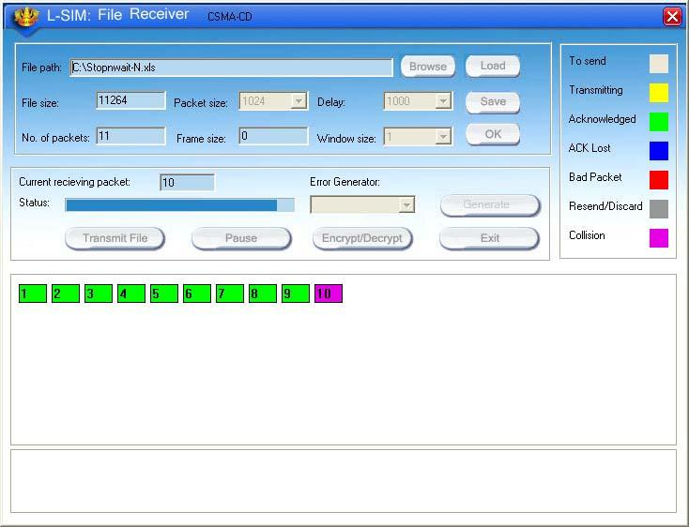

12. When packet from second sender collides with first sender it will be
indicated as collision packet on server & Client-1.

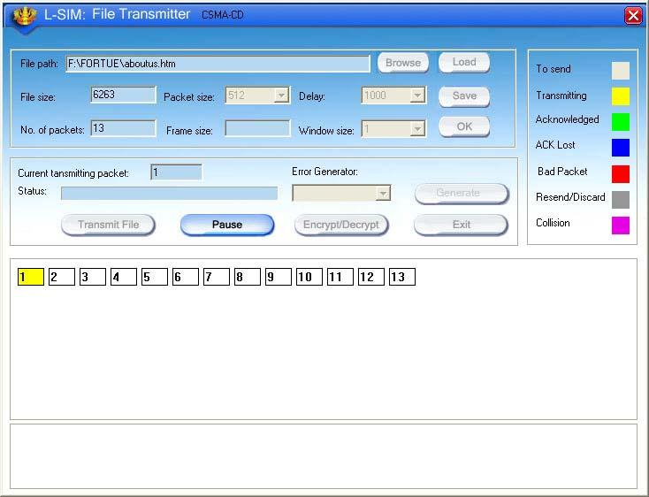

13. File from first sender will resume after some time and second sender file
will be kept on hold till first file transfer gets completed.

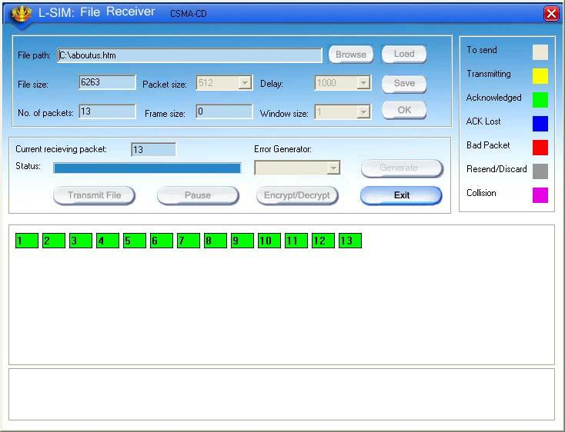

14. Once the first sender file reached to server its display is refreshed and
server will show packet status for second sender.
15. Second sender file transfer will also get completed and thus collision of two
packets transmitted simultaneously from two senders is detected and
cleared.
16. Multiple file transfer between various server-client combinations should be
performed to observe throughput v/s packet size graph on transmitter
computer.
17. Close file transfer window and click on protocol analyzer and Network
analyzer buttons on transmitter computer to view details of the log created.
18. Under Network analyzer window click on Graph analyzer button.
19. Calculate throughput and click on Plot graph button.

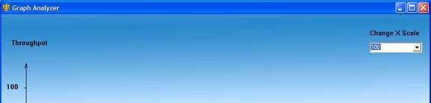

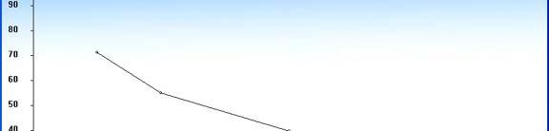

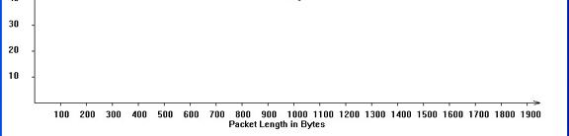

Graph for CSMA-CD protocol

20. Detailed graph of throughput v/s packet size for the total file transfer
activity will appear on graph window.
21. This plot can be printed by clicking on print button.

STUDY OF TOKEN BUS AND TOKEN

RING PROTOCOL

Token bus is a network implementing the token ring protocol over a "virtual ring" on a coaxial cable.^{[1]} A token is passed around the network nodes and only the node possessing the token may transmit. If a node doesn't have anything to send, the token is passed on to the next node on the virtual ring. Each node must know the address of its neighbour in the ring, so a special protocol is needed to notify the other nodes of connections to, and disconnections from, the ring. Token bus was standardized by IEEE standard 802.4. It is mainly used for industrial applications. Token bus was used by General Motors for their Manufacturing Automation Protocol (MAP) standardization effort.This is an application of the concepts used in token ring networks. The main difference is that the endpoints of the bus do not meet to form a physical ring.Due to difficulties handling device failures and adding new stations to a network, token bus gained a reputation for being unreliable and difficult to upgrade.
Token ring local area network (LAN) technology is a protocol which resides at the data link layer (DLL) of the OSI model. It uses a special three-byte frame called a token that travels around the ring. Token-possession grants the possessor permission to transmit on the medium. Token ring frames travel completely around the loop.Initially used only in IBM computers, it was eventually standardized with protocol IEEE 802.5.

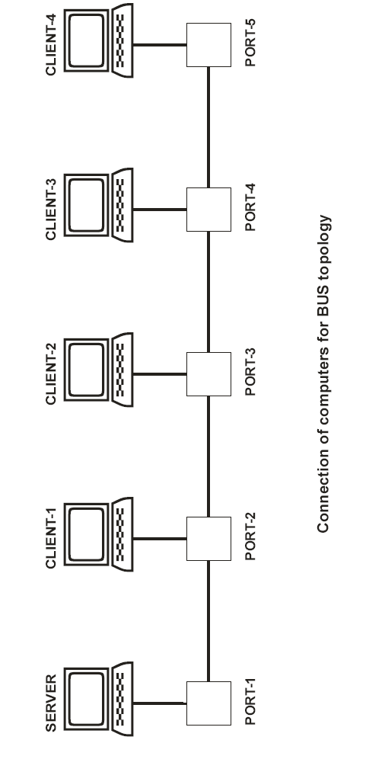

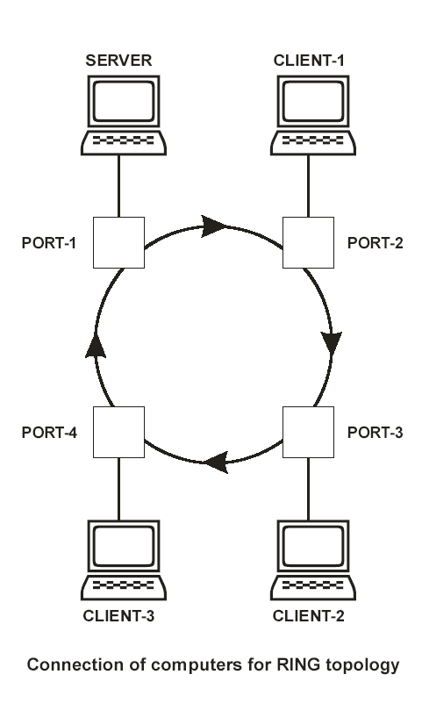

EXPERIMENT 6:

OBJECTIVE:

To study token bus and token ring protocol

EQUIPMENTS:
• LTS-01 trainer kit
• 4 or more Computers with win-2K / XP and Ethernet port available on them
• RJ-45 to RJ-45 LAN connecting cables
• L-SIM LAN protocol analyzer and simulator software

PROCEDURE:

A.TOKEN BUS:
1. Connect four or more computer LAN ports using RJ-45 to RJ-45 LAN
connecting cables provided with the system to LTS-01 bus topology ports.
2. Switch on the LTS-01 & Computers.
3. Run L-SIM software on all the computers, one should be server and others
should be client. Run the software in the sequence of connection i.e. server
first followed by first client to last client.
4. On the server computer select type of network as LAN.
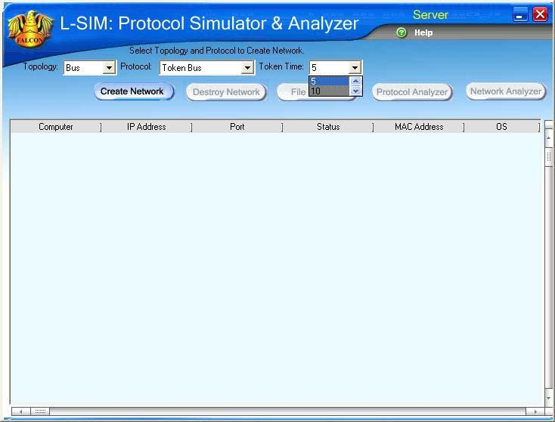

5. On the server computer select the topology as BUS, select protocol as
Token Bus and select token activation time as desired, click on create
network button.
6. To just observe how token passes from one computer to another computer
and effect of token time keep token duration from 5 to 40 seconds and to
do actual file transfer keep token duration as 50 or 60 seconds.
7. Remote computer details will appear on the computers connected in
network, server will be able to see all clients and all clients will be able to
see only server.

8.88SE 8. Select the computer to whom data file is to be transferred, from the load
button, previously stored/selected file information can be loaded or you can
select any file, which is to be transmitted.
SFFFF 9. File size will appear in the software window, select the packet size, inter
packet delay and click OK.

10. Total packets formed for that file will be indicated on computers, same
details of file will appear on remote computer to which file is to be
transmitted.
11. Click on file transfer button to transfer file.
12. File transfer from one computer to another will take place.
13. Remove connection of last client and see the effect on file transfer or token
transfer. You will find that token will process till the client who is connected
in network.
14. Remove connection of client which is in between the server and last client
and see the effect on file transfer or token transfer. You will find that token
will process till the client who is connected in network from client and will
not process from the client got disconnected from network.

B. TOKEN RING:
1. Connect four computer LAN ports using RJ-45 to RJ-45 LAN connecting
cables provided with the system to LTS-01 ring topology ports.
2. Switch on the LTS-01 & Computers.
3. Run L-SIM software on all the computers, one should be server and other 3
should be client. Run the software in the sequence of connection i.e. server
first followed by first client to last client.
4. On the server computer select type of network as LAN.

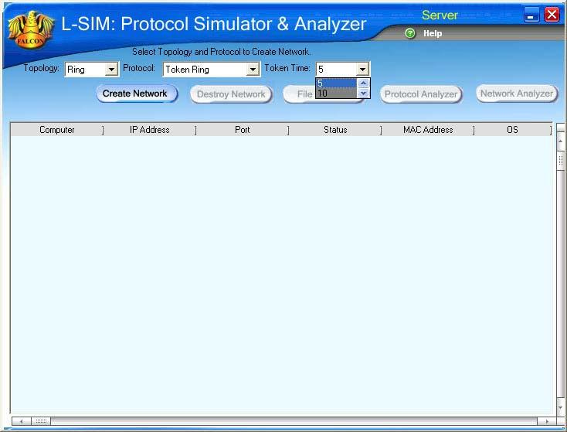

5. On the server computer select the topology as RING, select protocol as
Token Ring and select token activation time as desired, click on create
network button.

6. To just observe how token passes from one computer to another computer
and effect of token time keep token duration from 5 to 40 seconds and to
do actual file transfer keep token duration as 50 or 60 seconds.
7. Remote computer details will appear on the computers connected in
network, server will be able to see all clients and all clients will be able to
see only server.
8. Select the computer to whom data file is to be transferred, from the load
button, previously stored/selected file information can be loaded or you can
select any file, which is to be transmitted.
9. File size will appear in the software window, select the packet size, inter
packet delay and click OK.
10. Total packets formed for that file will be indicated on computers, same
details of file will appear on remote computer to which file is to be
transmitted.
11. Click on file transfer button to transfer file.
12. File transfer from one computer to another will take place.
13. To see the effect of ring break state remove any of the client from the
hardware and close L-SIM window for that client. Ring broken message will
be prompted on server computer and network will get destroyed, you need
to reconfigure the network. Since the network is created with logical ring
physical removal of computer from hardware will be detected when token
completes its cycle and reaches to the client whose connection is removed,
hence it will take some time to show disconnection of computer in case of
unplugging of computer.

STUDY OF DATA ENCRYPTION AND

DECRYPTION

Encryption is the process of encoding data to ensure it is accessible only by the intended recipient. Encryption is used by militaries and governments to facilitate secret communication Decryption is the process of converting encrypted data back into its original form.

EXPERIMENT 7:

OBJECTIVE:

Study of data encryption and decryption.

EQUIPMENTS:
• LTS-01 trainer kit
• 2 Computers with win-2K / XP and Ethernet port available on them
• RJ-45 to RJ-45 LAN connecting cables
• L-SIM LAN protocol analyzer and simulator software

PROCEDURE:

1.

2.
3.

4.
5.

6.

7.

8.

9.

Connect at least two computer LAN ports using RJ-45 to RJ-45 LAN
connecting cables provided with the system to LTS-01 star topology ports.
Switch on the LTS-01 & Computers.
Run L-SIM software on both the computers, one should be server and
another should be client.
On the server computer select type of network as LAN.
On the server computer select the topology as STAR and select protocol as
Stop & Wait and click on create network button.
Remote computer details will appear on the computers connected in
network, server will be able to see client and client will be able to see
server.
Select the computer to whom data file is to be transferred, from the load
button, previously stored/selected file information can be loaded or you can
select any file, which is to be transmitted, if notepad text file is selected
encryption information can be viewed very clearly for each packet formed
for that file.
File size will appear in the software window, select the packet size, inter
packet delay and click OK.
Total packets formed for that file will be indicated on computers, same
details of file will appear on remote computer to which file is to be
transmitted.

10. Click on file transfer button to transfer file.
11. Click on pause button to interrupt file transfer and click on encrypt/decrypt
button to see file packet encrypted and decrypted.

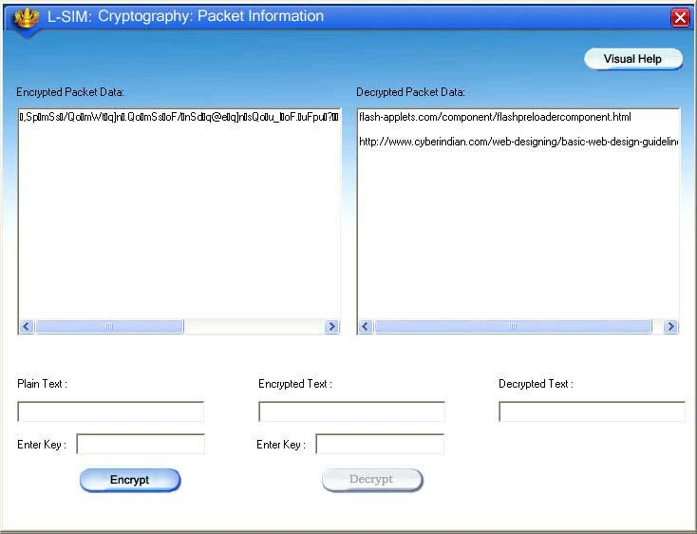
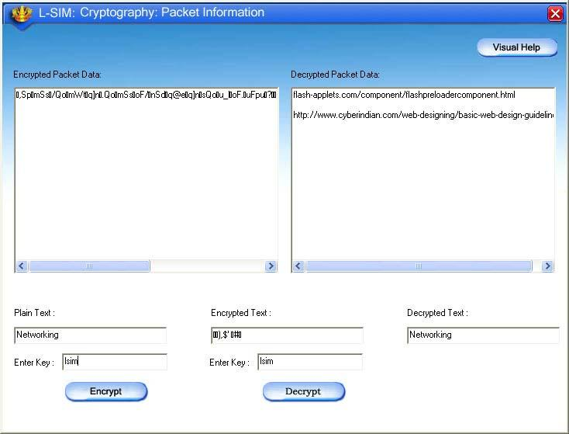

12. You will see actual file selected packet content and encrypted data content
in encryption details window.

13. You can type any text at the bottom box, which you want to encrypt and
provide key text for encryption. Similarly same key can be typed again to
decrypt and recover encrypted text. If the key at decryption stage differ
from key at encryption stage, decrypted data will not be perfect as per
original data.

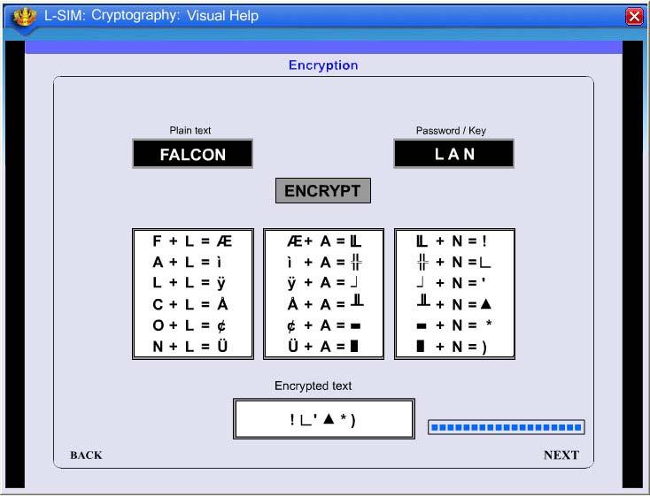
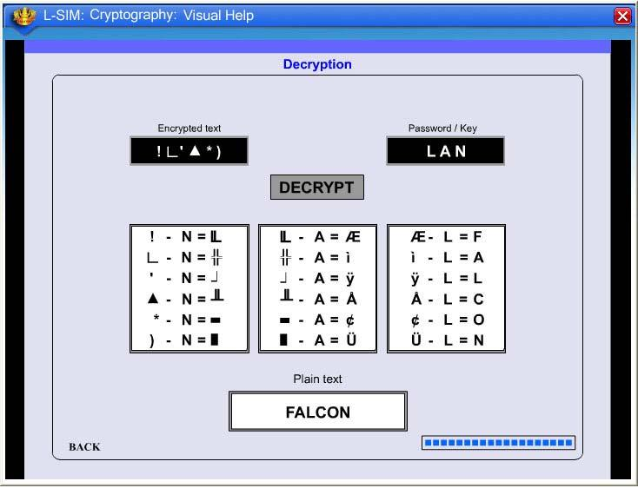

14. To understand the working of how encryption took place you can view
visual explanation of encryption and decryption process by clicking on
visual help button.

15. Visual help showing decryption procedure.
16. You can resume file transfer by clicking on continue button.
17. Encrypted format of each packet can thus be seen by pausing the file
transfer at respective packet when it is under transmission state.
18. File transfer from one computer to another will take place.
19. To study programming of Cryptography with Encryption and Decryption
process sample executable file & program is provided inside program files
– Lsim – SampleApplication.zip.
20. When user extracts this folder he will find cryptography folder inside which
cryptography.cpp & cryptography.exe files are provided.

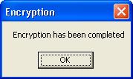
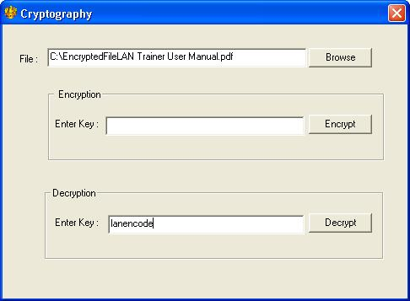
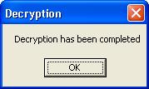

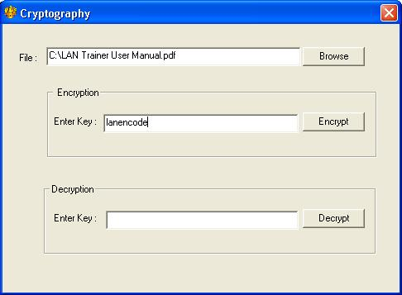

21. If user runs the cryptography.exe file screen with browse option for
selection of file to be encrypted and enter key for encryption option will get
open for user to select the file and enter encryption key.

22. When user clicks on Encrypt button a message with Encryption completed
will popup. Encrypted file will be stored at the same location from where file
for encryption is selected.

23. User has to select file to be decrypted and enter decryption key.

24. When user clicks on Decrypt button a message with Decryption completed
will popup. Decrypted file will be stored at the same location from where file
for decryption is selected.
25. To verify encryption and decrypted files user has to close the
cryptography.exe file.
26. Actual programming can be checked from cryptography.cpp program.

IMPLEMENTATION OF DISTANCE VECTOR ROUTING ALGORITHM

A distance-vector routing algorithm is one of the two major classes of routing protocols to calculate paths. A distance-vector routing protocol requires that a router informs its neighbours of topology changes periodically. Compared to link state algorithm, which require a router to inform all the nodes in a network of topology changes, distance-vector routing protocols have less computational complexity and message overhead. The term distance vector refers to the fact that the protocol manipulates vectors (arrays) of distances to other nodes in the network.

EXPERIMENT 9:

OBJECTIVE:

Implementation of distance vector routing algorithm.

EQUIPMENTS:
• N-SIM
• Computer with win-2K / XP

PROCEDURE:

1. Run N-SIM software from your computer.
2. To check working of distance vector routing algorithm in the form of
animated representation click on distance vector routing under routing
protocols.

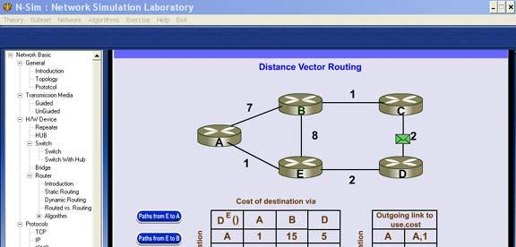

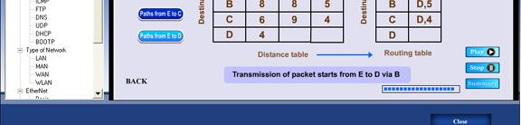

3. You can study the working of distance vector routing algorithm through this
animated movie.

4. To implement this algorithm click on algorithms under menu and click on
distance vector routing.

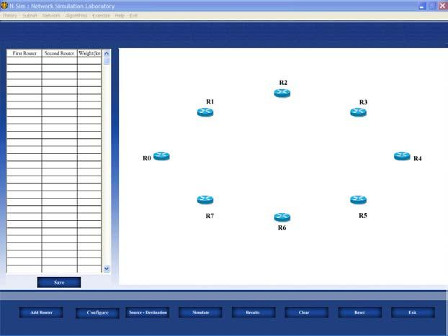

5. Add the number of routers you want to, select one by one, maximum 8
routers can be added, all the added routers will appear in the window.
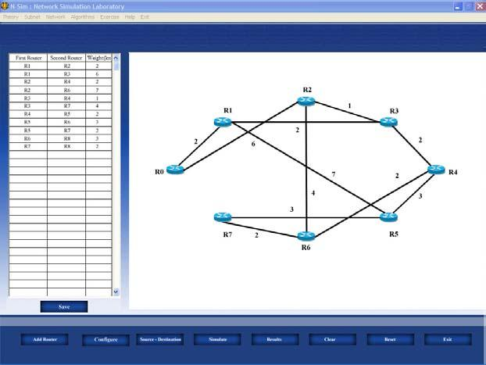

6. Click configure button to define the links between pair of routers and define
its cost in kilometers.
7. Once all the possible pairs have been defined click save button to save the
configuration defined by you.
8. Depending on the configuration you will see all the possible links defined by
you are implemented and drawn in the screen near the routers added.
9. You can edit the configuration at any time by clicking on the value of the
router number or cost.

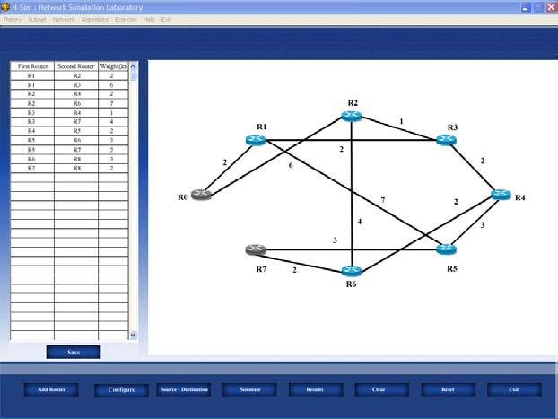

10. To simulate and find out shortest path select the source and destination
routers.

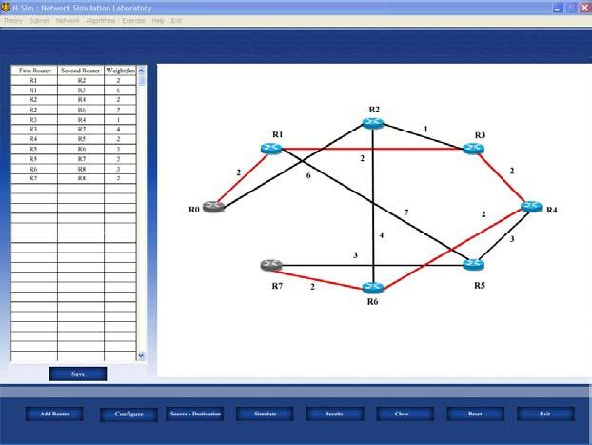

11. Click on simulate button to start the algorithm, this will calculate the
shortest path and will be shown on the screen.

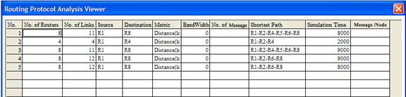
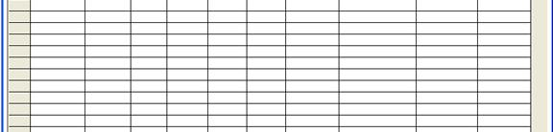
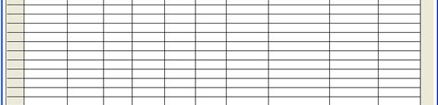
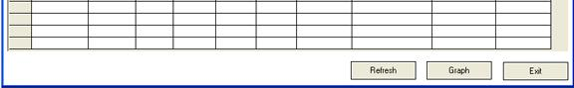
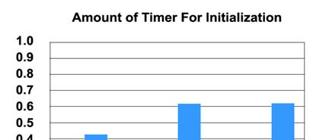
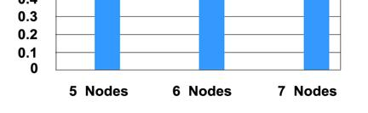
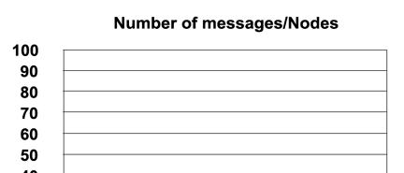
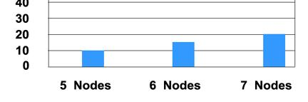

12. Click on the result button to see the parameters for shortest path.
13. Click on graph button to plot the readings against the various parameters.

IMPLEMENTATION OF LINK STATE ROUTING ALGORITHM

In link state routing, if each node in the domain has the entire topology of the domain, the list of nodes and links, how they are connected, including the type, cost(metric),and condition of the links(up or down)-the node can use Dijkstra’s algorithm to build a routing table.
The steps involved are:
(i)Creation of the states of links by each node, called the link state packet(LSP).
(ii)Dissemination of LSPs to every other router, called flooding.
(iii)Formation of shortest path tree for each node.
(iv)Calculation of a routing table based on the shortest path tree.

EXPERIMENT 10:

OBJECTIVE:

Implementation of link state routing algorithm.

EQUIPMENTS:
• N-SIM
• Computer with win-2K / XP

PROCEDURE:

1. Run N-SIM software from your computer.
2. To check working of state routing algorithm in the form of animated
representation click on state routing under routing protocols.

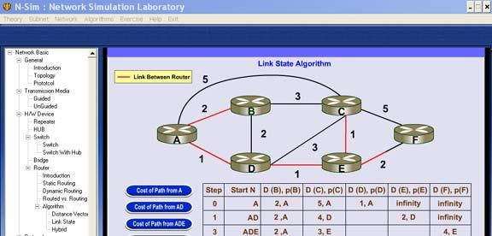

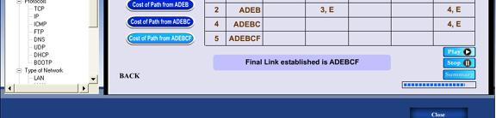

3. You can study the working of state routing algorithm through this animated
movie.
4. To implement this algorithm click on algorithms under menu and click on
state routing.

.

.

5. Add the number of routers you want to, select one by one, maximum 8
routers can be added, all the added routers will appear in the window.

6. Click configure button to define the links between pair of routers and define
its cost in kilometers.
7. Once all the possible pairs have been defined click save button to save the
configuration defined by you.
8. Depending on the configuration you will see all the possible links defined by
you are implemented and drawn in the screen near the routers added.
9. You can edit the configuration at any time by clicking on the value of the
router number or cost.

10. To simulate and find out shortest path select the source and destination
routers.

11. Click on simulate button to start the algorithm, this will calculate the
shortest path and will be shown on the screen.
.

12. Click on the result button to see the parameters for shortest path.
13. Click on graph button to plot the readings against the various parameters.

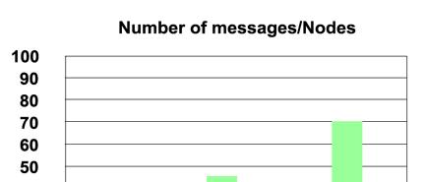

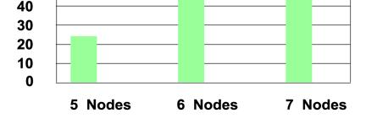

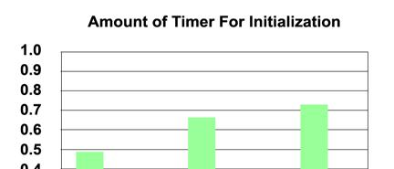

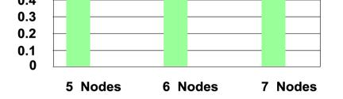

STUDY OF SOCKET PROCESSING

EXPERIMENT 12:

OBJECTIVE:

Study of socket processing.

EQUIPMENTS:
• LTS-01 trainer kit
• 2 Computers with win-2K / XP and Visual C++ installed and Ethernet port
available on them
• RJ-45 to RJ-45 LAN connecting cables

PROCEDURE:

1. Connect 2 computer LAN ports using RJ-45 to RJ-45 LAN connecting
Cables provided with the system to LTS-01 star topology ports.
2. Switch on the LTS-01 & Computers.
3. Run VC++ editor on both the computers.
4. Create dialog based application, for Server on any of the PC in VC++
5. Create dialog based application, for Client on other PC in VC++
6. TCP Test Server.exe, TCP Test Client.exe, server.h, server.cpp, client.h &
client.cpp files will be stored in the directory program files – LSIM –
SampleApplication.zip.
7. After extracting the said zip files all these files can be used for socket
programming.
8. Copy the server.h & server.cpp files in server workspace on first PC.
9. Copy the client.h & client.cpp files in Client workspace on second
computer.

10. server.h file contain following functions:

CreateSocket (int portNumber);
ListenSocket();
SendMessage(CString strMessage);
SendFile(CString strFilePath);
ReceiveFile();
CloseConnection();
Error() ;

11. client.h file contain following functions:

CreateSocket();
Connection (CString IPAddressOfServer ,int portNumber);
SendMessage (CString strMessage)
SendFile (CString strFilePath);
ReceiveFile();
CloseConnection();
Error() ;

12. Create an Object of Server class as : Server objServer
13. Create an Object of Client class as : Client objClient

14. Call the CreateSocket() , ListenSocket() function for the Server object pass
the port number for server.
15. Call the CreateSocket() , Connection() function for the Client object , in the
connection function pass the IP address of the server and port number
given at server.
16. After the connection call the SendMessage () function from Server or Client
object. Pass the message to send as parameter.
17. To Send a File call the SendFile() function from Server or Client and pass
the absolute path of the File to send .

18. CloseConnection () function can be called from server or client object to
close the connection.
19. Thus students can use these functions to do the socket processing for

TCP.
20. Students can create their own GUI and can define their own parameters
after making use of the given classes and prove their programming skills.
21. Thus socket processing can be carried out.
22. To see the functionality with sample executables use TCP Test Server.exe
& TCP Test Client.exe on two different computers.

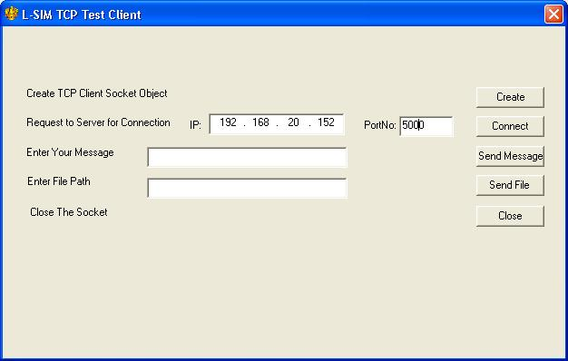
23. Run TCP Test Server.exe on one of the computer and pass port number.

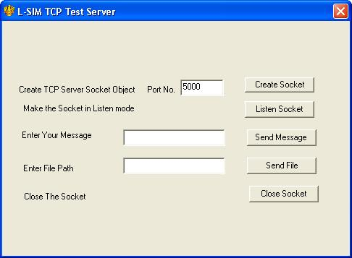

24. Run TCP Test Client.exe on other computer and pass IP address of server computer and port number provided at server.
25. Check the functionality by sending message and / or files.

Note: To see the code of specific function, open the server.cpp or client.cpp file & then check the code of the function.

Ethernet Cable Color – Code Standards & Methods of Crimping

And

How to Ping the IP Address of a Computer

EXPERIMENT 13:

OBJECTIVE:

Study of Ethernet Cable Color – Code Standards & Methods of Crimping and How to Ping the IP Address of a Computer

Ethernet Cable Color – Code Standards & Methods of Crimping

The 8 Position 8 Contact (8P8C) modular plugs and jacks are communications connectors
These connectors are often referred to as RJ 45 Plugs and Jacks
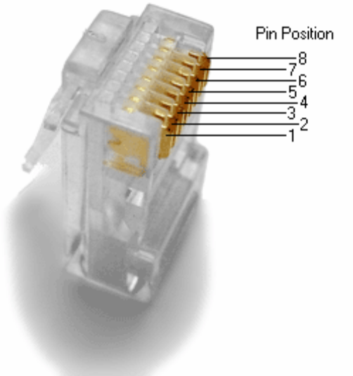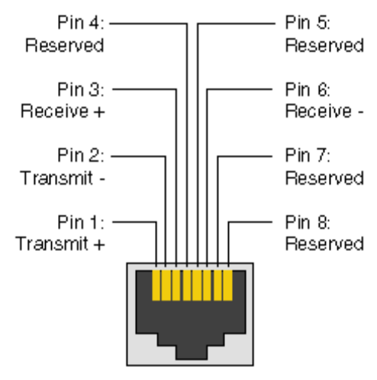

The information listed here is to assist Network Administrators in the color coding of Ethernet cables. Please be aware that modifying Ethernet cables improperly may cause loss of network connectivity. Use this information at your own risk, and insure all connectors and cables are modified in accordance with standards. The Internet Centre and its affiliates cannot be held liable for the use of this information in whole or in part.
T-568A Straight-Through Ethernet Cable
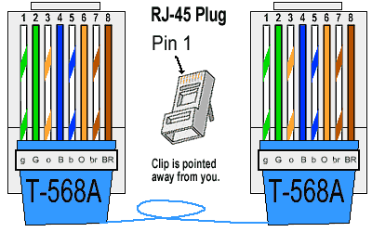
The TIA/EIA 568-A standard which was ratified in 1995, was replaced by the TIA/EIA 568-B standard in 2002 and has been updated since. Both standards define the T-568A and T-568B pin-outs for using Unshielded Twisted Pair cable and RJ-45 connectors for Ethernet connectivity. The standards and pin-out specification appear to be related and interchangeable, but are not the same and should not be used interchangeably.
T-568B Straight-Through Ethernet Cable
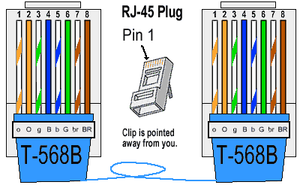
Both the T-568A and the T-568B standard Straight-Through cables are used most often as patch cords for your Ethernet connections. If you require a cable to connect two Ethernet devices directly together without a hub or when you connect two hubs together, you will need to use a Crossover cable instead.
RJ-45 Crossover Ethernet Cable
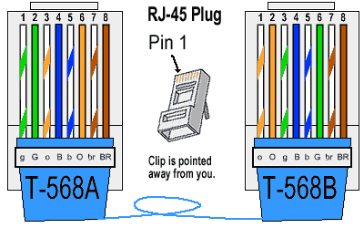
A good way of remembering how to wire a Crossover Ethernet cable is to wire one end using the T-568A standard and the other end using the T-568B standard. Another way of remembering the color coding is to simply switch the Green set of wires in place with the Orange set of wires. Specifically, switch the solid Green (G) with the solid Orange, and switch the green/white with the orange/white.
BASIC THEORY

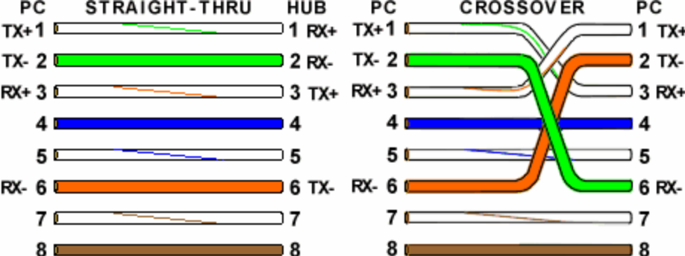

CROSS OVER CRIMPING

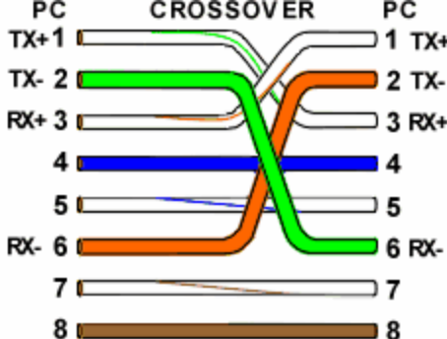

Ethernet Cable Instructions:
- Pull the cable off the reel to the desired length and cut. If you are pulling cables through holes, its easier to attach the RJ-45 plugs after the cable is pulled. The total length of wire segments between a PC and a hub or between two PC's cannot exceed 100 Meters (328 feet) for 100BASE-TX and 300 Meters for 10BASE-T.
- Start on one end and strip the cable jacket off (about 1") using a stripper or a knife. Be extra careful not to nick the wires, otherwise you will need to start over.
- Spread, untwist the pairs, and arrange the wires in the order of the desired cable end. Flatten the end between your thumb and forefinger. Trim the ends of the wires so they are even with one another, leaving only 1/2" in wire length. If it is longer than 1/2" it will be out-of-spec and susceptible to crosstalk. Flatten and insure there are no spaces between wires.
- Hold the RJ-45 plug with the clip facing down or away from you. Push the wires firmly into the plug. Inspect each wire is flat even at the front of the plug. Check the order of the wires. Double check again. Check that the jacket is fitted right against the stop of the plug. Carefully hold the wire and firmly crimp the RJ-45 with the crimper.
- Check the color orientation, check that the crimped connection is not about to come apart, and check to see if the wires are flat against the front of the plug. If even one of these are incorrect, you will have to start over. Test the Ethernet cable.
Ethernet Cable Tips:
- A straight-thru cable has identical ends.
- A crossover cable has different ends.
- A straight-thru is used as a patch cord in Ethernet connections.
- A crossover is used to connect two Ethernet devices without a hub or for connecting two hubs.
- A crossover has one end with the Orange set of wires switched with the Green set.
- Odd numbered pins are always striped, even numbered pins are always solid colored.
- Looking at the RJ-45 with the clip facing away from you, Brown is always on the right, and pin 1 is on the left.
- No more than 1/2" of the Ethernet cable should be untwisted otherwise it will be susceptible to crosstalk.
- Do not deform, do not bend, do not stretch, do not staple, do not run parallel with power cables, and do not run Ethernet cables near noise inducing components.
Basic Theory:
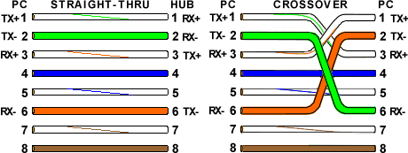
By looking at a T-568A UTP Ethernet straight-thru cable and an Ethernet crossover cable with a T-568B end, we see that the TX (transmitter) pins are connected to the corresponding RX (receiver) pins, plus to plus and minus to minus. You can also see that both the blue and brown wire pairs on pins 4, 5, 7, and 8 are not used in either standard. What you may not realize is that, these same pins 4, 5, 7, and 8 are not used or required in 100BASE-TX as well. So why bother using these wires, well for one thing its simply easier to make a connection with all the wires grouped together. Otherwise you'll be spending time trying to fit those tiny little wires into each of the corresponding holes in the RJ-45 connector.

How to Ping the IP Address of a Computer

Ping a IP Address that Responds
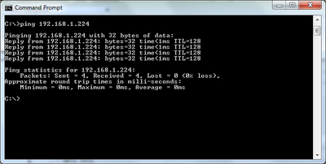

Ping is a standard utility program available on most computers. A ping utility sends test messages from the computer to a remote device over a TCP/IP network. Besides determining whether the remote computer is currently online, ping also provides indicators of the general speed or reliability of network connections.

Running Ping
Microsoft Windows, Mac OS X, and Linux provide command line ping programs that can be run from the operating system shell. Computers can be pinged by either IP address or by name.
To ping a computer by IP address,
- open a shell prompt (in Microsoft Windows, the Command Prompt or MS-DOS Prompt on Start Menu)
- type "ping" followed by a space and the IP address
- press the Enter (or Return) key

Interpreting the Results of Ping
The graphic below illustrates a typical ping session when a device at the target IP address responds with no network errors:
- Reply from: By default, Microsoft Windows ping sends a series of four messages to the address. The program outputs a confirmation line for each response message received from the target computer.
- Bytes: Each ping request is 32 bytes in size by default
- Time: Ping reports the amount of time (in milliseconds) between the sending of requests and receipt of responses
- TTL (Time-to-Live): A value between 1 and 128, TTL can be used to count how many different networks the ping messages passed through before reaching the target computer. A value of 128 indicates the device is on the local network, with 0 other networks in between.

Running Ping Continuously
On some computers (particularly those running Linux), the standard ping program does not stop running after four request attempts but instead runs until the user ends it. That is useful for those wanting to monitor the status of a network connection over longer periods of time. In Microsoft Windows, type "ping -t" instead of "ping" at the command line to launch the program in this continuously running mode (and use the Control-C key sequence to stop it).
Ping a IP Address that Does Not Respond

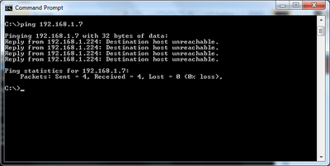
Command Prompt - Ping - Unresponsive IP Address

In some cases, ping requests fail. This happens for any of several reasons:
- the IP address specified to the ping program is invalid
- the host system (device being used to send pings) is not connected to an IP network (i.e., does not have a working IP address)
- no network device is connected to the target IP address
- network congestion or errors in between the host and target are preventing messages from passing through (in one or both directions)
The graphic below illustrates a typical ping session when the program does not receive any responses from the target IP address. Each "Reply from" line takes several seconds to appear on the screen as the program waits and eventually times out. The IP address referenced in each reply line of the output is the address of the pinging (host) computer.

Intermittent Ping Responses
Though uncommon, it is possible for ping to report a response rate other than 0% (fully unresponsive) or 100% (fully responsive). This most often occurs when the target system is shutting down (as in the example shown) or starting up:
C:\> ping bwmitche-home1

Pinging bwmitche-home1 [192.168.0.8] with 32 bytes of data:

Reply from 192.168.0.8: bytes=32 time=<10ms TTL=128
Reply from 192.168.0.8: bytes=32 time=<10ms TTL=128
Request timed out.
Request timed out.

Ping statistics for 192.168.0.8:
Packets: Sent = 4, Received = 2, Lost = 2 (50% loss),
Ping a Web Site or Computer by Name

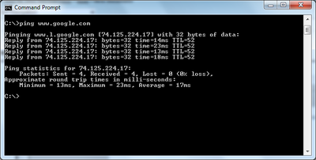
Command Prompt - Ping - Web Site

Pinging a Responsive Web Site
Ping programs allow specifying a computer name instead of an IP address. Users normally prefer pinging by name when targeting a home computer or a Web site.
The below graphic illustrates the results of pinging Google's Web site (www.google.com). Ping reports the target IP address and response time in milliseconds. Note that large Web sites like Google utilize many Web server computers worldwide. Therefore, many different (and valid) IP addresses may be reported by programs when pinging Web sites.

Pinging an Unresponsive Web Site
Many Web sites (including about.com) block ping requests as a network security precaution. The result of pinging these Web sites varies but generally includes a "Destination net unreachable" error message and no useful information. IP addresses reported by pinging sites that block ping tend to be those of DNS servers and not the Web sites themselves.

