**Moinul Hossain**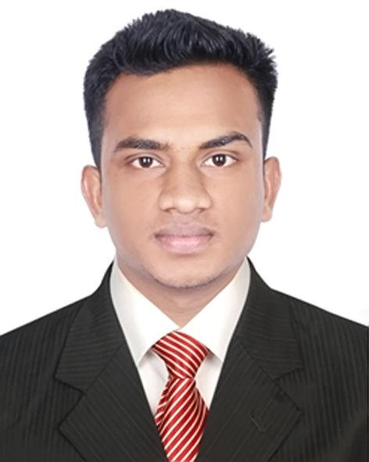

[moinulhossainmahim@gmail.com](mailto:moinulhossainmahim@gmail.com) (Email)

+880 1732748262 (Mobile)  
GitHub: <https://github.com/moinulhossainmahim>

LinkedIn: [https://www.linkedin.com/in/moinulhossainmahim](https://www.linkedin.com/in/moinulhossainmahim/)

**Career Objective:**

To work as a Programmer / Developer / IT Professional

**Experiences:**

* **TiBX LLC (Remote Part-Time)**

Designation: Junior Software Engineer (React)

Period: October 2022 - June 2023

Responsibilities:

* Develop and maintain user-facing features using React.js and related libraries.
* Collaborate with UI/UX designers to translate design mockups and wireframes into responsive and interactive web applications.
* Implement state management solutions such as Redux to manage application data and state.
* Work closely with backend developers to ensure seamless integration of front-end and back-end functionalities.
* Collaborate with product managers and stakeholders to understand and refine project requirements.
* Experiment with new technologies and tools that could enhance the development workflow and user experience.
* Write clean, efficient, and well-documented code while following coding standards and best practices.
* Participate in continuous integration and deployment (CI/CD) processes to ensure smooth and automated deployment of code changes.
* **Competitive Programming**
* Solved 200+ problems on different Online Judges with an adequate knowledge of Data Structures and Algorithms. Profile links:

- Codeforces: <https://codeforces.com/profile/moinulhossainmahim>

- LeetCode: <https://leetcode.com/moinulhossainmahim/>

- AtCoder: <https://atcoder.jp/users/mhmnub>

- HackerRank: <https://www.hackerrank.com/moinulhossain>

- UVa Online Judge: <https://uhunt.onlinejudge.org/id/1290858>

* Participated in online coding contests on different Online Judges.

**Computer Skills:**

* Programming / Scripting / Markup.
* Languages: JavaScript, TypeScript, C/C++, HTML, CSS.
* System: Linux Server Manage (Basic), Server monitoring etc.
* Database Management System: MySQL, MongoDB.
* Framework: Next.js, React, Node.js, Express.js, Nest.js, Tailwind CSS, Bootstrap.
* Tools & Libraries: Redux, Twilio, Keycloak, Material UI.
* IDE & Editor: Visual Studio Code, Vim, Sublime Text.
* Operating System: Ubuntu (Primary), Windows.
* DevOps Tools: Git, Docker (Basic), CI/CD.

**Portfolio Projects:**

* **Ecommerce Shop(Ongoing)**
  + An Ecommerce web application.
  + Technologies: React, React Typescript, Redux, Material UI, React Router, SASS, HTML, CSS.
  + Demo URL: <https://shop-ui-react.vercel.app/>
* **Ecommerce Shop Admin(Ongoing)**
  + An Ecommerce web application’s admin.
  + Technologies: Next.js, React, Typescript, Redux, Material UI, SASS, HTML, CSS.
  + Demo URL: <https://shop-admin-nextjs.vercel.app/>
* **US-BD IT Center**
  + IT Services based company
  + Technologies: HTML,CSS,JAVASCRIPT
  + Demo URL: <http://www.us-bdit.com/>
* **Cinehub**
  + A simple web app for searching Movies, Tv-series
  + Technologies: React, React Router Dom, Redux, TypeScript, Material UI, HTML5, CSS3
  + Demo URL : <https://cine-hub.netlify.app/>
* **Search Github User**
  + Search Github User By Username
  + Technologies: React, JavaScript, HTML5, CSS3
  + Demo URL : <https://github-user-reactjs.netlify.app/>
* **Quiz Application**
  + A simple Quiz Application
  + Technologies: React, JavaScript, HTML5, CSS3
  + Demo URL : <https://reactjs-quiz-application.netlify.app/>

**Academic Background:**

* Examination: Bachelor of Science

Department: Computer Science and Engineering

Year of Passing: Running

Institution: Northern University Bangladesh

Achieved GPA: 3.79 on a scale of 4.00 (Upto Second Year)

* Examination: Higher Secondary School Certificate

Department: Science

Year of Passing: 2020

Institution: Milestone College

Achieved GPA: 4.50 on a scale of 5.00

* Examination: Secondary School Certificate

Department: Science

Year of Passing: 2018

Institution: Jamila Khatun Chowdhury High School

Achieved GPA: 4.56 on a scale of 5.00

**Achievements:**

* Have participated in ICPC preliminary contests

**Strengths:**

* A team player
* Can skillfully negotiate
* Innovative in solving problems and Quick Learner
* Evaluate options before making decisions

**Language Proficiency:**

* Bengali - Native Language
* English - Fluent ( Reading, Writing), Intermediate ( Speaking)

**Personal Details:**

* Date of Birth: June 11, 2001
* Gender: Male
* Nationality: Bangladeshi
* Religion: Islam
* Marital Status: Unmarried
* Present Address: House 48, Road 5, Sector 12, Uttara, Dhaka
* Permanent Address: Village: West Dev Pur. Post office: Chandgazi. Upazila: Chhagalnaiya. Zila: Feni