Real- Time Jpeg Encoder Block Design
Alberto Lomeli, Simon Maurer, and Josafat Piraquive

Abstract — This paper presents the design process of a jpeg decoder segment from a functional level to a hardware design. To dimensioning the architecture we based our design decision on 3 steps, refinement of data types, communication and computations.
Our approach was to implement gradual steps of design modification from functional to RTL level, verifying that we met dB constraints every step before hardware calculation.

Index Terms – JPEG, encoder, RTL, specification languages

I. Introduction
Jpeg decoders are Hardware devices (either stand alone or as a component of video devices) implemented to compress images by eliminating high frequencies that have been quantized on the image. The process uses a set of Discrete Cosine Transforms as well as pattern scanning to compress and transfer the images to a decoder block.
- Task.
Design a decoder for the fig segment of a jpeg encoder diagram denominated “DCT Compressor”. Design considerations should be explained and HW Cost minimized.

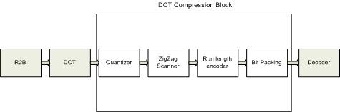
The following constraints were set up for the project.
1) Handle 1024x1024 pictures
2) 10 images per second.
3) Handle greyscale
4) Output rate of 1/8 of pixel clock rate.
5) Extra block that packs bits

B. Design Process and considerations.

Based on three different steps:

Data Refinement

First of all we design our functional architecture taken generic data types (int_32) for each module of the DCT compressor. Once we were able to achieve a functional design, we perform an optimization of each data types on the ports, signals and variables inside each module. To perform this operation we analyse the range of the values that can be take for each port, signal and variable, then calculate how many bits are necessary to represent this range and we fix the data and size.

Specially on our design we have one port(quantize-input)as float type and a signal (temp_out) to store an operation performed with the table quantization. For this we implement a refinement to a fixed point, data type. Modeling a fixed point are:
Input_quantize: sc_fixed <23,13>
Value_variable: sc_fixed<23,13>

With these changes(Version 3.0) we are able reduce the area and power and increase the speed of out architecture, which can be seen on, the value of the SNR:
SNR
Float point
Fixed point

- Task achieve: Perform fixed point refinement for the DCT compression.

Communication Refinement

For this point we develop a design structured on gradual communication refinement:
- Implementation and test of FF2P and P2FF converters between each module of the DCT Compression Block. (Version. 1.0)
- Integration of one modules FF2P or P2FF, inside each module in order to implement directly protocol communication between each module.(Version 2.0).
- Integration of both modules FF2P and P2FF.

One of the big steps followed on our implementation was changing the communication between processes via point-to-point queues for protocols which are required in the architecture for our design.

During this phase we faced several issues performing the handshaking between each module and taking care of the synchronization,

Computation Refinement

Finally our last step on our design decision was the implementation from behavioural blocks to RTL modules.

Based on integration of the handshaking protocol in the communication refinement we design clocked FSM for each module of the DCT Compression Block. Which enable us to implement RTL model for each block, where we perform decisions on the scheduling of the hardware implementation, modifying the constructor for each module instead using Threads we use Methods sensitive to the clock, an adding a reset signal to the module.

One representative change implemented was the implementation of signal to perform the communication between processes.

Thanks to the steps followed before at this phase of the design we were able to start to evaluate the performance of each block with the trade-off between the functional models of some blocks, reducing the hardware cost, memory and time requirement:
- Quantize block: Implementing just one comparation Saves: Hardware cost(comparator and adder), Vs Memory Size(increment on the variable of the comparator).
- Zig-Zag Block: Implementing on the memory the values “addresses” of the Zig- Zag positions and save it on an array. Saves: Hardware cost(2 comparators and adder), Vs Memory(64x8bits).

Once we achieve a working version with a RTL model of each block , we proceeded to implement to the design of a union of all the blocks in just one block, where we found:
- Integration Quantize, ZigZag and RL_encoder:
Saves: Hardware cost(comparator, adder)Memory Access.

- Task achieve: Perform scheduling for the hardware unit that realizes the DCT compression.

We followed the steps taught to us during the time in class.
-Established a working repository on Github. We Are able to set versions every time we achieve a milestone or go back if required.
-Used the provided program under Khan Network communication.
- Established intermediate protocol blocks (ff2p.h and p2ff.h provided) between functions so we could replace them individually and still be able to verify correct functionality. Then we recoded all.
-Generated State Machines for each function so we would get closer to RTL implementation of the assignment.
- Changed variables used so we can comply with synthesizable subset rules.

II. Approach
- Measuring Execution time
By finding a worst case scenario (Picture can be outputted every 100ms. We can immediately start to work, that would mean that we can input a picture without pipeline and it will meet that demand.

All of our projects meet this constraint as we run execution at 20 milliseconds with a 1 ns clock. With a maximum db loss at our last step (RTL model of every individual loss) equal to SNR .0001db.
Next step would be to adjust to the constrain of pixel rate/8 clock.
We immediately realize that one of the biggest constrains to our throughput is the zig zag Scanner element. We moved to an array containing the locations on the zigzag, therefore limiting or processing time to a single for function. Of 64.

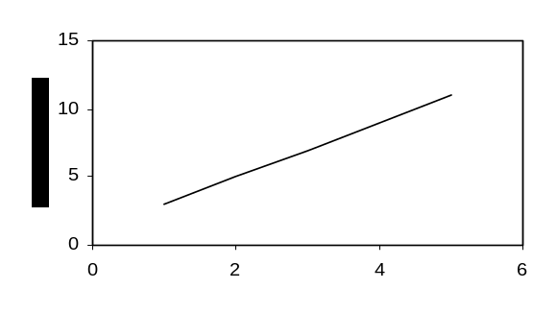
Magnetization (kA/m)
Applied Field (10³ A/m)
Fig. 1 Magnetization as a function of applied field.
Note how the caption is centered in the column.
B. RTL Unification and timing issues
Establishing the protocols between state machines required an optimization of the existing code into a friendlier code for state machines; one of the considerations in this sense was to create states where 2 nested for functions would be evaluated at once. We eliminated loops and tried, when possible, to immediately output values in order to avoid storage where some of the other actions taken.
We minimized the use of variables, and used unsigned integers in cases like counters.

C. Critical Path and output calculation
-Planned to vcdtrace the input and output of our components to establish if our assumption that zigzag (or other) block is considerably slower than the rest.
-Once no block would be seen as considerably different, we would then optimize critical paths.
D. Equations

Check tomorrow with professor regarding time

E. Hardware Calculation
-Once the critical path was within constraints, we could proceed to calculate elements and area required.
-If elements are too irregular or area prohibitive, we would analyze what of

III. Proposed Improvements Before HW Calculations
IV. Some Common Mistakes
- M. King and B. Zhu, “Gaming strategies,” in Path Planning to the West, vol. II, S. Tang and M. King, Eds. Xian: Jiaoda Press, 1998, pp. 158-176.
- B. Simpson, et al, “Title of paper goes here if known,” unpublished.
- J.-G. Lu, “Title of paper with only the first word capitalized,” J. Name Stand. Abbrev., in press.
- Y. Yorozu, M. Hirano, K. Oka, and Y. Tagawa, “Electron spectroscopy studies on magneto-optical media and plastic substrate interface,” IEEE Translated J. Magn. Japan, vol. 2, pp. 740-741, August 1987 [Digest 9th Annual Conf. Magnetics Japan, p. 301, 1982].

