**Cryostream 800**

**Software Architecture**

**Ref: Cryostream800.SAD Rev. 0.1**



**March 20 EMBL HAMBURG**

**Notkestrasse 85**

**22607 Hamburg**

# **Document Status**

|  |  |  |  |
| --- | --- | --- | --- |
| **Reference** | **Version** | **Date** | **Status** |
| **Cryostream800.SAD** | **Rev. 0.1** | **17/03/2020** | **WIP** |
| Author(s) | Moises Bueno | | |
| Short Description | Description of the software architecture for cryogenics | | |
| Approvals: | Stefan Fiedler **Date**: 17/03/2020 | | |

# **Changes Registry**

|  |  |  |  |  |
| --- | --- | --- | --- | --- |
| **Version** | **Rev.** | **Date** | **Details** | **Author** |
| **0** | **1** | **17/03/2020** | **Initial** | **Moises Bueno** |
|  |  |  |  |  |
|  |  |  |  |  |
|  |  |  |  |  |
|  |  |  |  |  |
|  |  |  |  |  |
|  |  |  |  |  |
|  |  |  |  |  |

# **Acronyms & Abbreviations**

|  |  |
| --- | --- |
| **Acronym** | **Meaning** |
| EMBL | European Molecular Biology Laboratory |
| GUI | Graphical User Interface |
| TINE | Three-fold Integrated Networking Environment |
| LN2 | Liquid Nitrogen |
| MX | Macrocrystallography |
| CDH | Crystal Direct Harvester |
| EPICS | Experimental Physics and Industrial Control Systems |
| PC | Personal Computer |
| VI | Virtual Instrument (Labview code) |

# **Table of Contents**

**Document Status** 1

**Changes Registry** 1

**Acronyms & Abbreviations** 2

**Table of Contents** 3

**Table of Figures** 4

**CHAPTER 1. INTRODUCTION** 6

**1.1 Purpose** 6

**1.2 Overview** 6

**CHAPTER 2. Cryoconnector Software** 6

**CHAPTER 3. Labview Software** 9

**3.1 Overview** 9

**3.2 Server Project** 9

**3.2.1 Sub-functions (Sub-vi’s)** 9

**3.2.1.1 Network Detector (NetworkDetector.vi)** 9

**3.2.1.1 Read Connection (ReadConnection.vi)** 10

**3.2.1.1 Read Info (ReadInfo.vi)** 14

**3.2.1.1 Read Status (ReadStatus.vi)** 16

**3.2.1.1 Set Temperature (Cool.vi)** 20

**3.2.2 Server** 22

**3.3 Client** 24

# **Table of Figures**

Figure 1. USB Driver 5

Figure 2. Website Cryoconnector 6

Figure 3. Download Cryoconnector 6

Figure 4. Cryoconnector: No Device Connected 7

Figure 5. Cryoconnector: Device Connected 7

Figure 6. Network Detector - GUI 8

Figure 7. Network Detector - Block Diagram 9

Figure 8. Read Connection - steps 10

Figure 9. Read Connection – Active Connection 10

Figure 10. Read Connection - Loading File Error 11

Figure 11. Read Connection - Parsing Error 11

Figure 12. Read Connection - FILO 12

Figure 13. Read Connection - GUI 12

Figure 14. Read Info - steps 13

Figure 15. Read Info - Empty Path 14

Figure 16. Read Info - Error Loading File 14

Figure 17. Read Info - Error Parsing 14

Figure 18. Read Info - FILO 15

Figure 19. Read Info - GUI 15

Figure 20. Read Status - Steps 16

Figure 21. Read Status - Error In 17

Figure 22. Read Status - Empty Path 17

Figure 23. Read Status - Error Loading File 17

Figure 24. Read Status - Error Parsing 18

Figure 25. Read Status - FILO 18

Figure 26. Read Status - GUI 18

Figure 27. Set Temperature - Block Diagram 20

Figure 28. Set Temperature - GUI 20

Figure 29. Server – Readout Loop 21

Figure 30. Server - Command Loop 22

Figure 31. Server - Clients Loop 22

Figure 32. Server - GUI (No Connection) 23

Figure 33. Server - GUI (Active) 23

Figure 34. Client – Readout Loop 24

Figure 35. Client - Command Loop 24

Figure 36. Client - GUI 25

# **CHAPTER 1. INTRODUCTION**

## **1.1 Purpose**

This document contains a detailed description of the software developed to connect, readout values and control the Cryostream 800 of Oxford Cryosystems using LabView.

## **1.2 Overview**

EMBL has at least 4 cryostream controllers, 3 in operation and 1 spare unit. They are located in P13 experimental hutch, P14 experimental hutch and in the CD harvester room. The cryostreams 800 allows the user to set the temperature of the LN2 gas and readout a hugh amount of values which are important for the correct functioning of the system. Oxford Cryosystems provides a piece of software called Cryoconnector which is the bridge between the hardware and the LabView application.

# **CHAPTER 2. Cryoconnector Software**

The cryostream 800 controller is possible to connect via usb to a personal computer (PC) however the usb driver has to be downloaded and installed manually. The drivers can be downloaded from <http://www.ftdichip.com/FTDrivers.htm>

1. Click on VCP Drivers under Drivers
2. Choose according your Windows configuration

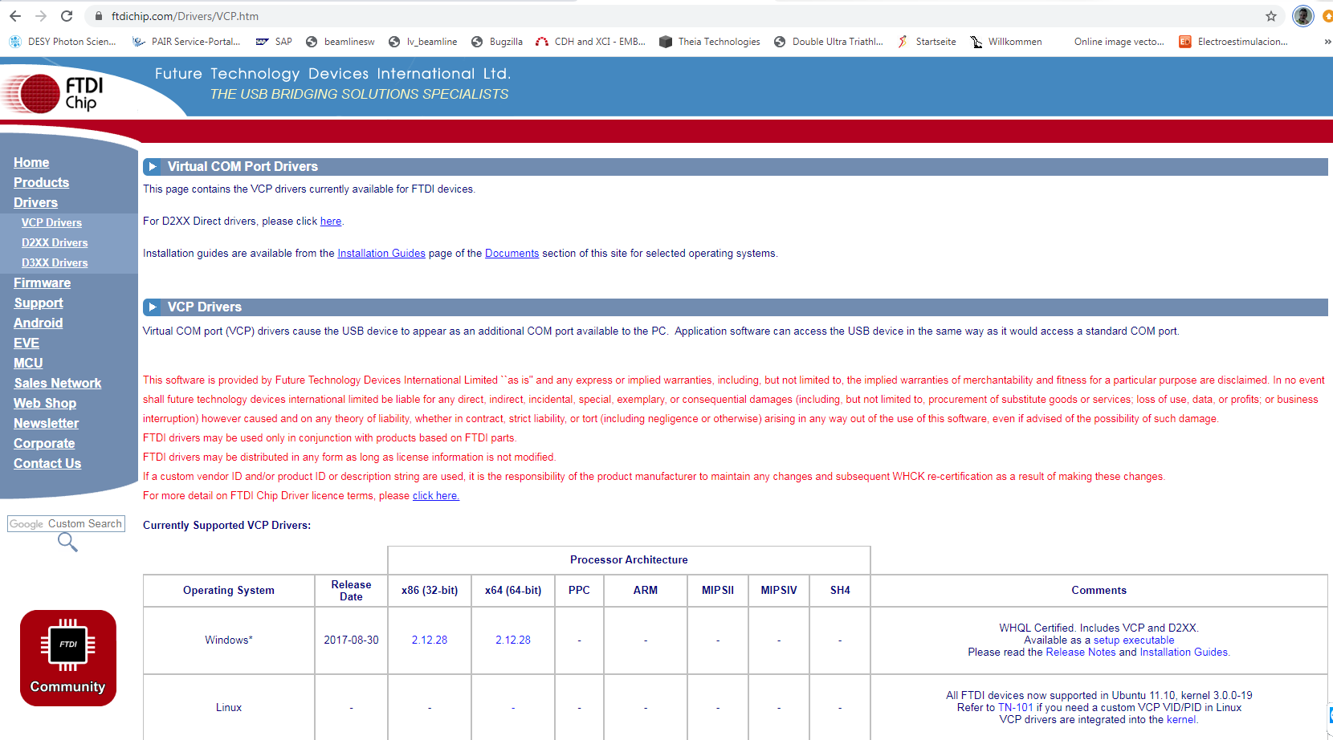

Figure 1. USB Driver

Using this option you are sure you get the latest, nevertheless there is an already downloaded version in tineshare\Programs called CDM v2.12.28 WHQL Certified

For installing the driver, locate the unknown device under Start\

Control Panel\Device Manager, right click on Update driver and choose the location where the file has been downloaded (and unzipped). Restart the PC probably is not necessary but good to do.

Download the latest version of cryoconnector from <https://www.oxcryo.com/content/control-software>

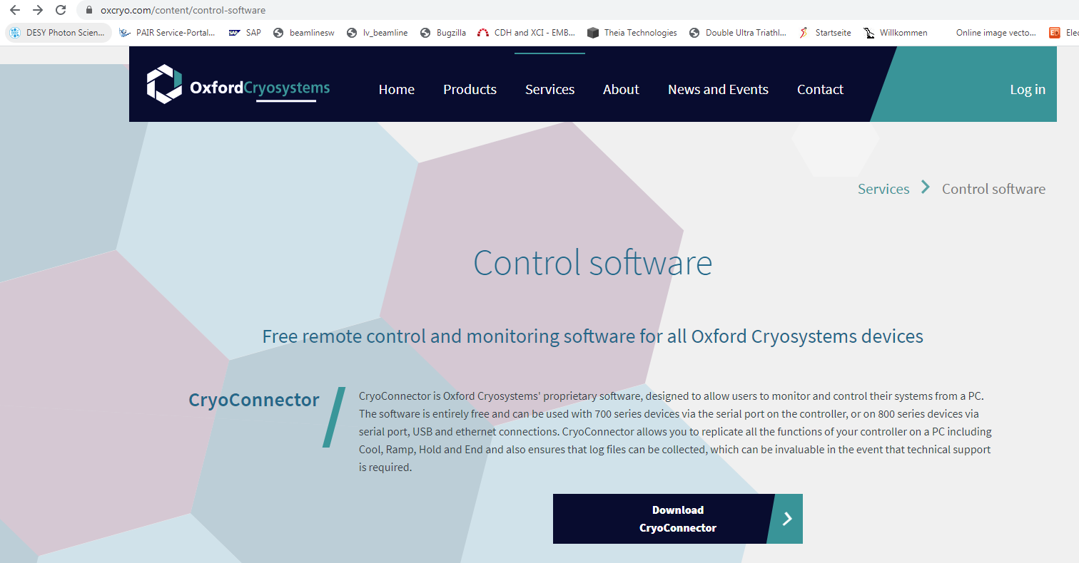

Figure 2. Website Cryoconnector

Click on Download CryoConnector

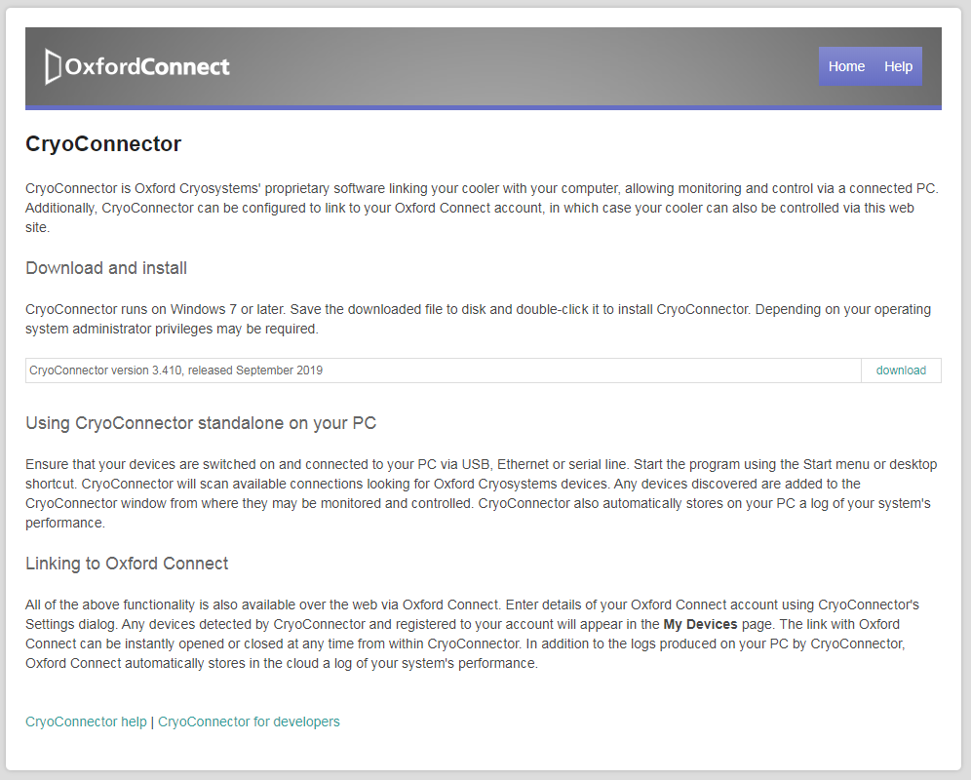

Figure 3. Download Cryoconnector

Click on download.

Once downloaded, it can be installed.

Using the icon on the desktop the software can be launched.

This software will scan for any controller connected. In case of no controller detected, the software will report accordingly showing the message as shown in the figure below.

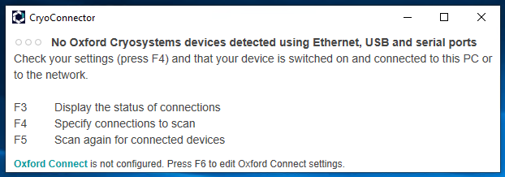

Figure 4. Cryoconnector: No Device Connected

In case of a controller detected, the data will be shown as in the figure below.

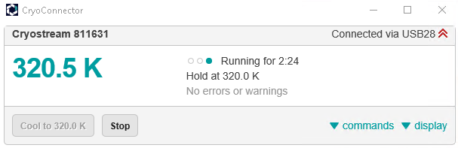

Figure 5. Cryoconnector: Device Connected

CryoConnector allows the communication with the Cryostream 800 controllers by the exchange of XML files, whilst CryoConnector handles all communication with the device. During the installation of Cryoconnector the file paths are creatred. In our case there are two paths important for use

1. C:\Users\user\AppData\Roaming\CryoConnector -> Here we can find the files
   1. connections.xml. This is a read only file, it offers all the information related to the connection, like serial number of the device connected.
   2. Lastcommand.xml. This is a write only file, it is used to command the controller. We will use it to set the temperature. Cryoconnector will check for this file, in case there is a change it will execute the command.
2. C:\Users\user\AppData\Roaming\CryoConnector\[serial number] -> Here we can find the file
   1. status.xml. This is a read only file where Cryoconnector is updating all the values and units of the controller.

# **CHAPTER 3. Labview Software**

## **3.1 Overview**

The aim of this project is to create a Labview code that can read and write XML files and push and pull data from and to TINE servers. In addition to this a client will be developed in order to read and send data to the devices through TINE

## **3.2 Server Project**

The server project is compound of the main VI called Cryostream800.vi and several sub-vi’s used to dial with not only the XML files but also with the network.

## **3.2.1 Sub-functions (Sub-vi’s)**

Sub-function, also called sub-vi’s have been programmed and used to have a clearer environment, making easier to follow the code.

### **3.2.1.1 Network Detector (NetworkDetector.vi)**

As it was mentioned earlier in this document, EMBL has several cryostream controllers. Therefore, the idea is to have only one piece of code that can be used with each one of them without changing the code. Then, the first step is to detect in which network the device is connected in order to start the proper server.

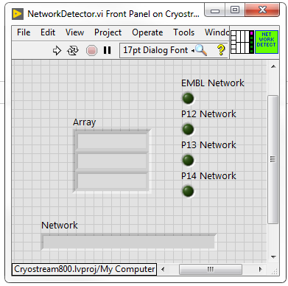 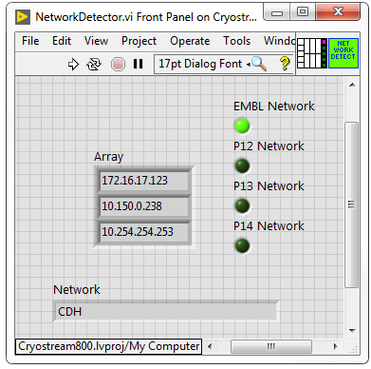

Figure 6. Network Detector - GUI

When this VI is run, it will check all the Ethernet ports to detect to which network is connected to.

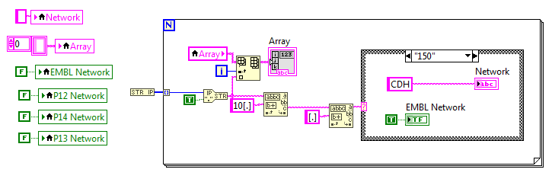

Figure 7. Network Detector - Block Diagram

The *FOR* loop is used in order to scan all the Ethernet ports available in the computer, otherwise it would take only the first one, that could happen to be one that is not connected. In every iteration of the loop each IP found is parsed and stored in an array.

The parsing is done by looking in the second field of the IP address (the string between the first two points), that means that when an IP like 10.14.10.19 is found, the second field is 14, then the P14 network is detected. **It is important to put the point between brackets, otherwise the parsing fails. The point is considered a special character and needs to be between brackets.**

This VI provides 5 outputs: 4 booleans corresponding to EMBL, P12, P13 and P14 and 1 string indicating network. In this case, when the EMBL network is detected corresponds to the CDH Cryostream controller.

### **3.2.1.1 Read Connection (ReadConnection.vi)**

This VI is used to detect whether there is a controller connected to the PC or not.

It has an input parameter which is the XPath expression to be used in the XML file to find the node.

The task of this VI is to readout the data from the XML file called connections.xml. This VI provides important information:

1. Id: serial number of the controller connected. This is a unique number.
   1. ConnectionStatus: if an Id is found in the xml file, the connection status is set to “Active”. When there is no id in the file, this output is set to “No connection”.
   2. Path: when an Id is found, the path where the status.xml is located can be also found in the file.
2. LastUpdated: timestamp of the last update of values. It allow us to detect whether the Cryoconnector program is running or not.

The connection.xml is written all the time by the Cryoconnector software. To avoid conflicts between Cryoconnector and Labview to access the file, the file is copied to a different location (the folder where the executable is stored) and the parsing is done to the copy.

As it can be seen in the figure below, the steps would be:

1. Copy the xml file
2. Open the xml file
3. Get the data using the XPath expression */LIST_OF_CONNECTIONS*
4. Parsing the output to get the id and the timestamp of the last update
5. If the id is found, parsing the output to get the path of the status.xml.
6. Close all open nodes. The way we stablish the sequence as usual is using the error wire, then the idea is keep in mind this: First In, Last Out (FILO). The first node that you open, must be the last to be closed.

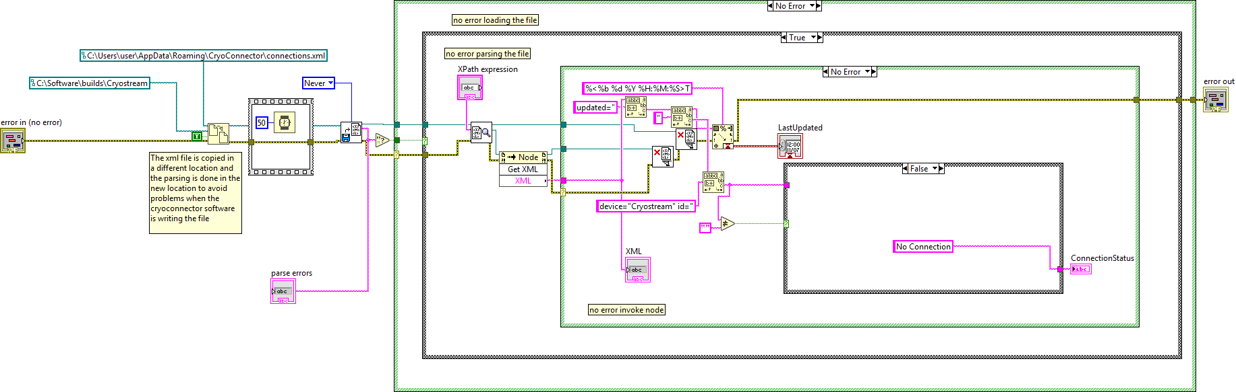

4

6

1

3

2

Figure 8. Read Connection - steps

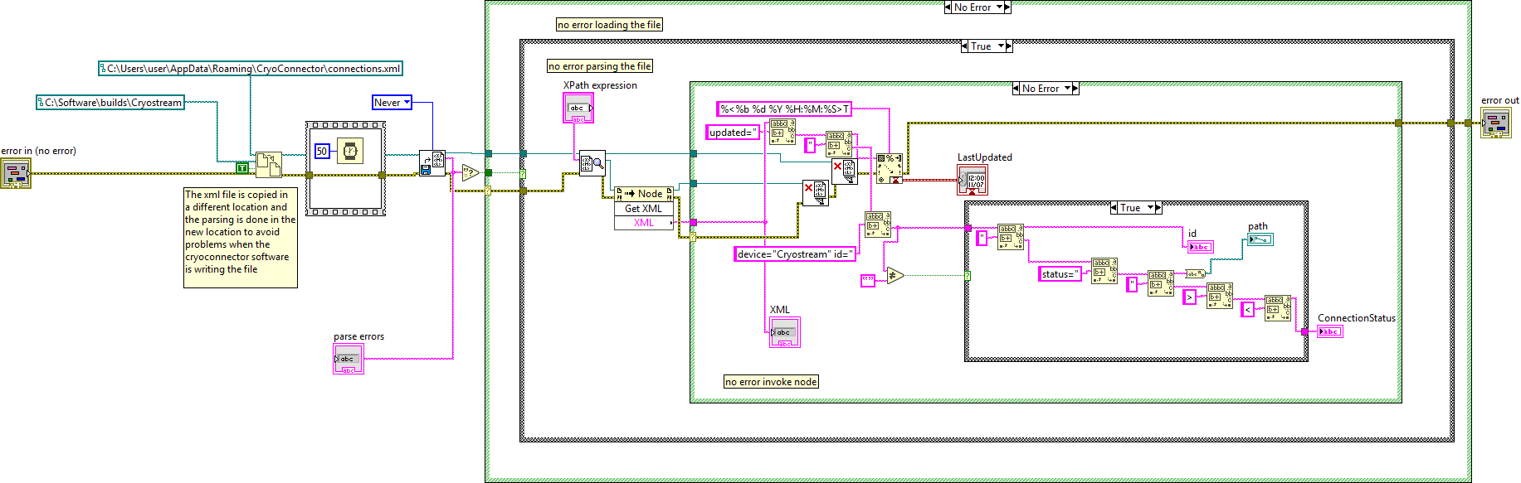

5

Figure 9. Read Connection – Active Connection

In case there is an error loading the file, the node is closed.

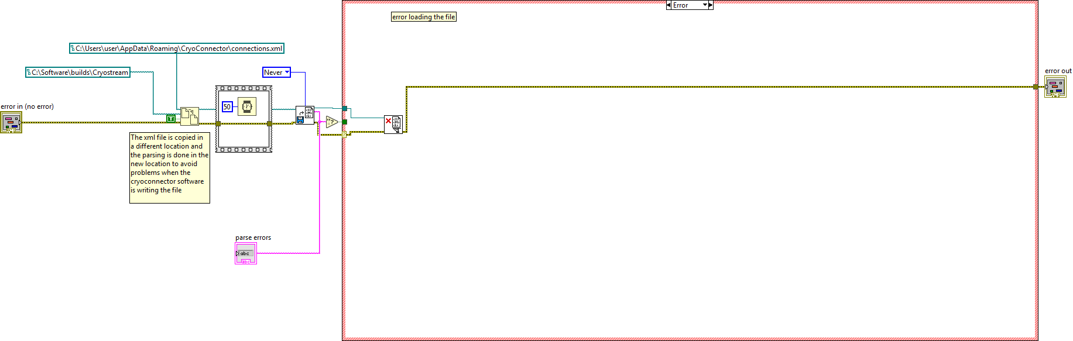

Figure 10. Read Connection - Loading File Error

The same happens when the error occurs when getting the data from the node. It is very important to close the nodes. Otherwise there will be an important leak of memory.

There is another aspect to be taken into account. In order to be sure that the parsing is done properly, we check that the error string output of the open XML file VI is empty. This output only gets values when there is an error. In case of an error during parsing, the node is closed.

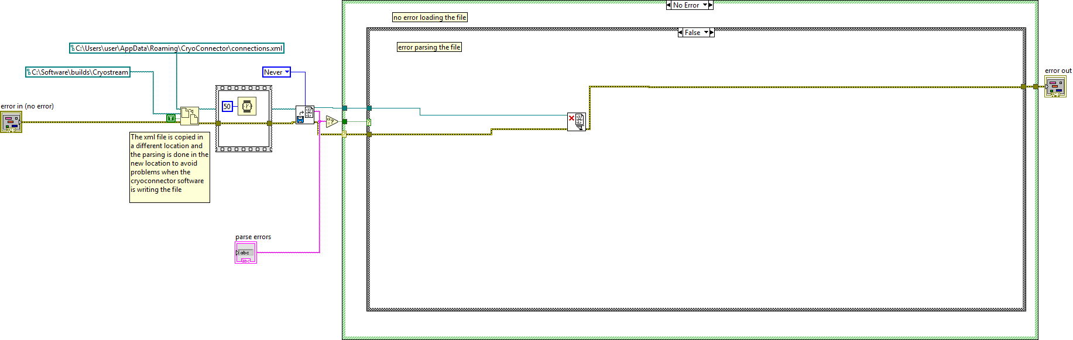

Figure 11. Read Connection - Parsing Error

It is important to close the nodes not only when they are used but also when there are errors.

In the figure below the FILO is explained.



Close node 1

Close node 2

Open node 2

Open node1

Figure 12. Read Connection - FILO

The GUI of this VI is shown below.

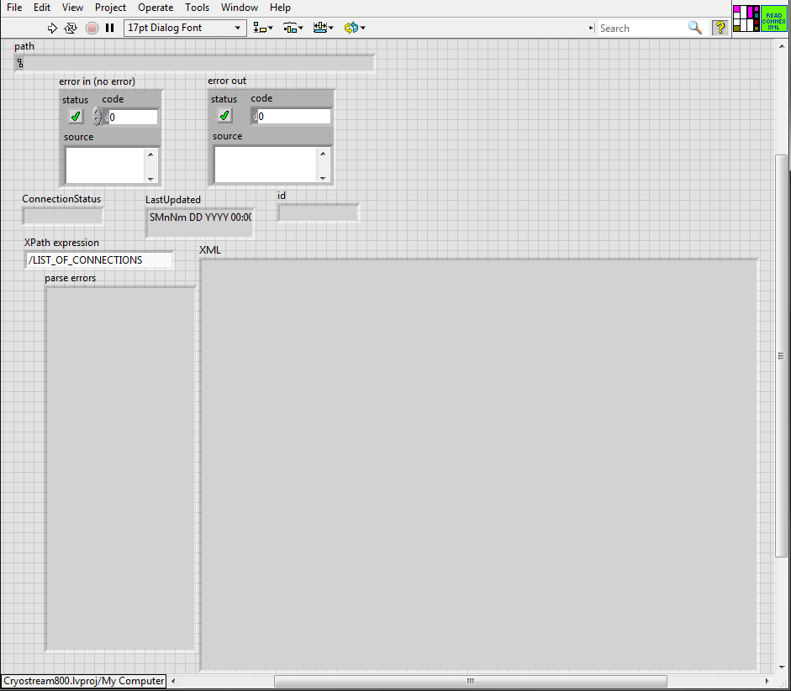

Figure 13. Read Connection - GUI

As it can be seen, the VI has two input terminals (controls) and 5 output terminals (indicators) and two internal indicators:

1. Controls:
   1. XPath (input terminal)
   2. Input error (input terminal)
2. Indicators:
   1. Connection status (output terminal)
   2. Id (output terminal)
   3. LastUpdated (output terminal)
   4. Path (output terminal)
   5. Error out (output terminal)
   6. Parse error (error indicator when loading a xml file)
   7. XML (content of the XML file)

An example of the node in the xml file could be these one:

<LIST_OF_CONNECTIONS updated="Mar 25 2020 12:33:58">

<CONNECTION server="401" properties="C:\Users\User\AppData\Roaming\CryoConnector\coolers\Cryostream.xml" status="C:\Users\User\AppData\Roaming\CryoConnector\811631\status.xml" alias="" device="Cryostream" port="USB28" id="811631">Active</CONNECTION>

</LIST_OF_CONNECTIONS>

### **3.2.1.1 Read Info (ReadInfo.vi)**

This VI is used to read the phase status of the controller, therefore it is possible to know whether the controller is cooling down, ramping up or holding the sample temperature that has been set. This information is extracted from the status.xml but from a different node.

This VI must worked in conjunction with the readconnection.vi, because readconnection.vi is providing the path where the status.xml file is located. The procedure is quite similar.

As it can be seen in the figure below, the steps would be:

1. Copy the xml file. After copying the file there is a small delay of 50ms.
2. Open the xml file
3. Get the data using the XPath expression */COOLER_STATUS/LIST_OF_INFO/INFO*
4. Parsing the output to get the info and the values in form of two arrays. These arrays obtained using the FOR loop.
5. Close all open nodes. The sequence of closing nodes is very important, otherwise the VI will fail. The way we stablish the sequence as usual is using the error wire, then the idea is keep in mind this: First In, Last Out (FILO). The first node that you open, must be the last to be closed.

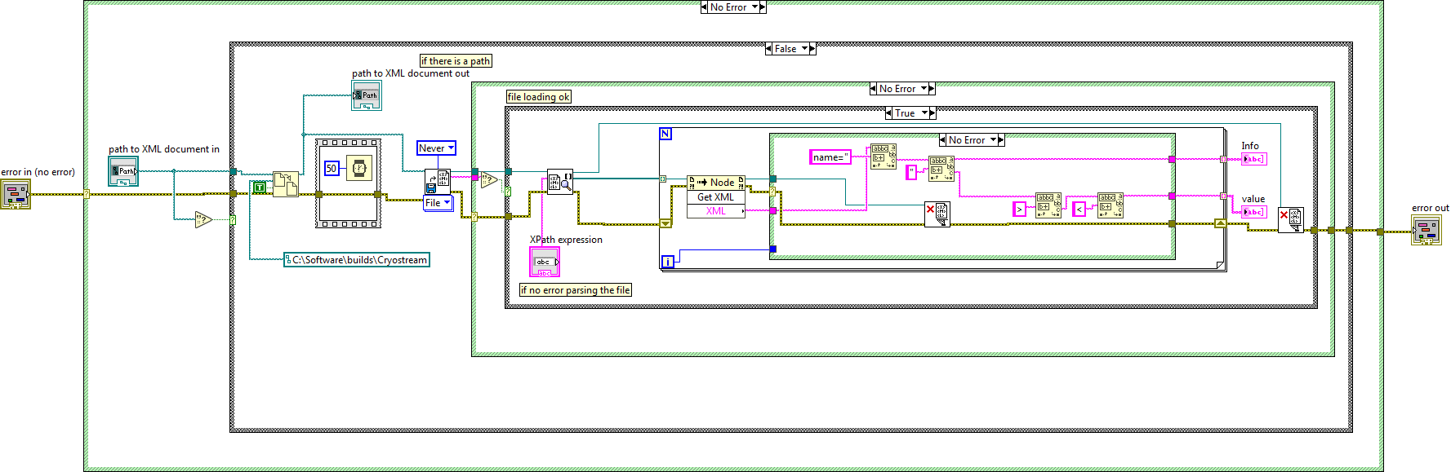

5

2

3

4

1

Figure 14. Read Info - steps

This VI has a compulsory parameter that is the path to the status.xml. In case that the path is empty, nothing will happen inside the VI.

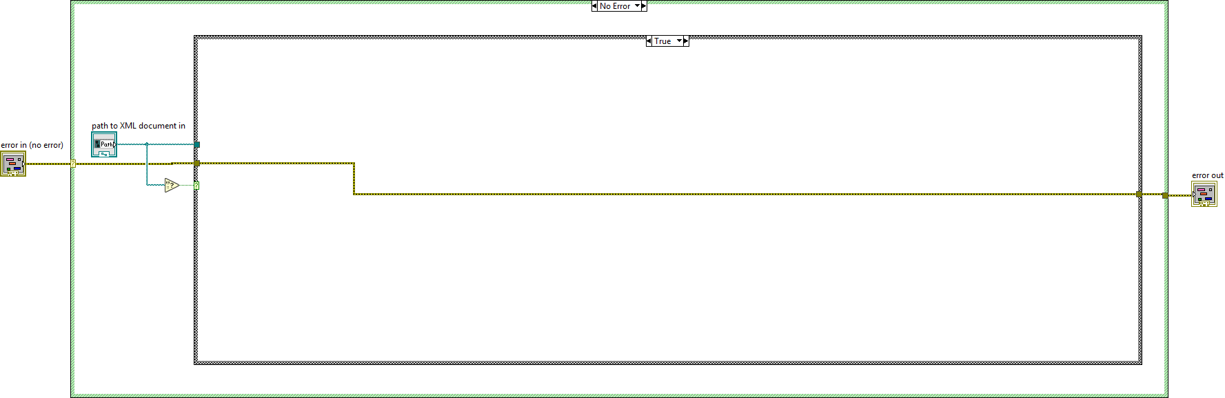

Figure 15. Read Info - Empty Path

In case of errors, we proceed exactly the same manner than in the readconnection.vi. In case there is an error loading the file, the node is closed.

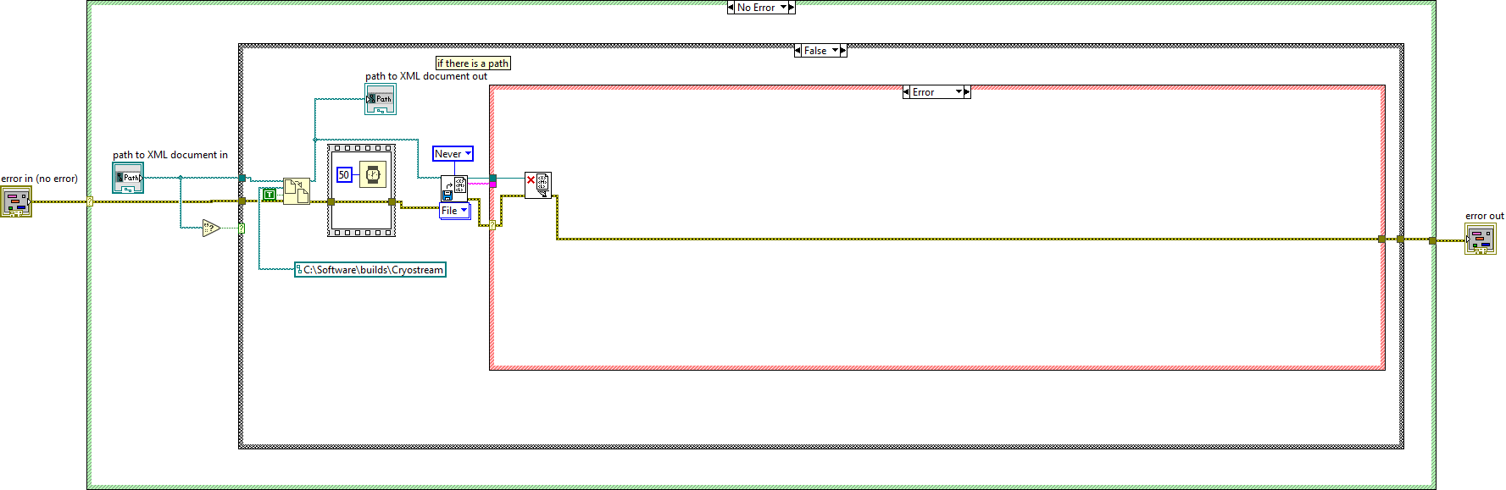

Figure 16. Read Info - Error Loading File

There is another aspect to be taken into account. In order to be sure that the parsing is done properly, we check that the error string output of the open XML file VI is empty. This output only gets values when there is an error.

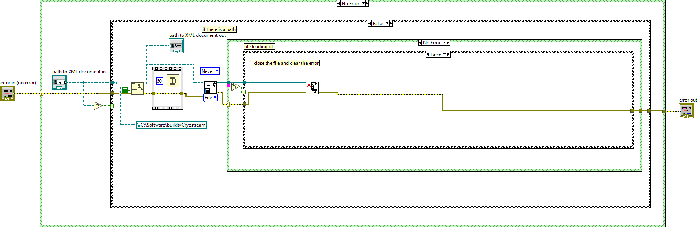

Figure 17. Read Info - Error Parsing

It is important to close the nodes not only when they are used but also when there are errors.

In the figure below the FILO is explained (again).



Close node 1

Close node 2

Open node 2

Open node1

Figure 18. Read Info - FILO

The GUI is shown in the figure below

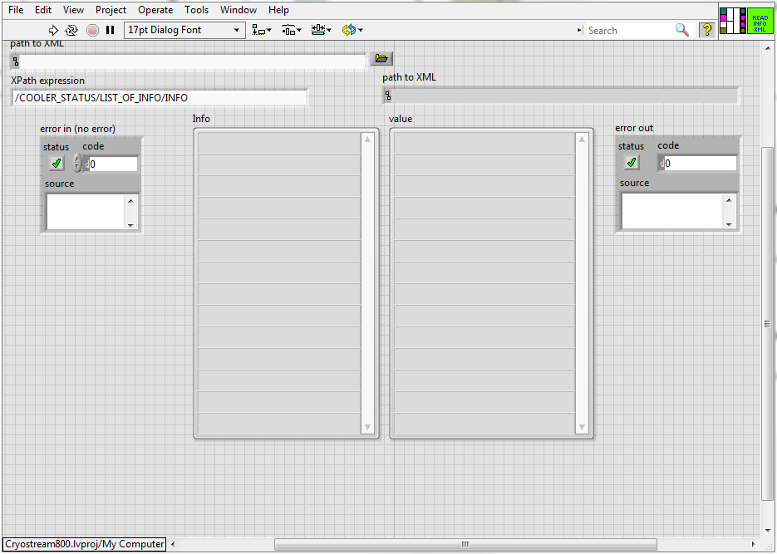

Figure 19. Read Info - GUI

As it can be seen, the VI has three input terminals (controls) and 4 output terminals (indicators):

1. Controls:
   1. XPath (input terminal)
   2. Path (input terminal)
   3. Input error (input terminal)
2. Indicators:
   1. Path (output terminal)
   2. Info (output terminal)
   3. values (output terminal)
   4. Error out (output terminal)

An example of the node in the xml file could be these one:

  <LIST_OF_INFO>

    <INFO name="Device name">Cryostream 7111023</INFO>

    <INFO name="Device alias">My Cryostream </INFO>

    <INFO name="Device status">Running for 3.0 days</INFO>

    <INFO name="Phase status">Ramp at 360.0 K/hour to 100.0 K</INFO>

    <INFO name="Alarm status">No Alarm</INFO>

    <INFO name="Time stamp">Jul 03 2012 17:47:11</INFO>

   </LIST_OF_INFO>

</COOLER_STATUS>

Although we are retrieving all the information, the current value used is the Phase status to determine what the controller is doing at this exact moment..

### **3.2.1.1 Read Status (ReadStatus.vi)**

This VI is used to read all the important data of the controller. This information is extracted from the status.xml but from a different node.

This VI must worked in conjunction with the readconnection.vi and readinfo.vi because they provides the path where the status.xml file is located and also generates the copy of the XML.

The procedure is quite similar.

As it can be seen in the figure below, the steps would be:

1. Open the xml file (this is the copy)
2. Get the data using the XPath expression */COOLER_STATUS/LIST_OF_PROPERTIES/PROPERTY*
3. Parsing the output to get the info and the values in form of three arrays (properties, values and units). These arrays are obtained using the FOR loop.
4. Close all open nodes. The sequence of closing nodes is very important, otherwise the VI will fail. The way we stablish the sequence as usual is using the error wire, then the idea is keep in mind this: First In, Last Out (FILO). The first node that you open, must be the last to be closed.

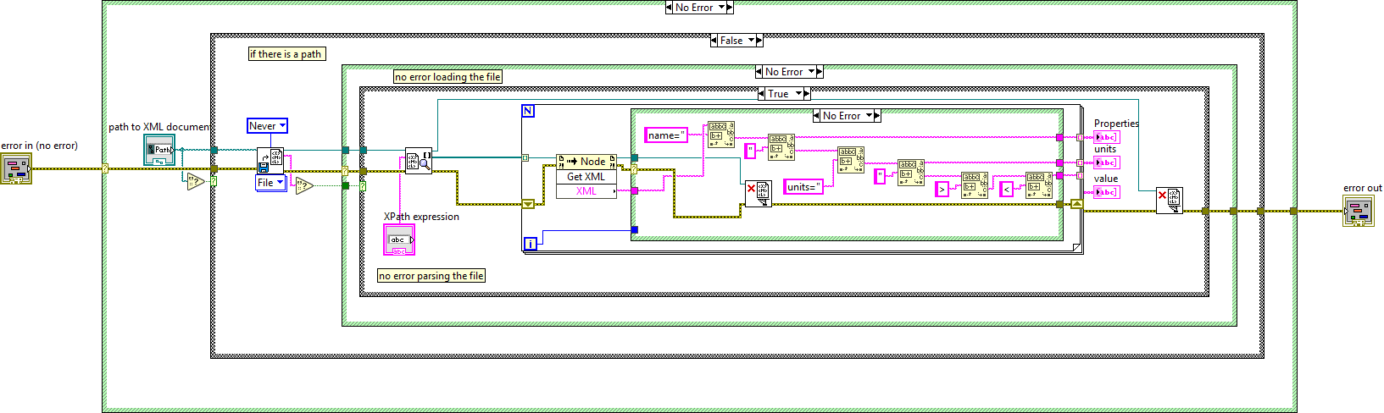

4

4

3

2

1

Figure 20. Read Status - Steps

If an error is coming from the previous VI, this VI will not be executed.

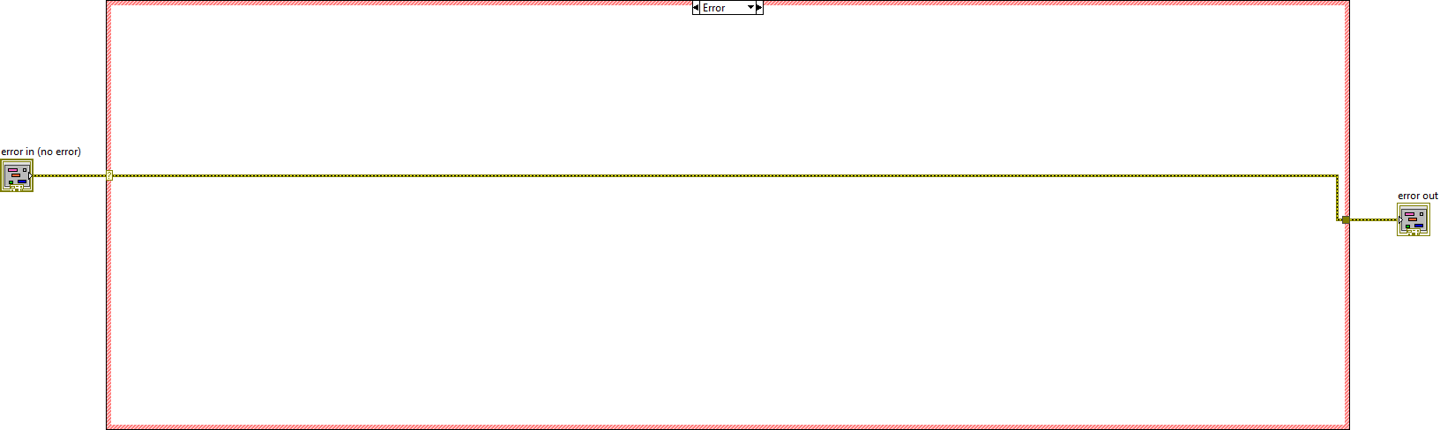

Figure 21. Read Status - Error In

This VI has a compulsory parameter that is the path to the status.xml. In case that the path is empty, nothing will happen inside the VI.

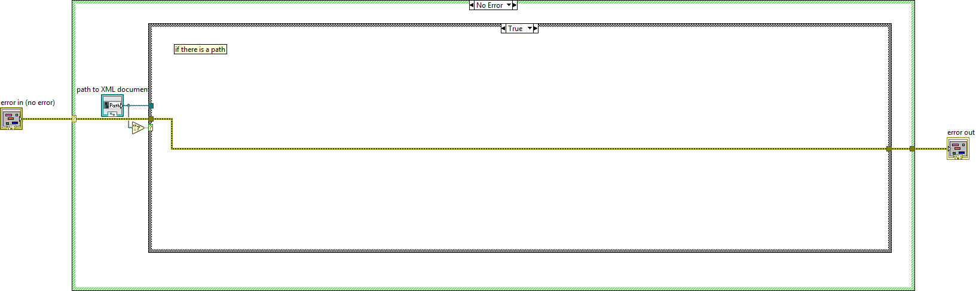

Figure 22. Read Status - Empty Path

In case of errors, we proceed exactly the same manner than in the readconnection.vi and readinfo.vi In case there is an error loading the file, the node is closed.

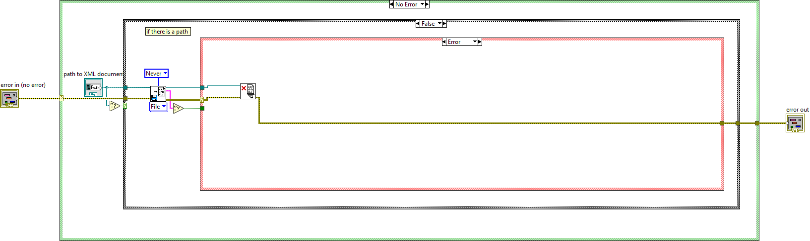

Figure 23. Read Status - Error Loading File

There is another aspect to be taken into account. In order to be sure that the parsing is done properly, we check that the error string output of the open XML file VI is empty. This output only gets values when there is an error.

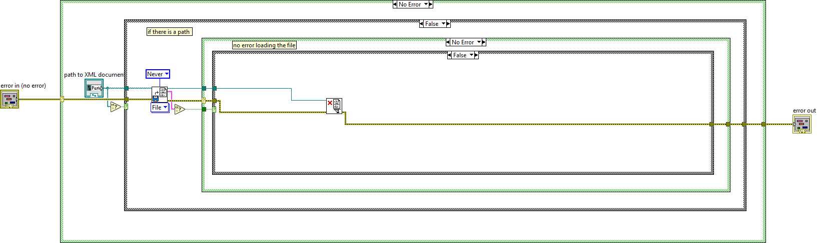

Figure 24. Read Status - Error Parsing

It is important to close the nodes not only when they are used but also when there are errors.

In the figure below the FILO is explained.



Close node 2

Close node 1

Open node 2

Open node1

Figure 25. Read Status - FILO

The GUI is shown in the figure below

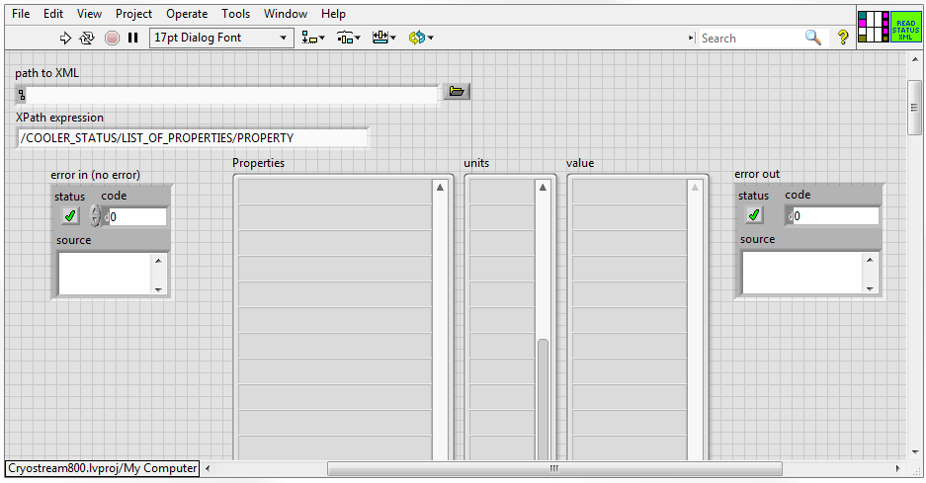

Figure 26. Read Status - GUI

As it can be seen, the VI has three input terminals (controls) and 4 output terminals (indicators):

1. Controls:
   1. XPath (input terminal)
   2. Path (input terminal)
   3. Input error (input terminal)
2. Indicators:
   1. Properties array (output terminal)
   2. Units array (output terminal)
   3. Values array (output terminal)
   4. Error out (output terminal)

An example of the node in the xml file could be these one (with every upgrade of the firmware the list is increased!):

<?xml version="1.0" encoding="UTF-8"?>

<COOLER_STATUS>

  <COOLER name="Cryostream"></COOLER>

  <COOLER_PROPERTIES>Cryostream.xml</COOLER_PROPERTIES>

  <LIST_OF_PROPERTIES>

    <PROPERTY name="Set temp" units="K">101.6</PROPERTY>

    <PROPERTY name="Sample temp" units="K">101.5</PROPERTY>

    <PROPERTY name="Run mode" units="">3</PROPERTY>

    <PROPERTY name="Phase id" units="">0</PROPERTY>

    <PROPERTY name="Ramp rate" units="K/hour">360</PROPERTY>

    <PROPERTY name="Evap temp" units="K">77.5</PROPERTY>

    <PROPERTY name="Suct temp" units="K">290.5</PROPERTY>

    <PROPERTY name="Gas flow" units="l/min">10.0</PROPERTY>

    <PROPERTY name="Gas heat" units="%">26</PROPERTY>

    <PROPERTY name="Evap heat" units="%">54</PROPERTY>

    <PROPERTY name="Average suct heat" units="%">12</PROPERTY>

    <PROPERTY name="Back pressure" units="mbar">150</PROPERTY>

    <PROPERTY name="Alarm code" units="">0</PROPERTY>

    <PROPERTY name="Run time" units="hour">4321</PROPERTY>

    <PROPERTY name="Firmware version" units="">46</PROPERTY>

    <PROPERTY name="Average gas heat" units="%">32</PROPERTY>

    <PROPERTY name="Suct heat" units="">1</PROPERTY>

    <PROPERTY name="Total hours" units="hour">23102</PROPERTY>

  </LIST_OF_PROPERTIES>

Although we are retrieving all the information, the properties used are:

1. Sample temp
2. Evap temp
3. Suct temp
4. Gas heat
5. Evap heat
6. Average suct heat
7. FC Gas flow
8. FC Back pressure
9. FC Valve opening

These properties will be later used as TINE properties that the client will readout from the server.

### **3.2.1.1 Set Temperature (Cool.vi)**

This VI is used to write the xml file with the command that we want to execute. Therefore, the xml is created by adding the ID of the controller and the desired temperature. The Cryoconnector will recognize that a new XML is there and the command will be executed. Although there are more commands available, in our application we only set the sample temperature.

As it was mentioned before, the path to the location of the xml files is constant (set by the installation of the Cryoconnector program.

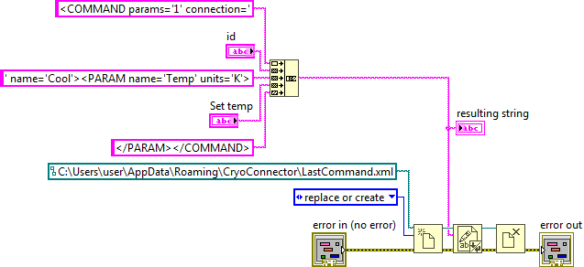

Figure 27. Set Temperature - Block Diagram

The GUI is shown below.

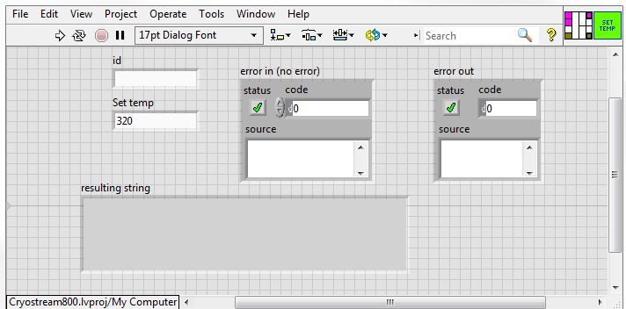

Figure 28. Set Temperature - GUI

As it can be seen, the VI has three input controls terminals (controls) and 1 output terminals (indicators):

1. Controls:
   1. Id (input terminal)
   2. Set Temp in Kelvin degrees (input terminal)
   3. Input error (input terminal)
2. Indicators:
   1. Resulting string (it shows the content of the created xml file)
   2. Error out (output terminal)

An example of the xml to set the temperature could be this where the connection id (81187) and the temperature (320) are the inputs parameters of the VI:

<COMMAND name=”Cool” connection=”811187” params=”1”>

<PARAM name=”Temp” units=”K”>320</PARAM>

</COMMAND>

## **3.2.2 Server**

This VI is considered the main VI of the application because it is considered the server. This VI is in charge of:

1. Detect the network.
2. Initiate the server according to the network detected
3. Check the connection to detect whether there is a controller connected.
4. Restart the Cryoconnector software if the last update is older than 5 minutes (this can be disabled)
5. Read the information of the controller (info and value arrays).
6. Read the status of the controller (properties, values and units arrays).
7. Extract values from arrays and push the data into the server.
8. Set the temperature locally (commands thread).
9. Accept requests from the client (clients thread). The client can only set the sample temperature.

This VI is compound of 3 threads:

1. Main thread is in charge of stablishing the sequence of calls of sub-vi’s, gathering all the information, parsing the arrays where needed and pushing the data into the server. The timing is not crucial, therefore the loop is executed every second (997ms).

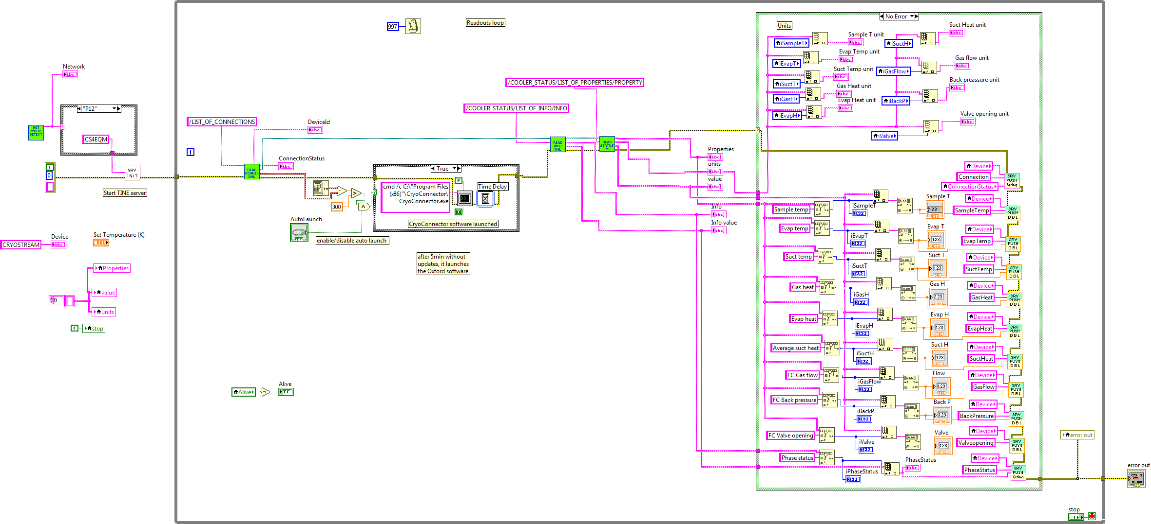

7

6

5

4

3

2

1

Figure 29. Server – Readout Loop

1. The commands thread is in charge of executing the commands coming from the server locally. Only the temperature can be set locally.

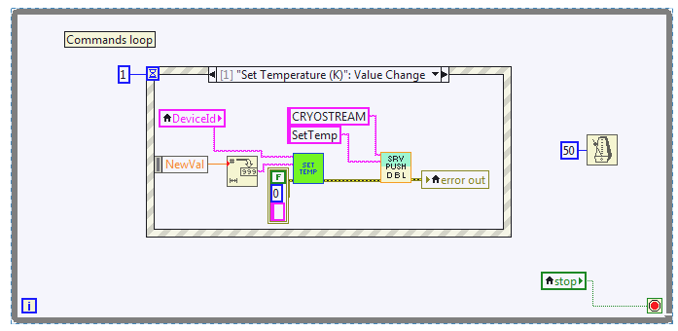

8

Figure 30. Server - Command Loop

1. Clients thread is waiting for commands coming from clients. Only the temperature can be set by the clients. In order to execute the command, first the data has to be pulled from the server and after the execution of the command the data is pushed to the server.

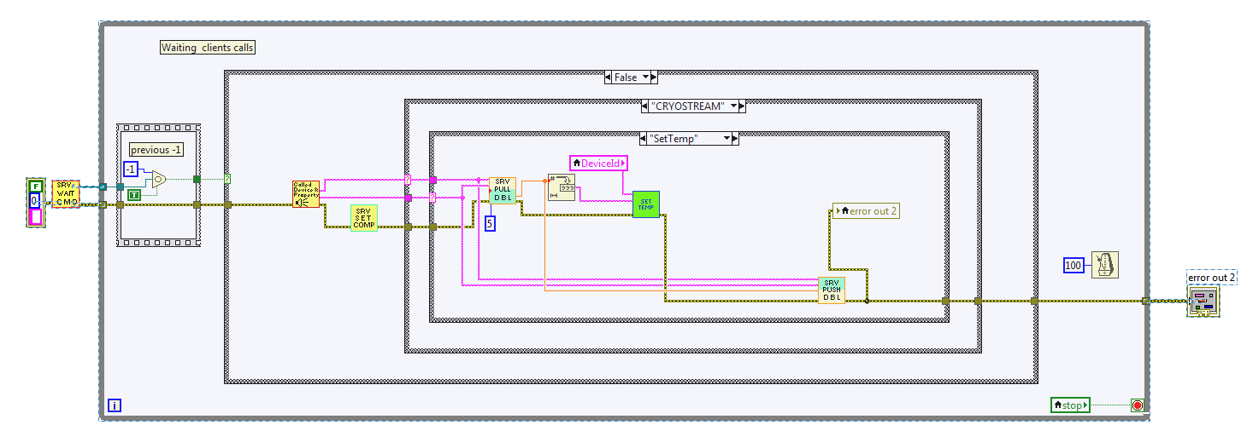

9

Figure 31. Server - Clients Loop

Thi GUI is presenting all the values and units that are considered most important at a first glance, taking that priority the sample temperature. The GUI is devided in 4 parts:

1. Program alive. The green indicator is blinking when everything is right.
2. Connection status. This indicator shows ‘No connection’ when the controller is off or ‘Active’ when the controller is on.
3. Status of the controller. These indicators show back pressure, flow, evaporation temperature, suction temperature, suction humidity, gas humidity, evaporation humidity, sample temperature and valve aperture.
4. This is the only controller available in the GUI, to allow the user to set the sample temperature from the server locally.

The GUI for “No Connection” and “Active” are shown below:

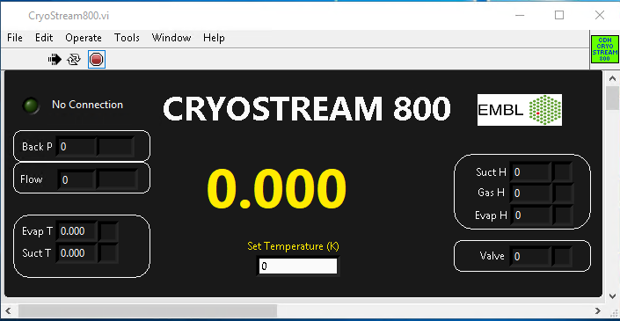

4

3

2

1

Figure 32. Server - GUI (No Connection)

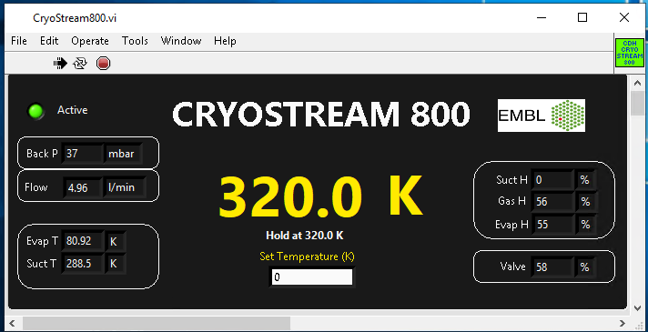

Figure 33. Server - GUI (Active)

## **3.3 Client**

The client is customized for each one of the locations where cryostreams are used because each one is talking to a different server.

This VI is considered the main client of the application. All the communication between client and server is done via TINE.

This VI is in charge of:

1. Pull all data from the server. Depending to which server is talking to, the context and server variables will change:

|  |  |
| --- | --- |
| Context | Server |
| P13 | P13Cryostream |
| P14 | P14Cryostream |
| SPC | CDHCryostream |

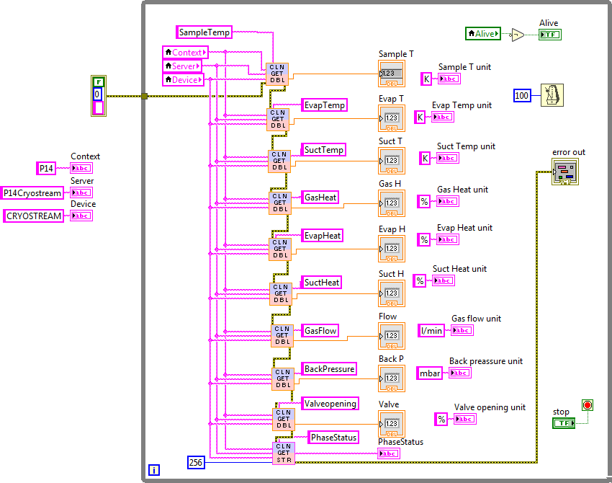

Figure 34. Client – Readout Loop

1. Put the new sample temperature into the server.

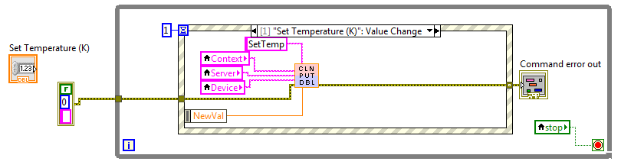

Figure 35. Client - Command Loop

This GUI is identical to the server’s GUI, presenting all the values and units that are considered most important at a first glance, taking that priority the sample temperature. The GUI is divided in 4 parts:

1. Program alive. The green indicator is blinking when everything is right.
2. Status of the controller. These indicators show back pressure, flow, evaporation temperature, suction temperature, suction humidity, gas humidity, evaporation humidity, sample temperature and valve aperture.
3. This is the only control available in the GUI, to allow the user to set the sample temperature from the server locally. The user introduces the new value and by hitting the enter key the command is executed.

The GUI is shown below:

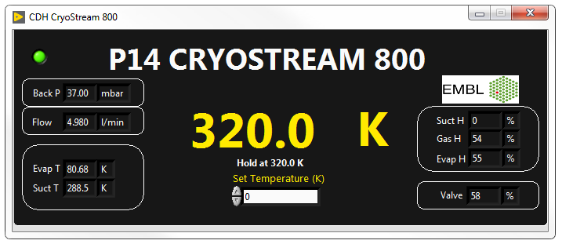

3

1

2

Figure 36. Client - GUI