**Software Engineering Project**

**Team**: Itu Anca, Mihuț Alina, Moisa Oana, Pop Ileana

**Technology:** Java + Spring

**Title:** Parking Management System

**Problem statement:** Simulate a parking system application for managing the free parking spots in a city. The user is able to see in real time the number of available parking spaces and their location in order to choose the nearest one. The parking situation is updated in real time.

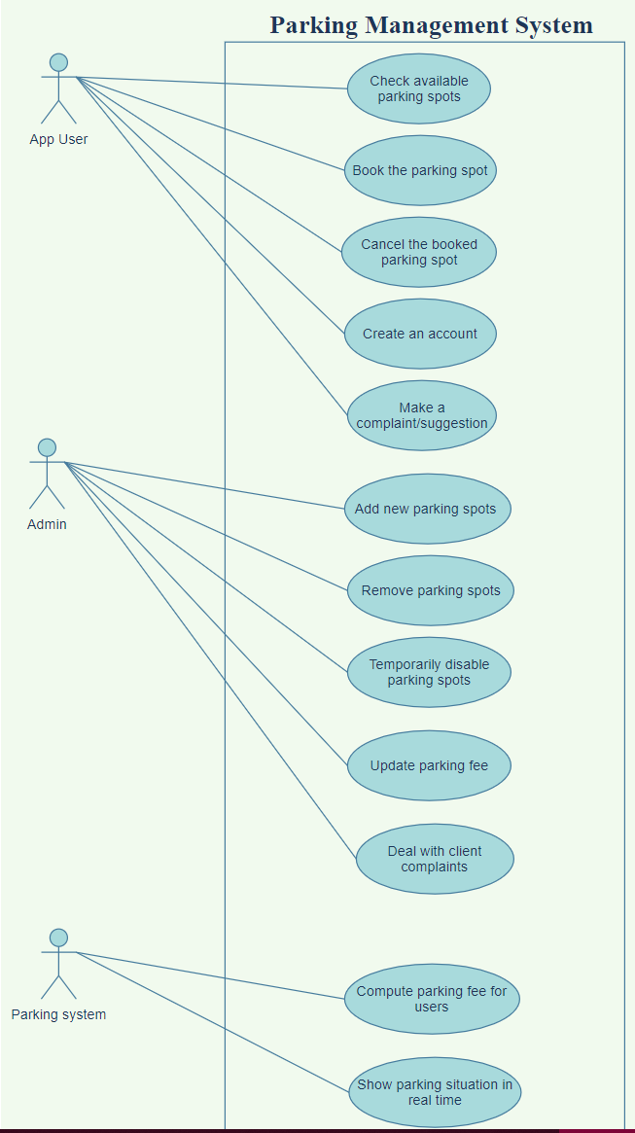**Use cases:**