

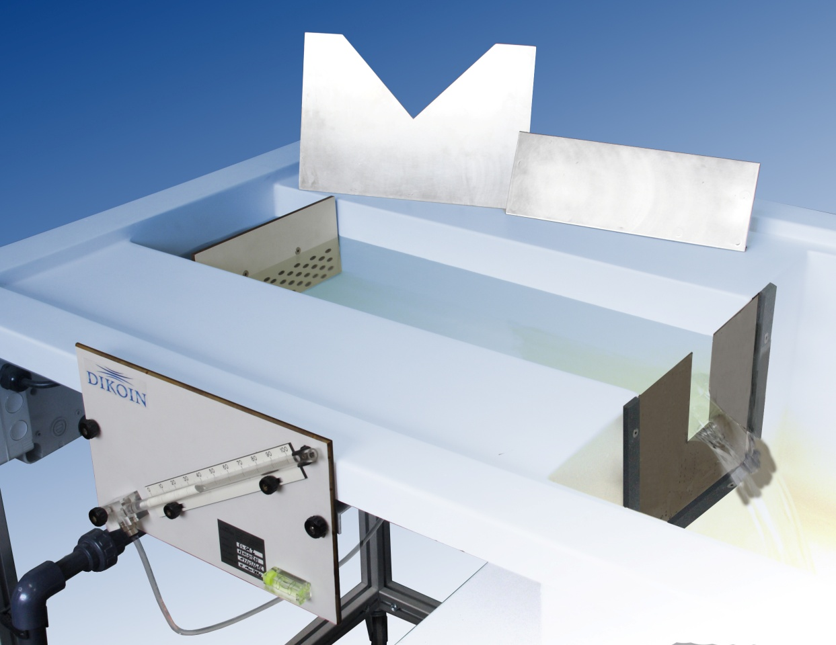

Flow over weirs
FL 01.2

Unresolved tables

CONTENTS
CONTENTS 2
5.1.2. READINGS AND RESULTS 4
5.2.2. READINGS AND RESULTS 5
5.3.2. READINGS AND RESULTS 6

5.1.2. READINGS AND RESULTS

Weir h₀ height= 80 mm.
Weir b width=50 mm
Reading  nº | Flow | Upstream height  h = H – h₀ (mm) | Discharge coef. | Theoretical discharge coef. | Global discharge coef
 |  |  | C_{w} | C_{theoretical} | C
1
2
3
4
5

5.2.2. READINGS AND RESULTS

Weir h₀ height= 80 mm
B width=255 mm
Reading  nº | Flow | Upstream height  h = H – h₀ (mm) | Discharge coef | Global discharge coef.
 |  |  | C_{w} | C
1
2
3
4
5

5.3.2. LECTURAS Y RESULTADOS

Weir h₀ height = 80 mm.
Angle $α=90°$
Reading  nº | Flow | Upstream height  h = H – h₀ (mm) | Discharge coef. | Global discharge coef
 |  |  | C_{w} | C
1
2
3
4
5

