Personal Finance Tracker
[Project Raven]
- Overview
When you are saving a part of your salary, it can be exhausting doing it by hand, so the website is going to do it for you and is going to save the information for you, my motivation is because when I save part of my salary it can be tedious.
- Target Audience
Is for persons who works and doesn’t have a lot of time, for adults and some teenagers
which can have more knowledge about how they are spending their savings.
- Major Functions
3.1 Display: Is going to display your actual savings
3.2 Save: Is going to save your savings in the data.
3.3 Calculation: It is going to calculate how much you will spend
3.4 Group: It is going to group the spends by categories
3.5 Graph: It will show a animation with the spends of the categories
3.6 Save: It will save the information in a document excel
3.7 Alerts: It will show if you don’t have enough to cover everything
3.8 It will save a record of what have you done

- Wireframes

Computer
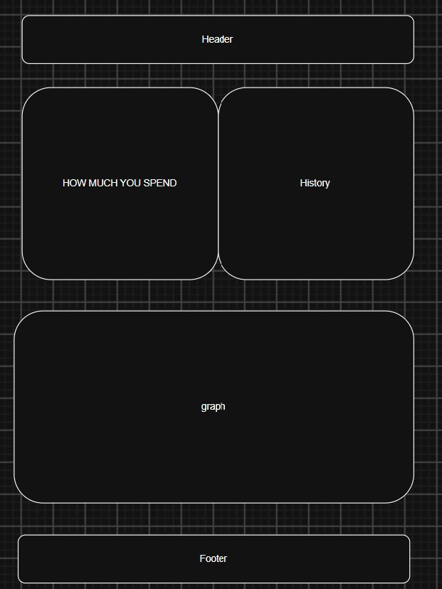
Mobile:
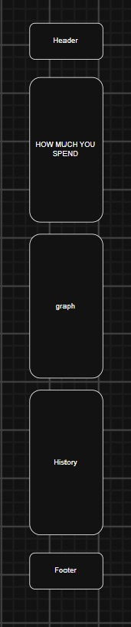

- External Data
ip-api.com: Automatically detects the user's location to set their local currency.
Frankfurter API: Handles real-time currency conversion across global currencies.
OCR.Space API: Extracts the total amount spent directly from receipt photos.
Google Gemini API: Automatically categorizes expenses based on transaction details.
I will need to store the entries for the economy from the user
- Module List
Modules needed:
6.1 dataChanger: Will have functions like Get, Delete and so on
6.2 getApis: Will storage and use all the apis
6.3 export: Will export the data
6.4 import: Will import the data
6.5 calculate: will calculate all the data
The major components were going to make those actions in order to help the client to make their calculations and import and export them
- Graphic Identity
7.1 Typography: Aptos / Aptos Narrow
7.2 Color scheme: Blue: #1a80bb, Orange: #ea801c, Gray: #b8b8b8
7.3 Icon Description: Because I don’t want something basic o complicated, I will do a Raven with glasses, because Raven have good memory.

- Timeline
I will work 2.5 hours every day between week 5 and week, except Sundays.
- Project planning
Trello link [https://trello.com/b/DfudqwGd/riven]
The project will be a functional website which will keep your records safe using HTML, CSS and vanilla JavaScript
- Challenges
The backend, if we cannot use libraries, it will be difficult

