  - IS115 Project Report

Last Mile Delivery Planning
Isaac Lin Jiale 01525047 | Ryan Swee 01534182

1 Introduction
A delivery hub must decide which waiting parcels to load onto each vehicle and in what order to deliver them. We aim to complete more deliveries while respecting customers' preferred delivery windows. A feasible route can still perform poorly if it keeps a vehicle travelling for a long time or delivers many parcels too early or too late. We compare dispatch policies on all 20 supplied daily scenarios using the same performance metrics [1]. Window-first nearest neighbour achieved the highest pooled Score B, 88.196, and is our recommended policy for this objective.
Ten vehicles start at the hub at 08:00. Planning takes place every ten minutes until 17:30, considering the longest-idle vehicles first. A confirmed trip departs 30 minutes later. At 60 km/h, each kilometre takes one minute. Every trip must carry at most 30 size units, travel at most 320 km including the return, and reach the hub by 18:00. Vehicles can make further trips after returning; delivery service time is zero. Distances are directed: A to B need not equal B to A [1].
Each planning call chooses one vehicle's whole route before departure. Waiting parcels have arrived and remain unassigned; parcels assigned elsewhere cannot be selected. Preferred windows are soft, so early and late deliveries are allowed.

2 How the baseline builds a trip
The supplied baseline tries parcels in arrival order. It accepts the first feasible choices it encounters; it does not compare alternative delivery orders [2].
- Prepare the waiting list. Keep unassigned parcels and sort them by hub arrival time, then parcel ID when arrival times tie.
- Try each parcel at the end. Check whether all selected parcels fit at departure and whether the proposed route can return within both the range and time limits.
- Accept or skip. If the parcel passes, append it and update the load, distance travelled and final stop. Otherwise, skip it and try the next parcel.
- Return the route. Finish after trying the waiting list. The simulator assigns the selected parcels and carries out the trip.
For example, assume the distance and return-time checks pass. With capacity 30, the baseline makes these choices:
Arrival order | Parcel size | Decision
A | 20 | Accept; selected load becomes 20
B | 15 | Skip; a load of 35 would exceed capacity
C | 10 | Accept; selected load becomes 30
The returned route is A then C. All selected parcels must fit before departure; delivering A cannot free loading capacity for B on this trip. The baseline ignores preferred windows and keeps the order of accepted parcels.
For n supplied parcel records and m waiting parcels, filtering takes O(n), sorting takes O(m log m), and scanning takes O(m). Overall time is O(n + m log m), with O(m) additional space for the waiting list and route.

3 Measuring delivery performance
We reward useful deliveries rather than minimise distance alone. A vehicle that never leaves the hub travels zero kilometres but delivers nothing. Our main score therefore gives credit for completing a delivery and additional credit for meeting its preferred window [3].

Score B gives partial credit for an early or late delivery
Parcel outcome | Credit | Meaning
Within the preferred window | 1 | Delivered at a preferred time
Early or late | 0.5 | Delivered, but outside the preferred time
Undelivered | 0 | No completed delivery
Let N be every parcel in the input, T the number delivered within their windows, and O the number delivered early or late. Both window endpoints count as in-window. We calculate:
$$\text{Score B = 100 × }\frac{\text{T + 0.5O}}{\text{N}}$$
For ten parcels, six in-window deliveries, two early or late deliveries and two unserved parcels earn 6 + 0.5 × 2 = 7 credits. Score B is therefore 70 out of 100. Leaving a parcel unserved earns zero credit and does not shrink the denominator.
The 0.5 weight is our modelling assumption. It assigns half a credit to completing any delivery and another half to meeting the preferred window. The supplied data do not establish a uniquely correct customer-value weight. We also rescore the same delivery logs using 0.25 and 0.75 to check how much the comparison depends on that choice. These checks do not change or retune the planners.

Score A prioritises completing deliveries
Score A compares completion rate first: delivered parcels divided by all input parcels. Only when completion rates are exactly equal do we compare the in-window service rate, which also uses all input parcels as its denominator. In the ten-parcel example, completion is 80% and in-window service is 60%. Score A keeps these priorities separate; it does not add the two percentages.

Combine all 20 days by counting parcels first
Each day is simulated independently, with no parcel carryover. Our overall comparison pools counts from all 20 days before calculating Score B [4]. A parcel receives the same weight whichever day it arrived on:
$$\text{Overall Score B = 100 × }\frac{\text{Total T + 0.5 × Total O}}{\text{Total N}}$$
We do not use the simple average of daily percentages as the main score, because the days contain different numbers of parcels. Exact unrounded Score B ties share a rank. Distance does not break those overall ties.

Distance and vehicle use explain the trade offs
We also report total kilometres, including every hub return, and departure-load utilisation. To calculate utilisation, divide total loaded parcel size by the combined capacity of all departures (number of trips multiplied by vehicle capacity), then multiply by 100. This measures how full vehicles are when they leave, rather than while driving. These supporting measures help explain operational cost and vehicle use; they are not added to Score B.

4 Nearest neighbour policies
Both policies build one trip by appending one parcel at a time. After each selection, the next comparison starts from the newly selected destination. All choices happen before departure. Every proposed route must fit the departure load, full-trip range and return deadline [1, 6].
The diagrams share this example: plan at 09:00, depart at 09:30, and take at most two parcels because each has size 15. All three have arrived and remain unassigned. One kilometre takes one minute [7].
Parcel | Hub arrival | Size | Preferred window | Hub distance
A | 08:00 | 15 | 09:45–10:00 | 20 km
B | 08:10 | 15 | 09:45–10:00 | 5 km
C | 08:20 | 15 | 09:30–09:50 | 10 km

Nearest feasible neighbour
Scan every remaining parcel and remember the closest feasible candidate. Equal next-leg distances prefer earlier hub arrival, then smaller parcel ID. Append the winner, remove it from the waiting candidates, update the load and final stop, then scan again. Stop when no feasible addition remains.
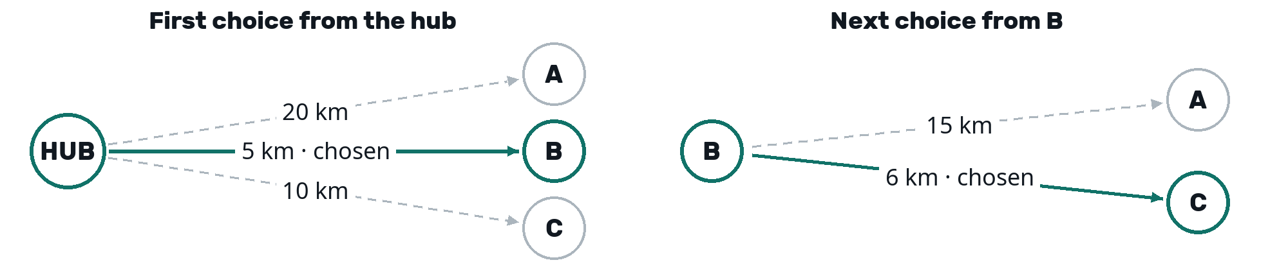
Figure 1 Solid green arrows are chosen; dashed arrows are alternatives. The chosen trip is HUB → B → C → HUB. B is delivered at 09:35, C at 09:41, and the vehicle returns at 09:51.
B wins first at 5 km. From B, C wins at 6 km rather than A at 15 km. The selected load then reaches 30. Preferred windows do not affect these choices, so B is delivered early. A short next leg does not guarantee the shortest complete route.

Window first nearest neighbour
For each feasible candidate, estimate delivery time as departure plus travel through selected stops plus the next leg. Prefer an in-window delivery; within the same window-status group, prefer shorter next-leg distance, earlier hub arrival, then smaller ID. Recalculate after every append. If none would be in-window, choose the nearest feasible early or late candidate.
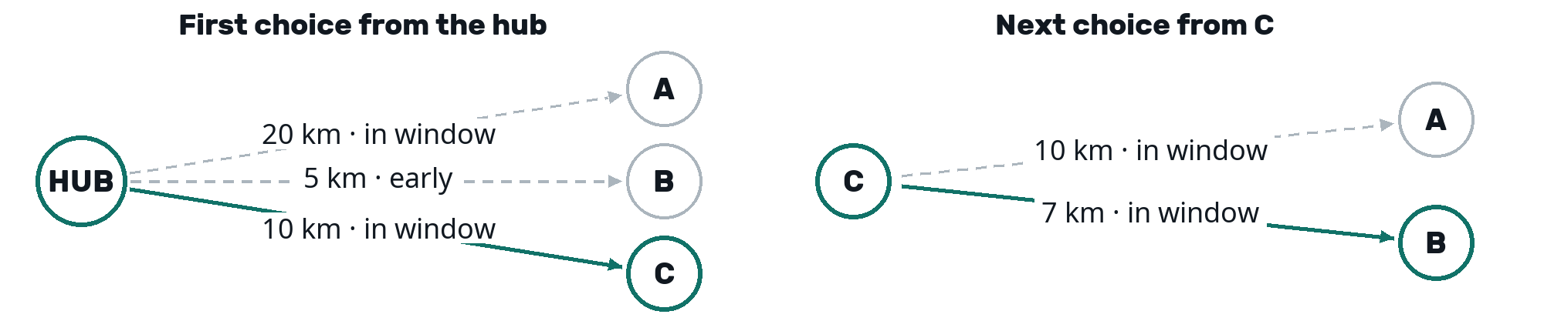
Figure 2 C is the nearer of the initially in-window choices. After C, B is also in-window. The chosen trip is HUB → C → B → HUB: deliveries at 09:40 and 09:47, return at 09:52.
Settings and limitation. Neither policy has a tunable parameter or inserts waiting time. Both stop when no feasible addition remains. Window first checks the next delivery rather than complete alternative arrangements.

5 Greedy insertion
Greedy insertion chooses a parcel and its position together. Start from an empty route. In each round, try every waiting parcel before, between and after the selected stops. Each placement creates a temporary proposal; the current route stays unchanged until every proposal in the round has been compared. Existing parcels keep their relative order [6].
Evaluate each feasible proposal using 1 credit per in-window delivery and 0.5 per early or late delivery. Net gain is the proposed route's credit minus the current route's credit. Recalculate all delivery times because inserting a parcel can change existing deliveries' window status.

Compare the placements before changing the route
In the shared example, C is selected first: C alone earns 1 credit over 20 km. A also earns 1 credit but needs 40 km, while B earns 0.5 credit because it would be early. From current route C, the second round compares four placements:
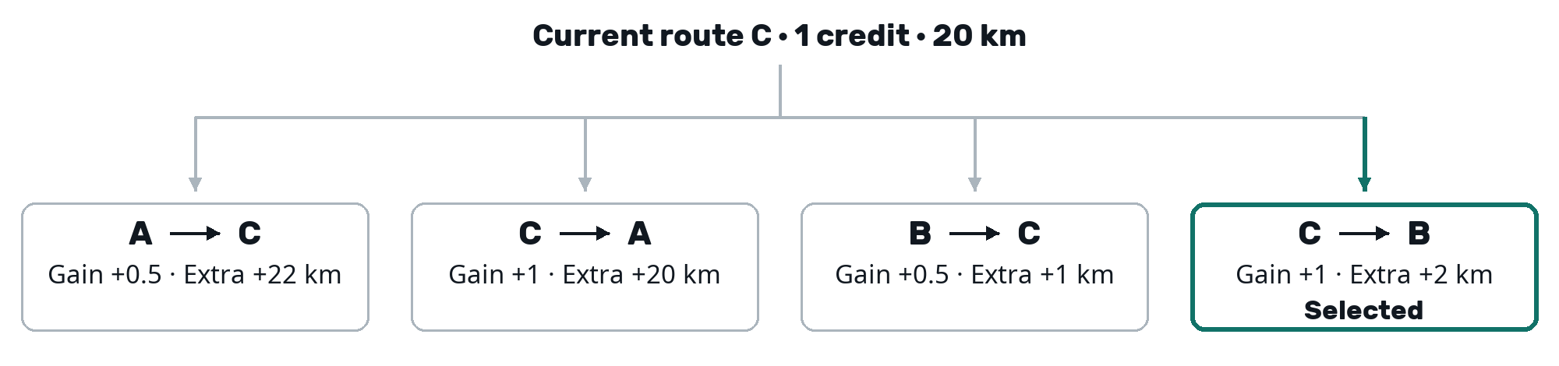
Figure 3 Gains and extra kilometres are relative to the same current route C. C → B and C → A tie on gain; C → B wins by adding only 2 km. These are temporary proposals until the winner is committed.
Putting A before C delays C to 10:02, outside its window. That proposal earns 1.5 credits in total, so its net gain is only 0.5. In C → B, both deliveries are in-window and total credit rises from 1 to 2. Replace C with the winning route C → B and remove B from waiting. The vehicle is now full.
Decision rule. Choose greater positive net gain first, then smaller extra complete-trip distance, earlier candidate hub arrival, smaller parcel ID and earlier insertion position. Stop when no feasible proposal has positive gain, even if a zero-gain proposal could physically fit.

Reuse the saved distance
For a route with spare capacity, inserting X between consecutive stops U and V replaces U → V with U → X → V. Update the saved complete-trip total by adding the two new legs and subtracting the replaced leg:
$\text{New distance = saved distance + d(U,X) + d(X,V) − d(U,V)}$
The hub acts as the neighbour at either end. Potential winners and close numerical comparisons receive a complete-distance recheck to preserve floating-point decisions. Delivery times are still replayed; the distance update does not remove window-scoring work.
Settings and limitation. Outside-window credit is fixed at 0.5. Internally, doubled integer credits avoid reward rounding. Distance is a tiebreak, so a higher-credit proposal can win despite adding substantially more travel. The policy does not evaluate how that extra travel affects future trips.

6 Insertion protecting existing windows
This variant constructs a route from empty using the same proposals, feasibility checks and credit calculation as original insertion. Both policies already consider preferred windows. The change is one tiebreak: when net gains tie, prefer fewer existing in-window deliveries becoming early or late [6].
Track parcel identities. For a separate route with spare capacity, suppose an insertion changes the in-window set from {U, V} to {V, X}. The count stays at two, but U has lost its in-window delivery. Count that loss when comparing equal-gain proposals.
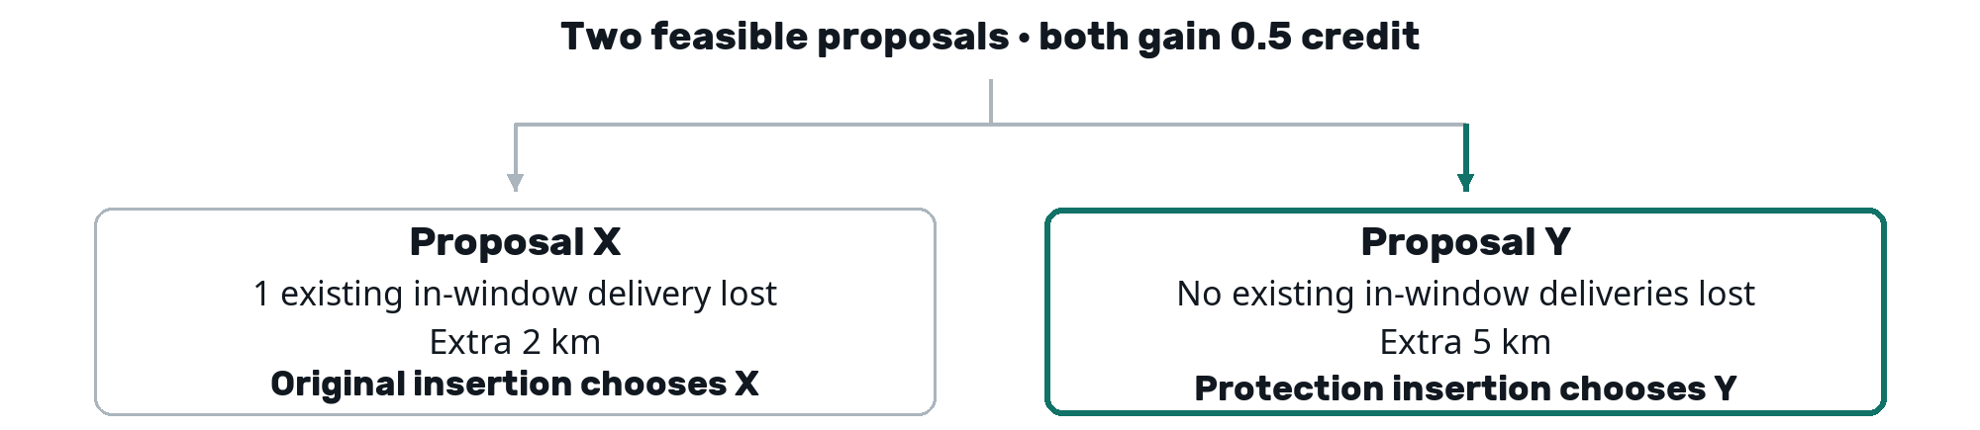
Figure 4 A separate illustrative tie, assuming both insertions are feasible. Original insertion chooses X for less extra distance. Protection chooses Y to preserve existing in-window deliveries.
Decision rule. Compare greater positive net gain first, then fewer existing in-window losses, smaller extra distance, hub arrival, parcel ID and insertion position. Preservation is not a hard constraint: a gain of 1 still beats a gain of 0.5 even when the larger gain makes an existing delivery late. Stop when no feasible positive-gain insertion remains.
Settings and limitation. Outside-window credit remains 0.5; there is no additional preservation weight. The evaluation metric values a newly achieved in-window delivery equally to a preserved one. In the shared three-parcel example, both highest-gain proposals preserve C, so distance selects C → B again.

Computational cost and course concepts
For one planning call, let n be all supplied arrived records, m eligible waiting parcels and k parcels ultimately selected. The bounds assume average constant-time dictionary access and exclude the supplied distance matrix from additional space.
Policies | Worst-case time | Additional space
Nearest neighbour and window first | $\text{O(n + }{\text{m}}^{\text{2}}\text{)}$ | $\text{O(m)}$
Original and protection insertion | $\text{O(n + m}{\text{(k + 1)}}^{\text{3}}\text{)}$ | $\text{O(m + k)}$
Nearest neighbour scans the remaining candidates repeatedly, giving quadratic worst-case work. With r stops selected, insertion tries each remaining parcel in r + 1 positions; copying and scoring each proposal takes time proportional to r + 1. Summing these rounds gives the insertion bound. If k reaches m, the bound becomes O(n + m⁴). Saved-distance updates reduce repeated arithmetic but leave this worst-case bound unchanged.
These policies use greedy selection and insertion [5]. A dictionary stores waiting parcels for lookup and removal by ID; a list preserves delivery order. Protection also uses sets of projected in-window parcel IDs to count losses. Trial routes are evaluated one at a time rather than retained together, which limits additional memory.

7 Results across all twenty days
We compared the baseline and four selected policies on all 20 supplied daily scenarios, covering 15,867 parcels. Each policy used the same inputs and operating constraints. The recommendation uses pooled Score B, calculated from combined delivery counts rather than a simple average of daily percentages. The comparison below includes 100 policy-day results [8].
Policy | Completion  % | In window  % | Score B | Distance  km | Load use  %
Baseline | 40.47 | 27.41 | 33.938 | 104,071 | 49.79
Nearest neighbour | 95.97 | 64.76 | 80.365 | 82,264 | 70.99
Window first | 95.82 | 80.57 | 88.196 | 83,466 | 73.70
Original insertion | 95.82 | 79.32 | 87.569 | 83,017 | 73.69
Protection insertion | 95.82 | 79.32 | 87.569 | 83,017 | 73.69
Table 1 Completion and in-window service use all input parcels as their denominator. Load use is departure-load utilisation. Figures are rounded for display; rankings use unrounded scores.
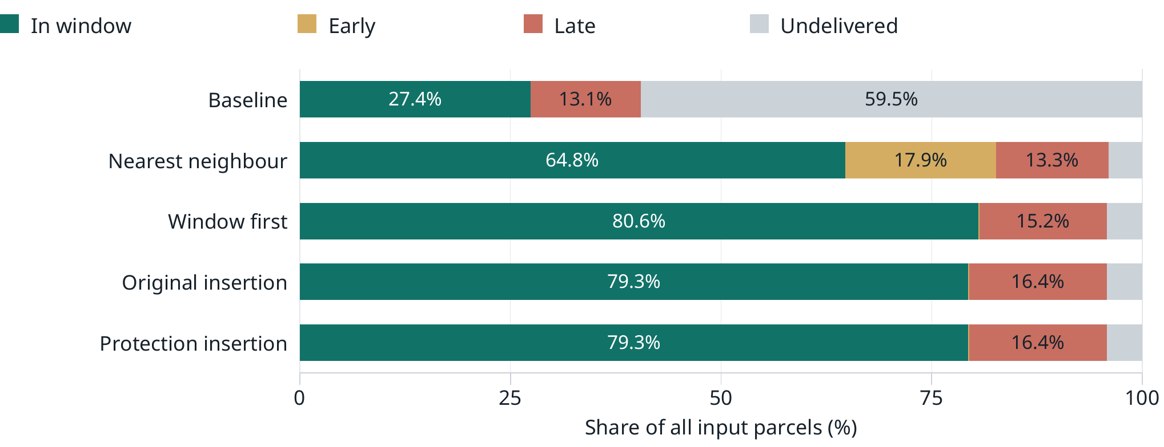
Figure 5 Every bar represents all 15,867 input parcels. Window-first retains high completion while achieving a larger in-window share. Narrow segments are left unlabelled.

Nearest neighbour improves on arrival order
Nearest neighbour completed 15,228 deliveries versus the baseline's 6,421, while travelling approximately 21% less distance. Nearby feasible selection was effective on these inputs. However, it produced 2,839 early and 2,114 late deliveries, leaving preferred-window service well below its completion rate.

Window first improves preferred window service
Window-first completed only 24 fewer deliveries than nearest neighbour, but achieved 2,509 more in-window deliveries. Early deliveries fell from 2,839 to 16, while late deliveries increased to 2,404. Score B rose by 7.831 points with approximately 1.46% more distance. Departure-load utilisation reached 73.70%, compared with 70.99% for nearest neighbour and 49.79% for baseline. The improvement involves a trade-off rather than gains on every measure.

8 Window first compared with insertion
Window-first and original insertion completed exactly the same total of 15,204 deliveries. Window-first achieved 199 more in-window deliveries, raising pooled Score B by 0.627 points. It travelled 448.665 km more across the 20 days, approximately 0.54%. Its service-score advantage therefore came from timing, not from completing more deliveries [8].
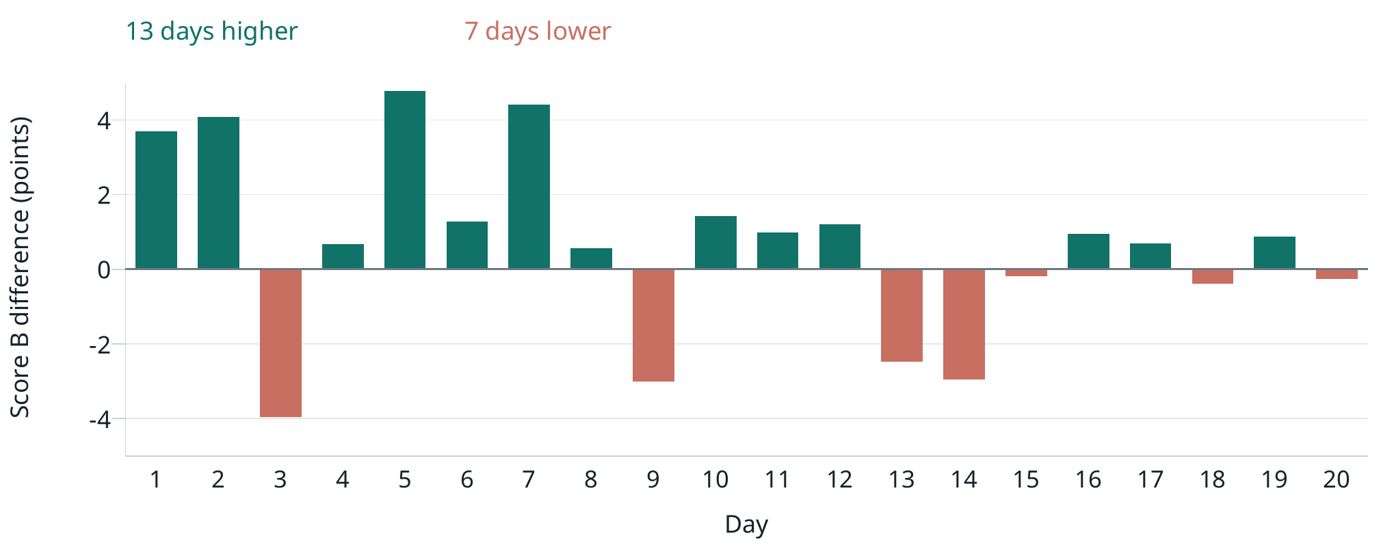
Figure 6 Daily Score B for window-first minus original insertion. Positive bars favour window-first; negative bars favour insertion. Window-first wins on 13 days and loses on seven.
The pooled lead is modest and does not imply superiority on every day. Both policies reach their lowest daily Score B on day 020, where insertion scores 83.504 and window-first 83.248. We therefore recommend on overall service performance while retaining the daily comparison as evidence of variation.

Why more insertion trials do not guarantee a better day
Original insertion already considers preferred windows. It examines more placements at each construction step, but still commits greedy choices, retains the relative order of selected parcels and maximises immediate route-credit gain. It does not optimise the whole day. Window-first makes different local choices by preferring nearby in-window deliveries. Those choices produced slightly better aggregate timing here; the summary counts do not establish which individual decisions caused the difference.

Protection adds no observed improvement
Protection insertion produced byte-identical delivery logs to original insertion on all 20 days. Its extra preservation tiebreak did not change the resulting trips or metrics in this experiment. This does not establish that the tiebreak can never affect another input [9].

The recommendation survives the tested credit weights
Outside-window credit | Window first | Original and protection
0.25 | 84.383 | 83.442
0.50 | 88.196 | 87.569
0.75 | 92.009 | 91.695
Window-first remains highest among the five selected policies at every tested weight. Its lead over insertion narrows as outside-window credit increases. These checks rescore the same logs; they do not retune or rerun the planners for alternative weights.

9 Recommendation and limitations
We recommend window-first nearest neighbour for the chosen service objective. It achieved the highest pooled Score B and in-window service rate across all 20 scenarios while completing more than 95% of parcels. Its simple preference for an in-window next delivery, followed by distance, provides a clear decision rule. Its advantage over insertion is modest, so the recommendation rests on the combined evidence rather than a claim that it always wins.

The preferred policy depends on the operating priority
Under Score A, nearest neighbour wins because it completed 24 more deliveries than window-first. Under our main Score B, the 2,509 additional in-window deliveries achieved by window-first outweigh that small completion loss. Original insertion travels approximately 0.54% less distance than window-first, but earns a lower service score. A business assigning different values to delivery timing and travel cost could reasonably make a different choice.

Implementation optimisation and computational cost
The insertion policies use the saved-distance edge update described earlier. In a separate benchmark on 36 fixed planning snapshots from days 001, 010 and 020, median constructor time fell by 19.9% for original insertion and 17.6% for protection. Each version received one warmup and five measured passes, with version order alternated. These are machine- and workload-specific comparisons between implementation versions, not full-day speed comparisons between policies [10].
The optimisation preserved route decisions and service results. Window-first retains a lower worst-case planning bound than insertion because it scans candidates rather than evaluating every insertion position. The saved-distance update reduces arithmetic but does not remove route copying and delivery-window scoring from insertion.

Validation and reproducibility
All 103 automated checks passed, covering eligibility, capacity, directed returns, preparation time, inclusive windows, insertion gains and score aggregation. Fresh reruns reproduce the archived logs and metrics exactly for all 100 day-runs included in this comparison. Original and protection insertion also have identical logs to each other. The supporting records retain commands, source and input hashes, and output hashes [9].
Each policy-day result has its own log and metrics file under results/full_evaluation_distance_optimised/. The root README supplies reproduction commands for simulations, the performance monitor, aggregation and the controlled constructor benchmark. Inputs, simulator and supplied baseline are retained unchanged.

Scope of the conclusion
The results describe the 20 supplied scenarios and the simulator's operating assumptions. They do not establish optimal routes or performance on unseen demand. Fixed travel speed, zero delivery service time and identical vehicles simplify real operations. The outside-window credit is a stated preference assumption rather than an estimated economic value. Sensitivity checks support the recommendation over the tested weights, while the seven daily losses to insertion show why no universal superiority claim is justified.

References and selected AI prompts
[1] IS115 Project Brief. Operating model, policy interface and twenty-day input data, pages 1–4.
[2] Supplied baseline. solution/policies/baseline.py, retained unchanged.
[3] Team implementation. solution/performance_monitor.py. Delivery classification, Scores A and B, distance and departure-load utilisation.
[4] Team implementation. solution/evaluation.py. Pooling daily counts and applying exact score rankings.
[5] IS115 course slides. 11 Heuristics Part 2a Greedy Algo; 05 Linear Data Structures Parts 1–3; 07b HashMaps. Greedy methods, lists and dictionary concepts.
[6] Team policy implementations. solution/policies/nearest_neighbour.py, window_first_nearest.py, greedy_insertion.py, greedy_insertion_protect.py and _insertion_variants.py.
[7] Worked example inputs and code-checked outcomes. docs/Algorithm_Worked_Example.json. These illustrations are separate from the twenty-day performance results.
[8] Complete twenty-day comparison. results/full_evaluation_distance_optimised/comparison.json, summary.csv and daily_scores.csv. Counts, pooled scores, supporting metrics, daily comparisons and sensitivity results.
[9] Validation and run provenance. results/insertion_distance_optimisation/validation.json; results/full_evaluation_distance_optimised/run_manifest.json; original independent replay in results/full_evaluation/independent_validation.json.
[10] Controlled constructor benchmark. results/insertion_distance_optimisation/benchmark.json and scripts/benchmark_insertion_distance.py. Archived pre-optimisation sources are retained beside the benchmark.

AI assistance
We used ChatGPT for explanations, metric-design discussion and coding assistance. Selected useful prompts retain their original wording below; full selected texts are recorded in docs/Selected_AI_Prompts.json. Code and simulator outputs provide the evidence for the calculations and decisions described here.

Metric design
“hmmm i feel yes this is good , do u think there should be a main score since we have completion rate score , and a on time service rate and total distance travelled and average load utilisation , how do we have a final score”

Half credit justification
“okay but lets justify the model assumping of 0.5 , why not 0.25 or 0.75”

Score A tiebreak
“wait i meant for a we have the simple ones but if we have the same scores then it compares the dellivery during preferened winodws”

Nearest neighbour choice
“okay sure lets try it nearest feasible neighbour”

Preferred window policy
“okay lets see now how we are able to incoporate prefered window selection into the policy”

Independent greedy alternative
“wait what ur doing is using the results from the first policy to create a new policy but what i want is a total new policy to suggest to use , like a different greedy algorithm that you think would work , then we can discuss about it”

Insertion variants
“okay lets work on optimizing the insertion way first u have any ideas on it?”

Twenty day aggregation and evaluation
“lets decide how we should aggregate the score now, and then well run all of our existing approaches across the 20 days , also i might choose to leave out some of the less meaningful permuations or approaches”

Insertion distance optimisation
“we can just have the last saved distance and then we plus the from a to b + b to c - a to c kind of formula”

Twenty day analysis and recommendation
“also becaus eits time window based so using window first nearest neighbours make the more sense then insertion i thought about it but maybe im wrong”

