Part-1

HIP stuff, IntelliJ , Spring5

Spring 5 new features:
- jdk baseline (java 8), which means minimum java-8 is required to work with Spring-5
- Spring-5 supports component Index as an alternative to classpath scanning
- Spring-5 Support for JetBrains Kotlin language (kotlin OOP language for functional programming)
- Got Reactive Programming Model (Reactive Streams is an API specification, provides a common API for reactive programming Implementations, EX. JPA for Hibernate where JPA is API and Hibernate is implementation )

Maven:

Software project management tool, used to manage - built automation for a project
Its based on concept of POM (project object model)

By default maven compiles project in java 1.5
to get the maven project to run and use java 11 (as java 11 is LTS - long term support), need to get below plugin
<plugin>
<groupId>org.apache.maven.plugins</groupId>
<artifactId>maven-compiler-plugin</artifactId>
<version>3.8.1</version>
<configuration>
<target>11</target>
<source>11</source>
<release>11</release>
</configuration>
</plugin>

Logging
Logging is keeping record of specific information from program execution.
It got 2 important aspects
- Visibility on what code is doing after its running(mainly for operations).
- Visibility during development.
Important about logging is it helps to categorize , to be logged output (ex. INFO, DEBUG, ERROR)

**Slf4j – Logging API
There are 2 aspects to a well configured logging System.
- Logging API: Its fronted or exposed part developer used to interact with.
- Logging Implementation: Its what logging-API will use internally and make calls in order to get logging working.

Slf4j – is like Java Interface, for developer it requires only implementation.
Logging Implementation using “logback”

**Now SLF4j – API & logback – Implementation.
To understand this, there are implementations for logging and “logback” is successor of “log4J”.
Each implementation has there own way of logging output, but application where this logging is implemented(where logback or log4j is used) will use the same “org.slf4j.logger” API.

Logback offers mechanism to log output to variety of destinations ex: database, file , console, email etc.

Logback has 3 main components
- Loggers: For capturing logging information.
- Appenders: For publishing logging information to preferred destinations.
- Layouts: For formatting logging information in different styles.

**Logback logger class implements slf4j API – hence no overhead.
Logback can be configured in 2 ways

- Programmatically
get a dependency in pom.xml & import in project
<dependency>  <groupId>ch.qos.logback</groupId>  <artifactId>logback-classic</artifactId>  <version>1.2.3</version>  </dependency> | import org.slf4j.Logger;  import org.slf4j.LoggerFactory  log.info("Hello Info");  log.debug("Hello Debug");  log.error("Hello Error");

-Using configuration file (xml/Groovy).
In here we define loggers, appenders & layouts (3 components of logback).
Below is the literals or patters dine in configuration file.
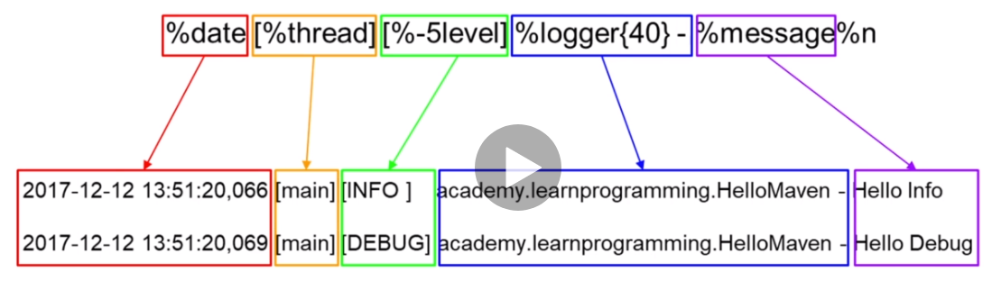
Now we create a file “logback.xml” in “Resources” folder of the maven project with below content.
<configuration>
<appender name="STDOUT" class="ch.qos.logback.core.ConsoleAppender">
<encoder class="ch.qos.logback.classic.encoder.PatternLayoutEncoder">
<pattern>%date [%thread] [%-5level] %logger{40} - %message%n</pattern>
</encoder>
</appender>
<logger name="spring.hello.HelloMaven" level="DEBUG"/>
<root level="INFO">
<appender-ref ref="STDOUT"/>
</root>
</configuration>
Now the output log changes as below.
OLD Log.
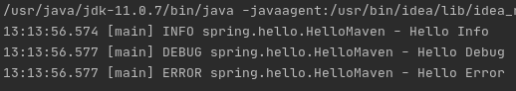
NEW Log.
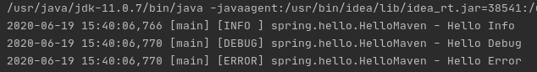
Note:
Logback initialization will be followed as below:
Checks for file in classpath as below (Resource folder). And uses if found and continue search if not found.
- logback-test.xml
- logback.groovy
- logback.xml
- Service-provider loading facility (Introduced in jdk1.6)
- If none found, logback creates own config with basic facilities and logging directed to console

Multi-module Project
Its way of having a parent project(pom project) & child projects (module projects).
This all will be defined in pom.xml
Here parent-project does not contain any code, so can get ride of src folder.

- Now in here to make a project (pom project) or parent project.
Delete src folder (optional)
Add <packaging>pom</packaging> in pom.xml

Pom is a container of sub modules
So now the child projects can be created by, rt-click on parent project and create new-module.

Once all modules or child projects are created inside a main project, dependencies need to be managed.
This can be done with the help of dependency-managament in parent pom.xml.
Also versions of different dependencies can also be managed from parent pom itself by having properties tag as mention below.

Parent pom.xml
----------------------
<properties>
<logback.version>1.2.3</logback.version>
<spring.version>5.2.7.RELEASE</spring.version>
<java.version>11</java.version>
</properties>
<dependencyManagement>
<dependencies>
<dependency>
<groupId>ch.qos.logback</groupId>
<artifactId>logback-classic</artifactId>
<version>${logback.version}</version>
</dependency>
<dependency>
<groupId>org.springframework</groupId>
<artifactId>spring-context</artifactId>
<version>${spring.version}</version>
</dependency>
</dependencies>
</dependencyManagement>
Child pom.xml
--------------------
<dependencies>
<dependency>
<groupId>ch.qos.logback</groupId>
<artifactId>logback-classic</artifactId>
</dependency>
<dependency>
<groupId>org.springframework</groupId>
<artifactId>spring-context</artifactId>
</dependency>
</dependencies>

Spring Container
IOC- Inversion of Control.
Spring IOC contaier – Component of Spring Framework. Contains quoted or unquoted beans and manage their complete lifecycle.
Bean- java Object, and in here managed & control by Spring IOC

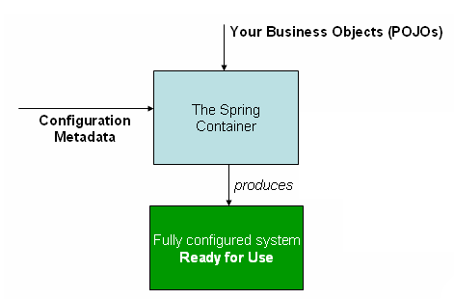
Diagram shows a high-level view of how Spring works. Our application classes are combined with configuration metadata so that, after the ApplicationContext is created and initialized, we have a fully configured and executable system or application.

So POJOs are loaded by IOC container after reading configuration metadata
Context-Circumstances form setting for an event.
Configure Spring container to create a bean.
To do this we need to instantiate container.(we configure container using .xml file)
In beans.xml file add a bean <bean id="anyname" class="pkg.class"/>
Configure & Instantiate main class
private static final String CONFIG_LOCATION = "beans.xml";
ConfigurableApplicationContext context = new ClassPathXmlApplicationContext(CONFIG_LOCATION);

Call Method(Get the Bean, from Interface).
NumberGenerator numberGenerator = context.getBean("numberGenerator", NumberGenerator.class);
Interface | Class
package spring.hello;  public interface NumberGenerator {  int next();  int getMaxNumber();  } | package spring.hello;  import java.util.Random;  public class NumberGeneratorImpl implements NumberGenerator{  private final Random random = new Random();  private int maxNumber = 1000;  public int next() {  return random.nextInt(maxNumber);  }  public int getMaxNumber() {  return maxNumber;  }  }

Main | beans.xml
package spring.hello;  import org.slf4j.Logger;  import org.slf4j.LoggerFactory;  import org.springframework.context.ConfigurableApplicationContext;  import org.springframework.context.support.ClassPathXmlApplicationContext;  public class Main {  private static final Logger log = LoggerFactory.getLogger(Main.class);  private static final String CONFIG_LOCATION = "beans.xml";  public static void main(String[] args) {  log.info("Guess The Number Game");  ConfigurableApplicationContext context = new ClassPathXmlApplicationContext(CONFIG_LOCATION);  NumberGenerator numberGenerator = context.getBean("numberGenerator", NumberGenerator.class);  int number = numberGenerator.next();  log.info("Number: {}",number);  context.close(); }} | <?xml version="1.0" encoding="UTF-8"?>  <beans xmlns="http://www.springframework.org/schema/beans"  xmlns:xsi="http://www.w3.org/2001/XMLSchema-instance"  xsi:schemaLocation="http://www.springframework.org/schema/beans  https://www.springframework.org/schema/beans/spring-beans.xsd">  <bean id="numberGenerator" class="spring.hello.NumberGeneratorImpl"/>  </beans>
Constructor Based Dependency Injection:
Its of 2 types Annotations-based & XML-based
In below example “numberGenerator” needed to be initialized for “GameImp” to run
Hence got below settings in beans.xml.

<bean id="numberGenerator" class="spring.hello.NumberGeneratorImpl"/>
<bean id="game" class="spring.hello.GameImpl">
<constructor-arg ref="numberGenerator"/>
</bean>

Setter based Dependency Injection:
In Setter based dependency Injection is accomplished by container by calling setter methods on beans after invoking a no argument constructor

<bean id="numberGenerator" class="spring.hello.NumberGeneratorImpl"/>
<bean id="game" class="spring.hello.GameImpl">
<property name="numberGenerator" ref="numberGenerator"/>
</bean>

property-name : is the name of reference created in the class(GameImpl), where we got the actual setter method
ref: is the bean-id for the actual class, in this case bean-id for class="spring.hello.NumberGeneratorImpl"

Constructor Vs Setter based dependency Injection:
Rule of thumb – Constructor for mandatory dependencies and methods for optional dependencies.
Recommended is constructor based – as it enables , implemented application components as immutable objects to ensure required dependencies are not NULL.
And also constructor-injected components always returned to client in fully initialized state.

Note: large number of constructor arguments is considered bad practice (3 args should be max.)

One benefit of setter injection is that, setter method make objects of class easily available to reconfiguration or re-injection later.

Circular Dependency:
Ex: Class-B requires instance of Class-A through Constructor-Injection & Class-A requires instance of Class-B through Constructor-Injection.
And if we configure beans for classes A & B to be injected into each other, the spring container detects circular reference at run-time and throws “BeanCurrentlyInCreationException”

Solution to above problem, is to have setter-based injection for one of that class. Another way is have setter for both.
Not recommended but setter can have circular ref.
Problem with circular ref is that “not fully initialized class may will be injected into another”.

Bean Life cycle callbacks:
Initialization:
We can run initialization code once bean is initialized. This can be achieved by having init-method
<bean id="game" class="spring.hello.GameImpl" init-method="reset">

With above we need to specify initialization for each bean, and hence we can have “default-init” and we can have that in <beans> tag
<beans xmlns="http://www.springframework.org/schema/beans"
xmlns:xsi="http://www.w3.org/2001/XMLSchema-instance"
xsi:schemaLocation="http://www.springframework.org/schema/beans
https://www.springframework.org/schema/beans/spring-beans.xsd"
default-init-method="reset">

As always having a init-method and destroy-method for different beans possibilities is that we may get lost and its not best practice to default them having it run for every bean (if we may define them with same name in each bean). So the best way is to have

**JSR 250 as it is post-construct & pre-destroy annotations, And best practice for receiving lifecycle callback (which means beans are not coupled to spring specific Interfaces).
To implement this we need to have
<bean class="org.springframework.context.annotation.CommonAnnotationBeanPostProcessor"/>

now to use annotation api get below dependency

<dependency>
<groupId>javax.annotation</groupId>
<artifactId>javax.annotation-api</artifactId>
<version>${annotation.version>}</version>
</dependency>
Also add below in beans.xml
<bean class="org.springframework.context.annotation.CommonAnnotationBeanPostProcessor"/>

And then we need to use below annotations before the methods which can perform reset & destroy.
@PostContruct | @PreDestroy
@PostConstruct  public void reset() {  smallest = 0;  guess = 0;  remainingGuesses = guessCount;  biggest = numberGenerator.getMaxNumber();  number = numberGenerator.next();  log.info("Number : {}", number);  } | @PreDestroy  public void preDestroy()  {  log.info("in game preDestroy()");  }

Annotation Vs XML Configurations:
XML based : Pros is , its separated from java classes (as we use .xml file), and if configuration needed to be changed then code does not have to go for recompilation. Also configuration is centralized.
Cons: Type safety is not available, where java-code via compiler will validate types.
Ex: we can have constructor, but we may miss to inject dependency.
Annotation based: Pros is , shorter and more concise. & Type-safety.
Change in annotations requires code recompilation, annotations may clutter projects POJO’s , argument will be they are no longer POJO anymore.

**Note we can use combination of both: with @Configuration annotations.
By using @Configuration, we can build java-based configuration classes and hence we centralize configuration with type-safety.

@Autowire annotations: To autowire/inject instance variables.
To do this we will just get below in beans.xml and get @Autowire before variables we want to initialize
Note: once we set autowire we can remove setters or default constructors used for variable initialization. Along with constructor or setter based dependency injection from beans.xml.

<?xml version="1.0" encoding="UTF-8"?>
<beans xmlns="http://www.springframework.org/schema/beans"
xmlns:context="http://www.springframework.org/schema/context" ----added
xmlns:xsi="http://www.w3.org/2001/XMLSchema-instance"
xsi:schemaLocation="http://www.springframework.org/schema/beans
https://www.springframework.org/schema/beans/spring-beans.xsd
http://www.springframework.org/schema/context ---------------------------added
http://www.springframework.org/schema/context/spring-context.xsd">---added
<context:annotation-config/>---------------------------added
<bean id="numberGenerator" class="spring.hello.NumberGeneratorImpl"/>
<bean id="game" class="spring.hello.GameImpl" >
<!--init-method="reset" -->
<!--constructor-arg ref="numberGenerator"/-->
<!--property name="numberGenerator" ref="numberGenerator" /-->
</bean>
<!--bean class="org.springframework.context.annotation.CommonAnnotationBeanPostProcessor"/-->
</beans>
Below example shows autowiring setter method.
//@Autowired
private NumberGenerator numberGenerator;
private int guessCount = 10;
private int number;
private int guess;
/* public GameImpl(NumberGenerator numberGenerator) {
this.numberGenerator = numberGenerator;
}*/
@Autowired
public void setNumberGenerator(NumberGenerator numberGenerator)
{
this.numberGenerator = numberGenerator;}

Beans as components:
Spring provides several stereotype annotations (Ex: @Component, @Service, @Controller).
Stereotype means something confirming to a fixed pattern, as it recommended that we annotate
Controller Classes → @Controller
Service Classes → @Service.

@Component : is generic stereotype for any Spring managed component.
@Repository, @Service, @Controller are specializations of component

Auto scan a package for components : To do this we need to add a Tag. And remove all bean references and then annotate bean componentrs.

<!--context:annotation-config/-->
<context:component-scan base-package="spring.hello"/>

Now we can add @Component for Impl classes but not to our Interfaces. As we want to decouple Interfaces from configurations.
And also in the main class getBean definition need to be changed as below.

//NumberGenerator numberGenerator = context.getBean("numberGenerator", NumberGenerator.class);
NumberGenerator numberGenerator = context.getBean(NumberGenerator.class);

One more way:
NumberGenerator numberGenerator = context.getBean("numberGenerator", NumberGenerator.class);
@Component ("numberGenerator")
Note: this change is needed as we have defined a bean name in Main.java

But this works in case of one Implementation of class but in case of multiple implementations we need to have “qualifiers”.

But as now we have Spring Container scanning packages to to use bean components.

Java Annotation Configuration:
@Configuration, @ComponentScan, @Bean

- Create a java class that will represent a Spring Container configuration.
- First Delete “beans.xml”
- Then create a java class and name it “AppConfig.java” and have a @Configuration annotation at top.
- The way we did in beans.xml, we got component-scan and base package we need to do same here and add component-scan annotation.
- In Main.java class “ConfigurableApplicationContext” needed to be changed
ClassPathXmlApplicationContext(CONFIG_LOCATION); → AnnotationConfigApplicationContext(AppConfig.class);

Now with above configurations we can run the project.
Moving further now we can remove the “@Component” annotations from Impl classes and then get them defined in “AppConfig.java” class.

public class AppConfig {
@Bean
public NumberGenerator numberGenerator()
{
return new NumberGeneratorImpl();
}
@Bean
public Game game()
{
return new GameImpl();
}
}

Application Events:
Application context Interface has a parent Interface “Application Event Publisher(to encapsulate event publication functionality)”.
Event handling is in Application-Context is provided through ApplicationEvent calss and ApplicationListner Interface.

And this Application Listner is triggered each time container is ready.
@Component
public class ConsoleNumberGuess implements ApplicationListener<ContextRefreshedEvent> {
private static final Logger log = LoggerFactory.getLogger(ConsoleNumberGuess.class);
@Override
public void onApplicationEvent(ContextRefreshedEvent contextRefreshedEvent) {
log.info("Container is ready ");
}
}
Another is by using @EventListner annotation, then we dont have to implement “AppliactionListner”.
@Component
public class ConsoleNumberGuess {
//public class ConsoleNumberGuess implements ApplicationListener<ContextRefreshedEvent> {
private static final Logger log = LoggerFactory.getLogger(ConsoleNumberGuess.class);
//@Override
@EventListener
public void start(ContextRefreshedEvent contextRefreshedEvent) {
log.info("Start Container is ready ");
}
}
Another way is supply class within annotation
@Component
public class ConsoleNumberGuess {
//public class ConsoleNumberGuess implements ApplicationListener<ContextRefreshedEvent> {
private static final Logger log = LoggerFactory.getLogger(ConsoleNumberGuess.class);
//@Override
@EventListener(ContextRefreshedEvent.class)
public void start() {
log.info("Start Container is ready ");
}}
Qualifiers:
When there is need for fine-tuning annotation-based auto wiring we use qualifiers.
A qualifier is an annotation that is applied to a Bean.
@Primary annotation is effective way to use autowiring by TYPE with several instances , when one primary candidate can be determined.
When more control over selection process is required, @Qualifier annotation is used.

Custom annotations:
lets create an annotation – create a new class, and here besides selecting, class or Interface we select annotation. So it will be an annotation type Interface.

@Target – a context where this qualifier can be added , like field, parameter, method.
@Retention – specifies how long, annotation with annotated type to be retained. If specified “RUNTIME” they are retained by JVM during runtime.
package spring.hello;
import org.springframework.beans.factory.annotation.Qualifier;
import java.lang.annotation.ElementType;
import java.lang.annotation.Retention;
import java.lang.annotation.RetentionPolicy;
import java.lang.annotation.Target;
@Target({ElementType.FIELD, ElementType.PARAMETER, ElementType.METHOD})
@Retention(RetentionPolicy.RUNTIME)
@Qualifier
public @interface MaxNumber {
}

****Reason for having this custom annotation names is when we initialize constants in config class (GameConfig.class) we take method names same as variable names.
So chances is we may get into typo & refactoring problems.

Now we need to update congig class and the classes where we define constant variables with @CustomQualifier.
@Bean
@MaxNumber
public int maxNumber()
{
return maxNumber;
}
@Bean
@GuessCount
public int guessCount()
{
return guessCount;
}

@Autowired  @MaxNumber  private int maxNumber; | @Autowired  @GuessCount  private int guessCount;

Properties:
@Value annotation, @PropertySource annotation.
Besides hard coding variables in code can be overcome by having this annotations.
To implement this we can create a properties file in Resources folder with below content
game.maxNumber = 100
game.guessCount = 10
@Configuration
@PropertySource("classpath:config/game.properties")
public class GameConfig {
@Value("${game.maxNumber:20}")
private int maxNumber;
@Value("${game.guessCount:5}")
private int guessCount;
And can retrieve values from properties files as above.
Note 20 & 5 are default values assigned , this will be used if in case values are not declared in properties file.

Best Practices:
→ Any class need to be managed by container need to have @Component annotataion
To have this in place we will remove bean methods from config-class and add @Component annotation to the respective classes.
Note : Interfaces should need to decoupled from spring-container and hence the reason we annotate java-class(in this case Impl classes).

→ Another way is to initialize using constructor based injection, below is example:
private final int maxNumber;
private final int minNumber;
public NumberGeneratorImpl(@MaxNumber int maxNumber, @MinNumber int minNumber) {
this.maxNumber = maxNumber;
this.minNumber = minNumber;
}
/* @Autowired
@MaxNumber
private int maxNumber;
@Autowired
@MinNumber
private int minNumber;*/
Also best practice is to remove @Autowire, set the fields which were autowired to “Final” and then add a constructor as shown above.

Lombok:
Its a Java library that allows us to generate boiler plate code(basically to spice up java code).
When say boiler plate code, it actually means we dont have to write Getters & Setters also some other methods like equals(), hsahCode(), toString().
It simplifies Development saves time.
Less code especially with JPA entities.

Lombok uses annotation processor API, when projects get compiled lombok generates code.

Some annotations:
@Getter
@Setter – returns void and take 1 parameter of same type as field.
@ToString
@EqualsAndHashCode- generates equals & hashcode method.
@RequiredArgsConstructor – generates constructor with required arguments.
@Slf4j- Generates private static final field for SLF4J logger

@Data – this at class level.
It generates boiler plate code for POJO.
It combines @Setter, @Getter, @ToString, @RequiredArgsConstructor & @EqualsAndHashCode.
Constructor is not generated if it has been declared already.

Getting ready for Lombok:
- Installing IntelliJ plugin for Lombok
- Add dependency for Lombok.

File – Settings – Plugins - “lombok” and get it installed.
We now need to enable annotation process for “lombok”. To do this we need to
File – Settings – Build,Execution,Deployment – Compiler – Annotation Processors – (check) Enable Annotation Processing & (select) Obtain processes from project classpath. – ok.

Now for adding dependency we can directly copy and use dependency tags from mvn-repository.
But we may get a situation where we need to include some external libraries, to do this will follow below process.
Download latest jar from “https://projectlombok.org/download”
Create new directory “libs” from parent directory structure.
Paste downloaded jar into libs.Now add below dependencies in respective poms.
parent | child(module), here dependency is used
<dependency>  <groupId>org.projectlombok</groupId>  <artifactId>lombok</artifactId>  <version>${lombok.version}</version>  </dependency>  <lombok.version>1.18.12</lombok.version> | <dependency>  <groupId>org.projectlombok</groupId>  <artifactId>lombok</artifactId>  <scope>system</scope>  <systemPath>${basedir}/../libs/lombok.jar</systemPath>  </dependency>

Now in-order to test this we will remove
“private static final Logger log = LoggerFactory.getLogger(Main.class);”
And add “@Slf4j” annotation on the class.

If @Getter or @Setter is added at class level its equivalent of wring getter and setters for all private variables and if we have some private references for which we dont want getter/setter then we can exclude them as below:
@Getter(AccessLevel.NONE)
private final NumberGenerator numberGenerator;
Note: annotations like Getter & Setter can be added at class level and at variable levels .

Spring MVC:
Web Framework build on Servlet API. Designed around front end controller pattern.
Model- Responsible for managing Application data, business logic & business rules.
View- front end representation.
Controller – Responsible for invoking Models to perform business logic and updating View based on Model output.

Spring MVC has a central servlet – Dispatcher Servlet.(for request processing)
Dispatcher-Servlet expects WebApplicationContext(and it is extension of ApplicationContext).

Dispatcher-servlet : get special beans to process requests and render responses.
In simple words with WebApplicationContext we get some beans registered for us automatically.

**With Spring MVC we use different View technologies to render web-pages (Groovy-Markup, Free-marker, Thyme-leaf).

Now the dependency for “Spring -webmvc”
<dependency>
<groupId>org.springframework</groupId>
<artifactId>spring-webmvc</artifactId>
<version>${webmvc-version}</version>
</dependency>

Maven “WAR” & “Cargo” plugins:
WAR- Web Application Archive, (contains resources necessary for developing web-applications)
web.xml – Deployment descriptor for a servlet-based java web application(alternate to this is using annotations).

To begin now
- Add packaging tag in project pom.xml file “<packaging>war</packaging>” right after pom version tag.

Get below mentioned directory structure:
- Create folders webapp & WEB_INF

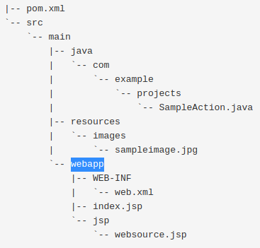

Now , webapp folder contains UI files like HTML (lets create one with below code)
<html>
<head>
<title>Start Page</title>
</head>
<body>
<h1>Hello World!</h1>
</body>
</html>
Now we need to have maven-war plugin in out pom.xml file.
<plugin>
<groupId>org.apache.maven.plugins</groupId>
<artifactId>maven-war-plugin</artifactId>
<version>3.2.0</version>
<configuration>
<failOnMissingWebXml>false</failOnMissingWebXml>
</configuration>
</plugin>
Note that we have also added failOnMissingWebXml to false as we have not created any web.xml in the project.

Cargo Plugin:
With Maven cargo-plugin we can use goals to manipulate war projects with in the Apache Tomcat servlet container (its like we run tomcat in embedded mode, no need to install).
Its like this plugin help us to develop an application without need to install standalone-tomcat.
Note once plugin is added to pom.xml of project for use, it also need to be configured , since we need a container we will add a container Tag.

<plugin>
<groupId>org.codehaus.cargo</groupId>
<artifactId>cargo-maven2-plugin</artifactId>
<version>1.7.15</version>
<configuration>
<container>
<containerId>tomcat9x</containerId>
<type>embedded</type>
</container>
</configuration>
</plugin>

Now we can clean and build project again
post this , we now go to Maven(TAB)-plugins-cargo-cargo:run
This runs out application todo-list on tomcat-container using plugin.
Test: http://localhost:8080/todo-list/index.html

Dispatcher Servlet:
Will setup spring-mvc Dispatcher servlet using java configuration.
It is front controller of Spring MVC and used to dispatch HTTP requests to other controllers.

@EnableWebMvc – to enable spring MVC configuration(allow/registers beans specific to spring MVC ex: ViewResolver, RequestMapper).
This annotation will be added in the “Configuration.java” file.

Now lets add Dispatcher-Servlet,
First add dependency in pom.xml.
<dependency>
<groupId>javax.servlet</groupId>
<artifactId>javax.servlet-api</artifactId>
<version>${javax-servlet-api.version}</version>
<scope>provided</scope>
</dependency>
Note in here we got scope as provided, which means this dependency will be provided by servlet-container at runtime, in simple words, it should not be packaged in WAR.

To programatically register Servlet we need to Implement Web Application Initializer Interface, and implementations of this Interface will be automatically detected by Spring upon start-up of appliaction.
Note: Servlet-Context is not same as spring-context, which means after implementation of WebApplicationInilializer Interface we need to we need to add servlet to spring container.
So ServletContext defines setter methods that servlet uses to communicate with its servlet container in our sample case it is Tomcat.

Now todo this annotation tobe used is “AnnotationConfigWebApplicationContext” , because we are going to create web-application not console application.

Next will create Dispatcher-Servlet and “context” is passed to it.
And then we perform “Dynamic servlet Registration”.
We also made use of 2 methods
- setLoadOnStartUp : to configure startup loading of servlet so that container will instantiate and initialize our servlet.
-addMapping : To Override default tomcat homepage (reason is we dont want our application users to see tomcat homepage in default).
@Slf4j
public class WebAppInitializer implements WebApplicationInitializer {
private static final String DISPATCHER_SERVLET_NAME = "dispatcher";
@Override
public void onStartup(ServletContext servletContext) throws ServletException {
log.info("on StartUp");
AnnotationConfigWebApplicationContext context = new AnnotationConfigWebApplicationContext();
context.register(WebConfig.class);
DispatcherServlet dispatcherServlet = new DispatcherServlet(context);
ServletRegistration.Dynamic registration =
servletContext.addServlet(DISPATCHER_SERVLET_NAME, dispatcherServlet);
registration.setLoadOnStartup(1);
registration.addMapping("/");
}
}

Controllers:
As we know Spring-MVC is designed around “Dispatcher-Servlet” (plays role of front controller).
Which means it receives all request from application.
And then we can map requests to methods in classes annotated with @Controller (called controller classes).
@RequestMapping annotation is used to map request to controller methods.
It has various attributes to match by (URL, HTTP method, Request parameters, headers, media-types).
Shortcut variants of @RequestMapping are:
@GetMapping (For HTTP GET requests).
@PostMapping, @PutMapping, @DeleteMapping, @PatchMapping.
Note: when we take @Controller annotation we won’t specify @Component annotation as “@Controller” annotation is specialization for @Component annotation.
Now let’s create a class for Controller.
@Controller
public class DemoController {
@ResponseBody
@GetMapping("/hello")
public String hello()
{
return "hello";}}
@ResponseBody – Indicates that method response should be bound to web page. Use in cases when we have not defined View.
Running combination of goals in IntelliJ.
Each time we have to do following to run application.
Mvn clean; mvn install; cargo:run (manually on IntelliJ UI).
To combine all this is one:
Rt click “cargo:run” -- create run configuration (<any_name>)
Command line “clean install cargo:run -f pom.xml”
Save & apply.
And a new configuration will appear in – Run Configurations. –a double click on this will run everything.

View:
Spring – MVC defines “ViewResolver & View” Interfaces which enable us to render model in a browser without forcing us to use specific view technology.
ViewResolver provides mapping between view-names & actual views.

Now we need to setup ViewResolver bean.
To do this we need to get below code in mentioned files
WebConfig.java | DemoController.java
public static final String RESOLVER_PREFIX = "/WEB-INF/view/";  public static final String RESOLVER_SUFFIX = ".jsp";  @Bean  public ViewResolver viewResolver()  {  UrlBasedViewResolver viewResolver = new InternalResourceViewResolver();  viewResolver.setPrefix(RESOLVER_PREFIX);  viewResolver.setSuffix(RESOLVER_SUFFIX);  return viewResolver;  } | @GetMapping("welcome")  public String welcome()  {  return "welcome";  }

Request Processing
Now let’s understand steps involve in request processing:
1.Browser creates a request to specific URL (it’s like dispatcher controller receives request from browser).
2.Use handler-mapping to find the right controller (here dispatcher-servlet identifies which controller will handle the request)
3.Handler-mapping returns specific handler method that handles request (ex. welcome-method)
4.Dispatcher-Servlet calls specific handler-method (method in controller is called) (ex. Logical view name returned “welcome”).
5.Handler method return to model and the view name
6.Dispatcher-servlet now has logical-view name, now it has to determine the actual view file and this achieved using view-resolver (ex: welcome.jsp)
7.View-resolver finds and return the JSP file (ex: from WEB-INF/view/welcome.jsp)
8.Dispatcher-Servlet executes it and makes the model available to view
9.View is rendered and content is returned back to Dispatcher-servlet
10.Dispatcher –servlet sends back response to browser.
Model & @ModelAttribute:
Model is Interface and is holder for ModelAttribute (primarily designed to add attributes to Model).
Now this model is exposed to views which means we can access it from our JSP.
We can take model as a key value pair and also there are methods that can convert a model to a MAP.

Model is created by Dispatcher-Servlet which invokes request-methods.
We get model as a parameter then we add attributes to Model and then this attributes are available in the view.
Now to add attribute to model we can do as below:
DemoController.java | Welcome.jsp
@GetMapping("welcome")  public String welcome(Model model)  {  model.addAttribute("user", "moiz");  log.info("model = {}",model);  return "welcome";  } | <html>  <head>  <title>Welcome</title>  </head>  <body>  <h1>Hello ${user}</h1>  </body>  </html>
Output:
Another way of doing this by using “@ModelAttribute”, update code as below
DemoController.java | Welcome.jsp
@ModelAttribute(")  public String welcomeMessage()  {  log.info("welcomeMessage() called");  return "welcome to this demo application";  } | <html>  <head>  <title>Welcome</title>  </head>  <body>  <h1>Hello ${user}</h1>  <h2>${welcomeMessage}</h2>  </body>  </html>

Note: Method annotated with @ModelAttribute is executed first, i.e., before @GetMapping.
And also as of now we need to have attribute name should be same in jsp controller ex: welcomeMessage

@Service
Another Stereotype annotation
This annotation will also be scanned by spring just as others ex @Component.
This is at the service layer of the application, which holds the business logic.
“Controllers” use service to get results of calculation performed by “Service”

A simple example to do this is having creating an Interface followed with implemented class and then we use this methods inside controller methods, but first we inject constructor based dependency into controller. Also same attributes are updated in jsp. Below example code explains all

DemoService(I) | DemoServiceImpl(C)
public interface DemoService {  String getHelloMessage(String user);  String getWelcomeMessage();  String getGreetingMessage();  } | @Service  public class DemoServiceImpl implements DemoService {  @Override  public String getHelloMessage(String user) {  return "Hello "+user;  }  @Override  public String getWelcomeMessage() {  return "Welcome to this Demo Application";  }  @Override  public String getGreetingMessage() {  return "How are you";  }  }
DemoController.java | Welcome.jsp
private final DemoService demoService;  @Autowired  DemoController(DemoService demoService)  {  this.demoService = demoService;  }  @GetMapping("welcome")  public String welcome(Model model)  {  model.addAttribute("helloMessage", demoService.getHelloMessage("Moiz"));  log.info("model = {}",model);  return "welcome";  }  @ModelAttribute("welcomeMessage")  public String welcomeMessage()  {  log.info("welcomeMessage() called");  return demoService.getWelcomeMessage();  }  @ModelAttribute("conveyGreetings")  public String conveyGreetings()  {  return demoService.getGreetingMessage();  } | <html>  <head>  <title>Welcome</title>  </head>  <body>  <h1>${helloMessage}</h1>  <h2>${welcomeMessage}</h2>  <h2>${conveyGreetings}</h2>  </body>  </html>

Request Parameters and @RequestParam annotation:
Its a parameter input by user, It can be added and supplied as below:
DemoController.java | Test
@GetMapping("welcome")  public String welcome(@RequestParam String user,@RequestParam int age, Model model)  {  model.addAttribute("helloMessage", demoService.getHelloMessage(user));  model.addAttribute("age", age);  log.info("model = {}",model);  return "welcome";  } | http://localhost:8080/todo-list/welcome?user=Moiz&age=31

@Data annotation:
This annotation from lombok is used to generate boiler plate code for
Setter
Getter
toString
equals & hashCode.

And also in case if we would like to generate code for specific fields , can be achieved using specific method annotation.
Ex: @EqualsAndHashCode(of = {“id”, “name”})

@NonNull:
An annotation can be used to get ride of code as below
if(a == null)
{throw new NullPointerException(“a cannot be empty”)}.

Mappings
We Frequently use strings for mappings and view names in our request-methods, it will turn out hard to maintain, especially in case of “multiple requests redirecting to same view” .To overcome this we can make use of constants.We can have constants created in a class for ex: “Mappings”, we mark this class as “Final”, as its gonna contain static data, and hence we make it non extendable.
Below is what we do to have mappings & view constants defined.
@Controller  public class ToDoItemController {  @ModelAttribute  public ToDoData todoData()  {  return new ToDoData();  }  @RequestMapping(Mappings.ITEMS)  public String items()  {  return ViewNames.ITEMS_LIST;  } | public final class Mappings {  public static final String ITEMS = "items";  private Mappings() {}  }  ---------------------------------------------------------------------  public final class ViewNames {  public static final String ITEMS_LIST = "ItemsList";  private ViewNames(){}  }
JSTL:
Java Server Pages Standard Tag Library, collection of useful JSP Tags.
It supports common structural tasks , such as iteration & conditional tags for manipulating XML documents, SQL tags and so on.

JSTL tag library got following groups:
Core, Formatting, SQL, XML, JSTL functions

Some Tags are
<c:forEach> - Used for iterating over collection.
<c:out> - Used to display result of an Expression
<c:url> - Used to format url into a string and store it into a variable.

To use JSTL we first need to get its dependency in to pom.xml
<dependency>
<groupId>javax.servlet</groupId>
<artifactId>jstl</artifactId>
<version>1.2</version>
</dependency>

@PostMapping:
Spring facilitates POST redirect get pattern (its like spring grants us the functionality to redirect to some other view after post by just simply prefixing redirect string).

Also in cases when we have to automatically bind the data with form-redirection then we can add annotation @ModelAttribute, and the name of the model-attribute will be name of the class with first letter lower-case (ex. ToDoItem), another option is to tell the form name of the model-attribute, and this can be managed via another class and having maintaining model-attributes.

Note: Name of model-attribute need to match name of form in jsp.
AttributeNames.java | Controller.java
public final class AttributeNames {  public static final String TODO_ITEM = "toDoItem";  private AttributeNames() {}  } | @PostMapping(Mappings.ADD_ITEM)  public String processItem(@ModelAttribute(AttributeNames.TODO_ITEM) ToDoItem toDoItem)  {  return "redirect:/" + Mappings.ITEMS;  }

Also inside JSP file we can import the constants class and have form attribute.

<%@ page import="com.spring.util.AttributeNames" %>
<form:form method="POST" modelAttribute="${AttributeNames.TODO_ITEM}">
</form:form>

Optional Request param: (@RequestParam(required = false,defaultValue = "-1"))

----------------------------------------------------------------------------------------------------------------------------

Spring Boot – 2

- Spring boot is a framework that helps developers build stand-alone, production-grade spring-based applications that can be run easily and quickly.
- No need to rewrite same configuration.
- Most spring-boot applications need very little spring configuration, almost everything is auto configured.

Main features

- Spring Boot Starters.
- Spring Boot auto-configuration.
- Easy to use embedded servlet container support.
- Elegant configuration management.

Spring Boot 2 Starters:
Modules to quickly help us started with commonly used technologies like Spring MVC, JPA etc.
Starters are configured with commonly used library dependencies so we don’t have to search for compatible versions and configure them manually.

Spring Boot 2 Auto Configuration:
With this we don’t need to setup boiler plate configuration
Ex. If we have “spring-webmvc” dependency spring-boot assumes we are building a spring MVC application and automatically registers dispatcher servlet.

Usually with web applications we create WAR file & deploy it to an external server like tomcat, but with spring-boot we create a self-contained JAR application with an embedded servlet-container.

Spring Initializer – It’s an online spring-boot application generator used to create spring-boot applications from scratch.

To generate a new project go-to https://start.spring.io/

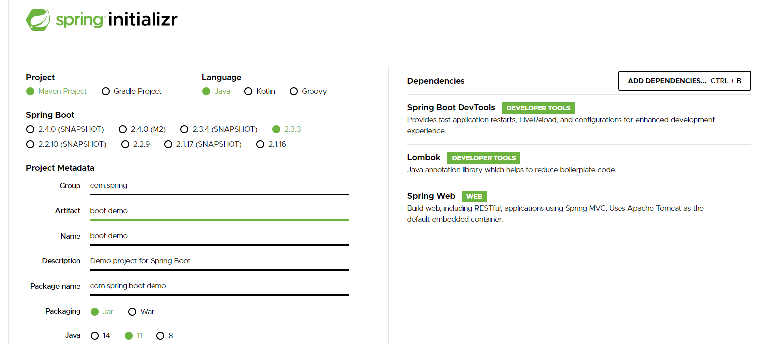

Understanding Spring boot project Structure
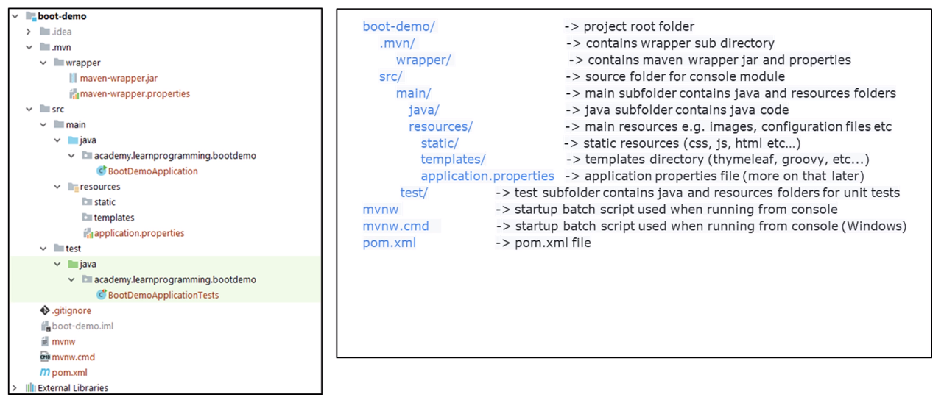
Apart from typical spring project in here we get “.mvn” directory with wrapper & properties file.

Maven –wrapper.jar helps us run maven goals without installing maven, and hence we can run application from console. (This is useful on servers and systems that has maven not installed, it got 2 startup batch scripts that we can run from console without installing maven).

Resources – static folder: to store images, CSS, JS etc. and this will be auto-detected by spring-boot.
Resources – templates folder: to store dynamic content, such as thyme-leaf & groovy-templates.
Resources – application.properties file: Used to set application properties allowing us to customize multitude of features like DB url’s, server-ports etc
****Checking project:*****

Pom.xml:
Got a parent tag which actually points to parent repository of spring-boot, that actually also contains versions for the dependencies, which makes easier for developers.
We also have a plugin “spring-boot-maven-plugin”, to pack an executable jar/war archive and run an application from console.

Note: sometimes we may get errors in our “main-application-class” file of the project, this usually happens if we run multiple versions of jdk, go-to “module-settings (by rt-click on project)”- project and select the right jdk(the one in pom.xml),

Main.class (BootDemoApplication.java):
@SpringBootApplication : This annotation automatically enables scanning in order configuration, allowing this class to be used as configuration-class(so here we define bean methods).

Note: have a dummy run of this main.class, because sometimes we may get issues with dependencies compatibility issues with java-version used (in that case we need to get right dependency version in local use that way we did for lombok-edge.jar [scope-system, systemPath-${basedir}/libs/Lombok-edge.jar]).

*** With this we get Tomcat, Dispatcher-Servlet & lot more automatically configured.
(it’s like we don’t have to define tomcat-container dependencies etc in this pom, it’s done for us).

Dummy-test: run main.java class check in browser “localhost:8080”

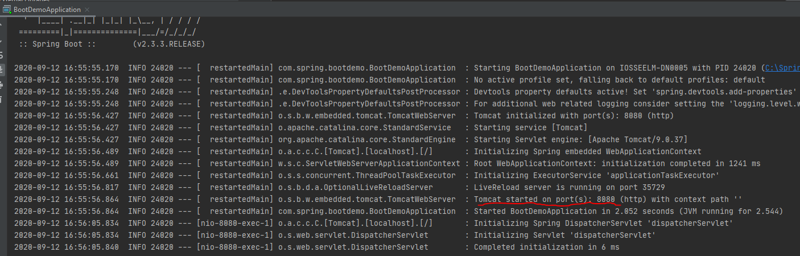

- Copy & paste logback.xml file from old project into the current one & rename it to “logback-spring.xml”, we did this so that spring should control log-initialization completely (it’s from spring-boot documentation).
- Now in logback-spring.xml remove appenders, root tags and include base.xml to include parts of configuration from another file.
Now let’s check out base.xml file (External Libraries – Maven:org.springframework.boot:spring-boot:2.3.3-RELEASE & expand folders accordingly org/springframework/boot/logging/logback/base.xml). and this base.xml has <included> tag which means this file can be included in other files as we did in logback-spring.xml
It got appenders & encoder defined.
Logback-spring.xml
<configuration>
<include resource="org/springframework/boot/logging/logback/base.xml"/>
<logger name="com.spring.todo-list" level="DEBUG"/>
<logger name="org.springframework" level="DEBUG"/>
</configuration>

Now let’s create a controller-class:
- Controller needs to be in same package or sub-package where we got Main-class (in other words our BootDemoApplication.class(is also a controller class))
DemoController.java
@Controller
@Slf4j
public class DemoController {
@GetMapping("demo")
@ResponseBody
public String demo(){
log.info("------this is demo spring-boot------");
return "Hello Spring Boot";
}
}

Now run the “BootDemoApplication.class” and open “localhost:8080/demo”
With this we can clearly see that it simplified lot of stuff for us, like initializing servlet-container & writing configuration class etc.

Note:
- We also don’t have to specify application name when we type in browser, because spring-boot automatically configure this settings thereby making url shorter (https://localhost:8080/demo).
- We can enable colors for output in IntelliJ by having below property in “application.properties” file “spring.output.ansi.enabled = always”.
- Also when we create a method in controller to redirect output from a .jsp file we may get issues with view-resolver to overcome this we need to specify below properties in “application.properties” file.(with this sprint-boot wil automatically configure view-resolver for us)
- spring.mvc.view.prefix = /WEB-INF/view/
spring.mvc.view.suffix = .jsp
- If we are getting more logs printed we can modify logback.xml file to set level to “INFO”
- There are limitations when it comes to JSP’s with embedded containers (in our case its Tomcat), its called hard coded file pattern, which is like we won’t be able to see content from welcome.jsp, will use Thymeleaf later to solve this.

Thymeleaf:

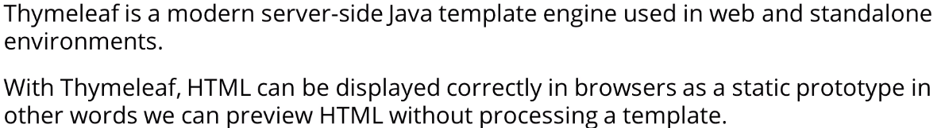

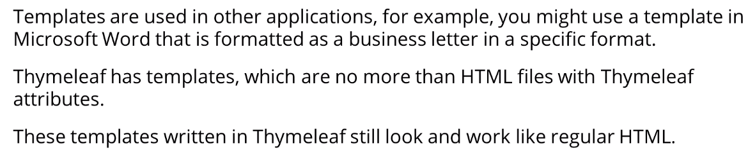

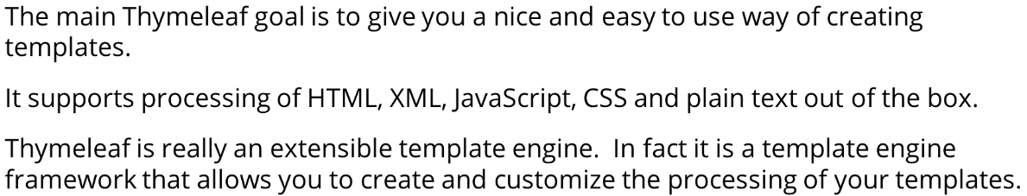

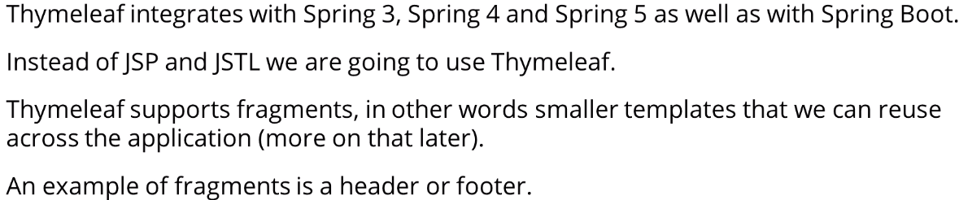

Now to have this working we create a file name home.html in “resources-templates-home.html (of type HTML5)”.
Pom.xml | Home.html
<dependency>  <groupId>org.springframework.boot</groupId>  <artifactId>spring-boot-starter-thymeleaf</artifactId>  </dependency> | <!DOCTYPE html>  <html lang="en" xmlns:th="http://www.thymeleaf.org">  <head>  <meta charset="UTF-8">  <title>Home Page</title>  </head>  <body>  <h1>Welcome to Home Page</h1>  <p th:text="${message}"/>  </body>  </html>

DemoController.java
@GetMapping("home")
public String home(Model model){
log.info("-----------welcome method called------------");
model.addAttribute("message","Welcome to Spring Boot");
return "home";
}

Note: In pom.xml we did not specify dependency version spring-boot is gonna handle this for us, also we have not specified any properties to scan “home.html” under “templates” again this will be handled by spring-boot

Spring-Boot developer tools:

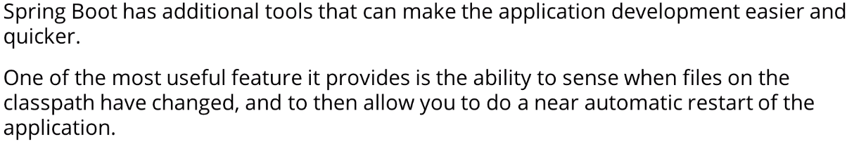

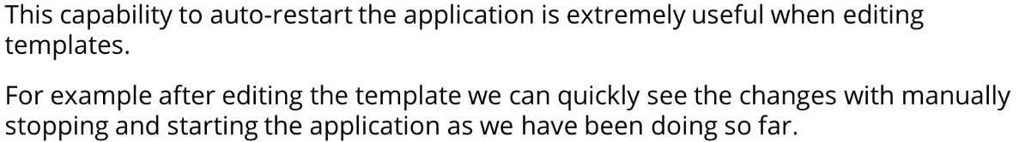

Ex: We test this on a running application, by updating “home.html”
Home.html(before) | Home.html(after)
<body>  <h1>Welcome to Home Page</h1>  <p th:text="${message}"/>  </body> | <body>  <div align="center">  <h1>Welcome to Home Page</h1>  <p th:text="${message}"/>  </div>  </body>

And now for this change to take effect we don’t need to rebuild entire application. We can just press (ctrl+F9) or Build (Tab)-Build Project & refresh the web page.

In the same way we can make changes to java-classes and press (ctrl+F9) and spring-boot automatically build application for us
Ex. Changes to DemoController.java

DemoController.java(before) | DemoController.java(after)
@GetMapping("demo")  @ResponseBody  public String demo(){  log.info("------this is demo spring-boot------");  return "Hello this is Spring Boot";  } | @GetMapping("demo")  @ResponseBody  public String demo(@RequestParam(required = false) String name){  log.info("------this is demo spring-boot------");  return "Hello "+name +" this is Spring Boot";  }

Some general Information on Spring Boot:

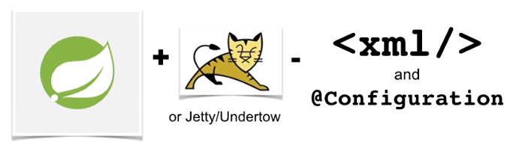

Ways to getting started with spring-boot:

STS (spring tool suite)
Spring Initializer & then load into STS or IntelliJ
Spring CLI

Install Spring CLI:

Download spring-boot-cli-2.3.3.RELEASE-bin.zip from https://docs.spring.io/spring-boot/docs/current/reference/html/getting-started.html#getting-started-installing-the-cli

Unzip and set environment variable PATH = till “/bin” folder.

Test: spring --version

Hello World using groovy:
HelloSpring.groovy
@RestController  public class HelloSpring{  @RequestMapping("/")  public String Hello(){  return "Hello World"  }  } | RUN: spring run HelloSpring.groovy  Test: https://localhost:8080

Below in-green, actually happens in background.

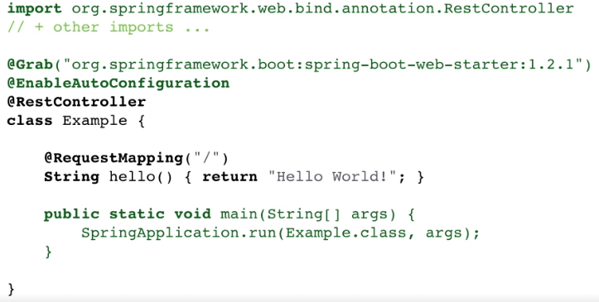

From command line as well we can generate spring-initializer projects (basic template of project).
>spring init [or] >curl start.spring.io
Ex:
> spring init --build=maven --java-version=1.11 --dependencies=web --packaging=war sample-app.zip

Useful command
>spring init –list
Can mavn clean install

Now once the project is generated create a new class called DemoController.java for test.
DemoController.java
@RestController
public class DemoController {
@RequestMapping("/")
public String hello(){
return "Hello World!!";
}
}

Then in visualcode – select (Open main class) – Run (from top right corner)
Test: localhost:8080
ORielly Training:

Spring is designed to represent project infrastructure.
To provide features like security, resource pooling, mails, message queues etc.

Manage lifecycle of java-classes (beans – any POJO with setters/getters).
Its like spring instantiate java classes, provide them when need and destroy them at the end.

Services it provides are – transaction, security, persistence etc.

If we use gradle (for spring starter and not maven) we get a nice html-based test report which is not possible with maven

Spring-boot also allows us to configure (Json decomposition) or we choose the spring-start-up it will automatically get a Jason serialisation library for Java (Jackson-2) as part of the build and because that will then be on the class-path spring will use that library automatically to convert Java classes into JavaScript object notation and back again.
And it won't bother us about it, as it'll just do it automatically we can also configure the mechanism within that application.properties or application.yml file.
And, if we add a data source or a jdbc driver for database to the class-path spring will automatically configure that as a database connection pool - so great simplification.

RC1 – Release Candidate stage-1

We will use “Integer” to define variable (that has to be primary key), because:
When we use hibernate and it will do persistence for us, null is a significant value when we have a primary key and primary key tells hibernate this object is in the so-called transient state meaning it is not currently mapped to a particular row in the database table.
So, the idea is for null there is no row representing this object whereas if we use lower case “int” it could never be null could only be zero and it's possible there is an ID of zero in the table.
And this is all to distinguish between those circumstances.

Spring-dataVersus Hibernate it is the combination.
Hibernate is the persistence engine being used by spring by its jpa.
And spring-data jpa is having spring manage the hibernate engine itself.
We will usually use hibernate under the hood through its jpa special API and spring data is managing the connections to the database and executing all the sql on our behalf, so it is the combination.

It is not encouraged to access the repository-class directly so add a service-class and do all the transactions on all the methods in the service and the service will work with the repository.
And then here instead of auto wiring in the repository-class and using it directly because we do CRUD operations.
Note: Services(class) are meant for transactional boundaries & business logic.

All exceptions in spring are runtime exceptions so for example - SQL exception being unchecked exception we don't have to put in any try catch blocks when we are working with our repository-class because spring catches that checked exception and throws it as one of a whole family of their own data access exceptions things like invalid data access API usage exception or optimistic locking failure exception or no such entity exception all series of those are all thrown as runtime exception so I don't need try catch blocks anywhere

Several times we make use of “Spring - CommandLineInterface” that runs on project start-up.
For this what we can do is have a @Bean annotated method in main class, which is also a config-class
and in this bean method we will return commandLineRunner, and this is done with Lambda exp of java8.

Below ref shows how entire class is replaced with @Bean method
AppInit.class | Main.class
@Component  public class AppInit implements CommandLineRunner {  private final ProductService service;  @Autowired  public AppInit(ProductService service) {  this.service = service;  }  @Override  public void run(String... args) throws Exception {  service.initializeDatabase();  }  } | @Bean  public CommandLineRunner initialize(@Autowired ProductService service){  return (String... args) -> service.initializeDatabase();  }

