Name: Abdul Moiz Asif

CMS: 263802

**AI lab 7**

**Code:**

import pandas as pd  
from sklearn.model_selection import train_test_split  
from sklearn.ensemble import RandomForestClassifier  
from sklearn import metrics  
  
  
  
  
df = pd.read_csv('TrainingSet.csv')  
X = df.iloc[:, 1:4]  
Y=df["plant"]  
X_train,X_test,y_train,y_test=train_test_split(X,Y,test_size=0.3)  
  
clf=RandomForestClassifier(n_estimators=500)  
clf.fit(X_train,y_train)  
y_pred=clf.predict(X_test)  
  
  
print("Accuracy:",metrics.accuracy_score(y_test, y_pred))  
  
  
# In[ ]:

**Output:**

**When treeSize=100:**

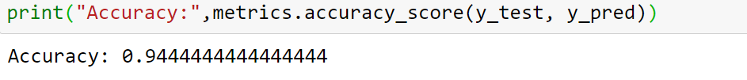

**When treeSize=300:**



**When treeSie=500:**



**Conclusion:**

No change in the accuracy of the results by changing the number of trees.