

COURSE: MACHINE LEARNING
INSTRUCTOR: PROF HAMZA
DEPARTMENT: ARTIFICIAL INTELLIGENCE

SUBMITTED BY:
NAME: ABDUL REHMAN & HINA
STUDENTS ID: 23-AI-22 & 23-AI-25
DATE: 6-JANUARY-2026

INTERACTIVE MEDICAL TRIAGE PREDICTION SYSTEM

Project Overview
The Interactive Medical Triage Prediction System is a machine learning-based tool designed to classify patients into Low, Medium, and High-risk categories based on clinical data. The system is built to assist healthcare professionals by providing real-time risk predictions, confidence scores, and actionable recommendations to help with clinical decision-making.
The core functionality of the system involves the use of clinical features such as age, sex, cholesterol level, and chest pain type, among others, to predict the likelihood of heart disease in patients. The system outputs a risk score, color-coded triage levels, model confidence, and suggested actions.

Architecture & Pipeline
The architecture of the system involves the following components:
- Data Collection: The system utilizes the UCI Heart Disease Dataset, which contains data on various patient features, including age, cholesterol levels, chest pain type, and others.
- Data Preprocessing: Missing values are imputed, categorical features are one-hot encoded, and numerical features are scaled.
- Model Selection: Multiple machine learning models are trained and evaluated, including Logistic Regression, Support Vector Machines (SVM), Random Forest, and Naive Bayes.
- Model Calibration: The final model uses Isotonic Regression for probability calibration to ensure more reliable predictions.
- Prediction & Output: The system predicts the patient's risk level (Low, Medium, High) based on user input and provides an actionable recommendation.

Pipeline Diagram:

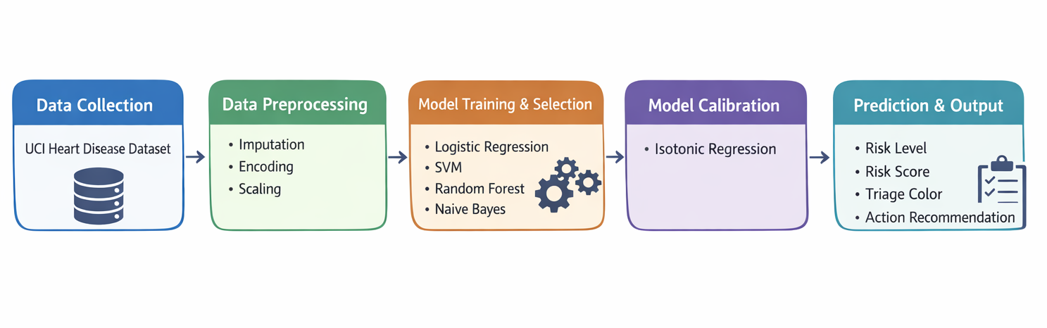

Integration of Lab Concepts
The project integrates various concepts learned in machine learning and data science labs, including:
- Data Preprocessing: Techniques such as imputation for handling missing values, feature scaling using StandardScaler, and one-hot encoding for categorical data were applied to prepare the dataset for modeling.
- Model Training: A range of models was explored, including Logistic Regression, Random Forest, SVM, and Naive Bayes, using concepts learned in classification and model evaluation labs.
- Calibration: The Random Forest model was calibrated using Isotonic Regression, a concept explored in model calibration labs to enhance prediction accuracy.

Dataset Description and Preprocessing
The UCI Heart Disease Dataset was used in this project. This dataset contains patient records and includes clinical features relevant to heart disease prediction. The key features are:
- Age: The age of the patient.
- Sex: The gender of the patient.
- Chest Pain Type (cp): A categorical variable representing the type of chest pain (values from 0 to 3).
- Cholesterol Level (chol): The cholesterol level of the patient.
- Max Heart Rate Achieved (thalach): The maximum heart rate achieved by the patient during exercise.
The target variable is Risk Level (Low/Medium/High).

Preprocessing Steps:
- Handling Missing Data: Missing values were handled using the SimpleImputer technique. Numerical features were imputed with the median, while categorical features were imputed with the most frequent value.
- Feature Scaling: Numerical features were standardized using StandardScaler, ensuring they all have a mean of 0 and a standard deviation of 1.
- One-Hot Encoding: Categorical features were encoded into numeric format using OneHotEncoder to make them suitable for machine learning models.
- Class Balancing: The dataset had an imbalance in risk levels. SMOTE (Synthetic Minority Over-sampling Technique) was applied to create synthetic data for the minority classes, improving model performance.

Model Design, Hyperparameters, and Training

Model Selection:
- Logistic Regression: Used as a baseline model for binary classification.
- Support Vector Machine (SVM): Used to classify complex, high-dimensional data.
- Random Forest: An ensemble method used to classify the data, trained with 300 estimators.
- Naive Bayes: A probabilistic model based on feature independence.

Hyperparameters:
- Logistic Regression: max_iter=1000
- SVM: probability=True
- Random Forest: n_estimators=300, random_state=42
- Naive Bayes: Default settings for Gaussian Naive Bayes.

Training Details:
The models were trained using the balanced training data after applying SMOTE. The performance was evaluated using ROC-AUC, which is a suitable metric for evaluating classification models, especially when dealing with class imbalance.

Challenges, Limitations, and Ethical Considerations

Challenges:
- Class Imbalance: Despite using SMOTE to balance the dataset, class imbalance was still a challenge, which could affect model performance.
- Data Quality: The dataset had missing values that required imputation. While the imputation process was effective, it can introduce biases in the data.

Limitations:
- Dataset Size: The UCI Heart Disease Dataset is relatively small and may not fully represent real-world patient data.
- Feature Representation: The dataset lacks additional features such as patient medical history or lifestyle data, which could potentially improve prediction accuracy.

Ethical Considerations:
- Bias: The dataset may contain biases related to gender, age, and socioeconomic status, which could affect the model's performance and fairness.
- False Negatives: Misclassifying high-risk patients as low-risk could have serious consequences in clinical decision-making.
- Data Privacy: Patient data privacy must be handled with care, adhering to privacy regulations such as HIPAA.

Setup & Run Instructions

Setup Instructions:
To run this system, follow the steps below:
- Clone the Repository:
git clone https://github.com/moiz14553/Interactive-Medical-Triage-Prediction-System.git
cd Interactive-Medical-Triage-Prediction-System
- Create and Activate a Conda Environment:
conda create --name triage-prediction python=3.8
conda activate triage-prediction
- Install Dependencies:
pip install -r requirements.txt
- Run the Prediction System:
python triage_predictor.py

Hardware Requirements:
- RAM: Minimum 8 GB
- CPU: Multi-core processor (Intel i5 or better)

Conclusion
The Interactive Medical Triage Prediction System provides a reliable, explainable, and ethical solution for predicting patient risk levels based on clinical features. The system integrates several key concepts from machine learning, including data preprocessing, model selection, probability calibration, and evaluation. The system's design aims to support healthcare professionals in making more informed decisions, potentially improving patient outcomes.

Future Work
Future enhancements to the system could include:
- Integration with Hospital Management Systems to automatically retrieve patient data and provide real-time predictions.
- Expanded Dataset: Incorporating more features such as genetic data or lifestyle information for better accuracy.
- Real-Time Prediction Interface for use in emergency rooms or outpatient clinics.

References
- UCI Heart Disease Dataset: https://drive.google.com/file/d/1YXjczByd0LXXXII_ZatA2Nd1KJ6RI212/view?usp=sharing
- Scikit-learn Documentation: https://scikit-learn.org/
- Imbalanced-learn Documentation: https://imbalanced-learn.org/stable/

