**GRADE C IS REQUIRED ( FROM BREIF )**

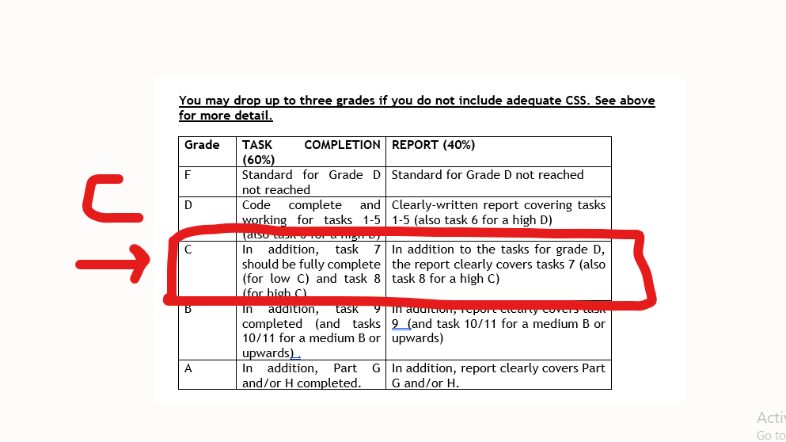

=======================================================================

1. Ignore date on brief. I need get early so need a change report in my style. Use postman where necessary I screenshot
2. When I get zip. Please make sure i can open straight and run... on lovalhost3000
3. It's shiud take maybe 4 hrs to do it for your:"expert " ( client comment for expert )
4. Use my data base which i upload with restaurant (Db file attached in order form )

======================================  
VERY IMPORTANT   
