COMSATS University Islamabad
Attack Campus



Name | Abdul moiz siddiqui
REG No. | FA24-BSE-002
Course | IS-Lab
Assignment | 03
Submitted To | Ma’am AMBREEN Gul
Date | 4-5-2026

QUESTION # 1:
CODE:
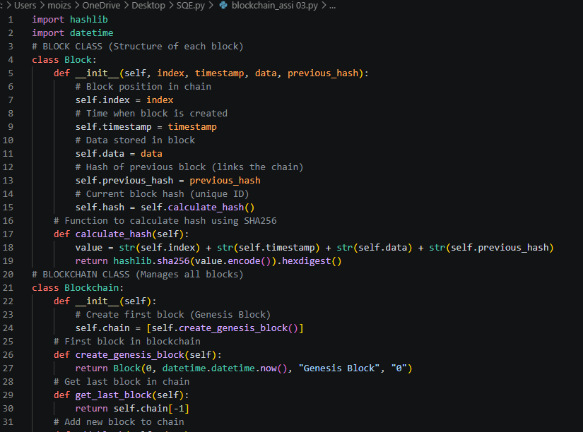

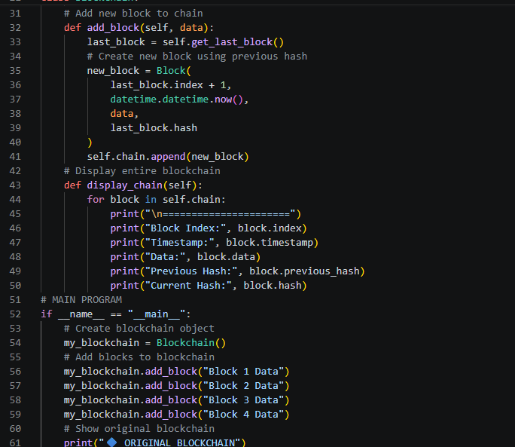

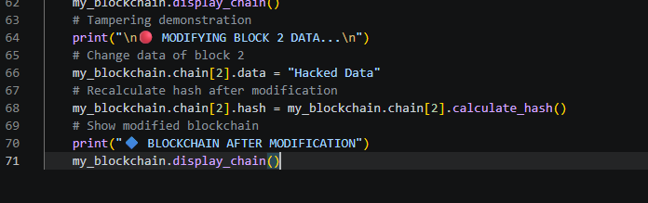

Output:
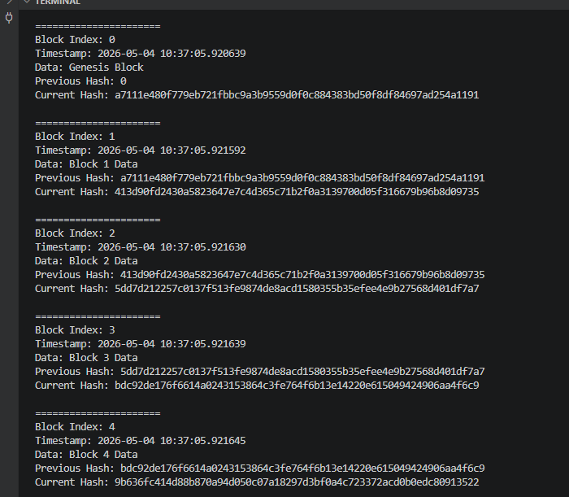

Output after modification block 2:
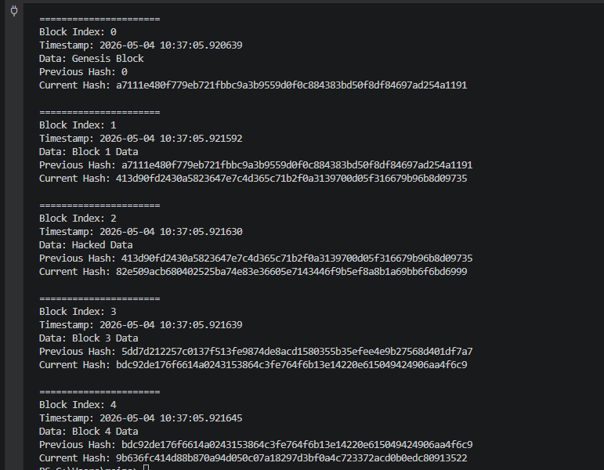

Explanation:
This program shows a simple blockchain system using Python. A blockchain is a chain of blocks where each block is connected to the previous one using a special code called a hash. Each block contains an index, time, data, previous hash, and current hash. The hash is created using the SHA256 method, which makes the data secure.
First, a Block class is created to store the information of each block. It saves the block number, time, data, previous block’s hash, and its own hash. The hash is created by combining all block information and converting it into a unique code. Even a small change in data will change the hash completely.
Then, a Blockchain class is created to manage all blocks. It starts with a Genesis Block, which is the first block in the chain. After that, new blocks are added using the previous block’s hash. This connects all blocks in order.
The program also displays all blocks in the chain. After that, one block is changed to show what happens when data is modified. When a block is changed, its hash also changes. This breaks the connection in the chain and shows that blockchain is secure and cannot be easily changed.

QUESTION # 02:
ECC IMPLEMENTATION
CODE:

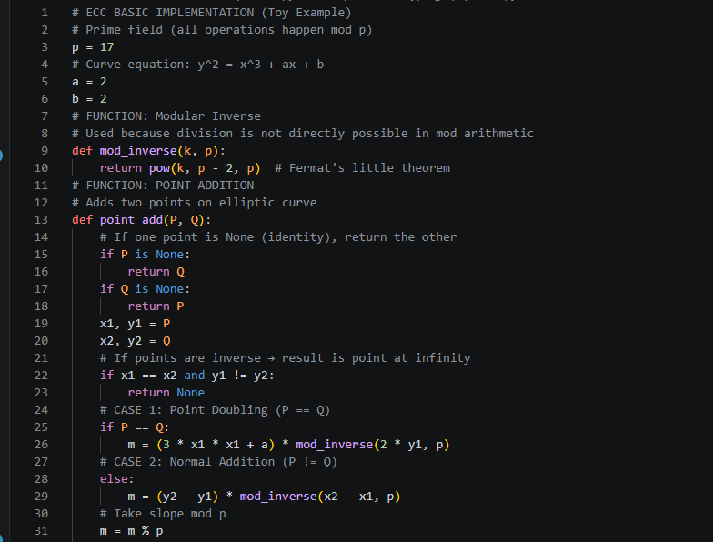
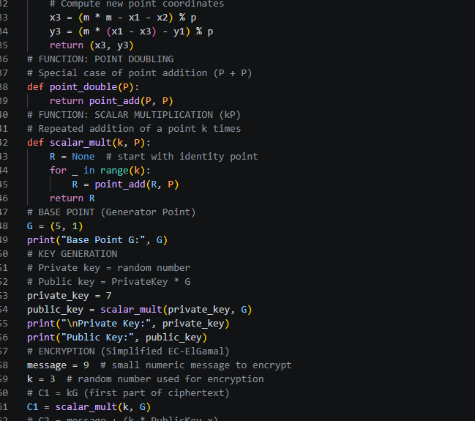

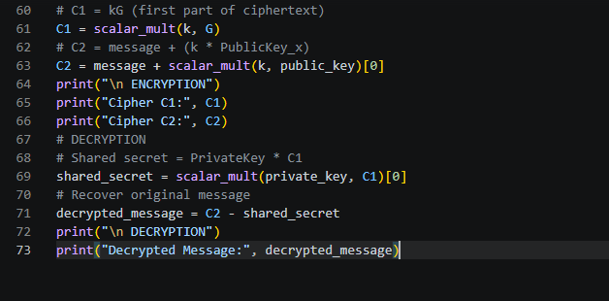

Output:
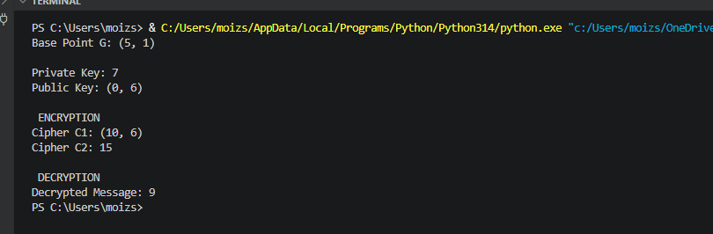
Explanation:
This program demonstrates the basic idea of Elliptic Curve Cryptography (ECC) using simple numbers for learning. It uses a small finite field with a prime number and defines an elliptic curve equation. The program first implements point addition and point doubling, which are the main operations in ECC. These operations are used to perform scalar multiplication, which means adding a point many times.
After that, the program generates a key pair. The private key is a secret number, and the public key is created by multiplying the private key with a base point on the curve. This shows how ECC keys are generated.
For encryption, a random number is used to create a ciphertext. The message is hidden using the public key and curve operations. For decryption, the receiver uses the private key to recover the shared secret and get back the original message.

