R Markdown training exercises

Ministry of Justice

14/03/2019

## Exercises

Recreate the following plot and text using what you have learnt in this training. You may find the cheatsheet and help window useful. Check your code works by swapping between the two data sets as before.

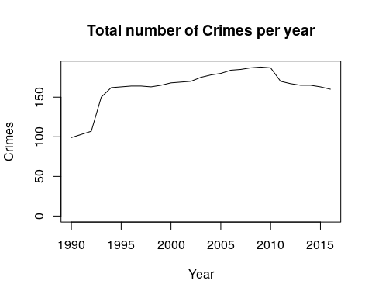

**For this crimes statistic we have data from 1990 to 2016.**

*The mean number of crimes per year across this period was 163.*