Air passengers

Vicky Hughes

22/08/2017

# Trend over time

Over time, the number of crimes has changed.

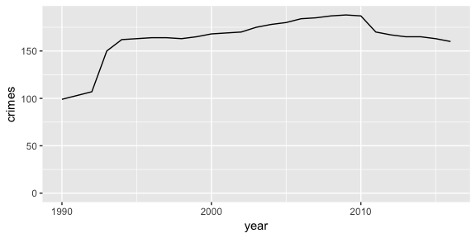

# Key figures

The minimum number of passangers was 99 and the maximum was 188.

In the latest year (2016) there were 160 crimes.