Crime stats

Vicky Hughes

24/08/2017

# Trend over time

Over time, crime has changed.

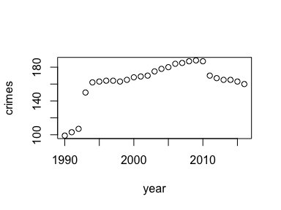

# Key figures

The maximum number of crimes was 188. The latest number was 160.