Crimes data

An Analyst

30/11/2020

# Trends over time

Over time, the number of crimes has changed.

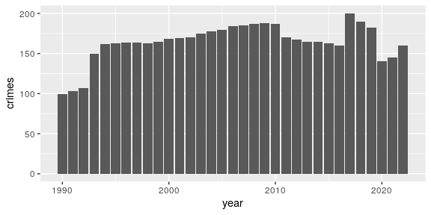

# Key figures

Since 1990, the minimum number of crimes was 99 and the maximum was 200.

In the latest year 2022 there were 160 crimes. This compares to an average of # r round(crimes_decade_previous,0) over the previous decade (from 2012 to 2021).