|  |  |
| --- | --- |
|  | **Machine Learning II**  **Final Project**  **by: Mina Hanna and Mojahid Osman Date: Dec-06-2021** |

1. **Overview**

“An image is worth a thousand words” is the famous statement by Henrik Ibsen which implies the value and the impact of an image and how a complex message can be delivered with one visual rather than a lengthy verbal description. On the other hand, a fake image can have a severe negative impact on the overall public respect and confidence in news and other social communications.

The other threatening fact about fake media (images, videos, and news) is the availability and sophistication of tools and platforms that helps to easily fabricate such fake media and distribute it. This project aims to utilize deep learning models to classify images and be able to detect forged images which was manipulated using different techniques.

This project focuses on Image tampering detection using Convolutional Neural Network (CNN) classification based on popular filters and analysis used in today’s forensic image analysis like Error Level Analysis, Noise Analysis and Luminance Gradient Analysis.

The report is divided into the following main sections:

* Introduction to digital image forensic
* The dataset and the exploratory data analysis conducted in the project
* Deep neural networks used
* Results and Conclusions

1. **Introduction to digital image forensic**

Image tampering can be defined as “adding or removing important features from an image without leaving any obvious traces of tampering” [1]. Image tampering or forgery techniques can have different forms which include the following [2]:

|  |  |
| --- | --- |
| **Image retouching**: reduce or improve certain features of the image | *Source: digitallybeautiful.blogspot.com* |
| **Copy-move**: copy part of the image to hide certain areas of shows areas several times | *source: conspiracy-cafe.com* |
| **Image splicing**: compose a new image using fragments from same or different images | *Source: https://www.mdpi.com/1099-4300/21/4/371* |
| **Processing** through filters and color changes | The difference after a little editing in Lightroom is astounding.  *Source: https://www.lightstalking.com/boost-golden-hour-images-lightroom/* |

Detecting image forgery follows Locard’s exchange principle “whenever two objects come in contact, there will always be an exchange” [3]. Each image tampering technique requires certain tools and analysis to reveal such exchange and detect the tampered image. There are different techniques known in the digital image forensic, but the report here will focus on the following listed techniques which will be used throughout this report:

|  |  |
| --- | --- |
| **Error Level Analysis (ELA)** | Based on the lossy nature of the JPG algorithm, where each save introduce new compression error, ELA algorithm is designed to detect different error rates in the image |
| **Noise Analysis** | Each image has its own natural noise based on the lens, lighting condition or other digitalization processes and this technique depends on detecting a change of the natural noise due to tampering the image. |
| **Gradient Analysis** | Detecting changes in the brightness level across the image and detect any anomalies |

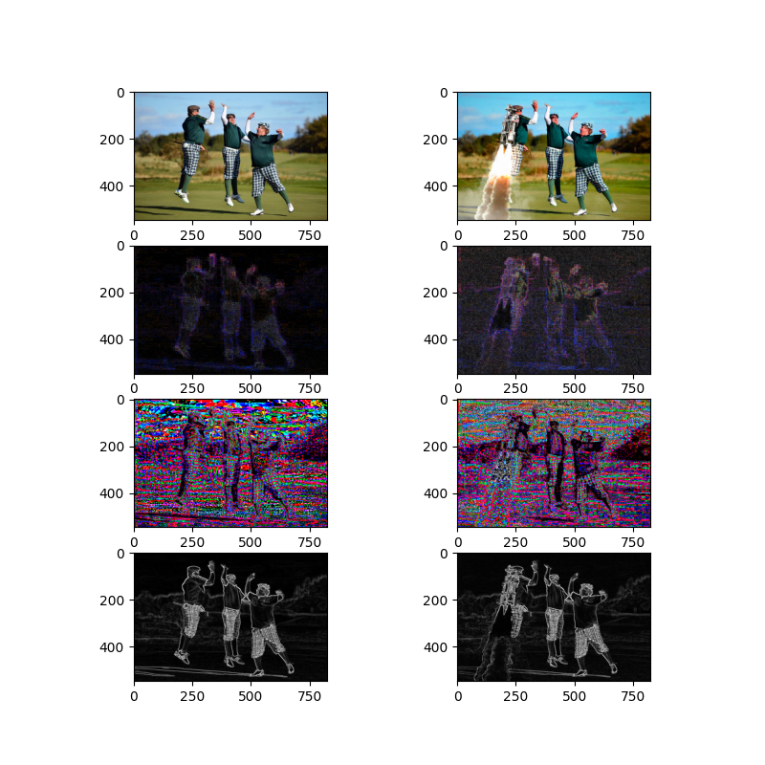

**Figure 1**: shows the original and photoshopped images (top row) and each is followed by the ELA, Noise ad Gradient filters.

1. **The dataset, Exploratory Data Analysis and Pre-Processing**

The dataset used in this project is the PS-Battles dataset which is gathered from a large community of image manipulation enthusiasts and provides a basis for media derivation and manipulation detection in the visual domain. The dataset consists of 102'028 images grouped into 11'142 subsets, each containing the original image as well as a varying number of manipulated derivatives. [4] which means that original photos are 11,142 and the photoshopped photos are 90,886.

Each original image has a corresponding sub directory (having the same image name) under the photoshopped directory that contains the manipulated version of this image.

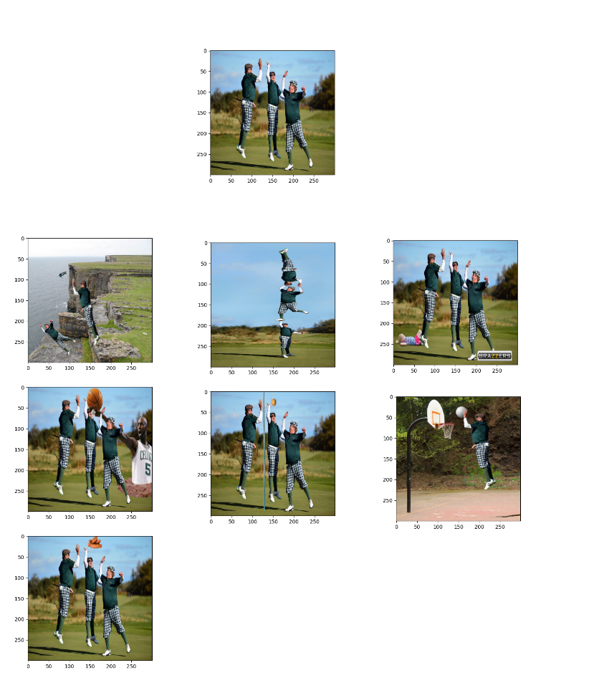

**Figure 2**: The original image (top row) and followed by the photoshopped versions

The following sequence took place to prepare the date:

1. Cleaning up: deleting any unwanted extensions and images that failed to be loaded by openCV
2. Exploration functions: count and analyze the data and run different functions to pull original picture and its corresponding photoshopped images for comparisons
3. Organization: remove sub-directories in photoshopped images and end up having two directories “original” and “photoshopped” each contains corresponding images
4. Use only subset of the ~10,000 from each class due to size and performance limitations
5. Apply filters: prepare filter extracted images (ELA, noise, and gradient) under the same folder structure

🡪  **Figure 3**: folder strcuture

1. **Convolutional Neural Network**

Using an ANN for the purpose of image classification would end up being very costly in terms of computation since the trainable parameters become extremely large. For example, if we have a 50 X 50 image of a cat, and we want to train our traditional ANN on that image to classify it into a dog or a cat the trainable parameters become –  
(50*50) * 100 image pixels multiplied by hidden layer + 100 bias + 2 * 100 output neurons + 2 bias = 2,50,302.

Convolutional Neural Networks come under the subdomain of Machine Learning which is Deep Learning. It was proposed by computer scientist ***Yann LeCun*** in the late 90s, when he was inspired from the human visual perception of recognizing things.[5]

Constructing CNN convolution layer follows a hierarchical model which works on building a network, like a funnel, and finally gives out a fully connected layer where all the neurons are connected to each other, and the output is processed.

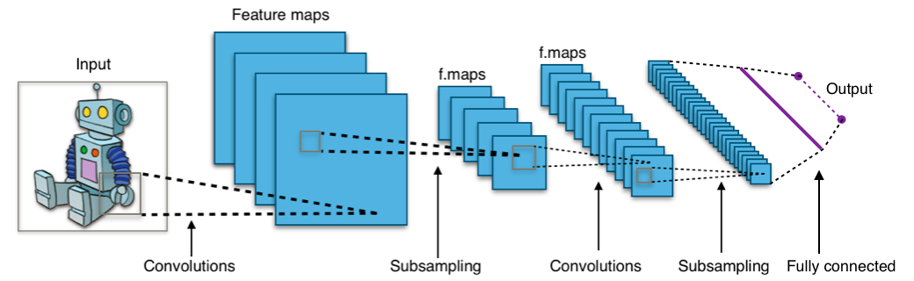

**Figure 4:** Convolution Concept

*(image source: https://medium.com/@himadrisankarchatterjee/a-basic-introduction-to-convolutional-neural-network-8e39019b27c4)*

A convolution network is a multilayer feedforward network that has two- or three-dimensional inputs. It has weight functions that are not generally viewed as matrix multiplication (or inner product) operations, The principal layer type for convolution networks is the convolution layer that convolute a kernel over the image and create feature maps, Pooling layer that is used to subsample the output of the convolution layer which reduce the size while maintaining the features for next layers.

**Figure 5:** Convolution Neural Network Architecture

For an image v with dimension Rr x Rc and kernel W with size of r x c, the weight function is calculated as follows:

**TensorFlow:**

When it comes to picking a framework for your deep learning project, people are always debating between TensorFlow and PyTorch. Both frameworks are very useful abstractions and reduce a decent amount of code and speed up model development. In this project, Tensorflow was the framework of choice due to the experimental nature of the project and the need to build fast model to assess the further implementation approaches.

**Building the model:**

As described in the previous section, four image datasets was created with the following properties:

* Normal image as downloaded from the original dataset
* Error Level Analysis version of the image
* Noise extracted version of the image
* Gradient magnitude version of the image

After the Data Preprocessing phase, the following was performed to complete the model architecture:

**Step 1: Prepare Dataset for Training**

|  |  |
| --- | --- |
| Leverage TensorFlow **image_dataset_from_directory()** function to automatically load images and their corresponding target class from the directory structure complete in the data preprocessing phase. The function is used also to Create Training & Validation Data, where data was divided into two groups: one for training and the other for model validation in a ratio of 80/20. |  |
|  |  |

**Step 2: Images Augmentation and rescaling:**

|  |  |
| --- | --- |
| Sperate layers for image augmentation and rescaling are defined and was added later to CNN Architectures utilizing the GPU and to minimize the overfitting |  |

**Step 3: Convolutional, Pooling and Batch Normalization Layers:**

The following is the architecture of the CNN used throughout the project.

**Figure 6:** CNN designed for the project

In this step we define the convolutional neural network where the convolution, **Pooling**, and **Fattening** layers will be applied. We also added **Dropout layer** to reduce overfitting. Since it’s a binary class problem, the **Sigmoid activation** function is applied in the last layer. **Batch normalization** is used to keep output close to mean of 0 and variance of 1 which prevents the saturations of the activation function

#### **Step 4: Model Compilation, optimizer, and loss function:**

The next step is to compile the model with the following parameters:

* **Adam** as an optimizer with small learning rate of 0.0001 (which is adapted by the algorithm) was the best performance of the model and known for its computational efficiencies with images
* **Binary Cross-entropy** loss is used because the labels are binary.

Y is the label and p(y) is the probability of y to belong to certain class and N is number of points.

In the event that you want to encode the labels, then you will have to use the [Categorical Cross-Entropy loss](https://www.tensorflow.org/api_docs/python/tf/keras/losses/CategoricalCrossentropy) function.

#### **Step 5: Training the model:**

The model is set to run for 50 epochs, but the process will be stopped by the callback when the loss doesn’t improve after 5 epochs as we defined in the Early Stopping callback to avoid overfitting. A batch size is set to 48 to minimize any memory allocation problems with large images and maintain a good rate of updating the weight based on avg batch gradient.

Once the training is completed, historical losses and accuracies obtained throughout the different epochs will be displayed for model assessment.

**Learning Transfer:**

As part of the experimental setup in the project, pre-trained **VGG19** model using Keras API was explored. This model and others like (Xception, ResNet50 & MobileNet) have been pre-trained on the ImageNet dataset which has over million images. This provides our model with a very relevant weight initialization which provide a better generalization and convergence likelihood.

The approach used in the transfer learning process is to freeze the base layer and add a set of linear layers as a head model to be trained and classify the images.

**Model performance measurement**

For model performance assessment, SK-learn package was used to obtain the confusion matrix, recall, precision, F1 score and weight accuracy.

**Model Stacking and Ensembling**

Due to the usage of multiple filters and different learning approaches (i.e., transfer learning), there was a need to utilize the best performance from all the models created throughout the training phase. To leverage the different models, the following two techniques were examined:

1. Voting Committee: where best performing models will be used for prediction and then the final prediction will be determined by majority vote by the models.

1. MLP Classifier: Collect all predictions from top performing models and train a Multi-Layer Perceptron to predict the final classification

**Implementation Approach Summary**

The following figure summarizes the full implementation approach of the project:

**Figure 7:** Implementation approach summary

1. **Results and Observations**

With early experimental models, it was obvious that ELA image is providing better performance compared to image datasets (normal image, noise analysis, gradient analysis other).

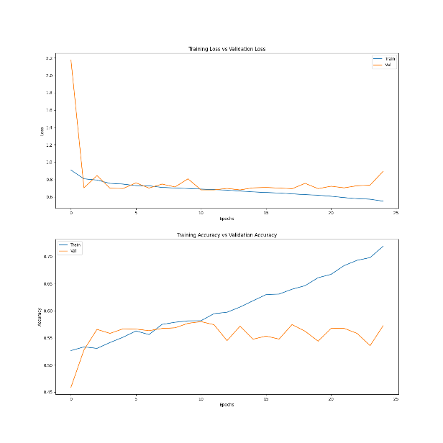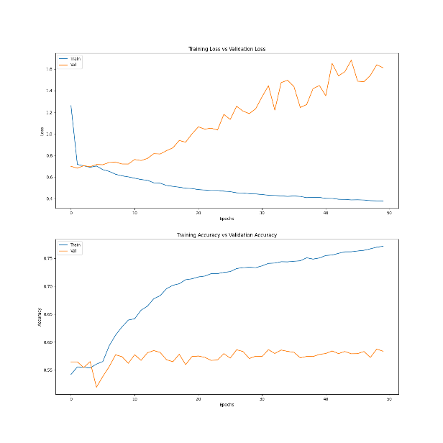

**Figure 8:** Model performance: ELA images top left, Noise images top right, Gradient images bottom left and normal images bottom right

Final layer output activation function is Sigmoid with 7 outputs.

[1] J. Fridrich, D. Soukal and J. Lukas, “Detection of Copy-move forgery in digital images”, in Digital Forensic Research Workshop, 2003.

[2] COMPREHENSIVE STUDY OF DIFFERENT TYPES IMAGE FORGERIES<http://www.ijstm.com/images/short_pdf/1440486816_229P.pdf>

[3] <http://aboutforensics.co.uk/edmond-locard/>

[4] <https://arxiv.org/abs/1804.04866>

[5] https://bdtechtalks.com/2020/01/06/convolutional-neural-networks-cnn-convnets/

Y. Guo, X. Cao, W. Zhang and R. Wang, "Fake Colorized Image Detection," in IEEE Transactions on Information Forensics and Security, vol. 13, no. 8, pp. 1932-1944, Aug. 2018, doi: 10.1109/TIFS.2018.2806926.