# My File Sharing App in Cloud

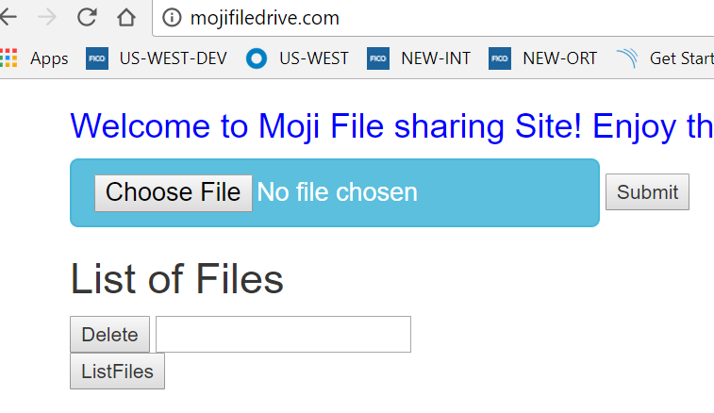

University Name: http://www.sjsu.edu/

Course: Cloud Technologies

Professor Sanjay Garje

ISA: Divyankitha Urs

Student: https://www.linkedin.com/in/mojdeh-keykhanzadeh-b8528043/

# Project Introduction

Highly scalable and publically available file sharing app

## Prerequisite:

**Cloud Resources (AWS)**

* EC2
* Multi-AZ deployment
* S3
* S3 Transfer Acceleration
* ELB
* Auto Scaling group
* Route 53
* CDN
* Cloud Watch

**Local Configuration**

* Install JDK and Maven (add JAVA_HOME and M2 to your path), build the project
* Install Eclipse IDE and add Spring Tool Suite
* Run as Spring boot app
* Launch on http://localhost:8080/

## Features Done:

• Uploading files (limit size 10 MB and prompt user at the beginning)

• Downloading files

• Deleting files (UI still need some attention but file get deleted from server side)

• Listing files (UI still need some attention but file listed from server side)

## Features under construction:

• Enhance UI

• Login page to keep track of authorized users

• Updating already uploaded files

• RDS Integration to keep track of users and files

• Lambda to trigger SNS to do needful action for alarms coming from CloudWatch

## **How it works:**

After clicking on choose file and select file, first application prompts you about the max size limit of upload (also your file size) . Then after clicking ok, click submit and the file gets uploaded.

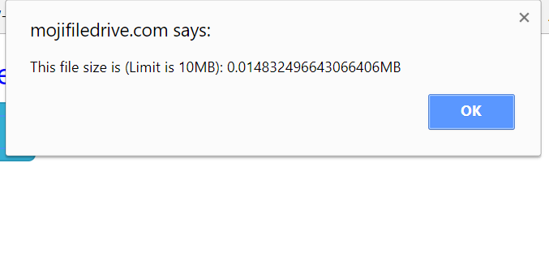

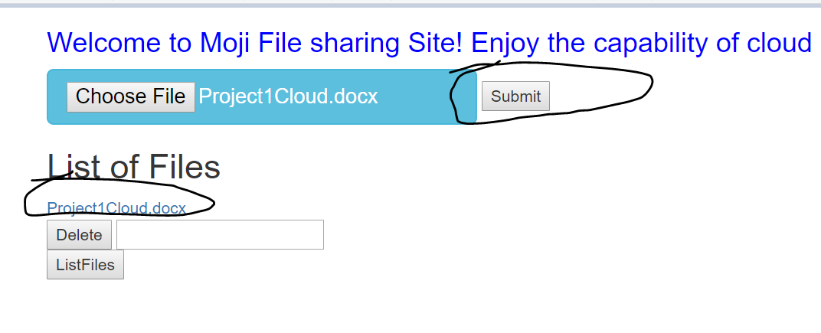

For delete, input the file you want to delete and click delete (UI still showing up but file gets deleted)

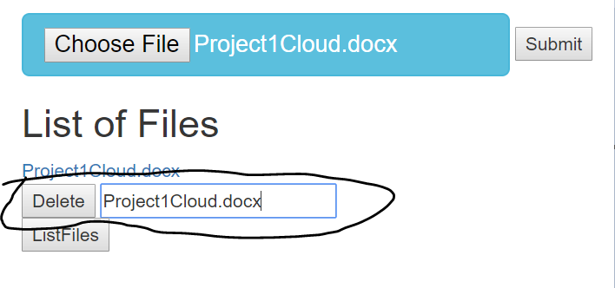

The list button has functionality but displaying on UI is still under construction