susoDash
User manual
Monitoring survey data collection: importing, tabulating,
dashboards, indicators, data quality and maps

07 September 2026

Contents
Every picture in this manual is a screenshot of a running instance carrying a demonstration labour force survey, so what you see here is what the platform actually looks like.
1. What susoDash is
2. Signing in and finding your way around
3. Projects: who can see what
4. Getting data in
5. Looking at a dataset
6. Explore: tabulations and charts
7. Dashboards
8. Maps and boundaries
9. Monitoring: indicators and targets
10. Data quality
11. Alerts
12. Sharing a dashboard
13. Taking your work away
14. Administration
15. Reference tables
16. If something goes wrong

1. What susoDash is
susoDash is a platform for watching a survey while it is still in the field. It takes the data your interviewers are collecting, and turns it into the things a survey manager needs during fieldwork: how many interviews are done and where, whether the numbers coming back look right, and which teams need a telephone call today.
It does four things.
- Brings data in. Either by connecting to a Survey Solutions server and importing on a schedule, or by uploading a Stata, SPSS, CSV or Excel file by hand.
- Lets you tabulate it. Frequencies, cross-tabulations, means and shares, with filters, weights and charts, without writing code.
- Puts it on a dashboard. Charts, tables, indicator tiles, maps and data-quality panels, arranged how you like and shared by link.
- Watches it for you. Indicators against targets, data-quality checks that run on a schedule, and alerts when something crosses a threshold you set.
It is self-hosted. It runs on your own server, the data never leaves your network, and it works on a machine with no route to the internet apart from the map tiles.

Who it is for
If you are | You will mostly use
A survey manager | Dashboards, monitoring and alerts
A data manager or statistician | Explore, data quality, datasets
A field supervisor | A shared dashboard link, on a phone or a laptop
An IT administrator | Administration, connections, projects

2. Signing in and finding your way around
Open the address your administrator gave you and sign in with your email address and password. If this is your first time, you will be asked to choose a new password before you go any further.
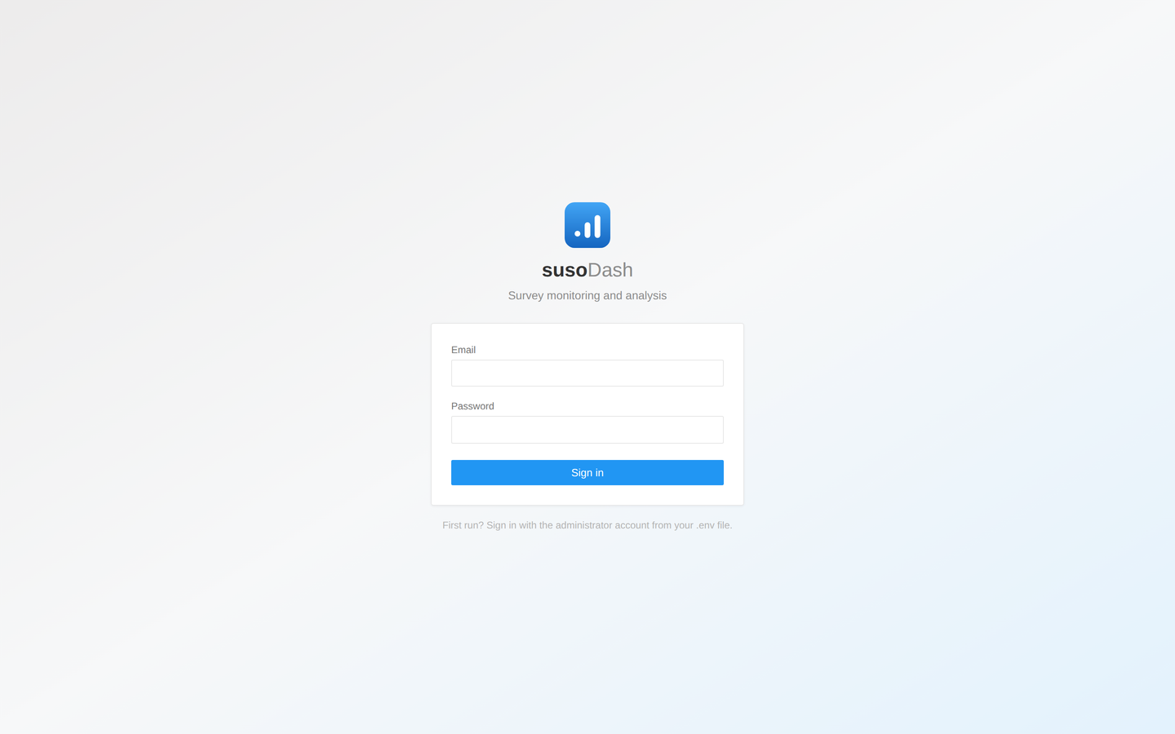
Figure 1. The sign-in page.

The parts of the screen
Everything is reached from the dark bar down the left. It does not change, so you can always get back.
Where | What is there
Overview | The state of everything at a glance: recent imports, indicators, failing checks
Projects | Groups of work, and who may see each one
Datasets | Every file that has been imported, and the boundary layers
Connections | Survey Solutions servers and their import schedules
Explore | Building tabulations and charts
Dashboards | Assembling and reading dashboards
Monitoring | Indicators and their targets
Data quality | Checks and their results
Alerts | What has crossed a threshold, and what to do about it
Administration | Users, roles and system settings

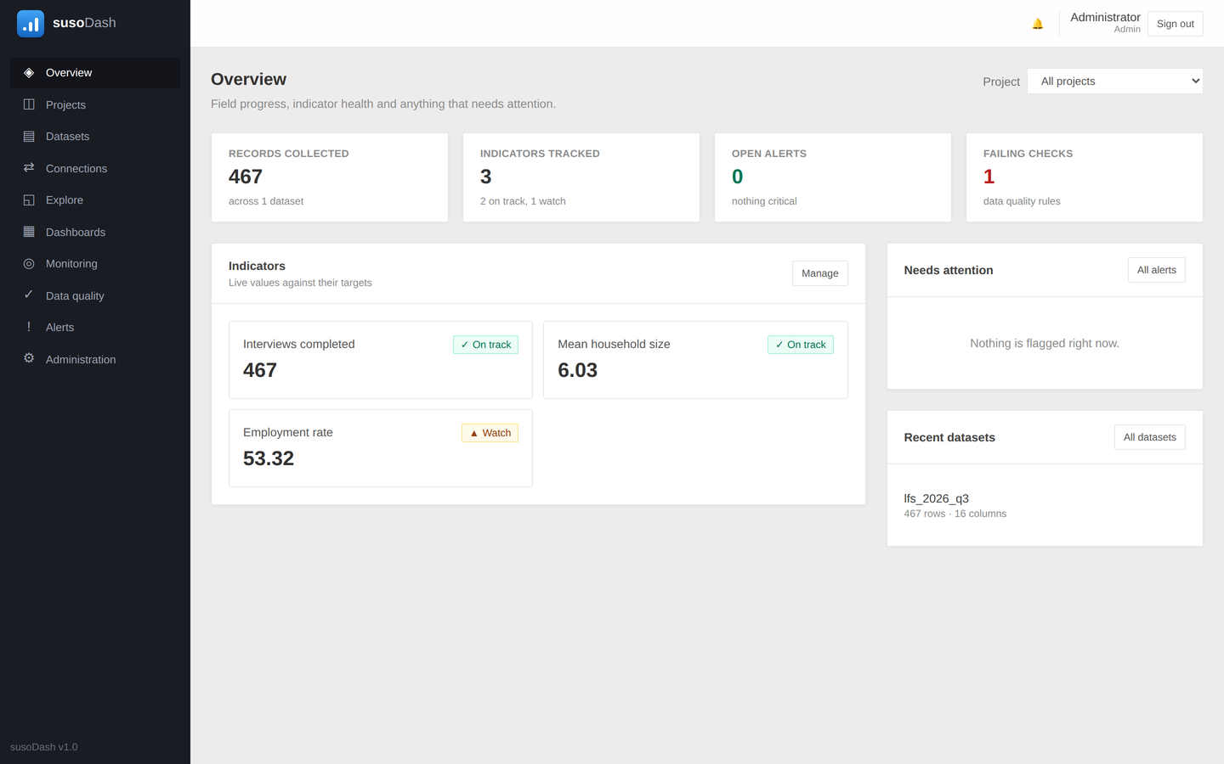
Figure 2. The Overview, which is where signing in leaves you.

3. Projects: who can see what
A project is a group of work: one survey, one round, one bureau. Datasets, dashboards, indicators and boundary layers all belong to a project, or to the shared area, which everybody can see.
The shared area is a real place rather than the absence of one. A national frame of enumeration areas usually belongs there, because every survey works to it; the interviews from one round belong to that round's project.
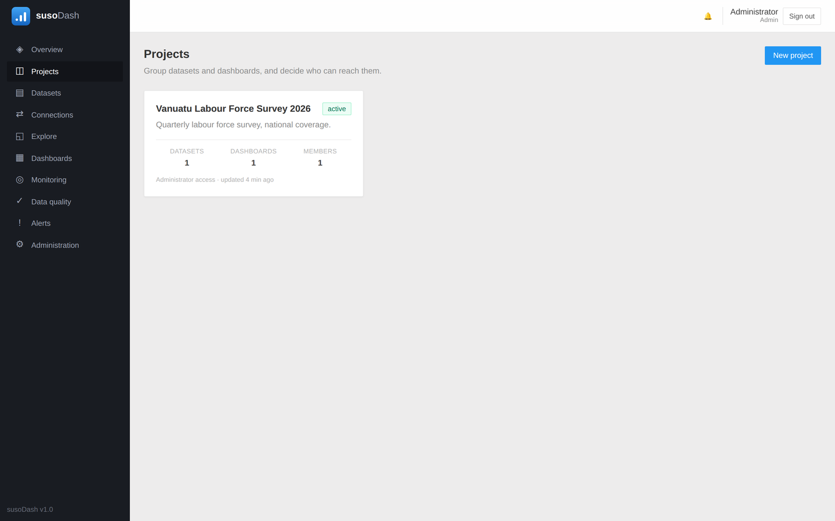
Figure 3. Projects, each showing what it holds and who is on it.

Giving someone one project only
- Open Administration → Users and create the account, or find it.
- Set the account to Restricted, which means it sees nothing except the projects it is added to.
- Open the project, go to Members, and add them with a role.
A restricted user who asks for something outside their projects is told it does not exist rather than that they may not see it. That is deliberate: a "forbidden" answer would confirm that the thing is there.

Deleting a project
Deleting a project releases its datasets back to the shared area rather than destroying them. If you really do want the data gone as well, the confirmation offers that as a separate choice.

4. Getting data in

Uploading a file
Datasets → Upload data takes Stata (.dta), SPSS (.sav), CSV, tab-separated, Excel, and zip archives of any of those. Choose the project it belongs to, give it a description if it needs one, and the file is read straight away.
A Stata or SPSS file brings its variable labels and value labels with it, so a column of codes shows as North and South rather than as 1 and 2 everywhere in the platform.
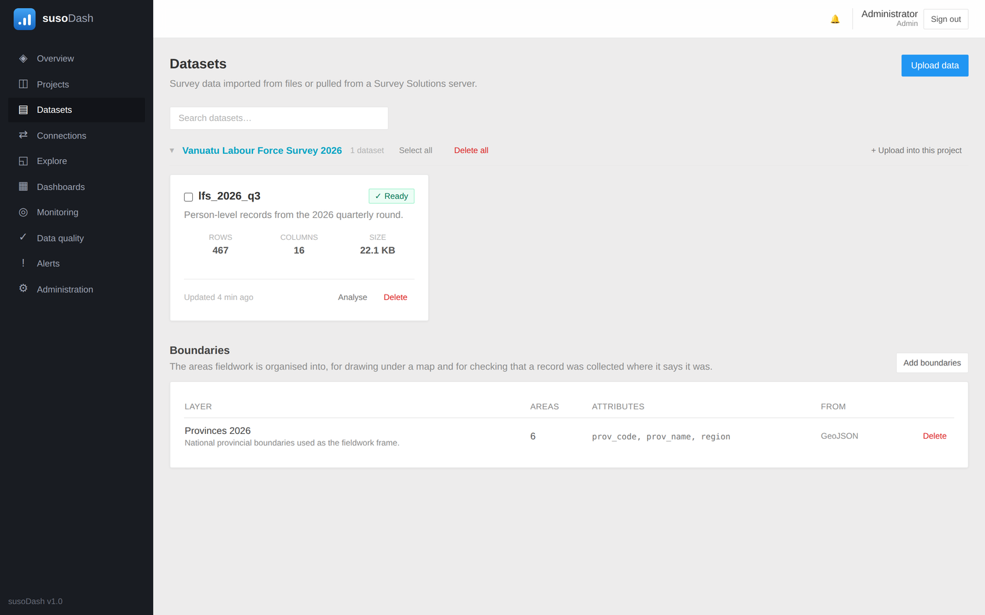
Figure 4. The Datasets page, grouped by project.

An archive with several files in it
A Survey Solutions export holds one file per roster level: the interview, the household members, the people abroad. Those are different tables, not different rounds, so uploading the archive makes one dataset per file inside it.
Uploading a later archive sends each of its files to the dataset already holding that file name. Replace (the default) swaps that dataset's data while keeping its identity, so the charts, indicators and quality rules built on it keep working. Append adds the new rows to what is there.

A questionnaire that changed mid-fieldwork
When a questionnaire is revised in the field, Survey Solutions gives each version its own export. Upload them together: the first version is handled with the mode you chose and the rest are appended onto it, so all versions end up in one dataset. Name the version column and each row is stamped with the version it came from, which is what lets you tabulate by it afterwards.
This is the one place where getting the mode wrong is expensive: with Replace applied to every version in turn, version 2 would wipe version 1 and version 3 would wipe version 2. Only the first version honours the mode for exactly that reason.

Importing from Survey Solutions
Connections → New connection takes the server address, a workspace, and the credentials of an API user. Use an API user rather than an administrator: it can export data and nothing else.
- Enter the server, workspace, user and password, and test the connection.
- Choose the questionnaire and which interview statuses to bring in.
- Set a schedule, or leave it manual and press Import when you want it.
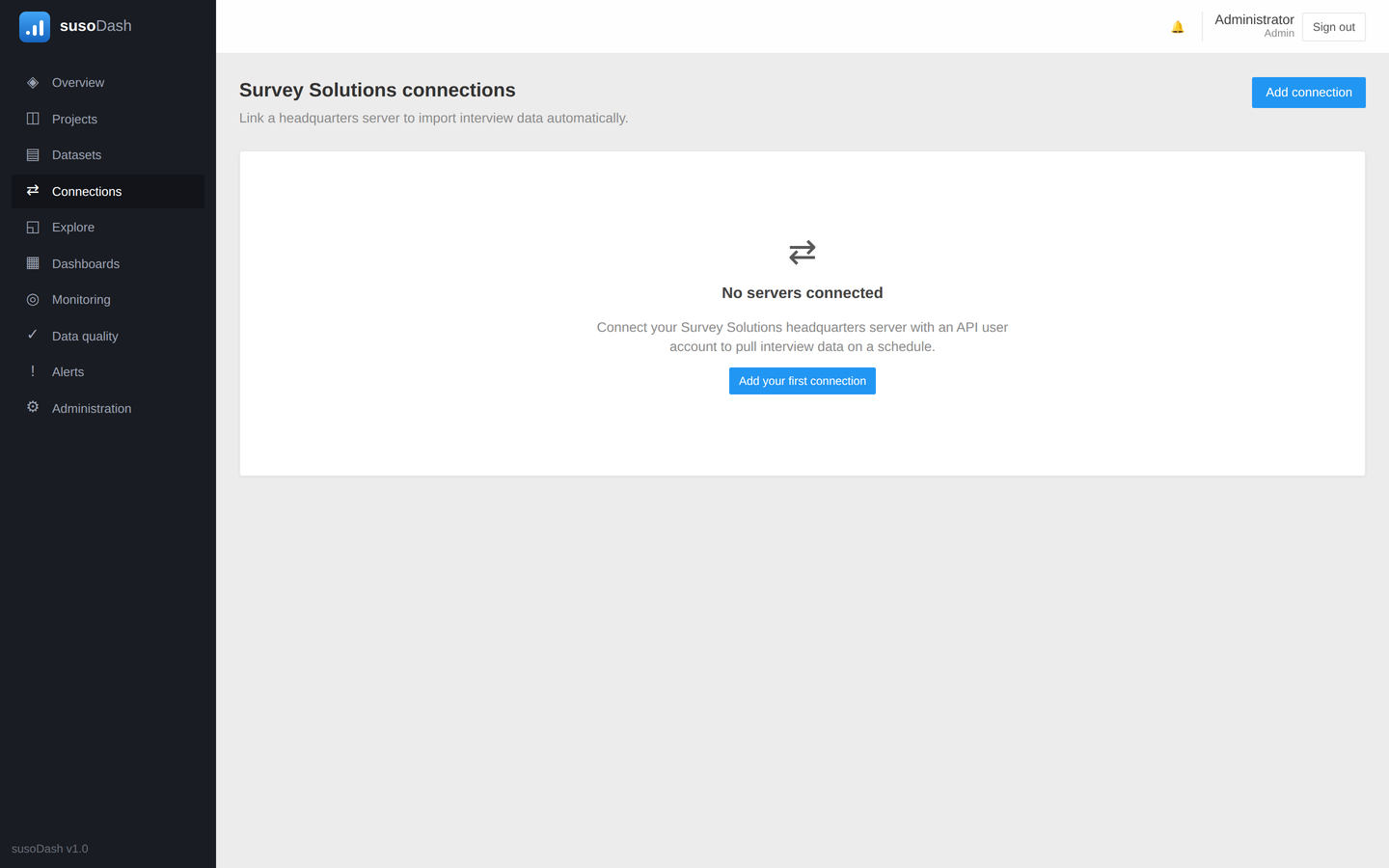
Figure 5. Connections to Survey Solutions servers.

5. Looking at a dataset
Clicking a dataset opens it: how many rows and columns, when it was last imported, and every variable with its type, its label and how much of it is missing.
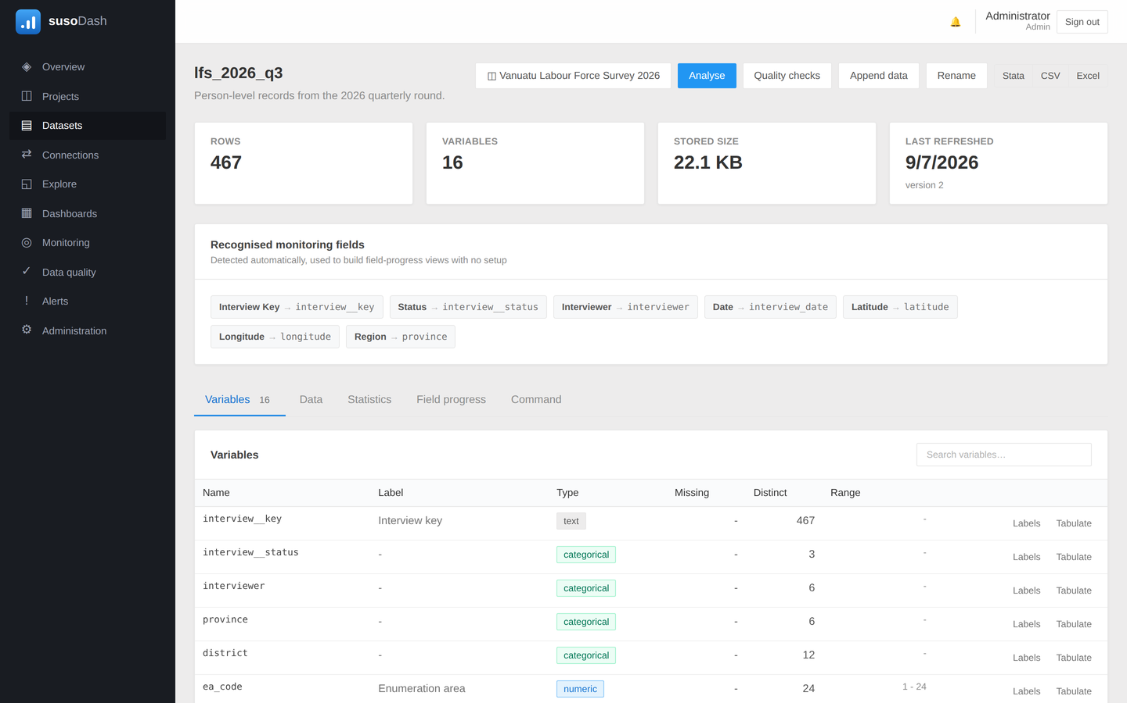
Figure 6. A dataset and its variables.

Naming variables and their codes
A variable called hh_prov_cd means nothing to a minister. Give it a label here and that label is what appears on every axis, legend and filter from then on. The same goes for value labels: 1 and 2 become Male and Female wherever they are shown.

The command box
For the changes that are quicker typed than clicked, the command box takes Stata-like commands against the dataset: gen, egen, replace, label, drop, rename, recode. They are checked before they run, and what they change is recorded, so a derived variable can be traced back to the line that made it.

6. Explore: tabulations and charts
Explore is where a question is turned into a table or a chart. Pick a dataset, choose what to group by and what to measure, and run it. Nothing here is saved until you save it, so it is a safe place to try things.

Tabulate and chart
Box | What it decides
Group by | The variable or variables the rows are broken down by
Measure | Count, share of total, sum, mean, median, minimum or maximum
Filters | Which rows are counted at all
Display | Chart type, ordering, top-N, labels, a target line

Suggested analyses across the top are built from the dataset's own variables, so they are a quick way into a file you have not seen before.
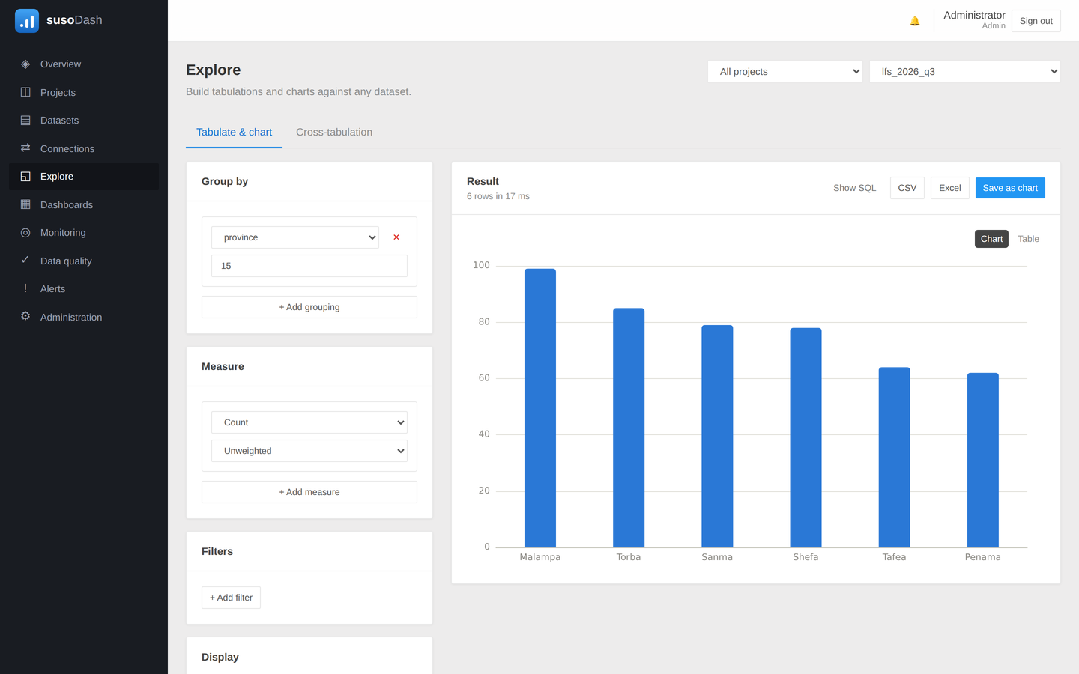
Figure 7. Explore, with a distribution of interviews by province.

Cross-tabulation
The second tab crosses two variables. Choose a row variable, a column variable, or just one of them: a table of one variable's frequencies is a perfectly ordinary thing to want, and the platform does not make you invent a second variable to get it.
Percentages can be of the row, the column or the total, and a chi-square test of independence is reported when there are two variables to test.
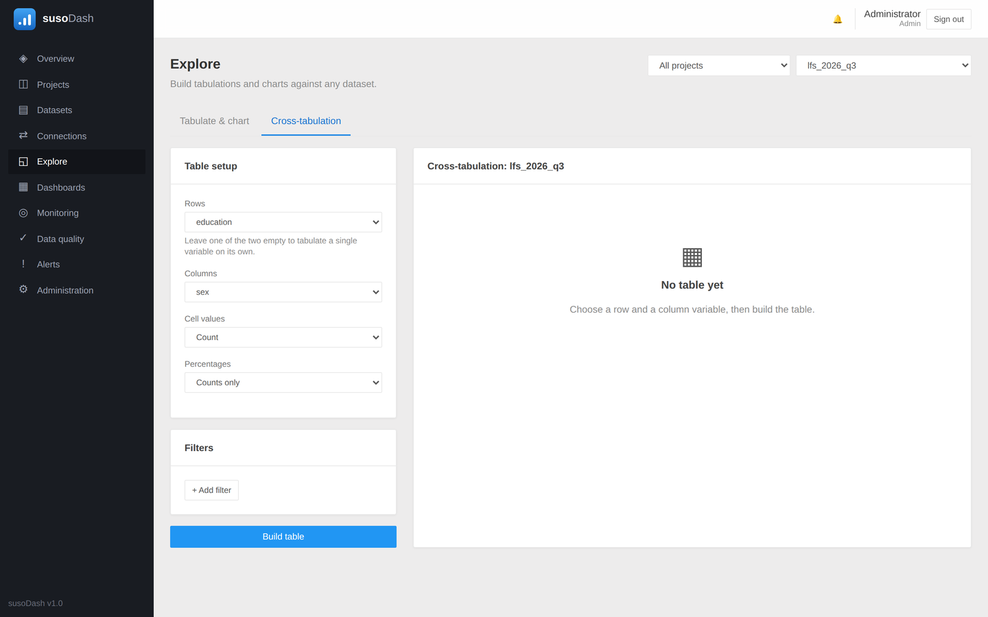
Figure 8. A cross-tabulation with column percentages.

Saving what you built
Save keeps the query, not its results. When the dashboard shows it tomorrow it re-runs against whatever has been imported by then, which is the whole point of a monitoring dashboard.

7. Dashboards
A dashboard is a page of widgets that re-runs itself. Dashboards → New dashboard, give it a name and a project, and it is ready for its first widget.
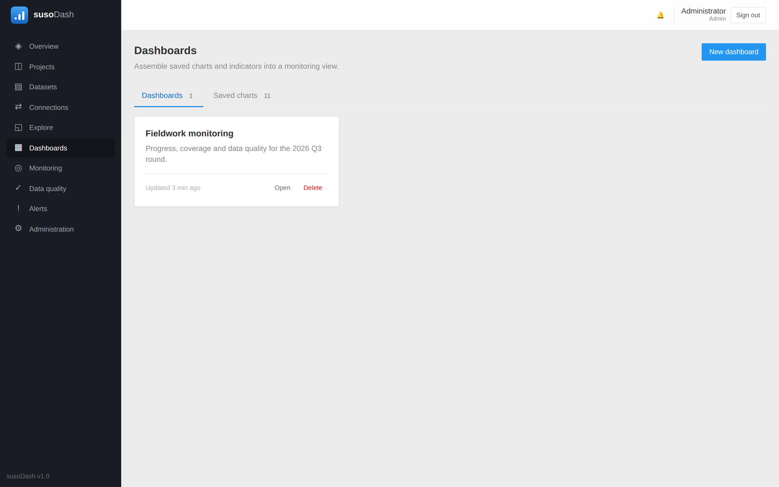
Figure 9. The list of dashboards.
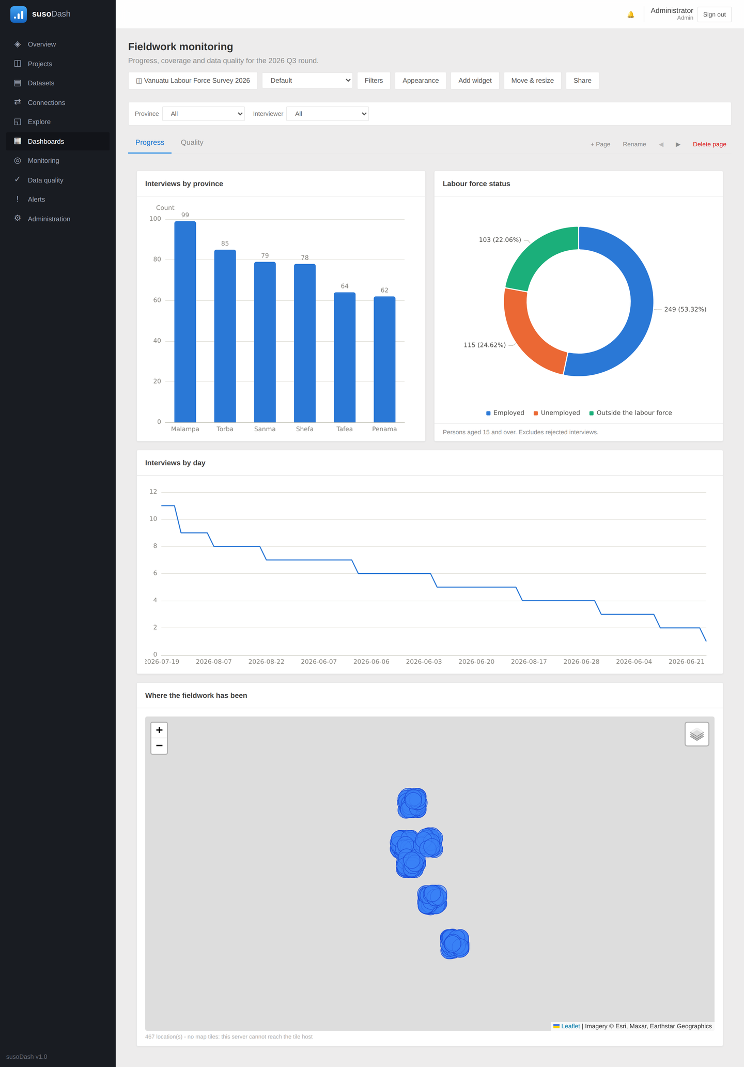
Figure 10. A fieldwork dashboard: charts, filters, pages and a map.

The widgets
Widget | Shows
Saved chart or cross-tab | Something saved from Explore, re-run against current data
Indicator tile | One tracked number with its target, status colour and trend
Data quality panel | The last result of every check on a dataset
Map | GPS points from a dataset, on a base map, with boundaries under them
Text note | A heading, an explanation, a caveat
Countdown | Time remaining to a deadline
Embedded HTML | Whatever you paste, in a sandboxed frame
How recent the data is | When each dataset was imported, and how old its newest record is

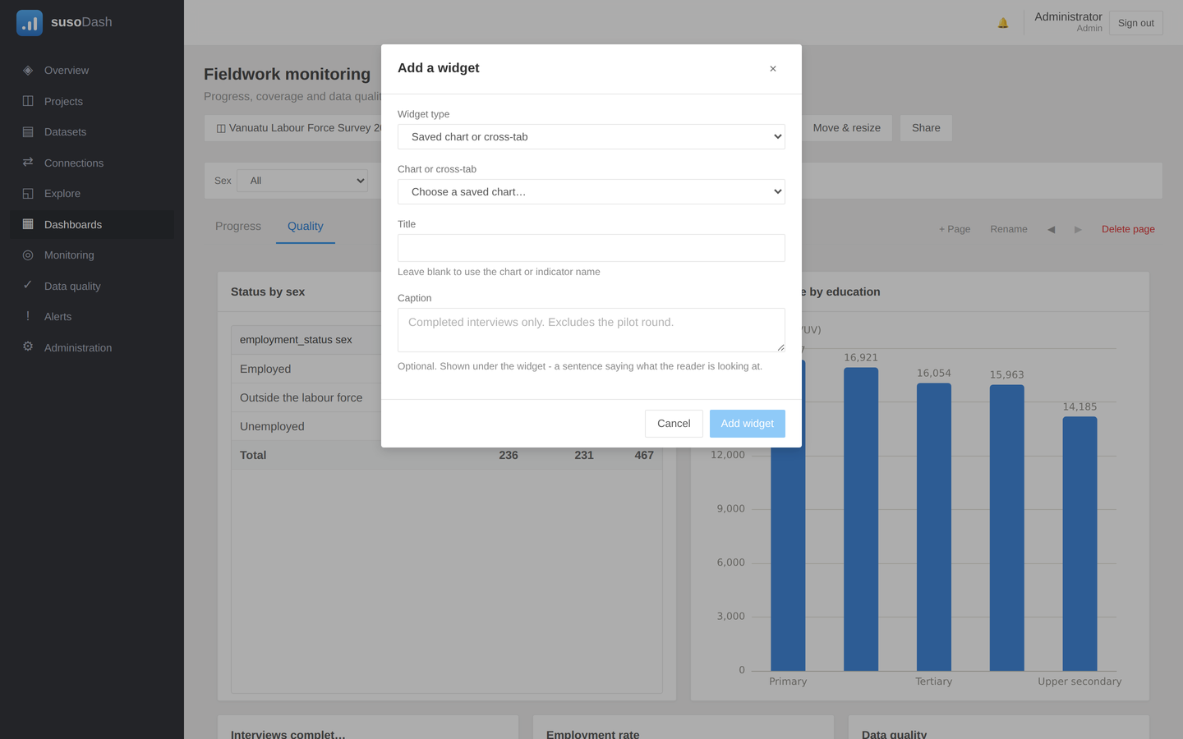
Figure 11. Adding a widget.

Filters
Filters puts dropdowns above the board. A filter names a variable rather than a dataset, so it narrows every widget whose data carries that variable and leaves the rest alone.
Give each one a label. A board built for a minister should say Province, not hh_prov_cd.
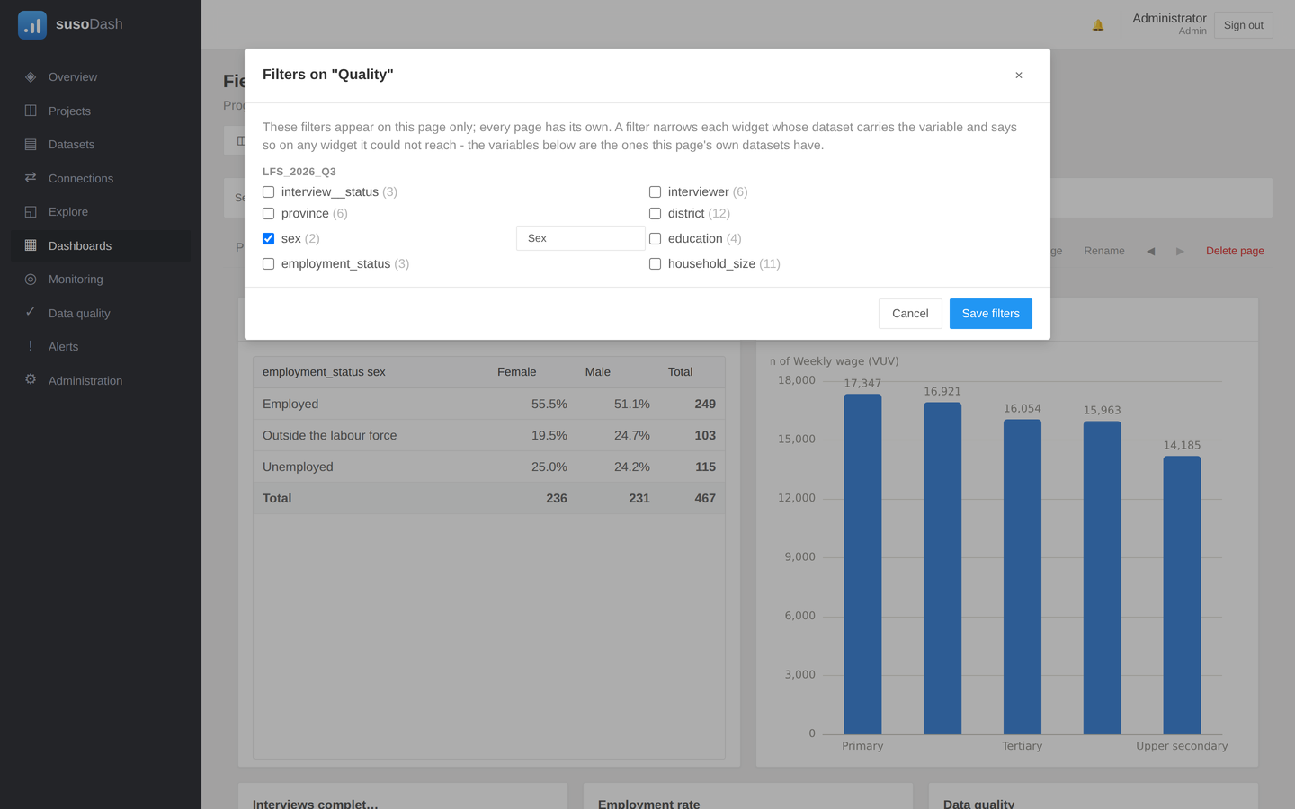
Figure 12. Choosing which filters a page offers.

Filtering by clicking
Clicking a bar, a slice, a point or a table row filters the rest of the page by what it stands for. The widget you clicked is left unfiltered, because narrowing it to the one bar you just chose would take away the means of choosing another. Click the same mark again, or the Clear button, to undo it.

Pages
A dashboard can have several pages, each with its own widgets and its own filters, because different pages ask different questions. Use + Page to add one and Rename to name it; the arrows move the current page left or right.
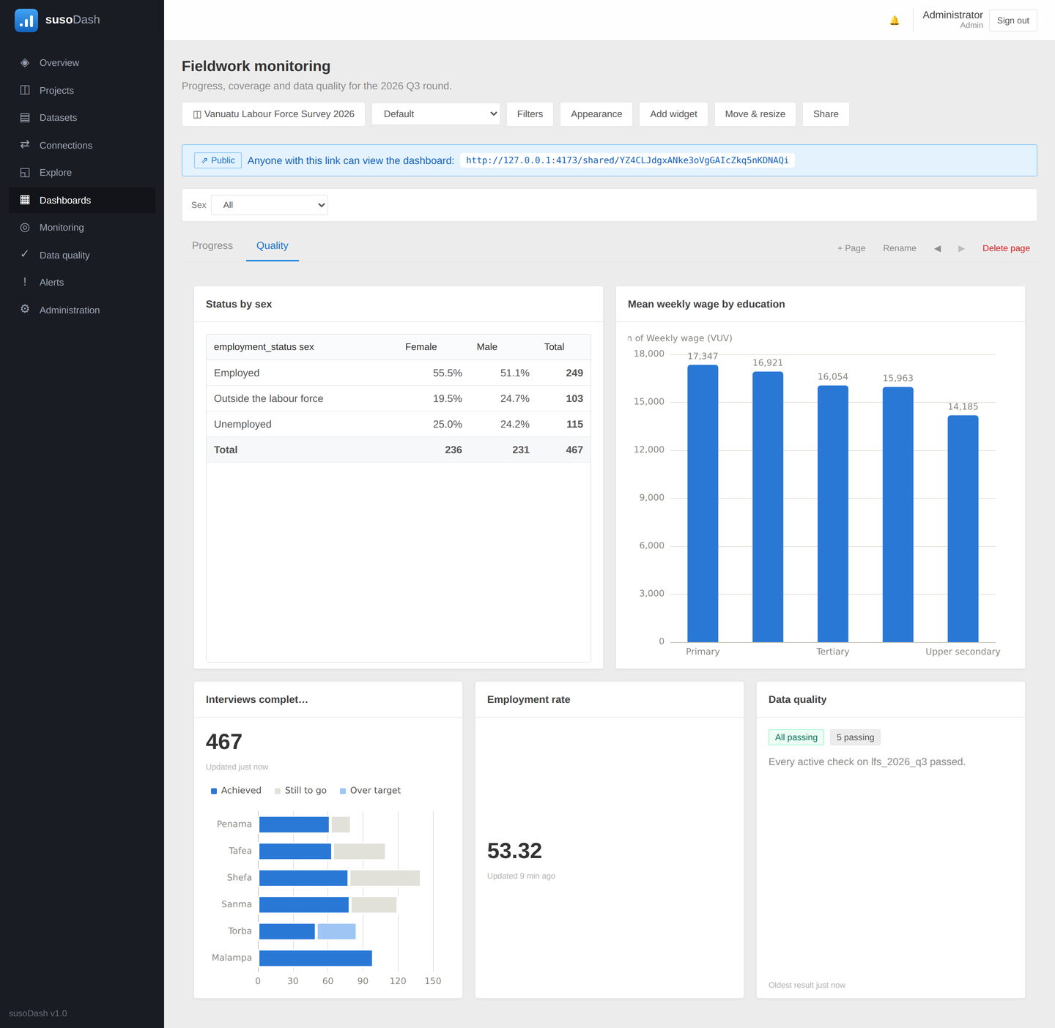
Figure 13. A second page: a cross-tab, indicator tiles and the quality panel.

Making it yours
Appearance dresses the whole dashboard: a background colour or image, the canvas width, how fine the grid is, how transparent the widgets are, and the colour behind the page tabs.
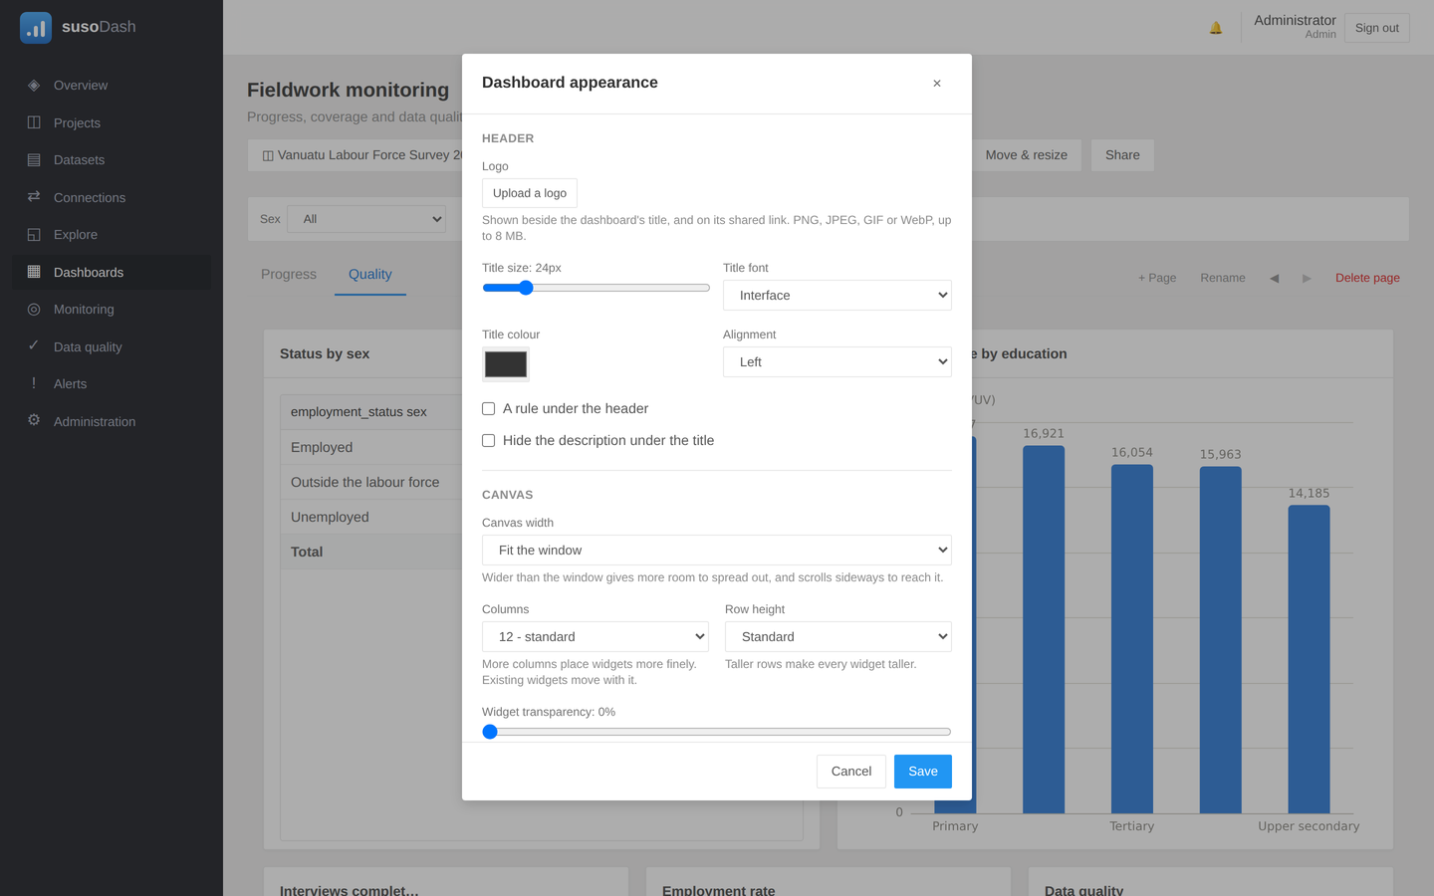
Figure 14. Dashboard appearance.

One widget at a time
The pencil on a widget sets what belongs to that widget alone: its own background colour and transparency, a font, a text colour, a face and position for its title, a shadow, and for a chart the colour it leads with. Each falls back to the dashboard when left alone, so a single tile can be lifted off a busy background without lifting all of them.
- Text colour covers the title, the caption and the labels on the chart. A value printed on top of a bar stays white, because it sits on a filled shape rather than on the page.
- Title font, size and position dress the heading on its own. A centred title suits a tile read on its own; left is easier to scan down a column of widgets.
- Shadow lifts the widget off the background, which matters on a coloured or photographic dashboard.
- Caption puts a sentence under the widget, where a figure caption goes in a report. Use it for what the reader cannot see: which rows are counted, what was excluded, where a target came from.
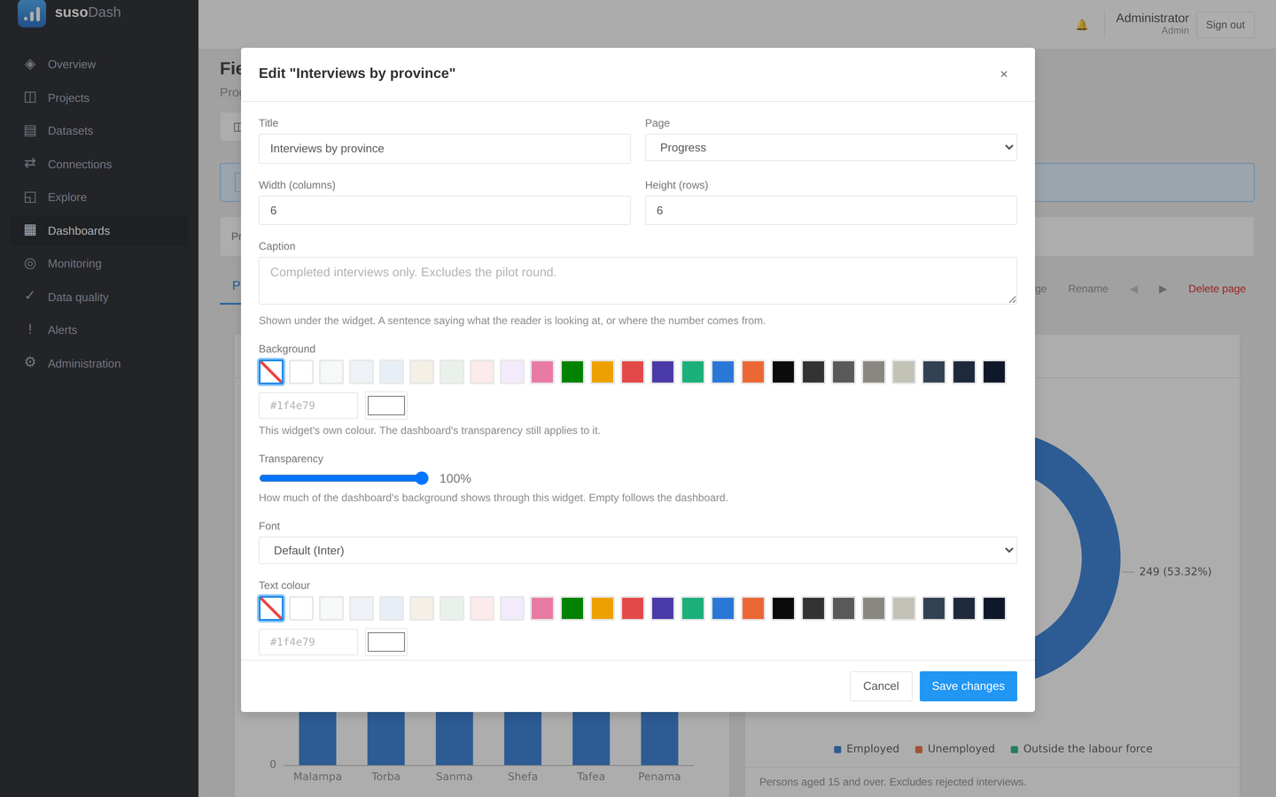
Figure 15. One widget's own settings.

8. Maps and boundaries
A map widget draws the GPS points from a dataset. Tell it which variables hold the latitude and the longitude, and which columns to show when a pin is clicked. Points at the same coordinate are grouped into one pin carrying a number, so a household visited three times is one pin rather than three on top of each other.
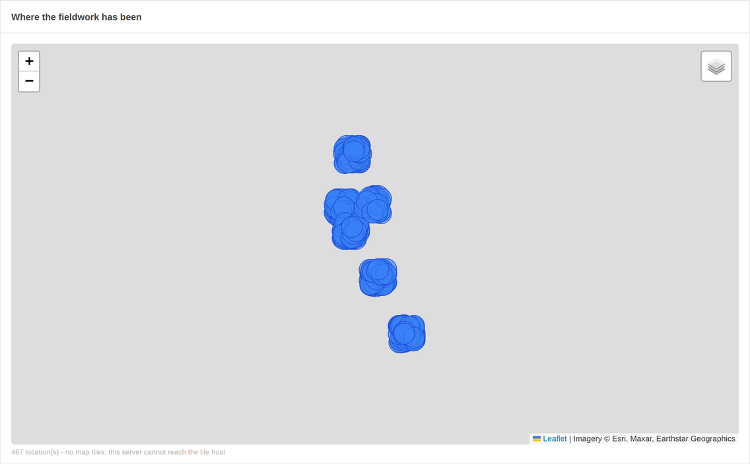
Figure 16. Interview locations, with the boundaries under them.

The ground under the map
- Streets - OpenStreetMap, the default.
- Satellite - aerial imagery, with place names drawn over it so a cluster of pins can still be read as a village.
- Terrain - contours and relief.
A reader can switch between them from the control in the map's top right corner, without being able to edit the widget. Point shape draws the pins as circles, squares, triangles, diamonds or pentagons; a shape is told apart in a photocopy, and two shades of one colour are not. The ⤢ button fills the window with the map.
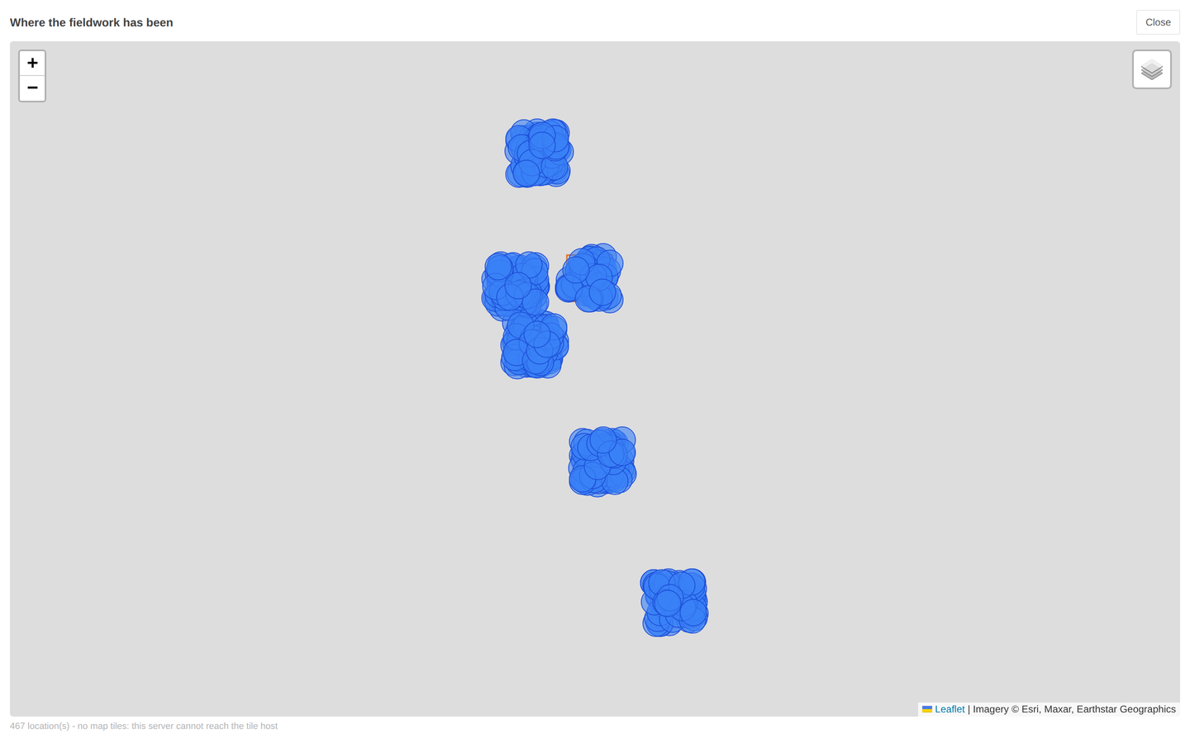
Figure 17. The same map filling the window.

Boundary layers
Datasets → Boundaries → Add boundaries takes the frame your fieldwork is organised into - enumeration areas, districts, villages - as GeoJSON, a GeoPackage (.gpkg), or a shapefile zipped together with its .dbf and .shx. Whatever your GIS office exports is read as it is; nothing has to be converted first.
A layer left in the shared area is available to every project, which is what a national frame usually wants.
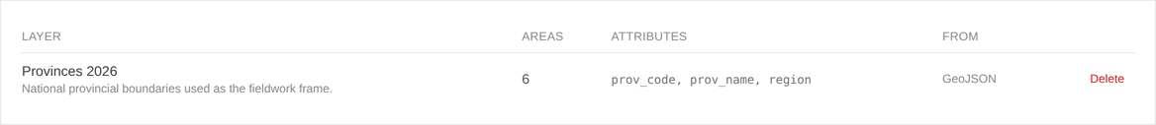
Figure 18. Boundary layers, with the attributes each one carries.

Checking that a record was collected where it says it was
This is what the boundaries are really for. A household listing records the enumeration area the interviewer says they were in; the device records where they actually were. Those disagreeing is one of three things, and each is worth knowing during fieldwork rather than after it: an area code typed wrong, an interviewer working the wrong area, or a boundary the field reads differently from the office.
On the map widget, set Recorded area to the variable holding the code the interviewer recorded, and Matched against to the attribute on the boundary layer holding the same code. Every pin is then coloured by its verdict and the legend counts them.
Colour | Meaning
Red | The recorded area does not match the area the GPS falls in
Amber | The point is outside every area in the layer
Purple | No area was recorded on this record
Green | The recorded area agrees with the GPS

Codes are compared by what identifies them rather than how they were typed: 07, 7 and 007 are one enumeration area. A code crosses from a questionnaire to a GIS file as text on one side and a number on the other, and treating those as different would report every record in the country as a mismatch.

9. Monitoring: indicators and targets
An indicator is one tracked number. Monitoring → New indicator: name it, pick a dataset, choose the measure, and optionally give it a target and the thresholds at which it should start worrying you.
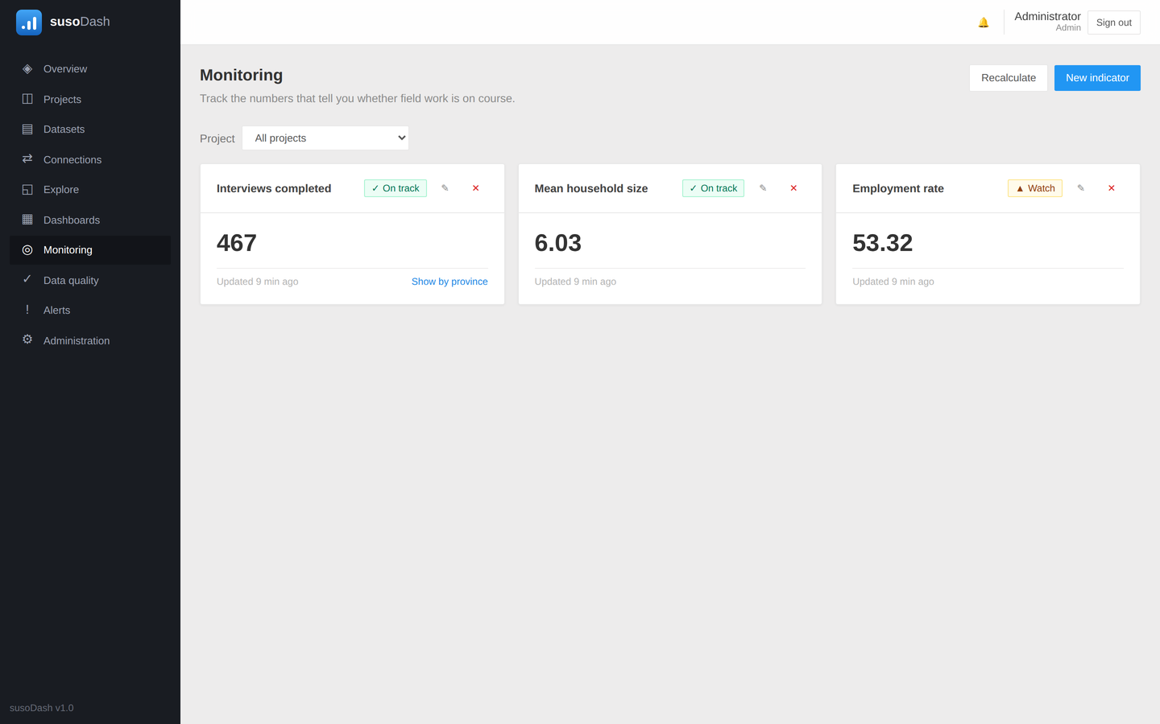
Figure 19. Indicators with their current values and status.
Setting | What it does
Target | Draws a progress bar and gives the number something to be measured against
Warning threshold | The value at which the indicator turns amber
Critical threshold | The value at which it turns red
Direction | Whether higher is better or lower is better, which reverses the logic
Breakdown variable | Lets the indicator be expanded per province, team or interviewer
Target per group | A separate target for each value of the breakdown
Percentage | Makes the number a share rather than a count

The datasets offered are the ones in whatever the project filter above the page is set to, because an indicator belongs to whatever project its dataset belongs to. Building one from another project's data is how an indicator quietly ends up somewhere its team will not find it.

Targets per group
Once a breakdown variable is chosen, each of its values can be given its own target: 140 interviews in Shefa, 50 in Torba. On the dashboard, an indicator tile with Show the breakdown turned on draws each group's achievement against its own target, so a province that is behind is visible without arithmetic.
Clicking a bar in an indicator's breakdown filters the rest of the dashboard by that group, the same as clicking any other chart.

10. Data quality
A quality rule is a question asked of a dataset on a schedule. Data quality → New rule, choose the dataset and the kind of check, and set what counts as a failure.
Check | Asks
Missing rate | How much of a variable is blank
Value range | Whether values fall between a minimum and a maximum
Duplicates | Whether a key, or a combination of columns, repeats
Outliers | Whether values sit far outside the usual spread
Consistency | Whether one variable agrees with another
Interview duration | Whether interviews were too short to be real
GPS missing | Whether a location was recorded
Constant value | Whether a variable never changes, which usually means it was never asked

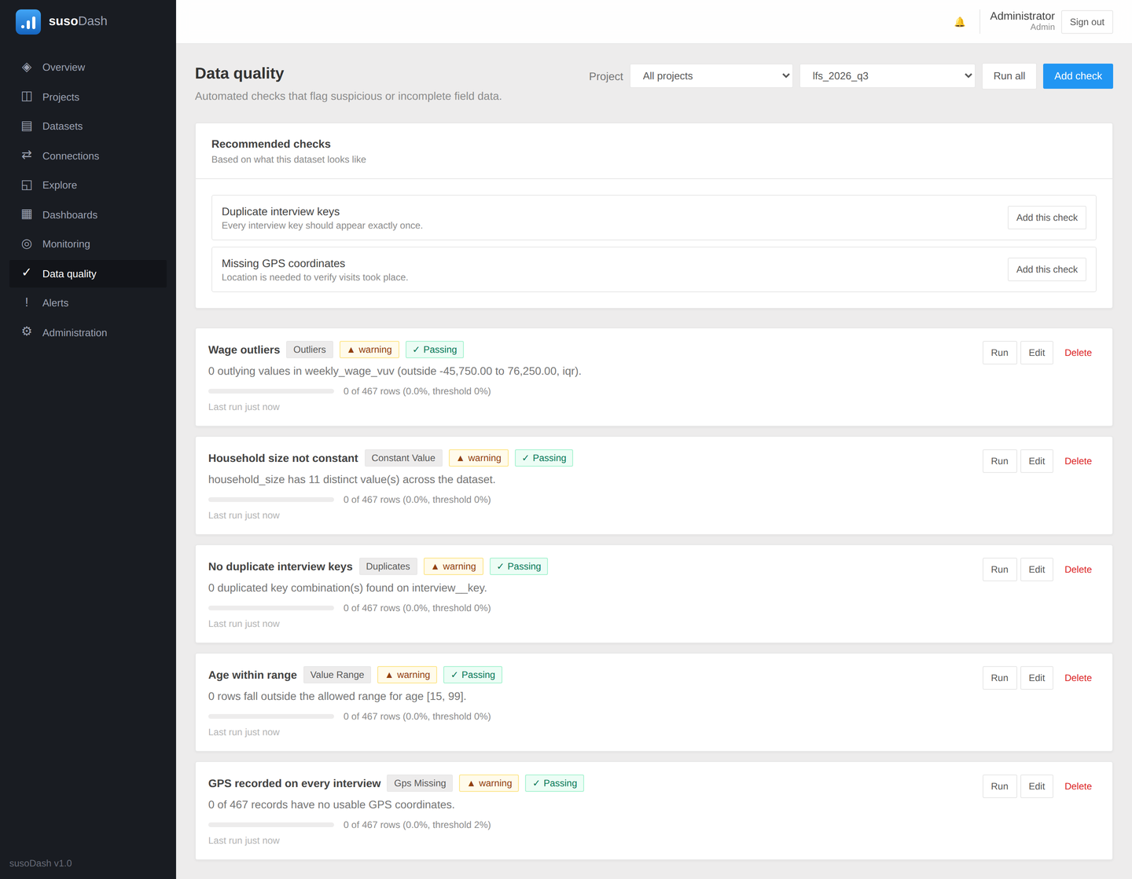
Figure 20. Quality rules and their most recent results.
Failing checks are listed first and in full; passing ones are counted. A panel that lists thirty green rows buries the one red row, which is the only one anybody needs.
The same picture goes on a dashboard as a data quality panel, so a board watched by a survey manager shows whether the data behind it can be trusted.

11. Alerts
An alert rule watches an indicator or a quality check and raises something when it crosses a line. Alerts collect on the Alerts page, where each can be acknowledged so the rest of the team knows it is being dealt with, and resolved when it is.
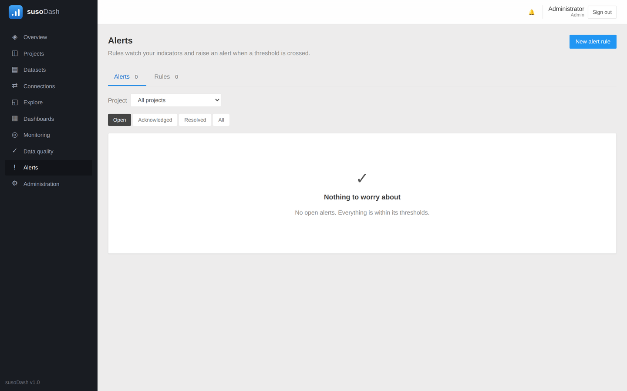
Figure 21. The alerts page.
Where email has been configured by an administrator, an alert can also be sent to a list of addresses when it is raised.

12. Sharing a dashboard
Share lists every address a dashboard is published at, and adds more. One board usually goes to several audiences at once - a minister, the field supervisors, a donor - and those do not end together, so each gets its own link.
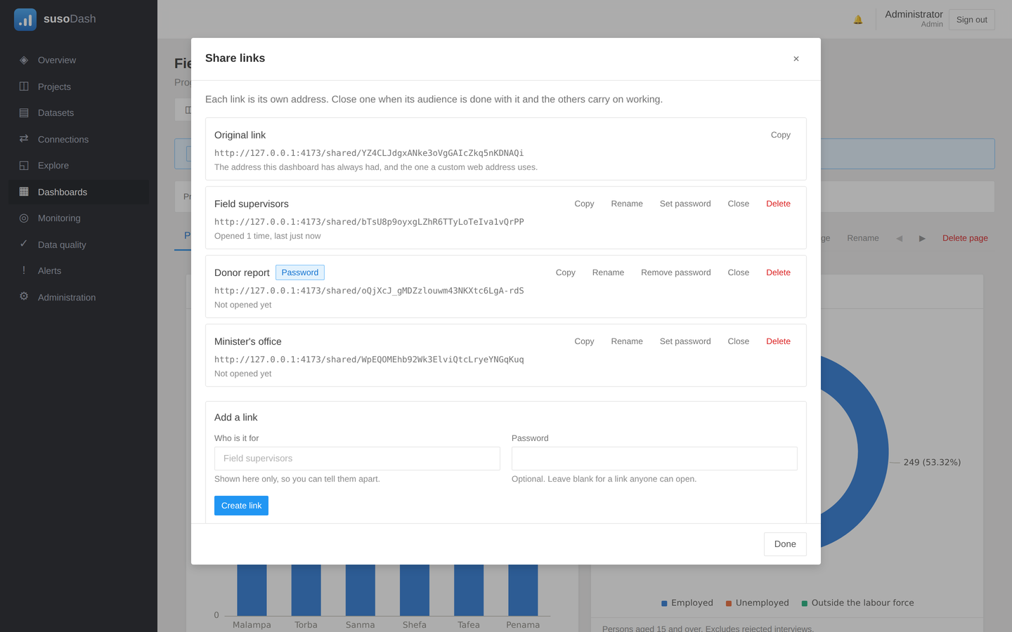
Figure 22. Several links to one dashboard.
Action | What it does
Copy | Puts the address on the clipboard
Rename | Names the link so you can tell your audiences apart
Set password | Asks readers for a password before showing anything
Close | Stops the link working, keeping the address so it can be reopened
Delete | Destroys the link permanently

Close a link rather than deleting it. A closed link can be switched back on at the same address, which matters once it is already pasted into somebody's email. Each link also records how often it has been opened, so one nobody uses can be recognised.

Passwords on a link
A reader of a protected link is asked for the password once and then reads the dashboard normally. It is remembered for that browser tab only, so a shared computer in a field office does not leave the next person holding it.
This is not an account. Everyone holding the password is the same anonymous reader, and it exists so that a forwarded link is not a public one.
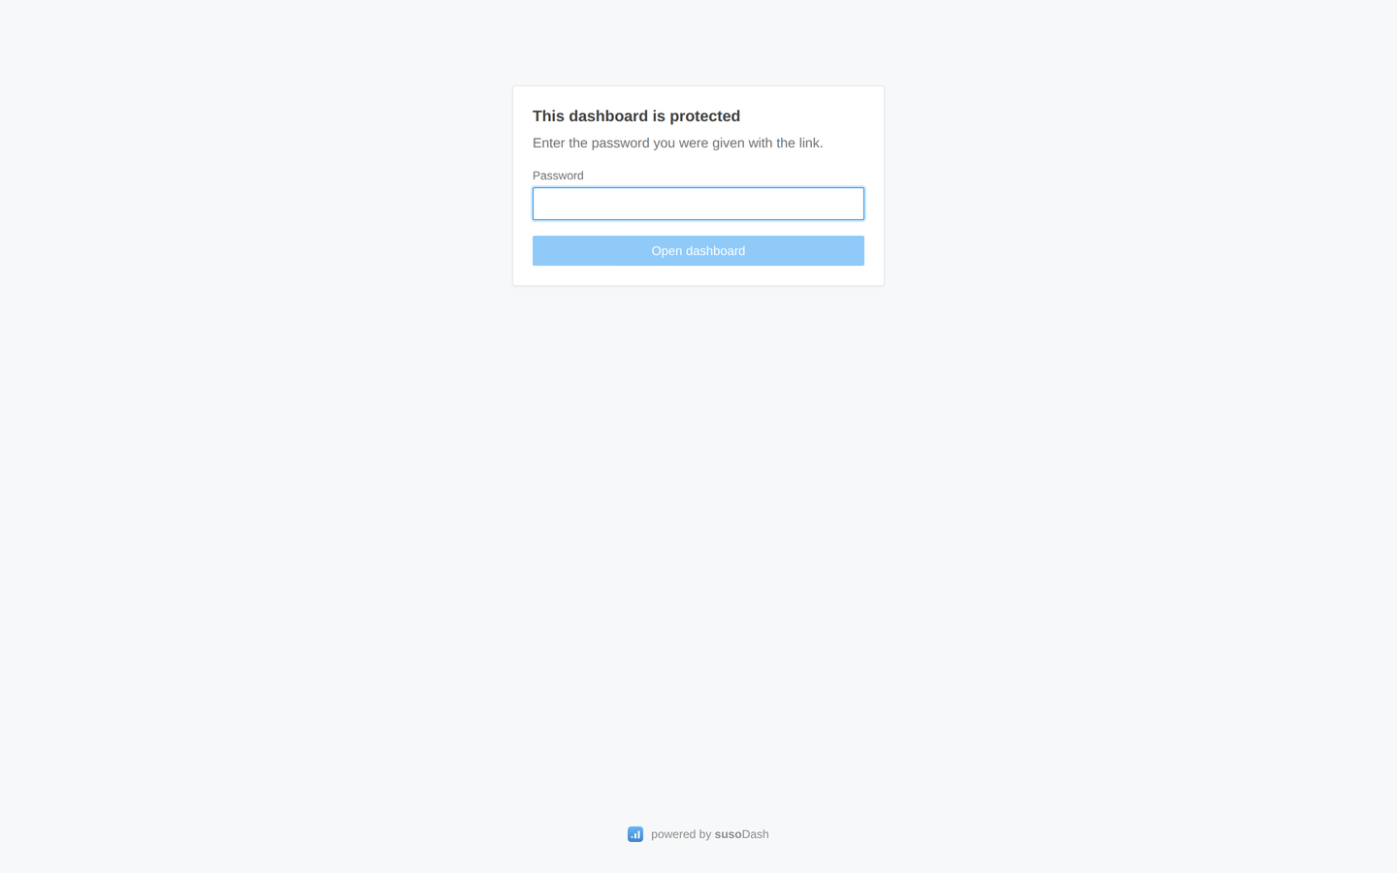
Figure 23. What a reader sees before giving the password.

What a reader sees
A shared dashboard is the survey team's page, not the platform's: it opens with your logo and your title, with no sign-in bar above it. Readers can use the filters, click charts to narrow the page, switch the map's base layer, and copy tables and charts, but they can change nothing.
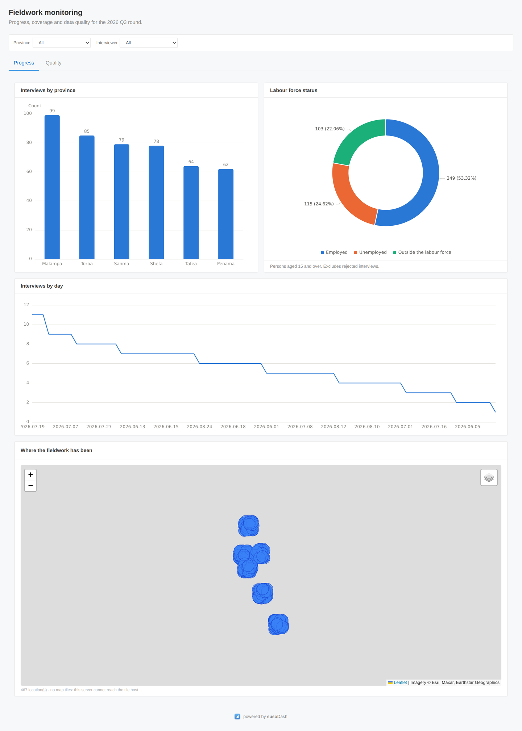
Figure 24. The same dashboard as a shared link, seen by somebody with no account.

Giving a dashboard its own web address
A dashboard can answer on a hostname of its own, such as labour-force.statistics.gov.vu. Your administrator points the name at the server; you then set it on the dashboard, and the page answers there with nothing of the platform around it.

13. Taking your work away

Copying a widget
Hovering a widget shows a ⧉ button, for readers as well as authors.
- On a table it copies the rows: paste into Excel and they land in columns, paste into a plain editor and they arrive tab-separated.
- On a chart it copies a picture, ready to paste into a report. Where a browser refuses to put an image on the clipboard, the picture is saved as a file instead.
What is copied is what is on screen, so a table narrowed by its column filters copies narrowed.

Filtering a table by its columns
The ⌕ button above a table opens a box under each heading. Typing in one narrows the rows on screen, and the button then reads how many of how many are showing. Text matches what the cell reads as, so a label matches rather than the code behind it; a number column also takes a comparison such as > 100.
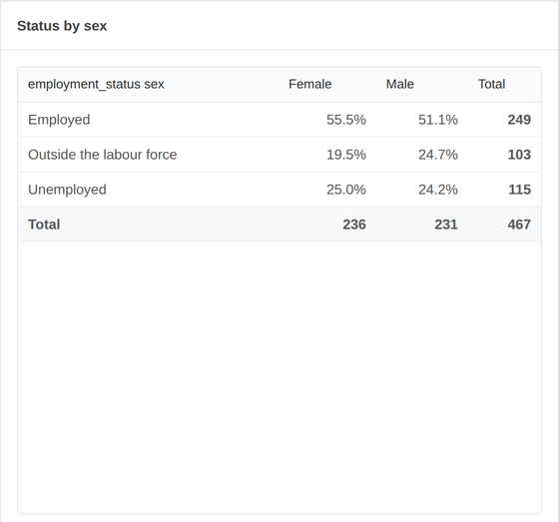
Figure 25. A cross-tabulation on a dashboard.

Downloading a dataset
A dataset can be taken out whole as Stata, CSV or Excel. Stata is worth choosing when the labels matter, because they ride along with the file.

14. Administration
Administration is where accounts are created, roles are set, and system settings are changed. It is visible only to administrators.

Roles
Role | May
Viewer | Read dashboards and datasets
Analyst | Also build charts, dashboards and indicators
Manager | Also import data, manage connections, quality rules and boundaries
Admin | Everything, including accounts and system settings

A role is what somebody may do. Restricted is a separate switch saying what they may see: a restricted account sees only the projects it has been added to.

API keys
For a script that needs to talk to the platform, an API key is safer than an account password: it carries a role of its own, it can be revoked on its own, and it is shown once when it is made.

15. Reference tables

Chart types
Type | Best for
Bar, horizontal bar | Comparing categories; horizontal when the labels are long
Stacked bar | Parts of a whole across categories
Population pyramid | Two groups facing each other by age
Line, area | A quantity over time
Pie, donut | Parts of one whole, for a handful of categories
Scatter | Two measures against each other
Heatmap | Two categories crossed, read by colour
Funnel | Stages that narrow
Table | When the numbers themselves are the point

Charts never use two different value axes. A second axis makes the crossing point of two lines look like a fact when it is an artefact of the scales chosen, so a second measure gets a second chart instead.

Measures
Measure | Meaning
Count | How many rows
Share of total (%) | That count as a percentage of all rows
Sum | The total of a numeric variable
Mean, median | The average, and the middle value
Minimum, maximum | The smallest and largest value

Boundary file formats
Format | What to upload
GeoJSON | A single .geojson or .json file
GeoPackage | A single .gpkg file
Shapefile | A .zip holding the .shp, .dbf and .shx together

Reading a boundary file needs no GIS software on the server and no internet at the moment it is read. That is deliberate: this platform is meant to run in a statistics office behind a ministry firewall.

16. If something goes wrong
What you see | What it usually is
A widget says a filter was ignored | That widget's dataset has no such variable. The filter applied to the widgets that do have it and left this one alone, which is what it is meant to do.
The map draws pins but no map | The server cannot reach the tile host. The pins are the data and they still draw. A deployment with its own tile service can be pointed at it with Map tiles.
Every record reports as a mismatch | The Matched against attribute is probably the wrong column on the boundary layer. Check which of its attributes actually holds the area code.
An import failed | Open the dataset: the reason is recorded against it. A file whose columns changed shape is the usual cause.
A dashboard is slow | Usually one widget over a very large dataset. Narrow it with a filter, or reduce how many categories it draws with top-N.
A shared link says it is not available | It has been closed, or deleted. Closed links can be reopened from Share on the dashboard.

Getting help
The full technical documentation - installation, backups, upgrades and the API - lives with the source code in the docs folder: deployment.md, architecture.md, api.md and survey-solutions.md. This manual covers using the platform; those cover running it.

