湖州师范学院求真学院
数字图像处理 实验报告
实验名称： | The test one
班 级： | 20142832 | 姓 名： | 莫佳伟 | 学 号： | 2014283402
实验地点： | 31bulding,4F | 日 期： | 2017/3/7

- 实验目的：
1、Learn to use tool of Matlab
2、Know and use function of tool Matlab
二、实验环境：
A computer
Window operate system
Matlab develop envirounment
- 实验内容和要求：
- 实验内容：

Pages is from 6 to 23 in the instruct.

四、实验步骤和实验结果：（文字描述或源代码）
1、Function of Show is to show the image on the desktop.
Function of Imread is to read the image from the current fold.

A=imread('13.bmp');
imshow(A)
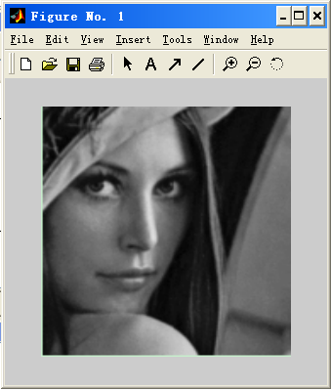

2、Function of colorbar is that color-bat is added into object of coordinate axis.

RGB=imread('13.bmp')
I = rgb2gray(RGB);
I2 = filter2(h,I);
imshow(I2,[]),colorbar('vert')
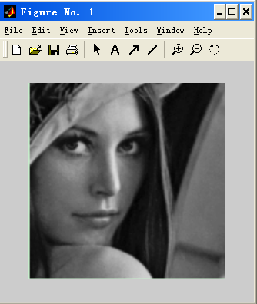

3、Function of subimage is that the graphics window can show more picture.

A=imread('13.bmp');
I=rgb2gray(A);
[x,y,z]=sphere;
warp(x,y,z,I);

4、Function of imresize is that image can be zoomed.
J=imread('13.bmp');
X1=imresize(J,2);
figure,imshow(J)
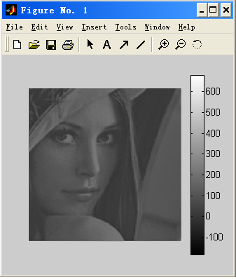

5、Function of imcrop is that image can be cropped.
I=imread(’13.bmp);
I2=imcrop(I,[75 68 130 112]);
sbplot(1,2,1),imshow(I);
sbplot(1,2,2)imshow(I2);

6、Function of imsubtract is that light of image will be substract.
I=imread(’13.bmp);
J= imsubtract(I,100);
sbplot(1,2,1),imshow(I);
sbplot(1,2,2)imshow(J);

7、Function of immultiply is that light of image will be zoomed to multiply.
I=imread(’13.bmp);
J= immultiply (I,0.5);
sbplot(1,2,1),imshow(I);
sbplot(1,2,2)imshow(J);

8、Function of imdivide is that light of image will be zoomed todivide.
I=imread(’13.bmp);
J= imdivide (I,0.5);
sbplot(1,2,1),imshow(I);
sbplot(1,2,2)imshow(J);

8、Function of imadd is that light of image will be add.
I=imread(’13.bmp);
J= imadd(I,100);
sbplot(1,2,1),imshow(I);
sbplot(1,2,2)imshow(J);

9、Function of roicolor is that area is selected by Gray Level.
a=imread(’13.bmp);
I=rgb2gray(a);
J=roicolor(I,128,225);
sbplot(1,2,1),imshow(I);
sbplot(1,2,2)imshow(J);

10、Function of imhist is that it produces histogtram of image.
A=imread(’13.bmp’);
B=rgb2gray(A);
imshow(B);
imshow(B);
五、实验分析以及建议改进等：
I really know the function Matlab and use tool of Matlab to learn these.
六、实验成绩：

