Sultanate of Oman
Ministry of Agriculture, Fisheries & Water Resources
Consultancy Services for Feasibility Study and Design of Flood Protection Scheme in North and South Al Batinah Governorates
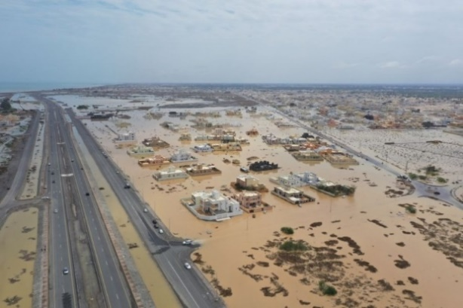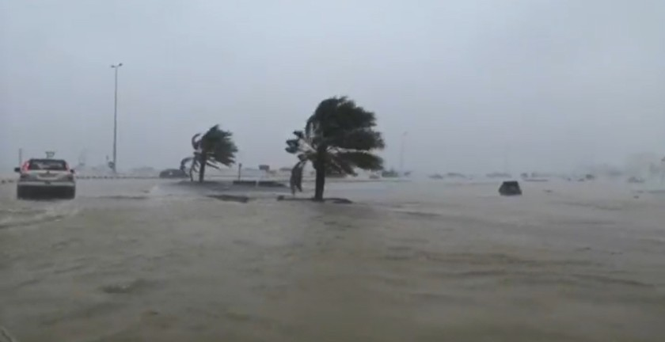
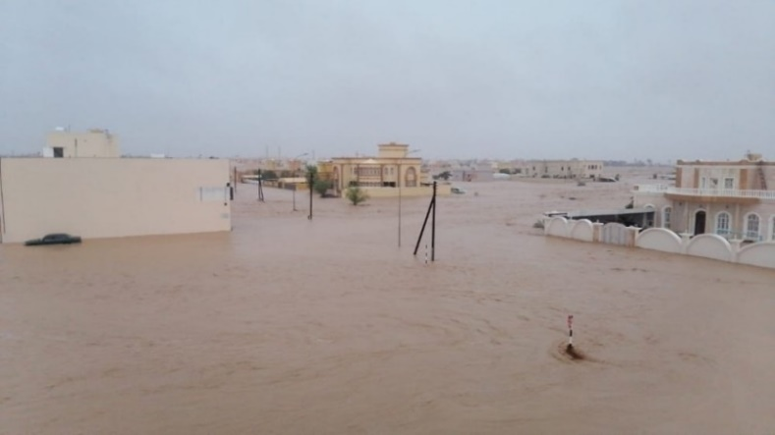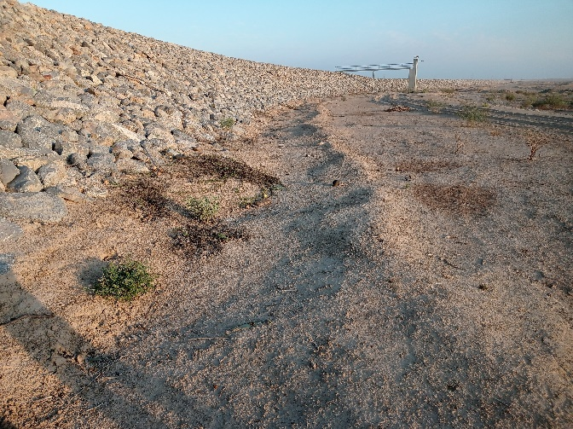
Hydraulic Design of Channels
Block No. 4
Rev 00
October 2026
Renardet S.A. & Partners Consulting Engineers L.L.C. | Artelia Muscat

Table of Contents
1. Introduction 1
2. Hydrology 2
3. Channel alignments 5
4. Channel condition and conflicts 8
5. Rainfall-runoff simulation 12
5.1. Dams' information 17
5.2. Dams' elevation-volume-area curves 20
5.3. Reservoir routing 22
5.4. Dams' peak flows 22
5.5. Reservoir levels 24
5.6. Hydrographs 24
5.7. Flood protection performance 25
6. Sediment yield and reservoir sedimentation 27
6.1. Soil loss of the catchments 27
6.2. Sediment delivery and yield 30
6.3. Reservoir volume reduction 33
6.3.1. Reservoir sediment trap efficiency 33
6.3.2. Density of deposited sediment 33
6.3.3. Sediment distribution: Empirical Area-Reduction Method 34
6.3.4. Input data and results 36
7. Climate at the dam sites 38
7.1. Record used 38
7.2. Temperature and rainfall 38
7.3. Wind 40
7.4. Climate change 41
8. Hydraulic design criteria 43
8.1. Main issues in channel design 43
9. Outfalls 45
10. Conclusion 46
Appendix A – Inflow hydrographs of the dams 47
Appendix B – Reservoir curves after sedimentation 52

List of Tables
Table 1 – Channel design process – Block 04 1
Table 2 – Design rainfalls 2
Table 3 – Area reduction factor 4
Table 4 – Channels and dykes in Block 04 5
Table 5 – Dams' information 17
Table 6 – Dam catchments 18
Table 7 – Dams' elevation-volume-area curves 20
Table 8 – Reservoir curves at full supply level and at crest 22
Table 9 – Dams' peak flow (m³/s) for the return periods 23
Table 10 – Dams' inflow and outflow volume (Mm³) for the return periods 24
Table 11 – Peak reservoir level (m) for the return periods 24
Table 12 – Flood protection performance of the dams 26
Table 13 – RUSLE factors and soil loss, catchment means 28
Table 14 – Sediment delivery and yield of the dam catchments 31
Table 15 – Sediment-supply and soil-texture inputs 36
Table 16 – Reservoir volume reduction after 50 and 100 years 36
Table 17 – Temperature and rainfall at the dam sites, 2001–2023 38
Table 18 – Rain gauges nearest to the dams and their records 40
Table 19 – Wind roses at the dam sites, all hours 2015–2024: the direction the wind blows from and the share of hours in each speed class 40
Table 20 – Channel design criteria 43
Table 21 – Mean tidal levels in North and South Al Batinah (m), Oman Maritime Book 2024 43
Table 22 – Challenges in the design of the channels 44

List of Figures
Figure 1 – Temporal distribution of the 24-hour design storm: cumulative share of the depth (left) and the share falling in each 10-minute interval (right), for the five patterns 3
Figure 2 – Channel alignments to control the 200-year flood, on the 200-year flood depth without the scheme 6
Figure 3 – Channel and dyke routes by category, with the channel and dyke names 7
Figure 4 – Roads and utilities 9
Figure 5 – Land use 11
Figure 6 – HEC-HMS model for Block 04 13
Figure 7 – (a) Q200 (m³/s) at the junctions of the HEC-HMS model, dams in place 15
Figure 8 – (b) Q200 (m³/s) at the dams and the junctions downstream of them, dams in place 16
Figure 9 – The nine dams of Block 04, their catchments and reservoirs, and the channel and dyke alignments of the plain 19
Figure 10 – Dams' peak inflow and outflow for the 100-, 200- and 500-year events 23
Figure 11 – Inflow and outflow hydrographs of the nine dams for the 200-year event 25
Figure 12 – RUSLE factors and soil loss over the dam catchments, and the sediment yield delivered to each dam 29
Figure 13 – From soil loss to sediment yield: the catchment mean soil loss, the delivery ratio used and the yield delivered to each dam 31
Figure 14 – Sediment delivered to each dam in 50 years (Mcm) and the storage lost at full supply level 32
Figure 15 – Sediment distribution design curves (reproduction of USBR Figure 2.25): percentage of the reservoir depth against the percentage of the sediment deposited, for types I to IV and the area-increment line 35
Figure 16 – Relative sediment-area functions a(p) = C·pᴬ·(1−p)ᴮ for reservoir types I to IV 35
Figure 17 – Storage lost at full supply level after 50 and 100 years, per dam 37
Figure 18 – Hawasinah 02: elevation-area-volume curves before and after sedimentation, capacity on the lower axis and area on the upper axis. The curves of the other dams are in Appendix B 37
Figure 19 – Monthly air temperature and rainfall of Block 04, 2001–2023, averaged over the nine dam sites 39
Figure 20 – Annual rainfall of Block 04, 2001–2023, averaged over the nine dam sites, and its mean 39
Figure 21 – 200-year peak flow at the thirteen outfalls without and with the dams 45
Figure 22 – 200-year runoff volume at the thirteen outfalls without and with the dams 45
Figure 23 – Hawasinah 02: inflow hydrographs for the return periods of 2 to 10 000 years and the PMP 47
Figure 24 – Hawasinah 11: inflow hydrographs for the return periods of 2 to 10 000 years and the PMP 47
Figure 25 – Hawasinah UP: inflow hydrographs for the return periods of 2 to 10 000 years and the PMP 48
Figure 26 – Shafan 02: inflow hydrographs for the return periods of 2 to 10 000 years and the PMP 48
Figure 27 – Shafan 08: inflow hydrographs for the return periods of 2 to 10 000 years and the PMP 49
Figure 28 – Sarami 03: inflow hydrographs for the return periods of 2 to 10 000 years and the PMP 49
Figure 29 – Sarami 05: inflow hydrographs for the return periods of 2 to 10 000 years and the PMP 50
Figure 30 – Sakhin 04: inflow hydrographs for the return periods of 2 to 10 000 years and the PMP 50
Figure 31 – Sakhin 08 (Mehmum): inflow hydrographs for the return periods of 2 to 10 000 years and the PMP 51
Figure 32 – Hawasinah 02: reservoir curves before and after sedimentation 52
Figure 33 – Hawasinah 11: reservoir curves before and after sedimentation 52
Figure 34 – Hawasinah UP: reservoir curves before and after sedimentation 53
Figure 35 – Shafan 02: reservoir curves before and after sedimentation 53
Figure 36 – Shafan 08: reservoir curves before and after sedimentation 54
Figure 37 – Sarami 03: reservoir curves before and after sedimentation 54
Figure 38 – Sarami 05: reservoir curves before and after sedimentation 55
Figure 39 – Sakhin 04: reservoir curves before and after sedimentation 55
Figure 40 – Sakhin 08 (Mehmum): reservoir curves before and after sedimentation 56

Executive Summary
Project context
The Ministry of Agriculture, Fisheries Wealth and Water Resources commissioned Renardet S.A. & Partners Consulting Engineers, in joint venture with Artelia Muscat, to prepare the comprehensive master plan for flood protection dams, river training schemes and stormwater drainage in North and South Al Batinah. Block 04 covers the wadis of Al Hawasinah, Shafan, Sarami and Sakhin between the Hajar foothills and the coast, from Al Khaburah to Saham. The scheme consists of nine flood-protection dams and a network of flood-protection and stormwater channels and dykes that carry the routed dam outflows and the runoff of the plain to the sea.
Scope of this report
This report presents the hydrology of Block 04 and the design information of the nine dams: catchments, inflow hydrographs for thirteen return periods up to the probable maximum precipitation, reservoir elevation-area-volume curves, reservoir routing, the sediment yield of the catchments and the storage lost to sedimentation, and the climate at the dam sites. It also sets out the channel alignments, the conditions and conflicts along them and the hydraulic design criteria of the channels.
Key findings
• The nine dams control 1,640 km² of catchment and hold 276 Mm³ at full supply level. The 200-year peak inflows range from 961 to 4,109 m³/s.
• Four reservoirs (Shafan 02, Sarami 03, Sarami 05, Sakhin 04) store the whole 200-year flood; Hawasinah 02, whose 11 Mm³ reservoir drains 420 km², attenuates the 200-year peak by 2 % only.
• At the probable maximum flood the reservoirs rise 4.7 to 5.0 m above full supply level.
• The sediment yield of the catchments is 90 to 185 m³/km²/yr. Over 50 years the reservoirs lose 1.9 to 36.9 % of their storage at full supply level; Hawasinah 02 (37 % in 50 years, 74 % in 100) and Shafan 08 (20 % in 50 years) need a sediment management provision.
• The climate at the dam sites is hot and arid: a mean annual temperature of 28.4 to 29.1 °C and a mean annual rainfall of 66 to 106 mm; the nearest rain gauges recorded 135 to 263 mm a year over their short records.

Introduction
The study area covers the governorates of North and South Al Batinah in northern Oman. The full project title is “Consultancy Services for Study and Prepare Comprehensive Master Plan for Flood Protection Dams, River Training Schemes and Updating of Flood Maps and Stormwater Drainage System in North and South Al Batinah Governorates, Sultanate of Oman”. The master plan combines dams, dykes and stormwater channels to protect the urbanised areas, the industrial zones, the infrastructure and the planned developments of the plain from flood damage.
Block 04 lies between Al Khaburah and Saham. Its wadis rise in the Hajar foothills and run 15 to 25 km across the coastal plain before reaching the Gulf of Oman. Nine flood-protection dams sit at the foot of the hills: Hawasinah 02, Hawasinah 11 and Hawasinah UP on Wadi Al Hawasinah, Shafan 02 and Shafan 08 on Wadi Shafan, Sarami 03 and Sarami 05 on Wadi Sarami, and Sakhin 04 and Sakhin 08 (Mehmum) on Wadi Sakhin. Downstream of the dams, flood-protection channels, stormwater channels and dykes take the routed outflows and the runoff of the plain to the sea.
All channels are designed with the upstream dams in place, since the dams attenuate the peak inflows, and the design target is the 200-year flood. Attenuated and routed dam outflows are conveyed through the channel network to the sea; dyke heights follow from two-dimensional hydrodynamic simulation. The design process follows the stages of Table 1.
Table 1 – Channel design process – Block 04
Stage | Title | Key components and methods
1 | Project input | Design rainfall, topography, land use, dam characteristics (height, reservoir, spillway)
2 | Catchment analysis | HEC-HMS subbasin delineation, area reduction factor, SCS curve number, time of concentration, reservoir and reach routing
3 | Rainfall-runoff simulation (HEC-HMS) | 200-year peak flow and the other return periods, inflow and outflow hydrographs, reservoir levels, sediment yield and reservoir sedimentation
4 | Channel alignment | HEC-RAS 2D results, wadi geometry, site visits, client and authority input
5 | Hydraulic channel design (SewerGEMS) | Manning equation, depth, slope, velocity, freeboard, culvert sizing, constraints (OQ pipelines, bridges and culverts)
6 | Performance assessment (HEC-RAS) | Dyke heights, culvert and bridge capacity, outfalls, 200-year protection check
7 | Outputs | Channel dimensions, dyke heights, crossing capacities, solutions for bottlenecks

Hydrology
A comprehensive nationwide hydrology analysis was conducted for the Ministry. It covers all the rainfall stations: data cleaning, trend and outlier tests, gap filling, distribution fitting and a regional frequency analysis of the rainfall depth of each region. The 24-hour design precipitation depths and the temporal patterns of that study, for the return periods of 2 to 10 000 years, drive the rainfall-runoff simulation of Block 04.
Table 2 – Design rainfalls
Recurrence interval (years) | Depth (mm)
2 | 27.6
5 | 55.3
10 | 105.5
25 | 137.5
50 | 168.1
100 | 205.4
200 | 251.0
500 | 327.2
1000 | 399.9
2000 | 488.7
5000 | 639.1
10000 | 685.1
PMP | PMP grid, 500 to 1 840 mm
The 24-hour depth is distributed in time with the temporal patterns of the nationwide study (Figure 1), one for the 2-year storm, one for the 5-year, one for the 10- to 1 000-year storms, one for the 2 000- to 10 000-year storms and one for the probable maximum precipitation. All five are centred: the heaviest interval falls at the twelfth hour, and the rarer the event the flatter the pattern, from a 2-year storm that drops a third of its depth in ten minutes to a probable maximum storm spread over the whole day.
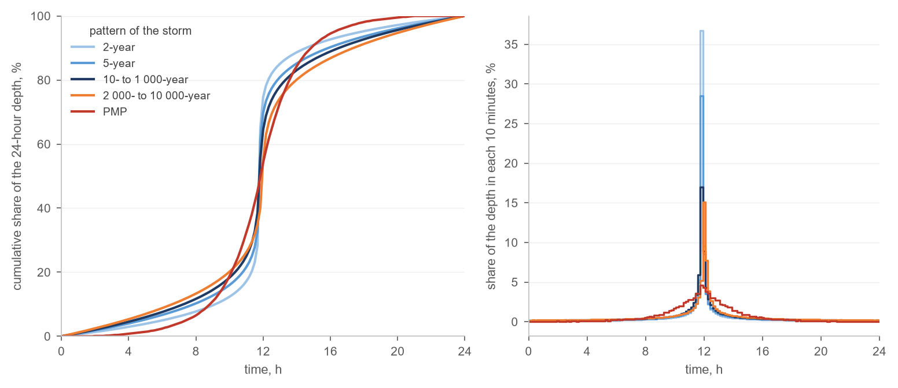
Figure 1 – Temporal distribution of the 24-hour design storm: cumulative share of the depth (left) and the share falling in each 10-minute interval (right), for the five patterns
The probable maximum precipitation is estimated with the storm transposition and moisture maximisation method recommended by the World Meteorological Organisation. The severest historical storms of the region are transposed to the catchment of interest and their precipitable water is raised to its theoretical upper limit on atmospheric thermodynamic principles. The resulting values are the greatest depth of precipitation that is physically possible for a given duration and area, and the basis for the design of critical hydraulic structures. The nationwide PMP grid supplies the 24-hour depth at each catchment; the dam spillways are sized for the probable maximum flood that results from it.
The area reduction factor accounts for the spatial variability of rainfall over a catchment. Point rainfall overstates the average depth over a large catchment, because an intense storm cell seldom covers the whole catchment at once. The factor, a dimensionless value of 1 or less, converts the design point depth to the areal depth. The values of the nationwide study (Table 3) are applied to every catchment through depth-area analyses in HEC-HMS: each element of the model is computed with the storm reduced for its own contributing area, so the peak at a dam site and the peak at a channel junction each carry the right reduction. The reduction matters for the larger catchments of Block 04, where it lowers the computed peaks appreciably.
Table 3 – Area reduction factor
Area (km²) | ARF
1 | 1.000
5 | 0.994
10 | 0.987
20 | 0.976
30 | 0.965
40 | 0.956
50 | 0.948
100 | 0.913
200 | 0.864
500 | 0.776
1000 | 0.694
2000 | 0.606
The curve number grid combines two global datasets: the ESA WorldCover 2020 land cover at 10 m, which classifies the surface roughness and vegetation, and the ISRIC SoilGrids texture at 250 m, from which the hydrologic soil groups follow. The two are aligned and combined through the standard SCS lookup table into a spatially distributed curve number. The area-weighted curve numbers of the dam catchments lie between 87.7 (Sarami 05 and Sakhin 04) and 90.5 (Hawasinah 11), the response of bare, rocky mountain soils. The initial abstraction and the lag time of each subbasin follow the SCS and Kirpich relations:
$I_{a} = 0.2 S, S = 25.4 \left(\frac{1000}{CN} - 10\right)$ (1)
$t_{lag} = 0.6 \frac{1}{52} L^{0.77} S^{-0.385}$ (2)
Ia: initial abstraction, mm
S: potential maximum retention, mm
CN: SCS curve number, –
t_{lag}: lag time, min
L: length of the 10–85 flow path, m
S: slope of the 10–85 flow path, m/m

Channel alignments
The channel routes were chosen from the two-dimensional flood simulation of the plain, the geometry of the existing wadis, and the site visits made with the client and the local authorities. The flood flow pattern depends on the terrain: where the wadis leave the foothills the flow is confined, and where the plain flattens it spreads and ponds. The channels follow the wadis wherever a defined bed exists and cross the flat ground on the shortest route to the sea.
By the flood or stormwater flow they carry, the channels are classified in three categories (Table 4 and Figure 3): flood-protection channels, which take the routed outflows of the dams and the main wadis to the sea; stormwater main channels, which collect the runoff of the larger intermediate catchments of the plain; and stormwater secondary channels, which drain the local catchments between them. Dykes of the same three classes confine the flow where the ground is too flat for a channel to hold it.
Table 4 – Channels and dykes in Block 04
Type | Length (km)
Flood protection channel | 57
Stormwater main channel | 70
Stormwater secondary channel | 97
Flood protection dyke | 49
Stormwater main dyke | 7
Stormwater secondary dyke | 7
Total | 287

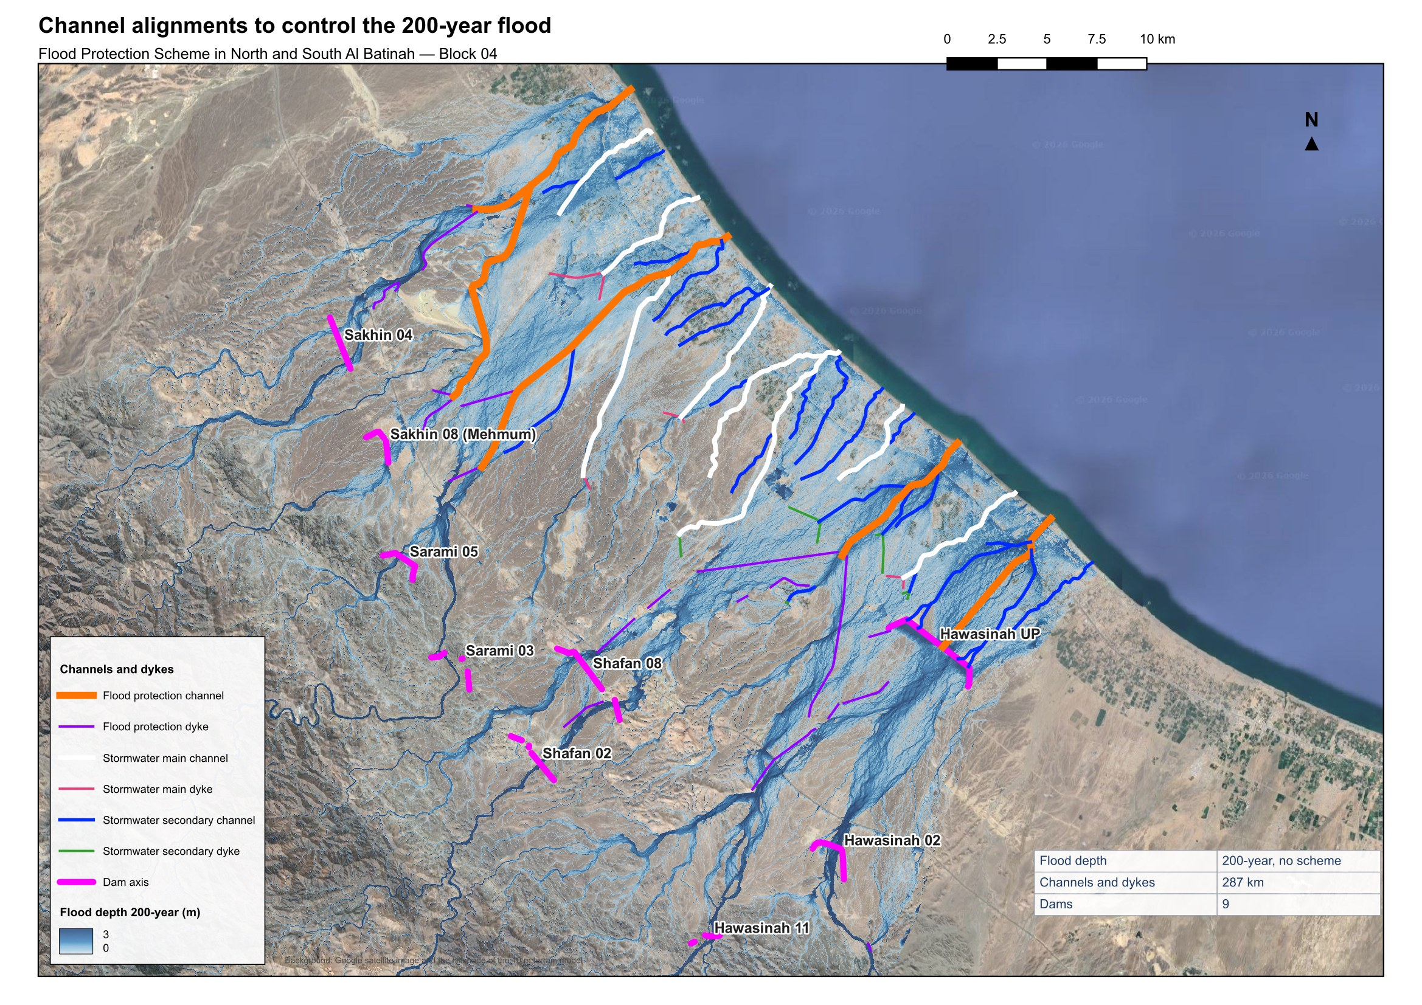
Figure 2 – Channel alignments to control the 200-year flood, on the 200-year flood depth without the scheme

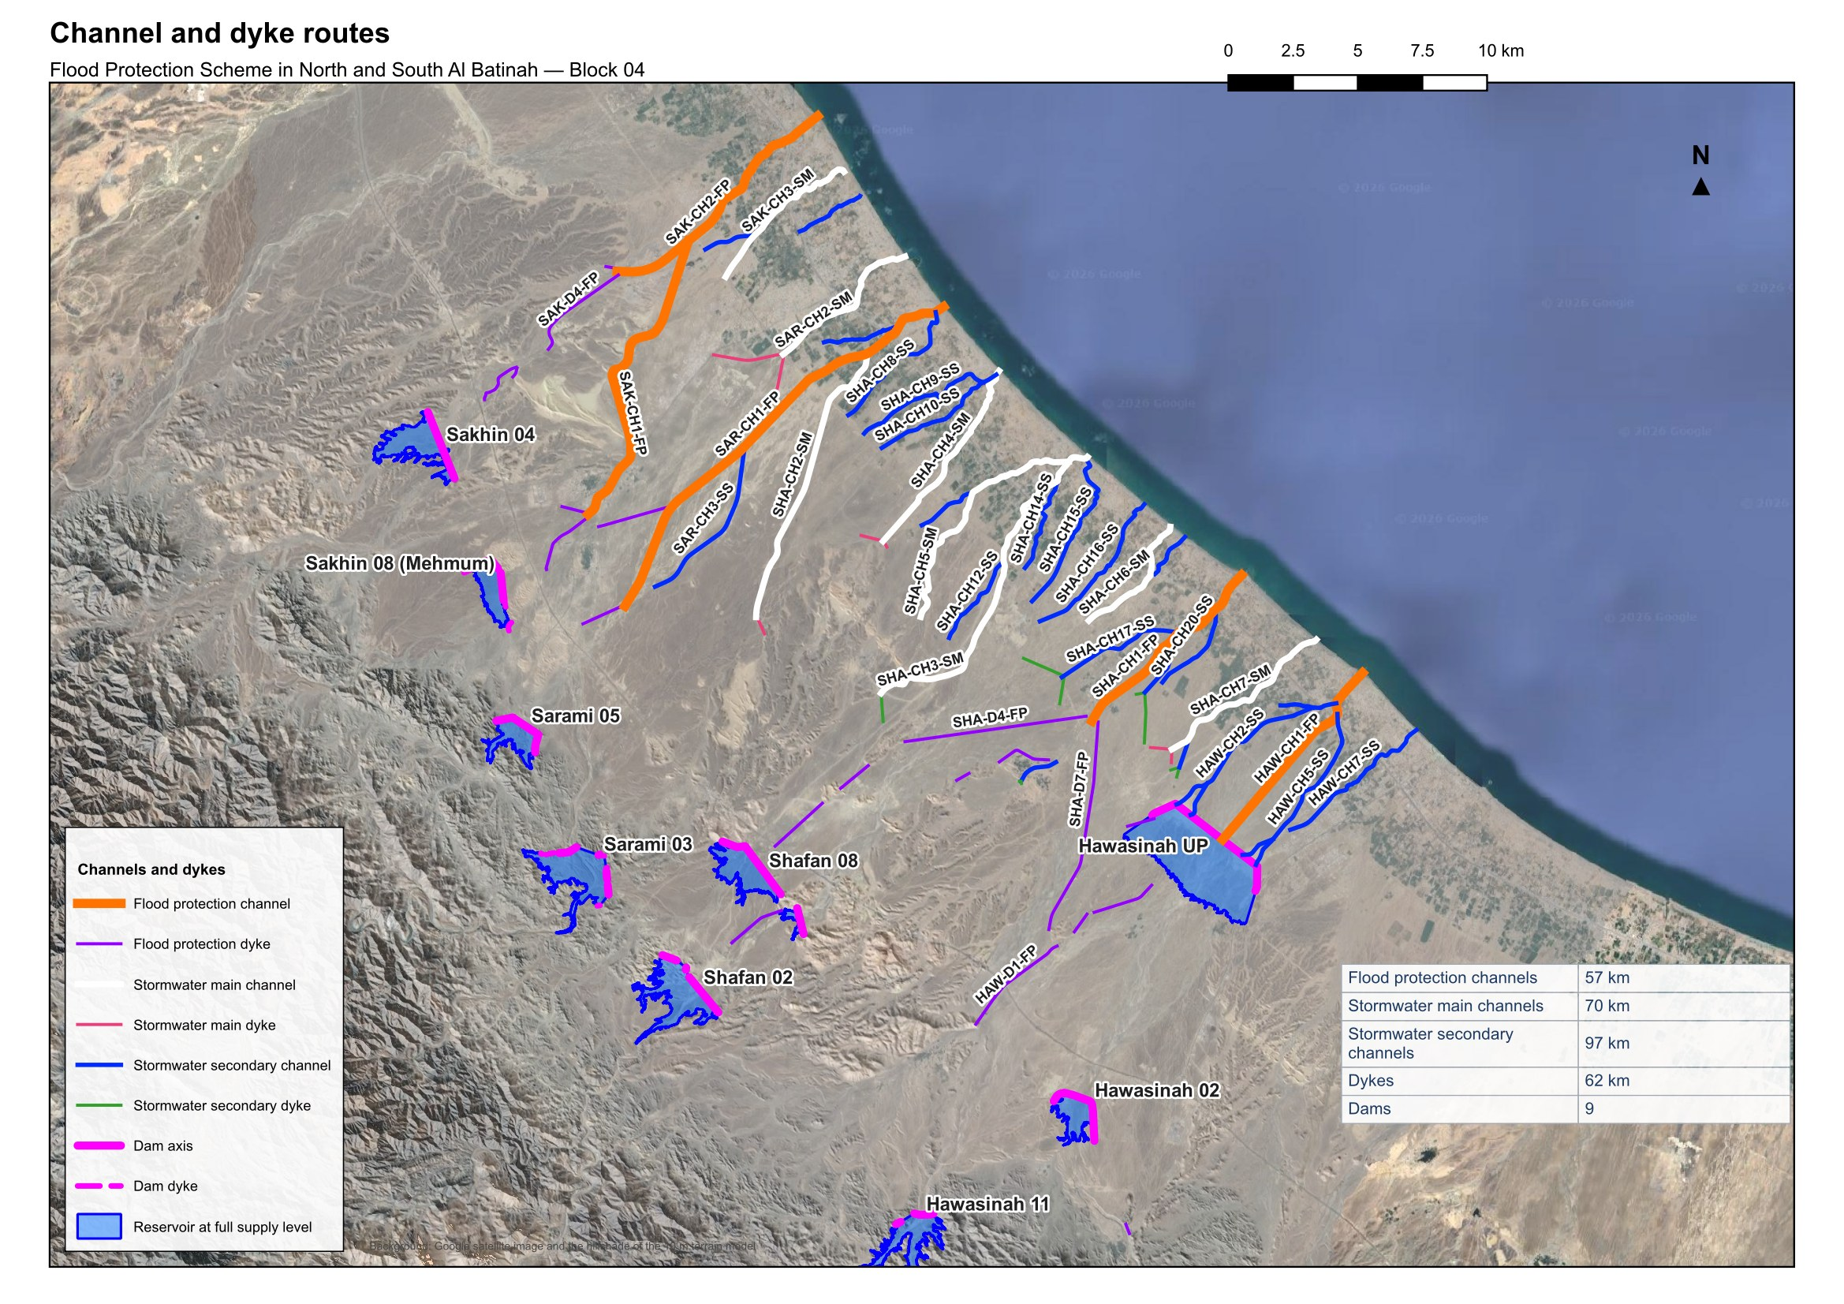
Figure 3 – Channel and dyke routes by category, with the channel and dyke names

Channel condition and conflicts
Several conditions along the routes govern how the channels can be designed: the existing flow patterns, the roads and the utilities that cross or run along the wadis, and the land use. The flood flow pattern depends strongly on the geometry of the plain; where the wadis leave the hills and spread over the flatter ground, the flow widens and loses its defined bed.
The Batinah Expressway, the Batinah Highway, the Batinah Coastal Road, the planned North Batinah bypass and the OQ pipelines are the main constraints (Figure 4). The existing crossings of the roads fix the channel levels and widths where they are kept, and the shallow pipelines limit the depth of the channels that cross them. Other utility corridors, electricity, water, wastewater and stormwater, also have to be respected and their exact position and depth are required for the detailed design.

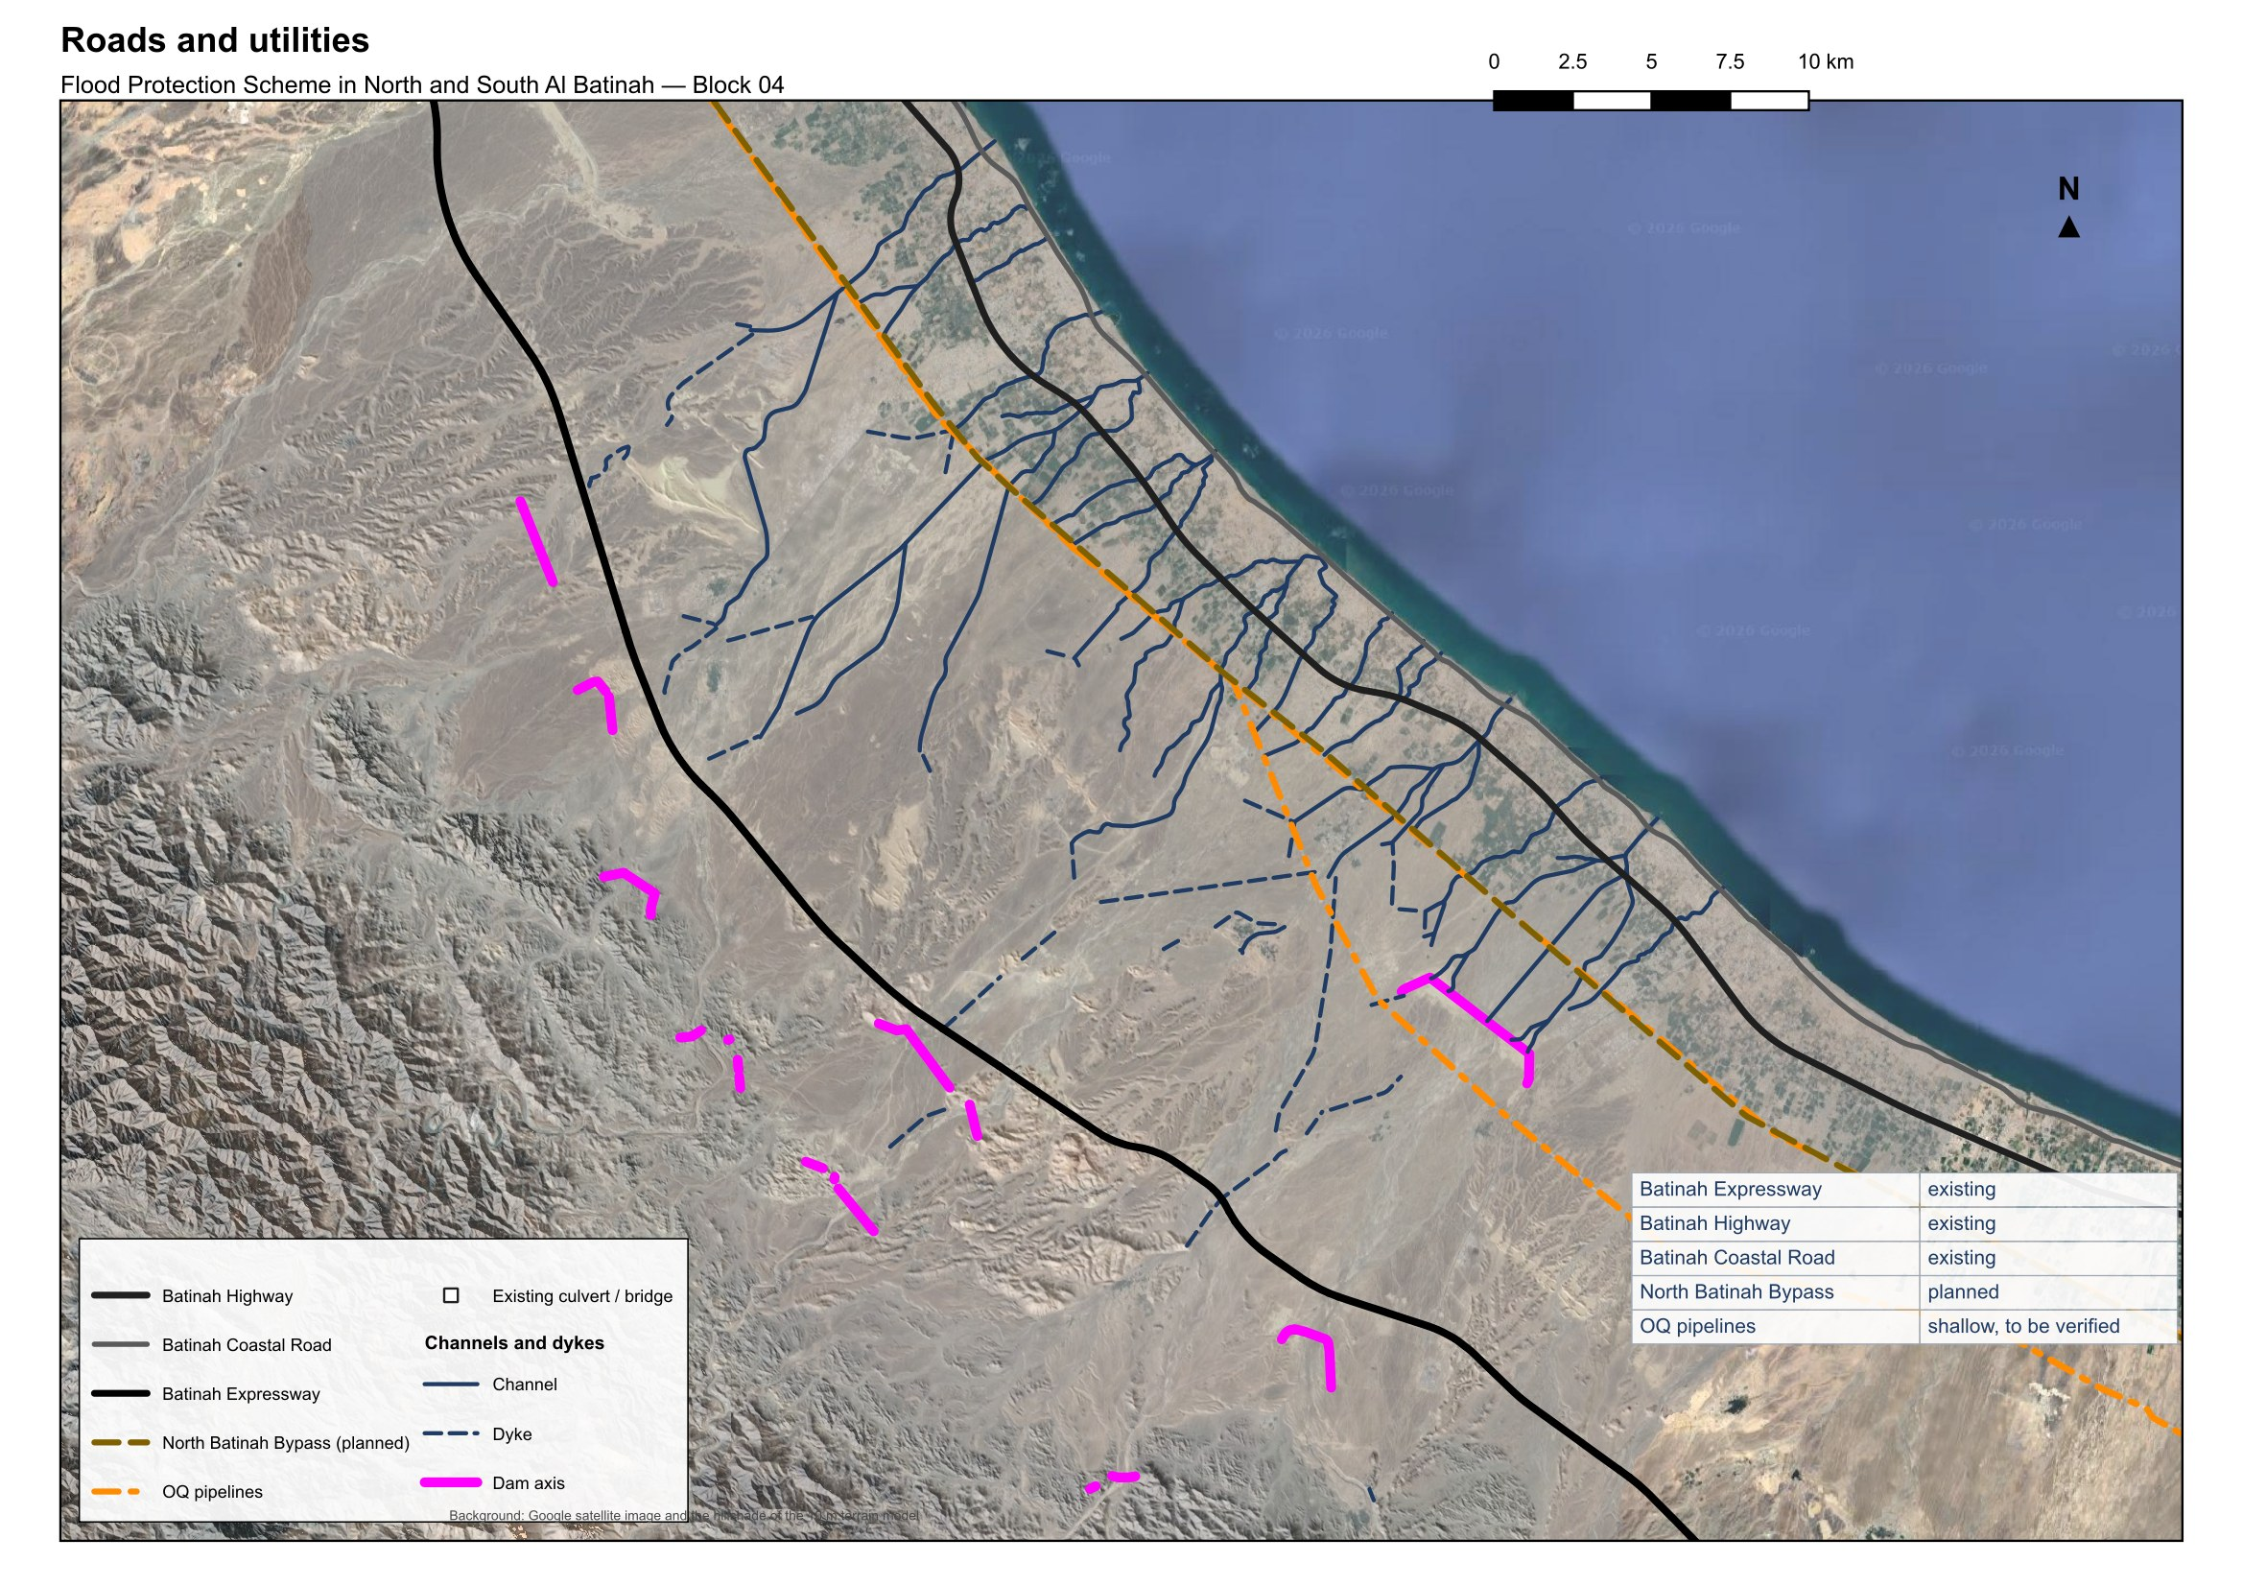
Figure 4 – Roads and utilities

The land use of the plain, managed mainly by the Ministry of Housing and Urban Planning, also shapes the alignments (Figure 5). Houses have been built inside the wadis or have encroached on them and narrowed their beds, and farms extend their boundaries into the wadi. The channels keep to the wadi corridor wherever it is free and deviate around the built plots where it is not.

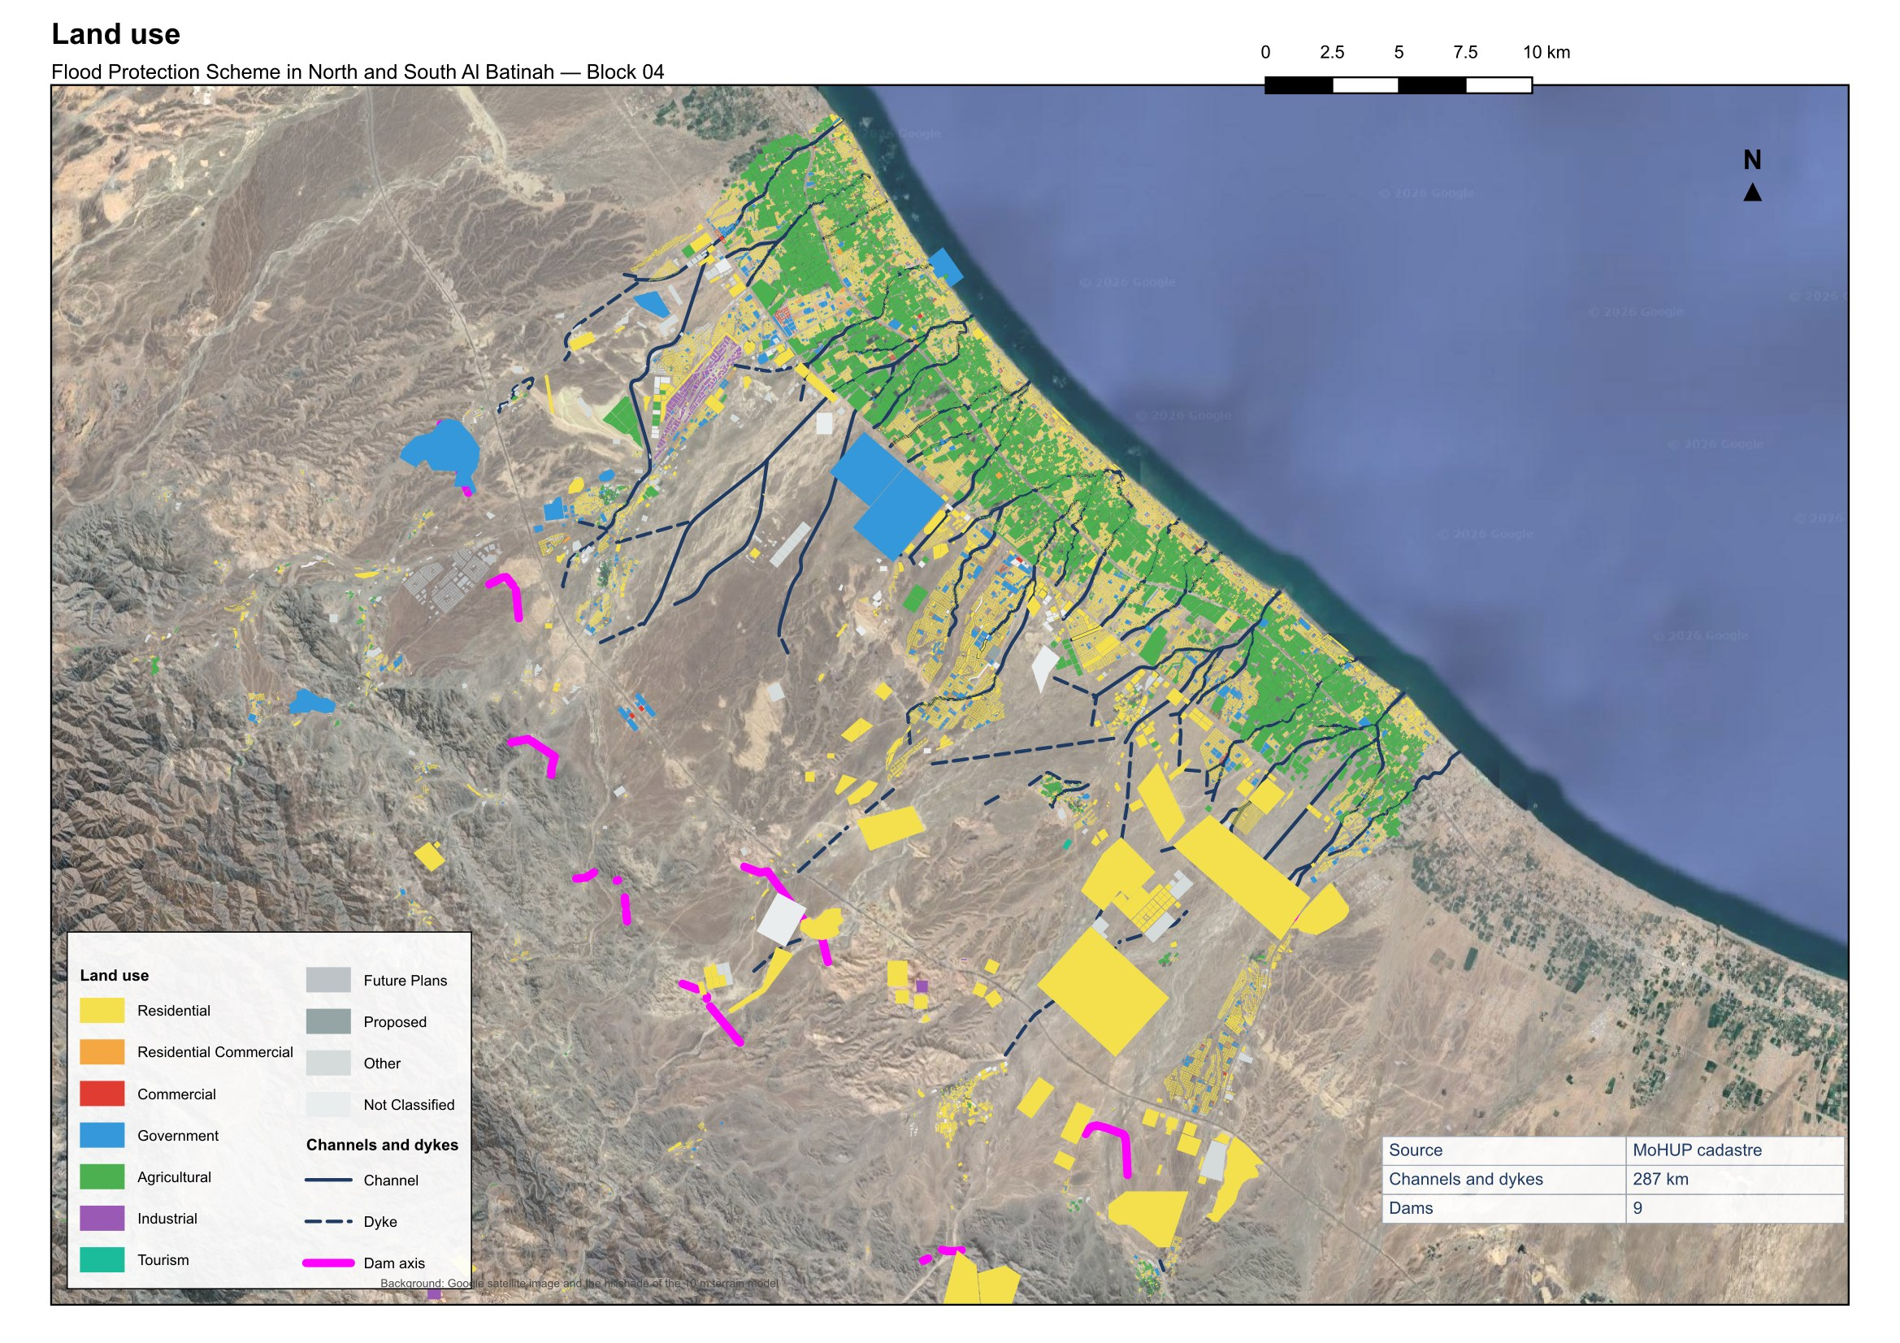
Figure 5 – Land use

Rainfall-runoff simulation
The HEC-HMS model of Block 04 is comprehensive: it includes the subbasins of the nine dams and those of the channel network, delineated on the 10 m terrain model with the channel alignments and the dykes as breaklines, so that even the smallest channel of the design has its own catchment. Depth-area analyses are run for every return period, so that the areal reduction of the storm is applied to each element for its own catchment area. The dams are represented by reservoir elements with their elevation-area curves and spillway ratings; the reaches are routed by Muskingum-Cunge. Figure 6 shows the model.

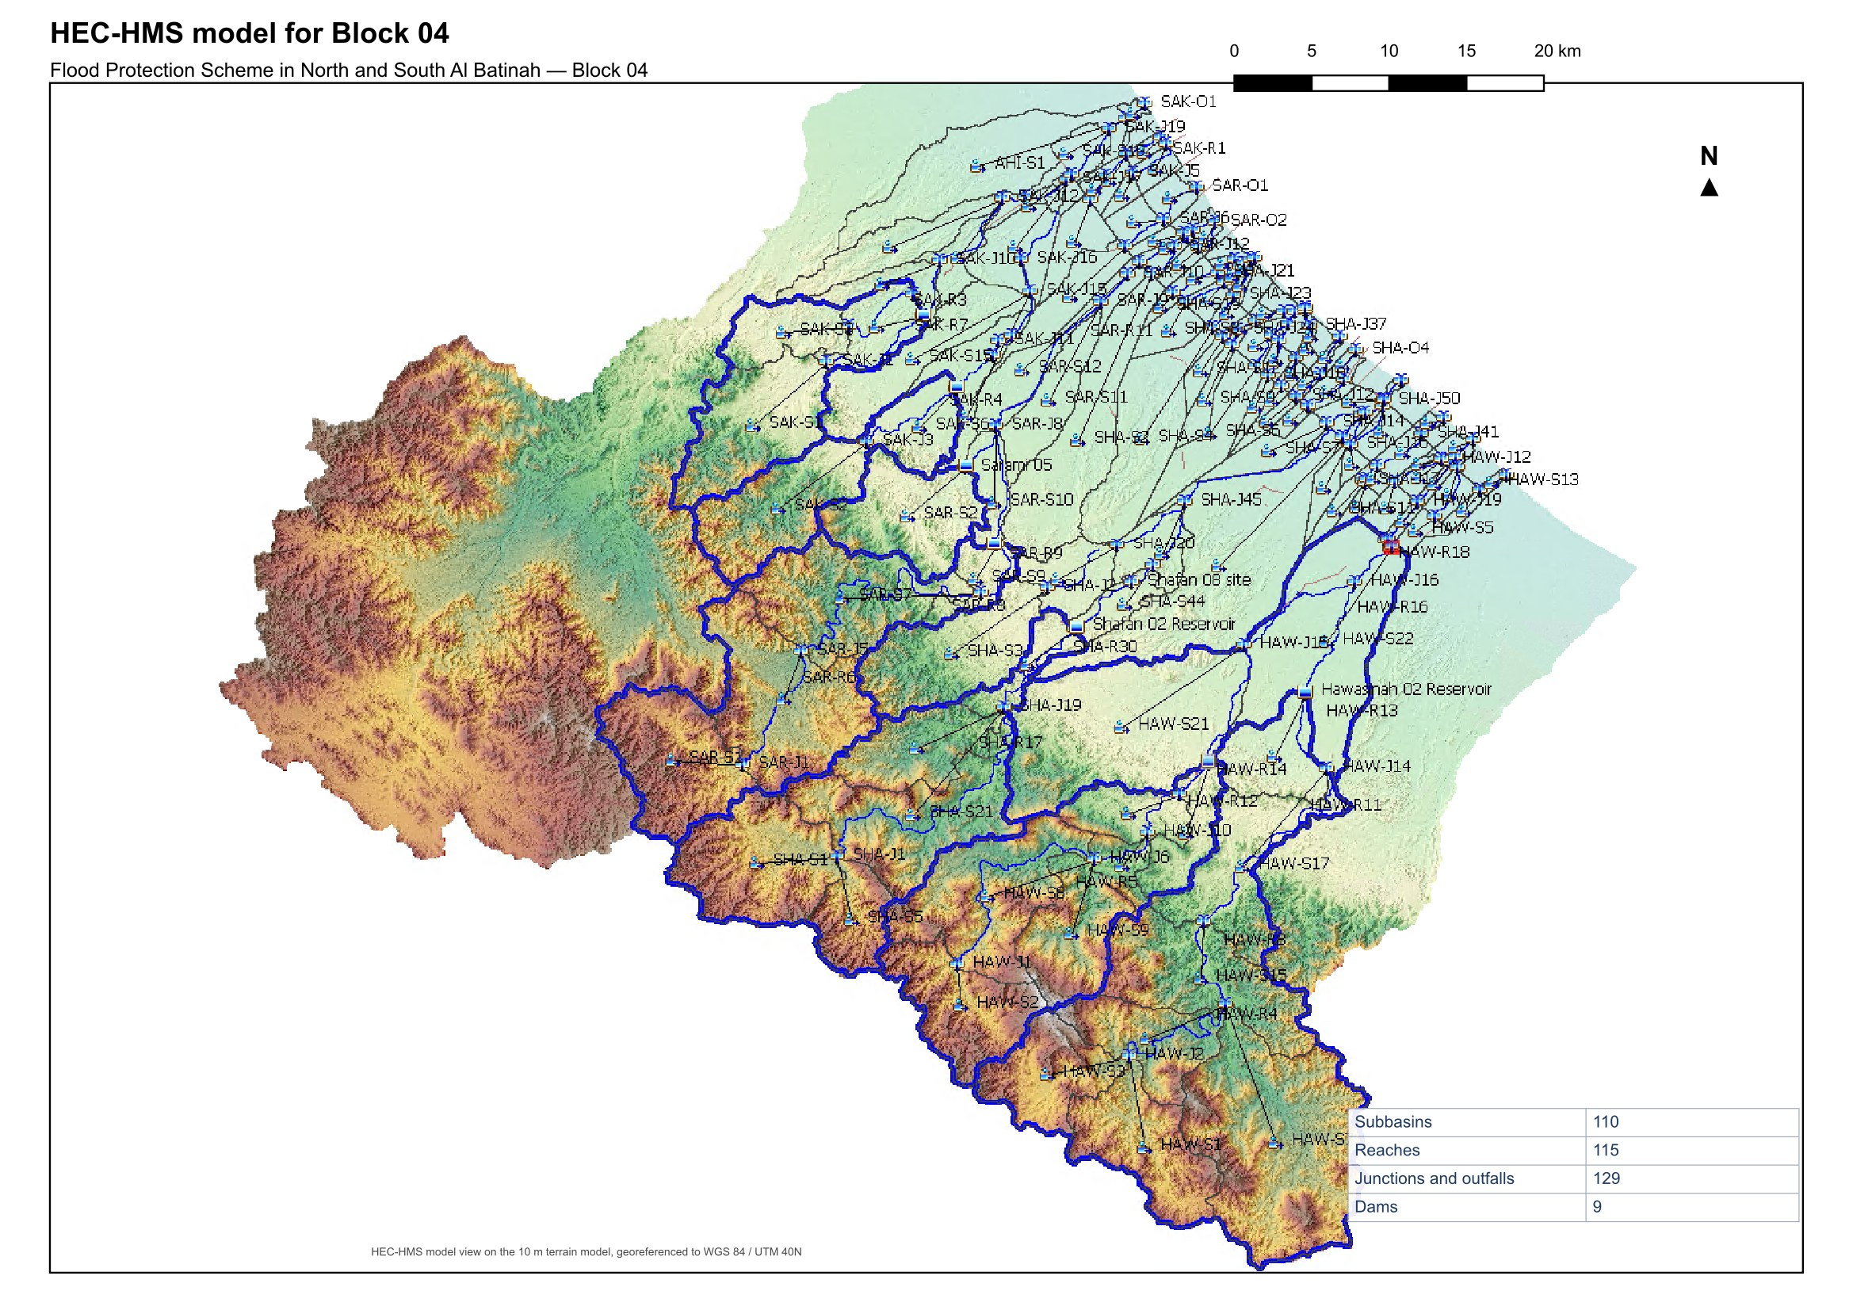
Figure 6 – HEC-HMS model for Block 04

The 200-year peak flow at every junction of the model, with the dams in place, is mapped in Figure 7 for the whole block and in Figure 8 for the dams and the plain downstream of them, where the channels are designed. The peaks at the junctions of the plain are the design flows of the channel reaches that leave them.

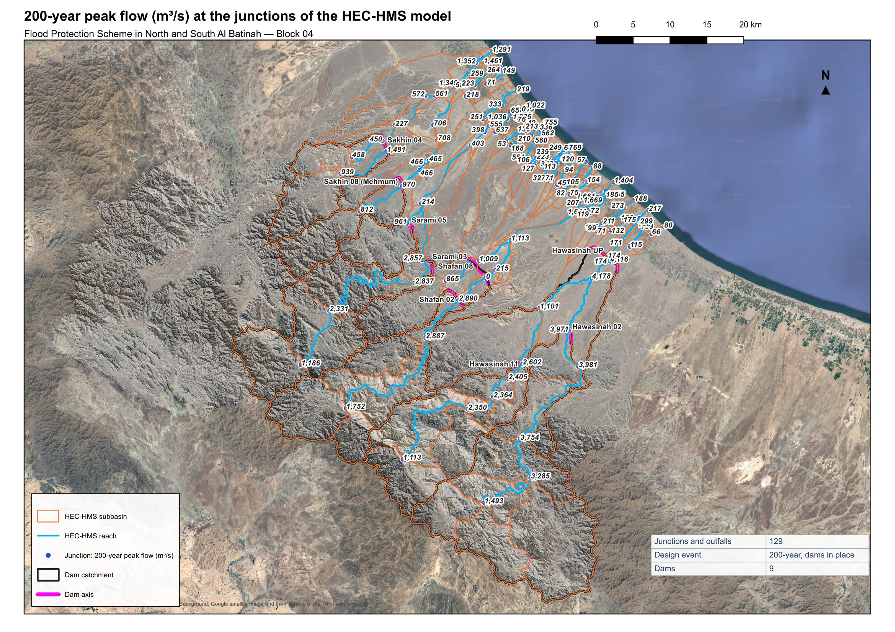
Figure 7 – (a) Q200 (m³/s) at the junctions of the HEC-HMS model, dams in place

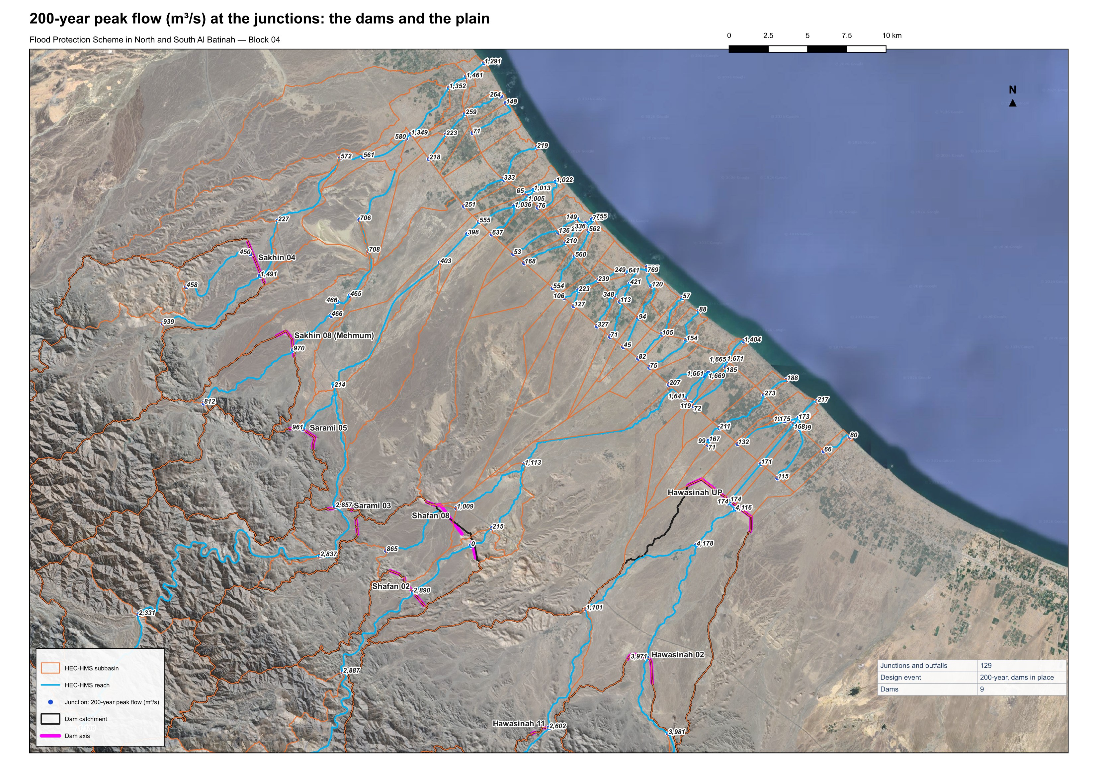
Figure 8 – (b) Q200 (m³/s) at the dams and the junctions downstream of them, dams in place

Some important points about the catchments of the study area are the following.
• Hawasinah UP, the existing dam on Wadi Al Hawasinah, receives the routed outflows of Hawasinah 02 and Hawasinah 11 upstream of it, and Shafan 08 receives the routed outflow of Shafan 02.
• Wadi Sarami and Wadi Sakhin each carry two dams on separate tributaries; their channels join on the plain before the sea.
• The intermediate catchments of the plain, below the dams, have no upstream storage; their flood-protection and stormwater channels are sized on their own runoff added to the routed dam outflows.

Dams' information
The nine dams sit at the foot of the hills where the wadis leave their gorges. Their characteristics are listed in Table 5: crest level, full supply level, height above the wadi bed, reservoir capacity at full supply level, spillway length, probable maximum flood and dam length.
Table 5 – Dams' information
Dam | Crest level (m) | FSL (m) | Height crest–bed (m) | Capacity at FSL (Mm³) | Spillway length (m) | QPMF (m³/s) | Dam length (m)
Hawasinah 02 | 149 | 144 | 19.5 | 11 | 759 | 17,809 | 3,159
Hawasinah 11 | 256 | 251 | 40.0 | 34 | 501 | 11,767 | 947
Hawasinah UP | 65 | 60 | 21.5 | 81 | 1,481 | 34,783 | 9,771
Shafan 02 | 240 | 235 | 38.0 | 43 | 472 | 11,086 | 2,431
Shafan 08 | 173 | 168 | 20.0 | 15 | 671 | 15,764 | 4,264
Sarami 03 | 242 | 237 | 45.5 | 45 | 479 | 11,254 | 1,476
Sarami 05 | 189 | 184 | 26.0 | 15 | 166 | 3,888 | 2,540
Sakhin 04 | 127 | 122 | 25.0 | 24 | 315 | 7,393 | 2,768
Sakhin 08 (Mehmum) | 144 | 139 | 17.5 | 8 | 209 | 4,912 | 2,048
The dam catchments are listed in Table 6 with their physiographic characteristics. Together the dams control 1,640 km², the nested catchments counted once. Hawasinah UP drains the largest area, 852 km², which includes the catchments of Hawasinah 02 and 11 upstream of it, and Shafan 08 includes that of Shafan 02. The longest flow paths run 15 to 80 km from the mountain divides to the dams, with 10–85 slopes of 0.8 to 2.8 %, and the times of concentration by Kirpich range from two to eleven hours.
Table 6 – Dam catchments
Dam | Area (km²) | Longest flow path length (km) | Longest flow path slope (10–85) | Basin slope | Tc (min) | Lag (min) | Curve number | Relief (m)
Hawasinah 02 | 420 | 66.2 | 0.0108 | 0.570 | 566 | 340 | 90.2 | 1,681
Hawasinah 11 | 226 | 45.7 | 0.0185 | 0.579 | 346 | 208 | 90.5 | 1,596
Hawasinah UP | 852 | 79.7 | 0.0100 | 0.472 | 672 | 404 | 89.4 | 1,766
Shafan 02 | 224 | 49.8 | 0.0145 | 0.620 | 406 | 243 | 90.2 | 1,291
Shafan 08 | 314 | 55.4 | 0.0137 | 0.538 | 451 | 270 | 89.4 | 1,334
Sarami 03 | 228 | 57.1 | 0.0134 | 0.636 | 465 | 279 | 90.1 | 1,311
Sarami 05 | 54 | 14.9 | 0.0284 | 0.390 | 124 | 74 | 87.7 | 910
Sakhin 04 | 110 | 28.7 | 0.0167 | 0.361 | 252 | 151 | 87.7 | 1,027
Sakhin 08 (Mehmum) | 81 | 31.7 | 0.0188 | 0.502 | 260 | 156 | 88.8 | 985

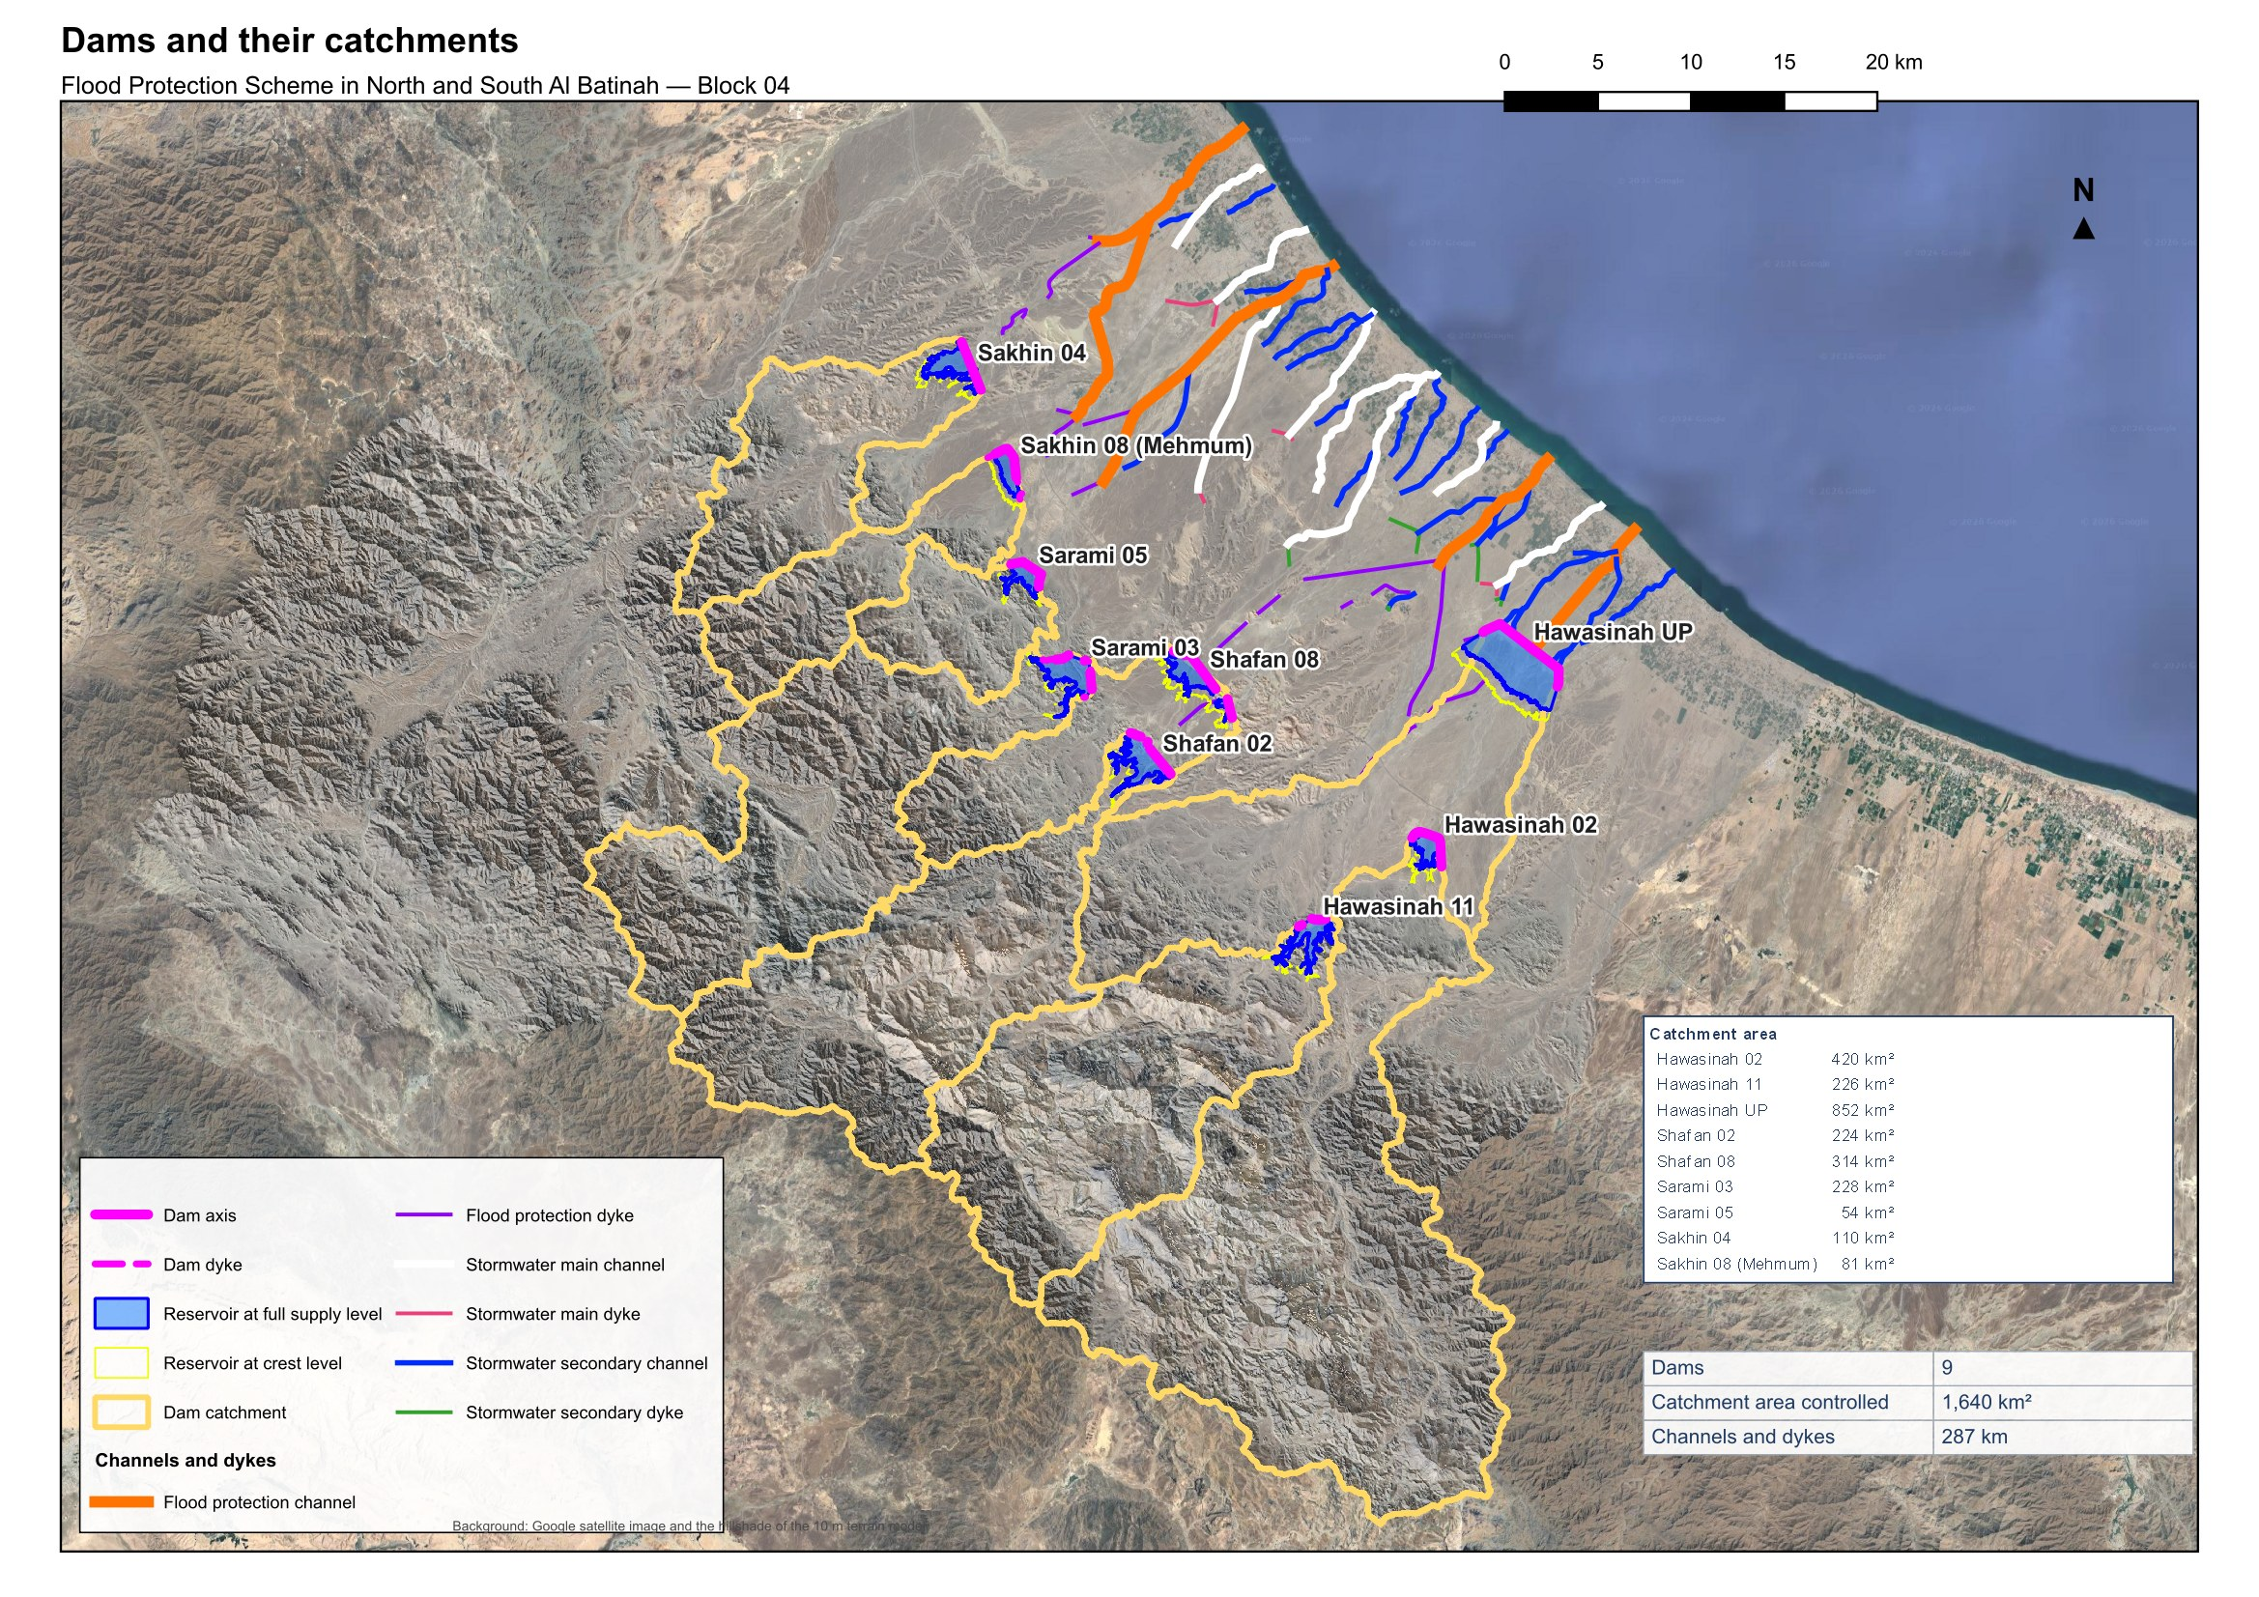
Figure 9 – The nine dams of Block 04, their catchments and reservoirs, and the channel and dyke alignments of the plain

Dams' elevation-volume-area curves
The reservoir elevation-area-volume curves are derived from the 10 m terrain model inside the crest-level contour of each dam, at 0.5 m steps from the wadi bed to the crest; the volume between steps follows the conic formula. Table 7 gives the curves of the nine reservoirs with the full supply level and the capacity and area at it, and Table 8 summarises the values at full supply level and at crest.
Table 7 – Dams' elevation-volume-area curves
Hawasinah 02 | Hawasinah 11
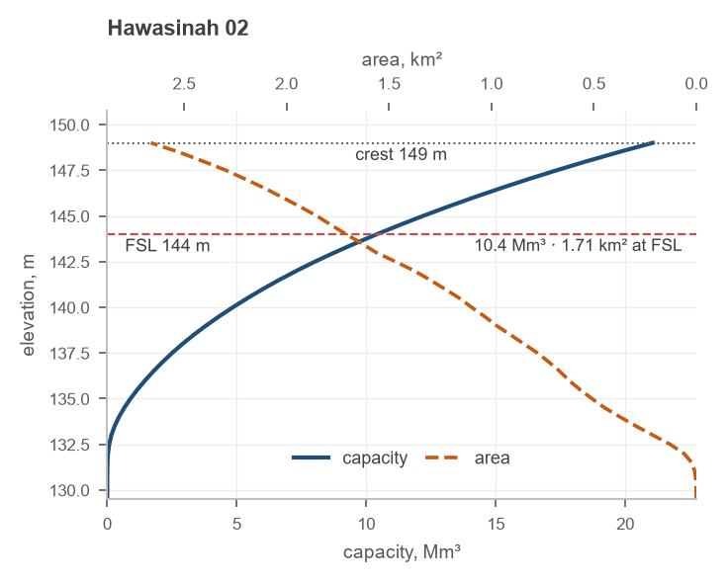 | 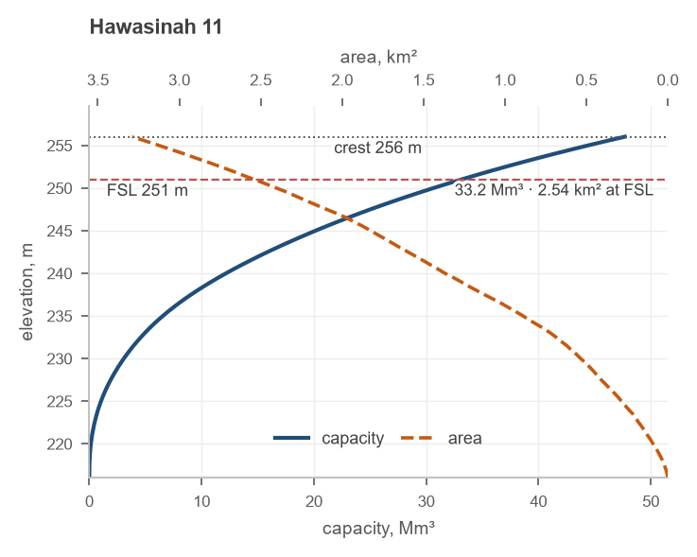
Hawasinah UP | Shafan 02
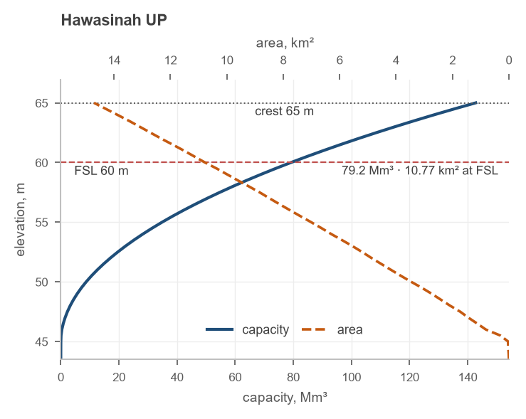 | 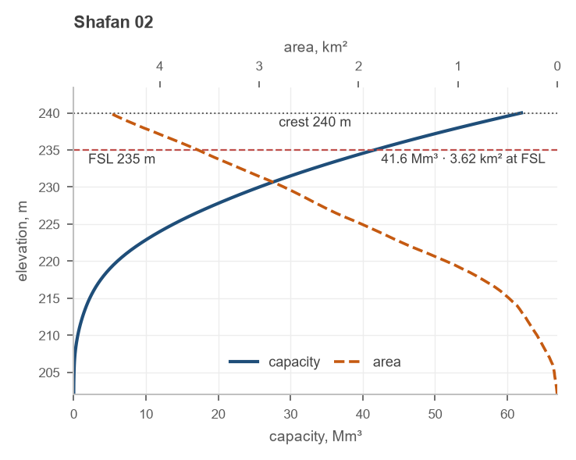
Shafan 08 | Sarami 03
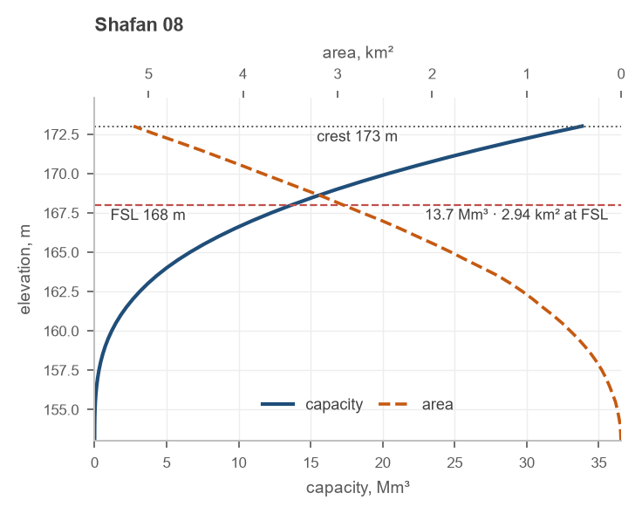 | 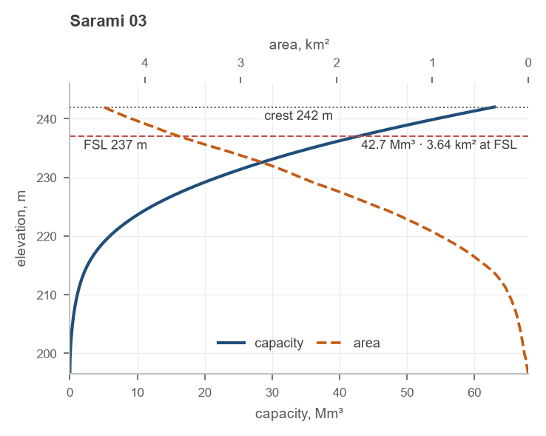
Sarami 05 | Sakhin 04
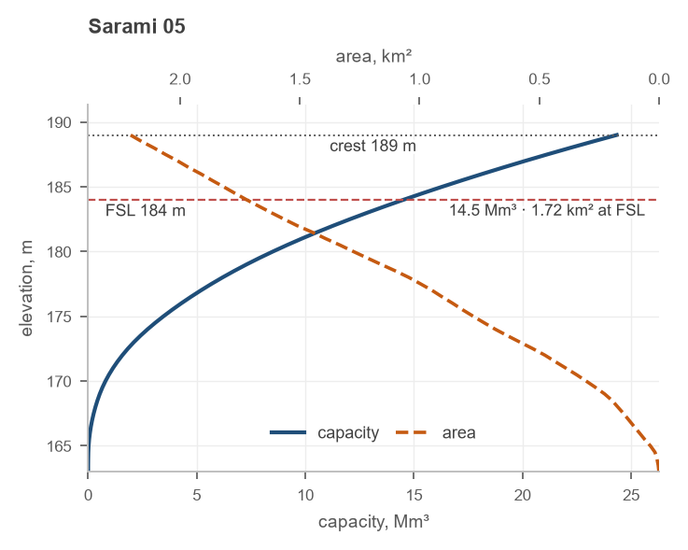 | 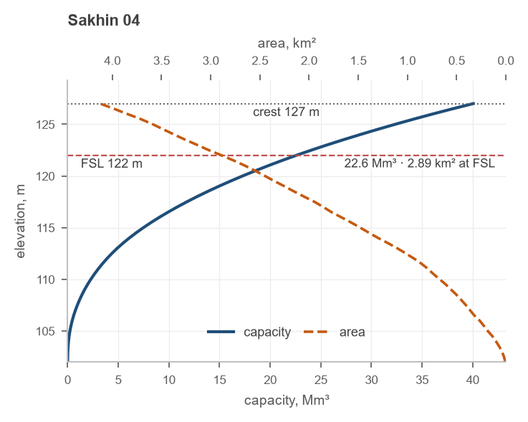
Sakhin 08 (Mehmum)
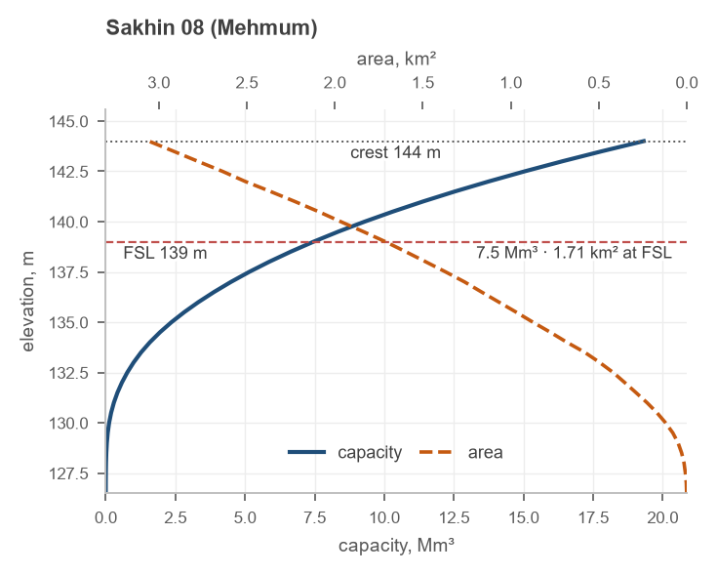
Table 8 – Reservoir curves at full supply level and at crest
Dam | Bed (m) | Area at FSL (km²) | Volume at FSL (Mm³) | Area at crest (km²) | Volume at crest (Mm³)
Hawasinah 02 | 129.5 | 1.71 | 10.4 | 2.66 | 21.1
Hawasinah 11 | 216.0 | 2.54 | 33.2 | 3.29 | 47.7
Hawasinah UP | 43.5 | 10.77 | 79.2 | 14.71 | 142.8
Shafan 02 | 202.0 | 3.62 | 41.6 | 4.51 | 61.9
Shafan 08 | 153.0 | 2.94 | 13.7 | 5.16 | 33.8
Sarami 03 | 196.5 | 3.64 | 42.7 | 4.43 | 63.0
Sarami 05 | 163.0 | 1.72 | 14.5 | 2.21 | 24.3
Sakhin 04 | 102.0 | 2.89 | 22.6 | 4.12 | 40.1
Sakhin 08 (Mehmum) | 126.5 | 1.71 | 7.5 | 3.06 | 19.3

Reservoir routing
Each reservoir is routed by the Modified Puls method on its elevation-area curve. The outflow is the spillway discharge above full supply level, a broad-crested weir with the spillway length of Table 5 and a coefficient of 2.1, plus the flow over the dam crest once the level exceeds it:
$Q = C L H^{1.5} + 1.7 L_{crest} {\left(z - z_{crest}\right)}^{1.5}$ (3)
Q: outflow, m³/s
C: spillway discharge coefficient, 2.1, m^{0.5}/s
L: spillway length, m
H: head over the full supply level, m
L_{crest}: length of the dam crest, m
z: reservoir level, m
The reservoirs are empty at the start of every event; a low-level outlet empties them between events and does not change the flood peak.

Dams' peak flows
Peak inflows and outflows at the dam sites are presented in Table 9 for all the return periods; the dams are designed to hold the 200-year flood. The inflow of Hawasinah UP and of Shafan 08 includes the routed outflow of the dams upstream of them.
Table 9 – Dams' peak flow (m³/s) for the return periods
Dam |  | 2 | 5 | 10 | 25 | 50 | 100 | 200 | 500 | 1000 | 2000 | 5000 | 10000 | PMP
Hawasinah 02 | In | 98 | 412 | 1,214 | 1,801 | 2,379 | 3,093 | 3,971 | 5,451 | 6,863 | 7,821 | 10,482 | 11,302 | 17,809
Hawasinah 02 | Out | 0 | 0 | 725 | 1,429 | 2,143 | 2,953 | 3,887 | 5,369 | 6,772 | 7,730 | 10,371 | 11,184 | 17,751
Hawasinah 11 | In | 99 | 370 | 862 | 1,231 | 1,591 | 2,042 | 2,602 | 3,539 | 4,465 | 5,083 | 6,917 | 7,474 | 11,767
Hawasinah 11 | Out | 0 | 0 | 0 | 0 | 0 | 15 | 325 | 1,404 | 2,757 | 4,087 | 6,400 | 7,039 | 11,608
Hawasinah UP | In | 23 | 120 | 570 | 1,240 | 1,975 | 2,936 | 4,109 | 6,016 | 7,727 | 10,004 | 16,546 | 18,212 | 34,603
Hawasinah UP | Out | 0 | 0 | 0 | 0 | 0 | 0 | 159 | 1,618 | 3,726 | 6,442 | 11,984 | 13,741 | 32,933
Shafan 02 | In | 86 | 319 | 913 | 1,348 | 1,773 | 2,283 | 2,890 | 3,888 | 4,830 | 5,416 | 7,170 | 7,705 | 11,086
Shafan 02 | Out | 0 | 0 | 0 | 0 | 0 | 0 | 0 | 528 | 1,398 | 2,485 | 4,755 | 5,447 | 10,556
Shafan 08 | In | 30 | 129 | 337 | 494 | 649 | 838 | 1,069 | 1,454 | 1,821 | 2,831 | 5,575 | 6,430 | 14,778
Shafan 08 | Out | 0 | 0 | 0 | 0 | 0 | 0 | 72 | 494 | 1,386 | 2,582 | 5,117 | 5,920 | 14,380
Sarami 03 | In | 77 | 347 | 954 | 1,359 | 1,763 | 2,259 | 2,857 | 3,853 | 4,796 | 5,379 | 7,125 | 7,655 | 11,254
Sarami 03 | Out | 0 | 0 | 0 | 0 | 0 | 0 | 0 | 485 | 1,314 | 2,378 | 4,632 | 5,328 | 10,732
Sarami 05 | In | 38 | 141 | 332 | 471 | 603 | 765 | 961 | 1,287 | 1,595 | 1,771 | 2,337 | 2,509 | 3,888
Sarami 05 | Out | 0 | 0 | 0 | 0 | 0 | 0 | 0 | 0 | 117 | 365 | 994 | 1,208 | 3,540
Sakhin 04 | In | 49 | 193 | 495 | 710 | 920 | 1,177 | 1,491 | 2,020 | 2,524 | 2,841 | 3,784 | 4,071 | 7,393
Sakhin 04 | Out | 0 | 0 | 0 | 0 | 0 | 0 | 0 | 199 | 608 | 1,138 | 2,277 | 2,628 | 6,919
Sakhin 08 | In | 40 | 139 | 333 | 471 | 605 | 768 | 970 | 1,307 | 1,630 | 1,844 | 2,453 | 2,641 | 4,912
Sakhin 08 | Out | 0 | 0 | 0 | 18 | 91 | 241 | 468 | 880 | 1,254 | 1,563 | 2,189 | 2,373 | 4,681
Four reservoirs store the whole 200-year flood: Shafan 02, Sarami 03, Sarami 05, Sakhin 04 release nothing up to 200 years. Hawasinah UP and Hawasinah 11 release 159 and 325 m³/s against inflows of 4,109 and 2,602 m³/s, Shafan 08 releases 72 m³/s, and Sakhin 08 (Mehmum) halves its 200-year peak. Hawasinah 02 is different: its reservoir holds 11 Mm³ against a 200-year inflow volume of 72 Mm³, so the spillway runs from the 10-year event and the 200-year peak passes almost unattenuated, at 3,887 m³/s; Hawasinah UP downstream of it holds that flood up to the 200-year event.
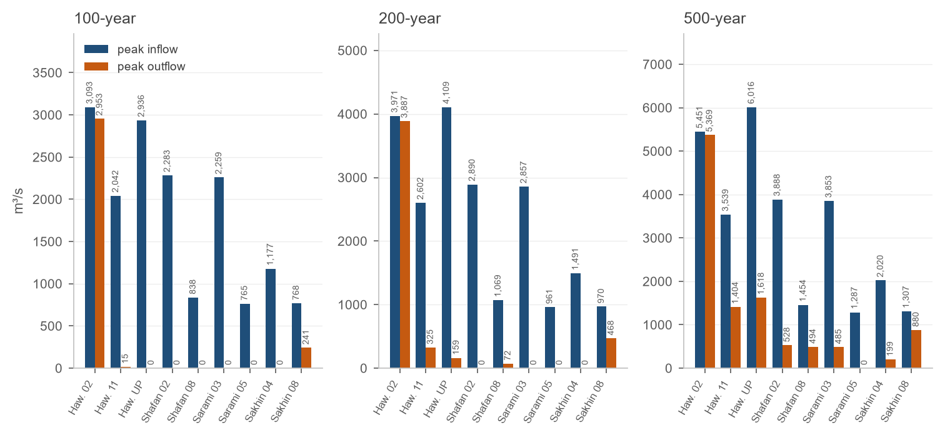
Figure 10 – Dams' peak inflow and outflow for the 100-, 200- and 500-year events
Table 10 – Dams' inflow and outflow volume (Mm³) for the return periods
Dam |  | 2 | 5 | 10 | 25 | 50 | 100 | 200 | 500 | 1000 | 2000 | 5000 | 10000 | PMP
Hawasinah 02 | In | 2.7 | 9.5 | 24.5 | 34.6 | 44.5 | 56.6 | 71.6 | 96.8 | 121.0 | 150.7 | 200.9 | 216.3 | 365.4
Hawasinah 02 | Out | 0.0 | 0.0 | 14.1 | 24.2 | 34.1 | 46.2 | 61.2 | 86.4 | 110.6 | 140.2 | 190.5 | 205.9 | 355.0
Hawasinah 11 | In | 1.8 | 5.9 | 14.7 | 20.6 | 26.3 | 33.3 | 42.0 | 56.6 | 70.6 | 87.7 | 116.7 | 125.6 | 217.7
Hawasinah 11 | Out | 0.0 | 0.0 | 0.0 | 0.0 | 0.0 | 0.2 | 8.9 | 23.4 | 37.4 | 54.5 | 83.5 | 92.4 | 184.5
Hawasinah UP | In | 0.6 | 3.0 | 19.7 | 32.9 | 45.8 | 61.9 | 82.8 | 128.6 | 172.4 | 226.4 | 317.7 | 345.6 | 681.4
Hawasinah UP | Out | 0.0 | 0.0 | 0.0 | 0.0 | 0.0 | 0.0 | 3.6 | 49.3 | 93.2 | 147.1 | 238.5 | 266.4 | 602.1
Shafan 02 | In | 1.7 | 5.7 | 14.4 | 20.2 | 25.9 | 32.9 | 41.5 | 55.9 | 69.8 | 86.8 | 115.6 | 124.4 | 212.7
Shafan 02 | Out | 0.0 | 0.0 | 0.0 | 0.0 | 0.0 | 0.0 | 0.0 | 14.3 | 28.2 | 45.2 | 74.0 | 82.8 | 171.1
Shafan 08 | In | 0.4 | 1.8 | 5.0 | 7.2 | 9.3 | 12.0 | 15.3 | 33.3 | 52.1 | 75.1 | 114.2 | 126.1 | 265.1
Shafan 08 | Out | 0.0 | 0.0 | 0.0 | 0.0 | 0.0 | 0.0 | 1.6 | 19.6 | 38.4 | 61.4 | 100.5 | 112.4 | 251.4
Sarami 03 | In | 1.7 | 5.8 | 14.5 | 20.4 | 26.2 | 33.3 | 42.0 | 56.7 | 70.7 | 87.9 | 117.1 | 126.0 | 218.5
Sarami 03 | Out | 0.0 | 0.0 | 0.0 | 0.0 | 0.0 | 0.0 | 0.0 | 14.0 | 28.0 | 45.2 | 74.4 | 83.3 | 175.8
Sarami 05 | In | 0.4 | 1.4 | 3.6 | 5.1 | 6.6 | 8.4 | 10.7 | 14.5 | 18.2 | 22.7 | 30.3 | 32.6 | 67.7
Sarami 05 | Out | 0.0 | 0.0 | 0.0 | 0.0 | 0.0 | 0.0 | 0.0 | 0.0 | 3.6 | 8.1 | 15.7 | 18.1 | 53.2
Sakhin 04 | In | 0.7 | 2.6 | 7.0 | 10.0 | 12.9 | 16.5 | 21.0 | 28.5 | 35.7 | 44.6 | 59.6 | 64.2 | 138.0
Sakhin 04 | Out | 0.0 | 0.0 | 0.0 | 0.0 | 0.0 | 0.0 | 0.0 | 5.9 | 13.1 | 22.0 | 37.0 | 41.6 | 115.4
Sakhin 08 | In | 0.6 | 2.1 | 5.5 | 7.8 | 10.0 | 12.7 | 16.1 | 21.8 | 27.2 | 33.8 | 45.1 | 48.6 | 97.3
Sakhin 08 | Out | 0.0 | 0.0 | 0.0 | 0.3 | 2.5 | 5.3 | 8.6 | 14.3 | 19.7 | 26.4 | 37.7 | 41.1 | 89.8

Reservoir levels
The peak reservoir level of every event is listed in Table 11. At the probable maximum flood the reservoirs reach 4.7 to 5.0 m above full supply level.
Table 11 – Peak reservoir level (m) for the return periods
Dam | FSL | 2 | 5 | 10 | 25 | 50 | 100 | 200 | 500 | 1000 | 2000 | 5000 | 10000 | PMP
Hawasinah 02 | 144 | 137.7 | 143.5 | 144.6 | 144.9 | 145.2 | 145.5 | 145.8 | 146.2 | 146.6 | 146.9 | 147.5 | 147.7 | 149.0
Hawasinah 11 | 251 | 227.1 | 234.2 | 241.7 | 245.2 | 248.1 | 251.0 | 251.4 | 252.2 | 252.9 | 253.5 | 254.3 | 254.5 | 256.0
Hawasinah UP | 60 | 46.2 | 47.9 | 52.5 | 54.7 | 56.4 | 58.3 | 60.1 | 60.6 | 61.1 | 61.6 | 62.5 | 62.7 | 64.8
Shafan 02 | 235 | 213.7 | 219.7 | 225.3 | 227.9 | 230.1 | 232.4 | 235.0 | 235.6 | 236.2 | 236.8 | 237.8 | 238.1 | 239.8
Shafan 08 | 168 | 158.0 | 161.0 | 164.0 | 165.3 | 166.3 | 167.4 | 168.1 | 168.5 | 169.0 | 169.5 | 170.4 | 170.6 | 172.7
Sarami 03 | 237 | 212.3 | 219.8 | 226.5 | 229.4 | 231.7 | 234.2 | 236.8 | 237.6 | 238.2 | 238.8 | 239.8 | 240.0 | 241.8
Sarami 05 | 184 | 168.1 | 171.5 | 175.2 | 176.9 | 178.4 | 179.9 | 181.6 | 184.0 | 184.5 | 185.0 | 186.0 | 186.3 | 188.7
Sakhin 04 | 122 | 106.7 | 110.5 | 114.7 | 116.5 | 118.1 | 119.7 | 121.4 | 122.4 | 122.9 | 123.4 | 124.3 | 124.5 | 126.8
Sakhin 08 | 139 | 132.0 | 134.7 | 137.7 | 139.1 | 139.3 | 139.7 | 140.0 | 140.6 | 141.0 | 141.3 | 141.9 | 142.1 | 143.8

Hydrographs
The inflow and outflow hydrographs of all the dam sites are presented in Figure 11 for the 200-year event, with the peak and the volume of each. The area between the two curves is the volume the reservoir stores; the delay of the outflow peak and its reduction measure the dam's performance. The inflow hydrographs of all the return periods are given for every dam in Appendix A.
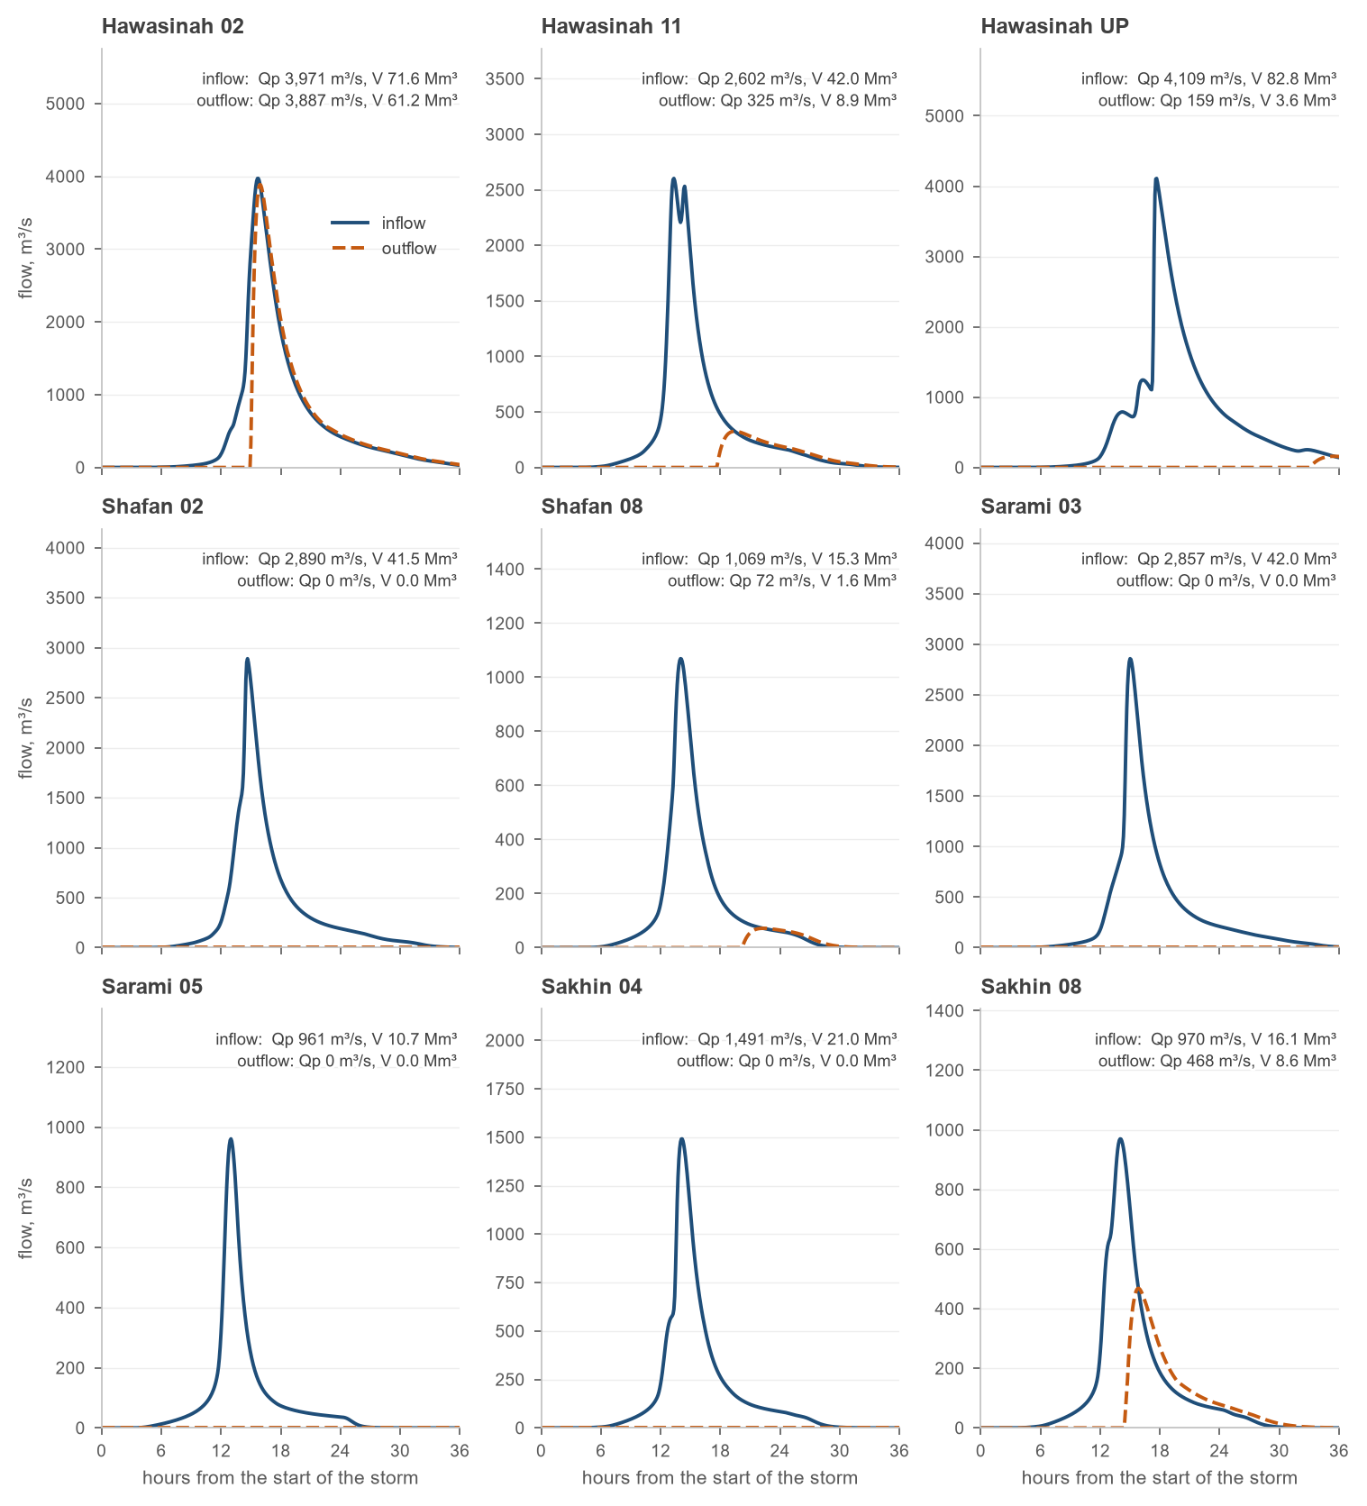
Figure 11 – Inflow and outflow hydrographs of the nine dams for the 200-year event

Flood protection performance
Table 12 measures the flood protection each dam offers to its global catchment: the potential net capacity is the capacity at full supply level less the sediment deposited in 50 years; the site runoff volume is the 200-year inflow volume at the dam; the global catchment volume is the 200-year runoff volume of the whole wadi catchment reaching the sea without the dams; and the performance is the ratio of the net capacity to that volume.
Table 12 – Flood protection performance of the dams
Dam site | Global catchment | Potential net capacity (MCM) | Site 200-yr runoff volume (MCM) | Global catchment 200-yr runoff volume (MCM) | Global flood protection performance (%)
Hawasinah 02 | Al Hawasinah | 6.6 | 71.6 | 128.6 | 5
Hawasinah 11 | Al Hawasinah | 30.7 | 42.0 | 128.6 | 24
Hawasinah UP | Al Hawasinah | 72.6 | 82.8 | 128.6 | 56
Shafan 02 | Shafan | 39.3 | 41.5 | 113.2 | 35
Shafan 08 | Shafan | 11.0 | 15.3 | 113.2 | 10
Sarami 03 | Sarami | 40.4 | 42.0 | 76.6 | 53
Sarami 05 | Sarami | 14.3 | 10.7 | 76.6 | 19
Sakhin 04 | Sakhin | 22.0 | 21.0 | 71.9 | 31
Sakhin 08 (Mehmum) | Sakhin | 6.9 | 16.1 | 71.9 | 10

Sediment yield and reservoir sedimentation

Soil loss of the catchments
The soil loss of each catchment is estimated with the Revised Universal Soil Loss Equation on a 250 m grid from public remote-sensing data:
$A = R K LS C P$ (4)
A: mean annual soil loss, t/ha/yr
R: rainfall erosivity, MJ mm/(ha h yr)
K: soil erodibility, t ha h/(ha MJ mm)
LS: slope length and steepness factor, –
C: cover management factor, –
P: support practice factor, 1 (no conservation practice), –
The rainfall erosivity comes from the mean monthly precipitation of the SM2RAIN climatology at 1 km, the soil erodibility from the sand, silt and clay fractions of the SoilGrids topsoil by the Williams relation, the slope factor from the Copernicus 30 m terrain model and its flow accumulation by Moore and Burch, and the cover factor from the vegetation index of a Landsat 8 mosaic. With no conservation practice in the catchments, the support practice factor is 1:
$R = 1.73 × {10}^{1.5 \left(\log{P_{m}} - 0.08188\right)}$ (5)
$LS = 1.4 {\left(\frac{FA · 30}{22.13}\right)}^{0.4} {\left(\frac{\sin{θ}}{0.0896}\right)}^{1.3}, C = 0.1 \frac{1 - NDVI}{2}$ (6)
P_{m}: mean monthly precipitation, mm
FA: flow accumulation, cells of 30 m, capped at 300, –
θ: slope angle, capped at 30°, °
NDVI: normalised difference vegetation index, –
The catchment means of the factors and of the soil loss are listed in Table 13 and mapped in Figure 12. The soil loss runs from 6.3 t/ha/yr (Sakhin 04) to 13.9 t/ha/yr (Hawasinah 11); the steep mountain catchments carry the highest erosivity and slope factors, the catchments of the foothills the lowest.
Table 13 – RUSLE factors and soil loss, catchment means
Dam | R | K | LS | C | P | Soil loss A (t/ha/yr)
Hawasinah 02 | 52.4 | 0.229 | 19.9 | 0.0467 | 1 | 11.8
Hawasinah 11 | 56.1 | 0.230 | 22.0 | 0.0467 | 1 | 13.9
Hawasinah UP | 48.8 | 0.227 | 16.9 | 0.0468 | 1 | 10.1
Shafan 02 | 56.9 | 0.228 | 21.4 | 0.0467 | 1 | 13.5
Shafan 08 | 52.8 | 0.227 | 18.3 | 0.0469 | 1 | 11.2
Sarami 03 | 58.6 | 0.229 | 20.7 | 0.0464 | 1 | 13.3
Sarami 05 | 43.4 | 0.223 | 12.9 | 0.0479 | 1 | 6.4
Sakhin 04 | 43.9 | 0.225 | 12.2 | 0.0468 | 1 | 6.3
Sakhin 08 (Mehmum) | 49.4 | 0.228 | 16.1 | 0.0472 | 1 | 9.7

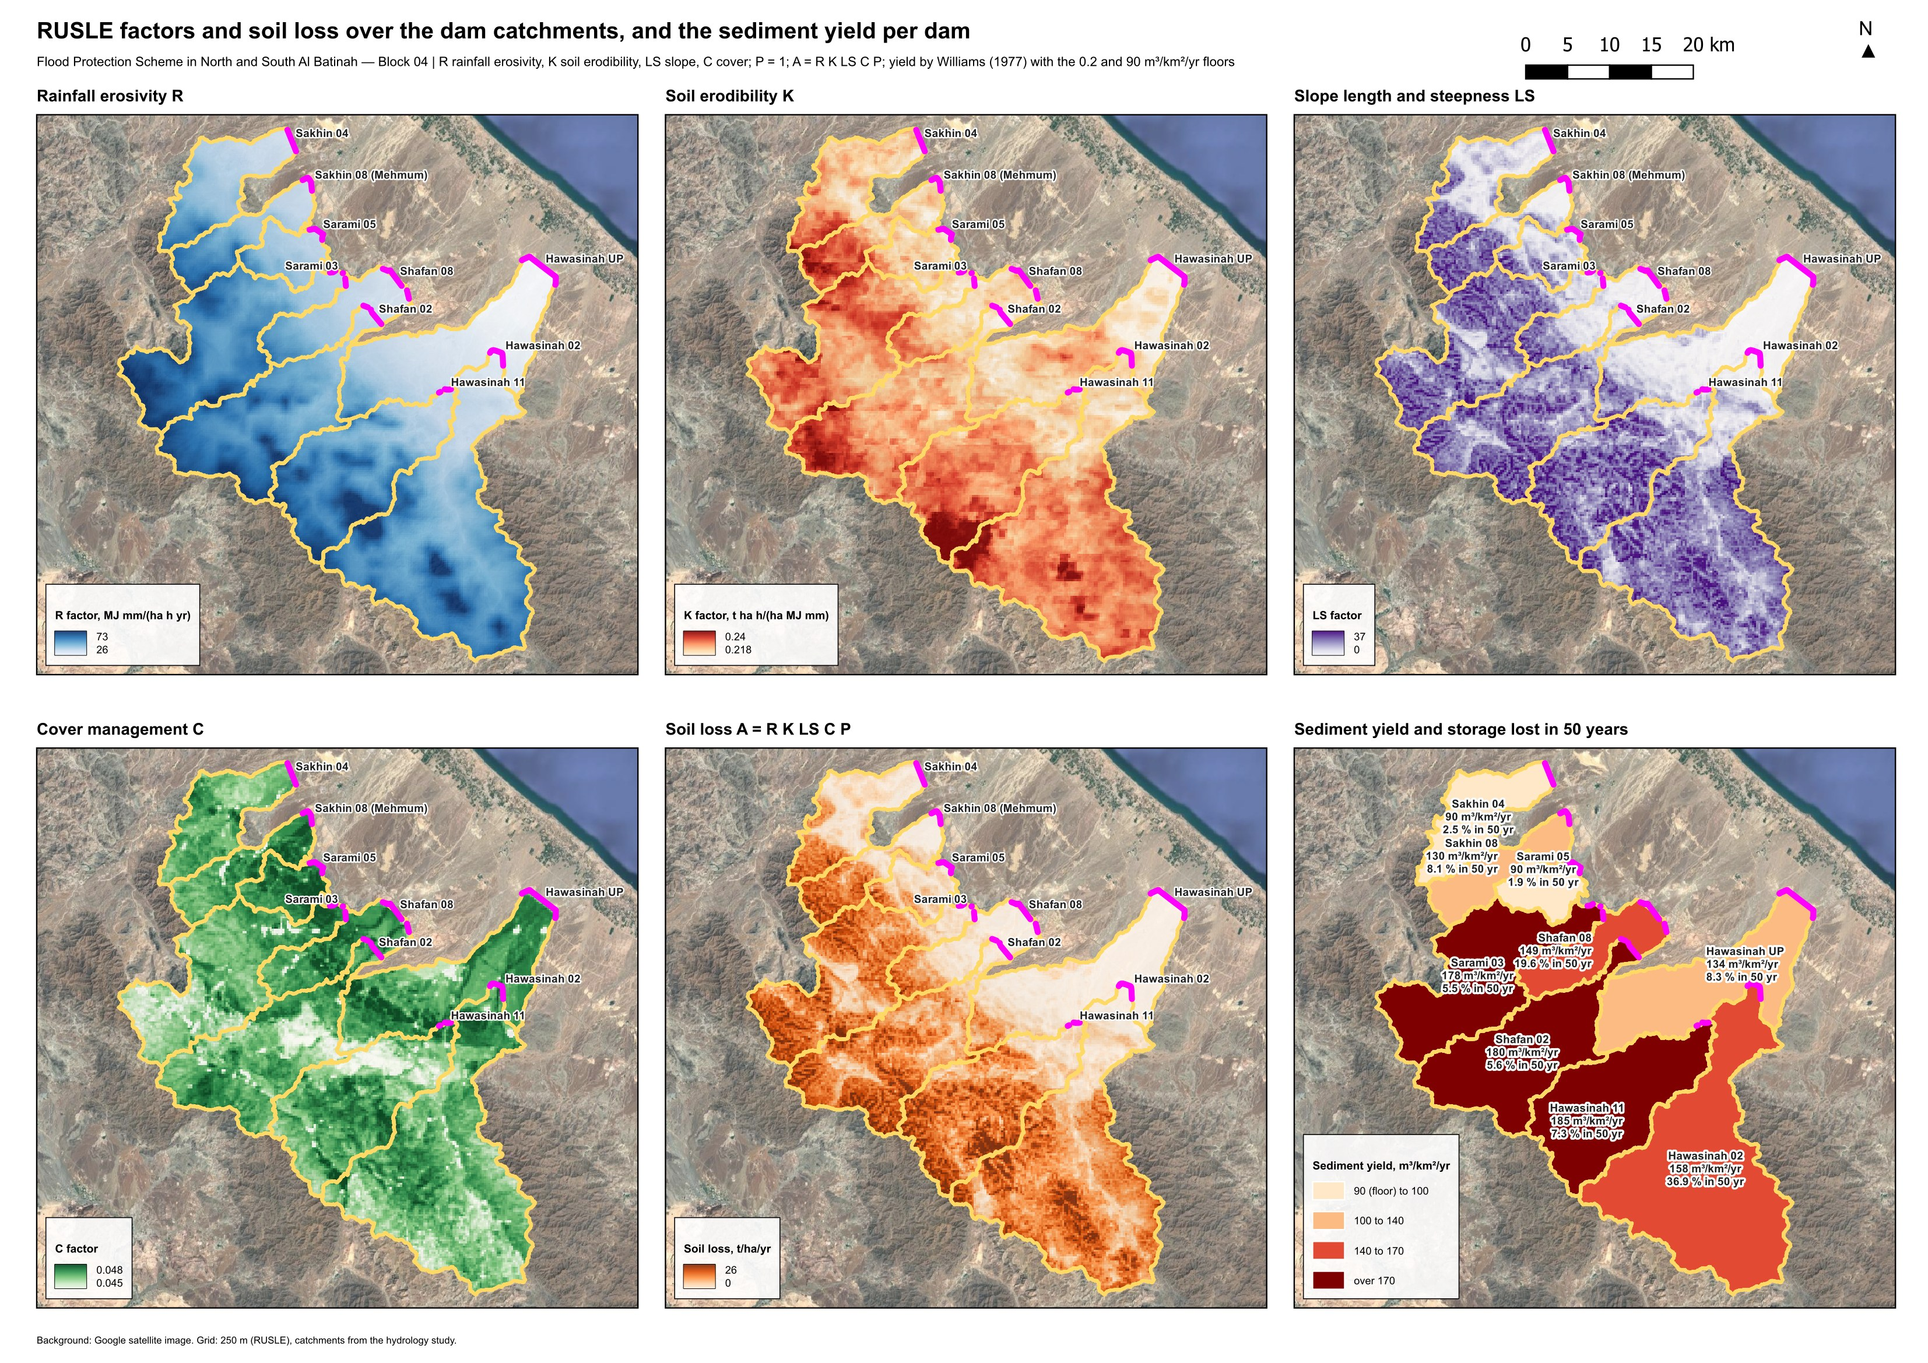
Figure 12 – RUSLE factors and soil loss over the dam catchments, and the sediment yield delivered to each dam

Sediment delivery and yield
Only part of the eroded soil reaches the dam; the rest settles on the way. The sediment delivery ratio follows Williams (1977) from the catchment area, its relief ratio and its curve number; the relief ratio is the relief of the catchment divided by the longest flow path to the dam:
$SDR = 1.366 × {10}^{-11} A^{-0.1} {RR}^{0.363} {CN}^{5.444}$ (7)
SDR: sediment delivery ratio, –
A: catchment area, km²
RR: relief ratio, relief / longest flow path, –
CN: area-weighted curve number, –
The equation gives delivery ratios of 0.07 to 0.13 for the catchments of Block 04; a floor of 0.2 is adopted for the design, together with a minimum sediment yield of 90 m³/km²/yr, so that the storage lost to sedimentation is not underestimated for the smaller and gentler catchments. Table 14 gives the resulting sediment yield and the sediment delivered to each dam in 50 and 100 years.
Table 14 – Sediment delivery and yield of the dam catchments
Dam | Area (km²) | Basin relief ratio | CN | SDR method | SDR value | SDR used (min 0.2) | Sediment density (t/m³) | Mean soil loss (m³/km²/yr) with SDR | Yield used (m³/km²/yr, min 90) | Sediment in 50 yr (Mcm) | Sediment in 100 yr (Mcm) | Tc (min)
Hawasinah 02 | 420 | 0.0254 | 90.2 | Williams (1977) | 0.087 | 0.20 | 1.5 | 158 | 158 | 3.31 | 6.62 | 566
Hawasinah 11 | 226 | 0.0349 | 90.5 | Williams (1977) | 0.105 | 0.20 | 1.5 | 185 | 185 | 2.09 | 4.18 | 346
Hawasinah UP | 852 | 0.0222 | 89.4 | Williams (1977) | 0.073 | 0.20 | 1.5 | 134 | 134 | 5.73 | 11.46 | 672
Shafan 02 | 224 | 0.0259 | 90.2 | Williams (1977) | 0.093 | 0.20 | 1.5 | 180 | 180 | 2.02 | 4.03 | 406
Shafan 08 | 314 | 0.0241 | 89.4 | Williams (1977) | 0.084 | 0.20 | 1.5 | 149 | 149 | 2.34 | 4.69 | 451
Sarami 03 | 228 | 0.0230 | 90.1 | Williams (1977) | 0.088 | 0.20 | 1.5 | 178 | 178 | 2.02 | 4.04 | 465
Sarami 05 | 54 | 0.0609 | 87.7 | Williams (1977) | 0.126 | 0.20 | 1.5 | 85 | 90 | 0.24 | 0.48 | 124
Sakhin 04 | 110 | 0.0357 | 87.7 | Williams (1977) | 0.096 | 0.20 | 1.5 | 84 | 90 | 0.50 | 0.99 | 252
Sakhin 08 (Mehmum) | 81 | 0.0311 | 88.8 | Williams (1977) | 0.101 | 0.20 | 1.5 | 130 | 130 | 0.53 | 1.05 | 260
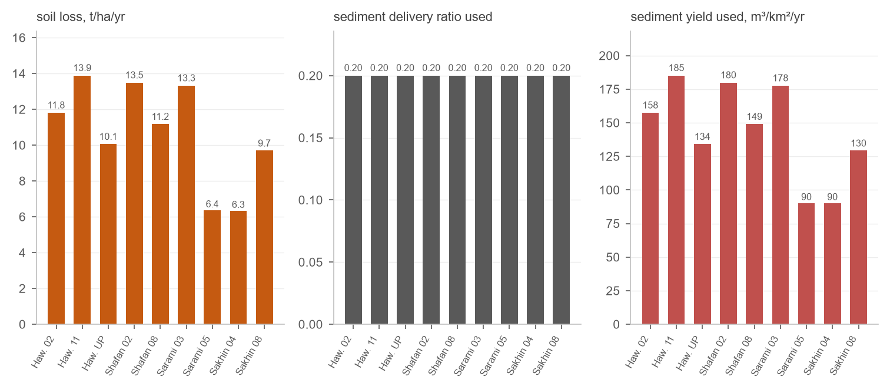
Figure 13 – From soil loss to sediment yield: the catchment mean soil loss, the delivery ratio used and the yield delivered to each dam

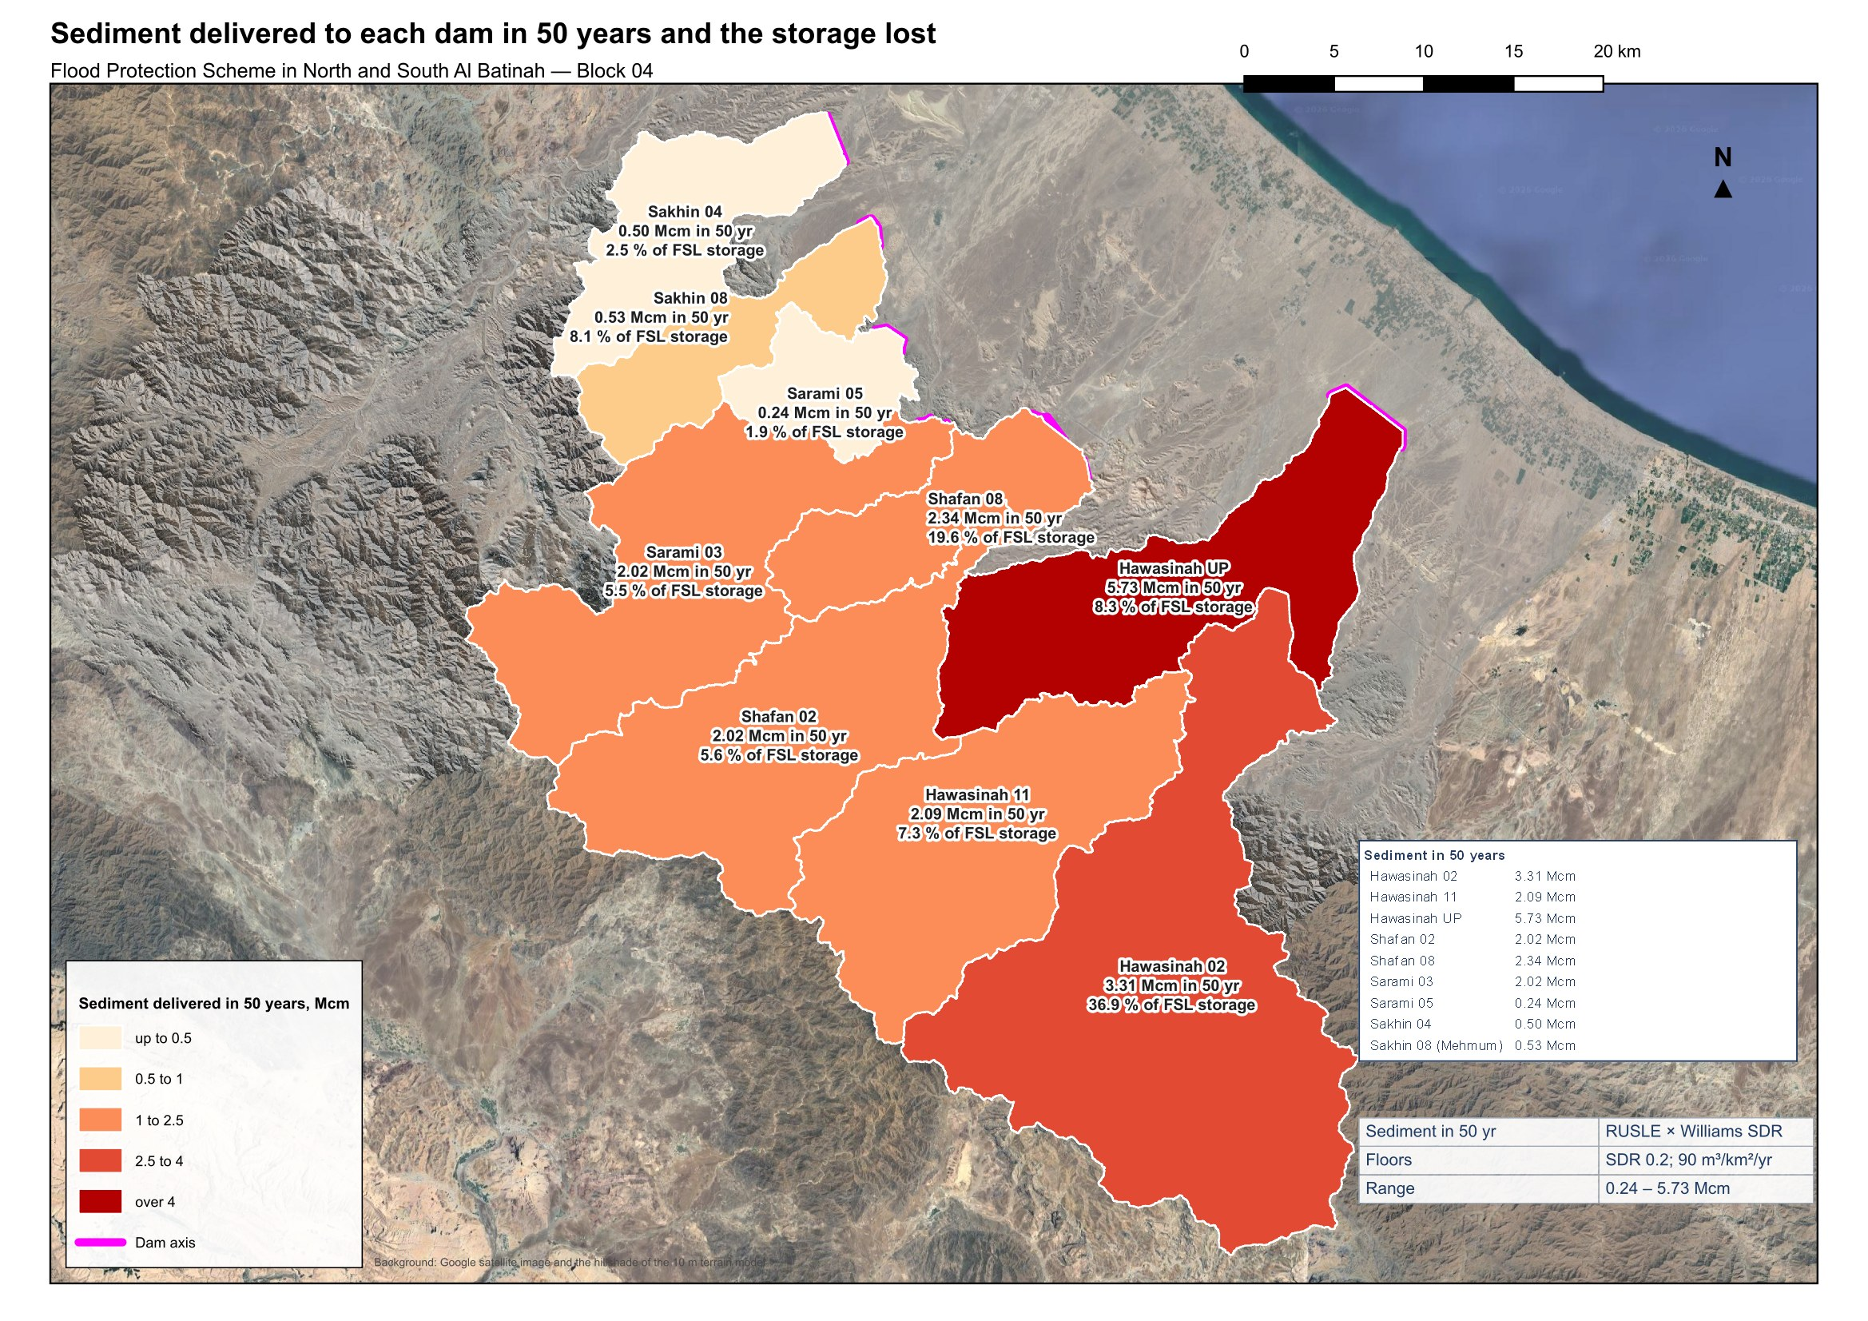
Figure 14 – Sediment delivered to each dam in 50 years (Mcm) and the storage lost at full supply level

Reservoir volume reduction
The storage each reservoir loses to the deposited sediment, and its elevation-area-volume curve after 50 and 100 years, follow Chapter 2, Section 2.6 of the USBR Erosion and Sedimentation Manual. The three components are the reservoir sediment trap efficiency (§2.6.1), the density of the deposited sediment (§2.6.2) and the distribution of the sediment within the reservoir by the Empirical Area-Reduction Method (§2.6.3).

Reservoir sediment trap efficiency
The trap efficiency is the fraction of the inflowing sediment retained in the reservoir. For large storage reservoirs the manual recommends Brune's median curve, in which the efficiency is a function of the ratio of the reservoir capacity to the mean annual inflow. The reservoirs of Block 04 are large relative to their sediment supply and a trap efficiency of 100 % is adopted, a conservative assumption for the storage loss. The volume of sediment retained over the design horizon is:
$S = q_{s} A_{c} T η$ (8)
S: sediment volume retained, m³
q_{s}: specific sediment yield of Table 14, m³/km²/yr
A_{c}: catchment area, km²
T: design horizon, 50 and 100 years, years
η: trap efficiency, 1.0, –

Density of deposited sediment
The deposited dry unit weight characterises the deposit and converts the sediment mass to the volume it occupies in the reservoir. The initial unit weight is given by Lara and Pemberton from the clay, silt and sand fractions of the incoming sediment and the reservoir operation; the reservoirs of Block 04 are flood-protection reservoirs that stand empty between floods (operation 3, reservoir normally empty), for which the deposit does not compact with time and the unit weight after T years equals the initial one:
$W_{1} = W_{c} p_{c} + W_{m} p_{m} + W_{s} p_{s}$ (9)
$W_{T} = W_{1} + 0.4343 K \left(\frac{T}{T - 1} \ln{T} - 1\right)$ (10)
W₁: initial dry unit weight, kg/m³
W_{c}, W_{m}, W_{s}: clay, silt and sand coefficients for operation 3: 641, 1 150, 1 550, kg/m³
p_{c}, p_{m}, p_{s}: clay, silt and sand fractions of the incoming sediment, –
W_{T}: average unit weight after T years, kg/m³
K: compaction constant, 0 for operation 3, –
The sediment yield of Table 14 is expressed as a volume at 1.5 t/m³; the deposited volume is rescaled to the deposited unit weight, V_dep = V_trap × 1 500 / W_T. The catchment topsoil texture is taken from the ISRIC SoilGrids clay, silt and sand contents averaged over each catchment.

Sediment distribution: Empirical Area-Reduction Method
The deposited sediment is distributed by depth with the Empirical Area-Reduction Method. The reservoir is assigned one of four standard types from the shape factor m, the slope of the logarithm of capacity against the logarithm of depth of the original curve, and each type has a relative sediment-area design curve:
$a\left(p\right) = C p^{A} {\left(1 - p\right)}^{B}$ (11)
a(p): relative sediment area, –
p: relative depth from the reservoir bed (0) to full supply level (1), –
C, A, B: type coefficients: type II 2.487, 0.57, 0.41; type III 16.967, 1.15, 2.32, –
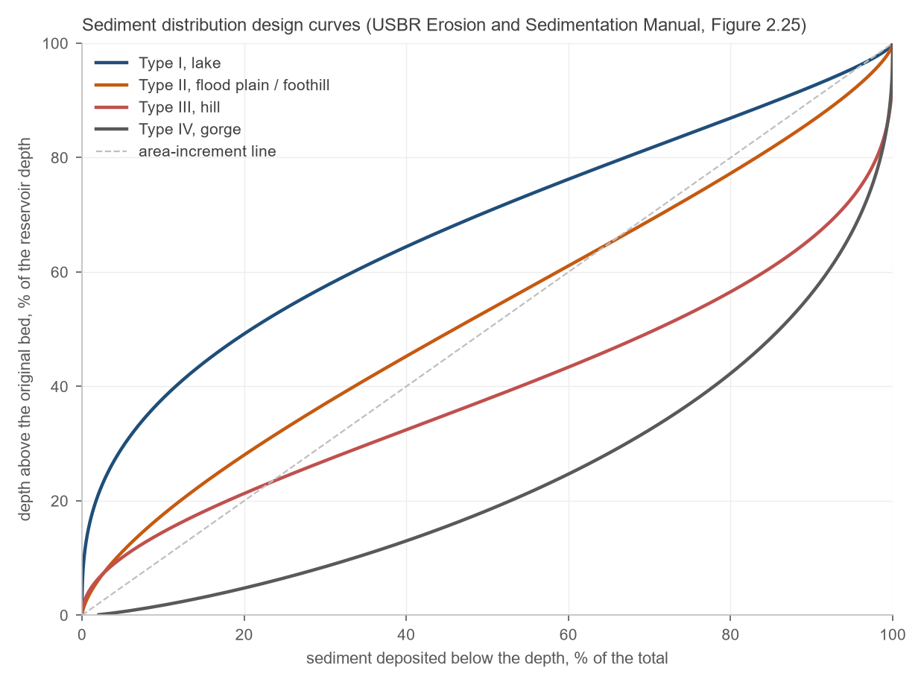
Figure 15 – Sediment distribution design curves (reproduction of USBR Figure 2.25): percentage of the reservoir depth against the percentage of the sediment deposited, for types I to IV and the area-increment line
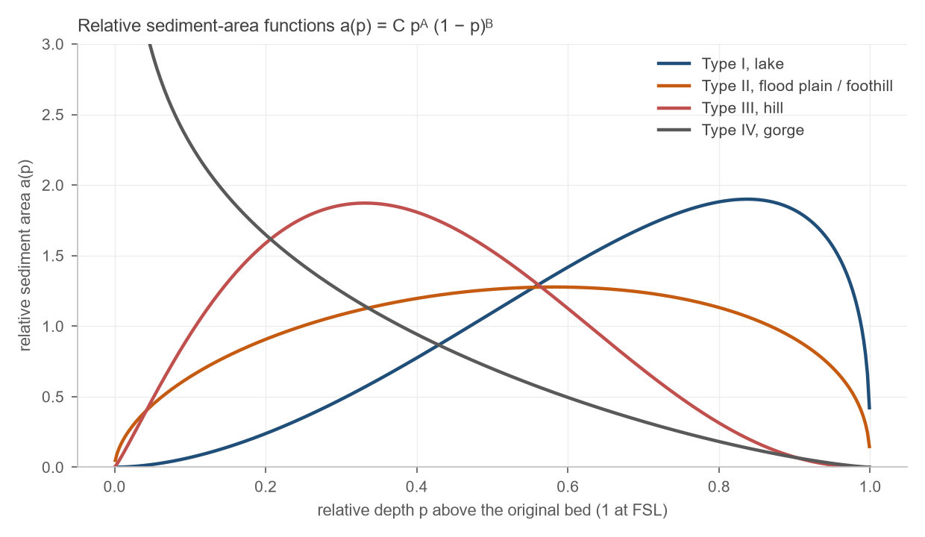
Figure 16 – Relative sediment-area functions a(p) = C·pᴬ·(1−p)ᴮ for reservoir types I to IV
The new zero-capacity elevation at the dam is the relative depth p₀ at which the reservoir function f(p) = (S − V_h) / (H A_h) equals the type curve F(p) = ∫ a dp / a(p), where V_h and A_h are the original capacity and area at the elevation of relative depth p and H the original reservoir depth. Below p₀ the reservoir is filled completely; above it the sediment area is a(p) scaled to the sediment volume, and the revised area and capacity follow by subtracting the sediment area and volume from the original curves.

Input data and results
Table 15 – Sediment-supply and soil-texture inputs
Dam | Catchment (km²) | Sediment yield (m³/km²/yr) | Clay (%) | Silt (%) | Sand (%) | Deposited unit weight (kg/m³) | Shape factor m | Reservoir type
Hawasinah 02 | 420 | 158 | 17 | 27 | 56 | 1,291 | 3.42 | II
Hawasinah 11 | 226 | 185 | 17 | 27 | 56 | 1,290 | 2.48 | III
Hawasinah UP | 852 | 134 | 16 | 27 | 57 | 1,301 | 3.14 | II
Shafan 02 | 224 | 180 | 16 | 27 | 57 | 1,294 | 2.70 | II
Shafan 08 | 314 | 149 | 15 | 27 | 58 | 1,304 | 2.87 | II
Sarami 03 | 228 | 178 | 16 | 27 | 57 | 1,295 | 2.47 | III
Sarami 05 | 54 | 90 | 12 | 27 | 60 | 1,327 | 2.67 | II
Sakhin 04 | 110 | 90 | 12 | 28 | 60 | 1,324 | 2.33 | III
Sakhin 08 (Mehmum) | 81 | 130 | 14 | 28 | 58 | 1,308 | 3.03 | II
Table 16 gives the sediment deposited in 50 and 100 years, the revised capacity at full supply level, the storage lost and the rise of the bed at the dam. Seven reservoirs lose 1.9 to 8.3 % of their storage in 50 years and 3.8 to 16.7 % in 100 years. Hawasinah 02 and Shafan 08 are the exceptions: 0.08 Mm³ of sediment a year settle in the 10.4 Mm³ reservoir of Hawasinah 02, which loses 37 % of its storage in 50 years and 74 % in 100, and Shafan 08 loses 20 % and 39 %. Their designs should provide for sediment management, a dead storage allowance or periodic removal; at Hawasinah 02 the lost storage also degrades a flood-routing performance that already passes the 200-year peak almost unattenuated.
Table 16 – Reservoir volume reduction after 50 and 100 years
Dam | Capacity at FSL (Mm³) | Deposit 50 yr (Mm³) | Capacity 50 yr (Mm³) | Loss 50 yr (%) | Bed rise 50 yr (m) | Deposit 100 yr (Mm³) | Capacity 100 yr (Mm³) | Loss 100 yr (%) | Bed rise 100 yr (m)
Hawasinah 02 | 10.41 | 3.84 | 6.57 | 36.9 | 4.2 | 7.69 | 2.73 | 73.7 | 9.5
Hawasinah 11 | 33.17 | 2.43 | 30.74 | 7.3 | 2.9 | 4.87 | 28.31 | 14.7 | 8.5
Hawasinah UP | 79.22 | 6.60 | 72.61 | 8.3 | 2.0 | 13.21 | 66.01 | 16.7 | 2.3
Shafan 02 | 41.61 | 2.34 | 39.27 | 5.6 | 4.2 | 4.68 | 36.94 | 11.2 | 6.3
Shafan 08 | 13.71 | 2.69 | 11.02 | 19.6 | 4.7 | 5.39 | 8.33 | 39.2 | 7.4
Sarami 03 | 42.70 | 2.34 | 40.36 | 5.5 | 8.4 | 4.69 | 38.01 | 11.0 | 15.8
Sarami 05 | 14.52 | 0.27 | 14.25 | 1.9 | 0.6 | 0.55 | 13.98 | 3.8 | 1.2
Sakhin 04 | 22.61 | 0.56 | 22.04 | 2.5 | 0.0 | 1.13 | 21.48 | 5.0 | 0.0
Sakhin 08 (Mehmum) | 7.46 | 0.60 | 6.86 | 8.1 | 2.4 | 1.21 | 6.25 | 16.2 | 3.4
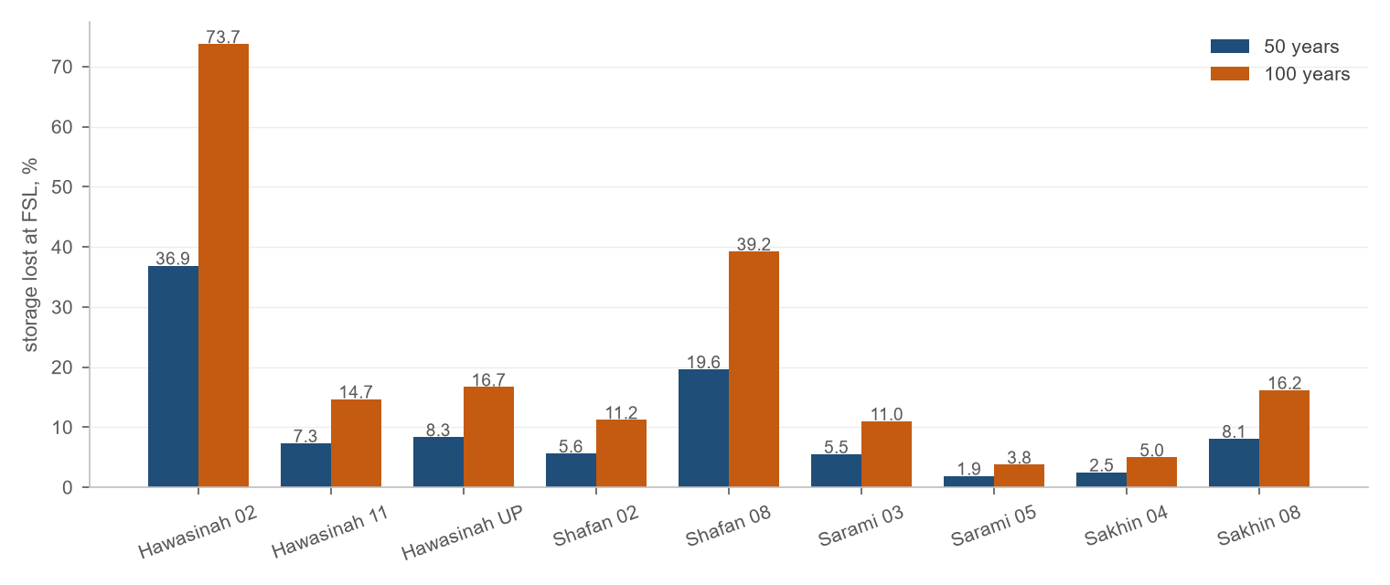
Figure 17 – Storage lost at full supply level after 50 and 100 years, per dam
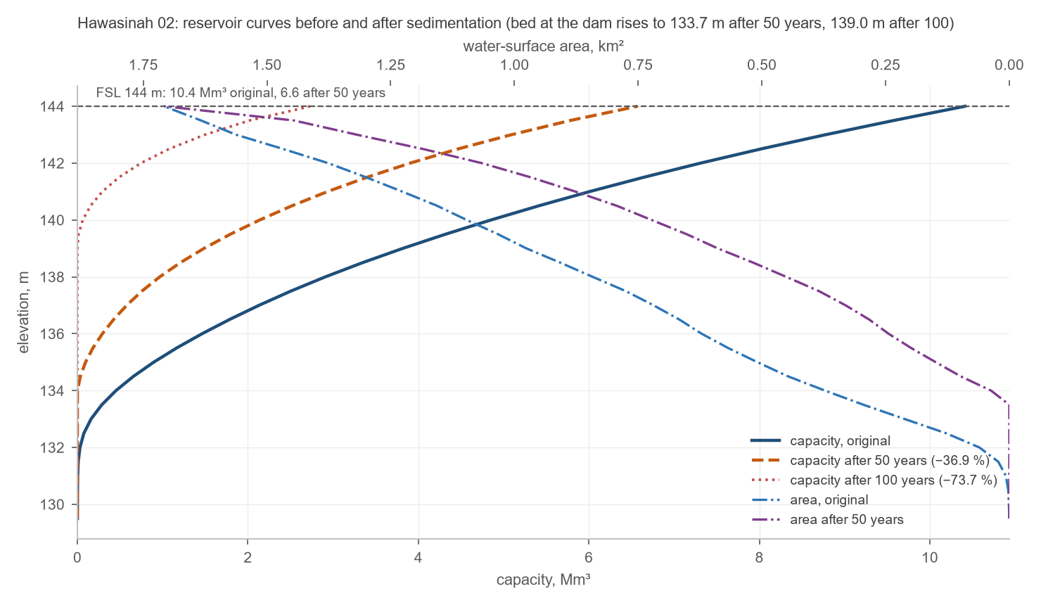
Figure 18 – Hawasinah 02: elevation-area-volume curves before and after sedimentation, capacity on the lower axis and area on the upper axis. The curves of the other dams are in Appendix B

Climate at the dam sites

Record used
The climate at each dam site is described from the ECMWF reanalysis at 9 km resolution read at the dam axis: daily temperature and rainfall for 2001 to 2023 and hourly wind at 10 m for 2015 to 2024. Neighbouring dams fall in the same grid cell and share a record: Shafan 02, Shafan 08 and Sarami 03 on one hand, Sakhin 04 and Sakhin 08 on the other. The rain gauges of the Ministry nearest to the dams, 3 to 14 km away, add the measured rainfall of recent years (Table 18).

Temperature and rainfall
The climate is hot and arid. The mean annual temperature at the dams is 28.4 to 29.1 °C; the hottest month is June or July, with mean daily maxima of 41.3 to 42.5 °C, and the coolest January, with mean daily minima of 13.7 to 14.5 °C. The mean annual rainfall is 66 to 106 mm, lowest at Hawasinah UP near the coast and highest at the dams of the foothills, with a strong variability from year to year: the driest years bring under 30 mm and the wettest over 200 mm. Most of the rain falls from November to April, with a secondary summer peak from the convective storms over the mountains.
Table 17 – Temperature and rainfall at the dam sites, 2001–2023
Dam | Mean T (°C) | Hottest month, mean daily max (°C) | Coolest month, mean daily min (°C) | Absolute max (°C) | Absolute min (°C) | Mean annual rain (mm) | Driest – wettest year (mm) | Wet days a year | Nov–Apr share (%)
Hawasinah 02 | 28.6 | Jun 41.3 | Jan 14.2 | 49.3 | 7.0 | 91 | 29 – 257 | 16 | 68
Hawasinah 11 | 29.1 | Jun 42.5 | Jan 14.0 | 48.8 | 6.3 | 92 | 29 – 274 | 16 | 68
Hawasinah UP | 28.7 | Jun 41.3 | Jan 14.5 | 49.3 | 7.5 | 66 | 8 – 250 | 10 | 69
Shafan 02 | 28.9 | Jun 42.2 | Jan 14.1 | 49.2 | 6.7 | 104 | 30 – 241 | 17 | 73
Shafan 08 | 28.6 | Jun 41.6 | Jan 14.0 | 49.2 | 6.6 | 104 | 30 – 241 | 17 | 73
Sarami 03 | 29.0 | Jun 42.2 | Jan 14.2 | 49.2 | 6.8 | 104 | 30 – 241 | 17 | 73
Sarami 05 | 28.4 | Jun 41.7 | Jan 13.7 | 49.3 | 7.1 | 106 | 30 – 221 | 18 | 74
Sakhin 04 | 28.6 | Jun 41.8 | Jan 13.8 | 49.3 | 7.2 | 106 | 30 – 207 | 18 | 75
Sakhin 08 (Mehmum) | 28.5 | Jun 41.7 | Jan 13.9 | 49.2 | 7.3 | 106 | 30 – 207 | 18 | 75
Figure 19 shows the monthly air temperature and rainfall of Block 04 and Figure 20 its annual rainfall, both as the average of the nine dam sites; the sites differ from that average by at most 6 mm in any month, and their own annual means are given in Table 17.
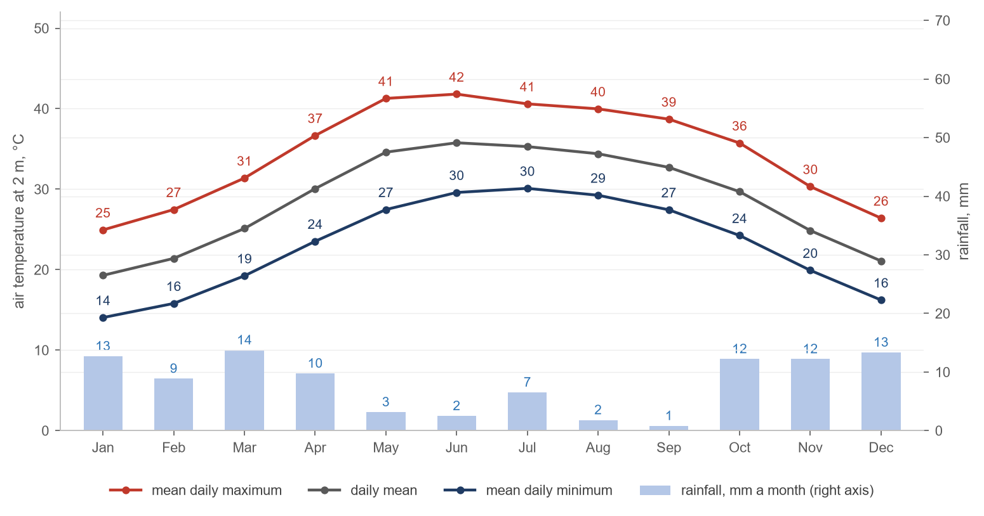
Figure 19 – Monthly air temperature and rainfall of Block 04, 2001–2023, averaged over the nine dam sites
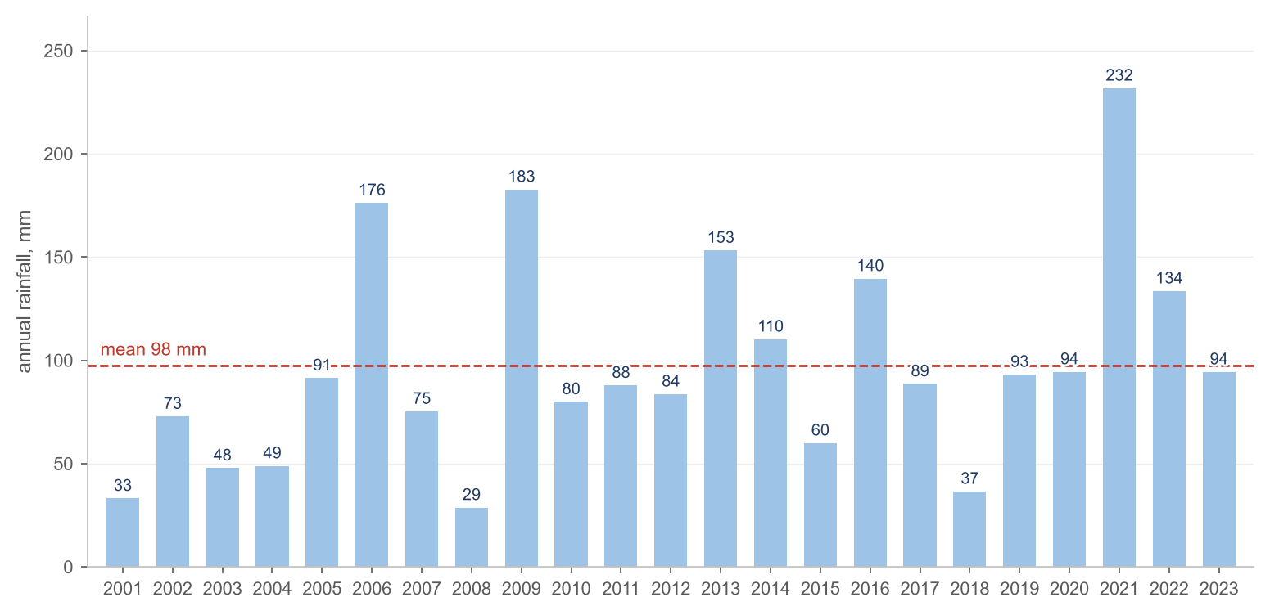
Figure 20 – Annual rainfall of Block 04, 2001–2023, averaged over the nine dam sites, and its mean
The rain gauges of the Ministry nearest to each dam are listed in Table 18 with their recent records. The telemetry gauges of the plain and the foothills recorded 135 to 263 mm a year over four to seven complete years, with the extreme year 2017 above 400 mm at some of them. The records are short and are shown beside the reanalysis, which covers 23 years, not instead of it.
Table 18 – Rain gauges nearest to the dams and their records
Dam | Nearest gauge with a record | Distance (km) | Complete years | Period | Mean annual rainfall (mm)
Hawasinah 02 | Y3 | 3.2 | 7 | 2015–2021 | 135
Hawasinah 11 | Y3 | 5.6 | 7 | 2015–2021 | 135
Hawasinah UP | Y3 | 14.2 | 7 | 2015–2021 | 135
Shafan 02 | Z71 | 7.8 | 5 | 2016–2020 | 141
Shafan 08 | Z71 | 11.7 | 5 | 2016–2020 | 141
Sarami 03 | Z71 | 5.6 | 5 | 2016–2020 | 141
Sarami 05 | Z71 | 9.8 | 5 | 2016–2020 | 141
Sakhin 04 | Z64 | 11.6 | 4 | 2016–2020 | 263
Sakhin 08 (Mehmum) | Z64 | 10.5 | 4 | 2016–2020 | 263

Wind
The wind at 10 m averages 2.8 to 3.0 m/s at the dam sites and is calm, below 1 m/s, for 8 to 11 % of the hours. At the dams of the foothills the land breeze from the south-west and west, flowing down the wadis at night, takes the largest share of the hours, and the north-easterly sea breeze the afternoons; at Hawasinah UP and Sarami 05, nearer the coast, the sea breeze from the north-east to east-north-east prevails. Speeds above 8 m/s are rare. The wind rose of each dam is given in Table 19.
Table 19 – Wind roses at the dam sites, all hours 2015–2024: the direction the wind blows from and the share of hours in each speed class
Hawasinah 02 | Hawasinah 11 | Hawasinah UP
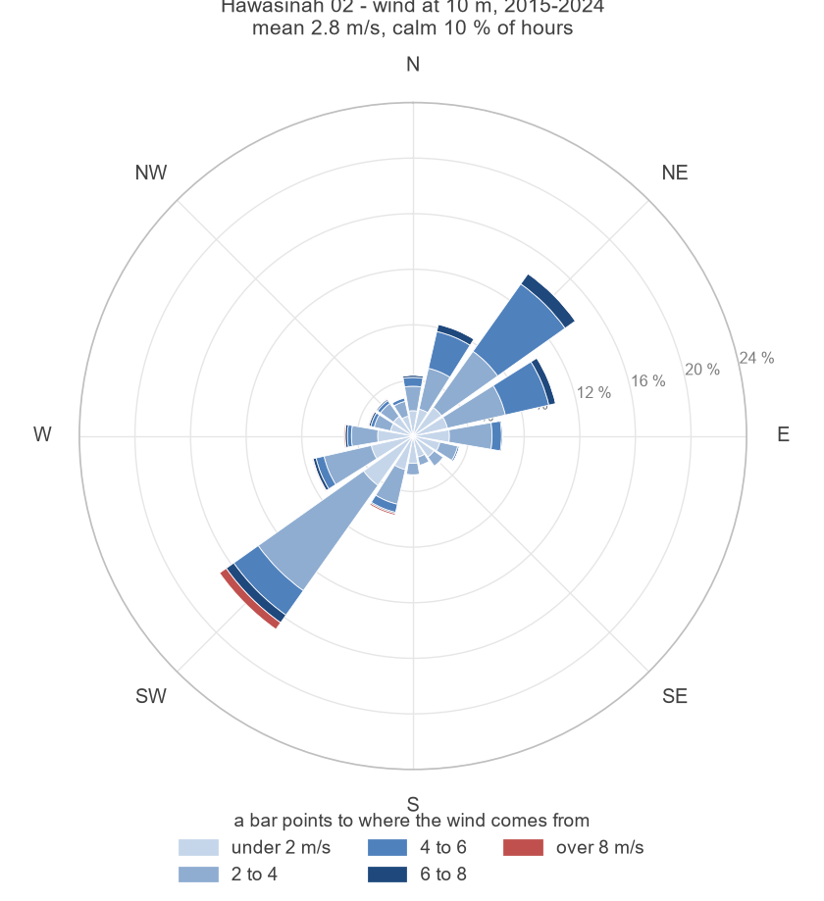 | 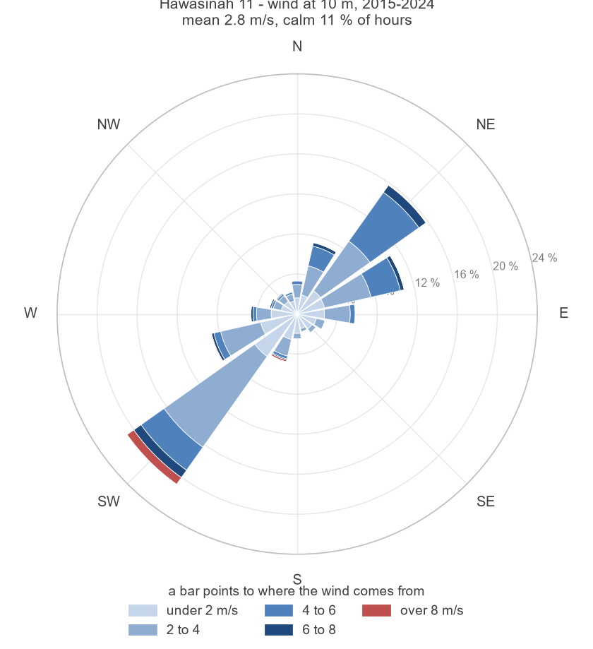 | 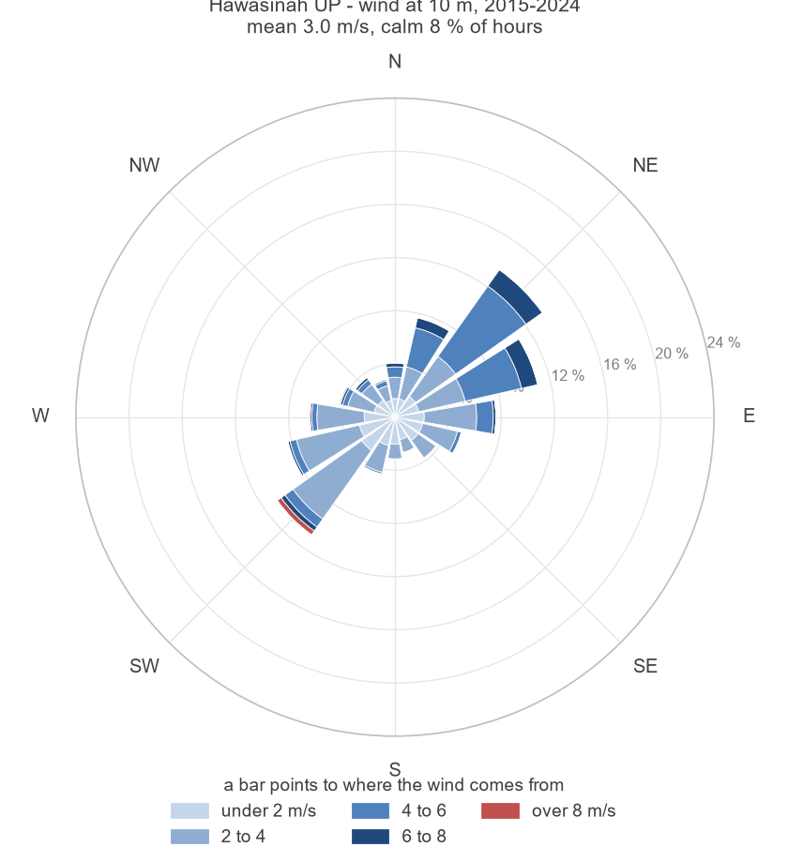
Shafan 02 | Shafan 08 | Sarami 03
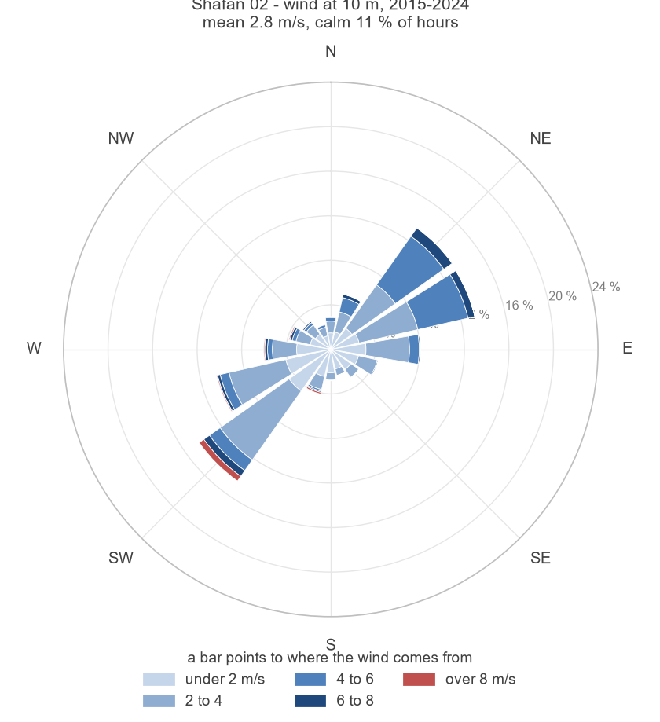 | 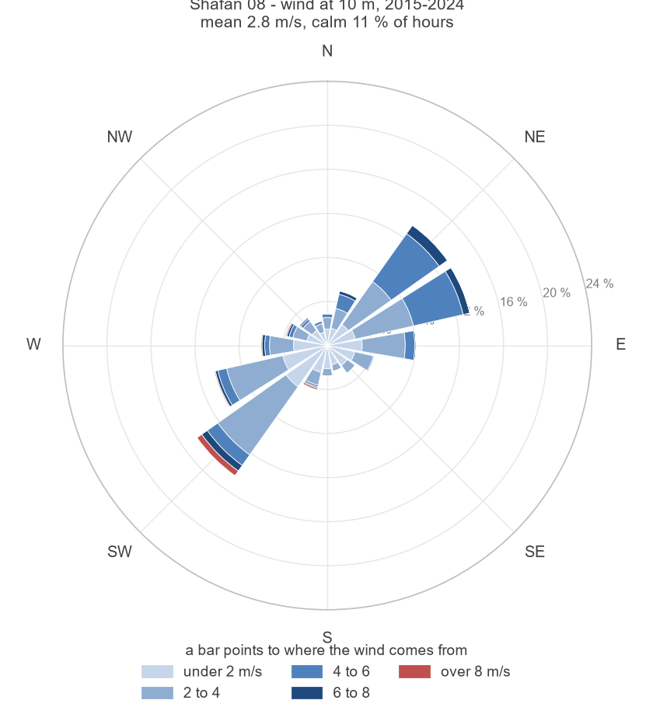 | 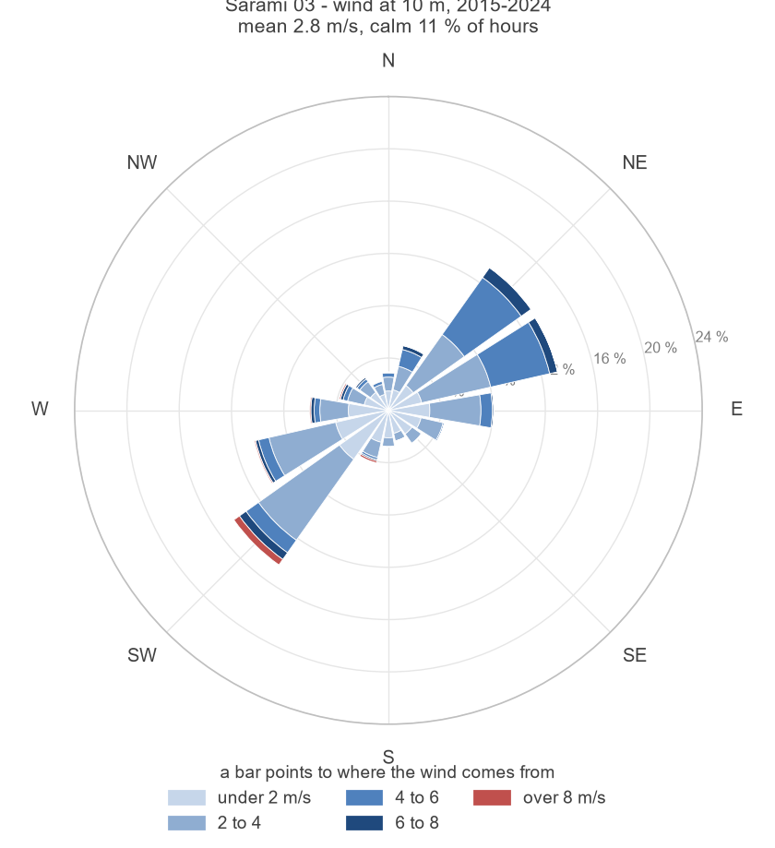
Sarami 05 | Sakhin 04 | Sakhin 08 (Mehmum)
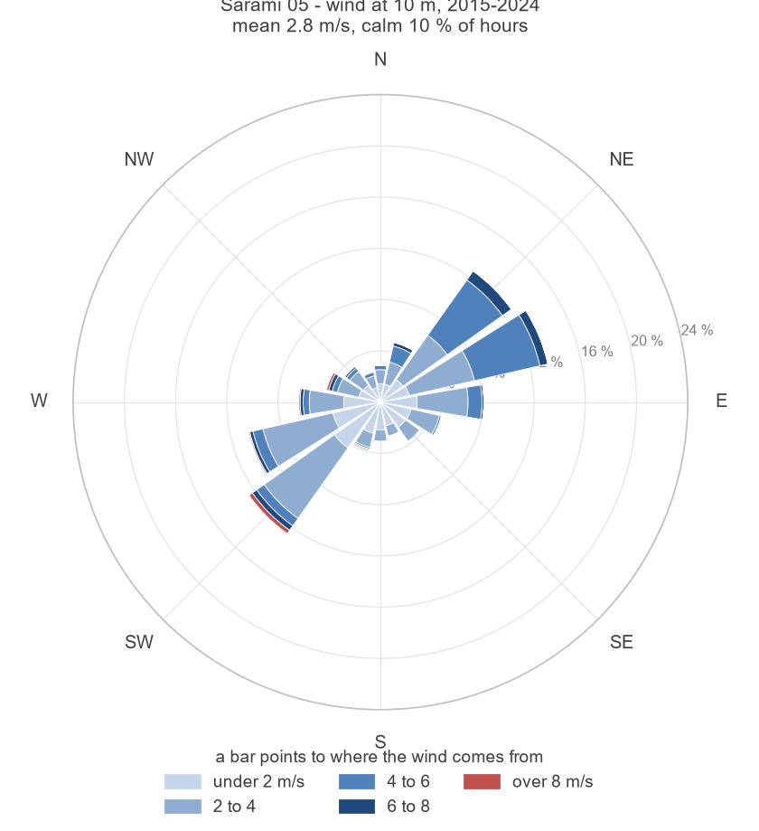 | 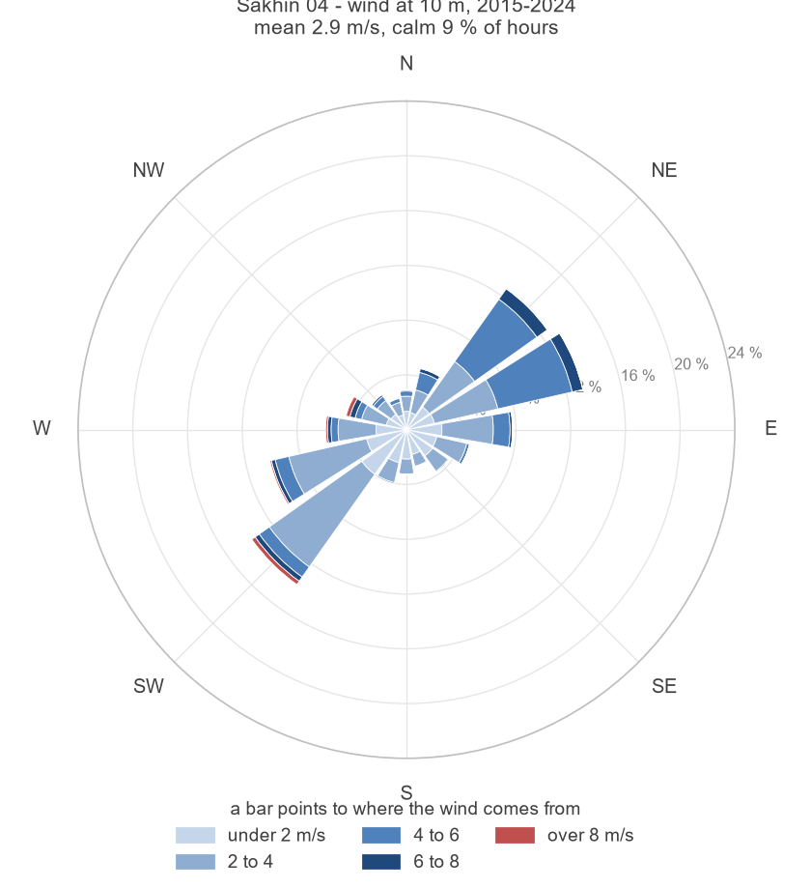 | 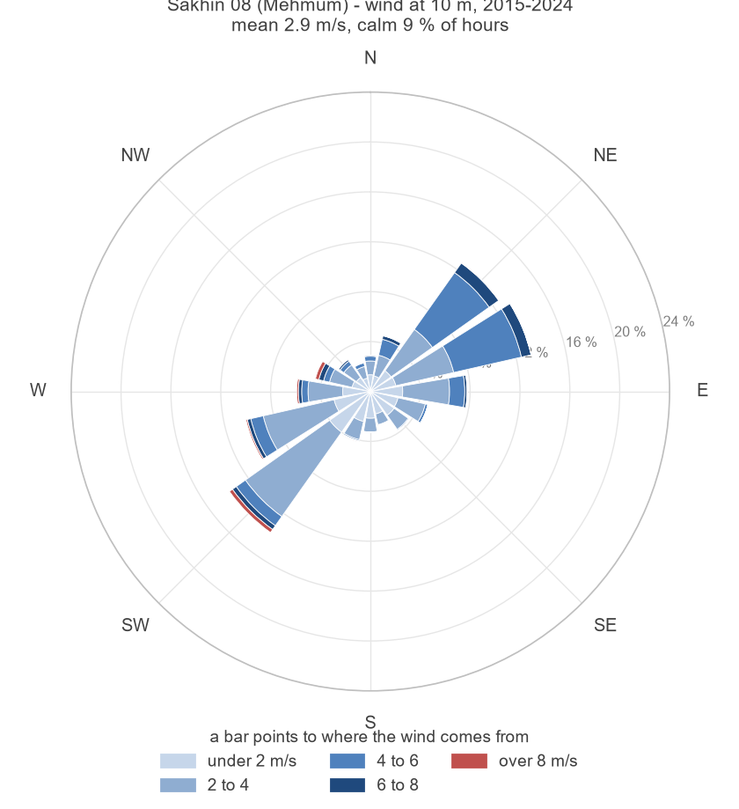

Climate change
The records themselves show a warming of 0.23 to 0.94 °C per decade over 2001 to 2023. The Sixth Assessment Report of the IPCC places the Arabian Peninsula among the regions warming faster than the global mean, with more frequent and longer hot spells, and projects for the Gulf of Oman coast a mean annual rainfall that stays low and uncertain in sign while the intensity of the heaviest daily rainfall increases with the warming of the sea and the air. The tropical cyclones of the Arabian Sea, Gonu in 2007 and Shaheen in 2021, have already brought daily totals to the Batinah coast beyond anything in the earlier gauged record.
For the dams this means three things. The design rainfall of the national study, derived from the gauged record, is the floor of the flood load and not its ceiling; the spillway capacity and the head at the probable maximum flood are the margin against a larger event. Hotter and drier years lengthen the empty periods of the reservoirs and the exposure of their beds, and more intense storms raise the sediment yield above the long-term rate, so the storage lost to sedimentation should be read as a lower bound. The operating rules of the outlets and the freeboard of the downstream channels should be reviewed against the updated rainfall statistics when the national study is revised.

Hydraulic design criteria
The hydraulic design of the channels follows one set of criteria for the channel geometry, the flow parameters, the slopes, the outfall conditions and the crossings, applied to every reach so that the system is coherent and hydraulically sound. The criteria are summarised in Table 20.
Table 20 – Channel design criteria
Item | Criterion
Channel geometry | Trapezoidal section; depth 2.5 m, or the depth of the existing wadi where it is deeper; side slopes 1:1.5 on both sides; freeboard 0.6 m
Flow formula | Manning equation, Q = (1/n) A R^(2/3) S^(1/2)
Manning's n | Earth channels 0.03; concrete culverts 0.02 (higher than the material value, for sedimentation)
Velocity and slope | Maximum velocity 3 m/s; minimum slope at the flat sea outfalls 0.0003 m/m
Outfall conditions | Bank height = max (MHHW, flow depth) + 0.6 m freeboard; the channels terminate at the coastal road crossings
Culvert design | Barrel height = channel height; full channel width covered; slope 0.5 to 5 %; n = 0.02
Cut and fill | Cut preferred, so that the surrounding runoff drains into the channel; fill only where a constraint forces the bed above ground, with embankments on both sides and a return to cut within 500 m
Geometric constraints | OQ pipelines; existing culverts and bridges at the Expressway, the Batinah Highway and the coastal road; outfalls
Table 21 – Mean tidal levels in North and South Al Batinah (m), Oman Maritime Book 2024
Reference port | Mean | MHHW | MLHW | MHLW | MLLW
Al Khaburah | 1.80 | 0.70 | 0.62 | -0.23 | -1.00
Saham | 1.82 | 0.68 | 0.61 | -0.25 | -1.02
Port of Suhar (Majis) | 1.20 | 1.40 | 1.30 | 0.50 | -0.30
The channels are trapezoidal in cut and in fill, with side slopes of 1:1.5 on the inner and the outer face. Cut is preferred, because the surrounding surface runoff then drains into the channel; where a constraint forces the bed above the ground, the channel runs in fill between two embankments and returns to cut within 500 m.

Main issues in channel design
A number of constraints and site-specific challenges affect both the hydraulic performance of the channels and the practicality of their construction. They fall in four groups: road and culvert crossings, energy corridors and utilities, wadi path and land-use conflicts, and sand mining and environmental risks.
Table 22 – Challenges in the design of the channels
Group | Issues
Culverts and road crossings | Existing culvert and bridge sizes insufficient for the channelised flow; drainage crossings that have altered the wadi paths downstream; floodways recommended for the internal roads
Energy corridors and utilities | Conflicts with the OQ pipelines, which are shallow; the exact position and depth of every utility are required for the detailed design
Wadi path and land-use conflicts | Wadi ownership by the Ministry is critical for enforcement; wadis blocked by constructions; depressed areas where the wadis flatten into wide plains and pond around homes and farms; wadis narrowed as farm owners extend their boundaries; the wadi bed to be reserved against developments within the 200-year flood extent
Sand mining and environmental risks | Sand extraction up to 3 m deep destabilises the channel beds; animal carcasses in the ponds after floods are a health hazard
Consequences | The system is not designed for cyclone-level protection; conveyance is constrained by undersized crossings, narrowed wadis and shallow pipelines; the upstream dams are essential to capture and reduce the flood volumes before they reach the developments

Outfalls
The thirteen outfalls of the channel network to the sea receive, in the 200-year event, between 57 and 1,404 m³/s with the dams in operation. Without the dams the three largest outfalls would carry 4,492, 2,476 and 2,428 m³/s; the reservoirs cut them to 217, 1,022 and 1,404 m³/s. The outfalls fed by the plain alone are unchanged. The 200-year volumes fall likewise, from 390.3 to 160.3 Mm³ over the thirteen outfalls.
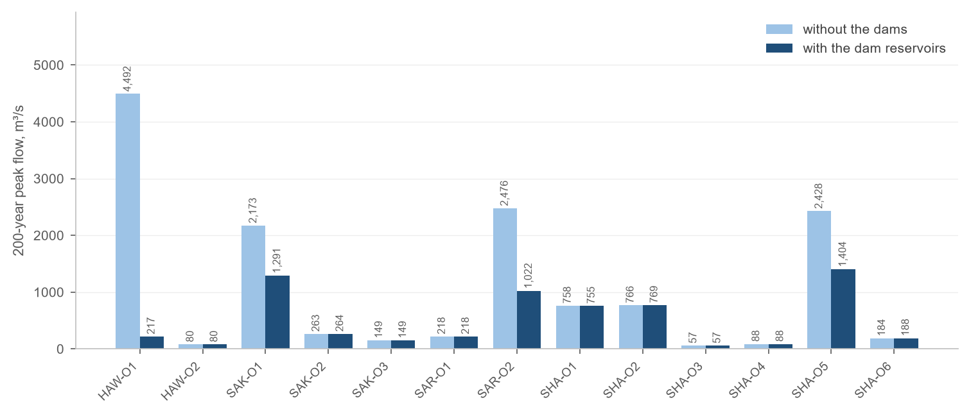
Figure 21 – 200-year peak flow at the thirteen outfalls without and with the dams
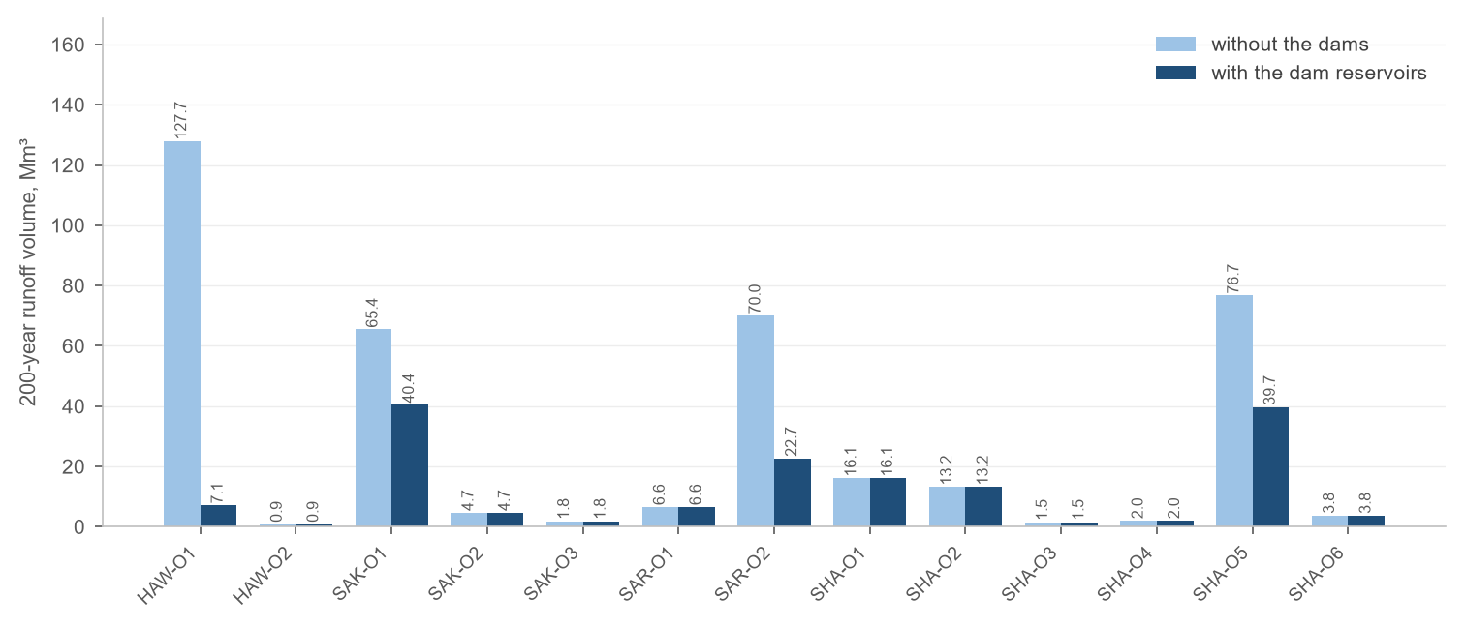
Figure 22 – 200-year runoff volume at the thirteen outfalls without and with the dams

Conclusion
The HEC-HMS model of Block 04 reproduces the catchments of the hydrology study for the nine dams and extends them to the whole plain, computed as depth-area analyses for thirteen return periods up to the probable maximum precipitation. Four of the nine reservoirs hold the whole 200-year flood and two more pass only a fraction of it; Hawasinah 02 is the exception, with 2 % attenuation. At the probable maximum flood the reservoirs rise 4.7 to 5.0 m above full supply level.
The catchments deliver 90 to 185 m³ of sediment per square kilometre and year. The reservoirs lose 1.9 to 36.9 % of their storage in 50 years; Hawasinah 02 loses 37 % and Shafan 08 20 %, and their designs should provide for sediment management, a dead storage allowance or periodic removal.
The channel alignments follow the wadis across the plain between the dams and the sea, within the constraints of the Batinah Expressway, the Batinah Highway, the coastal road, the planned bypass, the OQ pipelines and the cadastral land use. The channels are designed for the routed 200-year outflows with the criteria of Section 8.

Appendix A – Inflow hydrographs of the dams
Inflow hydrographs of the thirteen depth-area analyses at each dam, with the peak flow and the volume of every event.
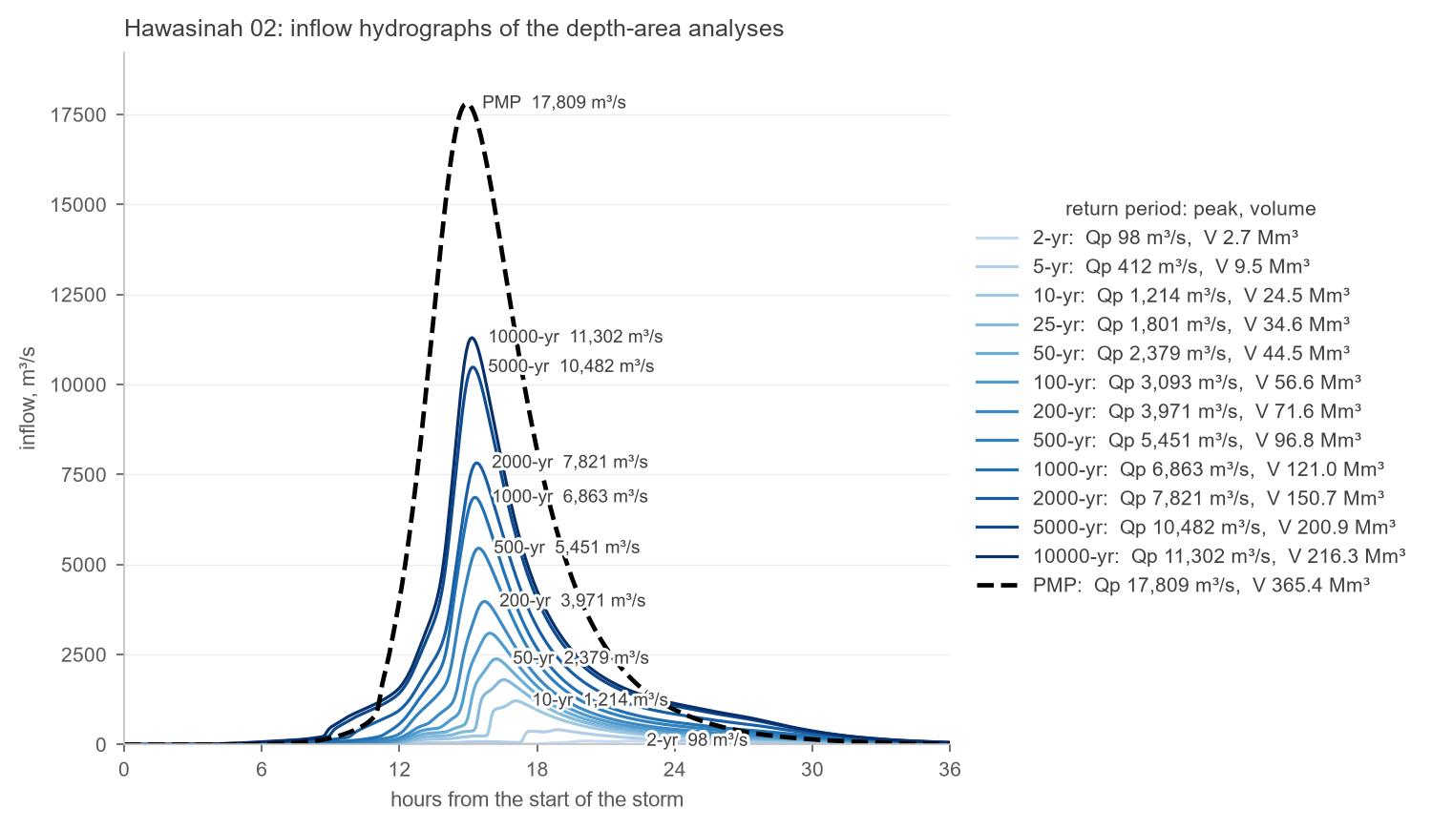
Figure 23 – Hawasinah 02: inflow hydrographs for the return periods of 2 to 10 000 years and the PMP
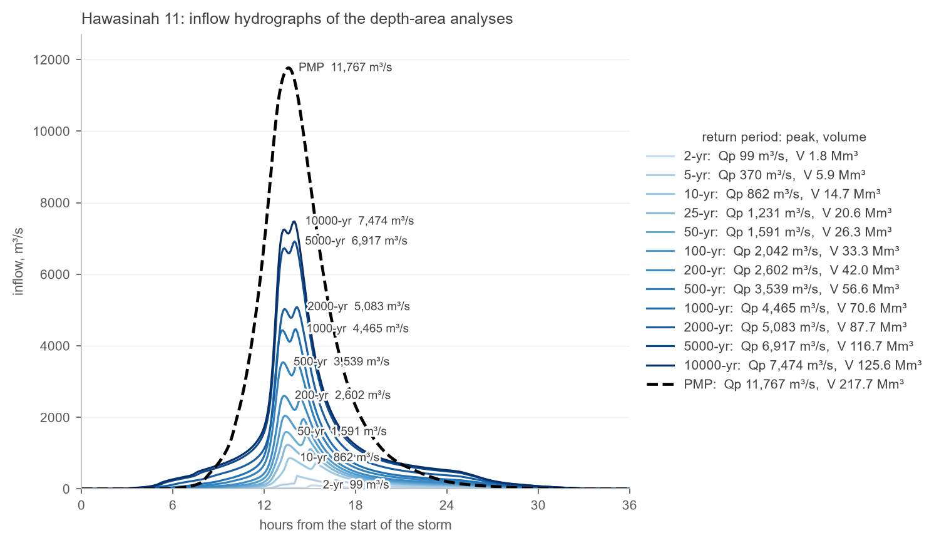
Figure 24 – Hawasinah 11: inflow hydrographs for the return periods of 2 to 10 000 years and the PMP
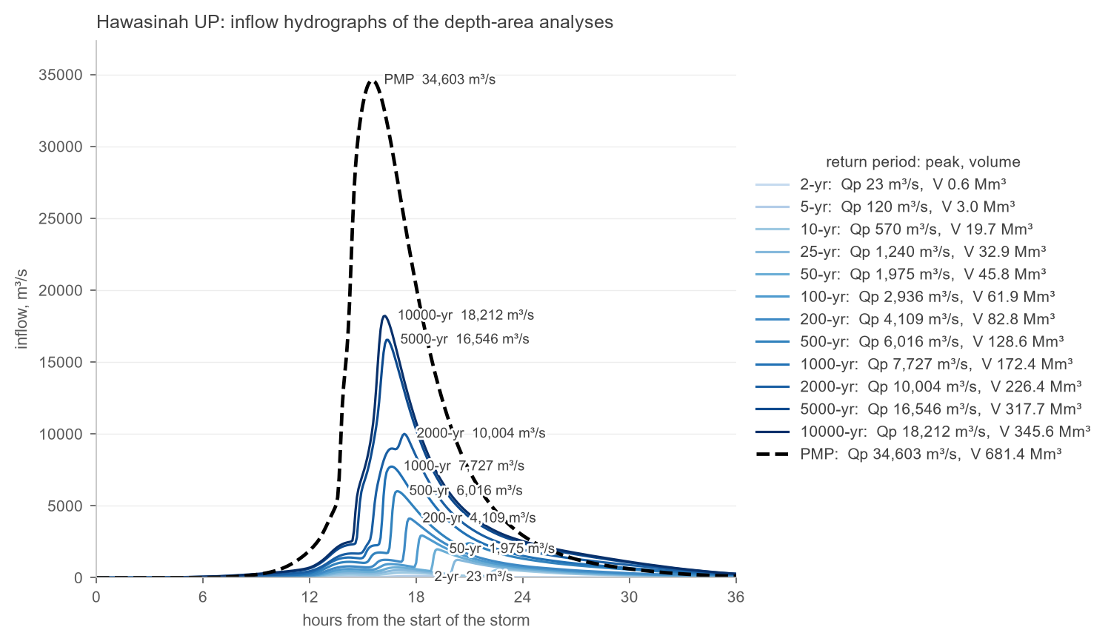
Figure 25 – Hawasinah UP: inflow hydrographs for the return periods of 2 to 10 000 years and the PMP
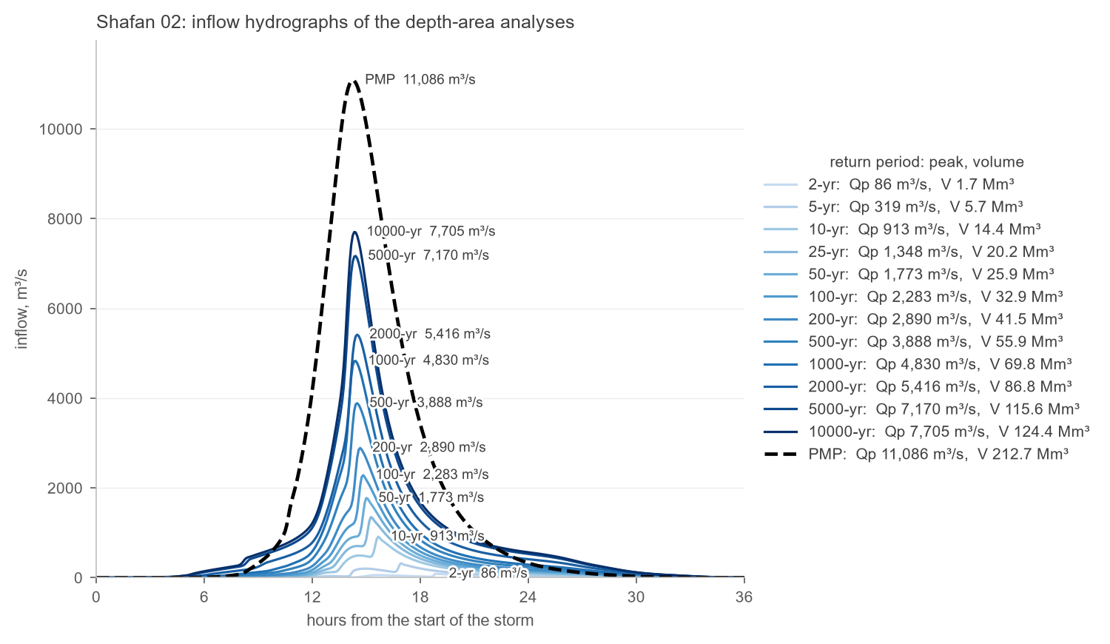
Figure 26 – Shafan 02: inflow hydrographs for the return periods of 2 to 10 000 years and the PMP
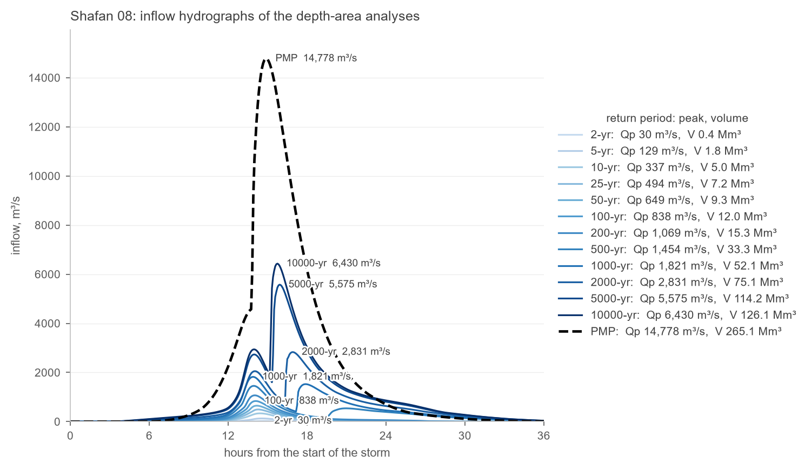
Figure 27 – Shafan 08: inflow hydrographs for the return periods of 2 to 10 000 years and the PMP
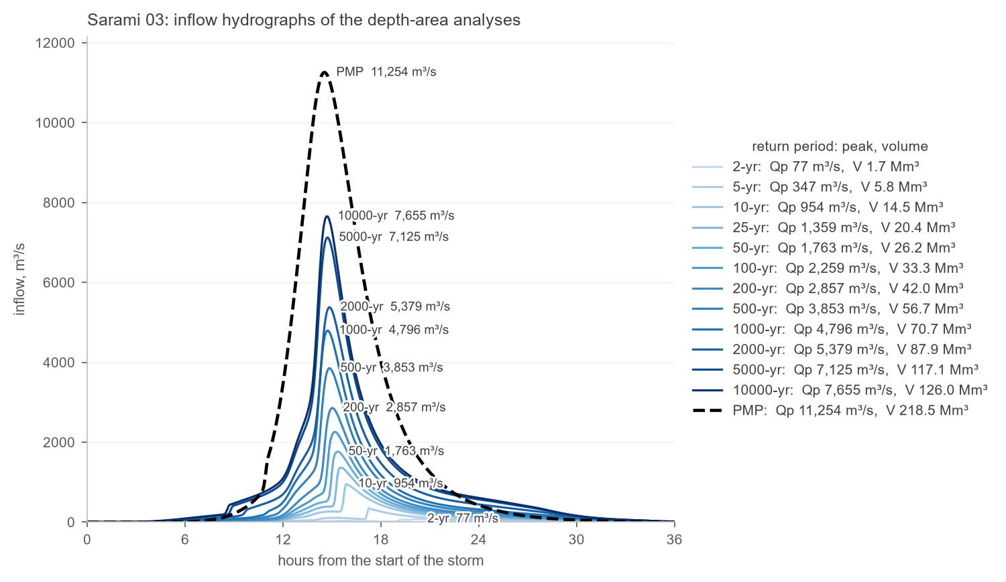
Figure 28 – Sarami 03: inflow hydrographs for the return periods of 2 to 10 000 years and the PMP
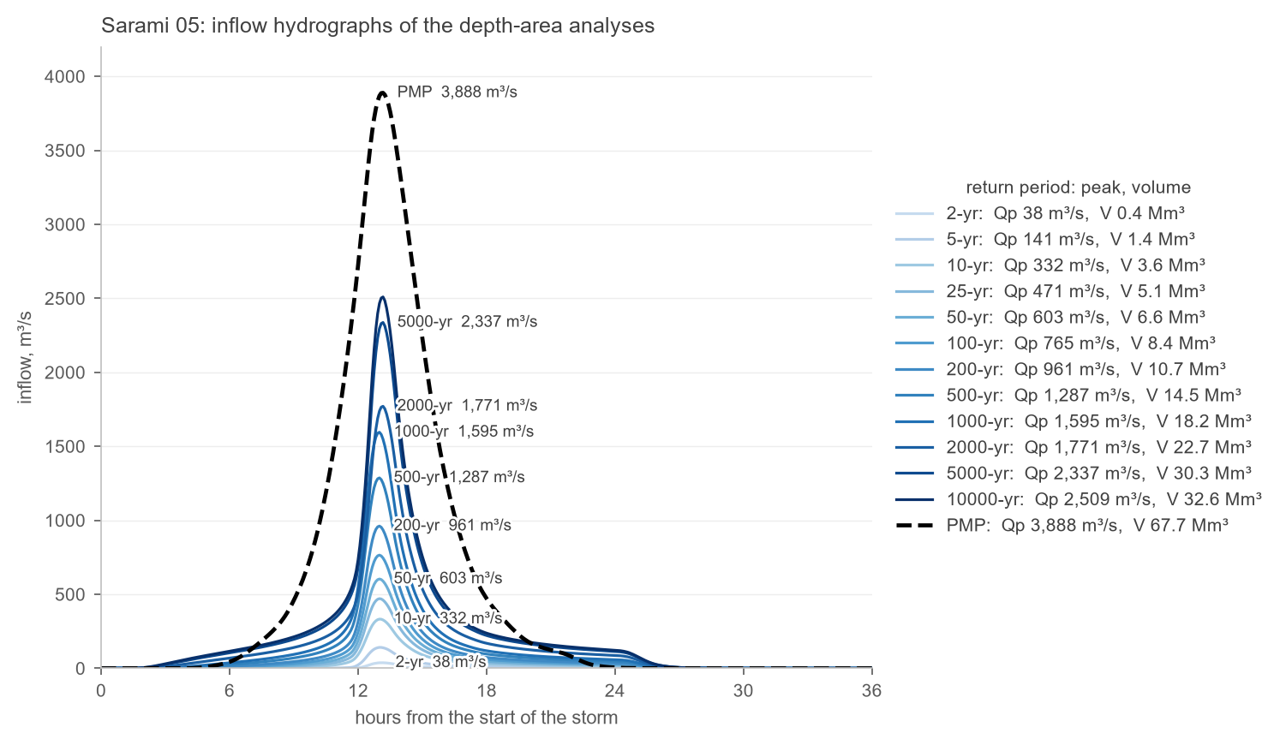
Figure 29 – Sarami 05: inflow hydrographs for the return periods of 2 to 10 000 years and the PMP
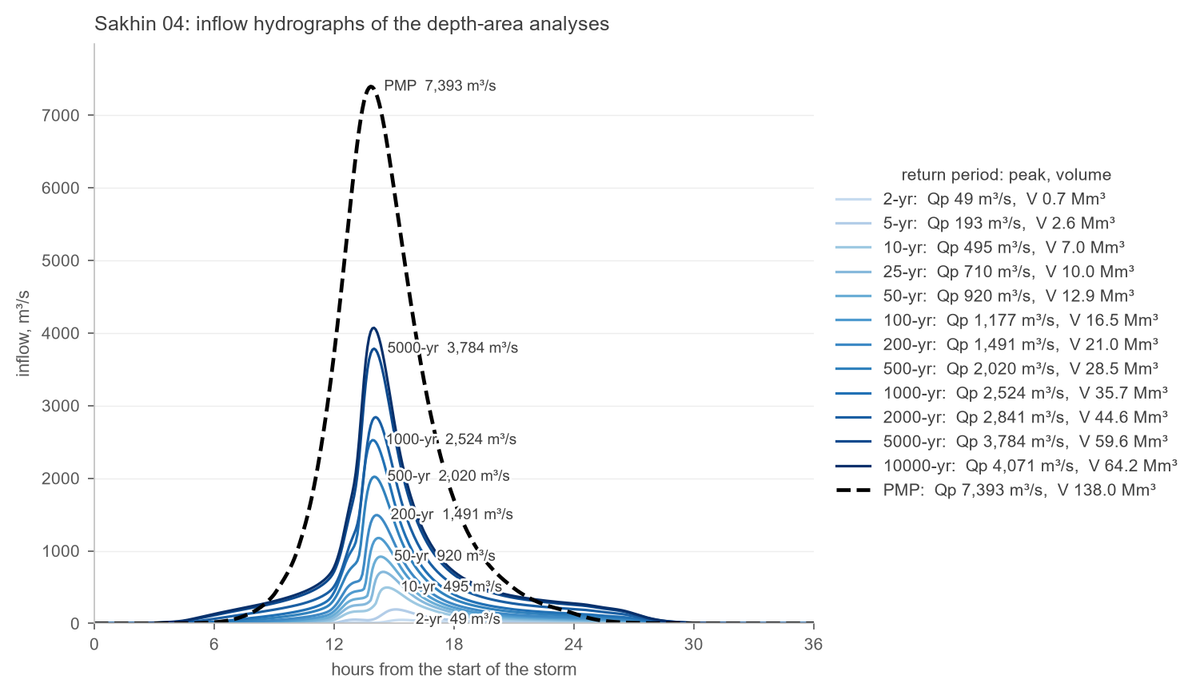
Figure 30 – Sakhin 04: inflow hydrographs for the return periods of 2 to 10 000 years and the PMP
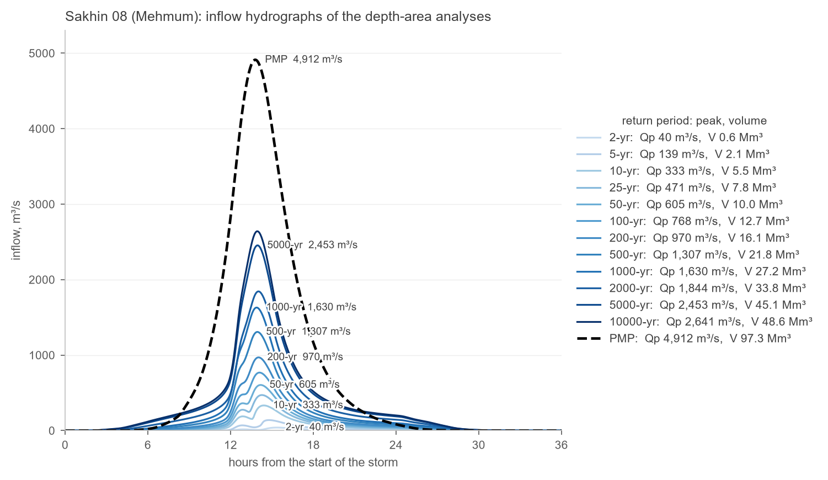
Figure 31 – Sakhin 08 (Mehmum): inflow hydrographs for the return periods of 2 to 10 000 years and the PMP

Appendix B – Reservoir curves after sedimentation
Original and revised elevation-area-volume curves of each reservoir after 50 and 100 years of sedimentation (Section 6): capacity on the lower axis, water-surface area on the upper axis.
Figure 32 – Hawasinah 02: reservoir curves before and after sedimentation
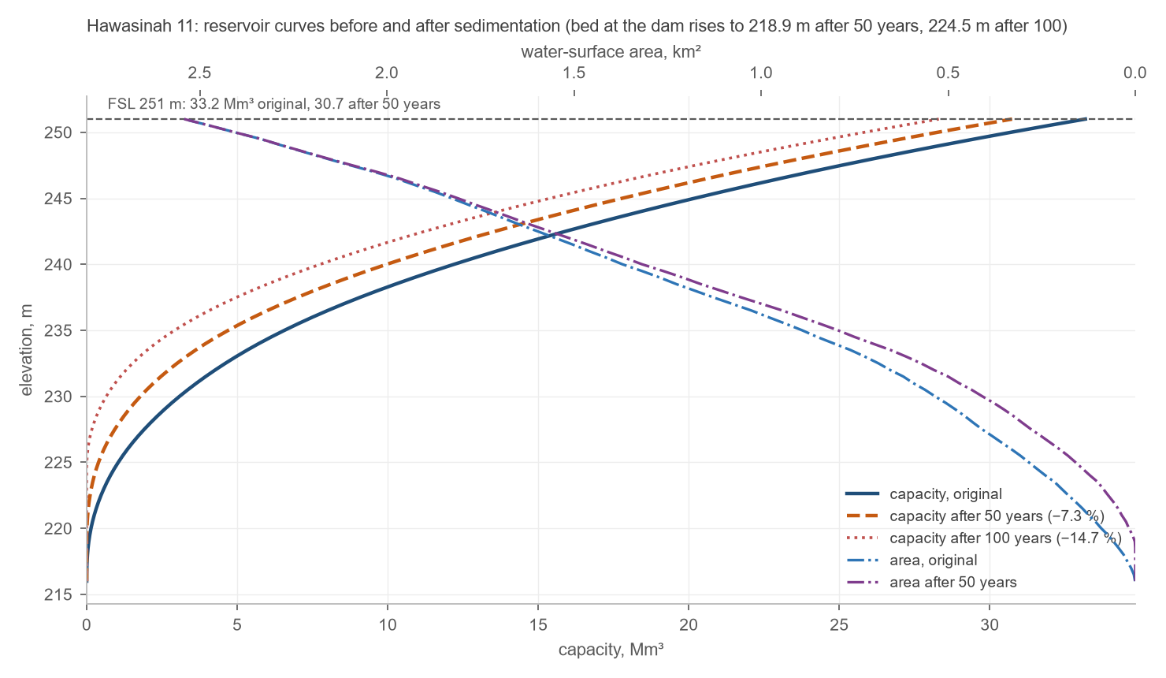
Figure 33 – Hawasinah 11: reservoir curves before and after sedimentation
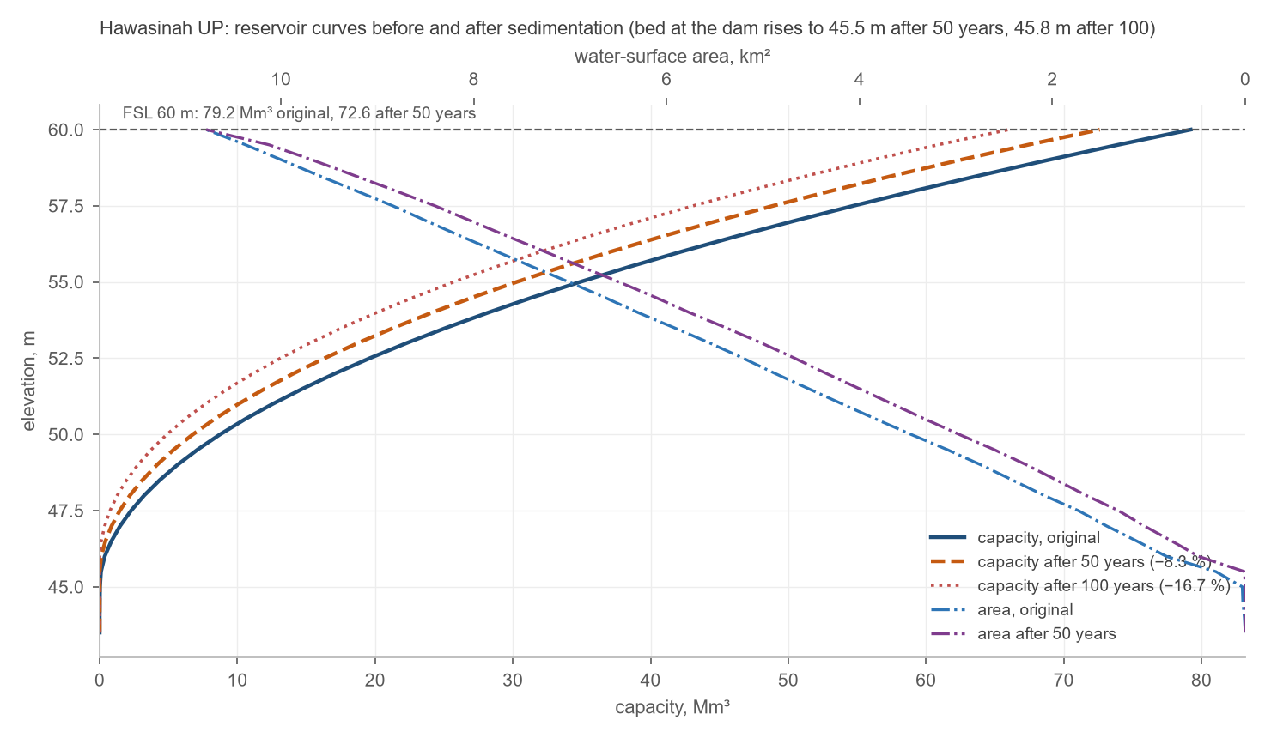
Figure 34 – Hawasinah UP: reservoir curves before and after sedimentation
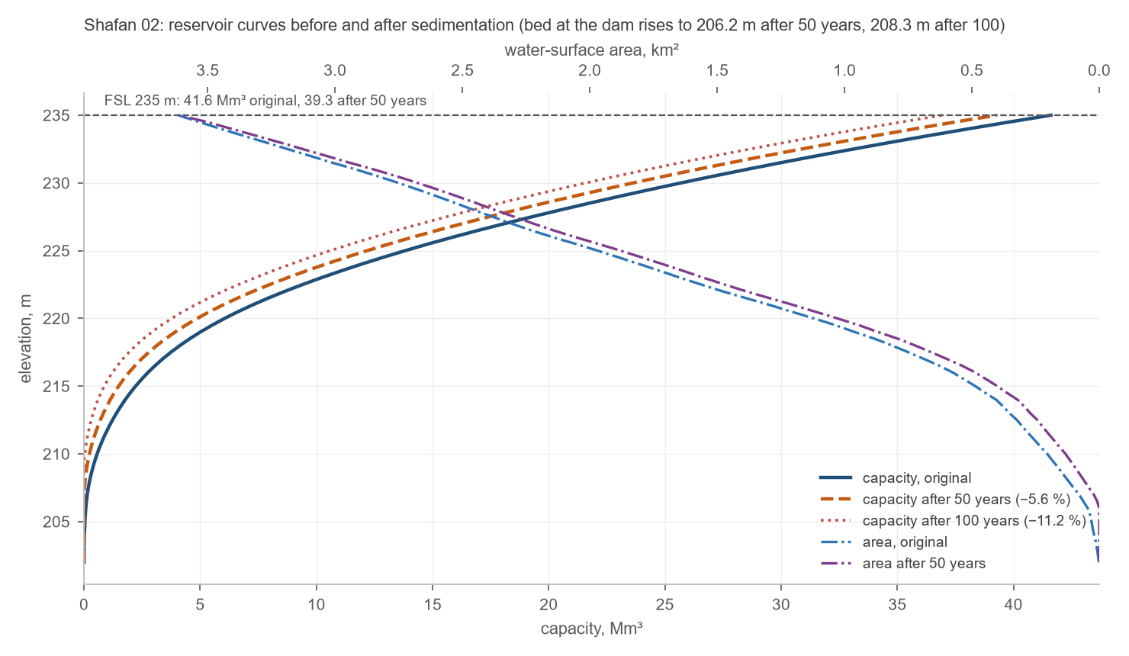
Figure 35 – Shafan 02: reservoir curves before and after sedimentation
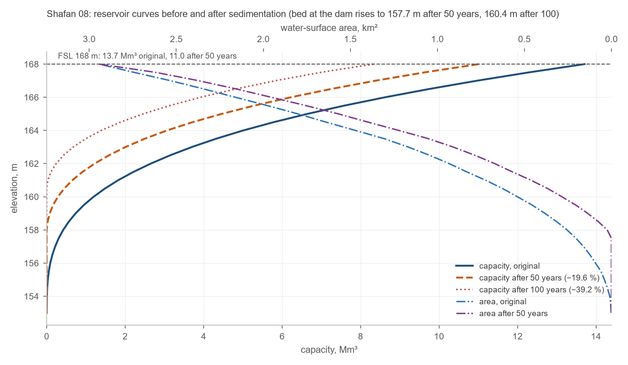
Figure 36 – Shafan 08: reservoir curves before and after sedimentation
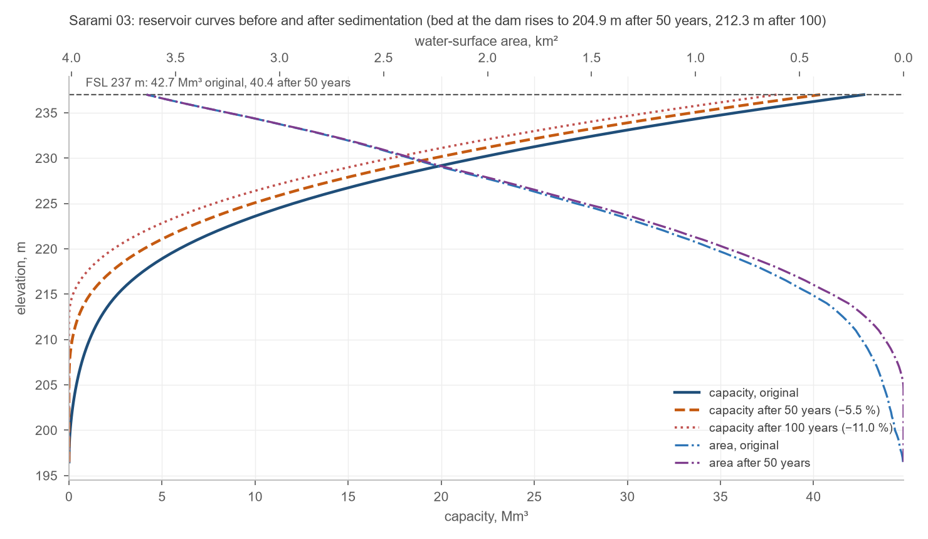
Figure 37 – Sarami 03: reservoir curves before and after sedimentation
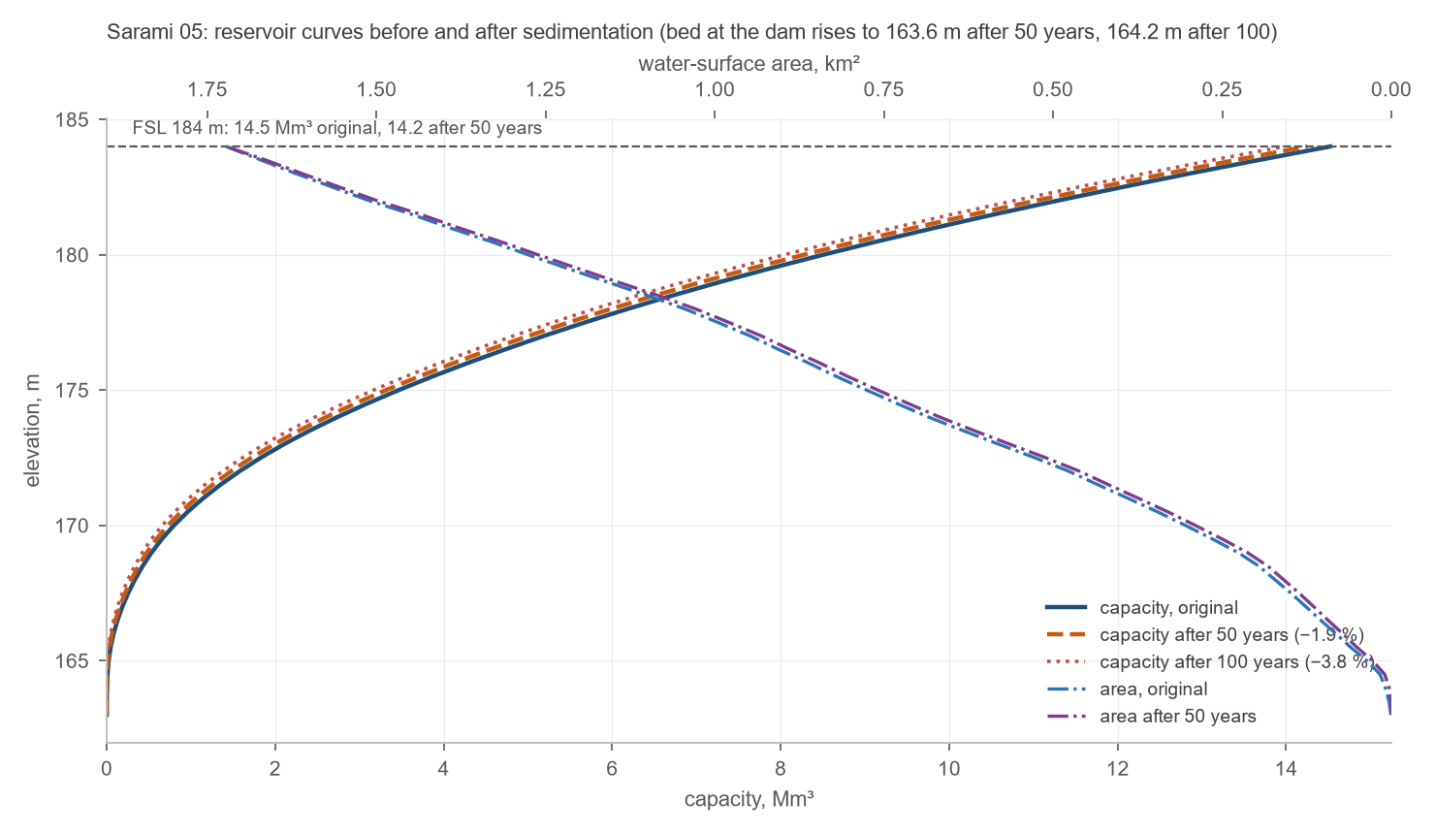
Figure 38 – Sarami 05: reservoir curves before and after sedimentation
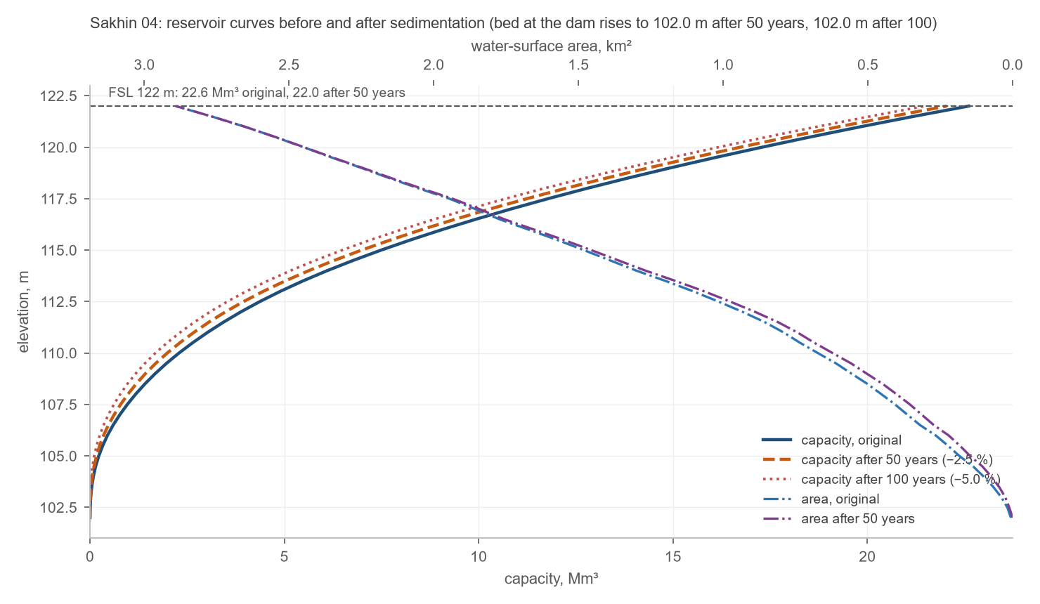
Figure 39 – Sakhin 04: reservoir curves before and after sedimentation
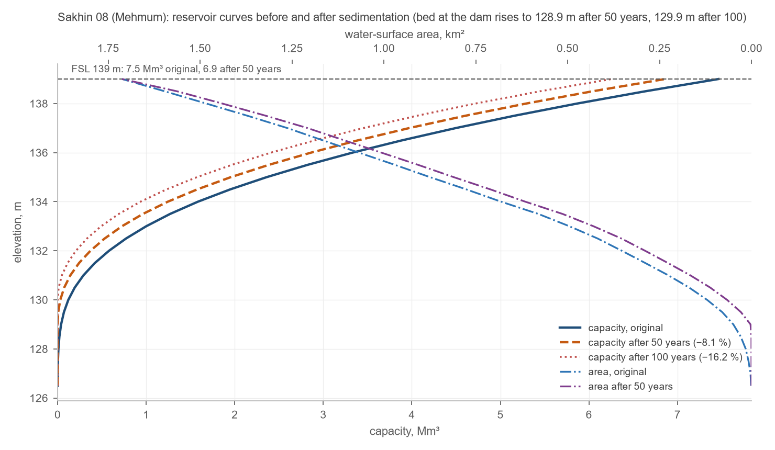
Figure 40 – Sakhin 08 (Mehmum): reservoir curves before and after sedimentation

MAFWR, nationwide hydrology study: regional frequency analysis of the 24-hour rainfall, design patterns and the PMP grid.
Renard, K.G. et al. (1997), Predicting soil erosion by water: a guide to conservation planning with the Revised Universal Soil Loss Equation (RUSLE), USDA Agriculture Handbook 703.
Williams, J.R. (1977), Sediment delivery ratios determined with sediment and runoff models, IAHS Publication 122. The delivered mass is converted to a volume at 1.5 t/m³.
Hawasinah UP and Shafan 08 are assessed on their whole catchment, without credit for the sediment that the reservoirs upstream of them (Hawasinah 02 and 11, Shafan 02) will trap; their sediment loads are therefore upper bounds.
U.S. Bureau of Reclamation (2006), Erosion and Sedimentation Manual, Chapter 2, Section 2.6: Brune (1953); Lara and Pemberton (1965); Miller (1953); Borland and Miller (1960); Lara (1962).
ECMWF IFS at 9 km (2017 on) and ERA5 / ERA5-Land before, through the Open-Meteo historical archive, read in October 2026 at the dam axes. MRMWR rain gauges: gap-filled daily record of July 2024.
IPCC (2021), Climate Change 2021: The Physical Science Basis, Sixth Assessment Report, Working Group I, Chapter 11 and Atlas, regional findings for the Arabian Peninsula.

