Ibri Sewer, TE & STP — Project 2621
W7 — Sewer Network Design
How the design is made, and what it gives for the test area
Internal working document — design team
20 August 2026
Item | Value
Test area | 551 hectares
Sewer designed | 1,906 chambers / 85.7 km
Properties served | 4,226 on 3,017 plots
Flow at the outfall | 3,620 m3/day average, 96 L/s peak
Pumping stations | 0 — the whole area runs on gravity
Deepest chamber | 10.61 m (limit 12.00 m)
Main pipe | 6.15 km, taken from your drawing
Joins onto it | 30 of 56 possible
Checks failing | 3 of 22

Contents
Right-click > Update Field to build the Table of Contents.

Summary
This run designs a full sewer for the 551 hectare test area: 1,906 chambers, 85.7 km of pipe, and a level for every pipe end. It serves 4,226 properties on 3,017 plots. At the outfall the flow is 3,620 cubic metres a day on average and 96 litres a second at the busiest hour. The whole run takes about 20 seconds, so any rule can be changed and the effect seen the same day.
Five things changed since the last run, and all five came from your review of the drawings.
- The main pipe is now yours, not mine. Earlier I tried to FIND a main pipe by picking streets near a line you described. It found 2.1 km in the southern corner, covering an eighth of the area, so almost the whole town reached it at one point. The trunk is now read straight from your drawing: 6.15 km serving this area, of which 3.87 km lies inside the boundary. Both legs drain to where they meet, and that meeting point sits about 792 m outside the boundary, so the pipe is followed a little way past the edge to reach it.
- The whole area now runs on gravity. With the main pipe where it really is, nothing has to be pumped. The last run needed four pumping stations; this one needs none, and the deepest chamber falls from 11.88 m to 10.61 m against a 12 m limit. That result belongs to the alignment you drew, not to anything clever in the code.
- Joins onto the main pipe are kept to the fewest that work. Each one becomes a chamber that will be deep once the whole town drains through it, so the route search is charged for using one. 56 places could take a connection; 30 are used. That number was found by trying: at 30 joins the area still runs on gravity, at 28 the first pumping station appears, and cutting below that buys nothing more.
- Crossing a dual carriageway is now a last resort. A crossing needs trenchless work, so it is charged heavily — except at the underpass you gave us, which costs nothing. Of 31 crossings offered, the design uses ONE, and it goes through that underpass. No trenchless work is needed anywhere.
- Fewer chambers, steadier gradients. Junction chambers are no longer added just to satisfy the inlet-angle rule — that was putting in roughly 200 chambers that buy nothing on site. Anything sharper than 85 degrees is now flagged for a designer to look at instead. And down a single street the pipe is laid at ONE gradient rather than a new one at every chamber, which is what a contractor wants to set out.
What still needs attention: 3 checks fail, and none of them touches pipe sizes, gradients or levels.
- 131 pipes arrive at a chamber at a sharp angle. Each needs a purpose-made chamber with a curved channel — ordinary detail work, and they are marked in the outputs.
- 230 plots have no sewer within 50 m. Their only frontage is a dual carriageway, where no pipe may be laid. They need either a sewer in the service road alongside or a local collector — your call, because it means relaxing the dual-carriageway rule in a limited way.
- 632 branch sewer starts too close to a junction chamber and should be merged into it on the drawing.
House connections, riders and stub-outs are NOT drawn in this iteration. You were not satisfied with them and asked to park them until the survey gives real frontages. The check that a house sitting below road level can still drain into the sewer is untouched and still runs — it deepened 57 chambers, and 0 plots are left unresolved.

1. How the design is made
The work runs in steps, each one a separate piece of code, so any rule can be found and changed in one place.
Step | What it does
Read the inputs | roads, plots, ground levels, flood map, electricity accounts
Clean the roads | remove what cannot carry a sewer, join broken streets back together
Build the tree | one path from every street to the outfall, no loops
Place chambers | at junctions, at bends, and at regular spacing
Count the load | properties per plot, added up down the network
Size and set levels | pipe size and gradient chosen together, deep spots become pumping stations
Connect the houses | each plot to the pipe it faces, and check it can drain
Check everything | 21 rules re-checked independently of the design code
Write the outputs | GIS files, CAD drawing, SewerGEMS package, maps

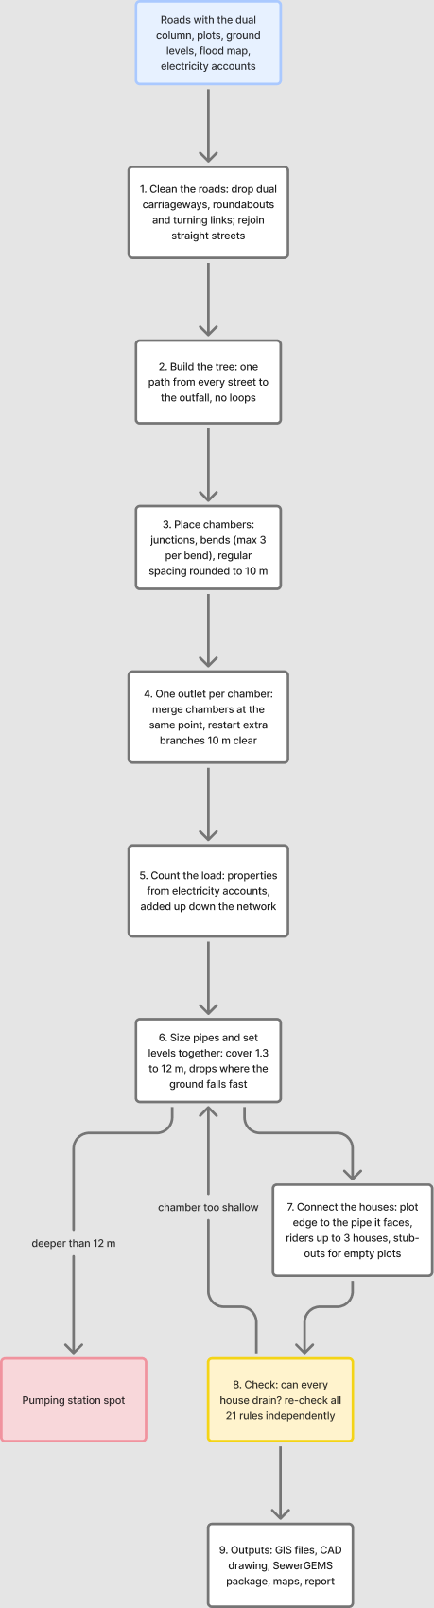
The steps in order. Blue is what comes in, yellow is the checking step, red is where a pumping station is needed, dashed lines are repeats.

2. Cleaning the roads
A road file describes how cars move. A sewer follows the street but joins at a point, so the file has to be cleaned first, or the design puts a chamber wherever the survey happened to break the line.
What was removed or changed | Amount
Dual carriageways — no pipe at all, trunk included | 101 lines
Roundabouts — they collect no sewage | 12
Rings kept because plots sit inside them (blocks, not roundabouts) | 69
Turning links and slip roads | 83
Straight streets joined back into one line | 102
Dead ends serving nobody | 0
Road length before / after | 97.4 km / 85.0 km

Everything removed is written to the corridor file with the reason beside it, so each one can be looked at and put back if the rule got it wrong. Telling a roundabout from a small block cannot be done on shape alone — a square scores higher on roundness than a real roundabout. The test used here is whether any plot sits inside the ring: a roundabout circles road, a block circles houses.

3. How much sewage, and from where
Each electricity account is one property. A plot with three accounts holds three properties. In the test area 3,885 accounts sit on 1,322 plots, giving 4,226 properties in total.
Item | Value | Where it comes from
People per property | 5 | your decision, 19 August
Sewage per person | 171.3 litres a day | guideline G201 p70-71
Properties per plot | 1.4 average | counted from electricity accounts
Plots loaded | 3,017 | built 2,217, planned 522, unparceled 248
Farm plots with houses | 30 | farming sends nothing, but houses on a farm do
Extra water leaking in | 720 litres a day per km of sewer | guideline G201 p72-73

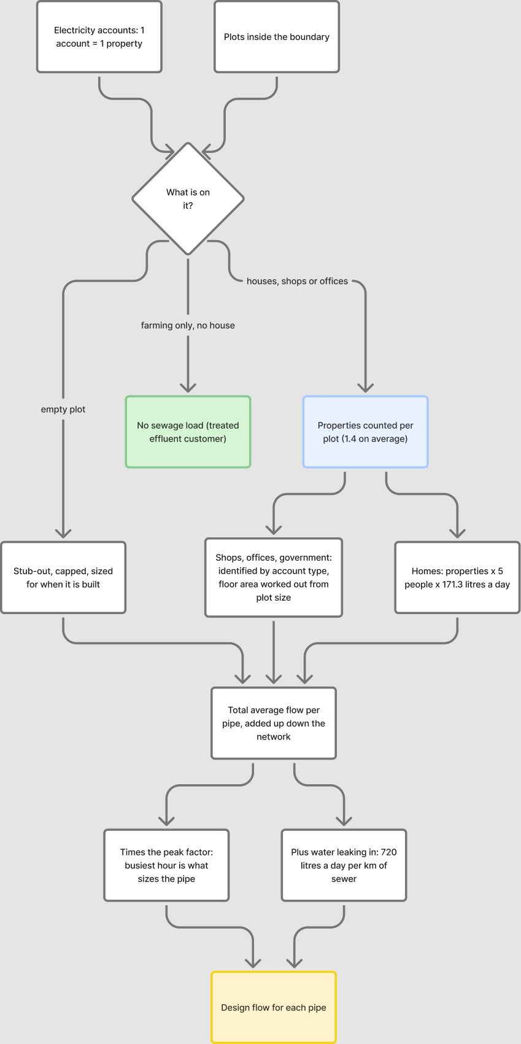
How a plot becomes a flow in the pipe.

4. House connections
The connection is schematic — the sizes are not designed. The one thing that must be right is whether the house can drain into the sewer at all, because roads are sometimes raised above the plots beside them.
Rule | Result here
Each plot joins the pipe it faces, by a short line from the plot edge | 0 connections
Up to 3 neighbours share one rider | 0 riders
Empty plots get a capped stub-out for later | 0 stub-outs
Houses that could not drain at first | 151
Chambers deepened to let them drain | 57
Still cannot drain — need a local answer | 0

These are kept in three separate files (connections, riders, stub-outs) so that SewerGEMS never reads them as sewers and the CAD drawing can switch them off.
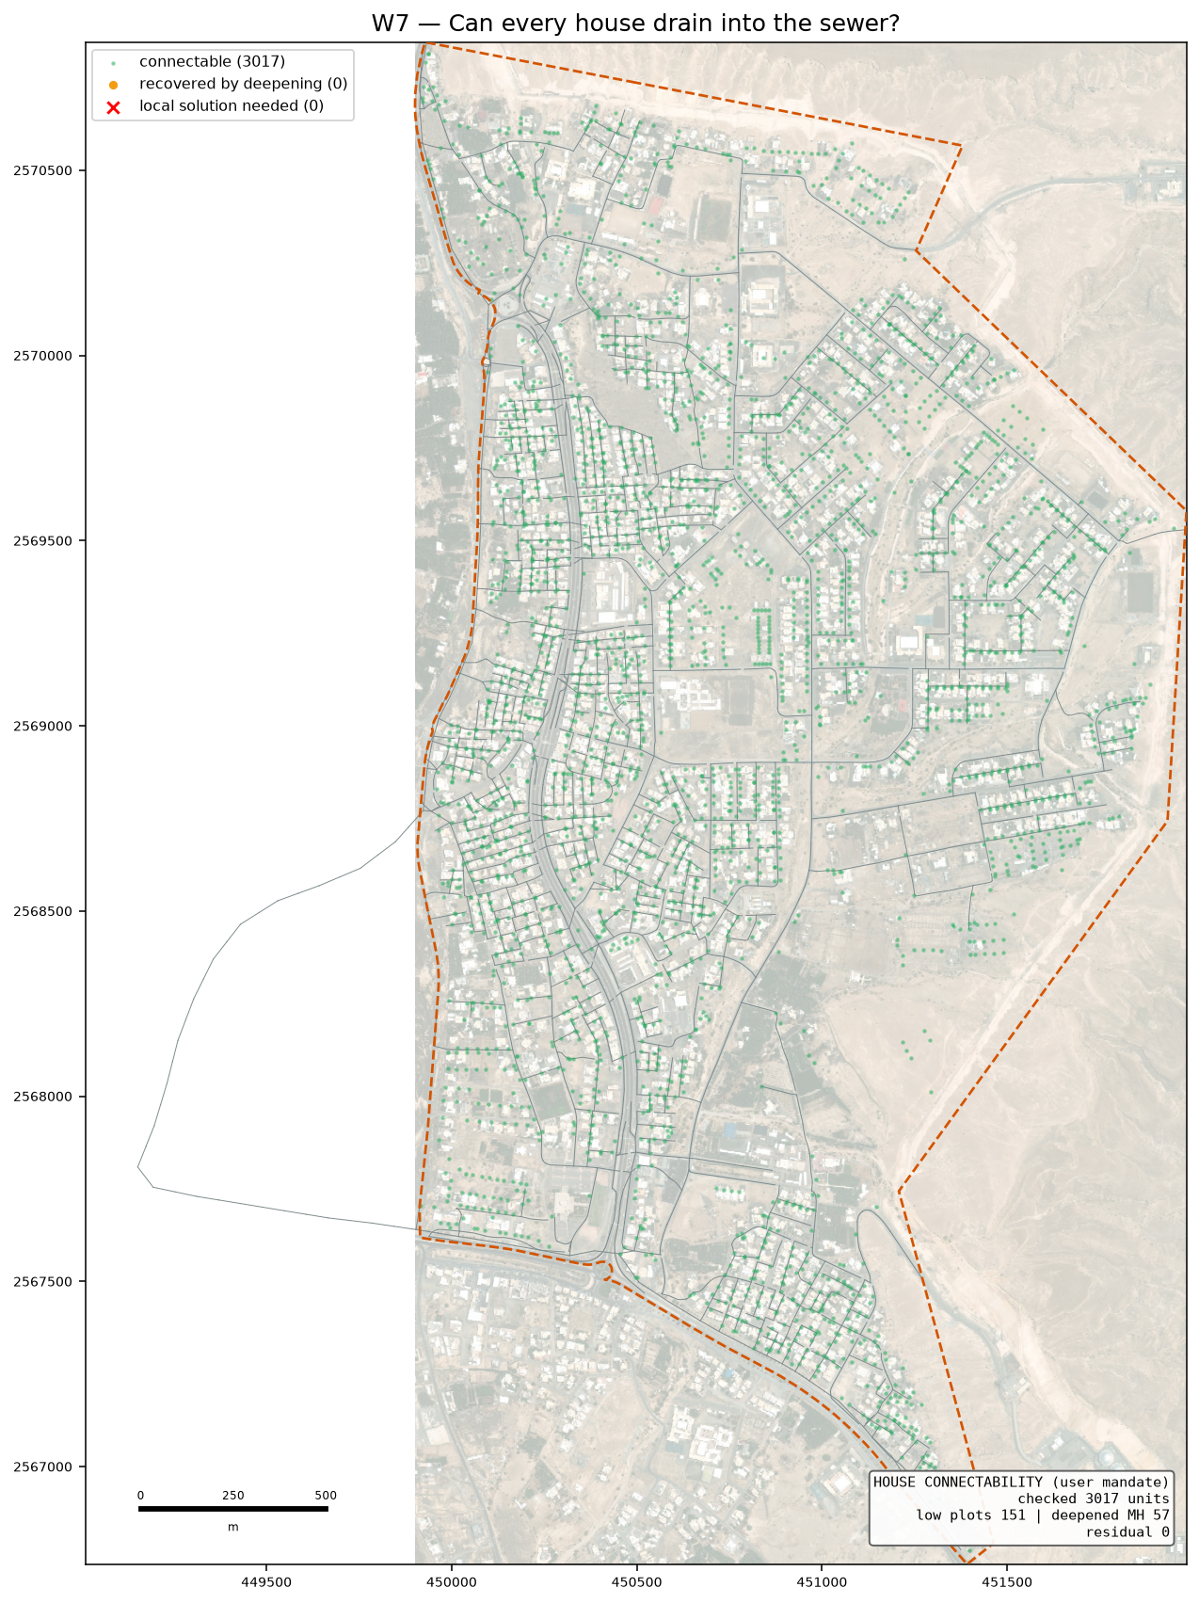
Green can drain as designed, amber needed a deeper chamber, red still cannot.

5. What the design gives
Item | Value
Chambers / pipes | 1,906 / 1,905
Sewer length | 85.7 km
Pipe sizes used | DN200 79.589 km · DN250 1.451 km · DN315 1.583 km · DN400 0.521 km · DN500 2.518 km
Flow at the outfall | 3,620 m3/day average, 96 L/s peak
Outfall position | (449152, 2567809), ground 352.3 m — where the two legs of your main pipe meet, then on to the existing Ibri STP
Main pipe | 6.15 km from your drawing (3.87 km inside the boundary), 68 chambers on it
Joins onto the main pipe | 30 used of 56 possible
Dual carriageway crossings | 1 — through the underpass, so no trenchless work
Deepest chamber | 10.61 m against a 12.00 m limit
Drop structures | 368 (165 need the tall type)
Pumping stations | none — the whole area runs on gravity
Streets laid at one steady gradient | 246 of 399 runs
Corner chambers sitting under 2 m from a plot | 0 — flagged for the drawing
Checks failing | 3 of 22

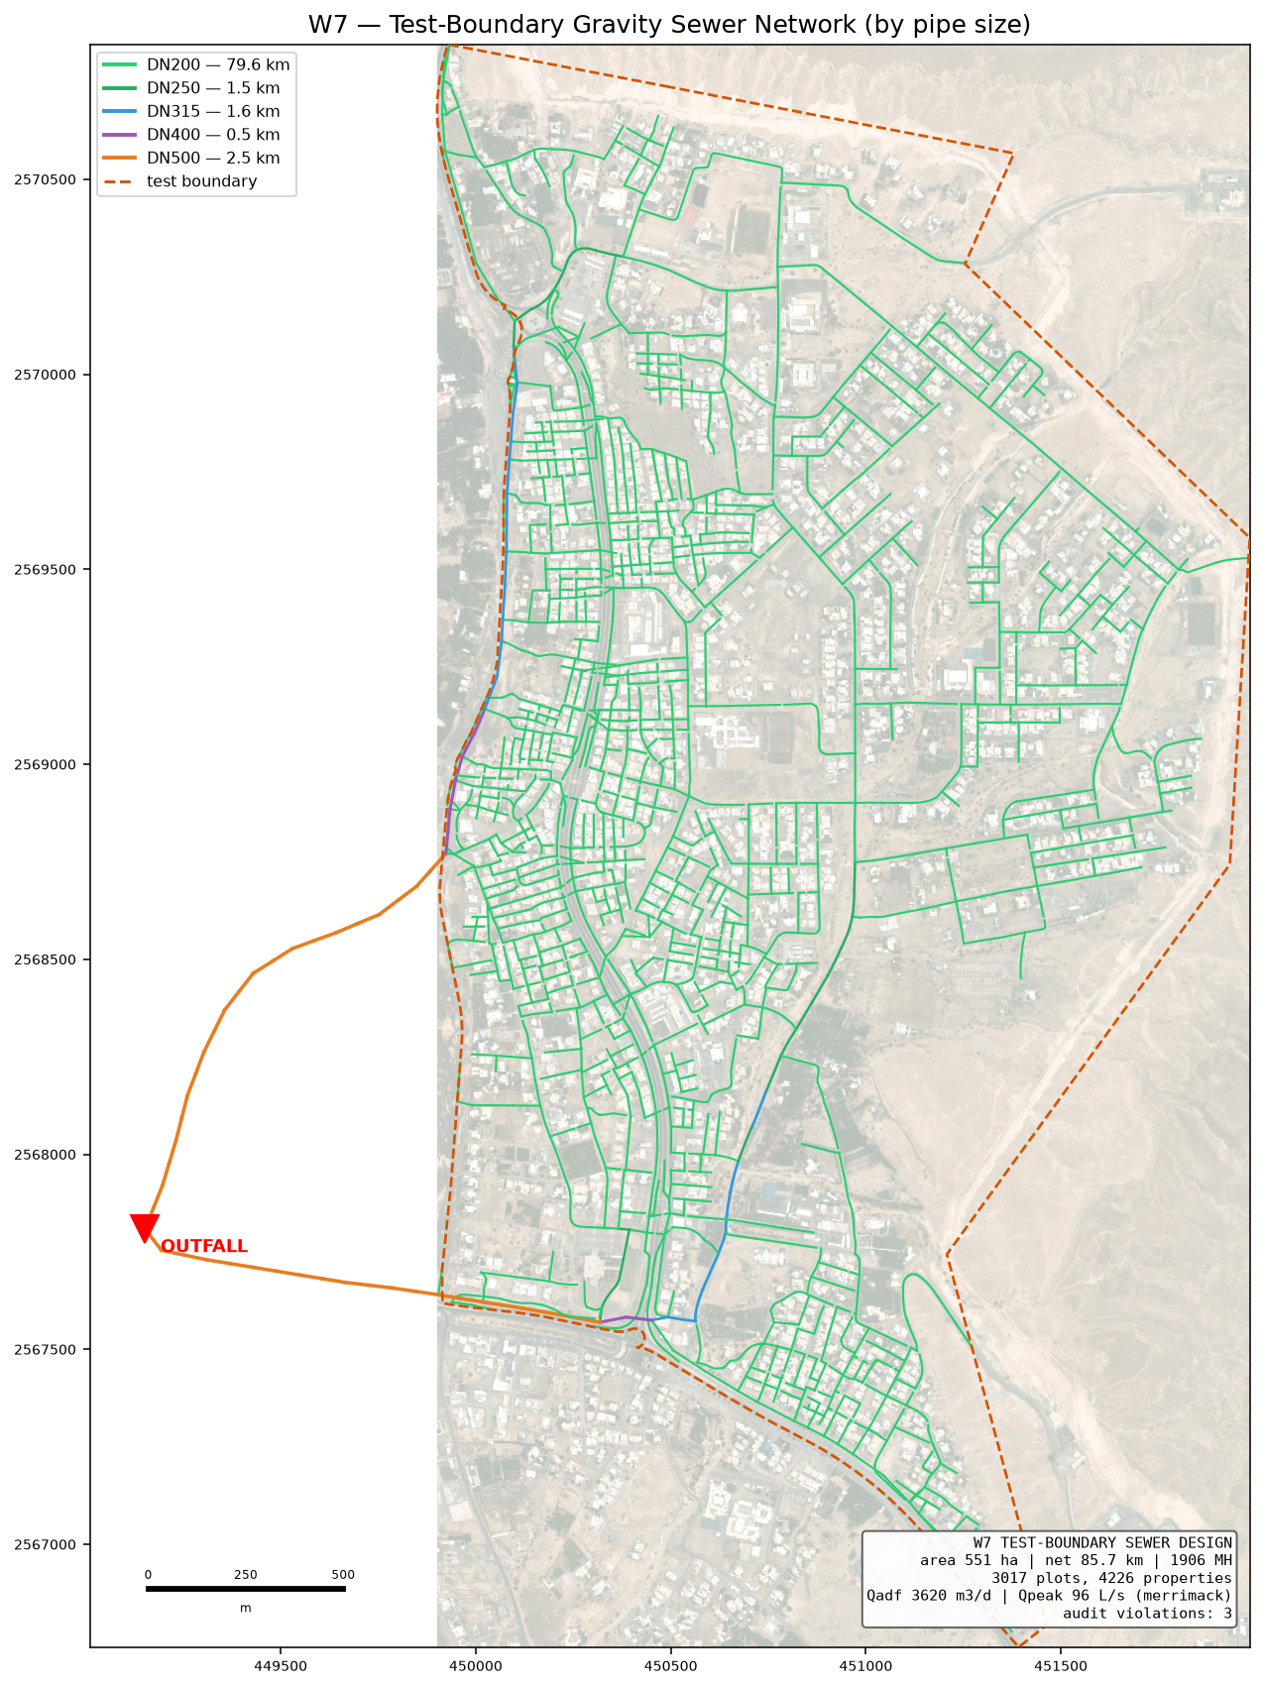
The designed sewer, coloured by pipe size.
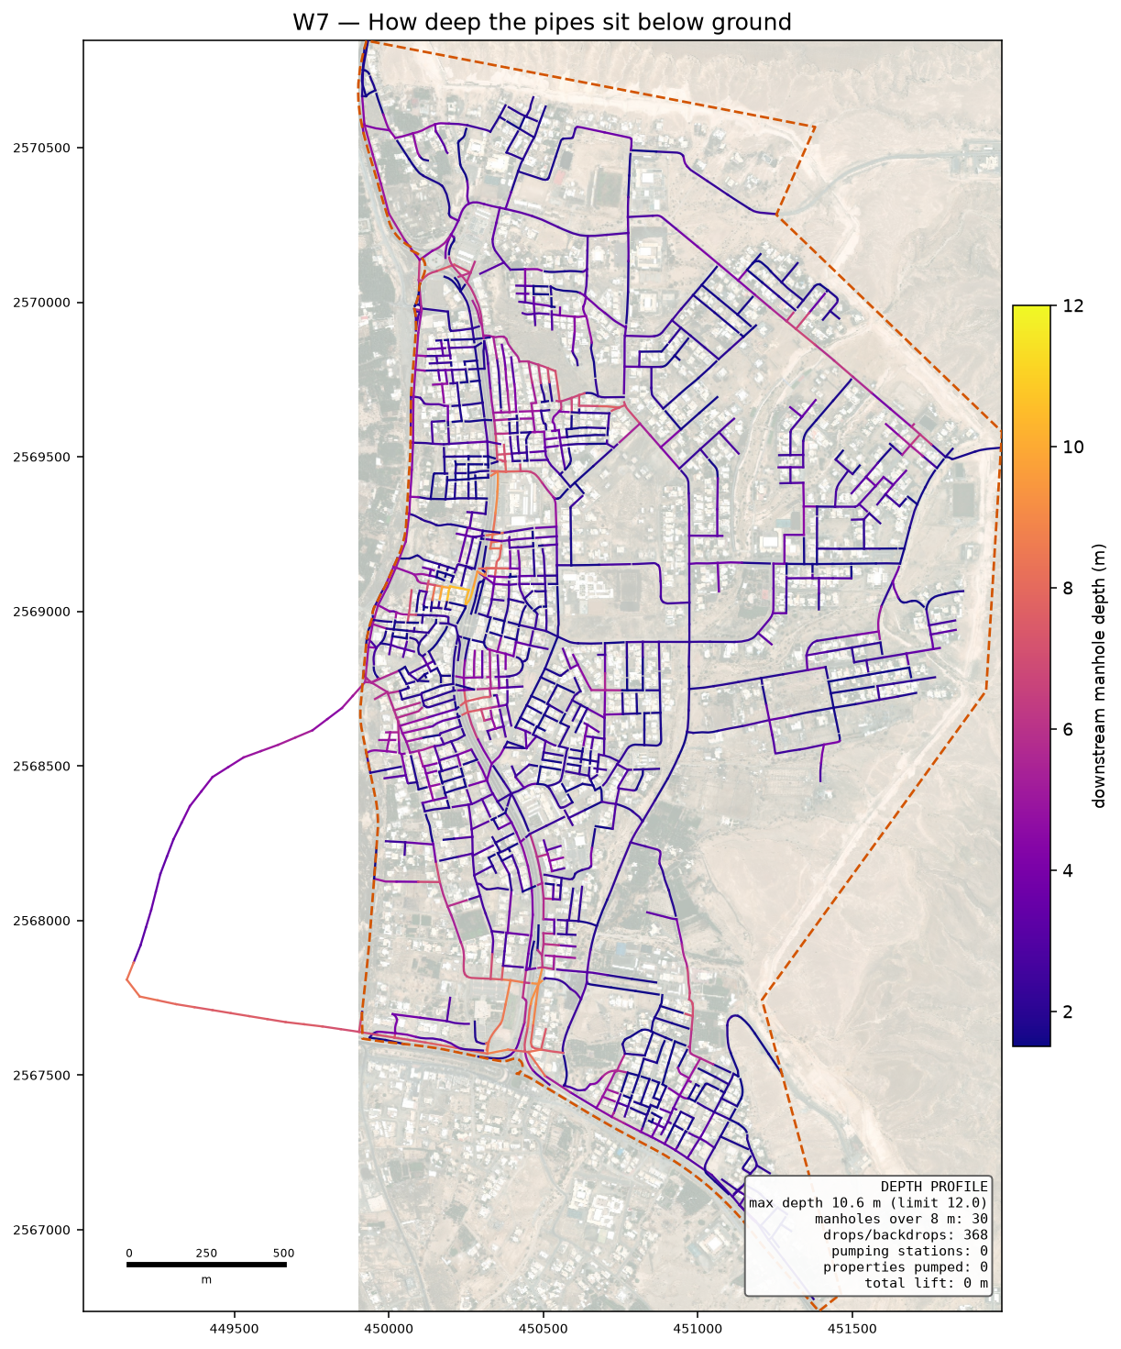
How deep the pipes sit. Dark means deep digging.

5.1 Why nothing has to be pumped
A sewer only flows because it falls. Over a long route the pipe must keep falling even where the ground does not, so it sinks further below the surface the further it travels. The guideline stops that at 12 metres: past that, digging and shoring cost more than a pump, and a pumping station has to go in.
On the previous run four stations were needed. On this one none are, and the deepest chamber is 10.61 m. The difference is not a cleverer program — it is the main pipe being where it really is. The trunk I had guessed at covered only an eighth of the area's length and sat in the southern corner, so sewage from the north had to travel the whole way to reach it and went deep doing so. Your alignment runs down the western side and in from the east, so each part of town reaches it close to home.
This matters for the report as much as for the design: when we were asked whether the trunk alignment was causing the pumping, the honest answer at the time was measured and said no. That measurement was made against a guessed alignment, and it was wrong.

6. The checks
The design is checked by separate code that re-works every rule from the finished drawing, so the design cannot mark its own homework. Each check names the guideline page it comes from.
ID | Check | Guideline | What was found
C4 | Inlet angle | G203-p30 (deviation: 75 deg) | 131 of 1905 inlets under 85 deg (project value; guideline is 90 - see
C8 | Branch start offset | user rule / SWNETWROK 10 m | 632/633 branch heads clear
D1 | Property connection length | G203-p18 Tab 4 (A9) | 230/3017 connections over 50.0 m; longest 356 m

On self-cleaning: 1,855 of 1,905 pipes cannot reach the 0.75 m/s flow speed even at their busiest hour. That is normal on small house streets, and the guideline allows a second method for exactly this case — a minimum gradient worked out from the drag on the pipe wall. All of them meet that instead. It rests on a value the guideline never gives (1 Pascal is assumed); if NWS sets it at 2, 1,242 pipes would need steeper gradients. That single number is the best reason to settle it at the kickoff meeting.

7. What is assumed, and what is measured
Assumed | Why
Drag value of 1 Pascal | the guideline gives no number; it decides the gradient on small pipes
5 people per property | your decision, 19 August
Plastic pipe wall thickness | pipe sizes are quoted outside; the inside bore is worked out from a standard wall class
Floor areas, staff and pupil numbers | nobody supplies them, so they are worked out from plot size and building cover — replace when the land use data arrives
Where a rider joins | the guideline does not say; the nearest chamber is used

Measured | Source
Properties per plot | electricity accounts
Ground levels | 0.5 m ground model
Which roads cannot be dug | the road file's own column
Flood-prone ground | 50-year hazard map, classes 4 to 6

8. What comes next
- Your trunk line. The main pipe is yours to fix. The design then grows the side networks into it — the code takes connection points as a setting, so this is a change of input, not a change of method.
- The SewerGEMS check. The import package is ready with a comparison sheet. Once the model runs, every pipe's flow and speed can be set beside ours; anything more than 5 per cent apart gets looked at before the design is called proven.
- Junction angles. 131 pipes still arrive at a chamber too sharply. This is a layout job at junctions and is the main open item in the design itself.
- The land use data from your colleague. Missing plots and properties per plot will replace the derived figures without touching the design code.

