Ibri Sewer, TE & STP — Project 2621
W6 — Sewer Network Design
How the design is made, and what it gives for the test area
Internal working document — design team
19 August 2026
Item | Value
Test area | 551 hectares
Sewer designed | 1,925 chambers / 78.7 km
Properties served | 4,226 on 3,017 plots
Flow at the outfall | 3,619 m3/day average, 96 L/s peak
Pumping stations | 3 (855 properties)
Deepest chamber | 11.88 m (limit 12.00 m)
Checks failing | 3 of 22

Contents
Right-click > Update Field to build the Table of Contents.

Summary
This run designs a full sewer for the 551 hectare test area: 1,925 chambers, 78.7 km of pipe, and a level for every pipe end. It serves 4,226 properties on 3,017 plots. At the outfall the flow is 3,619 cubic metres a day on average and 96 litres a second at the busiest hour. The whole run takes about 20 seconds, so any rule can be changed and the effect seen the same day.
Four things changed since the last run, and all four came from your review.
- The main pipe now runs where you asked. It follows the streets along the western edge of the area and then the southern side beside the dual carriageway — 2.1 km, with 44 points along it where side networks can join. Nothing has to travel to a single far outfall any more; each street drains to the nearest point on the main pipe.
- No chamber goes deeper than 12 metres. The guideline sets 12 m as the limit, and beyond it a pumping station is required. The last run reached 21.3 m in places because chambers inside a 'pumping pocket' were being skipped by the depth check — that hole is closed. The deepest chamber is now 11.88 m, and where the pipe would pass the limit a pump lifts it and the sewer restarts near the surface. That costs 3 stations serving 855 properties.
- Branch pipes meet the flow properly. The guideline says no pipe may arrive at a chamber pointing back against the flow. Where a side street met the main line at a bad angle, a bend chamber is now placed a few metres short of the junction so the turn is made in two smaller steps instead of one sharp one — 172 of them. 131 junctions have no room for that and are listed for a purpose-made chamber with a curved channel.
- Roads are cleaned before use. The road file now carries a column saying which roads are dual carriageway. Those carry no pipe at all — 101 lines, 12.7 km — because we cannot dig them up, and that holds for the trunk sewer too. 12 roundabouts and 83 turning links were also dropped: they carry no houses, and following them only adds chambers.
- House connections are drawn properly. Before, a connection ran from the middle of a plot to whichever chamber was nearest in a straight line, which cut across blocks. Now each plot reaches out to the pipe it actually faces, the line starts at the plot edge, and up to three neighbours share one rider. 522 empty plots get a capped stub-out ready for when they are built.
- Properties are counted, not guessed. 3,885 electricity accounts inside the boundary tell us how many properties sit on each plot — 1.4 on average instead of the flat one per plot we assumed before. Account type also tells us which are shops or offices rather than homes.
What still needs attention: 3 checks fail, and none of them touches pipe sizes, gradients or levels.
- 143 pipes arrive at a chamber at a sharp angle where the street layout leaves no room to turn them. Each needs a purpose-made chamber with a curved channel — normal detail-design work, and they are marked in the outputs so the chamber schedule can pick them up.
- 240 house connections run longer than 50 m. These are plots whose only frontage is a dual carriageway. Since no pipe may be laid in a dual carriageway, they have no near street to join. They need either a sewer in the service road alongside, or a local collector — a decision for you, because it means relaxing the dual-carriageway rule in a limited way.
- 586 branch sewers start closer than 10 m to an existing junction chamber and should simply be merged into it on the drawing.

1. How the design is made
The work runs in steps, each one a separate piece of code, so any rule can be found and changed in one place.
Step | What it does
Read the inputs | roads, plots, ground levels, flood map, electricity accounts
Clean the roads | remove what cannot carry a sewer, join broken streets back together
Build the tree | one path from every street to the outfall, no loops
Place chambers | at junctions, at bends, and at regular spacing
Count the load | properties per plot, added up down the network
Size and set levels | pipe size and gradient chosen together, deep spots become pumping stations
Connect the houses | each plot to the pipe it faces, and check it can drain
Check everything | 21 rules re-checked independently of the design code
Write the outputs | GIS files, CAD drawing, SewerGEMS package, maps

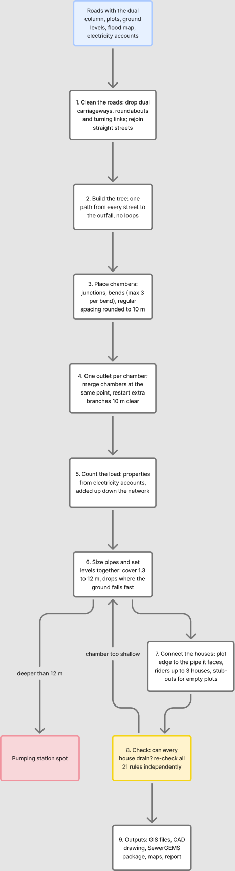
The steps in order. Blue is what comes in, yellow is the checking step, red is where a pumping station is needed, dashed lines are repeats.

2. Cleaning the roads
A road file describes how cars move. A sewer follows the street but joins at a point, so the file has to be cleaned first, or the design puts a chamber wherever the survey happened to break the line.
What was removed or changed | Amount
Dual carriageways — no pipe at all, trunk included | 101 lines
Roundabouts — they collect no sewage | 12
Rings kept because plots sit inside them (blocks, not roundabouts) | 69
Turning links and slip roads | 83
Straight streets joined back into one line | 107
Dead ends serving nobody | 4
Road length before / after | 97.4 km / 84.8 km

Everything removed is written to the corridor file with the reason beside it, so each one can be looked at and put back if the rule got it wrong. Telling a roundabout from a small block cannot be done on shape alone — a square scores higher on roundness than a real roundabout. The test used here is whether any plot sits inside the ring: a roundabout circles road, a block circles houses.

3. How much sewage, and from where
Each electricity account is one property. A plot with three accounts holds three properties. In the test area 3,885 accounts sit on 1,322 plots, giving 4,226 properties in total.
Item | Value | Where it comes from
People per property | 5 | your decision, 19 August
Sewage per person | 171.3 litres a day | guideline G201 p70-71
Properties per plot | 1.4 average | counted from electricity accounts
Plots loaded | 3,017 | built 2,217, planned 522, unparceled 248
Farm plots with houses | 30 | farming sends nothing, but houses on a farm do
Extra water leaking in | 720 litres a day per km of sewer | guideline G201 p72-73

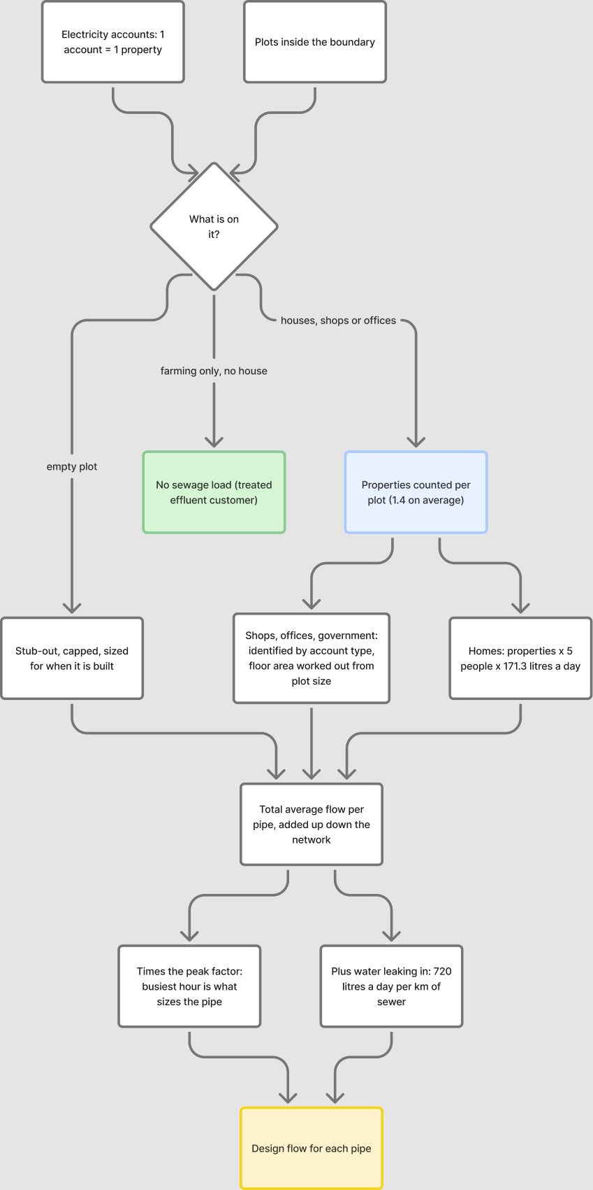
How a plot becomes a flow in the pipe.

4. House connections
The connection is schematic — the sizes are not designed. The one thing that must be right is whether the house can drain into the sewer at all, because roads are sometimes raised above the plots beside them.
Rule | Result here
Each plot joins the pipe it faces, by a short line from the plot edge | 2,495 connections
Up to 3 neighbours share one rider | 964 riders
Empty plots get a capped stub-out for later | 522 stub-outs
Houses that could not drain at first | 108
Chambers deepened to let them drain | 51
Still cannot drain — need a local answer | 2

These are kept in three separate files (connections, riders, stub-outs) so that SewerGEMS never reads them as sewers and the CAD drawing can switch them off.
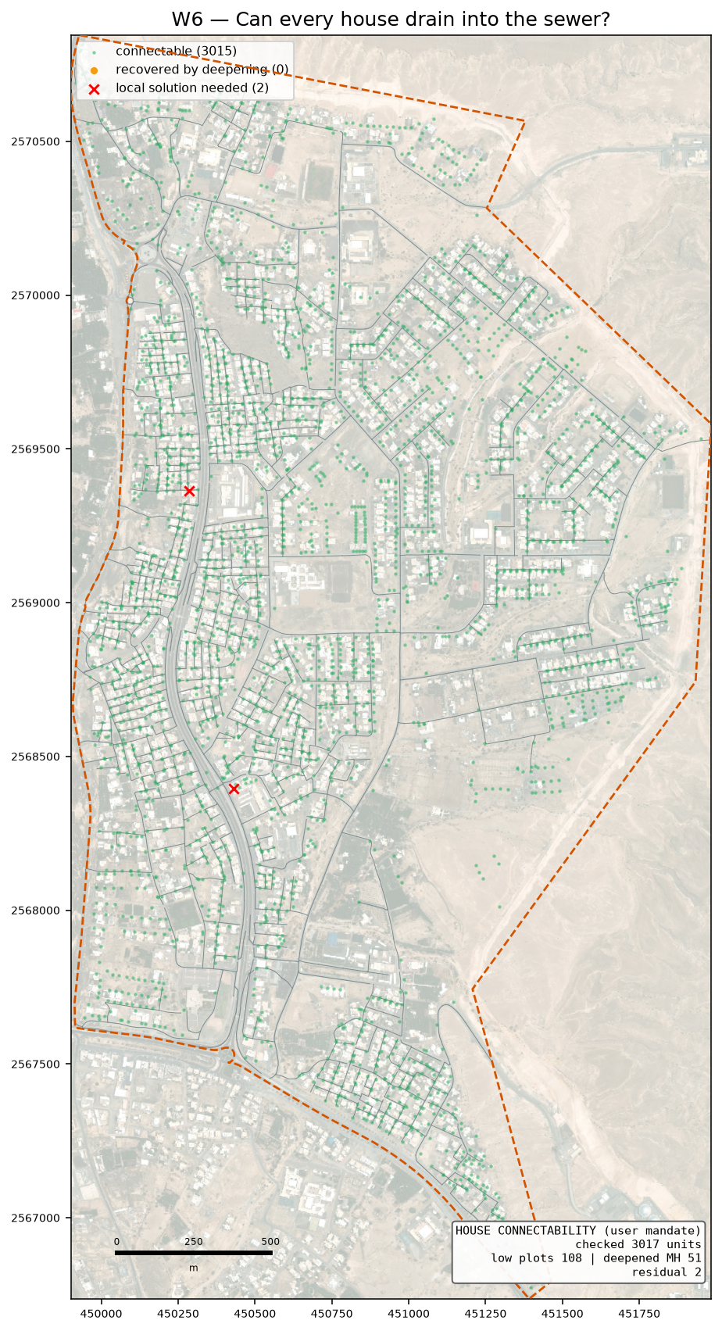
Green can drain as designed, amber needed a deeper chamber, red still cannot.

5. What the design gives
Item | Value
Chambers / pipes | 1,925 / 1,924
Sewer length | 78.7 km
Pipe sizes used | DN200 74.297 km · DN250 1.426 km · DN315 0.776 km · DN400 0.141 km · DN500 1.004 km · DN600 1.059 km
Flow at the outfall | 3,619 m3/day average, 96 L/s peak
Outfall position | (450882, 2567309), ground 353.0 m — the lowest road point on the boundary
Main pipe | 2.1 km along the western edge and the southern side, 44 joining points
Deepest chamber | 11.88 m against a 12.00 m limit
Drop structures | 381 (215 need the tall type)
Pumping stations | 3, lifting 855 properties a total of 31.4 m
Rising mains | 162 m in total
Bend chambers added to fix sharp junctions | 172
Corner chambers sitting under 2 m from a plot | 0 — flagged for the drawing
Checks failing | 3 of 22

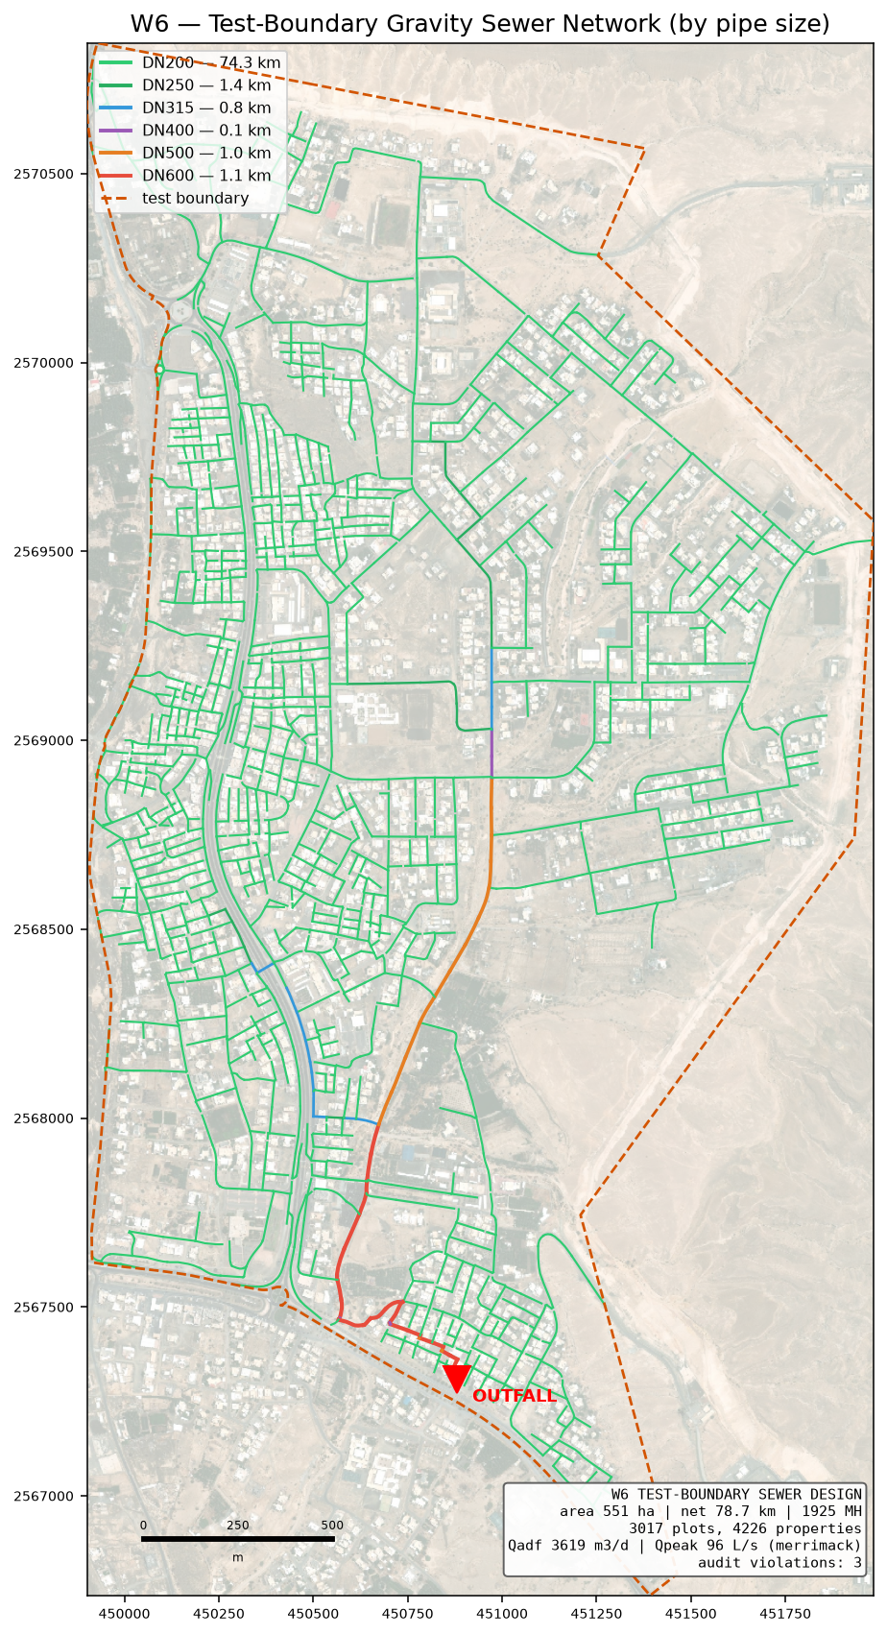
The designed sewer, coloured by pipe size.
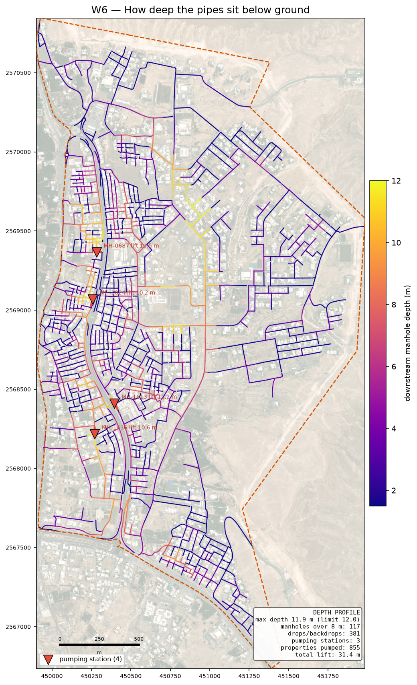
How deep the pipes sit. Dark means deep digging.

5.1 Why there are pumping stations, and where
A sewer only flows because it falls. Over a long route the pipe has to keep falling even where the ground does not, so it sinks further below the surface the further it goes. The guideline stops that at 12 metres: past that, digging and shoring cost more than a pump, and a pumping station has to go in. When the design reaches that point the sewage is lifted and the pipe restarts about 1.5 m below the surface, so the next stretch runs by gravity again.
For this area the ground is against us in one particular way. The main spine to the outfall is about 4.6 km long, and along the way the ground drops about 5 m and then climbs back over a ridge before falling to the outfall. The sewer cannot climb, so it goes deep under that ridge. That is what the pumping stations pay for — not a shortage of fall overall, which is roughly 14 m from the top of the spine down to the outfall.
The route is searched several times over, each time made expensive along the streets that forced deep digging on the previous attempt, so the design has a chance to find a way round the ridge instead of a pump. That search brought the count down; the 3 stations below are what is left after it.
Station | Ground | Depth | Lift | Rising main | Properties
MH-1024 | 364.4 m | 11.5 m | 10.2 m | 49 m DN200 | 340
MH-1488 | 355.6 m | 11.8 m | 10.7 m | 81 m DN200 | 289
MH-0687 | 364.1 m | 10.8 m | 10.5 m | 32 m DN200 | 226

Each station discharges through a rising main into the next chamber downstream. The rising main is sized on the pump duty, not on the rate sewage arrives: the pump fills a wet well and empties it faster, which is what keeps the flow between 0.75 and 3.0 m/s in the pipe.
A station needs land, so the count matters commercially. All 3 sit within 1.5 km of one another, which means detail design can look at whether the upper ones should feed the lower one instead of each having its own discharge — the consolidation rule we agreed.

6. The checks
The design is checked by separate code that re-works every rule from the finished drawing, so the design cannot mark its own homework. Each check names the guideline page it comes from.
ID | Check | Guideline | What was found
C4 | Inlet angle | G203-p30 | 143 of 1924 inlets under 90 deg
C8 | Branch start offset | user rule / SWNETWROK 10 m | 586/588 branch heads clear
D1 | Property connection length | G203-p18 Tab 4 (A9) | 240/3017 connections over 50.0 m; longest 356 m

On self-cleaning: 1,851 of 1,924 pipes cannot reach the 0.75 m/s flow speed even at their busiest hour. That is normal on small house streets, and the guideline allows a second method for exactly this case — a minimum gradient worked out from the drag on the pipe wall. All of them meet that instead. It rests on a value the guideline never gives (1 Pascal is assumed); if NWS sets it at 2, 1,246 pipes would need steeper gradients. That single number is the best reason to settle it at the kickoff meeting.

7. What is assumed, and what is measured
Assumed | Why
Drag value of 1 Pascal | the guideline gives no number; it decides the gradient on small pipes
5 people per property | your decision, 19 August
Plastic pipe wall thickness | pipe sizes are quoted outside; the inside bore is worked out from a standard wall class
Floor areas, staff and pupil numbers | nobody supplies them, so they are worked out from plot size and building cover — replace when the land use data arrives
Where a rider joins | the guideline does not say; the nearest chamber is used

Measured | Source
Properties per plot | electricity accounts
Ground levels | 0.5 m ground model
Which roads cannot be dug | the road file's own column
Flood-prone ground | 50-year hazard map, classes 4 to 6

8. What comes next
- Your trunk line. The main pipe is yours to fix. The design then grows the side networks into it — the code takes connection points as a setting, so this is a change of input, not a change of method.
- The SewerGEMS check. The import package is ready with a comparison sheet. Once the model runs, every pipe's flow and speed can be set beside ours; anything more than 5 per cent apart gets looked at before the design is called proven.
- Junction angles. 143 pipes still arrive at a chamber too sharply. This is a layout job at junctions and is the main open item in the design itself.
- The land use data from your colleague. Missing plots and properties per plot will replace the derived figures without touching the design code.

