Consultancy Services for Design and Supervision for STP, Sewer & TE Networks Systems in Ibri

Design Basis Report
Settlement Boundaries, Population, Flows and Loads
Revision 0 · September 2026

 | PO Box 579, Muscat. PC 113  Sultanate of Oman  Tel: (968) 244 84 292  Fax: (968) 244 83 039  e-mail: Renardet-oman@renardet.net

Contents
Right-click and choose Update Field to build the contents.
Figures
Right-click and choose Update Field to build the list of figures.
Tables
Right-click and choose Update Field to build the list of tables.

What this report asks for, and what it adopts
This report sets out the ground on which the sewer network, the treated effluent network and the treatment plant for Ibri will be designed: where the settlements are, how many people live in them, how many the land can hold, and the sewage each part of the system must carry. All of it will be part of the Concept Design Report. It is issued now, on its own, so that Nama Water Services can confirm the foundation before the design is built on it.
The study area holds 119,893 people in 2024 on the meters counted, and generates 20,852 cubic metres of sewage a day. Its empty land can hold 229,136 more. In 2055 it holds 244,914 people and generates 42,266 cubic metres a day; the last settlement fills in 2070, with 349,029 people and 60,099 cubic metres a day.
7 points need a decision from Nama Water Services. They are listed first, explained in the section named, and repeated in Section 10 with the answer sheet. 8 further values are the guideline's own or stated assumptions; they are adopted and reported, not put to approval. Seven data requests follow in Section 9.
Table 1 The decisions asked for
 | Group | Decision
1 | Settlements and people | Settlement boundaries
2 | Settlements and people | Persons per property
3 | Settlements and people | Use of each plot
4 | Growth | The overflow
5 | Growth | The design horizon
6 | Growth | The growth beyond 2050
7 | The network | Gradients and self-cleansing at the concept stage

Table 2 The values adopted, for information
 | Group | Value
8 | Settlements and people | The 126 meters with no plot within 15 metres
9 | Water and sewage rates | Water demand and return
10 | Water and sewage rates | The industrial estates
11 | Growth | The connection ratio
12 | The network | Infiltration and peak flow
13 | The network | Depth
14 | The plant and the effluent | STP flows and loads
15 | The plant and the effluent | Treated effluent

1. Purpose and how to read this report
The concept design will be submitted as one document. Its later parts, the options for the network and the plant, rest on the numbers in this report. If a number here changes after the options are drawn, the options are drawn again. Confirming the foundation first avoids that.
The report is written to be read in one sitting. Each section says what was done, what value is used, and why. Where a value is an assumption, it says so. Where the guideline gives a rule, the page is in a footnote. Section 8 collects every adopted value in one table; Section 10 is the answer sheet.

1.1. What it rests on
Table 3 Sources
Source | What it gives
PAM-GUD-201, General Design Guidelines, rev. 01, March 2026 | water demand, return to the sewer, peak flow, infiltration, STP margin, treated effluent
PAM-GUD-203, Wastewater Design Guidelines, rev. 01, March 2026 | self-cleansing, gradients, depth, STP flows, sewage strength
Inception Report R0 and its demand workbook | the population series to 2100, the settlement boundaries, the connection ratio
Electricity accounts, 33,971 meters | one property per domestic meter; shops, offices, government and farm meters by tariff
Cadastral plots, 77,265, Ministry of Housing and Urban Planning, September 2026 | the land: built or empty, and its area
Sentinel-2 satellite image of 9 September 2026 | which plots are planted

1.2. What it does not contain
No network is laid here and no plant is sized. The report gives the flow that each element will be designed for and the rule for finding it. The layout of the sewers, the stations and the plant follow in the concept design, on these numbers.

2. The settlements and their boundaries
Every rule in this report is applied settlement by settlement: the persons per property, the share of empty land that becomes housing, the growth rate and the year the land is full are all set for each settlement. So every plot must belong to exactly one settlement.
The Inception Report supplied twenty-six polygons for the twenty-five settlements, Al Aynayn being drawn as two. The polygons are drawn around the built cores. They do not touch, so the land between them belongs to nobody, and four of them, at Tanam, Satwah, Al Makhtibyah and Bat, miss part of the plots that carry the settlement's name. The map on the next page shows them in red.
The boundaries were therefore redrawn. Each of the 77,265 plots was given the settlement whose polygon contains it, or, where none does, the nearest one. The land was then divided so that every point belongs to the settlement of the nearest plot, and the shared edges were smoothed. The result, in blue on the map, covers the whole study area with twenty-five settlements and no gaps. Nothing else changed: the names, the population series and the plots are as received.
The twenty-five settlements inside the study area carry 63.4 per cent of the wilayat's population in every year of the series. The other settlements of the wilayat lie outside the boundary and are not part of the design.
Decision 1. Approve the twenty-five settlement boundaries redrawn so that every plot lies in one settlement and there are no gaps between them (Section 2).

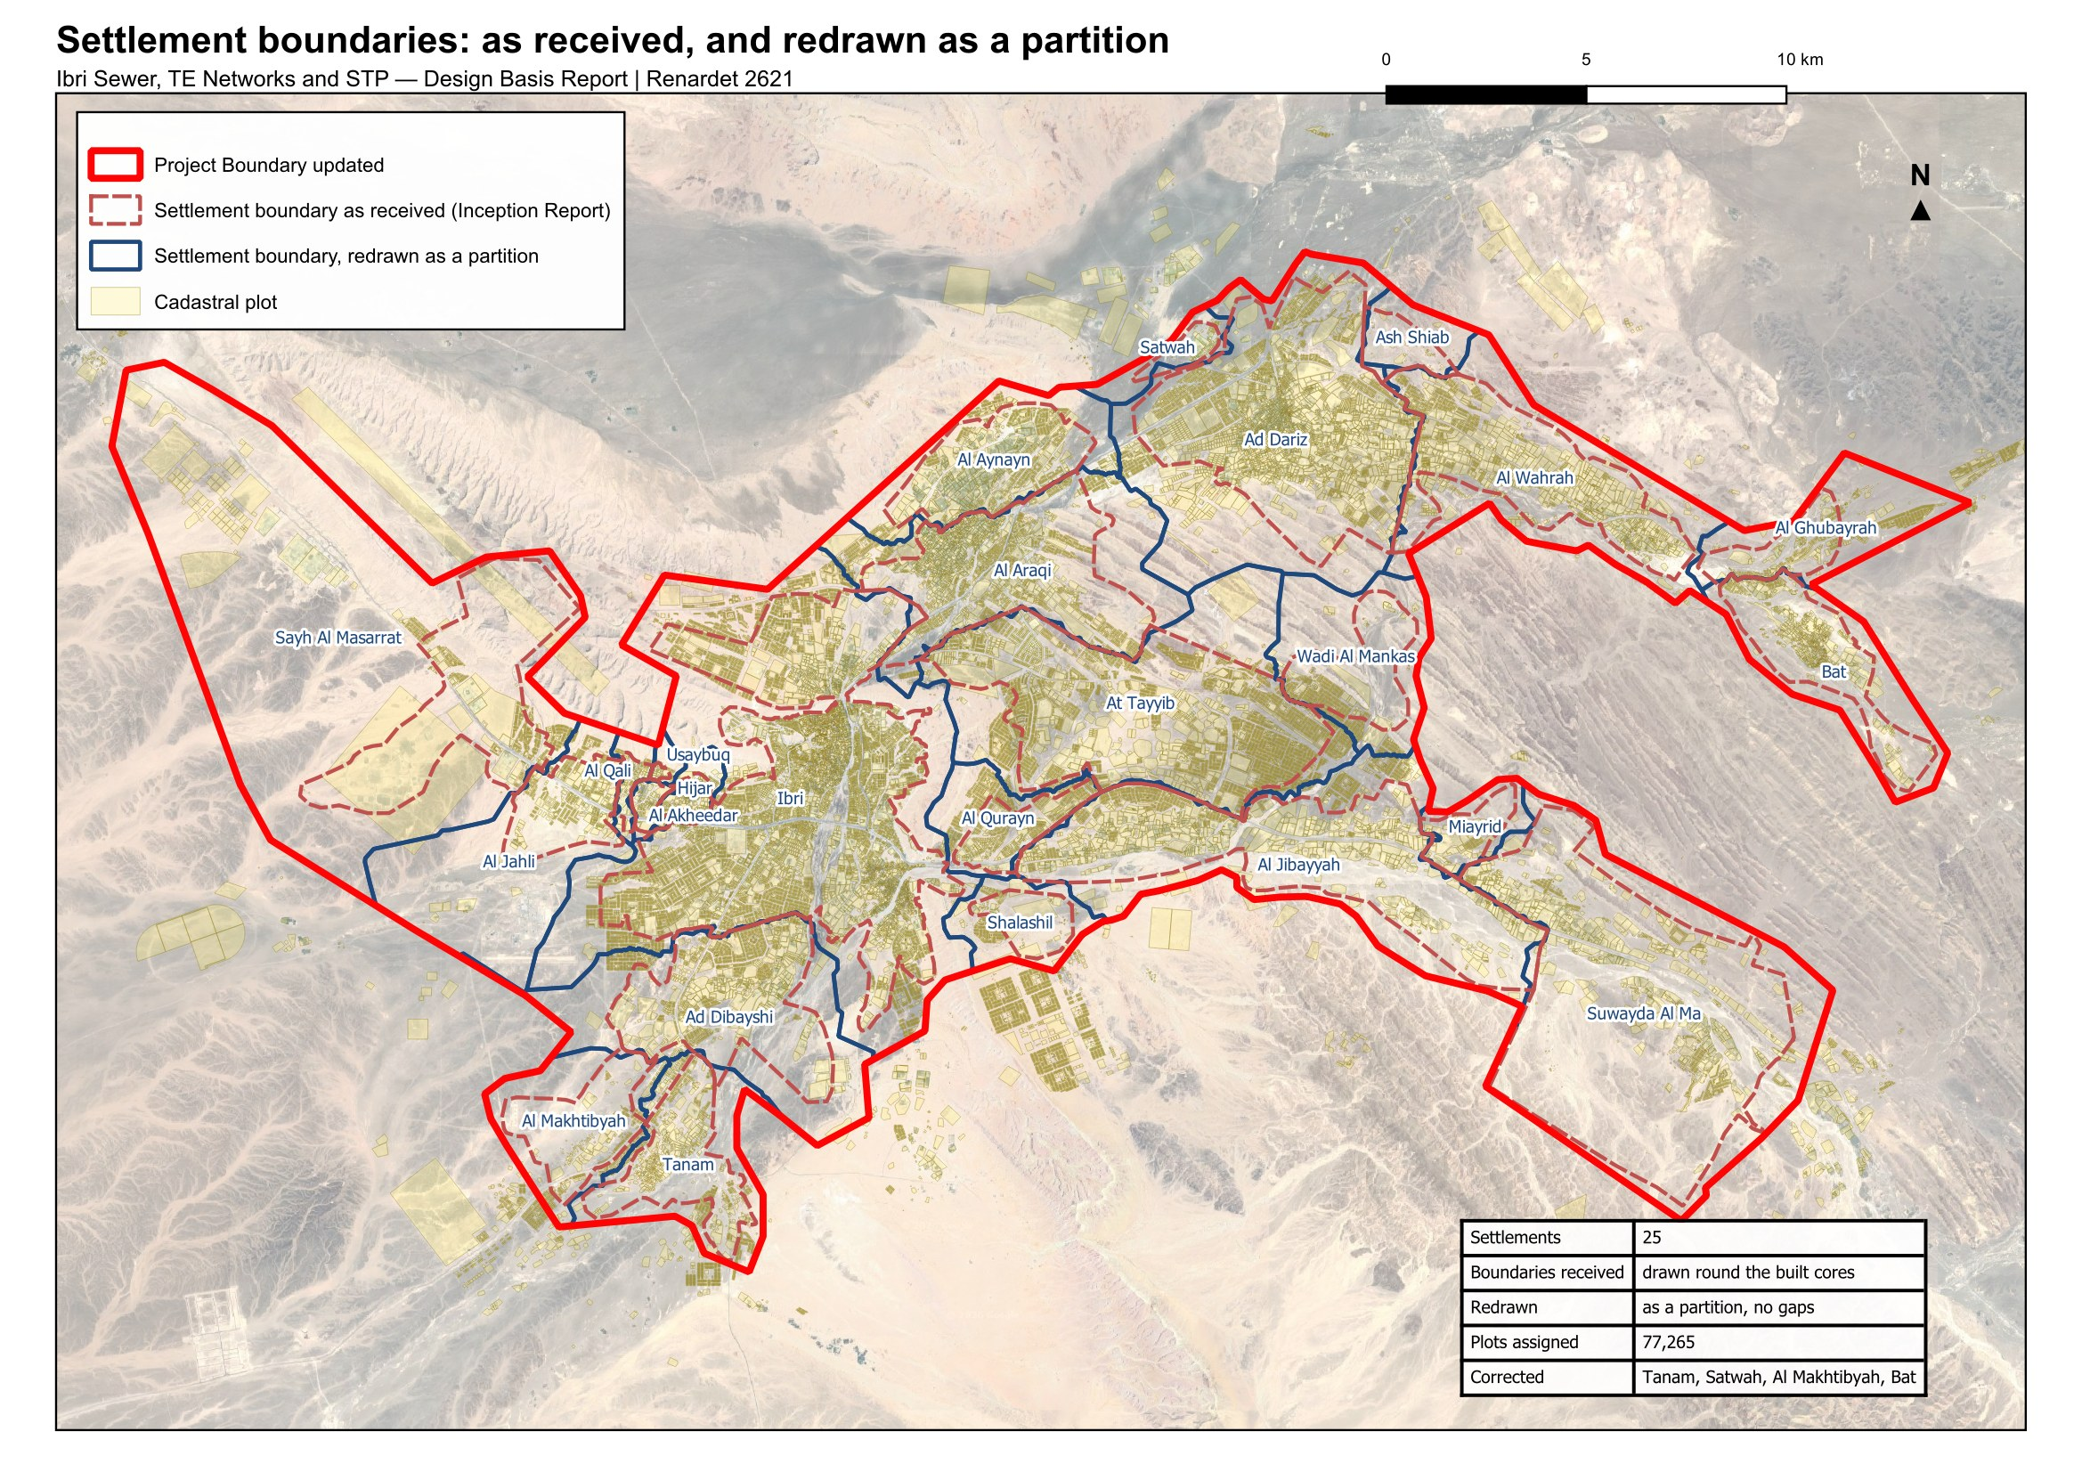
Figure 1 The settlement boundaries as received (red, dashed) and as redrawn for the design (blue). Every plot lies in one settlement and the boundaries meet without gaps.

3. People today
The population is counted, not assumed. Every domestic electricity meter is a property. The number of people in a property is set for each settlement from the official population. The two together give the people on every plot in 2024, the year of the electricity data.

3.1. From the meters to the properties
The electricity dataset holds 33,971 meters. 30,931 of them fall inside a plot. 2,914 lie on a road or in a gap between plots and were given the nearest plot within fifteen metres. 126 lie further than that from any plot; Section 3.3 shows them. Each meter on a household tariff is one property: 22,559 properties in all. Shop, office, government, farm and large-consumer meters carry no people.

3.2. Persons per property
The occupancy of each settlement is its population in 2024 divided by the properties counted in it.
$OR = \frac{population of the settlement in 2024}{properties counted in it}$ (1)
OR: occupancy, persons per property
Three rules bound the result. A floor of 4.0: some settlements would otherwise return between one and four persons per property, because their meters include the housing of the police, the college and similar institutions, whose occupants the census does not count as residents. Those properties discharge to the sewer whatever the census says, so the floor keeps them in. A cap of 6.12, the highest rate among the settlements of two thousand people or more. And a settlement of fewer than a thousand people takes 4.0 outright, one property per home plot and a home share of 0.9 (Section 6.1), because it has too few meters to measure on. That rule applies to 13 settlements.
Ibri returns 6.07 persons per property. Over the whole study area the census gives 5.16. The guideline derives occupancy from population and housing units published by the statistics centre; housing units are not published at settlement level, and the counted properties are used in their place.
Table 4 Persons per property by settlement, 2024
Settlement | Properties | Population 2024 | Rate calculated | Rate adopted | People in the design
Ibri | 11,052 | 67,106 | 6.07 | 6.07 | 67,106
Ad Dariz | 2,439 | 11,850 | 4.86 | 4.86 | 11,850
Al Araqi | 2,466 | 10,696 | 4.34 | 4.34 | 10,696
Al Aynayn | 889 | 4,554 | 5.12 | 5.12 | 4,554
Al Wahrah | 716 | 3,351 | 4.68 | 4.68 | 3,351
At Tayyib | 833 | 3,348 | 4.02 | 4.02 | 3,348
Al Jibayyah | 524 | 2,686 | 5.13 | 5.13 | 2,686
Bat | 418 | 2,557 | 6.12 | 6.12 | 2,557
Ad Dibayshi | 681 | 2,411 | 3.54 | 4.00 | 2,724
Tanam | 403 | 2,116 | 5.25 | 5.25 | 2,116
Suwayda al Ma | 301 | 1,559 | 5.18 | 5.18 | 1,559
Hijar | 352 | 1,033 | 2.93 | 4.00 | 1,408
Al Ghubayrah | 161 | 631 | 3.92 | 4.00 | 644
Al Qurayn | 147 | 549 | 3.73 | 4.00 | 588
Sayh al Masarrat | 457 | 466 | 1.02 | 4.00 | 1,828
Al Jahli | 344 | 415 | 1.21 | 4.00 | 1,376
Satwah | 27 | 263 | 9.73 | 4.00 | 108
Al Akheedar | 120 | 198 | 1.65 | 4.00 | 480
Al Qali | 56 | 191 | 3.41 | 4.00 | 224
Shalashil | 38 | 130 | 3.42 | 4.00 | 152
Al Makhtibyah | 91 | 122 | 1.34 | 4.00 | 364
Usaybuq | 21 | 91 | 4.33 | 4.00 | 84
Wadi al Mankas | 8 | 52 | 6.49 | 4.00 | 32
Ash Shiab | 11 | 47 | 4.27 | 4.00 | 44
Miayrid | 4 | 34 | 8.49 | 4.00 | 16
Total | 22,559 | 116,452 |  |  | 119,893

With the floor and the cap the study area holds 119,893 people, against 116,452 in the official series for the same settlements. The difference is the institutional housing.
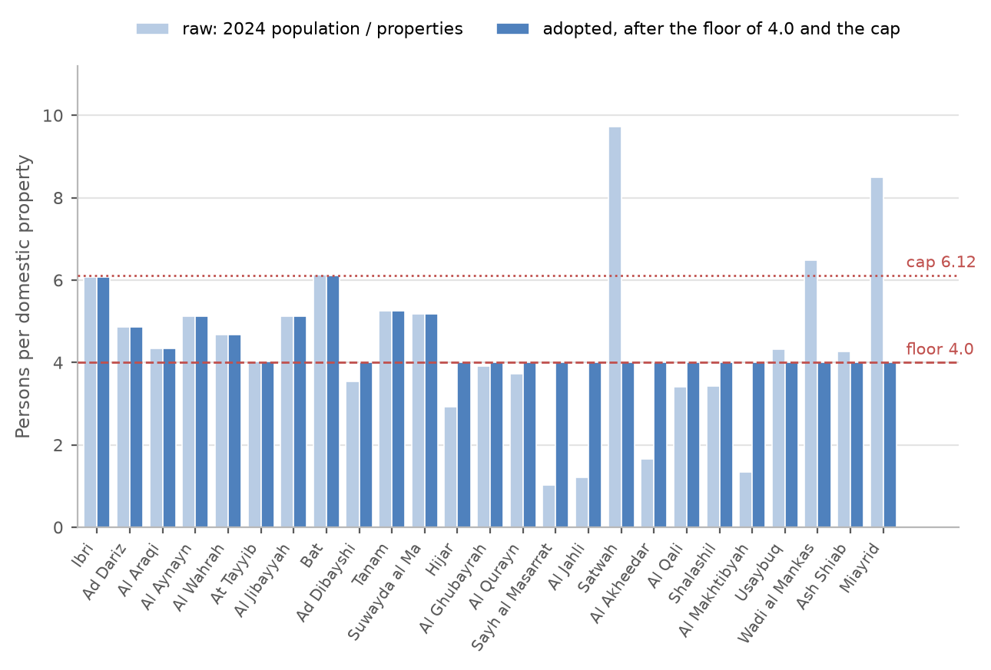
Figure 2 Persons per property by settlement: the value calculated from the census and the meters, and the value adopted after the floor and the cap.
Decision 2. Approve the persons per property calculated for each settlement, with the floor of 4.0, the cap of 6.12 and the rule for settlements under a thousand people (Section 3).

3.3. The 126 meters with no plot within 15 metres
126 meters lie more than fifteen metres from any plot. 30 of them are domestic meters, about 140 people at their settlement's occupancy; the rest are government, shop and farm meters. Some stand on buildings the cadastre has not yet captured. Others stand on nothing: a road reserve, open ground, a pumping station. All of them are left out of the plot loads. The map on the next page shows where they are, and the figure after it shows nine of them close up, with the plots around them.
Table 5 The 126 meters by settlement
Settlement | Meters | Settlement | Meters
Ibri | 29 | Ad Dibayshi | 3
Sayh al Masarrat | 14 | Al Jahli | 3
Al Qurayn | 14 | Al Makhtibyah | 2
Al Araqi | 9 | Al Wahrah | 2
Suwayda al Ma | 9 | Shalashil | 1
Al Jibayyah | 9 | Ash Shiab | 1
Tanam | 8 | Al Qali | 1
Ad Dariz | 6 | Bat | 1
Al Ghubayrah | 5 | Al Akheedar | 1
At Tayyib | 4 | Wadi al Mankas | 1
Al Aynayn | 3
Adopted (8). They are left out of the plot loads: about 140 people (Section 3.3).

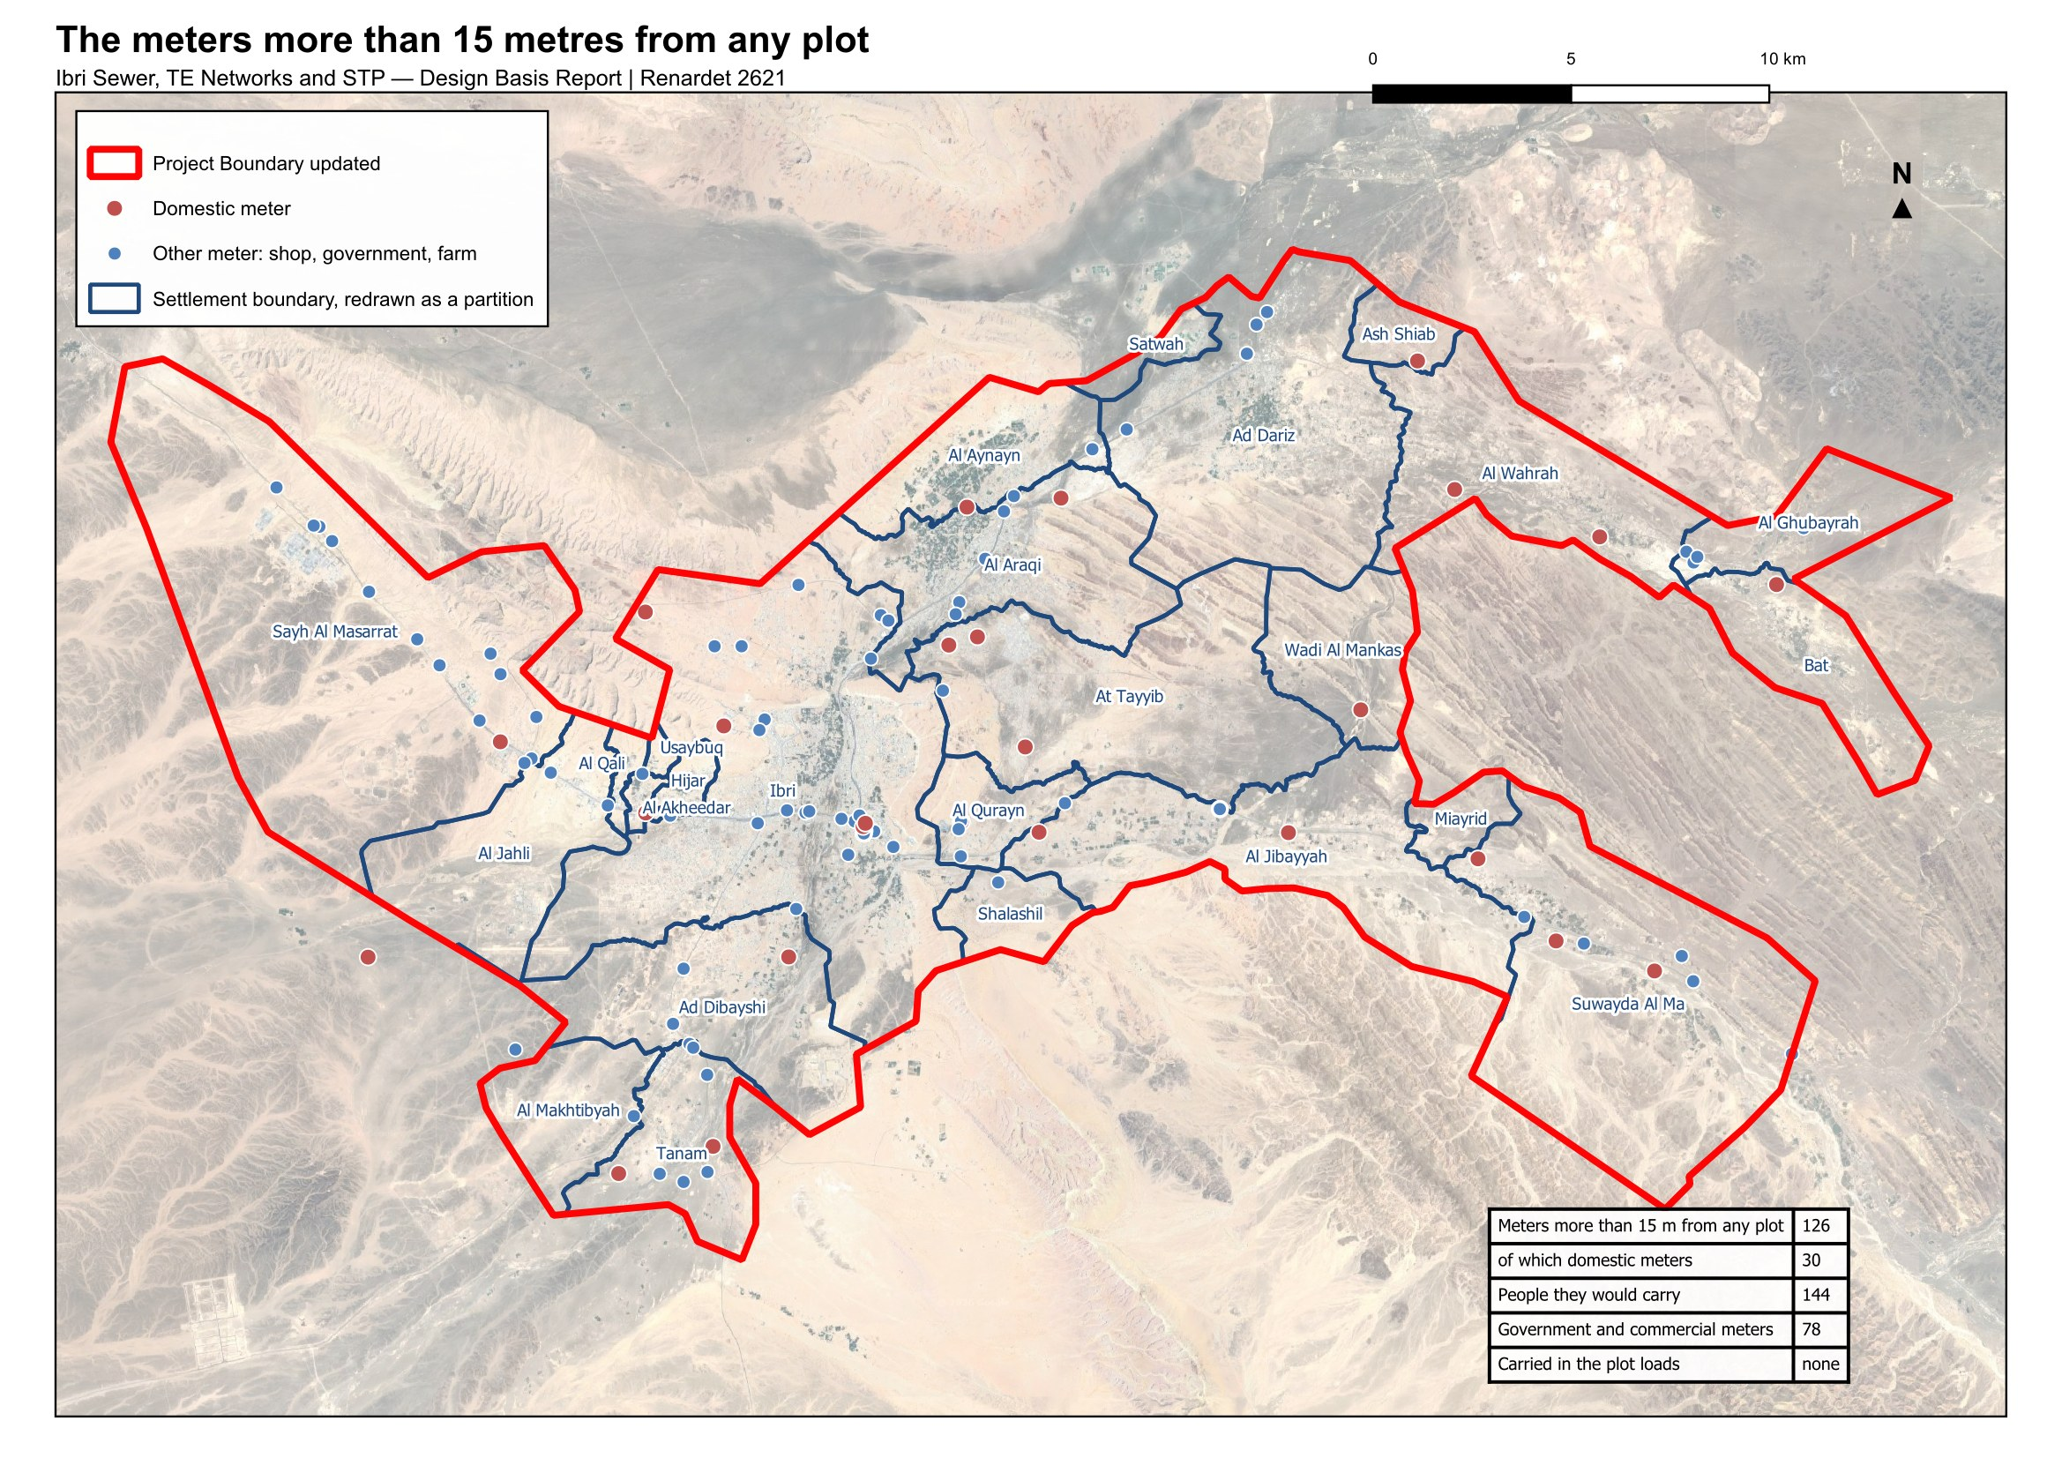
Figure 3 The 126 meters more than fifteen metres from any plot. Red: a domestic meter; blue: any other meter.
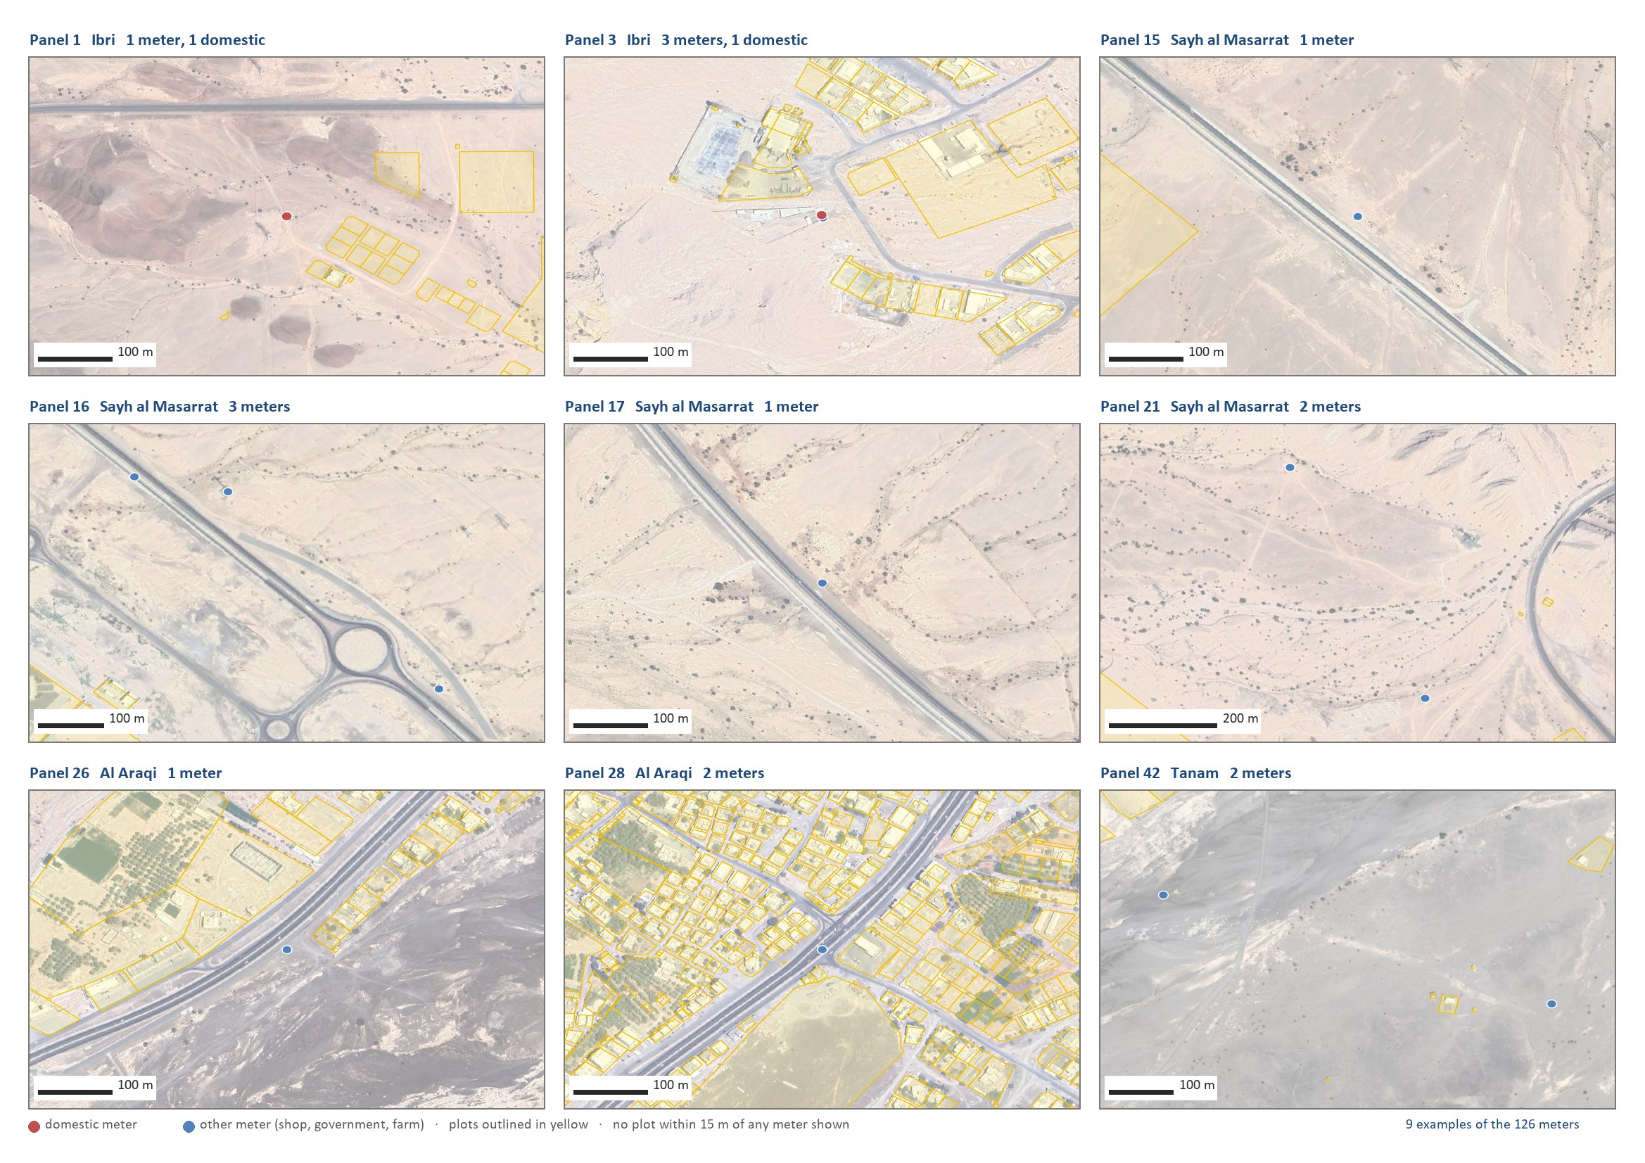
Figure 4 Nine of the 126 meters close up: on a road, in open ground, at a pumping station, on a building the cadastre does not carry. The plots are outlined in yellow.

4. The use of each plot
The cadastre's own land-use field cannot be used as it stands: it has no government class, it records whole districts under codes that mean unclassified, and on the plots that carry meters it disagrees with the meters on 24 per cent of them. The use of every plot has therefore been determined from what is on it, in a fixed order.
1. a plot inside one of the two industrial estates is industrial;
2. the 177 plots of the old quarter of Ibri, recorded as tourism, are heritage and carry no load;
3. a plot with a farm meter is a farm;
4. a plot the satellite image shows as planted is a farm, unless two thirds of its meters are shops or most are government;
5. a plot whose industrial meters equal or outnumber its households is industrial;
6. otherwise the meters decide by proportion: more than two thirds households makes a home, two thirds or more government makes a government plot, two thirds or more shops makes a shop, and a mix is a home with a shop, or a government plot where the government meters are the more;
7. a plot without a meter is empty.
The satellite image is a cloud-free Sentinel-2 image of 9 September 2026. It is used for one purpose: to tell a planted plot, a date-palm plantation, from a bare one, because a farm meter alone misses the plantations that pump from elsewhere.
Table 6 Use of the built plots that carry a meter
Use | Plots | How it was decided
Home | 12,464 | more than two thirds of the meters are households
Home with a shop | 614 | a mix, with at least as many shop as government meters
Shop | 1,321 | two thirds or more of the meters are shops
Government | 410 | two thirds or more government; or a mix with more government than shop meters; the treatment plant
Farm | 1,684 | a farm meter (488) or planted on the satellite image (1,196)
Industrial | 263 | inside an industrial estate, or industrial meters that match the households
Heritage | 177 | the old quarter of Ibri; no meter, no load
Empty | 60,509 | no meter

The use decides where the shop and government water is placed and which empty plots can become homes. It does not change the total: that comes from the people and the rates of Section 5.
Decision 3. Approve the use determined for each plot from the meters and the satellite image, in place of the cadastre's own land-use field, as the basis for placing the loads (Section 4).

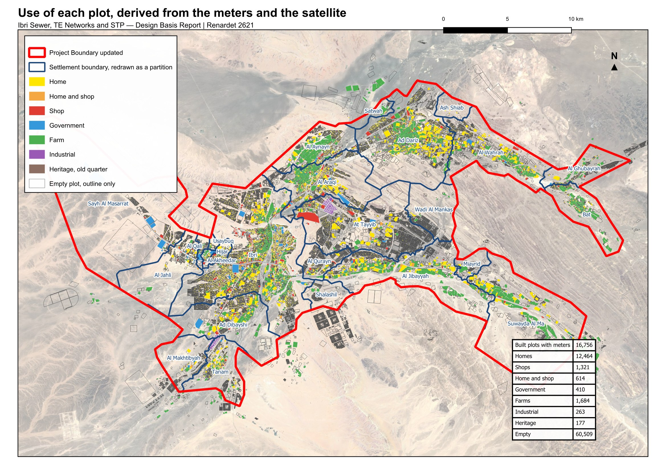
Figure 5 The use of each plot. Coloured plots are built and metered; empty plots are shown by their outline only.

5. From water to sewage
Sewage is calculated from water. Three streams are carried for every settlement: the water of its households, of its shops and offices, and of its government buildings. A fourth, the special consumption, is added on its own; in the study area it is the two industrial estates. Each stream returns a fixed share to the sewer.
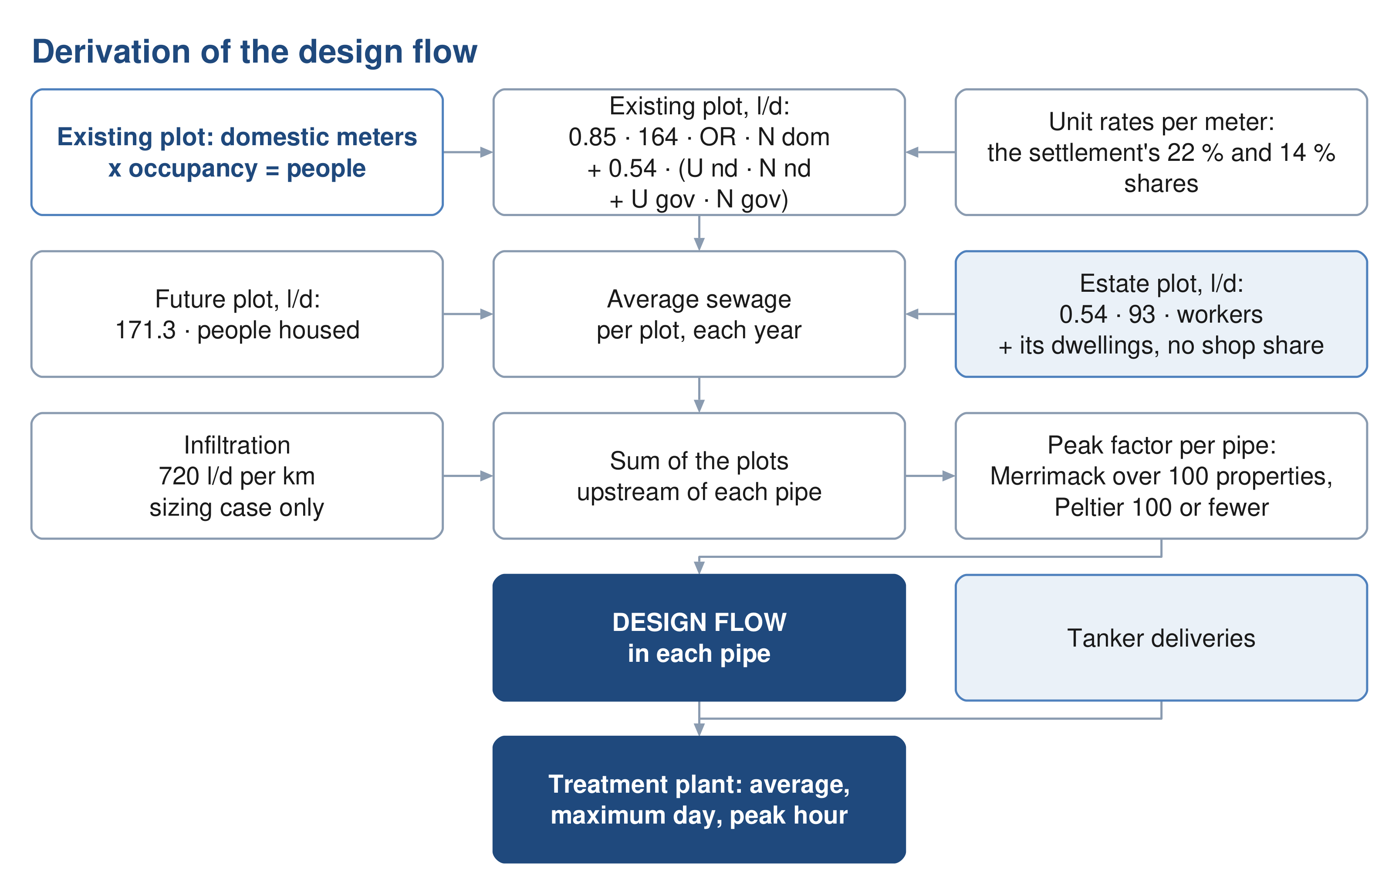
Figure 6 From the plot to the pipe and the STP: what each step adds.

5.1. Water demand
A person uses 164 litres a day at home. That is the value the guideline publishes for the Governorate of Adh Dhahirah, to be used until Nama Water Services issues an updated figure.
$Q_{dom} = people × 164$ (2)
Q dom: domestic water demand, l/d
Shops, offices and government buildings are added as shares of the domestic water: 22 per cent for shops and offices, 14 per cent for government. The guideline calls these shares distributed. They come from the governorate's water balance of 2021 to 2023, all the non-domestic water divided by all the domestic water, so they stand for the everyday shops, mosques, schools and offices that come with any population, and they are added whether or not a particular village has a shop today. They do not cover named projects such as economic zones, which are added separately.
$Q_{shops} = 0.22Q_{dom} Q_{gov} = 0.14Q_{dom}$ (3)
Q shops: water of shops and offices in the settlement, l/d
Q gov: water of government buildings in the settlement, l/d
The guideline prefers unit rates where detailed land use is known: so many litres per pupil, per hospital bed, per employee, per square metre of shop. None of those quantities is held for Ibri. Until they are, the ratios are used. They are not added on top of unit rates anywhere; it is one or the other.
The shares are placed where the water is used. Each settlement's shop water is divided equally among its shop meters, and its government water among its government meters, so the load sits on the shopping street and the school, not on the houses. A settlement with no shop or government meter keeps that share on its houses.

5.2. Return to the sewer
Not all water reaches the sewer. Households return 85 per cent, and so does water delivered by tanker; shops, offices, government buildings and the special consumption return 54 per cent. Farm meters feed irrigation pumps and return nothing.
$Q_{sewage} = 0.85Q_{dom} + 0.54\left(Q_{shops} + Q_{gov} + Q_{special}\right)$ (4)
Q sewage: average sewage flow, before infiltration, l/d
Q special: water of the special consumption, the guideline's term; in the study area the two industrial estates, l/d
For a person in a new home all three streams are added together: 164 × 0.85 + 36 × 0.54 + 23 × 0.54 = 171.3 litres of sewage a day. That is the rate every future plot carries, because where its shops will stand is not known.
Adopted (9). 164 litres per person per day, plus 22 per cent for shops and offices and 14 per cent for government, the values the guideline publishes for Adh Dhahirah; 85 per cent of domestic and tanker supply and 54 per cent of the rest return to the sewer. The published ratios are used in place of the unit rates per pupil, bed, employee and floor area until those quantities are held (Section 5).

5.3. Special consumption: the industrial estates and other named sites
Two industrial estates lie inside the study area, at Al Tayyeb in the north-east of the town and at Tanam beside the treatment plant. Their meters are on the commercial tariff. The guideline keeps such estates outside the ratios, as special consumption, so they are carried on their own: a workforce of 4,500 at Al Tayyeb and 1,800 at Tanam, at 93 litres a day each, the dry-industry rate. The workforce is an assumption from the number of workshop meters and is to be replaced by the estates' records.
Table 7 Named sites outside the ratios
Site | What it is | How it is carried
Al Tayyeb industrial area | 94 ha, 202 industrial plots | 4,500 workers at 93 l/d
Tanam industrial area | 61 ha, 105 plots, beside the STP | 1,800 workers at 93 l/d
Army camp | 296 ha west of the town, no meter | recorded, no load; occupancy and drainage to be confirmed
Ibri View resort | 2 km² at As Sulayf, announced | recorded, no load until its plan is issued
Ibri Industrial City (Madayn) | 10 km², 8.6 km outside the boundary | outside the network; a source of tankered sewage to confirm
Power station and solar plants | 7.5 to 11 km outside, with a camp | outside the network; tankered sewage to confirm

Water delivered by tanker and water from private wells are in no flow. No filling-station or delivery record is held, and no record of private wells. Both are requested in Section 9. A household on tanker supply is metered for electricity like any other, so its people are counted; only the extra water is missing, and it can only raise the loads.
Adopted (10). 4,500 workers at Al Tayyeb and 1,800 at Tanam at 93 litres a day each, an assumption to be replaced by the estates' records when received (Section 5.3).

5.4. The result for 2024
Applied plot by plot, the rules give 20,852 cubic metres of sewage a day in 2024: 16,713 from households, 2,336 from shops and offices, 1,486 from government buildings and 316 from the two estates. The table gives the settlements.
Table 8 Water and sewage by settlement, 2024, m³/d
Settlement | People | Household water | Shop and office water | Government water | Special | Sewage
Ibri | 67,106 | 11,005 | 2,421 | 1,541 | – | 11,494
Ad Dariz | 11,850 | 1,943 | 428 | 272 | – | 2,030
Al Araqi | 10,696 | 1,754 | 386 | 246 | – | 1,832
Al Aynayn | 4,554 | 747 | 164 | 105 | – | 780
Al Wahrah | 3,351 | 550 | 121 | 77 | – | 574
At Tayyib | 3,348 | 549 | 121 | 77 | 419 | 799
Al Jibayyah | 2,686 | 440 | 97 | 62 | – | 460
Bat | 2,557 | 419 | 92 | 59 | – | 438
Ad Dibayshi | 2,724 | 447 | 98 | 63 | 27 | 481
Tanam | 2,116 | 347 | 76 | 49 | 105 | 419
Suwayda al Ma | 1,559 | 256 | 56 | 36 | – | 267
Hijar | 1,408 | 231 | 51 | 32 | – | 241
Al Ghubayrah | 644 | 106 | 23 | 15 | – | 110
Al Qurayn | 588 | 96 | 21 | 14 | – | 101
Sayh al Masarrat | 1,828 | 300 | 66 | 42 | – | 313
Al Jahli | 1,376 | 226 | 50 | 32 | – | 236
Satwah | 108 | 18 | 4 | 2 | – | 19
Al Akheedar | 480 | 79 | 17 | 11 | – | 82
Al Qali | 224 | 37 | 8 | 5 | – | 38
Shalashil | 152 | 25 | 5 | 3 | – | 26
Al Makhtibyah | 364 | 60 | 13 | 8 | 36 | 82
Usaybuq | 84 | 14 | 3 | 2 | – | 14
Wadi al Mankas | 32 | 5 | 1 | 1 | – | 5
Ash Shiab | 44 | 7 | 2 | 1 | – | 8
Miayrid | 16 | 3 | 1 | 0 | – | 3
Total | 119,893 | 19,663 | 4,326 | 2,753 | 586 | 20,852

6. How the land fills
The population of 2024 is counted. The population at the end is set by the land: a settlement can only grow until its empty plots are built. Three things are needed: how many people the empty land can hold, how fast each settlement grows, and what happens when it is full.
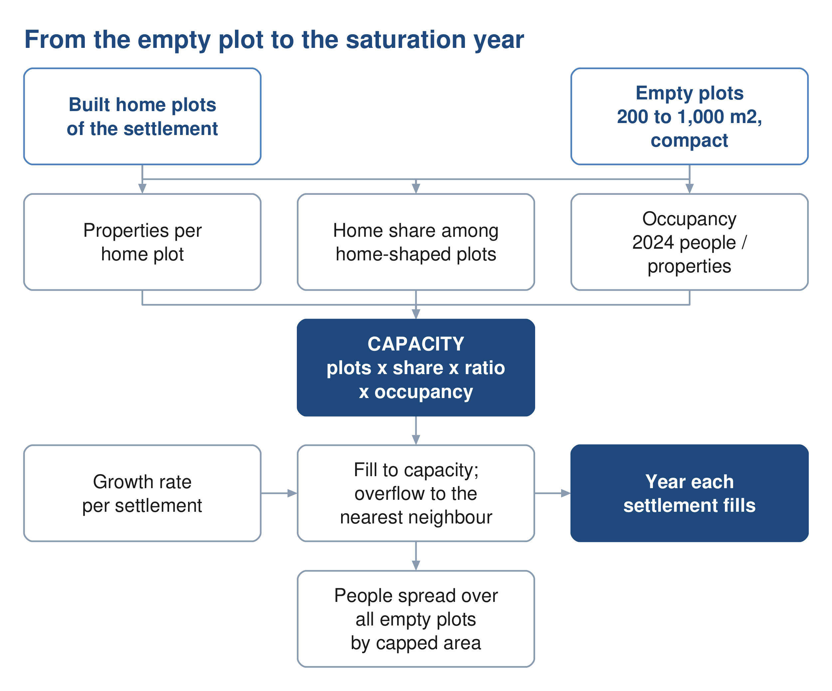
Figure 7 From the empty plot to the year each settlement is full.

6.1. How many people the empty land can hold
Of the 77,265 plots, 60,509 carry no meter. Not all of them will become homes. A future home plot must look like the built ones: between 200 and 1,000 square metres, compact, not a strip. Very small plots below 200 square metres, odd shapes and everything above 1,000 square metres are left out, as are plantations, industrial plots and the heritage quarter. 46,109 empty plots pass that test.
A district also needs mosques, shops and offices, so not every home-shaped plot becomes a home. The share that does is measured in each settlement over its built, metered, home-shaped plots. Ibri returns 0.87; among the settlements of a thousand people or more it runs from 0.67 at Tanam to 0.94 at Al Aynayn. The number of properties a home plot carries is measured the same way; Ibri returns 1.33.
$capacity = home‑shaped empty plots × home share × properties per plot × OR$ (5)
capacity: people the empty land of the settlement can hold, persons
home share: share of the home-shaped plots that become homes
OR: persons per property of the settlement
The empty land of the study area holds 229,136 people on this basis, against 119,893 living in it in 2024.

6.2. How fast each settlement grows
The growth rate comes from the population series of the Inception Report, and nothing else is taken from it. To 2040 the series is the official forecast for the wilayat, from the statistics centre and Nama Water Services; from 2041 to 2050 it is the extension of that forecast in the Inception Report. Both are the client's own figures. From 2051 the series rises from 2.2 per cent a year to 2.40 by 2058 and stays there to 2100, the horizon Nama Water Services instructed; that part goes beyond the ten years of extension the guideline allows and is put to approval. Every settlement carries the same annual rate, applied to its counted population. The rate averages 2.6 per cent a year to 2030, 2.5 in the 2030s, 2.0 in the 2040s, 2.3 in the 2050s and 2.4 after 2060.
The series' total for 2100 is not a target. The land fills long before then.
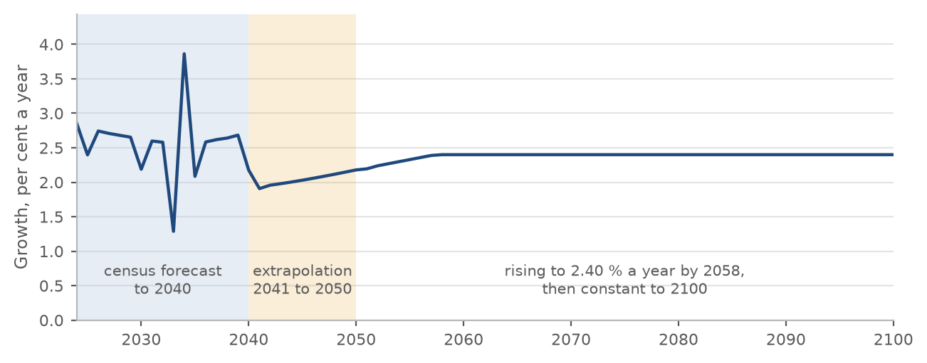
Figure 8 The annual growth rate of the series: the forecast to 2040, the extension to 2050, and the rise to a constant 2.40 per cent.
Decision 6. Approve the extension of the population series beyond 2050: the rise to 2.40 per cent a year by 2058 and that rate held to 2100. The series to 2050 is the client's own (Section 6.2).

6.3. What happens when a settlement is full: the overflow
Each settlement grows at the rate of the series until its empty plots are built. Then its further growth has to go somewhere. Two readings are possible, and the choice between them is the largest single decision in this report.
With the overflow: when a settlement is full, its further growth moves to a neighbour with room. Ibri's goes in parallel to Al Araqi, Al Qurayn and Shalashil, in the proportions seventy, twenty and ten per cent, then to Ad Dariz, then to the nearest settlement with room. At Tayyib's goes first to Miayrid. Every other settlement overflows to its nearest neighbour with room.
Without: each settlement grows on its own rate and stops when it is full. The growth it cannot house is lost to the study area.
The difference is large. With the overflow every settlement fills by 2070 and the study area holds 349,029 people. Without it, 7 settlements never fill before 2100, the study area holds 273,616 people in 2070, and 75,414 people of the series have nowhere to go. A sewer in those settlements sized on their own growth would be sized for land that never fills.
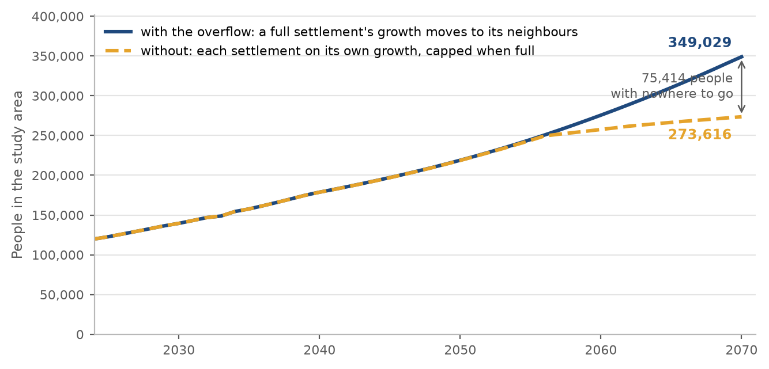
Figure 9 People in the study area by year, with the overflow and without it.
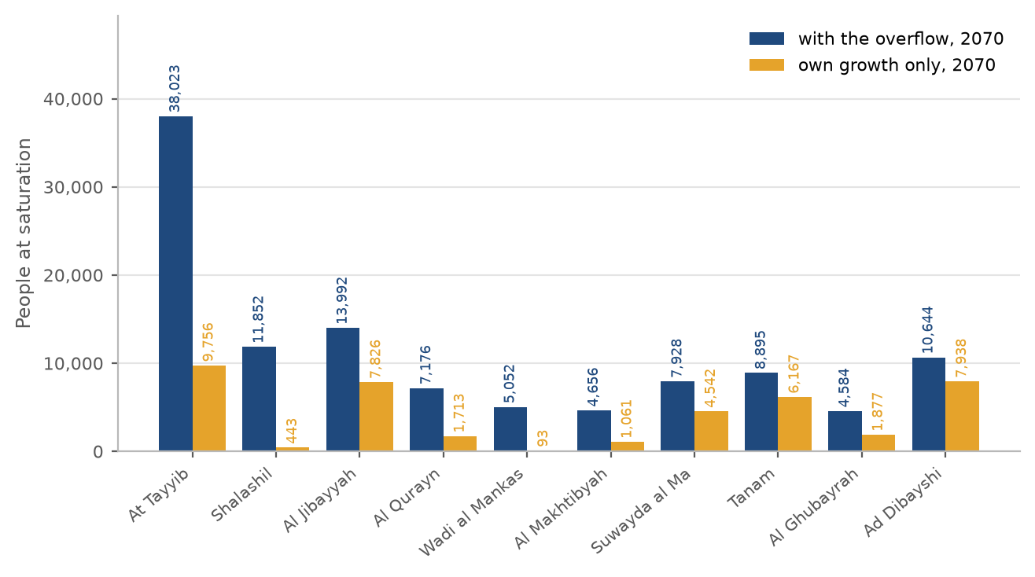
Figure 10 People at saturation in the ten settlements the choice affects most, with the overflow and without.
Table 9 Every settlement with and without the overflow: people in 2070 and the year it is full
Settlement | Capacity, people | With the overflow: people 2070 | full in | Own growth only: people 2070 | full in
Ibri | 73,299 | 140,405 | 2056 | 140,405 | 2057
Ad Dariz | 16,854 | 28,704 | 2062 | 28,704 | 2063
Al Araqi | 11,832 | 22,528 | 2057 | 22,528 | 2057
Al Aynayn | 7,459 | 12,013 | 2060 | 12,013 | 2066
Al Wahrah | 7,109 | 10,460 | 2070 | 9,765 | 2073
At Tayyib | 34,675 | 38,023 | 2068 | 9,756 | not before 2100
Ad Dibayshi | 7,920 | 10,644 | 2063 | 7,938 | 2083
Al Jibayyah | 11,306 | 13,992 | 2070 | 7,826 | 2095
Bat | 2,226 | 4,783 | 2052 | 4,783 | 2052
Tanam | 6,779 | 8,895 | 2069 | 6,167 | 2086
Sayh al Masarrat | 4,984 | 6,812 | 2069 | 5,327 | 2081
Suwayda al Ma | 6,369 | 7,928 | 2070 | 4,542 | 2094
Hijar | 1,288 | 2,696 | 2053 | 2,696 | 2053
Al Jahli | 3,684 | 5,060 | 2063 | 4,010 | 2080
Al Ghubayrah | 3,940 | 4,584 | 2070 | 1,877 | not before 2100
Al Qurayn | 6,588 | 7,176 | 2060 | 1,713 | not before 2100
Al Akheedar | 160 | 640 | 2036 | 640 | 2036
Al Makhtibyah | 4,292 | 4,656 | 2069 | 1,061 | not before 2100
Al Qali | 564 | 788 | 2054 | 653 | 2078
Shalashil | 11,700 | 11,852 | 2061 | 443 | not before 2100
Satwah | 284 | 392 | 2060 | 315 | 2080
Usaybuq | 140 | 224 | 2054 | 224 | 2067
Ash Shiab | 48 | 92 | 2056 | 92 | 2056
Wadi al Mankas | 5,020 | 5,052 | 2068 | 93 | not before 2100
Miayrid | 616 | 632 | 2070 | 47 | not before 2100
Total | 229,136 | 349,029 | 2070 | 273,616

Decision 4. Approve the overflow: when a settlement's land is full, its further growth moves to its neighbours. Without it 75,000 people of the series have nowhere to go by 2070 (Section 6.3).

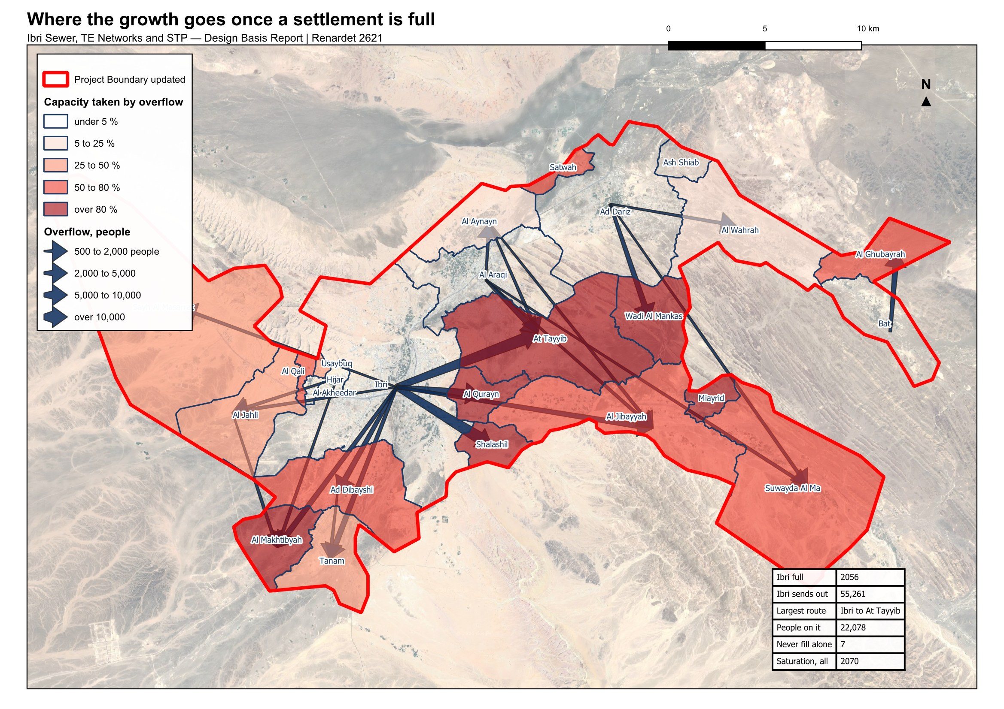
Figure 11 Where the growth goes once a settlement is full. Arrows show the routes carrying five hundred people or more; the shading shows how much of each settlement's capacity is taken by its neighbours' overflow.

6.4. The design horizon: 2055, or the year the land is full
The Terms of Reference name a horizon of completion plus twenty-five years. With the opening year taken as 2030, that is 2055: 244,914 people and 42,266 cubic metres a day. The Terms of Reference also ask for the saturation of the area. With the overflow, Ibri fills in 2056, Al Araqi in 2057, Ad Dariz in 2062, and the last settlement in 2070: 349,029 people and 60,099 cubic metres a day, 42 per cent more than in 2055.
The two horizons ask different things of the design. A network sized on 2055 is cheaper to build and reaches its capacity while the plots around it are still being built; the pipes under those streets would then need to be replaced or relieved. A network sized on the year the land is full is laid once, and its sewers run at low flow for longer, which the self-cleansing check of Section 7.3 is there to catch. The treatment plant is staged either way, on the series. The horizon is for Nama Water Services to decide.
Table 10 The study area in the design years
Year | People | Average sewage flow, m³/d | What it is
2024 | 119,893 | 20,852 | today, from the meters
2030 | 139,535 | 24,216 | opening year
2055 | 244,914 | 42,266 | opening year plus 25 years
2070 | 349,029 | 60,099 | saturation: the land is full

Decision 5. Decide the design horizon: 2055, the opening year 2030 plus 25 years, with 244,914 people and 42,266 cubic metres a day; or 2070, the year the land is full, with 349,029 people and 60,099 cubic metres a day (Section 6.4).
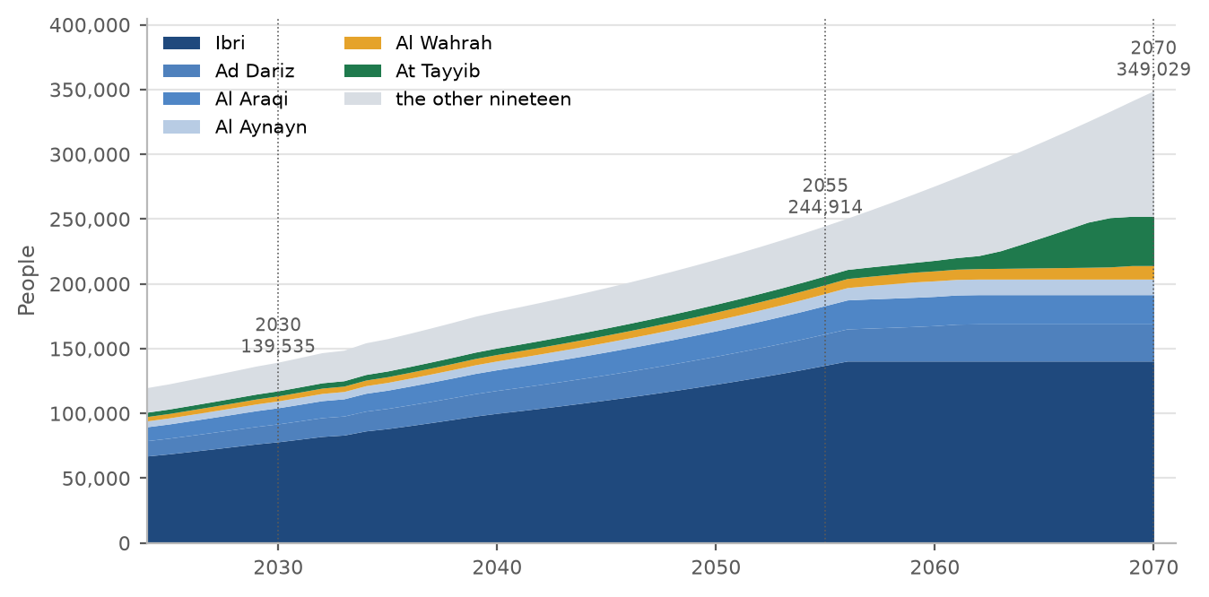
Figure 12 People by year to saturation, the six largest settlements shown separately. The flat top of each band is the year that settlement fills.
The people of every settlement at five-year steps, to the year it is full. A cell is blank once the settlement is full.
Table 11 People by settlement at five-year intervals
Settlement | 2024 | 2025 | 2030 | 2035 | 2040 | 2045 | 2050 | 2055 | 2060 | 2065 | 2070 | Full in | At saturation
Ibri | 67,106 | 68,713 | 78,099 | 88,272 | 100,066 | 110,349 | 122,535 | 137,198 |  |  |  | 2056 | 140,405
Ad Dariz | 11,850 | 12,134 | 13,791 | 15,587 | 17,670 | 19,486 | 21,638 | 24,206 | 27,350 |  |  | 2062 | 28,704
Al Araqi | 10,696 | 10,952 | 12,448 | 14,069 | 15,949 | 17,588 | 19,531 | 21,849 |  |  |  | 2057 | 22,528
Al Aynayn | 4,554 | 4,663 | 5,300 | 5,990 | 6,791 | 7,489 | 8,316 | 9,303 | 12,013 |  |  | 2060 | 12,013
Al Wahrah | 3,351 | 3,431 | 3,900 | 4,408 | 4,997 | 5,511 | 6,119 | 6,845 | 7,703 | 8,684 | 10,460 | 2070 | 10,460
At Tayyib | 3,348 | 3,428 | 3,897 | 4,404 | 4,993 | 5,506 | 6,114 | 6,839 | 8,130 | 23,972 |  | 2068 | 38,023
Ad Dibayshi | 2,724 | 2,789 | 3,170 | 3,583 | 4,062 | 4,479 | 4,974 | 5,564 | 6,262 |  |  | 2063 | 10,644
Al Jibayyah | 2,686 | 2,750 | 3,126 | 3,533 | 4,005 | 4,416 | 4,904 | 5,486 | 6,174 | 6,951 | 13,992 | 2070 | 13,992
Bat | 2,557 | 2,618 | 2,976 | 3,363 | 3,813 | 4,204 | 4,669 |  |  |  |  | 2052 | 4,783
Tanam | 2,116 | 2,167 | 2,463 | 2,784 | 3,156 | 3,480 | 3,864 | 4,323 | 4,865 | 5,961 |  | 2069 | 8,895
Sayh al Masarrat | 1,828 | 1,872 | 2,127 | 2,405 | 2,726 | 3,006 | 3,338 | 3,734 | 4,202 | 4,786 |  | 2069 | 6,812
Suwayda al Ma | 1,559 | 1,596 | 1,814 | 2,050 | 2,324 | 2,563 | 2,846 | 3,184 | 3,583 | 4,034 | 7,928 | 2070 | 7,928
Hijar | 1,408 | 1,442 | 1,639 | 1,852 | 2,100 | 2,315 | 2,571 |  |  |  |  | 2053 | 2,696
Al Jahli | 1,376 | 1,409 | 1,601 | 1,810 | 2,052 | 2,263 | 2,513 | 2,831 | 3,746 |  |  | 2063 | 5,060
Al Ghubayrah | 644 | 659 | 750 | 847 | 960 | 1,059 | 1,176 | 1,756 | 2,575 | 3,501 | 4,584 | 2070 | 4,584
Al Qurayn | 588 | 602 | 684 | 773 | 877 | 967 | 1,074 | 1,201 | 7,176 |  |  | 2060 | 7,176
Al Akheedar | 480 | 492 | 559 | 631 |  |  |  |  |  |  |  | 2036 | 640
Al Makhtibyah | 364 | 373 | 424 | 479 | 543 | 599 | 665 | 744 | 837 | 1,522 |  | 2069 | 4,656
Al Qali | 224 | 229 | 261 | 295 | 410 | 518 | 646 |  |  |  |  | 2054 | 788
Shalashil | 152 | 156 | 177 | 200 | 227 | 250 | 278 | 311 | 8,335 |  |  | 2061 | 11,852
Satwah | 108 | 111 | 126 | 142 | 161 | 178 | 197 | 221 | 392 |  |  | 2060 | 392
Usaybuq | 84 | 86 | 98 | 110 | 125 | 138 | 153 |  |  |  |  | 2054 | 224
Ash Shiab | 44 | 45 | 51 | 58 | 66 | 72 | 80 | 90 |  |  |  | 2056 | 92
Wadi al Mankas | 32 | 33 | 37 | 42 | 48 | 53 | 58 | 65 | 74 | 2,859 |  | 2068 | 5,052
Miayrid | 16 | 16 | 19 | 21 | 24 | 26 | 29 | 33 | 37 | 41 | 632 | 2070 | 632
Total | 119,893 | 122,766 | 139,535 | 157,710 | 178,781 | 197,153 | 218,926 | 244,914 | 275,608 | 310,307 | 349,029 | 2070 | 349,029

7. The flow each element is designed for
Every plot now carries an average sewage flow for 2024, 2030, 2055 and the saturation year. What each element of the system is designed for follows from those plot flows by fixed rules, set out below element by element. The rules are the same wherever the element sits, so the client can check any one of them.

7.1. The flows by settlement and year
The average sewage flow of every settlement at five-year steps, to the year it is full, before infiltration and before the STP margin. A cell is blank once the settlement is full.
Table 12 Average sewage flow by settlement at five-year intervals, m³/d
Settlement | 2024 | 2025 | 2030 | 2035 | 2040 | 2045 | 2050 | 2055 | 2060 | 2065 | 2070 | Full in | At saturation
Ibri | 11,494 | 11,769 | 13,377 | 15,119 | 17,140 | 18,901 | 20,988 | 23,500 |  |  |  | 2056 | 24,049
Ad Dariz | 2,030 | 2,078 | 2,362 | 2,670 | 3,027 | 3,338 | 3,706 | 4,146 | 4,685 |  |  | 2062 | 4,917
Al Araqi | 1,832 | 1,876 | 2,132 | 2,410 | 2,732 | 3,013 | 3,345 | 3,742 |  |  |  | 2057 | 3,859
At Tayyib | 800 | 813 | 893 | 980 | 1,081 | 1,169 | 1,273 | 1,398 | 1,618 | 4,332 |  | 2068 | 6,739
Al Aynayn | 780 | 799 | 908 | 1,026 | 1,163 | 1,283 | 1,424 | 1,593 | 2,058 |  |  | 2060 | 2,058
Al Wahrah | 574 | 588 | 668 | 755 | 856 | 944 | 1,048 | 1,173 | 1,320 | 1,487 | 1,792 | 2070 | 1,792
Ad Dibayshi | 481 | 492 | 557 | 628 | 710 | 782 | 866 | 967 | 1,087 |  |  | 2063 | 1,838
Al Jibayyah | 460 | 471 | 535 | 605 | 686 | 756 | 840 | 940 | 1,057 | 1,191 | 2,397 | 2070 | 2,397
Bat | 438 | 448 | 510 | 576 | 653 | 720 | 800 |  |  |  |  | 2052 | 819
Tanam | 419 | 428 | 479 | 534 | 597 | 653 | 719 | 797 | 890 | 1,078 |  | 2069 | 1,580
Sayh al Masarrat | 313 | 321 | 364 | 412 | 467 | 515 | 572 | 640 | 720 | 820 |  | 2069 | 1,167
Suwayda al Ma | 267 | 273 | 311 | 351 | 398 | 439 | 488 | 545 | 614 | 691 | 1,358 | 2070 | 1,358
Hijar | 241 | 247 | 281 | 317 | 360 | 397 | 440 |  |  |  |  | 2053 | 462
Al Jahli | 236 | 241 | 274 | 310 | 351 | 388 | 430 | 485 | 642 |  |  | 2063 | 867
Al Ghubayrah | 110 | 113 | 128 | 145 | 165 | 181 | 201 | 301 | 441 | 600 | 785 | 2070 | 785
Al Qurayn | 101 | 103 | 117 | 133 | 150 | 166 | 184 | 206 | 1,229 |  |  | 2060 | 1,229
Al Akheedar | 82 | 84 | 96 | 108 |  |  |  |  |  |  |  | 2036 | 110
Al Makhtibyah | 82 | 83 | 92 | 101 | 112 | 122 | 133 | 147 | 163 | 280 |  | 2069 | 817
Al Qali | 38 | 39 | 45 | 51 | 70 | 89 | 111 |  |  |  |  | 2054 | 135
Shalashil | 26 | 27 | 30 | 34 | 39 | 43 | 48 | 53 | 1,428 |  |  | 2061 | 2,030
Satwah | 19 | 19 | 22 | 24 | 28 | 30 | 34 | 38 | 67 |  |  | 2060 | 67
Usaybuq | 14 | 15 | 17 | 19 | 22 | 24 | 26 |  |  |  |  | 2054 | 38
Ash Shiab | 8 | 8 | 9 | 10 | 11 | 12 | 14 | 15 |  |  |  | 2056 | 16
Wadi al Mankas | 6 | 6 | 6 | 7 | 8 | 9 | 10 | 11 | 13 | 490 |  | 2068 | 865
Miayrid | 3 | 3 | 3 | 4 | 4 | 5 | 5 | 6 | 6 | 7 | 108 | 2070 | 108
Total | 20,852 | 21,344 | 24,216 | 27,329 | 30,938 | 34,085 | 37,815 | 42,266 | 47,523 | 53,466 | 60,099 | 2070 | 60,099

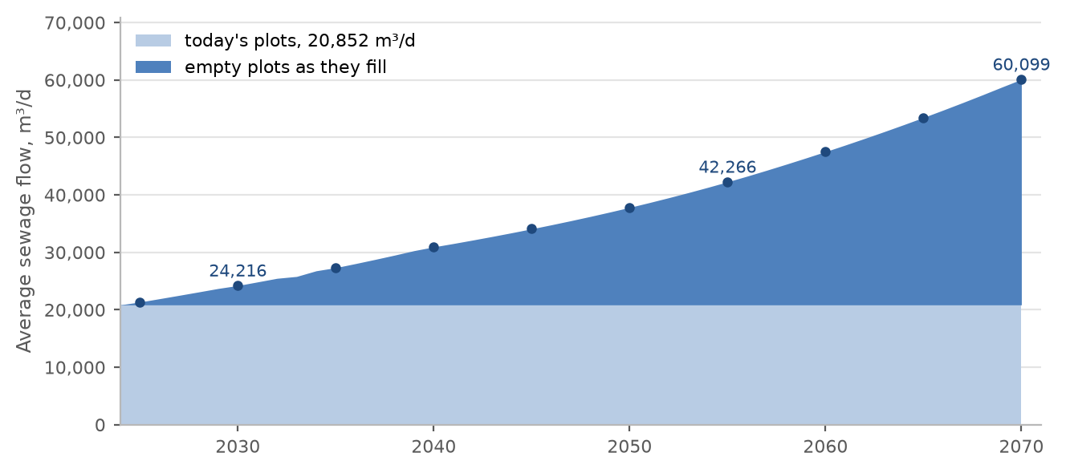
Figure 13 Average sewage flow of the study area by year, from today's plots and from the empty plots as they fill.

7.2. The plot
The plot carries the average flow of its people and meters, and nothing else: no peak, no infiltration, no tankers. Those belong to the pipe and the STP. A new home carries 171.3 litres a day per person; an existing plot carries its own meters at the rates of Section 5.

7.3. The pipe
A pipe is checked twice, on two different flows, because the two checks fail in opposite directions.
Size and capacity: the flow at saturation of every plot upstream, added up, peaked, plus infiltration along the pipe. Under-estimating it surcharges the pipe.
Self-cleansing: the flow in 2030 of the plots upstream, with 61 per cent of the properties connected, peaked, and no infiltration. Over-estimating it declares a pipe self-cleansing while it silts.
The 61 per cent is the connection ratio of the Inception Report, reached by 2028. It is never applied to the saturation flow: that would give a pipe in a new district most of its final flow in a year when it carries almost nothing.
Peak flow belongs to the pipe, not to the plot. Above 100 properties the Merrimack formula applies; at 100 or fewer, the Peltier formula.
$Q_{peak} = 2.65{Q_{avg}}^{0.879}$ (6)
Merrimack: above 100 properties; both flows in Ml/d
Q peak: peak flow: the guideline's peak daily flow, equal to its peak hourly flow, Ml/d
Q avg: average flow of the plots upstream, Ml/d
$Q_{peak} = \left(1.5 + \frac{1}{\sqrt{Q_{m}}}\right)Q_{avg}$ (7)
Peltier: at 100 properties or fewer
Q m: the average flow of the plots upstream, l/s
The guideline recommends that the hourly peak factor not exceed 5.0. It is a recommendation, applied as such. Infiltration is 720 litres a day per kilometre of new sewer, added along each pipe by its length; stormwater is not considered.
Adopted (11). 61 per cent of properties connected in 2030, the Inception Report's ratio, used only for the early-year self-cleansing check (Section 7.3).
Adopted (12). 720 litres a day per kilometre of sewer, added to each pipe and left out of the early-year check; the Merrimack formula above 100 properties and the Peltier formula at 100 or fewer (Section 7.3).

Gradients and self-cleansing at the concept stage
At the concept stage every pipe is laid at the guideline's minimum gradient for its size, rounded up to a step of 0.05 per cent, or 0.025 per cent for trunks of 500 mm and above. The steps are our rounding, so that the gradients are round figures on the drawings. The guideline asks for a second test, the minimum tractive force, and for the steeper of the two gradients to govern. At this stage that test is used only to list the pipes that will need washing in the early years, not to steepen them, because the tractive tension it needs is not given in the guideline. One pascal is used until Nama Water Services confirms a value. That is a departure from the guideline, stated here for approval.
Table 13 Minimum gradients at the concept stage
Pipe size, mm | 200 | 250 | 315 | 400 | 500 | 600 | 700 | 800 | 900 and above
Minimum gradient, mm/m | 5.00 | 3.75 | 2.70 | 2.05 | 1.55 | 1.25 | 1.00 | 0.85 | 0.75

The chart shows what the tractive test asks of a pipe. It is a curve: the smaller the flow, the steeper the pipe must be. A 200 mm pipe at its minimum gradient of 0.5 per cent passes the test at 1.29 l/s and above. Below that, at the very head of a street, no practical gradient passes; those pipes go on the washing list. A design floor is proposed: a pipe carrying less than 1.5 l/s is checked as if it carried 1.5, for which the curve asks 0.47 per cent, so a 200 mm pipe at the Table 11 gradient always passes.
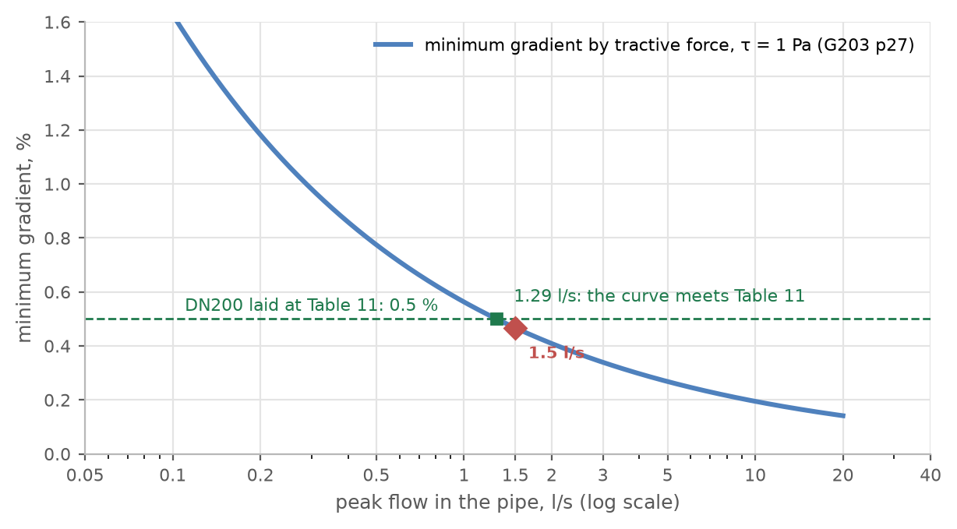
Figure 14 The minimum gradient the tractive-force test asks for, against the flow in the pipe.
Decision 7. Approve the concept-stage rule: pipes laid at the Table 11 minimum gradient rounded up to steps of 0.05 per cent; the tractive-force test at 1 pascal used only to list the pipes needing early washing, with a pipe carrying less than 1.5 l/s checked as if it carried 1.5. The guideline asks for the steeper of the two gradients; this is a departure (Section 7.3).

7.4. The pumping station and its rising main
A gravity sewer goes deeper the further it runs. The guideline recommends about 10 to 12 metres of cover as the point where the cost of excavation justifies a pumping station. That cost cannot be calculated without the detailed quantities, so 12 metres is applied as the limit at this stage: where a sewer would pass it, a station is placed before that point and the sewer restarts at normal cover. The preliminary design looks deeper where the quantities allow the cost to be calculated.
The station's duty flow is the peak flow of the catchment it drains plus the infiltration of its sewers, at saturation. The rising main is sized on that duty: at least 0.75 metres a second, 1.0 where the pumps start and stop, and at most 2.5 metres a second.
Adopted (13). 12 metres of cover is the limit at the concept stage, with a pumping station before that point; the preliminary design looks deeper where the quantities allow the cost to be calculated (Section 7.4).

7.5. The trunk sewers and the treatment plant
The trunk sewers and the STP carry the sum of the settlements upstream. The STP is sized on three flows, and the guideline names what each one sizes: the average annual flow for the biological treatment, with the load; the peak hourly flow for everything the flow passes through; and the maximum day flow, which the guideline defines but gives no factor for.
$Q_{AAF} = 1.10\left(Q_{avg} + Q_{inf}\right) Q_{PHF} = 1.10\left(Q_{peak} + Q_{inf}\right)$ (8)
Q AAF: average annual flow, the design average of the STP, m³/d
Q PHF: peak hourly flow, for the structures the flow passes through, m³/d
Q avg, Q peak: average flow of the settlements upstream, and its Merrimack peak, m³/d
Q inf: infiltration of the whole network upstream, 720 l/d per km, m³/d
1.10: the 10 per cent margin the guideline requires for a new STP, over and above any standby
If the whole study area drains to one STP, the flows are as in the table. The network has not yet been laid over the whole area, so its infiltration cannot be totalled; each 100 kilometres of new sewer adds 79 cubic metres a day with the margin. Tanker deliveries are added when their records arrive. The maximum day flow is read from a year of daily records at the existing STP, requested in Section 9.
Table 14 Flows at one STP for the whole area, before infiltration and tankers, m³/d
Flow | 2024 | 2030 | 2055 | 2070
People | 119,893 | 139,535 | 244,914 | 349,029
Average flow from the plots | 20,852 | 24,216 | 42,266 | 60,099
Peak flow before the margin | 38,263 | 43,639 | 71,202 | 97,022
Merrimack peak factor | 1.83 | 1.80 | 1.68 | 1.61
Average annual flow with the margin | 22,937 | 26,638 | 46,492 | 66,109
Peak hourly flow with the margin | 42,089 | 48,003 | 78,322 | 106,724
Infiltration with the margin, to add to both | 0.79 m³/d per km of sewer
Maximum day flow | from the existing STP's records

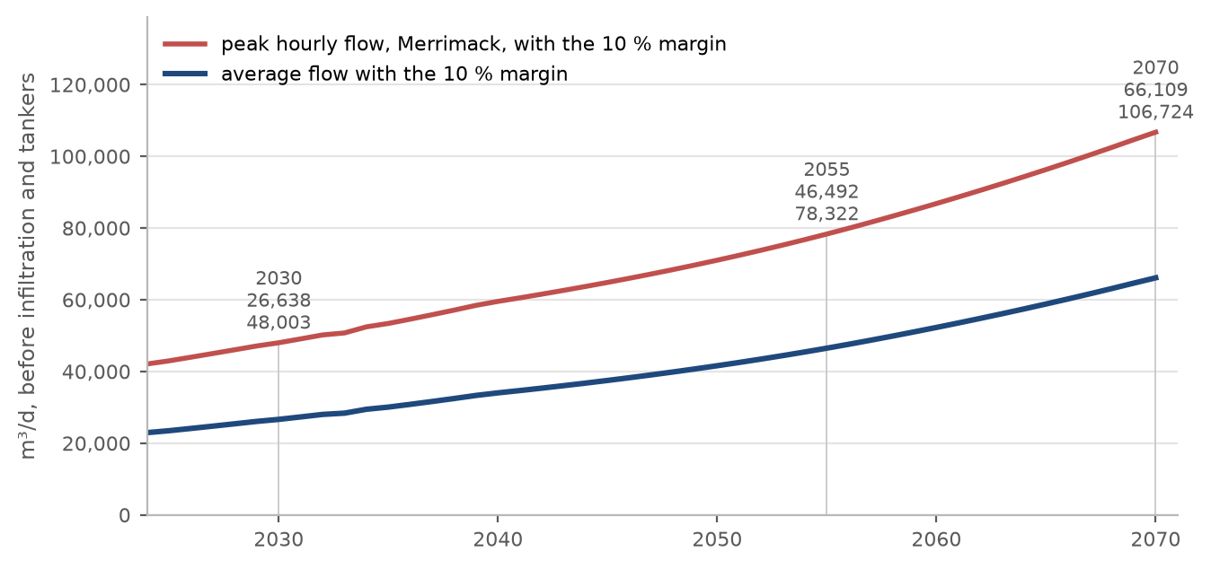
Figure 15 Average and peak-hour flow at one STP for the whole area, by year, with the margin.
The map on the next page gives every settlement's average flow in 2055 and at saturation, and the four steps to an STP flow, so that any grouping of settlements into one or more plants can be calculated by hand. The table below carries the same values.
Table 15 Average sewage flow by settlement in 2055 and at saturation, m³/d
Settlement | 2055 | 2070, saturation | Share in 2055, %
Ibri | 23,500 | 24,049 | 55.6
Ad Dariz | 4,146 | 4,917 | 9.8
Al Araqi | 3,742 | 3,859 | 8.9
Al Aynayn | 1,593 | 2,058 | 3.8
At Tayyib | 1,398 | 6,739 | 3.3
Al Wahrah | 1,173 | 1,792 | 2.8
Ad Dibayshi | 967 | 1,838 | 2.3
Al Jibayyah | 940 | 2,397 | 2.2
Bat | 819 | 819 | 1.9
Tanam | 797 | 1,580 | 1.9
Sayh al Masarrat | 640 | 1,167 | 1.5
Suwayda al Ma | 545 | 1,358 | 1.3
Al Jahli | 485 | 867 | 1.1
Hijar | 462 | 462 | 1.1
Al Ghubayrah | 301 | 785 | 0.7
Al Qurayn | 206 | 1,229 | 0.5
Al Makhtibyah | 147 | 817 | 0.3
Al Qali | 135 | 135 | 0.3
Al Akheedar | 110 | 110 | 0.3
Shalashil | 53 | 2,030 | 0.1
Usaybuq | 38 | 38 | 0.1
Satwah | 38 | 67 | 0.1
Ash Shiab | 15 | 16 | 0.0
Wadi al Mankas | 11 | 865 | 0.0
Miayrid | 6 | 108 | 0.0
Total | 42,266 | 60,099 | 100
Adopted (14). The average annual flow and the peak hourly flow with the 10 per cent margin as the guideline defines them; 60 grams of BOD and 80 grams of suspended solids per person per day, the guideline's minimum, until the laboratory data of the existing STP are received; the maximum day flow from that plant's records (Sections 7.5 and 7.6).

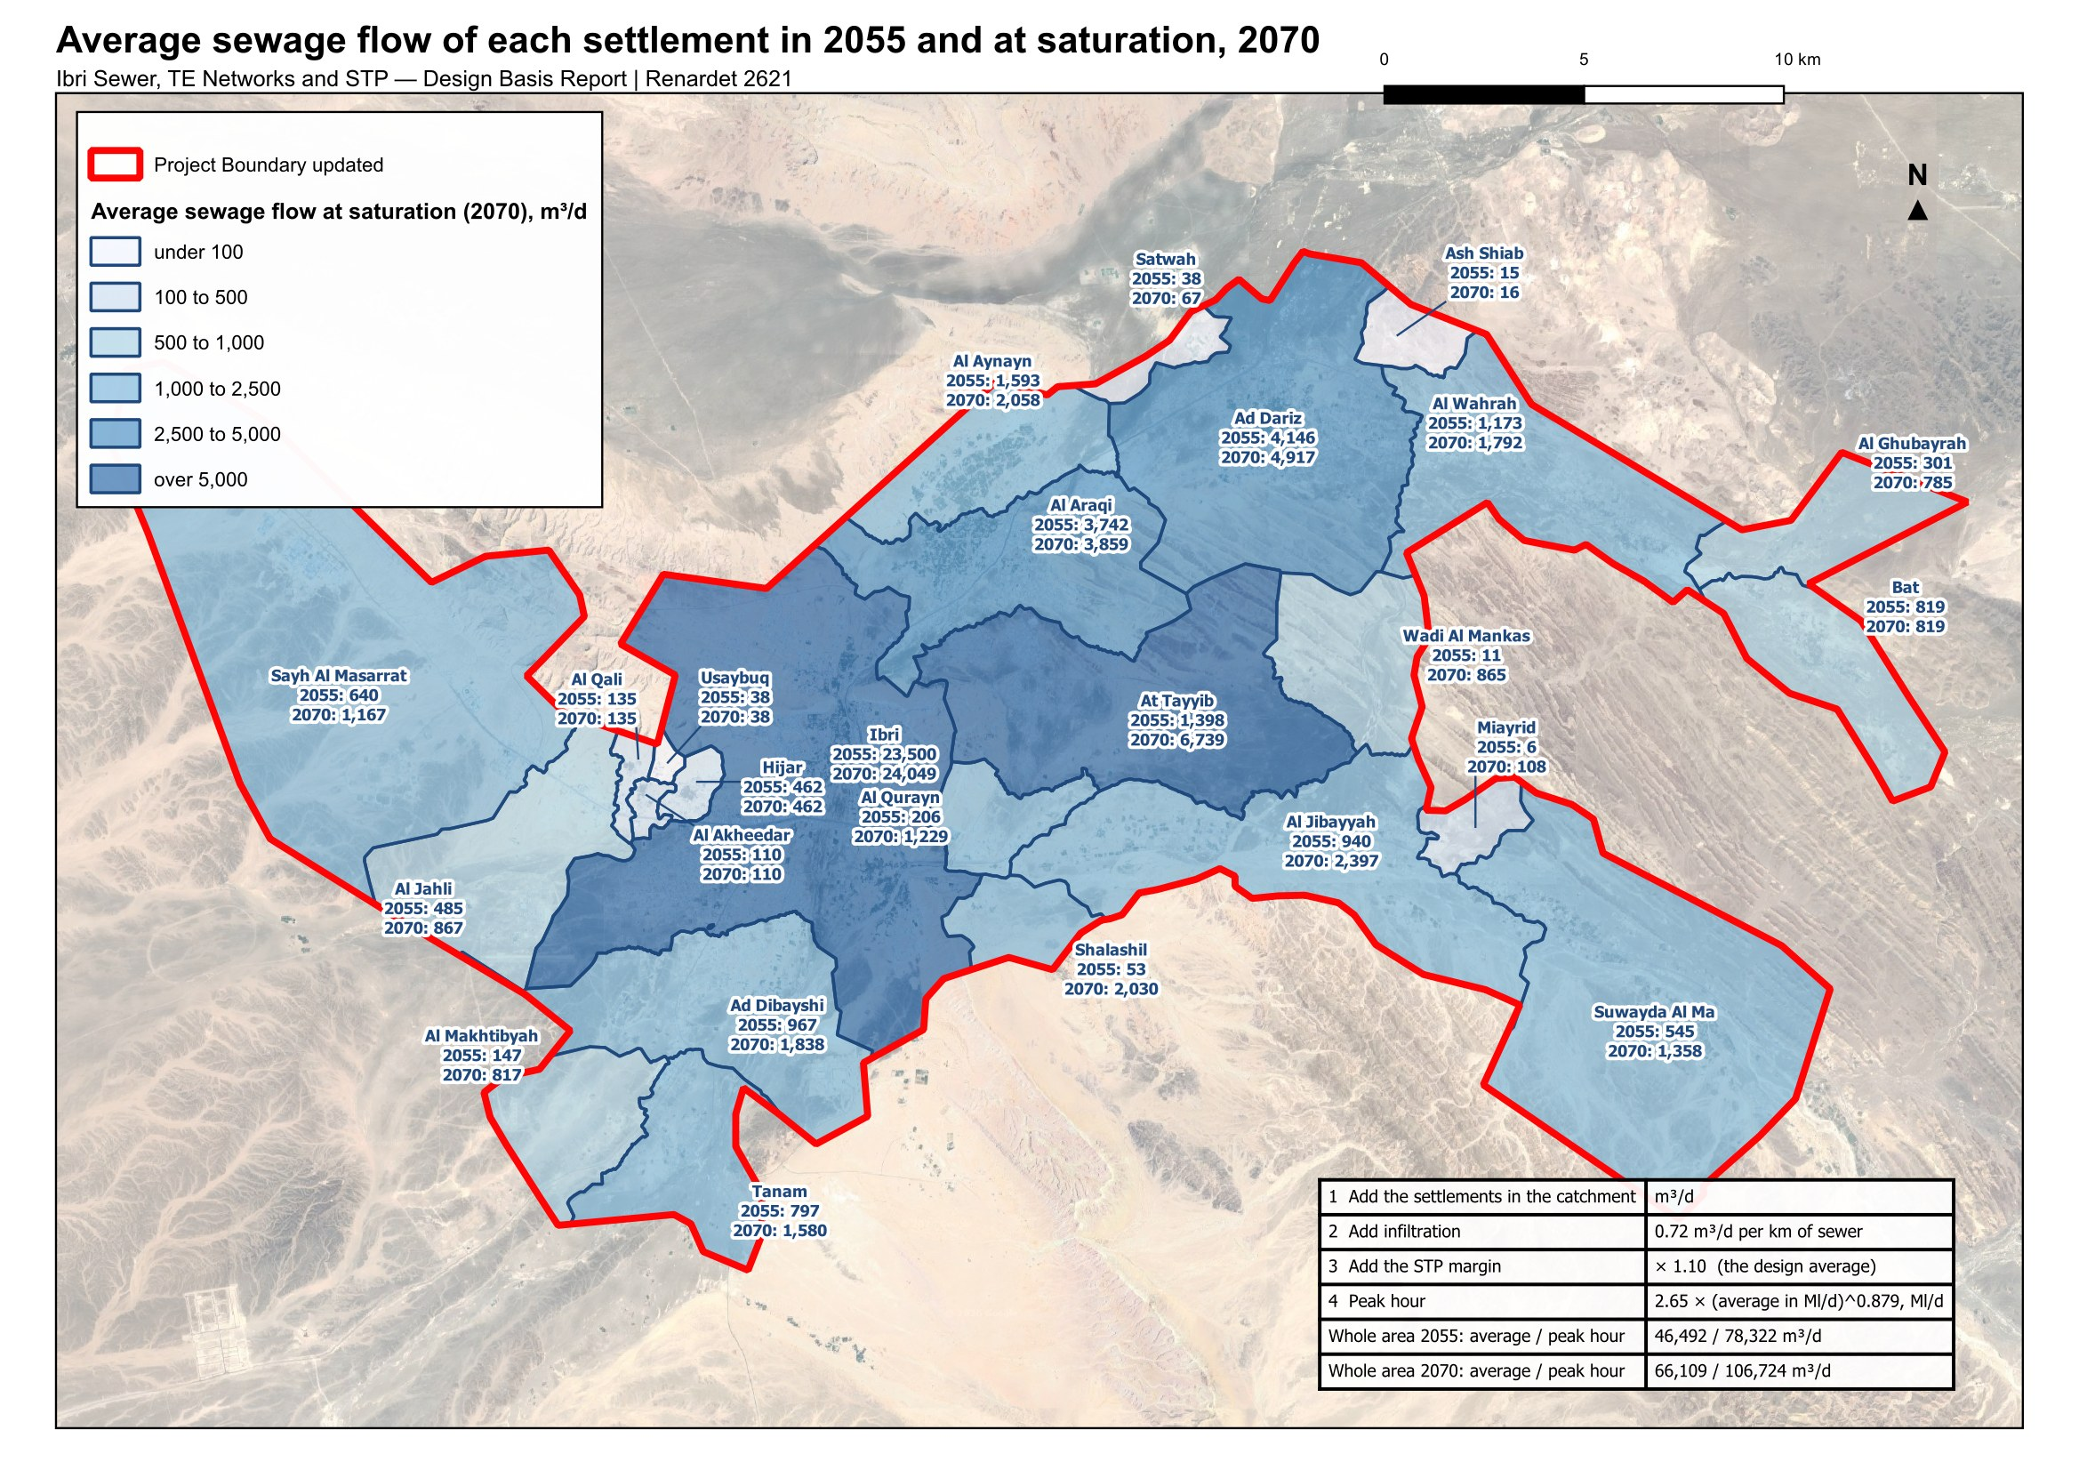
Figure 16 Average sewage flow of each settlement in 2055 and at saturation, and the four steps from the settlements in a catchment to the flow of their STP.

7.6. The load on the treatment plant
The biological treatment is sized on the load, not only the flow. No laboratory data for Ibri's sewage is held. The guideline sets a minimum for a new STP: 60 grams of BOD and 80 grams of suspended solids per person per day. At the flows above that is 348 milligrams of BOD per litre at saturation, at the low end of the range the guideline gives for raw sewage, 350 to 400. The per-person loads are used until the laboratory results of the existing STP are received, and the sewage brought by tanker, which is far stronger, is provided for separately once its records arrive.
Table 16 Loads at one STP for the whole area, from the per-person minima
 | 2024 | 2030 | 2055 | 2070
People | 119,893 | 139,535 | 244,914 | 349,029
BOD, kg/d | 7,194 | 8,372 | 14,695 | 20,942
Suspended solids, kg/d | 9,591 | 11,163 | 19,593 | 27,922
BOD as a concentration at the average flow, mg/l | 345 | 346 | 348 | 348
Suspended solids as a concentration, mg/l | 460 | 461 | 464 | 465
BOD at the peak factor of 1.2, kg/d | 8,632 | 10,047 | 17,634 | 25,130

Table 17 Raw sewage strength the guideline gives, for the network and for tankers, mg/l
Parameter | Network sewage | Sewage by tanker, average to maximum
BOD | 350 to 400 | 350 to 1,050
COD | 700 to 900 | 1,350 to 5,000
Suspended solids | 400 to 500 | 900 to 4,300
Total Kjeldahl nitrogen | 60 to 80 | 115 to 265
Ammonia as nitrogen | 40 to 50 | 70 to 125
Total phosphorus | 10 to 15 | 16 to 35

7.7. Sewage other than domestic
Sewage from industry and commerce, called trade effluent in the guidelines, affects the STP's load and how treatable the sewage is. Where its chemical to biochemical oxygen demand is above the domestic range, a separate line is needed if the volume is significant. In Ibri the two industrial estates are workshops on the commercial tariff; no wet industry has been found. The estates are carried at the dry-industry rate (Section 5.3), and no separate line is foreseen at this stage. A central slaughterhouse has been announced without a site; it will need pre-treatment and is added when sited.

7.8. Treated effluent
Treated effluent is produced at 95 per cent of the STP inflow, and a further 10 per cent is lost in the treated effluent distribution network, so 85.5 per cent of the inflow reaches the customers. The customers, their demand and its seasonal pattern are being identified and will be presented in the concept design.
Table 18 Treated effluent available, one STP for the whole area, m³/d
 | 2024 | 2030 | 2055 | 2070
STP inflow, design average | 22,937 | 26,638 | 46,492 | 66,109
Produced, 95 per cent | 21,790 | 25,306 | 44,168 | 62,803
Delivered, less 10 per cent in the network | 19,611 | 22,776 | 39,751 | 56,523
Adopted (15). 95 per cent of the STP inflow produced as treated effluent and 10 per cent of it lost in the distribution network (Section 7.8).

8. Every adopted value in one table
The values below are the ones the design rests on. Where a value is the guideline's, its page is given. Where it is a choice of this design, the reason is given and the value is marked as such.
Table 19 Adopted values and assumptions
Value | Adopted | Why | Source
Domestic water use | 164 l per person per day | the published value for Adh Dhahirah | G201 Table 11, p60
Shops and offices | 22 % of domestic | the distributed ratio for the governorate | G201 Table 11, p60
Government | 14 % of domestic | the distributed ratio; unit rates need quantities not held | G201 Table 11, p60; §7.3.3, p61
Return to the sewer | 85 % domestic and tanker; 54 % the rest | the published discharge ratios | G201 Table 19, p71
Farm meters | no sewage | they feed irrigation pumps; the house on a farm is metered separately | design rule
Industrial estates | 4,500 and 1,800 workers at 93 l/d | no record supplied; from the meter count | assumption; G201 Table 12, p61
Persons per property | per settlement; floor 4.0; cap 6.12 | institutional housing distorts the low ones; the cap is the highest large settlement | design rule; G201 §7.2, p59
Settlements under 1,000 people | 4.0, one property per plot, home share 0.9 | too few meters to measure on | design rule
Future home plot | 200 to 1,000 m², compact | the shape of the built home plots | design rule
Where the growth is placed | all empty plots up to 2,000 m², by area capped at 1,000 m² | the sewer serves every plot on its street | design rule
New home | 171.3 l of sewage per person per day | 164 × 0.85 + 36 × 0.54 + 23 × 0.54 | G201 Tables 11 and 19
Growth rates | the Inception Report series | the official forecast and its extension; used for rates only | Inception Report R0; Decision 6
Overflow | a full settlement's growth moves to its neighbours | the land, not the series, sets the population | design rule; Decision 4
Design horizon | 2055, or saturation in 2070 | opening year plus 25, or the year the last settlement fills | TOR; Decision 5
Connection in 2030 | 61 % of properties | the Inception Report ratio; used in the self-cleansing check only | Inception Report R0
Infiltration | 720 l/d per km, per pipe; none in the early-year check | new networks | G201 §7.4.3, p72
Peak flow | Merrimack above 100 properties; Peltier at or below | the guideline's formulae | G201 §7.4.2, p71 to 72
Hourly peak factor ceiling | 5.0, a recommendation | not applied silently | G201 p72
Minimum gradients | Table 11, rounded up to 0.05 % steps; 0.025 % for trunks | round figures on the drawings | G203 Table 11, p29; Decision 7
Tractive tension | 1 Pa; a 1.5 l/s floor | no value in the guideline; for washing lists only at this stage | G203 p27; Decision 7
Self-cleansing velocity | 0.75 m/s at peak flow, 0.90 preferred | the guideline | G203 p26
Depth of cover | 12 m at the concept stage; a station before it | the excavation cost needs the detailed quantities | G203 §4.6.3, p33
Rising main velocity | 0.75 to 2.5 m/s; 1.0 for start-stop pumping | the guideline | G203 §8.1, p50
STP margin | 10 % on average and peak | new plants | G201 §7.4.5, p73
STP loads | 60 g BOD, 80 g solids per person per day | the guideline minimum; no laboratory data held | G203 §10.3.1, p74
Treated effluent | 95 % produced; 10 % lost in the network | the guideline | G201 p73, p76
Tanker water, private wells | not in any flow | no records held; requested | G201 §7.4, p70; §7.3.5, p61

9. Data requested
Seven items would improve or confirm the numbers in this report. None of them stops the concept design; each replaces an assumption with a record.
Table 20 Data requests
Item | What is asked for | Why
Tanker water and sewage tankers | Filling-station volumes by area and sewage tanker deliveries to the STP, with their source | Water supplied by tanker is not in any flow. It can only raise the loads.
Private wells | Any record of private abstraction inside the study area | The guideline requires it to be assessed. Not held.
Existing STP records | Daily inflow and the laboratory results for the Ibri STP, three years | Sets the maximum day flow and checks the per-person loads.
Industrial estates | Workforce and water use of the Al Tayyeb and Tanam estates | Replaces the assumed 4,500 and 1,800 workers.
Army camp | Occupancy and drainage arrangement of the camp west of the town | 296 hectares with no meter in the dataset.
Ibri View | The development plan of the resort at As Sulayf | Two square kilometres announced; no load carried until the plan is issued.
Non-domestic quantities | Pupils, beds, employees and floor areas by plot, where held | Would allow the unit rates of the guideline in place of the ratios.

10. Decisions requested, and values adopted
Part A lists the 7 points that need a decision from Nama Water Services; each can be answered with a yes, a no, or one figure, and a no returns the report to the section named. Part B lists the values adopted from the guidelines and the stated assumptions, for information.

A. For approval
Settlements and people
1. Settlement boundaries. Approve the twenty-five settlement boundaries redrawn so that every plot lies in one settlement and there are no gaps between them (Section 2).
2. Persons per property. Approve the persons per property calculated for each settlement, with the floor of 4.0, the cap of 6.12 and the rule for settlements under a thousand people (Section 3).
3. Use of each plot. Approve the use determined for each plot from the meters and the satellite image, in place of the cadastre's own land-use field, as the basis for placing the loads (Section 4).
Growth
4. The overflow. Approve the overflow: when a settlement's land is full, its further growth moves to its neighbours. Without it 75,000 people of the series have nowhere to go by 2070 (Section 6.3).
5. The design horizon. Decide the design horizon: 2055, the opening year 2030 plus 25 years, with 244,914 people and 42,266 cubic metres a day; or 2070, the year the land is full, with 349,029 people and 60,099 cubic metres a day (Section 6.4).
6. The growth beyond 2050. Approve the extension of the population series beyond 2050: the rise to 2.40 per cent a year by 2058 and that rate held to 2100. The series to 2050 is the client's own (Section 6.2).
The network
7. Gradients and self-cleansing at the concept stage. Approve the concept-stage rule: pipes laid at the Table 11 minimum gradient rounded up to steps of 0.05 per cent; the tractive-force test at 1 pascal used only to list the pipes needing early washing, with a pipe carrying less than 1.5 l/s checked as if it carried 1.5. The guideline asks for the steeper of the two gradients; this is a departure (Section 7.3).

B. Adopted, for information
Settlements and people
8. The 126 meters with no plot within 15 metres. They are left out of the plot loads: about 140 people (Section 3.3).
Water and sewage rates
9. Water demand and return. 164 litres per person per day, plus 22 per cent for shops and offices and 14 per cent for government, the values the guideline publishes for Adh Dhahirah; 85 per cent of domestic and tanker supply and 54 per cent of the rest return to the sewer. The published ratios are used in place of the unit rates per pupil, bed, employee and floor area until those quantities are held (Section 5).
10. The industrial estates. 4,500 workers at Al Tayyeb and 1,800 at Tanam at 93 litres a day each, an assumption to be replaced by the estates' records when received (Section 5.3).
Growth
11. The connection ratio. 61 per cent of properties connected in 2030, the Inception Report's ratio, used only for the early-year self-cleansing check (Section 7.3).
The network
12. Infiltration and peak flow. 720 litres a day per kilometre of sewer, added to each pipe and left out of the early-year check; the Merrimack formula above 100 properties and the Peltier formula at 100 or fewer (Section 7.3).
13. Depth. 12 metres of cover is the limit at the concept stage, with a pumping station before that point; the preliminary design looks deeper where the quantities allow the cost to be calculated (Section 7.4).
The plant and the effluent
14. STP flows and loads. The average annual flow and the peak hourly flow with the 10 per cent margin as the guideline defines them; 60 grams of BOD and 80 grams of suspended solids per person per day, the guideline's minimum, until the laboratory data of the existing STP are received; the maximum day flow from that plant's records (Sections 7.5 and 7.6).
15. Treated effluent. 95 per cent of the STP inflow produced as treated effluent and 10 per cent of it lost in the distribution network (Section 7.8).

Appendix A1. Capacity and the overflow routes
Table 21 Capacity of the empty land by settlement
Settlement | Empty plots | of which home-shaped and counted | Home share | Properties per plot | Persons per property | Capacity, people
Ibri | 14,203 | 10,469 | 0.87 | 1.33 | 6.07 | 73,299
Ad Dariz | 4,888 | 3,219 | 0.90 | 1.20 | 4.86 | 16,854
Al Araqi | 3,360 | 2,463 | 0.84 | 1.32 | 4.34 | 11,832
Al Aynayn | 1,780 | 1,362 | 0.94 | 1.14 | 5.12 | 7,459
Al Wahrah | 2,000 | 1,373 | 0.91 | 1.22 | 4.68 | 7,109
At Tayyib | 10,012 | 8,640 | 0.92 | 1.09 | 4.02 | 34,675
Al Jibayyah | 2,784 | 1,966 | 0.89 | 1.26 | 5.13 | 11,306
Bat | 879 | 355 | 0.88 | 1.17 | 6.12 | 2,226
Ad Dibayshi | 2,430 | 1,887 | 0.90 | 1.16 | 4.00 | 7,920
Tanam | 2,045 | 1,556 | 0.67 | 1.24 | 5.25 | 6,779
Suwayda al Ma | 1,593 | 937 | 0.82 | 1.60 | 5.18 | 6,369
Hijar | 375 | 211 | 0.90 | 1.69 | 4.00 | 1,288
Al Ghubayrah | 1,448 | 1,094 | 0.90 | 1.00 | 4.00 | 3,940
Al Qurayn | 2,051 | 1,830 | 0.90 | 1.00 | 4.00 | 6,588
Sayh al Masarrat | 1,745 | 1,384 | 0.90 | 1.00 | 4.00 | 4,984
Al Jahli | 1,235 | 1,023 | 0.90 | 1.00 | 4.00 | 3,684
Satwah | 181 | 79 | 0.90 | 1.00 | 4.00 | 284
Al Akheedar | 120 | 45 | 0.90 | 1.00 | 4.00 | 160
Al Qali | 220 | 157 | 0.90 | 1.00 | 4.00 | 564
Shalashil | 3,686 | 3,250 | 0.90 | 1.00 | 4.00 | 11,700
Al Makhtibyah | 1,523 | 1,192 | 0.90 | 1.00 | 4.00 | 4,292
Usaybuq | 60 | 39 | 0.90 | 1.00 | 4.00 | 140
Wadi al Mankas | 1,580 | 1,394 | 0.90 | 1.00 | 4.00 | 5,020
Ash Shiab | 65 | 13 | 0.90 | 1.00 | 4.00 | 48
Miayrid | 246 | 171 | 0.90 | 1.00 | 4.00 | 616
Total | 60,509 | 46,109 |  |  |  | 229,136

Table 22 The overflow routes carrying fifty people or more at saturation
From | To | People at saturation | Donor full | Receiver starts | Receiver full
Ibri | At Tayyib | 22,078 | 2056 | 2060 | 2068
Ibri | Shalashil | 11,471 | 2056 | 2056 | 2061
Ibri | Al Qurayn | 5,856 | 2056 | 2056 | 2060
Ad Dariz | Wadi al Mankas | 4,965 | 2062 | 2062 | 2068
Al Araqi | At Tayyib | 4,873 | 2057 | 2060 | 2068
Ibri | Ad Dibayshi | 4,078 | 2056 | 2062 | 2063
Ibri | Al Jibayyah | 3,927 | 2056 | 2068 | 2070
Bat | Al Ghubayrah | 2,493 | 2052 | 2052 | 2070
Ibri | Al Makhtibyah | 2,441 | 2056 | 2063 | 2069
Ibri | Tanam | 2,010 | 2056 | 2063 | 2069
Al Araqi | Al Aynayn | 1,790 | 2057 | 2057 | 2060
Al Aynayn | At Tayyib | 1,639 | 2060 | 2060 | 2068
Al Araqi | Al Jibayyah | 1,410 | 2057 | 2068 | 2070
Ibri | Sayh al Masarrat | 1,225 | 2056 | 2063 | 2069
Ad Dibayshi | Tanam | 1,004 | 2063 | 2063 | 2069
Ibri | Al Jahli | 915 | 2056 | 2054 | 2063
Ad Dariz | Al Wahrah | 863 | 2062 | 2062 | 2070
Al Araqi | Suwayda al Ma | 730 | 2057 | 2070 | 2070
Al Aynayn | Al Jibayyah | 600 | 2060 | 2068 | 2070
Ad Dariz | Suwayda al Ma | 551 | 2062 | 2070 | 2070
Hijar | Al Makhtibyah | 519 | 2053 | 2063 | 2069
Hijar | Al Jahli | 518 | 2053 | 2054 | 2063
Al Jahli | Al Makhtibyah | 507 | 2063 | 2063 | 2069
Ibri | Suwayda al Ma | 490 | 2056 | 2070 | 2070
At Tayyib | Miayrid | 441 | 2068 | 2068 | 2070
Ibri | Ad Dariz | 440 | 2056 | 2057 | 2062
Al Aynayn | Ad Dariz | 347 | 2060 | 2057 | 2062
Al Aynayn | Suwayda al Ma | 311 | 2060 | 2070 | 2070
Al Akheedar | Al Qali | 297 | 2036 | 2036 | 2054
Ad Dariz | Al Ghubayrah | 258 | 2062 | 2052 | 2070
Al Qurayn | At Tayyib | 244 | 2060 | 2060 | 2068
At Tayyib | Suwayda al Ma | 229 | 2068 | 2070 | 2070
Al Wahrah | Suwayda al Ma | 229 | 2070 | 2070 | 2070
Ad Dibayshi | Suwayda al Ma | 186 | 2063 | 2070 | 2070
Al Jibayyah | Suwayda al Ma | 183 | 2070 | 2070 | 2070
Ad Dibayshi | Sayh al Masarrat | 182 | 2063 | 2063 | 2069
Al Akheedar | Al Makhtibyah | 177 | 2036 | 2063 | 2069
Al Akheedar | Al Jahli | 176 | 2036 | 2054 | 2063
Bat | Suwayda al Ma | 175 | 2052 | 2070 | 2070
Ibri | Al Araqi | 163 | 2056 | 2056 | 2057
Al Aynayn | Satwah | 150 | 2060 | 2060 | 2060
Tanam | Suwayda al Ma | 145 | 2069 | 2070 | 2070
Ibri | Miayrid | 141 | 2056 | 2068 | 2070
Tanam | Sayh al Masarrat | 141 | 2069 | 2063 | 2069
Sayh al Masarrat | Suwayda al Ma | 125 | 2069 | 2070 | 2070
Al Qali | Al Jahli | 103 | 2054 | 2054 | 2063
Hijar | Al Jibayyah | 94 | 2053 | 2068 | 2070
Al Jahli | Al Jibayyah | 92 | 2063 | 2068 | 2070
Al Qali | Sayh al Masarrat | 83 | 2054 | 2063 | 2069
Al Qurayn | Al Jibayyah | 78 | 2060 | 2068 | 2070
Hijar | Ibri | 66 | 2053 | 2054 | 2056
Shalashil | At Tayyib | 63 | 2061 | 2060 | 2068
Hijar | Usaybuq | 60 | 2053 | 2053 | 2054
Hijar | Al Qali | 54 | 2053 | 2036 | 2054
Sayh al Masarrat | Al Jibayyah | 52 | 2069 | 2068 | 2070

Appendix A2. The tractive-force curve in full
The same curve as in Section 7.3, with every pipe size's minimum gradient marked where it meets the curve, three readings on the steep part, and the 1.5 l/s floor.
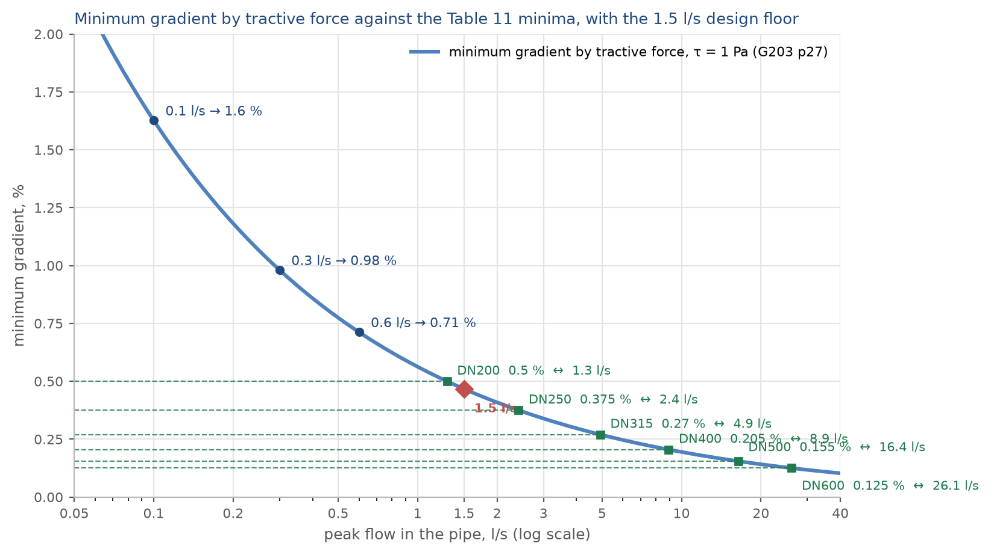
Figure 17 The minimum gradient by tractive force at one pascal, the Table 11 minima of every size, and the 1.5 l/s floor.

Average flows before infiltration and before the STP margin. Sections 6 and 7 give the series.
Final_Boundary_IBRI.kmz, issued with the Inception Report R0.
A Voronoi division of the plot centroids by settlement, merged, clipped to the study area boundary and smoothed as a coverage so that neighbours share one line.
The primary, subsidised primary and additional-dwelling tariffs count as properties. The 499 large-consumer accounts were placed by public records; their use decides only where the shop and government water is placed, not how much there is.
4.0 is the rate measured at At Tayyib, 3,300 people, the smallest settlement with a sample worth measuring. The cap is Bat's. The thirteen small settlements: Al Ghubayrah, Al Qurayn, Sayh al Masarrat, Al Jahli, Satwah, Al Akheedar, Al Qali, Shalashil, Al Makhtibyah, Usaybuq, Wadi al Mankas, Ash Shiab, Miayrid.
PAM-GUD-201, Section 7.2, page 59. The table below is the same as Table 15 of the Concept Design Report, Revision 2.
116,452 divided by 22,559 properties gives the area-wide 5.16.
By tariff: Government 46, Commercial 32, Primary Account Tariff 18, CRT Seasonal 9, Primary Account Tariff (with National Subsidy) 6, Additional Account Tariff 6, Agricultural 5, CRT Time of Use 4.
MoH_Plots, 77,265 plots, received September 2026.
38 per cent of the plots with a farm meter show no planting: pump sites without a crop. The treatment plant's own plot carries farm meters for its pumps and is classed as a government site.
PAM-GUD-201, Table 11, page 60, and Section 7.3.1, page 59.
PAM-GUD-201, page 59: the ratios "refer to spatially distributed non-domestic consumption that are to be added to the domestic consumption" and "do not apply to ... specific identified non-domestic projects such as economic zones". Per person the shares are 36 and 23 litres a day.
PAM-GUD-201, Table 12, page 61, and Sections 7.3.2 and 7.3.3, pages 60 and 61.
PAM-GUD-201, Table 19, page 71. The farm rule is a rule of this design: on 172 of 319 farm plots a household is metered separately from the pump.
36 and 23 are 22 and 14 per cent of 164.
PAM-GUD-201, page 59 and Table 12, page 61. Al Tayyeb: 94 hectares, 202 plots, 1,035 meters. Tanam: 61 hectares, 105 plots, 409 meters. About five meters per plot and three to six workers per workshop give the figures.
PAM-GUD-201, Section 7.4, page 70: an assessment of private wells and other non-network sources is required.
The sum of the plots equals the settlement in every column.
Compactness is the plot's area against that of its smallest enclosing rectangle, not less than 0.6, with the rectangle's sides no more than three to one. Built home plots have a median area of 717 square metres. Shapes above 2,000 square metres are whole future districts drawn as one plot; they take nothing until subdivided.
The settlements under a thousand people take 0.9 and one property per plot, as in Section 3.2. The table by settlement is in Appendix A1.
Capacity by settlement: Appendix A1.
Inception Report R0, Section 6, and the demand workbook, sheets Pop_Wilayat and Project Pop Settlements. PAM-GUD-201 allows an extrapolation of ten years beyond the available forecast.
The settlements that never fill on their own growth: At Tayyib, Al Ghubayrah, Al Qurayn, Al Makhtibyah, Shalashil, Wadi al Mankas, Miayrid. The overflow routes reflect local knowledge of where Ibri's growth is taking place.
Concept Design Report R2, Section 14.7. The five-year series is in the table below.
The flow of every plot in 2024, 2030, 2055 and the saturation year is carried in the project's plot layer.
Whole area: 24,216 × 0.61 = 14,772 m³/d in 2030, against 36,660 if the ratio were applied to saturation.
PAM-GUD-201, Section 7.4.2, pages 71 and 72; Section 7.4.3, page 72. PAM-GUD-203, Table 29, page 65, defines the peak hourly flow and gives it the symbol QPDF.
PAM-GUD-203, Table 11, page 29; Sections 4.2.2.1 and 4.3, pages 25 to 29. The Mara, Sleigh and Taylor relationship on page 27, K = 2.33 × 10⁻⁴ with the flow in m³/s.
The full curve with every size is in Appendix A2. The audit on the test area gave 70 per cent of the length as needing early washing, all of it 200 mm pipe carrying under 1.3 l/s.
PAM-GUD-203, Section 4.6.3, page 33.
PAM-GUD-203, Section 8.1, page 50. Which chamber the main discharges into, and whether neighbouring stations are joined, are layout decisions of the concept design.
PAM-GUD-203, Table 29, page 65, and Section 10.2.2.1, page 66.
PAM-GUD-201, Section 7.4.5, page 73, the margin. The margin is applied to the peak as to the average; the guideline does not state the order, and this reading is for confirmation.
PAM-GUD-203, Section 10.3.1, page 74, "at least 60 g of BOD5 per capita per day and 80 g of suspended solids"; Table 30, page 67; Table 31, page 68, tankered sewage at 350 to 1,050 mg/l BOD. Peak factors for the aeration design at a large STP: 1.2 on BOD and COD, 1.5 on TKN (page 74).
PAM-GUD-203, page 74: a COD to BOD ratio of 1.8 to 2.2 is typical of domestic sewage.
PAM-GUD-201, Section 7.4.6.1, page 73, and Section 7.4.6.3 (b), page 76: "a system loss of 10 percent of all produced TSE shall be assumed".

