Consultancy Services for Design and Supervision for STP, Sewer & TE Networks Systems in Ibri

Design Basis Report
Settlement Boundaries, Population, Flows and Loads
Revision 0 · September 2026

 | PO Box 579, Muscat. PC 113  Sultanate of Oman  Tel: (968) 244 84 292  Fax: (968) 244 83 039  e-mail: Renardet-oman@renardet.net

Contents
1 Purpose and how to read this report 5
1.1 What it rests on 5
1.2 What it does not contain 5
2 The settlements and their boundaries 6
3 People today 8
3.1 From the meters to the dwellings 8
3.2 Persons per dwelling 8
3.3 The 126 meters with no plot within 15 metres 10
4 The use of each plot 12
5 From water to sewage 14
5.1 Water demand 14
5.2 Return to the sewer 15
5.3 The industrial estates and other named sites 15
5.4 The result for 2024 16
6 How the land fills 17
6.1 How many people the empty land can hold 17
6.2 How fast each settlement grows 18
6.3 What happens when a settlement is full: the overflow 18
6.4 The year the land is full, and the design horizon 22
7 The flow each element is designed for 23
7.1 The plot 23
7.2 The pipe 23
7.3 The pumping station and its rising main 24
7.4 The trunk sewers and the treatment plant 25
7.5 The load on the plant 28
7.6 Sewage other than domestic 28
7.7 Treated effluent 29
8 Every adopted value in one table 30
9 Data requested 31
10 Decisions requested 32
Appendix A1 People and sewage by settlement, five-year steps to saturation 34
Appendix A2 Capacity and the overflow routes 36
Appendix A3 The 126 meters with no plot within 15 metres, close up 38
Appendix A4 The tractive-force curve in full 47
Appendix A5 The fields of the plot layer 48

Figures
Figure 1 The settlement boundaries as received (red, dashed) and as redrawn for the design (blue). Every plot lies in one settlement and the boundaries meet without gaps. 7
Figure 2 Persons per dwelling by settlement: the value worked out from the census and the meters, and the value adopted after the floor and the cap. 9
Figure 3 The 126 meters more than fifteen metres from any plot, and the zoom panels of Appendix A3. 11
Figure 4 The use of each plot. Coloured plots are built and metered; empty plots are shown by their outline only. 13
Figure 5 From the plot to the pipe and the plant: what each step adds. 14
Figure 6 From the empty plot to the year each settlement is full. 17
Figure 7 The annual growth rate of the series: the forecast to 2040, the extrapolation to 2050, and the rise to a constant 2.40 per cent. 18
Figure 8 People in the study area by year, with the overflow and without it. 19
Figure 9 People at saturation in the ten settlements the choice affects most, with the overflow and without. 19
Figure 10 Where the growth goes once a settlement is full. Arrows show the routes carrying five hundred people or more; the shading shows how much of each settlement's capacity is taken by its neighbours' overflow. 21
Figure 11 People by year to saturation, the six largest settlements shown separately. The flat top of each band is the year that settlement fills. 22
Figure 12 The minimum gradient the tractive-force test asks for, against the flow in the pipe, with the 200 mm line and the proposed 1.5 litres a second floor. 24
Figure 13 Average and peak-hour flow at one works for the whole area, by year, with the margin. 26
Figure 14 Average sewage flow of each settlement at saturation, and the four steps from the settlements in a catchment to the flow of its plant. 27
Figure 15 Panels 1 to 9 of 68. 39
Figure 16 Panels 10 to 18 of 68. 40
Figure 17 Panels 19 to 27 of 68. 41
Figure 18 Panels 28 to 36 of 68. 42
Figure 19 Panels 37 to 45 of 68. 43
Figure 20 Panels 46 to 54 of 68. 44
Figure 21 Panels 55 to 63 of 68. 45
Figure 22 Panels 64 to 68 of 68. 46
Figure 23 The minimum gradient by tractive force at one pascal, the Table 11 minima of every size, and the proposed 1.5 litres a second floor. 47

Tables
Table 1 The decisions asked for 5
Table 2 Sources 6
Table 3 Persons per dwelling by settlement, 2024 9
Table 4 Use of the built plots that carry a meter 13
Table 5 Named sites outside the ratios 16
Table 6 Water and sewage by settlement, 2024, m³/d 17
Table 7 Every settlement with and without the overflow: people in 2070 and the year it is full 20
Table 8 The study area in the design years 23
Table 9 Minimum gradients at the concept stage 25
Table 10 Flows at one works for the whole area, before infiltration and tankers, m³/d 26
Table 11 Loads at one works for the whole area, from the per-person minima 29
Table 12 Raw sewage strength the guideline gives, for the network and for tankers, mg/l 29
Table 13 Treated effluent available, one works for the whole area, m³/d 30
Table 14 Adopted values and assumptions 31
Table 15 Data requests 32
Table 16 People at five-year intervals 35
Table 17 Average sewage flow, m³/d at five-year intervals 36
Table 18 Capacity of the empty land by settlement 37
Table 19 The overflow routes carrying fifty people or more at saturation 37
Table 20 The meters by settlement 39
Table 21 Fields of the plot layer that the design reads 49

What this report asks for
This report sets out the ground on which the sewer network, the treated effluent network and the treatment plant for Ibri will be designed: where the settlements are, how many people live in them, how many the land can hold, and the sewage each part of the system must carry. All of it will be part of the Concept Design Report. It is issued now, on its own, so that Nama Water Services can confirm the foundation before the design is built on it.
The study area holds 119,893 people in 2024 on the meters counted, and generates 20,852 cubic metres of sewage a day. Its empty land can hold 229,136 more. The last settlement fills in 2070, with 349,029 people and 60,099 cubic metres a day. The network is sized on that figure; the plant is staged on the years in between.
Nineteen points need a yes or a no. They are listed here, explained in the section named, and repeated in Section 10 with the answer sheet. Seven data requests follow in Section 9.
Table 1 The decisions asked for
 | Group | Decision
1 | Settlements and people | Settlement boundaries
2 | Settlements and people | Occupancy per settlement
3 | Settlements and people | The 126 meters with no plot within 15 metres
4 | Settlements and people | Use of each plot
5 | Water and sewage rates | Water demand rates
6 | Water and sewage rates | Return to the sewer
7 | Water and sewage rates | Ratios in place of unit rates
8 | Water and sewage rates | The industrial estates
9 | Growth | The overflow
10 | Growth | The design horizon
11 | Growth | The growth series
12 | Growth | The connection ratio
13 | The network | Infiltration
14 | The network | Peak flow
15 | The network | Gradients and self-cleansing at the concept stage
16 | The network | Depth
17 | The plant and the effluent | Plant flows
18 | The plant and the effluent | Process loads
19 | The plant and the effluent | Treated effluent

1 Purpose and how to read this report
The concept design will be submitted as one document. Its later parts, the options for the network and the plant, rest on the numbers in this report. If a number here changes after the options are drawn, the options are drawn again. Confirming the foundation first avoids that.
The report is written to be read in one sitting. Each section says what was done, what value is used, and why. Where a value is an assumption, it says so. Where the guideline gives a rule, the page is in a footnote. Section 8 collects every adopted value in one table; Section 10 is the answer sheet.

1.1 What it rests on
Table 2 Sources
Source | What it gives
PAM-GUD-201, General Design Guidelines, rev. 01, March 2026 | water demand, return to the sewer, peak flow, infiltration, plant margin, treated effluent
PAM-GUD-203, Wastewater Design Guidelines, rev. 01, March 2026 | self-cleansing, gradients, depth, plant flows, sewage strength
Inception Report R0 and its demand workbook | the population series to 2100, the settlement boundaries, the connection ratio
Electricity accounts, 33,971 meters | one dwelling per domestic meter; shops, offices, government and farm meters by tariff
Cadastral plots, 77,265, Ministry of Housing and Urban Planning, September 2026 | the land: built or empty, and its area
Sentinel-2 image of 9 September 2026 | which plots are groves

1.2 What it does not contain
No network is laid here and no plant is sized. The report gives the flow that each element will be designed for and the rule for finding it. The layout of the sewers, the stations and the plant follow in the concept design, on these numbers.

2 The settlements and their boundaries
Every rule in this report is applied settlement by settlement: the persons per property, the share of empty land that becomes housing, the growth rate and the year the land is full are all set for each settlement. So every plot must belong to exactly one settlement.
The Inception Report supplied one polygon per settlement, drawn around the built core. The polygons do not touch, so the land between them belongs to nobody, and four of them, at Tanam, Satwah, Al Makhtibyah and Bat, miss part of the plots that carry the settlement's name. The map on the next page shows them in red.
The boundaries were therefore redrawn. Each of the 77,265 plots was given the settlement whose polygon contains it, or, where none does, the nearest one. The land was then divided so that every point belongs to the settlement of the nearest plot, and the shared edges were smoothed. The result, in blue on the map, covers the whole study area with twenty-five settlements and no gaps. Nothing else changed: the names, the population series and the plots are as received.
The twenty-five settlements inside the study area carry 63.4 per cent of the wilayat's population in every year of the series. The other settlements of the wilayat lie outside the boundary and are not part of the design.
Decision 1. Adopt the redrawn boundaries as the settlement boundaries for the design.

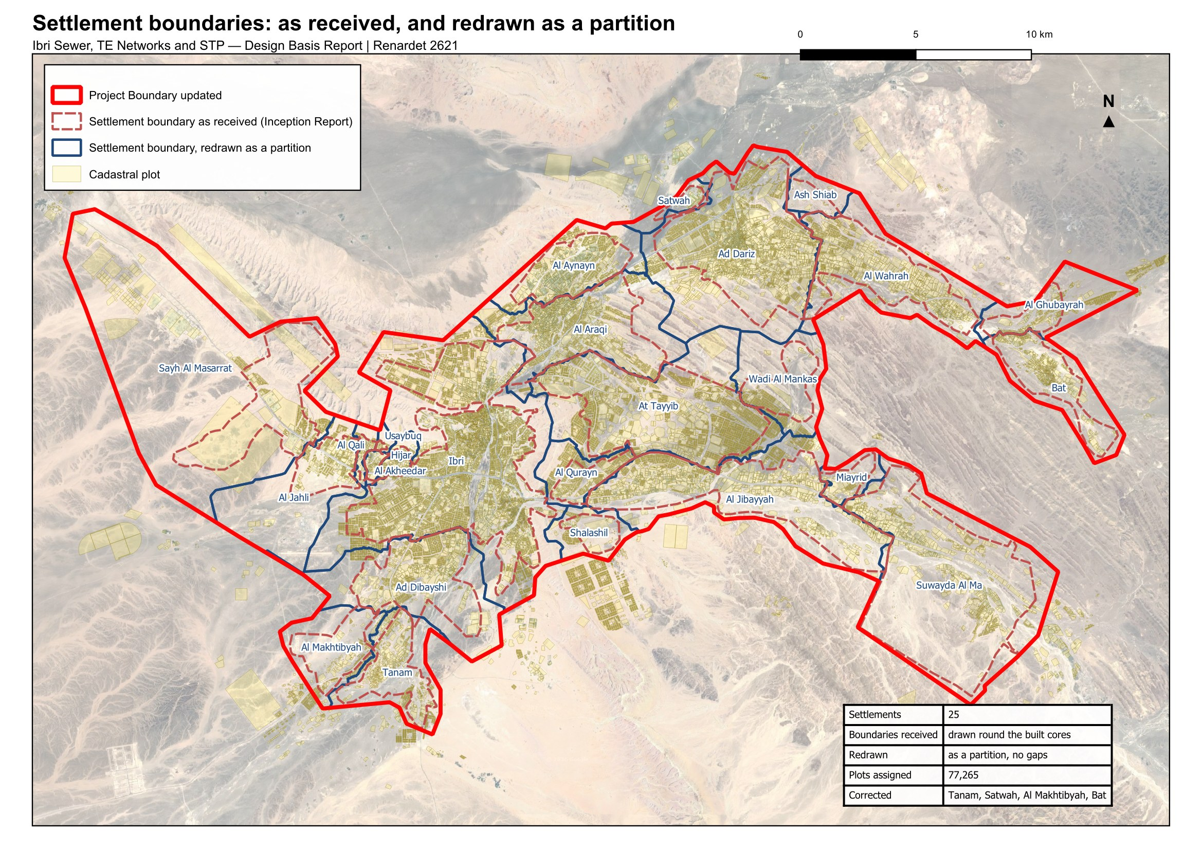
Figure 1 The settlement boundaries as received (red, dashed) and as redrawn for the design (blue). Every plot lies in one settlement and the boundaries meet without gaps.

3 People today
The population is counted, not assumed. Every domestic electricity meter is a dwelling. The number of people in a dwelling is set for each settlement from the official population. The two together give the people on every plot in 2024, the year of the electricity data.

3.1 From the meters to the dwellings
The electricity dataset holds 33,971 meters. 30,931 of them fall inside a plot. 2,914 lie on a road or in a gap between plots and were given the nearest plot within fifteen metres. 126 lie further than that from any plot; Section 3.3 shows them. Each meter on a household tariff is one dwelling: 22,559 dwellings in all. Shop, office, government, farm and large-consumer meters carry no people.

3.2 Persons per dwelling
The occupancy of each settlement is its population in 2024 divided by the dwellings counted in it.
$OR = \frac{population of the settlement in 2024}{dwellings counted in it}$ (1)
OR; occupancy, persons per dwelling
Three rules bound the result. A floor of 4.0: some settlements would otherwise return between one and four persons per dwelling, because their meters include the housing of the police, the college and similar institutions, whose occupants the census does not count as residents. Those dwellings discharge to the sewer whatever the census says, so the floor keeps them in. A cap of 6.12, the highest rate among the settlements of two thousand people or more. And a settlement of fewer than a thousand people takes 4.0 outright, one dwelling per home plot and a home share of 0.9 (Section 6.1), because it has too few meters to measure on. That rule applies to 13 settlements.
Ibri returns 6.07 persons per dwelling. Over the whole study area the census gives 5.16. The guideline derives occupancy from population and housing units published by the statistics centre; housing units are not published at settlement level, and the counted dwellings are used in their place.
Table 3 Persons per dwelling by settlement, 2024
Settlement | Dwellings | Population 2024 | Rate worked out | Rate adopted | People in the design
Ibri | 11,052 | 67,106 | 6.07 | 6.07 | 67,106
Ad Dariz | 2,439 | 11,850 | 4.86 | 4.86 | 11,850
Al Araqi | 2,466 | 10,696 | 4.34 | 4.34 | 10,696
Al Aynayn | 889 | 4,554 | 5.12 | 5.12 | 4,554
Al Wahrah | 716 | 3,351 | 4.68 | 4.68 | 3,351
At Tayyib | 833 | 3,348 | 4.02 | 4.02 | 3,348
Al Jibayyah | 524 | 2,686 | 5.13 | 5.13 | 2,686
Bat | 418 | 2,557 | 6.12 | 6.12 | 2,557
Ad Dibayshi | 681 | 2,411 | 3.54 | 4.00 | 2,724
Tanam | 403 | 2,116 | 5.25 | 5.25 | 2,116
Suwayda al Ma | 301 | 1,559 | 5.18 | 5.18 | 1,559
Hijar | 352 | 1,033 | 2.93 | 4.00 | 1,408
Al Ghubayrah | 161 | 631 | 3.92 | 4.00 | 644
Al Qurayn | 147 | 549 | 3.73 | 4.00 | 588
Sayh al Masarrat | 457 | 466 | 1.02 | 4.00 | 1,828
Al Jahli | 344 | 415 | 1.21 | 4.00 | 1,376
Satwah | 27 | 263 | 9.73 | 4.00 | 108
Al Akheedar | 120 | 198 | 1.65 | 4.00 | 480
Al Qali | 56 | 191 | 3.41 | 4.00 | 224
Shalashil | 38 | 130 | 3.42 | 4.00 | 152
Al Makhtibyah | 91 | 122 | 1.34 | 4.00 | 364
Usaybuq | 21 | 91 | 4.33 | 4.00 | 84
Wadi al Mankas | 8 | 52 | 6.49 | 4.00 | 32
Ash Shiab | 11 | 47 | 4.27 | 4.00 | 44
Miayrid | 4 | 34 | 8.49 | 4.00 | 16
Total | 22,559 | 116,452 |  |  | 119,893

With the floor and the cap the study area holds 119,893 people, against 116,452 in the official series for the same settlements. The difference is the institutional housing.
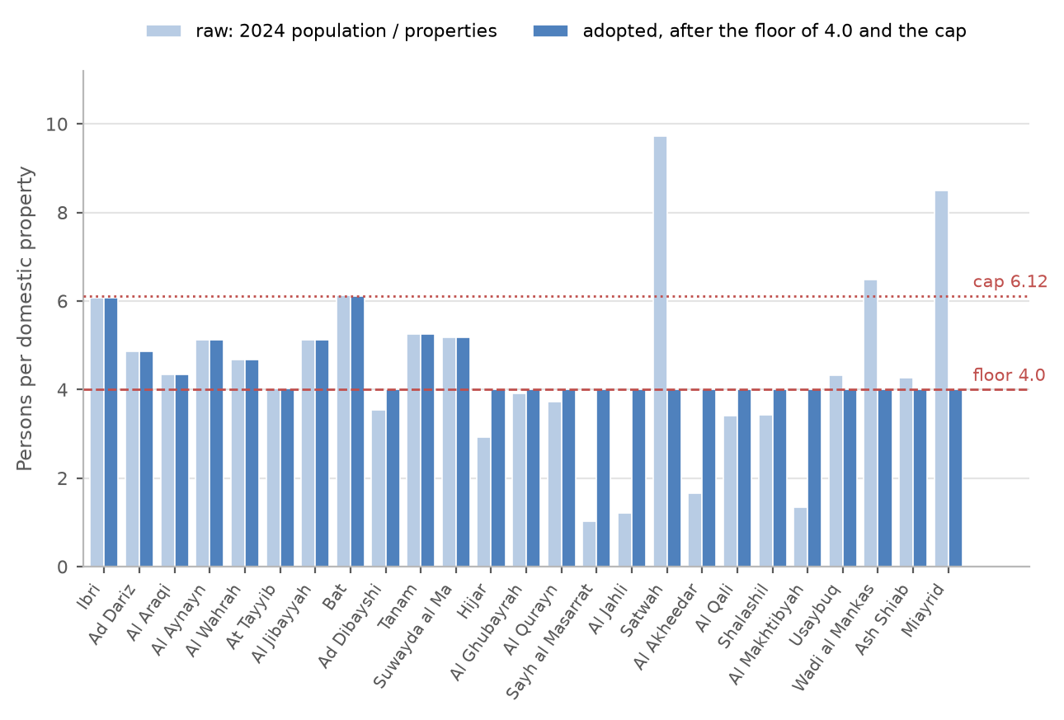
Figure 2 Persons per dwelling by settlement: the value worked out from the census and the meters, and the value adopted after the floor and the cap.
Decision 2. Adopt the persons per dwelling of each settlement as in the table, with the floor, the cap and the rule for small settlements.

3.3 The 126 meters with no plot within 15 metres
126 meters lie more than fifteen metres from any plot. 30 of them are dwellings, about 140 people at their settlement's occupancy; the rest are government, shop and farm meters. They carry no load in the plot table today. The map on the next page shows where they are, and Appendix A3 shows every one of them close up, with the plots around it, so the reader can see why it did not snap: a meter on a road reserve, at a pumping station, on a plot the cadastre does not carry.
Decision 3. Leave these meters out of the plot loads, as now, or assign each to its nearest plot whatever the distance. About 140 people either way.

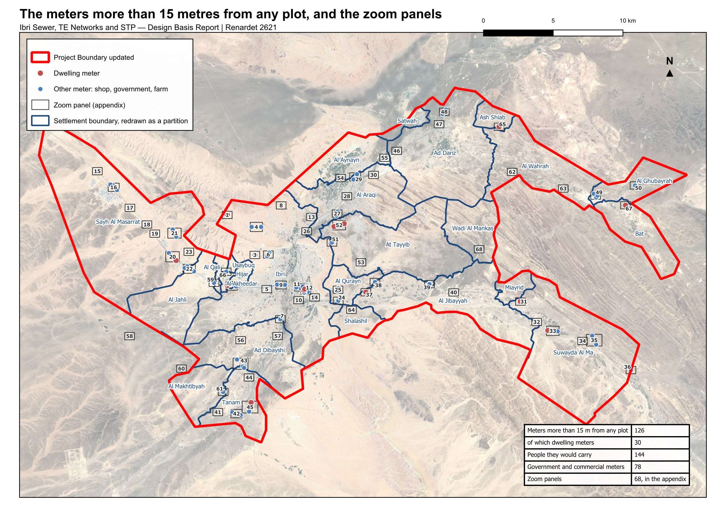
Figure 3 The 126 meters more than fifteen metres from any plot, and the zoom panels of Appendix A3.

4 The use of each plot
The cadastre's own land-use field cannot be used as it stands: it has no government class, it records whole districts under codes that mean unclassified, and on the plots that carry meters it disagrees with the meters on 24 per cent of them. The use of every plot has therefore been worked out from what is on it, in a fixed order.
1. a plot inside one of the two industrial estates is industrial;
2. the 177 plots of the old quarter of Ibri, recorded as tourism, are heritage and carry no load;
3. a plot with a farm meter is a farm;
4. a plot the satellite shows as a grove is a farm, unless two thirds of its meters are shops or most are government;
5. a plot whose industrial meters equal or outnumber its dwellings is industrial;
6. otherwise the meters decide by proportion: more than two thirds dwellings makes a home, two thirds or more government makes a government plot, two thirds or more shops makes a shop, and a mix is a home with a shop, or a government plot where the government meters are the more;
7. a plot without a meter is empty.
The satellite test uses one cloud-free image. Bare ground in the study area reads 0.08 on the vegetation index and a date grove 0.8, so one image separates the two. A plot is a grove where at least 1,000 square metres of it read above 0.30 with a mean above 0.20, or, for a small plot, where at least sixty per cent of it is green.
Table 4 Use of the built plots that carry a meter
Use | Plots | How it was decided
Home | 12,464 | more than two thirds of the meters are dwellings
Home with a shop | 614 | a mix, with at least as many shop as government meters
Shop | 1,321 | two thirds or more of the meters are shops
Government | 409 | two thirds or more government; or a mix with more government than shop meters
Farm | 1,685 | a farm meter (489) or a grove on the satellite (1,196)
Industrial | 263 | inside an industrial estate, or industrial meters that match the dwellings
Heritage | 177 | the old quarter of Ibri; no meter, no load
Empty | 60,509 | no meter

The use decides where the shop and government water is placed and which empty plots can become homes. It does not change the total: that comes from the people and the rates of Section 5.
Decision 4. Adopt the use worked out from the meters and the satellite as the basis for placing the loads.

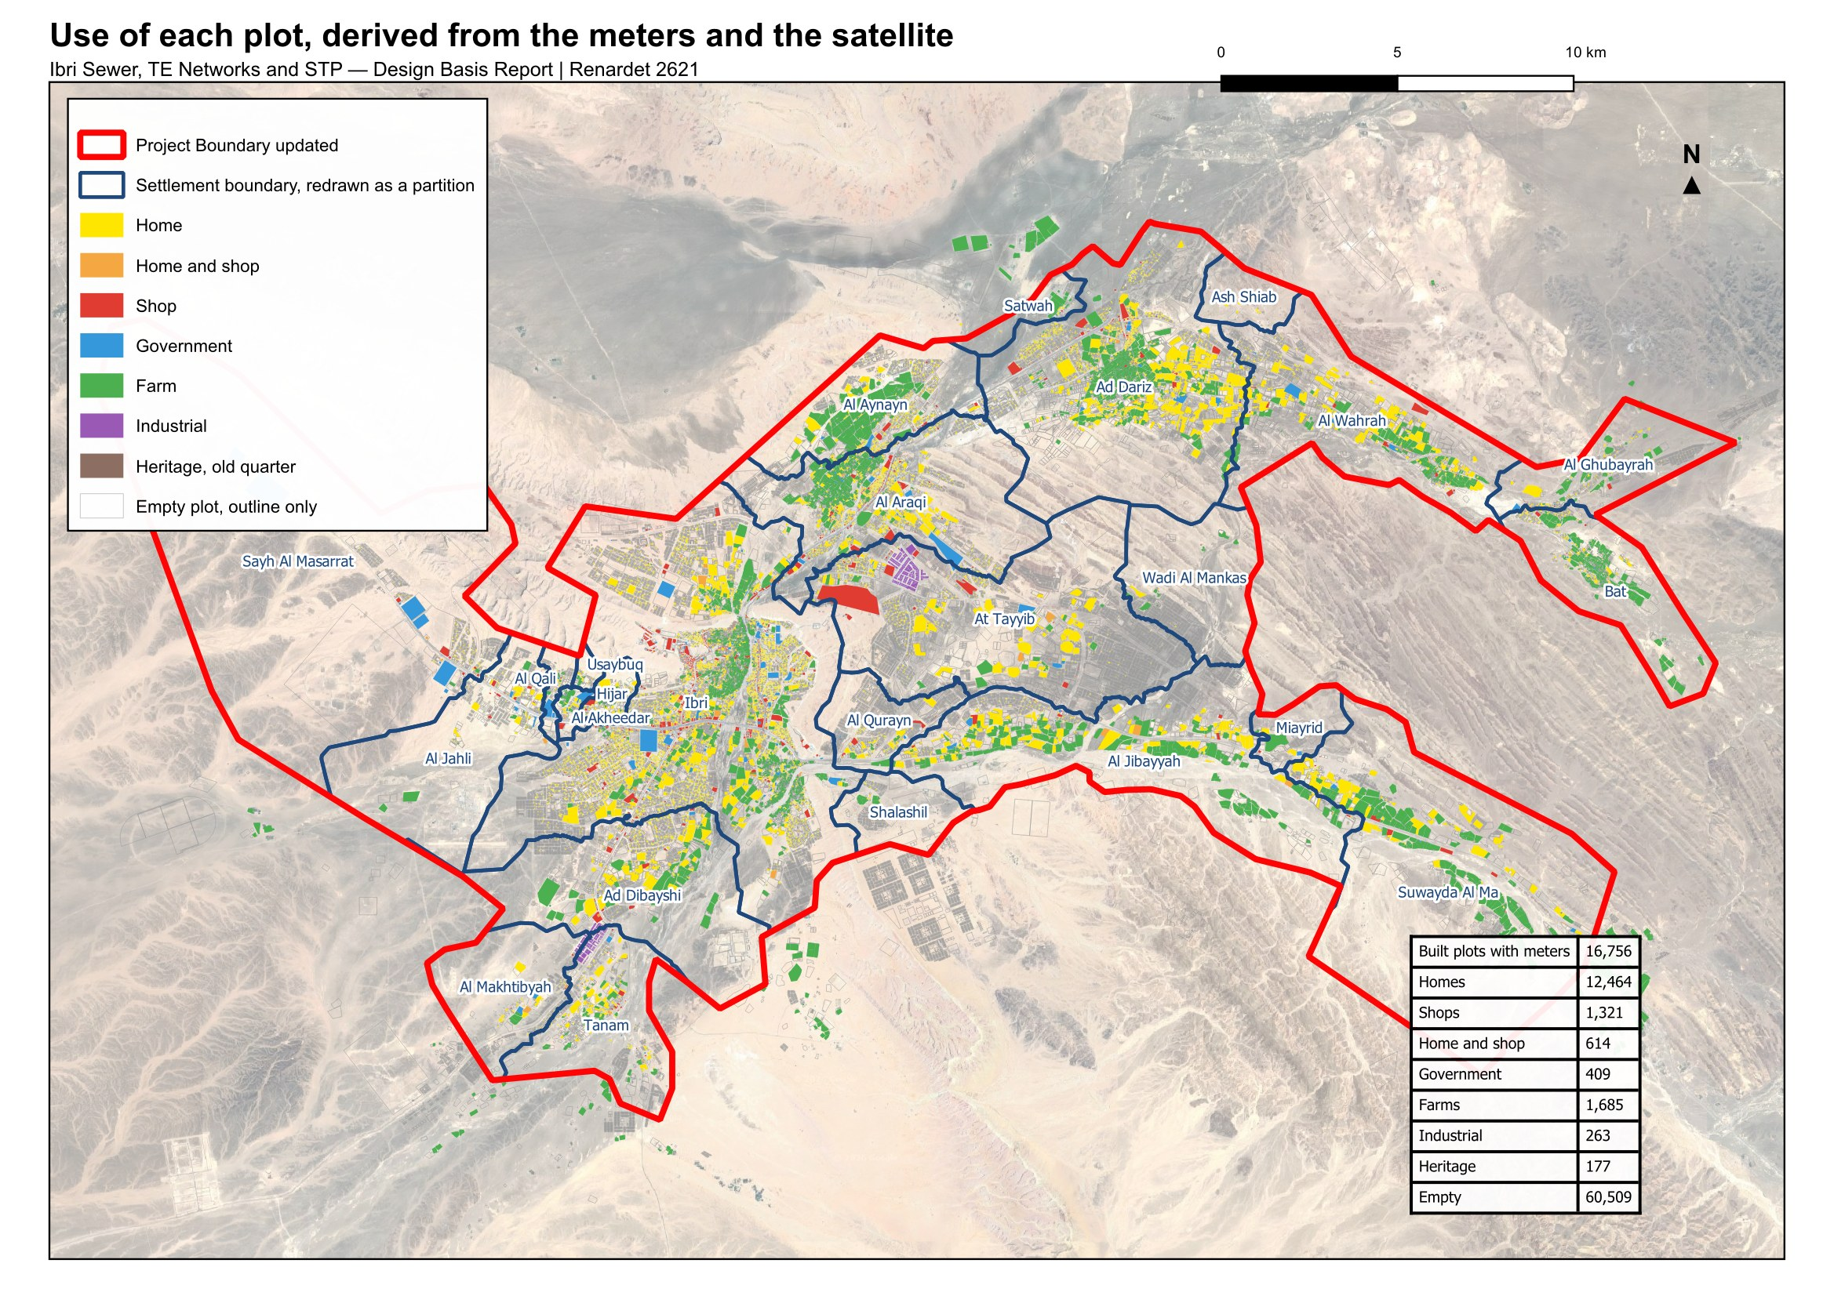
Figure 4 The use of each plot. Coloured plots are built and metered; empty plots are shown by their outline only.

5 From water to sewage
Sewage is worked out from water. Three streams are carried for every settlement: the water of its households, of its shops and offices, and of its government buildings. A fourth, the industrial estates, is added on its own. Each stream returns a fixed share to the sewer.
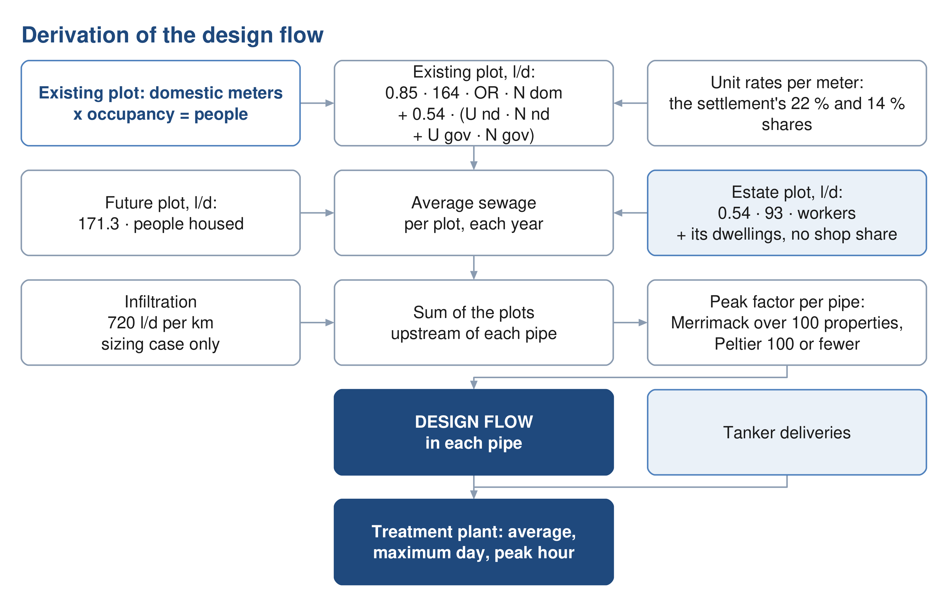
Figure 5 From the plot to the pipe and the plant: what each step adds.

5.1 Water demand
A person uses 164 litres a day at home. That is the value the guideline publishes for the Governorate of Adh Dhahirah, and it says the value applies until an updated figure is issued and should be validated by Nama Water Services before design.
$Q_{dom} = people × 164$ (2)
Q dom; domestic water demand, l/d
Shops, offices and government buildings are added as shares of the domestic water: 22 per cent for shops and offices, 14 per cent for government. The guideline calls these shares distributed. They come from the governorate's water balance of 2021 to 2023, all the non-domestic water divided by all the domestic water, so they stand for the everyday shops, mosques, schools and offices that come with any population, and they are added whether or not a particular village has a shop today. They do not cover named projects such as economic zones, which are added separately.
$Q_{shops} = 0.22Q_{dom} Q_{gov} = 0.14Q_{dom}$ (3)
Q shops; water of shops and offices in the settlement, l/d
Q gov; water of government buildings in the settlement, l/d
The guideline prefers unit rates where detailed land use is known: so many litres per pupil, per hospital bed, per employee, per square metre of shop. None of those quantities is held for Ibri. Until they are, the ratios are used. They are not added on top of unit rates anywhere; it is one or the other.
The shares are placed where the water is used. Each settlement's shop water is divided equally among its shop meters, and its government water among its government meters, so the load sits on the shopping street and the school, not on the houses. A settlement with no shop or government meter keeps that share on its houses.
Decisions 5 and 7. Confirm 164 litres a day, 22 per cent and 14 per cent; and accept the ratios in place of unit rates until the quantities are supplied, with the shares placed on the shop and government meters.

5.2 Return to the sewer
Not all water reaches the sewer. Households return 85 per cent, and so does water delivered by tanker; shops, offices, government buildings and the estates return 54 per cent. Farm meters feed irrigation pumps and return nothing.
$Q_{sewage} = 0.85Q_{dom} + 0.54\left(Q_{shops} + Q_{gov} + Q_{estates}\right)$ (4)
Q sewage; average sewage flow, before infiltration, l/d
Q estates; water of the industrial estates, l/d
For a person in a new home all three streams are added together: 164 × 0.85 + 36 × 0.54 + 23 × 0.54 = 171.3 litres of sewage a day. That is the rate every future plot carries, because where its shops will stand is not known.
Decision 6. Confirm 85 per cent for households and tanker supply and 54 per cent for the rest.

5.3 The industrial estates and other named sites
Two industrial estates lie inside the study area, at Al Tayyeb in the north-east of the town and at Tanam beside the treatment plant. Their meters are on the commercial tariff. The guideline keeps such estates outside the ratios, so they are carried on their own: a workforce of 4,500 at Al Tayyeb and 1,800 at Tanam, at 93 litres a day each, the dry-industry rate. The workforce is an assumption from the number of workshop meters and is to be replaced by the estates' records.
Table 5 Named sites outside the ratios
Site | What it is | How it is carried
Al Tayyeb industrial area | 94 ha, 202 industrial plots | 4,500 workers at 93 l/d
Tanam industrial area | 61 ha, 105 plots, beside the plant | 1,800 workers at 93 l/d
Army camp | 296 ha west of the town, no meter | recorded, no load; occupancy and drainage to be confirmed
Ibri View resort | 2 km² at As Sulayf, announced | recorded, no load until its plan is issued
Ibri Industrial City (Madayn) | 10 km², 8.6 km outside the boundary | outside the network; a source of tankered sewage to confirm
Power station and solar plants | 7.5 to 11 km outside, with a camp | outside the network; tankered sewage to confirm

Water delivered by tanker and water from private wells are in no flow. No filling-station or delivery record is held, and no record of private wells. Both are requested in Section 9. A household on tanker supply is metered for electricity like any other, so its people are counted; only the extra water is missing, and it can only raise the loads.
Decision 8. Accept the assumed workforce of the two estates until their records are supplied.

5.4 The result for 2024
Applied plot by plot, the rules give 20,852 cubic metres of sewage a day in 2024: 16,713 from households, 2,336 from shops and offices, 1,486 from government buildings and 316 from the two estates. The table gives the settlements.
Table 6 Water and sewage by settlement, 2024, m³/d
Settlement | People | Household water | Shop and office water | Government water | Estates | Sewage
Ibri | 67,106 | 11,005 | 2,421 | 1,541 | – | 11,494
Ad Dariz | 11,850 | 1,943 | 428 | 272 | – | 2,030
Al Araqi | 10,696 | 1,754 | 386 | 246 | – | 1,832
Al Aynayn | 4,554 | 747 | 164 | 105 | – | 780
Al Wahrah | 3,351 | 550 | 121 | 77 | – | 574
At Tayyib | 3,348 | 549 | 121 | 77 | 419 | 799
Al Jibayyah | 2,686 | 440 | 97 | 62 | – | 460
Bat | 2,557 | 419 | 92 | 59 | – | 438
Ad Dibayshi | 2,724 | 447 | 98 | 63 | 27 | 481
Tanam | 2,116 | 347 | 76 | 49 | 105 | 419
Suwayda al Ma | 1,559 | 256 | 56 | 36 | – | 267
Hijar | 1,408 | 231 | 51 | 32 | – | 241
Al Ghubayrah | 644 | 106 | 23 | 15 | – | 110
Al Qurayn | 588 | 96 | 21 | 14 | – | 101
Sayh al Masarrat | 1,828 | 300 | 66 | 42 | – | 313
Al Jahli | 1,376 | 226 | 50 | 32 | – | 236
Satwah | 108 | 18 | 4 | 2 | – | 19
Al Akheedar | 480 | 79 | 17 | 11 | – | 82
Al Qali | 224 | 37 | 8 | 5 | – | 38
Shalashil | 152 | 25 | 5 | 3 | – | 26
Al Makhtibyah | 364 | 60 | 13 | 8 | 36 | 82
Usaybuq | 84 | 14 | 3 | 2 | – | 14
Wadi al Mankas | 32 | 5 | 1 | 1 | – | 5
Ash Shiab | 44 | 7 | 2 | 1 | – | 8
Miayrid | 16 | 3 | 1 | 0 | – | 3
Total | 119,893 | 19,663 | 4,326 | 2,753 | 586 | 20,852

6 How the land fills
The population of 2024 is counted. The population at the end is set by the land: a settlement can only grow until its empty plots are built. Three things are needed: how many people the empty land can hold, how fast each settlement grows, and what happens when it is full.
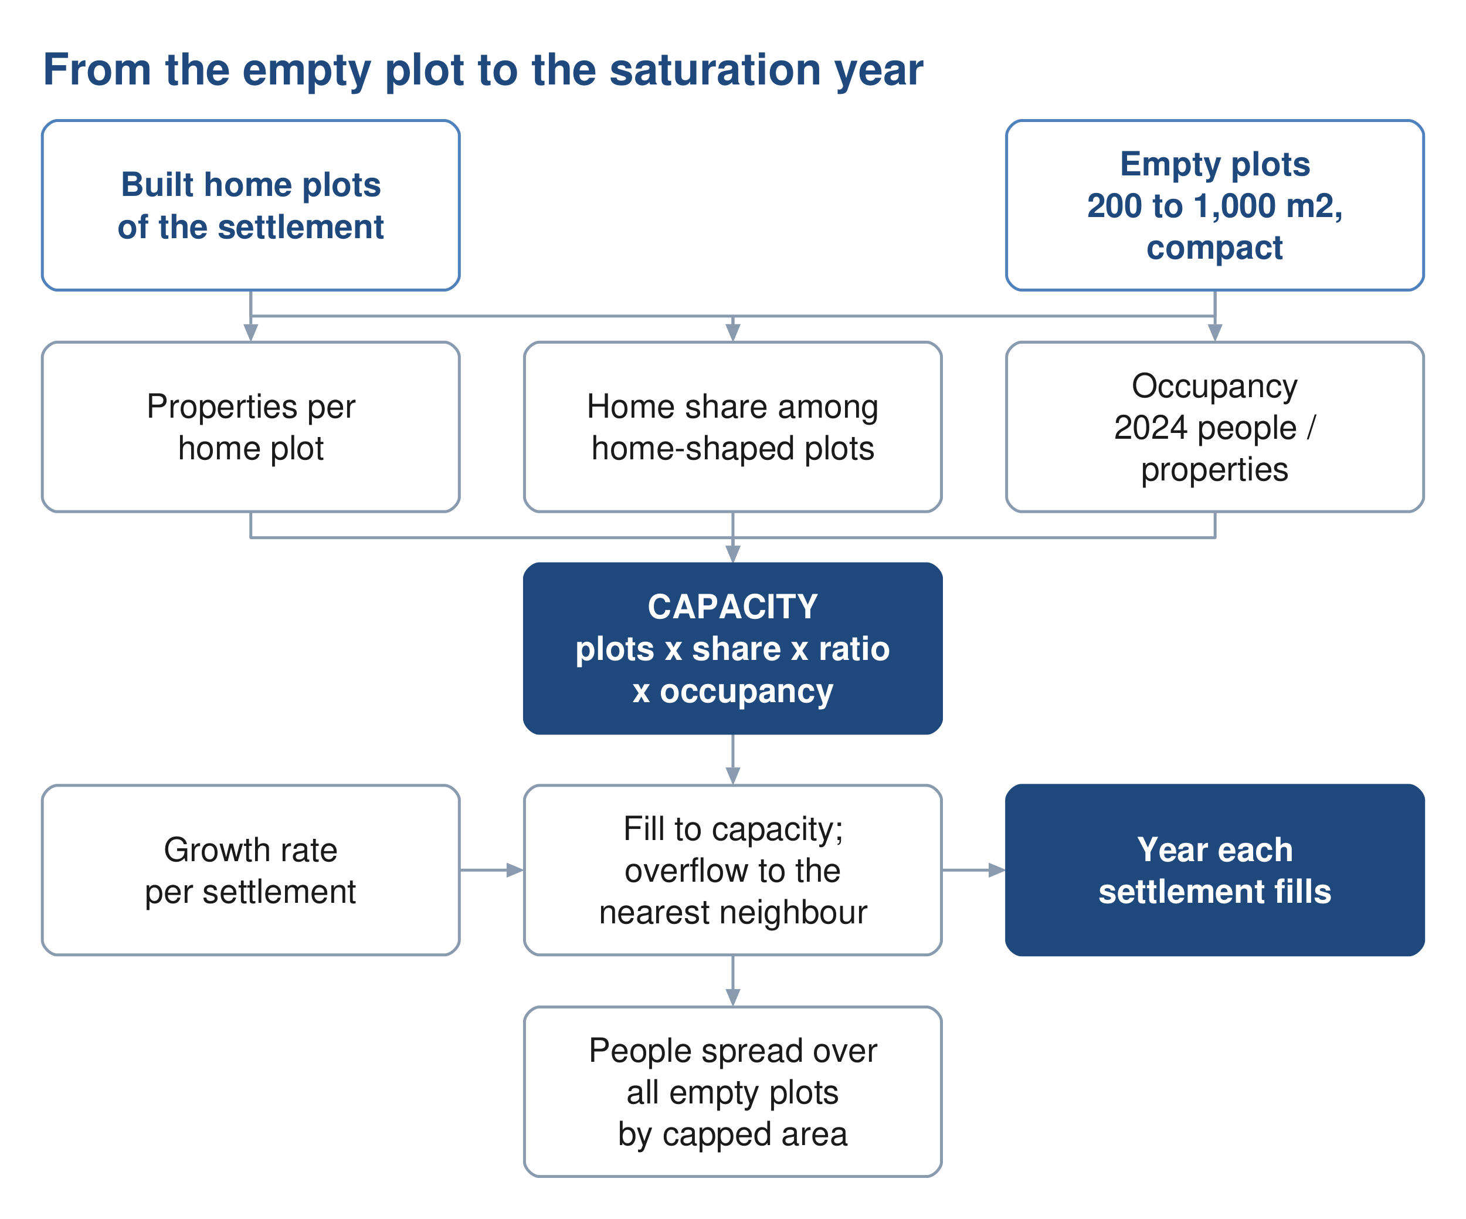
Figure 6 From the empty plot to the year each settlement is full.

6.1 How many people the empty land can hold
Of the 77,265 plots, 60,509 carry no meter. Not all of them will become homes. A future home plot must look like the built ones: between 200 and 1,000 square metres, compact, not a strip. Slivers below 200 square metres, odd shapes and everything above 1,000 square metres are left out, as are groves, industrial plots and the heritage quarter. 46,109 empty plots pass that test.
A district also needs mosques, shops and offices, so not every home-shaped plot becomes a home. The share that does is measured in each settlement over its built, metered, home-shaped plots. Ibri returns 0.87; among the settlements of a thousand people or more it runs from 0.67 at Tanam to 0.94 at Al Aynayn. The number of dwellings a home plot carries is measured the same way; Ibri returns 1.33.
$capacity = home‑shaped empty plots × home share × dwellings per plot × OR$ (5)
capacity; people the empty land of the settlement can hold, persons
home share; share of the home-shaped plots that become homes
OR; persons per dwelling of the settlement
The empty land of the study area holds 229,136 people on this basis, against 119,893 living in it in 2024.

6.2 How fast each settlement grows
The growth rate comes from the population series of the Inception Report, and nothing else is taken from it. To 2040 the series is the official forecast for the wilayat; from 2041 to 2050 it is an extrapolation of that forecast; from 2051 it rises from 2.2 per cent a year to 2.40 by 2058 and stays there to 2100, the horizon Nama Water Services instructed. Every settlement carries the same annual rate, applied to its counted population. The rate averages 2.6 per cent a year to 2030, 2.5 in the 2030s, 2.0 in the 2040s, 2.3 in the 2050s and 2.4 after 2060.
The series' total for 2100 is not a target. The land fills long before then.
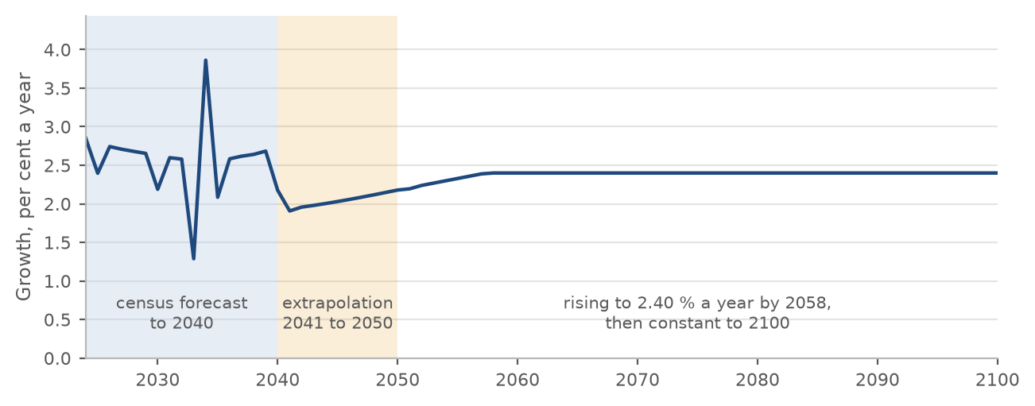
Figure 7 The annual growth rate of the series: the forecast to 2040, the extrapolation to 2050, and the rise to a constant 2.40 per cent.
Decision 11. Accept the series as the source of the growth rates, including the constant 2.40 per cent a year after 2058.

6.3 What happens when a settlement is full: the overflow
Each settlement grows at the rate of the series until its empty plots are built. Then its further growth has to go somewhere. Two readings are possible, and the choice between them is the largest single decision in this report.
With the overflow: when a settlement is full, its further growth moves to a neighbour with room. Ibri's goes in parallel to Al Araqi, Al Qurayn and Shalashil, in the proportions seventy, twenty and ten per cent, then to Ad Dariz, then to the nearest settlement with room. At Tayyib's goes first to Miayrid. Every other settlement overflows to its nearest neighbour with room.
Without: each settlement grows on its own rate and stops when it is full. The growth it cannot house is lost to the study area.
The difference is large. With the overflow every settlement fills by 2070 and the study area holds 349,029 people. Without it, 7 settlements never fill before 2100, the study area holds 273,616 people in 2070, and 75,414 people of the series have nowhere to go. A sewer in those settlements sized on their own growth would be sized for land that never fills.
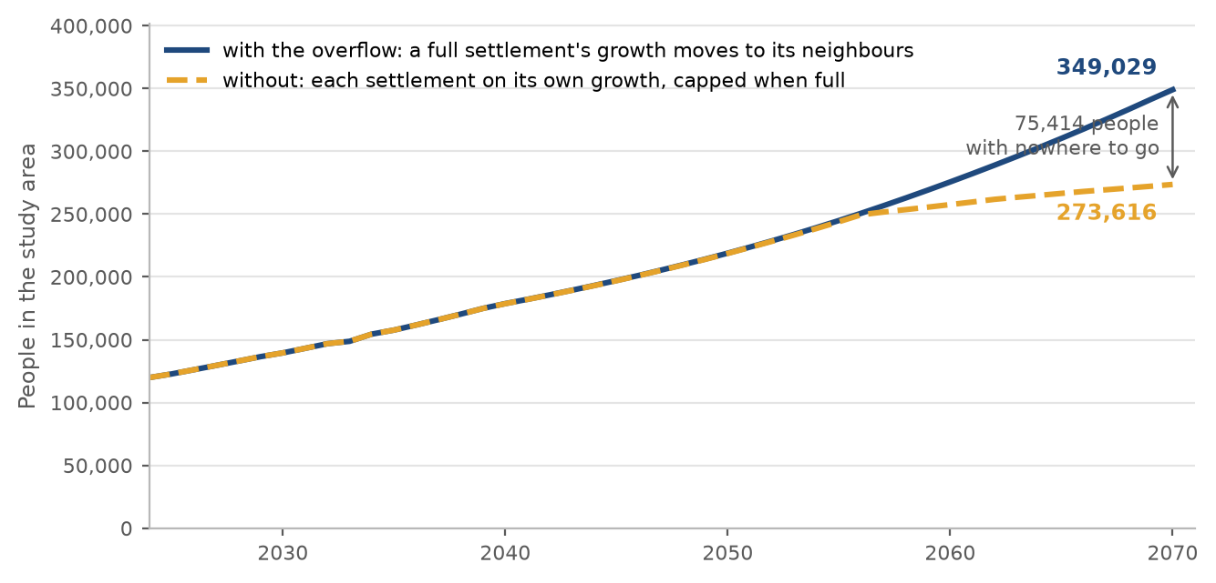
Figure 8 People in the study area by year, with the overflow and without it.
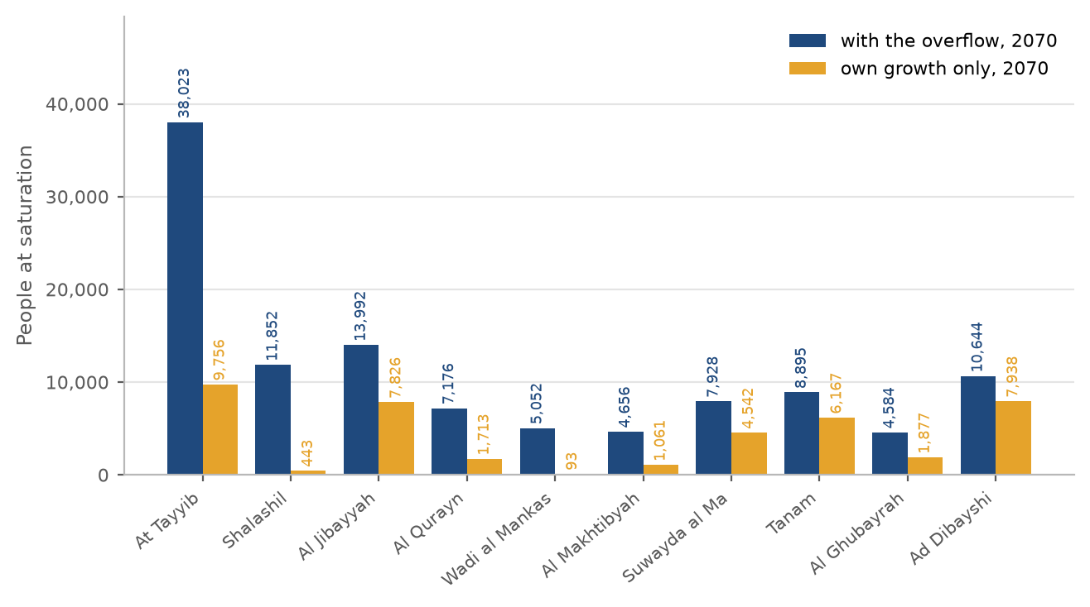
Figure 9 People at saturation in the ten settlements the choice affects most, with the overflow and without.
Table 7 Every settlement with and without the overflow: people in 2070 and the year it is full
Settlement | Capacity, people | With the overflow: people 2070 | full in | Own growth only: people 2070 | full in
Ibri | 73,299 | 140,405 | 2056 | 140,405 | 2057
Ad Dariz | 16,854 | 28,704 | 2062 | 28,704 | 2063
Al Araqi | 11,832 | 22,528 | 2057 | 22,528 | 2057
Al Aynayn | 7,459 | 12,013 | 2060 | 12,013 | 2066
Al Wahrah | 7,109 | 10,460 | 2070 | 9,765 | 2073
At Tayyib | 34,675 | 38,023 | 2068 | 9,756 | not before 2100
Ad Dibayshi | 7,920 | 10,644 | 2063 | 7,938 | 2083
Al Jibayyah | 11,306 | 13,992 | 2070 | 7,826 | 2095
Bat | 2,226 | 4,783 | 2052 | 4,783 | 2052
Tanam | 6,779 | 8,895 | 2069 | 6,167 | 2086
Sayh al Masarrat | 4,984 | 6,812 | 2069 | 5,327 | 2081
Suwayda al Ma | 6,369 | 7,928 | 2070 | 4,542 | 2094
Hijar | 1,288 | 2,696 | 2053 | 2,696 | 2053
Al Jahli | 3,684 | 5,060 | 2063 | 4,010 | 2080
Al Ghubayrah | 3,940 | 4,584 | 2070 | 1,877 | not before 2100
Al Qurayn | 6,588 | 7,176 | 2060 | 1,713 | not before 2100
Al Akheedar | 160 | 640 | 2036 | 640 | 2036
Al Makhtibyah | 4,292 | 4,656 | 2069 | 1,061 | not before 2100
Al Qali | 564 | 788 | 2054 | 653 | 2078
Shalashil | 11,700 | 11,852 | 2061 | 443 | not before 2100
Satwah | 284 | 392 | 2060 | 315 | 2080
Usaybuq | 140 | 224 | 2054 | 224 | 2067
Ash Shiab | 48 | 92 | 2056 | 92 | 2056
Wadi al Mankas | 5,020 | 5,052 | 2068 | 93 | not before 2100
Miayrid | 616 | 632 | 2070 | 47 | not before 2100
Total | 229,136 | 349,029 | 2070 | 273,616

Decision 9. Adopt the overflow, or keep every settlement on its own growth.

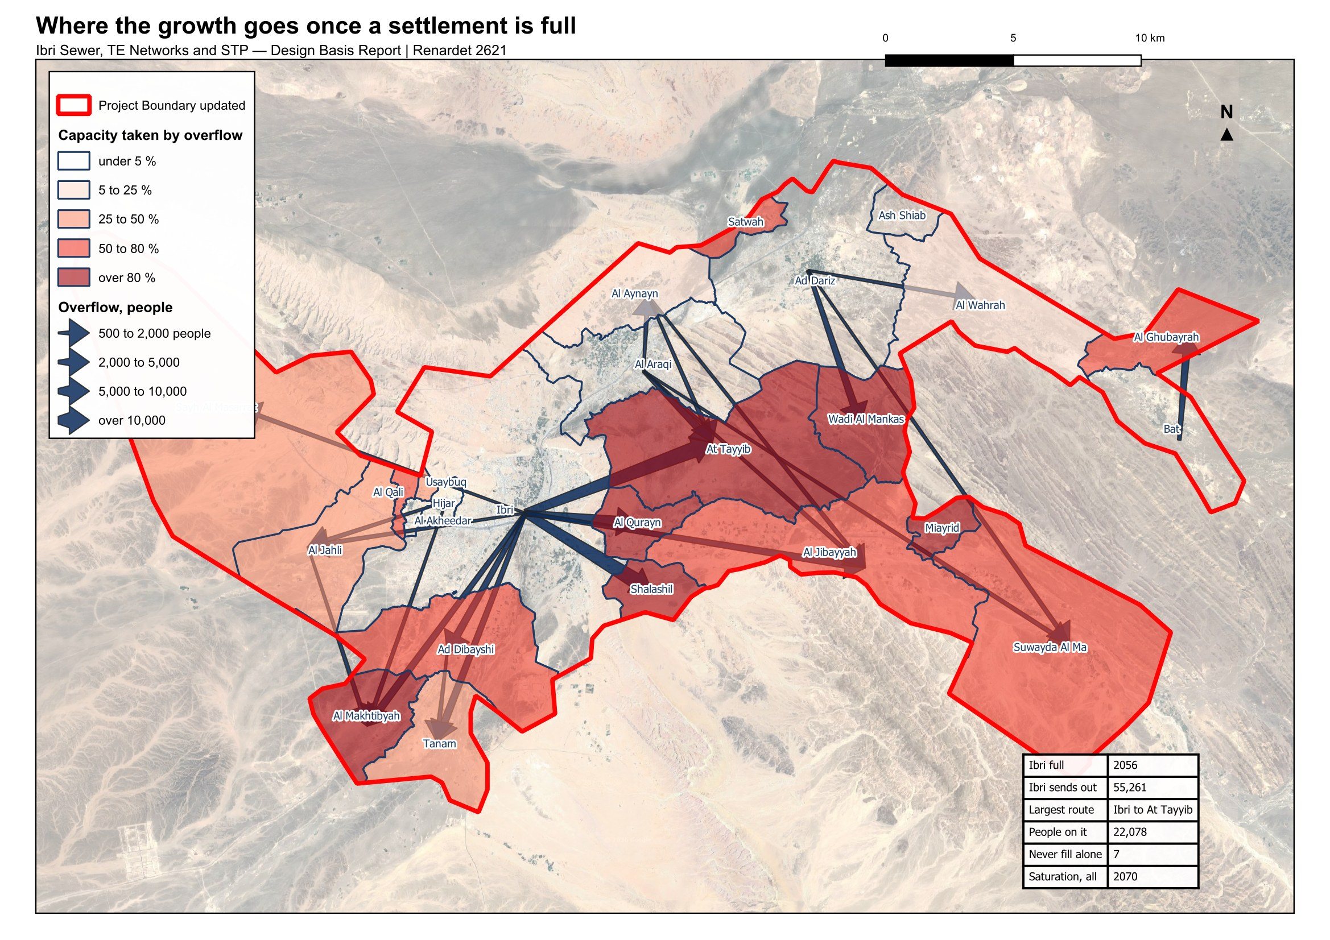
Figure 10 Where the growth goes once a settlement is full. Arrows show the routes carrying five hundred people or more; the shading shows how much of each settlement's capacity is taken by its neighbours' overflow.

6.4 The year the land is full, and the design horizon
With the overflow, Ibri fills in 2056, Al Araqi in 2057, Ad Dariz in 2062, and the last settlement in 2070. That is the saturation the Terms of Reference ask for: 349,029 people and 60,099 cubic metres of sewage a day. The Terms of Reference also name a horizon of completion plus twenty-five years. The land fills later than that, and a network sized on the earlier date would be full while the plots around it were still being built. The saturation year is adopted.
Table 8 The study area in the design years
Year | People | Average sewage flow, m³/d | What it is
2024 | 119,893 | 20,852 | today, from the meters
2030 | 139,535 | 24,216 | opening year
2055 | 244,914 | 42,266 | model year
2070 | 349,029 | 60,099 | saturation: the land is full

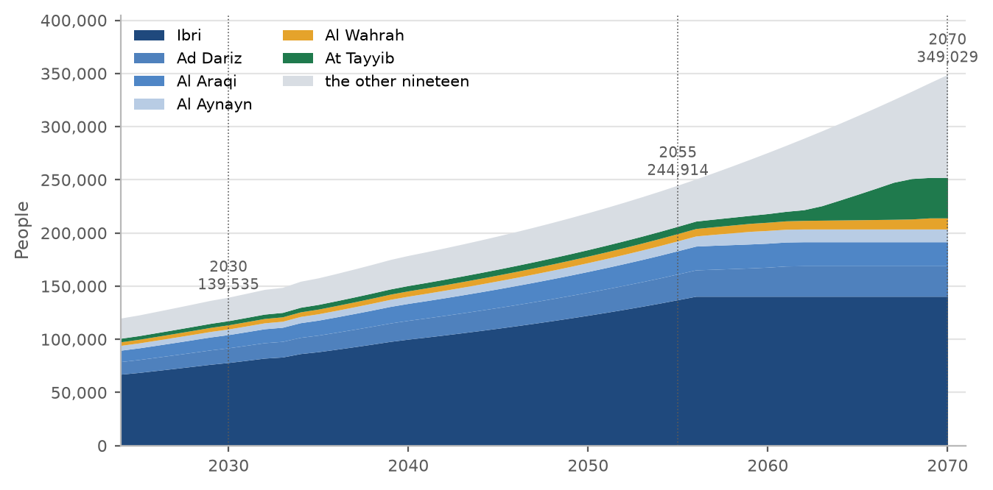
Figure 11 People by year to saturation, the six largest settlements shown separately. The flat top of each band is the year that settlement fills.
Decision 10. Adopt 2070, the year the land is full, as the design horizon.

7 The flow each element is designed for
Every plot now carries an average sewage flow for 2024, 2030, 2055 and the saturation year. What each element of the system is designed for follows from those plot flows by fixed rules, set out below element by element. The rules are the same wherever the element sits, so the client can check any one of them.

7.1 The plot
The plot carries the average flow of its people and meters, and nothing else: no peak, no infiltration, no tankers. Those belong to the pipe and the plant. A new home carries 171.3 litres a day per person; an existing plot carries its own meters at the rates of Section 5.

7.2 The pipe
A pipe is checked twice, on two different flows, because the two checks fail in opposite directions.
Size and capacity: the flow at saturation of every plot upstream, added up, peaked, plus infiltration along the pipe. Under-estimating it surcharges the pipe.
Self-cleansing: the flow in 2030 of the plots upstream, with 61 per cent of the properties connected, peaked, and no infiltration. Over-estimating it declares a pipe self-cleansing while it silts.
The 61 per cent is the connection ratio of the Inception Report, reached by 2028. It is never applied to the saturation flow: that would give a pipe in a new district most of its final flow in a year when it carries almost nothing.
Peak flow belongs to the pipe, not to the plot. Above 100 properties the Merrimack formula applies, at 100 or fewer the Peltier formula.
$Q_{peak} = 2.65{Q_{avg}}^{0.879} or Q_{peak} = \left(1.5 + \frac{1}{\sqrt{Q_{m}}}\right)Q_{avg}$ (6)
Q peak; peak flow: the guideline's peak daily flow, equal to its peak hourly flow, Ml/d
Q avg; average flow of the plots upstream, Ml/d
Q m; the same average flow, in the Peltier formula, l/s
The guideline recommends that the hourly peak factor not exceed 5.0. It is a recommendation, applied as such. Infiltration is 720 litres a day per kilometre of new sewer, added along each pipe by its length; stormwater is not considered.
Gradients. At the concept stage every pipe is laid at the guideline's minimum gradient for its size, in steps of 0.05 per cent, or 0.025 per cent for trunks of 500 mm and above. The guideline asks for a second test, the minimum tractive force, and for the steeper of the two to govern. At this stage that test is used only to list the pipes that will need washing in the early years, not to steepen them, because the tractive tension it needs is not given in the guideline. One pascal is used until Nama Water Services confirms a value. That is a departure from the guideline, stated here for confirmation.
Table 9 Minimum gradients at the concept stage
Pipe size, mm | 200 | 250 | 315 | 400 | 500 | 600 | 700 | 800 | 900 and above
Minimum gradient, mm/m | 5.00 | 3.75 | 2.70 | 2.05 | 1.55 | 1.25 | 1.00 | 0.85 | 0.75

The chart shows what the tractive test asks of a pipe. It is a curve: the smaller the flow, the steeper the pipe must be. A 200 mm pipe at its minimum gradient of 0.5 per cent passes the test at 1.29 litres a second and above. Below that, at the very head of a street, no practical gradient passes; those pipes go on the washing list. A design floor is proposed: a pipe carrying less than 1.5 litres a second is checked as if it carried 1.5, for which the curve asks 0.47 per cent, so a 200 mm pipe at the Table 11 gradient always passes. The floor and the value of one pascal are for Nama Water Services to confirm.
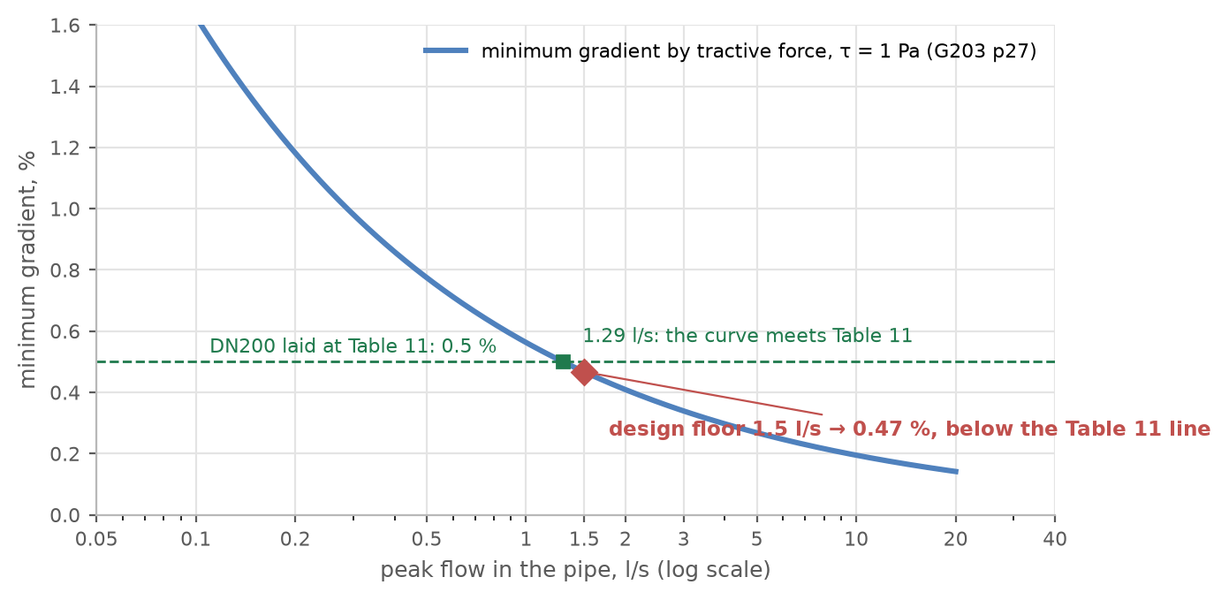
Figure 12 The minimum gradient the tractive-force test asks for, against the flow in the pipe, with the 200 mm line and the proposed 1.5 litres a second floor.
Decisions 12 to 15. Confirm the connection ratio, the infiltration, the peak formulae, and the concept-stage rule for gradients and self-cleansing with its floor.

7.3 The pumping station and its rising main
A gravity sewer goes deeper the further it runs. The guideline recommends about 10 to 12 metres of cover as the point where excavation cost justifies a pumping station. Nothing is costed at the concept stage, so 12 metres is applied as a hard limit: where a sewer would pass it, a station is placed before that point and the sewer restarts at normal cover. Each such pocket is a pumping station candidate.
The station's duty flow is the peak flow of the pocket it drains plus the infiltration of its sewers, at saturation. The rising main is sized on that duty: at least 0.75 metres a second, 1.0 where the pumps start and stop, and at most 2.5 metres a second.
Decision 16. Accept 12 metres of cover as a hard limit at the concept stage.

7.4 The trunk sewers and the treatment plant
The trunk sewers and the plant carry the sum of the settlements upstream. The plant is sized on three flows, and the guideline names what each one sizes: the average annual flow for the biological treatment, with the load; the peak hourly flow for everything the flow passes through; and the maximum day flow, which the guideline defines but gives no factor for.
$Q_{AAF} = 1.10\left(Q_{avg} + Q_{inf}\right) Q_{PHF} = 1.10\left(Q_{peak} + Q_{inf}\right)$ (7)
Q AAF; average annual flow, the design average of the plant, m³/d
Q PHF; peak hourly flow, for the structures the flow passes through, m³/d
Q avg, Q peak; average flow of the settlements upstream, and its Merrimack peak, m³/d
Q inf; infiltration of the whole network upstream, 720 l/d per km, m³/d
1.10; the 10 per cent margin the guideline requires for a new plant, over and above any standby
If the whole study area drains to one works, the flows are as in the table. The network has not yet been laid over the whole area, so its infiltration cannot be totalled; each 100 kilometres of new sewer adds 79 cubic metres a day with the margin. Tanker deliveries are added when their records arrive. The maximum day flow is read from a year of daily records at the existing works, requested in Section 9.
Table 10 Flows at one works for the whole area, before infiltration and tankers, m³/d
Flow | 2024 | 2030 | 2055 | 2070
People | 119,893 | 139,535 | 244,914 | 349,029
Average flow from the plots | 20,852 | 24,216 | 42,266 | 60,099
Merrimack peak factor | 1.83 | 1.80 | 1.68 | 1.61
Peak flow before the margin | 38,263 | 43,639 | 71,202 | 97,022
Average annual flow with the margin | 22,937 | 26,638 | 46,492 | 66,109
Peak hourly flow with the margin | 42,089 | 48,003 | 78,322 | 106,724
Infiltration with the margin, to add to both | 0.79 m³/d per km of sewer
Maximum day flow | from the existing plant's records

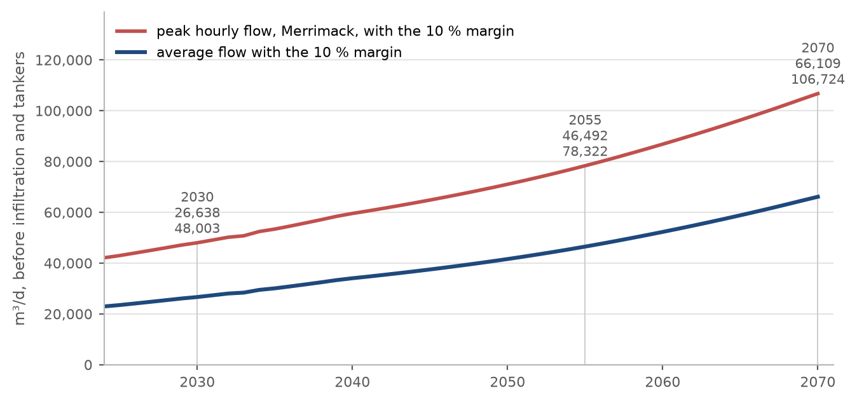
Figure 13 Average and peak-hour flow at one works for the whole area, by year, with the margin.
The map on the next page gives every settlement's average flow at saturation and the four steps to a plant flow, so that any grouping of settlements into one or more works can be worked out by hand.
Decision 17. Confirm the plant flows as defined, and supply the existing plant's daily inflow records for the maximum day.

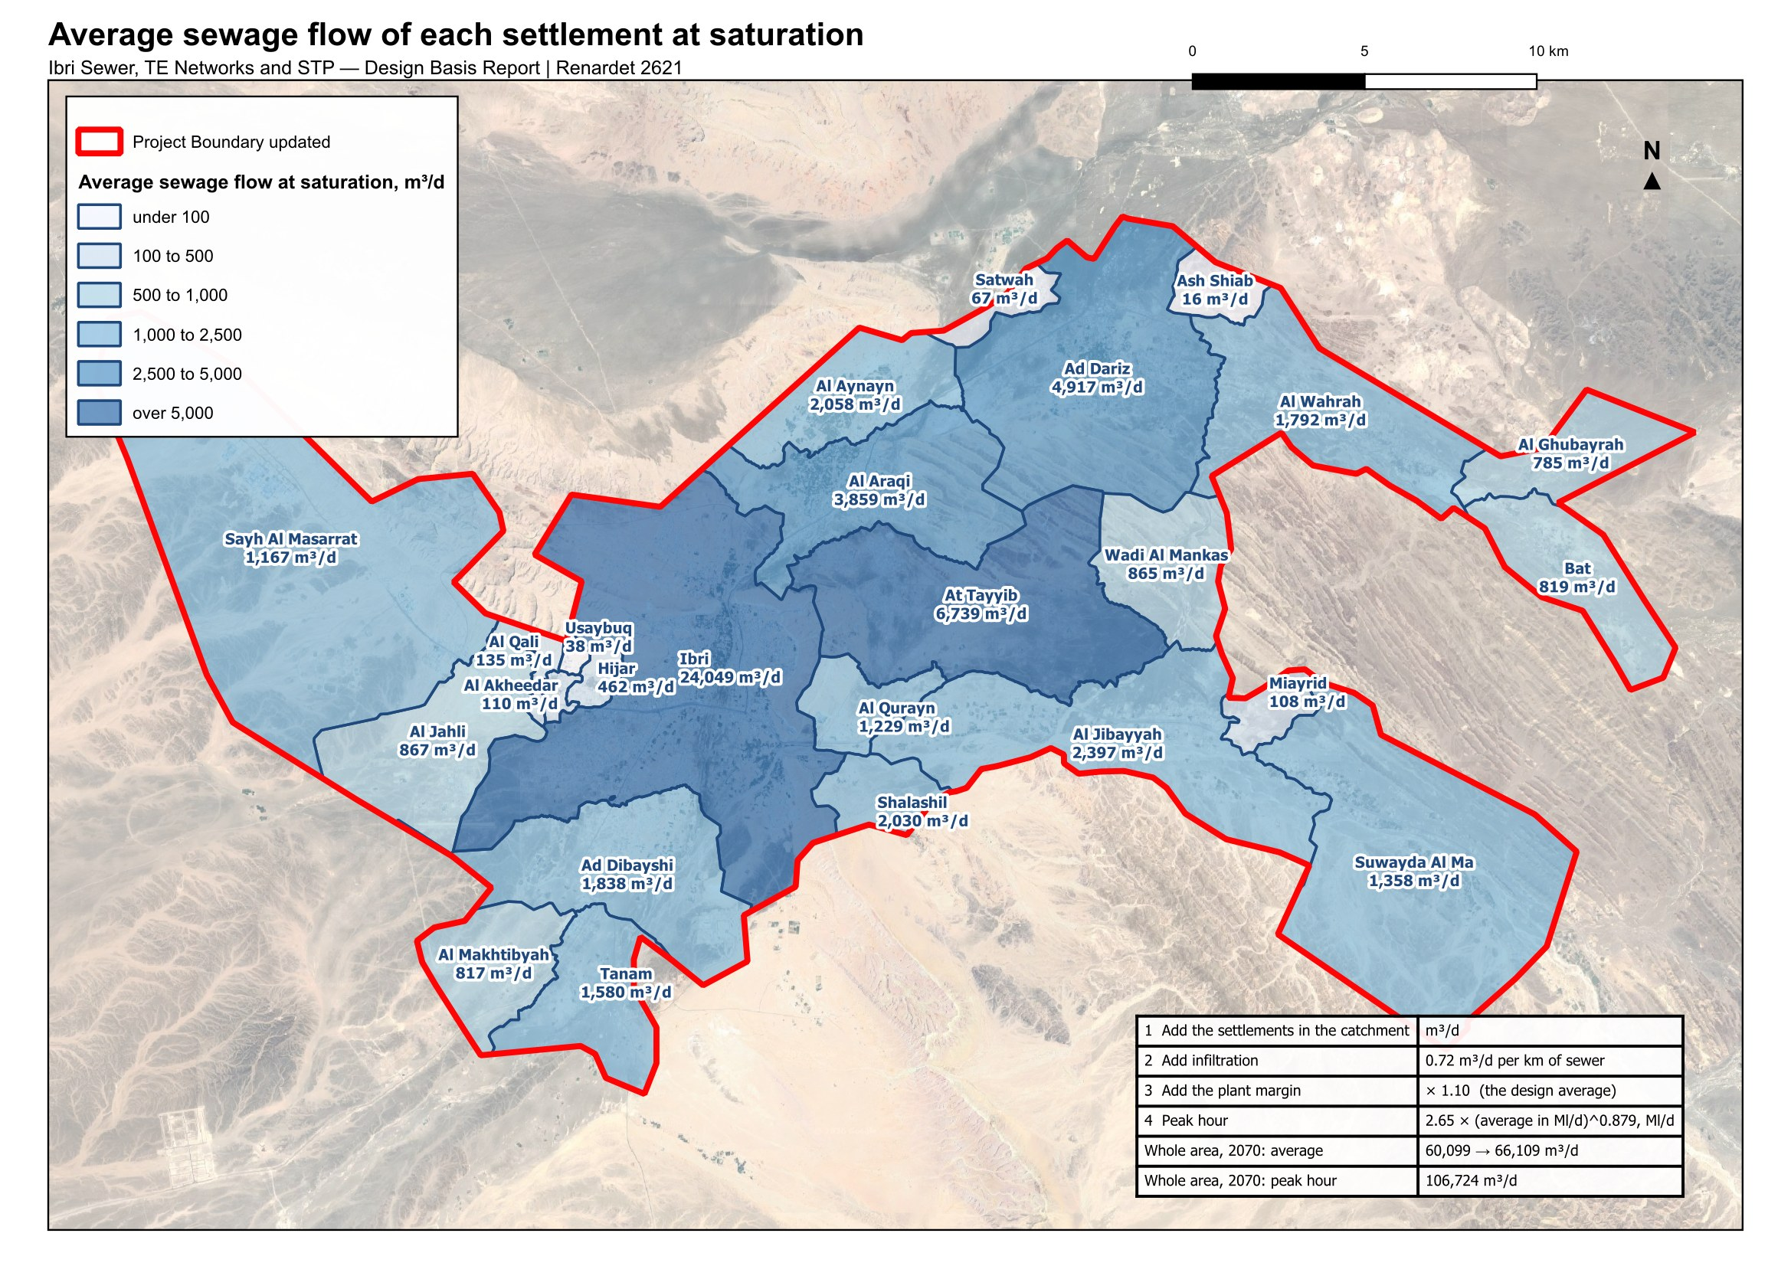
Figure 14 Average sewage flow of each settlement at saturation, and the four steps from the settlements in a catchment to the flow of its plant.

7.5 The load on the plant
The biological treatment is sized on the load, not only the flow. No laboratory data for Ibri's sewage is held. The guideline sets a minimum for a new plant: 60 grams of BOD and 80 grams of suspended solids per person per day. At the flows above that is 348 milligrams of BOD per litre at saturation, at the low end of the range the guideline gives for raw sewage, 350 to 400. The per-person loads are adopted until the laboratory results of the existing plant are supplied, and the sewage brought by tanker, which is far stronger, is provided for separately once its records arrive.
Table 11 Loads at one works for the whole area, from the per-person minima
 | 2024 | 2030 | 2055 | 2070
People | 119,893 | 139,535 | 244,914 | 349,029
BOD, kg/d | 7,194 | 8,372 | 14,695 | 20,942
Suspended solids, kg/d | 9,591 | 11,163 | 19,593 | 27,922
BOD as a concentration at the average flow, mg/l | 345 | 346 | 348 | 348
Suspended solids as a concentration, mg/l | 460 | 461 | 464 | 465
BOD at the peak factor of 1.2, kg/d | 8,632 | 10,047 | 17,634 | 25,130

Table 12 Raw sewage strength the guideline gives, for the network and for tankers, mg/l
Parameter | Network sewage | Sewage by tanker, average to maximum
BOD | 350 to 400 | 350 to 1,050
COD | 700 to 900 | 1,350 to 5,000
Suspended solids | 400 to 500 | 900 to 4,300
Total Kjeldahl nitrogen | 60 to 80 | 115 to 265
Ammonia as nitrogen | 40 to 50 | 70 to 125
Total phosphorus | 10 to 15 | 16 to 35
Decision 18. Accept 60 grams of BOD and 80 grams of suspended solids per person per day until the laboratory data of the existing plant are supplied.

7.6 Sewage other than domestic
Sewage from industry and commerce, called trade effluent in the guidelines, affects the plant's load and how treatable the sewage is. Where its chemical to biochemical oxygen demand is above the domestic range, a separate line is needed if the volume is significant. In Ibri the two industrial estates are workshops on the commercial tariff; no wet industry has been found. The estates are carried at the dry-industry rate (Section 5.3), and no separate line is foreseen at this stage. A central slaughterhouse has been announced without a site; it will need pre-treatment and is added when sited.

7.7 Treated effluent
Treated effluent is produced at 95 per cent of the plant inflow, and a further 10 per cent is lost in the treated effluent distribution network, so 85.5 per cent of the inflow reaches the customers. The customers, their demand and its seasonal pattern are being identified and will be presented in the concept design.
Table 13 Treated effluent available, one works for the whole area, m³/d
 | 2024 | 2030 | 2055 | 2070
Plant inflow, design average | 22,937 | 26,638 | 46,492 | 66,109
Produced, 95 per cent | 21,790 | 25,306 | 44,168 | 62,803
Delivered, less 10 per cent in the network | 19,611 | 22,776 | 39,751 | 56,523
Decision 19. Confirm 95 per cent produced and 10 per cent lost in the network.

8 Every adopted value in one table
The values below are the ones the design rests on. Where a value is the guideline's, its page is given. Where it is a choice of this design, the reason is given and the value is marked as such.
Table 14 Adopted values and assumptions
Value | Adopted | Why | Source
Domestic water use | 164 l per person per day | the published value for Adh Dhahirah; to be validated by NWS | G201 Table 11, p60
Shops and offices | 22 % of domestic | the distributed ratio for the governorate | G201 Table 11, p60
Government | 14 % of domestic | the distributed ratio; unit rates need quantities not held | G201 Table 11, p60; §7.3.3, p61
Return to the sewer | 85 % domestic and tanker; 54 % the rest | the published discharge ratios | G201 Table 19, p71
Farm meters | no sewage | they feed irrigation pumps; the house on a farm is metered separately | design rule
Industrial estates | 4,500 and 1,800 workers at 93 l/d | no record supplied; from the meter count | assumption; G201 Table 12, p61
Persons per dwelling | per settlement; floor 4.0; cap 6.12 | institutional housing distorts the low ones; the cap is the highest large settlement | design rule; G201 §7.2, p59
Settlements under 1,000 people | 4.0, one dwelling per plot, home share 0.9 | too few meters to measure on | design rule
Future home plot | 200 to 1,000 m², compact | the shape of the built home plots | design rule
Where the growth is placed | all empty plots up to 2,000 m², by area capped at 1,000 m² | the sewer serves every plot on its street | design rule
New home | 171.3 l of sewage per person per day | 164 × 0.85 + 36 × 0.54 + 23 × 0.54 | G201 Tables 11 and 19
Growth rates | the Inception Report series | the official forecast and its extension; used for rates only | Inception Report R0
Overflow | a full settlement's growth moves to its neighbours | the land, not the series, sets the population | design rule; Decision 9
Design horizon | saturation, 2070 | the year the last settlement fills | TOR; Decision 10
Connection in 2030 | 61 % of properties | the Inception Report ratio; used in the self-cleansing check only | Inception Report R0
Infiltration | 720 l/d per km, per pipe; none in the early-year check | new networks | G201 §7.4.3, p72
Peak flow | Merrimack above 100 properties; Peltier at or below | the guideline's formulae | G201 §7.4.2, p71 to 72
Hourly peak factor ceiling | 5.0, a recommendation | not applied silently | G201 p72
Minimum gradients | Table 11, in 0.05 % steps; 0.025 % for trunks | constructable and readable on drawings | G203 Table 11, p29; design rule
Tractive tension | 1 Pa; a 1.5 l/s floor | no value in the guideline; for washing lists only at this stage | G203 p27; Decision 15
Self-cleansing velocity | 0.75 m/s at peak flow, 0.90 preferred | the guideline | G203 p26
Depth of cover | 12 m hard limit; a station before it | no costing at concept stage | G203 §4.6.3, p33; Decision 16
Rising main velocity | 0.75 to 2.5 m/s; 1.0 for start-stop pumping | the guideline | G203 §8.1, p50
Plant margin | 10 % on average and peak | new plants | G201 §7.4.5, p73
Plant loads | 60 g BOD, 80 g solids per person per day | the guideline minimum; no laboratory data held | G203 §10.3.1, p74
Treated effluent | 95 % produced; 10 % lost in the network | the guideline | G201 p73, p76
Tanker water, private wells | not in any flow | no records held; requested | G201 §7.4, p70; §7.3.5, p61

9 Data requested
Seven items would improve or confirm the numbers in this report. None of them stops the concept design; each replaces an assumption with a record.
Table 15 Data requests
Item | What is asked for | Why
Tanker water and sewage tankers | Filling-station volumes by area and sewage tanker deliveries to the plant, with their source | Water supplied by tanker is not in any flow. It can only raise the loads.
Private wells | Any record of private abstraction inside the study area | The guideline requires it to be assessed. Not held.
Existing plant records | Daily inflow and the laboratory results for the Ibri plant, three years | Sets the maximum day flow and checks the per-person loads.
Industrial estates | Workforce and water use of the Al Tayyeb and Tanam estates | Replaces the assumed 4,500 and 1,800 workers.
Army camp | Occupancy and drainage arrangement of the camp west of the town | 296 hectares with no meter in the dataset.
Ibri View | The development plan of the resort at As Sulayf | Two square kilometres announced; no load carried until the plan is issued.
Non-domestic quantities | Pupils, beds, employees and floor areas by plot, where held | Would allow the unit rates of the guideline in place of the ratios.

10 Decisions requested
Each line can be answered with a yes, a no, or one figure. A no on any line returns the report to the section named.
Settlements and people
1. Settlement boundaries. Adopt the twenty-five settlement boundaries redrawn so that every plot lies in one settlement and there are no gaps between them (Section 2).
2. Occupancy per settlement. Adopt the persons per property worked out for each settlement, with the floor of 4.0, the cap of 6.12 and the rule for settlements under a thousand people (Section 3).
3. The 126 meters with no plot within 15 metres. Leave them out of the plot loads, as now, or assign each to its nearest plot whatever the distance. About 140 people either way (Section 3.3).
4. Use of each plot. Adopt the use worked out from the meters and the satellite image as the basis for placing the loads (Section 4).
Water and sewage rates
5. Water demand rates. Confirm 164 litres per person per day, plus 22 per cent for shops and offices and 14 per cent for government, the values published for Adh Dhahirah (Section 5.1).
6. Return to the sewer. Confirm 85 per cent of domestic and tanker supply and 54 per cent of the rest (Section 5.2).
7. Ratios in place of unit rates. Accept the published ratios in place of the unit rates per pupil, bed, employee and floor area, until those quantities are supplied, with the shares placed on the shop and government meters (Section 5.1).
8. The industrial estates. Accept 4,500 workers at Al Tayyeb and 1,800 at Tanam, at 93 litres a day each, as an assumption to be replaced by the estates' records (Section 5.3).
Growth
9. The overflow. Adopt the overflow: when a settlement's land is full, its further growth moves to its neighbours. The alternative leaves 75,000 people with nowhere to go by 2070 (Section 6.3).
10. The design horizon. Adopt the year the land is full, 2070, with 349,029 people and 60,099 cubic metres a day, as the design horizon, in place of completion plus 25 years (Section 6.4).
11. The growth series. Accept the Inception Report population series to 2100 as the source of the growth rates, including its constant 2.40 per cent a year after 2058, which goes beyond the ten years of extrapolation the guideline allows (Section 6.2).
12. The connection ratio. Accept 61 per cent of properties connected in 2030 for the early-year self-cleansing check, from the Inception Report (Section 7.2).
The network
13. Infiltration. Confirm 720 litres a day per kilometre of sewer, added to each pipe, and none in the early-year check (Section 7.2).
14. Peak flow. Confirm the Merrimack formula above 100 properties and the Peltier formula at 100 or fewer, with the 5.0 ceiling on the hourly factor treated as a recommendation (Section 7.2).
15. Gradients and self-cleansing at the concept stage. Accept that pipes are laid at the Table 11 minimum gradient in steps of 0.05 per cent, that the tractive force is used only to list the pipes needing early washing, at 1 pascal, and that a pipe carrying less than 1.5 litres a second is checked as if it carried 1.5 (Section 7.2).
16. Depth. Accept 12 metres of cover as a hard limit at the concept stage, with a pumping station before that point (Section 7.3).
The plant and the effluent
17. Plant flows. Confirm the average and peak-hour flows with the 10 per cent margin as defined, and supply the existing plant's daily inflow records so the maximum day can be set (Section 7.4).
18. Process loads. Accept 60 grams of BOD and 80 grams of suspended solids per person per day, the guideline's minimum, until laboratory data for the existing plant are supplied (Section 7.5).
19. Treated effluent. Confirm 95 per cent of the plant inflow produced as treated effluent and 10 per cent of it lost in the distribution network (Section 7.7).

Appendix A1 People and sewage by settlement, five-year steps to saturation
A cell is blank once the settlement is full. Totals are rounded from the unrounded values and may differ by one from the sum of the rows.
Table 16 People at five-year intervals
Settlement | 2024 | 2025 | 2030 | 2035 | 2040 | 2045 | 2050 | 2055 | 2060 | 2065 | 2070 | Full in | At saturation
Ibri | 67,106 | 68,713 | 78,099 | 88,272 | 100,066 | 110,349 | 122,535 | 137,198 |  |  |  | 2056 | 140,405
Ad Dariz | 11,850 | 12,134 | 13,791 | 15,587 | 17,670 | 19,486 | 21,638 | 24,206 | 27,350 |  |  | 2062 | 28,704
Al Araqi | 10,696 | 10,952 | 12,448 | 14,069 | 15,949 | 17,588 | 19,531 | 21,849 |  |  |  | 2057 | 22,528
Al Aynayn | 4,554 | 4,663 | 5,300 | 5,990 | 6,791 | 7,489 | 8,316 | 9,303 | 12,013 |  |  | 2060 | 12,013
Al Wahrah | 3,351 | 3,431 | 3,900 | 4,408 | 4,997 | 5,511 | 6,119 | 6,845 | 7,703 | 8,684 | 10,460 | 2070 | 10,460
At Tayyib | 3,348 | 3,428 | 3,897 | 4,404 | 4,993 | 5,506 | 6,114 | 6,839 | 8,130 | 23,972 |  | 2068 | 38,023
Ad Dibayshi | 2,724 | 2,789 | 3,170 | 3,583 | 4,062 | 4,479 | 4,974 | 5,564 | 6,262 |  |  | 2063 | 10,644
Al Jibayyah | 2,686 | 2,750 | 3,126 | 3,533 | 4,005 | 4,416 | 4,904 | 5,486 | 6,174 | 6,951 | 13,992 | 2070 | 13,992
Bat | 2,557 | 2,618 | 2,976 | 3,363 | 3,813 | 4,204 | 4,669 |  |  |  |  | 2052 | 4,783
Tanam | 2,116 | 2,167 | 2,463 | 2,784 | 3,156 | 3,480 | 3,864 | 4,323 | 4,865 | 5,961 |  | 2069 | 8,895
Sayh al Masarrat | 1,828 | 1,872 | 2,127 | 2,405 | 2,726 | 3,006 | 3,338 | 3,734 | 4,202 | 4,786 |  | 2069 | 6,812
Suwayda al Ma | 1,559 | 1,596 | 1,814 | 2,050 | 2,324 | 2,563 | 2,846 | 3,184 | 3,583 | 4,034 | 7,928 | 2070 | 7,928
Hijar | 1,408 | 1,442 | 1,639 | 1,852 | 2,100 | 2,315 | 2,571 |  |  |  |  | 2053 | 2,696
Al Jahli | 1,376 | 1,409 | 1,601 | 1,810 | 2,052 | 2,263 | 2,513 | 2,831 | 3,746 |  |  | 2063 | 5,060
Al Ghubayrah | 644 | 659 | 750 | 847 | 960 | 1,059 | 1,176 | 1,756 | 2,575 | 3,501 | 4,584 | 2070 | 4,584
Al Qurayn | 588 | 602 | 684 | 773 | 877 | 967 | 1,074 | 1,201 | 7,176 |  |  | 2060 | 7,176
Al Akheedar | 480 | 492 | 559 | 631 |  |  |  |  |  |  |  | 2036 | 640
Al Makhtibyah | 364 | 373 | 424 | 479 | 543 | 599 | 665 | 744 | 837 | 1,522 |  | 2069 | 4,656
Al Qali | 224 | 229 | 261 | 295 | 410 | 518 | 646 |  |  |  |  | 2054 | 788
Shalashil | 152 | 156 | 177 | 200 | 227 | 250 | 278 | 311 | 8,335 |  |  | 2061 | 11,852
Satwah | 108 | 111 | 126 | 142 | 161 | 178 | 197 | 221 | 392 |  |  | 2060 | 392
Usaybuq | 84 | 86 | 98 | 110 | 125 | 138 | 153 |  |  |  |  | 2054 | 224
Ash Shiab | 44 | 45 | 51 | 58 | 66 | 72 | 80 | 90 |  |  |  | 2056 | 92
Wadi al Mankas | 32 | 33 | 37 | 42 | 48 | 53 | 58 | 65 | 74 | 2,859 |  | 2068 | 5,052
Miayrid | 16 | 16 | 19 | 21 | 24 | 26 | 29 | 33 | 37 | 41 | 632 | 2070 | 632
Total | 119,893 | 122,766 | 139,535 | 157,710 | 178,781 | 197,153 | 218,926 | 244,914 | 275,608 | 310,307 | 349,029 | 2070 | 349,029

Table 17 Average sewage flow, m³/d at five-year intervals
Settlement | 2024 | 2025 | 2030 | 2035 | 2040 | 2045 | 2050 | 2055 | 2060 | 2065 | 2070 | Full in | At saturation
Ibri | 11,494 | 11,769 | 13,377 | 15,119 | 17,140 | 18,901 | 20,988 | 23,500 |  |  |  | 2056 | 24,049
Ad Dariz | 2,030 | 2,078 | 2,362 | 2,670 | 3,027 | 3,338 | 3,706 | 4,146 | 4,685 |  |  | 2062 | 4,917
Al Araqi | 1,832 | 1,876 | 2,132 | 2,410 | 2,732 | 3,013 | 3,345 | 3,742 |  |  |  | 2057 | 3,859
At Tayyib | 800 | 813 | 893 | 980 | 1,081 | 1,169 | 1,273 | 1,398 | 1,618 | 4,332 |  | 2068 | 6,739
Al Aynayn | 780 | 799 | 908 | 1,026 | 1,163 | 1,283 | 1,424 | 1,593 | 2,058 |  |  | 2060 | 2,058
Al Wahrah | 574 | 588 | 668 | 755 | 856 | 944 | 1,048 | 1,173 | 1,320 | 1,487 | 1,792 | 2070 | 1,792
Ad Dibayshi | 481 | 492 | 557 | 628 | 710 | 782 | 866 | 967 | 1,087 |  |  | 2063 | 1,838
Al Jibayyah | 460 | 471 | 535 | 605 | 686 | 756 | 840 | 940 | 1,057 | 1,191 | 2,397 | 2070 | 2,397
Bat | 438 | 448 | 510 | 576 | 653 | 720 | 800 |  |  |  |  | 2052 | 819
Tanam | 419 | 428 | 479 | 534 | 597 | 653 | 719 | 797 | 890 | 1,078 |  | 2069 | 1,580
Sayh al Masarrat | 313 | 321 | 364 | 412 | 467 | 515 | 572 | 640 | 720 | 820 |  | 2069 | 1,167
Suwayda al Ma | 267 | 273 | 311 | 351 | 398 | 439 | 488 | 545 | 614 | 691 | 1,358 | 2070 | 1,358
Hijar | 241 | 247 | 281 | 317 | 360 | 397 | 440 |  |  |  |  | 2053 | 462
Al Jahli | 236 | 241 | 274 | 310 | 351 | 388 | 430 | 485 | 642 |  |  | 2063 | 867
Al Ghubayrah | 110 | 113 | 128 | 145 | 165 | 181 | 201 | 301 | 441 | 600 | 785 | 2070 | 785
Al Qurayn | 101 | 103 | 117 | 133 | 150 | 166 | 184 | 206 | 1,229 |  |  | 2060 | 1,229
Al Akheedar | 82 | 84 | 96 | 108 |  |  |  |  |  |  |  | 2036 | 110
Al Makhtibyah | 82 | 83 | 92 | 101 | 112 | 122 | 133 | 147 | 163 | 280 |  | 2069 | 817
Al Qali | 38 | 39 | 45 | 51 | 70 | 89 | 111 |  |  |  |  | 2054 | 135
Shalashil | 26 | 27 | 30 | 34 | 39 | 43 | 48 | 53 | 1,428 |  |  | 2061 | 2,030
Satwah | 19 | 19 | 22 | 24 | 28 | 30 | 34 | 38 | 67 |  |  | 2060 | 67
Usaybuq | 14 | 15 | 17 | 19 | 22 | 24 | 26 |  |  |  |  | 2054 | 38
Ash Shiab | 8 | 8 | 9 | 10 | 11 | 12 | 14 | 15 |  |  |  | 2056 | 16
Wadi al Mankas | 6 | 6 | 6 | 7 | 8 | 9 | 10 | 11 | 13 | 490 |  | 2068 | 865
Miayrid | 3 | 3 | 3 | 4 | 4 | 5 | 5 | 6 | 6 | 7 | 108 | 2070 | 108
Total | 20,852 | 21,344 | 24,216 | 27,329 | 30,938 | 34,085 | 37,815 | 42,266 | 47,523 | 53,466 | 60,099 | 2070 | 60,099

Appendix A2 Capacity and the overflow routes
Table 18 Capacity of the empty land by settlement
Settlement | Empty plots | of which home-shaped and counted | Home share | Dwellings per plot | Persons per dwelling | Capacity, people
Ibri | 14,203 | 10,469 | 0.87 | 1.33 | 6.07 | 73,299
Ad Dariz | 4,888 | 3,219 | 0.90 | 1.20 | 4.86 | 16,854
Al Araqi | 3,360 | 2,463 | 0.84 | 1.32 | 4.34 | 11,832
Al Aynayn | 1,780 | 1,362 | 0.94 | 1.14 | 5.12 | 7,459
Al Wahrah | 2,000 | 1,373 | 0.91 | 1.22 | 4.68 | 7,109
At Tayyib | 10,012 | 8,640 | 0.92 | 1.09 | 4.02 | 34,675
Al Jibayyah | 2,784 | 1,966 | 0.89 | 1.26 | 5.13 | 11,306
Bat | 879 | 355 | 0.88 | 1.17 | 6.12 | 2,226
Ad Dibayshi | 2,430 | 1,887 | 0.90 | 1.16 | 4.00 | 7,920
Tanam | 2,045 | 1,556 | 0.67 | 1.24 | 5.25 | 6,779
Suwayda al Ma | 1,593 | 937 | 0.82 | 1.60 | 5.18 | 6,369
Hijar | 375 | 211 | 0.90 | 1.69 | 4.00 | 1,288
Al Ghubayrah | 1,448 | 1,094 | 0.90 | 1.00 | 4.00 | 3,940
Al Qurayn | 2,051 | 1,830 | 0.90 | 1.00 | 4.00 | 6,588
Sayh al Masarrat | 1,745 | 1,384 | 0.90 | 1.00 | 4.00 | 4,984
Al Jahli | 1,235 | 1,023 | 0.90 | 1.00 | 4.00 | 3,684
Satwah | 181 | 79 | 0.90 | 1.00 | 4.00 | 284
Al Akheedar | 120 | 45 | 0.90 | 1.00 | 4.00 | 160
Al Qali | 220 | 157 | 0.90 | 1.00 | 4.00 | 564
Shalashil | 3,686 | 3,250 | 0.90 | 1.00 | 4.00 | 11,700
Al Makhtibyah | 1,523 | 1,192 | 0.90 | 1.00 | 4.00 | 4,292
Usaybuq | 60 | 39 | 0.90 | 1.00 | 4.00 | 140
Wadi al Mankas | 1,580 | 1,394 | 0.90 | 1.00 | 4.00 | 5,020
Ash Shiab | 65 | 13 | 0.90 | 1.00 | 4.00 | 48
Miayrid | 246 | 171 | 0.90 | 1.00 | 4.00 | 616
Total | 60,509 | 46,109 |  |  |  | 229,136

Table 19 The overflow routes carrying fifty people or more at saturation
From | To | People at saturation | Donor full | Receiver starts | Receiver full
Ibri | At Tayyib | 22,078 | 2056 | 2060 | 2068
Ibri | Shalashil | 11,471 | 2056 | 2056 | 2061
Ibri | Al Qurayn | 5,856 | 2056 | 2056 | 2060
Ad Dariz | Wadi al Mankas | 4,965 | 2062 | 2062 | 2068
Al Araqi | At Tayyib | 4,873 | 2057 | 2060 | 2068
Ibri | Ad Dibayshi | 4,078 | 2056 | 2062 | 2063
Ibri | Al Jibayyah | 3,927 | 2056 | 2068 | 2070
Bat | Al Ghubayrah | 2,493 | 2052 | 2052 | 2070
Ibri | Al Makhtibyah | 2,441 | 2056 | 2063 | 2069
Ibri | Tanam | 2,010 | 2056 | 2063 | 2069
Al Araqi | Al Aynayn | 1,790 | 2057 | 2057 | 2060
Al Aynayn | At Tayyib | 1,639 | 2060 | 2060 | 2068
Al Araqi | Al Jibayyah | 1,410 | 2057 | 2068 | 2070
Ibri | Sayh al Masarrat | 1,225 | 2056 | 2063 | 2069
Ad Dibayshi | Tanam | 1,004 | 2063 | 2063 | 2069
Ibri | Al Jahli | 915 | 2056 | 2054 | 2063
Ad Dariz | Al Wahrah | 863 | 2062 | 2062 | 2070
Al Araqi | Suwayda al Ma | 730 | 2057 | 2070 | 2070
Al Aynayn | Al Jibayyah | 600 | 2060 | 2068 | 2070
Ad Dariz | Suwayda al Ma | 551 | 2062 | 2070 | 2070
Hijar | Al Makhtibyah | 519 | 2053 | 2063 | 2069
Hijar | Al Jahli | 518 | 2053 | 2054 | 2063
Al Jahli | Al Makhtibyah | 507 | 2063 | 2063 | 2069
Ibri | Suwayda al Ma | 490 | 2056 | 2070 | 2070
At Tayyib | Miayrid | 441 | 2068 | 2068 | 2070
Ibri | Ad Dariz | 440 | 2056 | 2057 | 2062
Al Aynayn | Ad Dariz | 347 | 2060 | 2057 | 2062
Al Aynayn | Suwayda al Ma | 311 | 2060 | 2070 | 2070
Al Akheedar | Al Qali | 297 | 2036 | 2036 | 2054
Ad Dariz | Al Ghubayrah | 258 | 2062 | 2052 | 2070
Al Qurayn | At Tayyib | 244 | 2060 | 2060 | 2068
At Tayyib | Suwayda al Ma | 229 | 2068 | 2070 | 2070
Al Wahrah | Suwayda al Ma | 229 | 2070 | 2070 | 2070
Ad Dibayshi | Suwayda al Ma | 186 | 2063 | 2070 | 2070
Al Jibayyah | Suwayda al Ma | 183 | 2070 | 2070 | 2070
Ad Dibayshi | Sayh al Masarrat | 182 | 2063 | 2063 | 2069
Al Akheedar | Al Makhtibyah | 177 | 2036 | 2063 | 2069
Al Akheedar | Al Jahli | 176 | 2036 | 2054 | 2063
Bat | Suwayda al Ma | 175 | 2052 | 2070 | 2070
Ibri | Al Araqi | 163 | 2056 | 2056 | 2057
Al Aynayn | Satwah | 150 | 2060 | 2060 | 2060
Tanam | Suwayda al Ma | 145 | 2069 | 2070 | 2070
Ibri | Miayrid | 141 | 2056 | 2068 | 2070
Tanam | Sayh al Masarrat | 141 | 2069 | 2063 | 2069
Sayh al Masarrat | Suwayda al Ma | 125 | 2069 | 2070 | 2070
Al Qali | Al Jahli | 103 | 2054 | 2054 | 2063
Hijar | Al Jibayyah | 94 | 2053 | 2068 | 2070
Al Jahli | Al Jibayyah | 92 | 2063 | 2068 | 2070
Al Qali | Sayh al Masarrat | 83 | 2054 | 2063 | 2069
Al Qurayn | Al Jibayyah | 78 | 2060 | 2068 | 2070
Hijar | Ibri | 66 | 2053 | 2054 | 2056
Shalashil | At Tayyib | 63 | 2061 | 2060 | 2068
Hijar | Usaybuq | 60 | 2053 | 2053 | 2054
Hijar | Al Qali | 54 | 2053 | 2036 | 2054
Sayh al Masarrat | Al Jibayyah | 52 | 2069 | 2068 | 2070

Appendix A3 The 126 meters with no plot within 15 metres, close up
Every one of the 126 meters, in 68 panels, each about 700 to 1,100 metres across. A red dot is a dwelling meter, a blue dot any other meter; the plots are outlined in yellow. The panel numbers are those of the map in Section 3.3.
Table 20 The meters by settlement
Settlement | Meters | Settlement | Meters
Ibri | 29 | Ad Dibayshi | 3
Sayh al Masarrat | 14 | Al Jahli | 3
Al Qurayn | 14 | Al Makhtibyah | 2
Al Araqi | 9 | Al Wahrah | 2
Suwayda al Ma | 9 | Shalashil | 1
Al Jibayyah | 9 | Ash Shiab | 1
Tanam | 8 | Al Qali | 1
Ad Dariz | 6 | Bat | 1
Al Ghubayrah | 5 | Al Akheedar | 1
At Tayyib | 4 | Wadi al Mankas | 1
Al Aynayn | 3

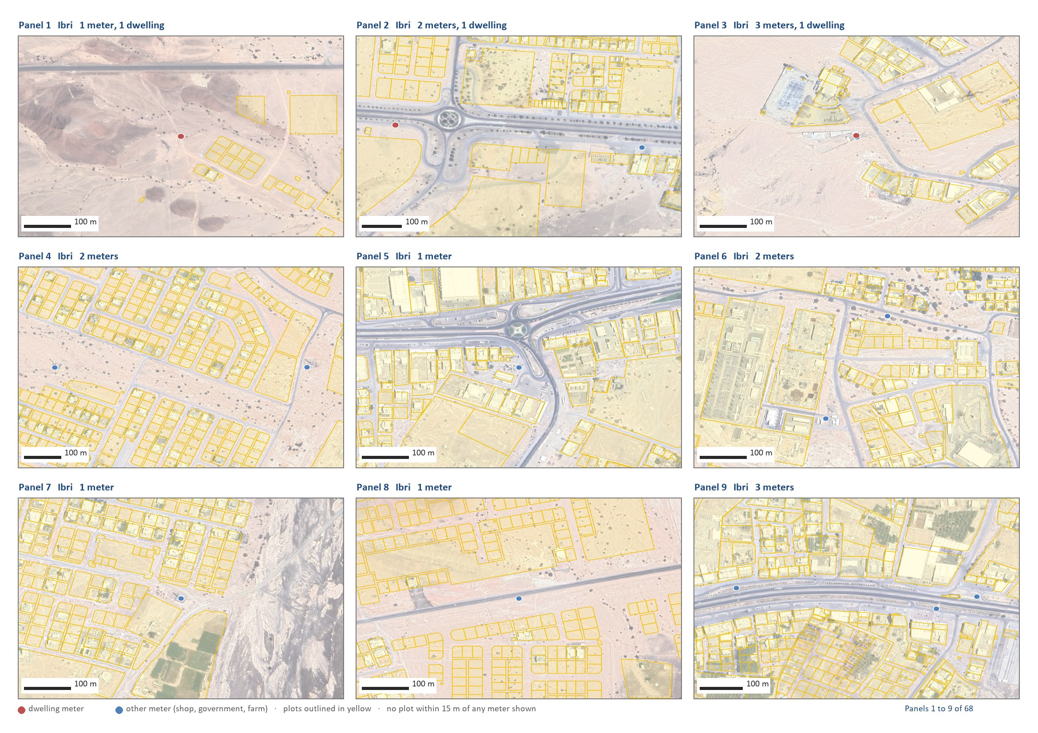
Figure 15 Panels 1 to 9 of 68.
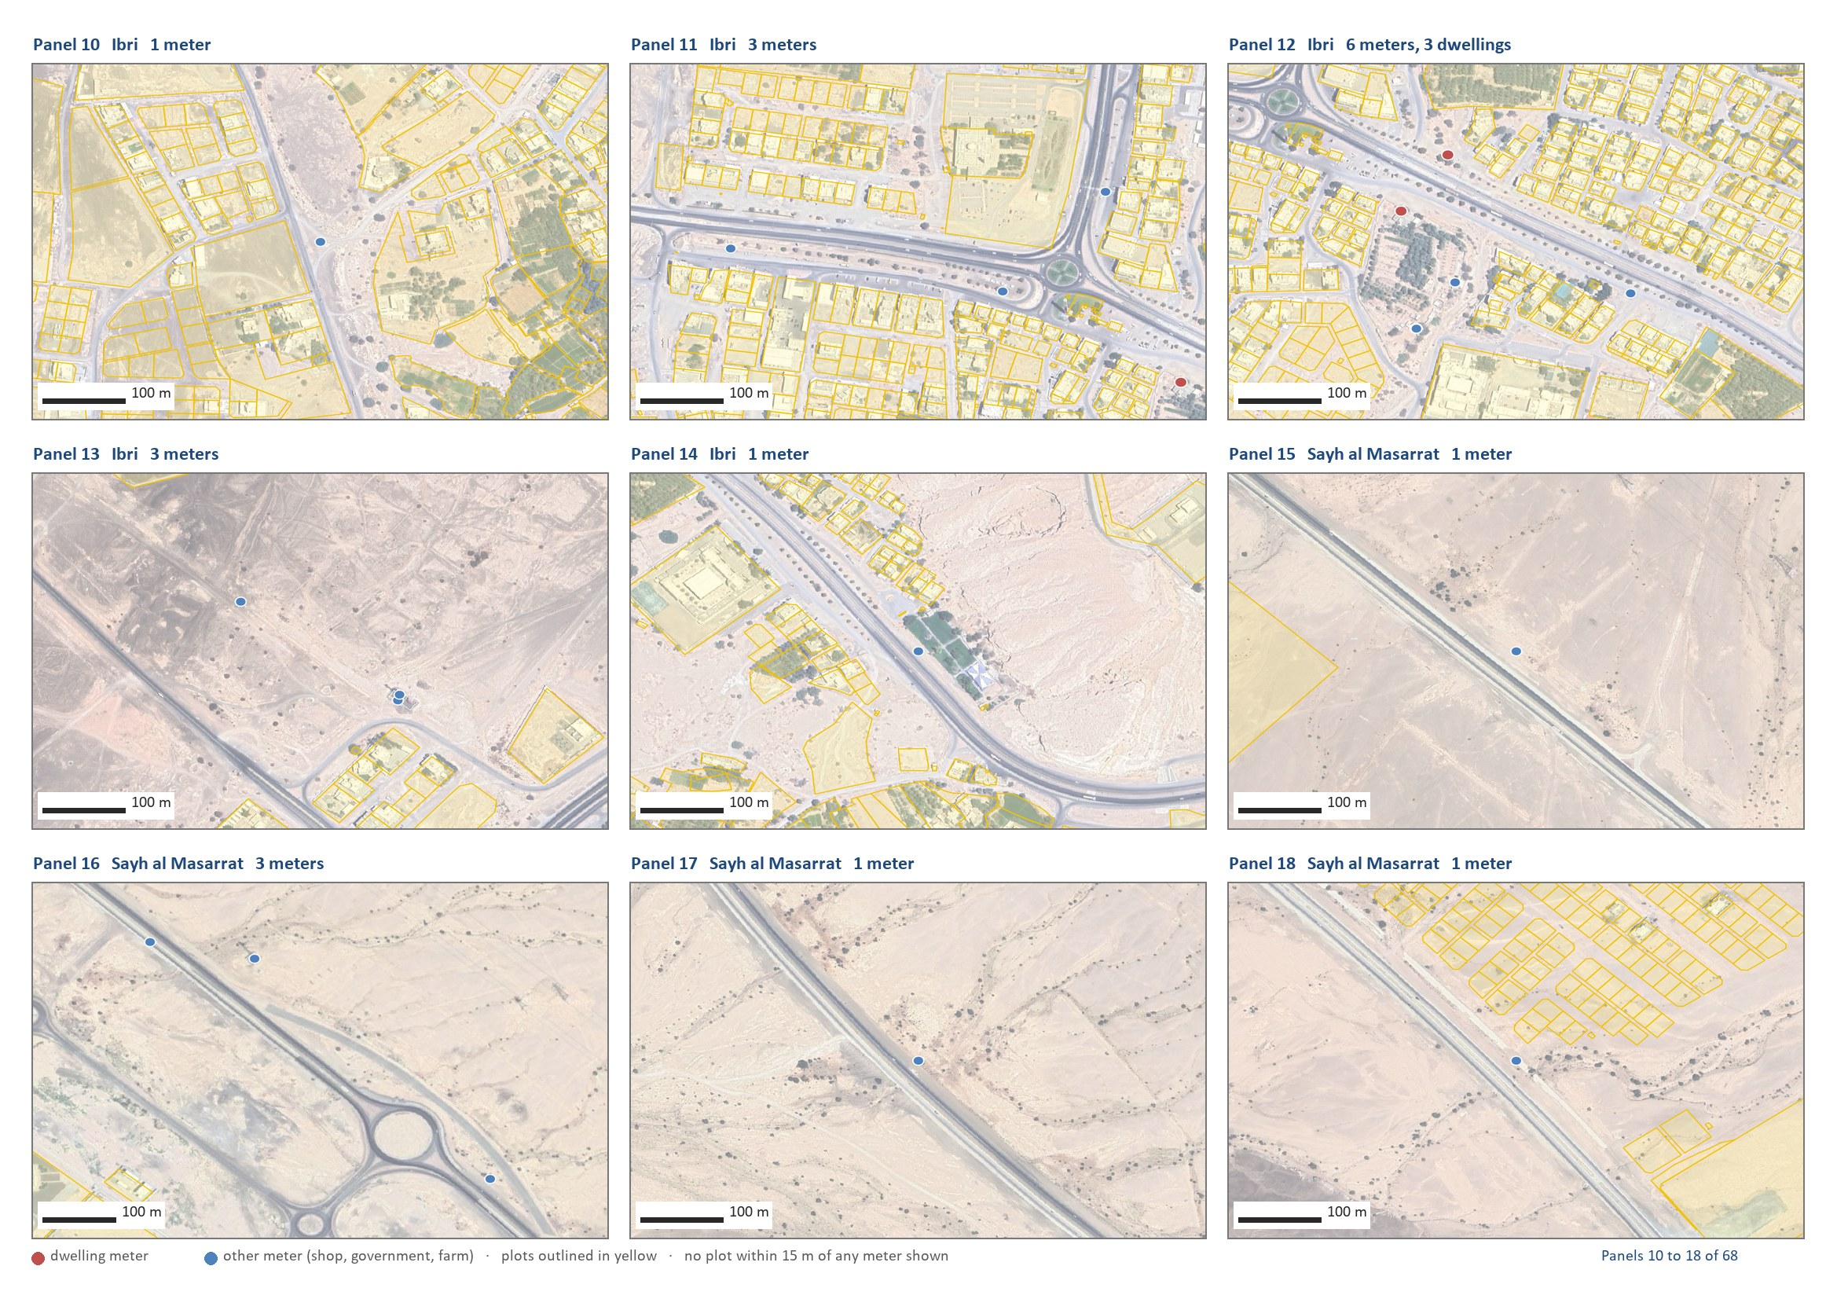
Figure 16 Panels 10 to 18 of 68.
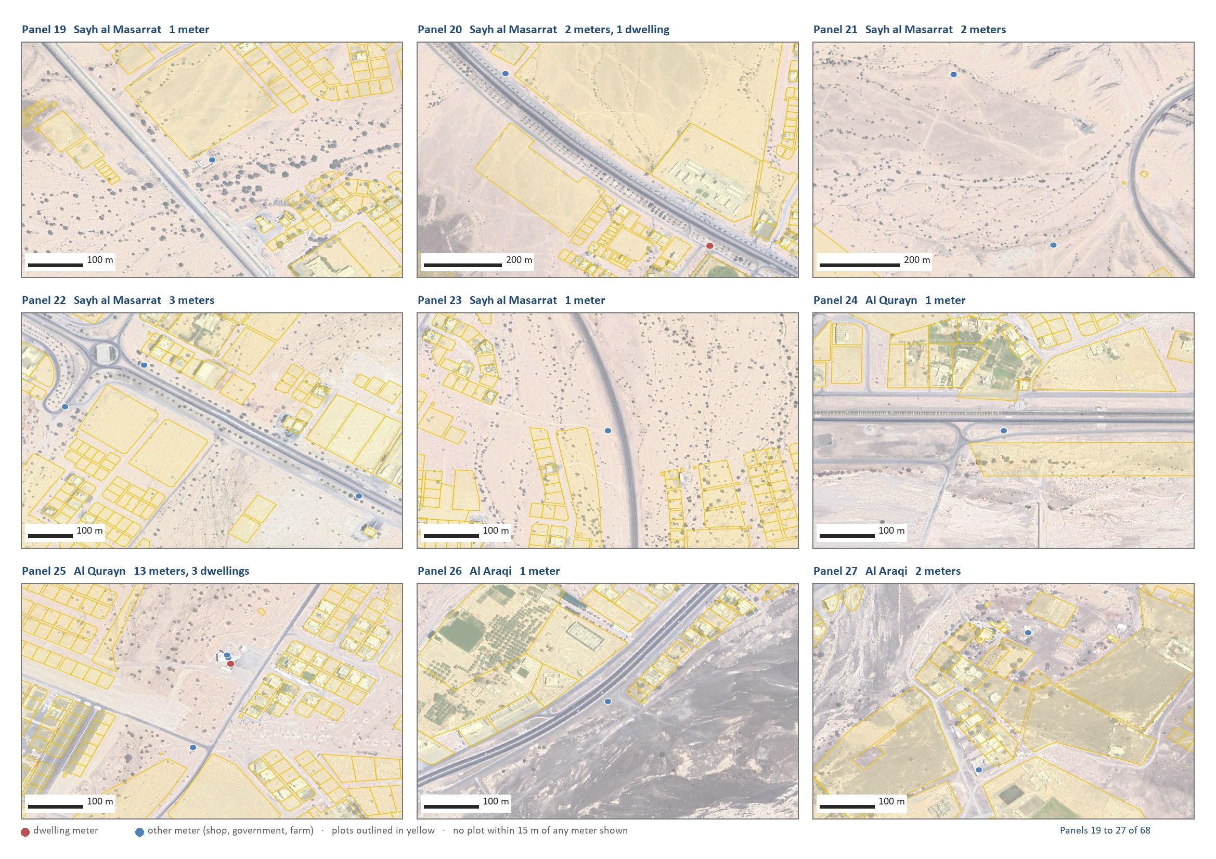
Figure 17 Panels 19 to 27 of 68.
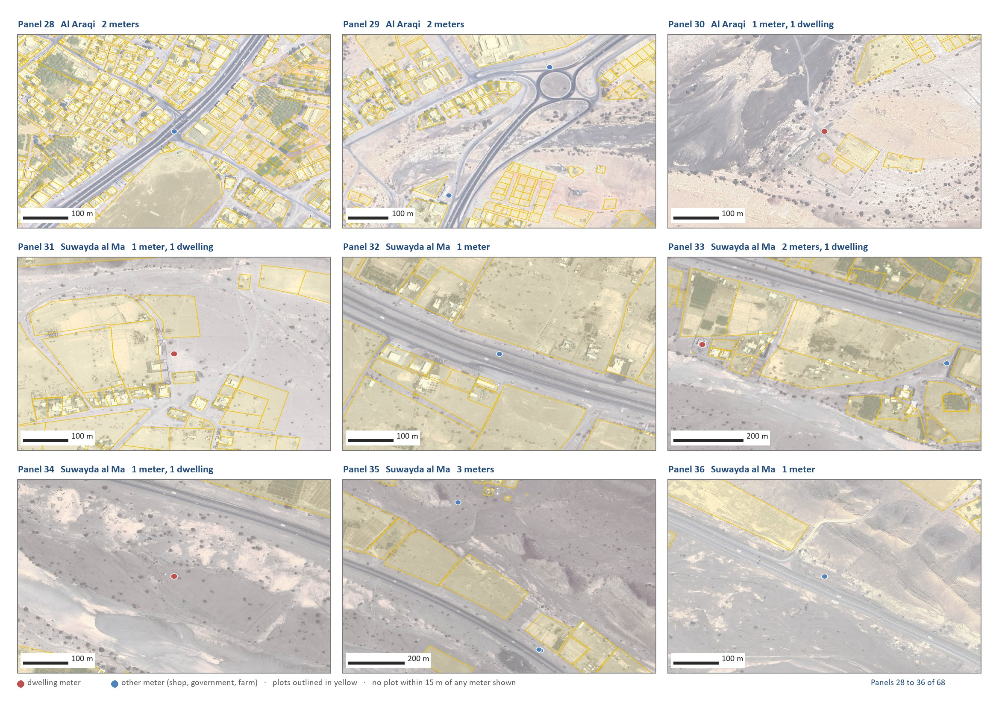
Figure 18 Panels 28 to 36 of 68.
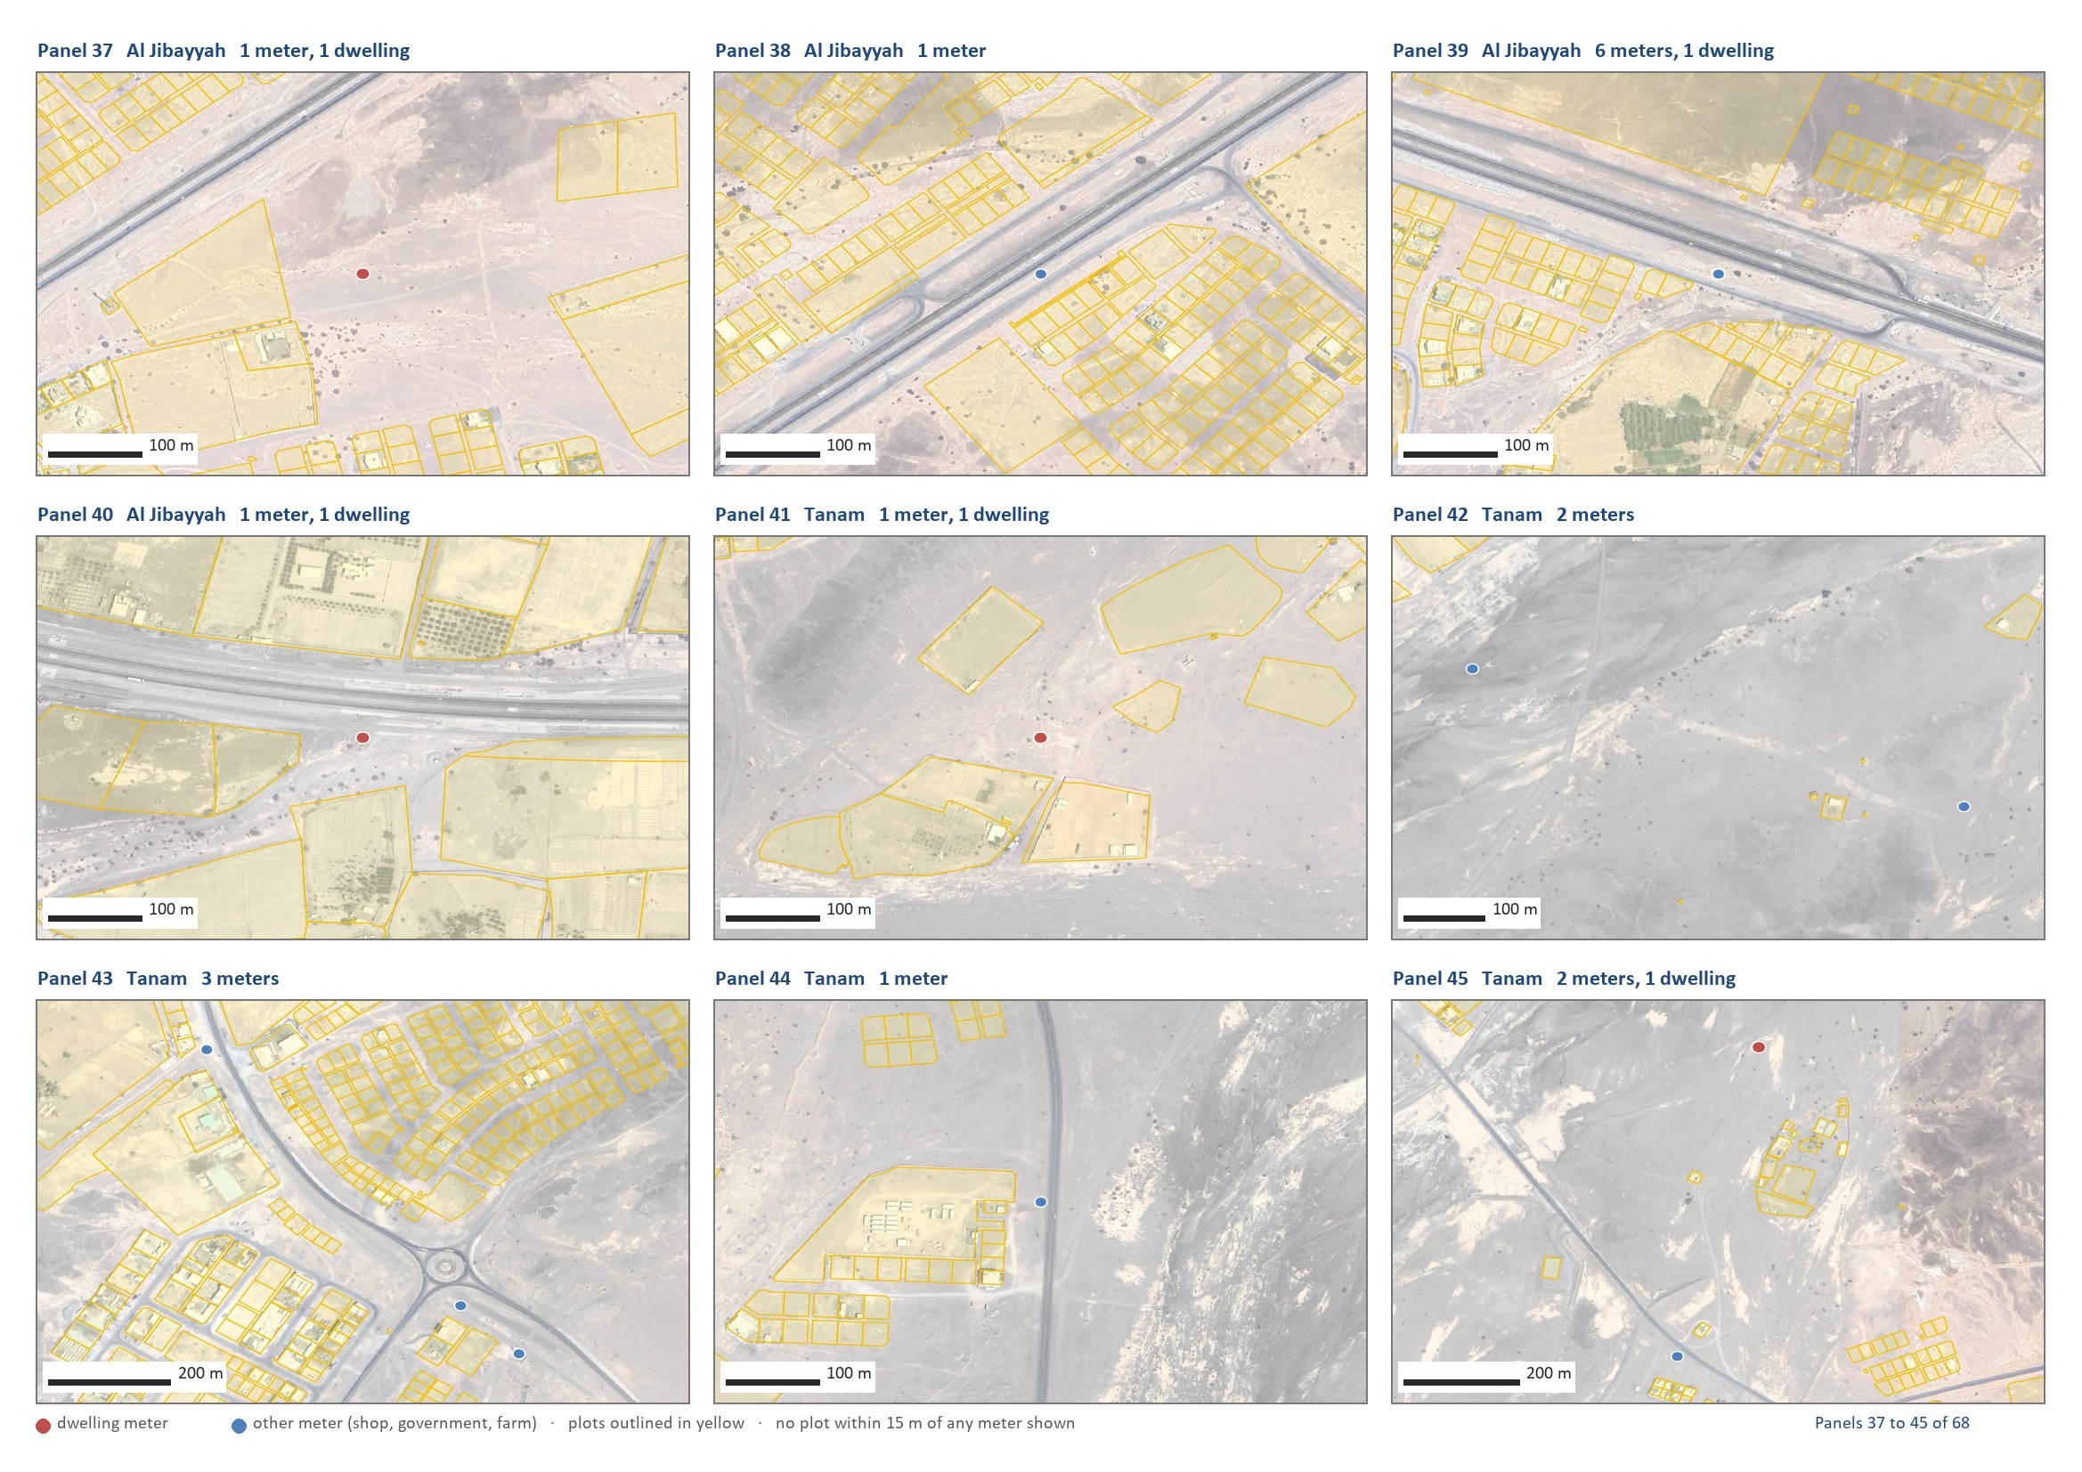
Figure 19 Panels 37 to 45 of 68.
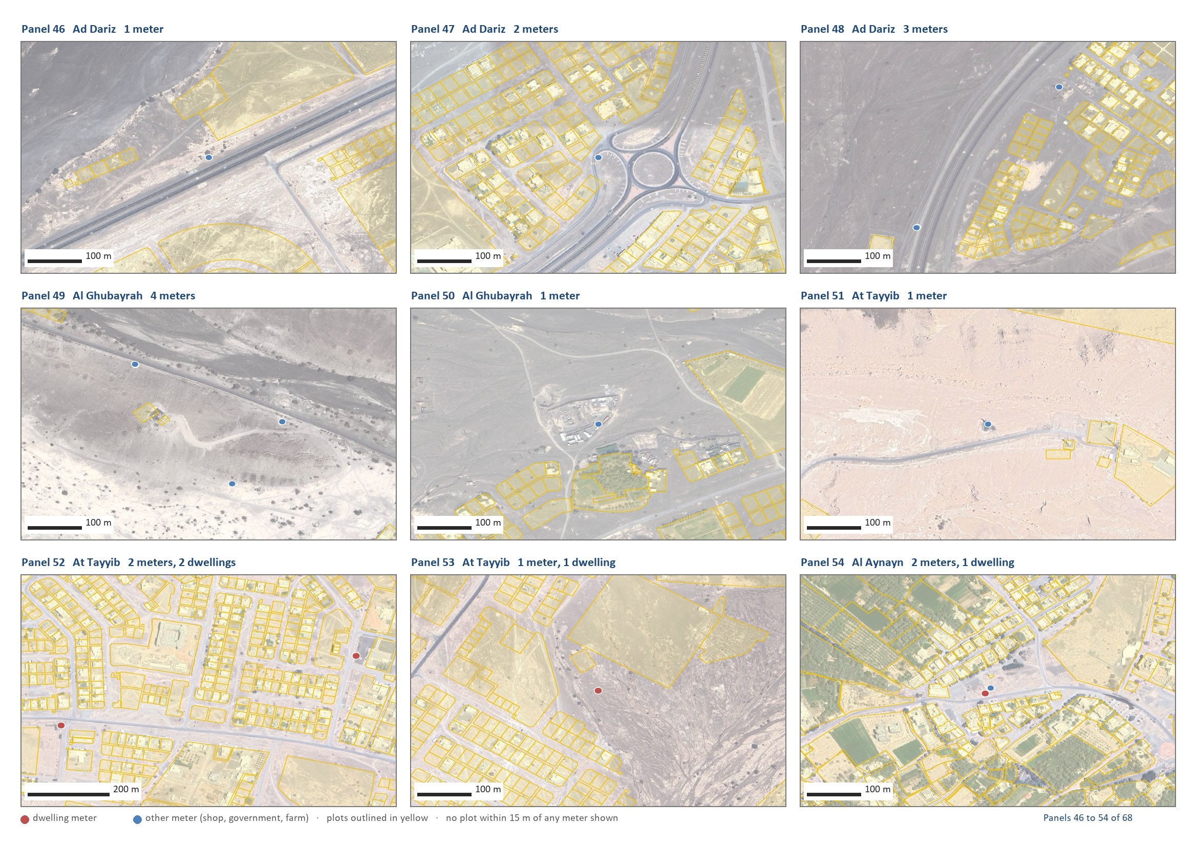
Figure 20 Panels 46 to 54 of 68.
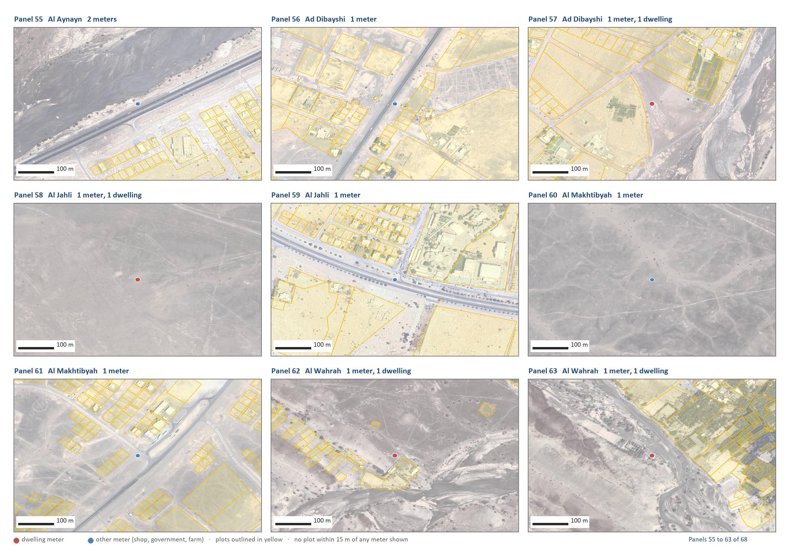
Figure 21 Panels 55 to 63 of 68.
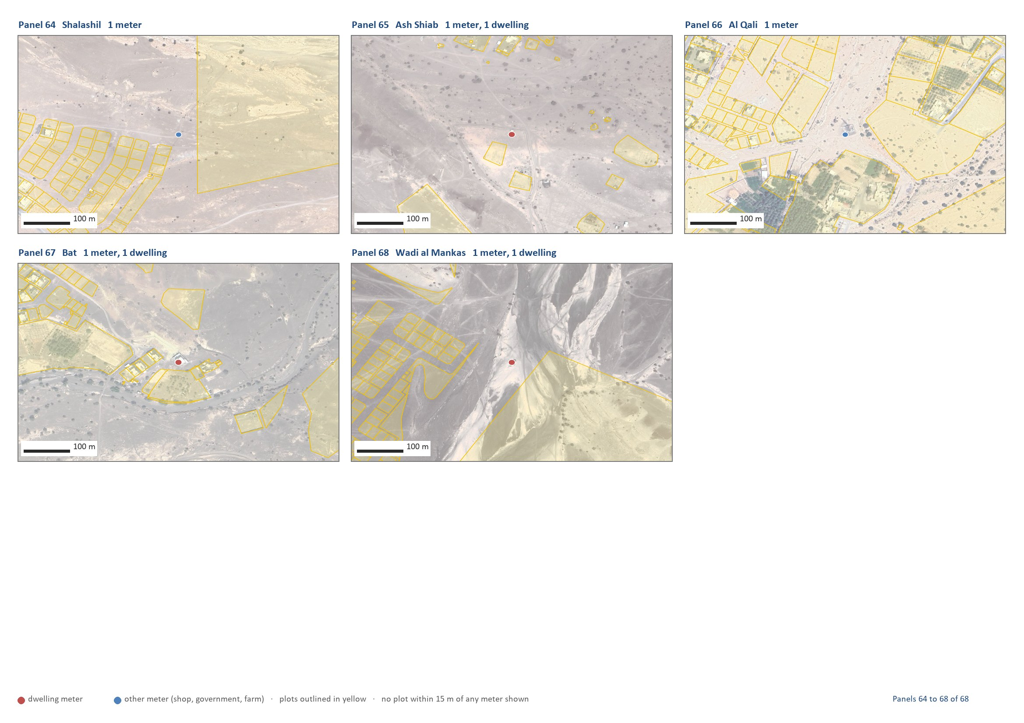
Figure 22 Panels 64 to 68 of 68.

Appendix A4 The tractive-force curve in full
The same curve as in Section 7.2, with every pipe size's minimum gradient marked where it meets the curve, and three readings on the steep part.
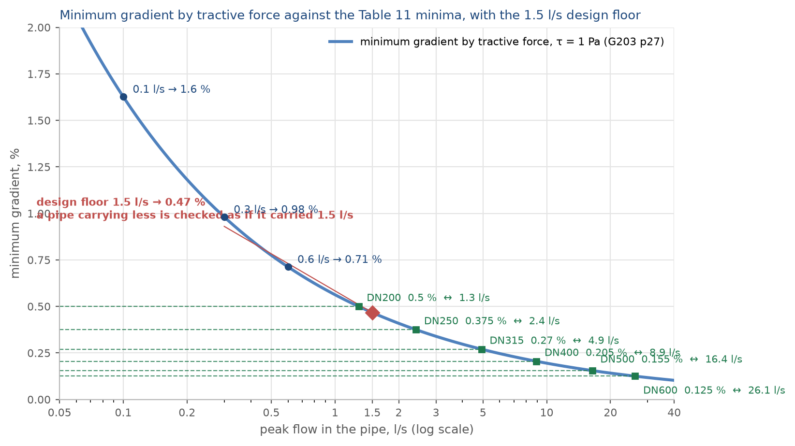
Figure 23 The minimum gradient by tractive force at one pascal, the Table 11 minima of every size, and the proposed 1.5 litres a second floor.

Appendix A5 The fields of the plot layer
The plot layer delivered with the Concept Design Report carries, for each of the 77,265 plots, the fields below. It is the load table of the design.
Table 21 Fields of the plot layer that the design reads
Field | Content
SETTLE | the settlement the plot belongs to
DERIVED | use of the plot (Section 4)
G_DOM | dwellings on the plot, one per domestic meter
OR_S | persons per dwelling adopted for the settlement
POP, POP_2030, POP_2055, POP_ULT | people on the plot in 2024, 2030, 2055 and the saturation year
QADF, Q_2030, Q_2055, Q_ULT | average sewage flow, m³/d, in the same years; a future plot at 171.3 l/d per person
S_DOM, S_NDOM, S_GOV, S_SPEC | the 2024 sewage by stream: households, shops and offices, government, estates
FUT_CAP | 1 if an empty plot counts as a future home
SAT_YEAR | the year the plot's settlement is full

Average flows before infiltration and before the plant margin. Sections 6 and 7 give the series.
Final_Boundary_IBRI.kmz, issued with the Inception Report R0.
A Voronoi division of the plot centroids by settlement, merged, clipped to the study area boundary and smoothed as a coverage so that neighbours share one line.
The primary, subsidised primary and additional-dwelling tariffs count as dwellings. The 499 large-consumer accounts were placed by public records; their use decides only where the shop and government water is placed, not how much there is.
4.0 is the rate measured at At Tayyib, 3,300 people, the smallest settlement with a sample worth measuring. The cap is Bat's. The thirteen small settlements: Al Ghubayrah, Al Qurayn, Sayh al Masarrat, Al Jahli, Satwah, Al Akheedar, Al Qali, Shalashil, Al Makhtibyah, Usaybuq, Wadi al Mankas, Ash Shiab, Miayrid.
PAM-GUD-201, Section 7.2, page 59. The table below is the same as Table 15 of the Concept Design Report, Revision 2.
116,452 divided by 22,559 dwellings gives the area-wide 5.16.
By tariff: Government 46, Commercial 32, Primary Account Tariff 18, CRT Seasonal 9, Primary Account Tariff (with National Subsidy) 6, Additional Account Tariff 6, Agricultural 5, CRT Time of Use 4.
MoH_Plots, 77,265 plots, received September 2026.
Sentinel-2 Level 2A, tile 40QDL, 9 September 2026, red and near-infrared at 10 m. 38 per cent of the plots with a farm meter fail the grove test: pump sites without a crop. That is why the meter alone under-counts farms.
PAM-GUD-201, Table 11, page 60, and Section 7.3.1, page 59.
PAM-GUD-201, page 59: the ratios "refer to spatially distributed non-domestic consumption that are to be added to the domestic consumption" and "do not apply to ... specific identified non-domestic projects such as economic zones". Per person the shares are 36 and 23 litres a day.
PAM-GUD-201, Table 12, page 61, and Sections 7.3.2 and 7.3.3, pages 60 and 61.
PAM-GUD-201, Table 19, page 71. The farm rule is a rule of this design: on 172 of 319 farm plots a household is metered separately from the pump.
36 and 23 are 22 and 14 per cent of 164.
PAM-GUD-201, page 59 and Table 12, page 61. Al Tayyeb: 94 hectares, 202 plots, 1,035 meters. Tanam: 61 hectares, 105 plots, 409 meters. About five meters per plot and three to six workers per workshop give the figures.
PAM-GUD-201, Section 7.4, page 70: an assessment of private wells and other non-network sources is required.
The sum of the plots equals the settlement in every column. The plot layer and the settlement layer are delivered with the Concept Design Report.
Compactness is the plot's area against that of its smallest enclosing rectangle, not less than 0.6, with the rectangle's sides no more than three to one. Built home plots have a median area of 717 square metres. Shapes above 2,000 square metres are whole future districts drawn as one plot; they take nothing until subdivided.
The settlements under a thousand people take 0.9 and one dwelling per plot, as in Section 3.2. The full table by settlement is in the Concept Design Report, Appendix A3.
Capacity by settlement: Appendix A2.
Inception Report R0, Section 6, and the demand workbook, sheets Pop_Wilayat and Project Pop Settlements. The guideline allows an extrapolation of ten years beyond the available forecast; the series goes further, on the client's instruction, and the point is listed for confirmation.
The settlements that never fill on their own growth: At Tayyib, Al Ghubayrah, Al Qurayn, Al Makhtibyah, Shalashil, Wadi al Mankas, Miayrid. The overflow routes reflect local knowledge of where Ibri's growth is taking place.
Concept Design Report R2, Section 14.7. The five-year series is in Appendix A1.
Fields QADF, Q_2030, Q_2055 and Q_ULT of the plot layer; POP and its years for the people.
Whole area: 24,216 × 0.61 = 14,772 m³/d in 2030, against 36,660 if the ratio were applied to saturation.
PAM-GUD-201, Section 7.4.2, pages 71 and 72; Section 7.4.3, page 72. PAM-GUD-203, Table 29, page 65, defines the peak hourly flow and gives it the symbol QPDF.
PAM-GUD-203, Table 11, page 29; Sections 4.2.2.1 and 4.3, pages 25 to 29. The Mara, Sleigh and Taylor relationship on page 27, K = 2.33 × 10⁻⁴ with the flow in m³/s.
The full curve with every size is in Appendix A4. The audit on the test area gave 70 per cent of the length as needing early washing, all of it 200 mm pipe carrying under 1.3 litres a second.
PAM-GUD-203, Section 4.6.3, page 33.
PAM-GUD-203, Section 8.1, page 50. Which chamber the main discharges into, and whether neighbouring stations are joined, are layout decisions of the concept design.
PAM-GUD-203, Table 29, page 65, and Section 10.2.2.1, page 66.
PAM-GUD-201, Section 7.4.5, page 73, the margin. The margin is applied to the peak as to the average; the guideline does not state the order, and this reading is for confirmation.
PAM-GUD-203, Section 10.3.1, page 74, "at least 60 g of BOD5 per capita per day and 80 g of suspended solids"; Table 30, page 67; Table 31, page 68, tankered sewage at 350 to 1,050 mg/l BOD. Peak factors for the aeration design at a large plant: 1.2 on BOD and COD, 1.5 on TKN (page 74).
PAM-GUD-203, page 74: a COD to BOD ratio of 1.8 to 2.2 is typical of domestic sewage.
PAM-GUD-201, Section 7.4.6.1, page 73, and Section 7.4.6.3 (b), page 76: "a system loss of 10 percent of all produced TSE shall be assumed".

