Sultanate of Oman
Nama Water Services Company SAOC

Consultancy Services for Design and Supervision for STP, Sewer and TE Networks Systems in Ibri
Tender No. T/2719110/2025

Concept Design Report
Revision 0

Renardet S.A. & Partners Consulting Engineers
Project 2621 · August 2026

Contents
Right-click and choose Update Field to build the contents.

Abbreviations and definitions
Term | Meaning
AAF | Average annual flow
APSR | Authority for Public Services Regulation
BOD | Biochemical oxygen demand
CAPEX / OPEX | Capital expenditure / operating expenditure
CESMM3 | Civil Engineering Standard Method of Measurement, third edition
COD | Chemical oxygen demand
EIA | Environmental impact assessment
GIS | Geographic information system
LPCD | Litres per capita per day
MoHUP | Ministry of Housing and Urban Planning
NCSI | National Centre for Statistics and Information
NOC | No objection certificate
PAEW | Public Authority for Electricity and Water
PE | Population equivalent
Qadf | Average daily flow
Qpdf | Peak daily flow
SRT | Solids retention time
STP | Sewage treatment plant
TKN | Total Kjeldahl nitrogen
TSS | Total suspended solids
UTM 40N | Universal Transverse Mercator zone 40 North, WGS 84 datum

A note on the term TE
The Terms of Reference and this report use TE to mean treated effluent, that is the treated product of the sewage treatment plant. The NAMA design guidelines define TE as trade effluent and use TSE for treated sewage effluent. To avoid ambiguity, this report uses the term treated effluent in full, and TSE where a guideline value is quoted.

Executive summary
This report presents the concept design for the wastewater and treated effluent systems serving Ibri, together with the sewage treatment plant that will receive the collected flow. It records the data collected to date, the checks applied to that data, the design basis adopted, and the state of the work at the date of issue.
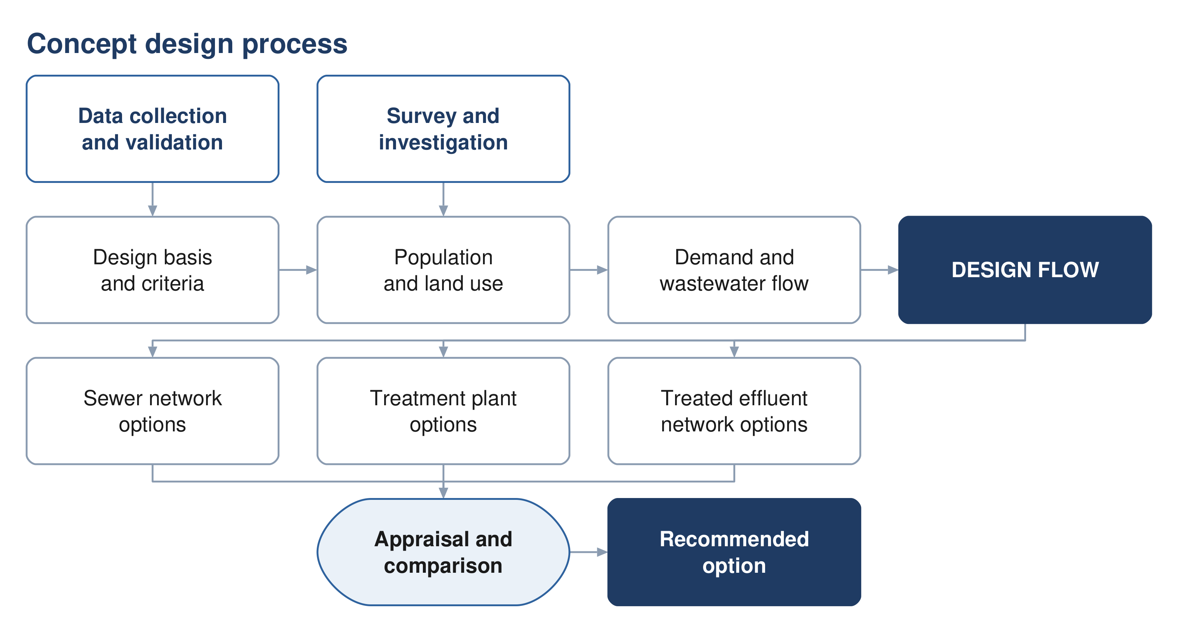
Figure 1 The concept design process, from the data collected to the recommended option.

The project area
The study area covers 531.4 square kilometres within the Wilayat of Ibri, Governorate of Adh Dhahirah, and contains twenty-five named settlements. All spatial work is carried out in UTM zone 40 North on the WGS 84 datum.

Data collected
Data has been obtained from Nama Water Services covering the existing wastewater assets, the potable water network, electricity accounts and the cadastral plot layer. The datasets have been loaded into the project geographic information system, checked against the project boundary, and assessed for completeness. Section 7 records the outcome of those checks in full.
Four points arise from that assessment and are carried through the report.
- Existing assets — 310.9 kilometres of gravity sewer, 33.2 kilometres of force main and 45.7 kilometres of treated effluent main lie within the study area.
- Potable water — the PAEW dataset provides 647.8 kilometres of water mains within the study area, and is adopted as the source for utility interfaces.
- Electricity accounts — 33,970 accounts have been used to establish the number of properties on each plot and the category of use.
- Survey — a topographic and utility survey covering the whole study area is in progress and will confirm levels, diameters and asset condition.

Design basis
Wastewater generation is derived from water demand in accordance with the NAMA design guidelines. For the Governorate of Adh Dhahirah the domestic consumption rate is 164 litres per capita per day, with uplifts of 22 per cent for non-domestic and 14 per cent for governmental consumption. Return rates of 85 per cent for domestic and tanker supply and 54 per cent for non-domestic supply are applied to obtain the wastewater flow.
An occupancy rate of 5.32 persons per domestic property has been derived from the settlement populations and the counted domestic electricity accounts. Section 15 sets out the derivation and the checks applied to it.

State of the work
The design basis, the data assessment and the assessment framework are complete. The network design has been developed and tested over a representative area of the town and is being extended to the whole study area as the survey data becomes available. The options for the sewer network, the treated effluent network and the treatment plant are presented as a framework in Part F and will be completed in the next revision.

How the options are developed and compared
Three options are developed for each of the sewer network, the treated effluent network and the treatment plant. Each set follows the character the guidelines describe: one advancing sustainability, one representing international best practice, and one based on practice already established in Oman. Every option meets the same functional requirement and the same effluent standard, so that the difference between them lies in how the result is achieved. Section 21 sets out what distinguishes them in design terms.
The options are compared over a twenty-five year period against seven criteria: total lifetime cost; sustainability, comprising carbon, circular economy and nature-based solutions; social development and in-country value; adaptability and resilience; operability; constructability; and environmental impact. Costs are discounted at five per cent. Nama Water Services sets the weight given to each criterion.
Where two options fall within ten per cent of one another on total lifetime cost they are treated as equivalent in cost, and the more sustainable of the two is adopted. Sensitivity is tested by varying the weighting between criteria, the discount rate, and the input design criteria.

Deliverables
The Terms of Reference set out forty numbered deliverables for the concept stage. This report issues the design basis, the assessment of the data, the design criteria and the framework for the options and their appraisal. The flow series, the options themselves, the cost estimate and the comparison follow in the next revision, once the design horizon is confirmed and the survey is complete. Section 3.1 lists each deliverable and its position.

Matters requiring confirmation
Six matters require confirmation from Nama Water Services. They are set out in Section 5 with the relevant references, and are summarised here.
 | Matter
1 | The design horizon to be adopted
2 | The approved project boundary
3 | Georeferenced versions of the project figures
4 | The hydraulic modelling software to be used
5 | The timing of the environmental impact assessment
6 | The convention for the term TE

PART A

Project, scope and process

1 Introduction and background
Nama Water Services is developing wastewater collection, treated effluent distribution and sewage treatment for the Wilayat of Ibri. Renardet S.A. & Partners has been appointed to provide consultancy services for the design and supervision of these works.
This report is the concept design deliverable. It establishes the design basis, records and assesses the data collected, and sets out the framework within which options for the sewer network, the treated effluent network and the treatment plant are developed.

1.1 Objectives
The Terms of Reference set three objectives for the work: to verify the Regional Master Plan, to establish the ultimate expected sewage flow in the Ibri catchment, and to develop the concept, preliminary and detailed designs together with the tender documentation.

1.2 Structure of this report
The report follows the structure approved for the concept stage. Part A records the project and its process. Part B presents the data and the assessment of it. Part C sets out the design basis. Part D establishes demand and flow. Part E assesses the existing system. Part F presents the options. Part G carries the technical and financial appraisal, and Part H the delivery arrangements.

2 Scope and boundaries

2.1 The study area
The study area covers 531.4 square kilometres and contains twenty-five named settlements. Ibri is the principal settlement; the remainder are distributed along the wadi system and the main road corridors.
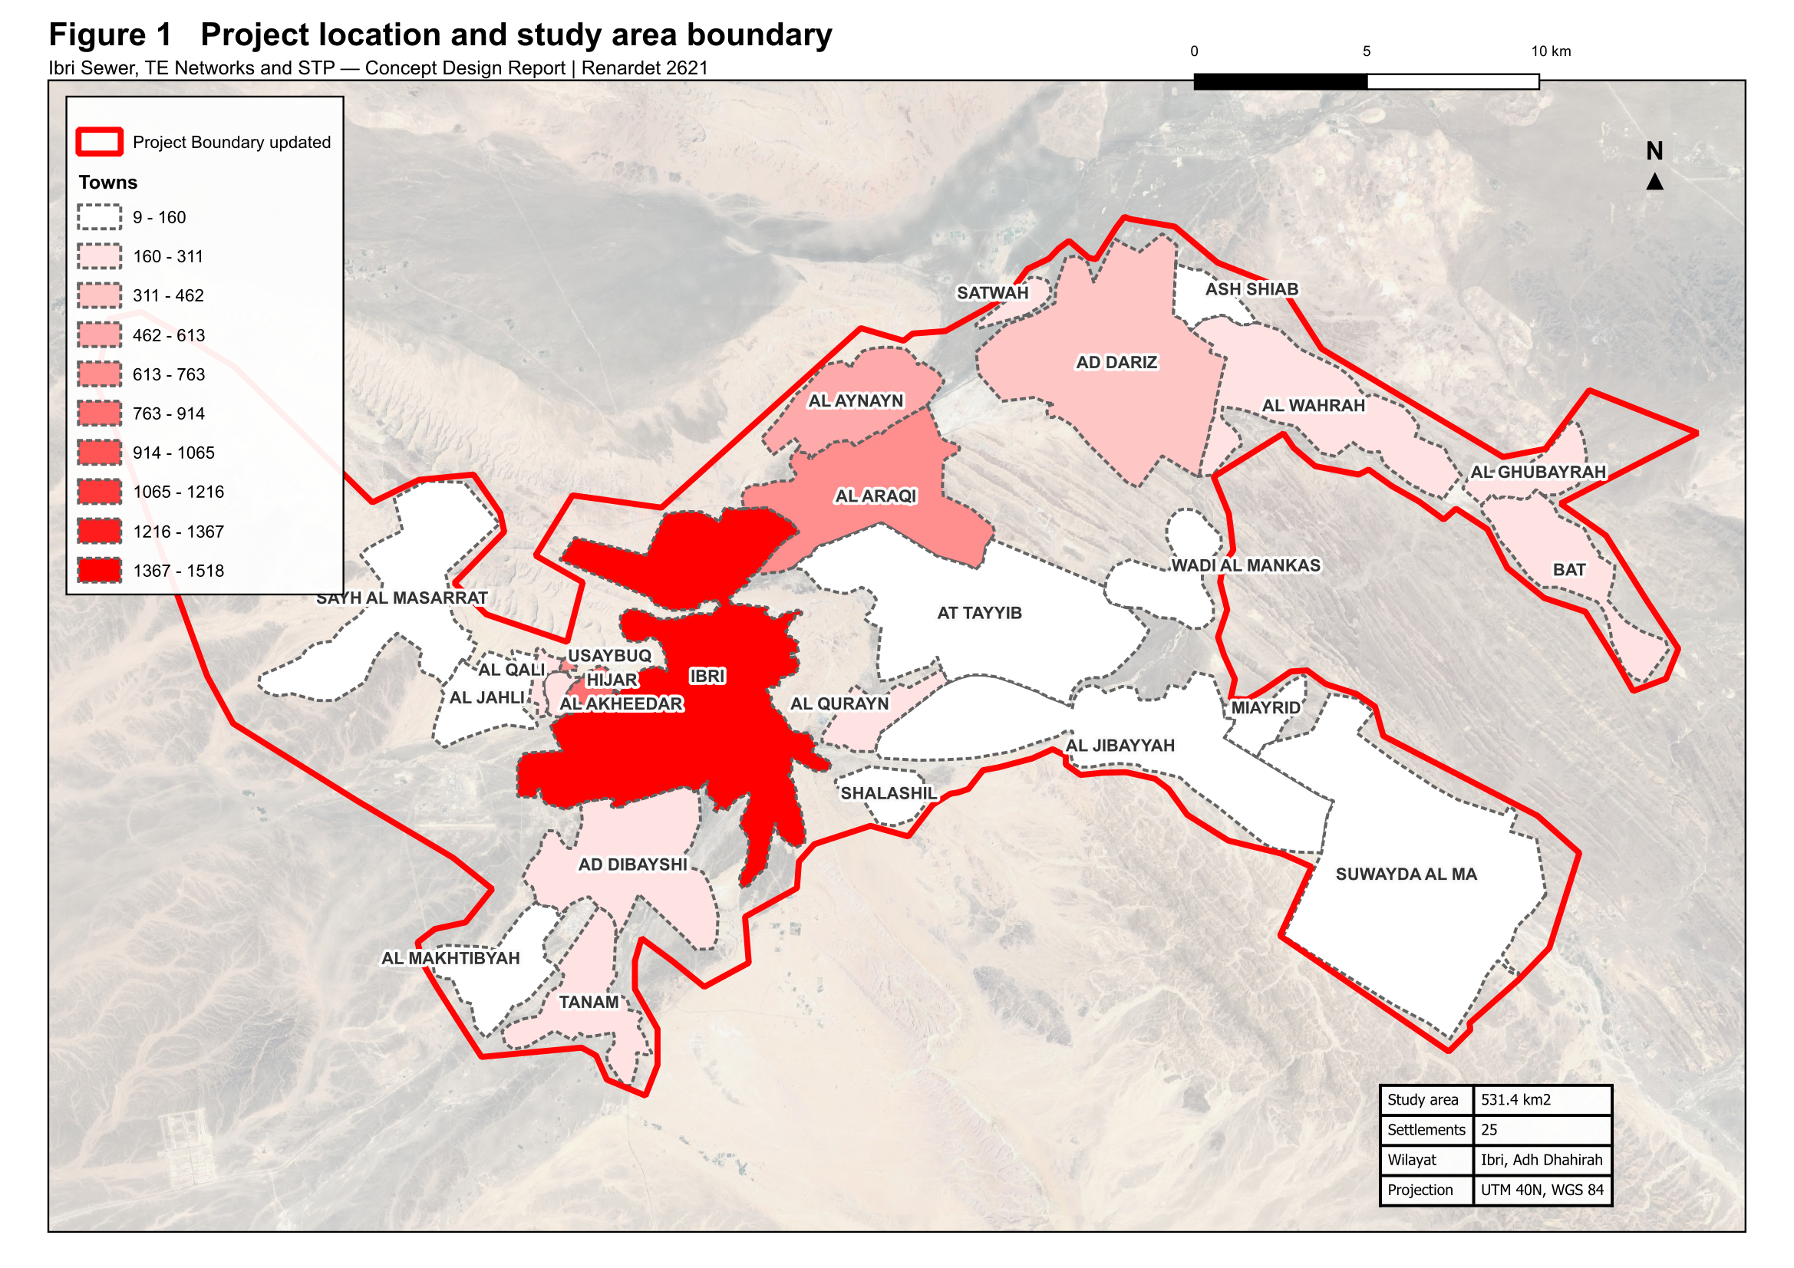
Figure 2 Project location and study area boundary, showing the twenty-five settlements within the Wilayat of Ibri.

2.2 Boundary
Two boundary datasets were issued with the Inception Report. The two differ in extent. The larger of the two has been adopted for the work presented here so that no part of the area is omitted, and confirmation of the approved boundary is requested.

2.3 Coordinate system
All spatial data is held and all measurements are made in Universal Transverse Mercator zone 40 North on the WGS 84 datum. Datasets supplied in geographic coordinates have been reprojected. Levels are referenced to the terrain model described in Section 8.

3 Programme and design stages
The design comprises four stages: concept design, preliminary design, detailed design and the preparation of tender documents. Each stage is submitted for review and approval before the following stage begins.
The Terms of Reference allow sixty days for the concept design and a further twenty-one days for review. The preliminary design stage begins on approval of the concept design for the treatment plant.
Two programmes have been issued during mobilisation, in the kick-off presentation and in the Inception Report. Confirmation of the governing programme is requested.

3.1 Deliverables at the concept stage
The Terms of Reference set out forty numbered deliverables for the concept stage. They are grouped below by subject. Those marked as issued form part of this report or accompany it; the remainder follow in the next revision as the survey and the options are completed.
Table 1 Concept stage deliverables
Deliverable | Position
Executive summary and project schedule | Issued
Data collection report and assessment of the data | Issued
Design criteria and design basis | Issued
Population forecasting and flow projection at five-year intervals | Basis issued; series follows confirmation of the design horizon
Topographic survey and geotechnical investigation | Survey in progress
As-built records and GIS for the existing systems | Follows the survey
Hydraulic assessment of the existing systems | Follows the survey
Wastewater network options, not fewer than three | Next revision
Treated effluent network options, not fewer than three | Next revision
Treatment plant options, not fewer than three, with siting and phasing | Next revision
Pumping and lifting station concept design | Next revision
Treated effluent and sludge management strategy | Framework issued; strategy in the next revision
Excess effluent and emergency overflow provisions | Next revision
Environmental impact assessment for the plant location | Follows confirmation of scope
Cost estimates and life cycle cost | Next revision
Risk analysis and value engineering | Next revision
Multi-criteria comparison and recommended option | Next revision
Hydraulic models in SewerGEMS and WaterGEMS | Follows confirmation of the software
Contracting strategy and implementation plan | Next revision
Register of approvals and no objection certificates | Maintained

3.2 Deliverables of the following stages
The preliminary design develops the approved concept to an estimate within ten per cent, with full survey, hazard and operability study, and preliminary bills of quantities. The detailed design completes the engineering, the drawings and the priced bills. Tender documentation follows the approved detailed design.

4 Consultation record
The following meetings have been held with Nama Water Services to the date of this report.
Table 2 Meetings held
Meeting | Date | Outcome
Kick-off meeting | 15 July 2026 | Project scope, approach, programme and organisation presented
Inception Report submission | August 2026 | Design basis, methodology and programme submitted

Coordination with the authorities holding assets in the project area is described in Section 33, together with the register of approvals and no objection certificates.

5 Matters requiring confirmation
The following matters require confirmation from Nama Water Services. Each affects work that would otherwise be carried out twice, and confirmation is therefore requested at the earliest opportunity.

5.1 Design horizon
The Terms of Reference define the design horizon as the year of project completion plus twenty-five years, or the ultimate saturated flow. The Inception Report states that the planning and demand assessment extends to the year 2100. The two are different bases and produce different results. Confirmation of the horizon to be adopted is requested.

5.2 Project boundary
Two boundary datasets were issued with the Inception Report, differing in extent. Confirmation of the approved boundary is requested, together with the extent to be surveyed.

5.3 Project figures
Figures 1, 2 and 3 of the tender define the project location, the areas requiring as-built records, and the areas subject to each design stage. They are supplied as images without coordinates. Georeferenced versions are requested so that the design areas can be established without ambiguity.

5.4 Hydraulic modelling software
The Scope of Work requires the wastewater network to be modelled in SewerGEMS and the treated effluent network in WaterGEMS. The staffing schedule in the tender refers to a different package. Confirmation of the software to be used for the deliverable models is requested.

5.5 Environmental impact assessment
The design guidelines place environmental impact assessment scoping at the preliminary design stage in one clause and the full assessment at the concept and preliminary stages in another. Confirmation of the scope required at this stage is requested.

5.6 Terminology
Confirmation is requested that the term TE, as used in the Terms of Reference and in this report, is understood to mean treated effluent.

5.7 Design manual reference
The Terms of Reference require the treatment plant location report to follow item 2.1 of Section 05 of the Wastewater Design Manual. The current revision of PAM-GUD-203 consolidated and renumbered the former manuals, and the corresponding content is now Section 10.1, Site Selection. The report follows Section 10.1, and confirmation is requested.

PART B

Data

6 Data collection
Data has been requested from Nama Water Services and from the authorities holding assets in the project area. The table below records what has been requested and the position at the date of this report.
Table 3 Data register
Dataset | Received | Position
Existing sewer network, as-built | Yes | GIS geometry received. Levels and diameters incomplete; being surveyed
Existing force mains | Yes | Received
Existing treated effluent network | Yes | Received
Lifting station details | Partial | One station located; equipment and duty details being surveyed
Treatment plant records | Partial | Location and nominal capacity received; operating data outstanding
Electricity account data | Yes | Received
Cadastral plot data | Yes | Received. Land use and missing plots being addressed
Potable water network | Yes | Received as part of the PAEW dataset
Topographic survey | In progress | Survey team mobilised
Integrated Master Plan | No | Requested
Plant inflow and tanker records | No | Requested
Electricity, telecom and gas service records | No | To be requested from the respective owners

A topographic and utility survey covering the whole study area is in progress. It will establish cover and invert levels, diameters, materials and condition for the existing sewer, force main and treated effluent networks, together with the lifting stations, the topography and the cadastral boundaries including plot gates. The results will be incorporated in the next revision of this report.

7 Assessment of the data
Each dataset has been loaded into the project geographic information system, reprojected where necessary, and checked against the project boundary. This section records the quantity of each dataset, the proportion falling within the study area, and the limitations identified.
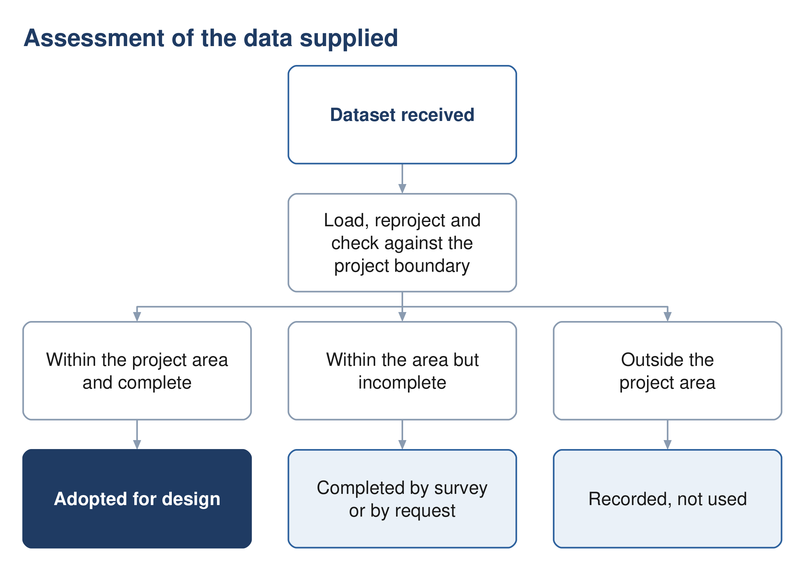
Figure 3 The assessment applied to each dataset supplied.

7.1 Existing wastewater assets
Table 4 Wastewater assets supplied by Nama Water Services
Dataset | Features | Quantity | Within the study area | Observation
Gravity sewer | 3,396 | 314.3 km | 310.9 km (99 %) | diameter recorded on 129 segments carrying 202.7 km; the remaining 111.6 km carries no diameter
Force mains | 9 | 33.6 km | 33.2 km (99 %) | diameters 80 to 250 mm
Treated effluent main | 8 | 49.4 km | 45.7 km (92 %) | —
Pumping station | 1 | 1 point | 1 | —
Treatment plant | 2 | 2 points | 2 | one existing at 1,800 m3/d, one shown as design at 29,038 m3/d
Plant structures | 15 | 15 polygons | 15 | —

The wastewater datasets are substantially complete in extent, with 99 per cent of the gravity sewer and force main lying within the study area. The principal limitation is attribute completeness: of 314.3 kilometres of gravity sewer, 202.7 kilometres carry a recorded diameter and 111.6 kilometres do not. Levels are not recorded. The survey now in progress will establish both.
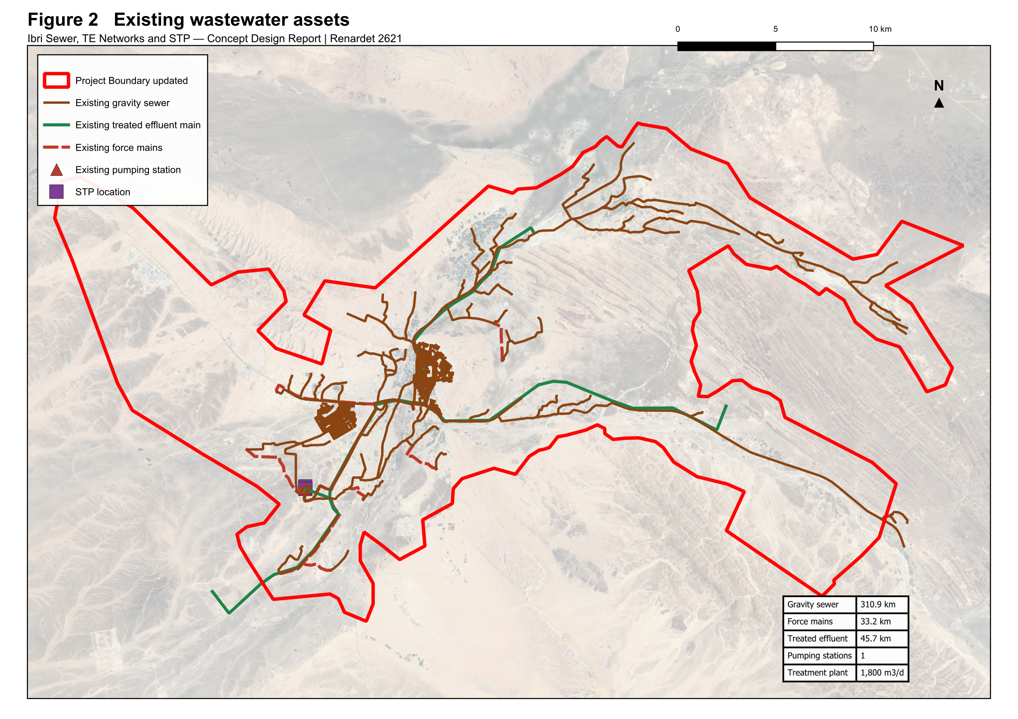
Figure 4 Existing wastewater assets within the study area: gravity sewer, force mains, treated effluent main, pumping station and treatment plant.

7.2 Potable water network
Two datasets describing potable water assets were supplied. They differ substantially in coverage.
Table 5 Potable water datasets
Dataset | Features | Quantity | Within the study area | Observation
PAEW water mains | 6,156 | 1,315.9 km | 647.8 km (49 %) | the usable source for utility interfaces
PAEW water laterals | 1,954 | 12.7 km | 8.1 km (64 %) | —
PAEW system valves | 2,866 | 2,866 points | 1,586 | —
PAEW hydrants | 965 | 965 points | 568 | —
PAEW services | 318 | 318 points | — | —
PAEW facilities | 265 | 265 points | 20 | —
NAMA water mains extract | 90 | 3.5 km | none | located near 55.80 E, 24.27 N, approximately 130 km north-west of the project area

The PAEW dataset provides 647.8 kilometres of water mains within the study area and is adopted as the source for utility interfaces. The second dataset, supplied under an Ibri file name, contains 3.5 kilometres of mains located approximately 130 kilometres north-west of the project area; none of it falls within the study area. Confirmation is requested that the PAEW dataset is the current record for Ibri.
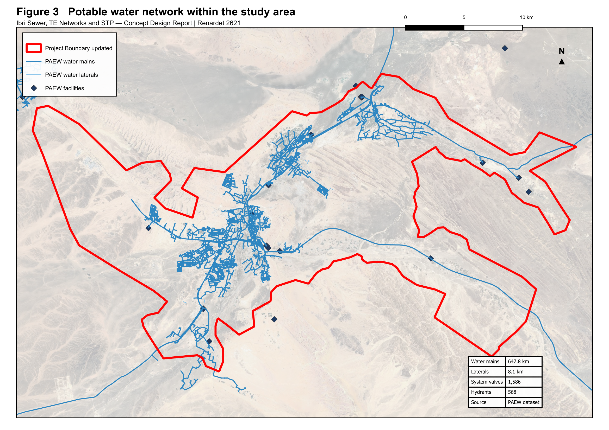
Figure 5 Potable water network within the study area, from the PAEW dataset.

7.3 Electricity accounts
The electricity account dataset contains 33,970 records. Each record carries a tariff name and a coordinate. The dataset does not record land use, floor area or consumption, and the wilayat field is empty on every record. It therefore establishes the number and category of connections at a location, and is used for that purpose in Section 14.
Table 6 Electricity accounts by tariff
Tariff | Accounts | Category adopted
Primary Account | 10,972 | Domestic
Primary Account with National Subsidy | 5,272 | Domestic
Additional Account | 6,344 | Domestic, additional dwelling
Commercial | 9,385 | Non-domestic
Government | 966 | Governmental
Agricultural | 523 | Agricultural
Cost Reflective Tariff | 499 | Large consumer, category to be confirmed
Fisheries, Tourism, Industrial, Defence | 9 | Non-domestic and governmental
Total | 33,970

The Cost Reflective Tariff is applied to consumers above a consumption threshold and is therefore a measure of size rather than of use. The 499 accounts carrying it are being resolved against the plot layer and by inspection.
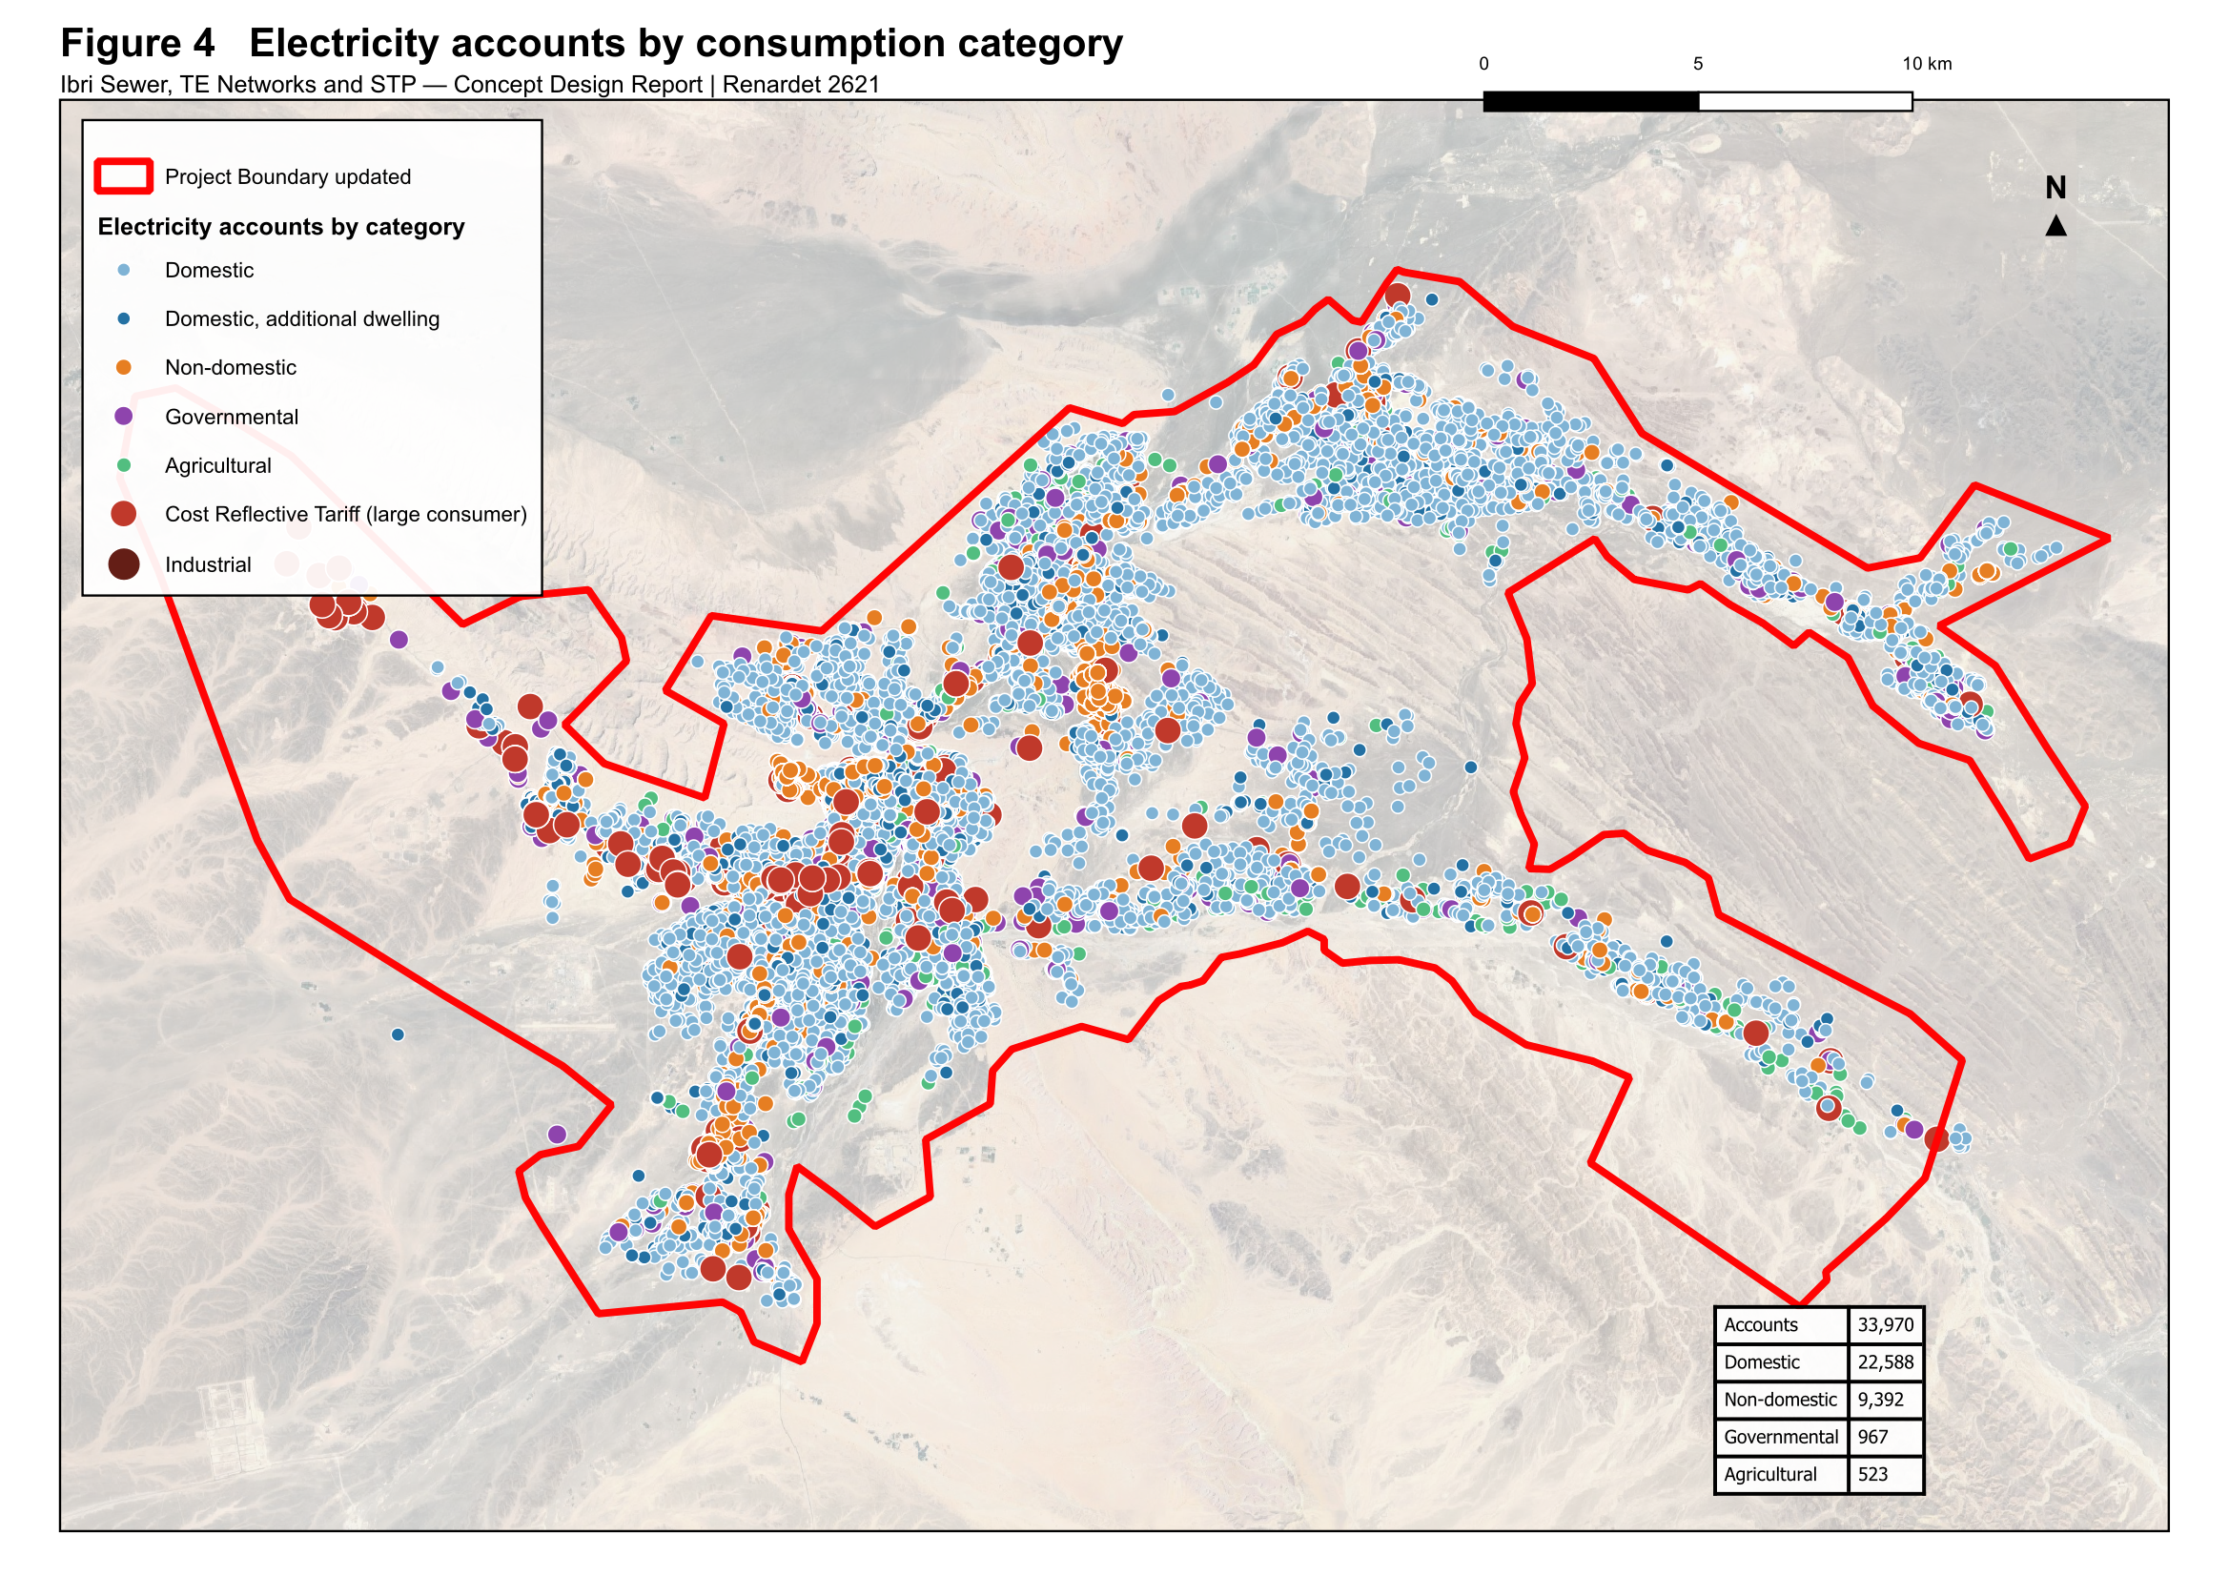
Figure 6 Electricity accounts by consumption category. The pattern of connections defines the developed extent of each settlement.

7.4 Cadastral and settlement data
The cadastral plot layer supplied by the Ministry of Housing and Urban Planning provides plot geometry. It does not distinguish developed from undeveloped plots, does not record land use, and does not record the number of dwellings on a plot. Plots present on the ground are absent from the layer in places. A corrected layer is in preparation and the survey now in progress will establish the cadastral boundaries including plot gates.
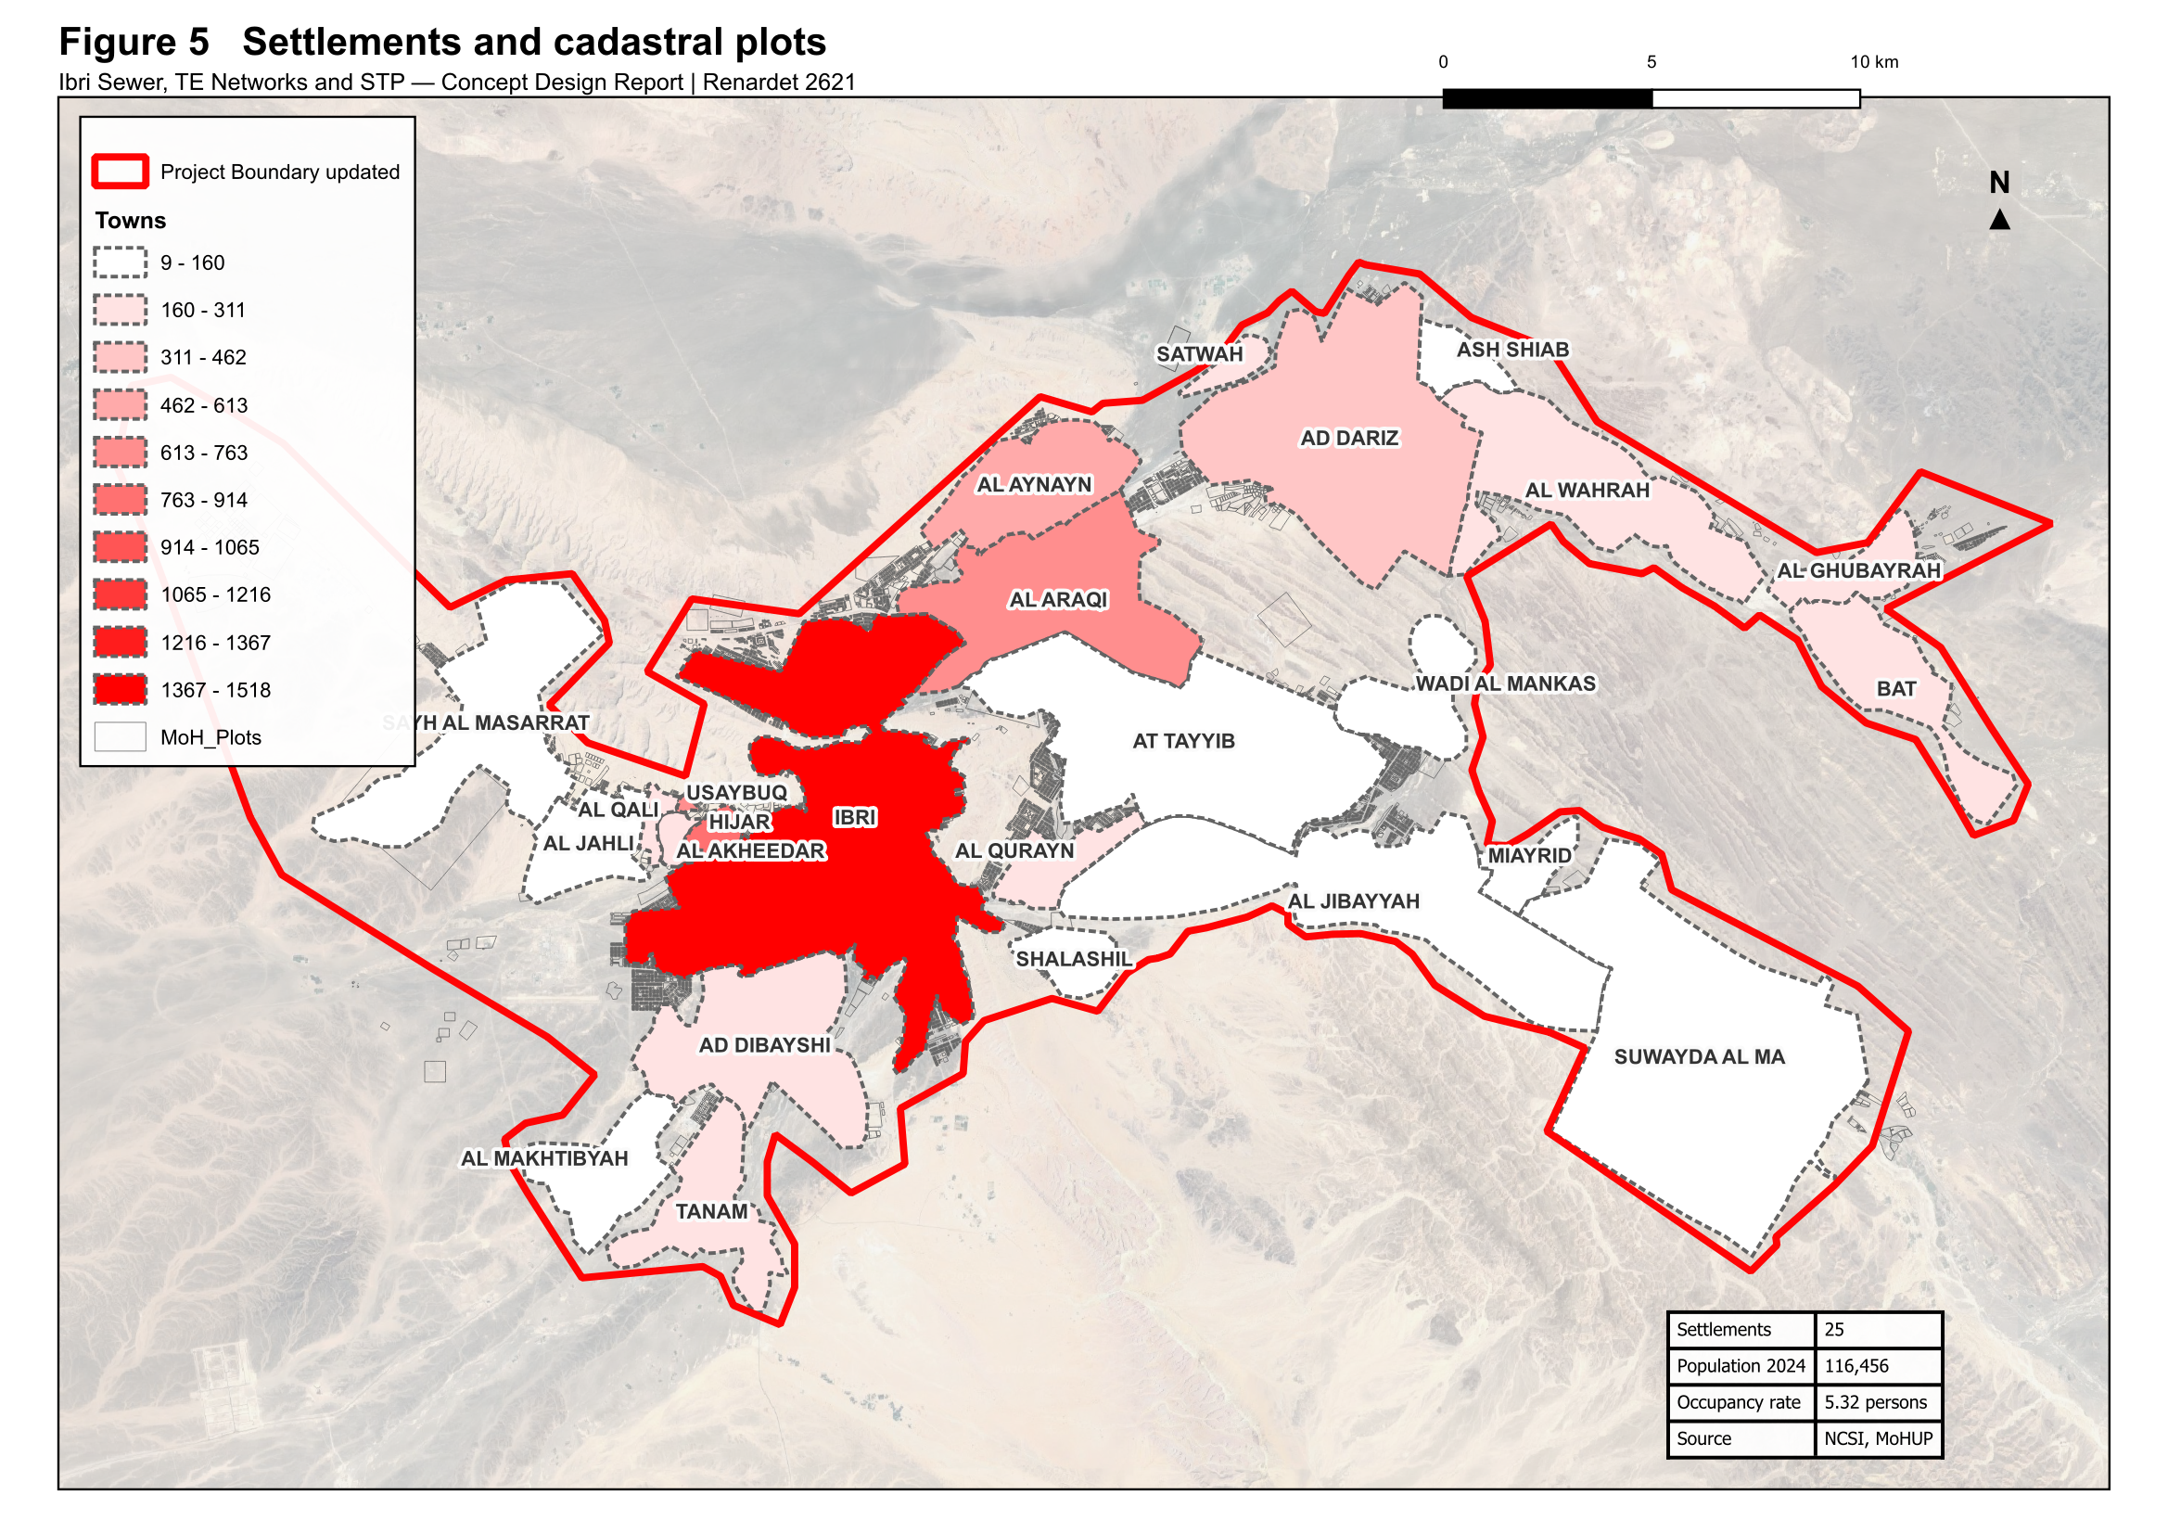
Figure 7 Settlements and cadastral plots within the study area.

7.5 Other datasets supplied
Table 7 Further datasets received
Dataset | Extent | Observation
Electricity accounts | 33,970 points | Tariff, coordinates and governorate. No land use, floor area or consumption is recorded.
Ibri Bypass scheme | 13,404 placemarks | A drawing export carrying 11,715 sublayers of blocks, hatches and dimensions. Suitable as a positional reference; conversion is required before it can be used as structured data.
Al Raybah pipelines | 3 files | Pipeline alignments at 110, 180 and 225 mm, within the project area.
Rehabilitation packages | 6 archives | Work-order submissions covering Al Sad, Khadil, Yanqul, Dhank and Hay Al Aqabah, comprising drawings, meter schedules and geodatabases.
House connection packages | 4 archives | Contractor submissions dated May and June 2026.

Five of the datasets supplied relate to areas outside the project boundary and have not been used. They are recorded here for completeness.
Table 8 Datasets relating to areas outside the project
Dataset | Extent | Location
Mudhaibi zone 6 | 544 placemarks | Wilayat of Mudhaibi, Ash Sharqiyah
Mudhaibi zone 8 | 461 placemarks | Wilayat of Mudhaibi, Ash Sharqiyah
Qabil Al Rukha | 5 placemarks | Wilayat of Mudhaibi
Qunaib | 4 placemarks | Wilayat of Mudhaibi
New location | 8 placemarks | Approximately 30 km north of the project area

8 Survey and investigation

8.1 Topographic and utility survey
A survey team is mobilised and working across the study area. The survey covers the existing sewer network, lifting stations, force mains and treated effluent network as built; the topography; and the cadastral boundaries including plot gates. Its outputs will establish the levels, diameters and condition that the supplied datasets do not carry, and will be incorporated in the next revision of this report.

8.2 Terrain model
A bare-earth terrain model at 0.5 metre resolution covering the study area is in use for the work presented here. It will be superseded by the topographic survey for design purposes.

8.3 Geotechnical investigation and trial pits
Geotechnical investigation and trial pits form part of the scope. Fifty trial pits are to be carried out at critical locations proposed by the consultant and approved by Nama Water Services. The programme of pits will be set out following the desk study of utility records described in Section 33.

9 Existing systems: as-built records and GIS
The preparation of as-built records and geographic information for the existing sewer and treated effluent systems forms part of the scope of work. The datasets supplied provide the geometry of those systems; the survey in progress will establish the levels, diameters, materials and condition required to complete the records.
The records will be prepared to the Nama Water Services specification and uploaded to the client's geographic information system for acceptance. Progress will be reported in the next revision.

PART C

Basis of design

10 Codes, standards and departures
The design follows the Nama Water Services design guidelines and standard specifications. Where a value is taken from a guideline it is cited to the guideline and page.
Table 9 Governing documents
Reference | Title
PAM-GUD-201 | General Design Guidelines, Revision 01, March 2026
PAM-GUD-202 | Water and TSE Design Guidelines, Revision 01, March 2026
PAM-GUD-203 | Wastewater Design Guidelines, Revision 01, March 2026
MD 145/1993 | Ministerial Decision, treated effluent and sludge reuse
MD 159/2005 | Ministerial Decision, discharge to the marine environment
MD 41/2017 | Ministerial Decision, ambient air quality

10.1 Departures
Three departures from the guidelines arise from the data available. Each is set out below with the reason and the consequence, and confirmation is requested.
Table 10 Departures from the design guidelines
Subject | Guideline position | Position adopted | Reason
Occupancy rate | Population divided by housing units, both from NCSI | Population divided by counted domestic electricity accounts | Housing units are not published at settlement level
Non-domestic and governmental demand | Unit rates per pupil, bed, employee and floor area where detailed land use allocation is available | The published governorate ratios | The quantities the unit rates require are not recorded in any dataset held
Allocation of non-domestic demand | Distributed across the served population | Placed on the plots that generate it | A residential street generates no commercial flow; the total is unchanged and only its distribution differs

The unit rates will be adopted for non-domestic and governmental demand as soon as the quantities they require become available.

11 Level of service and resilience
The systems are designed to convey and treat the flows arising across the design horizon without surcharge in the collection network and without loss of treatment capacity at the plant.
- Redundancy — sufficient capacity is provided that the design peak flow can be achieved with any one unit out of service.
- Design margin — a margin of ten per cent is applied to the treatment plant design flow, over and above redundancy.
- Flood resilience — structures are sited and set above the flood levels described in Section 29, and the plant is to remain operational during floods.
- Failure — emergency provisions are described in Section 26.

12 Design criteria: collection network
The criteria below govern the gravity network. All are taken from the wastewater design guideline.
Table 11 Gravity sewer design criteria
Criterion | Value | Reference
Self-cleansing velocity | not less than 0.75 m/s at peak flow | PAM-GUD-203 p26
Preferred velocity | 0.90 m/s at peak flow | PAM-GUD-203 p26
Maximum velocity | 3.0 m/s at the design depth of flow | PAM-GUD-203 p27
Depth of flow, up to 350 mm | 0.65 of the diameter at peak flow | PAM-GUD-203 Table 10
Depth of flow, above 350 mm | 0.50 of the diameter at peak flow | PAM-GUD-203 Table 10
Roughness, Colebrook-White | 1.5 mm for all sizes and materials | PAM-GUD-203 p24
Minimum cover | 1.3 m to the crown of the pipe | PAM-GUD-203 p33
Minimum cover with protection | 0.5 m | PAM-GUD-203 p33
Recommended maximum cover | approximately 10 to 12 m | PAM-GUD-203 p33
Minimum diameter, laterals and mains | 200 mm outside diameter | PAM-GUD-203 Table 6
Maximum lateral length | 45 m | PAM-GUD-203 Table 6
Manhole spacing, 200 to 315 mm | 100 m | PAM-GUD-203 Table 12
Manhole spacing, 350 to 900 mm | 120 m | PAM-GUD-203 Table 12
Backdrop required | where inverts differ by more than 600 mm | PAM-GUD-203 p30
Inlet angle at a manhole | not less than 90 degrees to the flow | PAM-GUD-203 p19 and p30

12.1 Hydraulic formulation
Full-bore velocity is computed by the Colebrook-White equation.
$V = −2\sqrt{2gDS}\log{{}_{10}}\left[\frac{k_{s}}{3.7D} + \frac{2.51ν}{D\sqrt{2gDS}}\right]$ (1)
Symbol | Meaning | Unit
V | full-bore velocity | m/s
g | acceleration due to gravity | m/s²
D | internal diameter of the pipe | m
S | hydraulic gradient | m/m
k s | roughness coefficient, 1.5 mm | m
ν | kinematic viscosity of the sewage | m²/s
Gradients are set so that the self-cleansing velocity is achieved at peak flow, and are checked against the minimum gradients tabulated in the guideline. The tabulated gradients correspond to a full-bore velocity of 0.75 m/s; the velocity at the design depth of flow is verified separately for each run.

12.2 Sediment transport
Two checks are applied together, and the steeper gradient resulting from them governs: the self-cleansing velocity above, and the minimum tractive force. At the head of the system, where the self-cleansing velocity cannot be achieved, the gradient is set by the tractive force method.
$S_{min} = Kτ^{1.23}Q^{−0.461}$ (2)
Symbol | Meaning | Unit
S min | minimum gradient to move the deposited particle | m/m
τ | tractive tension | Pa
Q | flow | m³/s or l/s, with K taken to suit
K | coefficient, 2.33 × 10⁻⁴ for Q in m³/s | —
The value of tractive tension to be adopted is not stated in the guidelines. A value will be proposed with its basis and confirmation requested before the gradients are fixed.

13 Design criteria: treatment plant
Table 12 Treatment plant design criteria
Criterion | Value | Reference
Design horizon | not less than 15 years | PAM-GUD-203 p65
Planning life cycle | 25 years | PAM-GUD-201 p57
Design margin | 10 per cent | PAM-GUD-201 p73
Size category | large where 20,000 m³/d or above | PAM-GUD-203 p65
Organic load | not less than 60 g BOD per person per day | PAM-GUD-203 p74
Solids load | not less than 80 g suspended solids per person per day | PAM-GUD-203 p74
COD to BOD ratio, domestic | 1.8 to 2.2 | PAM-GUD-203 p74
Effluent standard | Class A of MD 145/1993 | PAM-GUD-203 p69
Total nitrogen | less than 15 mg/l as N | PAM-GUD-203 p71
Chlorine residual at the plant | 0.3 to 1.0 mg/l at the consumer | PAM-GUD-203 p71 and p130
Treated effluent produced | 95 per cent of the inflow | PAM-GUD-201 p73
Sludge produced | 0.25 kg per cubic metre of inflow, indicative | PAM-GUD-201 p78

The total nitrogen limit is the governing criterion for process selection. Class A of Ministerial Decision 145/1993 does not itself set a total nitrogen limit, and the individual nitrogen limits it does set would together permit a higher concentration than 15 mg/l. Full nitrification and denitrification are therefore required.

PART D

Demand and flows

14 Population and land use

14.1 Approach
Population is established by two routes, as the guideline permits. The census route projects the official population series and distributes it to settlements. The plot route multiplies the number of plots by the properties on each and by the occupancy rate, and establishes the population at full development. The two answer different questions: the census route gives the population at a stated year, the plot route the ceiling that the land can hold.

14.2 Properties per plot
The number of properties on each plot has been counted from the electricity accounts rather than assumed. Accounts falling within a plot are attributed to it. Accounts sharing a coordinate are counted individually, as each represents a separate connection.
Table 13 Domestic properties and plots
Quantity | Value
Domestic accounts, including additional dwellings | 22,588
Domestic accounts falling within a plot | 16,640
Domestic accounts not falling within any plot | 5,948
Plots carrying at least one domestic account | 11,425
Mean domestic properties per plot | 1.46

Approximately one quarter of domestic accounts do not fall within a mapped plot. This reflects the omissions in the cadastral layer described in Section 7.4. These accounts are held unattributed pending the corrected plot layer and the survey, and the mean above is computed only from accounts that are attributed.

14.3 Occupancy rate
The occupancy rate is derived by dividing the population of each settlement by the domestic properties counted within it. Both quantities are taken over the same ground.
$OR = \frac{Settlement population}{Domestic properties}$ (3)
Symbol | Meaning | Unit
OR | occupancy rate | persons per property
Table 14 Occupancy rate
Quantity | Value
Settlement population, 2024 | 116,456
Domestic properties within the settlements | 21,889
Occupancy rate adopted | 5.32 persons per property
Occupancy rate, Ibri settlement | 6.21 persons per property

The derivation has been checked for consistency of coverage. The twenty-five settlements contain 63.4 per cent of the wilayat population. At the derived occupancy rate the wilayat as a whole would contain 34,504 domestic properties, of which the dataset holds 65.5 per cent. The two proportions agree within 2.1 percentage points, which confirms that the rate is a property of the data rather than an artefact of partial coverage.
Four settlements return values that are not consistent with the remainder and have been excluded from the derivation pending review of their boundaries against the account positions.

14.4 Land use
Land use for each plot is established from the tariff carried by the accounts on it. The categories used are set out in Section 7.3. The dataset records the category of a connection but not its size, so it establishes which plots generate non-domestic demand but not how much each generates. The demand itself is therefore established as described in Section 15.

Agricultural plots
An agricultural connection supplies an irrigation pump, and the water it lifts does not enter the sewer. Where a dwelling stands on an agricultural plot it carries its own domestic connection and is counted as a dwelling. Of 319 plots carrying an agricultural connection, 172 also carry domestic connections and are counted accordingly.

15 Wastewater generation and design flows
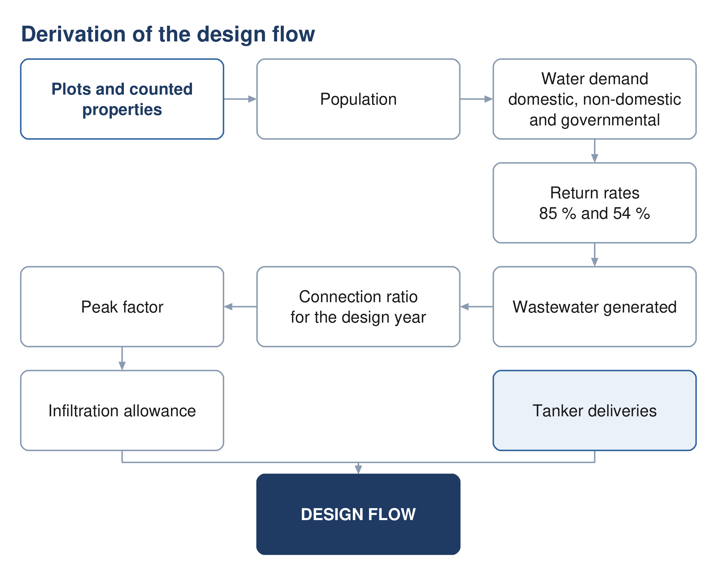
Figure 8 Derivation of the design flow, from counted properties to the flow the network is sized on.

15.1 Water demand
Wastewater generation is derived from water demand. Demand comprises five components: domestic, non-domestic, governmental, special consumption, and consumption supplied by tanker.
$Q_{dom} = Population × LPCD$ (4)
Symbol | Meaning | Unit
Q dom | domestic water demand | l/d
LPCD | unit consumption, 164 l/c/d for Adh Dhahirah | l/c/d
Non-domestic and governmental demand are established as proportions of domestic demand.
$Q_{ND} = 0.22Q_{dom}$ (5)
$Q_{gov} = 0.14Q_{dom}$ (6)
The proportions are the values published for the Governorate of Adh Dhahirah. They represent the non-domestic and governmental volumes recorded in the governorate water balance expressed against domestic consumption. The total they produce is therefore a measured quantity; its distribution across the area is established from the land use in Section 14.4.

15.2 Return to the sewer
Not all supplied water reaches the sewer. The proportion that does is applied by category.
$Q_{ww} = 0.85Q_{dom+tanker} + 0.54Q_{ND+gov}$ (7)
Symbol | Meaning | Unit
Q ww | wastewater generated, before infiltration | m³/d
Q dom+tanker | domestic demand and tanker supply | m³/d
Q ND+gov | non-domestic and governmental demand | m³/d
Water supplied by tanker returns to the sewer at the same proportion as piped supply and is included accordingly.

15.3 Infiltration
For newly constructed networks an allowance of 720 litres per day per kilometre of sewer is included. Infiltration from stormwater is not considered.

15.4 Peak flow
For catchments of more than one hundred properties the peak daily flow is established by the Merrimack formula.
$Q_{pdf} = 2.65{Q_{adf}}^{0.879}$ (8)
Symbol | Meaning | Unit
Q pdf | peak daily flow | Ml/d
Q adf | average daily flow | Ml/d
Both flows are expressed in megalitres per day. The peaking factor is the ratio of the two.

15.5 Projection through the design period
Flows are established at five-year intervals across the design period, as required by the Terms of Reference. The calculation is carried out annually and reported at five-year intervals, so that the early years, in which the connected population is a fraction of the ultimate, are represented. The connection ratio applied in each year is taken from the demand model prepared at inception.
The design horizon to be adopted is the subject of Section 5.1. The flow series will be issued in the next revision once the horizon is confirmed and the survey data is available.

16 Trade effluent and industrial contributions
Discharges other than domestic sewage affect both the load on the treatment plant and the treatability of the influent. Where the ratio of chemical to biochemical oxygen demand exceeds the domestic range, a separate treatment line for high-strength wastewater is required if the volumes concerned are significant.
The electricity account dataset identifies 499 connections carrying the Cost Reflective Tariff, which is applied to consumers above a consumption threshold. These are being resolved against the plot layer to establish which represent industrial or other high-strength sources. A register of such sources, with the pre-treatment required, will be presented in the next revision.
Sewage delivered by tanker is materially stronger than sewage arriving through the network and is accounted for separately in the plant load.

17 Treated effluent demand and customers
Treated effluent is produced at 95 per cent of the plant inflow. A further ten per cent is lost within the distribution network.
$Q_{delivered} = 0.90 × 0.95 × Q_{inflow}$ (9)
Symbol | Meaning | Unit
Q delivered | treated effluent available to customers | m³/d
Q inflow | flow entering the treatment plant | m³/d
Customers are classified as public or private. Public consumers comprise the landscaping of highways, secondary roads, interchanges and roundabouts, and public parks. Private consumers comprise community parks, golf courses, private gardens, and nurseries and farms.
Table 15 Treated effluent demand for concept planning
Planting | Summer demand | Planting | Summer demand
Shrubs | 20 to 40 l per plant per day | Ground cover | 10 l/m²/d
Palm trees | 120 to 165 l per plant per day | Seasonal flowers | 10 l/m²/d
Other trees | 40 to 80 l per plant per day | Grass | 12 l/m²/d
Hedges | 10 l per metre per day | Roads and junctions | 10 l/m²/d

Demand varies seasonally, at 100 per cent from June to August, 75 per cent in spring and autumn and 50 per cent from December to February. The system is sized for the summer peak. Consumers whose average demand exceeds 500 cubic metres per day are assessed individually.
The identification of customers, their present and potential demand and their development plans is in progress. The register will be presented in the next revision.

PART E

The existing system

18 Hydraulic assessment of the existing networks

18.1 Purpose
The existing sewer, force main and treated effluent networks are assessed against the flows arising across the design period, to establish which assets have capacity for the future flow, which require upgrading, and where the new works connect to them.

18.2 Approach
The assessment is carried out by hydraulic model. The existing network is verified before it is modelled: the datasets supplied provide geometry but not levels, and the diameter is recorded on part of the network only. The survey now in progress establishes both, and the model will be built on the surveyed data.
Each asset is then classified as having capacity for the design flow, requiring upgrading, or requiring replacement. Where an asset is retained, the point and manner of connection to the new works is designed.

18.3 Model
The wastewater network is modelled in SewerGEMS and the treated effluent network in WaterGEMS. Models are submitted in native editable format with the calculations and assumptions, and are updated following construction.
The model is run for the design year at peak flow, for the ultimate condition, and for the opening years at low flow. The last of these establishes the period during which the network requires assisted cleansing, described in Section 22.4.
The assessment will be presented in the next revision, following completion of the survey.

19 Rehabilitation and upgrading
Rehabilitation of the existing systems forms part of the concept scope. The extent of it follows from the assessment in Section 18 and from the condition established by survey and closed-circuit television inspection.
Rehabilitation work received to date comprises contractor submissions for completed work orders at Al Sad, Khadil, Yanqul, Dhank and Hay Al Aqabah. These have been reviewed and recorded; they describe work already carried out rather than work required.
The rehabilitation schedule, with quantities and cost, will be presented in the next revision.

20 Verification of the Regional Master Plan
The Terms of Reference require the Regional Master Plan to be verified. The verification compares the flows established in Part D against those on which the master plan was based, and identifies and explains any difference.
The asset data supplied includes a treatment plant record shown as a design case with a capacity of 29,038 cubic metres per day, annotated as arising from the Regional Master Plan concept design and not yet approved. That figure is taken as the master plan position for comparison.
The comparison depends on the design horizon, which is the subject of Section 5.1, and on the flow series described in Section 15.5. It will be presented in the next revision.
The data required by Nama Water Services Asset Management Planning for the updating of the master plan will be provided in the format the client specifies.

PART F

Options

21 Options methodology
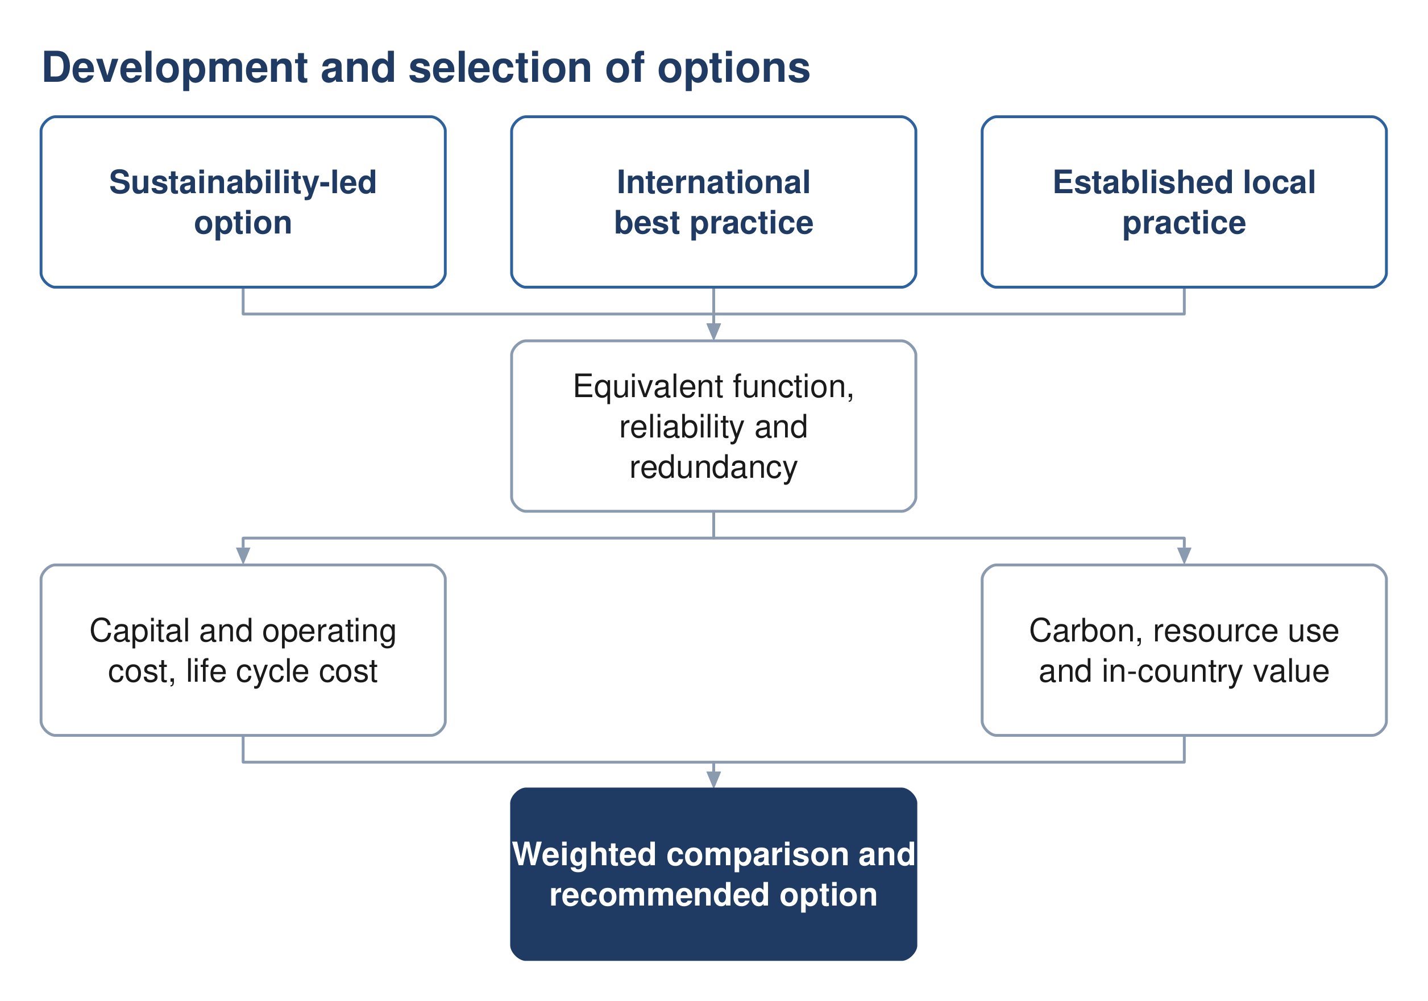
Figure 9 Development of the options and the basis on which they are compared.

21.1 Number and character of the options
Not fewer than three options are developed for each of the sewer network, the treated effluent network and the treatment plant. The guidelines indicate the character the options should take: one advancing environmental sustainability including nature-based solutions, one representing international best practice, and one based on established practice and technology available in the Sultanate.
Each option is developed to equivalent functional requirements with comparable reliability and redundancy, so that the comparison between them is not influenced by differences in scope.

21.2 The approach proposed for each option
The guidelines describe the character of the three options but do not prescribe what distinguishes them in design terms. The following approach is proposed, and is offered for comment before the options are developed.
Table 16 Proposed approach for each option
 | Sustainability-led | International best practice | Established local practice
Network | Gravity maximised, accepting deeper excavation in order to avoid pumping | Layout optimised by model, with pumping where it reduces whole life cost | Conventional layout, with pumping where the topography requires
Treatment process | Lower-energy process, with nature-based polishing where the scale permits | Highest-performing process, smallest footprint | Process already established in Oman, simple to operate and maintain
Energy | Generation on site, with a self-sufficiency target | High-efficiency plant and advanced process control | Grid supply with standby generation
Reuse | Reuse maximised, discharge to wadi minimised | High reuse at high effluent quality | Reuse to the demand identified, surplus discharged
Materials | Low-carbon and locally sourced where performance permits | Specified for performance and durability | Standard specification
Consequence | Higher capital cost, lowest carbon and operating cost | Highest capital cost, least land, best effluent quality | Lowest capital cost, most land, highest operating cost

Two constraints apply across all three. Nature-based treatment is limited by the guidelines to small works, so it is available for outlying settlements or for polishing rather than for the main plant. And every option is developed to the same functional requirement and the same effluent standard, so that the difference between them lies in how the result is achieved and not in what is achieved.

21.3 Basis of comparison
The options are compared on capital and operating cost, life cycle cost, carbon footprint over the project lifetime, resource efficiency, in-country value and the degree to which they employ nature-based solutions. The evaluation period is twenty-five years. The weighting applied to each parameter is set by Nama Water Services.

21.4 Selection
A weighted multi-criteria analysis compares the options against total lifetime cost, sustainability, social development and in-country value, adaptability and resilience, operability, constructability and environmental impact. Sensitivity is tested by varying the weighting between categories, the discount rate and the input design criteria. Where options fall within ten per cent of one another on total lifetime cost, the more sustainable option is adopted.

22 Sewer network options
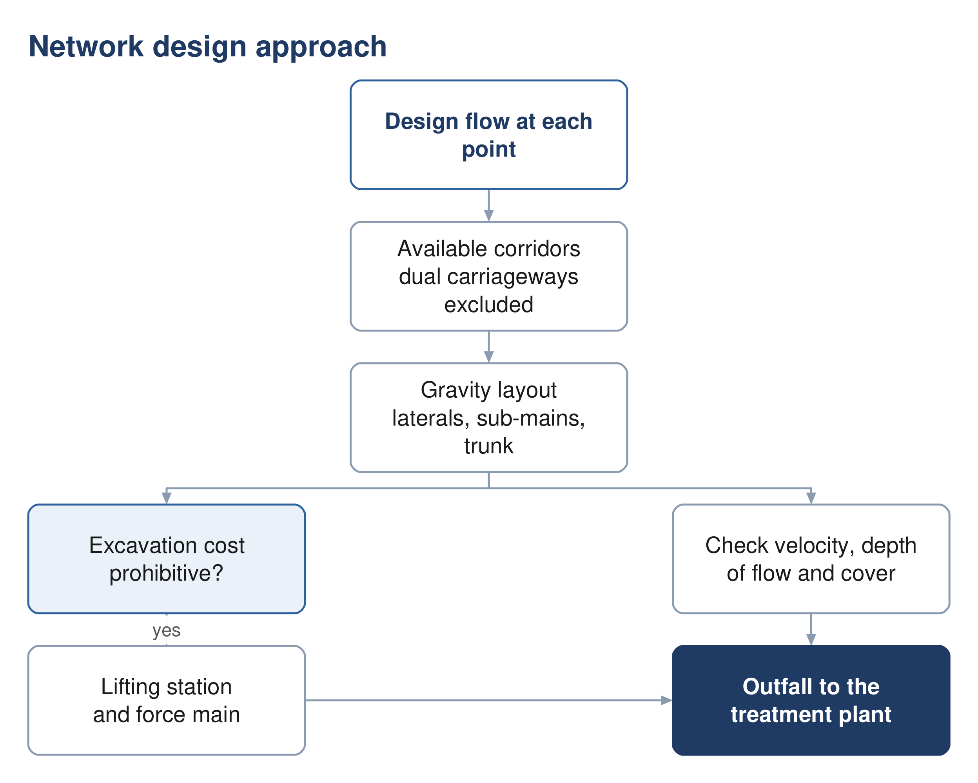
Figure 10 The network design approach, and the point at which a lifting station becomes necessary.

22.1 Principles
The network is laid out to convey the flow by gravity wherever that is feasible and cost effective, and to keep pumping to the minimum that the topography requires. The layout follows the road corridors, and the flow is directed towards the existing treatment plant site, which lies at a low elevation relative to the developed areas.

22.2 Corridor constraints
Dual carriageways are excluded as sewer corridors, as they cannot be taken out of service for construction or maintenance. Crossings of a dual carriageway are made perpendicular and, where available, through an existing underpass. Wadi crossings are designed to the cover required by the guideline.

22.3 Network hierarchy
The network is arranged in three tiers, following the arrangement of the existing network in Ibri: laterals collecting from properties, sub-mains collecting from laterals, and a trunk main conveying the collected flow to the plant. Arranging the network this way limits the number of connections made directly to the trunk main and keeps each tier to a manageable size.

22.4 Early-year operation
In the years following commissioning the connected population is a fraction of the design population, and the flow in the network is correspondingly lower. Velocities in that period may fall below the self-cleansing value, and the network requires assisted cleansing until the flow is sufficient to scour the pipes.
The period during which this applies is established for each pipe from the flow series and the connection ratio, and is presented as a schedule of the pipes affected and the years concerned, so that the operating requirement is known before the network is handed over.
The network options and the cleansing schedule will be presented in the next revision.

23 Pumping and lifting stations
A lifting station is provided where the cost of excavation to maintain gravity flow becomes prohibitive. Each station lifts the flow to a level from which gravity conveyance resumes, discharging through a force main to a receiving manhole or to the treatment plant.
Table 17 Force main design criteria
Criterion | Value
Minimum velocity, raw sewage | 0.75 m/s at minimum flow
Minimum velocity, intermittent flow | 1.0 m/s
Minimum velocity, vertical mains | 1.2 m/s
Maximum velocity | 2.5 m/s
Minimum internal diameter | 75 mm
Gradient, rising | 1 in 500
Gradient, falling | 1 in 300
Retention time | as short as the alignment permits

Retention in a force main allows sulphide to form, which is both a corrosion and an odour risk in this climate. Alignments are therefore kept short, discharges are submerged to limit turbulence, and the need for dosing is assessed for each station.
Surge analysis is carried out for each force main in approved software, and the protection required is established from it.

24 Treated effluent network options
The treated effluent network conveys the product of the treatment plant to the customers identified in Section 17. The network is sized for the summer peak demand, with storage of not less than twenty-four hours.
Where demand is below the volume produced, provision is made for the disposal of the excess, described in Section 26.
The network options will be presented in the next revision, following confirmation of the customers and their demand.

25 Treatment plant options

25.1 Capacity and phasing
The plant is sized on the flow established in Part D with the ten per cent design margin applied, and is built in phases so that capacity follows demand. The capacity of the first phase, and the years at which subsequent phases are required, follow from the flow series and are presented with it.

25.2 Process selection
Process selection is governed by the effluent standard. The total nitrogen limit described in Section 13 requires full nitrification and denitrification, which narrows the technologies that can be considered. Land area, energy consumption, operating complexity and whole life cost distinguish the remaining options.
Table 18 Indicative land requirement by process
Process | Area, m² per m³/d
Membrane bioreactor | 0.45 to 0.9
Sequencing batch reactor | 0.9 to 1.8
Moving bed biofilm reactor | 0.9 to 1.8
Integrated fixed film activated sludge | 1.2 to 2.5
Conventional activated sludge and extended aeration | 1.8 to 3.6

The areas are indicative and are used for planning. The land required includes the process units, the sludge facilities, the buffer zone and provision for the energy-efficiency measures described in Section 34.

25.3 Siting
The site is assessed against the criteria in the wastewater guideline, covering access, physical characteristics, environmental and climatic impact, social impact and cost. Two criteria carry stated requirements: the site is assessed against the twenty-five and one hundred year flood levels, and the plant is to remain operational during floods.
The buffer distance to residential areas for a plant of this size is established from odour dispersion modelling rather than from a fixed figure, and lies between 300 and 1,000 metres measured to the five odour unit contour. The modelling is described in Section 30 and precedes the confirmation of the site.
The plant options, the site assessment and the phasing will be presented in the next revision.

26 Excess effluent, emergency provisions and tankers

26.1 Tanker reception
A proportion of the wastewater arising in the area is collected by tanker and delivered to the treatment plant. Sewage delivered this way is stronger than sewage arriving through the network, and its arrival is concentrated in the working day. A dedicated reception facility is provided, with screening, grease removal, sampling before acceptance and flow equalisation.

26.2 Excess treated effluent
Where the effluent produced exceeds the demand, provision is made for its disposal. Discharge to a wadi requires the effluent to meet Class A of Ministerial Decision 145/1993, and where the wadi discharges to the sea the limits for ammonia, nitrogen and phosphorus of Ministerial Decision 159/2005 apply in addition. Any such discharge is subject to the approval of the Environment Authority and the Authority for Public Services Regulation.

26.3 Emergency provisions
Provision is made for the diversion of raw sewage in the event that the plant is out of operation, and for emergency storage. Every pumping station is provided with an emergency overflow to prevent flooding of the station or of connected properties; overflows are subject to the approval of the Environment Authority.

27 Sludge management strategy
The Oman Sludge Management Plan, as reproduced in the wastewater design guideline, identifies a sludge treatment centre performing composting at Ibri as the solution for the Governorate of Adh Dhahirah. The plant is therefore to be designed to receive and process sludge arising beyond its own catchment, and the land area, buffer distance and vehicle access are established accordingly.
Sludge is to be reused unless no form of reuse is possible, and its quality is to comply with the heavy metal limits of Ministerial Decision 145/1993. Where disposal to landfill is required, the receiving authority sets acceptance criteria including a minimum solids content of eighty per cent. That content is above what mechanical dewatering alone achieves, and drying or composting is therefore required.
Dewatering facilities are provided on site. The strategy, with the quantities arising and the disposal route for each, will be presented in the next revision.

PART G

Assessment and appraisal

28 Ground conditions
Geophysical investigation is required for all infrastructure and geotechnical investigation for all above-ground assets. At this stage the purpose is to establish a site-wide ground model and a range of parameters sufficient to select foundation types and platform levels, and to identify the risks that the detailed investigation must resolve.
Boreholes at the treatment plant and lifting station sites are taken to a minimum depth of fifteen metres or to a competent stratum, and are closely spaced at wet wells, valve chambers and electrical rooms. Groundwater monitoring is required, as the depth to groundwater governs both the excavation method and the infiltration allowance.
The ground model and the concept geotechnical report will be presented in the next revision.

29 Flood protection
The study area is crossed by a wadi system, and flood behaviour governs both the alignment of the works and the siting of the treatment plant. The site is assessed against the twenty-five and one hundred year flood levels, and the plant is to remain operational during floods.
Pumping station floor levels, transformers and standby generators are set not less than 300 millimetres above the one in fifty year flood level. Wadi crossings are designed with a minimum cover of 1.5 metres to the crown of the pipe.
The flood protection assessment will be presented in the next revision.

30 Odour assessment
Odour governs the buffer distance between the treatment plant and residential development, and for a plant of this size the buffer is established from dispersion modelling rather than from a fixed distance. The modelling establishes the distance to the five odour unit contour, using site meteorological records and the treatment processes proposed.
Odour control is provided at the inlet works, the sludge facilities and the pumping stations, with the treatment train selected from the assessment. Compliance is verified by continuous monitoring at the site boundary.
The dispersion modelling and the resulting buffer will be presented in the next revision, and precede confirmation of the plant site.

31 Climate resilience
The works are assessed for resilience to the climate conditions anticipated over their service life. The assessment considers a fifty-year horizon at two and at four degrees Celsius of warming, and addresses the effect of changes in rainfall frequency and intensity on site selection and on the design of the infrastructure.
The assessment will be presented in the next revision.

32 Environmental and social assessment
An environmental impact assessment is required for the treatment plant and its associated works. The Environment Authority is informed of the project, its objectives and its anticipated impact, and is consulted on the location of the facilities.
Each option is assessed against resource use, ecosystem disruption, pollution risk, climate resilience, socio-economic impact and land use, and the assessment forms part of the comparison described in Section 38.
The scope required at this stage is the subject of Section 5.5.

33 Utility interfaces and approvals

33.1 Approach
The proposed alignments are superimposed on the service records of each authority holding assets in the area. Where a conflict cannot be avoided by re-routing within the corridor, the cost of relocating the proposed works is compared with the cost of relocating the existing service, and the agreement of the owning authority is obtained for whichever is adopted.

33.2 Records held and required
The potable water network is available from the dataset described in Section 7.2 and provides 647.8 kilometres of mains within the study area. Records for electricity distribution, telecommunications and, where present, gas and fuel pipelines are being requested from the respective owners.
The electricity data held records the position of consumer connections. It does not record the routes of the distribution cables, which are required for clash assessment and are requested separately.

33.3 Clearances
Table 19 Separation from other services
Situation | Requirement
Force main to water main, horizontal | 3.0 m
Force main crossing a water main | the force main passes beneath, with 450 mm vertical clearance
Shallow sewer beneath a major road | 3.0 m horizontal clearance
Another service in the same trench | placed on a separate bench on undisturbed ground

Beyond these, the clearance applied is that specified by the authority owning the service.

33.4 Trial pits
Fifty trial pits are provided for. Their locations are selected at road intersections, along the routes of major existing services and along the expected routes of the trunk sewers and force mains. The programme is agreed with Nama Water Services and the municipal excavation approvals obtained before work begins.

33.5 Approvals register
Approvals and no objection certificates are required from the authorities listed below. A register is maintained recording the authority, the consent required, the date of application and the current position, and is reported to Nama Water Services.
Authority
Ministry of Housing and Urban Planning
Environment Authority
Ministry of Agriculture, Fisheries and Water Resources
Directorate General of Roads
Regional electricity distribution company
Oman Telecommunications Company
Royal Oman Police
Ministry of Heritage and Tourism
Municipality of Ibri

34 Sustainability
The carbon footprint of each option is evaluated for both construction and operation in accordance with recognised greenhouse gas accounting standards, and is expressed in tonnes of carbon dioxide equivalent per year and per cubic metre of effluent produced.
Because the greater part of operational emissions arises from electricity consumption, the measures that reduce carbon are largely the same as those that reduce operating cost: conveying the flow by gravity wherever possible, minimising lift, selecting efficient equipment, and generating renewable energy on site. Provision for photovoltaic generation within the plant perimeter is included in the land requirement.
Resource efficiency, in-country value and the use of nature-based solutions are assessed for each option and carried into the comparison in Section 38.

35 Cost

35.1 Basis
Item | Basis
Accuracy | plus or minus twenty per cent at concept stage
Measurement | CESMM3
Rates | current market rates, from recent tender and contract documents
Price basis | current prices at the date of the estimate
Presentation | by system element

35.2 Scope of the estimate
The estimate covers the works, the associated costs and the provisions, as set out below.
- Collection network — excavation by depth and by ground condition, trench support, bedding and backfill, pipework, manholes, property connections, road reinstatement, traffic management, crossings, and testing.
- Lifting stations — land, civil structures, pumps and station pipework, electrical supply and standby generation, control and telemetry, odour control, and the force main with its chambers and valves.
- Treatment plant — land, site preparation and flood protection, inlet works, tanker reception, biological treatment, clarification, tertiary treatment, disinfection, the sludge line, chemical systems, odour control, electrical and control installations, buildings, and commissioning.
- Treated effluent network — pipework, storage, boosting, filling stations and customer connections.
- Associated costs — design and supervision, survey and investigation, environmental assessment, consents and land, and physical and price contingency.
The estimate will be presented with the options in the next revision.

36 Risk
A risk register is established at this stage and maintained through the project. Each risk carries a description, a likelihood, an impact expressed in cost or time, an owner and the mitigation adopted. Risks that fall on one option and not on another are identified as such, as they affect the comparison rather than only the total.

37 Value engineering
A formal value engineering study is required at the concept and preliminary stages for a treatment plant or pumping station above the stated threshold, carried out by an independent certified consultant. The study is arranged within the concept programme and its outcome reported.

38 Comparison and recommendation
The options are compared by the method described in Section 21.3. The comparison presents, for each option, the capital cost by phase, the operating cost by year, the net present value over twenty-five years, the carbon footprint, and the assessment against each of the remaining criteria, together with the results of the sensitivity tests.
$NPV = \sum_{t=0}^{n}{\frac{C_{t}}{{\left(1 + i\right)}^{t}}}$ (10)
Symbol | Meaning | Value
C t | net cost in year t | —
i | discount rate | 5 per cent
n | evaluation period | 25 years

The comparison and the recommended option will be presented in the next revision.

PART H

Delivery

39 Implementation roadmap
An implementation roadmap is prepared for the recommended option, defining the scope of the subsequent design stages, the procurement route for each element, the phasing of construction, and the framework by which performance is monitored once the works are in service.
The roadmap follows the selection of the recommended option and will be presented with it.

40 Contracting strategy
The contracting strategy establishes how the works are packaged and procured. It is developed with Nama Water Services in a dedicated workshop, and considers the division of the works into packages, the procurement route for each, and the interfaces between them.

41 Project integration
A project integration plan sets out how the water and wastewater components are coordinated through design, construction and commissioning. It also addresses the rehabilitation or replacement of the existing potable water network where its performance is found to be unsatisfactory.

42 Conclusions
The design basis for the wastewater and treated effluent systems is established and is set out in Part C. The data supplied has been assessed, and the datasets that are usable, those that require correction and those that relate to areas outside the project have been identified in Part B.
The existing wastewater assets within the study area comprise 310.9 kilometres of gravity sewer, 33.2 kilometres of force main and 45.7 kilometres of treated effluent main. The potable water network within the area comprises 647.8 kilometres of mains. The number of properties on each plot and the category of use have been established from 33,970 electricity accounts, and an occupancy rate of 5.32 persons per property has been derived and checked.
A topographic and utility survey covering the whole study area is in progress. It will establish the levels, diameters and condition that the supplied datasets do not carry, and its completion is the principal step between this revision and the next.

42.1 Recommendations
It is recommended that Nama Water Services confirm the six matters set out in Section 5, and that the datasets identified in Section 7 as requiring correction or clarification be resolved, so that the flow series, the options and the appraisal can be completed on an agreed basis.

43 Appendices
Appendix | Content
A | Data register and sources
B | Design criteria, with references
C | Population and demand calculations
D | Drawings and figures
E | Register of matters requiring confirmation

The appendices will be issued with the next revision.

PAM-GUD-201, Table 1, page 16; PAM-GUD-203, page 13. Confirmation of the preferred convention is requested.
Area measured from the project boundary supplied with the Inception Report. Two boundary versions were issued with that report; confirmation of the approved boundary is requested, and the item is listed in Section 5.
PAM-GUD-201, Table 11, page 60 and Table 19, page 71. The guideline states that the consumption values apply in the absence of updated figures and should be validated by NAMA before design.
The guideline derives occupancy from population and housing units published by NCSI. Housing units are not published at settlement level, and counted domestic accounts have been used in their place. The departure is recorded in Section 10.
PAM-GUD-201, Sections 12.6 to 12.9, pages 104 to 106.
Area measured in the project geographic information system from the boundary supplied with the Inception Report, computed in UTM zone 40 North.
Project_Boundary.kmz and Final_Boundary_IBRI.kmz, both supplied in the Inception Report package.
Appendix to the Form of Bid, page 147, restated as a contract term at page 177 of the tender document.
Scope of Work, pages 63 and 64 of the tender document.
Terms of Reference, page 51 of the tender document; Inception Report Revision 0, Section 6.2.
Scope of Work, pages 56, 57, 62, 65 and 73; Bidding Form 24, page 123 of the tender document.
PAM-GUD-201, Table 2, pages 19 to 22, and Section 6.1.4.3, page 44.
PAM-GUD-203 Revision 01, page 2, records the consolidation of the former manuals. Site selection is at pages 63 and 64.
Measured from SEWERLINE_IBRI.shp as supplied. The tender records that the existing network layout is based on available information; the preparation of complete as-built records and GIS is part of the consultant's scope.
The extent of the second dataset is 55.802 to 55.814 degrees east and 24.269 to 24.292 degrees north, in the vicinity of Al Buraymi.
Fields present: identifier, tariff, coordinates in projected and geographic form, governorate and wilayat. The governorate is recorded as Dahira on all records; the wilayat field is empty on all records.
The tariff comprises three variants in the dataset: fixed rate (9 accounts), seasonal (298) and time of use (192).
The model excludes buildings and is held in UTM zone 40 North.
PAM-GUD-201, Table 12, page 61. The rates are expressed per pupil, per bed, per employee and per square metre of floor area.
PAM-GUD-203, Table 11, page 29. The tabulated values have been reproduced using the Colebrook-White equation with a roughness of 1.5 mm at 15 degrees Celsius, and correspond to full-bore flow.
The equation and its coefficient are given at PAM-GUD-203, page 27. No corresponding value of tractive tension in pascals is stated in PAM-GUD-203 or PAM-GUD-201.
Class A permits ammoniacal nitrogen at 5 mg/l, organic nitrogen at 5 mg/l and nitrate at 50 mg/l as NO3, equivalent to 11.3 mg/l as N.
5,948 of 22,588 domestic accounts, being 26.3 per cent.
Wilayat population 183,564 in 2024, from the National Centre for Statistics and Information as reported in the Inception Report.
Those 172 plots carry 428 domestic connections between them, an average of 2.49 per plot, against 1.46 for plots generally.
PAM-GUD-201, Table 11, page 60. The column headings describe the ratios as distributed, being governorate volumes recorded between 2021 and 2023.
PAM-GUD-201, Table 19, page 71, which gives a single discharge ratio for domestic and tanker supply.
PAM-GUD-201, Section 7.4.3, page 72.
PAM-GUD-201, Section 7.4.2, page 71. The guideline states that the formula is to be used for a catchment or sub-catchment having over 100 properties.
PAM-GUD-203, Table 31, page 68, gives tankered sewage at 350 to 1,050 mg/l BOD against 350 to 400 mg/l for network sewage.
PAM-GUD-201, Tables 21 to 23, pages 75 and 76. The rate for roads and junctions applies in the absence of specific vegetation information and is subject to municipality approval.
The software to be used is the subject of Section 5.4.
STP_PT_IBRI.shp, record identifier 10, status Design, source recorded as Asset Planning.
PAM-GUD-201, Section 12.1, page 95.
PAM-GUD-203, Section 10.5, page 101, limits constructed wetlands to works of approximately 500 cubic metres per day.
PAM-GUD-201, Sections 12.6 to 12.9, pages 104 to 106.
PAM-GUD-203, Sections 8.2.1 and 11.5.3, pages 50 and 181.
PAM-GUD-203, Table 28, page 64.
PAM-GUD-201, Table 8, pages 43 and 44.
PAM-GUD-203, Section 10.2.4.3, pages 72 and 73. The substituted limits are materially tighter than Class A for phosphorus and ammoniacal nitrogen.
PAM-GUD-203, Table 67, page 136.
PAM-GUD-201, Table 8, page 43; PAM-GUD-203, Table 90, page 170, which sets five odour units per cubic metre at the site boundary where the surrounding area is sensitive.
PAM-GUD-201, Section 4.3, page 33.
The account dataset described in Section 7.3 comprises point locations of metered connections.
PAM-GUD-201, Section 12.5.1, pages 98 to 100, which cites ISO 14064 and the Greenhouse Gas Protocol and gives a benchmark of 1.17 × 10⁻³ tonnes of carbon dioxide equivalent per cubic metre of treated effluent.
PAM-GUD-201, Table 27, page 93, and its accompanying note.
PAM-GUD-201, Section 13, page 107.

